WORLD METEOROLOGICAL ORGANIZATION
COMMISSION FOR INSTRUMENTS AND  METHODS OF OBSERVATION  OPAG-UPPER-AIR  JOINT MEETING  CIMO EXPERT TEAM ON  UPPER-AIR SYSTEMS INTERCOMPARISONS  First Session  AND  INTERNATIONAL ORGANIZING COMMITTEE (IOC) ON  UPPER-AIR SYSTEMS INTERCOMPARISONS  First Session  GENEVA (SWITZERLAND), 17-20 MARCH 2004 |  | Distr.: RESTRICTED  CIMO/OPAG-UPPER-AIR/  /ET-UASI-1/IOC-1/Doc. 3.2(5)  (12.III.2004)  _________  ITEM: 3.2  Original: ENGLISH ONLY

PRESENTATION ON RECENT NATIONAL TESTS/COMPARISONS

(Submitted by Jean-Louis Gaumet, France)

Summary and purpose of document

This document provides information on recent tests and comparisons of new radiosondes made by the Météo France and requirements for further tests and/or intercomparisons.

Action proposed

The meeting is invited to note and comment on the information contained in the report and take actions on the issues raised in the report, as appropriate.
PRESENTATION ON RECENT NATIONAL TEST COMPARISONS

Jean-Louis GAUMET
Météo France
7 Rue Teisserenc de Bort
78195 Trappes Cedex

1 – RADIOSONDE PRESENTATIONS

  - Vaisala RS 92 KL and RS 92 AGP sondes

The new RS 92 radiosondes use the same pressure, temperature and humidity sensors as in RS 90 radiosondes.
The pressure measurement is obtained from a capacitive sensor ( measuring range 1050 hPa to 3 hPa and accuracy ± 0.5 hPa).
The temperature sensor called F. Thermocap uses the capacitive technology (measuring range + 60°C to – 90°C and accuracy ± 0.2°C).
The humidity sensor uses again the capacitive technology. In fact two elements called Humicap H are alternatively heated. During the measurements with the first sensor, the second is heated.

The main characteristics are :

 | RS92 - KL | RS 92 - AGP
Electronic type | Analogical | Numerical
Wind determination | Loran C | GPS 3D receiver (12 channels) code correlation
Modulation | FM | GFSK
Frequency bandwidth | 200 Khz | < 20 khz
Emitted Power | 200 mW min | 60 m W min
Receiver and data processing | STAR system or SPS 220 + Digicora III | SPS 220 + Digicora III

  - Modem M2K2 Sondes

The temperature is measured with a thermistance sensor.
The humidity sensor uses a capacitive technology.
The temperature and humidity are processed by a voltage/frequency converter, the measuring frequencies being analysed by use of a microcontroller, and associated to the calibration data, and then mixed to the GPS receiving signals.
The radiosonde is not pressure sensor equipped. The pressure is calculated by the Laplace equation using the GPS position and temperature versus height.

The main characteristics are :

Radiosonde | M2K2 Measures : TU DGPS
Electronic type | Numerical
Wind determination | GPS 3D (8 channels) Correlation code
Modulation | PSK
Frequency bandwidth | < 20 khz
Emitted Power | 300 mW min
Receiving system and Processing Unit | SR2K2 Station + STAR Software  Or  SR2K Station + STAR Software

- – TEST IMPLEMENTATION

  - At ground

The sondes were controlled by means of the ground check set proposed by the manufacturers :

- The Vaisala Ground check set GC 25 (thermometer and barometer references)
- The Modem Ground Check (thermometer and humidity Sensor references)

  - Multiple radiosoundings

For the different radiosoundings, the attachment was composed of a balloon, a parachute and 1, 2 or 3 or 4 sondes.

The signal are received on the following ground stations :

- STAR for Vaisala RS90 and RS92-KL
- DIGICORA III for Vaisala RS92 – AGP and RS92-KL
- SR2K2 and SK2K for the Modem M2K2 sondes

    - Attachment with one sonde
0.2m
20m minimum

Balloon (23000m) parachute sonde
or unwinder

    - Attachment with 2, 3 or 4 sondes

Vertical attachment :
Mean advantage : to reduce interferences between sondes
drawback : The sondes are not at the same pressure
0.2m
30m
10m

Balloon (23000m or 30000m) parachute RS1 RS2

0.2 mètre

30 mètres

RS1
10 metres

RS2
Sondes (RS1, RS2, RS3, RS4)
10 metres

10 metres
RS3

Figure 1

Triangular attachment

Mean advantage : Les sondes are at the same level of pressure.
Drawback : The system does not offer great distances between sondes. The emission can make interferences between each sonde.
RS3

1mM
30mM
8-10m
8-10m
2-3m
Balloon (23000 or 30000m) Parachute RS1 RS2

RS4

- With 2, 3 ou 4 sondes :

30 metres

8 à 10 metres

Sondes (RS1, RS2, RS3, RS4)
8 à 10 metres

Wood board

Figure 2

- – TEST RESULTS

  - Technical Controls of Sondes

    - Weight (in gramme)

M2K2 RS92KL RS92-AGP RS90-AG RS90-AL
207g 204g 176g 287g 236g

The weight is with electric battery

    - Electric

M2K2 85mA to 250mA 250mA (6V)
RS92-KL 110mA (19V)
RS92-AGP 115mA to 200mA 200mA (8V)

    - Electromagnetic compatibility

No interferences between sondes have been observed when they are close together till 0.5m

  - Ground results

All the ground tests are good for the different sondes

  - Flight results

The following figures show differences between sondes under test and sonde reference. The reference sonde is the Vaisala RS90 at present time used in the French network.
The measurements are either raw data every second, or corrected data. The storage begins 300 seconds before the radiosounding departure.
In operational use, the data processing will consist in averaging the signal.

    - RS92 KL and RS92 AGP

The difference in respect to RS 90 is about ± 20m for geopotential. Concerning pressure the difference is around 2-3 hpa at the beginning of the sounding and 0.5 hpa after.

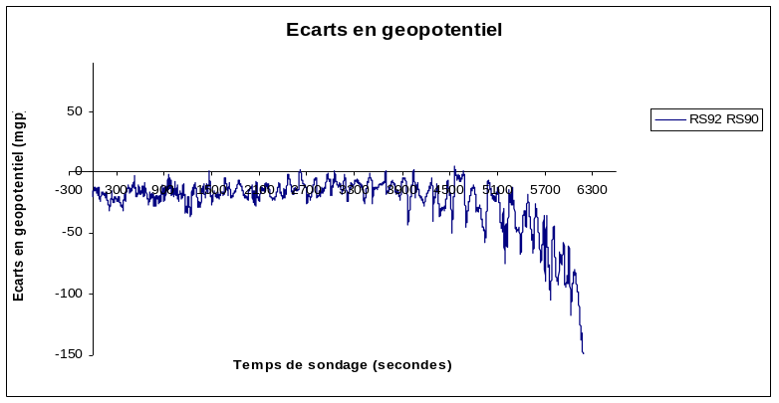
Test 9
Difference in geopotential

Figure 3

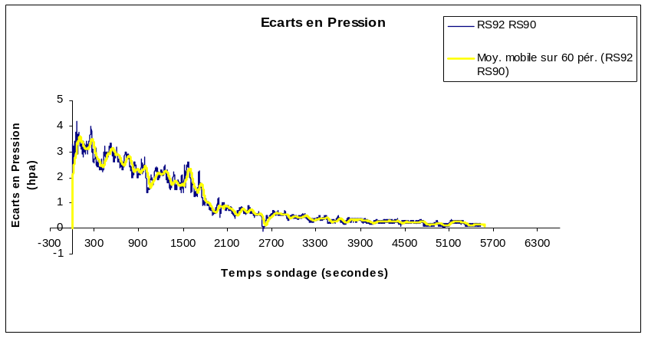
Test 11

Pressure difference
Figure 4

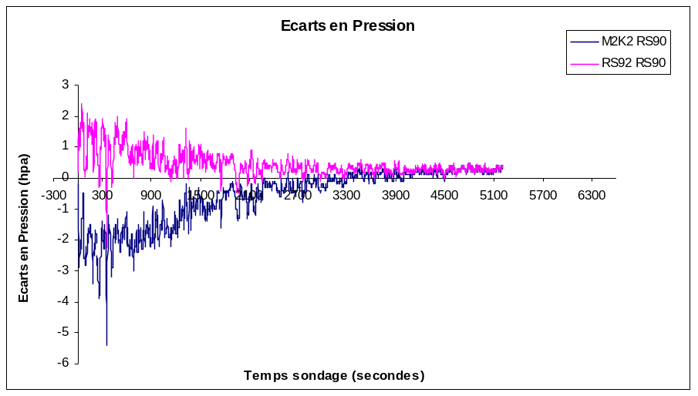
Test 6
Pressure difference
Figure 5

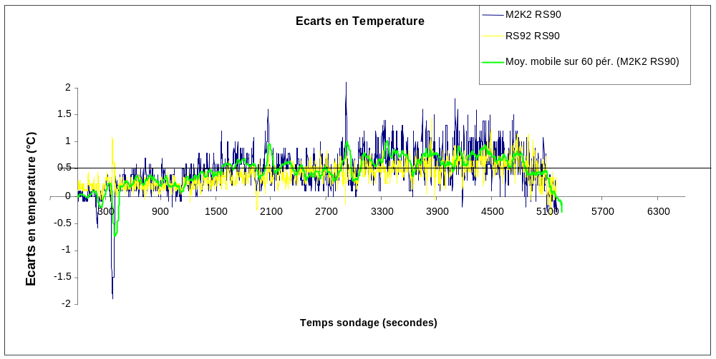
Figure 6 Difference between M2K2 and RS92 instantaneous corrected temperatures and RS90
instantaneous corrected temperatures

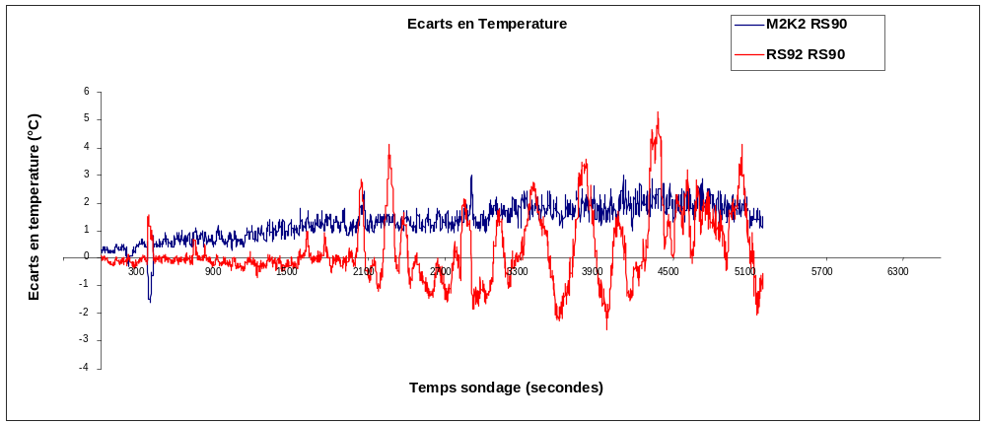Temperature difference

Figure 7 Difference between M2K2 and RS92 raw temperature and RS90 corrected temperature

Test 9
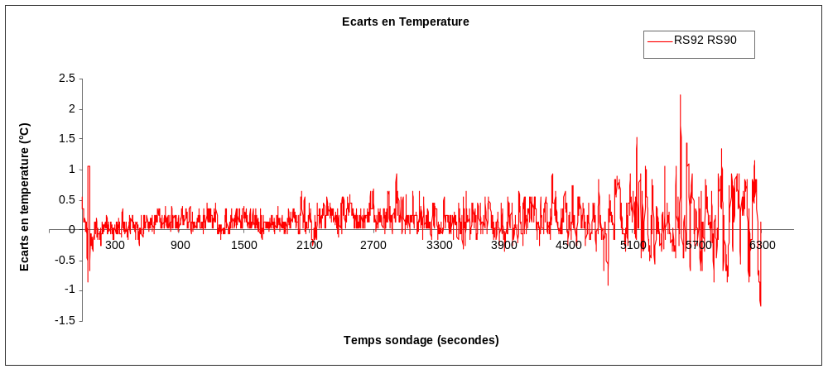
Temperature difference

Figure 8 Difference between RS92 corrected temperature and RS90 corrected temperature

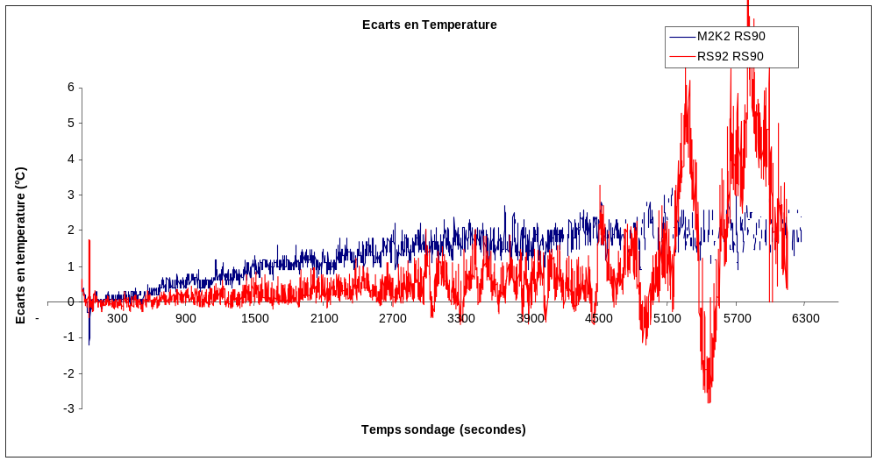
Temperature difference

Figure 9 Difference between M2K2 and RS92 temperatures without calibration or radiative
correction and RS90 corrected temperatures

Test 11
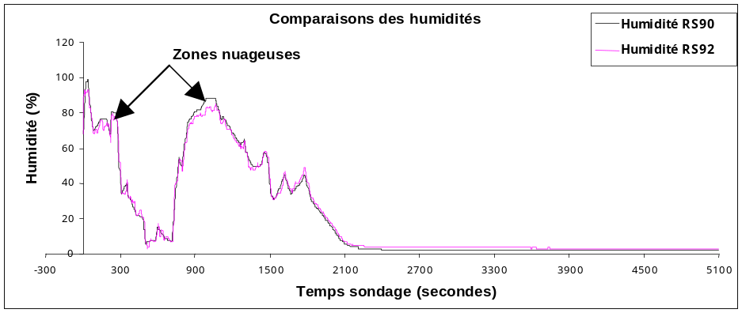
Figure 10 Humidity profile comparisons

Test 4
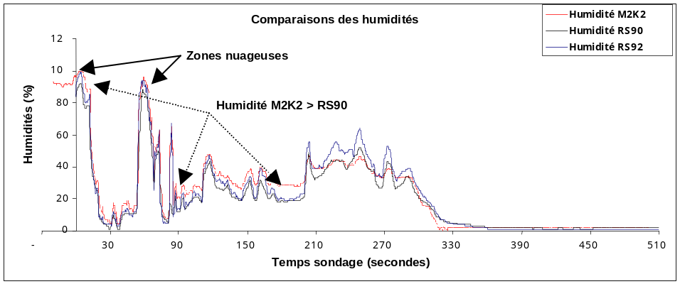

Figure 11 Humidity profile comparisons

After ground check and radiative corrections, the temperature profiles are similar. The maximum difference in respect to the reference sonde is 0.5°C in average value. The difference are always positive, the new sondes giving higher temperatures than RS90. For Vaisala sondes, the addition of a second sensor is benefit for the results. However, the alternative heating introduces an important noise on raw data. The RS 92 sondes give good humidity measurements : for example in a cloud the sondes give a 100% relative humidity, as expected.
Concerning the wind data, there is a good coherence between RS92 and RS90 LORAN C sondes.

    - Modem M2K2 sondes

In major situations, the differences in geopotential altitude in respect to RS 90 is lower than 60 m in the higher troposphere . The geopotential altitude is calculated using the pressure which is derived from the GPS height and the Laplace Equation.

Test 4
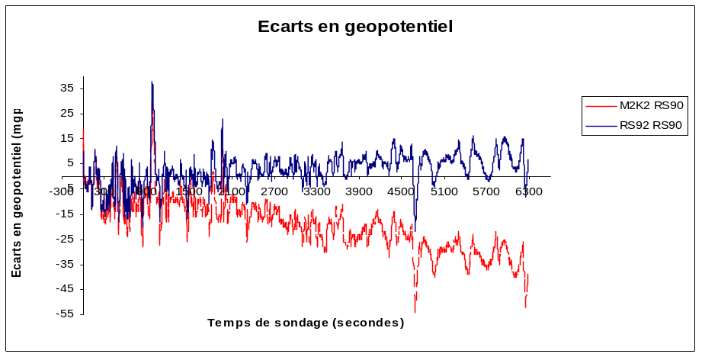
Test 7
Figure 12 Geopotential difference

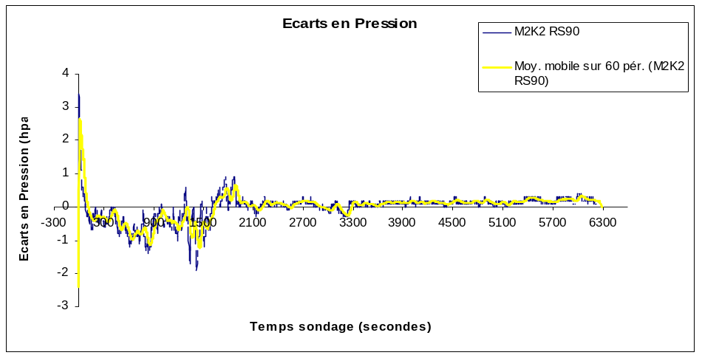
Test 2
Figure 13 Pressure difference

Test 6
Figure 14 Pressure Difference

The pressure calculation is effected by the Laplace equation.
To this end, it is supposed that the gravitation is constant and that the hydrostatic hypothesis can be applied.
For temperature, the radiative correction taking into account the solar flux and the air thermal conductivity seems to be pertinent due to the slight difference about 0.5C. The Modem sonde M2K2 gives the same humidity variations as the RS90 sonde and is able to detect clouds.
Finally, for wind measurements, one can see a very good availability higher than 98%. The difference in respect to the RS90 is 1-2m/s.

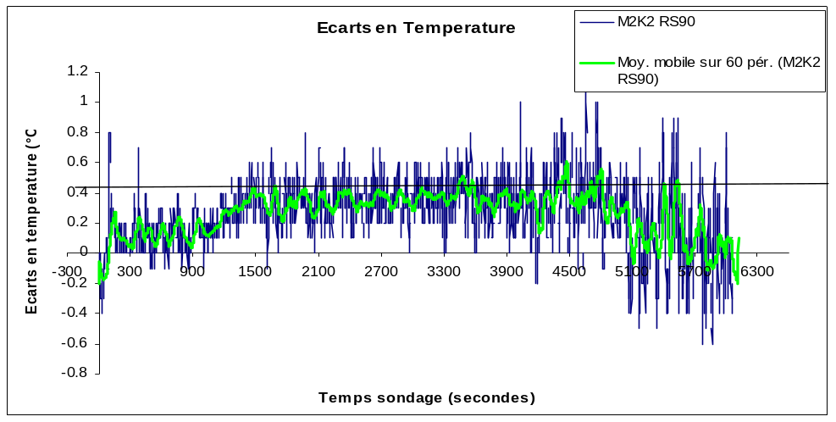
Test 3
Figure 15 Difference between M2K2 and RS90 corrected temperature

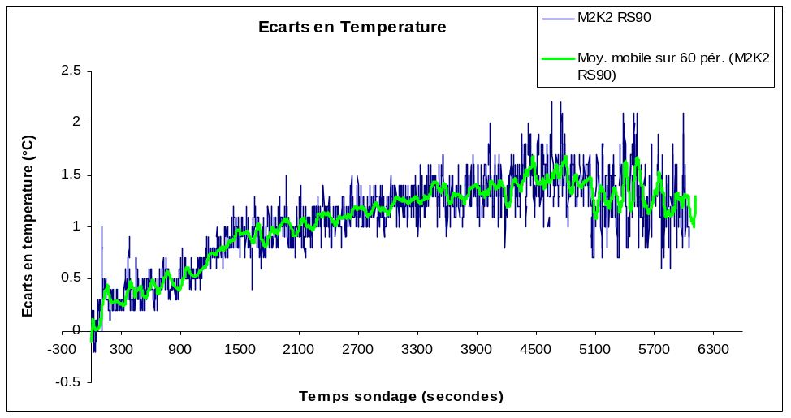
Temperature difference

Figure 16 Difference between M2K2 raw temperatures without calibration and radiative correction
and RS90 corrected temperatures

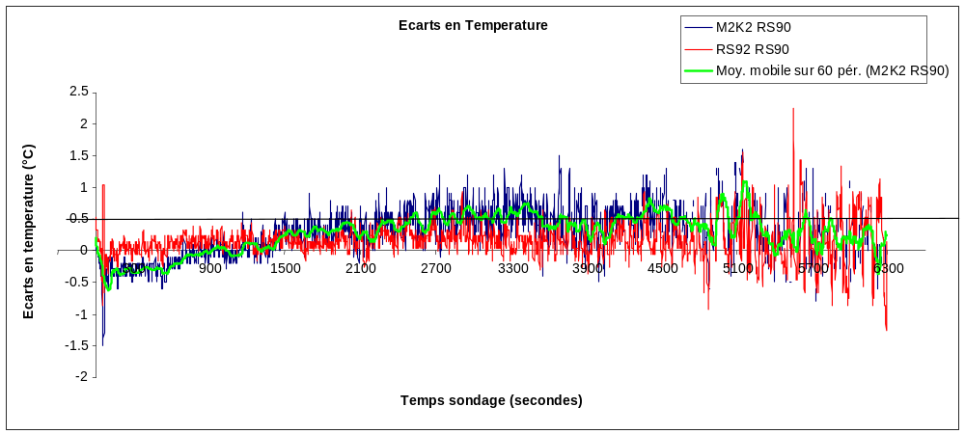
Temperature difference

Test 9

Figure 17 Difference between M2K2 and RS92 corrected temperatures
and RS90 corrected temperature

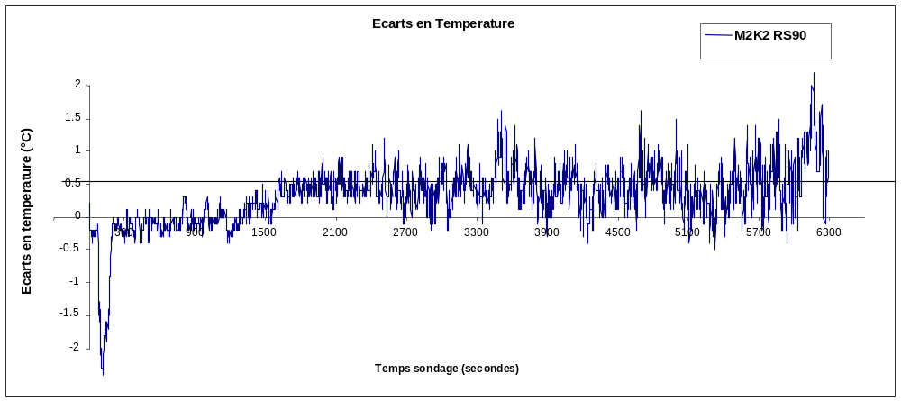
Temperature difference
Test 7
Figure 18 Difference between M2K2 and RS90 corrected temperatures
and RS90 corrected temperatures

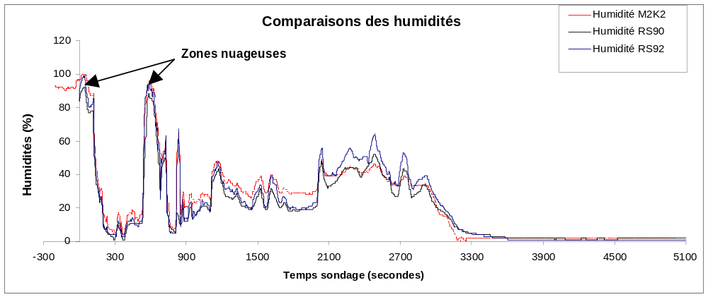
Test 4
Figure 19 Humidity profile comparisons

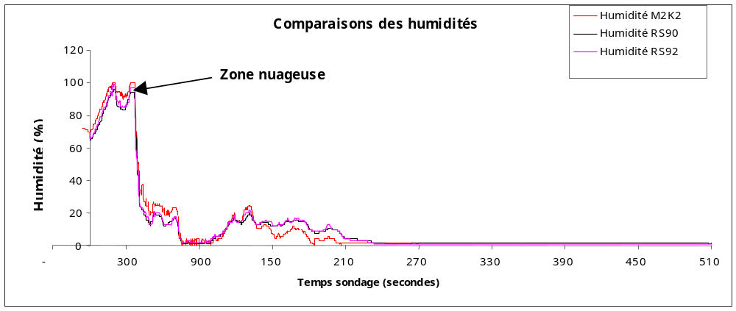

Figure 20 Humidity profile comparisons

- – CONCLUSIONS

For Vaisala RS92KL and RS92AGP radiosondes and related material

Both Vaisala RS92-Kl and AGP fulfil the overall requirements as well technical as meteorological.
various handlings for flight preparation and sondes setting -such as putting the sonde onto groundcheck, and connecting it- are easier than with RS90 sondes.
We must although notice that the hand-tuning of the frequency of the RS92 KL analogic sonde, the maintenance and the control of the drying salt seems slightly tricky.
Operators must therefore have been trained and strictly follow a clearly defined and explicit way of operation
We notice too the temperature sensor frailness.
Coming to flight measurements, pressure, temperature and humidity outputs are as good as those obtained with RS90, and thus fulfil CCTP requirements. One notice that the temperature output of the new sondes look out to be 0.2 to 0.4 ° C warmer than those obtained with RS90 and are thus closer to those of M2K2
Wind measurement outputs of RS92KL are quite the same as RS90AL ones and their ability is suitable.
GPS-3D wind measurement as provided by GPS RS92 AGP are quite equivalent to those of RS90 AG
Wind measurement through GPS 3D is outstanding, and availability of wind data is higher than 95%.
Modifications of STAR software to fit LORAN C RS 92-KL were applied and worked successfully.
To process GPS RS92AGP data we must foresee major modifications of STAR software to fit better DIGICORA 3 (which provides raw data) and the use of new sondes.
Noise was found on PTU measurements during reception of LORAN KL sondes through DIGICORA. It was although filtered out during the end process.
Two RS92-AGP sondes underwent GPS dysfunction needing Vaisala ‘s intervention.
After those interventions on DIGICORA III, two flight files had disappeared from the system.
Vaisala RS92KL and RS92 AGP sondes therefore fulfil the perfomance requirements of CCTP.

For Modem M2K2 and related material
Modem M2K2 sondes fulfil the overall requirements as well technical as meteorological.
Handling and operation are made easier by a new check up, which provides data directly to the station and to the acquisition software, and by a built-in transmitter which enables to test the sonde receiver without having to go outdoor.
Even if it is relatively easy, handling needs the operators to undergo an in-depth formation to understand the numerical working of the sonde.
Like for other sondes , the chronological process must be clearly defined and explicited.
Battery autonomy allows a three hour’s sounding.
Accuracy of wind measurement is outstanding, and wind data availability is higher than 95%. Modifications were done on STAR software for the use of M2K2 and work fine.
Modem M2K2 sondes therefore fulfil the perfomance requirements of specification document.

Synthesis
All the different analyses and conclusions, were summed up in a table enumerating CCTP general demands, and a quality notation on each point for each sonde.
--:bad performance .Does not meet CCTP requirements
-:fair performance .Does not meet CCTP requirements
0:fair performance. Meet CCTP requirements
+:good performance Meet CCTP requirements
++:good performance. Meet CCTP requirements

 | Vaisala RS92KL  PTU+GPS-2D | Vaisala RS92AGP  PTU+GPS-3D | Modem M2K2  PTU+GPS-3D
Metrological quality PTU | ++ | ++ | ++
Wind metrological quality | + | ++ | ++
Data availability during tests | ++ | ++ | ++
Geographical coverage and perenniality of wind navigation system | 0 | ++ | ++
Ease of operation and control(checkup) | + | + | +
Ground rejection | + | + | +
Sensor stoutness | 0 | 0 | +
Weight | + | ++ | ++
Receiver and data processing system | + | ++ | ++
Maintenance of the receiver | + | + | +
Maintenance and management of the data processing system | ++ | + | ++
Final notation | 12 | 16 | 18

Note 1 :CCTP is the document of general meteorological specifications
2 Figures are shown with french legend
3 A more complete document will be available soon

