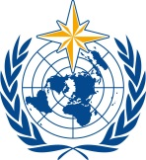  World Meteorological Organization  Commission for Instruments and Methods of Observation  Task Team on Radiation References, First Session  Teddington, UK, 15-17 November 2017 | CIMO/TT-RadRef-1/Doc. 1.2(1)
Submitted by:
The Secretariat
7.11.2017
DRAFT 1

Provisional agenda

- Organization of the Session
  - Opening
  - Adoption of the Agenda
  - Working Arrangements
- Report of the Chairperson
- review of the current status and issues of infrared radiometrY
- issues with the traceabiliy of field measurements
- Recommendations for the traceability of terrestrial radiation measurements
- Other Business
- Closure of the Session

__________

