**WMO-SPICE Report on Precipitation Gauge Heating**

May 1, 2014

**Purpose:** The purpose of this report is to document the precipitation gauge heating configurations used during the WMO-SPICE data collection periods (2012/2013 and 2013/2014 Northern Hemisphere and 2013 Southern Hemisphere Winters), noting if and how they differ from the IOC-2 and IOC-4 recommendations, and summarize the successes or issues reported by the site managers. The report also contains a summary of the field intercomparison of a heated and unheated Geonor inside DFIRs at the Bratt’s Lake Intercomparison site and a summary of the snow chamber experiment performed at NCAR in Boulder.

**Sites Reporting:**

|  |  |
| --- | --- |
| Guthega Dam (Australia) | ✓ |
| Bratt’s Lake (Canada) | ✓ |
| CARE (Canada) | ✓ |
| Caribou Creek (Canada) | ✓ |
| Tapado (Chile) |  |
| Sodankylä (Finland) | ✓ |
| Col de Porte (France) |  |
| Forni Glacier (Italy) |  |
| Joetsu (Japan) |  |
| Rikubetu (Japan) |  |
| Gochang (Korea) |  |
| Pyramid (Nepal/Italy) |  |
| Mueller Hut (New Zealand) |  |
| Haukeliseter (Norway) | ✓ |
| Hala Gasienicowa (Poland) |  |
| Valdai (Russia) |  |
| Voljskaya (Russia) |  |
| Aramon-Formigal (Spain) |  |
| Weissfluhjoch (Switzerland) | ✓ |
| Marshall (USA) |  |

**Heating Configurations:**

The following table indicates if the sites adhered to guidelines for heating set out in the IOC-2 report (for the 2012/2013 Northern Hemisphere Season) and the IOC-4 report (for the 2013/2014 Northern Hemisphere Season and the 2013 Southern Hemisphere Season). A checkmark indicates all guidelines were followed while an x indicates discrepancies. Column 3 indicates that discrepancies are reported and are summarized below. No marks indicate that the site did not report.

|  |  |  |  |  |
| --- | --- | --- | --- | --- |
| **Site** | **2012/2013**  **Followed IOC-2** | **2012/2013 Reported Discrepancies or Issues** | **2013/2014**  **Followed IOC-4** | **2013/2014**  **Reported Discrepancies or Issues** |
| Guthega Dam (Australia) | - | - | x | ✓ |
| Bratt’s Lake (Canada) | ✓ | - | x | ✓ |
| CARE (Canada) | ✓ | - | ✓ | - |
| Caribou Creek (Canada) | x | ✓ | x | ✓ |
| Tapado (Chile) |  |  |  |  |
| Sodankylä (Finland) | ✓ | ✓ | x | ✓ |
| Col de Porte (France) |  |  |  |  |
| Forni Glacier (Italy) |  |  |  |  |
| Joetsu (Japan) |  |  |  |  |
| Rikubetu (Japan) |  |  |  |  |
| Gochang (Korea) |  |  |  |  |
| Pyramid (Nepal/Italy) |  |  |  |  |
| Mueller Hut (New Zealand) |  |  |  |  |
| Haukeliseter (Norway) | ✓ | - | x | ✓ |
| Hala Gasienicowa (Poland) |  |  |  |  |
| Valdai (Russia) |  |  |  |  |
| Voljskaya (Russia) |  |  |  |  |
| Aramon-Formigal (Spain) |  |  |  |  |
| Weissfluhjoch (Switzerland) | - | - | x | ✓ |
| Marshall (USA) |  |  |  |  |

**Discrepancies or Issues Reported:**

Guthega Dam

2013:

The R3 (Geonor) gauge heaters used the CRN hardware components and were activated whenever the rim temperature was between -5 °C and +2 °C. The operation of the heater did not require the presence of precipitation. It is expected that the lower temperature limit will be removed for the 2014 winter (although this is not expected have a significant impact as precipitation is not common at temperatures below -5 °C).

Based on a relatively short period of data collection, the heating configuration appears to be reasonably suitable for conditions at Guthega Dam. Although the rim temperatures did sometimes fall below +2 °C when winds were high, no clear impact on the operation of the gauges has yet been observed.

A few examples:

* In clear and relatively calm conditions (<2 ms-1 at 3 m), the heaters were observed to keep the rim at +2 °C as the ambient temperature fell below -5 °C.
* During a precipitation event with wind speeds between 4 and 8 ms-1, the heater mostly kept the rim above +1 °C when the ambient temperature was above -3 °C, but the rim temperature varied between +1.5 and -1 °C when the ambient temperature was between -3 and -5 °C.
* During a windy (5-12 ms-1) event with trace amounts of precipitation, the rim temperature varied between about +0.5 and +2 °C when the ambient temperature was between -2.5 and -1 °C.

The heaters were observed to be quite responsive around the upper end of their operating temperature range – they were able to maintain the rim temperature close to +2 °C with minimal fluctuation in temperature as the heater cycled off and on.

Bratt’s Lake

2013/2014:

The heater configuration used at Bratt’s Lake was based on the IOC-4 guidelines except that a lower threshold for air temperature was set at -30°C. This was done to prevent the heaters from operating and very low temperatures and putting unnecessary stress on the 12V power supplies that were only rated to -20°C.

It was observed that the rim temperature could not be maintained at +2°C when air temperatures dropped below the -5°C threshold. Although the heater seemed to work well when the +2 to -5°C range was employed in 2012/2013, the power was insufficient to operate the heaters below that range. A solution will be examined prior to the 2014/2015 winter that may involve doubling the voltage and increasing the gauge of the conductors between the power supply and the heaters.

Figure 1 shows the Bratt’s Lake DFAR (Geonor) rim temperature for the 2013/2014 winter period. The blue line shows the rim temperature when air temperature (black) is above -10°C. The green line marks the rim temperature when air temperature is less than -10°C. Since the configuration is to attempt to keep the rim temperature at +2°C, it obviously is not maintaining that desired rim temperature at lower air temperatures, although it is rasing the rim temperature above ambient which may be beneficial in keeping the rims free of snow and frost.

 **Figure 1: DFAR (Geonor) rim (blue and green) and air (black) temperatures at Bratt’s Lake during the 2013/2014 winter collection period**

Caribou Creek

2012/2013

The Caribou Creek site did not become functional until late February of 2013 and was not commissioned until July 2013. The unshielded Geonor R3 was not heated between February and July. The functioning heaters complied with the IOC-2 protocols. The R0a Pluvio2 was also not heated during this period due to a wiring issue.

2013/2014

As with Bratt’s Lake, a -30°C air temperature threshold was used to turn off the heaters at very cold temperatures. The same observations about the efficacy of the heaters below -5°C also apply. The heaters on the gauges in the bush, being more sheltered from the wind, generally worked better at maintaining rim temperatures at +2°C than the less sheltered gauges in the clearing. Unfortunately, the rim temperature of the Pluvio in the bush was not monitored. Figure 2 illustrates the heater issues at this site.

**Figure 2: DFAR (Geonor) rim (blue and green) and air (black) temperatures at Caribou Creek during the 2013/2014 winter collection period**

Sodankylä

2012/2013

For most of the 2012/2013 winter, the WMO algorithm was in use.  Using this algorithm, there were problems with snow accumulating on the rim of the gauges (Figure 3). The algorithm did not provide enough heating to keep the rim clear of snow. On the 18th of March, 2013 the gauges at the site were switched to OTT’s own heating algorithm. Following the switch, no issues with snow collecting on the rim were observed.

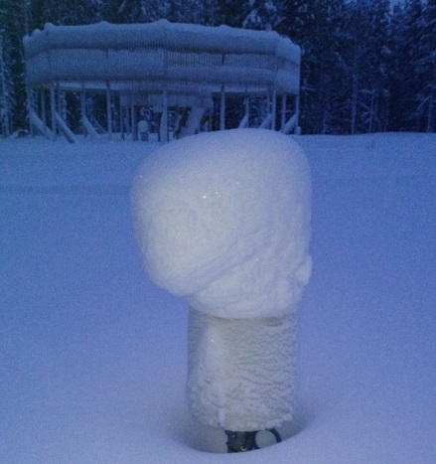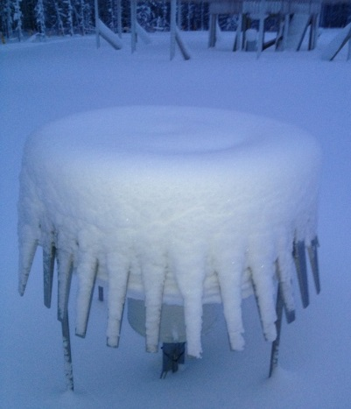

**Figure 3: Snow collection on the Pluvio rim at Sodankylä while using the IOC-2 heating algorithm**

2013/2014

Throughout the 2013/2014 winter, the site Pluvio gauges were configured with OTT’s heating algorithm. No issues with snow collecting on the rim were observed. However, snow did collect on the shoulders of the gauges (Figure 4).

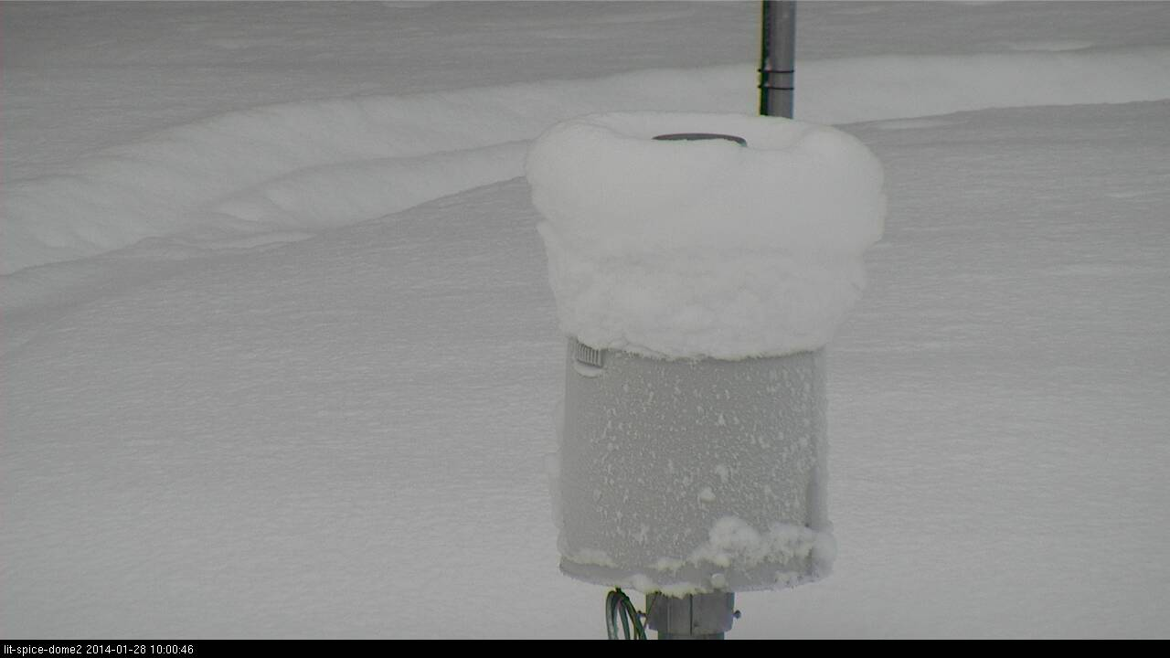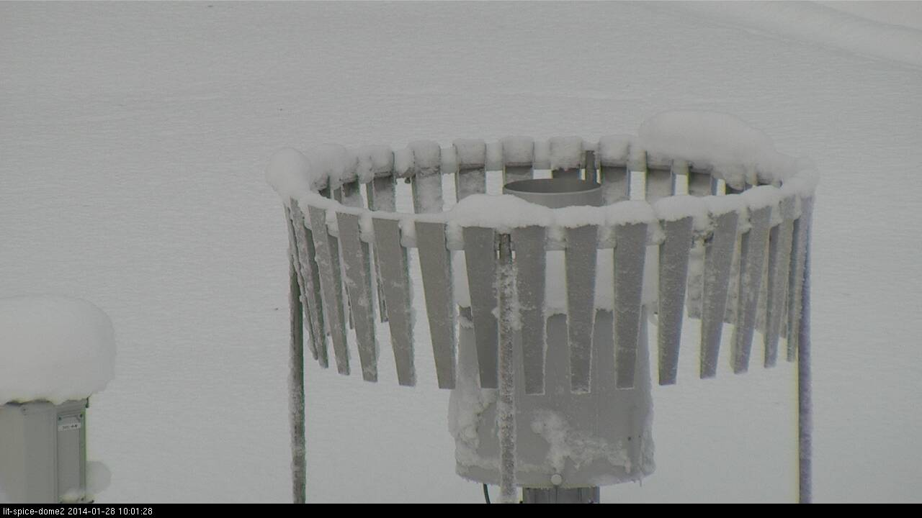

**Figure 4: Pluvio gauges at Sodankylä using the OTT heating algorithm**

Haukeliseter

2013/2014

The R3 (unshielded) gauge has a non-working heater and the problem could not be solved during the season. The R1 (DFIR) heater was damaged several times before December 13, 2013. Following that, the site introduced short periods with higher rim-temperatures for removing any potential snow capping. The low temperature threshold for heating was not removed until the middle of the season.

In order to increase the heating energy, the two heating element were modified (connected in series ?), This helped to keep positive rim temperature during cold period with high winds.

Ice-capping at the DFIR-Geonor was observed during relatively mild snow events (wet snow) where snow-buildup was very fast. None of the outside Geonors outside of the DFIR experienced the same, most likely due to higher winds which helped remove the snow from around the rim. In order to remove the snow cap, heating was applied to a higher rim-temperature than defined in the official heating configuration, for as long as was necessary.

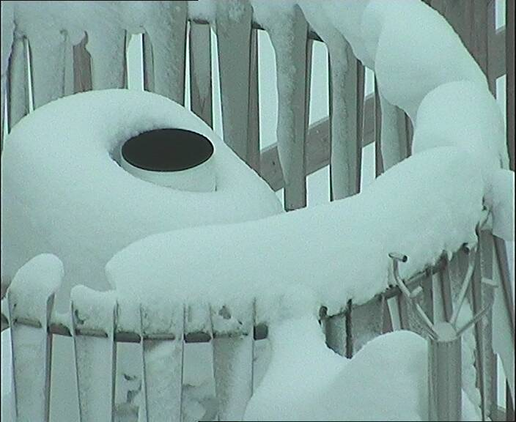

**Figure 5: Impact of heating on the DFIR Geonor at Haukeliseter, January 5, 2014**

Weissfluhjoch

2012/2013

Gauges were not installed until February of 2013 so nothing reported for 2012/2013.

2013/2014

The upper limit for the DFIR (Pluvio2) heater was set to 3.5°C while the upper limit for the shielded R3 was set to 5°C. The heater for the Unshielded R3 was not functional for the 2013/2014 winter.

Other than the non-functional heater on the Unshielded R3, there were no heating or capping issues reported. Figure 6 illustrates the non-uniform heater thresholds. However, some snow accumulation of snow was observed on the shoulder and the rim of the gauges, even during periods when heat was consistently applied (Figure 7).

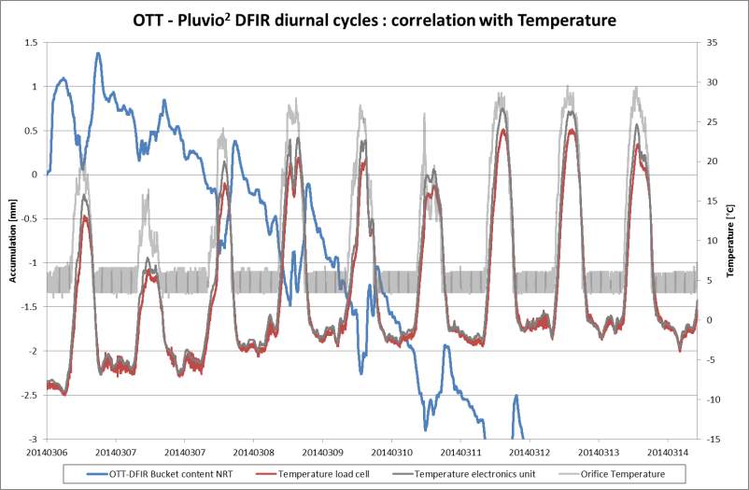

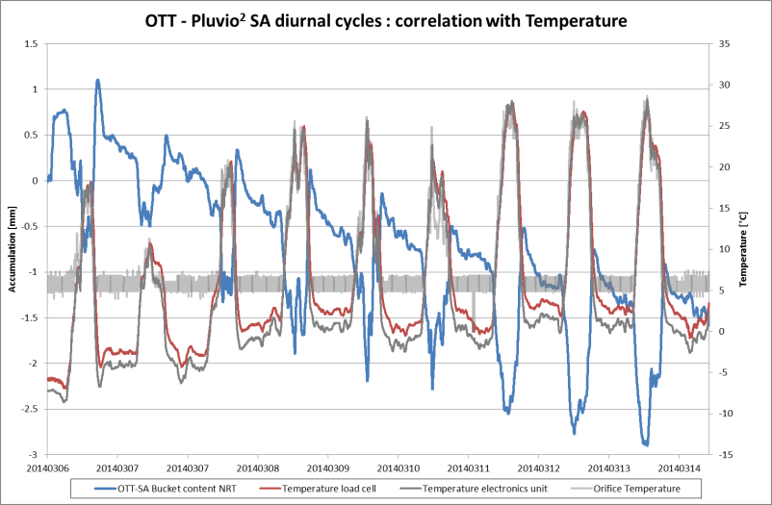

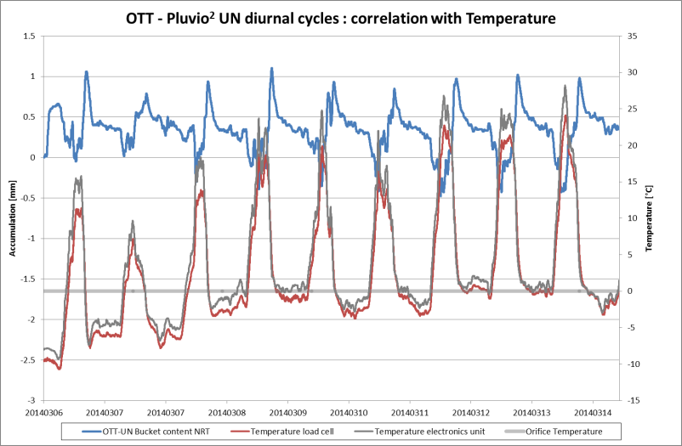

**Figure 6: Pluvio2 output from Weissfluhjoch illustrating the differences in heating thresholds for the DFIR (top left), Shielded R3 (top right) and the Unshielded R3 (bottom left)**

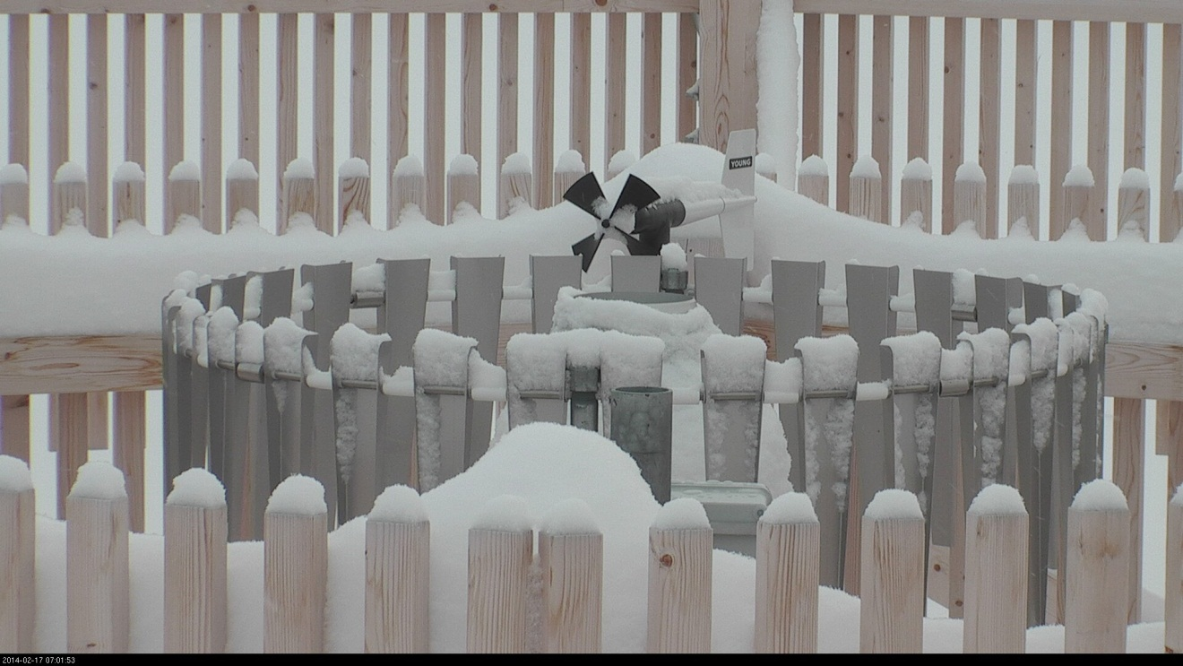

**Figure 7: Snow collecting on the shoulder and rim of the DFIR at Weissfluhjoch during continuous heating.**

**Field Intercomparison of Heated and Unheated Geonor Gauges inside DFIR Fences**

During the 2012/2013 and 2013/2014 winters, the Bratt’s Lake site performed an intercomparison between a heated and an unheated Geonor inside different DFIR fences (R2 configuration). The field intercomparison was set up to determine if there are clear advantages or disadvantages to heating gauge rims during snowfall events, especially in a cold and dry environment. Clearly, there are advantages to heating in locations were heavy, wet snow often leads to capping and measurement errors. However, it is speculated that a negative bias in measurements of snowfall using a heated gauge are also possible. The mechanism of this bias could be a chimney effect caused by a temperature differential of the air around the heated orifice. More plausible is a potential negative measurement bias caused by evaporation or sublimation of small snow particles that contact the heated surface of the gauge but never reach the bucket for measurement.

At Bratt’s Lake, the heated Geonor was housed inside the East DFIR while the unheated Geonor was housed in the West DFIR (Figure 8). The heated Geonor used the USCRN type heater and the SPICE IOC-2/4 algorithm with discrepancies and issues described in previous sections of this report. Preliminary results were presented at the 2013 Joint Scientific Congress of the CMOS, CWRA and CGU (May 26-30, Saskatoon Canada) and at the 2013 WMO-SPICE IOC-4 meeting (June 17-21, Davos Switzerland).

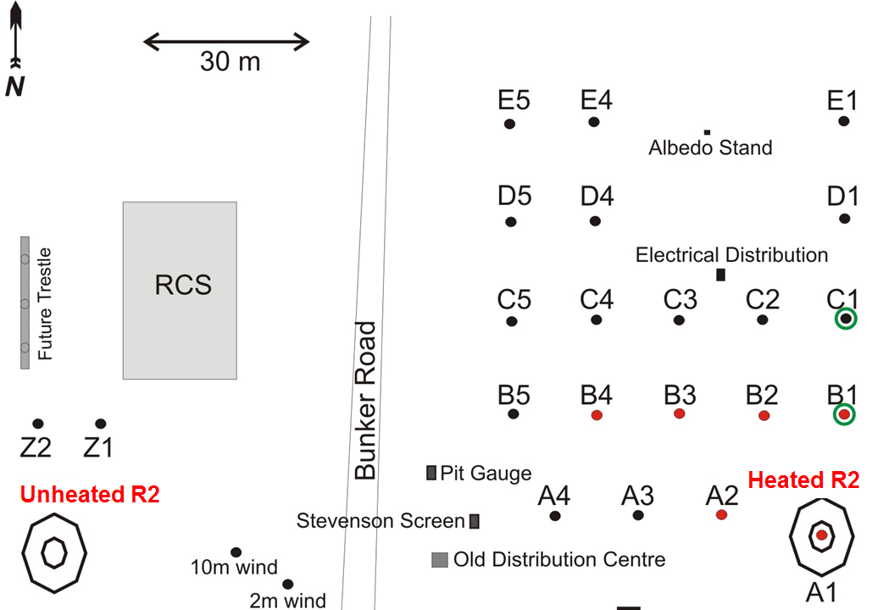

**Figure 8: Bratt’s Lake site diagram**

Preliminary results from the 2012/2013 winter showed how difficult field intercomparison can be for two very similar gauges measuring snowfall in a relatively harsh environment. Because the gauges were necessarily installed at opposite ends of the compound (approximately 125m apart) inside fences that have subtle deviations in construction, it is difficult to isolate systematic from random differences in catch. Subtle differences in catch could quite possibly be caused by differential catch in blowing snow or differential undercatch due to slight differences in the wind regime or construction of the fence. Figure 6 shows a summary of an event intercomparison for 2012/2013 and suggests no clear advantage or disadvantage to heating.

Event totals from the 20 events shown in Figure 9 appear in Table 1 and show that the heated R2 measures 6.0% less snowfall during heated events than the unheated R2. During unheated events, the opposite occurs with the heated R2 catching 5.4% more snowfall than the unheated R2. This is consistent with the 2011/2012 totals when neither gauge configuration was heated. Jan-2012 through March-2012 totals show that the East R2 (heated in 2012/2013 but not in 2011/2012) catches almost 6% more precipitation than the West R2 (unheated) with no heating. When compared to the West R2, it is somewhat suspicious that the East R2 consistently catches more snowfall until the heaters become operational, at which time it catches less snowfall. This needs to be explored further using the 2013/2014 data.

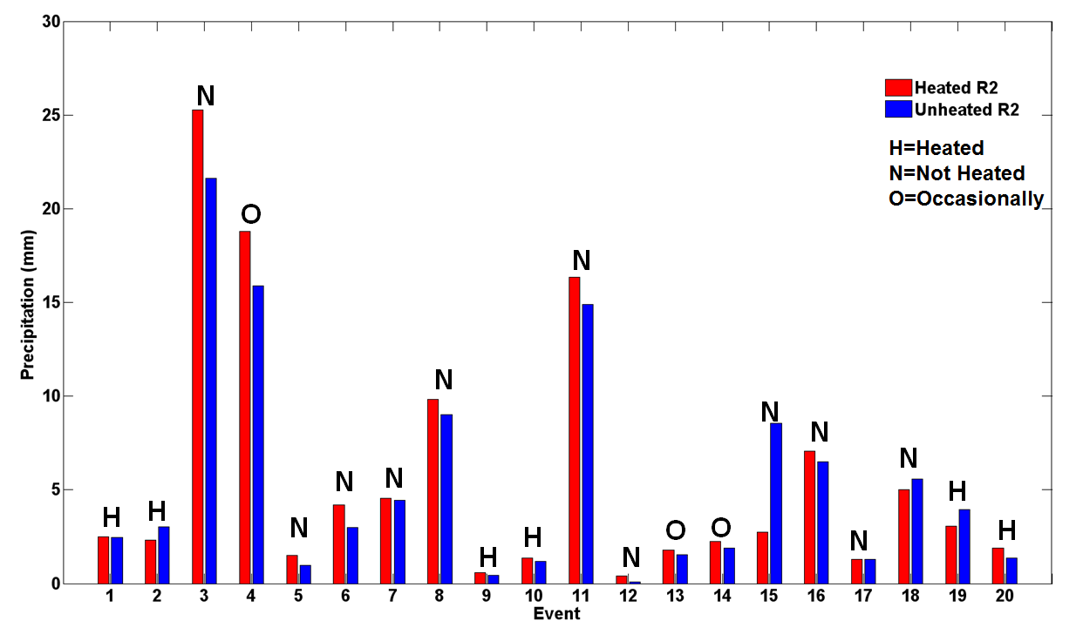

**Figure 9: Summary of precipitation events at Bratt’s Lake during the 2012/2013 winter for the heated R2 (red) and unheated R2 (blue) for heated (H), non-heated (N) and occasionally heated (O) events.**

**Table 1: Summary of heated R2 and unheated R2 total snowfall for Heated, Unheated, and Occasionally Heated snowfall events during the 2012/2013 winter.**

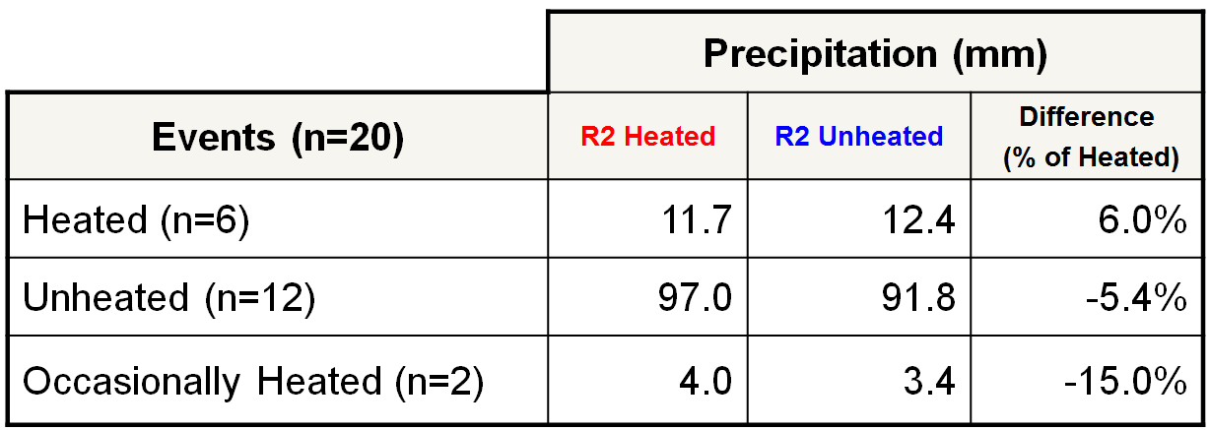

**Snow Chamber Heating Intercomparison**

A snow chamber experiment was performed by Matteo Colli at the NCAR facility in Boulder Colarado. The complete experiment is described in CIMO/SPICE-IOC-4/Doc. 4(7) (<http://www.wmo.int/mwg-internal/de5fs23hu73ds/progress?id=tuLnyM2IE6>) by Colli et al. (2013) entitled “SNOW MACHINE TESTING OF SPICE REFERENCE SNOW GAUGES”.

Colli et al. investigated the presence of plumes above the orifice of the heated precipitation gauge as well as the potential evaporation of snow particles on the inner wall of the heated orifice. Both could potentially lead to the underestimation of snowfall.

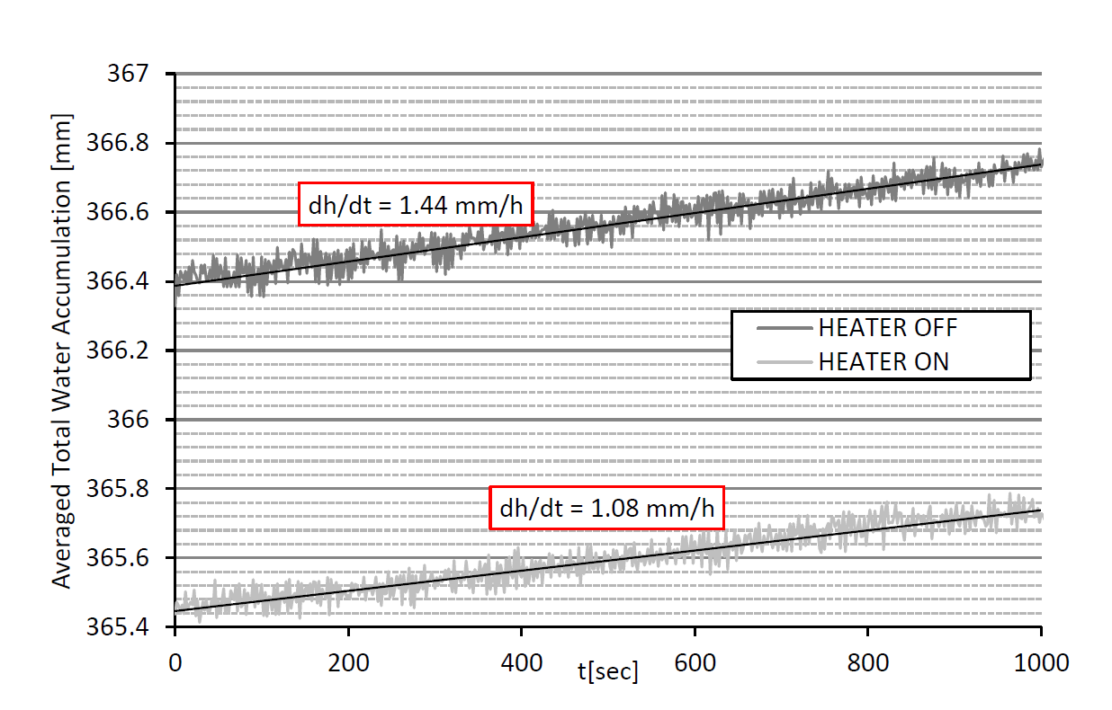Tests were undertaken with a Geonor T-200B with the heater turned on and then turned off using the same snow rate conditions and temperature. The snowfall rate underestimation was made using relative percentage errors between the rates when the heaters were on and off. The authors found that it was difficult to clearly define the influence of heater related errors but did show lower measured precipitation rates, by up to 15%, in the heated experiments with ambient air temperatures at -5°C and snow rates approximately 0.5 mm/h. This is illustrated in Figure 10.

**Figure 10: GEONOR T200B total water accumulation measured before and after deactivating the heater from a sample test performed with SR = 0.5 mm/h and Tair= -5°C**

High speed cameras were used to look for evidence of a heating plume above the heated gauge by tracking falling snow flakes. No evidence of plumes or deflected snow flakes due to the chimney effect were observed. The evaporation or sublimation of snow particles on the inner wall of the orifice were not investigated or reported in this report, but the possibility of this occurring is quite possible.

The study of Colli et al. did not use the SPICE heating algorithm which led to gauge rim temperatures greater than the 2°C maximum threshold used by SPICE. This experiment showed rim temperatures up to 9.6°C.

One of the recommendations following this experiment is to repeat the experiment using the SPICE heating algorithm.