Event selection methodology
(Developed for the reference)
Audrey Reverdin, Craig Smith, Mareile Wolff, Mike Earle, Samuel Morin, Barry Goodison

Version history
Document | Version | Date | Notes
Event selection for reference gauges data | 1 | May 11, 2014 | Initial draft prepared by Audrey Reverdin with input from Mareile Wolff and Mike Earle
Event selection for SoG data | 1 | April 10, 2014 | Initial draft prepared by Craig Smith with input from Samuel Morin and Barry Goodison
Whole document | 2 | May 14, 2014 | Revision following comments from Mike Earle and Yves-Alain Roulet

Table of Contents

- Description of Concept 2
- Chosen Algorithm 2
2.1 Algorithm description 2
2.2 Thresholds and periods selected for algorithm 6
2.3 Inputs : Reference gauges as “event-selectors” and precipitation detector 7
2.4 Outputs : Parameters in event file 8
2.5 Preliminary tests results 9
- Limitations and Possible Alternatives 11
- Event Identification for Snow-on-Ground (SoG) Data Analysis 12

1. Description of Concept
- In order to analyze the site data sets, precipitation events must be identified. Precipitation events can be highly variable, and the different site climatologies add to this diversity. Existing detection methods are very individual and are not very well documented. In order to achieve comparable site data sets, a uniform method is required.

- Pre-analyses conducted using datasets from several sites have shown that false detected precipitation events will add a lot of noise to the data set, confounding subsequent analysis. In order to analyse the nature of the precipitation, and possibly relationships to meteorological parameters, a relatively low false-alarm rate is required for the precipitation event identification process.

- Starting from the quality controlled reference data sets, the following methodology for the aggregation of precipitation events was developed in order to create analysis-ready (level 3) datasets, which are as comparable as possible across sites.

2. Chosen Algorithm

2.1 Algorithm description
- The event selection algorithm enables the selection of precipitation events using quality-controlled data from two instruments:
  - A precipitation detector : indicates if precipitation occurs or not (yes/no output).
  - A reference gauge : collects precipitation and gives the corresponding accumulation.

- The algorithm creates an output file in which all of the events selected through the process are listed, along with their characteristics and related parameters used for further analysis.

- The algorithm is based on 1 min data. It has been decided to average 6 s data before using them for event selection.

- The flowchart in Figure 1 illustrates the different steps of the event selection. It is composed of three columns:
Column 1 : uses data from both the precipitation detector and reference gauge.
Column 2 : describes the method without implementing data from a precipitation detector (sensor not available, not working for some reason, not stable, in maintenance or under revision); events selected using this approach are based only on data from the accumulation gauge.
Column 3 : indicates to go further through the algorithm process.
Columns 1 and 2 indicate different ways for the data to pass through, depending on whether or not there is a sensitive and reliable precipitation detector. The specific approach followed for a given event will be tracked in the output file by means of a data flag.

- The event selection algorithm follows three main steps :
  - First step – Starting Point
The first step searches for possible starting points of precipitation events. Starting points are detected when sufficient accumulation occurs in a ten-minute period after a selected data point. The procedure has the following features:

- Rate check over 10 minute moving window
Check if there is an accumulation in the reference gauge over a ten minute period. A potential starting point is identified if the accumulation is greater than, or equal to, a threshold value (currently defined as 0.1 mm). If insufficient accumulation is recorded (less than the threshold value), the 10 min window moves one minute forward.

- 1st minute check
If sufficient accumulation is detected, the first minute of the 10 min period is checked for recorded precipitation. If either the precipitation sensor is positive or a positive accumulation in the gauge is observed for that minute, then the minute is marked as a possible starting point.

Note : Both methods (precipitation detector or accumulation gauge) are set equal and only one is required to identify a potential starting point. Tests have shown that requiring a logical “and” for these two conditions will identify significantly less starting points. Falsely identified starting points will be screened out in the following “event check” step (see below), and are therefore not a problem.

  - Second step – Event Selection
The second step looks at the 30 minutes following a potential starting point. To be selected as an event, the 30 min window has to fulfill the following two conditions :

- Net precipitation duration sufficiently long
The number of minutes during which precipitation is detected has to be more than 60% of the window time, i.e. more than 18 minutes. The precipitation duration is primarily calculated based on precipitation detector data (first column) by looking at the number of “YES” cases that happened during the 30 minute period. In cases where precipitation detector data are not available, the duration check can be satisfied if the number of 1 minute reference gauge data points with increasing accumulation exceeds the same 60% frequency threshold (second column).

- Accumulation of reference gauge sufficient
The total accumulation in the reference gauge during the 30 minute period must meet or exceed a defined threshold. This threshold rate has been set to 0.25 mm over 30 minutes when a reliable precipitation detector is available (first column), and to 0.5 mm over 30 minutes if such an instrument is not available (second column).

A more strict rate check has been imposed in cases when independent validation by a precipitation detector is not available, to help ensure the veracity of selected events.

If these two required conditions are fulfilled, the window is set as a 30 min event; if not, the algorithm goes to the next potential starting point.
Note : The possibility to identify an event based solely on accumulation data (second column) has been introduced in order to allow the algorithm to run in cases where a precipitation detector is not available or reliable. However, to keep track of the specific method by which events are selected, events selected in this manner are flagged. This flag will appear in the output file to caution the analyst that it’s maybe not a real event, or at least that it has been selected without independent validation by a precipitation detector. On this basis, events that aren’t flagged are judged to be more probable and reliable.

  - Third step – Event parameters
When an event is identified, the algorithm calculates several different parameters to characterize the event in detail for further analysis.
Note : Among the list of required parameters (see Figure 1), the net precipitation duration of the event is calculated both with the precipitation detector data and the reference gauge accumulation data. The initial idea was to have the net duration of the event for cases without a reliable precipitation detector, but reporting both allows for a consistency check between the results from each approach.
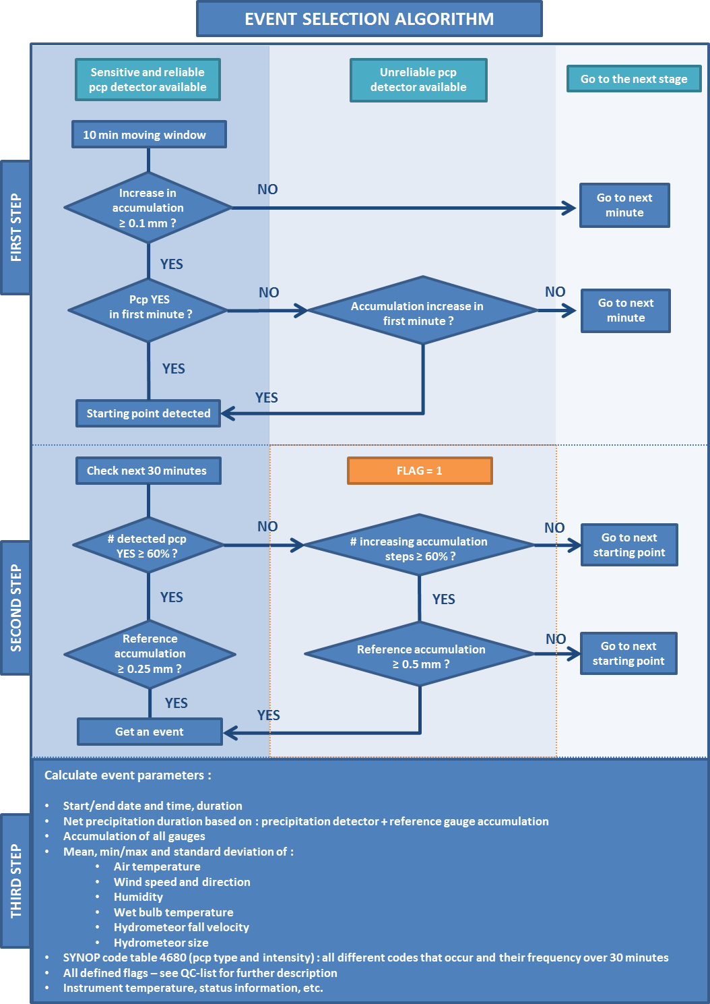
Figure 1 : Event selection algorithm flowchart.

2.2 Thresholds and periods selected for algorithm
The following thresholds and periods to be used in the algorithm were selected following discussions of the SPICE Data Analysis Team (DAT) during the 4th SPICE meeting in Davos (Switzerland). These thresholds/periods generally represent best estimates, and will be tested and refined further throughout the analysis.
First step :
- 10 minute window
Ten minute windows were chosen because teams in Norway and in the US used to apply 10 min running averages to the data as a very simple short-wave-filter, which reduces the noise such that typical accumulation amounts are clearly detectable. It is expected that this will also be valid for the filtering process now applied to the precipitation data. Furthermore, the 10 min period will allow for a more precise detection of the actual starting point of a precipitation event than the use of the complete event period (30 minutes). However, the 10 minutes is rather conservative and is only based on experiences from unfiltered Geonor measurements in Norway and USA; no tests have been performed using Pluvio² data.

- Rate check : accumulation ≥ 0.1 mm
A precipitation event requires an accumulation greater than zero. A threshold value of 0.1 was selected because residual noise in the data could potentially lead to a false starting point if the threshold was only set to zero.

Second step :
- 30 minute window
This fixed period of time is needed to compare events from different sites. A period of 30 minutes is short enough to allow for stable conditions (temperature, wind speed, etc.) during the event. Furthermore, analysis has shown that selecting 30 minute periods optimize the balance between the number and significance of events selected. It might be possible to change the period between 10 minutes and 1 hour, but moving to 12 or 24 hours periods is not reasonable for the current algorithm, and would require a different process.

- Net precipitation duration ≥ 60% of time
It has been decided within the SPICE project that the precipitation does not necessarily need to be continuous during the event period, but should still occur over a ‘significant’ portion of the event time. The choice of 60% of the time was set as a starting point, and needs to be further evaluated.

- Rate checks : accumulation ≥ 0.25/0.5 mm
The selection of a threshold accumulation of 0.25 mm over 30 minutes is based on previous experience in characterizing events by participating sites/analysts, with threshold rates of 0.2 – 0.3 mm/30min typically employed. The threshold should be sufficiently high to distinguish ‘real’ events from measurement artefacts, but not so long as to significantly reduce the number of events identified.
A higher threshold rate of 0.5mm/30min was set for the cases where precipitation detector data are not reliable, in an attempt to compensate for not having independent validation of events.
Note : The first goal of DAT in defining such thresholds is to select ‘real’ events, meaning events that have sufficiently high accumulation and last sufficiently long to make sure they are reliable, and not very light or spurious events (that are more difficult to characterize) or measurement artefacts (e.g. artificial accumulation due to temperature effects).

2.3 Inputs : Reference gauges as “event-selectors” and precipitation detector

- The event selection needs to be done with data from the most accurate and reliable gauge on site to ensure the best quality of the selection. It is thus appropriate to choose the on-site reference gauge as the dedicated event-selector :

  - For S2 sites, the event-selector should be the reference gauge in the DFIR (R2 reference). In cases of sites with multiple DFIR-references, only one will be used for the event selection.

  - For S3 sites, the shielded gauge of the R3 reference will be used as the event-selector (as it should collect more snow than the unshielded gauge).

Note : The choice of the event-selector should follow these recommendations, but the DAT suggests to keep the possibility to change the event-selector, if necessary, throughout the duration of the project.

- The precipitation detector used to select an event should be an optical precipitation detector as defined during the 4th SPICE meeting in Davos (IOC-SPICE-4 Report, ANNEX IV, p. 4).
  - For S2 sites, it is located near the reference gauge within the DFIR, between the Alter shield and the inner wooden fence.
  - At sites without a DFIR-fence it should be at a wind-protected place or shielded by a suitable shield.

2.4 Outputs : Parameters in event file
- The list of parameters in the output event file should be as consistent as possible for all sites to facilitate comparative analysis; however, since no two sites have identical equipment or sensor setups, some adaptation is required. The DAT decided to start with a parameter list common for all sites (checking what is available on all sites), followed by the individual site parameters. All possible parameters and their determination for the event file should be gathered in a separate file. This parameter files (eventually one per SPICE site) will be used to generate event lists based on each site’s available instrumentation.

- The list of parameters the DAT agreed to start with includes :
- Parameters characterizing the event :
  - Start and end date and time of the event
  - Duration of the event (should be 30 minutes)
- Parameters used to select the event :
  - Reference gauge accumulation
  - Net precipitation duration (from precipitation detector and accumulation increases)
- Parameters from other instruments during the event :
  - Accumulation of all gauges on site
  - Air temperature
  - Wind speed and direction
  - Humidity
  - Wet bulb temperature
  - Hydrometeor fall velocity
  - Hydrometeor size
  - SYNOP codes and their frequency
  - Housekeeping parameters : instrument temperature, status information, etc.
Note : Of course, this list should be flexible as the DAT gains new experiences during the analysis and might want to look at additional parameters.
- In addition to these parameters, two additional columns should be included in the output event file for flags :
  - Event selection flag : indicates if the event has been chosen with reliable precipitation detector data or not (value of 0 or 1, respectively);
  - QC flag(s) : indicates any potential shifts in the measurement baseline and/or gauge performance issue over the 30 minute period.
Note : The goal of these flags is to inform the event file user of events which may be less reliable and/or impact subsequent analysis.
- Some of the above listed parameters (air temperature, wet bulb temperature, hydrometeor fall velocity and size distributions, SYNOP codes) have been chosen to describe the precipitation type during an event. The named parameters are those that are in principle available on all sites.

2.5 Preliminary tests results
- Different tests have to be performed on the event selection algorithm to determine the best values to choose on the various steps of the whole algorithm process and to assure the good quality of event selection. Iterative process have to be made to get the optimal values for accumulation rate and net precipitation duration thresholds as well as for time windows.

- Although the DAT aims to test all thresholds in a consistent and systematic way, some preliminary testing took place on few algorithm components :

  - Accumulation rate threshold test
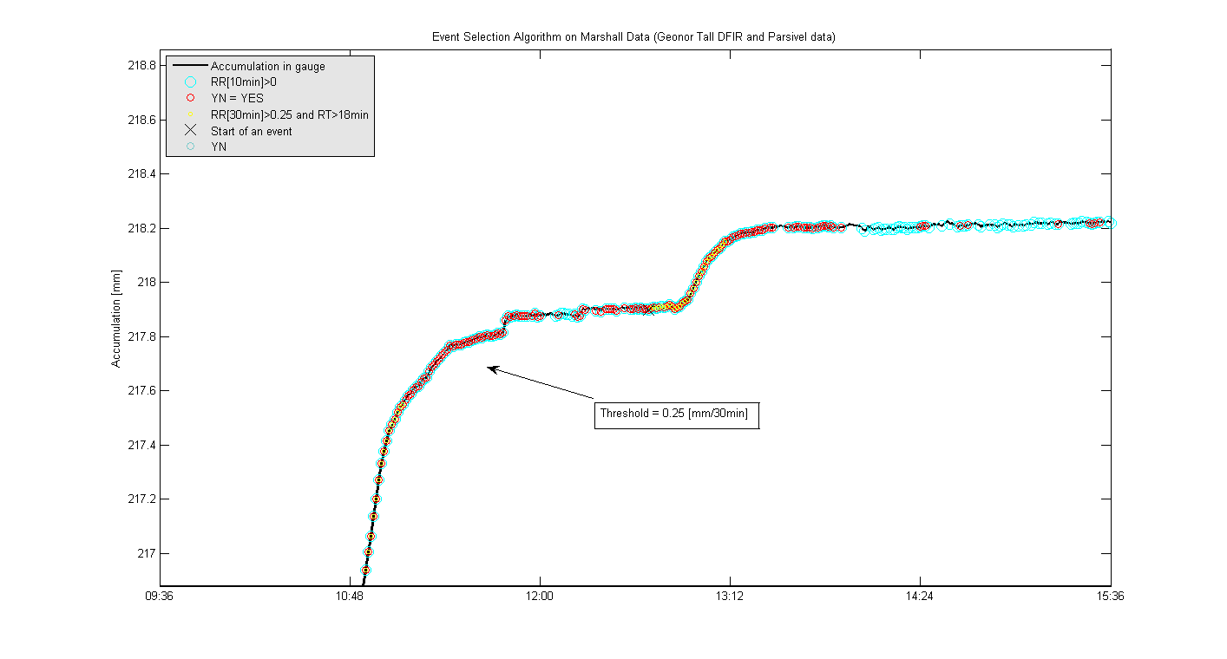
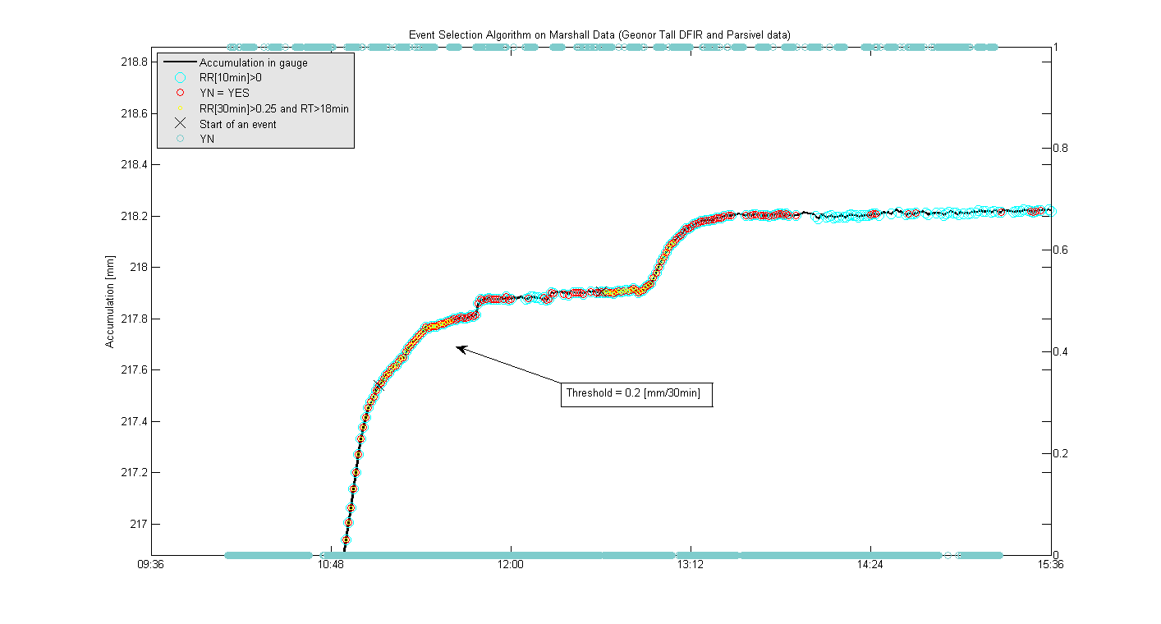
The accumulation rate threshold in the second step defined as 0.25mm/30min has been changed into 0.2mm/30min to assess the difference in terms of the number of selected events. The result shows (see Figure 2) that the lower threshold better characterize the entirety of the event (start and end of the event taken into account) while the upper threshold tend to miss part of the event if the accumulation rate is low. As a consequence, the number of 30 min events selected with the lower threshold is greater than for the upper threshold. The DAT concluded that a 0.2mm/30min could be therefore used for the event selection, but further tests need to be done in order to know the balance between the capacity to well describe the event and the chance to select too light accumulation that would not originate from a real event.
Figure 2 : Two event selection results on the same dataset with an accumulation rate threshold of (a) 0.2 mm/30min and (b) 0.25 mm/30min on the second step of the algorithm.
ba
a
Accumulation in gauge
RR[10min] ≥ 0.1mm
YN sensor = YES
RR[30min] ≥ 0.2mm and RT>18min
Start of an event
YN sensor

Accumulation in gauge
RR[10min] ≥ 0.1mm
YN sensor = YES
RR[30min] ≥ 0.25mm and RT>18min
Start of an event
YN sensor

≥

  - Flag test
The original idea of flagging data (for unreliable precipitation detector) comes from some data of Bratt’s Lake site where three of their Geonor gauges did accumulate significant precipitation quantities, while the YES/NO sensor didn’t record the whole event (see Figure 3.a). Without the second column of the flowchart (see Figure 1), the algorithm wouldn’t have recorded any event as the 60% of net precipitation duration based on precipitation detector would not be fulfilled. With the possibility to select events only based on accumulation data, events are then recorded and flagged (see Figure 3.b).

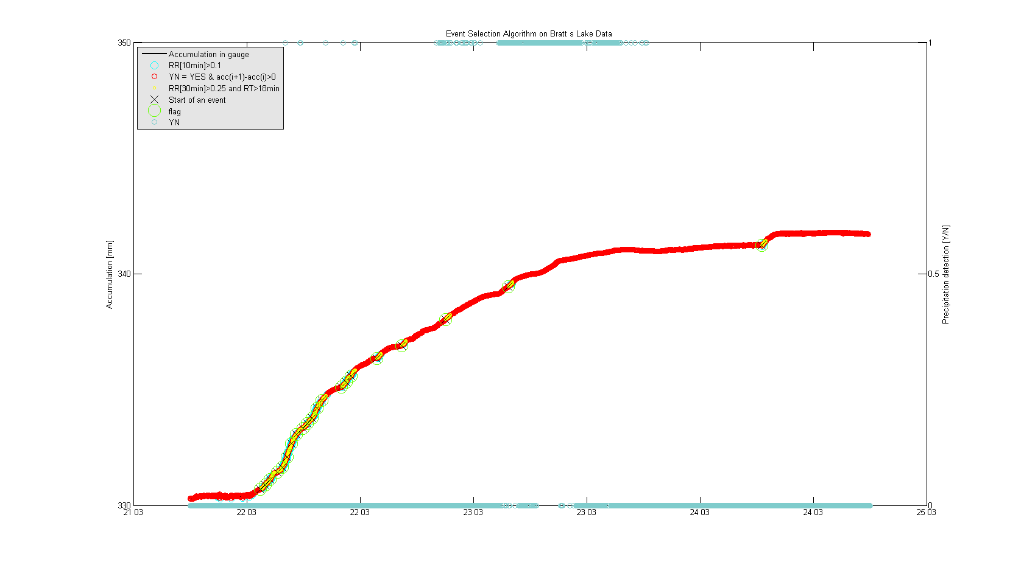
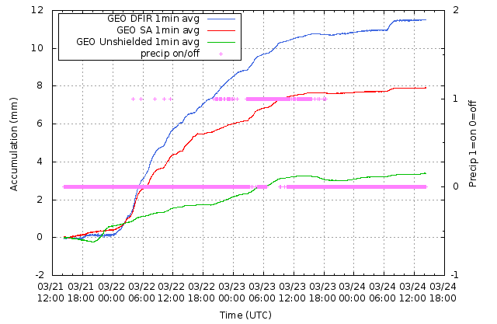
Figure 3 : (a) Bratt’s Lake data during precipitation event ; (b) Resulting figure from the event selection algorithm with flagged events.
a
ba
Accumulation in gauge
RR[10min] ≥ 0.1mm
YN sensor = YES OR RR(i+1)-RR(i) ≥0
RR[30min] ≥ 0.5mm and RT>18min
Start of an event
flag
YN sensor

  - Event-selectors test
In order to test stability of the algorithm and to assess differences between several potential event-selectors on one site, the algorithm has been applied on Marshall data of four gauges placed within DFIRs (three Geonor gauges, one Pluvio² gauge). Over one month of data, the algorithm retrieves globally the same amount of events for the four gauges (see Figure 4). This leads to the conclusion that either gauge could be taken as the event-selector.
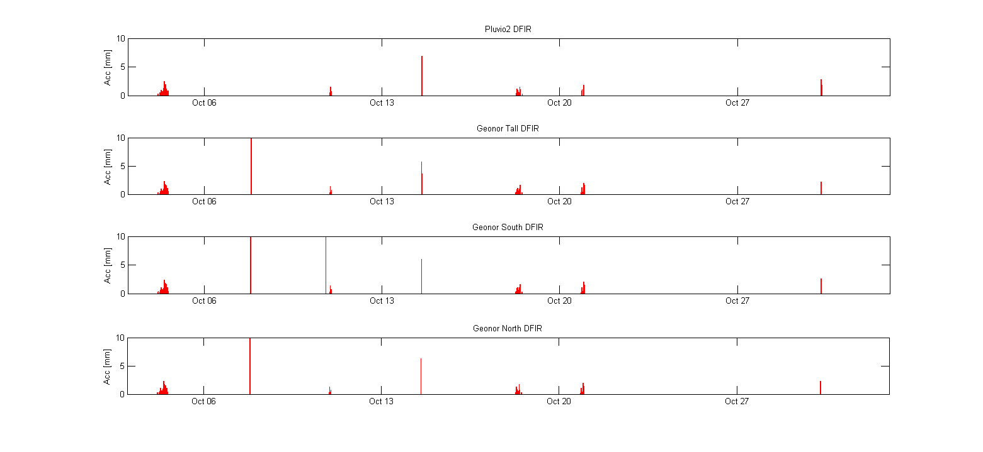
Figure 4 : Events selected for four different configurations of DFIR at Marshall site.

3. Limitations and Possible Alternatives
- Limitation of event selection methodology :
The main purpose of the described event identification process is to find clear precipitation data in order to understand and describe physical relationships between the precipitation loss due to wind speed, direction, precipitation type and possibly other meteorological parameters. In order to make this process applicable at all stations (for comparability), some generalizations had to be made. The set limits for duration of an event and minimum rates are chosen to be rather high in order to make sure that only real precipitation events are caught at all sites. The drawback of this approach is that not all events will be identified completely; the less intense on-/offset of an event might be missed.

- Fuzzy Logic as a possible alternative :
The DAT is aware of alternative techniques to identify precipitation events. For example, a fuzzy logic approach does not consider precipitation in terms of a definite Yes or No, but rather, gives a quantified probability of precipitation occurrence. Capturing additionally the cases where precipitation was not only 100% certain, but quite likely, will undoubtedly bear lot of valuable information. At this stage of the analysis, though, it was decided to start with a rather simple process in order to focus analysis resources on working with the produced data. Based on the further analysis of the precipitation events, a possible review of the selection process will be evaluated.

- Outlook on data analysis :
After describing the physics/statistics of the event-only dataset and the derivation of one or more transfer functions, an evaluation of a more operational data set has to be performed. At that stage an evaluation of the “maybe”-cases will be performed.

4. Event Identification for Snow-on-Ground (SoG) Data Analysis
Craig Smith, Samuel Morin, Barry Goodison

- Limitation of using solely SoG data for event selection :
It is recognized that event identification of SoG events using only SoG instrumentation would be problematic. The accumulation of snow on the ground is dynamic by nature, with small accumulations forming, melting, and re-forming, often more dependent on ground temperature (for shallow snowpack) and snowpack properties (compaction) than solely precipitation accumulation. Wind redistribution can also cause issues with snow amount increasing or decreasing under the sensor without actual precipitation. However, it is still necessary to identify and delineate snowfall events to meet some of the SoG objectives.

- Use of gauge event selection algorithm for event identification :
We propose to use the gauge identification of snowfall events (see Figure 1) as a starting point for event identification for SoG purposes. Using gauge (and ancillary) data and the gauge event selection process, snowfall event start and end times can be identified for use in the SoG analysis. This will be a useful starting point for intercomparisons between gauge and SoG instrumentation. These can also serve as a starting point for determining the quantitative and temporal thresholds of the SoG instrumentation.

- Proposed thresholds and strategy :
The proposal is to start with SoG measurement thresholds of 1 cm depth at a temporal resolution of 1 hour. Analysis will refine these thresholds and this process : A SoG accumulation event will begin following the initiation of a gauge snowfall event (as indicated in Figure 1) AND upon the exceedance of the minimum depth threshold using SoG measurements averaged over a 1 hour window.

