**Summary of R0 vs. R1 and R1 vs. R2 Analysis**

Daqing Yang, Kai Wong, Craig Smith

1. Problem Statement

During the previous solid precipitation intercomparison, the project reference gauge (termed the reference standard) was a manually measured Tretyakov gauge inside a large octagonal double fence (currently called the R1 reference). This configuration was called the Double Fence Intercomparison Reference (DFIR). It was validated against many years of manually observed Tretyakov gauges sheltered by bushes (currently called the R0 reference). The current intercomparison requires an automated reference (or an R2 reference). Prior to changing the older reference configuration and recommending a new configuration, a link must be established between them. The following sections serve to establish this link by reviewing historical intercomparisons between the R0 and R1 and the R1 and R2 configurations and by using new data collected at CARE during the current SPICE intercomparison.

1. R0 vs. R1 (Daqing Yang, Craig Smith)

Past data and analyses show that the Bush Gauge at Valdai systematically catches more precipitation (snow and mixed precipitation) than the DFIR and wind speed during the storm affects gauge catch. For instance, the Bush Gauge measures 20-50% more snow over a 12-hour period than the DFIR for wind speeds of 6-7 m/s (**Fig. 0/a**). The correction of the DFIR for wind induced loss, thus, is necessary in order to best represent true precipitation. It is important to point out that this error is not a constant loss at all wind speeds; it changes with wind speed and precipitation type.

In comparison to previous analyses [Yang et al., 1993; Goodison et al 1998], recent work (Yang et al., 2013) produces similar but more reasonable results; which suggest lower snow undercatch by the DFIR relative to the Bush Gauge by 3-6%. This means that the DFIR performance is better than what we previously documented in the past WMO intercomparison [Goodison et al., 1998]. This result will affect the evaluation of national precipitation gauges again the DFIR. More effort is needed to quantify this impact through field data collections and additional data analyses at selected WMO test sites.

It has been noted that the intercomparison data between the bush and DFIR gauges came only from the Valdai station in Russia. The Valdai data are valuable to represent the climate and snow conditions near that site. There is, however, a need to further test the reference (gauge) systems in a broader range of climate regimes. As part of Canada’s contribution to the WMO SPICE project, a test site has been set up in the southern Canadian Boreal forest SK (the Caribou Creek) to compare the DFIR and bush systems with automatic gauges. Data collection has begun since February of 2013 and will continue for some years. Preliminary analysis of hourly data snowfall suggests that DFIR measured, on average, 10% more snow than the bush gauge, and catch ratio (DFIR/BUSH) did not change much with wind speed up to 5 m/s **(Fig.0/b**). This result is very different from the outcome of the Valdai site. Our effort continues to collect more data at the Caribou Creek site and refine the analysis, so as to better assess both references for the WMO SPICE project and other gauge intercomparison studies in the broader northern regions.



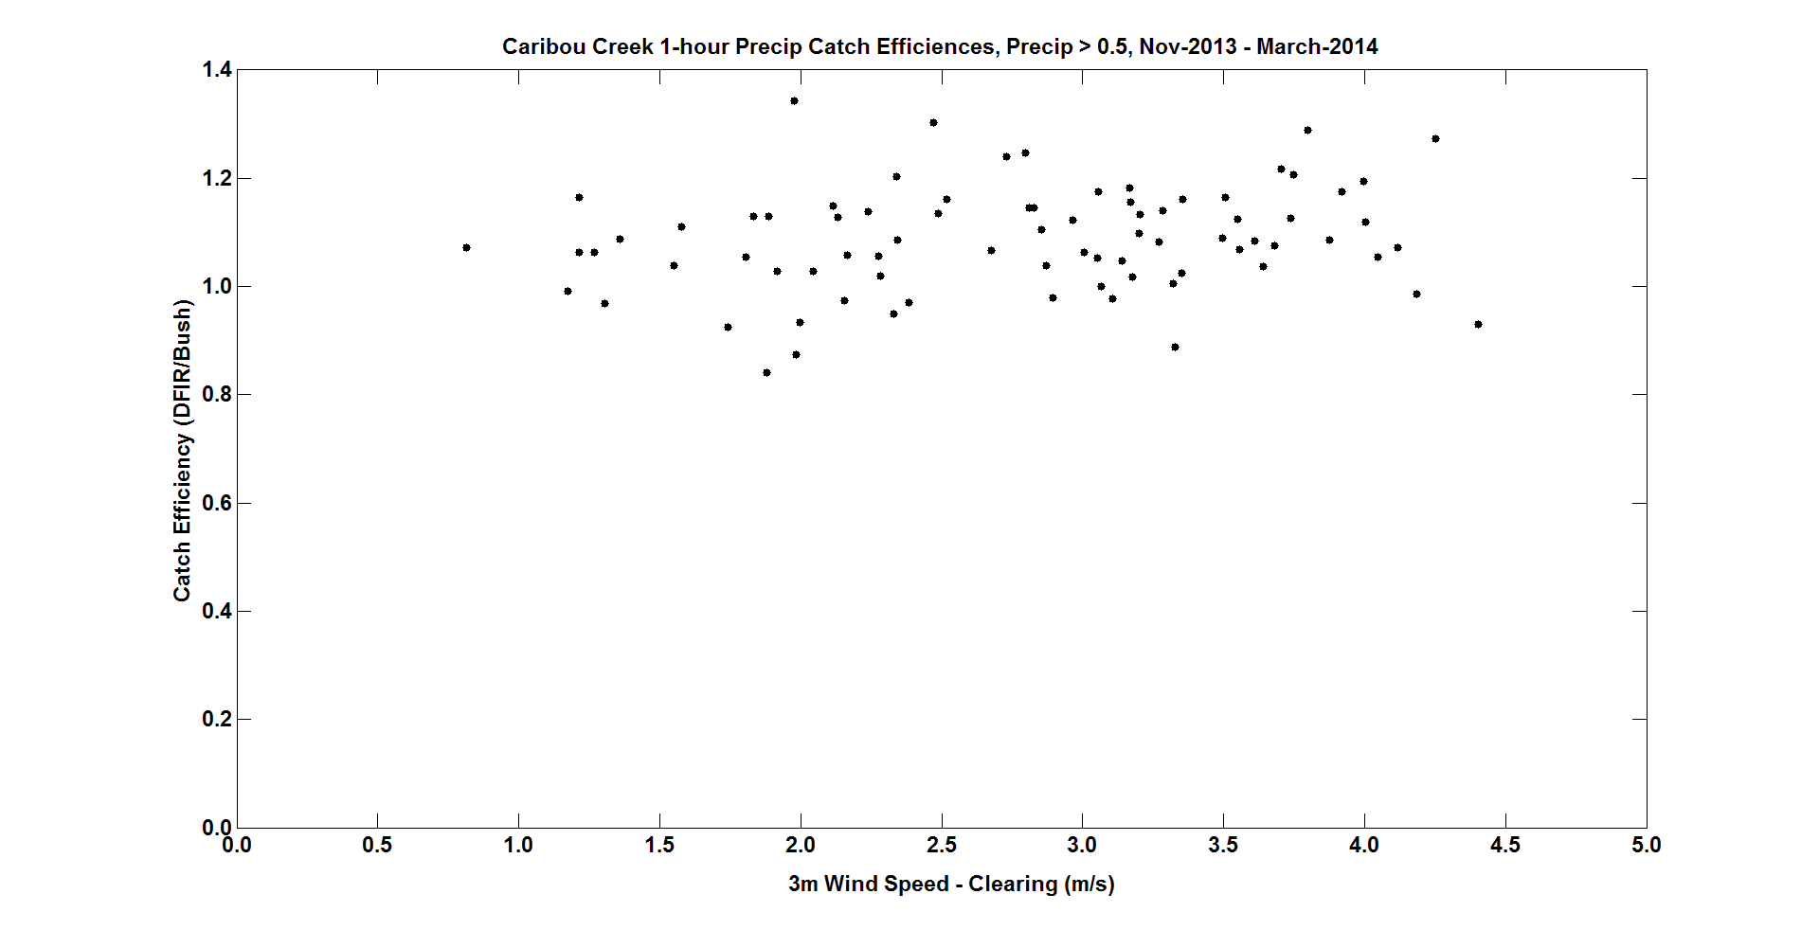

Fig. 0: Catch ratio vs. wind speed for a) Valdai/Russia, and b) Caribou Creek/Canada.

1. R1 vs. R2 Historical (Craig Smith)

R1 vs. R2 (unheated) intercomparisons were obtained during the previous WMO Solid Precipitation Intercomparison at Jokioinen, Finland between 1988 and 1993. Observations of the manual gauge were made twice daily by the Finnish Meteorological Institute, including present weather observations and precipitation type. Figure 1 compares the observations of the DFIR and the accumulated Geonor-DF for observation periods when both gauges measured at least 1mm and the maximum temperature during the period did not exceed -2°C. Previous analysis (not shown here) has suggested that scatter in gauge intercomparisons and CE-Wind Speed relationships increase during warmer snowfall events so this analysis has been limited to cold snow events. Figure 2 shows that there is virtually no impact on the relative catch between the R1 and R2 at Jokioinen due to wind.

Further data (post WMO Intercomparison) is available from FMI for Jokioinen and will be incorporated into future analysis.

From 2003 to 2011, Environment Canada intercompared an R1 with an R2 (unheated) at the Bratt’s Lake intercomparison facility. Manual observations of precipitation were made twice daily with a Tretyakov gauge inside a DFIR. Concurrently, manual observations of present weather and precipitation type were also made. Manual DFIR observations were then compared to the R2 over the same observation period. Data filtered by precipitation amount (> 1mm) and temperature (< -2°C) are shown in Figure 3 and 4.



Figure : Comparison between the Geonor-DF (R2) and the DFIR (R1) with a 1:1 relationship (black line). Data is for daily measurements of snowfall greater than 1mm during periods when the temperature did not exceed -2°C.



Figure : Catch efficiency – wind speed relationship for the Jokioinen double fence Geonor (Geonor-DF) as compared to the DFIR for daily precipitation amounts greater than 1mm while temperatures did not exceed -2°C. DFIR is adjusted for wetting loss but not wind bias.



Figure 3: Comparison between the Geonor-DF (R2) and the DFIR (R1) with a 1:1 relationship (black line). Data is for daily measurements of snowfall greater than 1mm during periods when the temperature did not exceed -2°C.



Figure 4: Catch efficiency – wind speed relationship for the Bratt’s Lake double fence Geonor (Geonor-DF) as compared to the DFIR for daily precipitation amounts greater than 1mm while temperatures did not exceed -2°C. DFIR is adjusted for wetting loss but not wind bias.

As with the Jokioinen data, the Bratt’s Lake data shows very little relative difference between the two configurations with increasing wind speed, with the possible exception of very high wind speeds. Unfortunately, blowing snow at higher wind speeds makes these data somewhat suspect.

1. R1 vs. R2 During WMO-SPICE (Kai Wong)

During the 2012/2013 and 2013/2014 Northern Hemisphere SPICE winters, a R1 vs. R2 (heated) intercomparison was made at the Environment Canada CARE SPICE site. The manual Tretyakov DFIR was observed once daily and compared to the same period observed by the automated R2. The data was filtered by temperature (< -2 °C) and amount (> 1mm). Figure 5 shows the scatter plot of the intercomparison and Figure 6 shows the relationship between catch efficiency of the R2 and wind speed.

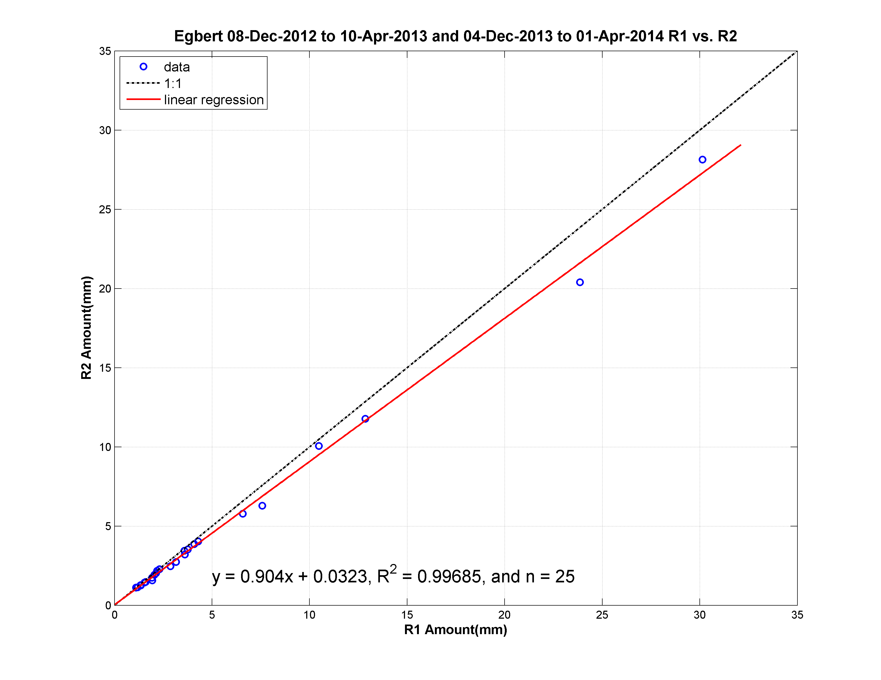

**Figure 5: scatter plot of R2 vs. R1 at CARE for 2012/2013 and 2013/2014 when both gauges measure greater than 1 mm**

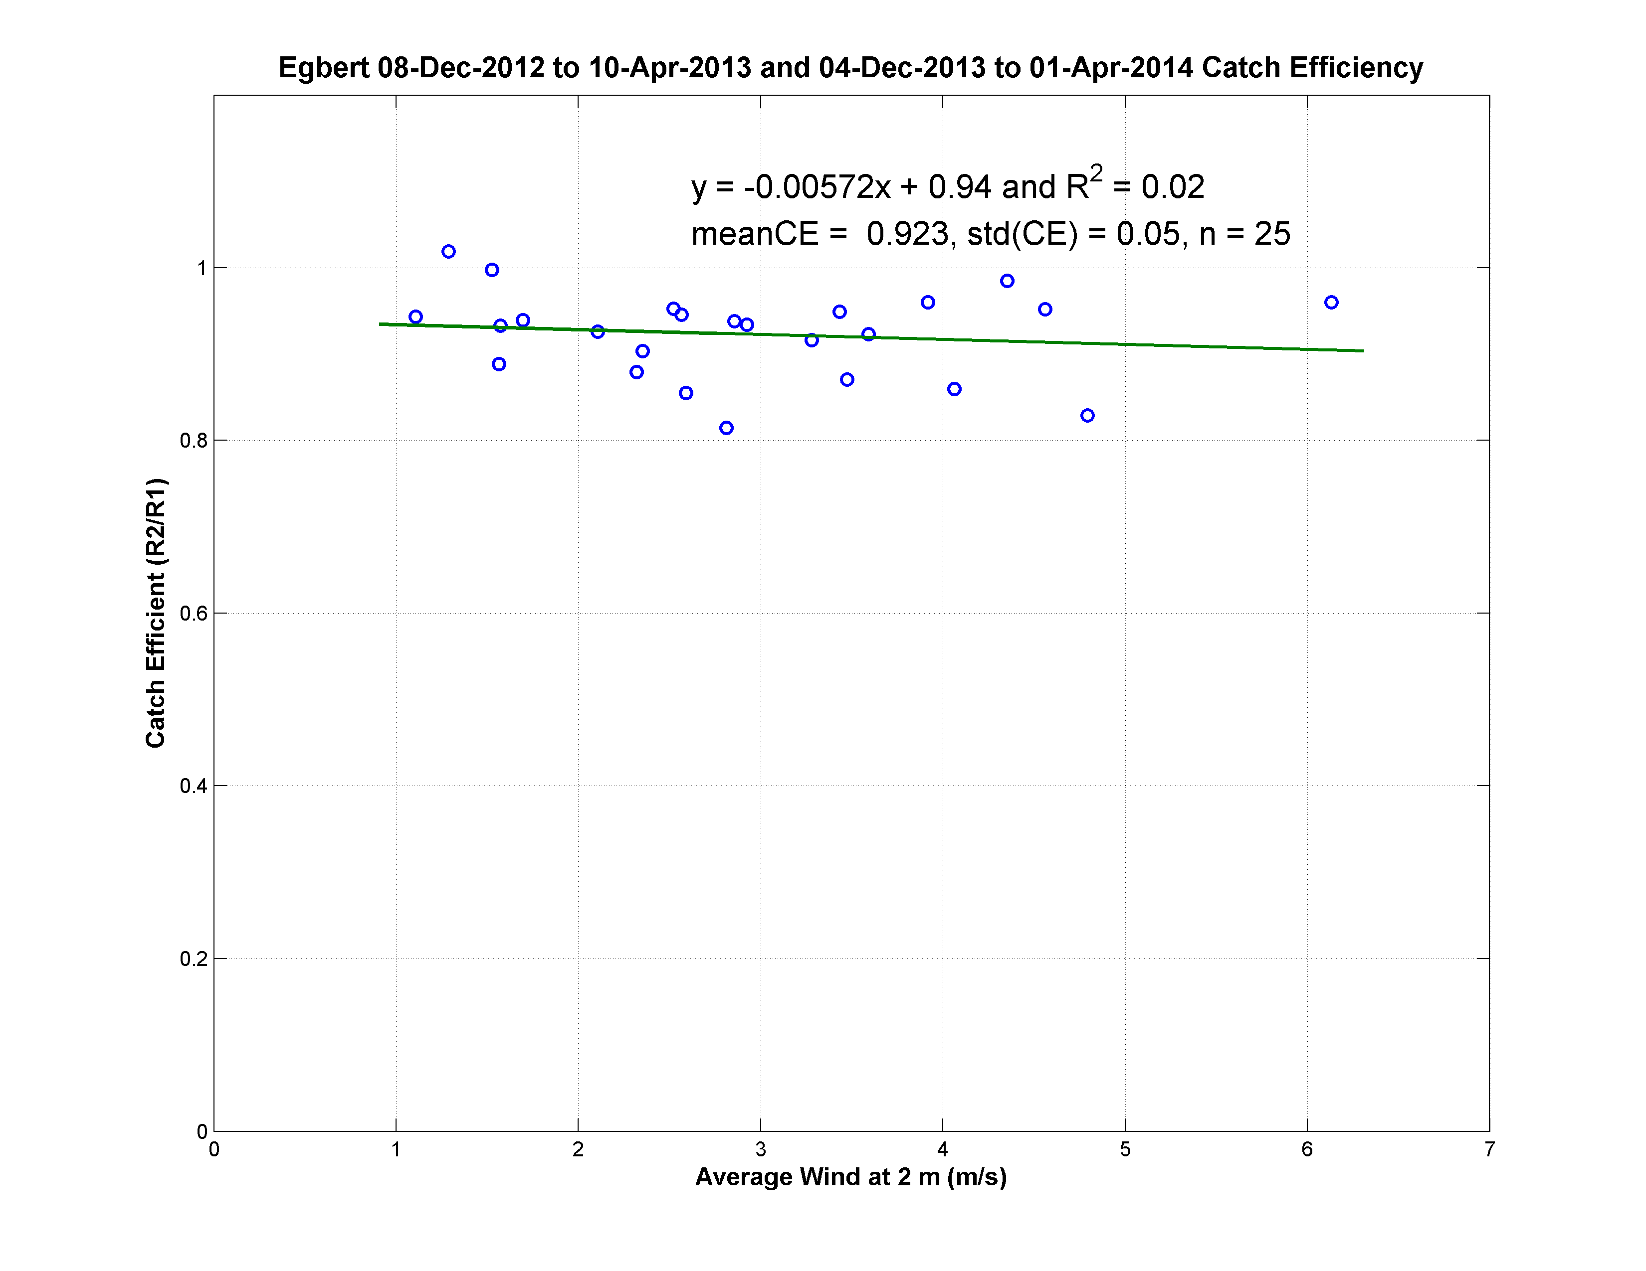

**Figure 6: Catch Efficiency vs. wind Speed for events with 1 mm or more accumulations. The mean and standard deviation of the CE are also included**

Although the slope of the regression line shown in Figure 6 is not significantly different than zero, the systematic under catch of the R2 (as compared to the R1), which is approximately 8% on average, is evident. This cause of this offset is being examined with the calibration of the R2 already being ruled out. Since the manual gauge is not heated while the R2 is heated, the effects of heating should be examined more closely.