CIMO/WIGOS EXPLORATORY WORKSHOP:

IMPROVING SURFACE-BASED DATA QUALITY THOUGH IMPROVED STANDARDIZATION OF PRACTICES AND PROCEDURES

Langen, Germany , 5-3 December 2014

WORKSHOP RATIONALE AND PLAN

Workshop Objectives:

1. To explore mechanisms for improving the quality of surface-based observations through standardization of calibration, maintenance, and operational (algorithms etc) procedures, as a WIGOS Standardization initiative.

2. To explore mechanisms for ensuring optimal communication of such standardized procedures to Members, as a WIGOS Capacity Development initiative.

Background:

Global improvements in the quality and traceability of observational data from basic observational instrumentation (surface pressure, temperature, humidity, wind, rainfall, radiation) have resulted from the implementation of standardized calibration, maintenance and operational procedures, partly as a result of the establishment of the WMO Regional Instrument Centres, Regional Marine Instrument Centres, Regional Radiation Centres, and from the role played by the Regional Training Centres in providing training on such standardized procedures.

WMO Members are increasingly transitioning from manual to automated observations for more than these basic measurements, yet similar success in ensuring global data quality has not yet been accomplished for the more complex associated observing equipment (such as ceilometers, vismeters, weather radars, radar wind profilers and lidars).

One of the aims of WIGOS Quality Management is to address this matter, initially by exploring mechanisms for improving the quality of observational data from surface-based remotely sensed observing systems, by improved standardization of calibration, maintenance and operational procedures for this equipment. At the same time the WIGOS Quality Management activity seeks to explore the scope for further improvement of the effectiveness of the RIC/RMIC/RRC model.

Workshop Plan:

The proposed three day workshop will address the above matters.

The first day will comprise a series of presentations on the topic. Participants will first hear from representatives of key application areas of their requirements for standardized data, both in situ and remotely sensed. To capitalize on the benefit of the in situ observations experience, this will be followed by presentations from representatives of the established instrument centres (RICs, RMICs, RRCs), on their perceived strengths and weaknesses, and presentations from regional representatives on current regional arrangements and additional needs for standardization of both in situ and remote sensing systems. The first day will conclude with presentations from representatives of the more commonly employed and emerging remote sensing systems on their current use of and additional needs for standardized processes and procedures.

Having heard from key stakeholders about the overall needs for standardization, and the current arrangements for satisfying these requirements, days two and three of the workshop will focus on proposing and exploring potential mechanisms for effecting improvements to the global situation.

A number of potential mechanisms can be envisaged for bringing about improvements to observational data quality by global standardization of processes and procedures:

- Expand the role of the RICs to include remote sensing instrumentation;
- Expand the RIC concept to embrace ‘distributed’ or ‘virtual’ WIGOS Regional Instruments Centres, with individual centres within a particular region dealing with a particular type of instrumentation;
- Establish Regional Remote Sensing Instrument Centres, with a model similar to and parallel to the RIC model;
- Address the issue via accelerated development and expanded scope of the CIMO Test Bed / Lead Centre model,
- Rely on the efforts of individual Members to improve their situation nationally, and focus on improved communication and sharing of best practices;
- A combination of the above.

Of all these possibilities, perhaps the most practicable would be the establishment of a ‘virtual’ centre model (see the schematic diagram below).
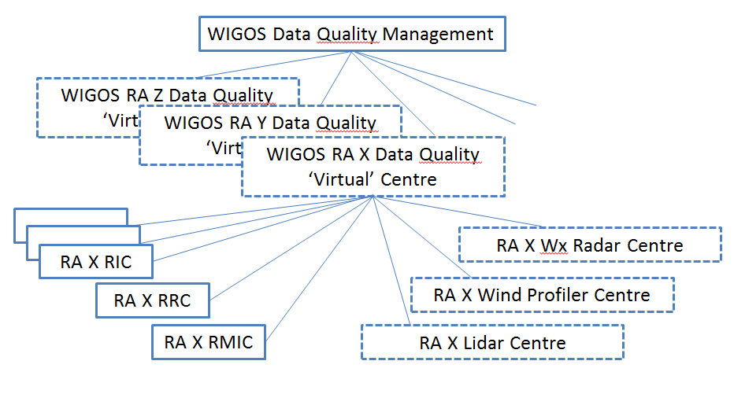
But would this be both economical and effective? Would it be equally successful in all regions? Is there a better model to pursue?

Day two will commence with a plenary brainstorming session to propose and discuss potential mechanisms. The workshop will then divide into breakout groups to explore the more promising ideas in greater depth.

On day three, the breakout groups will merge again to summarize their discussions and findings, followed by further discussion if required, distillation of a consensus view if possible and finally, drafting of a summary report with recommendations to CIMO Management Group and ICG WIGOS.

