WORLD METEOROLOGICAL ORGANIZATION

COMMISSION FOR INSTRUMENTS AND METHODS OF OBSERVATION

INTERNATIONAL ORGANIZING COMMITTEE (IOC) FOR THE WMO SOLID PRECIPITATION INTERCOMPARISON EXPERIMENT (SPICE)
Fourth Session

Davos, Switzerland 17 – 21 June 2013
CIMO/ SPICE-IOC-4/Doc 3(8).
(15.VI.2013)

Original: ENGLISH

SITE REPORT FOR VOLJSKAYA
(RUSSIAN FEDERATION)
(Submitted by Arkadi Koldaev)

Summary and purpose of document

This document provides Voljskaya site report (Russian Federation) for the winter 2012/2013

ACTION PROPOSED

The Meeting is invited to take this information into consideration when deciding on necessary modifications and clarifications on the overall set-up of the experiment.

Voljskaya site report

- Site layout

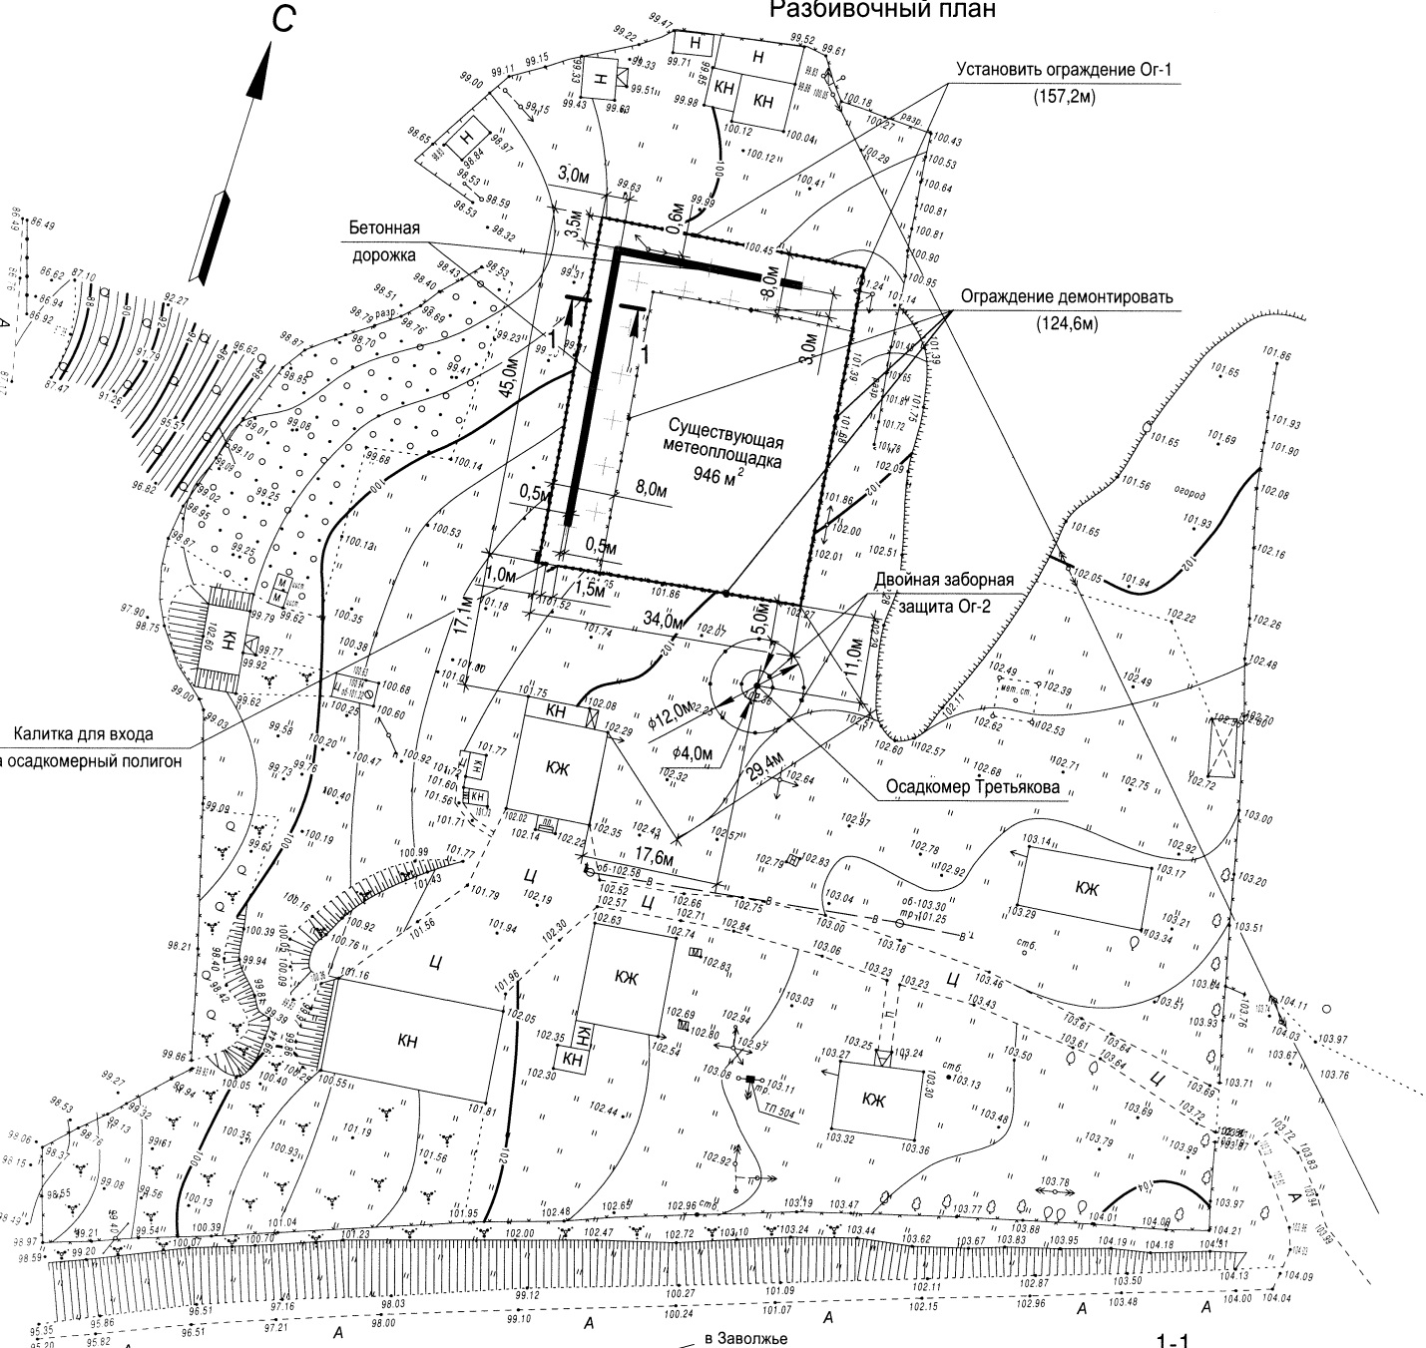

General topography plane of Voljskaya Hydro-Meteo Observatory
Bright solid line is the line of installation of the experimental instruments. Two circles- Tretiakov double fance R0.

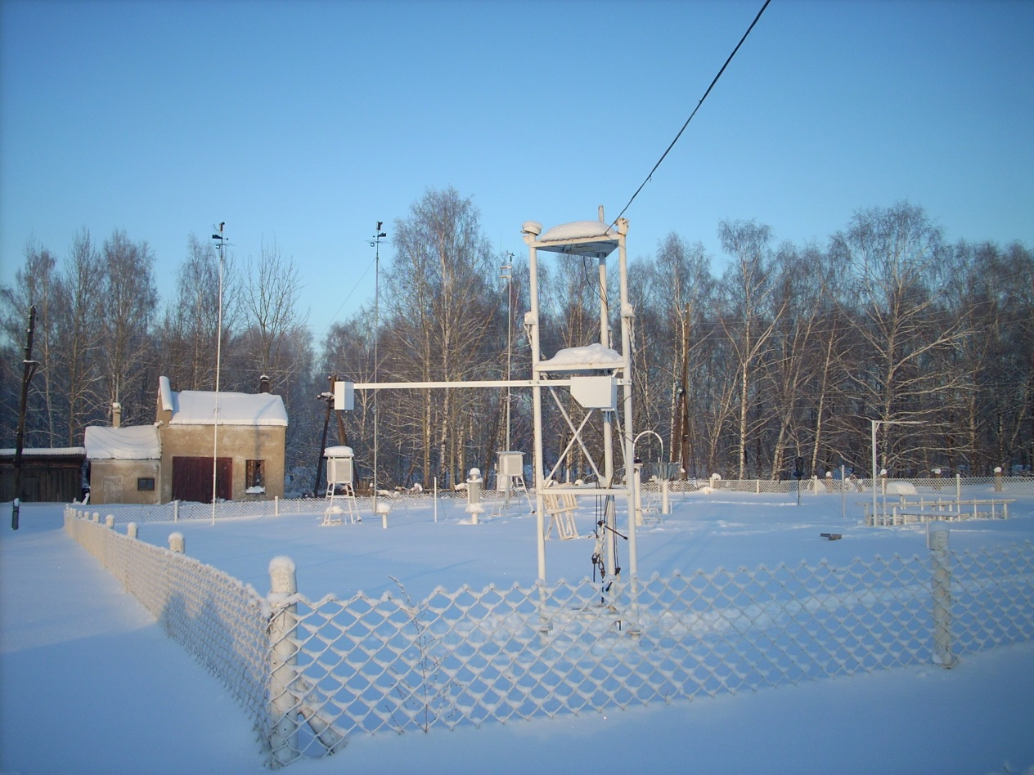
Common view of experimental site for winter 2012-2013. Automatic snow depth sensor “Nast” is on the front place. Tretyakov with winnd shield is on the right and at the rear. Snow depth at the time of photo is about 700mm

- Configuration of references:
Covering: gauge used, heating (hardware, algorithm), sampling strategy, physical configuration (height, shields, etc):
Reference  type | Gauge | Heating | Shield | Data  sampling interval | Sampling  strategy | Output  interval | Height  of the rim
R0 | Tretykov  gauges | n/a | Tretyakov wind  shield | 1/24 hrs | Manual,  volume | 1/24 hrs | 2 m
 | 3 Snow depth gauges | n/a | n/a | 1/24 | manual | 1/24 | 2m
 | Snow dencity guage | n/a | n/a | 1/10 days-1/5days | Manual,  weighing | 1/10days  1/5days | n/a

- Changes made during the season 12/13, if any.
No changes performed with R0. R1, R2 and R3 were not installed.

- Issues: heating, data quality, vibrations, capping;
It was no heating for manual devices. Data quality for manual devices were double checked (at the observatory and in headquarter of Volga river hydrometeorology department).Vibration of the laser snow depth sensor during strong wind led to losses in the data set. Capping is not applicable for manual devices. Capping was observed on the laser snow depth sensor, but it does not impact anyhow.

- Heating report:
Heating were not used for manual instruments. Internal heating of the laser snow depth sensor allows keeping instrument operating up to -30C and keep clean all optical parts. It does not prevent capping, but as it was mentioned above no any visible effect on the data quality were observed.

- What has worked well;
No problems with manual instruments.

- What has not worked that well: lessons learned;
Time to time was observed malfunctions of the laser snow depth sensor. It was found that the problem is with the regular electric power net. The problem was rejected just after a specially organized very careful grounding as at the power supply site as at the site of sensor.

Strong wind, which were observed two times during the season, led to the reduction of the automatic snow depth data set, which means that the data are collected not every 10 minute, but twice per hour, or so.

- Data available:
Data available for period from 1 DEC 2012 to 1 APR 2013.

- Instruments under test: list, issues
As the construction works were not finished before first snow fall, only one experimental instrument were installed for winter season 2012-2013. It is automatic remote snow depth sensor ”Nast” operating on base of the small semiconductor laser.

- Information on the Precipitation Detector(s) used;
Snow depth sensor “Nast” has very sensitive output, and even 1mm of fresh snow can be detected. So, this instrument, were used as the snow precipitation detector also.

- Commissioning:
The construction works has to be finished to August 2013. One Geonor and one MPS were delivered yet to the site and will be installed in August – September 2013. Pluvio200 is agreed for renting from Russian representative of OTT and will be installed in September. Fiber optics Internet was provided yet on site. As the data from all above listed instruments will be collected on one joint data logger (was delivered on site yet), the data transfer will be available in real time by remote access to our site computer ftp.

- Results to date:
3 out of 4 testing instruments are on site, data logger and fast Internet are on site. Construction works must be finished soon due to administrative impact from Roshydromet. Principal agreement regarding Pluvio200 renting was achieved. ---

- Interaction Site manager and the IOC and Project team
Via e-mail only. The technical problems with software in our institute not allow me to take part in the teleconference, provided by SPICE community.

- Small things, big impacts?

Quality of regular power net on the acting meteorological sites of Roshydromet is under big question. As most of them are located at the country side, the quality of electricity is very pure. To avoid any electrical interference, caused by the splashes of voltage or even loses of power during snow falls because of trouble on the open air electric lines, we propose to use
-UPS with big capacity,
- gasoline electric engine as spare
- and very careful grounding at all possible sites of electric lines.

