WORLD METEOROLOGICAL ORGANIZATION  ____________________  CIMO EXPERT TEAM ON NEW REMOTE  SENSING TECHNOLOGIES (ET-NRST)  (First Session)  Geneva, Switzerland, 22 – 25 August 2016 | CIMO_ET-NRST/Doc. 5  (19.VIII.2016)  _________  ITEM: 5  Original: ENGLISH ONLY |  |  | CIMO/MG-14/Doc. 6.9  (24.III.2016)  _______  ITEM: 6.9  Original: ENGLISH

AGENDA ITEM 5: PASSIVE MICROWAVE PROFILERS

Guidance Material on Passive Microwave Profilers

(Submitted by P.W. Chan and D. Ruffieux)

Summary and purpose of document

This document proposes updated draft guidance material on passive microwave profiling for WMO Members.

Action proposed

The Meeting is invited to review the draft guidance material provided in Appendix I, and to provide feedback to the author on its suitability for publication as an IOM report, with any suggestions for refinement. The Meeting is invited also to review the draft update to the CIMO Guide contained in Appendix II, and to decide whether there would now be merit in using the material as the basis for an update of the CIMO Guide.

________________

Appendices: I Guidance Material on Passive Microwave Profilers
II Proposed Update to CIMO Guide on Microwave radiometers

AGENDA ITEM 5: PASSIVE MICROWAVE PROFILERS

Guidance Material on Passive Microwave Profilers and proposed update for the CIMO Guide

  - This Agenda Item concerns the development of updated draft guidance material for Members of WMO, for inclusion in the CIMO Guide.
  - During the previous intersessional period, the Expert Team on New Technologies and Test Beds developed initial draft guidance material on Passive Microwave Profilers. That material was submitted to a Meeting of the team held in Geneva, from 4 to 7 March 2013. The meeting welcomed the new material, but recommended that the document be expanded somewhat to cover additional aspects of this technique, including an analysis of the uncertainties of such measurements, height resolution estimation and how the estimates are obtained, so that the material might be published as an IOM report.
  - At that meeting it was noted that microwave radiometry was already succinctly addressed in the CIMO Guide. In view of the very limited operational implementation of ground based microwave radiometers world-wide, the meeting felt that it would be premature to include the content of the document in the CIMO Guide.
  - The draft documentation has now been further refined to take into account the feedback received at the ET-NTTB meeting in 2013, and is contained in the Appendix to this document.
  - ET-NRST is invited the review the document and to provide feedback to Prof Chan on the its suitability for its publication as an IOM report, with any suggestions for refinement, and on whether it might now be timely to use the material as the basis for an update to the CIMO Guide.

_________________
APPENDIX I:

Guidance Material on Passive Microwave Profilers and proposed update for the CIMO Guide

LIST OF CONTENTS

1 Introduction

2 Theoretical Principal
2.1 Comparison to conventional techniques for measuring temperature profiles
2.2 Microwave radiometry theory

3 Typical constructions

4 Practical recommendations for installations

5 Regular operations and data quality control
5.1 Software
5.2 Calibration for angle scanning system
5.3 Calibration for multi frequency system
5.4 Quality assurance of the measurements

6 Maintenance instructions

7 Data utilization
7.1Temperature fields
7.2 Temperature profiles

8. References

Introduction

There are a number of applications in meteorological and environmental sciences where it is desirable, or indeed necessary, to measure the temperature of the atmosphere. A temperature profile provides the temperature at different heights above the ground.

There are two basic practical applications for temperature profiling: Numerical Weather Prediction models and Environment Protection .

Where we are concerned with environmental issues relating to air quality the most important part of the atmosphere is the 1–3 km nearest to the ground. This is often called the Planetary Boundary Layer (PBL) or Atmospheric Boundary Layer (ABL) and is the lowest level of the Troposphere. Under Adiabatic conditions pollutant gases, aerosols and fine particulates tend to rise into the atmosphere and disperse. However, there are conditions under which the normal lapse rate does not apply within the PBL. For instance during heavy rain or snow the temperature profile at low altitudes could be isothermal because the temperature at all heights is effectively the temperature of the raindrops or snowflakes.

Of more concern is a temperature inversion, in which there is a layer of air where the temperature rises instead of falling, often by several degrees. The effect of this is to trap the pollutants below the inversion so that the concentration builds up at, or close to ground level, leading to poor air quality events. Once established an inversion can be stable and last for many hours.

If the atmospheric temperature profile can be monitored in real-time it is possible to predict both the development and break-up of inversions within a specific area and action can be taken to minimize the environmental and health impact. Actions can vary from public information broadcasts to restricting or re-routing traffic flows. The greater the density of a conurbation, the greater is the potential health hazard.
Many industries have processes which require the emission of gasses into the atmosphere and these should not take place when an inversion is present. Temperature profiling can help decide when emissions can take place under the least harmful conditions and is also an essential input for accurate plume and dispersion modeling.

The development of a temperature inversion is one of the key parameters in the formation of certain types of fog and is an important input to fog forecasting. At airports the atmospheric stability and air density along the flight path is of great interest for aircraft on the final approach to landing.

It can be seen that for most of the above applications the temperature profile needs to be monitored in real-time at very regular intervals, because the temporal evolution of inversions is few hours.

For NWP models, the regular radiozonds information is traditionally used. But recent development of short range high temporary and space resolution models need to be supported by the data flow much often then 4 times a day radiozonds launching. And the part of NWP with the name Nowcasting of course needs in very frequent updating of the atmosphere profiles data.

2 Theoretical Principles

2.1 Comparison to conventional techniques for measuring temperature profiles

There are several possible methods for measurement of the PBL temperature profiles. However none of the conventional or direct measurements are capable of providing a continuous monitoring of a temperature profile above an arbitrary site.

Examples of profiling techniques are radiozonds and sensors mounted on tethered balloons and meteorological tower. Radiozonds can measure a temperature profile at about 50 m height resolution from about 50 m to 30 km. This requires the launching of radiozonds and does not give the possibility of the continuous measurements. Tethered balloons and meteorological towers can provide fast response turbulence measurements in the lower 1 km (balloon) or 10-300 m (tower) altitude range, however, there are strong location restrictions.

There is competitive technology for remote sensing measurements with a Radio Acoustic Sounding System (RASS). Radio Acoustic Sounding System can provide continuous profiling of the temperature from 100 m to about 1 km, however the technique uses a powerful sound source, which creates a noise nuisance. Also the lower levels are not measurable, and this system will give false readings in conditions with water droplets (rain, mist), and with strong wind.

Meteorological satellites can provide temperature profile measurements on a global scale, but can not measure the lower 3 km with sufficient accuracy{16,17} as satellite channels that are sensitive to the temperature changes at the lowest 3km of the atmosphere are also sensitive to the surface emissivity of the planet, which can have a great spatial variation.

Ground based passive meteorological temperature profiler, offers many features that are not available with the other techniques. {3, 4, 8, 11, 12, 14}The main benefits are that the instrument has a wide operational range (also covering conditions of fog, snow and rain), zero emission of radiation, and a high level of quality assurance, automatic calibration and low operational costs. For experiments the added features of being portable and having a low weight are important.

2.2 Microwave radiometry theory

The technique that is used for meteorological remote sensing of PBL temperature profile is based on measuring the thermal radiation of the atmosphere in the centre of the molecular oxygen absorption band where the effective thickness of the radiating layer is about 300…400 m.

By definition the effective thickness is equal to the height Hb where optical depth: {17}

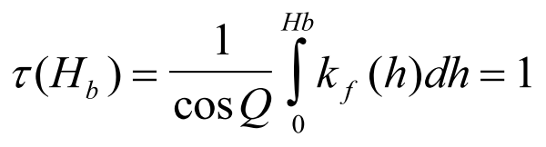 (1)

The absorption of microwave kf(h) near the central part of absorption line 60GHz can be approximated by:

kf(h)=const=kf(0)

and thus from (1) we will get:

Hb(h)=cosQ/kf(0) =300m,

where Q is the zenith angle.

Remote sensing of the PBL temperature profiles is conducted by measurements of the radio brightness temperatures at different zenith angles from Q=0 degree up to Q=90 degree.
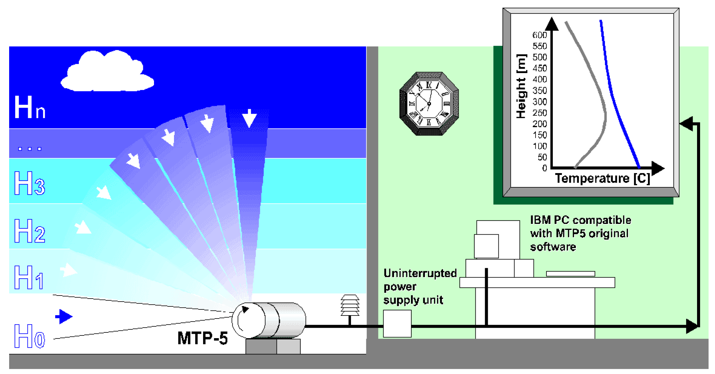

Figure1. Schematic picture of sounding (example with MTP-5 manufactured by PVK “ATTEX”)

. In this case the optical depth of the contributing radiation layer ranges from 0 to 300 m. The expression for the radio brightness temperature Tb has the form:

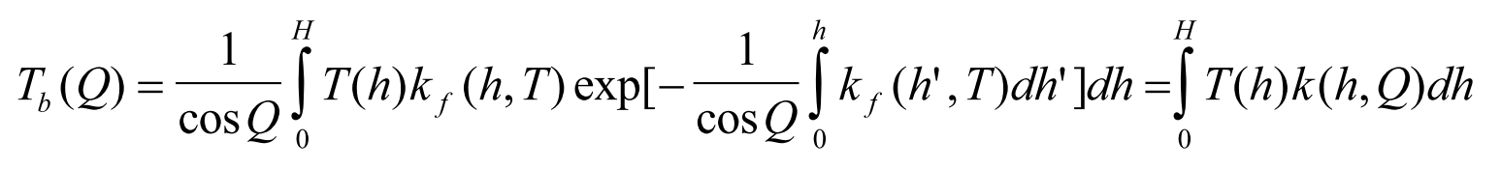 (2)

where k is the kernel; H =2 km – the upper limit of integration.

The layers of the atmosphere higher than 2 km, practically do not influence Tb at frequency 60 GHZ.

As the working frequency is chosen in the centre of the molecular oxygen absorption band, where the attenuation is very high, fog, changes in water vapor density, clouds {9} and weak rain do not influence the measurements. Equation (2) is the type 1 Fredholm equation.

For solving (2) it is possible to use Tikhonov method in form of a generalized variations or an iteration method with a dedicated algorithm permitting retrieval of the temperature profiles in real time. Different algorithms for inverse problem solution are described at {2,5,13,15}.The accuracy of the temperature profile retrieval at the altitude range 0-1000 m is 0,2C for usual adiabatic profiles and 0,5C for profiles with an inversion.

The vertical resolution of the retrieved temperature profile is defined by the antenna pattern for scanning retrieval.

For retrieving of the temperature profiles in the upper atmosphere, the multi frequency radiometers are used. A multi-frequency radiometer measures the radio brightness temperature at a number of frequency channels located near by centre of absorption frequency of atmospheric oxygen – 60GHz. Spectral information obtained mostly in the vertical direction (zenith observation). The theory behind the retrieval was the one dimensional radiative transfer equations which reads
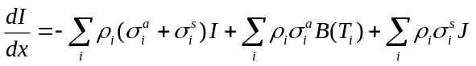
where is the irradiance of the radiation, is the optical path, is a label for individual species of scattering/absorbing particles, 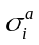(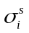) is the absorption (scattering) cross section of species , 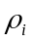 is the number density of species , 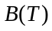 is the Plank function at temperature and is a source function from scattering. is related to scattering phase function 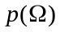 by
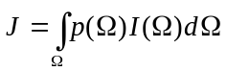
Solution to the above equation is the forward model that, with a given atmospheric states, it gives the irradiance measured by the radiometer. 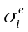 for the gaseous components can be obtained from empirical models like Millimeter-wave Propagation Model (MPM-93), HITRAN, etc.

As the frequency of the observing channel is further away from the central part of the 60GHz oxygen absorption line, the channel becomes more sensitive to the temperature in the higher part of the atmosphere. Thermal radiation from low clouds and precipitation would also contribute to the thermal radiation measured by the radiometer, in addition to those from the oxygen molecule. For cloud droplets, since it is small compared with the usual operating wavelength of microwave radiometer, it is in the Rayleigh scattering regime
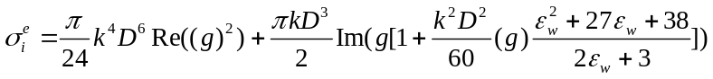
where 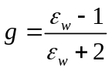, 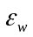 is the square of the frequency-dependent complex refractive index of bulk liquid water,  is the effective diameter of the droplet, and is the wavenumber. For cloud droplets following a size distribution, it is the 3rd, 5th and 6th moments of the distribution that determines the scattering/absorption cross section. Parameters for the size distribution of the cloud droplets can be derived from either climatology or output of numerical weather models. For liquid rain droplets that is spherical in shapes, since their sizes are usually comparable with the operating wavelength of the radiometer, Mie theory would be needed to accurately calculate their effect on the irradiance measured by the radiometer (18),
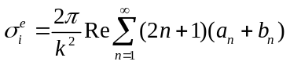
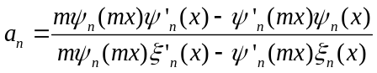
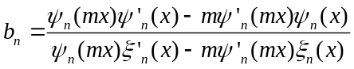
where 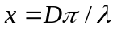, is the complex refractive index of liquid water, 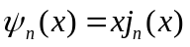, 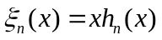, 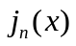 and 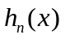 are the spherical Bessel functions and spherical Hankel functions of the first kind respectively. For non-spherical liquid rain droplets and solid precipitations, due to their irregular shapes, look up tables based on offline discrete dipole approximation computation is needed for real-time applications.

There are a number of retrieving methods. Early widely used methods were based on regression between measured thermal radiation and ground truth. They can only handle non-precipitating situations. Latest developments are towards the use of a variational solution to the radiative transfer equation and are able to handle precipitating cases after

integrating observations from other equipment such as radar and coupled with a cloud/precipitation model {19}. Also, under precipitation, the accumulation of water, snow or ice over the radome of the radiometer would also affect the accuracy of the radiometer measurement {20,21}. These problems can be solved with using a hydrophobic radome, forcing airflow over the radiometer surface to avoid accumulation of water, snow and ice and/or observing the thermal radiation at an off-zenith angle {22,23,24}. By using variational approach, with a reasonable first guess, the average error of the temperature profile retrieval at the altitude below 10000 m can be no greater than 1ºC {19}.

Multi- frequency radiometers can also be used for retrieving the moisture profile in the atmosphere. Such radiometers will also observe the radio brightness temperature at a number of frequency channels located nearby centres of absorption frequency of water vapour – 22GHz and/or 183GHz, in additional to the 60GHz oxygen absorption band. Retrieval of moisture profile is usually carried out together with the temperature profile, since the brightness temperatures at 22GHz/183GHz would also depends on the temperature profile.

The atmospheric attenuation is much lower at 22GHz than at 60GHz. Thus, the brightness temperature at 22GHz would be quite sensitive to the presence of low clouds and precipitation. The effects from low clouds and precipitation must be put into account in the retrieval for accurate retrieval. Solar-emitted microwave can also affect the brightness temperature measurement at 22GHz if the radiometer points directly towards the sun and should be avoided.

The retrieval accuracy for the part upper part of the atmosphere can be improved by combining the measurement of ground-based microwave radiometer with satellite-based radiometers. Due to the high attenuation of microwave near the oxygen absorption line, the retrieved profile based on ground-based radiometer alone is only skilful in the lowest couples of kilometres near to the surface. On the other hand, profile retrieval based on satellite-based radiometer is more skilful in the upper part of the atmosphere and is complementary to the measurement from ground-based radiometer. However, since satellite-based microwave radiometer is only equiped on polar-orbiting satellites, such integration of satellite-based and ground-based measurement is not available when a satellite-based radiometer flies over the ground-based radiometer location, limiting the temporal resolution in general.

For multi-channel retrieval, the vertical resolution of the retrieved temperature profile is defined by the frequency step and it can vary from 10m at the first 100m up to 600m in upper troposphere {1,7,10,}.

3 Typical Constructions.

Typically ground based microwave radiometer system consists with 5 major components. These components are:

1. Microwave temperature profiler (receiver with antenna, scanner, microprocessor-controller, meteoprotection)
2. Ambient Air Temperature Sensor or micro meteorological station
3. Personal Computer (PC)
4. Software
5. Power Supply Unit
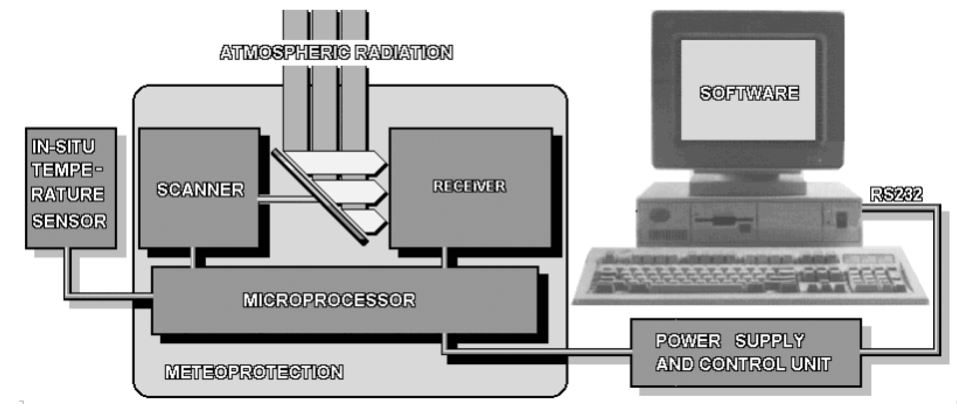
Figure 2. More detailed view of the microwave temperature profiling system. Scanner, receiver, controller and thermal radiation are specifically shown.

The system is normally diploid into meteoprotection housing. The housing protects the radiometer and offers a thermally stable environment for the receiver. The reception of radiation from the different zenith angles is achieved by mechanical rotation of a mirror-reflector. This reflector is mounted at 45 degrees relative to the receiver axis. The combination of a stepping motor and the mirror-reflector is called scanner.

The mirror is rotated around the receiver axis. Thermal radiation of the atmosphere from different zenith angles is reflected to the input of the receiver. The PC , through the microprocessor controls the scanner. The mirror-reflector is located in the so-called the rotating part. The rotating part shielded by a foil from the environment. The foil is transparent for the microwave radiation.

The measured signal is amplified and processed in the receiver and then goes to the controller (still inside the housing but outside the receiver) where the signal is digitized by the Analogue to Digital Converter (ADC). After that it is transmitted through a serial port to the PC.

There is a separate Power Supply Unit. This unit supplies power at various DC levels to the instrument. Usually, digital signals travel to the PC through a separate cable.

After signal processing, the graphs of the temperature profile (as a function of altitude and time)
are immediately displayed on screen.

4 Practical recommendations for installations

The receiver antenna has usually a narrow field of view that is a cone of 3° and this must be clear from any trees or constructions in a plane from horizon to vertical, ideally for more than 500 m for boundary layer microwave profilers and 5 km for upper air profilers
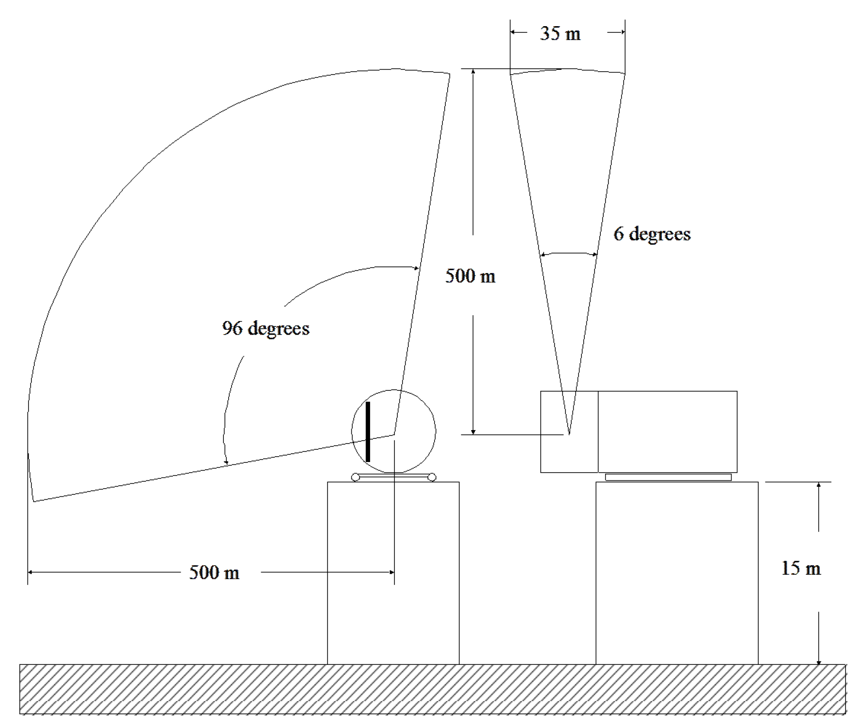

Figure 3. Typical installation of microwave temperature profiler

Microwave temperature profiler is a device for measuring air temperature and it will see changes due to exhausts, vents and gas plumes and any bodies within its field of view that are not at the ambient air temperature (e.g. metal structures, buildings, etc). For this reason the system should not be mounted looking across building roofs, particularly black asphalt roofs (these make effective black body radiators).

The edge of the roof of a building is ideal place for installation. Microwave temperature profiler is not itself affected by the sun being in its field of view, but the column of air directly in line with the sun may be slightly warmer than the surrounding air mass. For the best results the system should be oriented with its field of view towards the nearest pole (North in the Northern Hemisphere).
If it is not possible to mount the system sufficiently above the ground it may be possible to offset the horizontal first measurement on 1-3 degree, with some loss of accuracy

The power and data cables are usually 15-30m long. The Power Supply Unit and any controlling PC are not environmentally protected and must be located indoors.

In areas with intense sunshine it may be necessary to mount a reflective heat-shield above the Microwave temperature profiler or to place it in a shaded location. If the internal temperature becomes too high no damage will occur, but the instrument will shut down until the temperature drops. The mounting cradle should be securely fixed to the mounting surface to resist strong winds, knocks and vibration.

The ambient air temperature sensor has usually not long then 3 m cable and should be mounted approximately at the same height as the radiometer and in a shaded and sheltered position, so that it truly represents the temperature of the air.

5 Regular operations and data quality control

The digital output from the microwave system is processed by the software to calculate the mean radio brightness temperature in Kelvin at each elevation angle. Algorithms for inverse task solution is converting the angular radiometer measurements into temperature profiles. This calculates the air temperature in ºC for altitudes from 0 m to1000 m with a 50 m height resolution. After signal processing, the graph of the temperature profile is displayed on the computer screen immediately after each scan.

5.1 Software

An important part of the microwave temperature profiler is its software. The software is the primary user interface of the system. Also it performs several essential functions: control of the device, collection and storage of data and data visualisation. In case of trouble it is a tool for trouble shooting. The software plays a major role in the day-to-day quality assurance of the measurement.

The software performs several essential functions, including:
Physical location information (site name, longitude, latitude, altitude, etc)
Directory for data storage
Communication and installation tests
Scan interval (user defined, default is 5 minutes)
Data processing and storage
Display of temperature profile after each scan
Display of historical profiles
Display of trends
Error log file

The software makes a new set of data files each day. These are in readable ASCII text form. Each scan usually has 3 data files:

DATA’ contains the digital radiation values at each elevation angle, plus all calibration and internal status data;

‘TBR’ contains the path averaged radio brightness temperature in Kelvin at each elevation angle, calculated using the current calibration data;

‘RESULT’ contains the air temperature in ºC at each 50 m height interval.

The graphical display software can be used in stand-alone mode on another computer, without connection to a microwave temperature profiler, for viewing imported temperature profile data.

5.2 Calibration for angle scanning system

The core of the Microwave temperature profiler for boundary layer is a single channel solid state Dicke-type super heterodyne receiver. As the central frequency of the receiver is at the centre of a strong absorption line of molecular oxygen (14dB/km absorption on wavelength of 5 mm). If so the brightness temperature at the reception of the atmosphere radiation from a horizontal direction is practically equal to the atmosphere temperature near by a ground surface. It gives an opportunity to use the atmosphere like a quality microwave target.

Using the natural difference of the atmosphere temperature near a ground surface during several hours it is possible to define the slope of calibration line of the radiometer (dependence of the radiometer output code to the atmosphere temperature). An Ambient Air Temperature Sensor that is delivered as part of the system serves as a source for continuous calibration.

This provides one calibration temperature for the radiometer. The response of the radiometer is linear over a wide range so only one other calibration temperature is necessary and this is provided by an internal radiometer reference load of high stability.

Calibration is automatically carried between measurement scans and averaged over a period The software makes a best fit to the data to calculate the linear radiometer response. Each calibration is checked for the quality of the data, if there is too much statistical variation (e.g. thermal noise from the ambient temperature sensor) it is rejected.

If the new calculated calibration differs only slightly from the current values it is used, but if the new calibration differs significantly from the current calibration it is rejected until confirmed by several repeated calibrations.

All calibration data is recorded in the ‘raw’ data files. The scanner rest position is horizontal, so most dirt, rain and snow falls on the unused part of the cover. The auto-calibration will correct for some dirt but the signal is reduced and will eventually result in a noisy and inaccurate measurement.

5.3 Calibration for multi frequency system

The core of the Microwave temperature profiler for upper troposphere is a multi channel solid state Dicke-type super heterodyne receiver. The atmosphere even at horizon direction is not equal to the absolutely “black body” for all channels as it is far enough from the central part of the oxygen absorption line. To calibrate this type of radiometer the Liquid Nitrogen Calibration is used.
Safety Considerations
Handlers must also take precautions to ensure adequate ventilation. The gas is not toxic, but at high concentrations, it reduces the available oxygen in the air.
To calibrate the profiling radiometer, use two ―microwave targets (microwave loads) of known temperature:
A built-in ambient-temperature Black Body Target
An external Cryogenic Target filled with liquid nitrogen (LN2)

Using the Cryogenic Target When LN2 is placed in a Cryogenic Target containing microwave absorber the target brightness temperature will be that of boiling LN2 (-195° C).

The LN2 calibration procedure points the radiometer internal mirror to alternately view the ambient temperature Black Body Target and the Cryogenic Target

When a calibration is performed, the Cryogenic Target is placed on top of the radiometer, above the Radome.
The Saddle is used to position the Cryogenic Target above the radiometer Radome. It also forms a wave guide that serves to minimize extraneous microwave emissions (warm bias) reaching the antenna. The radiometer views the target through a microwave transparent window in the bottom of the target.

When properly installed, the Saddle fits securely to the radiometer with no gaps between the Saddle and the hood (except at the bottom of the Saddle)

Ensure the radiometer has been powered on for more than one hour to allow the microwave components to reach stable operating temperatures.

Safety Considerations
Ensure proper LN2 handling safety by filling the Cryogenic Target while it is sitting on the ground. Use the safety strap to secure the lid to the target before placing the target on the Saddle.
NEVER attempt to pour LN2 into the target when it is on the radiometer.
NOTE: Do not fill the Cryogenic Target until the operator is ready to start calibration. Load Cryogenic Target onto the Saddle from the front only.

LN2 calibration observations are logged in a special file. Carefully pour LN2 into the Cryogenic Target until the LN2 level is at least one cm above the microwave absorber. Do not overfill – there should be at least a 2.5 cm (1 inch) gap between the LN2 and the top of the target.

Allow the calibration to continue for 1-2 hours, provided that dry conditions prevail, and condensation on the target is not observed or expected. If condensation on the bottom of the target is likely to form, due to high humidity (RH > 70%), then the calibration should be shortened to ~30 minutes.

There are two methods to verify that the calibration completed correctly. First, the new and previous configuration files can be opened and inspected using the text editor Notepad. When closing these files, be sure not to save changes. Unless the calibration follows repairs or changes to the hardware, the new values of calibration coefficients should be close to the previous values. Typically, it is within 1-2% of the value computed in the previous known good calibration. Departure from these guidelines may indicate a poor calibration.
Second, to verify that moisture did not corrupt the calibration, open and plot the values of brightness temperature. If it is reasonably constant over time (only a small amount of random noise, but no long-term drift up or down), then the calibration is good.. Notice that all channels remain constant over the duration of the calibration and the noise level is very low. These checks provide high confidence that a successful, accurate calibration has been achieved.

While the target is still on the Saddle, the new calibration can be further verified by running a special procedure that alternates between views of the internal Black Body Target (elevation angle = 270 degrees) and the external cryogenic target (elevation angle = 90 degrees). It is best to start this verification immediately after the calibration completes, while the target still has sufficient LN2, and moisture has not started to build up on the bottom surface.

If the calibration was successful, then the brightness temperatures for all channels should closely match the calculated values of the effective target temperature (typically, 77-80 K, depending on barometric pressure). If the target has not been moved on the Saddle, and the LN2 level has not dropped below the black absorbing foam in the target, then the average of the cryogenic target observation errors (observations minus effective target temperature) should be < 0.5 K. The average of the ambient target observation errors should be < 0.5 K.

It is sufficient to observe the Brightness Temperature for a few cycles of the procedure to verify that all channels were calibrated reasonably well.

5.4 Quality assurance of the measurements

The quality of the measurement is assured in several ways. The condition of the instrument is checked by self-tests that are typically performed every 10 minutes. These tests take place without the interference of the user. If anything is wrong, an error message will appear.

The measurement is fairly well under control during conditions of high humidity, rain and snow. The heater systems make sure that water will quickly evaporate, and in any case not condense on the instrument. The measurement accuracy in principle does not suffer from precipitation unless it is very intense rain showers (above 10mm/h).

Finally, if simultaneous results of temperature profile measurement from some other in situ or remote sensors are available, then inter comparisons are always very productive. But the readjustment of the system (in case of bad correspondence of the compared data) is appropriate just by the manufacturer

6 Maintenance instructions

Microwave temperature profilers are usually needed in limited maintenance. The recommended maintenance schedule, as for any meteorological equipment, depends strongly on the local conditions. For instance in wet subtropics and tropic regions it is necessary to check periodically all moving inside parts of scanning system on the point of insects.

The only regular maintenance is to clean the Teflon™ scanner cover periodically with a cloth and domestic glass cleaner

A range of test and diagnostic facilities are built into the microwave profiler firmware, software and hardware. And in the case of any problem exists, it will indicate the proper maintenance procedure.

7 Data utilization

Below are two examples of the meteorological products provided by the microwave temperature profilers. Each picture has legend, which allows understanding all the parameters reflected on the pictures

7.1Temperature fields
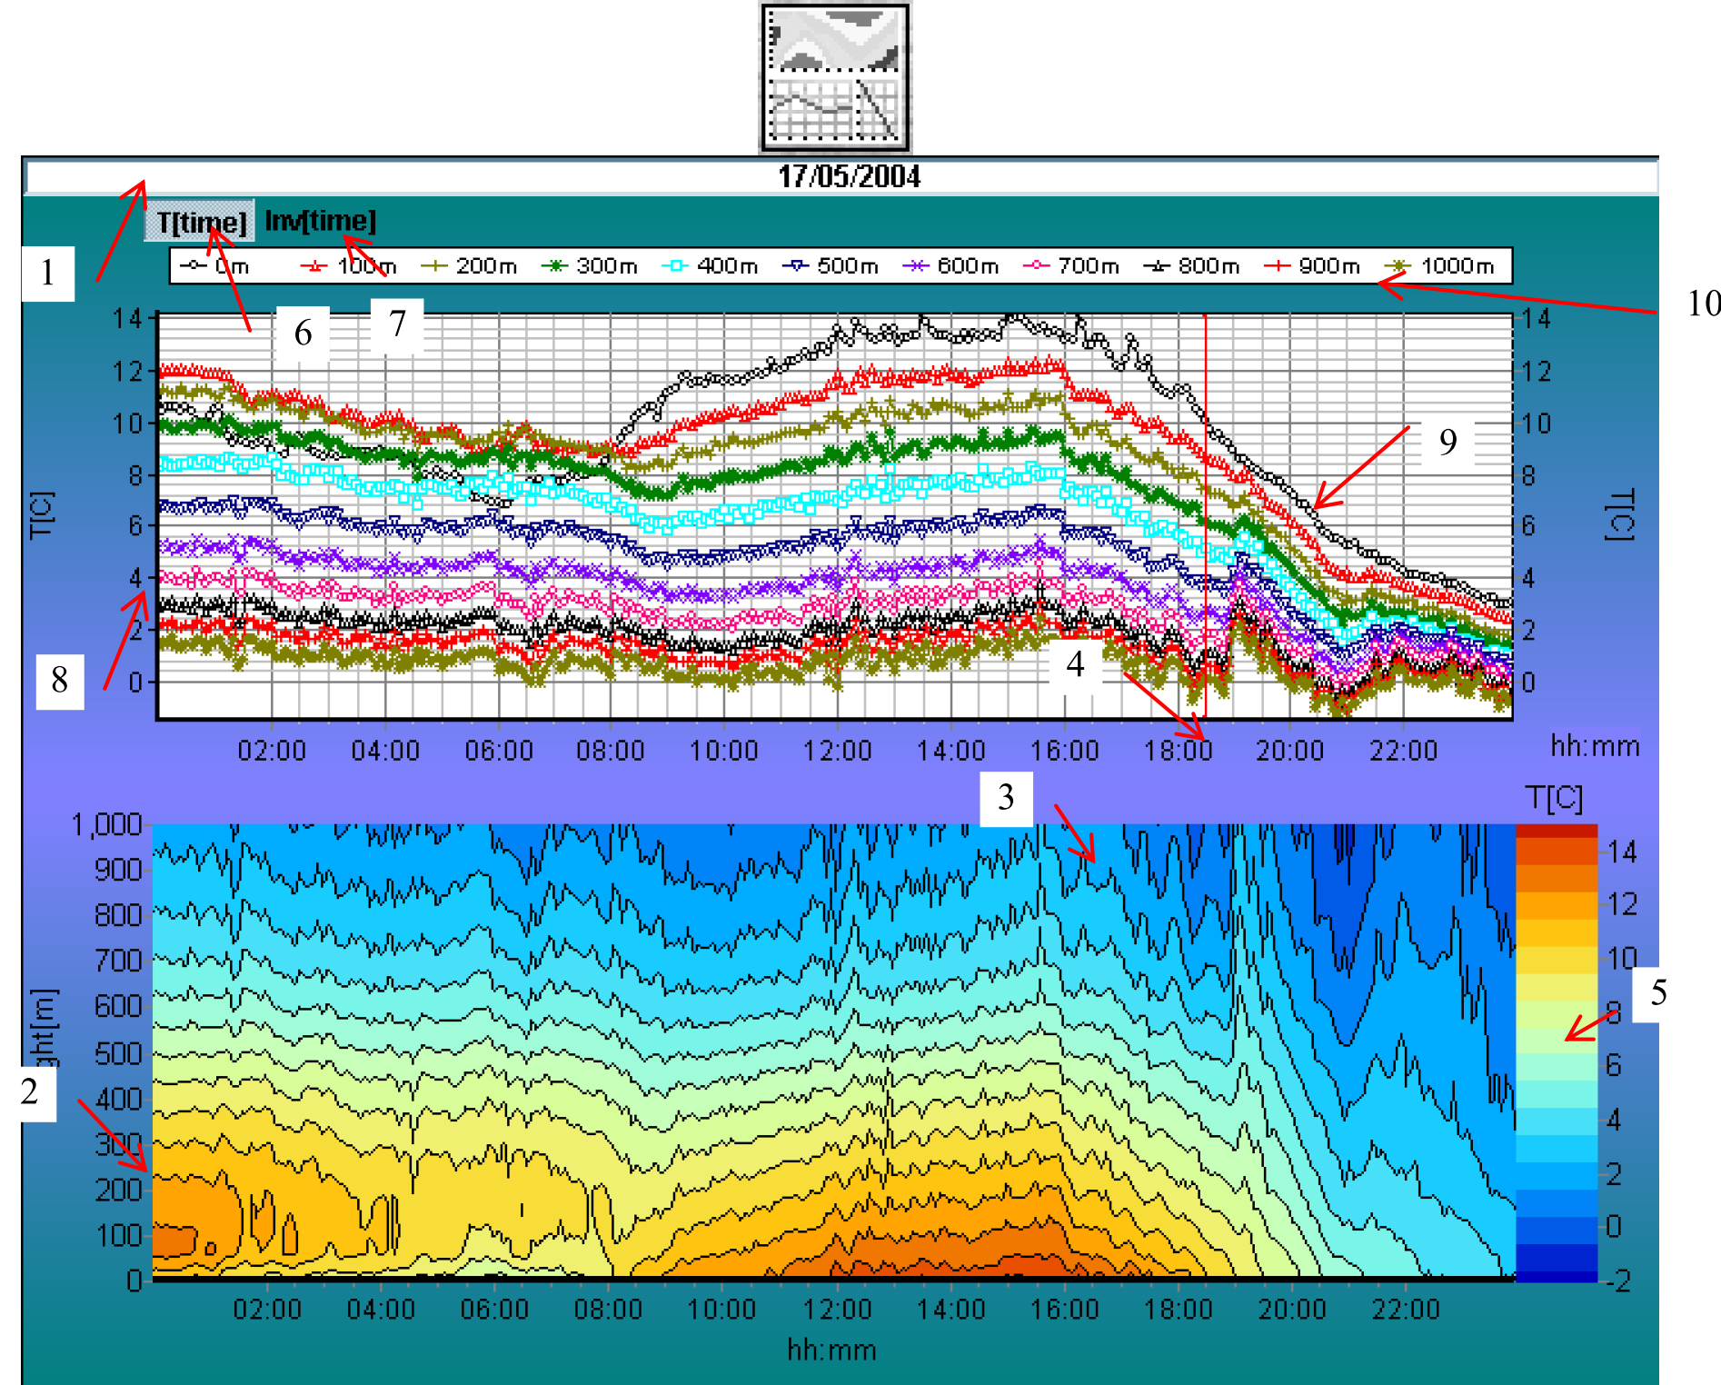

Figure 4 Temperature field

1) Comment – Indicates the place of installation and current date. Use Apply button in the Main window to refresh
comment string.

2) Height scale

3) Temperature fields - Displays temperature or temperature gradients fields in the color palette scale Temperature range [C]

4) Time scale

5) Temperature range [C] - Temperature ranges of the color scale

6) Temperature as function of time - Measured temperature values will be shown on the graph for the heights from 0 up to 600(1000) meters with 50 (25-50) meters step.

7) Inversion as function of time - changing of the temperature inversion depth MaxIn (on the left scale) and the inversion height H[m] (on the right scale) will be shown on the graph.

8) Temperature scale

9) Graph field
press left mouse button to see cursor coordinates
click on the field to choose new temperature profile
press left mouse button and specify the region from up left side to down right side that you want to zoom in.
press left mouse button and specify the region from down right side to up left side that you want to zoom out

10) Legend
click right mouse button if you want to change style of graphs for the temperature series of values
click left mouse button to hide any of the temperature series at different heigths.
click T[time] or Inv[time] to restore the series for the appropriate regime.

7.2 Temperature profiles

1) Table of Т[C] - table of temperature values for the heights from 0 up to 1000 meters with
50(25-50) meters step.

2) Profile time

3) Field of graph

4) Temperature gradients for every 50 meters

5) Temperature gradient - abs(Tmax-Tmin) =>
for adiabatic process - the value of the bias in degrees
for inversion - its depth.

6) Temperature scale - click on the scale for automatic correction of gauge.

7) Profiles navigation - use buttons for consequent review of the temperature profiles.
You can use cursor control buttons to navigate by the sets of profiles using keyboard.

8) Values of Т[C] and H[m] - cursor coordinates in the graph window

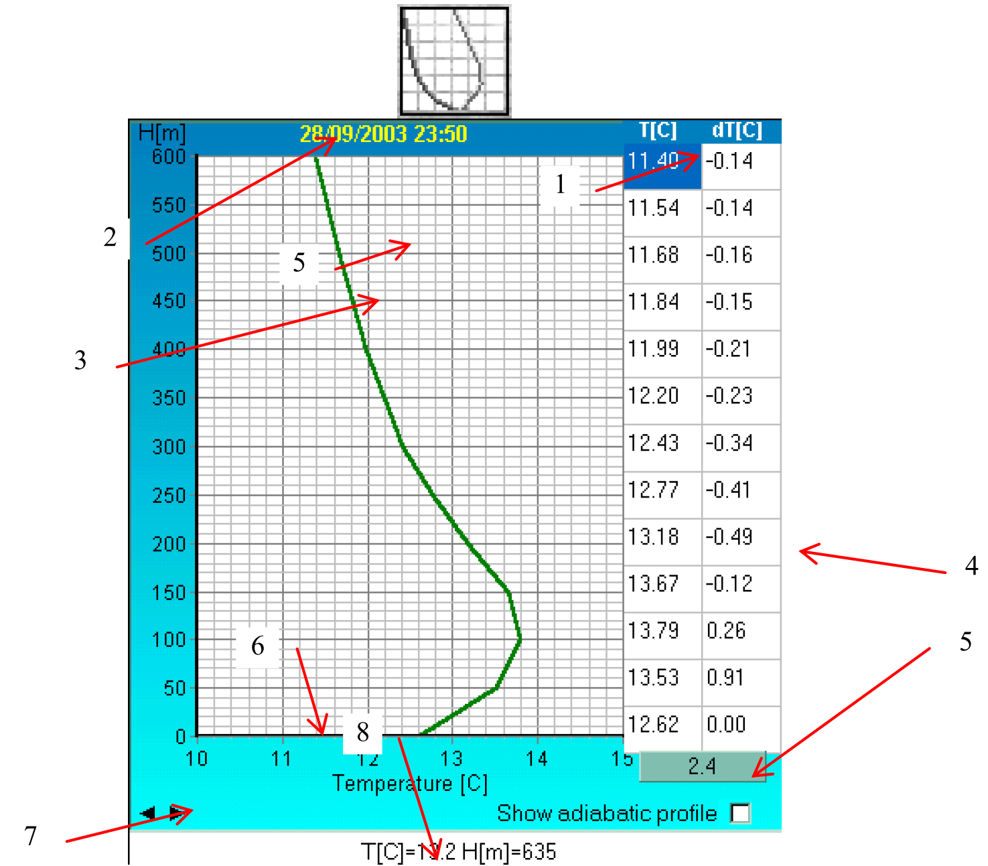

Figure 5 Temperature profile

8. References
1.Cadeddu, M.P., G.E. Peckham, and C. Gaffard, 2002: The vertical resolution of ground based microwave radiometers analyzed through a multi resolution wavelet technique. IEEE Trans. on Geosc. And Remote Sens., 40, No 3.
2.Chahine, M.T., 1970: Inverse problems in radiative transfer: Determination of atmospheric parameters. J. Atmos. Sci., 27, 960-967.
3.Clifford, S.K., J.C. Kaimal, R.J. Lataits, and R.G. Strauch, 1994: Ground-based remote profiling in atmospheric studies: An overview. Proc. IEEE, 82, No 3, 313-355.
4.Crewell, S., H. Czekala, U. Lohnert, C. Simmer, Th. Rose, R. Zimmermann, and R. Zimmermann, 2001: A 22-channel ground-based microwave radiometer for atmospheric research. Radio Sci., 36, 621-628.
5.Del Frate, F., and G. Schiavon, 1998: A combined natural orthogonal function/neural network technique for radiometric estimation of atmospheric profiles, Radio Sci., 33, 405-410.
6.Dicke, R.H., R. Beringer, R.L. Kyhl, and A.B. Vane, 1946: Atmospheric absorption measurements with a microwave radiometer. Phys. Rev., 70, 340-348.
7.Kadygrov, E.N., and D.R. Pick, 1998: The potential for temperature retrieval from a angular scanning single-channel microwave radiometer and some comparisons with in situ observations. Meteor. Appl., 5, Cambridge University Press, 393-404.
8.Pampaloni, P. and S. Paloscia, editors, VSP BV 2000: Microwave Radiometry and Remote Sensing of the Earthís Surface and Atmosphere.
9.Rodgers, C.D., 1970: Remote sounding of the atmospheric temperature profile in the presence of cloud. Q.J.R. Meteorol. Soc., 96, 654-666.
10.Rodgers, C.D., 1976: The vertical resolution of remotely sounded temperature profiles with a-priori statistics. J. Atmos. Sci., 33, 707-709.
11.Snider, J.B., 1972: Ground-based sensing of temperature-profiles from angular and multispectral microwave emission measurements. J. Appl. Meteorol., 11, 958-967.
12.Solheim, F.S., J.R. Godwin, E.R. Westwater, Y. Han, S.J. Keihm, K. Marsh, and R. Ware, 1998: Radiometric profiling of temperature, water vapor, and cloud liquid water using various inversion methods. Radio Sci., 33, 393-404.
13.Tikhonov, A.N., and V.Y. Arsenin, 1977: Solutions of Ill-Posed Problems. V.H. Winston and Sons, Washington, D.C.
14.Troitsky, A.V., 1986: Remote definition of the atmosphere temperature from spectral radiometric measurements in the line 5 mm. Izv. Vuzov, Radiophysics, 29, 878-884.
15.Twomey, S., 1977: Introduction to the Mathematics of Inversion in Remote Sounding. Academic Press, New York.
16. Ulaby, F.T., R.K. Moore, and A.K. Fung, 1986: Microwave Remote Sensing, Active and Passive. Vol. I-III. Boston, MA, Artech House.
17.Waters, J.W., 1976: Absorption and emission of microwave radiation by atmospheric gases. Methods. Exp. Phys., 12B, Sect. 2.3.
18. Bohren, C.F., and D.R. Huffman, 1983: Absorption and Scattering of Light by Small Particles. John Wiley & Sons, Inc.
19. Chan, W.S., and J.C.W. Lee, 2015: Vertical profile retrievals with warm-rain microphysics using the ground-based microwave radiometer operated by the Hong Kong Observatory. Atmos. Res., 161-162, 125-133.
20. Woods, C.P., M.T. Stoelinga, J.D. Locatelli, and P.V. Hobbs, 2005: Microphysical process and synergistic interaction between frontal and orographic forcing of precipitation during the 13 December 2001 IMPROVE-2 event over the Oregon Cascades. J. Atmo. Sci., 62, 3493-3519.
21. Fernandex-Gonzalez, S., F. Valero, J.L. Sanchez, E. Gascon, L. Lopez, E. Garcia-Ortega, and A. Merino, 2014: Observation of a greezing drizzle episode: a case study. Atmos. Res., 149, 244-245.
22. Chan, P.W., 2009: Performance and application of a multi-wavelength, ground-based microwave radiometer in intense convective weather. Meteorol. Z., 18, 253-265.
23. Xu, G., R. Ware, W. Zhang and, G. Feng, 2014: Effect of the off-senith observation on reducing the impact of precipitation on ground-based microwave radiometer measurement accuracy in Wuhan. Atmos. Res. 140-141, 84-94.
24. Araki, K. M. Murakami, H. Ishimoto and T. Tajiri, 2015: Ground-Based Microwave Radiometer Variational Analysis during No-Rain and Rain Conditions. SOLA, 11, 108-112.

________________
APPENDIX II
PROPOSED UPDATE TO CIMO GUIDE ON MICROWAVE RADIOMETERS

Microwave radiometers

Thermal radiation from the atmosphere at microwave frequencies originates primarily from oxygen, water vapour and liquid water and is dependent on their temperature and spatial distribution. For a gas such as oxygen, whose density as a function of height is well known, given the surface pressure, the radiation contains information primarily on the atmospheric temperature. Vertical temperature profiles of the lower atmosphere can be obtained by ground-based passive microwave radiometers measuring the microwave thermal emission by oxygen in a spectral band near 60 GHz. Spectral measurements in the 22-30 GHz upper wing of the pressure broadened water vapour absorption band provide information on the integrated amount of water vapour and liquid water, and the vertical distribution of water vapour. In addition, spectral measurements in both bands, combined with infrared cloud-base temperature measurements, provide information on the integrated amount and the vertical distribution of liquid water. For further information, see Hogg and others (1983) and Westwater, Snider and Falls (1990), Solheim and others (1998), Ware and others (2003) and Westwater and others (2005).

Individual downward-looking radiometers operating at different frequencies are maximally sensitive to temperature at particular ranges of atmospheric pressure. The sensitivity as a function of pressure follows a bell-shaped curve (the weighting function). The frequencies of the radiometers are chosen so that the peaks in the weighting functions are optimally spread over the heights of interest. Temperature profiles above the boundary layer are calculated by means of numerical inversion techniques using measured radiations and weighting functions. The relatively broad width of the weighting function curves, radiation from the terrestrial surface and the fact that channels that are sensitive to the lower part of the atmosphere would also be sensitive to the skin temperature, precludes accurate temperature profiles from being obtained near the surface and in the boundary layer when using space-based radiometer soundings.

The principles of upward-looking radiometric temperature and humidity sounding from the terrestrial surface are well established. The temperature weighting functions of upward-looking profiling radiometers have narrow peaks near the surface that decrease with height. In addition, sensitivity to oxygen and water vapour emissions is not degraded by radiation from the terrestrial surface. This allows accurate temperature and humidity profile retrievals with relatively high resolution in the boundary layer and lower troposphere. On the other hand, the attenuation of microwave by the atmosphere, and the relatively broad width of the weighting function curves for channels sensitive to the upper part of the atmosphere, put a limit to the accuracy in retrieving temperature profiles above the boundary layer. Inversion techniques for upward-looking radiometers are either based on temperature and humidity climatology for the site that is typically derived from radiosonde soundings, or based on variational techniques on modeling the relation between the measured radiation, vertical temperature and humidity profiles.

Ground-based radiometers usually have a reduced accuracy in retrieving temperature profiles when it rains or snows. It is due to the accumulation of water, snow (Woods and others, 2005) or ice (Fernández-González and others, 2014) over the radome, lack of scattering and emission/absorption effects of precipitation in the retrieval algorithm, and enhanced microwave attenuation in the atmosphere by precipitation. The first issue can be remedied by using a hydrophobic radome and forcing airflow over the radiometer surface to avoid accumulation of water, snow and ice (Chan, 2009) or making the observations at an off-zenith angle to stay away from the thin films of water (Xu and others 2014). For the second issue, it can be handled by incorporating observations from radar and parameterization of rain microphysics in the retrieval (Chan and Lee, 2015).

Ground-based and satellite-based radiometers are highly complementary. Satellite measurements provide coarse temporal and spatial resolution in the upper troposphere, and ground-based measurements provide high temporal and spatial resolution in the boundary layer and lower troposphere. Retrieved profiles from ground-based radiometers can be assimilated into numerical weather models to improve short term (1–12 h) forecasting by providing upper-air data in the interval between radiosonde soundings. Alternatively, raw brightness temperature from terrestrial radiometers can be assimilated directly into numerical weather models. This approach improves results by avoiding errors inherent in the profile retrieval process and also allows for flow-dependent considerations in the assimilation. A similar method, which assimilates raw satellite radiometer radiances directly into weather models, demonstrated improved results years ago and is now widely used.

The main advantages of ground-based radiometers are their ability to produce continuous measurements in time, and their ability to measure cloud liquid. Continuous upper-air temperature, humidity and cloud liquid measurements can be used to improve nowcasting and short-term precipitation forecasting. Changes in brightness temperature can also help to nowcast the on-set of convective events (Chakraborty, Das and Maitra, 2016).These continuous measurements can be also used to detect the development or time of arrival of well-defined temperature changes (for studies of gas emissions, air pollution, urban heat islands, severe weather forecasting and warnings) (Kadygrov, Shur and Viazankin 2003). Real-time radiometer data can also be used for alerting low level windshear events for aviation use (Chan and Lee 2013).

Profiling radiometer reliability and accuracy have been widely demonstrated during long-term arctic, mid-latitude and tropical operations (Güldner and Spänkuch, 2001; Liljegren and others 2005, Loehnert and Maier, 2012). The result of the 13-month operation of the Radiometrics MP3000 (Gaffard and Hewison, 2003) shows that the root mean square value of the difference between the temperature observed by the radiosonde and that retrieved by the microwave radiometer ranges from 0.5 K (near the surface) to 1.8 K (at a height of 5 km). Güldner and Spänkuch (2001), who operated the Radiometrics TP/WVP-3000 for 18 months and compared retrievals with four radiosonde soundings daily, also shows a similar root mean square value from 0.6 K (near the surface) to 1.6 K (at a height of 7 km in summer and 4 km in winter). The root mean square value of water vapour profile is not more than 1 gm–3 in all altitudes (Gaffard and Hewison, 2003; Güldner and Spänkuch, 2001).

Terrestrial profiling radiometers demonstrate significant economic and practical advantage whenever lower tropospheric temperature, humidity and cloud liquid measurements with high temporal resolution are required, and where moderate vertical resolution is acceptable. Commercial profiling radiometer prices have dropped significantly over the past several years, and are now less than the typical annual cost of labour and materials for twice daily radiosonde soundings.

