Regular Reporting of CIMO Testbeds and Lead Centres
(expand the cells as required to properly reflect your activities)
Terms of Reference for CIMO Testbeds and Lead Centres are available under: ttp://www.wmo.int/pages/prog/www/IMOP/Testbeds-and-LC.html

Name of Testbed / Lead Centre | MeteoSwiss Payerne Testbed
Location of Testbed / Lead Centre | Payerne, Switzerland

Contact Person for the Testbed/Lead Centre
Courtesy Title | Mr / Ms / Mrs / Dr / Prof / Eng / etc Dr
Family name | Ruffieux
First name | Dominique
Full Postal Address | MeteoSwiss, Ch de l’Observatoire, 1530 payerne, Switzerland
Country | Switzerland
Tel. number(s) | +41 26 662 6247
Fax number(s) | +41 26 662 6212
Email(s) | Dominique.ruffieux@meteoswiss.ch
Has contact person changed in last 2 years? |  | Yes / No ?
If yes, who was the previous contact person?

Report on Activities
Main activities that TB/LC carried out in the last 2 years for which results are already available:

- Radiosounding : solar and thermal radiation profiles (Rolf Philipona)
In September 2011, a Kipp & Zonen CNR 4 net radiometer was used to make the first high quality measurements of radiative flux profiles through the atmosphere from the Earth’s surface to above 30 km in the stratosphere (Figure 1). During two-hour balloon flights, the solar short-wave and thermal long-wave radiation was measured, both downward and upward.

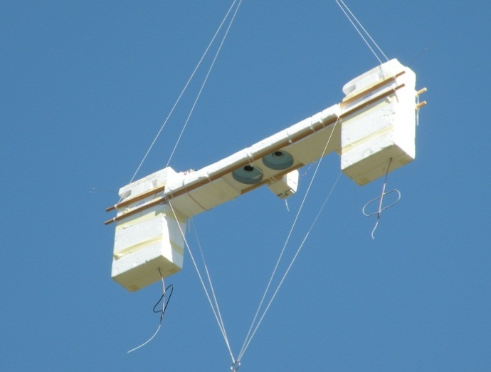
Solar short-wave and thermal long-wave radiation at the Earth’s surface and at the top of the atmosphere is commonly measured at surface stations, from aeroplanes and from satellites. However, upper-air observations for climate have recently been given more attention with the initiation of the Global Climate Observing System (GCOS) Reference Upper Air Network (GRUAN) to provide climate-quality measurements of variables in the upper troposphere and lower stratosphere (UTLS).
Figure 1. CNR4 mounted between two Meteolabor sondes.

Of greatest importance with regard to climate change are the upward and downward long-wave radiation profiles, which are directly related to radiative forcing through the atmosphere. Measurement of these profiles would provide greater understanding of radiative forcing and the Earth’s greenhouse effect.

Figure 2 shows the radiation components at ground level at the Payerne Baseline Surface Radiation Network (BSRN) station. Short-wave downward (SDR), upward (SUR) and net (SNR) radiation; and the corresponding long-wave radiation, (LDR), (LUR) and (LNR). These are 1 minute averages over 24 hours on 23 September 2011.

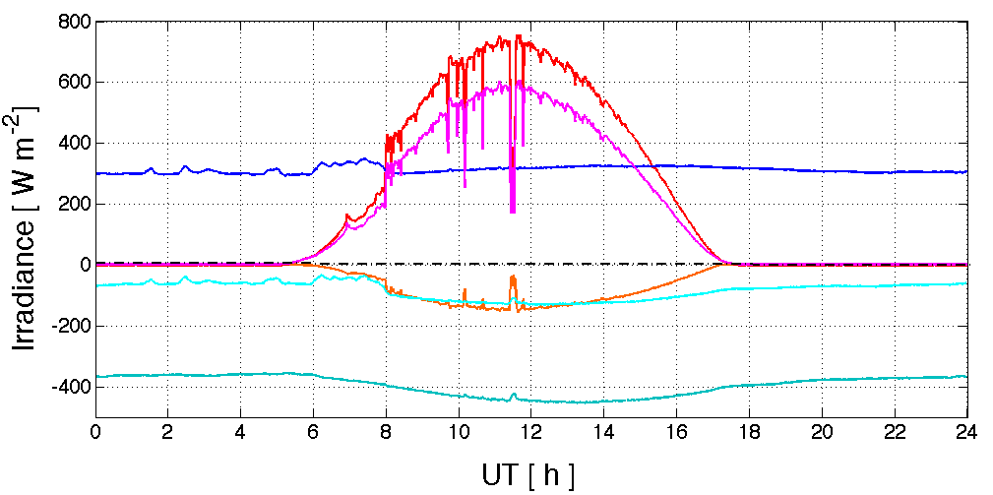
SDR
SNR
SUR
LNR
LDR
LUR
Figure 2. Surface radiation measurements at Payerne BSRN station

The daytime upper-air radiometry sounding was launched from Payerne at UT 10:13. The payload was recovered in the afternoon and launched again at 21:20 UTC, nighttime. Upper-air radiation profiles for the day and night flights are shown in Figure 3.
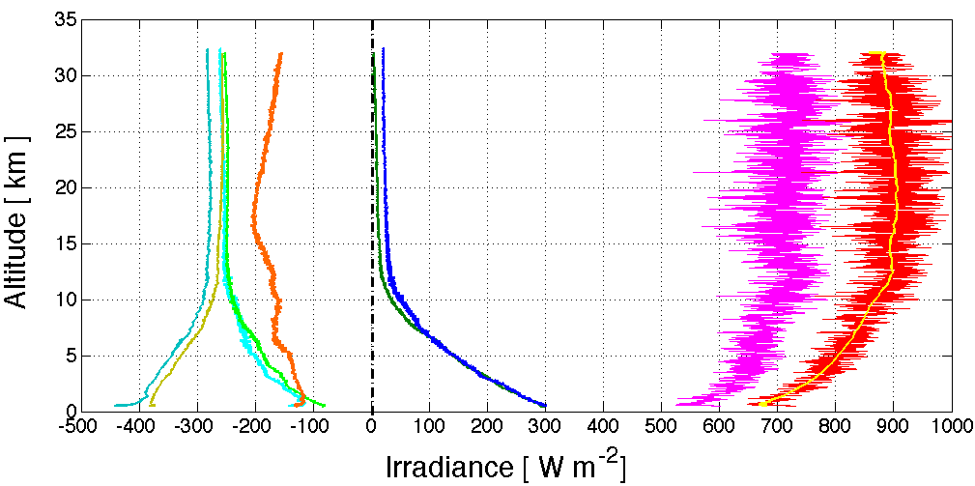
Sep 23 UT 10:13
Sep 23 UT 21:20
LUR_d
SUR_d
LNR_d
LUR_n
LNR_n
SDR_d
SNR_d
Figure 3. Day and night radiation profiles above Payerne

The daytime short-wave downward radiation (SDRd) shows about 680 W/m² at the surface and 880 W/m² at 32 km. This altitude was reached at UT 12:30. The solar height at the sonde’s location was 40.92 degrees, resulting in a direct solar component of 1344 W/m². This is more than 99% of the direct solar irradiance of 1352 W/m² above the atmosphere on 23 September.

The measured SDRd signal is rather noisy due to rotation of the payload, and to fit a smoothing curve to the dataset a locally weighted least squares regression technique is used (yellow line). The short-wave upward radiation (SURd) shows about -130 W/m² at the surface and -160 W/m² at 32 km. The short-wave net radiation (SNRd) is 550 W/m² at the surface and 720 W/m² at 32 km.

The surface-emitted long-wave upward radiation is about -445 W/m² during the day (LURd), but only -380 W/m² during the night (LURn). However, LURd shows a strong decrease during the first 1,000 m and then decreases to about -280 W/m² at the tropopause. LURn decreases similarly. Above the tropopause LURd and LURn stay fairly constant, with the night emission about 20 W/m² lower. Long-wave downward radiation in the day (LDRd) is similar to nighttime (LDRn) in the lower troposphere, decreasing from about 300 W/m² at the surface down to about 15 W/m² at the tropopause. Above the tropopause, LDRn decreases steadily down to 4 W/m² at 32 km. However, LDRd is always about 15 W/m² higher even at 32 km.

This difference, which is observable above 7 km, is due to thermal long-wave radiation from the sun. LNRd at the surface is about -140 W/m², whereas during the night LNRn is only about -80 W/m². However, the difference decreases with height and at 32 km the day and night net emissions are -270 W/m² and -260 W/m², respectively.

Consistency observed between different flights, with measurements of more than 99% of direct solar irradiance at 32 km and long-wave downward radiation down to 4 W/m² at 32 km, show that upper air solar and thermal radiation can be reliably measured through the atmosphere.
The radiation profiles shown were all measured under cloud-free conditions, which constitutes the basis for greenhouse effect studies. However, future measurements through clouds, aerosols or other atmospheric constituents will allow the investigation of short-wave and long-wave radiative effects, and the climate forcing at different altitudes which is directly related to the greenhouse effect.

Reference

R. Philipona, A. Kräuchi, E. Brocard (2012) : Solar and thermal radiation profiles and radiative forcing measured through the atmosphere. Geophys. Res. Lett. , 39, L13806, doi: 10.1029/2012GL052087.

This paper became a Journal Highlight of the American Geophysical Union and has been published as Research Spotlight in the weekly newspaper EOS transaction of AGU.

- Raman Lidar (Alexander Haefele)
The measurement of water vapor in the atmosphere is very challenging and the Raman lidar is one of the few methods that can resolve the very high spatial and temporal variability of water vapor. This technology is hence of greatest interest for meteorology and climatology. The Raman Lidar for Meteorological Observations, RALMO, is a Raman lidar for water vapor profiling. It has been built by the Ecole Polytechnique Fédérale de Lausanne (EPFL), Lausanne, Switzerland, and is operated since 2008 by the Federal Office of Meteorology and Climatology MeteoSwiss, Payerne, Switzerland. RALMO is dedicated to operational meteorology and meets the requirements in terms data availability (day and night), timeliness and data quality. The lidar is fully automated and eye-safe. Its design guarantees a very high system stability and allows water vapor profiling up to 5 km during the day and up to 9 km during night. A detailed description of the instrument has been published in 2012 (Dinoev et al., 2012).

There are only a few Raman lidar systems suited for operational applications. Since Raman water vapor lidars are not yet an established observation method, RALMO has the character of a demonstrator. In the past 2 years a major effort has been done to improve the data availability. Adapted maintenance procedures have been elaborated, staff training has been intensified and the spare part management has been improved. Figure 4 shows the evolution of the data availability since the installation of the instrument at the Regional Centre of Payerne. The data availability is defined as the measurement time divided by the total amount of time. Rain and low clouds prevent from measuring for approximately 30 % of the time. Hence, the data availability of more than 60 % for 2012 shows that the technique is reliable and becomes suitable for operational applications.

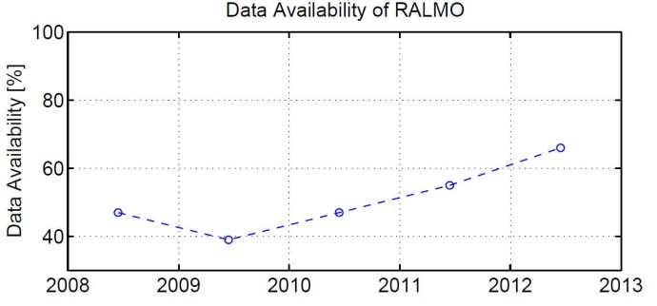
A thorough validation of the water vapor profiles has been carried out and published in 2012 (Brocard et al., 2012). A one year data set has been compared to collocated radiosoundings and to GPS and microwave radiometers in terms of total column. During this one year the lidar has not been recalibrated. Time series of the difference between the lidar and radiosondes at different levels show drifts well below 1 % / month for most of the levels and reveal a high system stability (see Figure 5).
Average down time due to rain and low clouds.
Figure 4. Evolution of the yearly averaged data availability of the RALMO lidar system in Payerne, Switzerland.

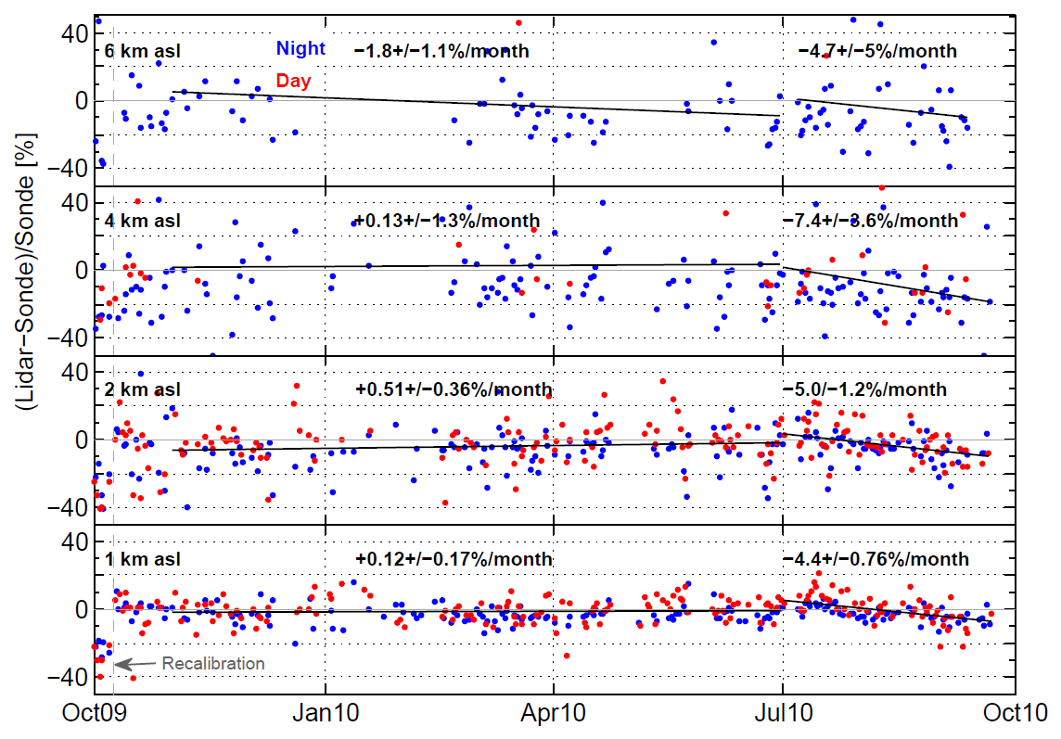
Figure 5. Time series of the difference in water vapor between RALMO and the operational radiosonde. The lidar has been calibrated in October 2009.

The lidar system has been upgraded with a temperature and aerosol module consisting of two pure rotational Raman channels and one elastic channel. This module is still under testing and not operational yet. However, first analyses and comparisons show that the aerosol measurements are of good quality: volcanic ash has been observed in real-time after both volcanic eruptions in Iceland in 2010 and 2011. Additionally many dust and smoke events were captured. A highlight was the detection of smoke from a Canadian wildfire, which passed over Payerne on July 17, 2012, at an altitude between 4000 and 6000 m asl (Figure 6).
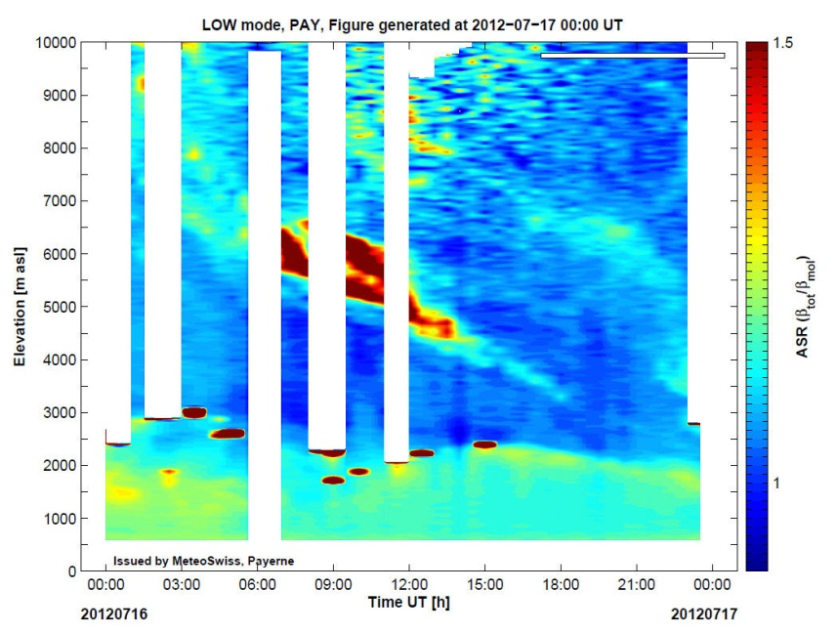
Figure 6. Detection of smoke from Canadian wildfires above Payerne at an altitude between 4000 and 6000 m asl. The origin of the air masses has been verified with backtrajectories.

The combination of different observation methods to improve both data quality and availability represents an important and promising development. In this context, a sophisticated approach to combine the measurements of the lidar and the nearby microwave radiometer for improved temperature profiling has been developed. An optimal estimation retrieval (1Dvar) allows to take advantage from the strengths of both technologies in a single profile (Haefele et al., 2012).

The RALMO system is also represented in the international team of the International Space Science Institute (ISSI), Bern, Switzerland, on “Critical Assessment and Standardized Reporting of Vertical Filtering and Error Propagation in the Data Processing Algorithms of the NDACC Lidars”. This team attempts to standardize the reporting of vertical resolution and developed tools that can be plugged in the processing software of lidar stations to calculate the vertical resolution and uncertainty according to the harmonized definitions.

References

Dinoev, T. S., V. B. Simeonov, Y. F. Arshinov, S. M. Bobrovnikov, P. Ristori, B. Calpini, M. B. Parlange, and H. van den Bergh, Raman Lidar for Meteorological Observations, RALMO – Part I: Instrument description, Atmos. Meas. Tech. Discuss., 5, 6867-6914, 2012

Brocard, E., R. Philipona, A. Haefele, G. Romanens, D. Ruffieux, V. Simeonov, and B. Calpini, Raman Lidar for Meteorological Observations, RALMO – Part 2: Validation of water vapor measurements, Atmos. Meas. Tech. Discuss., 5, 6915-6948, 2012

Haefele A., E.- M. Barras, O. Maier, D. Ruffieux, and B. Calpini, Composite Temperature Profiles from Raman Lidar and Microwave Radiometer, Proceedings of the 9th International Symposium on Tropospheric Profiling, L’Aquila, Italy, 2012

Performance evaluation of radiation sensors for the solar energy sector (Laurent Vuilleumier)

Dedicated meteorological products are designed for the energy sector, including specific measurement techniques, and the need for a corresponding “regulatory” framework is emerging (e.g., standard operating procedures, certification, traceability, etc.). For meteorology, a general framework for observation techniques is defined by the Commission for Instruments and Methods of Observations (CIMO) in its Guide for Meteorological Measurements (CIMO Guide) [1]. This document defines accuracy requirements for different type of measurements, standard operating procedures and certification guidelines for sensors and measurement systems.
Proper characterization of measurement techniques tuned to the energy sector requires several steps, the first one being the definition of the parameter of interest. The Guide to the expression of uncertainty in measurements [2] describes this as specification of the measurand. For example, different geometries are used for the solar energy collection devices such as solar concentrators, photovoltaic panels with various orientations or solar thermic panels. Thus, the information about the overall solar energy flux over an horizontal surface (global irradiance – more commonly used in meteorology) is not sufficient for assessing the solar energy input onto the collection device. Determining separately the solar direct and diffuse radiation components is more adequate since one can reconstruct the radiance distribution with this information and limited assumptions on the distribution of the diffuse radiance. Definition of the parameter of interest should be complete, including for instance geometrical or spectral specifications (e.g., collimation, spectral range etc.).
Once the parameters of interest are identified, the observational requirements of the energy sector should be clarified. This includes measurement frequency, required accuracy, minimum level of data availability, and eventually other characteristics specific of the domain of interest. Such observational requirements must be defined considering the purpose that the measurement should serve in applications for the energy sector. This allows combining end-user requirements and uncertainties of the inference process for defining the measurement requirements. They may of course be different for every application, but general requirements can often be defined for groups of applications.
Procedures are then defined for evaluating instrument performance and standard operating procedures are elaborated for reaching the specified requirements. This eventually leads to defining standards (e.g., ISO standards). In meteorology, such tasks are devoted to bodies within the World Meteorological Organization (WMO), typically the CIMO. In general these are carried out jointly with other international bodies such as the Bureau international des poids et mesures (BIPM). In the case of meteorological measurement for the energy sector, it is judicious to also involve the International Energy Agency (IEA).
COST ES1002 WIRE is a European action aimed at enhancing meteorological forecasting for renewable energy production. Switzerland plays a leading role in COST WIRE, MeteoSwiss being one of the Swiss partners in the collaboration. Within COST WIRE, it was recognized that instruments allowing inferring the diffuse and direct component of solar radiation separately, and operating in a robust and cost effective way without requiring sun trackers are increasingly used in the solar energy sector. The necessity of evaluating their performance was emphasized. Following a specific request from COST WIRE, MeteoSwiss took the responsibility of conducting an inter-comparison of radiometers measuring Direct Normal solar Irradiance (DNI) as contribution to the collaboration. The goal of this project is comparing target instruments to high accuracy radiation monitoring instruments (references) from the Baseline Surface Radiation Network (BSRN) Payerne site. The BSRN reference instruments are directly traceable to the World Radiometric Reference [3] established by the World Radiation Center at Davos, Switzerland. This performance evaluation will allow verifying that they fulfill the requisites of the solar energy sector. This instrument performances assessment represents a first step towards establishing Standard Operating Procedure (SOP) for their use. These subsequent tasks (SOP, certification definition, etc.) should be carried out in collaboration with relevant official certification committee, instrument users in the solar energy sector and the IEA.

Target instruments
Besides allowing the inference of the diffuse and direct component of solar (shortwave) radiation separately, instruments of interest for the solar energy sector should operate in a robust and cost effective way without the use of sun trackers and maintenance-intensive sensors: They are usually deployed in the field for continuous operation with limited maintenance. Two kinds of such instruments are on the market. The first type uses a rotating shadow-band that alternately shades and then exposes the entrance aperture of the instrument (see Figure 7, left). Such measurement cycles allow estimating the global solar irradiance and the diffuse irradiance component with proper algorithms. The direct-normal component is then inferred from the difference of the two measurements.
The other type of instrument uses an elaborate computer-generated shading pattern and an array of thermopile sensors (see Figure 7, right). These instruments are designed so that for almost any position of the sun in the sky, some sensors are exposed to the direct sun and some are in the shade. This also allows inferring the global solar irradiance and its diffuse component, and subsequently the direct normal irradiance.
Different combinations of sensors, correction algorithms and calibrations are used. The complete combination should be considered as the “instrument”. Thus there are potentially more “instruments” than the number of available hardware models.

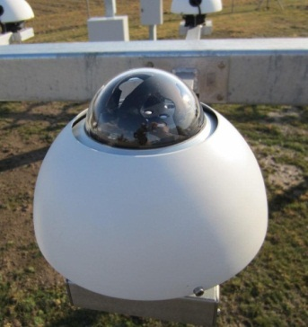
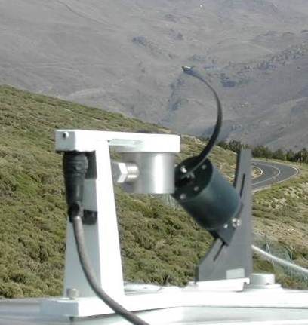
Deliverables
Figure 7. Instruments allowing the inference of the diffuse and direct component of solar radiation separately; left: rotating shadow-band instrument (photo courtesy N. Geuder), right: instrument with shading pattern.
Preliminary enquiries indicate that, beside the ability of distinguishing the direct and diffuse component of solar irradiance, target instruments are expected to allow at least a 10 to 15 min time resolution, to exhibit a root mean square error RMSE ≤ 5% (at 10min resolution), and to ensure a data availability > 90%. In addition, a measurement frequency on the order of 1 min⁻¹ (with a sampling frequency of 1 Hz and statistics such as mean, standard deviation, minimum and maximum during the integration period) allows obtaining useful information on ramps.
In order to conduct an evaluation that allows determining whether requirements such as those listed above are reached, the inter-comparison described here is conducted in the following way: Sets of instruments from different manufacturers are compared to the BSRN reference measurements during an intensive operation period (IOP). This is followed by a long-term performance evaluation period (1 year) with a subset of instruments tested. After the IOP, a preliminary analysis is conducted within a few months and submitted to recognized experts for review and eventually procedural modifications following expert advice. For each type of instrument tested, a datasheet summarizing the performances of the instrument will be issued. Analysis will be enhanced by meteorological data recorded at Payerne aerological station.
The instrument performance are evaluated with respect to the reference for: a) direct normal irradiance, b) diffuse irradiance and c) global irradiance. The performance evaluation will estimate bias and RMSE for assessing the effective error between the instrument and reference measurements. Effective error is here meant as an estimate of the difference between the measurements from the target instruments and a reference derived from the measurements by the BSRN instruments.
The reference derived from the BSRN instruments includes measurement of the same parameter by several methods (redundant instruments as well as different combination of instruments), correction of known errors in BSRN measurements and evaluation of the uncertainty of the BSRN corrected measurements and the reference derived from it.
The error estimates (typically bias and RMSE) are themselves subject to an uncertainty that will need to be analyzed and evaluated. In addition their dependencies to different factors will also be investigated. In particular this includes the RMSE dependence on time step (the reference shortest time step is 1min, but longer integration time will also be investigated). Similarly, the dependence of bias and RMSE on solar zenith angle will be studied for evaluating the quality of the correspondence between the diurnal cycles as measured by the tested instruments and the references. In addition, the dataset will be separated in data recorded during clear-sky, broken cloud coverage and overcast times. Algorithms for evaluating cloud cover with a sky camera [4] or long-wave radiation [5] are available at Payerne. In addition a clear-sky detection algorithm based on the shortwave global and diffuse signal [6] is also implemented at Payerne (see Figure 8). Other influence such as the seasonal cycle will also be studied. Measurement frequency and data availability will also be part of the evaluation criteria.
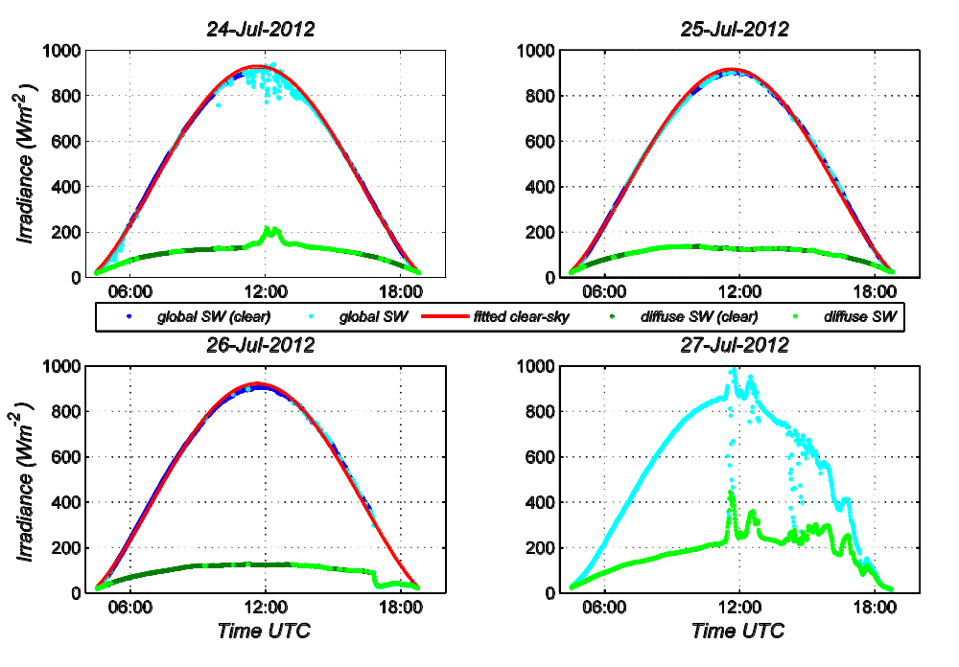
Figure 8. Clear-sky detection algorithm applied on 4 consecutive days during the inter- comparison. Shortwave (SW) global and diffuse data are classified (clear-sky or not) and a clear-sky fit is performed when possible.

Payerne BSRN reference data
Accuracy of reference measurements from the Payerne BSRN station is guaranteed by traceability of the instruments to standards and by observance of BSRN standard operating procedures [7]. In addition strict quality control checks and quality analysis allow detecting instrumental malfunctions and evaluating the probability of instrumental drift.
The Payerne BSRN station (46.81° N, 6.94° E, 491m above sea level – a.s.l.) is located on the Swiss Plateau between the Jura Mountains and the Alps. A full array of broadband radiometers monitors the solar shortwave (LW) and infrared longwave (LW) fluxes (cut-off around 3500 nm). Both upward and downward fluxes are monitored. For SW irradiance, the direct and diffuse components are monitored separately in addition to the global irradiance. The direct and diffuse component measurements are carried out using computer controlled sun trackers and collimation or shading. Most measurements are performed using more than one instrument (redundancy). During the inter-comparison, the SW irradiance measurements that are used to define the reference are carried out with two pyranometers Kipp and Zonen (K&Z) CM21 and one K&Z CMP22 for global irradiance, with one K&Z CM21 and one K&Z CMP22 for the diffuse irradiance and a K&Z CHP1 pyrheliometer and a PMO6 absolute cavity radiometer for direct irradiance (see ).
 | Instrument | Calibration
 | Instrument | Period | Value
Direct | K&Z  CHP1 | Nov-2011  K&Z | 7.88 µV/(Wm⁻²)±  0.09 µV/(Wm⁻²)
Direct | PMOD/WRC  PMO6 | Sep/Oct-2011  PMOD/WRC | 135.39 (m² * Ω)⁻¹ ±  0.06 (m² * Ω)⁻¹
Diffuse | K&Z  CMP22 | Sep-2011  PMOD/WRC | 8.74 µV/(Wm⁻²)±  0.06 µV/(Wm⁻²)
Diffuse | K&Z  CM21 | Sep-2011  PMOD/WRC | 11.83 µV/(Wm⁻²)±  0.16 µV/(Wm⁻²)
Global | K&Z  CMP22 | 2008  K&Z | 9.40 µV/(Wm⁻²)±  0.10 µV/(Wm⁻²)
Global | K&Z  CM21 | Nov-2010  MeteoSwiss | 10.52 µV/(Wm⁻²)±  0.12 µV/(Wm⁻²)
Global | K&Z  CM21 | Nov-2010  MeteoSwiss | 10.73 µV/(Wm⁻²)±  0.12 µV/(Wm⁻²)

Table 1. List of reference instrument used during the inter-comparison.
The measurements are performed at a sampling rate of 1 Hz, and one-minute mean values are recorded, as well as the sample minimum and maximum values, and the sample standard deviation. The pyranometers are ventilated and heated in order to minimize thermal offsets.
The BSRN SW instruments feature calibration uncertainties of ~1% (). One exception is the PMO6 absolute open cavity radiometer that feature a calibration uncertainty on the order of 0.05%. In addition, this instrument is extremely stable: A calibration of the same instrument carried out in 2001 (10 years before the calibration currently in use) gave a calibration value that is compatible with the current within this extremely tight uncertainty.
The PMO6 radiometer is operated permanently in parallel to the CHP1 pyrheliometer. However, the PMO6 features a slow time constant and is operated with an open/close cycle of 120 sec (60 sec open and 60 sec closed), effectively making one measurement every two minutes. This instrument is thus not suited to monitoring the direct solar irradiance when rapid changes are induced by clouds. Therefore the CHP1 provides the main observation, but the PMO6 is used as reference to check the CHP1 performance when the direct irradiance is slowly changing (no clouds in the direct beam path).
PMO6 and CHP1 measurements are compared for slowly changing direct irradiance. Such selection is achieved by requesting that the solar zenith angle: SZA < 86°, the CHP1 direct irradiance: SWdir > 30 W/m², and the rate of change: abs(ΔSWdir / Δt) < 10 (W/m²)/min if SZA < 78.5° or < 30 (W/m²)/min if 78.5 ≤ SZA < 86°. The condition on the rate of change is applied on the differences between two successive 1 min measurements, but it is requested that the condition is satisfied on at least 15 successive measurements (15 min). It results in about 15 days from the beginning of June to mid-August 2012 (IOP) with selected data (usually more than 100 data per day). The selection criteria produces a dataset enriched in high irradiance values: the average of the direct normal irradiance on the whole selected dataset is ~785 W/m² (min: 110 W/m², max 962 W/m²). Fig. 9 shows the extent of the daily distributions of the differences between the PMO6 and the CHP1 (only for the days with selected data).
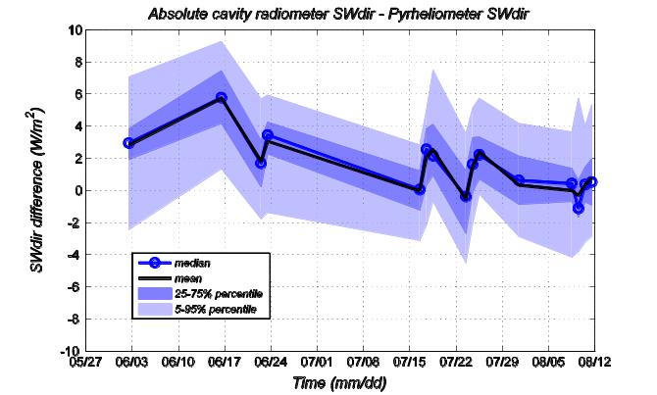

Figure 9. Evolution of the median and percentiles of the daily distribution PMO6-CHP1 differences.
These difference distributions are usually within ±1% of the average of the selected direct normal irradiances (~±8 W/m²), except on June 16th when the 95th percentile reaches about 9 W/m². Similarly, Figure 10 shows the evolution of the fit parameters of a linear regression fit of CHP1 vs. PMO6 measurements for the days with selected data. For each day the slope and zero intercept are given with confidence intervals, as well as the coefficient of determination r ² and the RMSE with respect to the fit. On some days, especially June 2nd, the confidence interval is relatively large. This is either due to some variability linked to hazier conditions (days with larger RMSE end of July and beginning of August) or days with a limited range of selected data (on June 2nd only data with high irradiance are selected).

Figure 10. Evolution of linear regression fit parameters for CHP1 = a * PMO6 + b. The fit is performed for days with selected data. The slope a and zero intercept b are given with confidence intervals, as well as the coefficient of determination r ² and the RMSE with respect to the fit.

For most days the zero-intercept is compatible with 0 W/m² or within a few W/m² from zero, which is remarkable because there are very few low irradiance data included in the fit, the minimum on the whole selected dataset being 110 W/m². The slope is most of the time compatible with 1 or within ±0.5% from 1 (limits shown with the two red lines on Fig. 4). Only two days (June 16th and August 11th) are outside this ±0.5% band (on June 2nd the slope has a large confidence interval that is compatible with 1). In both cases, the slope is below 1, which can be explained if the CHP1 window were not absolutely clean (the PMO6 is windowless).
This analysis is an example of the quality analysis, which is performed to ensure the quality of the BSRN data. In this case it shows that the CHP1 and PMO6 data remain compatible within extremely tight limits, which are actually tighter than the 1% K&Z estimate on the CHP1 calibration uncertainty. In addition to the calibration uncertainty, other uncertainties must be taken into account such as uncertainties due to instrument cleanliness (even if the instruments are maintained almost daily), due to eventual thermal effects, uncertainties due to eventual instrumental drift, etc.
This type of quality analysis will be applied to the direct, diffuse and global irradiance. For diffuse and global irradiance, it is expected that the instrument leveling and cosine error will have to be considered as significant uncertainty sources in addition to the ones mentioned above, especially for the global irradiance.
The uncertainty analysis will evaluate the different contributions to the uncertainties using the multiple redundancies available at Payerne (including the computation of global irradiance from the sum of direct and diffuse components), and try to relate these data to the PMO6 absolute cavity radiometer, which is the most precise reference instrument available on-site.
ComparisonAfter the accuracy of the reference measurements has been established, these can be used to evaluate the performance of the target instruments tested during the inter-comparison. There are 9 target instruments of 4 different types that are tested with respect to the BSRN references. The list of these instruments is given in .
The target instruments all measured the global irradiance and its components at one minute intervals. These can be compared to the reference BSRN measurements. The data availability is in average greater than 95%. The analysis of the comparisons is currently on-going and a corresponding report will be issued

Instrument  provider | Instrument name | Number of  instruments
Delta-T Devices Ltd | Sunshine  Pyranometer (SPN1) | 3
CSP Services GmbH | Rotating Shadowband Irradiometer (RSI) | 2
Solar Millennium AG (through CSP Services) | Rotating Shadowband Pyranometer (RSP) | 2
Irradiance Inc. | Rotating Shadowband Radiometer (RSR2) | 2

Table 2. List of target instruments participating to the inter-comparison.

References cited
[1] World Meteorological Organization, Guide to Meteorological Instruments and Methods of Observation, WMO-No. 8, Geneva, Switzerland, 2010.
[2] Joint Committee for Guides in Metrology, Evaluation of measurement data — Guide to the expression of uncertainty in measurement, Bureau International des Poids et Mesures, Paris, 2008.
[3] C. Fröhlich, World Radiometric Reference, in WMO/CIMO Final Report, Geneva, World Meteorological Organization, 1977, pp. 97-110.
[4] A. Kazantzidis, P. Tzoumanikas, A. Bais, S. Fotopoulos et G. Economou, Cloud detection and classification with the use of whole-sky ground-based images, Atmos. Res., 113, 80 - 88, 2012.
[5] B. Dürr and R. Philipona, Automatic cloud amount detection by surface longwave downward radiation measurements, J. Geophys. Res., 109, D05201, 2004.
[6] C. N. Long and D. D. Turner, A method for continuous estimation of clear-sky downwelling longwave radiative flux developed using ARM surface measurements, J. Geophys. Res., 113, D18206, 2008.
[7] A. Ohmura, E. G. Dutton, B. Forgan, C. Fröhlich, H. Gilgen, H. Hegner, A. Heimo, G. König-Langlo, B. McArthur, G. Müller, R. Philipona, R. Pinker, C. H. Whitlock, K. Dehne and M. Wild, Baseline Surface Radiation Network (BSRN/WCRP): New precision radiometry for climate research, B. Am. Meteorol. Soc., 79, 2115-2136, 1998.

The SwissMetNet network and the CIMO SPICE experiment (Yves-Alain Roulet)
SwissMetNet

The renewal and extension of the ground-based meteorological network of MeteoSwiss, SwissMetNet, has entered its 3rd phase in 2012. Up to now about 100 full automatic stations have been built since 2004, and integrated into the SwissMetNet network (Figure 11), one unique platform for data acquisition and transfer.

A dedicated network for automatic precipitation measurement is currently being set up and added on SwissMetNet, for specific needs on severe weather monitoring and for automation of long series manual measurement. These compact and fast deployed stations use the Ott Pluvio2 rain gauge and a GPRS connection for data transmission. Not less than 120 stations will be built by 2014.

Recent developments on data acquisition and transfer performed at the CIMO Testbed in Payerne allowed to implement simple data logger on SwissMetNet (cost reduction, used for small stations like the precipitation stations), and to install the first station using satellite for data transfer (Figure 12).

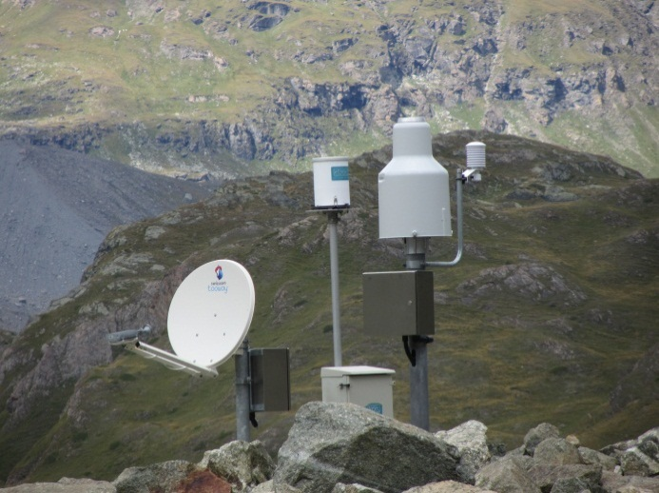
Figure 12. SwissMetNet automatic precipitation station with data transfer via satellite.
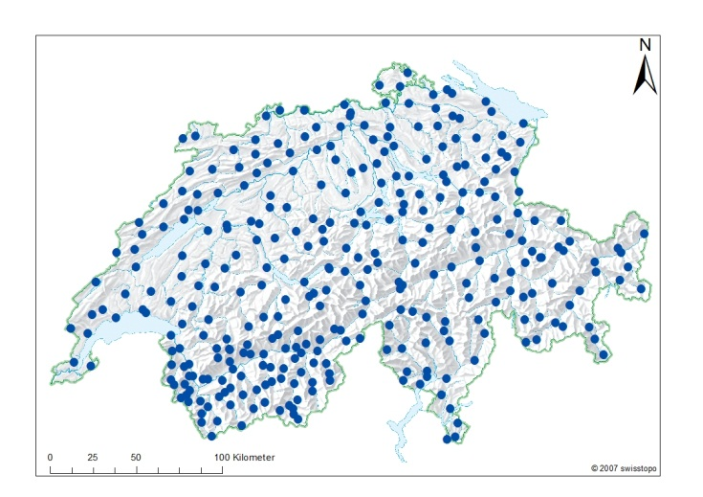
Figure 11. Final state of the SwissMetNet ground-based meteorological network.

CIMO SPICE

In the frame of the CIMO SPICE Project (Solid Precipitation Intercomparison Experiment), a reference test site is being equipped at Weissfluhjoch/Davos (2500 m asl), in collaboration with the Swiss Snow and Avalanche Research Institute (SLF). This test site, property of SLF, has been elected by the SPICE IOC as the reference test site for the Alpine region. In order to fit to the project’s requirements, a DFIR (Double Fence Intercomparison Reference) is currently being built and added to the already existing infrastructure (Figure 13).

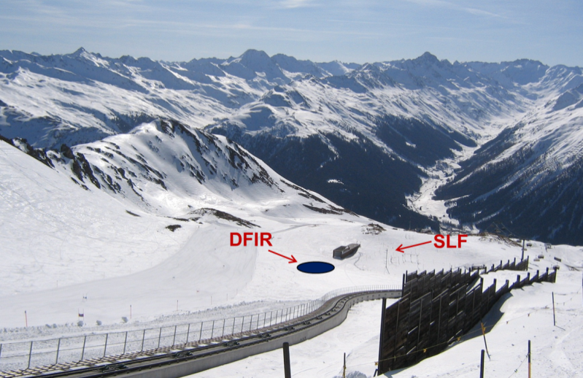
Figure 13. The SPICE reference site at Weissfluhjoch, with the position for the new DFIR (under construction).
The site will serve as reference site, and will therefore be equipped with three Ott Pluvio2 (one in the DFIR and two outside the DFIR). Additional instruments under tests will also be installed, as for example precipitation gauges, precipitation laser monitor, etc. Ancillary measurements and additional information (webcam) will be extracted from the SLF test site which is already in use. All collected data will be transferred to the SPICE data base, being then available for data analysis, together with the other reference sites.

The SPICE measurement campaign starts in November 2012, and will extend to the end of the 2013-2014 winter season.

MeteoSwiss, as weather services of an Alpine country, has a great interest in SPICE and its possible outcome. A strong effort (financial, HR) has been, and will be, put on this project (eg. construction of the DFIR).

Main activities that TB/LC carried out in the last 2 years for which results will soon be available:
- SPICE experiment (see above)
- DNI Experiment (see above)
- GRUAN developments including Lidar developments

Which guidance documents/standard procedures were developed during the last 2 years (please include full reference and web-link if available)?

Which IOM reports / peer-reviewed publications were published in the last 2 years (please include full reference and web-link if available)?
R. Philipona, A. Kräuchi, E. Brocard (2012) : Solar and thermal radiation profiles and radiative forcing measured through the atmosphere. Geophys. Res. Lett. , 39, L13806, doi: 10.1029/2012GL052087.

Dinoev, T. S., V. B. Simeonov, Y. F. Arshinov, S. M. Bobrovnikov, P. Ristori, B. Calpini, M. B. Parlange, and H. van den Bergh, Raman Lidar for Meteorological Observations, RALMO – Part I: Instrument description, Atmos. Meas. Tech. Discuss., 5, 6867-6914, 2012

Brocard, E., R. Philipona, A. Haefele, G. Romanens, D. Ruffieux, V. Simeonov, and B. Calpini, Raman Lidar for Meteorological Observations, RALMO – Part 2: Validation of water vapor measurements, Atmos. Meas. Tech. Discuss., 5, 6915-6948, 2012

Haefele A., E.- M. Barras, O. Maier, D. Ruffieux, and B. Calpini, Composite Temperature Profiles from Raman Lidar and Microwave Radiometer, Proceedings of the 9th International Symposium on Tropospheric Profiling, L’Aquila, Italy, 2012
Title(s) of IOM report(s) presently being developed by your Testbed/Lead Centre:
(please specify level of development: draft, ready for review, …)

Has your Testbed/Lead Centre collaborated with one or more CIMO Expert Teams in developing guidance material? Yes/No Yes
If yes, with which CIMO Expert Team(s)?
Strong relations were maintained with the Lindenberg DWD site for various GRUAN activities.

Capacity Building and Training Activities
Which capacity building/training activities have been carried out by the Testbed in the last 2 years?
- The main capacity building activities were related to the DNI Experiment (see above) during which a special workshop was organized

Has your testbed developed a twinning activity / special relationship with a companion station/site from a developing country? Yes/No Yes
If yes, with which station/site?
A continuous collaboration is maintained between Meteoswiss and the Kenyan Met Service at Nairobi. The main focus of this partnership is the ozone measurements with bith in-situ (radiosounding) and remote sensing (Dobson) ozone measurements

Is your Testbed/Lead Centre making an oral/poster presentation at this year’s TECO? Yes / No
(If yes, please specify Title(s) and Author(s) of the presentation(s))
Yes, cf programme

Recent Changes in Circumstance
Have there been any recent changes in your Test Bed/Lead Centre’s capabilities? If so, please specify:

Have there been any recent changes in your Test Bed/Lead Centre’s infrastructure? If so, please specify:

Have there been any recent changes in your staffing? If so, please specify, and advise whether replacement staff have the required competencies:

Future Plans
What are your plans for the next two years?
- Continuation of the efforts to develop Payerne as a GRUAN site
- Reinforcement of the lidar –related activities (both Raman lidar and ceilometers)

Is your Testbed/Lead Centre able to continue in the role of a Test Bed/Lead Centre during the coming two years? | Yes / No YES

Other relevant information (other activities of special interest to CIMO, etc…)

15.10.2012 Dominique Ruffieux
Date |  | Name of Person Filling the Form

