World Meteorological Organization  Commission for Instruments and Methods of Observation OPAG on Remote-Sensing Technologies  Inter-Programme Expert Team on Operational Weather Radars  Tokyo, Japan, 13-16 March 2017 | CIMO/OPAG-RST/IPET-OWR-1/Doc. 2
Submitted by:
Daniel Michelson, Canada
03.03.2017
Version 1

report of the chairperson

SUMMARY
The Chairperson’s outlook on IPET-OWR and its activities are summarized for the benefit of the meeting participants.

DECISIONS/ACTIONS REQUIRED: The participants of IPET-OWR-1are invited to review this document prior to the meeting and provide their feedback at the meeting.

ISSUES TO BE DISCUSSED: Issues to be discussed as they emerge at the meeting.

__________

1 WMO Weather Radar Activities
Up until recently weather-radar has been split between two WMO Technical Commissions: the Commission on Basic Systems (CBS) and the Commission on Instruments and Methods of Observation (CIMO) according to the following very brief descriptions.

1.1 CBS
Under CBS, the Open Programme Area Group on Integrated Observing Systems (OPAG-IOS) has the following activities.

1.1.1 ET-SBO
Expert Team on Surface-Based Observations. This ET has been chaired by Stuart Goldstraw of the UK Met Office. When it comes to weather radar specifically, the focus has been on drafting new Regulatory Material for the Manual on the Global Observing System (WMO No. 544), and to addressing radar in relation to the WMO Integrated Global Observing System (WIGOS). Such new Regulatory Material has been drafted, and it is currently under review within CBS.

1.1.2 TT-WRDE
Task Team on Weather Radar Data Exchange. This TT was chaired by Daniel Michelson of Environment and Climate Change Canada. The overarching goals have been to ensure that global meteorological infrastructure, hosted and operated by WMO’s Members, is prepared for weather radar data in standard ways, ie. data representation and exchange mechanisms. TT-WRDE embarked on the creation of an Information Model and a Data Model for weather radar data that, when mature, would be recommended to WMO as its standard, together with a recommendation for a single global standard file format representation.

1.2 CIMO
The majority of Guidance material to WMO’s Members on weather radar has been compiled into a Chapter 9 of WMO No. 8: the CIMO Guide. This is a wealth of information that addresses technical and operational characteristics that must be considered when planning, developing and operating weather radars. This material also pays significant attention to issues related to data quality, and also meteorological applications of weather radar. The WMO Guidance Statement on Weather Radar / Wind Turbine Siting is an Annex to this chapter of the CIMO Guide.

1.2.1 ET-ORST
Expert Team on Operational Remote Sensing. This ET has been chaired by Volker Lehmann of the German Weather Service (DWD). ET-ORST addresses weather radar and radar wind profilers as instruments. It also addresses data quality issues related to dual polarization, new technologies, operating radar in mountainous terrain, operational calibration, collaborative mode operations, and coordination mechanisms.

1.2.2 RQQI
Weather Radar Quality Control and Quantitative Precipitation Estimation Intercomparison Project. RQQI was formerly chaired by Paul Joe of Environment and Climate Change Canada, who more recently handed it over to Daniel Michelson. Following RQQI’s initial start in 2011, a period of inactivity followed. RQQI was re-started towards the end of 2015, with a two-year timeline. It has been proven extremely difficult to address RQQI’s ‘intercomparison’ focus. Resultingly, the decision was taken in January 2017 to stop RQQI and include some of its interests and activities in IPET-OWR. This will be discussed at IPET-OWR-1.

1.3 Consolidation of Activities into IPET-OWR
Based on the spread of activities and responsibilities outlined above, a proposal to consolidate all weather-radar related activities into a single Inter-programme Expert Team on Operational Weather Radar (IPET-OWR) was submitted to WMO Council (EC-68), where it was approved in June 2016. In short, the justification for the consolidation identifies the potential for reducing inefficiencies and improving coordination. The Terms of Reference for IPET-OWR has been gleaned from the above-mentioned activities, and they are found in Doc. 2.2(1) of this meeting’s Document Plan.

1.4 Other Activities
Despite the intention for IPET-OWR to be “all things weather radar” in WMO, there are still some radar-related activities that are ongoing that are being carried out independently of, or in liaison with, IPET-OWR and will continue to do so. Examples of such activities are:
- An activity ongoing in the Commission for Hydrology.
- Atmospheric Observation Panel for Climate (AOPC), GCOS (Global Climate Observing System), where a task team led by Elena Saltikoff of the Finnish Meteorological Institute is tasked to assess the use of archived radar data in climate analysis.
- Interest in CIMO on integration of data from multiple sources, mostly observational, among them weather radar.
- Continued interest in wind-profiling radar by ET-ORST.
- Coastal surveillance radars are being addressed by the WMO-IOC Joint Technical Commission for Oceanography and Marine Meteorology (JCOMM). This is admittedly peripheral in relation to IPET-OWR, but nevertheless worth mentioning for completeness.

2 IPET-OWR
The scope of IPET-OWR is, as indicated by the name, operational. Hence, there is a core scope that puts weather radar front and centre as an observing system, leaving application areas such as those listed in Sec. 1.4 to be addressed by other parts of WMO. The Members of IPET-OWR are, however, recognized subject-matter experts and are thereby available to liaise with such other activities. This operational constraint should be “generous” in the sense that it recognizes change initiated through e.g. emerging technologies or user requirements related to things like data quality. In the following, the tasks formulated in the IPET-OWR Work Plan will be highlighted with the goal of seeing how they interrelate. An attempt at supporting this exercise is made by illustrating these interrelations in Figure 1.
Weather radar as an observing system and a network has not received much attention in CBS until recently, whereas it has received significant attention in CIMO. The impetus for mobilizing around weather radar in CBS came with the anticipation of increased demand on weather-radar data by Numerical Weather Prediction (NWP). This was articulated in the Final Report of the Fifth WMO Workshop on the Impact of Various Observing Systems on Numerical Weather Prediction in 2012. Although weather radar was only mentioned among other observing systems in this report, it was enough to start organizing weather radar globally, with resulting activities in ET-SBO and TT-WRDE. Interestingly, at the Sixth WMO Workshop on the Impact of Various Observing Systems on Numerical Weather Prediction in 2016, the amount of work on assimilating weather radar data had increased to the point where more qualified statements on what kinds of data to use were made, and the usefulness of dual-polarization and systematic quality control was also recognized. These statements were supported by several weather-radar data assimilation studies presented at the sixth workshop.
While assimilating weather-radar data into NWP is but one application area, it is an exceptionally important one because it 1) is a quantitative application, 2) makes great demands on data quality, therefore also quality control, 3) potentially scales to the global level. The ECMWF has already shown how assimilating radar data can improve forecast skill several days ahead globally. This indicates the importance of unlocking the potential of weather-radar as a global resource, and as such it needs much coordination which is the role of IPET-OWR and WMO. And such coordination will benefit other application areas too.

2.1 Emerging technologies
Polarimetry can be considered mainstream now, but it has not yet been accommodated adequately in the WMO Guidance and Regulatory Material, so there is work to be done. While good examples of the deployment of such technology exist and are being reported, we should try to identify potential common ground, so that good examples can be transformed into Guidance material that can be globally applicable. By targeting polarimetry and developing methods for deriving advice and guidance to WMO’s Members, we will benefit by having such methods for new and technologies as they emerge.

2.2 Weather-radar data exchange (WRDE)
Progress carried over from TT-WRDE will help us arrive at WMO’s objective of a single global standard for representation of weather-radar data. Addressing data exchange mechanisms will also help provide the foundation for weather radar successfully becoming a global resource supporting many application areas.

2.3 Intercomparisons (RQQI)
The acronym “RQQI” has been deliberately re-used here to indicate that intercomparison experiments are still expected play a vital role in IPET-OWR. With weather radar emerging as a global resource, quality assurance (QA), quality control (QC), and quantitative precipitation estimation (QPE) will all be critical elements needed to help harmonize data nationally, regionally, and globally for the benefit of downstream applications. Clarity of user requirements will help guide such activities.

2.4 Policy
Liaison with other groups in WMO for the purposes of protecting frequency bands used by weather radar, and for addressing what to do about wind turbines, are what is identified by “policy”. Such issues continue to cause concern, especially in the light of increased quantitative application of weather radar.

2.5 Open Source Software (OSS)
An Open Science approach can be very useful in supporting the data representation and exchange functionality that helps achieve weather radar as a global resource. OSS can also support the science conducted as part of the intercomparison activities, e.g. through proof-of-concept solutions. The creation of open training materials also stands to benefit from open and transparent software solutions.

2.6 Training and Capacity Development
Members from countries with emerging economies, who reach the level of ambition with their observing systems where they are prepared to invest in weather radar, are expected to benefit from harmonized materials drawn from the outcomes of IPET-OWR activities, e.g. the intercomparisons and also the WRDE building blocks, to help develop and maintain capacity. A clear understanding of user requirements will help ensure that such materials and activities are relevant.

2.7 Advice, Guidance, and Regulatory Material
Inevitably, all activities aim at providing WMO’s Members with these three things. IPET-OWR will focus on recommending solutions, and such recommendations will be transformed into Advice and Guidance in different ways, e.g. updates to the CIMO Guide and a Weather Radar Best Practices Guide. Some of the advice and guidance may end up being promoted to become Regulatory Material, ie. in the Manual on the Global Observing System (No. 544) and/or the Manual on WIGOS (No. 1160). Supporting WIGOS is OSCAR with, among other things, observing system capabilities, and the WMO Weather Radar Database (WRDB) contains metadata that can be used to generate such capabilities for weather radar. Current draft Regulatory Material on weather radar that was created in ET-SBO, and that is in the process of being approved, represents a baseline that will require updating and complementing regularly. There is potential for this Guidance and Regulatory Material to contribute to the joint WMO-ISO standard on weather radar currently being prepared.

2.7 Approved Work Plan
Finally, it is encouraging that the President of CIMO has approved the draft IPET-OWR Work Plan, adding that the deliverables must be clear and achievable. With this in mind, it will be critical that IPET-OWR-1 succeeds in identifying a realistic scope and level of ambition for the practical work ahead. The activities need to be targeted in order to make them achievable within the given time frame. It will be the teamwork of IPET-OWR that ushers in weather radar as a global resource.
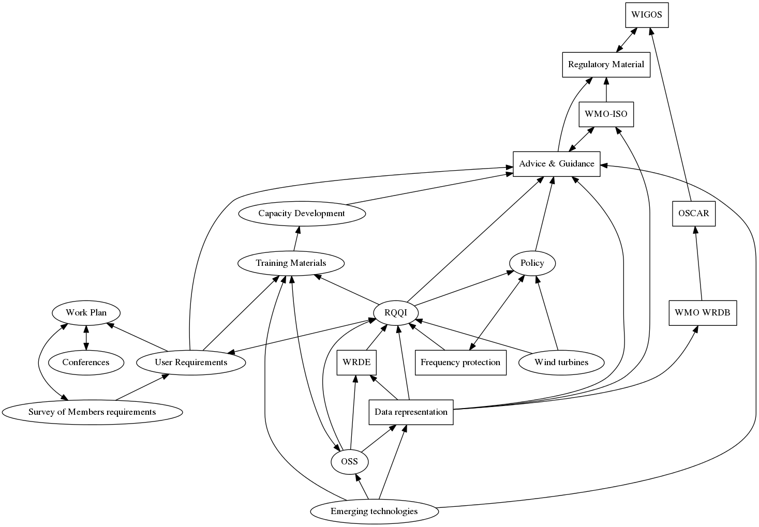
Figure 1. Visualization of how the IPET-OWR tasks interrelate. Boxes indicate things that already exist, or that can be considered achievements. Ellipses indicate means to such ends. A couple of boxes (WIGOS, OSCAR) have been added to illustrate relationships with important WMO activities.
__________

