Guidance on the Replacement of Mercury-Based and Obsolete Meteorological Instruments

Table of content

1 Introduction 3

2 Process for transition from mercury-based and obsolete instruments to modern alternatives 4

2.1 General 4

2.2 Identify instruments to be replaced 4

2.3 Available alternative instruments 5

2.3.1 General remarks 5

2.3.2 Temperature 6

2.3.3 Pressure 14

2.3.4 Humidity 26

2.3.5 Surface wind measurement 33

2.3.6 Precipitation 37

2.3.7 Sunshine recorder 40

2.3.8 Evaporation 43

2.4 Possible transition paths 46

2.4.1 General considerations for choosing a transition path 46

2.4.2 Replacement of instruments using manual readings and data logger 50

2.4.3 Replacement of instruments using automatic weather stations (AWS) 51

2.5 Requirements for different transition paths 52

2.5.1 Requirements and procedures of operation, maintenance and calibration 53

2.5.2 Qualifications of personnel to do the maintenance and calibrations 53

2.5.3 Local specifications in developing countries 53

2.5.4 Cost-effectiveness and adequate spare parts 54

2.5.5 Risks encountered in transition process 54

2.6 Define the roadmap for the transition 55

3 Disposing of Mercury based instruments 55

4 Summary and Conclusion 56

5 References 57

# Introduction

Mercury-in-glass instruments have a long history of use in meteorological observing networks and in calibration laboratories especially for the measurement of temperature, pressure and humidity. As these instruments provided an excellent performance of stability and accuracy they have been the main reference for several decades. In the last years, concerns have been growing about the health and safety risks, such as glass breakage and the potential for mercury poisoning. *Mercury is a very toxic substance, which has serious effects on both human health and the environment.* Due to its high volatility and rapid vaporization into air, mercury spills are an inhalation hazard that could reach central nervous system, lungs and kidneys. Symptoms include shortness of breath, depression and dyspnoea.

In 2013, The United Nations Environment Programme (UNEP) agreed on the “Minamata Convention on Mercury” at the fifth session of the Intergovernmental Negotiating Committee on mercury in Geneva.. This Convention is a global treaty to protect human health and the environment from the adverse effects of mercury. It entered into force on 16 August 2017. (<http://www.mercuryconvention.org>).

As per the Convention, the National Meteorological and Hydrological Services (NMHS) are strongly encouraged to take appropriate measures to move away from the use of all instruments containing mercury. This includes the several obsolete and unserviceable meteorological instruments that are still in use in meteorological observing networks and in calibration laboratories as a reference standard for calibration of field meteorological instruments. Due to difficulties of regular maintenance and recalibrations related to these instruments, they also need to be replaced by appropriate alternatives.

Electronic and digital technologies are the most promising alternatives for mercury based and obsolete instruments. They can provide an economical, accurate and reliable solution with significant advantages in terms of data storage, sampling rate and real-time data display. As an additional benefit, deployment of Automatic Weather Stations (AWSs) can be considered as an alternative to manned stations or for stations in remote areas as well. It is important to note that there is a necessity that AWS meets the necessary requirements and must gather reliable meteorological data.

The purpose of this document is to provide guidance on possible transition path for WMO Members and other providers of meteorological measurement data from the use of mercury-based and obsolete instruments to newer methods. Meteorological and metrological aspects covered in this document should ensure homogeneity of data series and sustainability of measurements. While some examples of successful transition should encourage users to implement transition plans as soon as possible. This document also intends to provide guidance for the safe disposal of the removed mercury-based instruments.

# Process for transition from mercury-based and obsolete instruments to modern alternatives

## General

There are many opportunities to find suitable ways to replace a dangerous or obsolete instrument and transition to a modern alternative. An appropriate solution depends on many factors, examples of these include stakeholder requirements, the meteorological and climatic conditions of the country, the specific local conditions, the qualifications of staff and, the existing economic situation. Therefore it is not possible to define a general solution and transition path that could be applicable everywhere. This guidance should provide support to network managers in organizing a process for transition to alternative instruments. Sections 2.2 and 2.3 deal with the identification of instruments to be replaced and available alternatives. In sections 2.4 and 2.5 different transition paths and their specific requirements and aspects are discussed. At the end of this chapter, in section 2.6, recommendations for defining a roadmap for the transition are shown.

Further information on instruments and observing methods necessary for a transition process can be found in the Guide to Meteorological Instruments and Methods of Observation (WMO-No. 8, also known as the CIMO Guide). In addition, other WMO regulatory and guidance material, for example Manual on WIGOS, Guide to WIGOS, IOM reports, could also provide additional support for a successful transition. Details on companies selling meteorological instruments can be explored on the HMEI webpage, <http://www.hmei.org/>

## Identify instruments to be replaced

The main guideline to identify instruments that need to be replaced includes; inability to be maintained due to a lack of replacement or spare parts, the ban of mercury-based instruments, difficulties meeting the specifications of WMO, and the inability to calibrate. The list below shows various instruments that can be considered as instruments that need to be replaced, arranged by parameter type.

Temperature measurements:

1. Mercury-in-glass thermometers
2. Thermographs
3. Mercury-in-glass soil thermometers

Pressure measurements:

1. Mercury-in-glass barometers
2. Barographs

Humidity measurements:

1. Mercury-in-glass psychrometers
2. Hygrographs

Other measurements:

1. Anemographs
2. Rain gauge recorders (Udographs)
3. Sunshine recorders with glass sphere (Campbell-Stokes)
4. Classic evaporation pans and tanks with hookgauge or fixed-point gauge

## Available alternative instruments

### General remarks

Instruments for measuring pressure, temperature, humidity, wind, precipitation and other meteorological parameters should be carefully chosen. Most of modern alternative instruments are electronic instruments and require a power supply and a communication link with options to transmit information from data-loggers or AWS to a central data base or cloud base.

The following issues may be taken under consideration in the process of selection alternative instruments:

The following issues may be taken under consideration in the process of selection alternative instruments:

* Technical specifications of instruments should be considered, such as response time of the sensor, stability and its reliability, and long term drift. Specifications should compy with information in the CIMO Guide (WMO No. 8), annex 1.E, “Operational measurement uncertainty requirements and instrument performance” for the variables most commonly used in synoptic, aviation and marine meteorology, and in climatology.
* Not all new instruments and emerging technologies have the required reliability or specifications, which are verified during calibration. There can be some other factors that may contribute to their incompatibility. (e.q.improper instrument’sexposure).
* Radiation shields used for temperature and humidity measurements may have many different designs, especially in the case of a thermometer screen (such as Stevenson screen). It is recommended that these alternative instruments and shields are tested by the user first, to check their compatibility with existing system, inter-comparison tests prior to replacement can avoid inhomogeneous data series in the future. Some results of intercomparisons of different shields in test beds and reports on instrument performance have been published on WMO web site.
* In the case of using automatic weather stations or data loggers for data collection, archiving and transmission, several aspects need to be considered: programming the interrogation time or observation time, choosing a communication protocol, and what principles of calculating aggregated values and data transmission should be included. The decision making process should be performed very carefully and address the differences in instrumentation type, measurement methods, data processing, data control, communication interface and also issues related to calibration and maintenance of the instruments.
* Instruments to be used in harish environemnt and extreme wather conditions have to be specified very carefully. (E.g. in Africa, SW Pacific, colder regions, etc.)

Usage these recommendations can improve consistency in the measurements of the weather parameters. An application of the device may contain conformity to a recognized standard and this can eliminate the need to review the actual testing of the device for those aspects addressed by the standard. In some cases, conformance with recognized standards may not always be a sufficient basis for decisions of selecting alternatives.

To keep with established standards, efforts will be made to harmonize requirements with those of other countries wherever possible by using internationally accepted standards as in the suggestions and recommendations from the CIMO Guide (WMO No. 8). Assurance of conformity can provide effectiveness and reliability for meteorological and metrological aspects of the alternative instruments addressed by the recommended standard.

Most meteorological instruments are in continuous use, meaning that immediate repair or adjustment is not always possible at some sites. Accordingly, a simple, strong structure along with easy operation and maintenance are important factors. A robust structure is especially important for instruments installed outdoors. Although the equipment used for such units may be expensive, they offer better observation results at lower cost in the long run.

### Temperature

A wide variety of thermometers are available on the market based on various technologies with different specifications which can be used in many applications. Instruments in the following list are arranged from the most recommended to the least:

* Platinum resistance thermometer
* Thermistor
* Integrated semiconductor circuit
* Alcohol-in-glass thermometer
* Thermocouple
* Bimetallic thermometer

Although bimetallic instrument is considered as obsolete, it can still be used as backup in some cases.

#### Platinum resistance thermometer

A platinum resistance thermometer (PRT) is a thermometer constructed from a high purity platinum element (wire-wound coil or thin film) placed in a tube of metal or glass and sealed with an inert atmosphere and/or mineral insulator. Two, three, or four leads are connected to the element and are used to provide for the measurement of the electrical resistance which changes as a function of temperature. These thermometers have positive temperature coefficients (PTC) and their output is extremely linear producing very accurate measurements of temperature. The most commonly used is the Pt100 type, which has a standard resistance value of approximately 100Ω at 0°C. Electrical current needs to pass through this resistive device to monitor the resulting voltage and derive resistance. When a 4 wired connection is used, the length of connecting wires has no impact on temperature measurements.

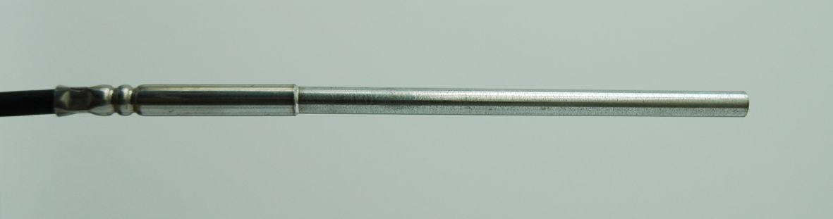

Figure 1: Platinum Resistance Thermometer

**Advantages:**

* high accuracy, high reproducibility, low hysteresis and low drift,
* wide temperature range (–260°C to 1000°C),
* stable over time,
* relatively easy to perform measurements,
* relatively easy to be calibrated,
* 4 wire connection eliminates the influence of connecting wires.

Disadvantages:

* may become unstable due to impurities, water penetration , mechanical and thermal stress,
* electrical error in case of measurements with 2 or 3 wires,
* thermal leaks,
* Shallow slope (i.e. 0.4Ω/°C for a PRT100)

#### Thermistor

A thermistor (THERM-ally sensitive res-ISTOR) is a special type of resistor which changes its physical resistance when exposed to changes in temperature. Thermistors are generally made from ceramic materials such as oxides of nickel, manganese or cobalt coated in glass which makes them easily damaged. Most types of thermistors have a Negative Temperature Coefficient (NTC) of resistance which means their resistance value decreases with an increase in the temperature. Thermistors are non-linear devices and their standard resistance values at room temperature are different for different thermistors. This is mainly due to semiconductor materials that thermistors are made from. Thermistors are generally connected in series with a suitable biasing resistor or used with a series resistor such as in a voltage divider network or Wheatstone Bridge type arrangement. The current obtained in response to a voltage applied to the divider/bridge network is linear with temperature. Then, the output voltage across the resistor becomes linear with temperature.

The most common range of temperature is between 0 °C and 100 °C or (-90 to 130 °C).

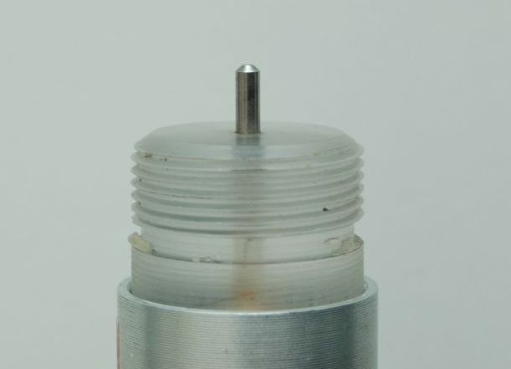

Figure 2: Thermistor

Advantages:

* highly sensitive, provide fast responses which can be done in seconds,
* low cost and easy to use,
* small and usually accurate within interval from ± 0.05 % to ± 0.02 %,
* high resistance negates the need for a four-wire bridge circuit,

Disadvantages:

* subject to large drifts at higher temperatures,
* high non-linearity, if not compensated,
* a source of error is due to the self-heating effects produced by an excessive bias current, during powering up.

#### Integrated Semiconductor Circuit

The integrated circuit temperature sensors offer another alternative for temperature measurement. The advantages of integrated circuit silicon temperature sensors include wide choices of output formats and ease of installation in the PCB assembly environment. There are various types of integrated circuit sensors, but the most common are analog output devices, digital interface devices and remote temperature sensors. Some integrated silicon sensors include extensive signal processing circuitry, providing a digital I/O interface for the microcontroller.

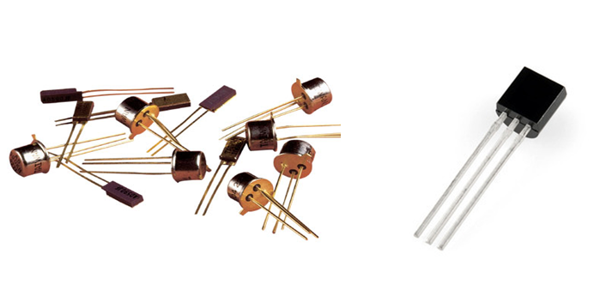

Figure 4: IC Temperature Sensors

<https://www.indiamart.com/proddetail/temperature-sensors-12903417462.html>   
<http://sea.omega.com/ph/pptst/AD590.html>

Advantages:

* good sensitivity,
* linear output, no curve fitting,
* direct reading of temperature on some analog devices,
* various communication interfaces,
* low power consumption,
* easy to interface with other electronics for display and control.

Disadvantages:

* wide variation in accuracy between different models,
* self heating,
* requires power supply,
* limited configuration.

#### Alcohol-in-glass thermometer

The alcohol-in-glass thermometer has similar properties as mercury-in-glass thermometer. The ethanol version is the most widely used due to its low cost, and relatively low safety hazard in case of breakage.

The liquid used can be pure ethanol, toluene, kerosene or Isoamyl acetate, depending on manufacturer and operational temperature range. The range of the thermometer is set by the boiling point of the liquid used. In the case of the ethanol-filled thermometer, the upper limit for measurement is 78 °C. Ethanol-filled thermometers are used in preference to mercury for meteorological measurements of minimum temperatures, down to −70 °C. However, the measurement temperature range −200 °C to 78° C, is highly dependent upon the type of alcohol used.

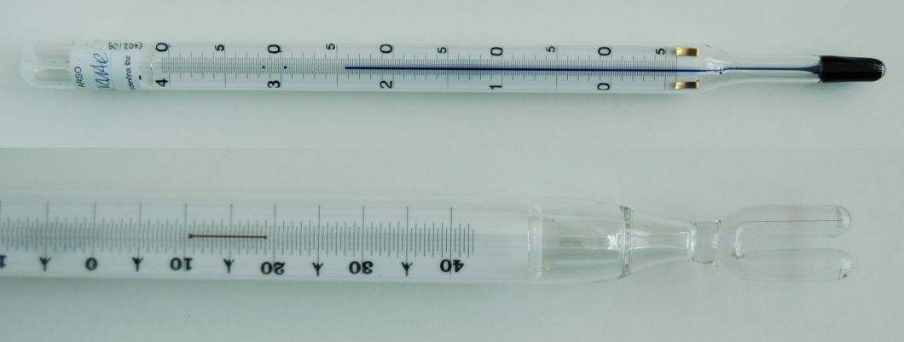

Figure 5: Alcohol Thermometer

Advantages:

* no power source required,
* repeatable,
* easy to use, and low price,
* less toxic and hazardous than mercury-in-glass thermometers,

Disadvantages:

* cannot be digitised or automated,
* careful handling is required,
* adhesion on glass,
* it is colourless so it must be given dyestuff in order to be visible,
* low accuracy.

#### Thermocouple

Thermocouples are frequently used in industry due to its wide operational range (-200°C to 2000°C), simplicity, ease of use and their speed of response to changes in temperature, mainly due to their small size. Due to their disadvantages they are usually not used in meteorological applications.

Advantages:

* robust, immune on shock and vibration,
* fast response,
* small,
* low thermal capacity,
* no self-heating effects.

Disadvantages:

* complex signal conditioning: substantial signal conditioning is necessary to convert the thermocouple voltage into a usable temperature reading,
* low accuracy: in addition to the inherent inaccuracies in thermocouples due to their metallurgical properties, a thermocouple measurement is only as accurate as the reference junction temperature can be measured, typically within 1 °C to 2°C,
* sensitive to corrosion,
* susceptibility to noise (microvolt signal levels).

#### Bimetallic thermometers

Bimetallic thermometers are made up of bimetallic strips formed by joining two different metals having different thermal expansion coefficients. The bimetallic strip is in the form of a cantilever beam. An increase in temperature will result in the deflection of the free end of the strip. This deflection is linear and can be related to temperature changes. It can be attached to the pointer of a measuring instrument, or a position indicator. The bimetallic strip senses strain in proportion to temperature changes. It is usually bulky, slow, and vulnerable to mechanical and electrical interference for most applications. Bimetallic thermometers can be recording thermometers affixing a pen to the pointer and record readings to a chart. Bimetallic strips often come in very long sizes. Hence, they are usually coiled into spirals which make them compact and small in size. This also improves the sensitivity of bimetallic strips towards little temperature variations.

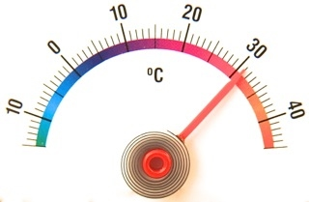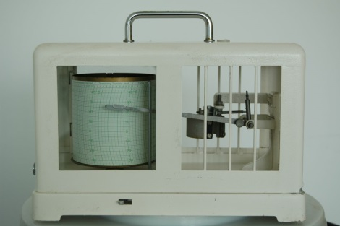

Figure 6: Bimetallic Strip Thermometer and Thermograph

<https://sites.google.com/site/coleccionguillermocrovetto/home/instrumentos-diversos/termmetro-regwell>

Advantages:

* power source is not required,
* robust, easy to use and simple,
* relatively low price.

Disadvantages:

* low accuracy, low resolution, low repeatability,
* limited to applications where manual reading is acceptable.,
* not suitable for very low temperatures because the expansion of metals tend to be too similar, so the device becomes a rather insensitive thermometer,
* large hysteresis.

Table 1: Typical characteristics of some alternatives to mercury-based thermometers***

|  |  |  |  |  |  |  |  |  |
| --- | --- | --- | --- | --- | --- | --- | --- | --- |
|  | **Usage**  **(AWS, manual)** | **Range\*\*** | **Accuracy** | **Response time** | **Linearity** | **Stability** | **Calibration** | **Cost** |
| **Platinum Resistance** | AWS, or  manual with digital display | - 260°C to 1000°C | Depends on Class: ±0.15°C typical or better | 30s to 120 s typical | Linear over wide operating range | Good to excellent | Easy to calibrate | Moderate to expensive |
| **Thermistor** | AWS, or  manual with digital display | -90°C to 130°C | ±0.1°C to  ±0.2°C | 5 s | Poor but can be compensated | Fair to good | Easy to calibrate when linearized | Low to moderate |
| **IC Sensor** | AWS, or  manual with digital display | -55°C to +150°C | ±0.3°C typical | 4s to 60s | No linearization required | Long term stability, 0.1°C/month typical | Easy to calibrate | Inexpensive |
| **Alcohol-in-glass** | Manual | −200°C to 78°C | ±0.2°C typical | 100 s | Linear | Fair | Easy to calibrate | Inexpensive |
| **Thermocouple** | AWS, or  manual with digital display | –200°C to 2500°C | ±0.2% of full scale, ±0.2°C to ±0.25°C | <5 s , | Fair and can also be compensated | Fair to  Excellent | Hard to calibrate if not linearized | Low to moderate |
| **Bimetallic** | Manual, automatic recording by graph | -40°C to 500°C | Less accurate  ±1% full-scale accuracy, ±0.5°C over most of the range used | 2-4 minutes | Linear | Poor;  ±0.5°C to ±1.0°C/yr. | Easy to calibrate, Requires frequent calibration | Inexpensive |
| **Mercury Thermometer\*** | Manual | -37°C to 356°C | ±0.05°C to ±0.5°C depending on design | 2 to 3 minutes | Linear | Good | Easy to calibrate | Expensive |

* Mercury is banned due to the Minamata Convention and to be phased out by 2020: <http://www.mercuryconvention.org/Convention>

** Ranges given above are the limits for each of the thermometer but for all fits within range for meteorological applications.

*** The table contains information on typical values of instrument’s properties, based on the available literature. Cross reference must also be considered from WMO No. 8, Guide to Meteorological Instruments and Methods of Observation, under Annex 1D, Operational Measurement Uncertainty Requirements and Instrument Performance.

#### Selecting appropriate thermometer

The choice of a thermometer type to be used in meteorological applications is based on the purpose of use and the type of observation station but must follow the recommendations from the CIMO Guide (Part I, Chapter 2). The most frequently used instrument for a meteorological observation system is a platinum resistance thermometer, which is recognized by many of its excellent metrological properties. Other alternative thermometers are also acceptable and used for different meteorological observations: thermistors, integrated semiconductor circuit, alcohol-in-glass and bimetallic thermometers. Bimetallic sensors are used when accuracy is not as critical, but trends are to be observed. However, thermocouples are not often encountered in meteorological observation systems.

#### Soil thermometers

The instruments for soil temperature could be found in many designs starting from platinum resistance thermometers, thermistors, thermocouples and mercury in glass (obsolete partial immersion mercury thermometer, used inside tubes that are anchored in the desired soil depths).

##### Electric thermometers:

The electrical signals transmitted from the sensors to the datalogger.

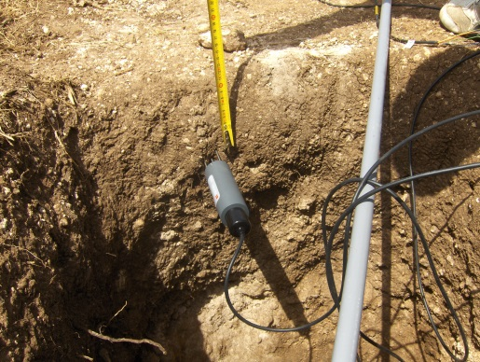

Figure 7: Soil temperature measurement

Advantages:

* designed for harsh, corrosive environments,
* fast response time,
* wide temperature measurement range,
* higher accuracy.

Disadvantages:

* Require more space for all levels of measuring.

##### Temperature profiler

The profiler could consist, for example, of a rigid probe assembly. The rigid probe assembly maintains the precise position of the temperature points within the profile, while protecting the temperature sensors in all mediums for the long-term. The sealed probe assembly permit to be used in soils for soil temperature profiling.

Advantages:

* small spacing for all levels of measuring,
* lifetime min/max temperature recording,
* low power,
* long-term stability of measurements.

Disadvantages

* slightly less accurate than other electric thermometers,
* water intrusion can occur.

### Pressure

Most pressure sensors, as alternatives to mercury barometers, operate on the principle of converting a pressure change into a mechanical displacement or deformation. Deformation of the sensing element may be converted into an electrical signal that is processed by the measuring system. Some types of sensors are available that can be used for the measurement of atmospheric pressure as in the following:

* Variable Capacitance (Capacitive)
* Piezo-resistive (Strain Gauge)
* Piezo-electric
* Resonant
* Optical
* Electromagnetic
* Variable Reluctance
* Potentiometric
* Mechanical Pressure Sensors

#### Variable capacitance (Capacitive)

Capacitive pressure sensors use the electrical property of capacitance to measure the displacement of a diaphragm. The diaphragm is an elastic pressure sensor displaced in proportion to changes in pressure. It acts as one plate of a capacitor which detects strain due to applied pressure to become a variable capacitor. The change in value of the capacitance causes this electrical signal to vary. This is then conditioned and displayed on a device calibrated in terms of pressure. Common technologies use metal, ceramic and silicon diaphragms.

Compared to piezo resistive pressure sensors, they have increased pressure sensitivity, decreased temperature sensitivity, low power consumption, low hysteresis, excellent repeatability, tremendous resolution and superior long-term stability. It uses capacitive measurement technology to guarantee unrivalled precision, speed, temperature stability and power consumption

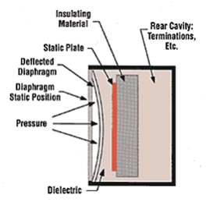

Figure 9: Capacitance Pressure Sensor

<http://www.ni.com/white-paper/3639/en/>

Advantages:

* resistant to mechanical and thermal shocks,
* long term stability (typically 0.01%/yr),
* excellent hysteresis and repeatability characteristics,
* low temperature dependence.
* low power consumption,
* unmatched accuracy for laboratories and industry,
* linear response,
* ideal for low and high-pressure applications,
* good frequency response.

Disadvantages:

* an increase or decrease in temperature to a high level will change the accuracy of the device
* relatively high price.

#### Piezo-resistive (Strain Gauge)

Piezo-resistive effect is a change in electrical resistance in response to mechanical strain. By placing the piezo-resistive material (either semiconductor or metal) around a hermetically sealed cavity, changes in pressure apply varying amounts of strain on the material resulting in differing amounts of electric current, which is used to interpret pressure

Usually, the output voltage of this piezo-resistive pressure sensor is small in magnitude so that this output must be amplified to increase the signal to noise (S/N) ratio and provides an output that is used in microprocessor system.

.

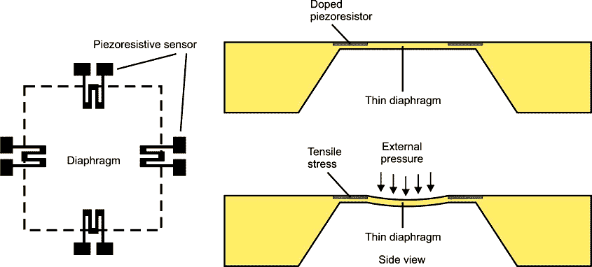

Figure 10: Piezoresistive Pressure Sensor

<http://www.radiolocman.com/review/article.html?di=148185>

Advantages:

* high sensitivity (> 10mV/V),
* good linearity at constant temperature,
* ability to track pressure changes without signal hysteresis,
* low-cost sensor fabrication opportunity,
* various sensitivities can be obtained.

Disadvantages:

* nonlinear dependence of the full-scale signal on temperature, large initial offset (up to 100% of full scale or more),
* strong drift of offset with temperature,
* within limits, these disadvantages can be compensated with electronic circuitry.

#### Piezo-electric

The piezo-electric (PE) material is a crystal that produces a differential tension proportional to the pressure applied on its faces: quartz, Rochelle salt, barium titanium, tourmaline, and several other naturally occurring crystals generate an electrical charge when strained. This material cumulates electric loads in certain areas of its crystal structure, when they suffer physical deformation by the action of a pressure. Unlike strain gauge transducers, PE devices require no external excitation. Because their output has a very high impedance and their signal levels are low, they require special signal conditioning such as charge amplifiers and noise-treated coaxial cable.

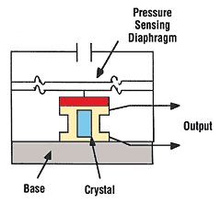

Figure 11: Piezo-electric Pressure Sensor

<http://www.ni.com/white-paper/3639/en/>

Advantages:

* fast response,
* linear relation between electric load and the pressure applied.

Disadvantages

* susceptible to noises,
* due to their dynamic nature they do not perform solid state pressure measurement,
* sensitive to shock and vibration,
* may exhibit large changes of sensitivity with temperature variations if not properly compensated.

#### Resonant

It measures the change in frequency of a resonant circuit usually using a quartz, or sensors have been made out of vibrating wire, vibrating cylinders, silicon micro electromechanical systems (MEMS), or ceramic piezo-electric device as the mechanical resonator integrated with a pressure-sensitive structure, such as a diaphragm. Under an applied pressure the structure deforms inducing a shift in the natural frequency of the mechanical resonator. Resonant sensors are attractive because they offer a high sensitivity, high resolution, excellent long term stability and low hysteresis, all of which lead to a high accuracy. It features long-term stability as the resonant frequencies are mainly determined by the intrinsic material properties and geometrical parameters. The frequency output signal has the advantage of high immunity to noise and interference.

Advantages:

* high sensitivity, high resolution and low hysteresis,
* excellent long term stability,
* high immunity to noise and interference,
* high accuracy.

Disadvantages:

* high cost,
* high sensitivity to temperature but can be compensated.

#### Electromagnetic

It measures the displacement of a diaphragm by means of changes in [inductance](https://en.wikipedia.org/wiki/Inductance) (reluctance) as in Linear Variable Differential Transformer (LVDT), [Hall Effect](https://en.wikipedia.org/wiki/Hall_Effect), or by eddy currentprinciple.

The LVDT type is an electro-mechanical device that produces an electrical output that is linearly proportional to the displacement of a moveable core. It consists of a primary coil with two secondary coils placed on either side of the primary coil. A rod-shaped soft magnetic core inside the coil assembly provides a path for the magnetic flux linking the coils. To form a pressure transducer, the core displacement of the LVDT is produced by the movement of a metallic pressure responsive diaphragm.

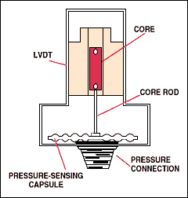

Figure 13: Linear Variable Differential Transformer (LVDT)

<http://www.sensorsmag.com/components/fundamentals-pressure-sensor-technology>

In LVDT pressure sensors, the limits of accuracy are defined by the diaphragm (pressure-responsive element).

Advantages:

* the transducers possess high sensitivity,
* low hysteresis and hence repeatability is excellent under all conditions,
* they have infinite resolution,
* they are simple, light in weight and easy to maintain,
* low power consumption (<1W),
* frictionless device,
* tolerant to shocks and vibrations.

Disadvantages:

* sensitive to stray magnetic fields but shielding is possible,
* inherently low in power output, or the dynamic response is limited mechanically by the mass of the core and electrically by the applied voltage,
* temperature affects the performance transducer,

#### Variable Reluctance

The variable reluctance sensor is strain-based, wherein a magnetic circuit is formed, and the parameter input causes mechanical deflection of the spring member as a function of pressure, force, or acceleration.

To provide a static output capability, variable reluctance sensors require an oscillator and demodulator system, internally limiting operational temperatures from -40 C  
to +120 C.

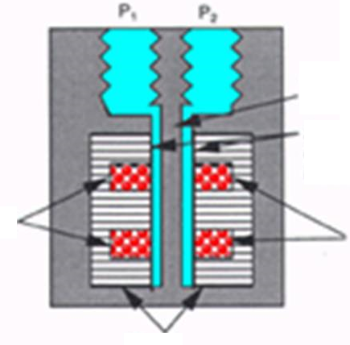

Spring Member

Stainless Steel

(Low Magnetic susceptibility)

Media Interface barriers

Coils

E Coil forms

Coils

Figure 14: The Variable Reluctance Differential Pressure Sensor

<http://www.sensorland.com/HowPage012.html>

Advantages

* wide temperature range,
* low sensitivity to shock and vibration,
* measurement of very low pressures,
* low power consumption,
* fast dynamic response,

Disadvantage

* low cost of the transducer is increased by the cost of the additional signal-processing circuitry needed to recover a useful signal.

#### Potentiometric

It uses the motion of a wiper along a resistive mechanism to detect the strain caused by applied pressure. The wiper of a potentiometer is connected to a diaphragm, a Bourdon tube or cell (capsule or bellows) so that the deformation of this sensing element causes a displacement of the wiper. For reliable operation the wiper must bear on the element with some force, which leads to repeatability and hysteresis errors. These devices are very low cost and are used in low-performance applications.

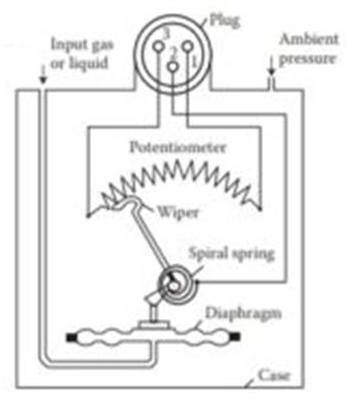

Figure 15: A rotary potentiometric pressure sensor

<http://transducersensors.com/potentiometric-sensor-applications/>

Advantages

* high output signal level,
* low cost,
* technological robustness,
* adaptable to many applications.

Disadvantages

* high hysteresis,
* sensitive to vibrations,
* moving contact: wear, contact resistance,
* low accuracy.

#### Aneroid Barometer Sensors (mechanical)

The motion created by the sensing element in mechanical gauges are read directly or through amplifying mechanisms to a dial or pointer. There are some newer designs that still perform well such as aneroid barometers. However, low accuracy of these sensors may be the reason for the mechanical sensors decline to obsolescence. These devices are typically seen in low-performance applications.

An aneroid barometer device is composed of a hollow metal casing that has flexible surfaces on its top and bottom. Atmospheric pressure changes cause this metal casing to change shape, with mechanical levers augmenting the deformation in order to provide more noticeable results. The level of deformation can also be enhanced by manufacturing the sensor in a bellows design. The levers are usually attached to a pointer dial that translates pressurized deformation into scaled measurements or to a barograph that records pressure change over time. Aneroid barometer sensors are compact and durable, employing no liquid in their operations. However, the mass of the sensing element limits the device’s response rate, making it less effective for dynamic pressure sensing.

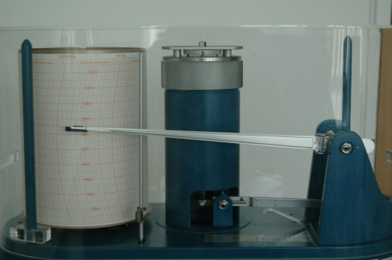

Figure 16: Aneroid Barograph

Advantages:

* easily portable,
* low weight,
* adaptable to recording,
* easy transportation.

Disadvantages:

* low accuracy needs frequent calibration (annual or biannual),
* sensitive to temperature and hysteresis.

#### Bourdon Tube (mechanical)

Although they function according to the same essential principles as aneroid barometers, bourdon tubes employ a helical or C-shaped sensing element instead of a hollow capsule. One end of the bourdon tube is fixed into connection with the pressure, while the other end is closed. Each tube has an elliptical cross-section that causes the tube to straighten as more pressure is applied. The instrument will continue to straighten until fluid pressure is matched by the elastic resistance of the tube. For this reason, different tube materials are associated with different pressure ranges. A gear assembly is attached to the closed end of the tube and moves a pointer along a graduated dial to provide readings. The amount by which the tube moves in relation to the pressure applied to it depends on factors including its material, shape, thickness, and length. Compared to other elastic pressure sensors the deflection produced by Bourdon tubes is large.

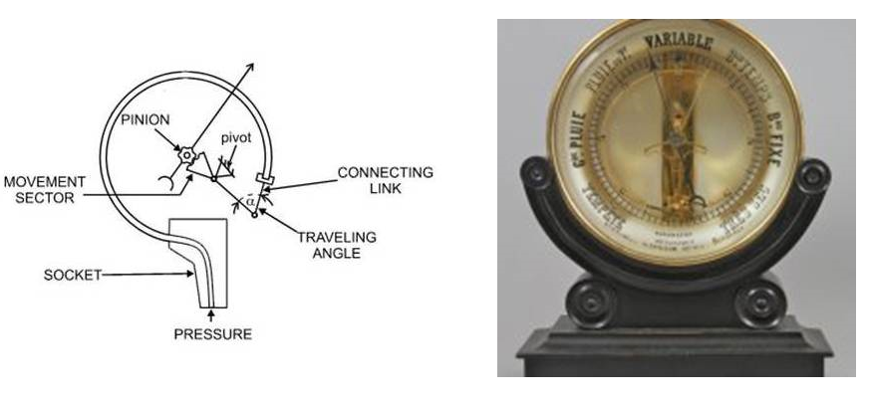

Figure 17: Bourdon Tube Sensor and Barometer

<http://4mechtech.blogspot.com/2014/05/c-type-bourdon-tube.html>  
<http://www.antique-clocks.com/php/details1Eng.php?ItemNummer=1717>

Advantages:

* cheaper in cost and simple in construction,
* availability over wide range of pressure,
* high sensitivity and good repeatability,
* good accuracy especially at high pressure but except at low pressures,
* adaptable design for obtaining better electrical outputs.

Disadvantages:

* prone to shock vibration and shock resistance,
* slow response to changes in pressure,
* larger hysteresis,
* it cannot be used for precision measurement.

Both aneroid barometer and bourdon tube can be converted from mechanical to electrical signal output.

Table 2: Mercury barometer comparisons with alternative pressure sensors**

|  | **Usage (AWS or manual)** | **Range\*\*** | **Accuracy** | **Response time** | **Linearity** | **Stability** | **Calibration** | **Cost** |
| --- | --- | --- | --- | --- | --- | --- | --- | --- |
| **Variable**  **Capacitance** | AWS; and/or  Manual with digital display | 500hPa – 1100hPa Depends on application and construction | ±0.1hPa to ±0.2hPa | 2 sec | Can be made  linear | 0.01%/yr,  or 0.1hPa/yr | Easy to calibrate | Relatively higher price |
| **Piezo-resistive** | AWS; and/or  Manual with digital display | 600hPa - 1100hPa  Depends on application and construction | ±0.1 hPa to ± 0.5 hPa @ 20°C;  Can be made for high accuracy | <1 sec to < 200 msec | Good linearity at constant temperature | ±0.1hPa/year;  Good but strong drift of offset with temp. | Easy to calibrate | Low-cost |
| **Piezo-electric** | AWS; and/or  Manual with digital display | 600hPa - 1100hPa | ±1% FSO | Quick response | Practically linear | ±1% FSO | Easy to calibrate | Low-cost |
| **Resonant** | AWS; and/or  Manual with digital display | 500hPa - 1100hPa,  Depends on design | ±0.05hPa  to ±0.1hPa,  High accuracy | <5 sec. | Can be made linear | <100 ppm/year,  Long term | Easy to calibrate | High cost |
| **Electro-magnetic** | Can be designed for AWS, or for manual with digital display | Depends on  design and  application | <±1.0% FS | Quick response | Good | ±0.5% FS/yr | Easy to calibrate | Low-cost but offset by additional  circuitry |
| **Variable**  **Reluctance** | Can be designed for AWS, or for manual with digital display | 550Pa to 22MPa, Depends on application | ± 0.25% to ±0.5% FS | 0.1 msec to 0.5 msec | usually linear | 0.1% FS/yr Limited by characteristics of materials | Easy to calibrate | Low-cost but offset by additional  circuitry |
| **Potentiometric** | Usually for manual with analog or digital display | 35 KPa to 70 MPa, Depends on application and construction | 0.5% and 1% of full scale, not including drift and the effects of temperature. | Limited by friction | Depends on sensor and friction | Low | Needs frequent recalibration | Low-cost |
| **Aneroid** | AWS; and/or  Manual with analog, or digital display | 890 hPa - 1050 hPa, depending on brand and design | ±0.15 to ±2.5 hPa, depending on brand | Affected by friction of mechanism | Non-linear but can be compensated | Subject to unpredictable drift | Easy to calibrate but needs frequent recalibration (1-2 years) | Cheaper in cost but higher in price on certain brand |
| **Bourdon Tubes** | Manual with analogue display | Depends on design for barometer;  Mostly for industrial use,  0->7MPa | Typical +2% of span | Poor response time due to friction and design of mechanism | Non-linear but can be compensated | Subject to unpredictable drift | Easy to calibrate but needs frequent recalibration | Cheaper in cost on certain construction |
| **Mercury Barometer \*** | Manual | Depends on application,  500hPa – 1050hPa typical | ±0.01hPa to ±0.1hPa | Fairly good | Good | Long term | Not easy to calibrate | expensive |

* Mercury is banned due to Minamata Convention and to be phased out by 2020. <http://www.mercuryconvention.org/Convention>

** The table contains information on typical values of instrument’s properties, based on the available literature. Cross reference must also be considered from WMO No. 8, Guide to Meteorological Instruments and Methods of Observation, under Annex 1D, Operational Measurement Uncertainty Requirements and Instrument Performance.

#### Selecting appropriate barometer

This guidance gives the background knowledge required to understand and compare the different technologies in an easy-to understand and clear way. Selection of a barometer involves consideration of the compatibility with the user’s specification. Manufacturer's specifications usually can help in the selection of the right barometer to be used. General WMO recommendations on pressure measurement can be found in the CIMO Guide, Part I, Chapter 3.

In order to be able to make a proper selection of a suitable alternative barometer, users should have knowledge about the physical principles of pressure measurement, the advantages and disadvantages of different sensor technologies and the key basics of instrument technology.

Due to the wide range of technologies available, pressure instruments vary considerably in their design, performance, and cost. Every technology has its own benefits and reasons for selection. Mechanical transducers have largely been abandoned because of their obsolete metrological characteristics and lack of digital real time readout. They are still used for basic applications at the lower end of the economic spectrum, or as backup for an electronic barometer.

Bridge-based or piezo-resistive sensors are relatively simple and low-cost instruments. They are commonly used barometers due to simple construction and durability. Capacitive and piezo-electric pressure sensors are generally stable and linear and temperature compensated. Capacitive barometers are widely used in meteorological applications. Piezo-electric sensors respond quickly to pressure changes. Due to their superior dynamic performance, piezo-electric sensors are the least cost-effective and you must be careful to protect their sensitive crystal core.

Conditioned sensors are typically more expensive because they contain components for filtering and signal amplification, excitation leads, and the regular circuitry for measurement. Non-conditioned pressure bridge-based sensors require hardware signal conditioning.

The selection of the suitable barometer is based, among other things, on such characteristics and criteria as:

* Pressure range
* Required measurement accuracy
* Stability and high reliability
* Temperature compensation
* Digital output signal and communication interface
* Self-Diagnostics
* Easy installation and calibration
* Maintenance periods
* Allowing upgrades
* Transient protection, without power supply polarity
* Price
* Electrical connection, etc.

### Humidity

Most widely used humidity instruments especially in automatic weather stations are based on the electrical capacitance and electrical resistance type. But the traditional instrument being used for the measurement of relative humidity is the dry and wet bulb psychrometer, which is made of liquid of mercury as the sensing element but now can be replaced with electronic thermometers. Other liquids like ethyl alcohol can be used as the sensing element but is not as good as mercury, specifically with the speed of response. Since mercury-based instruments have to be replaced, alternative instruments have to be established in order of accuracy similar or better than the mercury-based psychrometers. Dew point (chilled-mirror) hygrometer is also presented although is more frequently used as standard in calibration laboratories. Here are most common alternative instruments listed:

* Electrical capacitance
* Electrical resistance
* Dry and wet bulb platinum resistance thermometer (PRT)
* Dew point hygrometer (chilled-mirror)
* Hair hygrometer

General WMO recommendations on humidity measurement can be found in the CIMO Guide, Part I, Chapter 4.

#### Electrical capacitance

Capacitive hygrometers consist of a ceramic substrate usually glass, ceramic, or silicon on which a thin film of polymer is deposited between two conductive electrodes. The sensing surface is coated with a micro porous metal electrode, allowing the polymer to absorb moisture while protecting it from contamination and exposure to condensation. As the polymer absorbs water, the dielectric constant changes incrementally and is nearly directly proportional to the relative humidity of the surrounding environment. Thus, by monitoring the change in capacitance, relative humidity can be derived.

They are characterized by a low temperature coefficient, ability to operate at high temperatures, good linearity, low hysteresis, fast response time, full recovery from condensation and high chemical resistance.

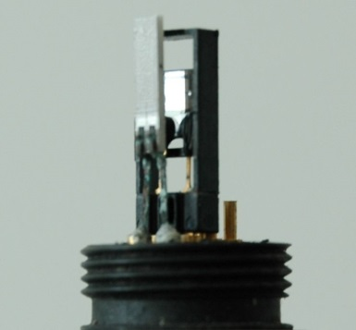

Figure 19: Capacitive RH sensor

The capacitive humidity sensors provide a digital output that allows for easy integration to semiconductor circuit. For example, a monolithic signal conditioning circuitry integrated onto the substrate. The most widely used signal conditioner incorporates a complementary metal-oxide semiconductor (CMOS) timer to pulse the sensor and to produce a near-linear voltage output.Their good long-term stability is very well perceived and the cutting-edge low energy consumption makes it the right choice for any application. Capacitive sensors can also be made as ultra-small digital humidity sensors. The typical uncertainty of capacitive sensors is ±2% RH from 5% to 95% RH.

Advantages:

* typical measurement uncertainty of 2% to 3% RH,
* high chemical resistance,
* low drift,
* wide temperature range,
* good long term stability,
* resistance to condensation,
* fast recovery time.

Disadvantages

* sensitive to contamination in harsh environment,
* need periodic recalibration to accommodate [hysteresis](http://encyclopedia.che.engin.umich.edu/Pages/ProcessParameters/HumidityMeasurement/Hotspot/Hysteresis.html) and contamination,
* accuracy is temperature depended
* prolonged exposure to relative humidity over 85% can cause inaccuracy in readings,
* condensation may form on the sensor and corrupt the measurement when exposed to humid environment. .

#### Electrical resistance

Resistive humidity sensors measure the change in electrical resistance of a hygroscopic medium such as a conductive polymer, salt, or treated substrate.

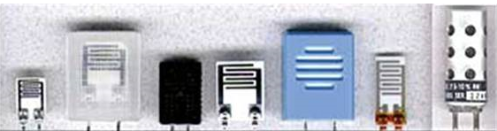

Figure 21: Resistive Humidity Sensors

<http://www.sensorsmag.com/components/choosing-a-humidity-sensor-a-review-three-technologies>

Resistive sensors are less sensitive than capacitive sensors – the change in material properties is less, so they require more complex circuitry. The resistance change is typically an inverse exponential relationship to humidity.

The material properties also tend to depend both on humidity and temperature, which means in practice that the sensor must be combined with a temperature sensor. Temperature compensation is incorporated for better accuracy. The accuracy and robustness against condensation vary depending on the chosen resistive material. Robust, condensation-resistant sensors experience accuracy up to ±3% RH.

Advantages:

* typical measurement uncertainty of 3% RH,
* low cost,
* good long term stability,
* response time typically of the order of a few seconds.

Disadvantages:

* suitable for measuring relative humidity between 15% and 95%,
* contamination and operation in saturation conditions both cause drift,
* should not be exposed to conditions of 100% humidity as the resulting condensation may damage the device.

#### Dry and wet bulb PRT

One of the alternatives is electronic hygrometer where platinum resistance thermometers are used as dry and wet bulb thermometers in a psychrometer. Uncertainty of temperature measurement with the platinum resistance thermometers can achieve 0.1°C level.

Psychrometric charts are usually valid at the “standard” barometric pressure and require a correction at other pressures. This can be corrected using direct calculation associated with the software used and a digital display can be provided. Results of measurements can be recorded using data logger. From the maintenance standpoint, proper handling and frequent maintenance are major requirements of the wet and dry bulb technique.

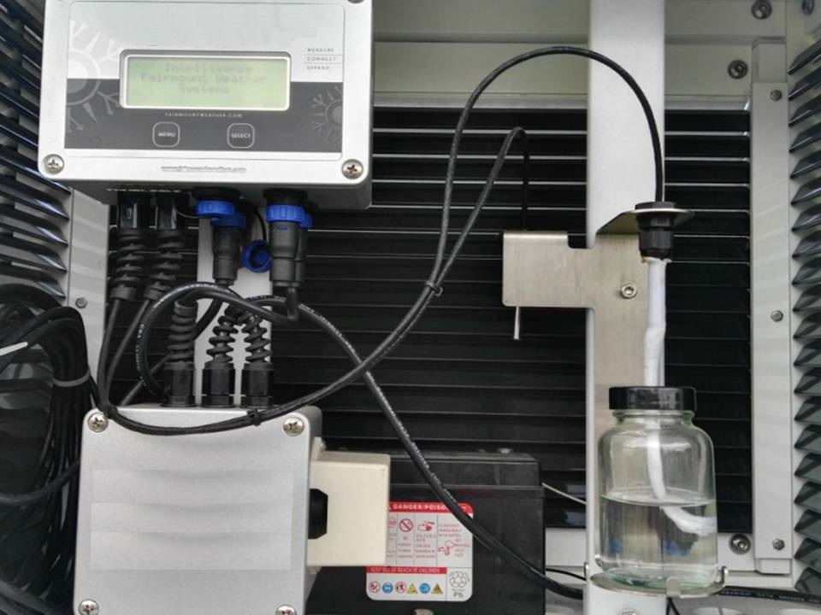

DRY-Bulb

WET-Bulb

Figure 23: Dry and Wet-Bulb PRT

Advantages:

* simple and fundamental measurement,
* good stability, if operated correctly and consistently,
* tolerates condensation without damage,
* digital display and data recording can be provided with the use of microcontroller, data logger and its associated software.

Disadvantages:

* requires training and skill to use and maintain,
* results must be calculated but direct calculation through digital display can be provided,
* requires a large air sample,
* requires pure water supply and regular sock check.

#### Dew point hygrometer (Chilled-mirror)

Dew point is the temperature at which a sample of humid air (or any other water vapour) at constant pressure reaches water vapour saturation. At this saturation temperature, further cooling results in condensation of water in the form of water droplets or ice crystals. Chilled mirror hygrometers are some of the most precise instruments available. They use a chilled mirror and optoelectronic mechanism to detect condensation on the mirror's surface. The temperature of the mirror is controlled by electronic feedback to maintain a dynamic equilibrium between evaporation and condensation, thus closely measuring the dew point temperature.

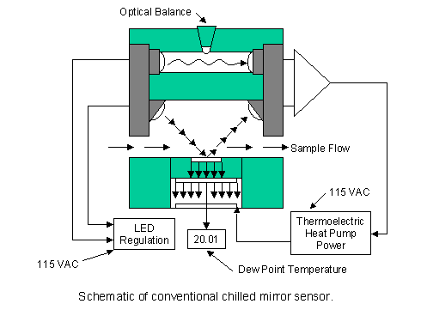

Figure 24: The chilled mirror sensor that measures dew point temperature directly.

<http://www.thunderscientific.com/tech_support/support_docs/set-up-cal1.html>

Temperature data is received from a PRT (platinum resistance thermometer) embedded directly beneath the chilled mirror surface. The PRT is very tightly thermally coupled to the mirror surface, in order to minimize measurement error. An accuracy of 0.1 °C is attainable with these devices, which correlates at typical office environments to a relative humidity accuracy of about ±1.2%. These instruments need frequent cleaning of mirror surface, a skilled operator and periodic calibration to attain these levels of accuracy. Even so, they are prone to heavy drifting in environments where smoke or otherwise impure air may be present.

More recently, spectroscopic chilled-mirrors have been introduced. In these techniques, the dew point is detected using a spectroscopic detection, ascertaining the nature of the condensation. This method avoids many of the pitfalls of the previous chilled mirror hygrometres and has been shown to be able to operate drift free

Advantages:

* high accuracy,
* high repeatability,
* wide dew point range,
* low hysteresis,
* low drift,
* resistant to chemical vapours.

Disadvantages

* sensitive to impurities,
* more complex, may be more expensive,
* narrow flow rate range,
* periodic cleaning may be required.

#### Hair hygrometer

This type of hygrometer uses animal or human hair mounted in clusters as sensing elements. Keeping the hair under tension increases the sensitivity of the hair to change in humidity, temperature, thus a direct change in the length of the hair can be measured by using a dial or scale. The tips of each hair are bundled together and held in position using a screw. Any change in atmospheric temperature and humidity will change the length of each hair connected to an array of levers wired to a recording device. In response to change in humidity, hair expands or contracts which displaces the movement of a hook. The movement of each hair is magnified which provides measurement of relative humidity.

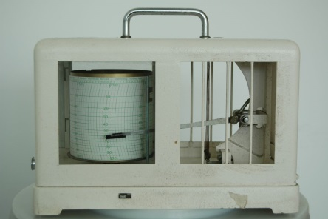

Figure 25: Hygrograph

Advantages:

* no electrical power needed,
* simple operation.

Disadvantages:

* rapid changes in humidity magnify the errors recorded by the dry-hair hygrometer,
* hair samples can become damaged due to continuous tension,
* low accuracy,
* large hysteresis,
* long term drift,
* low sensitivity.

#### Selecting appropriate hygrometer

A large variety of hygrometers are available on the market. The task of selecting the most suitable humidity sensor from a cost and performance standpoint is not an easy one. The range of humidity sensors available extends from a large variety of polymer sensors, to chilled mirror dew point hygrometers.

Resistive and capacitive sensing technologies each offer distinct advantages. Both sensors are interchangeable, usable for remote locations, provide wide RH range and cost effective. Capacitive sensors provide wide RH range and condensation tolerance, and are also interchangeable.

The most widely used types of humidity sensors are the polymer-based relative humidity sensor. The chilled mirror hygrometer offers one of the widest range and highest precision humidity measurements. The polymer relative humidity sensor is much less expensive and is adequate for a large category of day-to-day environmental measurements.

(If there are any suggestions)

Table 3: Comparison of Mercury dry and wet bulb psychrometers with alternative methods**

|  |  |  |  |  |  |  |  |  |
| --- | --- | --- | --- | --- | --- | --- | --- | --- |
|  | **Usage (AWS, or manual)** | **Range\*\*** | **Accuracy** | **Response time** | **Linearity** | **Stability** | **Calibration** | **Cost** |
| Electrical Capacitance | AWS, or manual with digital display | 0 – 100%RH | ±1% - ±5%RH | fast response  <50 ms | Near linear | ±1%RH/yr | Easy to calibrate | Low price |
| Electrical Resistance | AWS or  manual with digital display | 15 – 95%RH | ±3% - ±10%RH | Few seconds, 5 s without filter | Poor but can be compensated | ±3%RH/yr | Easy to calibrate | Low price |
| Dry and wet bulb PRT | AWS or  manual with digital display | 0 – 100%RH | ±2% - ±5%RH | medium | Good | ±0.5 to 1%RH/yr | High degree of calibration | Expensive |
| Dew point hygrometer (Chilled-mirror) | Manual with digital display | 5 – 100%RH | ±1.2%RH, or ±0.15°C for dew point | slow to fast | Linear | Better than 1.5°C dew point drift/yr | Easy to calibrate | Expensive |
| Hair hygrometer | Manual | 0 – 100%RH | ±5%RH if treted carefully | 5 minutes | Non-linear but can be compensated | up to 10%RH/Yr | hard to calibrate | Inexpensive way to obtain a week’s record for hygrograph |
| Mercury dry and wet bulb psychrometers * (Sling or Assmann) | Manual | 0 - 100%RH | ±0.2°C | slow response, depending on construction | Linear | ±1%RH/yr | Easy to calibrate | Medium to high cost |

* Mercury is banned due to Minamata Convention and to be phased out by 2020. <http://www.mercuryconvention.org/Convention>

** The table contains information on typical values of instrument’s properties, based on the available literature. Cross reference must also be considered from WMO No. 8, Guide to Meteorological Instruments and Methods of Observation, under Annex 1D, Operational Measurement Uncertainty Requirements and Instrument Performance.

### Surface wind measurement

Wind speed and direction can be measured with a variety of instruments mounted generally into arm at the top of a 10 m mast above ground level. CIMO Guide n°8, Part I, Chapter 5 and IEC 61400-12-1 standard accommodate more details of the use of wind sensors.

#### Cup anemometer and vane for wind direction

A cup anemometer consists of three or four cups, conical or hemispherical in shape, mounted symmetrically about a vertical spindle. The wind blowing into the cups causes the spindle to rotate. The rate of rotation is proportional to the speed of the wind.

Wind direction is measured by a vane consisting of a thin horizontal arm carrying a vertical flat plate at one end with its edge to the wind and at the other end a balance weight which also serves as a pointer. The arm is carried on a vertical spindle mounted on bearings which allow it to turn freely in the wind.

Mechanical anemometers require calibration in a wind tunnel covering operational range. However, alternative method as functional test of electronic and bearings may be additionally applied using anemometers drive. Functional test do not replace calibration in wind tunnel.

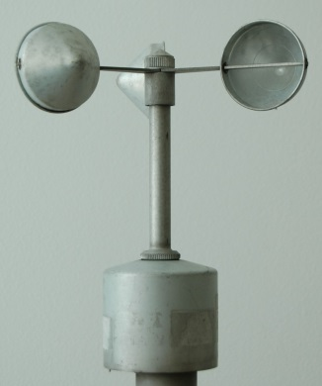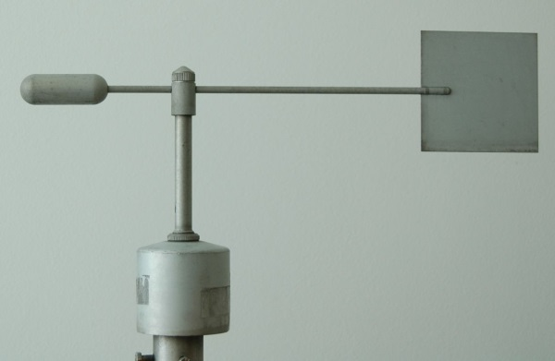

Figure 26: Cup and vane anemometer

Advantages:

* low cost alternative,
* easier to maintain (e.q. head or bearing replacement).

Disadvantages:

* requires regular maintenance and calibration; especially in harsh environment,
* limitations of the mechanical moving parts of wind systems in start up torque or to register a rapid change in wind speed,
* potential problems with icing in cold environment,
* no self-diagnostics available.

#### Ultrasonic wind sensor

Operating without moving parts, the instrument measures the speed of acoustic signals transmitted between two transducers located at the end of thin arms. Measurements from two or three pairs of transducers can be combined to yield an immediate and precise measurement of wind speed and direction.

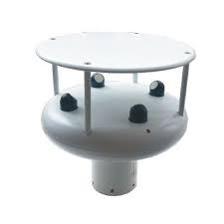

Figure 27: Ultrasonic anemometer

encrypted-tbn0.gstatic.com/images?q=tbn: ANd9GcQpBfmRjuKb2Q8dQMV8dH4YetjI8D1D1UUp83AGSNEDPwd-sinPng

Advantages:

* require less maintenance,
* have longer life cycles than traditional cup and vane sensors,
* better in terms of response to gusts,

no threshold: measurements starts form 0m/s,

* possible 3D wind speed and direction measurements,
* excellent accuracy,
* no movable parts.

Disadvantages

* distortion of the air flow by the structure supporting the transducers is a problem which can be minimized by applying corrections based on calibrations in a wind tunnel.
* instruments may need to be protected against bird attacks (i.e. use of bird repelling techniques)

#### Acoustic resonance anemometers

Acoustic resonance anemometers are more recent version of sonic anemometer using resonating acoustic (ultrasonic) waves within a small purpose-built cavity in order to perform their measurement. Built into the cavity is an array of ultrasonic transducers, which are used to create the separate standing-wave patterns at ultrasonic frequencies. As wind passes through the cavity, a change in the wave’s property occurs (phase shift). By measuring the amount of phase shift in the received signals by each transducer, and then by mathematically processing the data, the sensor is able to provide an accurate horizontal measurement of wind speed and direction.

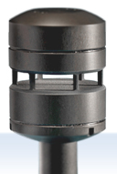 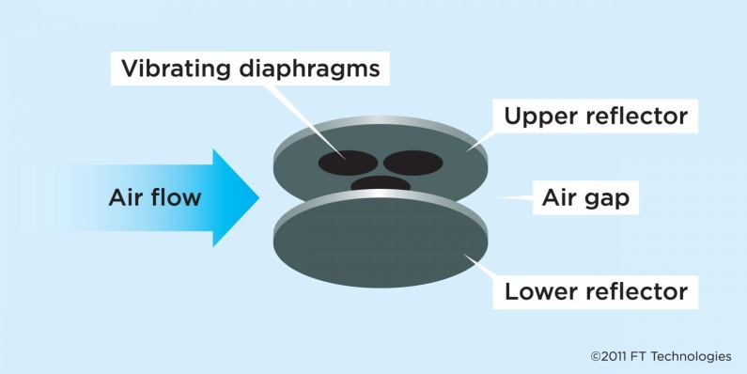

Figure 28: acoustic resonance anemometer

[www.web190654.clarahost.co.uk/ufiles/image/Wind%20Sensors](http://www.web190654.clarahost.co.uk/ufiles/image/Wind%20Sensors)

Advantages:

* robust sensor that require less maintenance,
* wind direction accuracy independent of speed,
* small size of acoustic resonance anemometers makes them physically strong,
* very good response to gusts,
* easy to heat and resistant to icing,
* typically smaller in size than other sensors,
* low power consumption when operating without heating.

Disadvantages:

* low accuracy when compared to a calibrated ultrasonic sensor,
* low wind direction accuracy.

Table 4: Comparison of wind sensors

|  |  |  |  |  |  |  |  |  |
| --- | --- | --- | --- | --- | --- | --- | --- | --- |
|  | **Use in AWS, or manual** | **Range\*\*** | **Accuracy** | **Response** | **Linearity** | **Stability** | **Calibration** | **Cost** |
| mechanical wind systems  (cup and vane sensors) | M /AWS | 0-75 m/s  0-360° | ±0.2m/s to 1m/s  ±3° | Low response to sudden wind changes | Linear | Good | Easy to calibrate | Medium to high cost |
| Ultrasonic sensors | AWS | 0-75 m/s  0-360° | ±2% | <50 ms | Linear | Good | wind tunnel | Medium to high cost |
| Acoustic resonance wind sensors | AWS | 0-75 m/s  0-360° | ±4% | <50 ms | Linear | Good | wind tunnel | Medium to high cost |

#### Selecting appropriate anemometer

Ultrasonic wind systems (including resonance type) present majority of market shares initially held by mechanic cup and vane anemometers All anemometer types require built-in heating systems when used in cold environment to prevent freezing. Anemometer heating systems significantly increase power consumption.

By comparing the advantages and disadvantages of each of the technologies for wind measurement, it can be found that ultrasonic systems are more suitable in standard environments where maintenance is minimized.

The use of acoustic resonance sensors is useful in extreme environments and in mobile applications where the robustness and small size of the sensor are highly appreciated and also when there is no maintenance operator capable of supervising the measurement of wind.

Conventional cup anemometer and wind vane systems are most useful if the installation site is not experiencing wind gusts and when maintenance and calibration operators are available for supervision.

### Precipitation

The resolution, sensitivity, and surface collection have to be determined ensuring a good quality of measurement. Special attention must be paid to the support rod, which must ensure stability and to avoid vibrations which usually cause large measurement errors when a strong wind is observed on the site. General WMO recommendations on precipitation measurement can be found in the CIMO Guide, Part I, Chapter 6.

#### Electric impulsion tipping bucket

Tipping buckets mechanic rain gauge recorder using manual paper recorders could easily be replaced by electric impulsion tipping bucket.

Advantages:

* good accuracy,
* simple use, installation and maintenance,
* low power.

Disadvantages

* require regular maintenance and calibration.

#### Weighing rain gauge

Particularly for demanding precise measurements, the weighing sensor rain is also a good instrument for use in cold snowy regions.

Advantages

* very good accuracy.

Disadvantages

* high cost,
* require regular maintenance and calibration.

#### Storage rain-gauge:

The gauge has a sharp brass or steel rim, with a funnel that collects rain in a narrow necked bottle placed in a removable can. To make the rainfall measurement, the observer empties the collected rain into a graduated glass rain measure.

Advantages

* good accuracy and stability,
* simple use, installation and maintenance,
* no power required,
* can be used as a manual back-up solution.

Disadvantages

* require reading by an observer,
* require manual records.

#### Rain-gauge recorder:

The rain reaches a cylinder containing a floating mechanism that rises as water enters, moving a pen on a flip chart.

When the float approaches the top, it releases a cap that causes the cylinder to tilt. When it is almost empty, the cylinder returns to its vertical position.

Advantages

* no power required,
* continuous record of precipitation.

Disadvantages

* require using by a qualified observer,
* require manual records

Table 6: Comparison of rain gauges

|  |  |  |  |  |  |  |  |  |
| --- | --- | --- | --- | --- | --- | --- | --- | --- |
|  | **Use in AWS, or manual** | **Range** | **Accuracy** | **Response** | **Linearity** | **Stability** | **Calibration** | **Cost** |
| Tipping bucket rain gauge | AWS | 0 to 100mm/h | 2% | <1 s | Near linear | Good | Easy to calibrate | medium cost |
| Weighting rain gauge | AWS | 0 to 100mm/h | 1% | <1 s | Linear | Good | Easy to calibrate | high cost |
| Storage rain-gauge | M | 0 to 60mm/h | 2% | ND | Linear | Good | Easy to calibrate | Low cost |
| Rain gauge recorder | M | 0 to 60mm/h | 5% | <1 s | Near linear | medium | Easy to calibrate | high cost |

#### Selecting appropriate rain gauge

Among the rain gauges on the market today, tipping bucket rain gauges take a great part of the market initially held by mechanic sensors in the form of storage rain gauge and mechanic rain gauge recorders.

By comparing the advantages and disadvantages of each of the technologies mentioned for rain measurement, it is found that tipping bucket rain gauges are more suitable for use with AWS in standard environments when maintenance and calibration operators are available to supervise this sensor.

The use of weighing rain gauge is useful in very cold snowy environments.

Conventional storage rain gauges are most useful as a backup solution when observers are available. This type of mechanical sensors is used when calibration and maintenance of electronic rain gauge is not ensured at regular intervals.

### Sunshine recorder

Measurement of sunshine duration can be performed with different principles: the pyrheliometric principle, the pyranometric principle, the principle of traces of burning of the heliograph, the principle of contrast and the principle of sweeping.

#### Pyrheliometer

Considered as the reference method and derived directly from the definition of the sunshine duration. The instrument must be used with a reliable solar pointer whose cost reduces the use of this method to demanding particular uses.

Advantages:

* good accuracy,
* direct link to definition of sunshine duration.

Disadvantages:

* require regular maintenance and calibration,
* high price.

#### Pyranometer

Considered as a good estimating method and used with measurement of solar global radiation which is a very important parameter.

It is possible to derive a very approximate measure of sunshine duration by applying a threshold approach to global solar radiation records obtained from pyranometers, the threshold itself usually being a function of solar angle and azimuth. A number of methods have been described in CIMO Guide n°8.

The estimation is reliable for decadal or monthly cumulations rather than for hourly and daily observation.

Advantages:

* low cost,
* associated to global solar radiation.

Disadvantages:

* require regular maintenance and calibration,
* low accuracy for hourly and daily observation.

#### Heliometer

Considered as a good sensor for precise data that does not depend on a human interpreter.

Advantages:

* medium cost.

Disadvantages:

* require regular maintenance and calibration.

#### Heliograph recorder

Sunshine recorder also called a [heliograph](https://en.wikipedia.org/wiki/Heliograph_(disambiguation)) is a device that records the amount of [sunshine](https://en.wikipedia.org/wiki/Sunlight) at a given location.

A [heliograph](https://en.wikipedia.org/wiki/Heliograph_(disambiguation)) with a sun glass sphere mounted concentrically in a section of a spherical bowl and burns line onto card, is one of the oldest instruments that is still in use in meteorological networks and recorders required a human observer to interpret the results; so recorded results might differ among observers.

Advantages:

* medium cost.

Disadvantages

* important running cost,
* require regular cleaning.

Table 7: Comparison of sunshine measurement technologies

|  |  |  |  |  |  |  |  |  |
| --- | --- | --- | --- | --- | --- | --- | --- | --- |
|  | **Use in AWS, or manual** | **Range** | **Accuracy** | **Response** | **Linearity** | **Stability** | **Calibration** | **Cost** |
| Pyrheliometer | AWS | 200 to 4000 nm | First class ISO9060 | < 2 s | Linear | Good | Easy to calibrate | Very high cost including  sun-tracker |
| Pyranometer | AWS | 290 to 2800 nm | Secondary standard ISO9060 | < 5 s | Linear | Good | Easy to calibrate | Medium to high cost |
| Heliometer | AWS | 400 to 1100 nm | ~ 90% | ~ 1 ms | Linear | Good | Easy to calibrate | Medium to high cost |
| Heliograph | M | 400 to 1100 nm | ~ 70% | Low response | Near linear | medium | difficult | Medium cost |

#### Selecting appropriate sunshine sensor

By comparing the advantages and disadvantages of each of the technologies mentioned for solar measurements, it is found that among all principles of determining sunshine duration, the pyranometric principle remains the best method in terms of quality / price ratio, because of the possibility of measuring solar global radiation and estimating sunshine duration using a simple sensor.

Pyrheliometers are more suitable for use with AWS in very demanding application and BSRN stations when maintenance and calibration operators are available to supervise this sensor.

The use of heliometers is useful in AWS where hourly and daily quantities of sunshine duration are important with high accuracy.

Conventional heliograph recorders are most useful as a backup solution when observers are available and electronic measurements are not reliable because of lake of maintenance and calibration process.

### Evaporation

Several indirect methods have been derived from point measurements or calculations developed which provide reasonable results, where direct measurements from extended natural water or land surfaces are not practicable. General WMO recommendations on evaporation measurement can be found in the CIMO Guide, Part I, Chapter 10.

#### Atmometers

Atmometers measure the loss of water from a wetted, porous surface (the Piche evaporimeter, Bellani atmometer, livingstone atmometer…). Atmometers are likely to remain useful while using a dense network of atmometers for micrometeorological studies. The use of atmometers is not recommended for water resource surveys if other data are available.

Advantages

* small size,
* low cost,
* small water requirements,

Disadvantages:

* not as accurate as evaporation Pan and tanks,
* inaccurate readings.

#### Evaporation Pan

There are several types of evaporation pans used worldwide

The Class A evaporation pan, is a cylinder with a diameter of 120.7 cm that has a depth of 25 cm). The pan rests on a levelled wooden base and is enclosed by a chain link fence to prevent from animals. Evaporation is measured daily as the depth of water evaporates from the pan. The measurement day begins with the pan filled to exactly 5 cm from the pan top. At the end of 24 hours, the amount of water to refill the pan to exactly 5 cm from its top is measured. If precipitation occurs in the 24-hour period, its amount is taken into account in calculating the evaporation.

Advantages:

* no power source required,
* no electronic associated module.

Disadvantages:

* low accuracy due to human readings errors,
* limited to applications where manual reading is possible and acceptable,
* careful handling is required.

For automation purpose sensors are equipped with high precision water level detector, which automatically measures water level variations in the evaporation pan. An interface module performs a digital wavelet filtering and delivers an output signal.

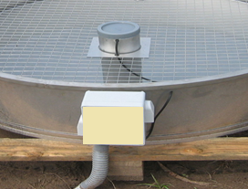

Figure 31: automatic measurement device for an evaporation pan

<http://www.cimel.fr/wp-content/uploads/2011/09>/CES188-Capteur-flotteur-module-interface.png

Advantages:

* automatization of evaporation measurements,
* high level measurement accuracy through electronic detector,
* high measure stability through automatic wavelet filtering,
* additional frequency of measurement,
* no human intervention required for measurement,

Disadvantages:

* require data logging and software analysis

Table 5: Comparison of evaporation measurement technologies

|  |  |  |  |  |  |  |  |  |
| --- | --- | --- | --- | --- | --- | --- | --- | --- |
|  | **Use in AWS, or manual** | **Range** | **Accuracy** | **Response** | **Linearity** | **Stability** | **Calibration** | **Cost** |
| Classic evaporation pan with hook gauge | M | 0 – 100 mm | 2% for > 5 mm  0,1 mm  for <5mm | ND | Linear | Good | Easy to calibrate | Medium to high cost |
| Atmometers | M | 0 – 100 mm | 0.1 mm | ND | Linear | Good | Easy to calibrate | Low cost |
| Automatic evaporation pan | AWS | 0 – 200 mm | 2% for > 5 mm  0,1 mm  for <5mm | Few seconds | Linear | Good | Easy to calibrate | Medium to high cost |

#### Selecting appropriate evaporation instrument

The estimation of evaporation can be derived from observations of air temperature, humidity, wind speed and global radiation. However, if direct measurement of evaporation is needed several atmometers are available with limited degree of automatization and accuracy.

Choosing an automatic Class A evaporator is the best way to perform accurate measurement in various time steps. If there is no efficient automatic system for the acquisition and processing of observed data, a Class A evaporation tank with a mechanical hook gauges can be used.

## Possible transition paths

Surface based meteorological observations are widely expanding due to several reasons: emerged new technologies which become affordable for many users, enhanced data transmission paths, increased requirements for environmental data processing (e.q. early warning). Transition from manual to automatic observation is a requirement facing majority of meteorological services. The purpose of this chapter is to address issues which must be challenged during the planning and implementation of the transition. The efficiency of the transition strongly depends on the representativeness of locations, selection of instruments and training processes on network maintenance which will derive efficient AWS’s management and data quality. AWSs provide benefits in frequent, regular, objective and consistent measurements however, human observers may still be needed for visual observations, cloud classification and weather type identification.

### General considerations for choosing a transition path

Several aspects should be considered before introducing automatization: extend of transition, management of transition process, resource requirements, benefits and drawbacks of the transition and capabilities of personnel.

In choosing a transition path, a decision tree may help on its implementation (see Figure 32). The process starts with the determination of the number of stations and their locations for the replacement of mercury-based and obsolete instruments with alternative ones. Availability of stable power supply and communication network in the selected locations must be considered first.

Most appropriate solution is stable power supply with backup battery which may withstand shortage of power. If power supply is unstable use of a regulated power supply to correct the fluctuation of electric source is required. If power supply is not available a rechargeable battery reliant on solar power is an alternative. This method must charge it during daytime and has enough reserve time, even when the duration of sunshine is not present, of a week or more.

Another parameter to be considered at the location is the presence of a communication network. Common communication platforms can be used: landline, mobile, radio and satellite. Where landlines are already available, they are generally a robust, low cost, low power communication solution. Both land lines and mobile communication are a reasonable, manageable solution in populated areas, but limited, to non-­existent in remote location, where the service could be poor. Satellite communication is an increasingly viable option due to the extensive global coverage, in particular in remote areas, where setting up ground based communication systems is not possible or cost prohibitive. When selecting the communication platforms several parameters must be taken into account:

* frequency of data transmission,
* size and format of the data,
* one or two way communication,
* redundancy, where possible.

The use of one or two way communication platforms, is an important decision for the reliable operation of the system. Two way communication may improve the data availability and reduces maintenance costs as it allows remote access to functionalities of the AWS (e.g. performance diagnostics, error analysis, upgrades of program version, downloads, synchronization of transmission ...)

Members should determine if the location of the instruments at a station is in agreement with the CIMO guidelines. Members may consider them as special stations according to the different purpose like agriculture or for urban stations which do not fully comply with WMO guidelines.

The extension of the transition is an important issue to be addressed. Many different possibilities are available and combinations possible:

* to retain manually operated stations and to replace mercury-based and obsolete instruments with alternatives,
* to transit from manually operated stations to partially automatic stations,
* to transit from manually operated stations to fully automatic stations,
* to transit from partially automatic stations to fully automatic stations,
* to transit from obsolete automatic stations to modern, fully automatic stations.

The choice of transition to certain network type depends on many factors including the network purpose, the proximity of weather stations, availability of trained employees and short/long term funding.

Determination of number of stations and locations

Station type

**Replacement of mercury based   
and obsolete instruments**

Availability of power supply

Availability of communication platforms

Station classification

Electric power with backup battery

Solar panel with backup battery

Land lane

Cellular ((GPRS,…)(GPRS…)

Radio transceiver

Satellite

Standard station

Special station

Fully automatic

Partial automatic

Manual station

Figure 32: Replacement of Mercury-based and obsolete Instruments

A variety of instruments for manually operated stations directly indicate the measurement on digital or analogue display (s. Figure 33). These are mostly proprietary products and there is no need of a data logger.

The difference with manually operated station and partially automatic station is in interface with the display or monitor. Usually, there is a need of signal conditioning unit from the sensors to the display circuits, or between the data logger and the monitor. In partially automatic stations the data logger will automatically archive the data at its regular measurements which may be programmed, or fixed as in proprietary products and internal to the device. Depending on the users, partially automatic stations may not need communication network to automatically transmit data to central data server. Data loggers must have the capacity to store a predetermined quantity of reportable data and information, covering, at the most, the period between two scheduled maintenance visits.

Selection of sensors for own automatic stations depends on the manufacturer’s designs and specifications. There are examples of data loggers on the market today which also act as signal conditioner and microcontroller aside from its main function (data storage) and can connect sensors of different manufacturers. Other accessories that must be integrated will be the modem for communication network, solar charger controller, battery, etc.

Many commercial automatic stations are available on the market and the selection depends on usage and purpose. Take note of the CIMO Guide compliance for the exposure of the instruments.

Select microcontroller-data logger and other accessories for own automatic station

Manual station

Partially automatic station

Fully automatic station

Selection of alternative instruments

Selection of display (digital or analogue)

Selection of alternative instruments for partial automatic station

Selection of alternative instruments for fully automatic station

Selection of data logger

Instrument integration to own automatic station

Selection of commercial automatic station

Figure 33: Selection of manual, partially automated or fully automated stations

Recommendation is to test samples of alternative instruments first. Procedure includes instrument calibration to verify if required specifications are met. According to Global Observing System (GOS) manual (WMO No. 544, Vol. 1), section 3.2.4, the testing of parallel measurements of new and old instruments is recommended with adequate overlap is at least two (2) years. Other problems that may occur can be attributed on the exposure of the instruments and other factors (e.g. using different radiation shields in temperature sensors). Members can use experiences from other already transitioned Members and published reports.

### Replacement of instruments using manual readings and data logger

Replacement of the traditional manual instruments like liquid-in-glass thermometers, psychrometers, mercury based barometers and instruments with chart recorders are becoming obsolete due to the advent of digital technology. Manual readings which are usually of the analogue types have been replaced by easy to read instruments in either LED or LCD display.

More sophisticated device is the data logger. They are generally small, battery powered, portable, and equipped with a microprocessor (microcontroller), internal memory for data storage and sensors for specific use. Some data loggers interface with a personal computer, and use software to activate the data logger and view and analyse the collected data, while others have a local interface device (keypad, LCD) and can be used as a stand-alone device. Some dataloggers will incorporate both methods, i.e. have both a software and an local interface. Electronic data loggers have replaced chart recorders in many applications.

Advantages:

* Measures analogue and digital sensors
* Memory can accommodate many days, or even months and years, of unattended recording
* Set up easily with PC software or local interface
* Programmability and multiple general purpose I/O
* Graphs and tables of results can be produced automatically by the data logging software
* Communicate from anywhere when using cellular or satellite peripheral
* Can be Internet ready with integrated options or required add-ons
* Network wirelessly to another node or Internet gateway with integrated radio option
* Short-range, wireless IP communication
* Connects with standard communication protocols
* Stand-alone device, no need to have a person present
* Can be installed in harsh and/or remote locations
* Battery-backed clock (internal to the datalogger) that ensures accurate time is maintained
* Readings are taken and recorded at exact time
* Improved accuracy due to a reduction of human error.
* May include integrated battery solar charge regulator
* Multiple sensor readings can be taken quickly

Disadvantages

* The main disadvantage of using a data logging system is the initial cost of purchasing the equipment.
* If the data logging equipment experience failures or malfunctions, some data could be lost or not recorded.
* If there is a fault it may go unnoticed for a long time.
* Equipment could break down or give false readings.
* Improper installation and programming could introduce errors in observations.
* Cost of communication systems can be high.

### Replacement of instruments using automatic weather stations (AWS)

Many conventional weather station (CWS) networks are being gradually replaced by automatic weather stations (AWS) in the developed and developing countries.

General benefits of introducing AWSs include standardized or uniform, more frequent observations free of subjective errors, selection of remote or inhospitable locations, observations made outside working hours and a reduction of personnel costs. The use of AWS network increased rapidly during the 1980s due to improvements in battery-powered data loggers and computer communications. Although CWS networks continue to provide basic climate information, AWS networks have the ability to collect and disseminate greater quantities of data at more frequent intervals. Instrument calibration and regular maintenance are of utmost importance to assure good quality of observational data. The data is transmitted to the large networks either via land lines, cellular phone, radio or, in remote areas, via satellite. As such, automatic stations are now the primary surface-weather-observing network in many regions.

Other variables can be measured with modern technologies:

* sky condition: cloud height and amount (clear, scattered, broken, overcast)
* visibility (to at least 15 km), as well as fog or haze
* type of precipitation
* wind gusts

sunshine duration, and possibly other radiances (visible, infrared, snow equivalence, leaf wetness, duff moisture, ice detection,...)

In the estimation of cloudiness, there is an important difference between human and AWS observations: a person takes a look at the entire sky at the measurement time, whereas a ceilometer continuously looks up (to the zenith) and integrates over time to estimate cloudiness.

Advantages

* 24/7 real-time continuous measuring of parameters;
* Standardization of observations in terms of quality and time;
* Better accuracy and resolution;
* Better reliability and consistency;
* Automatic data archiving available;
* Adjustable sampling and reporting interval;
* Free of subjective observer’s errors;
* Automatic quality control procedures applied;
* Automatic message generation and transmission;
* Access to archived data locally or remotely;
* Data collection in harsh climates;
* Accurate measurement of current weather conditions for a particular location and surrounding;
* AWS can be installed in sparsely populated areas;
* Digital data transfer from an AWS to a central computer eliminates human errors;
* Ability to record meta-data

Disadvantages:

* Some parameters are difficult to automate (e.g. cloud cover and type);
* AWS requires a large capital investment;
* Requires periodic routine maintenance;
* Requires well trained maintenance technicians;
* May introduce data inhomogeneity, if not properly corrected, compared to old data series;
* Has a large power requirement

## Requirements for different transition paths

To assure effective control of sets of processes relating the transition to modern automatic instruments and system, the operational procedures needs to be established and implemented. In this context, the leadership shall be aware of the importance of transition process in their observation network. To help improve management the following steps are recommended:

Management:

1. To establish well described and documented processes related to the transition to modern automatic instruments and system. The descriptions identify responsible persons and their activities and also documentation and information flow.
2. To nominate person(s) for interaction with instrument distributor regarding technical aspects: instrument calibration and maintenance, preventive actions needed, data management, communication platforms, etc.. Person should also be responsible for building metadata database.
3. To provide equipment and training the personnel identified in point 2.
4. To develop schedule of foreseen regular interactions with instrument distributor and to prepare and schedule regular maintenance inspections at observational sites.
5. To fully support capacity building activities to develop its own good quality service. WMO guidance material and capacity building such as training, publications and technical advice.

Technical issues:

1. To calibrate and maintain in good condition alternative instruments, to perform tests, routine checks, training and related activities in their laboratories.
2. To keep and maintain a set of spare parts (instruments) or accessories such as batteries, solar panels, data logger and sensors. At least 5-10% of instruments should be available in stock as a back-up in case of failures or recalibration.
3. To setup a portable set of instruments to be used as a “travelling standard” for filed inspections at observational site.
4. Develop standard operating procedures that describes work processes typical for upgraded observation generation of alternative instruments.

### Requirements and procedures of operation, maintenance and calibration

One of the important components to ensure sustainability of AWS network are the processes related to maintenance of the network: preventive, corrective maintenance and instruments calibrations. Preventive maintenance refers to regular scheduled activities in the observational network devoted to ensure data quality. Corrective maintenance are the activities needed when failure or malfunction occurs related to instruments, power and communication. Calibrations of instruments are activities which ensure traceability of measured data. Several possibilities are available for traceability assurance and details can be found in CIMO Guide Part I, Chapter 1.

Other requirements are:

* Standard exposure of the sensors
* Measuring ranges and uncertainty requirements
* Sufficient power supply especially in remote areas. The use of solar power to charge the battery during daytime is necessary to prevail for longer period without charging.
* Training on maintenance and AWSs setting-up.
* Communication system must be compatible with the present system or can be upgraded to a more reliable system. Use of satellite technology can be an alternative.
* Documentation for the maintenance and calibration so changes can be recorded.
* Remote validation of data is required.
* Meta data: documentation on instruments and intervention in the network.

### Qualifications of personnel to do the maintenance and calibrations

Usage of alternative instruments has facilitated the qualification of meteorological observers to those easy to read and display on screen with continuous and automatic recording of the measured data. However, maintenance and calibration challenges have become more cumbersome and require a higher level of qualification especially in electronics, communication technique and automation. Performance, reliability and consequently data quality and availability depend on the skills of the maintenance personnel:

* certain requirement in education should be, preferably, from technical courses
* sufficient training of personnel is needed.
* capability to perform tests, and calibrations
* training at all levels of personnel not only employed in maintenance and calibration section may also be needed so as to have qualified alternative personnel.

### Local specifications in developing countries

A lot of NMHS in developing countries face serious problems in different tasks of meteorological measurement. This ranges from technical knowledge, quality management and financial aspects.

Serious problems are affecting the resources for operation and maintenance of equipment. That includes the unstable power supply which suffers from an irregularity and a lack of reliability. A solar panel power supply associated with rechargeable batteries could be a good alternative in most cases.

Lack of spares affect the continuity of measurements, while arrangements for importation from manufacturers can take time and incur additional costs. It's strongly recommended to ensure the supply of spares will be available on time.

Local qualified technicians are also a big challenge, so it's strongly recommended that appropriate systems be selected and training should be conducted preferably by manufacturers before delivery.

### Cost-effectiveness and adequate spare parts

Many factors need to be considered: investment price of the alternative instruments: the costs of disposal of mercury-containing instruments and the education of staff (users, maintenance and calibration operators), also use of consumable items (batteries …).

Alternative electronic instruments become economically more attractive taking into account the number of broken mercury based instruments every year and the fact that these direct reading instruments require recorders to fill the measurement between two readings. Instruments are out dated and require a considerable operating cost because of the use of diagrams and mechanical or electrical clocks;

Costs of training on the use and operation of measurements becomes less important due to the simplification of readings and computer processing of measurements but the cost of maintenance training is slightly increased due to the need for more qualification in the electronic field.

Assurance of long term sustainability also requires regular investments in adequate spare parts in order to guarantee continuity in measurements.

### Risks encountered in transition process

The transition to AWS is often instigated by a perception that AWSs observations are cheaper to operate and easier to manage than human observers. This was not the experience of a number of member countries. Therefore, it identifies a number of responsibilities and costs that may not be immediately apparent to those that adopt automatic systems.

The lack of local trained personnel and resource availability to manage the instrumentation, together with the risks associated with the safety of the equipment in remote and possibly insecure areas, represent the most relevant constraints.

Costs of maintenance, calibration and operating expenses for an AWS network could outweigh the initial purchase expense, so these expenses should be kept in mind before planning the siting and installation of an AWS network. It is mandatory to evaluate this aspect to avoid useless investments by lack of subsequent network management, maintenance, calibration, and training.

Donation of equipment by outside agencies could impose the risk of insufficient consultation with NMHS beforehand. NMMSs should well prepare for challenges related to observation automation otherwise the sustainability of the project is endangered.

## Define the roadmap for the transition

A successful replacement of mercury based, obsolete and unserviceable instruments entails:

1. Involve stakeholders in the planning and implementation of the phase-out of dangerous and obsolete instruments.
2. Conduct or update an inventory to determine the quantity and location of dangerous and obsolete devices.
3. Choose the alternative solution, validate it with stakeholders and approved it by management.
4. Implement procedures of storage and clean-up of mercury containing devices.
5. Processes a pilot phase of trial alternative solution and after receiving feedback from stakeholders identify the final appropriate solution
6. Develop a budget for replacement within a phase-in schedule taking into account a period of at least two years of parallel measurement by the both old and new systems, at least in some pilot locations.
7. Conduct training activities related to the phase–out of dangerous and obsolete instruments and the phase-in of the alternative solution.
8. Transfer the dangerous instruments to an appropriate storage area and remove mercury in accordance with the local regulations on hazardous waste.

# Disposing of Mercury based instruments

WMO's goal is to process a progressive replacement of obsolete and mercury instruments before 2020, by a transition period of one to two years comparison between the obsolete and alternative instruments.

Once the managers of meteorological network begin to replace and dispose of mercury based instruments, they are hazardous waste that is probably regulated under state laws.

That mercury based equipment can be managed according to standards for hazardous waste or by an alternative set of standards for what is known as universal waste.

To make it easier to collect mercury based equipment and other universal wastes for recycling or disposal, people handling this equipment prevent releases to the environment by following specified procedures, such as placing it in labelled, sturdy, closed containers that do not leak.

Those instruments can be managed along with these other universal wastes; often this means the wastes are collected by or taken to a waste management or environmental services company.

# Summary and Conclusion

Transition to automatic observing systems is being conducted by many NMHSs with the intention to provide better meteorological service. The design of automated observing systems should meet user requirements and criteria. AWS products and services should reflect user needs. The designed network should be robust enough to include new hardware and software upgrades in future. Site selection should be done by following the WMO recommendations. Infrastructure of observational location must also be addressed (power supply requirements, communication platforms, grounding, lightning protection, access to the station).

The transition to modern automatic system and replacement of obsolete and unserviceable instruments requires a decision process that results in a cross-cutting activity. The applications, the site accessibility, harsh environments, lack of data transmission platforms and power supply options may lead to a very difficult selection procedure. The most important constraints are represented by the limited technical capacity in organizations to operate and maintain the systems, lack of data transmission platforms and power supply options and the risks associated with the safety of the equipment in remote and possibly insecure areas.

Several alternatives to dangerous and obsolete instruments are available, practical according to different specifications as well for developed countries as developing countries. Instruments are of an excellent level of accuracy and has the advantage of ease operation. There is no maintenance-free alternative instruments nor automatic weather stations, but the selection of appropriate sensors can reduce inspections operations.

Since the skills of personnel grows normally up according to the complexity of the network, the multiple setup of AWS’s and alternative instruments can impose problem of sustainability at the beginning. The organisations may tend to choose a system managed by a third party (manufacturer, local distributor), if they cannot rely on skilled personnel.

Transition process should be prepared, planned and implemented with accompanying measures to ensure its success.

# References

*Needs further work: Check, which references should be mentioned, Date of publication should be added. Rearrange in terms of WMO Style guide*

Collected relevant publications and links that may help in selecting modern alternatives to mercury-based and obsolete, or unserviceable instruments:

Information Flyer [on Mercury Instruments Ban](http://www.wmo.int/pages/prog/www/IMOP/publications/Flyers/Mercury_flyer.pdf)  
<http://www.wmo.int/pages/prog/www/IMOP/publications/Flyers/Mercury_flyer.pdf>

Survey on Alternatives for Dangerous and Obsolete Instruments by Amudha Bakthavathsalu and Rabia Merrouchi (Morrocco) as IMOP Report No. 117.  
<https://googledrive.com/host/0BwdvoC9AeWjUazhkNTdXRXUzOEU/iom_117_en.pdf>

Hazards, Hazardous Substances, the Minamata Convention on Mercury and Other Stuff, Bruce Wayne Hartley, (New Zealand)   
<https://www.wmocimo.net/eventpapers/session4/O4(1)_Hartley_Minamata.pdf>

Moving on from mercury: maintaining homogeneity in meteorological records, Stephen Burt.  
(United Kingdom of Great Britain and Northern Ireland)   
<https://www.wmocimo.net/presentations/DAY4/SESSION4/O4(2)_Burt%20-%20Moving%20on%20from%20mercury%20FINAL.pdf>

Challenges and strategies for climate monitoring in the Pacific, Andrew Harper (New Zealand)  
<https://www.wmocimo.net/eventpapers/session4/O4(3)_Harper_Challenges_Pacific.pdf>

Challenges and plans for phasing out mercury based meteorological instruments from Nepal, Mr Chiranjibi Bhetuwal (Nepal), et al.  
<https://www.wmocimo.net/eventpapers/session4/posters4/P4(8)_Bhetuwal_Nepal.pdf>

Requirement Specifications for SYNOPTIC Observation Networks, A World Bank/HMEI/WMO Cooperation, F. Kuik, G. Pevny, B. Day  
<https://www.wmocimo.net/eventpapers/session4/K4B_Kuik_HMEI.pdf>

Guidance Material on the Choice of Meteorological Instruments for Surface Observations Suitable for Use in Developing Countries (1998).   
<http://library.wmo.int/pmb_ged/wmo-td_873.pdf>

Guidance on Automatic Weather Systems and their Implementation, Part I, Part II (1997)  
<http://library.wmo.int/pmb_ged/wmo-td_862.pdf>

Papers Presented at the International Workshop on Experiences with Automatic Weather Stations on Operational use within National Services  
<https://drive.google.com/file/d/0BwdvoC9AeWjUdEJUbTZISzFYMms/edit?usp=sharing>

RA VI Seminar on Capacity Building and New technologies in Meteorology: Challenges and Opportunities for the Balkan Countries, Sofia, Bulgaria, 11-13 October 2001   
<https://www.google.com/url?q=http://www.wmo.int/pages/prog/www/IMOP/WebPortal-AWS/Autom-NatObsSys.ppt&sa=U&ved=0CAQQFjAAahUKEwjdl4m30JjIAhUGV5IKHWRcAFc&client=internal-uds-cse&usg=AFQjCNFxJMHPwVhDIDJhEbPfskeaZxMWzA>

Comparison of Digital Automatic Recording System Data with Autographic Charts Recorder Data at India Meteorological Department’s Conventional Observatory, Anjit Anjan, Dr. R.D.Vashistha,P.S.Biju & Rudra Pratap  
<https://www.wmo.int/pages/prog/www/IMOP/publications/IOM-104_TECO-2010/P1_2_Anjan_India.pdf>

Reduction of Air Temperature Measurement Errors by a New Measuring System, Konrad Miegel and Joachim Pätz  
<https://www.wmo.int/pages/prog/www/IMOP/publications/IOM-116_TECO-2014/Session%201/P1_33_Miegel_ReductionofAirTempErrors.pdf>

MeteoSwiss acceptance procedure for automatic weather stations, J. Fisler, M. Kube, E. Grueter and B. Calpini MeteoSwiss, Krähbühlstrasse 58, 8044 Zurich, Switzerland  
<https://www.wmo.int/pages/prog/www/IMOP/publications/IOM-109_TECO-2012/Session4/O4_04_Fisler_Meteoswiss_AWS_Acceptance_Procedure.pdf>

An overview of the UK Met Office’s Meteorological Monitoring System and on key future challenges facing the network, Aidan Green  
<https://www.wmo.int/pages/prog/www/IMOP/publications/IOM-109_TECO-2012/Session5/O5_05_Green_UKMO_MMS.pdf>

RIC-Tsukuba (Japan) Intercomparison of Thermometer Screens/Shields in 2009 – 2010, - AOSHIMA Tadayoshi, et al; from Technical Conference of 2010 - TECO-2010  
<https://www.wmo.int/pages/prog/www/IMOP/publications/IOM-104_TECO-2010/P3_1_Aoshima_Japan.pdf>

Results of the WMO Intercomparison of Thermometer Screens/Shields and Hygrometers in Hot Desert Conditions, Muriel Lacombe  
<https://www.wmo.int/pages/prog/www/IMOP/publications/IOM-104_TECO-2010/3_4_Lacombe_France.pdf>

The WMO field intercomparison of rainfall intensity in Vigna di Valle, VUERICH, et al (ITALY)  
<https://www.wmo.int/pages/prog/www/IMOP/publications/IOM-104_TECO-2010/3_Keynote_1_Vuerich_Italy.pdf>

Laboratory and field inter-comparison of sonic and cup anemometers in Hong Kong, CHAN Ying-wa and TAM Kwong-hung (Hong Kong Observatory)  
<https://www.wmocimo.net/eventpapers/session3/posters3/P3(32)_ChanYW_anemom-intercomp.pdf>

A New Absolute Barometer without Mercury, Scott Kevin (Great Britain)  
<https://www.wmo.int/pages/prog/www/IMOP/publications/IOM-109_TECO-2012/Session1/P1_21_Scott_Breakthrough_Absolute_Barometry.pdf>

Project T-Hygro.S. Thermo Hygrometers sensors in different Screens, F. Foti, S.Vergari, A. Oliva, R. Angeletti, (Italy)   
<https://www.wmo.int/pages/prog/www/IMOP/publications/IOM-109_TECO-2012/Session3/P3_05_Foti_T_Hygro_S_Project.pdf>

[INMET EXPERIENCE IN DEPLOYING ITS NETWORK OF AUTOMATIC WEATHER STATIONS SURFACE](https://www.wmo.int/pages/prog/www/IMOP/publications/IOM-104_TECO-2010/1_4_Rodrigues_Brazil.pdf), RODRIGUES Jorge Emilio, et. al. (BRAZIL)  
<https://www.wmo.int/pages/prog/www/IMOP/publications/IOM-104_TECO-2010/1_4_Rodrigues_Brazil.pdf>

Automation of Grass and Soil Temperature Measurements at King’s Park Meteorological Station of Hong Kong Observatory, CHAN Kai-wing (HONK KONG, CHINA) et al.  
<https://www.wmo.int/pages/prog/www/IMOP/publications/IOM-104_TECO-2010/P1_11_Chan_HK_China.pdf>

[ESTABLISHING A NETWORK OF 550 AUTOMATIC WEATHER STATIONS AND 1350 AUTOMATIC RAIN GAUGE STATIONS ACROSS INDIA: SCHEME, SCOPE AND PRELIMINARY PERFORMANCE](https://www.wmo.int/pages/prog/www/IMOP/publications/IOM-104_TECO-2010/P1_36_Ranalkar_India.doc), Mr RANALKAR Manish (INDIA),   
<https://www.wmo.int/pages/prog/www/IMOP/publications/IOM-104_TECO-2010/P1_36_Ranalkar_India.doc>

Guide to Meteorological Instruments and methods of Observation (CIMO Guide) - WMO – No. 8, 2014 Edition   
<http://www.wmo.int/pages/prog/www/IMOP/CIMO-Guide.html>

Guide on the Global Observing System (WMO – No. 488)  
<https://googledrive.com/host/0BwdvoC9AeWjURlFWdC1qSzRNdkE/wmo_488-2013_en.pdf>

JMA/WMO Training Workshop on Calibration and Maintenance of Meteorological Instruments in RA II (Asia) (2013)

http://www.jma.go.jp/jma/jma-eng/jma-center/ric/Our%20activities/International/International.html

**References Thermometers:**

A Thermometer Comparison  
<http://www-das.uwyo.edu/~geerts/cwx/notes/chap03/thermometer.html>

Comparison of Alcohol and Mercury Thermometer  
<http://notions-english-disciple.blogspot.com/2012/04/comparison-of-alcohol-and-mercury.html>

Mercury Thermometer  
<http://www.ld99.com/reference/old/text/2878909-295.html>

Standard Meteorological Measurements  
Kenneth Hubbard University of Nebraska-Lincoln, [khubbard1@unl.edu](mailto:khubbard1@unl.edu)   
Steven E. Hollinger University of Illinois at Urbana-Champaign, hoboinc87@comcast.net

Two Ways to Measure Temperature Using Thermocouples Feature Simplicity, Accuracy, and Flexibility[by Matthew-Duff and Joseph Towey](http://www.analog.com/en/analog-dialogue/articles/measuring-temp-using-thermocouples.html#author)

Meteorological Measurements and Instrumentation  
by Giles Harrison

Surface Meteorological Instruments and Measurement Practices  
by Gyan P. Srivastava

Mercury Thermometer Alternatives: Thermistor (2 Pics)  
<https://www.nist.gov/pml/mercury-thermometer-alternatives-thermistor>

TH300 Thermistor Thermometer   
<http://www.milwaukeeinst.com/site/products/products/thermometers/122-products-g-thermometers-g-th300>

IC Sensors  
<http://www.omega.com/prodinfo/Integrated-Circuit-Sensors.html>

Integrated Circuit IC Temperature Probe  
<http://www.omega.com/pptst/OM-2628.html>

Thermocouple Thermometer  
<https://www.eijkelkamp.com/files/media/Gebruiksaanwijzingen/EN/m4-1634ethermometer.pdf>

Delta Ohm;   
<http://www.deltaohm.com/ver2012/download/HD9008TRR_uk.pdf>

Reference Thermometers   
<http://www.isotechna.com/v/vspfiles/pdf_datasheets/asl/T100-Series.pdf>

Bimetallic sheet thermometer, Regwell Control. Bimetallic Strip Thermometer  
<https://sites.google.com/site/coleccionguillermocrovetto/home/instrumentos-diversos/termmetro-regwell>

**References for pressure**

Pressure transducer technology  
<http://petrowiki.org/Pressure_transducer_technology>

PRESSURE MEASUREMENT  
<https://www.discountpdh.com/course/pressure_measurement.pdf>

Measure Laser Power With A Modified MEMS Pressure Sensor  
<http://www.radiolocman.com/review/article.html?di=148185>

Demystifying Piezoresistive Pressure Sensors, Bernhard Konrad, Maxim GmbH, and Martin Ashauer, Institute for Microelectronics and Information Technology  
<http://resenv.media.mit.edu/classarchive/MAS836/Lisa_PDF/Pressure%20sensor%20Two%20.pdf>

Design and Experiment of a Laterally Driven Micromachined Resonant Pressure Sensor for Barometers: Deyong Chen , Yuxin Li, Meng Liu, Junbo Wang

Silicon Resonant Microsensors  
Martin A. Schmidt and Roger T. Howe

Assessment of Fiber Optic Pressure Sensors  
Prepared by H. M. Hashemian, C. L. Black, J. l Farmer

LVDT Pressure Sensors, How They Work  
[www.sensorland.com/HowPage095.html](http://www.sensorland.com/HowPage095.html)

THE VARIABLE RELUCTANCE SENSOR as a pressure sensor and accelerometer  
<http://www.sensorland.com/HowPage012.html>

VARIABLE RELUCTANCE PRESSURE TRANSDUCER DEVELOPMENT  
W. E. Smotherman and W. V. Maddox von Karman Gas Dynamics Facility ARO, Inc.

Potentiometric Sensor Applications  
<http://transducersensors.com/potentiometric-sensor-applications/>

C-Type Bourdon Tube  
<http://4mechtech.blogspot.com/2014/05/c-type-bourdon-tube.html>

PRESSURE MEASUREMENT, [Hewitt, Geoffrey F.](http://www.thermopedia.com/authors/1/),   
<http://www.thermopedia.com/content/1056/>

The Sensor Guide, Bourdon Gauge.   
<http://www.thesensorsguide.com/2014/06/bourdon-tube.html>

Pressure Measurement Overview:  
<http://www.ni.com/white-paper/13034/en/>

High precision air pressure sensor  
<http://www.lambrecht.net/datasheets/druck/8127_leaflet_en.pdf>

Digital 3 cells barometer  
<http://www.cimel.fr/?sensor=numeric-barometer&lang=en>

Barometric Pressure Sensor   
<http://www.ammonit.com/images/stories/download-pdfs/DataSheets/AirPressure/Barometer_AB60-100_S31100-S31200.pdf>

Barometer BM35  
http://www.meteolabor.ch/fileadmin/user_upload/pdf/meteo/WX/bm35_e.pdf

Pressure Low, Differential Transmitter AST5100TE Sensor Solution

[The Operation of, and Benefits Provided by, Our Variable Reluctance Pressure Transducer](http://validyne.com/blog/operation-benefits-provided-variable-reluctance-pressure-transducer/)  
<http://validyne.com/blog/category/variable-reluctance-pressure-transducer/>

**References Hygrometer**

Choosing a Humidity Sensor: A Review of Three Technologies, July 1, 2001By: [Denes K. Roveti](http://www.sensorsmag.com/sensors-author/denes-k-roveti-158)  
<http://www.sensorsmag.com/components/choosing-a-humidity-sensor-a-review-three-technologies>

THE CASE FOR CHILLED MIRROR HYGROMETRY (EdgeTech)   
by Gerald Schultz, PhD and Sumner Weisman

Hygrometer, from Wikipedia, the free encyclopedia

What is a Hygrometer?, by Kalwinder Kaur, Jun 21, 2012

Hygrometers, Tamanna Sharmin, Feb 4, 2015

[Measurements and controls - DriSteem](https://www.google.com.ph/url?sa=t&rct=j&q=&esrc=s&source=web&cd=10&cad=rja&uact=8&ved=0ahUKEwil7Yeno-nTAhWGlJQKHRqvCcsQFgheMAk&url=http%3A%2F%2Fwww.dristeem-media.com%2Fliterature%2FWeb_MeasurementsAndControls.pdf&usg=AFQjCNF3FeGNDjwQfFxm_eANtDrdtLCDXg)  
[www.dristeem-media.com/literature/Web_MeasurementsAndControls.pdf](http://www.dristeem-media.com/literature/Web_MeasurementsAndControls.pdf)

Methods of Measuring Humidity and Testing Hygrometers, Arnold Wexler and W.G. Brombacher

The wet bulb/dry bulb Technology, Rotronic 2014  
<http://content.rotronic-usa.com/rs/rotronicinstrumentcorp/images/Wet%20Bulb%20-%20Dry%20Bulb.pdf>

METEOROLOGICAL MEASUREMENTS GUIDE, Meteorology Group, Range Commanders Council, January 1992

DEW POINT HYGROMETER WITH CONSTANT RESISTANCE HUMIDITY TRANSDUCER, by Curtis B. Campbell, 1969

Toward a New Generation of Photonic Humidity Sensors, Stanislav A. Kolpakov *, Neil T. Gordon, Chengbo Mou and Kaiming Zhou

Humidity Generation and Calibration Equipment  
Thunder Scientific Corporation (The Humidity Source)  
<http://www.thunderscientific.com/humidity_equipment/model_2500.html>

FTS Temperature and Humidity Sensor  
<http://ftsinc.com/wp-content/uploads/2016/12/THS-Technical-Specifications-12-21-16.pdf>

Temperature/Humidity Transducers/Converters, Performance Specifications, Chino  
<http://www.chino.co.jp/english/download/pdf/PSE-200A.pdf>

Air Temperature and Relative Humidity Sensor, KAL, October 03, 2012  
<http://www.komoline.com/memberfiles/Catalog/air-temperature-and-relative-humidity-sensor-kas-011-pct1-70.pdf>

**References Data Logger**

Data logger  
<https://en.wikipedia.org/wiki/Data_logger>

Data logging: Advantages and Disadvantages  
<http://www.thomastallis.greenwich.sch.uk/gcse/gcseict3/online/artdlpc.htm>

Data Logging  
<https://www.slideshare.net/sufinahensian/powerpoint-presentation-for-data-logging?next_slideshow=1>

Data logging systems  
<https://getrevising.co.uk/grids/data-logging-systems>

Data Logging  
<http://www.ict4u.net/databases/data-logging.php>

Data Loggers and Data Acquisition Systems  
<https://www.campbellsci.com.au/dataloggers?gclid=CPvWt7Ttw9UCFcOXvQod6AsPpg>

**References AWS**

Automatic weather stations, B. Geerts and E. Linacre, 7/'98  
<http://www-das.uwyo.edu/~geerts/cwx/notes/chap15/asos.html>

A REPORT ON (ASSIGNMENT TWO) PROCEDURES AND FORMAT FOR DATA COLLECTION AT AN AUTOMATIC WEATHER STATION, IKUDAYISI AYODELE EMMANUEL (ARC/00/4969); ADEBUSUYI ADESEYE MOSES (ARC/00/4945); SOLANKE ABIODUN (ARC/00/4993); Lecturer, Prof. O.O Ogunsote

Weather Station in Agriculture   
<http://www.warioweather.com/domains/1/users/letaky1/ww-agro-en-s.pdf>

A Guide to Automated Weather Station Networks in North America - R.L. SNYDER!, P.W. BROWN2, K.G. HUBBARD3, and S.J. MEYER: <https://link.springer.com/chapter/10.1007/978-3-642-61132-2_1>

RA VI Seminar on Capacity Building and New technologies in Meteorology: Challenges and Opportunities for the Balkan Countries, Sofia, Bulgaria, 11-13 October 2001  
<https://www.google.com/url?q=http://www.wmo.int/pages/prog/www/IMOP/WebPortal-AWS/Autom-NatObsSys.ppt&sa=U&ved=0CAQQFjAAahUKEwjdl4m30JjIAhUGV5IKHWRcAFc&client=internal-uds-cse&usg=AFQjCNFxJMHPwVhDIDJhEbPfskeaZxMWzA>