CHAPTER CONTENTS
CHAPTER 2. MEASUREMENT OF SNOW 4
2.1 General 4
2.1.1 Definitions, Units, and Scales 4
2.2 Siting and exposure 6
2.3 Snow depth (HS, in cm) 7
2.3.1 Manual measurements of snow depth 7
2.3.1.1 Snow depth manual measurement techniques 7
2.3.1.2 Snow depth manual measurement procedures and best practices 10
2.3.1.3 Snow depth manual measurement sources of error 13
2.3.2 Automated measurements of snow depth 14
2.3.2.1 Snow depth automated measurement techniques 14
2.3.2.2 Snow depth automated measurement procedures and best practices 15
2.3.2.3 Snow depth automated measurement sources of error 19
2.4 Snow water equivalent (SWE, kg m⁻²) 21
2.4.1 Manual measurements of snow water equivalent 21
2.4.1.1 Snow water equivalent manual measurement techniques 21
2.4.1.2 Snow water equivalent procedures and best practices 25
2.4.1.3 Snow water equivalent manual measurement sources of error 31
2.4.2 Snow water equivalent automated measurements 32
2.4.2.1 Snow water equivalent automated measurement techniques 32
2.4.2.2 Snow water equivalent automated measurement procedures and best practices 34
2.4.2.3 Snow water equivalent automated measurement sources of error 35
2.5 Snow stratification 36
2.6 Depth of snowfall (HN, in cm) 36
2.6.1 Manual measurements of depth of new snow 36
2.6.1.1 Depth of snowfall measurement techniques 36
2.6.1.2 Depth of snowfall measurement procedures and best practices 38
2.6.1.3 Depth of snowfall measurement sources of error 38
2.7 Presence of snow on the ground (PSG) 39
2.7.1 Manual measurements of presence of snow on the surface 39
2.7.1.1 Presence of snow on the surface measurement techniques 39
2.7.1.2 Presence of snow on the ground measurement procedures and best practices 39
2.7.1.3 Presence of snow on the surface measurement sources of error 39

MEASUREMENT OF SNOW

General
This chapter describes some of the most common snow measurement methods, provides guidance on the procedures and best practices to set up a snow monitoring network, and indicates the common sources of error for making measurements of snow on the ground (where “ground” or “base surface” could refer to any reference surface below the top of the snow cover, for example, soil, glacier, sea ice, etc.). Snow measurements included here are snow depth (HS), snow water equivalent (SWE), depth of snowfall (HN), presence of snow on the ground (PSG), and snow stratification (which includes density, grain size and shape, hardness, liquid water content, salinity, chemistry, isotopic content, and impurities of a snow layer). It excludes the measurement of precipitation, which is described as a meteorological variable in Chapter 6 of PART IA. The information provided is for both manual and automated measurements (where applicable).

Definitions, Units, and Scales
The SNOW COVER is, in general, the accumulation of snow on the base surface, and in particular, the areal extent of snow-covered ground (NSIDC, 2018); term to be preferably used in conjunction with the climatologic relevance of snow on the ground. For the definition of shallow versus deep snow cover in this document, we define a shallow snow cover as having a depth of 50 cm or less.
The SNOWPACK is the accumulation of snow at a given site and time; term to be preferably used in conjunction with the physical and mechanical properties of the snow on the ground.
The BASE SURFACE is taken as the surface at the interface to the bottom of the snow cover or snowpack. It is the ground surface in case of soil, and the surface of glaciers, firn fields, sea ice, etc., in case of snow lying on another component of the cryosphere.
A SNOW LAYER is due to the intermittent nature of precipitation, the action of wind and the continuously ongoing metamorphism of snow. Distinct layers of snow build up the snowpack and each such stratigraphic layer differs from the adjacent layers above and below by at least one of the following characteristics: microstructure or density, which together define the snow type, additionally snow hardness, liquid water content, salinity, chemistry, isotopic content, or impurities that all describe the state of this type of snow. Thus, at any one time, the type and state of the snow forming a layer have to be defined because its physical and mechanical properties depend on them (Fierz et al., 2009). One should keep in mind that a snow layer cannot be classified with a single parameter such as grain shape.
SNOW DEPTH (HS, for height of snow) shall be defined as the vertical distance from the snow surface to the underlying base surface and reported in units of centimetres (cm), rounded to the nearest cm. Snow depth, HS, is related to snow thickness (D, the perpendicular distance between the base surface and the top of the snow surface) through the slope angle ($φ$) by $D=HS(\cos{φ)}$ where $φ$ is the acute angle measured from the horizontal plane of the slope (Figure 1). Conversely, snow depth can be calculated from snow thickness by $=D({\cos{φ)}}^{-1}$ . Unless otherwise specified, a snow depth measurement refers to a measurement at a single location at a given time.

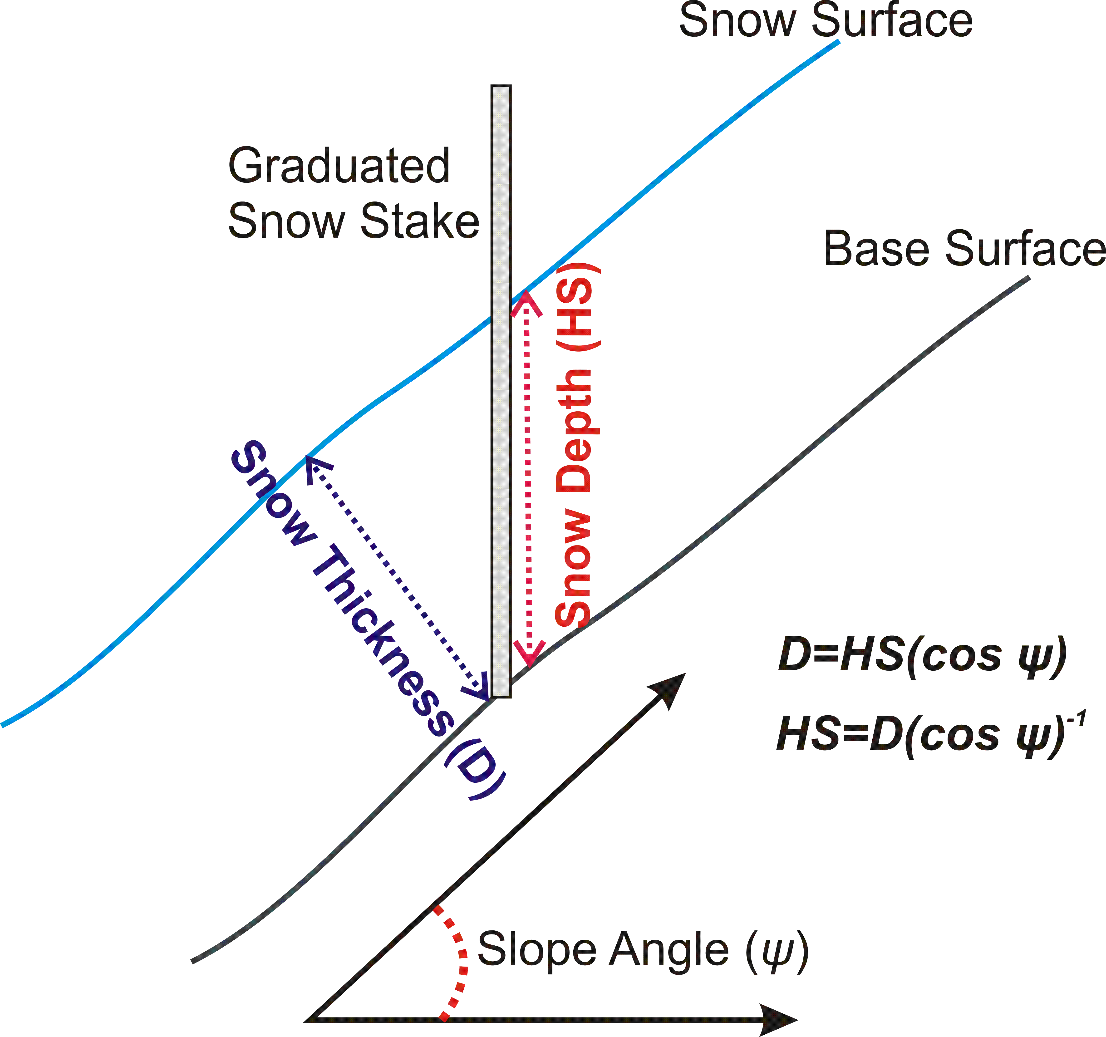
Figure 1: Relationship between snow depth (HS) and snow thickness (D) on a slope

The WATER EQUIVALENT of a layer of snow is its mass per unit area and is expressed as kg m⁻². Water equivalent is the height of the snow layer in metres times the density of that layer in kilograms per cubic metre.
SNOW WATER EQUIVALENT (SWE) is the mass of the snow cover per unit area and is expressed as
kg m⁻². It is the product of the snow height in metres and the vertically-integrated density in kilograms per cubic metre (Goodison et al., 1981, p. 224). It can represent the snow cover over a given region or a confined snow sample over the corresponding area. Because it can be thought of as the depth of water contained in the snow cover per unit area, SWE can also be expressed as an equivalent vertical depth of water in mm w.e. The reported resolution of snow cover SWE is to be 1 kg m⁻² or 1 mm w.e.
SNOW STRATIFICATION defines the physical and chemical properties of a snow layer (see above for the definition of ‘snow layer’).
DEPTH OF SNOWFALL (HN, for height of new snow) is the vertical height in centimetres of freshly fallen snow that has accumulated on the base surface or on a snow board during an observing period, usually of 24 hours. When reporting depth of snowfall for observation periods other than for 24 hours, the period shall be represented in the symbol (e.g. the symbol for an 8 hour measurement becomes HN(8h)). Depth of snowfall is reported in units of cm and rounded to the nearest cm. As with snow depth, the perpendicular measurement of snowfall (DN), is related to HN via the slope angle.
PRESENCE OF SNOW on the ground (PSG) is a yes or no measurement of the existence of snow cover at the measurement location. The measurement location is of the scale of the instrument compound and is generally about 50 m x 50 m.

Siting and exposure
The characteristics of the measurement site should be captured in the station metadata. Important siting details for snow measurements to be listed in the metadata include, but may not be limited to, slope, aspect, surface type (mineral soil and/or organic layers, vegetation type, ice, etc.), prevailing wind direction, site layout and exposure (including distance to surrounding barriers to wind). Generally, the ideal site for measuring snow is a flat, wind sheltered area, where the snow cover and the base surface is relatively homogenous. However, the representativeness of the measurement area to the surrounding landscape needs to be considered. For example, if the surrounding landscape is open (i.e. a flat plain with no significant barriers to wind) the snow depth or SWE measurement(s) should not be made inside an unrepresentative sheltered area. The exception to this is for the measurement of the depth of snowfall which should, if possible, be made in a sheltered location to minimize the impact of wind. For forested sites, a measurement location within a clearing is preferred. In alpine areas, chose a flat area large enough to make a representative measurement without encountering edge effects, avoiding basins, slopes and ridges. Alpine sites in particular should be sheltered from the prevailing wind and clear of large rocks. At alpine stations, measurements on areas with higher exposure than the surrounding landscape should be avoided as these exposures may cause unrepresentative seasonal melting rates and yield unrepresentative measurements.
For the point measurement of snow depth or SWE (either via a manual or automated measurement), a measurement field should be established prior to the snowfall season. An optimal size is a 10 m x 10 m area that can remain relatively undisturbed over the course of the winter (i.e. sufficiently distant from walking paths or other instruments that may require servicing over the winter such that instrument servicing will not disturb the area of the snow measurement). A priori knowledge of the snow depth distribution in the measurement area is beneficial for the siting of point measurements such that it can be spatially representative. Caution is required such that obstructions or variability in exposure do not result in preferential accumulation or scouring due to drifting snow or preferential melt due to exposure. Measurements should be separated from obstructions by a distance of at least twice the obstruction height but a site assessment is required to be sure that this spacing is adequate taking into consideration exposure (and shading) and dominant wind direction during the winter season.
Siting considerations for an automated snow depth or SWE sensor should be made in the same manner as siting for a point measurement, even though the measurement principal of automated SWE instruments provides more spatial integration. As with snow depth, unless the measurement area is very homogenous, the point SWE measurement will likely not be representative of the surrounding landscape and an extensive survey of snow depths and SWE is recommended at least once per season (see Sections 1.3.1.2 and 1.4.1.2), timed to coincide with maximum accumulation, to assess the spatial representativeness of the point measurement.
The measurement of the depth of snowfall should be sited such that the new snow falling on the measurement area is representative of the surrounding area. This is best done in a sheltered location where wind effects will be minimal and where the snow is allowed to fall undisturbed. As with a precipitation measurement, the surrounding obstacles should be at a sufficient distance (roughly twice the height of the obstruction) so as not to interfere with the measurement through interception.
Fixed snow depth transects, also known as stake farms, should be sited using the same criteria as point measurements at a sufficient distance from instruments, obstructions, and walking paths to minimize disturbance without jeopardizing the observer’s ability to read the stakes. The transect will necessarily be closer to a path that the observer will use to make the measurements in the transect while avoiding disturbance of the measurement area as much as possible.
Finally, siting should take into consideration accessibility and permanence which will ultimately impact the continuity of the record. For automated measurements, considering the source of available power and communications may also be a consideration for siting.

Snow depth (HS, in cm)

Manual measurements of snow depth

Snow depth manual measurement techniques
Graduated devices: Manual snow depth measurements are made with a sturdy ruler, stake (Figure 2 left and centre), or extendible graduated rod (Figure 2 right). Measurements can be an observation at a single point, as well as at many points in a transect. Unlike a point measurement, the observation of multiple snow depths in a transect provides the ability to assess the spatial variability at the observation site. The measurement instrument can be permanently fixed to the ground (stake) or manually inserted at the observation point (rod) before each measurement.
 | 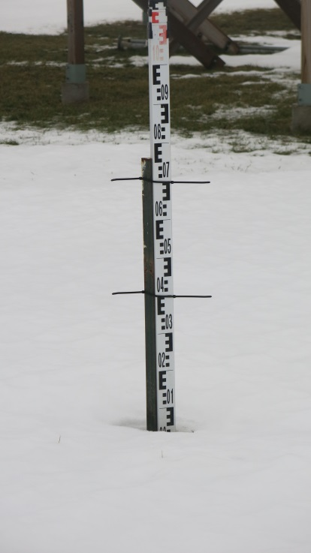 | 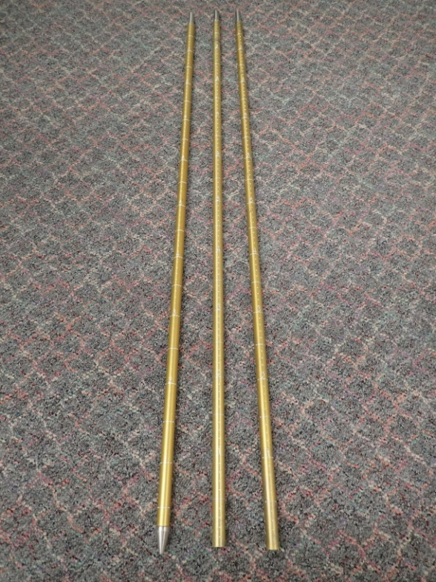  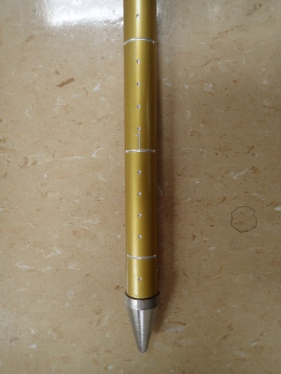
Figure 2: Graduated snow stakes in a deep alpine snow cover (left: Pyrenees, Spain, photo courtesy of AEMET), shallow snow cover (centre, southern Ontario, Canada, photo courtesy of ECCC), and an extendable 1 cm graduated snow rod (right, photo courtesy ECCC).

Snow depth measurements at remote sites with deep snow cover can be achieved using vertical snow stakes with horizontal cross arms at fixed intervals which can be viewed from long distances (Figure 3).
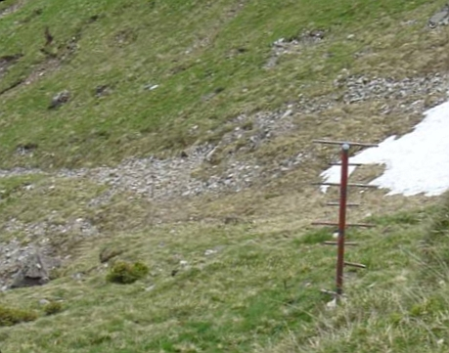 | 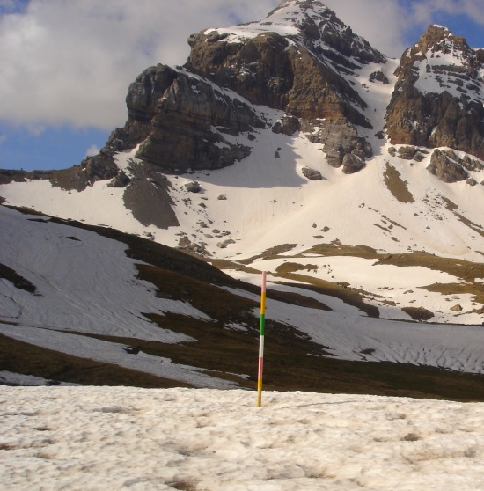
Figure 3: Vertical snow stakes with horizontal cross arms (left, photo courtesy of SLF) and colour coded bands (right, photo courtesy of AEMET) so that they can be viewed from a distance. These are usually used in remote areas of alpine snow covers.

Photometry: At unmanned sites, a viable alternative to visually observed snow stakes is the use of scheduled automated photometry (e.g. a web camera) where the snow stakes are photographed and the snow depth manually interpreted from the images (
Figure 4). Snow depths can either be retrieved in real-time or the images saved for future extraction.
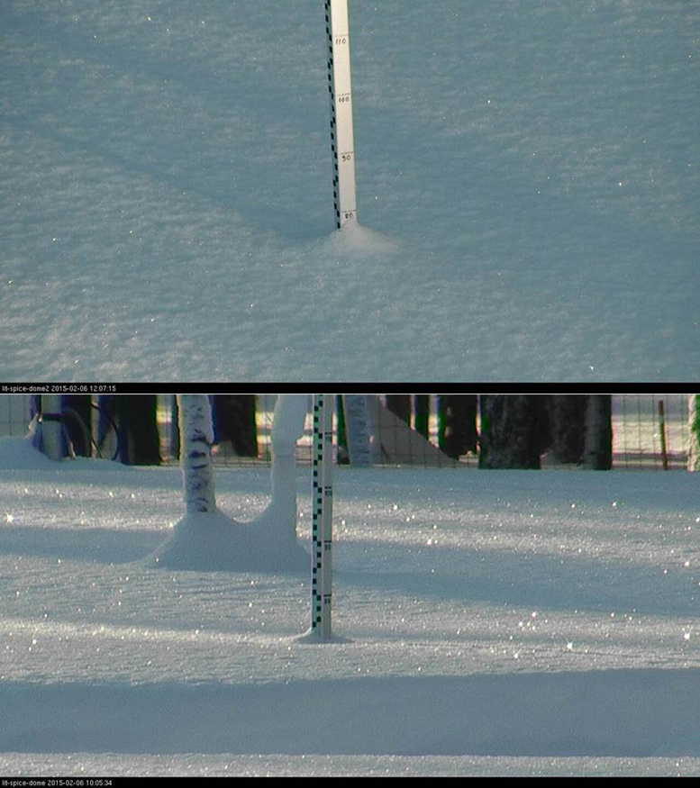
Figure 4: Example of a snow stake in Sodankylä, Finland photographed by a web camera at an elevated angle to the stake (photo courtesy of FMI).
Electronic probe: Another alternative, especially for surveys in shallow snow cover, is the use of an electronic snow rod (see Figure 5). The electronic rod is inserted into the snowpack until it contacts the base surface and the snow depth is electronically retrieved from the rod and stored for future retrieval. This device is often paired with a GPS observation for geo-referencing the snow depth measurement.
Figure 5: Electronic snow rod in use in the Canadian Arctic (photo courtesy of Environment and Climate Change Canada).

Snow depth manual measurement procedures and best practices
Measurement device: The measurement device for the manual measurement of snow depth shall be a graduated stake (fixed measurement) or a graduated ruler or rod (non-fixed measurements) with the graduations in the scale of centimetres. The choice of measurement device may depend both of the permanency of the installation and the nature of the snowpack being measured. Regardless of permanency, the location of the measurement shall be consistent for each measurement, as outlined below.

For permanent (fixed) or semi-permanent (i.e. seasonally fixed) point installations, the recommended measurement device is a fixed snow stake (Figure 2 left) with highly visible graduations such that it can be read at a distance. The snow stake should be vertical and firmly anchored to the ground via concrete or with pegs. If the installation is seasonal, it is important that the stake is placed at the exact same location each year. Use of a DGPS is preferred; otherwise, orientation with help of landmarks is the next option. The material of the stake should be of a substance with a relatively low thermal conductivity and low heat storage capacity (such as wood or fiberglass) and painted white (high albedo) to minimize melting around the stake. If the stake is to be photographed in low light conditions, graduations delineated by reflective material may increase visibility. Low light photography of a snow stake may require specialized camera equipment such as infrared capability and/or an external (i.e. LED) light source to improve the quality of the photographs. The angle between the camera and the snow stake should be as low as practical to minimize interpretation of the snow line against the stake. Attention should be paid to the orientation of the camera with respect to direct sunlight and shadowing.
For manual snow depth measurements where permanent stakes are not installed (i.e. non-fixed), the measurement can be made with a ruler (e.g. aluminum or wooden metre stick) inserted into the snow pack to the ground surface. For measuring deep and/or dense snowpacks or snowpacks with ice layers, the use of a snow rod is advisable such that it can be rammed through the snow until the pointed end contacts the surface, with the rod extensions added as required for deep snowpacks. A rod, unlike a ruler, will not flex when inserted into deep or dense snow cover.
For spatially distributed snow depth measurements the length and the number of stakes in the transect will be determined by the snow variability at the study site. Generally, a transect will consist of 5 to 10 stakes installed 5 to 10 metres apart. From Shook (1995) and Neumann et al. (2006), the minimum length of a transect can be determined by assessing the change in the coefficient of variation (CV) with increasing transect length, where CV is defined as the ratio of the standard deviation to the sample mean expressed as a percentage. A constant CV indicates that the transect has captured the local variability. López-Moreno et al. (2011) indicate that for plot size measurements (i.e. 10 m x 10 m), the error can be minimized by obtaining 5 to 10 samples with measurement spacing of at least 2 m.
Measurement Protocols: Snow stakes are to be observed from a sufficient distance so as not to disturb the snow near the stake. Observations are to be made parallel to the snow surface. This can be accomplished with the observer viewing the graduations on the stake from a vantage point close to the surface of the snowpack. It is recommended that the observations be made from approximately the same observation point each time, especially if there is more than one observer. This observation point should be identified prior to the measurement season. Some interpolation by the observer may be required when there is a mound, a well, or an uneven distribution of snow around the snow stake at the time of observation, such that a mean snow depth across the face of the snow stake is reported (Figure 6). Snow depth, stake number (if more than one) and time of observation should be recorded along with any relevant present weather information such as the occurrence and intensity of precipitation during the observations. If multiple stakes in a transect are averaged, the reported average should be rounded to the nearest cm. If more than 50% of the measurement field is bare (see section 1.6, Presence of snow on the ground), a snow height of 0 cm is entered into the logbook, even if there is still some snow at the stake itself.

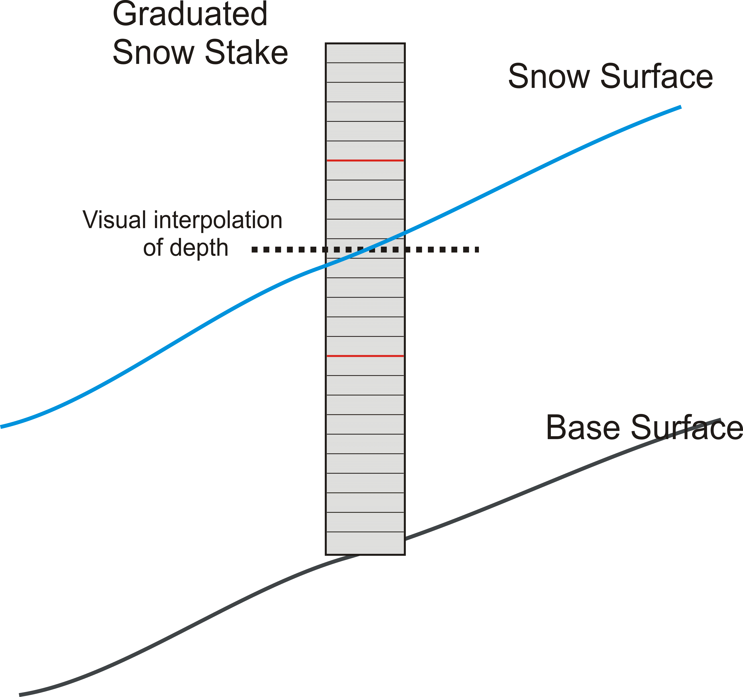 | 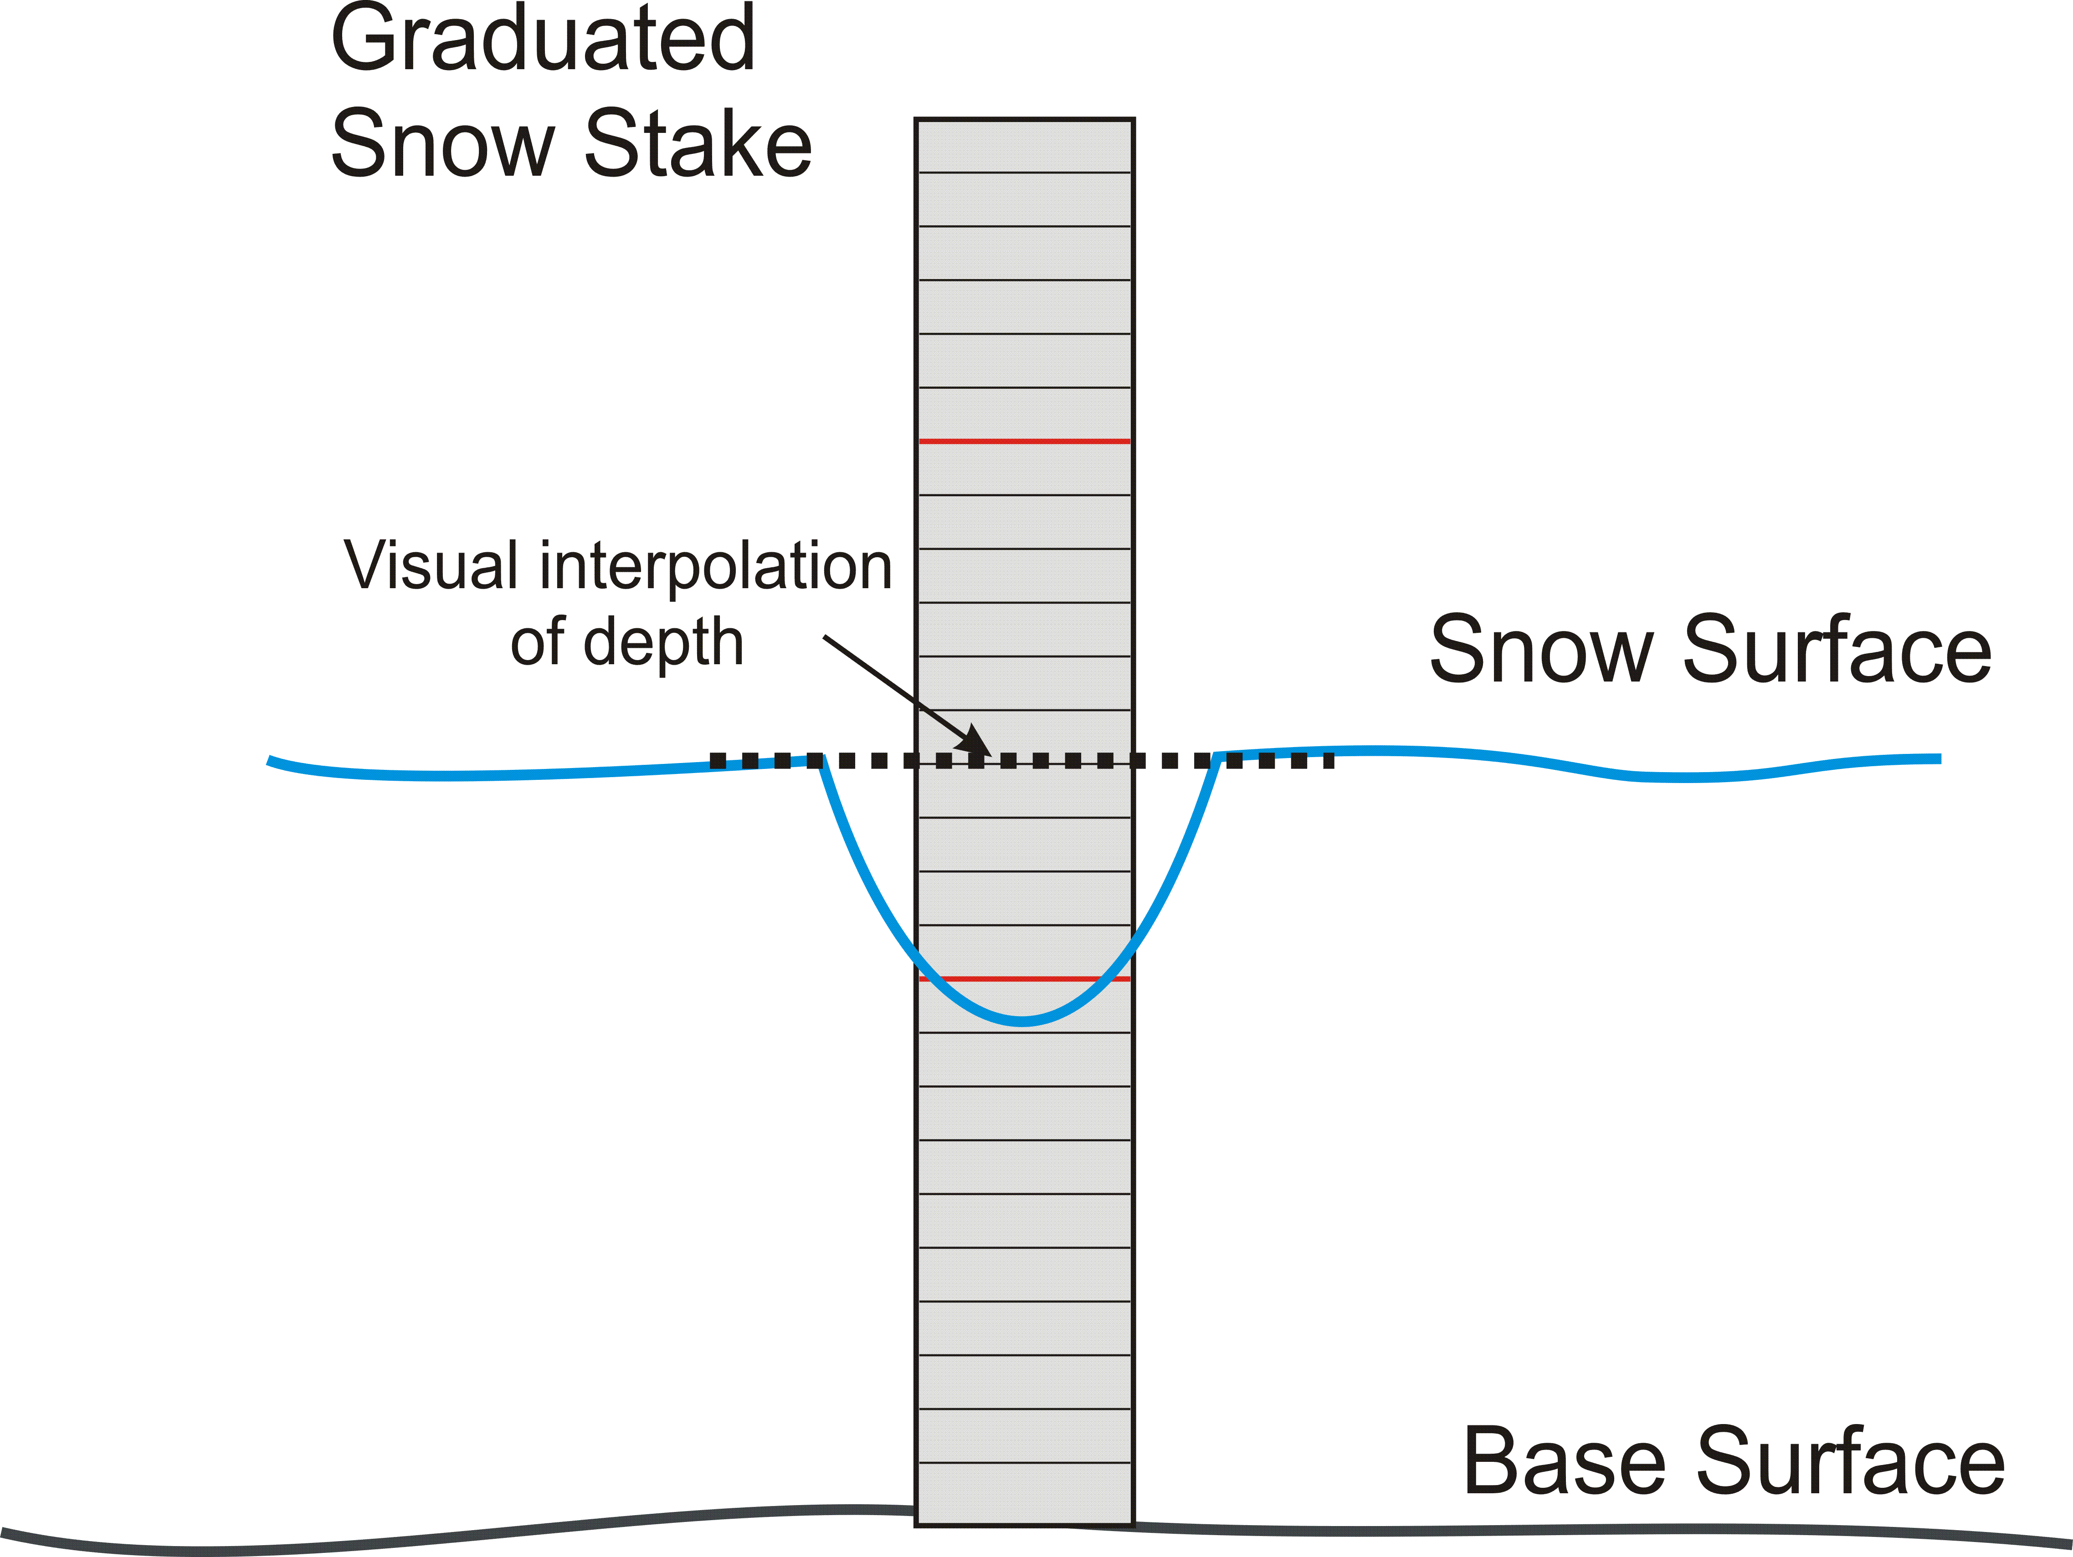 | 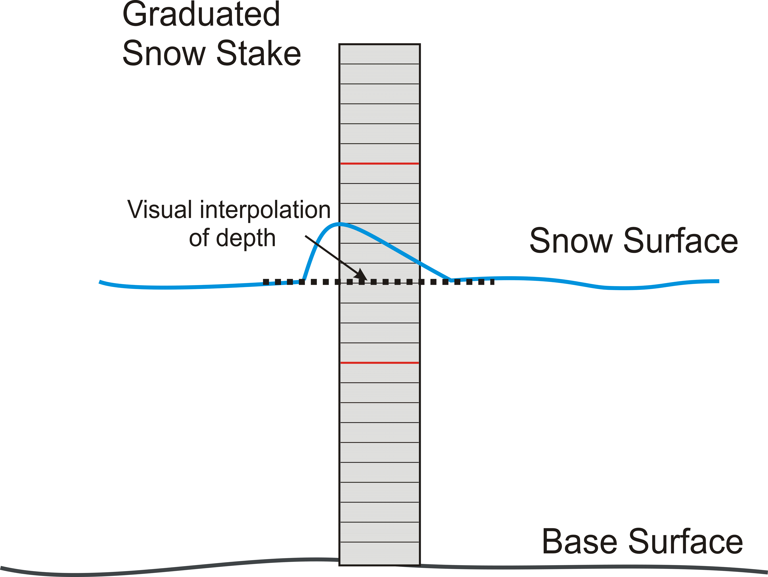
Figure 6: Cross section of a fixed snow stake illustrating how to interpolate and observe uneven snow depth across the face of the stake due to a sloping snow surface (left), welling (middle) and mounding (right).

For a non-fixed snow depth observation, the same principles as above apply. The observation should be made in the same location each time, recognizing that some adjustment in the location may be required to sample undisturbed snow. The observer should walk on the same path for each observation, reaching as far as possible off of the path to measure undisturbed snow. The ruler or rod is inserted firmly into the snowpack to penetrate any layers of dense snow or ice. The observer must insure that the device reaches the base surface but caution is required not to penetrate soft soil or organic layers (over-probing) and thus overestimate the snow depth. This requires a priori knowledge of the nature of the surface below the snow as well as some judgement on behalf of the observer. On inclined surfaces, the rod (or avalanche probe) should be inserted vertically into the snowpack to the base surface. A clinometer may be used to insure that the measurement is made at the correct inclination. The measurement or estimate of the slope angle (ψ) shall be included in the metadata for the measurement. These techniques also apply to snow depth transects measured with an electronic probe. Note that an electronic probe will likely have a flat basket (see Figure 5) which rests on the top of the snow surface during the measurement. The potential for an overestimate exists when the incline is steep and the basket is not flush with the surface. This should be noted in the metadata for the measurement along with an estimate of the error.
Photometry: When snow stakes are observed via photometry, the camera should be at the lowest angle practical from the snow surface near the stake. The observer should use their best judgement to interpret the mean level of the snow against the snow stake considering the viewing angle. It is recognized that this can be difficult, especially in low light conditions, increasing the uncertainty of a photometric measurement as compared to a visual measurement. If automated retrieval methods are used, they should be compared extensively to manual retrievals and quality controlled appropriately.

Snow depth manual measurement sources of error
Sources of error in the manual measurement of snow depth include observer errors when reading or recording the measurement or in finding the base surface with a snow rod (in non-fixed measurements), frost heave of fixed stakes, poor siting, and misinterpretation of photographed snow depths due to the observation angle. Many errors in manual measurements result from human error leading to a misinterpretation of a snow depth reading or the incorrect entry into a log book. These can be minimized by following measurement procedures. With due care and attention along with observer experience, many of these sources of error can be minimized. Errors in measurements of this type can usually be removed by data quality control processes (i.e. range and jump checks).
A measurement error can occur when an observer misjudges the location of the base surface with a snow ruler or rod. In deep snowpacks, an observer may mistakenly interpret a deep ice layer as being the base surface since it may be difficult to penetrate with the snow rod and result in an underestimate of the snow depth. Alternatively, a soft organic layer will also be difficult to interpret as the base surface and will result in over-probing and an overestimate of the snow depth. These errors can be avoided by having a priori knowledge of the base surface conditions and with observer experience. This error is not a factor with fixed snow depth measurements. The magnitude of these errors, depending on the nature of the snowpack and the base surface, could range from a few cm to 10s of cm.
In fixed transects, errors in snow depth observations can occur if the frost changes the height of the snow stake relative to the ground, resulting in an underestimate of the snow depth. Generally, these errors will have a magnitude less than a few cm.
Poor siting of a snow depth measurement (see Section 1.2), whether a single stake or a multi-point transect, could result in large errors, the magnitude of which is dependent on the site mean and variability but could potentially be a high as 100% of the mean. . A poorly sited snow depth measurement could result in the stake located within a snow drift or scoured area. This can be minimized by siting snow stakes in areas where the snow depth is known to be relatively homogenous, usually in sheltered locations. If this is not possible and the observer believes the stake to be non-representative, the observation should be replaced with spatially distributed non-fixed observations, noting this where appropriate in the site metadata.
Errors in interpretation of both visually observed and photographed stakes, especially if the viewing angle is high and the snow around the stake in uneven (mounding, welling, or sloping), , can be as large as a few cm but is usually be minimized with experience and following best practices for stake observations.

Automated measurements of snow depth

Snow depth automated measurement techniques
Automated measurements of snow depth, can be made using instruments employing either sonic or optical (laser) technology. Both sonic and optical devices measure the distance to a target (i.e. the snowpack, the base surface or a target flush with the base surface), rather than a direct measurement of the distance from the base surface to the top of the snow cover. Although other automated techniques are available, these two sensor types are the most commercially available and most commonly used.
Sonic sensors: Sonic sensors transmit an ultrasonic pulse towards the target and listen for a return echo reflected from that target. Correcting for the speed of sound with concurrently measured air temperature, the distance to the target is calculated by:
$Distance to Target=Instrument Reading × \sqrt{\frac{Tair}{273.15}}$ (1)
where Tair is measured in Kelvin and assuming that the raw instrument reading is correct for the speed of sound at 0° C.
By subtracting the measured distance to the target from a previously derived distance to the snow free base surface (zero depth distance), the depth of the snow cover (H), can be derived:
$Snow Depth(HS)=Zero Depth Distance-Distance to Target$ (2)
Sonic sensors usually measure the distance to the highest obstacle within the sensor response area. The response area is a conical footprint, the radius of which is dependent on the height of the sensor above the target (for example, Figure 7).

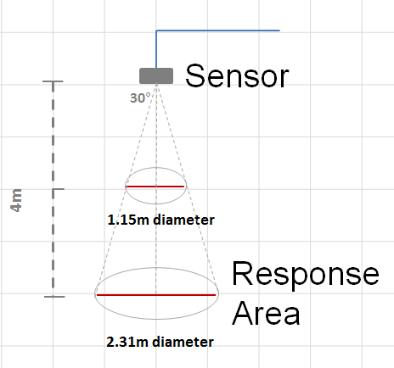
Figure 7: Conceptual diagram of a typical sonic sensor and its response area which is related to the height of the instrument above the target.
Optical sensors: An optical or laser sensor emits a modulated beam of light in the visible spectrum and determines the distance to a target by comparing the phase information from the reflected beam. Unlike sonic sensors, the response area of a laser sensor is quite small (< 5 mm radius at a distance of 4 m). Optical sensors usually have the capability of outputting a signal strength measurement which can be useful for optically determining the presence of snow beneath the sensor.

Snow depth automated measurement procedures and best practices
Choice of automated sensor: The choice of using a sonic or laser sensor mainly depends on both the requirements for measurement accuracy and the availability of power. Laser sensors have a higher degree of precision (~ 0.1 cm) than sonic sensors (~ 2 cm), but require more power for operation and may not be suitable for measurements at remote sites where power consumption is a concern. Heated sonic or laser sensors should be considered for climates where snow or frost accumulation on the sensor has the potential to impede its function (Figure 11), recognizing that these functions require more power. Automated snow depth sensors should be purchased from a reputable supplier and proven to work within the manufacturer’s specifications to provide a data accuracy of at least ± 2 cm. Proper installation, use, and maintenance as prescribed in this document and in the instrument manual will assist the sensor in achieving the manufacturer’s specified accuracy.
Installation height: Automated sensors need to be installed at a sufficient height above the maximum anticipated snowpack. The minimum and maximum height above the target should be verified with the instrument manufacturer. As an example, some sonic sensors require at least a 1 m clearance between the instrument and the target. In some networks, the peak snow depth can vary substantially from station to station, so it is not important that all of the sensors in the network be installed at the same height.
Mounting infrastructure: The mounting structure needs to be solidly constructed in a manner to prevent sensor movement (e.g. due to wind) but yet minimize interference with the accumulation and ablation of snow beneath the sensor. Steel mounting beams and vertical poles secured with concrete are recommended (Figure 8). The mounting arm of a sonic sensor needs to extend the sensor out horizontally from the vertical mounting pole such that the target area is minimally influenced by the mount (Figure 8 left). At locations that receive heavy snowfall in low wind conditions, it is advisable that the horizontal mounting beam be mounted at a 30° to 45° angle (Figure 8 middle) to prevent snow from collecting on the beam, potentially influencing the measurement of snow depth in the target area. Laser sensors need to be mounted at an angle (e.g. 10° to 20°) large enough so that the targeted point is sufficiently distant from the mounting infrastructure to minimize interference from the vertical mounting pole (Figure 8 right).
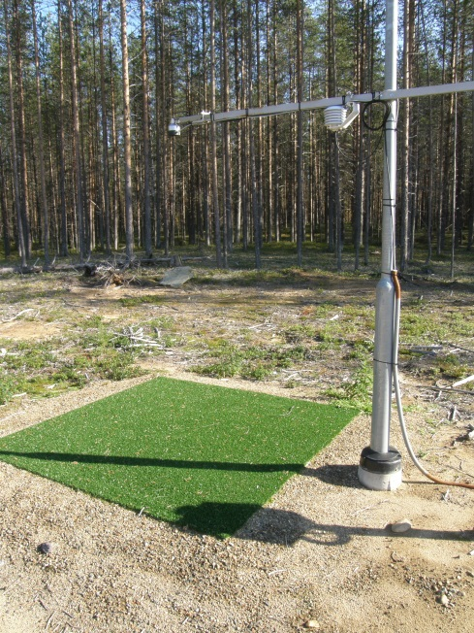 |  | 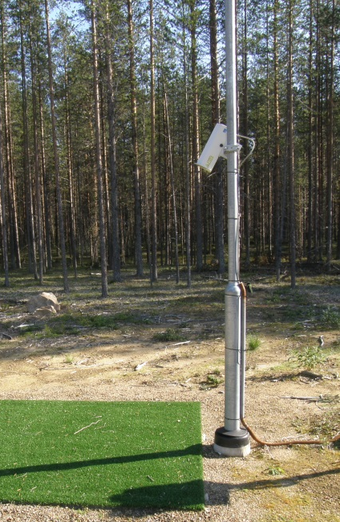
Figure 8: Automated sonic snow depth sensor mounting with steel mounting beam and pole secured with concrete (left), angled mounting beam to reduce collection of snow (middle), and laser sensor mounted at an angle away from the vertical mounting pole (right). Photos courtesy of FMI, Sodankylӓ.
Installations in alpine regions, where the sensor is necessarily installed at a much higher distance above the ground, the infrastructure may have to be more substantial to solidly support the sensor and prevent the sensor from wind vibration. An example of this infrastructure is shown in Figure 9. Note that the response area of the sensor also increases with the sensor’s distance to the target (Figure 7).
Surface target: It is recommended to make the snow depth measurement on a level surface but if this is not possible due to sloping terrain, the measurement should be made perpendicular to the sloping surface such that the instrument is measuring snow thickness (D) rather than snow depth (HS). For sonic instruments, this is done by adjusting the angle of the instrument mount so that the instrument itself is perpendicular to the surface. Since laser sensors point towards a target at an angle, the depth of snow on a sloping surface can be calculated geometrically (see Section 1.1.1). Surface preparation prior to snowfall is required to minimize sensor noise and erroneous data due to interference from surface vegetation or other obstacles within the response area of the sensor. An adequately prepared target area will increase the sensor’s capability to detect the first accumulations of snowfall occurring on the bare surface. Because sonic sensors have a much larger response area than laser sensors, surface preparation is generally more important. Sonic sensors require a stable, flat surface for the clean reflection of the sonic pulse, keeping in mind that the sonic measurement will usually be made from the tallest obstacle in the response area. A high quality measurement can be achieved by either siting the sensor over closely mown grass (or an otherwise flat and bare natural surface, e.g. under the sensor in Figure 9) or by using an artificial target similar to the target shown in Figure 8 constructed with artificial turf. An acceptable maintenance free option is the use of a plastic surface such as the perforated and textured target construction shown in Figure 10, which has been shown to have similar thermal properties as natural ground. It is advantageous if the artificial target resembles the optical properties (which could impact the radiation budget) and texture (which could influence snow deposition or scouring) of the natural surroundings.
Minimizing vegetation and vegetation growth in the target area will prevent misinterpretation of growing vegetation as a change in snow depth and therefore will improve data quality. This is more significant in regions where snow depth is shallow or ephemeral and the accuracy of the shallow measurements is more important.

Figure 9: Sonic snow depth sensor installed in the Pyrenees of Spain (photo courtesy AEMET)

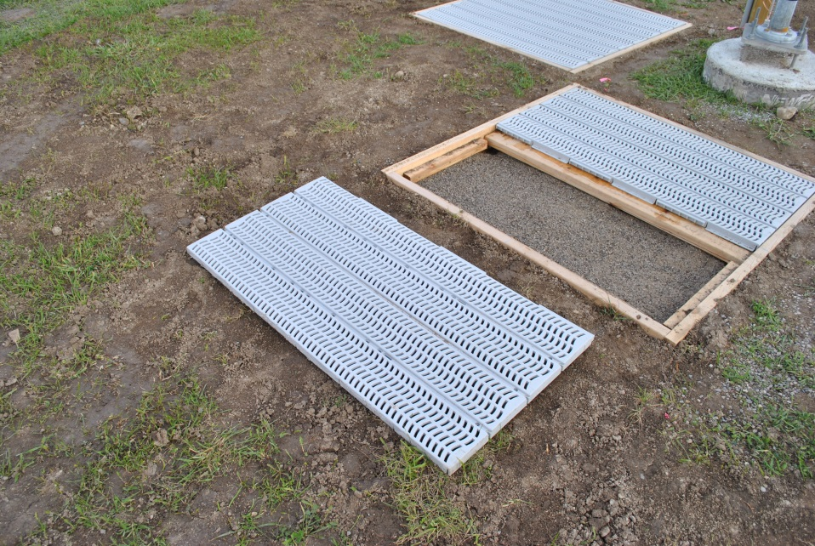
Figure 10: Photo of a perforated and textured grey plastic target during construction, with dimensions of approximately 1.2 m x 1.2 m installed on a constructed frame. Landscape fabric (thick textile) is installed beneath the target to minimize vegetation growth (Photo courtesy of Environment and Climate Change Canada).
Data quality control: Data quality from automated sensors can be increased through frequent (e.g. sub-minutely) measurements over a period of time small enough to not incur significant changes in snow depth (e.g. 5 minutes) with the value reported for the period being the median of those high frequency measurements. This reduces the impact of signal noise on the reported value. Further to this, other quality control procedures are advisable. These should include a maximum and minimum (site specific) range check for the snow depth measurement, where the maximum value should be ~20% higher than the maximum expected snow depth and the minimum value should be 0 minus 2 x the manufacturer’s stated instrument accuracy. A minimum range check value less than 0 allows for variability in the zero snow depth distance around the instruments stated accuracy without flagging the data as out of range. A jump check should also be used to ensure that changes in snow depth from one measurement to the next are within a physically realistic range for the site. Note that the zero depth distance should be verified at the end of each winter and the offset adjusted if necessary. Drift in the zero depth distance, caused by relative changes in height of the target surface and the sensor, is a source of measurement uncertainty. If the timing and magnitude of the drift can be identified, then the observation can easily be adjusted, but often zero depth distance drift will be a non-linear process occurring between the start and end of the snow season, making the data difficult to adjust. Change in the zero depth distance should be noted in the metadata.

Snow depth automated measurement sources of error
The sources of error in automated snow depth measurements include instrument malfunction, inadequate or improperly installed mounting infrastructure, zero depth drift, incorrect sonic temperature correction and the impedance of the measurement by the accumulation of frost or snow on the sensor, and inconsistencies in the target area due to rapid melt or rain.
For automated point measurements inconsistencies under the sensor can be minimized by an artificial surface target, especially during the season of active vegetation growth and at the beginning of the accumulation period. Inconsistencies due to rapid melt (i.e. large variations in depth across the target area, especially in deep snow covers) are difficult to prevent or correct, but they can be identified through the use of daily photometry of the target area.
Instrument malfunctions can be minimized through proper and routine maintenance as suggested by the manufacturer. Sensor failures can also be a result of power supply, wiring, or data logger (operation or programming) issues.
Improper sensor installation could lead to unwanted motion during windy conditions resulting in erroneous or uncertain measurements due to changing the relative distance between the sensor and the surface target.
Zero snow depth drift could potentially produce small but incremental errors in measured snow depth that are difficult to assess or to adjust during a winter season. This impact should be assessed annually at the end of each seasonal ablation and the zero snow depth distance updated before the beginning of the next accumulation season. If an artificial target is used, settling is most likely to occur during the first accumulation season (due to the disturbed ground followed by the weight of the snowpack on the target) although frost heave of the target could occur during any winter season. An incorrect zero depth offset in the sensor, data logger or during post processing will result in the reporting of erroneous snow depths.
Potentially large errors can result from erroneous air temperature measurements when used for correcting sonic distances. This can occur due to a faulty sensor or as a result of radiative heating of unshielded or poorly shielded temperature sensors. Good radiation shields (e.g. white reflective construction with well-ventilated louvers to allow air to pass freely through) along with quality assurance of the temperature data used for the sonic correction can minimize these errors. If possible, the temperature measurements should be aspirated to reduce radiation errors. Generally, errors associated with the height of the sensor in relation to the temperature profile between the sensor and the target are small, even with the temperature sensor installed at the same height as the snow depth sensor rather than closer to the average distance to the target.
Lastly, errors in the automated measurement of snow depth could result from the impedance on the sensor due to the accumulation of frost or snow on the sensor (Figure 11). Some sonic sensors have heating capability to minimize this potential and should be used where required. Heating of the mounting beams with heat tape and the use of angled mounting beams (Figure 8 middle) may also assist in prevention of snow and frost build-up around the sensor.

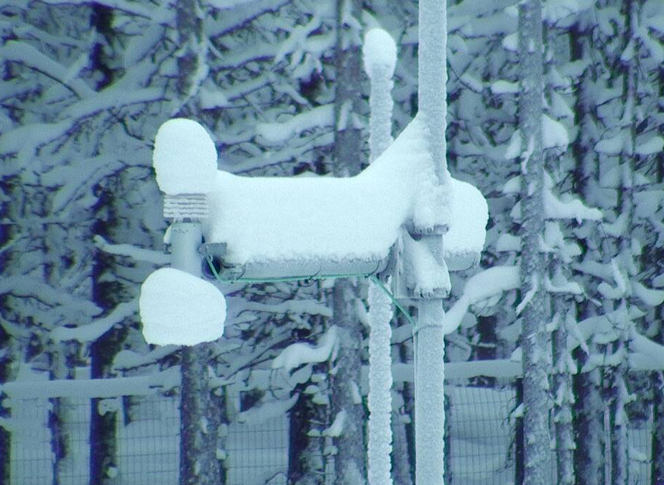
Figure 11: Unheated snow depth instrument and mounting infrastructure collecting snow in a low wind environment. Snow collecting on the unheated instrument has a potential to impede the measurement (photo courtesy of FMI).

Snow water equivalent (SWE, kg m⁻²)

Manual measurements of snow water equivalent

Snow water equivalent manual measurement techniques
There is a large variety of manual measurement techniques for SWE. Measurement techniques will vary depending on snowpack depth and conditions. The following sections try to capture those techniques and some of the factors that determine them. Only direct measurement methods (i.e. no active or passive radiative absorption methods) are discussed here, as many of these techniques have either been phased out or automated and discussed in subsequent sections. Generally, all direct measurement techniques involve a gravimetric snow sampler which collects a known (or calculable) volume of snow from which a snow density can be derived. From this, techniques vary from the use of a small volumetric sampler (e.g. 1000 cm³) in a snow pit (Figure 12 left) to a 10 point snow course using a snow tube (Figure 12 right). There are a large variety of volumetric samplers and snow tubes in use and their choice largely depends on the nature of the snowpack being sampled. Many of these samplers are listed and discussed in Farnes et al. (1983) and only a few are discussed in this document in the context of measuring various snowpack regimes.

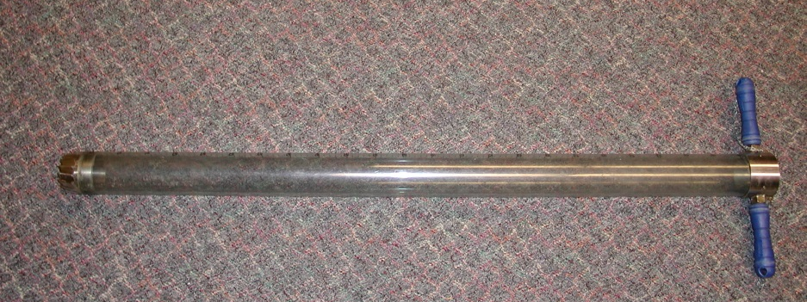
Figure 12: A volumetric sampler (left, 55 cm in height) being weighed with a spring scale and a tube snow sampler (right).

There is not a standard volumetric sampler for making SWE measurements. Rather, some samplers work better in some snow conditions than others. These are outlined further where required in the “Procedures and Best Practices” section to follow. The discussion here focusses on two general SWE measurement techniques: snow pits and snow courses, with advantages and disadvantage to either.
SWE measurements in snow pits: Snow pits (Figure 13) involve manually digging a hole in the snowpack down to the reference surface such that an undisturbed face of the snowpack is exposed. Snow pits are a useful technique for observing the stratigraphy of the snow, especially for deeper snowpacks. SWE is observed by volumetrically sampling the layers from the surface of the snow down to the reference surface. These SWE observations are generally performed weekly, bi-weekly or seasonally, depending on their purpose. The measurement technique is relatively destructive in that a large pit is usually necessary, so they need to be performed in a different location each time. A sampler (Figure 12 left) is inserted into the layer and a sample of a known volume (typically 500 to 1000 cm³) is extracted and weighed. Snow density of the sample is then derived by:
$ρ\text{s=}\frac{m\text{sample}}{V\text{sample}}$ (3)
where ρ_{s} is the density of the snow sample (g cm⁻³), m_{sample} is the mass of the sample (g) and
V_{sample} is the volume of the sampler (cm³). The SWE of the sample is then determined by:
$\text{SWE}\text{=}ds\frac{ρ\text{s}}{ρ\text{w}}$ (4)
where ds is the depth of the snow in the pit (cm) and ρ_{w} is the density of water (1 g cm⁻³), and integrated from the top of the snow to the surface.
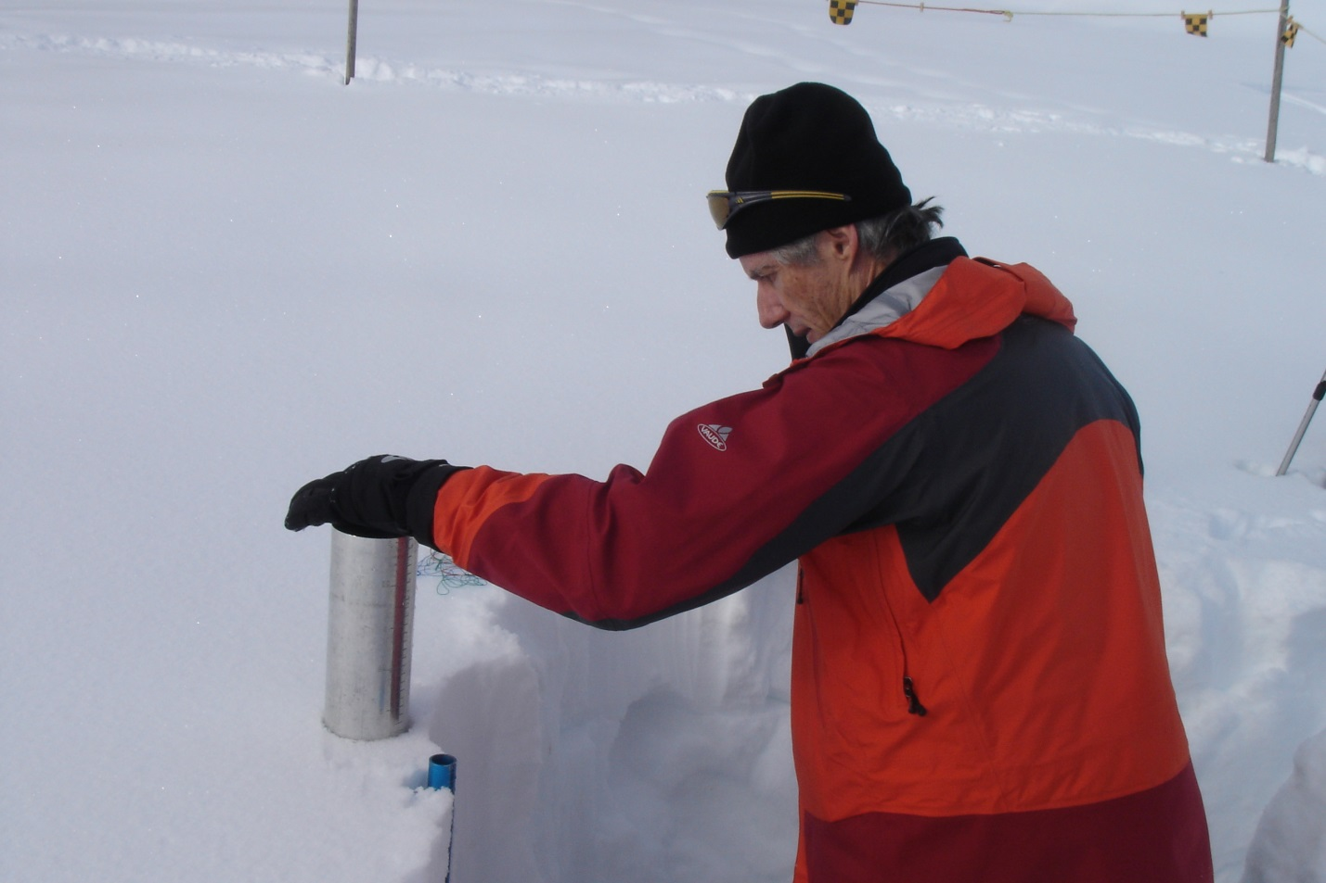
Figure 13: SWE sampling the top layer in a snow pit with an ETH-Cylinder probe.

SWE measurements in snow courses: Observation of SWE in a snow course generally employs a snow tube sampler (e.g. Figure 12 right) and is performed in a multi-point transect, usually of 5 to 10 measurement locations spaced 30 m apart. There are many varieties of snow tubes but the sampling principals are much the same. The snow tube is inserted into the snowpack (Figure 14) to the ground surface, using tube extensions where required, and a snow core is extracted. The volume of that core is calculated from the depth of the core in the tube, knowing the sampler radius. The sample is then either weighed with a snow tube cradle and spring balance or bagged and weighed with a scale. Some spring balances are calibrated to directly provide the SWE measurement in mm w.e. or kg m⁻² (after subtracting the weight of the tube) or density can be calculated manually by:
$ρ\text{s=}\frac{m\text{sample}}{(π{ R}^{2}×ds)}$ (5)
where R is the radius of the snow tube cutter (cm), ds is the depth of the snow sample measured by the snow tube (cm), and m_{sample} is the mass of the sample (g) with the weight of the tube or the sample bag (if the sample is collected in a bag rather than weighed in the tube) removed. SWE is then calculated with Equation 4.
Figure 14: SWE sampling with a snow tube.

The advantage of snow tube sampling over snow pit sampling is in the relative speed of the sampling technique and the minimal disturbance of the snowpack allowing for repeated measurements very close to each other over the course of the winter season. The disadvantage as compared to snow pits is the inability of the observer to determine if the snow sample is being collected intact, especially in complex snow covers with non-cohesive layers or ice lenses. Some of these difficulties are discussed in Section 1.4.2.2.
A snow course usually employs a technique called “double sampling” where multiple snow depths (usually 10 to 15 but dependent on the snow cover variability) are obtained between each SWE sample using a ruler or rod (see Section 1.3). The areal SWE is then calculated, using the average density from the 5 or 10 snow tube samples and the average snow depth measured between the samples, from Equation 4. This technique has been shown to improve the areal estimation of SWE and reduce the variance in the measurement as compared to SWE sampling only in the snow course (Rovansek et al., 1993), provided that the snow depths are obtained with minimal error.

Snow water equivalent procedures and best practices
Measurement technique and device: The two options available for manually sampling SWE are via a snow course using a snow tube sampler and via a snow pit and integration of small volumetric samples. A snow course and snow tube should be used where SWE is less spatially homogenous and thus the necessity for increased spatial sampling. A snow course and snow tube will therefore create less disturbance of the snow cover and allow for faster multi-point sampling. Site variability can be estimated by using a snow depth transect as discussed in Section 1.3.1.2 and a CV greater than 10% would suggest the necessity for multiple point samples via a snow course rather than a snow pit. The disadvantage of a snow course and using a snow tube sampler is reduced certainty in the measurement accuracy. Where the snow cover is more homogenous, a single snow pit can be used to assess SWE by integrating multiple small volumetric samples from the surface of the snow to the surface of the ground. These are more labour intensive (and require more time and disturbance of the snowpack) but are generally more accurate. The measurement protocols are detailed below.
Measurement protocols for snow pits: Manual SWE measurements are often conducted by measuring the density of the snowpack in incremental steps starting at the surface of the snow in the snow pit and continuing until the base has been reached. The procedure requires a graduated cylinder, a spring scale, a sharpened thin metal plate (with dimensions of about 20 x 20 cm) and a tool such as a crystal card, scraper, or a spatula to cut out the samples from the surrounding snow. The maximum height of a layer is determined by the length of the cylinder. A conceptual diagram of the process is shown in Figure 15.
Choosing a snow pit location:
- A snow pit location should be chosen at a flat location where the pit can be excavated without disturbing other measurements at the site.
- Depending on the frequency of the pit measurements, room will be required for future pit excavations, so keep this in mind when locating the first and subsequent pits.
- Choose a location for the snow pits before snow accumulation starts so that the base surface is clear of rocks or other debris.
Making the measurements:
- At the location of the snow pit measurement, dig a pit to expose the face of the snow pack that does not incur direct sunlight. This will help to prevent the face from warming in the sun and will help to avoid snow sticking in the sampler.
- The samples for the measurement of SWE are taken vertically and continuously starting at the top of the snowpack. It is recommended to take the first sample at one end of the pit and work towards the other end with subsequent samples. Insert the metal plate horizontally into the exposed face at a depth slightly less than the cylinder length.
- Insert the cylinder, which should have sharpened edges on one end, vertically down to the plate and record the corresponding sample from the graduations on the cylinder.
- Cut the sample out of the exposed face using a crystal card, scraper, or a spatula, being careful not to lose loose snow out of the sampler before it is weighed.
- The sample is either weighed with a spring scale hung in a convenient location as shown in Figure 12 (left) but the sample can also be bagged, labelled, and weighed on a bench scale at a later time.
- It is recommended that the level be resampled a short distance away from the first sample (see Figure 15). It is important that the distance not be too great in order to decrease the uncertainty related to spatial variability. The mean height and weight of the repeated measurements determines the sample volume and mass, which is then used to calculate the density and finally the SWE for each layer. If the height or weight of the repeated measurements differ by more than 5%, the measurement should be repeated a third time.
- To sample the next incremental level, clear the remaining snow away from metal plate and re-insert the metal plate near the bottom of the next level. Repeat the sampling procedure until the base surface is reached.
- Finally, the SWE of the total snowpack is calculated by adding up the water equivalents of each sampled layer. Be aware that the sum of the layer thicknesses is often smaller than the measured snow depth due to uneven ground and/or due to the thickness of the metal plate.

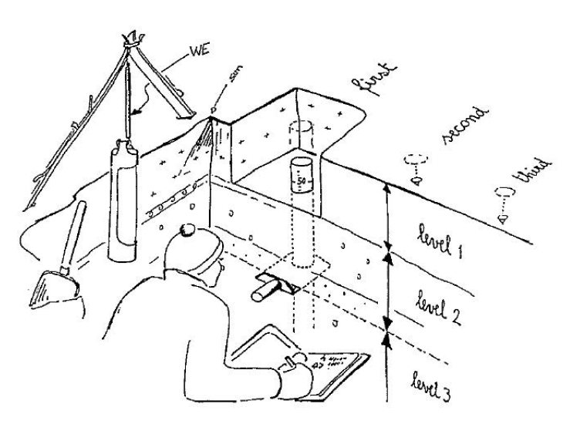
Figure 15: Conceptual diagram of a snow pit SWE observation
Measurement protocols for snow surveys:
The following general procedure should be used to make a snow course SWE measurement using a snow tube. The double sampling technique is described here.
A snow course should be established prior to the beginning of the snow accumulation season; although a priori knowledge of the local snow cover variability would be useful (see section 1.2). Avoid sampling locations where large rocks, logs, underbrush, or drainage channels could impede the measurement.
To set up a snow course:
- Select a site and determine the length of the course and the number of samples required to capture the spatial variability at the site. A 10 point course, spaced 30 m apart, will have a baseline of 270 m. A 5 point course will have a 120 m baseline but should be extended if the site experiences high spatial variability due to drifting, etc. A straight baseline is preferably but a ‘T’, ‘Z’, ‘L’ or cross pattern is acceptable.
- Establish the starting point of the course with a marker (stake or post) that will be visible well above the maximum snow depth. It is suggested that the stake or post be painted with a highly visible colour and marked clearly with a number.
- With a measuring tape, measure the 30 m distance to the next survey point and install the next marked stake or post. Continue this to the end of the snow course, numbering the stakes sequentially. Obstacles, such as tree stumps or ditches that may impact the snow cover should be avoided.
- For metadata purposes, draw a diagram of the snow course including direction of course, distance between marker stakes, slope, vegetation cover, and obstacles.
Making the measurement:
- The first snow course should commence on the first snow survey date after the depth of the snow at the site exceeds 5 cm in depth and continue on the schedule until 2 or more points of the 5 point course or four or more points on the 10 point course are snow free. A typical measurement schedule is weekly or bi-weekly.
- The snow course should be completed early in the day when air temperatures are cooler and the snowpack is dry. A cold tube should be used to avoid snow sticking to the inside of the tube. If the tube has been stored in a warm location, lay it in the snow to allow the tube to cool off before starting the survey. Wear gloves to avoid transferring heat to the tube during the survey. Note the time of the start of the snow course sampling.
- Starting with the first marked stake in the course and continuing sequentially to the last marked stake, make a bulk density sample with the tube in an undisturbed location within 1.5 m of the marked stake, avoiding previous sampling locations and minimizing disturbance of the area that may impact future measurements. Consecutive samples can be made at a prescribed incremental distance from the marked stake to avoid sampling in previously disturbed snow. A field diagram of the sampling locations is recommended, especially if there is more than one observer at the site.
- Before each sample, inspect the tube to make sure that it is free of snow and soil, being cautious of the sharp teeth on the cutter.
- Vertically insert the snow tube, cutter first, into the surface of the snow. Gently rotate the tube so that the cutters drill into the snow until the cutter reaches the base surface (priori knowledge of the snow depth can assist in this assessment). Use of excessive pressure will cause the tube to plow through the snow, push material away from the tube instead of collecting it. If resistance is encountered due to ice layers, rotate the tube more aggressively clockwise using the handles and apply increasing vertical pressure on the tube to allow the cutters to penetrate the ice layer and continue through the remaining snowpack. Hesitation during the sample should be avoided if possible. The efficiency and accuracy of the sample will be increased by keeping the cutter teeth as sharp as possible, re-sharpening the teeth with a file or sharpening stone following contact with rocks or hard surfaces.
- When the observer is confident that the cutter has reached the surface, the depth of the snowpack observed on the graduations on the tube should be noted on the data form. In the case of sampling a deep snowpack (i.e. deeper than the length of the snow tube), the observer will be required to add segments onto the tube to reach the required depth. Note the depth of the core sample in the tube and record this information on the data form. If the depth of the core in the tube is less than 80% of the depth of the undisturbed snow, the core has likely collapsed beneath the cutter and either spilled out from the tube or was not captured by the cutter. In this case, the observer will have to re-attempt the sample.
- Applying increasing pressure, turn the tube at least twice in a clockwise direction so that the cutter bites into the surface beneath the snowpack. Ideally, the cutter should penetrate the surface approximately 2 cm such that an adequate soil plug can be extracted to hold the snow sample in the tube during extraction from the snowpack. If the surface is too hard for the cutter to extract a plug, the observer will need to dig down to the surface along the tube so that a shovel or plate can be carefully inserted under the tube to contain the sample during extraction (this is generally only practical in shallow snow cover).
- With a soil plug in the cutter, the tube can then be carefully extracted from the snowpack with the sample intact.
- With a small tool such as a flat screwdriver or small knife, remove the plug from the cutter, be cautious working around the sharp teeth. If the plug has ice or large crystals clinging to it, the observer should scrape or remove these carefully, returning as much ice or snow back into the tube (or the sample collection bag).
- If the sample is to be weighed with a spring scale and cradle, point the tube lengthwise into the wind (or find a sheltered location), place the tube into the cradle, and attach the cradle to the spring scale. The scale may be hung on a structure, such as a sturdy tree branch, to increase the stability and accuracy of the weight measurement. The user should bounce the scale gently to make sure that it is not sticking, observe the weight via the scale graduations, and note the weight (which includes the tube) on the data form. Once complete, dump the sample from the handle end of the tube and observe that the tube is empty and clear of snow and debris. The empty tube is then weighed again using the cradle and spring scale to observe the tare weight. The tare weight is recorded on the data form and removed from the total weight to derive the weight of the snow sample.
- If the sample is to be bagged and weighed at a later time using a bench scale, empty the contents of the tube into a water tight sealable bag from the handle end of the tube. The bag should be marked with the measurement location. An empty bag can be used as a tare prior to weighing the sample on the scale. The scale should be calibrated and of a precision appropriate to the weight of the sample (e.g. +/- 1%). The calibration of the scale should be confirmed seasonally with a calibration weight. Medium quality postal or food scales are generally accurate and portable enough for this purpose.
- Between bulk density sample markers, use a snow rod and obtain at least 10 equally spaced snow depth measurements and record these in the data form.

It is recognized that the sampling procedure and choice of sampler will vary with snow conditions. Observers may choose to use sampling equipment that is historically used in their national observation programs and which may be specially adapted to the snow conditions being sampled. This is acceptable, although it is preferred that observers use equipment that has been characterised in previous intercomparisons (e.g. Farnes et al., 1983).
For shallow snowpacks (<=50 cm), snowpacks with ice layers or depth hoar, it is recommended to use a snow tube with a larger (> 20 cm²) cutter area but with a cutter area small enough to insure that a soil plug can be extracted from the surface. Larger cutter areas will be less prone to plugging with ice or dense snow and are less prone to inducing the collapse of non-cohesive layers under the cutter. However, the observer needs to pay particular attention to the length of the extracted core to insure that the entire sample has been captured. For densified snowpacks or snowpacks with ice lenses, sharp cutter teeth are required to reduce sampling errors. In deeper snowpacks, a smaller diameter cutter (e.g. the standard Federal 11.2 cm² cutter and tube, Figure 16) may be used as it will be easier to insert into the deeper snow. It needs to be recognized that smaller diameter cutters tend to overestimate SWE and a correction (see Farnes et al., 1983) should be applied.

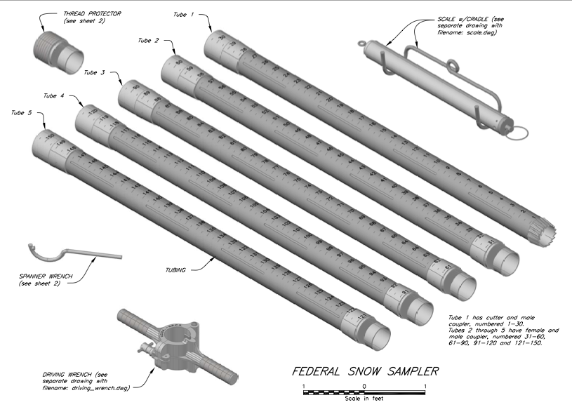
Figure 16: A Federal Snow Sampler (drawing by Kristi Yasumiishi, National Resources Conservation Service, United States Department of Agriculture, https://www.nrcs.usda.gov/wps/portal/nrcs/detail/vt/home/ ?cid=NRCSEPRD329084)

In deep alpine snowpacks where one or more tube extensions may be required, it may be more difficult for the observer to determine if the snow tube cutter has contacted the surface. A priori information about the total snow depth at the marked snow stake (i.e. via a snow rod or avalanche probe) is useful as a reference to the depth measurement obtained from the tube graduations. In these situations, and where snow cover characteristics are relatively homogenous, a single snow pit SWE measurement may be the preferable technique.

Snow water equivalent manual measurement sources of error
Snow pits (integrated volume samplers): (to be completed) compaction of loose material in low density layers can cause in overestimation of the snowpack density. Loss of material from the sampler during extraction will result in an underestimate of sample SWE.
Snow course (with snow tubes): When sampling with a snow tube, the snow is largely undisturbed except for the small area around the sample. However, this means that the observer is unable to observe how the tube is penetrating through the snow or determine if the cutter has contacted the surface. It is impossible for the observer to determine if the cutter becomes plugged with dense snow or ice or if layers of loosely packed crystals are collapsing beneath the cutter and therefore biasing the density sample. The observer is also unable to visually determine if the cutter is biting into the surface of the ground to obtain a sufficient soil plug to prevent spillage from the tube as the core is extracted from the snowpack. These errors are exacerbated by a snowpack with ice layers, basal ice and layers of depth hoar and non-cohesive crystals. The experience of the observer also plays a role in reducing potential errors.
The design and specification of the snow tube and cutter also influence sampling errors and bias. Many commonly used snow tubes and cutters were compared to a reference in Farnes et al. (1982). To summarize, when compared with an integrated sample from a snow pit using a “Glacier” sampling tube (81.9 cm²), the authors showed that errors were generally greater for smaller diameter tubes than they were for larger diameter tubes. For example, the standard Federal sampler (11.2 cm² cutter, Figure 16) was shown to overestimate SWE by up to 12% as a result of the design of the cutter teeth which acted to force extra snow into the tube as the tube was inserted into the snowpack. Also, smaller diameter cutters (down to 20 cm²) were more prone to plugging as they encounter ice lenses and more prone to having non cohesive layers collapse under the cutter, resulting in an underestimate of total SWE. The trade off with size is the ability for larger diameter cutters to be able to cut a sufficient soil plug such that the sample is contained in the tube during extraction (rather than using a shovel or plate to retain the tube, causing increased disturbance of the snowpack). A cutter with sharpened teeth will help to reduce these errors. Farnes et al. (1982) showed that the ideal cutter area was about 30 cm², demonstrated by a low error percentage from the ESC30 sampler, which had errors ranging from a 5% overestimate to a 2% underestimate.
Sampling new snow or wet snow also has the potential to increase sampling error, especially if the observer is collecting core samples to be weighed later rather than using a spring balance and tube cradle. Depending on temperature new and wet snow will tend to stick in the tube and therefore create an underestimate of the SWE measurement which could exceed 10%.
Another sampler characteristic that may serve to reduce errors is the material that the sampling tube is constructed from. Clear plastic tubes allow the sample depth to be more easily read than with slotted aluminum tubes, reducing the potential for reporting errors. It also much easier to visually determine if a snow core has collapsed when it can be observed through a transparent tube. Although tubes made from a clear plastic material are easier to use and lighter to carry, the material is not as durable as aluminum (especially in the cold).

Snow water equivalent automated measurements

Snow water equivalent automated measurement techniques
There are several measurement principles that are available for the automated measurement of SWE. The most common ones are either weighing mechanisms (snow pillows or snow scales) or passive radiation (gamma) sensors. Other sensors, such as GPS (Jacobson, 2010; Koch et al., 2014) and cosmic ray sensors (Sigouin and Si, 2016) are also available and the reader is directed to the current literature for more information.
Snow pillow: Probably the most common method for the automated measurement of SWE is the snow pillow. Snow pillows have been in use since the 1960’s (Beaumont, 1965) and consist of a fluid (antifreeze) filled synthetic rubber or stainless steel bladder with an approximate diameter of 3 m. The pillow is installed level with the surface of the ground so as not to impact the accumulation of snow on the surface (Figure 17 left). The hydrostatic pressure in the bladder increases with the weight of the overlying snowpack and is measured with a float device which is pushed up a vertical standpipe. The float level is recorded to an electronic logging device via the use of a shaft encoder. The level of the float is calibrated with the weight of the snow on the pillow which is converted to mm w.e. of SWE. Typical measurement frequency is hourly with resolutions as high as 1 mm w.e. (Beaumont, 1965) and expected accuracies of 6-12% (Palmer, 1986).

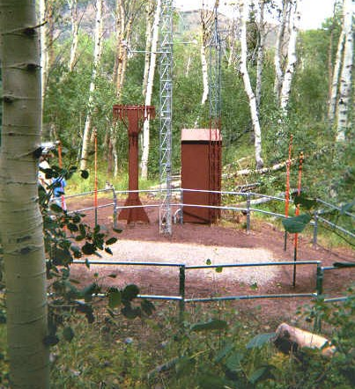
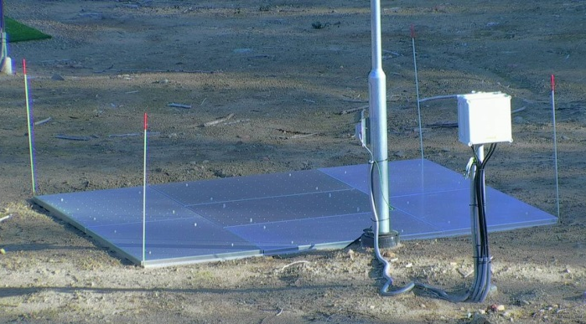
Figure 17: Operational snow pillow site (left) and snow scale (right).
Snow scale: Snow scales (Figure 17 right) are becoming more common as a replacement for snow pillows. The measurement principle is similar in that the instrument measures the weight of the snowpack on top of it, converting the weight to a SWE estimate. However, the weight measurement is made with an electronic load cell, eliminating the need for a fluid filled bladder. Snow scales have a typical measurement area of 6 to 10 m² and although the typical measurement frequency is 1 hour, the sensors have the capability of measuring at higher frequencies. Measurement resolution is typically less than 1 mm w.e. but the expected accuracy is 10%.
Passive gamma radiation sensors: Passive gamma radiation sensors (Figure 18) work on the principle that the natural breakdown of Potassium or Thallium in the soil produces a background level of gamma radiation which is attenuated by the water in the snowpack. The sensor, mounted above the surface, compares gamma radiation measurements with snow on the ground with measurements obtained over bare soil and calculates the attenuation due to the presence of snow. The attenuation is then related to SWE. The sensor typically reports a SWE value every 6 hours with a resolution and expected accuracy of 1 mm w.e. and 5 to 30% (Smith et al., 2017) respectively. The response area is related to the height of the instrument (~40 m² at 2 m above the snow surface). Sensors require a pre-snowpack soil moisture calibration so that the attenuation due to soil moisture can be accounted for in the SWE retrieval.

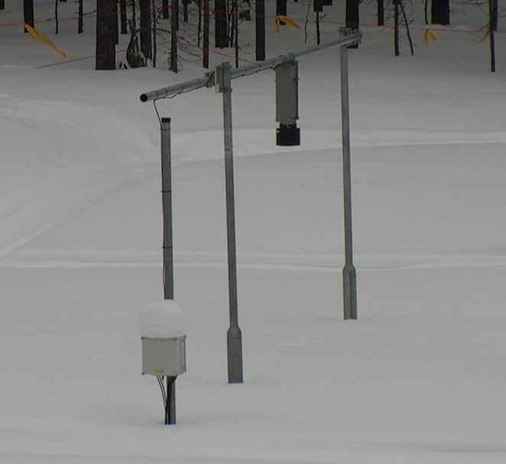
Figure 18: Passive gamma radiation SWE sensor.

Snow water equivalent automated measurement procedures and best practices
Choice of automated sensor: Choosing an automated sensor should depend on site conditions, the required temporal measurement resolution, installation considerations, and environmental concerns. Passive gamma sensors should be used if the instrument needs to be installed over the surface without disturbing the substrate, or to measure an existing snowpack. However, these sensors require long (6+ hour) integration periods which limit their temporal resolution and accuracy. Passive gamma sensors also have a maximum SWE depth measurement capability which should be considered if the measurement is to be made in deep alpine snowpacks (greater than ~600 mm w.e.). The user should also be aware that passive gamma sensors may also be interpreting near surface soil moisture as SWE and therefore overestimate the total SWE in the snowpack (Smith et al., 2017). Snow scales are the preferred option to measure SWE at temporal resolutions of 6 hours or less but require more substantial surface preparation before installation. The user must also consider the potential for the system to “bridge” in some snowpack conditions (snow with freeze and thaw cycles, wind-swept regions, etc.). While snow pillows have similiar capabilities as snow scales, their use should be avoided due to increases maintenance concerns and potential environmental considerations resulting from leakage of the antifreeze fluid from the rubber bladder. The desired accuracy of an automated SWE measurement should be +/- 5 mm w.e. understanding that even in perfect conditions, the accuracy of gamma sensors will be reduced in relation to weighing methods.
Installation height: Snow scales (and pillows) are to be installed flush with the surface to prevent adverse edge effects. Passive gamma sensors need to be installed at a height as recommended by the manufacturer but generally 2 m above the height of the maximum snow depth, noting that the height above the snow impacts the radius of the instrument response area.
Mounting infrastructure: Gamma sensors are generally not impacted by disturbances related to mounting infrastructure but the infrastructure must be designed and installed in a fashion as to minimize the preferential accumulation of snow inside the response area of the sensor. The mounting structure should be as minimal as possible but yet sturdy enough to securely support the sensor. Although not installed above the surface, the same considerations should be made with snow scales and pillows such that the infrastructure does not impact the accumulation or melt of snow within and around the response area.
Data quality control: As with snow depth, the first level of data quality control should be a range check for reasonable (site dependent) values between 0 (or close to 0 to allow for a small amount of sensor drift) and the maximum possible SWE for the site. A jump filter should also be employed to check for unreasonable changes in the hourly (or daily) SWE values, taking into consideration maximum accumulation and ablation rates and wind redistribution. As noted above, changes in SWE can be referenced to changes in snow depth using a co-located sensor. The snow depth sensor will help to identify the snow free period (i.e. the period when the SWE sensor should also read 0) and bridging occurrences on weighing sensors (i.e. extended periods of increasing snow depth without a corresponding increase in SWE).

Snow water equivalent automated measurement sources of error
Errors in automated measurement can occur due to non-environmental issues such as instrument malfunction and incorrect instrument calibration (or calibration drift). Errors can also be a result of circumstances related to the measurement environment such as bridging of weight based measurements or changes in mid-season soil moisture levels under a gamma sensor. Non environmental errors are more easily identified by quality control procedures (i.e. min/max filtering) than environmental errors which tend to be more subtle and less easily detected in the absence of manual sampling.
Bridging is a common issue with weight based SWE measurements generally caused by freeze thaw cycles and snowpack settling which ultimately leads to disconnect between the weighing mechanism and the overlying snowpack and could theoretically be as high as 100%. The occurrence of bridging is most easily identified by periodic manual SWE measurements near the instrument but often this may not be possible. Another indication of bridging is an increase in snow depth (over several days or weeks) without a corresponding increase in sensor measured SWE. This is most easily accomplished by co-locating an automated snow depth sensor with the SWE sensor. A technique for the detection and correction of errors associated with SWE weight based sensors is described by Johnson and Marks (2004).

Errors in automated SWE weight based measurements, especially for snow scales, can be caused by the instrument either settling into the substrate (e.g. sand) in which it was installed or conversely caused to heave out of the ground by freezing and thawing of the substrate (e.g. soils with a high clay and water content). Settling would serve to decrease the pressure on the load cell and therefore cause an underestimation of the SWE measurement while heaving would increase the pressure on the load cell thereby causing an overestimation of the SWE measurement. Both conditions are difficult to assess during the accumulation period but may be identified by observing changes in the height of the instrument relative to the surface (which ideally should be zero) as soon as the instrument is free of snow. The magnitude of these errors is difficult to predict but are likely small in comparison to bridging errors discussed above.
Gamma sensors are influenced by the amount of soil moisture present at the time that the soil freezes and are sensitive to mid-season changes in soil moisture. Generally, the sensors should be calibrated annually with a gravimetric soil moisture measurements made just before the soil freezes but usually this is impossible as quite often the first seasonal snow accumulation will occur on non-frozen soil. It is estimated that SWE errors are approximately 10 mm w.e. for each 0.10 change in gravimetric water content (Smith et al., 2017). Monitoring the change in soil moisture prior to the ground freezing may assist in identifying these errors that could potentially persist throughout the accumulation period.

Snow stratification
Performing snowpack observations requires digging a large enough snow pit to allow for multiple observations, including Snow Water Equivalent (see 2.4 above). The pit face on which the snow is to be observed should be in the shade, vertical and smooth. On inclined terrain the shaded observation face should be parallel to the fall line, i.e., the natural downhill course of a slope.
Characterizing a distinct layer of snow requires more than simply classifying the observed grain shapes. Additional properties like snow density also need to be recorded to give an as accurate as possible description of the snow type and its state. Appendix C.2 “Snowpack observations” in Fierz et al. (2009) give guidelines for how this is best achieved, with examples shown either in graphical or tabular form.

Depth of snowfall (HN, in cm)
No accepted automated technique is available for the depth measurement of new snowfall so only manual techniques are described here.

Manual measurements of depth of new snow

Depth of snowfall measurement techniques
The depth of new snow is measured by a graduated device, such as a ruler, at a defined temporal interval (the most common interval being 24 hours). Snow is allowed to accumulate undisturbed on an artificial surface (e.g. a snowboard, see Figure 19) for the prescribed measurement interval and then a ruler is vertically inserted into that accumulated snow to obtain a depth measurement. Following the observation, the artificial surface is cleared of snow and placed on top of the existing snowpack in preparation for the next observation period.
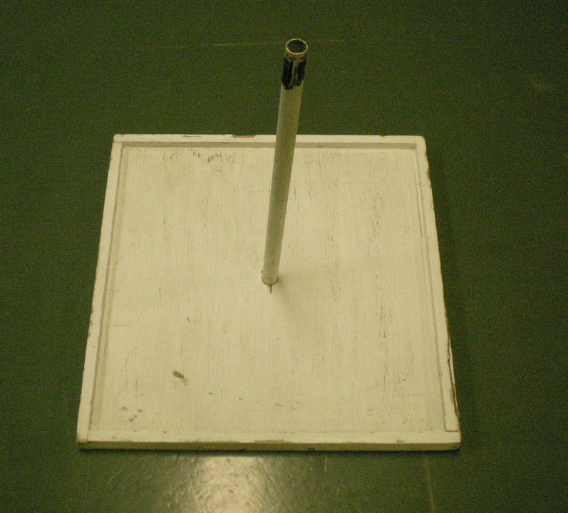 | 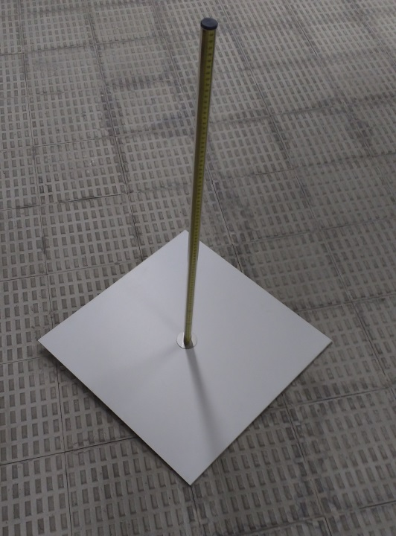
Figure 19: Example of some snowboards used for measuring the depth of new snow. The board on the left is called a Weaver board and is used for new snowfall observations in Canada. The 42.5 cm square board has a small 1 cm lip around the perimeter to prevent new snow from blowing off, and a handle in the middle to locate the board under the snow and assist with clearing and replacing the board (source: https://en.wikipedia.org/wiki/Snowboard_(meteorology)). The board on the right is used by AEMET in Spain and has a graduated rod attached to the centre which doubles as a measuring device and a handle.
Another method for measuring the depth of snowfall is through the use of a cylindrical container such as a rain gauge. If the cylinder is of sufficient diameter (at least 20 cm) and depth (to prevent snow from blowing out), snow can collect uncompressed in the container and be measured by a ruler to estimate depth. However, a cylinder mounted high enough above the surface to prevent catch of blowing snow is also subjected to wind induced bias. A shield around the collector may reduce but not eliminate this bias.
Some work has been done on using automated techniques to estimate the depth of new snowfall (as an example, Fischer, 2011) but this has proven difficult due to factors like drifting and melting without guidance from an observer.

Depth of snowfall measurement procedures and best practices
Depth of new snow measurements shall be made using a snowboard constructed of plywood (with a thickness of 2 cm or less) with dimensions (length and width) between 40 and 60 cm. The snowboard shall be painted white or covered in white felt to prevent the board from becoming warmer than the snow surface during the day. The snowboard shall be placed directly on the surface, which will be the bare ground prior to the accumulation of snow. See Section 1.2 for siting and exposure considerations.
Snowfall is to be allowed to collect undisturbed on the snowboard during the observation period. Observations are to be made at the same time each day. The observer shall measure the depth of the snowfall on the board using a ruler to the nearest 0.2 cm. The depth measurement may have to be obtained in several locations on the board in the event that the snow is not evenly distributed, in which case an average depth shall be reported. After the depth is observed and recorded, the board shall be swept clear and placed on top of the existing snow cover for the next accumulation period. If the snow cover on the board is less than 50% or the snow cover is too thin to be measurable (less than 0.2 cm), then the observer shall record trace as the observation. Surface frost on the snowboard should not be considered as new snow and should be cleared off at the time of the observation.
In the event of wind redistribution or melting, the observer will be required to use some judgement when interpreting the depth of the new snowfall. If wind has swept some of all of the snow from the snowboard, the observer should estimate what would have fallen on the board in the absence of wind. The observer can make this estimate taking into account what can be observed in the vicinity of the board and considering both the presence of drifts and shallow areas. With inhomogeneous depths of new snow due to wind redistribution, the observer should make multiple measurements until they are satisfied that they have approximated the mean. If melting has occurred during the accumulation period, the observer should make an estimate of what the depth of new snowfall would have been had no melting occurred. In either event, the observer shall make a note regarding melting or blowing snow such that the observation is known to be an estimate rather than a ruler measurement.

Depth of snowfall measurement sources of error
The largest source of error in the measurement of the depth of new snowfall will be in the estimate of depth in the presence of either wind redistribution or melting and could be largely dependent on the experience of the observer. The magnitudes of these errors are difficult to assess but could be as large as 100%. Errors due to wind can be reduced by proper siting and minimizing the exposure of the snowboard. Errors due to melting can be minimized by not locating the snowboard in direct exposure to the sun. The uncertainty of the measurement can also be heavily influenced by the timing of the measurement. Especially during warm temperatures the observation an hour earlier or later may differ by several centimeters.
Small errors (< 0.5 cm) can occur as a result of misreading the depth measurement on the ruler, especially at an angle to the snow surface. This can be minimized by reading the ruler graduations at an angle as close to perpendicular with the surface as possible.

Presence of snow on the ground (PSG)
The observation of the presence of snow on the ground is usually done manually although semi-automated or automated techniques such as photometry can be used.

Manual measurements of presence of snow on the surface

Presence of snow on the surface measurement techniques
The manual measurement of the presence of snow on the surface is generally a visual assessment of whether or not the field of view of the measurement site is more or less than 50% covered with snow of any depth.
Photometry techniques for measuring the presence of snow are identical to visual measurements except that the interpretation of coverage is done via a photograph or live video feed rather than in person. Although automated techniques are available for extracting this information from photographs, they are not discussed here.

Presence of snow on the ground measurement procedures and best practices
Firstly, the size of the area in which the presence of snow on the surface is to be assessed needs to be established. This should be the area in which the meteorological and cryospheric measurements are being made and not limited to the area surrounding the snow stake. The field of view of this area should be approximately 50 m x 50 m but no larger than 100 m x 100 m.
At the same time each day, the field of view of the measurement site shall be observed visually or photographed and the percentage of snow cover assessed. If the snow cover extent is larger than 50%, the site should report the presence of snow on the surface. If the snow cover extent is less than 50%, then the site should report no presence of snow. This observation is independent of the point snow depth measurement.

Presence of snow on the surface measurement sources of error
The largest source of error in this observation will be the observer’s interpretation of the areal extent of snow cover, especially as that coverage approaches 50%. A small error in this interpretation may impact the timing of snow free report for the site by several days.

Beaumont, R.T.: Mt. Hood pressure snow gage, Journal of Applied Meteorology, 4, 626–631, 1986.
Farnes, P.F., B.E. Goodison, N.R Peterson and R.P. Richards. 1983. Metrication Of Manual Snow Sampling Equipment. Final Report Western Snow Conference, Spokane, Washington 106 p.
Fierz, C., Armstrong, R. L., Durand, Y., Etchevers, P., Greene, E., McClung, D. M., Nishimura, K., Satyawali, P. K. and Sokratov, S. A.: The International Classification for Seasonal Snow on the Ground, UNESCO-IHP, Paris, France. [online] Available from: http://www.cryosphericsciences.org/outcomes/snowClassification/snowclass_2009-11-23-tagged-highres.pdf, 2009, (Accessed 23 January 2018).
Fischer, A.P., 2011: The Measurement Factors in Estimating Snowfall Derived from Snow Cover Surfaces Using Acoustic Snow Depth Sensors. J. Appl. Meteor. Climatol., 50, 681–699, https://doi.org/10.1175/2010JAMC2408.1
GCW: Global Cryosphere Watch - Glossary, Global Cryosphere Watch [online] Available from: http://globalcryospherewatch.org/reference/glossary.php (Accessed 19 January 2018).
Goodison, B. E., Ferguson, H. L. & McKay, G. A. (1981) Measurement and data analysis. In: Handbook of Snow (ed. by D. M. Gray & D. H. Male). 191– 274. Reprint. The Blackburn Press, Caldwell, NJ, USA.
Jacobson, M.D., Inferring Snow Water Equivalent for a Snow-Covered Ground Reflector Using GPS Multipath Signals, Remote Sensing, 2(10), 2426-2441, doi:10.3390/rs2102426, 2010.
Johnson, J. B. and Marks, D. (2004), The detection and correction of snow water equivalent pressure sensor errors. Hydrol. Process., 18: 3513–3525. doi:10.1002/hyp.5795
Koch, F., Prasch, M., Schmid, L., Schweizer, J., and Mauser, W.: Measuring Snow Liquid Water Content with Low-Cost GPS Receivers. Sensors, 20975-20999, doi: 10.3390/s141120975, 2014.
López-Moreno, J.I., Fassnacht, S.R., Beguería, S. and Latron, J.B.P., 2011. Variability of snow depth at the plot scale: implications for mean depth estimation and sampling strategies. The Cryosphere, 5(3), pp.617-629.
Neumann, N. N., et al. "Characterizing local scale snow cover using point measurements during the winter season." Atmosphere-Ocean 44.3 (2006): 257-269.
NSIDC (2018) NISDC’s Cryospheric Glossary. The National Snow and Ice Data Center, Boulder, CO, USA. [online] Available from: http://nsidc.org/cgi-bin/words/glossary.pl. (Accessed: 23 January 2018).
Palmer, P.L.: Estimating snow course water equivalent from SNOTEL pillow telemetry: An analysis of accuracy, Proc. Of the 54th Western Snow Conference, 81-86, 1986.
Rovansek, R.J., Kane, D.L., Hinzman,L.D.: Improving estimates of snowpack water equivalent using double sampling, Proceedings of the 61st Western Snow Conference, 157-163, 1993.
Shook, K.R. 1995. Simulation of the ablation of prairie snowcovers, unpublished PhD Thesis, Dept. of Agricultural and Bioresource Engineering, University of Saskatchewan, Saskatoon, Canada, 214 pp.
Sigouin, M. J. P. and Si, B. C.: Calibration of a non-invasive cosmic-ray probe for wide area snow water equivalent measurement, The Cryosphere, 10, 1181-1190, doi:10.5194/tc-10-1181-2016, 2016..
Sturm, M., Holmgren, J. and Liston, G. E.: A Seasonal Snow Cover Classification System for Local to Global Applications, J. Climate, 8(5), 1261–1283, doi:10.1175/1520-0442(1995)008<1261:ASSCCS>2.0.CO;2, 1995.
WMO, Ed.: Guide to hydrological practices, 6th ed. (WMO-No. 168), Volume I. Geneva, Switzerland. [online] Available from: http://www.whycos.org/hwrp/guide/index.php, 2008.

