Chapter 9. Observation and measurement of visibility
9.1 General
9.1.1 Definitions
Visibility has traditionally been defined for meteorological purposes as a quantity to be estimated by a human observer, and observations made in that way are widely used. However, the estimation of visibility is affected by many subjective and physical factors. The essential meteorological quantity, which is the transparency of the atmosphere, can be measured objectively and is represented by the meteorological optical range (MOR).
The meteorological optical range is the length of path in the atmosphere required to reduce the luminous flux in a collimated beam from an incandescent lamp, at a colour temperature of 2 700 K, to 5% of its original value. The luminous flux being evaluated by means of the photometric luminosity function of the International Commission on Illumination (CIE) which describes the average spectral sensitivity of human visual perception of brightness (see section 9.4.1).
Visibility, meteorological visibility (by day) and meteorological visibility at night are defined as the greatest distance at which a black object of suitable dimensions (located on the ground) can be seen and recognized when observed against the horizon sky during daylight or could be seen and recognized during the night if the general illumination were raised to the normal daylight level (WMO, 1992a, 2010a).
Visual range (meteorological): Distance at which the contrast of a given object with respect to its background is just equal to the contrast threshold of an observer (WMO, 1992a).
Airlight is light from the sun and the sky which is scattered into the eyes of an observer by atmospheric suspensoids (and, to a slight extent, by air molecules) lying in the observer’s cone of vision. That is, airlight reaches the eye in the same manner as diffuse sky radiation reaches the Earth’s surface. Airlight is the fundamental factor limiting the daytime horizontal visibility for black objects, because its contributions, integrated along the cone of vision from eye to object, raise the apparent luminance of a sufficiently remote black object to a level which is indistinguishable from that of the background sky. Contrary to subjective estimates, most of the airlight entering observers’ eyes originates in portions of their cone of vision lying rather close to them.
The following four photometric qualities are defined in detail in various standards, such as by the International Electrotechnical Commission (IEC, 1987):
(a) Luminous flux (symbol: F (or Φ); unit: lumen) is a quantity derived from radiant flux by evaluating the radiation according to its action upon the International Commission on Illumination standard photometric observer;
(b) Luminous intensity (symbol: I; unit: candela or lm sr^{–1}) is luminous flux per unit solid angle;
(c) Luminance (symbol: L; unit: cd m^{–2}) is luminous intensity per unit area;
(d) Illuminance (symbol: E; unit: lux or lm m^{–2}) is luminous flux per unit area.
The extinction coefficient (symbol σ) gives the extent to which the luminous flux of a collimated beam, emitted by an incandescent source at a colour temperature of 2 700 K, is reduced while travelling the length of a unit distance in the atmosphere. The coefficient is a measure of the attenuation due to both absorption and scattering.
The luminance contrast (symbol C) is the ratio of the difference between the luminance of an object and its background and the luminance of the background.
The contrast threshold (symbol ε) is the minimum value of the luminance contrast that the human eye can detect, namely, the value which allows an object to be distinguished from its background. The contrast threshold varies with the individual.
The illuminance threshold (symbol E_{t}) is the smallest illuminance, required by the eye, for the detection of point sources of light against a background of specified luminance. The value of E_{t}, therefore, varies according to lighting conditions.
The transmission factor (symbol T) is defined, for a collimated beam from an incandescent source at a colour temperature of 2 700 K, as the fraction of luminous flux which remains in the beam after traversing an optical path of a given length in the atmosphere. The transmission factor is also called the transmission coefficient. The terms transmittance or transmissive power of the atmosphere are also used when the path is defined, that is, of a specific length (for example, in the case of a transmissometer). In the latter case, T is often multiplied by 100 and expressed in %.
An aerodrome is a defined area on land or water (including any buildings, installations and equipment) intended to be used either wholly or in part for the arrival, departure and surface movement of aircraft (International Civil Aviation Organization, 2016).
9.1.2 Units and scales
The meteorological visibility or MOR is expressed in metres or kilometres. The measurement range varies according to the application. While for synoptic meteorological requirements, the scale of MOR readings extends from below 100 m to more than 70 km, the measurement range may be more restricted for other applications. This is the case for civil aviation, where the upper limit may be 10 km. This range may be further reduced when applied to the measurement of runway visual range representing landing and take-off conditions in reduced visibility. Runway visual range is required from 50 m or below to 2 000 m or above and is calculated from MOR using amongst other variables the runway light intensity and the background luminance (see Part II, Chapter 2). For other applications, such as road or sea traffic, different limits may be applied according to both the requirements and the locations where the measurements are taken.
The errors of visibility measurements increase in proportion to the visibility, and measurement scales take this into account. This fact is reflected in the code used for synoptic reports by the use of three linear segments with decreasing resolution, namely, 100 to 5 000 m in steps of 100 m, 6 to 30 km in steps of 1 km, and 35 to 70 km in steps of 5 km. This scale allows visibility to be reported with a better resolution than the accuracy of the measurement, except when visibility is less than about 1 000 m.
9.1.3 Meteorological requirements
The concept of visibility is used extensively in meteorology in two distinct ways. First, it is one of the elements identifying air-mass characteristics, especially for the needs of synoptic meteorology and climatology. Here, visibility must be representative of the optical state of the atmosphere. Secondly, it is an operational variable which corresponds to specific criteria or special applications. For this purpose, it is expressed directly in terms of the distance at which specific markers or lights can be seen.
One of the most important special applications is meteorological services to aviation (see Part II, Chapter 2).
The measure of visibility used in meteorology should be free from the influence of extra-meteorological conditions; it must be simply related to intuitive concepts of visibility and to the distance at which common objects can be seen under normal conditions. MOR has been defined to meet these requirements, as it is convenient for the use of instrumental methods by day and night, and as the relations between MOR and other measures of visibility are well understood. MOR has been formally adopted by WMO as the measure of visibility for both general and aeronautical uses (WMO, 2014). It is also recognized by the International Electrotechnical Commission (IEC, 1987) for application in atmospheric optics and visual signalling.
MOR is related to the intuitive concept of visibility through the contrast threshold. In 1924, Koschmieder, followed by Helmholtz, proposed a value of 0.02 for ε. Other values have been proposed by other authors. They vary from 0.007 7 to 0.06, or even 0.2. The smaller value yields a larger estimate of the visibility for given atmospheric conditions. For aeronautical requirements, it is accepted that ε is higher than 0.02, and it is taken as 0.05 since, for a pilot, the contrast of an object (runway markings) with respect to the surrounding terrain is much lower than that of an object against the horizon. It is assumed that, when an observer can just see and recognize a black object against the horizon, the apparent contrast of the object is 0.05, and, as explained below, this leads to the choice of 0.05 as the transmission factor adopted in the definition of MOR.
Accuracy requirements for MOR, runway visual range and background luminance are given in Part I, Chapter 1.
9.1.4 Measurement methods
Visibility is a complex psycho-physical phenomenon, governed mainly by the atmospheric extinction coefficient associated with solid and liquid particles held in suspension in the atmosphere; the extinction is caused primarily by scattering rather than by absorption of the light. Its estimation is subject to variations in individual perception and interpretative ability, as well as the light source characteristics and the transmission factor. Thus, any visual estimate of visibility is subjective.
When visibility is estimated by a human observer it depends not only on the photometric and dimensional characteristics of the object which is, or should be, perceived, but also on the observer’s contrast threshold. At night, it depends on the intensity of the light sources, the background illuminance and, if estimated by an observer, the adaptation of the observer’s eyes to darkness and the observer’s illuminance threshold. The estimation of visibility at night is particularly problematic. The first definition of visibility at night in section 9.1.1 is given in terms of equivalent daytime visibility in order to ensure that no artificial changes occur in estimating the visibility at dawn and twilight. The second definition has practical applications especially for aeronautical requirements, but it is not the same as the first and usually gives different results. Both are evidently imprecise.
Instrumental methods measure the extinction coefficient from which the MOR may be calculated. The visibility may then be calculated from knowledge of the contrast and illuminance thresholds, or by assigning agreed values to them. It has been pointed out by Sheppard (1983) that:
strict adherence to the definition (of MOR) would require mounting a transmitter and receiver of appropriate spectral characteristics on two platforms which could be separated, for example along a railroad, until the transmittance was 5 per cent. Any other approach gives only an estimate of MOR.
However, fixed instruments are used on the assumption that the extinction coefficient is independent of distance. Some instruments measure attenuation directly and others measure the scattering of light to derive the extinction coefficient. These are described in section 9.3. The brief analysis of the physics of visibility in this chapter may be useful for understanding the relations between the various measures of the extinction coefficient, and for considering the instruments used to measure it.
Visual perception – photopic and scotopic vision
The conditions of visual perception are based on the measurement of the photopic efficiency of the human eye with respect to monochromatic radiation in the visible light spectrum. The terms photopic vision and scotopic vision refer to daytime and night-time conditions, respectively.
The adjective photopic refers to the state of accommodation of the eye for daytime conditions of ambient luminance. More precisely, the photopic state is defined as the visual response of an observer with normal sight to the stimulus of light incident on the retinal fovea (the most sensitive central part of the retina). The fovea permits fine details and colours to be distinguished under such conditions of adaptation.
In the case of photopic vision (vision by means of the fovea), the relative luminous efficiency of the eye varies with the wavelength of the incident light. The luminous efficiency of the eye in photopic vision is at a maximum for a wavelength of 555 nm. The response curve for the relative efficiency of the eye at the various wavelengths of the visible spectrum may be established by taking the efficiency at a wavelength of 555 nm as a reference value. The curve in Figure 9.1, adopted by the International Commission on Illumination for an average normal observer, is therefore obtained.

Figure 9.1. Relative luminous efficiency of the human eye for monochromatic radiation. The continuous line indicates daytime vision, while the broken line indicates night-time vision.

Night-time vision is said to be scotopic (vision involving the rods of the retina instead of the fovea). The rods, the peripheral part of the retina, have no sensitivity to colour or fine details, but are particularly sensitive to low light intensities. In scotopic vision, maximum luminous efficiency corresponds to a wavelength of 507 nm.
Scotopic vision requires a long period of accommodation, up to 30 min, whereas photopic vision requires only 2 min.
Basic equations
The basic equation for visibility measurements is the Bouguer-Lambert law:
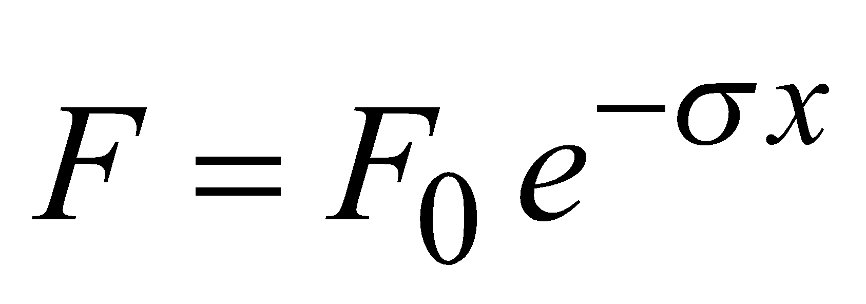 (9.1)
where F is the luminous flux received after a length of path x in the atmosphere, F₀ is the flux for x = 0 and σ is the extinction coefficient per unit length. Differentiating, we obtain:
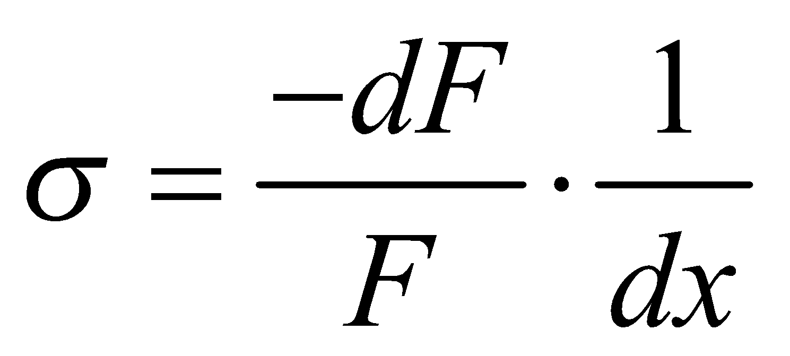 (9.2)
Note that this law is valid only for monochromatic light, but may be applied to a spectral flux to a good approximation. The transmission factor is:
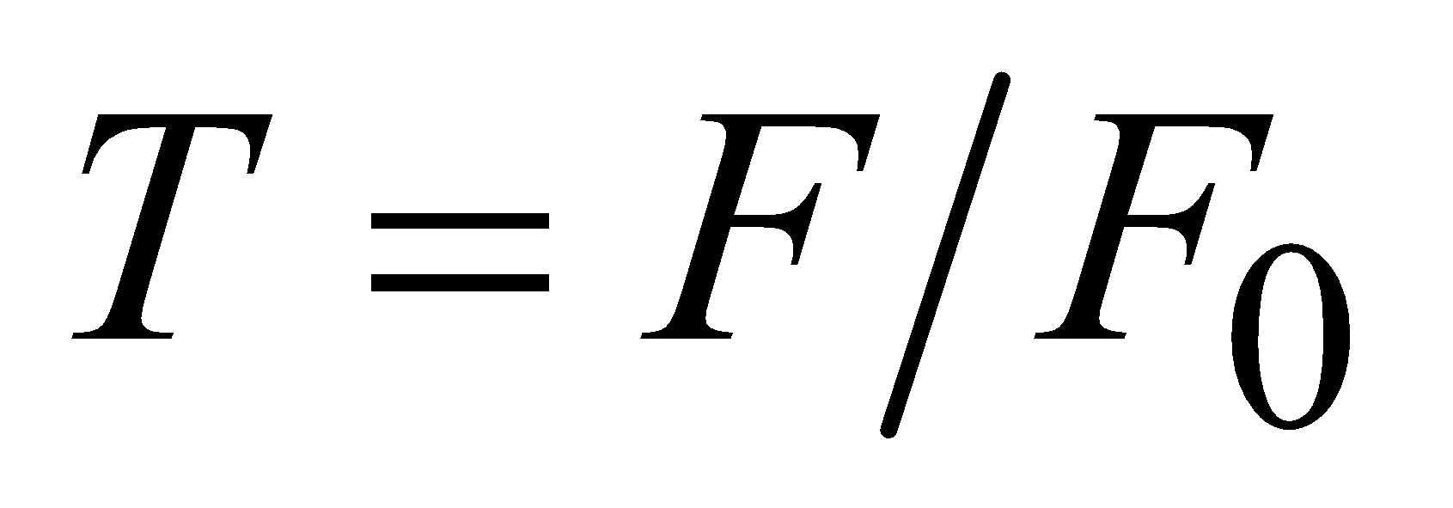 (9.3)
Mathematical relationships between MOR and the different variables representing the optical state of the atmosphere may be deduced from the Bouguer-Lambert law. The relationship between the transmission factor and MOR is valid for fog droplets, but when visibility is reduced by other hydrometeors (such as rain or snow) or lithometeors (such as blowing sand), MOR values should be treated with more care.
From equations 9.1 and 9.3 we may write:
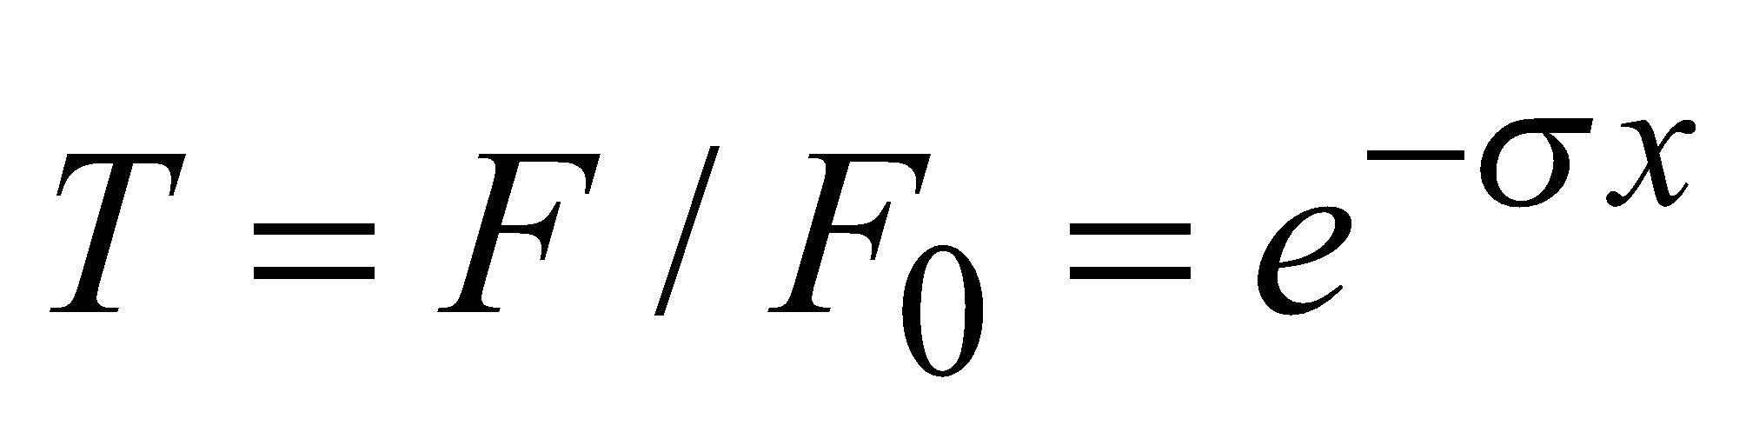 (9.4)
If this law is applied to the MOR definition T = 0.05, and setting x = P where P denotes the MOR then the following may be written:
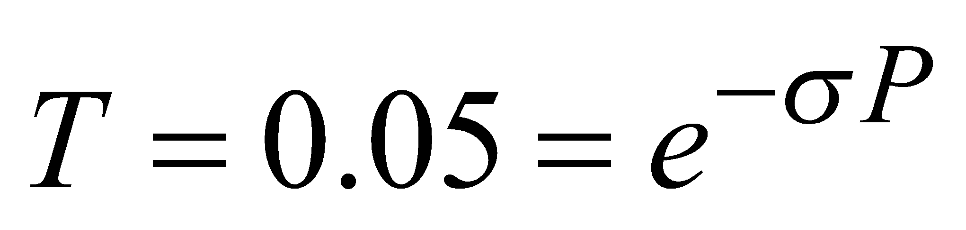 (9.5)
Hence, the mathematical relation of MOR to the extinction coefficient is:
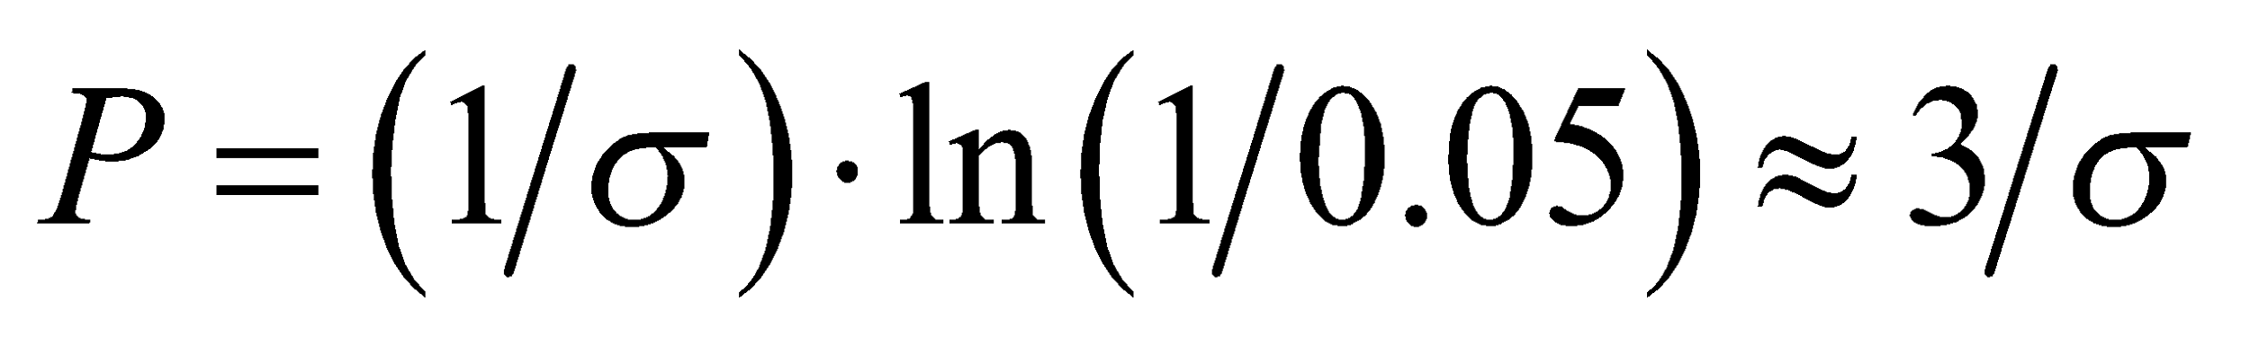 (9.6)
where ln is the log to base e or the natural logarithm. When combining equation 9.4, after being deduced from the Bouguer-Lambert law, and equation 9.6, the following equation is obtained:
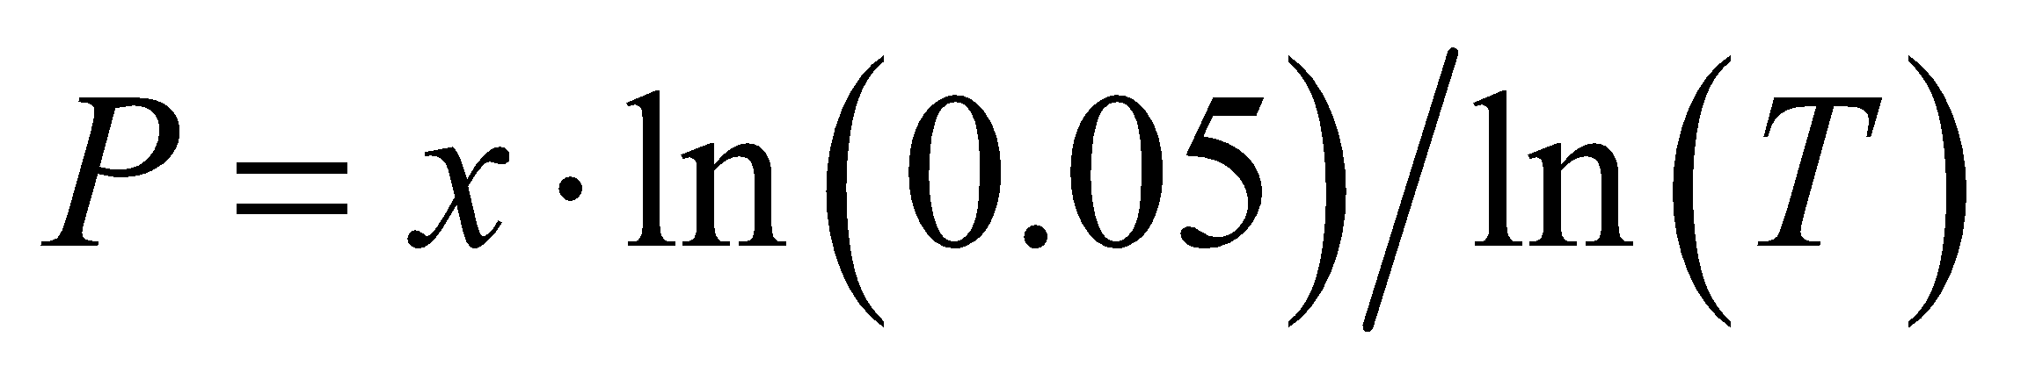 (9.7)
This equation is used as a basis for measuring MOR with transmissometers where x is, in this case, equal to the transmissometer baseline a in equation 9.14.
Meteorological visibility in daylight
The contrast of luminance is:
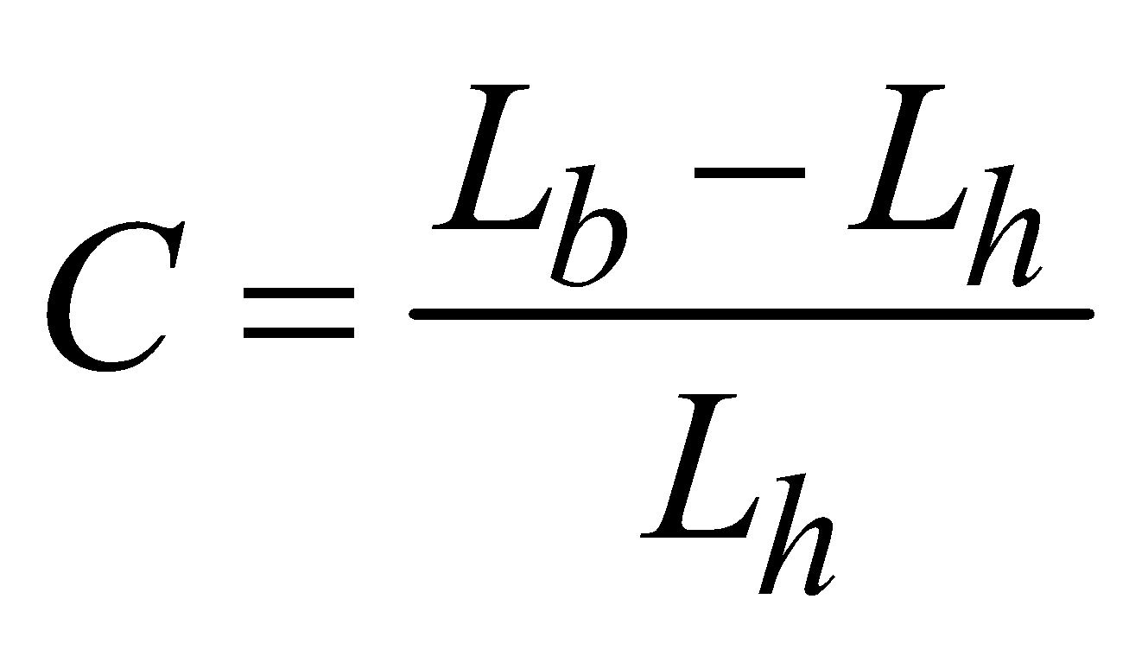 (9.8)
where L_{h} is the luminance of the horizon, and L_{b} is the luminance of the object.
The luminance of the horizon arises from the airlight scattered from the atmosphere along the observer’s line of sight.
It should be noted that, if the object is darker than the horizon, C is negative, and that, if the object is black (L_{b} = 0), C = –1.
In 1924, Koschmieder established a relationship, which later became known as Koschmieder’s law, between the apparent contrast (C_{x}) of an object, seen against the horizon sky by a distant observer, and its inherent contrast (C₀), namely, the contrast that the object would have against the horizon when seen from very short range. Koschmieder’s relationship can be written as:
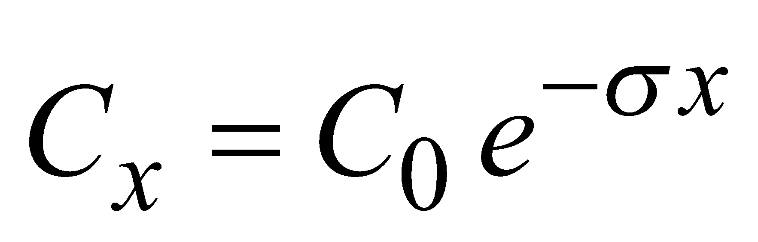 (9.9)
This relationship is valid provided that the scatter coefficient is independent of the azimuth angle and that there is uniform illumination along the whole path between the observer, the object and the horizon.
If a black object is viewed against the horizon (C₀ = –1) and the apparent contrast is –0.05, equation 9.9 reduces to:
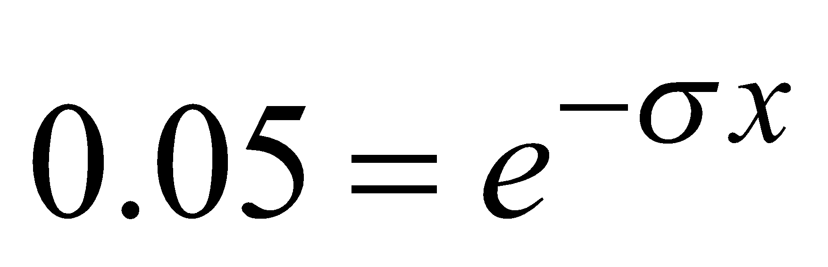 (9.10)
Comparing this result with equation 9.5 shows that when the magnitude of the apparent contrast of a black object, seen against the horizon, is 0.05, that object is at MOR (P).
Meteorological visibility at night
The distance at which a light (a night visibility marker) can be seen at night is not simply related to MOR. It depends not only on MOR and the intensity of the light, but also on the illuminance at the observer’s eye from all other light sources.
In 1876, Allard proposed the law of attenuation of light from a point source of known intensity (I) as a function of distance (x) and extinction coefficient (σ). The illuminance (E) of a point light source is given by:
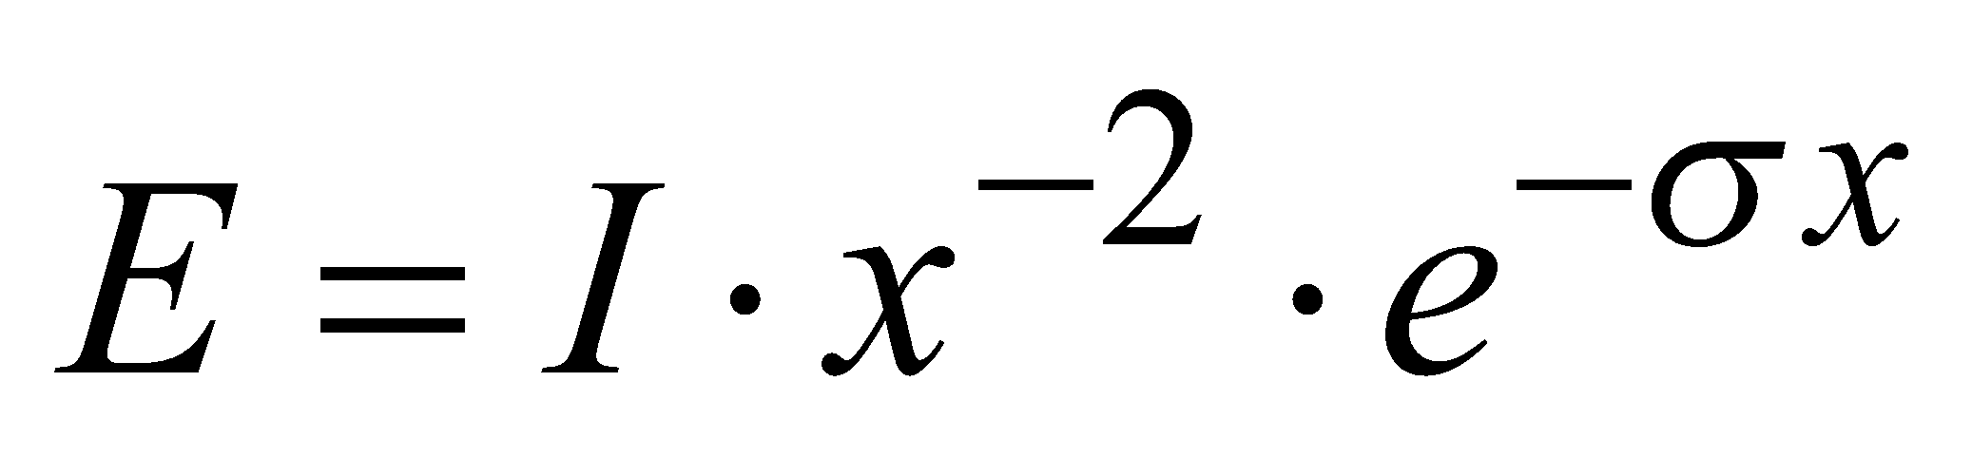 (9.11)
When the light is just visible, E = E_{t} and the following may be written:
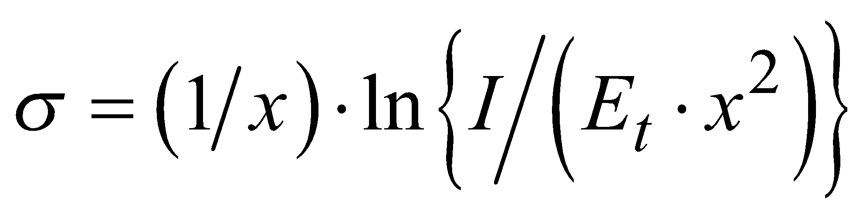 (9.12)
Noting that P = (1/σ) · ln (1/0.05) in equation 9.6, we may write:
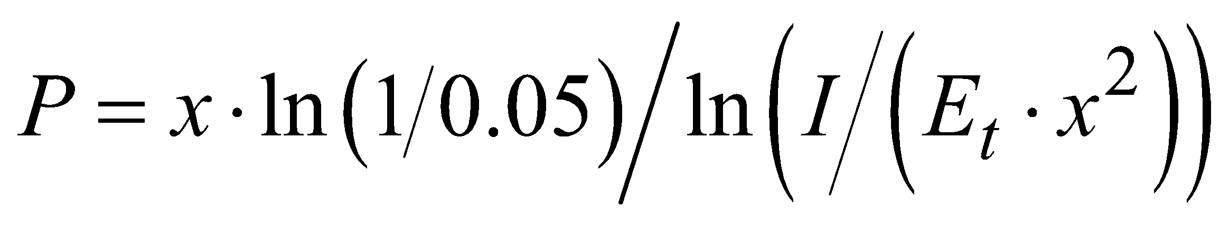 (9.13)
The relationship between MOR and the distance at which lights can be seen is described in section 9.2.3, while the application of this equation to visual observations is described in section 9.2.
9.2 Visual estimation of meteorological optical range
9.2.1 General
A meteorological observer can make a visual estimation of MOR using natural or man-made objects (groups of trees, rocks, towers, masts, churches, lights, and so forth).
Each station should prepare a plan of the objects used for observation, showing their distances and bearings from the observer. The plan should include objects suitable for daytime observations and objects suitable for night-time observations. The observer must also give special attention to significant directional variations of MOR during the assessment of visibility.
Observations should be made by observers who have “normal” vision and have received suitable training. The observations should normally be made without any additional optical devices (binoculars, telescope, theodolite, and the like) and, preferably, not through a window, especially when objects or lights are observed at night. The eye of the observer should be at a normal height above the ground (about 1.5 m); observations should, thus, not be made from the upper storeys of control towers or other high buildings. This is particularly important when visibility is poor.
When visibility varies in different directions, the value recorded or reported may depend on the coding practises of the report. In synoptic messages, the lower value should be reported, but in reports for aviation the guidance in WMO (2014) should be followed.
9.2.2 Estimation of meteorological optical range by day
For daytime observations, the visual estimation of visibility gives a good approximation of the true value of MOR.
Provided that they meet the following requirements, objects at as many different distances as possible should be selected for observation during the day. Only black, or nearly black, objects which stand out on the horizon against the sky should be chosen. Light-coloured objects or objects located close to a terrestrial background should be avoided as far as possible. This is particularly important when the sun is shining on the object. Provided that the albedo of the object does not exceed about 25%, no error larger than 3% will be caused if the sky is overcast, but it may be much larger if the sun is shining. Thus, a white house would be unsuitable, but a group of dark trees would be satisfactory, except when brightly illuminated by sunlight. If an object against a terrestrial background has to be used, it should stand well in front of the background, namely, at a distance at least half that of the object from the point of observation. A tree at the edge of a wood, for example, would not be suitable for visibility observations.
For observations to be representative, they should be made using objects subtending an angle of no less than 0.5° at the observer’s eye. An object subtending an angle less than this becomes invisible at a shorter distance than would large objects in the same circumstances. It may be useful to note that a hole of 7.5 mm in diameter, punched in a card and held at arm’s length, subtends this angle approximately; a visibility object viewed through such an aperture should, therefore, completely fill it. At the same time, however, such an object should not subtend an angle of more than 5°.
9.2.3 Estimation of meteorological optical range at night
Methods which may be used to estimate MOR at night from visual observations of the distance of perception of light sources are described below.
Any source of light may be used as a visibility object, provided that the intensity in the direction of observation is well defined and known. However, it is generally desirable to use lights which can be regarded as point sources, and whose intensity is not greater in any one more favoured direction than in another and not confined to a solid angle which is too small. Care must be taken to ensure the mechanical and optical stability of the light source.
A distinction should be made between sources known as point sources, in the vicinity of which there is no other source or area of light, and clusters of lights, even though separated from each other. In the latter case, such an arrangement may affect the visibility of each source considered separately. For measurements of visibility at night, only the use of suitably distributed point sources is recommended.
It should be noted that observations at night, using illuminated objects, may be affected appreciably by the illumination of the surroundings, by the physiological effects of dazzling, and by other lights, even when these are outside the field of vision and, more especially, if the observation is made through a window. Thus, an accurate and reliable observation can be made only from a dark and suitably chosen location.
Furthermore, the importance of physiological factors cannot be overlooked, since these are an important source of measurement dispersion. It is essential that only qualified observers with normal vision take such measurements. In addition, it is necessary to allow a period of adaptation (usually from 5 to 15 min) during which the eyes become accustomed to the darkness.
For practical purposes, the relationship between the distance of perception of a light source at night and the value of MOR can be expressed in two different ways, as follows:
(a) For each value of MOR, by giving the value of luminous intensity of the light, so that there is a direct correspondence between the distance where it is barely visible and the value of MOR;
(b) For a light of a given luminous intensity, by giving the correspondence between the distance of perception of the light and the value of MOR.
The second relationship is easier and also more practical to use since it would not be an easy matter to install light sources of differing intensities at different distances. The method involves using light sources which either exist or are installed around the station and replacing I, x and E_{t} in equation 9.13 by the corresponding values of the available light sources. In this way, the Meteorological Services can draw up tables giving values of MOR as a function of background luminance and the light sources of known intensity. The values to be assigned to the illuminance threshold E_{t} vary considerably in accordance with the ambient luminance. The following values, considered as average observer values, should be used:
(a) 10^{–6.0} lux at twilight and at dawn, or when there is appreciable light from artificial sources;
(b) 10^{–6.7} lux in moonlight, or when it is not yet quite dark;
(c) 10^{–7.5} lux in complete darkness, or with no light other than starlight.
Tables 9.1 and 9.2 give the relations between MOR and the distance of perception of light sources for each of the above methods for different observation conditions. They have been compiled to guide Meteorological Services in the selection or installation of lights for night visibility observations and in the preparation of instructions for their observers for the computation of MOR values.

Table 9.1. Relation between MOR and intensity of a just-visible point source for
three values of E_{t}

MOR | Luminous intensity (candela) of lamps only  just visible at distances given in column P
P  (m) | Twilight  (E_{t} = 10^{–6.0}) | Moonlight  (E_{t} = 10^{–6.7}) | Complete darkness  (E_{t} = 10^{–7.5})
100 | 0.2 | 0.04 | 0.006
200 | 0.8 | 0.16 | 0.025
500 | 5 | 1 | 0.16
1 000 | 20 | 4 | 0.63
2 000 | 80 | 16 | 2.5
5 000 | 500 | 100 | 16
10 000 | 2 000 | 400 | 63
20 000 | 8 000 | 1 600 | 253
50 000 | 50 000 | 10 000 | 1 580

Table 9.2. Relation between MOR and the distance at which a 100 cd point source is just visible for three values of E_{t}

MOR | Distance of perception (metres) of a lamp of 100 cd as a function of MOR value
P  (m) | Twilight  (E_{t} = 10^{–6.0}) | Moonlight  (E_{t} = 10^{–6.7}) | Complete darkness  (E_{t} = 10^{–7.5})
100 | 250 | 290 | 345
200 | 420 | 500 | 605
500 | 830 | 1 030 | 1 270
1 000 | 1 340 | 1 720 | 2 170
2 000 | 2 090 | 2 780 | 3 650
5 000 | 3 500 | 5 000 | 6 970
10 000 | 4 850 | 7 400 | 10 900
20 000 | 6 260 | 10 300 | 16 400
50 000 | 7 900 | 14 500 | 25 900

An ordinary 100 W incandescent bulb provides a light source of approximately 100 cd.
In view of the substantial differences caused by relatively small variations in the values of the visual illuminance threshold and by different conditions of general illumination, it is clear that Table 9.2 is not intended to provide an absolute criterion of visibility, but indicates the need for calibrating the lights used for night-time estimation of MOR so as to ensure as far as possible that night observations made in different locations and by different Services are comparable.
9.2.4 Estimation of meteorological optical range in the absence of distant objects
At certain locations (open plains, ships, and so forth), or when the horizon is restricted (valley or cirque), or in the absence of suitable visibility objects, it is impossible to make direct estimations, except for relatively low visibilities. In such cases, unless instrumental methods are available, values of MOR higher than those for which visibility points are available have to be estimated from the general transparency of the atmosphere. This can be done by noting the degree of clarity with which the most distant visibility objects stand out. Distinct outlines and features, with little or no fuzziness of colours, are an indication that MOR is greater than the distance between the visibility object and the observer. On the other hand, indistinct visibility objects are an indication of the presence of haze or of other phenomena reducing MOR.
9.2.5 Accuracy of visual observations
General
Observations of objects should be made by observers who have been suitably trained and have what is usually referred to as normal vision. This human factor has considerable significance in the estimation of visibility under given atmospheric conditions, since the perception and visual interpretation capacity vary from one individual to another.
Accuracy of daytime visual estimates of meteorological optical range
Observations show that estimates of MOR based on instrumental measurements are in reasonable agreement with daytime estimates of visibility. Visibility and MOR should be equal if the observer’s contrast threshold is 0.05 (using the criterion of recognition) and the extinction coefficient is the same in the vicinity of the instrument, and between the observer and objects.
Middleton (1952) found, from 1 000 measurements, that the mean contrast ratio threshold for a group of 10 young airmen trained as meteorological observers was 0.033 with a range, for individual observations, from less than 0.01 to more than 0.2. Sheppard (1983) has pointed out that when the Middleton data are plotted on a logarithmic scale they show good agreement with a Gaussian distribution. If the Middleton data represent normal observing conditions, we must expect daylight estimates of visibility to average about 14% higher than MOR with a standard deviation of 20% of MOR. These calculations are in excellent agreement with the results from the First WMO Intercomparison of Visibility Measurements (WMO, 1990), where it was found that, during daylight, the observers’ estimates of visibility were about 15% higher than instrumental measurements of MOR. The interquartile range of differences between the observer and the instruments was about 30% of the measured MOR. This corresponds to a standard deviation of about 22%, if the distribution is Gaussian.
Accuracy of night-time visual estimates of meteorological optical range
From Table 9.2 in section 9.2.3, it is easy to see how misleading the values of MOR can be if based simply on the distance at which an ordinary light is visible, without making due allowance for the intensity of the light and the viewing conditions. This emphasizes the importance of giving precise, explicit instructions to observers and of providing training for visibility observations.
Note that, in practice, the use of the methods and tables described above for preparing plans of luminous objects is not always easy. The light sources used as objects are not necessarily well located or of stable, known intensity, and are not always point sources. With respect to this last point, the lights may be wide- or narrow-beam, grouped, or even of different colours to which the eye has different sensitivity. Great caution must be exercised in the use of such lights.
The estimation of the visual range of lights can produce reliable estimates of visibility at night only when lights and their background are carefully chosen; when the viewing conditions of the observer are carefully controlled; and when considerable time can be devoted to the observation to ensure that the observer’s eyes are fully accommodated to the viewing conditions. Results from the First WMO Intercomparison of Visibility Measurements (WMO, 1990) show that, during the hours of darkness, the observer’s estimates of visibility were about 30% higher than instrumental measurements of MOR. The interquartile range of differences between the observer and the instruments was only slightly greater than that found during daylight (about 35% to 40% of the measured MOR).
9.2.6 Usage of cameras
Camera systems are sometimes used as an aid for an observer in order to assess the visibility for an area that is blocked from view by buildings or to make visibility observations for a remote location. Automated determination of the presence of fog and the estimation of visibility from camera images is under development. This is not surprising given that the availability and quality of (web)cameras has increased, the costs of these systems decreased and the images can easily be made available on internet. Furthermore, image processing techniques are evolving and are now readily available. Various techniques have been implemented such as determining whether objects at known distances are visible by evaluating the presence of edges or contrast reduction. Other techniques use statistical parameters of an image such as gradients or Fourier analysis and relate these to visibility, or use the results of image enhancement methods such as dehazing. These techniques can be applied to either individual images, or 2 images of the same scene obtained with 2 camera’s at different distances, or one image relative to a (set of) reference image(s) under specific atmospheric conditions. Often the techniques are limited to daytime and implementation needs to be tuned to the images/scenes for a specific site (see for example WMO, 2016).
9.3 Instrumental measurement of the meteorological optical range
9.3.1 General
The adoption of certain assumptions allows the conversion of instrumental measurements into MOR. It is not always advantageous to use an instrument for daytime measurements if a number of suitable visibility objects can be used for direct observations. However, a visibility-measuring instrument is often useful for night observations or when no visibility objects are available, or for automatic observing systems. Instruments for the measurement of MOR may be classified into one of the following two categories:
(a) Those measuring the extinction coefficient or transmission factor of a horizontal cylinder of air: Attenuation of the light is due to both scattering and absorption by particles in the air along the path of the light beam;
(b) Those measuring the intensity of light scattered in specific directions by a small volume of air from which the scatter coefficient is derived: In natural fog, absorption is often negligible and the scatter coefficient may be considered as being the same as the extinction coefficient.
Both of the above categories include instruments using a light source and an electronic device comprising a photoelectric cell or a photodiode photodetector to detect the scattered and attenuated light beam.
The main characteristics of these two categories of MOR-measuring instruments are described below.
9.3.2 Instruments measuring the extinction coefficient
Telephotometric instruments
A number of telephotometers have been designed for daytime measurement of the extinction coefficient by comparing the apparent luminance of a distant object with that of the sky background (for example, the Lohle telephotometer), but they are not normally used for routine measurements since, as stated above, it is preferable to use direct visual observations. These instruments may, however, be useful for extrapolating MOR beyond the most distant object.
Visual extinction meters
A very simple instrument for use with a distant light at night takes the form of a graduated neutral filter, which reduces the light in a known proportion and can be adjusted until the light is only just visible. The meter reading gives a measure of the transparency of the air between the light and the observer, and, from this, the extinction coefficient can be calculated. The overall accuracy depends mainly on variations in the sensitivity of the eye and on fluctuations in the radiant intensity of the light source. The error increases in proportion to MOR.
The advantage of this instrument is that it enables MOR values over a range from 100 m to 5 km to be measured with reasonable accuracy, using only three well-spaced lights, whereas without it a more elaborate series of lights would be essential if the same degree of accuracy were to be achieved. However, the method of using such an instrument (determining the point at which a light appears or disappears) considerably affects the accuracy and homogeneity of the measurements.
Transmissometers
The use of a transmissometer is the method most commonly used for measuring the mean extinction coefficient in a horizontal cylinder of air between a transmitter, which provides a modulated flux light source of constant mean power, and a receiver incorporating a photodetector (generally a photodiode at the focal point of a parabolic mirror or a lens). The most frequently used light source is a halogen lamp or xenon pulse discharge tube. Modulation of the light source prevents disturbance from sunlight. The transmission factor is determined from the photodetector output and this allows the extinction coefficient and the MOR to be calculated.
Since transmissometer estimates of MOR are based on the loss of light from a collimated beam, which depends on scatter and absorption, they are closely related to the definition of MOR. A good, well-maintained transmissometer working within its range of highest accuracy provides a very good approximation to the true MOR.
There are two types of transmissometer:
(a) Those with a transmitter and a receiver in different units and at a known distance from each other, as illustrated in Figure 9.2;
(b) Those with a transmitter and a receiver in the same unit, with the emitted light being reflected by a remote mirror or retroreflector at a known distance which is half the baseline (since the light beam travels to the reflector and back), as illustrated in Figure 9.3.

Figure 9.2. Double-ended transmissometer

Figure 9.3. Single-ended transmissometer
The distance covered by the light beam between the transmitter and the receiver is commonly referred to as the baseline and may range from a few metres to 150 m (or even 300 m) depending on the range of MOR values to be measured and the applications for which these measurements are to be used.
As seen in the expression for MOR in equation 9.7, the relation:
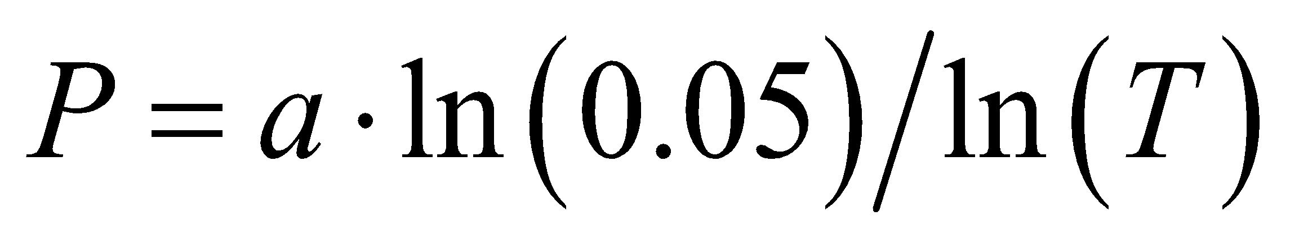 (9.14)
where a is the transmissometer baseline, is the basic formula for transmissometer measurements. Its validity depends on the assumptions that the application of the Koschmieder and Bouguer-Lambert laws is acceptable and that the extinction coefficient along the transmissometer baseline is the same as that in the path between an observer and an object at MOR.
If the measurements are to remain acceptable over a long period, the luminous flux must remain constant during this same period. When halogen light is used, the problem of lamp filament ageing is less critical and the flux remains more constant. However, some transmissometers use feedback systems (by sensing and measuring a small portion of the emitted flux) giving greater homogeneity of the luminous flux with time or compensation for any change.
As will be seen in the section dealing with the accuracy of MOR measurements, the value adopted for the transmissometer baseline determines the MOR measurement range. It is generally accepted that this range is between about 1 and 25 times the baseline length. Modern opto-electronics, however, may provide more accurate results with an extended range (see section 9.3.6 and WMO, 1992b).
A further refinement of the transmissometer measurement principle is to use two receivers or retroreflectors at different distances to extend both the lower limit (short baseline) and the upper limit (long baseline) of the MOR measurement range. These instruments are referred to as “double baseline” instruments.
Many state-of-the-art transmissometers use LEDs as light sources. It is generally recommended that polychromatic light in the visible spectrum be used to obtain a representative extinction coefficient.
Visibility lidars
The lidar (light detection and ranging) technique as described for the laser ceilometer in Part I, Chapter 15, may be used to obtain visibility when the beam is directed horizontally. The range-resolved profile of the backscattered signal S depends on the output signal S₀, the distance x, the backscatter coefficient β, and transmission factor T, such that:
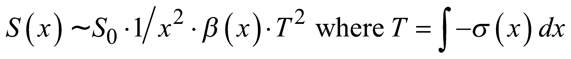 (9.15)
Under the condition of horizontal homogeneity of the atmosphere, β and σ are constant and the extinction coefficient σ is determined from only two points of the profile:
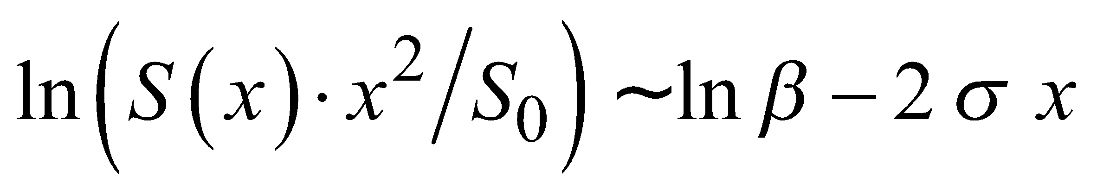 (9.16)
In an inhomogeneous atmosphere the range-dependent quantities of β(x) and σ(x) may be separated with the Klett Algorithm (Klett, 1985).
As MOR approaches 2 000 m, the accuracy of the lidar method becomes poor.
More information on the requirements for performing visual-range lidar measurements to determine the direction-dependent meteorological optical range can be found in the International Organization for Standardization standard, ISO 28902-1:2012 (ISO, 2012).
9.3.3 Instruments estimating the scatter coefficient
The attenuation of light in the atmosphere is due to both scattering and absorption. The presence of pollutants in the vicinity of industrial zones, ice crystals (freezing fog) or dust may make the absorption term significant. However, in general, the absorption factor is negligible and the scatter phenomena due to reflection, refraction, or diffraction on water droplets constitute the main factor reducing visibility. The extinction coefficient may then be considered as equal to the scatter coefficient, and an instrument for determining the latter can, therefore, be used to estimate MOR.
Measurements are most conveniently taken by concentrating a beam of light on a small volume of air and by determining, through photometric means, the proportion of light scattered in a sufficiently large solid angle in directions where scattering provides the best estimate of the scatter coefficient in all conditions. Provided that it is completely screened from interference from other sources of light, or that the light source is modulated, an instrument of this type can be used during both the day and night. The scatter coefficient b is a function that may be written in the following form:
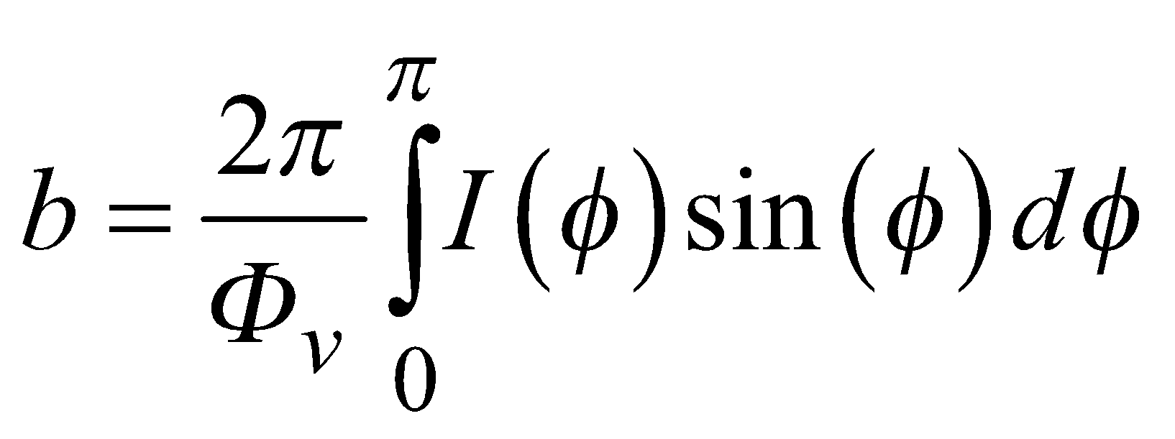 (9.17)
where Φ_{v} is the flux entering the volume of air V and I(Φ) is the intensity of the light scattered in direction Φ with respect to the incident beam.
Note that the accurate determination of b requires the measurement and integration of light scattered out of the beam over all angles. Practical instruments measure the scattered light over a limited angle and rely on a high correlation between the limited integral and the full integral in all conditions.
Three measurement methods are used in these instruments: backscatter, forward scatter, and scatter integrated over a wide angle.
(a) Backscatter: In these instruments (Figure 9.4), a light beam is concentrated on a small volume of air in front of the transmitter, the receiver being located in the same housing as the light source where it receives the light backscattered by the volume of air sampled. Several researchers have tried to find a relationship between visibility and the coefficient of backscatter, but it is generally accepted that that correlation is not satisfactory.

Figure 9.4. Visibility meter measuring backscatter

(b) Forward scatter: The amount of light scattered by small particles (aerosols, small droplets) is angular dependent. Moreover, the angular dependency depends on the chemical composition (e.g. salt concentration), type of nucleus (sand, dust) and size and shape of the particles. As a consequence, a scattering angle should be chosen so that the angular dependence is minimal and representative for the scatter coefficient. Several authors have shown that the best angle is between 20° and 50° (Kneizys et al., 1983; Jia and Lü, 2014; Barteneva, 1960; Van de Hulst, 1957). The instruments, therefore, comprise a transmitter and a receiver, the angle between the beams being 20° to 50°. Another arrangement involves placing either a single diaphragm half-way between a transmitter and a receiver or two diaphragms each a short distance from either a transmitter or a receiver. Figure 9.5 illustrates the two configurations that are used. Instruments determining MOR based on the forward scatter principle are generally called forward scatter sensors or forward scatter meters.

Figure 9.5. Two configurations of visibility meters measuring forward scatter

(c) Scatter over a wide angle: Such an instrument, illustrated in Figure 9.6, which is usually known as an integrating nephelometer, is based on the principle of measuring scatter over as wide an angle as possible, ideally 0° to 180°, but in practice about 0° to 120°. The receiver is positioned perpendicularly to the axis of the light source which provides light over a wide angle. Although, in theory, such an instrument should give a better estimate of the scatter coefficient than an instrument measuring over a small range of scattering angles, in practice it is more difficult to prevent the presence of the instrument from modifying the extinction coefficient in the air sampled. Integrating nephelometers are not widely used for measuring MOR, but this type of instrument is often used for measuring pollutants.
In all the above instruments, as for most transmissometers, the receivers comprise photodetector cells or photodiodes. The light used is pulsed (for example, high-intensity discharge into xenon).
These types of instruments require only limited space (1 to 2 m in general). They are, therefore, useful when no visibility objects or light sources are available (on board ships, by roadsides, and so forth). Since the measurement relates only to a very small volume of air, the representativeness of measurements for the general state of the atmosphere at the site may be open to question. However, this representativeness can be improved by averaging a number of samples or measurements. In addition, smoothing of the results is sometimes achieved by eliminating extreme values.
The use of these types of instruments has often been limited to specific applications (for example, highway visibility measurements, or to determine whether fog is present) or when less precise MOR measurements are adequate. These instruments are now being used in increasing numbers in automatic meteorological observation systems because of their ability to measure MOR over a wide range and their relatively low susceptibility to contamination of optical surfaces compared with transmissometers.

Figure 9.6. Visibility meter measuring scattered light over a wide angle
9.3.4 Instrument exposure and siting
Measuring instruments should be located in positions which ensure that the measurements are representative for the intended purpose. Thus, for general synoptic purposes, the instruments should be installed at locations free from local atmospheric pollution, for example, smoke, industrial pollution, dusty roads.
The volume of air in which the extinction coefficient or scatter coefficient is measured should normally be at the eye level of an observer, about 1.5 m above the ground.
It should be borne in mind that transmissometers and forward scatter meters should be installed in such a way that the sun is not in the optical field of view of the receiver at any time of the day. This is normally achieved either by mounting with a north-south optical axis (to ±45°) with the receiver horizontal and pointing away from the equator for latitudes up to 50°, or by using a system of screens or baffles. Forward scatter meters should also be aligned such that reflecting objects in the optical field of view of the receiver are avoided.
For aeronautical purposes, measurements are to be representative of conditions at the aerodrome or along the runway. These conditions, which relate more specifically to aerodrome operations, are described in Part II, Chapter 2.
The instruments should be installed in accordance with the directions given by the manufacturers. Particular attention should be paid to the correct alignment of transmissometer transmitters and receivers and to the correct adjustment of the light beam. The poles on which the transmitter/receivers are mounted should be mechanically firm (while remaining frangible when installed at aerodromes) to avoid any misalignment due to ground movement during freezing and, particularly, during thawing. In addition, the mountings must not distort under the thermal stresses to which they are exposed. Some modern transmissometers can automatically adjust their alignment to compensate for this.
9.3.5 Calibration and maintenance
In order to obtain satisfactory and reliable observations, instruments for the measurement of MOR should be operated and maintained under the conditions prescribed by the manufacturers, and should be kept continuously in good working order. Regular checks and calibration in accordance with the manufacturer’s recommendations should ensure optimum performance.
9.3.5.1 Maintenance

For most transmissometers their optical surfaces must be cleaned regularly therefore frequent servicing must be planned for, particularly at aerodromes. The instruments should be cleaned during and/or after major atmospheric disturbances, since rain or violent showers together with strong wind may cover the optical systems with a large number of water droplets and solid particles resulting in major MOR measurement errors. The same is true for snowfall, which could block the optical systems. Heating systems are often placed at the front of the optical systems and in the hood to improve instrument performance under such conditions. Air-blowing systems are sometimes used to reduce the above problems and the need for frequent cleaning. However, it must be pointed out that these blowing and heating systems may generate air currents warmer than the surrounding air and may adversely affect the measurement of the extinction coefficient of the air mass. In arid zones, sandstorms or blowing sand may block the optical system and even damage it. Modern transmissometers and forward scatter meters monitor the contamination on the optical lens or window and produce warnings and errors when the contamination reaches a threshold. Some instruments make a correction for the window contamination.
The MOR measurement of a forward scatter meter is affected by cobwebs or even individual spider silk in the sample volume. Flying insects, which typically swarm around dusk in calm weather conditions can contribute to the scattered signal. Both cause the forward scatter meter to report artificially low MOR values. The reduction of the MOR of a forward scatter meter by cob-webs and flying insects can be very large, whereas these hardly affect the MOR obtained by a transmissometers. Some forward scatter meters filter the raw signal for spikes induced by flying insects (see for example WMO, 2012). However, care must be taken that spikes resulting from particles or droplets are not filtered out as this filtering leads to higher MOR values which may lead to safety issues.
The main sources of error and recommended actions are summarised below.
Transmissometers: Sources of Error and Actions
Error Source | Action
Atmospheric pollutants deposited on optical surfaces | 1. Sensor self-diagnostic features: contamination measurement and contamination compensation algorithms in sensor software.  2. Preventative maintenance: regular cleaning in accordance with manufacturer’s instructions.  3. Reactive maintenance: cleaning at need.
Instability of system electronics | Regular calibration check, using a graduated set of attenuation filters under stable, high visibility conditions. Adjust instrument settings, if required, in accordance with manufacturer's instructions.
Snow or ice build-up on surfaces near to the optical measurement path | Preventative measure: install sensor head heaters and hood heaters
Aging of transmitter light source or incorrect centring of lamps. | 1.Sensor self-diagnostic features: lamp intensity measurement and aging warning messages  2. Preventative/reactive maintenance: replacement of transmitter light source, if required.  3. Use automatic alignment assistant, where available.
Insufficient rigidity and stability of transmitter and receiver mounts and effects of freezing or thawing of the ground and thermal stress | Regular calibration check, using a graduated set of attenuation filters under stable, high visibility conditions. Adjust instrument settings, if required, in accordance with manufacturer’s instructions.
Remote transmission of the extinction coefficient as a low current signal may be subject to interference from electromagnetic fields. (a particular problem at aerodromes) | Digital signal formats are less prone to interference than analogue signals.
Calibration error due to calibration/adjustment being carried out when visibility is low, or unstable atmospheric conditions that affect the extinction coefficient. | Calibration and adjustment should be carried out in accordance with manufacturer’s instructions.
Incorrect alignment of transmitters and receivers | Use automatic alignment assistant, where available
Disturbance when sun is near horizon, or due to reflections from adjacent surfaces | Installation and orientation should be carried out in accordance with manufacturer’s instructions.

Instruments based on Forward Scatter: Sources of Error and Actions
Error Source | Action
Atmospheric pollutants deposited on optical surfaces | 1. Sensor self-diagnostic features: contamination measurement and contamination compensation algorithms in sensor software.  2. Design features: look-down geometry and hoods over sensor heads provide better protection to optics and enable longer intervals between maintenance.  3. Preventative maintenance: regular cleaning in accordance with manufacturer’s instructions.  4. Reactive maintenance: cleaning at need.
Instability of system electronics | Regular calibration check, using scatter plates (also known as SCU) that emulate defined fog conditions. Adjust instrument settings, if required, in accordance with manufacturer’s instructions.
Snow or ice build-up on surfaces near to the optical measurement path | Preventative measure: install sensor head heaters and hood heaters
Aging of transmitter light source | 1.Sensor self-diagnostic features: lamp intensity measurement and aging warning messages  2. Preventative/reactive maintenance: replacement of transmitter light source, if required.
Atmospheric conditions (for example, rain, snow, ice crystals, sand, local atmospheric pollutants) giving a scatter coefficient that differs from the extinction coefficient. | This is taken into account by the transmissometer measurement principles.  1. Design feature: optimised scattering angle  2. Discrimination and correction for atmospheric conditions
Extra absorption by sand, dust and smoke that affects visibility and its measurement. | This is taken into account by the transmissometer measurement principles.  Discrimination and correction for absorption??
Calibration error due to calibration/adjustment being carried out when visibility is low, or unstable atmospheric conditions that affect the extinction coefficient. | Calibration and adjustment should be carried out in accordance with manufacturer’s instructions.
Incorrect procedures for calibration/adjustment, or use of incorrect or damaged scatter plates. | Calibration and adjustment should be carried out in accordance with manufacturer’s instructions.
Disturbance when sun is near horizon, or due to reflections from adjacent surfaces | Installation and orientation should be carried out in accordance with manufacturer’s instructions.
Disturbance by cob-webs, or even individual spider silk, and flying insects in the sample volume. | 1. Preventative maintenance: regular cleaning in accordance with manufacturer’s instructions.  2. Reactive maintenance: cleaning at need.  3. Discrimination and correction for spikes in scattered signal due to flying insects

9.3.5.2 Calibration
The calibration should be verified regularly (this is normally performed in very good visibility i.e. over 10 to 15 km) and the instrument should be calibrated and adjusted if necessary. Atmospheric conditions resulting in erroneous calibration must be avoided. When, for example, there are strong updraughts, or after heavy rain, considerable variations in the extinction coefficient are encountered in the layer of air close to the ground; if several transmissometers are in use on the site (in the case of aerodromes), dispersion is observed in their measurements. Calibration should not be attempted under such conditions.

A transmissometer can be calibrated by direct comparison with the distance at which specified objects and lights of known intensity can be seen by an observer. The observation should be as close as possible to MOR, as it is MOR which is used for conversion to obtain transmittance. The calibration can also be performed by directly using traceable optical neutral density filters.
Calibration of instruments based on measurement of the scattering coefficient, also known as scatter meters, cannot be carried out directly. The calibration of a forward-scatter meter has to be traceable and verifiable to a transmissometer standard, the accuracy of which has been verified over the intended operational range (ICAO 2016). The calibration of a scatter meter involves the insertion of optical plates (often called Scatter meter Calibration Units or SCU) into the measurement volume, at a fixed position, which simulates defined value of MOR. These SCU are specific and provided by the instrument manufacturer. Generally only SCU corresponding to a low MOR value is required in combination with blocking the receiver (high MOR value).
SCU are susceptible to changes over a period of use due to contamination and ageing and should be initially and then regularly checked and calibrated. This should be done by returning the plates to a suitable testing facility equipped with adequate visibility references and a traceable calibration chain. For some instruments, the manufacturer may offer an equivalent calibration service for SCU supplied by themselves.
According to the ICAO (2005), part 9.4.3 on references for visibility: an “ideal” reference is a set of instruments of at least two transmissometers (ideally using two different baselines) and two forward scatter meters exhibiting median values with a bias less than 5 per cent, when compared to the transmissometers.

At the visibility calibration facility, the SCU should be checked on a known reference forward scatter meter, and if necessary recalibrated with a new coefficient.
There, the known reference forward scatter meters are themselves regularly calibrated with a reference SCU and they are systematically checked against the reference transmissometers during low visibility episodes. In case of a bias over a defined threshold (5% for ICAO), the reference SCU is recalibrated with a new coefficient. The reference transmissometers must also be regularly calibrated. This can be done against human observations or by using a set of optical neutral density filters. The traceability of the MOR measurements to a known standard should be established. A visibility reference and calibration chain is described in for example WMO (2006).
The resulting chain of calibration is described on Figure 9.7.
Figure 9.7. Visibility calibration chain for scatter meters
The comparison of forward scatter meters and transmissometers should be carefully conducted with validated data.
Comparison of scatter meters and transmissometers should be carried out during periods of low visibility, as a SCU generally simulates these conditions. Additionally, the accuracy of the reference transmissometers is very good at lower visibility and low visibility values are critical for aviation purposes.
Data from fog only episodes should be kept although higher visibility values may also be considered as long as the transmissometer can serve as a reference, and episodes including precipitations (rain, snow) must be excluded. The reason was noted in part 9.1.4: the relationship between the transmission factor and MOR is valid for fog droplets, but when visibility is reduced by other hydrometeors (such as rain or snow) or lithometeors (such as blowing sand), MOR values should be treated with more care.

Finally as explained in ICAO (2005): When comparing instruments, it is necessary to check the homogeneity of fog. Nonhomogeneous fogs may strongly disturb the MOR distribution ratio of an instrument. Therefore, such periods must be identified and excluded from the data analysis.
Note that higher visibility values may also be considered in the comparison of forward scatter meters and transmissometers as long as the transmissometer can serve as a reference. This extension of the MOR range also serves as a check of the linearity and the 2-point calibration of the forward scatter meters over a larger visibility range.

9.3.6 Accuracy estimates for the measurement of meteorological optical range
General
All practical operational instruments for the measurement of MOR sample a relatively small region of the atmosphere compared with that scanned by a human observer. Instruments can provide an accurate measurement of MOR only when the volume of air that they sample is representative of the atmosphere around the point of observation out to a radius equal to MOR. It is easy to imagine a situation, with patchy fog or a local rain or snow storm, in which the instrument reading is misleading. However, experience has shown that such situations are not frequent and that the continuous monitoring of MOR using an instrument will often lead to the detection of changes in MOR before they are recognized by an unaided observer. Nevertheless, instrumental measurements of MOR must be interpreted with caution.
Another factor that must be taken into account when discussing representativeness of measurements is the homogeneity of the atmosphere itself. At all MOR values, the extinction coefficient of a small volume of the atmosphere normally fluctuates rapidly and irregularly, and individual measurements of MOR from forward scatter meters and short baseline transmissometers, which have no in-built smoothing or averaging system, show considerable dispersion. It is, therefore, necessary to take many samples and to smooth or average them to obtain a representative value of MOR. The analysis of the results from the First WMO Intercomparison of Visibility Measurements (WMO, 1990) indicates that, for most instruments, no benefit is gained by averaging over more than 1 min, but for the “noisiest” instruments an averaging time of 2 min is preferable.

Accuracy of transmissometers
The sources of error in transmissometer measurements may be summarized as follows:
(a) Incorrect alignment of transmitters and receivers;
(b) Insufficient rigidity and stability of transmitter/receiver mountings (freezing and thawing of the ground, thermal stress);
(c) Ageing and incorrect centring of lamps;
(d) Calibrating error (visibility too low or calibration carried out in unstable conditions affecting the extinction coefficient);
(e) Instability of system electronics;
(f) Remote transmission of the extinction coefficient as a low-current signal subject to interference from electromagnetic fields (particularly at aerodromes). It is preferable to digitize the signals;
(g) Disturbance due to rising or setting of the sun, and poor initial orientation of the transmissometers;
(h) Atmospheric pollution dirtying the optical systems and/or incorrect compensation for this contamination;
(i) Local atmospheric conditions (for example, rain showers and strong winds, snow) giving unrepresentative extinction coefficient readings or diverging from the Koschmieder law (snow, ice crystals, rain, and so forth). Extra absorption by sand and dust affects visibility and its measurement. This is taken into account by the transmissometer measurement principle. (Forward scatter meter measurements cannot take into account the effect of extra absorption due to the nature of the measurement principle.) Large-particle scattering and reflection creates a small amount of unwanted forward scatter in transmissometer measurements. This may affect the measurement uncertainty of transmissometer measurements, depending on the transmitter divergence and the receiver’s field of view.
The use of a transmissometer that has been properly calibrated and well maintained should give good representative MOR measurements if the extinction coefficient in the optical path of the instrument is representative of the extinction coefficient everywhere within the MOR. However, a transmissometer has only a limited range over which it can provide accurate measurements of MOR. A relative error curve for MOR may be plotted by differentiating the basic transmissometer formula (see equation 9.7). Figure 9.7 shows how the relative error varies with transmission, assuming that the measurement accuracy of the transmission factor T is 1%.

Figure 9.7. Error in measurements of meteorological optical range as a function of
a 1% error in transmittance

This 1% value of transmission error, which may be considered as correct for many older instruments, does not include instrument drift, dirt on optical components, or the scatter of measurements due to the phenomenon itself. If the accuracy drops to around 2% to 3% (taking the other factors into account), the relative error values given on the vertical axis of the graph must be multiplied by the same factor of 2 or 3. Note also that the relative MOR measurement error increases exponentially at each end of the curve, thereby setting both upper and lower limits to the MOR measurement range. The example shown by the curve indicates the limit of the measuring range if an error of 5%, 10% or 20% is accepted at each end of the range measured, with a baseline of 75 m. It may also be deduced that, for MOR measurements between the limits of 1.25 and 10.7 times the baseline length, the relative MOR error should be low and of the order of 5%, assuming that the error of T is 1%. The relative error of MOR exceeds 10% when MOR is less than 0.87 times the baseline length or more than 27 times this length. When the measurement range is extended further, the error increases rapidly and becomes unacceptable. However, since contemporary transmissometers produce transmission errors that are clearly lower than the exemplary 1%, the usable measurement range may be extended accordingly.
Already results from the First WMO Intercomparison of Visibility Measurements (WMO, 1990) show that the best transmissometers, when properly calibrated and maintained, can provide measurements of MOR with a standard error of about 10% when MOR is up to 60 times their baseline.
Accuracy of forward scatter meters
The principal sources of error in measurements of MOR taken with forward scatter meters are as follows:
(a) Calibration error (visibility too low or calibration performed in unstable conditions);
(b) Calibration error (stability, contamination and ageing of the calibration plates);

(c) Calibration error (differences in geometry between transmitter and receiver, the measurement volume, and the position of the plates during calibration);
(d) Instability of system electronics;
(e) Communications errors;
(f) Disturbance from reflections of sun light due to poor initial instrument orientation;
(g) Atmospheric pollution dirtying the optical systems and/or incorrect compensation for this;
(h) Incorrect installation causing reflections of transmitted signal by objects and surface;
(i) Presence of cobwebs or individual spider silk and flying insects in the measurement volume;
(j) Differences introduced by operating not at visible wavelengths and/or incorrect compensation for this;

(k) Atmospheric conditions (for example, rain, snow, ice crystals, sand, local pollution with different scatter angular dependence).
Results from the First WMO Intercomparison of Visibility Measurements (WMO, 1990) show that forward scatter meters are generally less accurate than transmissometers at low values of MOR, and forward scatter meters show greater variability in their readings. There was also evidence that forward scatter meters, as a class, were more affected by precipitation than transmissometers. However, the best forward scatter meters showed little or no susceptibility to precipitation and provided estimates of MOR with standard deviation of about 10% over a range of MOR from about 100 m to 50 km. Almost all the forward scatter meters in the intercomparison exhibited significant systematic error over part of their measurement range. forward scatter meters showed very low susceptibility to contamination of their optical systems.
An overview of the differences between forward scatter meters and transmissometers is given by WMO (1992b).
Accuracy of telephotometers and visual extinction meters
Visual measurements based on the extinction coefficient are difficult to take. The main source of error is the variability and uncertainty of the performance of the human eye. These errors have been described in the sections dealing with the methods of visual estimation of MOR.

References and further reading
Barteneva, O.D., 1960: Scattering functions of light in the atmospheric boundary layer. Izv. Akad. Nauk SSR, Ser. Geofiz. [Bull. Acad. Sci. USSR, Geophysics Series], 12:1237–1244.
International Civil Aviation Organization, 2005: Manual of Runway Visual Range Observing and Reporting Practices (Doc 9328, AN/908) Third edition. Montreal.
International Civil Aviation Organization, 2016: Meteorological Service for International Air Navigation, Annex 3 to the Convention on International Civil Aviation. Nineteenth edition. Montreal.
International Electrotechnical Commission, 1987: International Electrotechnical Vocabulary, Chapter 845: Lighting, IEC 60050-845. Geneva.
International Organization for Standardization, 2012: Air Quality – Environmental Meteorology – Part 1: Ground-based Remote Sensing of Visual Range by Lidar, ISO 28902-1:2012. Geneva.
Jia S-J. and D-R. Lü, 2014: Optimal forward-scattering angles of atmospheric aerosols in North China. Atmospheric and Oceanic Science Letters, 7(3):236–242.
Klett, J.D., 1985: Lidar inversion with variable backscatter/extinction ratios. Applied Optics, 24(11):1638–1643.
Kneizys, F.X., E.P. Shettle, W.O. Gallery, J.H. Chetwynd, L.W. Abreu, J.E.A. Selby, S.A. Clough and R.W. Fenn, 1983: Atmospheric Transmittance/Radiance: Computer Code LOWTRAN 6, Appendix D. AFGL-TR-83-0187, Environmental Research Papers No. 846. Air Force Geophysics Laboratory, Massachusetts.
Middleton, W.E.K., 1952: Vision Through the Atmosphere. University of Toronto Press, Toronto.
Sheppard, B.E., 1983: Adaptation to MOR. Preprints of the Fifth Symposium on Meteorological Observations and Instrumentation (Toronto, 11–15 April 1983), pp. 226–269.
Van de Hulst, H.C., 1957: Light Scattering by Small Particles. Wiley & Sons, New York (repr. Dover Books on Physics, 1981).
World Meteorological Organization, 1990: The First WMO Intercomparison of Visibility Measurements: Final Report (D.J. Griggs, D.W. Jones, M. Ouldridge and W.R. Sparks). Instruments and Observing Methods Report No. 41 (WMO/TD-No. 401). Geneva.
———, 1992a: International Meteorological Vocabulary (WMO-No. 182). Geneva.
———, 1992b: Visibility measuring instruments: Differences between scatterometers and transmissometers (J.P. van der Meulen). Paper Presented at the WMO Technical Conference on Instruments and Methods of Observation (TECO-92) (Vienna, Austria, 11–15 May 1992), Instruments and Observing Methods Report No. 49 (WMO/TD-No. 462). Geneva.
———, 2006: KNMI Visibility Standard for Calibration of Scatterometers (H. Bloemink). Paper presented at the WMO Technical Conference on Instruments and Methods of Observation (TECO 2006) (Geneva, Switzerland, 4-6 December 2006), Instruments and Observing Methods Report No. 94 (WMO/TD-No. 1354). Geneva.
———, 2010a: Manual on the Global Observing System (WMO-No. 544), Volume I. Geneva.
———, 2010b: Guide to the Global Observing System (WMO-No. 488). Geneva.
———, 2012: Filtering of insect reduced MOR measurements by a forward scatter sensor (W. Wauben). Paper presented at the WMO Technical Conference on Meteorological and Environmental Instruments and Methods of Observation (TECO-2012) (Brussels, Belgium, 16-18 October 2012), Instruments and Observing Methods Report No. 109. Geneva.
———, 2014: Guide to Meteorological Observing and Information Distribution Systems for Aviation Weather Services (WMO-No. 731). Geneva.
———, 2016: Exploration of fog detection and visibility estimation from camera images (W. Wauben and M. Roth). Paper presented at the WMO Technical Conference on Meteorological and Environmental Instruments and Methods of Observation (TECO-2016) (Madrid, Spain, 27-30 September 2016), Instruments and Observing Methods Report No. 125. Geneva.

To avoid confusion, visibility at night should not be defined in general as “the greatest distance at which lights of specified moderate intensity can be seen and identified” (see the Abridged Final Report of the Eleventh Session of the Commission for Instruments and Methods of Observation (WMO-No. 807)). If visibility should be reported based on the assessment of light sources, it is recommended that a visual range should be defined by specifying precisely the appropriate light intensity and its application, like runway visual range. Nevertheless, at its eleventh session CIMO agreed that further investigations were necessary in order to resolve the practical difficulties of the application of this definition.

