MACROBUTTON TPS_Section SECTION: Table_of_Contents_Chapter

Chapter 2. Measurement of temperature

Chapter 2. Measurement of temperature 1
2.1 General 3
2.1.1 Definition 3
2.1.2 Units and scales 3
2.1.3 Meteorological requirements 4
2.1.3.1 General 4
2.1.3.2 Measurement uncertainty 4
2.1.3.3 Response times 4
2.1.3.4 Recording the circumstances in which measurements are taken 4
2.1.4 Methods of measurement and observation 5
2.1.4.1 General measurement principles 5
2.1.4.2 General exposure requirements 6
2.1.4.2.1 Measuring air temperatures 6
2.1.4.2.2 Measuring soil temperatures 6
2.1.4.2.3 Measuring minimum temperatures (grass or bare soil) 7
2.1.4.3 Sources of error – general comments 7
2.1.4.4 Maintenance – general comments 8
2.1.4.5 Implications of the Minamata Convention for the temperature measurement 8
2.2 Electrical thermometers 8
2.2.1 General description 8
2.2.1.1 Metal resistance thermometers 9
2.2.1.2 Thermistors 11
2.2.1.3 Thermocouples 12
2.2.2 Measurements procedures 14
2.2.2.1 Electrical resistance thermometers 14
2.2.2.2 Thermocouples 14
2.2.3 Exposure and siting 15
2.2.4 Sources of error 16
2.2.4.1 Electrical resistance thermometers 16
2.2.4.2 Thermocouples 16
2.2.5 Comparison and calibration 17
2.2.5.1 Electrical resistance thermometers 17
2.2.5.2 Thermocouples 17
2.2.6 Corrections 17
2.2.7 Maintenance 18
2.3 Liquid-in-glass thermometers 19
2.3.1 General description 19
2.3.1.1 Ordinary (station) thermometers 20
2.3.1.2 Maximum thermometers 20
2.3.1.3 Minimum thermometers 20
2.3.1.4 Soil thermometers 20
2.3.2 Measurement procedures 21
2.3.2.1 Reading ordinary thermometers 21
2.3.2.2 Measuring grass minimum temperatures 21
2.3.3 Thermometer siting and exposure 21
2.3.4 Sources of error in liquid-in-glass thermometers 21
2.3.4.1 Elastic errors 22
2.3.4.2 Errors caused by the emergent stem 22
2.3.4.3 Parallax and gross reading errors 22
2.3.4.4 Errors due to differential expansion 23
2.3.4.5 Errors associated with spirit thermometers 23
2.3.5 Comparison and calibration in the field and laboratory 23
2.3.5.1 Laboratory calibration 23
2.3.5.2 Field checks 24
2.3.6 Corrections 24
2.3.7 Maintenance 25
2.3.7.1 Breakage in the liquid column 25
2.3.7.2 Scale illegibility 25
2.3.8 Safety 25
2.4 Mechanical thermographs 25
2.4.1 General description 25
2.4.1.1 Bimetallic thermograph 26
2.4.1.2 Bourdon-tube thermograph 26
2.4.2 Measurement procedures 26
2.4.3 Exposure and siting 26
2.4.4 Sources of error 26
2.4.5 Comparison and calibration 26
2.4.5.1 Laboratory calibration 26
2.4.5.2 Field comparison 27
2.4.6 Corrections 27
2.4.7 Maintenance 27
2.5 Radiation shields 27
2.5.1 Louvred screens 28
2.5.2 Other artificially ventilated shields 29
2.6 Traceabilitty assurance and calibration 29
Annex 2.A. Defining the fixed points of the International Temperature Scale of 1990 30
References and further reading 32

2.1 General

2.1.1 Definition
Thermodynamic temperature, T, is a physical quantity characterizing the average energy of random molecular motion within a substance. Direct measurement of T using so-called primary thermometers is experimentally difficult, and is only intermittently carried out even at National Measurement Institutes. Instead, the Consultative Committee on the Thermometry (CCT) of the International Bureau of Weights and Measures (BIPM) recommend the use of the International Temperature Scale of 1990 (ITS-90) to produce practical approximations to thermodynamic temperature (BIPM 1989, 1990). ITS-90 summarises our knowledge of primary thermometry in 1990 and recommends the value of freezing points, melting points, or triple-points of pure substances, which can be used to calibrate Standard Platinum Resistance Thermometers (SPRTs). In the temperature range of meteorological interest, (-80 °C to +60 °C), ITS-90 specifies the way in which the electrical resistance of SPRTs varies in between these fixed point temperatures. The approximations to thermodynamic temperature produced by ITS-90 have been shown to be in error by less than ±0.01 °C over the entire range of meteorological interest (Underwood et al., 2017).
For meteorological purposes, temperatures are measured for a number of media. The most common variable measured is air temperature (at various heights). Other variables are ground surface temperature, sub-surface soil temperature, minimum air temperature above grass surface and seawater temperature. WMO (1992) defines air temperature as “the temperature indicated by a thermometer exposed to the air in a place sheltered from direct solar radiation”. Although this definition cannot be used as the definition of the thermodynamic quantity itself, it is suitable for most applications.

2.1.2 Units and scales
The thermodynamic temperature (T) is measured in units of kelvin (K). One kelvin is defined as the fraction 1/273.16 of the thermodynamic temperature of the triple point of water. Thus the triple point of water occurs at 0.01 °C exactly by definition, the temperature (t), in degrees Celsius defined by equation 2.1, is used for most meteorological purposes:
(2.1)
Often the equilibrium between melting ice and air-saturated water (the “ice point”) is used for calibration. At standard atmospheric pressure (101.325 kPa), the ice point occurs at 273.150 K (0.000 °C) and varies by -9.91 x 10⁻⁵ K kPa⁻¹. The variation thus amounts to less than ±0.001 °C for atmospheric pressure changes from 111 kPa to 92 kPa (Harvey et al, 2013)
A temperature difference of one degree Celsius (°C) is equal to a temperature difference of one kelvin (K). Note that the symbol for the kelvin K is used without the degree symbol.
In the thermodynamic scale of temperature, measurements are expressed as differences from absolute zero (0 K), the temperature at which the molecules of any substance possess no thermal energy. ITS-90 provides a practical approximation to thermodynamic temperature (see the annex), which is based on assigned values for the temperatures of a number of reproducible equilibrium states (see Table 2.A.1 in the annex) and on specified standard instruments calibrated at those temperatures (Nicholas and White, 1991; Quinn, 1990). Most thermometers for meteorological applications are calibrated by comparison against either a thermometer calibrated according to ITS-90, or a secondary standard which has in turn been calibrated according to ITS-90 (BIPM, 1990; Nicholas and White, 1990; Bentley, 1998)

2.1.3 Meteorological requirements

2.1.3.1 General
Meteorological requirements for temperature measurements primarily relate to the following:
(a) The air near the Earth’s surface;
(b) The surface of the ground;
(c) The soil at various depths;
(d) The surface levels of the sea and lakes (see Part II, Chapter 4 of this Guide);
(e) The upper air (see Part I, Chapter 12 of this Guide).
These measurements are required, either jointly or independently and locally or globally, for input to numerical weather prediction models, for synoptical analyses, for hydrological and agricultural purposes, and as indicators of climatic variability. Local temperature also has direct physiological significance for the day-to-day activities of the world’s population. Measurements of temperature may be required as continuous records or may be sampled at different time intervals. This chapter deals with requirements relating to (a), (b) and (c).

2.1.3.2 Measurement uncertainty
The range, reported resolution and required uncertainty for temperature measurements are detailed in Part I, Chapter 1, of this Guide. Meteorological thermometers should be calibrated against a laboratory standard and may be used with corrections being applied to their readings as necessary. It is necessary to limit the size of the corrections to keep residual errors within bounds. Also, the operational range of the thermometer will be chosen to reflect the local climatic range.

All thermometers should be issued with a certificate confirming compliance with the appropriate uncertainty or performance specification, or a calibration certificate that gives the corrections that must be applied to meet the required uncertainty. The initial as well as regular testing and calibration should be performed by a laboratory accredited according to ISO/IEC 17025.

2.1.3.3 Response times
For routine meteorological observations there is no advantage in using thermometers with a very small time-constant or lag coefficient, since the temperature of the air continually fluctuates up to one or two degrees within a few seconds. Thus, obtaining a representative reading with such a thermometer would require taking the mean of a number of readings, whereas a thermometer with a larger time-constant would tend to smooth out the rapid fluctuations. Too long a time constant, however, may result in errors when long-period changes of temperature occur. It is recommended that the time constant, defined as the time required by the thermometer to register 63.2 % of a step change in air temperature, should be approximately 20 s. Nevertheless the time constant will become shorter at high airflow over the sensor.

2.1.3.4 Recording the circumstances in which measurements are taken
Temperature is one of the meteorological quantities whose measurements are particularly sensitive to exposure. For climate studies in particular, temperature measurements are affected by the state of the surroundings, by vegetation, sources of heat like buildings and other objects, by ground cover, by the condition of, and changes in, the design of the radiation shield or screen, and by other changes in equipment (WMO, 2011). It is important that records should be kept, not only of the temperature data, but also of the circumstances in which the measurements are taken. Such information is known as metadata (data about data; see Part I, Chapter 1, Annex 1.D).

2.1.4 Methods of measurement and observation
Radiation from the sun, the clouds, the ground and other surrounding objects passes through the air without appreciably changing its temperature, but a thermometer exposed freely in the open can absorb considerable radiation. As a consequence, its temperature may differ from the true air temperature. The difference depends on the balance between the absorption and emission of radiation and the thermal contact with the air. The effect of radiation can be minimised by using shiny thermometers – which reflect rather than absorb radiation – with a small diameter – so that they are effectively cooled by the air (Çengal and Ghajar, 2014; Incropera and de Witt, 2011; Erell et al., 2005; Harrison, 2015). For very fine wires used in an open-wire resistance thermometer, the difference from true air temperature may be very small or even negligible. It has been found (Harrison and Pedder, 2001; Harrison and Rogers, 2006; Harrison, 2010) that a thermometer made of 500 mm of 0.025 mm diameter platinum wire held over a frame and exposed directly to the sun showed a warming due to irradiance of less than 0.07 °C /100 W m⁻² for wind speeds greater than 1 m s⁻¹. Such a thermometer would typically show less than 1 °C of error in full sunlight. Similar effects have been shown for very thin thermocouples (Bugbee et al., 1995)
However, with the more usual operational thermometers, the temperature difference may reach 25 K under extremely unfavourable conditions. Therefore, in order to ensure that the thermometer is as close to true air temperature as possible, it is necessary to protect the thermometer from radiation by a screen or shield that usually also serves to support the thermometer (see chapter 2.5).
This screen also shelters the thermometer from precipitation while allowing the free circulation of air around it, and prevents accidental damage. If there is precipitation on the sensor, then evaporation will cool the sensor to an extent which depends on the local airflow. This cooling is similar to the behavior of the ‘wet-bulb’ thermometer in a psychrometer (see Part I, Chapter 4 of this guide). Maintaining free circulation may, however, be difficult to achieve under conditions of rime ice accretion. Practices for reducing observational errors under such conditions will vary and may involve the use of special designs of screens or temperature-measuring instruments, including artificial ventilation.
Nevertheless, in the case of artificial ventilation, care should be taken when moisture may be drawn onto the thermometer. In precipitation, drizzle and fog, moisture deposition in combination with evaporation may give rise to anomalous readings An overview of concepts of temperature measurement applicable for operational practices is given by Sparks (1970). Actual best practice in thermometer exposure is exemplified by “triply redundant” aspirated sensors (Diamond et al., 2013).

2.1.4.1 General measurement principles
Temperature measurements of an object or substance can be categorised as either contact or non-contact.
In contact thermometry a thermometer is placed in physical contact with an object, and ideally (in thermodynamic equilibrium) it attains the same temperature as the object and so the temperature of the object can be inferred from the temperature of the thermometer itself
. Any physical property of a substance which is a function of temperature can be used as the basis of a thermometer. The properties most widely used in meteorological thermometers are the change in electrical resistance of metals with temperature and thermal expansion of liquids and solids.
Electrical thermometers are the recommended instruments for temperature measurement. They are already in widespread use in meteorology for measuring temperatures providing the potential for automatic and continuous measurements. The most frequently used measurement principle is the temperature dependence of the electrical resistance of a metal. Thermocouples are not often encountered in meteorological observation systems. They are based on the principle of the “Seebeck”-effect generating a temperature dependend voltage.
The principle of the thermal expansion of metal is used in mechanical thermographs with bimetallic or Bourdon-tube sensors. These instruments are used when accuracy is not as critical, but trends are to be observed. They can be considered to be obsolete and should be replaced by alternatives, if possible.
The large difference between the thermal expansion of liquids and glass is exploited in liquid-in-glass thermometers. This technology has been most commonly used for temperature measurement in meteorological applications for centuries with mercury or alcohol as liquid for discontinuous measurements. Mercury-in-glass thermometers, used in a range of -30 to 50 °C, have been widespread, but they are no longer recommended taking into account the Minamata convention on mercury (see 2.1.4.5). NMHSs are encouraged to take appropriate measures to replace mercury-in-glass thermometers with modern alternatives, as soon as possible.
In non-contact thermometry, the thermal radiation emitted from the surface of an object is used to estimate its temperature. This radiation is typically most intense in the infrared or microwave region of the electromagnetic spectrum. Additionally the temperature of air may be measured without physical contact over a region of space by characterising the transmission of sound, ultrasound or electromagnetic waves through the air (WMO, 2002a). Non-contact thermometers are commonly not used for the above mentioned meteorological measurements, but can have advantadges in some specialized applications.
There is considerable research aimed at developing non-contact techniques for air temperature measurement. Ultrasonic anemometers yield a parameter called ‘acoustic temperature’ which can follow the fluctuations in air temperature at up to 100 readings per second. These rapid measurements are useful for estimating heat flux (Schotanus et al., 1983) but the overall accuracy is poor (Richiardone et al., 2002). Other acoustic and optical techniques have been developed (e.g. Underwood et al., 2017) but are not yet suitable for operational metrology.
Thermometers which indicate the prevailing temperature are often known as ordinary thermometers, while those which indicate extreme temperature over a period of time are called maximum or minimum thermometers. If the temperature measurement is done with electrical thermometers, the maximum and minimum temperature can be determined from the measured data, if a continuous recording and sufficient measuring frequency is provided. As the only liquid for liquid-in-glass maximum thermometers is mercury, electrical alternatives should be used.
There are various standard texts on instrument design and laboratory practice for the measurement of temperature, such as (Harrison, 2015; Jones, 1992). Considering the concepts of thermometry, care should be taken that, for meteorological applications, only specific technologies are applicable because of constraints determined by the typical climate or environment.

2.1.4.2 General exposure requirements

2.1.4.2.1 Measuring air temperatures
In order to achieve representative results when comparing thermometer readings at different places and at different times, a standardized exposure of the screen and, hence, of the thermometer itself is also indispensable. For general meteorological work, the observed air temperature should be representative of the free air conditions surrounding the station over as large an area as possible, at a height of between 1.25 and 2 m above ground level. For reasons of comparability the measurement should be done over natural ground, preferably over grass. The height above ground level is specified because large vertical temperature gradients may exist in the lowest layers of the atmosphere. The most appropriate site for the measurements is, therefore, over level ground, freely exposed to sunshine and wind and not shielded by, or close to, trees, buildings and other obstructions. Sites on steep slopes or in hollows are subject to exceptional conditions and should be avoided. In towns and cities, local peculiarities are expected to be more marked than in rural districts. Temperature observations on the top of buildings are of doubtful significance and use because of the variable vertical temperature gradient and the effect of the building itself on the temperature distribution.
The siting classification for surface observing stations on land (see Part I, Chapter 1, Annex 1.C of this Guide) provides additional guidance on the selection of a site and the location of a thermometer within a site to optimize representativeness.

2.1.4.2.2 Measuring soil temperatures
The standard depths for soil temperature measurements are 5, 10, 20, 50 and 100 cm below the surface; additional depths may be included (e.g. 2 cm). The site for such measurements should be a level plot of bare ground (about 2 m x 2 m) and typical of the surrounding soil for which information is required. When the ground is covered with snow, it is desirable to measure the temperature of the snow cover as well. Where snow is rare, the snow may be removed before taking the readings and then replaced.
When describing a site for soil temperature measurements, the soil type, soil cover and the degree and direction of the ground’s slope should be recorded. Whenever possible, the physical soil constants, such as bulk density, thermal conductivity and the moisture content at field capacity, should be indicated. The level of the water table (if within 5 m of the surface) and the soil structure should also be included. This is important to estimate the soil heat flow in numerical weather prediction.
At agricultural meteorological stations, the continuous recording of soil temperatures and air temperatures at different levels in the layer adjacent to the soil (from ground level up to about 10 m above the upper limit of prevailing vegetation) is desirable.

2.1.4.2.3 Measuring minimum temperatures (grass or bare soil)
The grass minimum temperature is the lowest temperature reached overnight by a thermometer freely exposed to the sky just above short grass. Grass minimum temperatures should be conducted in 5 cm above grass or a surface representative of the locality.
If bare soil minimum temperatures are observed, theses measurements should be conducted in 5 cm above the natural bare ground level.
When the ground is covered with snow, the thermometer should be supported immediately above the surface of the snow, as near to it as possible without actually touching it. At a station where snow is persistent and of varying depth, it is possible to use a support that allows the thermometers to be raised or lowered to maintain the correct height above the snow surface.

2.1.4.3 Sources of error – general comments
Errors in the measurement of temperature may be caused by the following:
(a) Direct and indirect radiation from different sources, e.g. the sun, the clouds, from soil and surrounding objects and lakes;
(b) Uncertainty of the sensing element, the instrument and for electrical measurements other technical devices in the data chain;
(c) Insufficient ventilation of the screen (wind speed under 1 m/s) especially at high solar radiation conditions;
(d) Psychrometric cooling due to wet surfaces on the screen and/or the sensor;
(e) Contamination of the sensor, for example, by dirt, sea spray;
(f) Incorrect operation, for example, failure to achieve stable equilibrium or reading errors from the observer.
The time constant of the sensor, the time-averaging of the output and the data requirement should be consistent.
The different types of temperature sensors vary in their susceptibility to, and the significance of, each of the above; further discussion will be found in the appropriate sections of this chapter.
Due to its high relevance for temperature measurements, radiation errors are discussed in more details.
Radiation errors are caused by direct heating of a thermometer by electromagnetic radiation which passes freely through the air. The heating effects arise from both ‘direct’ irradiation – due to visible light leaking into a thermometer enclosure – and ‘thermal’ irradiation due to differences in temperature between the thermometer and its surroundings. The absorption of radiation in these two bands determines the magnitude of the radiative ‘load’ on a sensor. The load is determined by the intensity of the irradiation in each band, and the emissivity of the sensor surface – which generally varies with the wavelength of the irradiation. However, the heating load is always minimised by having low-emissivity, polished (i.e. shiny) surface.
The measurement of air temperature with contact sensors is particularly sensitive to radiative loading because of the weak thermal contact between the sensors and the air, especially when the air is slow-moving. The heat flow between the thermometer and the air is characterised by a heat transfer coefficient h (Çengal and Ghajar, 2014; Incropera and de Witt, 2011) which depends on the speed of the air flowing past the thermometer and the diameter of the thermometer. For a wide range of thermometers with a cylindrical or spherical form, the heat transport improves as the square root of the air speed past the thermometer and inversely as the square root of the diameter of the thermometer (Ney et al., 1960; Erell et al., 2005; Harrison, 2015). Thus for any air speed, the error caused by a radiant heat load will be reduced by a factor 2 if the diameter of the sensor is reduced by a factor 4.
The strength of radiative coupling between a thermometer and its environment is stronger than is often considered. For cylindrical sensors with a stainless steel case, a screen which is 3 °C warmer than the air, in a wind speed of 0.1 m s⁻¹ will result in ~0.5 °C error for a 6 mm diameter sensor but only ~ 0.2 °C error for 1 mm diameter sensor.

2.1.4.4 Maintenance – general comments
The following maintenance procedures should be considered:
(a) Sensors and housings should be kept clean to reduce radiation errors;
(b) If artificially ventilated screens are used, the fan status should be checked regularly, either manually or prefereably automatically;
(c) Regular calibration is required for all temperature sensors and, if applicable, for the electrical interfaces. Field checks should be performed between calibration intervals;
(d) If analog-digital-converters are used, they should be checked regular with ohmic resistance whether they still fullfill the requirements.
Detailed maintenance requirements specific to each type of thermometer described in this chapter are included in the appropriate section.

2.1.4.5 Implications of the Minamata Convention for the temperature measurement
The United Nations Environment Programme (UNEP) Minamata Convention on Mercury came into force globally in August 2017, and bans all production, import and export of mercury-in-glass thermometers (Part I, Chapter 1, 1.4.1). Therefore mercury-in-glass thermometers are no longer recommended and it is strongly encouraged to take appropriate measures to replace mercury-in-glass thermometers with modern alternatives, as soon as possible. Electrical resistance thermometers provide an economical, accurate and reliable alternative to their dangerous, mercury-based precedents and offer significant advantages in terms of data storage and real-time data display.

2.2 Electrical thermometers

2.2.1 General description
Electrical instruments are in widespread use in meteorology for measuring temperatures. Their main virtue lies in their ability to provide an output signal suitable for use in remote indication, recording, storage, or transmission of temperature data. The most frequently used sensors are platinum resistance thermometers, but semiconductor thermometers (thermistors) and thermocouples are also used.

2.2.1.1 Metal resistance thermometers
Across the entire meteorological temperature range from –80 °C to +60 °C the electrical resistance of most pure metals is an almost linear function of temperature. Although many pure metals could be used for thermometry, platinum metal is most widely used for electrical resistance thermometers because of its exceptional resistance to corrosion. Ultra-pure, strain-free platinum is used for so-called Standard Platinum Resistance Thermometers (SPRTs) that are used for interpolating between fixed points in realisations of ITS-90 in standard laboratories. But these thermometers are too delicate for use in the field.
The most common format of platinum resistance thermometer (PRT) is called a Pt100 because the sensors are engineered to have a resistance R₀ close to 100 Ω at 0 °C. These sensors use slightly less pure platinum and are much more robust that SPRTs. Typically, the sensors consist of platinum wires wound around a ceramic core and held inside a ceramic, glass, or stainless steel outer casing (Figure 2.1a). Alternatively thin films of platinum can be deposited in a labyrinthine pattern onto a ceramic substrate and then typically packaged in stainless steel (Figure 2.1b).

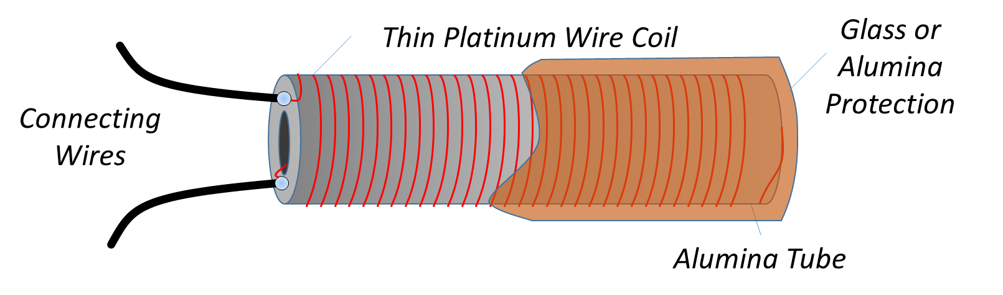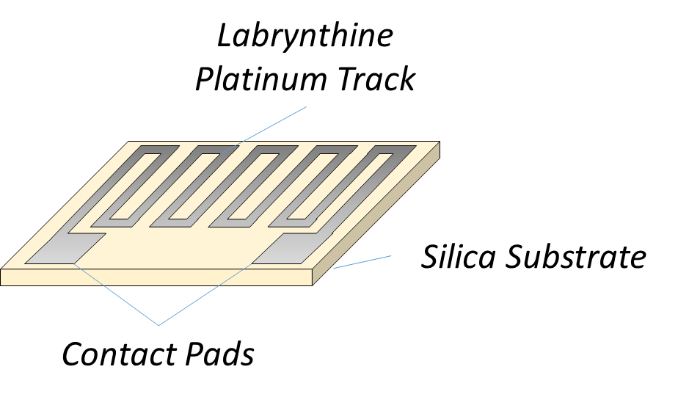
Figure 2.1. (a) Wire wound platinum resistance thermometer. (b) Thin film platinum resistance thermometer.
From – 80 °C to +60 °C, the electrical resistance of a platinum resistance thermometer can be represented by the Callender-van Dusen equation:
$R=R_{0}\left(1+At+Bt^{2}+C{\left(t-100\right)t}^{3}\right)$ (2.2)
where t is the temperature in degrees Celsius.
Pt100 sensors are commonly specified by the tolerance within which they conform to standards such as IEC 60751 (DIN EN 60751) or ASTM E1137. For a thermometer which conforms closely to the IEC 60751 specification, the Callendar-van Dusen coefficients are R₀ = 100 Ω, A = 3.908 x 10⁻³ °C⁻¹ and B = -5.80 x 10⁻⁷ °C⁻², while the C coefficient takes different values above and below 0 °C. Below 0 °C, its value is C = 4.27 x 10⁻¹² °C⁻⁴, while C is exactly zero above 0 °C. The resistance and sensitivity of an IEC standard Pt100 sensor are shown in Figure 2.2.

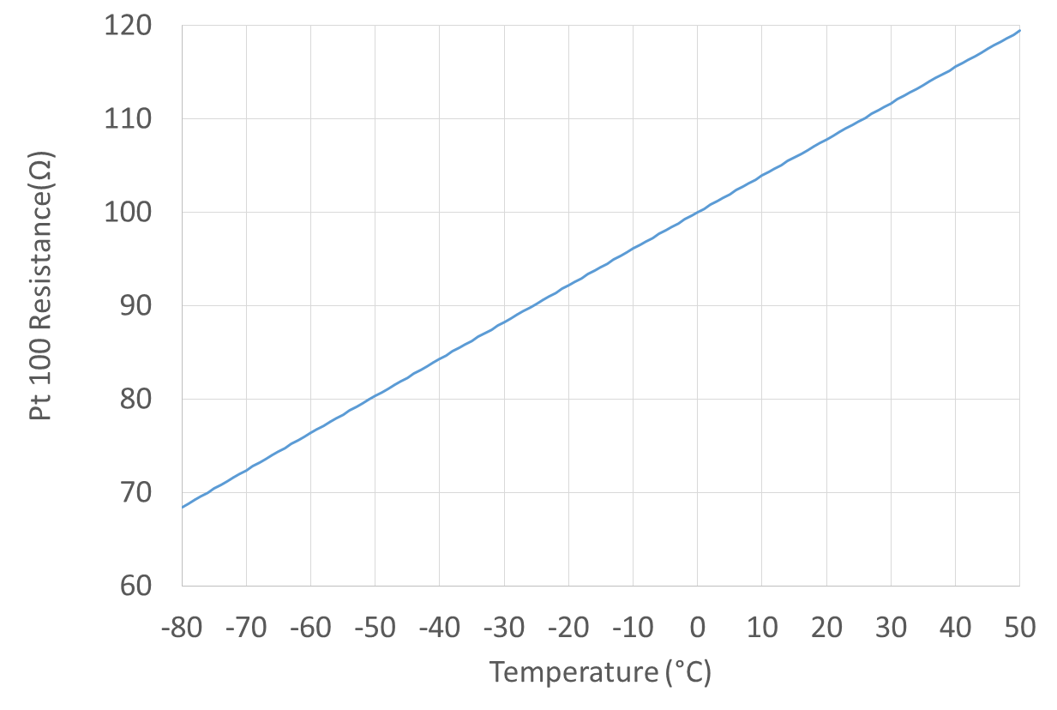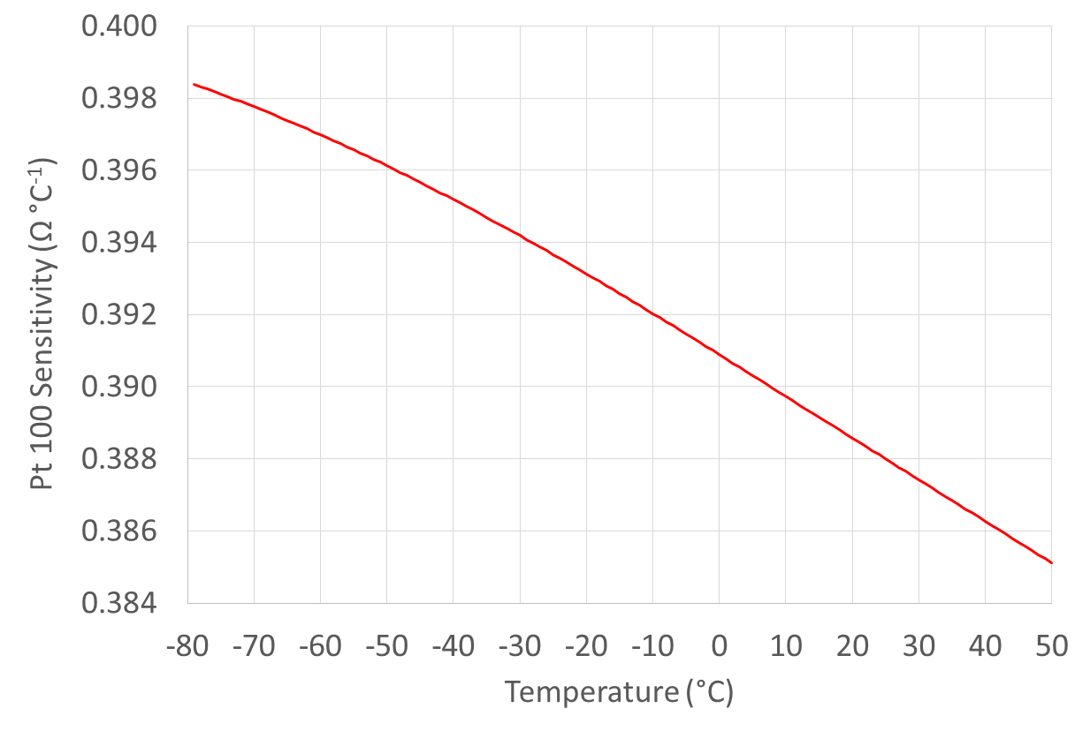
Figure 2.2. (a) The resistance versus temperature for an IEC 60751 compliant Pt 100 sensor.
(b) The sensitivity versus temperature for an IEC 60751 compliant Pt 100 sensor
The sensitivity of Pt100 thermometers is also commonly specified by an $α$ (alpha) value defined by:
 | α=R100-R0100*R0 | (2.3)

The sensitivity (Figure 2.2 (b)) is almost independent of temperature, being 0.3952 Ω °C⁻¹ at -40 °C, 0.3909 Ω °C⁻¹ at 0 °C and 0.3863 Ω °C⁻¹ at +40 °C. There is a variation of just 2.3 % across a range of 80 K.
For IEC 60751 compliant thermometers, $α$ has a value close to 3850 x 10⁻⁶ °C⁻¹. The tolerance classes of IEC 60751 or ASTM E1137 are shown in Table 2.1 and graphed in Figure 2.3. Sensors are also available with smaller tolerance typically specified as a fraction of one of the standards shown in Table 2.1.

Table 2.1. The tolerance classes of IEC 60751 or ASTM E1137.
(Note: In the IEC specification the F indicates a thin-film sensor and is replaced with a W for a wirewound sensor. |t| indicates the absolute value of the temperature in degrees Celsius.

IEC 60751 (2008) |  | ASTM E1137
Tolerance Class | Definition | Tolerance Grade | Definition
F0.3 (Old Class B) | ±(0.3 + 0.005 |t|) | B | ±(0.25 + 0.0042 |t|)
F0.15 (Old Class A) | ±(0.15 + 0.002 |t|) | A | ±(0.13 + 0.0017|t|)

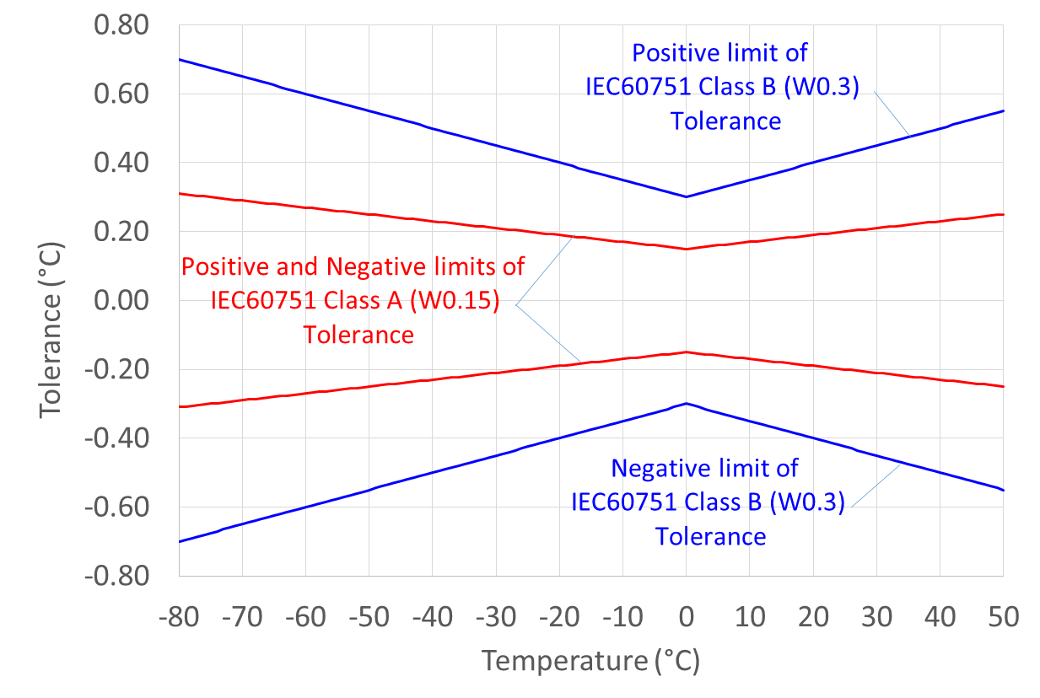
Figure 2.3. Tolerance bands for an IEC 60751 compliant Pt100 sensor.

For example, an IEC 60751 W0.3 (old Class B) sensor describes a wirewound sensor which conforms to the IEC 60751 curve within ±(0.3 +0.005t) °C, so at 20 °C a class B sensor would be guaranteed to fall within 0.400 °C of the IEC curve.
The Callendar-van Dusen equation (equation 2.2) is quartic and has no simple inverse equation expressing temperature as a function of resistance, t(R). There are two solutions to this difficulty. Firstly, for temperatures greater than -40 °C, the C term in equation 2.2 corresponds to less than 0.01 °C and may reasonably be neglected in many applications. In this case the Callendar-van Dusen equation may be approximated as:
 | R=R01+At+Bt2 | (2.4)
and its inverse can be calculated using the standard quadratic formulae:
 | t=-A2B+A2B1-4BA21-RRT | (2.5)
The error from using this formula is still less than 0.1 °C at -80 °C. Alternatively, equation 2.4 may be used to generate an initial estimate of the temperature, which is then iteratively refined by repeated use of the forward equation for R(t).
Before calibration for deployment in a meteorological setting Pt100 sensors are usually ‘aged’ (by manufacturers) by temperature cycling the sensor between, typically, the ice point and 20 °C. This aim of this procedure is to discover any manufacturing faults before deployment and to relieve any strain in the wires that will eventually be released in the field.

2.2.1.2 Thermistors
Another type of resistance element in common use is the thermistor. Although thermistors are available with positive temperature coefficients of resistance, the most common and useful form have large negative coefficients of resistance. The composition of thermistors is a proprietary secret, but they typically consist of sintered metallic oxides in the form of small discs, rods or spheres and are often glass-coated to prevent chemical reactions with the air, particularly moisture.
The temperature dependence of the resistance, R, of a thermistor can be qualitatively described by:
 | R=R0exp-β1T0-1T | (2.6)
where R₀ is the resistance of the thermistor at absolute temperature T₀ (in kelvin) and T is the temperature of the thermistor in kelvin. Thermistors are typically specified for the value R₀ at a temperature of 25 °C i.e. T₀ = 25 + 273.15 = 298.15 K, and $β$ is specified in kelvin. Typical values are R₀ $≈$ 1 kΩ and $β≈$ 4000 K (for example see Figure 2.4).
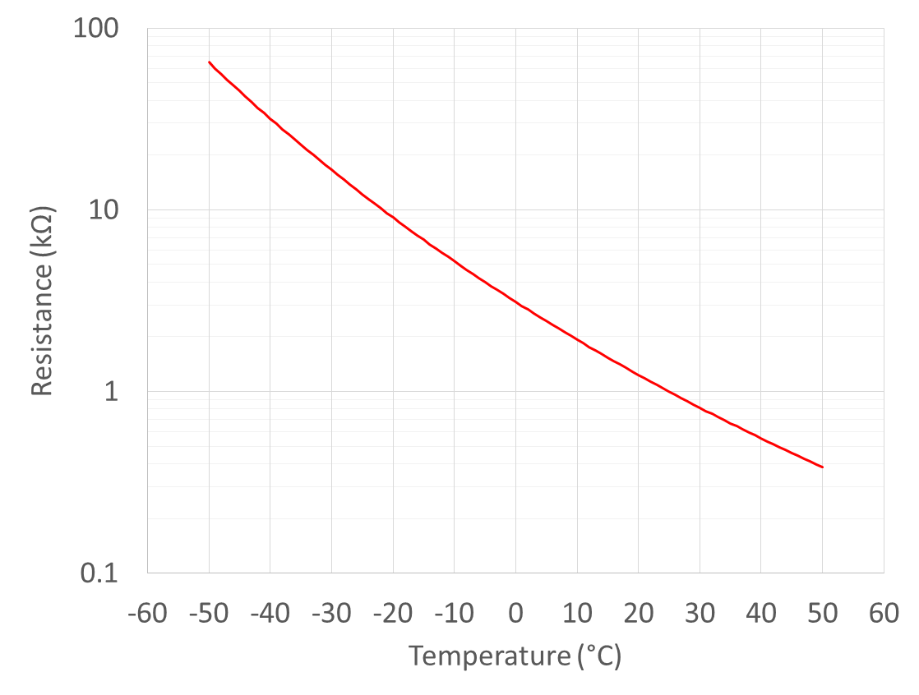
Figure 2.4 The resistance versus temperature for a thermistor R₀ = 1 kΩ and $β=$3700 K.
(Note the vertical axis is logarithmic.)
There are three key differences in the behaviour of thermistors when compared with Pt100 sensors.
The first is the high resistance of the thermistors which is often sufficiently high that the the resistance of the connecting wires may be neglected. This is almost never true for Pt100 sensors for which a four wire measurement technique is always necessary.
The second is the high sensitivity compared with Pt100 sensors. Although this is an advantage at any specific temperature, the fact that the sensitivity varies with temperature is problematic, and the very high dynamic range of the sensors also presents signal processing problems.
Finally, the sensors can be very small, and so they can have a small time-constants and high heat transfer coefficients (Erell et al., 2005). However, very small thermistors have the disadvantage that, for a given power dissipation, the self-heating effect is greater than for larger thermometers. Thus, care must be taken to keep the power dissipation small.
It should be noted that although equation 2.6 describes the general behaviour of thermistors and is useful for interpolation across small temperature intervals, it is not accurate enough to be used for meteorological applications. Several expressions of the general form:
 | R=R0expA+BT+CT2+DT3 | (2.7)

are commonly used to describe the behaviour of thermistors more accurately than equation 2.6. One special case of equation 2.7 where the coefficient C is set to zero is known as the Steinhart-Hart equation. The coefficients R₀, A, B, C (if used) and D must be determined for each sensor by calibration. An equivalent inverse expression for the temperature is:
 | T=A'+B'lnRR0+C'lnRR02+D'lnRR03-1 | (2.8)
where the parameters A’, B’, C’ and D’ are completely different from the parameters from the parameters A, B, C and D in Equation 2.7. In both equations 2.7 and 2.8 it must be remembered that the temperature T must be expressed in kelvin.
In general the inverse formula is not is as accurate as the forward formula, and if a computer is used to calculate the temperature it is often advantagous to iterate the forward formula (equation 2.7) to find the correct temperature. Many iteration schemes have been devised, optimised for accuracy and speed, but a typical approach is outlined below. In this procedure the correct temperature is first guessed as being in the midpoint of the calibration range, and the resistance corresponding to this guess is calculated using equation 2.7.
- If this resistance is greater than the measured resistance, then a new temperature guess is made in the upper half of the calibration range.
- If this resistance is less than the measured resistance, then a new temperature guess is made in the upper lower half of the calibration range.
A new resistance is calculated from the second temperature guess and depending on the value of this resistance compared to the measured resistance, a third temperature guess is made. Iteration criteria must be met to stop iteration process. In this way the temperature may be inferred from a measured resistance using only the forward formula 2.7.

2.2.1.3 Thermocouples
The Seebeck effect describes the phenomenon whereby a temperature gradient in a metal gives rise to an accompanying electric field. The magnitude of the accompanying electric field is always proportional to the temperature gradient but depends on a material-dependent and temperature-dependent Seebeck Coefficient (Nicholas and White, 1991; Bentley, 1998). Thus a wire of pure material in a temperature gradient spontaneously acquires a voltage across its ends, the magnitude of which is equal to the integrated Seebeck voltage along the wire.
A thermocouple (Figure 2.5) is made from two wires of different materials with differing Seebeck coefficients joined at one end – the so-called ‘hot-junction’. The open ends of the wires are connected to a sensitive voltage measuring device in one of a variety of configurations. Typically in operation the open ends of the junctions are connected to the terminals of a high-resolution voltmeter.
The thermovoltage of a thermocouple is generated continuously along the entire length of the wires. We can consider each wire in the thermocouple to experience a sequence of small temperature changes$, ΔT_{i}$ (Figure 2.5a). Each small temperature difference $ΔT_{i}$ gives rise to a voltage $ΔV_{i}$ that is proportional to $ΔT_{i}$ and a material and temperature dependent Seebeck coefficient, S (Figure 2.5b). The thermovoltage measured across the open ends of the thermocouples is proportional to the temperature difference between the open ends of the wire and the thermocouple junction even though no voltage is generated at the junction. Notice that terms ‘hot’ and ‘cold’ junctions are entirely conventional and thermcoouples can measure temperatures where the ‘hot junction’ is colder than the ‘cold junction’

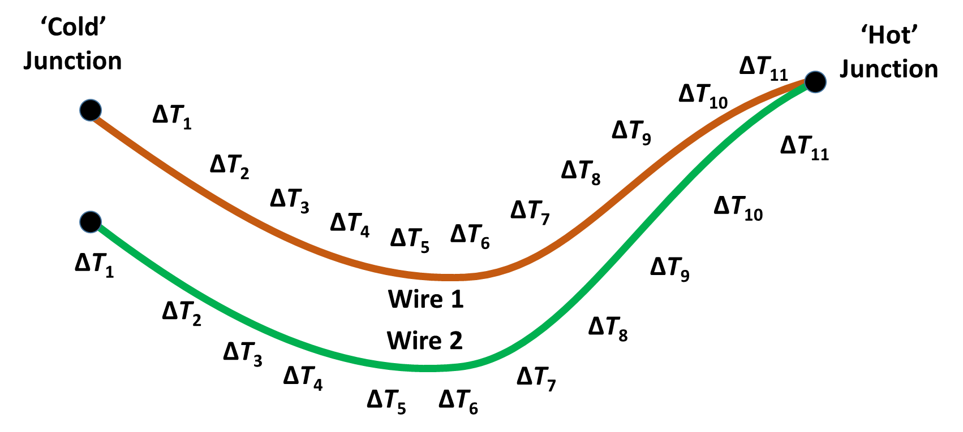 | 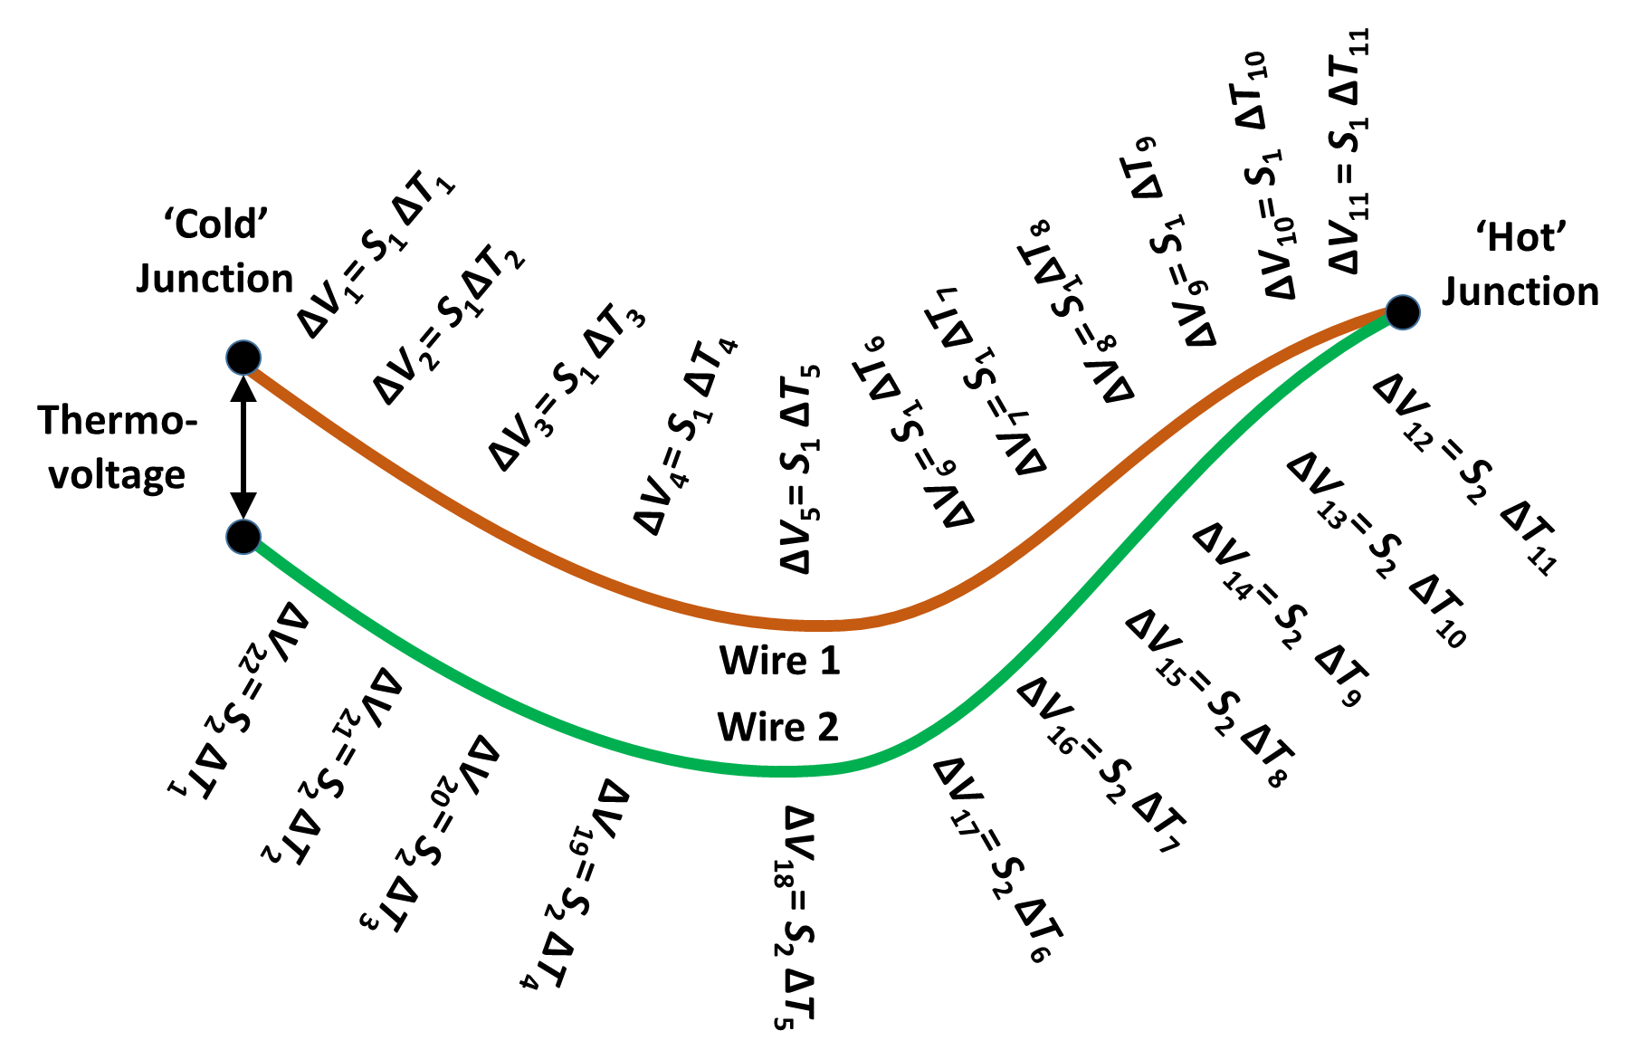
Figure 2.5: In a temperature gradient (a) voltages are generated (b) along the entire length of both wires.
It is important to stress that the thermo-voltage is generated along the entire length of the thermocouple wires and that no voltage is generated at the junction itself – where the temperature is measured. The thermocouple junction merely joins the two wires in the thermocouple together and may be made by welding or soldering together the two wires. All that is required is to create a suitably robust electrical connection between the wires.
Thermocouple wires can be made very narrow and the junctions can be made very small with three potential benefits. Firstly thermocouples can be made with response times in air much less than one second. Secondly, the small size also improves heat exchange with the air resulting in lower errors when the thermocouple is irradiated (Bugbee et a., 1996). Finally the effect of thermal conduction along the thermocouple wires is reduced.
Thermocouples are characterised as being made from either ‘base metals’ (typically alloys of either copper or nickel) or ‘noble metals’ (typically alloys of platinum, rhodium or gold). In meteorological applications there is no advantage to the use of noble metal thermocouples. Thermocouples are typically purchased as a manufactured item with the two wires pre-selected from standard alloy combinations which are specified by a ‘letter-type’.
The most commonly used types in meteorological applications according to IEC 60584-1:2013 are:
- Type K: made from two nickel alloys, chromel and alumel;
- Type J: made from iron and constantan;
- Type T: made from copper and a copper-nickel alloy called constantan.
In the meteorological temperature range there is little advantage to using one type over another. Type K is the most common specification and at 20 °C it produces a signal of approximately 40 µV °C⁻¹. Type J has a slightly higher sensitivity (approximately 50 µV °C⁻¹) but the pure iron leg is potentially subject to corrosion if exposed for long periods. Type T has a similar sensitivity to Type K but the copper wire has a high thermal conductivity which can lead to errors in some circumstances.
Tables of thermovoltage versus temperature for standard thermocouple types are available from manufacturers and standards bodies.

2.2.2 Measurements procedures

2.2.2.1 Electrical resistance thermometers
Electrical resistance thermometers may be connected to a variety of electrical measurement circuits. Historically, many variations of resistance bridge circuits were used in either balanced or unbalanced form. In such circuits, a single voltage or current measurement enables the comparison of the unknown resistance of the thermometer with known temperature-independent standard resistors.
The excellent resolution and linearity of modern analogue-to-digital converters (ADCs), the measurement component within voltmeters and multimeters, enables an alternative approach. The unknown resistance of the thermometer is estimated from two measurements; a measurement of the current flowing through the temperature sensor; and a measurement of the voltage across the temperature sensor. This allows the measurement of a resistance of approximately 100 Ω with an uncertainty of just a few mΩ.
The resistance of the wires connecting the sensor to the ADC must also be considered. Typically such wires have an electrical resistance of a few tenths of an ohm per metre. For a Pt100 sensor, an additional resistance of 0.39 Ω is equivalent to an error of 1 °C. And so for Pt100 sensors, a ‘4-wire’ measurement configuration must be used in which an additional pair of wires is used to sense the voltage.
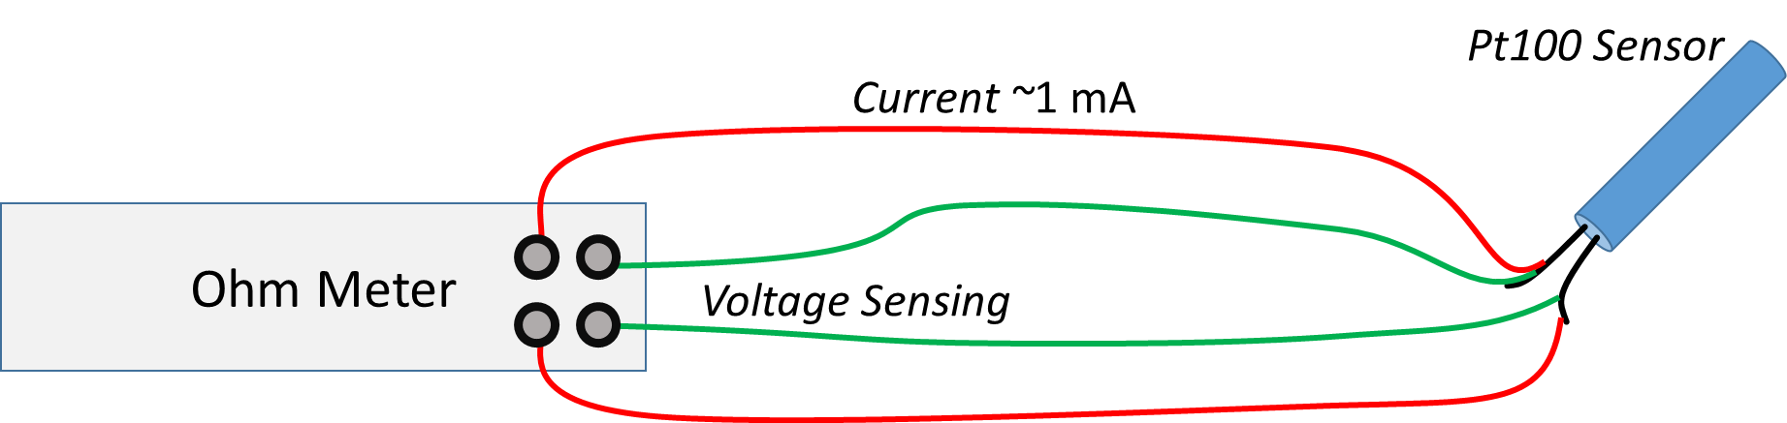
Figure 2.6. A four-wire arrangement for reading a Pt100 sensor.
For a thermistor, the error caused by the connecting wires varies strongly with temperature. For the sensor with R₀ = 1 kΩ and $β=$3700 K illustrated in Figure 2.4, at -20 °C the sensor resistance is 9.08 kΩ and the sensitivity is -542 Ω °C⁻¹, a change of 6.0% °C⁻¹, but at +20 °C the sensor resistance is 1.24 kΩ and the sensitivity is -55 Ω °C⁻¹, a change of 4.4% °C⁻¹. Thus at 20 °C, an additional resistance of 0.39 Ω is equivalent to an error of 0.007 °C which in some cases may be negligible.
In order to maintain the advantages of thermistors such as rapid response and high heat transfer coefficient, but avoid the disadvantages of the high dynamic range and varying sensitivity, thermistors are often used in ‘linearising’ circuits. A large number of such circuits exist, but the simplest consists simply of a parallel constant resistor (White, 2015; White, 2017).

2.2.2.2 Thermocouples
Historically thermocouples have been used in a wide variety of configurations that required the open ends of the thermocouple – the so called ‘cold-junction’ – to be immersed in melting ice. The temperature of the hot junction was then deduced from standard tables for the pair of metals used in the thermocouple. In practice it is inconvenient to maintain an ice point and this is now only rarely done in practice.
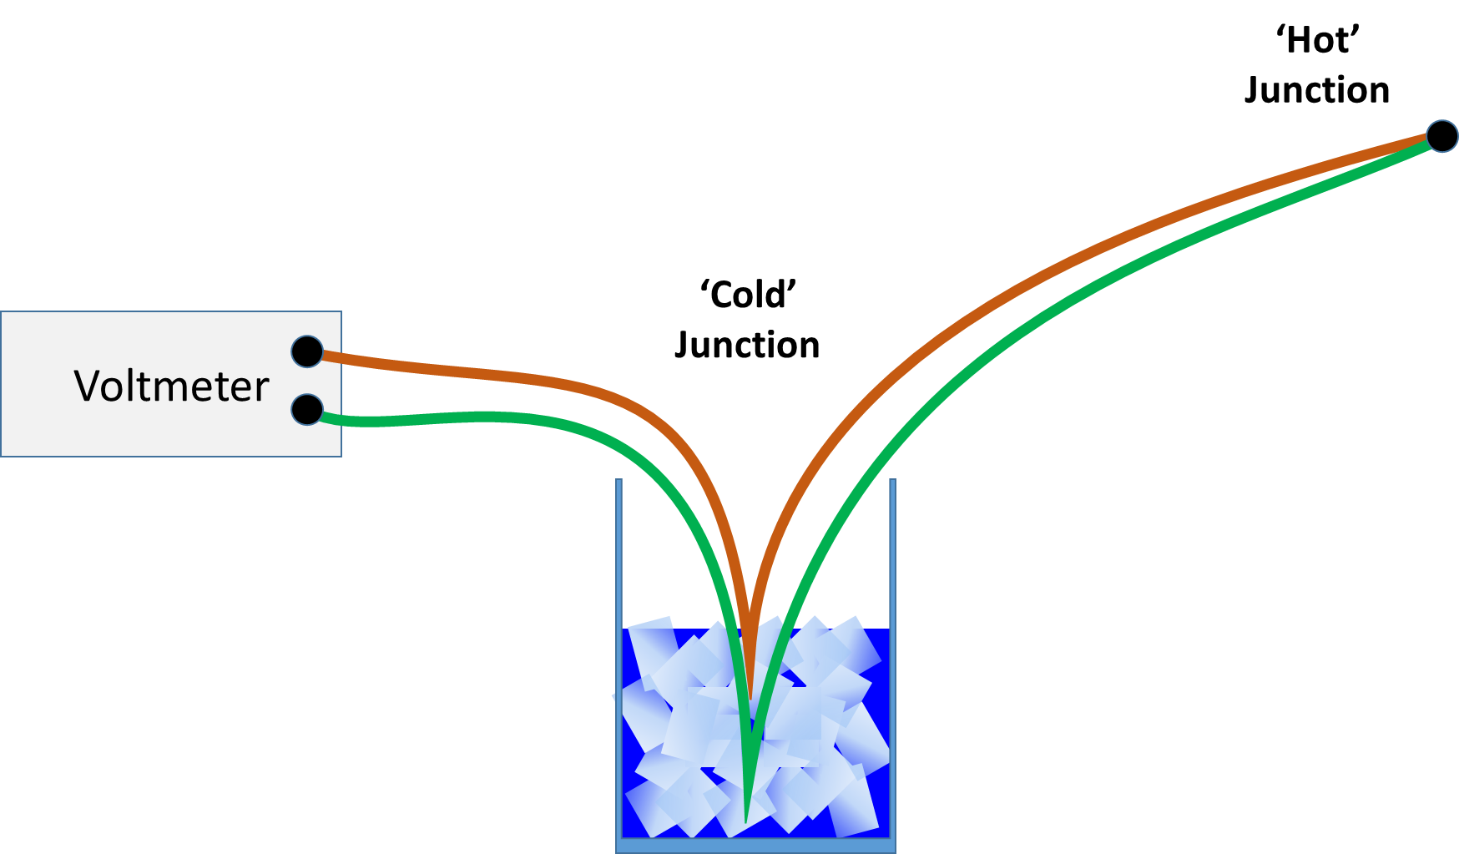 | 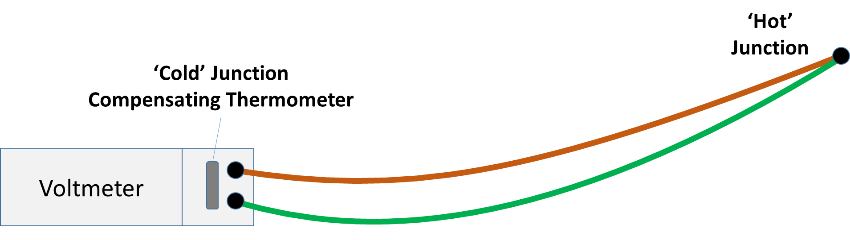
Figure 2.7. Arrangements for reading a thermocouple. (a) One of several traditional arrangements in which the cold junction is immersed on metling ice. (b) A modern alternative in which a thermistor or Pt100 thermometer measures the temperature of the ‘cold’ junction.
Instead the measurements are referenced to the temperature of the terminals of the digital voltmeter. This technique – known as cold-junction compensation – requires a measurement of the temperature of the voltmeter terminals using a thermistor or platinum resistance thermometer. The additional thermocouple voltage that would have been expected if an ice-point had been used is then calculated and added to the measured voltage. The sum is then used to determine the temperature using interpolation of standard tables. Where cold-junction compensation is used, especial care must be taken close to voltmeter junctions where small temperature differences between the terminals can generate spurious voltages.
Typically a purchased thermocouple is not long enough to connect to a voltmeter in an environmentally isolated casing and so-called ‘extension cable’ is required for this purpose. As noted above, the thermo-voltage is generated along the entire length of the thermocouple including any extension cable. Since the temperature gradients in the cable are often largest close to the enclosure containing the data acquisition equipment, the thermo-voltages generated in the extension cable are as significant as those generated close to the ‘hot junction’ of the thermocouple. It is for this reason that thermocouples are generally not chosen for routine meteorological use.
In meteorology, thermocouples are used for thermometry for two special applications. The first application is when a thermometer with a low mass and thus a very small time-constant is required for special research tasks (e.g. Bugbee et al., 1996). The second application is when a small temperature difference is to be measured. In this application the thermocouple is wired as two thermocouples in opposition (Figure 2.8(a)). In this configuration the measured voltage is sensitive only to the difference in temperature between the two junctions. A modification of the differential thermocouple is the ‘thermo pile’ (Figure 2.8(b)) which consists of a large number of differential thermocouples wired in series. The output voltage from a thermopile of N junctions is just N times the thermocouple output from a single thermocouple, and for 10 junctions this can approach 400 µV °C⁻¹. This allows high resolution detection of very small temperature differences such as those which occur in pyranometer.

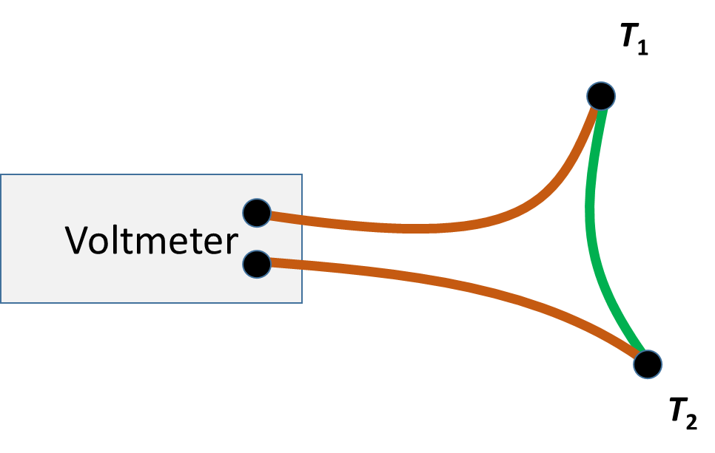 | 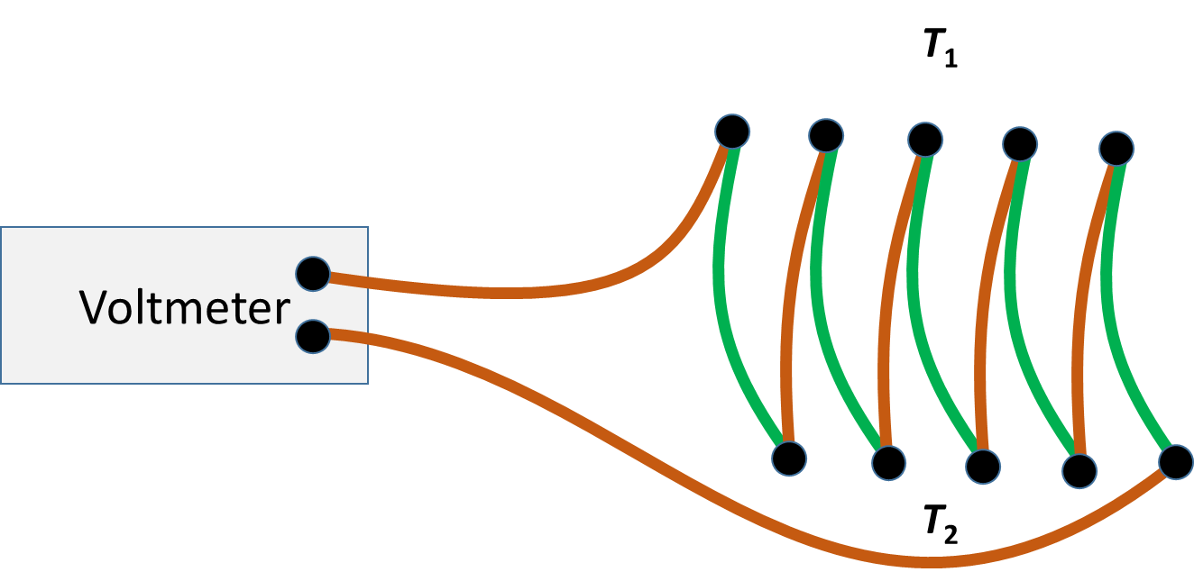
Figure 2.8. Use of thermocouple in differential mode: (a) difference between the two junctions (b) ‘thermo pile’

2.2.3 Exposure and siting
The general requirements relating to the exposure and siting of thermometers are described in 2.1.4.2. Additional requirements include the following:
(a) The measurement of extreme values: separate maximum and minimum thermometers may no longer be required if the electrical thermometer is connected to a continuously operating data recording system;
(b) The measurement of surface temperatures (bare soil or grass minimum thermometer): the radiative properties of electrical thermometers will be different from liquid-in-glass thermometers. Electrical thermometers exposed as grass minimum (or other surface) thermometers will, therefore, record different values from similarly exposed conventional thermometers. These differences may be minimized by placing the electrical thermometer within a glass sheath with the same diameter as the superceded thermometers.
(c) The measurement of soil temperatures: electrical thermometers are deployed in brass plugs, inserted at the required depth into an undisturbed vertical soil face, the latter having been exposed by trenching. Electrical connections are brought out through plastic tubes via the trench, which is then refilled in such a way to restore, as far as possible, the original strata and drainage characteristics.

2.2.4 Sources of error

2.2.4.1 Electrical resistance thermometers
The main sources of error in a temperature measurement taken with electrical resistance thermometers are the following:
(a) Self-heating of the thermometer element;
(b) Inadequate compensation for lead resistance;
(c) Inadequate compensation for non-linearities in the sensor or processing instrument;
(d) Sudden changes in switch contact resistances.
Self-heating occurs because the passage of a current through the resistance element produces heat and, thus, the temperature of the thermometer element becomes higher than that of the surrounding medium. For a 1 mA (10 mA) current in a Pt100 sensor the heating is approximately 0.1 mW (10 mW). For a sensor with a diameter of 6 mm, 30 mm long, in a wind speed of 1 m s⁻¹, the heat transfer coefficient h will be approximately 40 Wm⁻² K⁻¹ and the resultant sensor heating will be between 0.004 K and 0.4 K.
The resistance of the connecting leads will introduce an error in the temperature reading. This will become more significant for long leads, for example, when the resistance thermometer is located at some distance from the measuring instrument; the reading errors will also vary as the temperature of the cables changes. To reduce errors, it is highly recommended to use four-wire measurements of Pt100 thermometers (see Figure 2.6).
Neither the electrical resistance thermometer nor the thermistor is linear over an extended temperature range. While for electrical resistance thermometrers the output may be considered to be approximately linear for a limited range, appropriate provision must be made to compensate for such non-linearities with thermistors. (White, 2016)
Sudden changes in switch contact resistance can occur as switches age. They may be variable and can go undetected unless regular system calibration checks are performed (see section 2.2.5).

2.2.4.2 Thermocouples
The main uncertainty arising in the use of thermocouples arises from the distributed nature of the thermo-voltage generation. As shown in Figure 2.5 the measured voltage is generated along the entire length of the thermocouple along with its extension wires. This requires extreme uniformity in the alloy composition of thin wires. Additionally, the thermocouple must then be calibrated with the temperature gradients that the thermocouple will experience operationally.
Additionally the secondary measurement of temperature used for the cold-junction compensation introduces an unknown error based on the environment of the analogue-to-digital converter within voltmeter or data acquisition system
For meteorological deployments, proper calibration is not practical and the effectiveness of the cold-junction compensation cannot be assessed without additional knowledge. For these reasons, thermocouples are not recommended for standard meteorological deployment.

2.2.5 Comparison and calibration

2.2.5.1 Electrical resistance thermometers
Laboratory calibrations of thermometers should be carried out regularly by calibration laboratories with ISO/IEC 17025 accrediation. Thermometers should be compared against standard thermometers usually in a stirred liquid bath, climatic chamber or a dry-block calibrator in the temperature range of interest. More details can be found in chapter 2.6 Traceability assurance and calibration.
Since the measurement instrument is an integral part of the electrical thermometer, its calibration should be checked by substituting the resistance thermometer by an accurate decade resistance box and by applying resistances equivalent to fixed temperature increments (e.q. 10 K) over the operational temperature range. The error at any point should not exceed 0.1 K. This work would normally be performed by a servicing technician.

2.2.5.2 Thermocouples
The calibration and checking of thermocouples require the hot and cold junctions to be maintained at accurately known temperatures and the gradient between these temperatures to be varied to assess non-uniformity of the Seebeck coefficient. The techniques and instrumentation necessary to undertake this work are generally very specialized and will not be described here (Bentley, 1998; Nicholas and White, 1991; ASTM, 1993).

2.2.6 Corrections
When initially issued, electrical thermometers should be provided with either:
(a) A dated certificate confirming compliance with the appropriate standard; or
(b) A dated calibration certificate giving the actual resistance or temperature (using the IEC standard Callendar van Dusen parameters) at fixed points in the temperature range. These resistances/temperatures should be used when checking the uncertainty of the measuring instrument or system interface before and during operation. The magnitude of the resistance difference from the nominal value should not, in general, be greater than an equivalent temperature error of 0.1 or 0.2 K.
After each calibration, a Pt100 sensor will have a table of values of resistance, R_{i}, at a set temperatures T_{i}. These values may be used to generate a table of corrections (either ΔR_{i} or ΔT_{i}) to be used with a thermometer.
Based on this calibration data conformance to the specified standard (e.q. IEC 60751 class or tolerance band can be checked. However, in order to properly assess conformance within a tolerance band, users should additionally consider the effect of measurement uncertainty, u_{T}, associated with the calibration. There are three cases to consider:
- In the first case, the correction ± u_{T} falls entirely within the conformance band. In this case the thermometer can be judged as being compliant with the specification. If this were the case, the thermometer could be returned to use and its temperature inferred from the standard IEC 60751 curve specified by the standard Callendar van Dusen coefficients. Examination of Figure 2.9 shows that this case would describe the data from Table 2.2 if the uncertainty were u_{T} = 0.05 °C.
- In the second case case, the correction ± u_{T} falls entirely outside the conformance band. In this case the thermometer can be judged as being non-compliant with the specification. If this were the case, the thermometer could not be returned to use and the sensor would typically be discarded.
- In the third case, the correction ±u_{T} overlaps the conformance band so that there is a significant possibility that the sensor is non-compliant. In this case, the action taken is a matter of judgement depending on the degree of overlap. If the liklihood of non-conformance is judged to be sufficiently small, the thermometer might be returned to use and its temperature inferred from the standard IEC60751 curve specified by the standard Callendar van Dusen coefficients. This case would describe the data from Table 2.2 if the uncertainty were u_{T} = 0.15 °C (see Figure 2.9).
Note that conformance or non-conformance may depend on the coverage factor ascribed to the uncertainty.
In the simplest scheme which applies corrections, the corrections at a particular temperature are presumed to apply to all temperatures which are closer to that calibration point than any other calibration point. The temperature is thus inferred from the resistance using a standard curve and then the correction is added. This scheme (Figure 2.9(a)) has the disadvantage of generating a discontinuity in the temperature versus resistance curve midway between the calibration points.
An improvement on the simple correction scheme is linear interpolation (Figure 2.9b)). The correction which applies to a particular measurement is calculated by linearly interpolating between the corrections from the calibration points above and below the particular temperature chosen. This has the advantage of generating a continuous temperature versus resistance curve.
Two schemes for applying corrections derived from the calibration data are shown in Figure 2.9. The left scheme shows how the calibration correction from a particular calibration point is applied to all temperatures which are closer to that point than any other calibration point. This correction function thus has a series of steps. The other scheme shows how the calibration correction is linearly interpolated between the corrections uncovered at each calibration point. This results in a continuous calibration curve.

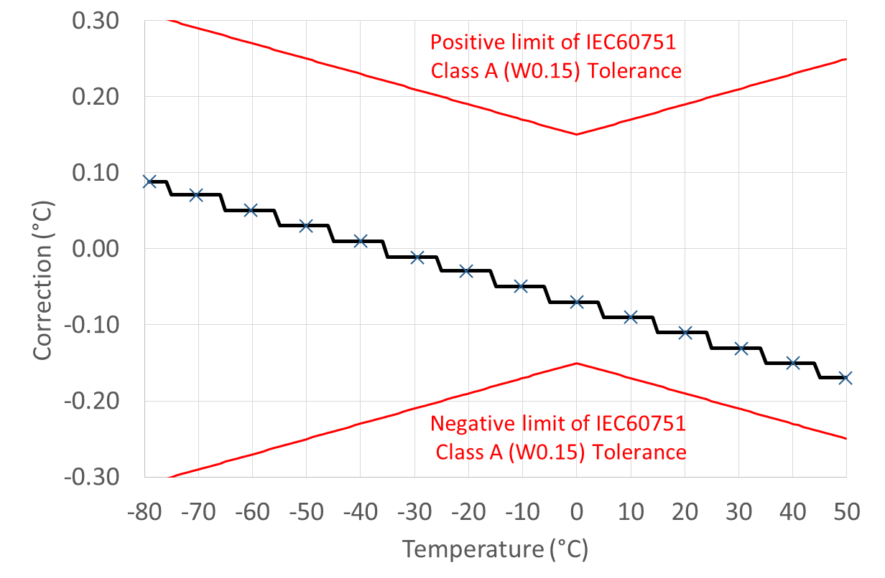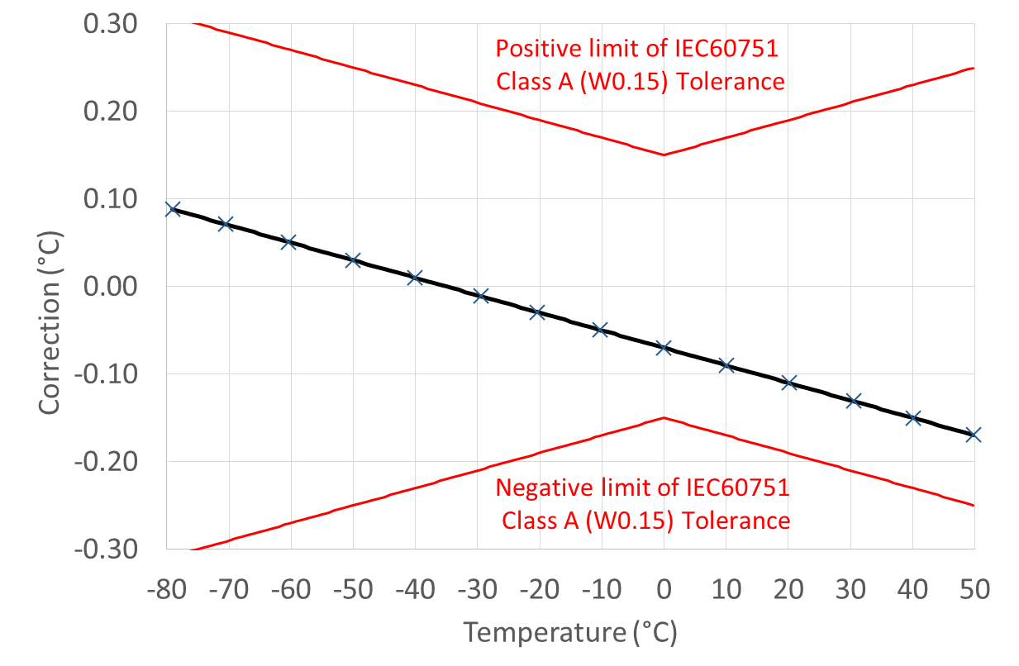
Figure 2.9: Schemes for applying corrections derived from the calibration data, stepwise(a) or linear (b)
A more sophisticated treatment of the data would be to use the data to generate custom Callendar van Dusen parameters associated with that particular thermometer. This procedure is described in (Nicholas and White, 1991).

2.2.7 Maintenance
The regular field checks should identify any changes in system calibration. These may occur as a result of long-term changes in the electrical characteristics of the thermometer, degradation of the electrical cables or their connections, changes in the contact resistance of switches or changes in the electrical characteristics of the measuring equipment. Identification of the exact source and correction of such errors will require specialized equipment and training and should be undertaken only by a maintenance technician.

2.3 Liquid-in-glass thermometers
Mercury-in-glass thermometers are indeed widespread, but no longer recommended taken into account the Minamata convention on mercury (see 2.1.4.5). NMHSs are encouraged to take appropriate measures to replace mercury-in-glass thermometers with modern alternatives (e.g. electrical resistance thermometers). Due to historical development of thermometry and the residual use of mercury-in-glass thermometers the following text includes also mercury-in-glass thermometers

2.3.1 General description
For routine observations of air temperature, including maximum, minimum and wet-bulb temperatures, liquid-in-glass thermometers are still commonly used. Such thermometers make use of the differential expansion of a pure liquid with respect to its glass container to indicate the temperature. The stem is a tube which has a fine bore attached to the main bulb; the volume of liquid in the thermometer is such that the bulb is filled completely but the stem is only partially filled at all temperatures to be measured. The changes in volume of the liquid with respect to its container are indicated by changes in the liquid column; by calibration with respect to a standard thermometer, a scale of temperature can be marked on the stem, or on a separate scale tightly attached to the stem.
The liquid used depends on the required temperature range; mercury has generally been used for temperatures above its freezing point (–38.9 °C), while ethyl alcohol or other pure organic liquids are used for lower temperatures. The glass should be one of the normal or borosilicate glasses approved for use in thermometers. The glass bulb is made as thin as is consistent with reasonable strength to facilitate the conduction of heat to and from the bulb and its contents. A narrower bore provides greater movement of liquid in the stem for a given temperature change, but reduces the useful temperature range of the thermometer for a given stem length. The thermometer should be suitably annealed before it is graduated in order to minimize the slow changes that occur in the glass with ageing.
There are four main types of construction for meteorological thermometers, as follows:
(a) The sheathed type with the scale engraved on the thermometer stem;
(b) The sheathed type with the scale engraved on an opal glass strip attached to the thermometer tube inside the sheath;
(c) The unsheathed type with the graduation marks on the stem and mounted on a metal, porcelain or wooden back carrying the scale numbers;
(d) The unsheathed type with the scale engraved on the stem.
The stems of some thermometers are lens-fronted to provide a magnified image of the liquid thread.
Types (a) and (b) have the advantage over types (c) and (d) that their scale markings are protected from wear. For types (c) and (d), the markings may have to be reblackened from time to time; on the other hand, such thermometers are easier to make than types (a) and (b). Types (a) and (d) have the advantage of being less susceptible to parallax errors (see section 2.3.4). An overview of thermometers, designed for use in meteorological practices is given by HMSO (1980).
Whichever type is adopted, the sheath or mounting should not be unduly bulky as this would keep the heat capacity high. At the same time, the sheath or mounting should be sufficiently robust to withstand the normal risks associated with handling and transit.
For mercury-in-glass thermometers, especially maximum thermometers, it is important that the vacuum above the mercury column be nearly perfect. All thermometers should be graduated for total immersion, with the exception of thermometers for measuring soil temperature. The special requirements of thermometers for various purposes are dealt with hereafter under the appropriate headings.

2.3.1.1 Ordinary (station) thermometers
Usually it has been a very accurate mercury-in-glass-type thermometer. Its scale markings have an increment of 0.2 K or 0.5 K, and the scale is longer than that of the other meteorological thermometers.
The ordinary thermometer is used in a thermometer screen to avoid radiation errors. A support keeps it in a vertical position with the bulb at the lower end. The form of the bulb is that of a cylinder or an onion.
A pair of ordinary thermometers can be used as a psychrometer if one of them is fitted with a wet-bulb sleeve (to estimate the humidity of air masses with the formula of Sprung).

2.3.1.2 Maximum thermometers
The recommended type for maximum thermometers has been a mercury-in-glass thermometer with a constriction in the bore between the bulb and the beginning of the scale. This constriction prevents the mercury column from receding with falling temperatures. However, observers can reset by holding it firmly, bulb-end downwards, and swinging their arm until the mercury column is reunited. A maximum thermometer should be mounted at an angle of about 2° from the horizontal position, with the bulb at the lower end to ensure that the mercury column rests against the constriction without gravity forcing it to pass. It is desirable to have a widening of the bore at the top of the stem to enable parts of the column which have become separated to be easily united. As the only liquid suitable for liquid-in-glass maximum thermometers is mercury, electrical alternatives should be used to measure maximum temperature (see chapter 2.2).

2.3.1.3 Minimum thermometers
As regards minimum thermometers, the most common instrument is a spirit thermometer with a dark glass index, about 2 cm long, immersed in the spirit. Since some air is left in the tube of a spirit thermometer, a safety chamber should be provided at the upper end which should be large enough to allow the instrument to withstand a temperature of 50 °C without being damaged. Minimum thermometers should be supported in a similar manner to maximum thermometers, in a near-horizontal position. Various liquids can be used in minimum thermometers, such as ethyl alcohol, pentane and toluol. It is important that the liquid should be as pure as possible since the presence of certain impurities increases the tendency of the liquid to polymerize with exposure to light and after the passage of time; such polymerization causes a change in calibration. In the case of ethyl alcohol, for example, the alcohol should be completely free of acetone.
Minimum thermometers are also exposed to obtain grass minimum temperature (see 2.1.4.2.3).

2.3.1.4 Soil thermometers
For measuring soil temperatures at depths of 20 cm or less, mercury-in-glass thermometers, with their stems bent at right angles, or any other suitable angle, below the lowest graduation, have been in common use. The thermometer bulb is sunk into the ground to the required depth, and the scale is read with the thermometer in situ. These thermometers are graduated for immersion up to the measuring depth. Since the remainder of the thermometer is kept at air temperature, a safety chamber should be provided at the end of the stem for the expansion of the mercury.
For measuring temperature at depths of over 20 cm, mercury-in-glass thermometers, mounted on wooden, glass or plastic tubes, with their bulbs embedded in wax or metallic paint, have been used. The thermometer-tube assemblies are then suspended or slipped in thin-walled metal or plastic tubes sunk into the ground to the required depth. In cold climates, the tops of the outer tubes should extend above the ground to a height greater than the expected depth of snow cover.
The technique of using vertical steel tubes is unsuitable for measuring the diurnal variation of soil temperature, particularly in dry soil, and calculations of soil thermal properties based on such measurements could be significantly in error because they will conduct heat from the surface layer.
The large time-constant due to the increased heat capacity enables the thermometers to be removed from the outer tubes and read before their temperature has had time to change appreciably from the soil temperature.
When the ground is covered by snow, and in order that the observer may approach the line of thermometers without disturbing the snow cover, it is recommended that a lightweight bridge be constructed parallel to the line of thermometers. The bridge should be designed so that the deck can be removed between readings without affecting the snow cover.

2.3.2 Measurement procedures

2.3.2.1 Reading ordinary thermometers
Thermometers should be read as rapidly as possible in order to avoid changes of temperature caused by the observer’s presence. Since the liquid meniscus, or index, and the thermometer scale are not on the same plane, care must be taken to avoid parallax errors. These will occur unless the observer ensures that the straight line from his/her eye to the meniscus, or index, is at a right angle to the thermometer stem. Since thermometer scales are not normally subdivided to less than one fifth of a degree, readings to the nearest tenth of a degree, which are essential in psychrometry, must be made by estimation. Corrections for scale errors, if any, should be applied to the readings. Maximum and minimum thermometers should be read and set at least twice daily. Their readings should be compared frequently with those of an ordinary thermometer in order to ensure that no serious errors develop.

2.3.2.2 Measuring grass minimum temperatures
The temperature is measured with a minimum thermometer such as that described in section 2.3.1.3. The thermometer should be mounted on suitable supports so that it is inclined at an angle of about 2° from the horizontal position, with the bulb lower than the stem, 50 mm above the ground
Normally, the thermometer is exposed at the last observation hour before sunset, and the reading is taken the next morning. The instrument is kept within a screen or indoors during the day. However, at stations where an observer is not available near sunset, it may be necessary to leave the thermometer exposed throughout the day. In strong sunshine, exposing the thermometer in this way can cause the spirit to distil and collect in the top of the bore. This effect can be minimized by fitting a cotton sock on a black metal shield over the safety chamber end of the thermometer; this shield absorbs more radiation and consequently reaches a higher temperature than the rest of the thermometer. Thus, any vapour will condense lower down the bore at the top of the spirit column.

2.3.3 Thermometer siting and exposure
Both ordinary thermometers and maximum and minimum thermometers are always exposed in a thermometer screen as described in 2.2.3. Extreme thermometers are mounted on suitable supports so that they are inclined at an angle of about 2° from the horizontal position, with the bulb being lower than the stem.
The siting and exposure of grass minimum thermometers is as prescribed in section 2.1.4.2.3 and 2.3.2.2.

2.3.4 Sources of error in liquid-in-glass thermometers
The main sources of error common to all liquid-in-glass thermometers are the following:
(a) Elastic errors;
(b) Errors caused by the emergent stem;
(c) Parallax and gross reading errors;
(d) Changes in the volume of the bulb produced by exterior or interior pressure;
(e) Capillarity;
(f) Errors in scale division and calibration;
(g) Inequalities in the expansion of the liquid and glass over the range considered.
The last three errors can be minimized by the manufacturer and included in the corrections to be applied to the observed values. Some consideration needs to be given to the first three errors. Error (d) does not usually arise when the thermometers are used for meteorological purposes.

2.3.4.1 Elastic errors
There are two kinds of elastic errors, namely reversible and irreversible errors. The first is of importance only when a thermometer is exposed to a large temperature range in a short period of time. Thus, if a thermometer is checked at the steam point and shortly afterwards at the ice point, it will read slightly too low at first and then the indicated temperature will rise slowly to the correct value. This error depends on the quality of the glass employed in the thermometer, and may be as much as 1 K (with glass of the highest quality it should be only 0.03 K) and would be proportionately less for smaller ranges of temperature. The effect is of no importance in meteorological measurements, apart from the possibility of error in the original calibration.
The irreversible changes may be more significant. The thermometer bulb tends to contract slowly over a period of years and, thus, causes the zero to rise. The greatest change will take place in the first year, after which the rate of change will gradually decrease. This alteration can be reduced by subjecting the bulb to heat treatment and by using the most suitable glass. Even with glass of the highest quality, the change may be about 0.01 K per year at first. For accurate work, and especially with inspector or check thermometers, the zero should be redetermined at the recommended intervals and the necessary corrections applied.

2.3.4.2 Errors caused by the emergent stem
A thermometer used to measure air temperature is usually completely surrounded by air at an approximately uniform temperature, and is calibrated by immersing the thermometer either completely or only to the top of the liquid column (namely, calibrated by complete or partial immersion). When such a thermometer is used to determine the temperature of a medium which does not surround the stem, so that the effective temperature of the stem is different from that of the bulb, an error will result.
For meteorological applications, the most likely circumstance where this might be encountered is when checking the calibration of an ordinary thermometer in a vessel containing another liquid at a temperature significantly different from ambient temperature and only the bulb or lower part of the stem is immersed.

2.3.4.3 Parallax and gross reading errors
If the thermometer is not viewed on the plane that is perpendicular to the stem of the thermometer, parallax errors will arise. The error increases with the thickness of the thermometer stem and the angle between the actual and the correct line of sight. This error can be avoided only by taking great care when making an observation. With mercury-in-glass thermometers suspended vertically, as in an ordinary screen, the thermometer must be viewed at the horizontal level of the top of the mercury column.
Errors can also occur because observers usually disturb the surroundings in some way when they approach to read the thermometer. It is, therefore, necessary for observers to take the readings to the nearest tenth of a degree as soon as possible. Gross reading errors are usually 1°, 5° or 10° in magnitude. Such errors will be avoided if observers recheck the tens and units figure after taking their initial reading.

2.3.4.4 Errors due to differential expansion
The coefficient of cubical expansion of mercury is 1.82 · 10–4 K–1, and that of most glass lies between 1.0 · 10–5 and 3.0 · 10–5 K–1. The expansion coefficient of the glass is, thus, an important fraction of that of mercury and cannot be neglected. As neither the coefficients of cubical expansion of mercury and glass nor the cross-sectional area of the bore of the stem are strictly constant over the range of temperature and length of the stem being used, the scale value of unit length of the stem varies along the stem, and the thermometer has to be calibrated by the manufacturer against a standard thermometer before it can be used.

2.3.4.5 Errors associated with spirit thermometers
The expansion coefficients of the liquids used in spirit thermometers are very much larger than those of mercury, and their freezing points are much lower (ethyl alcohol freezes at –115 °C). Spirit is used in minimum thermometers because it is colourless and because its larger expansion coefficient enables a larger bore to be used. Spirit thermometers are less accurate than mercury thermometers of similar cost and quality. In addition to having the general disadvantages of liquid-in-glass thermometers, spirit thermometers have some peculiarities to themselves:
(a) Adhesion of the spirit to the glass: Unlike mercury, organic liquids generally wet the glass. Therefore, when the temperature falls rapidly, a certain amount of the liquid may remain on the walls of the bore, causing the thermometer to read low. The liquid gradually drains down the bore if the thermometer is suspended vertically;
(b) Breaking of the liquid column: Drops of the liquid often form in the upper part of the thermometer stem by a process of evaporation and condensation. These can be reunited with the main column, but errors may be caused at the beginning of the process before it is noticed. The column is also often broken during transport. This error is reduced during manufacture by sealing off the thermometer at its lowest temperature so that it contains the maximum amount of air in the stem;
(c) Slow changes in the liquid: The organic liquids used tend to polymerize with age and exposure to light, with a consequent gradual diminution in liquid volume. This effect is speeded up by the presence of impurities; in particular, the presence of acetone in ethyl alcohol has been shown to be very deleterious. Great care has therefore to be taken over the preparation of the liquid for the thermometers. This effect may also be increased if dyes are used to colour the liquid to make it more visible.
The reduction of errors caused by breakage in the liquid column and the general care of spirit thermometers are dealt with later in this chapter.

2.3.5 Comparison and calibration in the field and laboratory

2.3.5.1 Laboratory calibration
Laboratory calibrations of thermometers should be carried out by ISO/IEC 17025 accredited calibration laboratories. For liquid-in-glass thermometers, a liquid bath should be employed, within which it should be possible to maintain the temperature at any desired values within the required range. The rate of temperature change within the liquid should not exceed the recommended limits, and the calibration apparatus should be provided with a means of stirring the liquid. The reference standard thermometers and thermometers being calibrated should be suspended independently of the container and fully immersed, and should not touch the sides.
Sufficient measurements should be taken to ensure that the corrections to be applied represent the performance of the thermometer under normal conditions, with errors due to interpolation at any intermediate point not exceeding the non-systematic errors (see Part IV, Chapter 4).

2.3.5.2 Field checks
All liquid-in-glass thermometers experience gradual changes of zero. For this reason, it is desirable to check them at regular intervals, usually about once every two years. The thermometers should be stored in an upright position at room temperature for at least 24 h before the checking process begins.
The ice point may be checked by a Dewar flask filled with crushed ice made from distilled water and moistened with more distilled water. The space between the ice pieces as well as the bottom of the vessel should be free from air. The water should remain 2 cm beneath the ice surface. An ordinary thermos flask will accommodate the total immersion of most thermometers up to their ice point. The thermometers should be inserted so that as little of the mercury or spirit column as possible emerges from the ice. An interval of at least 15 min should elapse to allow the thermometer to take up the temperature of the melting ice before a reading of the indicated temperature is taken. Each thermometer should be moved backwards and forwards through the mixture and immediately read to a tenth part of the scale interval. Further readings at 5 min intervals should be taken and a mean value computed.
Other points in the range can be covered by reference to a travelling standard or inspection thermometer. Comparison should be made by immersing the reference thermometer and the thermometer, or thermometers, to be checked in a deep vessel of water. It is generally better to work indoors, especially if the sun is shining, and the best results will be obtained if the water is at, or close to, ambient temperature.
Each thermometer is compared with the reference thermometer; thermometers of the same type can be compared with each other. For each comparison, the thermometers are held with their bulbs close together, moved backwards and forwards through the water for about 1 min, and then read. It must be possible to read both thermometers without changing the depth of immersion; subject to this, the bulbs should be as deep in the water as possible. Most meteorological thermometers are calibrated in the laboratory for total immersion; provided that the difference between the water and air temperature is not more than 5 K, the emergent stem correction should be negligible. Often, with the bulbs at the same depth, the tops of the columns of mercury (or other liquid) in the reference thermometer and the thermometer being checked will not be very close together. Particular care should therefore be taken to avoid parallax errors.
These comparisons should be made at least three times for each pair of thermometers. For each set of comparisons, the mean of the differences between readings should not exceed the specified uncertainties given in Part I, Chapter 1 Annex 1.E of this guide.
Soil thermometers may be checked in this manner, but should be left in the water for at least 30 min to allow the wax in which the bulbs are embedded to take up the temperature of the water. The large time-constant of the soil thermometer makes it difficult to conduct a satisfactory check unless the temperature of the water can be kept very steady. If the check is carefully carried out in water whose temperature does not change by more than 1 K in 30 min, the difference from the corrected reading of the reference thermometer should not exceed 0.25 K.

2.3.6 Corrections
When initially issued, thermometers identified by a serial number should be provided with either a dated certificate confirming compliance with the uncertainty requirement, or a dated calibration certificate giving the corrections that should be applied to the readings to achieve the required uncertainty.
In general, if the errors at selected points in the range of a thermometer (for example, 0 °C, 10 °C, 20 °C) are all within 0.05 K, no corrections will be necessary and the thermometers can be used directly as ordinary thermometers in naturally ventilated screens and as maximum, minimum, soil or grass minimum thermometers. If the errors at these selected points are greater than 0.05 K, a table of corrections should be available to the observer at the place of reading, together with unambiguous instructions on how these corrections should be applied.
Thermometers for which certificates would normally be issued are those:
(a) For use in ventilated psychrometers;
(b) For use as travelling standards;
(c) For laboratory calibration references;
(d) For special purposes for which the application of corrections is justified.
For psychrometric use, two identical thermometers should be selected.

2.3.7 Maintenance

2.3.7.1 Breakage in the liquid column
The most common fault encountered is the breaking of the liquid column, especially during transportation. This is most likely to occur in spirit (minimum) thermometers. Other problems associated with these thermometers are adhesion of the spirit to the glass and the formation by distillation of drops of spirit in the support part of the bore.
A broken liquid column can usually be reunited by holding the thermometer bulb-end downward and tapping the thermometer lightly and rapidly against the fingers or something else which is elastic and not too hard. The tapping should be continued for some time (5 min if necessary), and afterwards the thermometer should be hung, or stood, upright in a suitable container, bulb downward, for at least 1 h to allow any spirit adhering to the glass to drain down to the main column. If such treatment is not successful, a more drastic method is to cool the bulb in a freezing mixture of ice and salt, while keeping the upper part of the stem warm; the liquid will slowly distil back to the main column. Alternatively, the thermometer may be held upright with its bulb in a vessel of warm water, while the stem is tapped or shaken from the water as soon as the top of the spirit column reaches the safety chamber at the top of the stem. Great care must be taken when using this method as there is a risk of bursting the thermometer if the spirit expands into the safety chamber.

2.3.7.2 Scale illegibility
Another shortcoming of unsheathed liquid-in-glass thermometers is that with time their scale can become illegible. This can be corrected at the station by rubbing the scale with a dark crayon or black lead pencil.

2.3.8 Safety
Mercury, which has been the most commonly used liquid in liquid-in-glass thermometers, is poisonous if swallowed or if its vapour is inhaled. If a thermometer is broken and the droplets of mercury are not removed there is some danger to health, especially in confined spaces. More information on safety precautions for the use of mercury is given in Part I, Chapter 3, Annex 3.A of this guide. There are also restrictions on the carriage of mercury-in-glass thermometers on aircraft, or special precautions that must be taken to prevent the escape of mercury in the event of a breakage. The advice of the appropriate authority or carrier should be sought.

2.4 Mechanical thermographs

2.4.1 General description
The types of mechanical thermographs still commonly used are supplied with bimetallic or Bourdon-tube sensors since these are relatively inexpensive, reliable and portable. However, they are not readily adapted for remote or electronic recording. Such thermographs incorporate a rotating chart mechanism common to the family of classic recording instruments. In general, thermographs should be capable of operating over a range of about 60 K or even 80 K if they are to be used in continental climates. A scale value is needed such that the temperature can be read to 0.2 K without difficulty on a reasonably sized chart. To achieve this, provisions should be made for altering the zero setting of the instrument according to the season. The maximum error of a thermograph should not exceed 1 K.

2.4.1.1 Bimetallic thermograph
In bimetallic thermographs, the movement of the recording pen is controlled by the change in curvature of a bimetallic strip or helix, one end of which is rigidly fixed to an arm attached to the frame. A means of finely adjusting this arm should be provided so that the zero of the instrument can be altered when necessary. In addition, the instrument should be provided with a means of altering the scale value by adjusting the length of the lever that transfers the movement of the bimetal to the pen; this adjustment is best left to authorized personnel. The bimetallic element should be adequately protected from corrosion; this is best done by heavy copper, nickel or chromium plating, although a coat of lacquer may be adequate in some climates. A typical time-constant of about 25 s is obtained at an air speed of 5 m s–1.

2.4.1.2 Bourdon-tube thermograph
The general arrangement is similar to that of the bimetallic type but its temperature-sensitive element is in the form of a curved metal tube of flat, elliptical section, filled with alcohol. The Bourdon tube is less sensitive than the bimetallic element and usually requires a multiplying level mechanism to give sufficient scale value. A typical time-constant is about 6 s at an air speed of 5 m s–1.

2.4.2 Measurement procedures
In order to improve the resolution of the reading, thermographs will often be set, in different seasons, to one of two different ranges with corresponding charts. The exact date for changing from one set of charts to the other will vary according to the locality. However, when the change is made the instrument will need to be adjusted. This should be done either in the screen on a cloudy, windy day at a time when the temperature is practically constant or in a room where the temperature is constant. The adjustment is made by loosening the screw holding the pen arm to the pen spindle, moving the pen arm to the correct position and retightening, the screws. The instrument should then be left as is before rechecking, and any further adjustments made as necessary.

2.4.3 Exposure and siting
These instruments should be exposed in a large thermometer screen (e.g. Stevenson screen with an indoor measurement chamber of 450 x 700 x 400 mm).

2.4.4 Sources of error
In the thermograph mechanism itself, friction is the main source of error. One cause of this is bad alignment of the helix with respect to the spindle. Unless accurately placed, the helix acts as a powerful spring and, if rigidly anchored, pushes the main spindle against one side of the bearings. With modern instruments this should not be a serious problem. Friction between the pen and the chart can be kept to a minimum by suitably adjusting the gate suspension.

2.4.5 Comparison and calibration

2.4.5.1 Laboratory calibration
There are two basic methods for the laboratory calibration of bimetallic thermographs. They may be checked by fixing them in a position with the bimetallic element in a bath of water. Alternatively, the thermograph may be placed in a commercial calibration chamber equipped with an air temperature control mechanism, a fan and a reference thermometer.
Comparisons should be made at two temperatures; from these, any necessary changes in the zero and magnification can be found. Scale adjustments should be performed by authorized personnel, and only after reference to the appropriate manufacturer’s instrument handbook.

2.4.5.2 Field comparison
The time constant of the instrument may be as low as one half that of the ordinary mercury thermometer, so that routine comparisons of the readings of the dry bulb and the thermograph at fixed hours will, in general, not produce exact agreement even if the instrument is working perfectly. A better procedure is to check the reading of the instrument on a suitable day at a time when the temperature is almost constant (usually a cloudy, windy day) or, alternatively, to compare the minimum readings of the thermograph trace with the reading of the minimum thermometer exposed in the same screen. Any necessary adjustment can then be made by means of the setting screw.

2.4.6 Corrections
Thermographs would not normally be issued with correction certificates. If station checks show an instrument to have excessive errors, and if these cannot be adjusted locally, the instrument should be returned to an appropriate calibration laboratory for repair and recalibration.

2.4.7 Maintenance
Routine maintenance will involve an inspection of the general external condition, the play in the bearings, the inclination of the recording arm, the set of the pen, and the angle between the magnification arm and recording arm, and a check of the chart-drum clock timing. Such examinations should be performed in accordance with the recommendations of the manufacturer. In general, the helix should be handled carefully to avoid mechanical damage and should be kept clean. The bearings of the spindle should also be kept clean and oiled at intervals using a small amount of clock oil. The instrument is mechanically very simple and, provided that precautions are taken to keep the friction to a minimum and prevent corrosion, it should give good service.

2.5 Radiation shields
A radiation shield or screen should be designed to provide an enclosure with an internal temperature that is both uniform and the same as that of the outside air. It should completely surround the thermometers and exclude radiant heat, precipitation and other phenomena that might influence the measurement.
Screens with forced ventilation, in which air is drawn over the thermometer element by a fan, may help to reduce biases when the microclimate inside the screen deviates from the surrounding air mass. Such a deviation is most significant when the natural wind speed is very low (< 1 m s–1). When such artificial ventilation is used, care should be taken to prevent the deposition of aerosols and rain droplets on the sensor which decrease its temperature towards the wet-bulb temperature. Artificially ventilated radiation shields should provide a clear indication of the fan status directly on the screen or on the control unit or data logger to allow maintenance staff to check whether the fan is functioning properly by visual inspection. Additionally, the fan status and preferably the fan speed should be provided in the data output for automatic monitoring purposes.
As a shield material, highly polished, non-oxidized metal is favourable because of its high reflectivity and low heat absorption. Nevertheless, plastic-based material with low thermal conductivity is preferable because of its simple maintenance requirements. Material with low thermal conductivity must be used if the system relies on natural ventilation as well.
The performance of a screen (response behaviour and microclimate effects introducing unwanted biases) depends predominantly on its design, in which care must be taken to ensure both radiation protection and sufficient ventilation. Since the start of meteorological temperature measurements, very diverse types of screens have been designed. Following the introduction of temperature measurements taken in automatic weather stations, the variety of these designs has increased significantly (see WMO, 1998a). Because of differences in specific applications, the degree of automation and climatology, it is difficult to recommend one specific type of design suitable for worldwide measurements. Nevertheless, many investigations and intercomparisons on designs and their performance have been carried out. A clear overview of screen designs is given by WMO (1972). Results of thermometer screen intercomparisons are reported by Andersson and Mattison (1991), Sparks (2001), WMO (1998b, 1998c, 1998d, 2000a, 2000b, 2002b, 2002c, 2002d, 2011) and Zanghi (1987).
An international standard (ISO/DIS 17714) defines most relevant screen types and describes the methods to determine or compare screen performances (ISO, 2007).
As the radiation shield can give high contribution to the uncertainty-bugdet of temperature measurements, the effect of diferent meteorological situations should be evaluated and calculated (e.g. rising sun after clear night, frost pattern or snow in- and outside, condensation in- and outside, effect of liquid precipitation).

2.5.1 Louvred screens
Most of the numerous varieties of louvred screen rely on natural ventilation. The walls of such a screen should preferably be double-louvred and the floor should be made of staggered boards, but other types of construction may be found to meet the above requirements. The roof should be double-layered, with provisions for ventilation of the space between the two layers. In cold climates, owing to the high reflectivity of snow (up to 88%), the screen should also have a double floor. At the same time, however, the floor should easily drop or tilt so that any snow entering the screen during a storm can be removed.
The size and construction of the screen should be such that it keeps the heat capacity as low as practicable and allows ample space between the instruments and the walls. The latter feature excludes all possibility of direct contact between the thermometer sensing elements and the walls, and is particularly important in the tropics where insolation may heat the sides to the extent that an appreciable temperature gradient is caused in the screen. Direct contact between the sensing elements and the thermometer mounting should also be avoided. The screen should be painted both inside and outside with white, non-hygroscopic paint.
When double walls are provided, the layer of air between them serves to reduce the amount of heat that would otherwise be conducted from the outer wall to the inner enclosure, especially in strong sunshine. When the wind is appreciable, the air between the walls is changed continually so that the conduction of heat inwards from the outer walls is further decreased.
The free circulation of air throughout the screen helps the temperature of the inner wall adapt to ambient air changes. In this way, the influence of the inner wall upon the temperature of the thermometer is reduced. Also, the free circulation of air within the screen enables the thermometer to follow the ambient air changes more quickly than if radiative exchanges alone were operative. However, the air circulating through the screen spends a finite time in contact with the outer walls and may have its temperature altered thereby. This effect becomes appreciable when the wind is light and the temperature of the outer wall is markedly different from the air temperature. Thus, the temperature of the air in a screen can be expected to be higher than the true air temperature on a day of strong sunshine and calm wind, and slightly lower on a clear, calm night, with errors perhaps reaching 2.5 and –0.5 K, respectively, in extreme cases. Additional errors may be introduced by cooling due to evaporation from a wet screen after rain. All these errors also have a direct influence on the readings of other instruments inside the screen, such as hygrometers, evaporimeters, and the like.
Errors due to variations in natural ventilation can be reduced if the screen is fitted with a suitably designed forced ventilation system that maintains a constant and known ventilation rate, at least at low wind speeds. Care should be taken in the design of such systems to ensure that heat from the fan or an electrical motor does not affect the screen temperature.
In general, only one door is needed, with the screen being placed so that the sun does not shine on the thermometers when the door is open at the times of observation. In the tropics, two doors are necessary for use during different periods of the year. Likewise, in polar regions (where the sun is at a low angle) precautions should be taken to protect the inside of the screen from the direct rays of the sun either by a form of shading or by using a screen which is mounted so that it can be turned to an appropriate angle while the door is open for readings.
Although most screens are still made of wood, some recent designs using plastic materials offer greater protection against radiation effects because of an improved louvre design that provides a better airflow. In any case, the screen and stand should be constructed of sturdy materials and should be firmly installed so that errors in maximum and minimum thermometer readings caused by wind vibration are kept to a minimum. In some areas where wind vibration cannot be entirely damped, elastic mounting brackets are recommended. The ground cover beneath the screen should be grass or, in places where grass does not grow, the natural surface of the area.
The screen should be kept clean and repainted regularly; in many places, repainting the screen once every two years is sufficient, but in areas subject to atmospheric pollution it may be necessary to repaint it at least once a year.

2.5.2 Other artificially ventilated shields
The main alternative to exposure in a louvred screen, which is either naturally or artificially ventilated, is to shield the thermometer bulb from direct radiation by placing it on the axis of two concentric cylindrical shields and drawing a current of air (with a speed between 2.5 and 10 m s–1) between the shields and past the thermometer bulb. This type of exposure is normal in aspirated psychrometers (see Part I, Chapter 4). In principle, the shields should be made of a thermally insulating material, although in the Assmann psychrometer the shields are made of highly polished metal to reduce the absorption of solar radiation. The inner shield is kept in contact with a moving stream of air on both sides so that its temperature, and consequently that of the thermometer, can approximate very closely to that of the air. Such shields are usually mounted with their axes in a vertical position. The amount of direct radiation from the ground entering through the base of such shields is small and can be reduced by extending the base of the shields appreciably below the thermometer bulb. When the artificial ventilation is provided by an electrically driven fan, care should be taken to prevent any heat from the motor and fan from reaching the thermometers.

2.6 Traceabilitty assurance and calibration
A national meteorological or other accredited calibration laboratory should have, as a working standard, a high-quality platinum resistance thermometer, traceable to the national/international standard (WMO, 2010). The high-quality platinum resistance thermometer may be standard platinum resistance thermometer (SPRT) or platinum resistance thermometer (PRT). SPRTs should be traceable to national/international level by external calibration in selected fixed points (see Table 2.A.1). As SPRTs are state-of-art thermometers with lowest uncertainty available, laboratory procedures require additional laboratory equipment (measurement bridge, standard resistors, etc.) and technique for best utilization of instrument’s capabilities. The behaviour of SPRTs may be checked periodically in a water triple-point cell. The triple point of water can be reproduced in a triple-point cell with an uncertainty of 1 · 10^{–4} K. PRTs should be traceable to national/international level by external comparison calibration in meteorological range of interest. SPRTs or PRTs are used in calibration laboratory for value dissemination to working standards and/or instruments under calibration usually by comparison calibration. All laboratory equipment involved in calibration process contributes to measurement uncertainty and must be traceable to international system of units (SI) in accordance with traceability strategy (Part 1, Chapter 1, Annex 1A).
Comparison calibration is typically performed by measurements of reference standard and the resistance/voltage of the instrument under calibration while exposed to a stable temperature in whole temperature range of interest. Fundamentally, four types of instruments are required:
- Reference standard;
- Data acquisition system for the reference standard;
- Data acquisition system for the instrument under calibration;
- Source of a stable temperature.
Reference standard should be checked at the ice or water triple-point before use to ensure that the resistance has not significantly changed since the previous calibration of the instrument. External calibration of reference standard should be carried out at intervals depending upon the frequency and temperature range of use. Internal procedures for quality assurance must be applied (redundant stability checks).
When calibrating resistance thermometer against a reference PRT or SPRT, the technical requirements for the readout devices are the same for the instruments under calibration and the reference thermometer. If a multiplexing system is available, one readout device can usually be used for both. If the readout device is designed for temperature calibration (not just temperature measurement) and has variable settings (current, timing, etc.), then it can be used for both. If the readout device is not designed for temperature calibration and/or a switching system is not available, then two or more readout devices are required. Best results will be obtained with readout devices designed specifically for thermometer calibration. There are two important points to consider with regard to PRT and SPRT:
- Ensure that the readout device has a resistance range appropriate for the reference thermometer and instruments under calibration for which it is intended. Many modern thermometer readout devices are designed to cover this span on a single range.
- Ensure that the readout device is using the proper source current. Incorrect source current will result in excessive self-heating and incorrect calibration.
During the calibration, the thermometers are placed into a heat transfer medium in the temperature source. The heat transfer medium might be a stirred fluid, a metal block or air. The heat transfer medium maintains a constant and uniform temperature environment that allows the reading of the thermometer under test to be compared to a more accurate thermometer. A calibration bath/chamber cannot be considered as completely stable in time and homogeneous throughout its volume, especially when temperature calibrations by comparison are performed at the lowest uncertainties. This typically represents a major contribution to the total uncertainty of a calibration procedure. In order to decrease this uncertainty contribution, equalizing blocks can be used in calibration baths. The dimension of the block depends on the bath dimension.
The measurement uncertainty in the calibration of a thermometer depends on the calibration method used, the uncertainty contribution of the standards, the characteristics of the measuring equipment used and the characteristics of the device under calibration.
In general, the intervals between calibrations depend upon the conditions of use. Since different temperature measuring devices may be used under a wide variety of conditions, precise calibration intervals cannot necessarily be specified. In such cases, evidence (e.g. from regular ‘between calibration’ checks) should be available to demonstrate that calibration intervals have been selected so that calibration takes place before any significant changes in calibration corrections occur.

Annex. Defining the fixed points of the International Temperature Scale of 1990
The fixed points of the International Temperature Scale of 1990 (ITS-90) of interest to meteorological measurements are contained in Table 2.A.1.
The standard method of interpolating between the fixed points uses formulae to establish the relation between indications of the standard instruments and the values of the ITS-90 (BIPM, 1990). The standard instrument used from –259.34 °C to 961.78 °C is a platinum resistance thermometer.
An alternative practical method for ITS-90 approximation in platinum resistance thermometer calibration (determination of R0, A , B and C, see equation below) is to obtain resistance-temperature data by making a comparison with a calibrated standard platinum resistance thermometer at numerous temperatures in the range of interest and then fit a polynomial to the data by a least-squares technique.
The relationship between the resistance of the platinum resistance thermometer under calibration and the temperature measured with a reference thermometer is described with an interpolation equation. The Callendar–Van Dusen equation is generally accepted as the interpolation equation for industrial platinum resistance thermometers (defined in the IEC 60751 (2008)) rather than for standard platinum resistance thermometers:

R=R01+At+Bt2+Ct-100t3
where R is the resistance at temperature t of a platinum wire, R0 is its resistance at 0 °C (ice point) and A, B and C (C = 0 for t > 0 °C) are constants which are found using the least-squares method on the data acquired during the calibration.
Table 2.A.1. Defining fixed points on the ITS-90 in the meteorological range

Equilibrium state | Assigned value of ITS
 | K | ˚C
Equilibrium between the solid, liquid and vapour phases of argon  (triple point of argon) | 83.805 8 | –189.344 2
Equilibrium between the solid, liquid and vapour phases of mercury  (triple point of mercury) | 234.315 6 | –38.834 4
Equilibrium between the solid, liquid and vapour phases of water  (triple point of water) | 273.160 0 | 0.01
Equilibrium between the solid and liquid phases of gallium  (melting point of gallium) | 302.914 6 | 29.764 6
Equilibrium between the solid and liquid phases of indium  (freezing point of indium) | 429.748 5 | 156.598 5

References and further reading
Andersson, T. and I. Mattison, 1991: A Field Test of Thermometer Screens. SMHI Report No. RMK 62, Norrköping.
ASTM, 1993: ASTM manual on The Use of Thermocouples in Temperature Measurement, ASTM, Philadelphia.
Bentley, Robin E., 1998: Temperature and Humidity Measurement, Springer-Verlag, Singapore.
Bugbee, B. O. Monje, and B. Tanner. 1996: Quantifying Energy and Mass Transfer in Crop Canopies. Advances in Space Research 18:149-156.
Bureau International des Poids et Mesures, 1989: Procès-Verbaux du Comité International des Poids et Mesures, 78th meeting, 1989, Paris (available from http://www.bipm.org/utils/common/pdf/its-90/ITS-90.pdf).
Bureau International des Poids et Mesures/Comité Consultatif de Thermométrie, 1990: The International Temperature Scale of 1990 (ITS-90) (H. Preston-Thomas). Metrologia, 27:3–10 (amended version) (available from http://www.bipm.org/utils/common/pdf/its-90/ITS-90_metrologia.pdf).
Çengal, Yunus A. and Afshin J. Ghajar, 2014: Heat and Mass Transfer: Fundamentals and Application (5th Edition), McGraw-Hill Education, New York.
Diamond, H. J., T. R. Karl, M. A. Palecki, C. B. Baker, J. E. Bell, R. D. Leeper, D. R. Easterling, J. H. Lawrimore, T. P. Meyers, M. R. Helfert, G. Goodge, and P. W. Thorne, 2013: U.S. Climate Reference Network after one decade of operations: status and assessment. Bull. Amer. Meteor. Soc., 94, 489-498. doi: 10.1175/BAMS-D-12-00170.1
Erell, Leal and Maldonaldo, 2005: Measurement of air temperature in the presence of a large radiant flux: an assessment of passively ventilated thermometer screens. Boundary Layer Meteorology 114: 205-231.
Harrison, R.G., 2010 Natural ventilation effects on temperatures within Stevenson screens, Quarterly Journal of the Royal Meteorological Society (DOI: 10.1002/qj.537 Volume 136, Issue 646 January 2010 Part A pp 253–259)
———, 2015: Meteorological Measurements and Instrumentation Wiley, Chichester
Harrison, R. G. and G.W Rogers, 2006: Fine wire thermometer amplifier for atmospheric measurements, Review of Scientific Instruments, 77, 116112
Harvey, A. H., M. O. McLinden, W. L. Tew, 2013: Thermodynamic analysis and experimental study of the effect of atmospheric pressure on the ice point, AIP Conference Proceedings 1552, 221; doi: 10.1063/1.4819543, http://dx.doi.org/10.1063/1.4819543.
Her Majesty’s Stationery Office (HMSO)/Meteorological Office, 1980: Handbook of Meteorological Instruments, Volume 2: Measurement of temperature, London.
International Electrotechnical Commission, 2008: Industrial Platinum Resistance Thermometers and Platinum Temperature Sensors, IEC 60751:2008. Geneva.
Incropera, Frank P. and David P. De Witt, 2011: Fundamentals of Heat and Mass Transfer, Wiley, Chichester.
International Organization for Standardization, 2007: Meteorology – Air Temperature Measurements – Test Methods for Comparing the Performance of Thermometer Shields/Screens and Defining Important Characteristics, ISO/DIS 17714:2007. Geneva.
Jones, E.B., 1992: Jones’ Instrument Technology. Volume 2: Measurement of temperature and chemical composition, Butterworths-Heinemann, Oxford.
Middleton, W.E.K. and A.F. Spilhaus, 1960: Meteorological Instruments. University of Toronto Press.
Ney, Edward P., Maas, Raymond W., and Huch, William F., 1960: The Measurement of Atmospheric Temperature. Journal of Meteorology 18, pp 60-80.
Nicholas, J.V. and D. R. White, 1991: Traceable Temperatures, 2nd Edition, Wiley, Chichester
Quinn, T., 1990: Temperature, 2nd Edition, Academic Press, San Diego
Richiardone, R., M. Manfrin, S. Ferrarese, C. Francone, V. Fernicola, R. M. Gavioso, L. Mortarini Influence of the Sonic Anemometer Calibration on Turbulent Heat-Flux Measurements, Bound-Lay. Meteorol. 142, 425-442 (2012).
Schotanus, P., Nieuwstadt FTM, De Bruin HAR (1983) Temperature measurement with a sonic anemometer and its application to heat and moisture fluxes. Boundary-Layer Meteorol 26:81–93
Sparks, W.R., 1970: Current concepts of temperature measurement applicable to synoptic networks. Meteorological Monographs, 11(33):247–251.
———, 2001: Field trial of Metspec screens. Technical Report TR19, Met Office/OD, Wokingham, United Kingdom of Great Britain and Northern Ireland.
Underwood, R., M. de Podesta, G. Sutton, L. Stanger, R. Rusby, P Harris, P. Morantz, G. Machin, 2017: Further estimates of (T – T90) close to the triple point of water. Int J Thermophys 38: 44..
Underwood, R., T. Gardiner,, A. Finlayson,, J. Few, J. Wilkinson, S. Bell, J. Merrison, J.J. Iverson, and M. de Podesta, 2015: A combined non-contact acoustic thermometer and infrared hygrometer for atmospheric measurements, Met. Apps, 22: 830–835.
Underwood, R., T. Gardiner, A. Finlayson, S. Bell and M. de Podesta, 2017; An improved non-contact thermometer and hygrometer with rapid response. Metrologia 54 S9
White, D.R., 2015: Temperature Errors in Linearizing Resistance Networks for Thermistors, Int. J. Thermophys. 36: 3404-3420: DOI 10.1007/s10765-015-1968-2.
———, 2017: Interpolation Errors in Thermistor Calibration Equations, Int. J. Thermophys. 38: 59: DOI 10.1007/s10765-017-2194-x.
World Meteorological Organization, 1972: The Effect of Thermometer Screen Design on the Observed Temperature (W.R. Sparks). (WMO-No. 315). Geneva.
———, 1992: Measurement of Temperature and Humidity: Specification, Construction, Properties and Use of the WMO Reference Psychrometer (R.G. Wylie and T. Lalas). Technical Note No. 194 (WMO-No. 759). Geneva.
———, 1998a: Recent Changes in Thermometer Screen Design and their Impact (A. Barnett, D.B. Hatton and D.W. Jones). Instruments and Observing Methods Report No. 66 (WMO/TD-No. 871). Geneva.
———, 1998b: An investigation of temperature screens and their impact on temperature measurements (J. Warne). Papers Presented at the WMO Technical Conference on Meteorological and Environmental Instruments and Methods of Observation (TECO-98). Instruments and Observing Methods Report No. 70 (WMO/TD-No. 877). Geneva.
———, 1998c: A thermometer screen intercomparison (J.P. van der Meulen). Papers Presented at the WMO Technical Conference on Meteorological and Environmental Instruments and Methods of Observation (TECO-98). Instruments and Observing Methods Report No. 70 (WMO/TD-No. 877). Geneva.
———, 1998d: Comparison of meteorological screens for temperature measurement (G. Lefebvre). Papers Presented at the WMO Technical Conference on Meteorological and Environmental Instruments and Methods of Observation (TECO-98). Instruments and Observing Methods Report No. 70 (WMO/TD-No. 877). Geneva.
———, 2000a: A comparison of air temperature radiation screens by field experiments and computational fluid dynamics (CFD) simulations (A. Spetalen, C. Lofseik and P. Ø. Nordli). Papers Presented at the WMO Technical Conference on Meteorological and Environmental Instruments and Methods of Observation (TECO-2000). Instruments and Observing Methods Report No. 74 (WMO/TD-No. 1028). Geneva.
———, 2000b: Temperature measurements: Some considerations for the intercomparison of radiation screens (J.P. van der Meulen). Papers Presented at the WMO Technical Conference on Meteorological and Environmental Instruments and Methods of Observation (TECO-2000). Instruments and Observing Methods Report No. 74 (WMO/TD-No. 1028). Geneva.
———, 2002a: Measurement of temperature with wind sensors during severe winter conditions (M. Musa, S. Suter, R. Hyvönen, M. Leroy, J. Rast and B. Tammelin). Papers Presented at the WMO Technical Conference on Meteorological and Environmental Instruments and Methods of Observation (TECO-2002). Instruments and Observing Methods Report No. 75 (WMO/TD-No. 1123). Geneva.
———, 2002b: Norwegian national thermometer screen intercomparison (M.H. Larre and K. Hegg). Papers Presented at the WMO Technical Conference on Meteorological and Environmental Instruments and Methods of Observation (TECO-2002). Instruments and Observing Methods Report No. 75 (WMO/TD-No. 1123). Geneva.
———, 2002c: Results of an intercomparison of wooden and plastic thermometer screens (D.B. Hatton). Papers Presented at the WMO Technical Conference on Meteorological and Environmental Instruments and Methods of Observation (TECO-2002). Instruments and Observing Methods Report No. 75 (WMO/TD-No. 1123). Geneva.
———, 2002d: Temperature and humidity measurements during icing conditions (M. Leroy, B. Tammelin, R. Hyvönen, J. Rast and M. Musa). Papers Presented at the WMO Technical Conference on Meteorological and Environmental Instruments and Methods of Observation (TECO-2002). Instruments and Observing Methods Report No. 75 (WMO/TD-No. 1123). Geneva.
———, 2010: Guidance on Instrumentation for Calibration Laboratories, Including RICs (D. Groselj). Instruments and Observing Methods Report No. 101 (WMO/TD-No. 1543). Geneva.
———, 2011: WMO Field Intercomparison of Thermometer Screens/Shields and Humidity Measuring Instruments (M. Lacombe, D. Bousri, M. Leroy and M. Mezred). Instruments and Observing Methods Report No. 106 (WMO/TD-No. 1579). Geneva.
Zanghi, F., 1987: Comparaison des Abris Météorologiques. Technical Memorandum No. 11, Météo-France/SETIM, Trappes.

The authoritative body for this scale is the International Bureau of Weights and Measures/Bureau International des Poids et Mesures (BIPM), Sèvres (Paris); see http://www.bipm.org. BIPM’s Consultative Committee for Thermometry (CCT) is the executive body responsible for establishing and realizing the ITS.
Wet-bulb temperatures are explained in Part I, Chapter 4

