|  |  |
| --- | --- |
| **World Meteorological Organization**  **Commission for Instruments and Methods of Observation**  **Second Session of the Expert Team on Operational Metrology (ET-OpMet)**  Tokyo, Japan, 27-30 November 2017 | **CIMO/ET-OpMet-2/Doc. 5.3 (2)** |
| Submitted by: Kouichi NAKASHIMA  20.11.2017 |

# 

# Status and plans for interlaboratory comparisons in WMO RA II & V

|  |
| --- |
| **Summary and purpose of document**  This document provides information on status and plans for interlaboratory comparisons in WMO RA II & V. |

**Action proposed**

The Meeting is invited to review this document and make recommendations

towards the completion of this task

________________

**Appendices:** I Tentative ILC protocol

II Questionnaire on basic information of RIC and participation in the ILC

**STRENGHTENING RICS, INCLUDING INTERLABORATORY COMPARISONS**

**Status and plans for interlaboratory comparisons in WMO RA II & V**

**1. Introduction**

According to Terms of Reference, a RIC must participate in, or organize inter-laboratory comparisons (ILC) of standard calibration instruments and methods.

Regarding the implementation of ILC in RA II and V, it has been discussed since the ET-RIC meeting in 2013, but preparations for equipment for ILC have become a bottleneck and ILC has not come true.

This time, with the cooperation of RA-VI, ILC implementation is in progress as follows.

**2. Tentative plan for ILC in RA II, V and VI**

This ILC is an extension of ILC performed in RA-VI region according to the protocol and the procedure prepared in scope of European Metrology Research Project ENV58 MeteoMet2 and accepted by World Meteorological Organization (WMO). Results of the RA-VI ILC are reported in the document MM-ILC-2015-THP submitted to WMO to be published as IOM report.

This ILC will be organized by the RIC Tsukuba (Japan Meteorological Agency) in cooperation with MeteoMet, University of Ljubljana and Slovenian Environmental Agency.

A tentative ILC protocol is shown in **Appendix I**. The outline of tentative ILC protocol is as follows.

**2.1. Pilot Laboratory**

RIC-Tsukuba (Japan).

**2.2. Participants**

- RA-II

RIC-Beijing (China), RIC-Tsukuba (Japan),

- RA-V

RIC-Manila (Philippines), RIC-Melbourne (Australia),

- RA-VI

RIC-Ljubljana (Slovenia), University of Ljubljana (Slovenia),

Other NMHS may participate in addition. A possible participant is Fiji Meteorological Service (FMS), which has expressed intention to become a RIC in RA-V in the future. In that case, the schedule will be changed.

**2.3. Schedule and route**

Tentative schedule and route are as shown in Table 1 and Figure 1.

As this schedule is the first draft, the start of ILC may be delayed because it will take time to coordinate between participants.

Table 1. Schedule plan



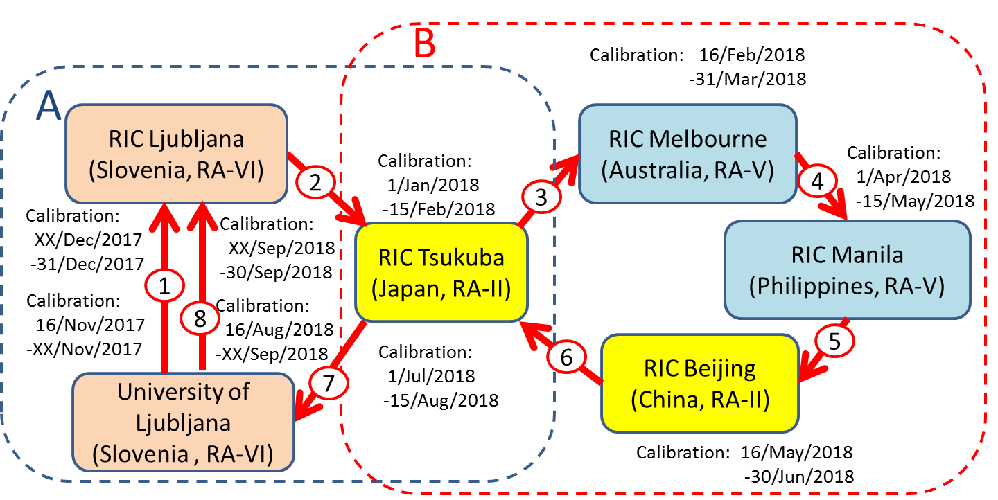

Figure 1. Route plan

**2.4. Measurement equipment**

The equipment for this ILC will be lent by RIC-Ljubljana (Slovenia) and University of Ljubljana.

- Two Pt-100 resistance thermometers ELPRO in combination with Keysight/Agilent/Hewlett

Packard 34420A

- Capacitive hygrometer Vaisala HMP155

- Barometer Vaisala PTB220

**2.5. Measuring points**

- Temperature



- Relative humidity:



- Air pressure:



**3. Questionnaire on basic information of your RIC and participation in the ILC**

A questionnaire is sent to RICs in RA-II and V for the purpose of obtaining basic information on participating laboratories and obtaining conditions for ILC participation in implementing the ILC in 7 November 2017 (**Appendix II**).

**4. Memorandum of understanding**

A tentative memorandum of understanding (MoU) was prepared and it is currently confirmed among the prospective participants.

The MoU is a statement of intent to consult, cooperate and exchange information in connection with the responsibilities for conduction of an ILC in the field of temperature, humidity and pressure, for calibration laboratories.

**5. Future schedule**

After discuss and agreed on the ILC protocol and the MoU by all the participants, it is expected to move to implementation of the ILC.

When implementing the ILC, an invitation letter from WMO is desirable, and support from the WMO Secretariat is necessary.