WORLD METEOROLOGICAL ORGANIZATION  ____________________  JOINT MEETING OF  CIMO EXPERT TEAM ON OPERATIONAL REMOTE  SENSING TECHNOLOGIES (ET-ORST)  (First Session)  and  CBS EXPERT TEAM ON SURFACE-BASED  OBSERVATIONS (ET-SBO)  (Second Session)  Tokyo, Japan, 5 – 8 October 2015 | CIMO_ET-ORST_CBS_ET-SBO/Doc.6.2  20.IX.2015  _________  ITEM: 6  Original: ENGLISH

AGENDA ITEM 6: LIGHTNING DETECTION SYSTEMS

Report on the Performance Evaluation of the VLF/LF Lightning Sensors

(Submitted by PEI Chong, China)

SUMMARY AND PURPOSE OF DOCUMENT

This document provides the method for evaluation of performance characteristics of the VLF/LF lightning sensors and an overview of Guangzhou Field Experiment Site for Lightning Research and Testbed.
.

ACTION PROPOSED

The session is invited to note the information provided in the document and to use it as the basis for discussion on the preparation of related guidance to WMO Members.

______________

REPORT ON THE PERFORMANCE EVALUATION OF THE VLF/LF LIGHTNING SENSORS

The performance of the VLF/LF lightning sensors is evaluated by CMA Meteorological Observation Centre and Chengdu University of Information Technology during the period of October 2014 to August 2015. Presently, the environmental and experimental test have been carried out, and the field test is conducting by using the rocket-triggered lightning experiment at the Guangzhou Field Experiment Site for Lightning Research and Testing in Conghua, Guangdong province, China. Because the sensors were rectified in terms of the test results before May 11, 2015, only observation data of the triggered lightning strokes between May 11, 2015 and July 31, 2015 are analyzed in this report.

1. Introduction to Test Environment

The sensors to be tested are LT7002, ADTD-2C and LINET, which have been installed at Qujiang Xinfeng, Huiyang, Zhongshan, Sihui and Conghua, respectively. Three 6-sensor lightning detection networks have been set up and are being evaluated by utilizing the observation data on lightning triggered at the Guangzhou Field Experiment Site for Lightning Research and Testing.

1.1 Lightning Detection Network

The location of the stations in the lightning detection networks is shown in Fig. 1.

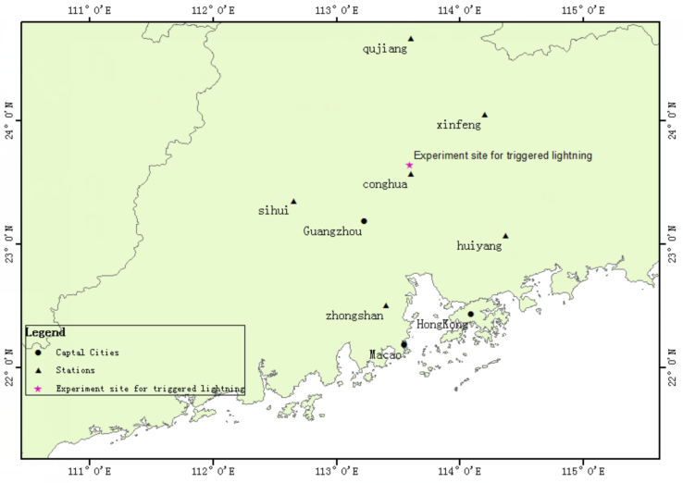

Fig. 1 The location of the stations in the lightning detection networks

The coordinates of the stations in the lightning detection networks are shown is Table 1.

Table 1 The coordinates of the stations in the lightning detection networks (Unit: degree)

Number | Station | Longitude | Latitude | Altitude
1 | Qujiang | 113.60 | 24.67 | 121.3
2 | Xinfeng | 114.20 | 24.05 | 198.6
3 | Huiyang | 114.37 | 23.07 | 108.5
4 | Conghua | 113.60 | 23.57 | 38.3
5 | Zhongshan | 113.40 | 22.50 | 33.73
6 | Sihui | 112.65 | 23.35 | 40.1
1.2 Guangzhou Field Experiment Site for Lightning Research and Testing

Guangzhou field experiment site for lightning research and testing is located in Guangzhou city, Guangdong province. The annual thunderstorm days in this region are more than 80. The field experiment site includes Conghua triggered and natural lightning observation station, and Guangzhou tall-object lightning observatory.

Conghua triggered and natural lightning observation station consists of the field experiment and optical observation site for triggered-lightning, and the lightning observation site at Conghua Meteorological Bureau. The field experiment site covers a total area of 1km², which is equipped with control room, generator room, automatic weather station (AWS), communication tower, high-voltage transmission line and wind turbine. The optical observation site is located approximately 1.9 km away from the rocket launcher, where acoustic, electrical and magnetic devices have also been installed.

At Conghua Meteorological Bureau, 4 observation rooms (nearly 600 m²) and 2 expert apartments (about 700 m²) have been built for equipment development and test, synchronous record of various flash parameters and comfortable living environment. At Guangzhou tall-object lightning observatory located at Guangdong Meteorological Bureau, the comprehensive observation system has been used to monitor optical, electrical and magnetic characteristics of the lightning.

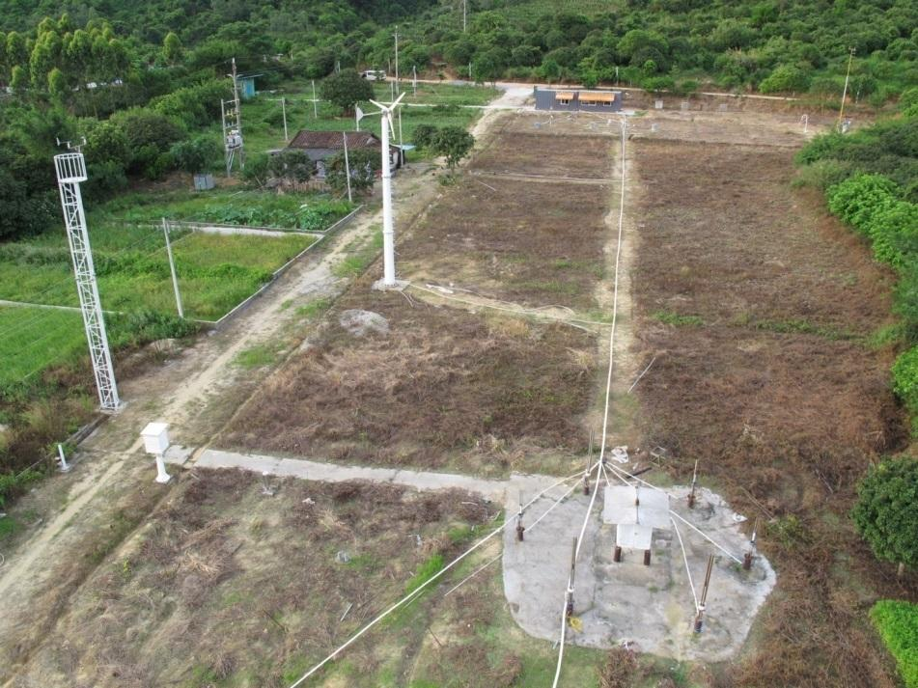
(a)
High-voltage Transmission Line
Control Room
Rocket Launcher
Wind Turbine
Generator Room
AWS

Fig.2 The field experiment site for triggered-lightning in Conghua. (a) An overview of the experiment site

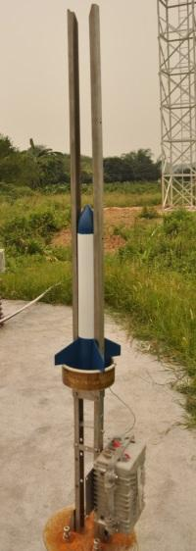
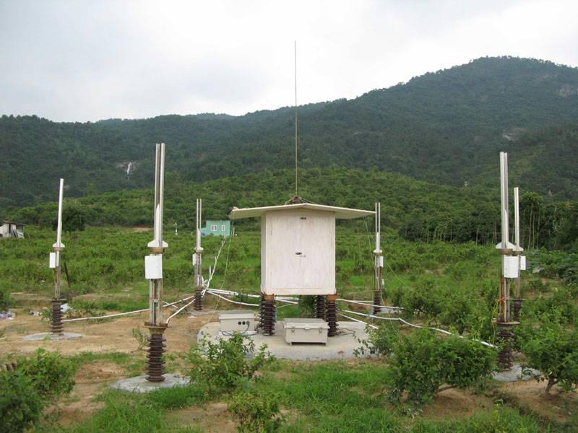
Wooden Box Launcher
(b)
Ignitor
Rocket
Fig.2 The field experiment site for triggered-lightning in Conghua. (b) Rocket launcher

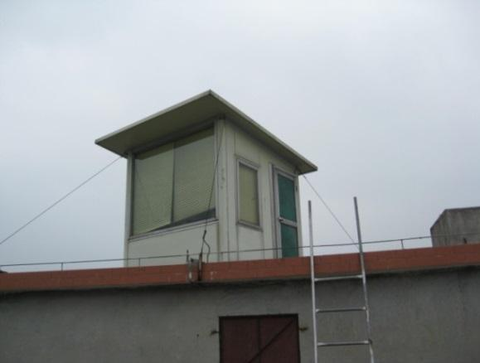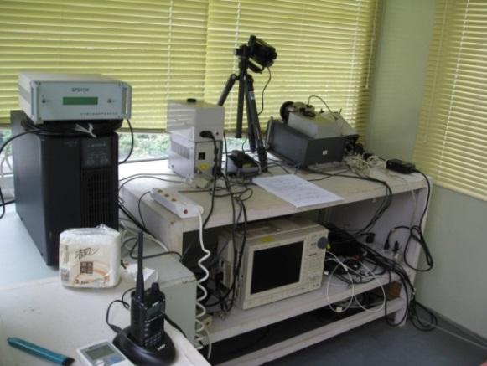
Optical Observation Room
LAPOS

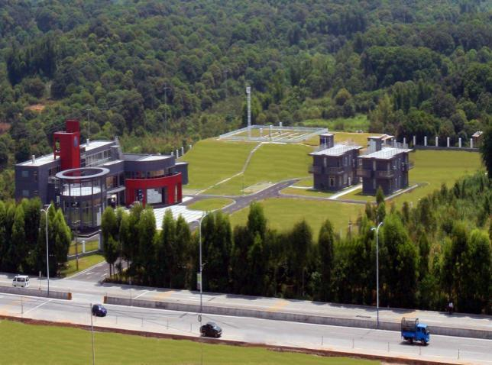
Fig.3 The optical observation site for triggered-lighting in Conghua

Fig.4 The observation site at Conghua Meteorological Bureau

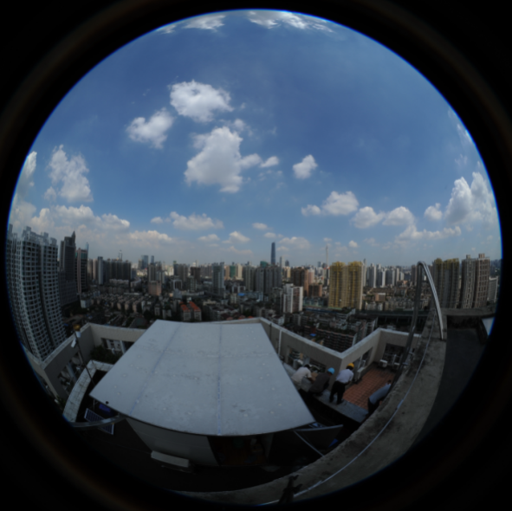
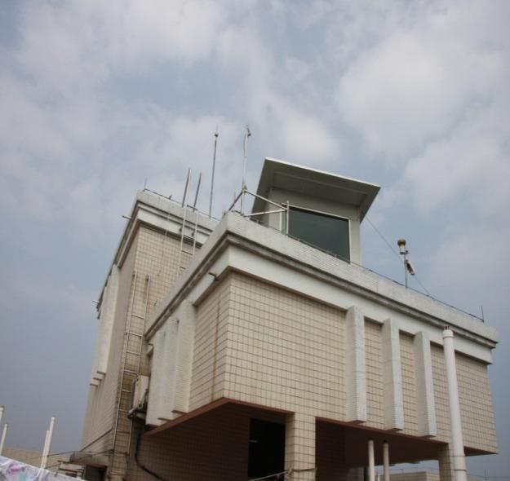
Observation Room
Fig.5 Tall-object lightning observatory in Guangzhou

Guangzhou field experiment site for lightning research and testing has the lightning observation equipment, such as coaxial shunts, rocket launcher, atmospheric average electric field meter, scopecorder, oscilloscope, high-speed camera, spectrum analyzer, signal generator, high voltage isolation acquisition devices, and also developed the detection equipment, such as fast & slow antenna, magnetic field sensor, continuous data acquisition system, broadband radiation field detection system and comprehensive photoelectromagnetic observation system to detect and record the lightning flashes.

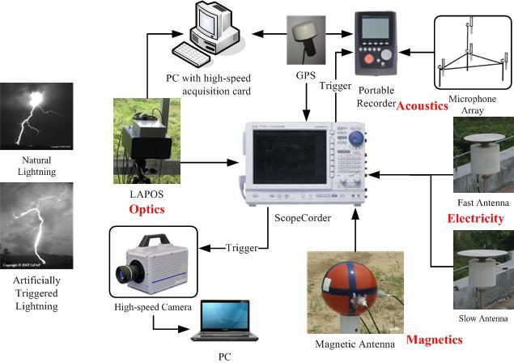
Fig. 6 The synchronous photoelectromagnetic observation system

Guangzhou field experiment site for lightning research and testing is capable of conducting the experiments related to triggered-lightning, comprehensive observation of lightning physical characteristic, evaluation of lightning location system, lightning warning and protection technologies, which meets the requirement for equipment development and test.
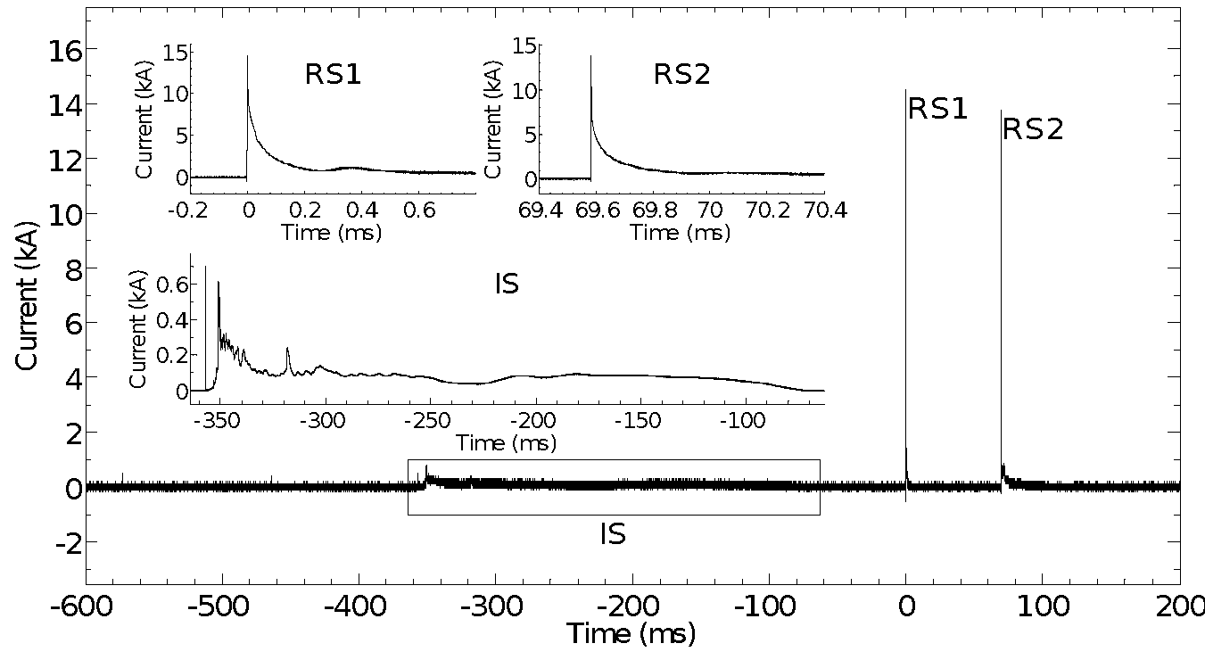

Fig. 7 Cloud-to-ground (CG) stroke currents of the artificially triggered lightning

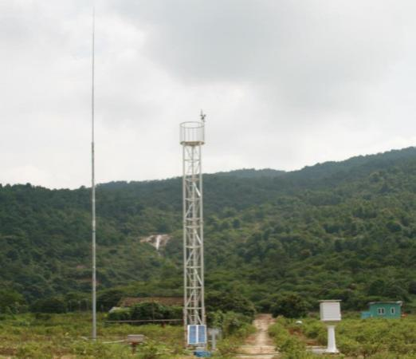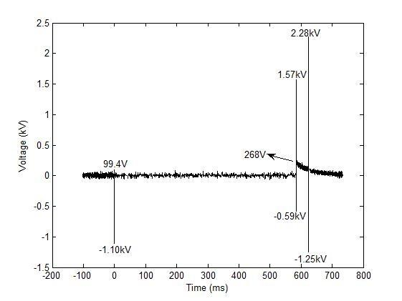

Fig. 8 Lightning protection experiment for AWS

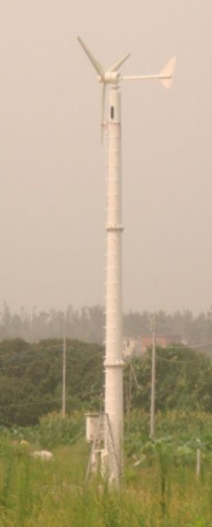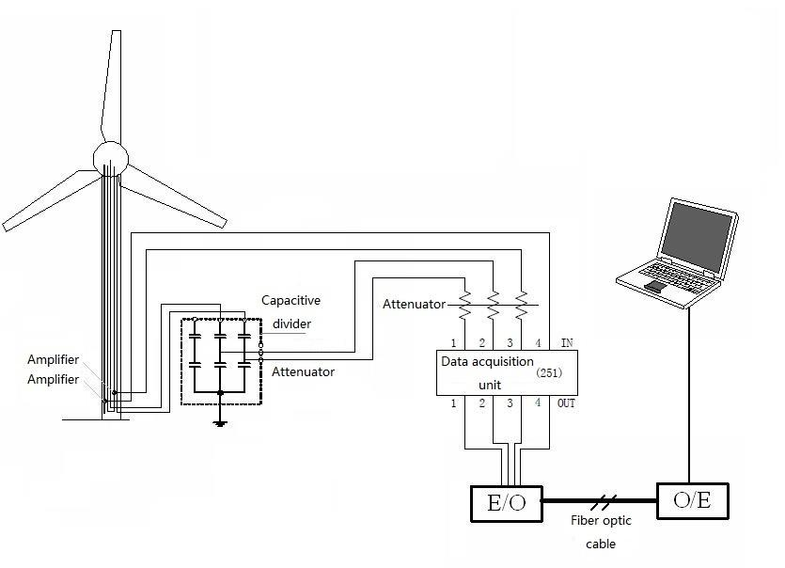

Fig.9 Lightning protection experiment for Wind turbine
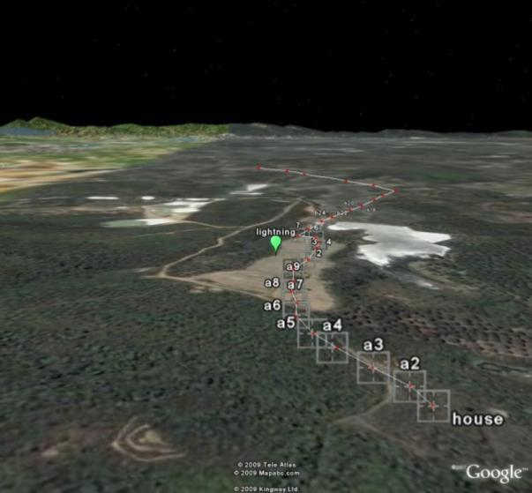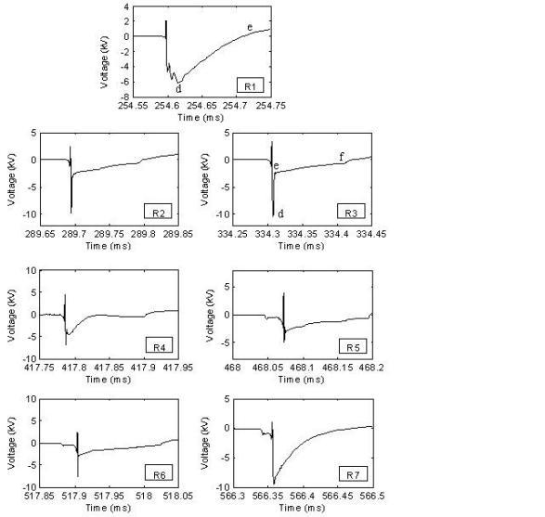

Fig.10 Lightning-induced overvoltage on low-voltage transmission lines

2. Tested Equipment

The interval distance between two sensors is about 3 meters, as shown in Fig.11.

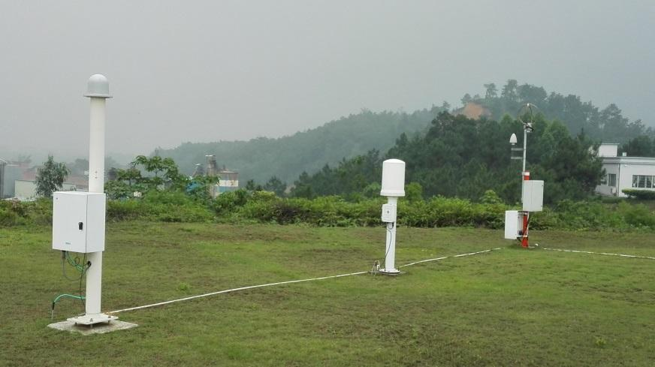
(a)
LINET
ADTD-2C
LT7002
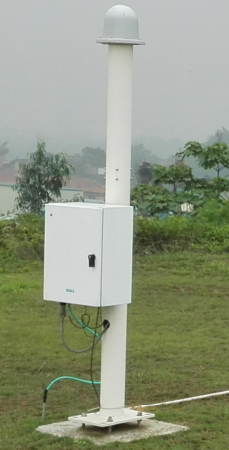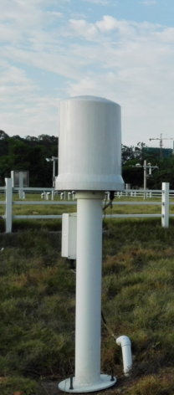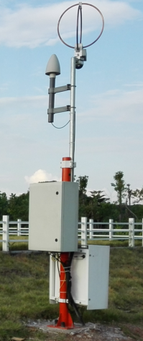
(d)
(c)
(b)

Fig.11 the evaluated sensors. (a) the location of the sensors,(b) LT7002, (c)ADTD-2C, (d)LINET

2.1Technical requirements for the lightning location system

Technical requirements for lightning locaiton system are shown in Table 2.

Table 2. Technical requirements for lightning location system

Number | Item | Requirements
1 | CG flash detection efficiency | 90% for plains and 85% for others when peak current is greater than 5kA
2 | CG stroke detection efficiency | 60% for plains and 55% for others when peak current is greater than 5kA
3 | Median location accuracy | 500m
4 | Absolute percentage error of CG stroke peak current | 15%
5 | Intra-cloud(IC) stroke detection efficiency | 40%

2.2 Specifications for the lightning detection networks comprised of the sensors

2.2.1 ADTD-2C

CG stroke detection efficiency: 90% when peak current is greater than 10kA
Arithmetic mean location accuracy: 500m for horizontal (latitude-longitude) position; 1000m for vertical position.

Absolute percentage error of CG stroke peak current: 10%

2.2.2 LT7002

Median location accuracy: 250m
Detection efficiency: 95% for CG flash; 50% for IC flash

2.2.3 LINET

Median location accuracy: 150m for horizontal (latitude-longitude) position; 300m for vertical position
CG flash detection efficiency: 90% when peak current is greater than 4kA

3. Methods for comparative analysis of the lightning data

The rocket-triggered lightning experiment and CG stroke current measurement system at the Guangzhou Field Experiment Site for Lightning Research and Testing are used to evaluate the performance characteristics of the lightning detection networks, and the lightning location data are analyzed.

3.1 Performance analysis of the lightning detection networks

The performance analysis of the lightning detection networks involves the computation of CG flash detection efficiency, CG stroke detection efficiency, location accuracy and absolute percentage error of CG stroke peak current.

3.1.1 CG flash and CG stroke detection efficiency

Detection efficiency is defined as
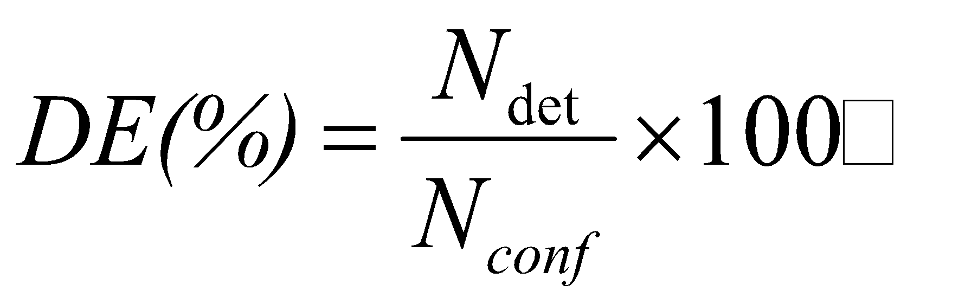
Where, is the total number of the triggered lightning flashes(or strokes), and is the total number of the corresponding CG flashes (or strokes) detected by the networks.

3.1.2 Location accuracy

The CG strokes of the triggered lightning are applied to calculate the arithmetic mean and geometric mean and median for location accuracy of the networks
Arithmetic mean 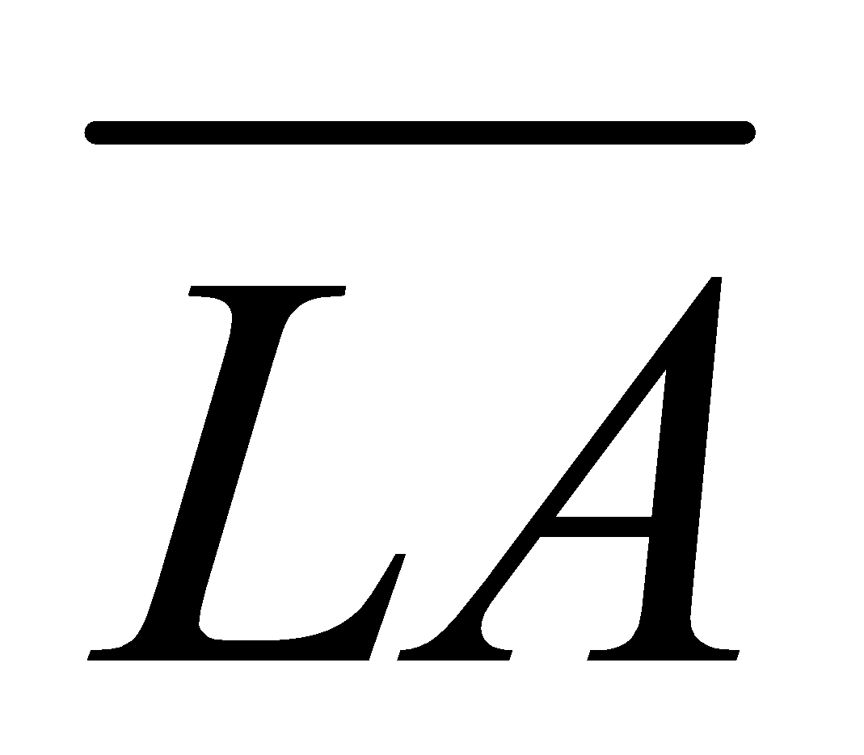 is defined as
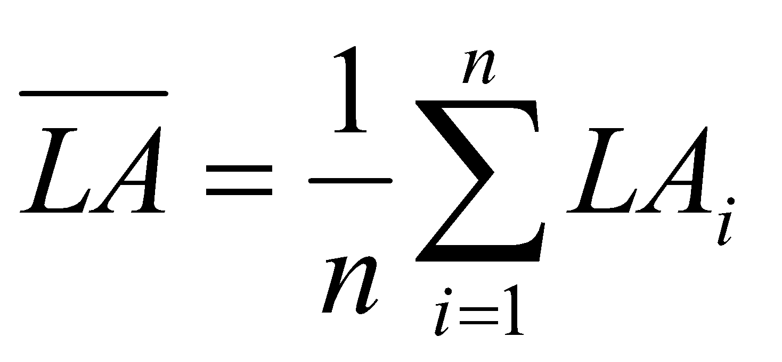
Where, n is the total number of the triggered strokes, and is the location accuracy of the CG stroke, indicating the distance between the rocket launcher and the stroke location.
Geometric mean 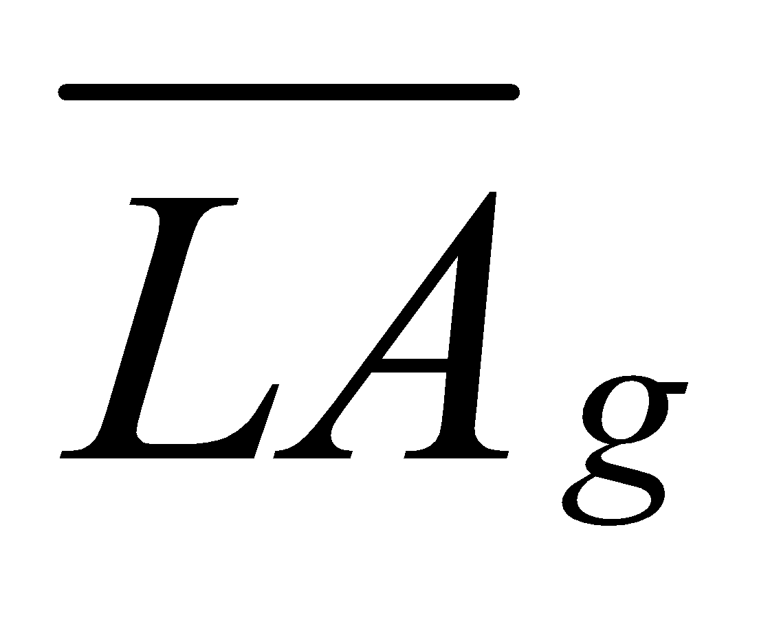 is defined as
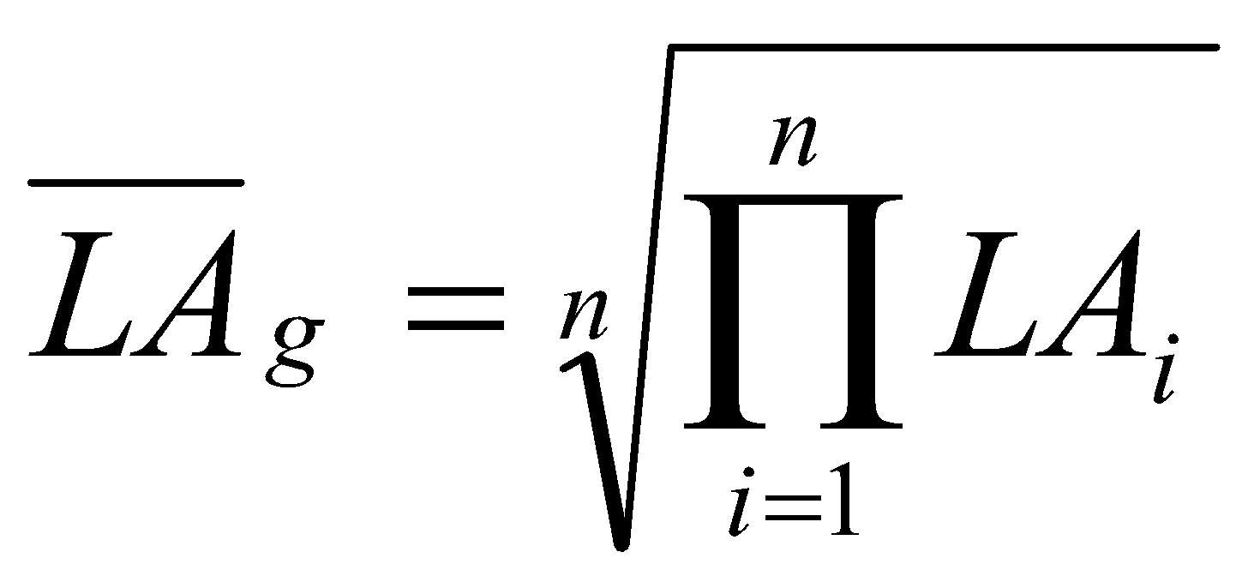
Median is defined as

The location accuracy of CG strokes is sorted in ascending order.

If n is odd, then 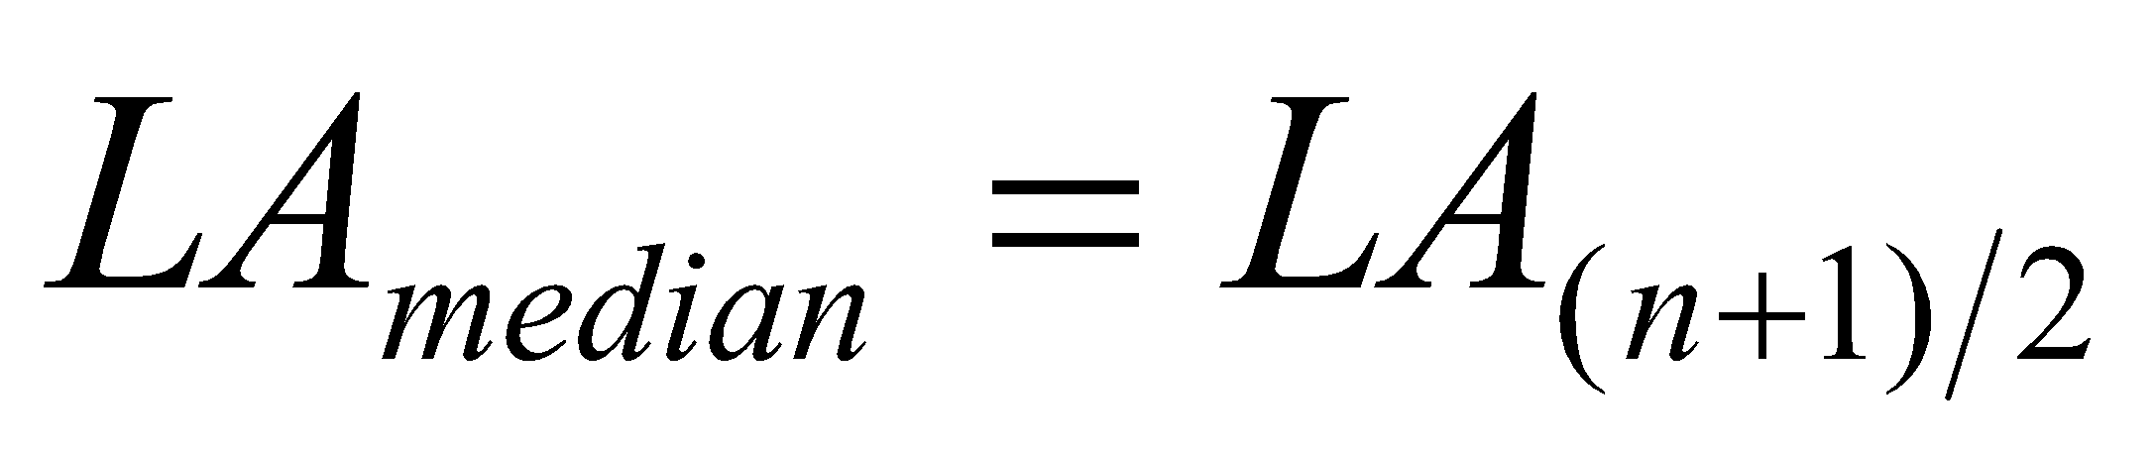
If n is even, then 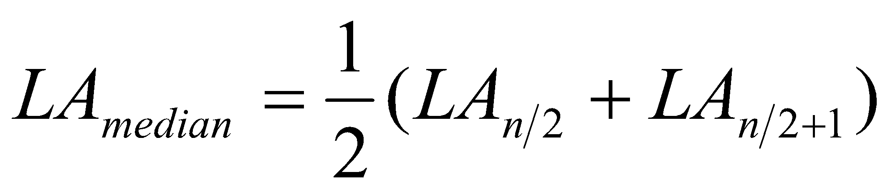

3.1.3 Absolute percentage error of CG stroke peak current

The stroke amplitudes of the triggered lightning is applied to calculate the absolute percentage error of CG stroke peak current of the networks.

Absolute percentage error of CG stroke peak current is defined as
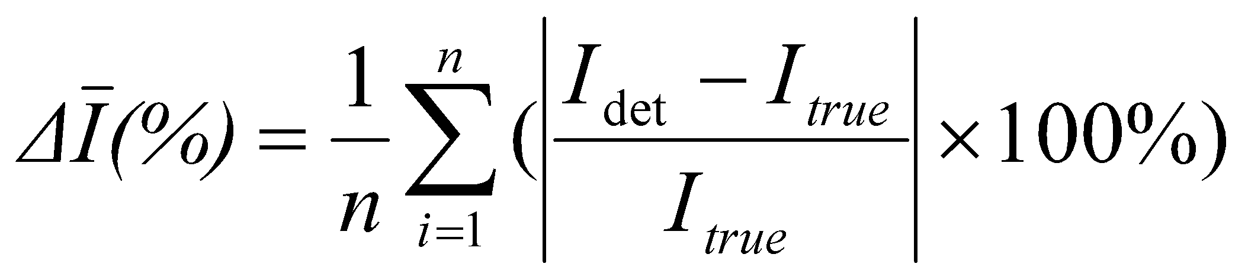
Where, is the stroke peak current estimated by the networks, is the stroke peak current measured directly in the triggered lightning experiment.

3.2 Comparative analysis of the lightning detection networks

The comparative analysis of the lightning detection networks involves the total number of CG flashes and strokes, distribution of stroke locations and amplitudes. Meanwhile, CG and IC flashes are superposed on the composite reflectivity (CREF) images and the lightning location and radar echo data are analyzed.

4. Analysis of the lightning location data

4.1 Performance analysis of the lightning detection networks

A total of 8 lightning flashes have been successfully triggered since May 11, 2015. The performance characteristics of the lightning detection networks are evaluated by using the location results of artificially triggered lighting flashes and the directly measured value of CG stroke peak currents.

4.1.1 Detection efficiency

Detection efficiency of the networks is shown in Table 3.

Table 3. Detection efficiency of the networks

Model | CG flash detection efficiency | Stroke detection efficiency
LINET | 87.5%(7/8) | 65.71%(23/35)
LT7002 | 87.5%(7/8) | 97.14%(34/35)
ADTD-2C | 37.5%(3/8) | 8.57%(3/35)

Note: The value in bracket is the fraction of detected CG flash (or stroke) number of the total CG flash (or stroke) number.

4.1.2 CG Stroke Location accuracy

CG Stroke location accuracy of the networks is shown in Table 4.

Table 4. CG Stroke location accuracy of the networks (Unit: meter)

Model | Arithmetic mean | Geometric mean | Median
LINET | 229.41（23） | 205.09 (23) | 189.1(23)
LT7002 | 101.51（34） | 96.84 (34) | 94.35 (34)
ADTD-2C | 100.03（3） | 48.90 (3) | 32.0 (3)

Note: The value in bracket is the total number of strokes detected by the network.

4.1.3 Absolute percentage error of CG stroke peak current

Absolute percentage error of stroke peak current of the networks is shown in Table 5.

Table 5. Absolute percentage error of CG stroke peak current of the networks

Model | Absolute percentage errors of CG stroke peak current
LINET | 41.41%（23）
LT7002 | 44.11%（34）
ADTD-2C | 12.33%（3）

Note: The value in bracket is the total number of strokes detected by the network.

4.2 Comparative analysis of the lightning detection networks

A detailed analysis of the lightning location records has been performed with the use of CG and IC strokes instead of the CG and IC flashes as the strokes of the networks are not grouped into the flashes.

4.2.1 Comparison of the stroke numbers

The number of strokes of the networks is shown in Table 6.

Table 6. The number of strokes of the networks

Model | CG stroke numbers | IC stroke numbers | Total stroke numbers
LINET | 1,765,337 | 938,031 | 2,703,368
LT7002 | 1,902,372 | 3,774,513 | 5,676,885
ADTD-2C | 693,289 | 160,727 | 854,016

The total number of strokes observed by LT7002 is the most in the lightning detection networks, which is about 2.1 times that of LINET, and 6.6 times of ADTD-2C, respectively. The number of CG strokes picked up by LT7002 is nearly 1.1 times that of LINET, and 2.7 times that of the ADTD-2C, respectively. The number of IC strokes detected by LT7002 is far more than that of other two networks, which is about 4 times that of the LINET, and 23.5 times that of ADTD-2C, respectively.

The number of IC strokes observed by LT7002 is more than that of CG strokes accounting for 33.5% of all strokes. On the other hand, the number of IC strokes detected by LINET and ADTD-2C is less than that of CG strokes accounting for 65.3% and 81.2% of all strokes, respectively.

4.2.2 Comparison of the monthly stroke numbers

The monthly change of the stroke numbers of the networks is shown in Fig. 12.

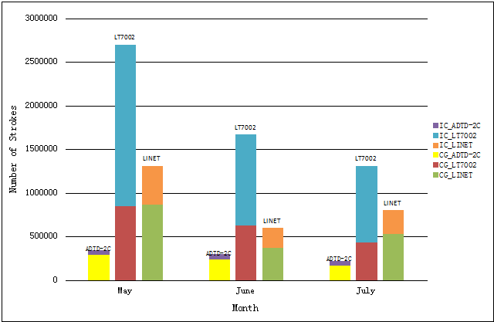

Fig. 12 Monthly change of the stroke number of the networks

The monthly change of the number of strokes detected by ADTD-2C has the same general trend as LT7002. Most of the strokes occur in May and the minor strokes occur in July. In contrast, majority of the strokes observed by LINET occur in May, while the minor strokes occur in June. Perhaps there is no lightning data provided by LINET from June 13-16, resulting in the reduction of strokes.

4.2.3 Comparison of the CG strokes density

The CG and IC stroke density of the networks is shown in Fig. 13 and Fig.14, respectively.

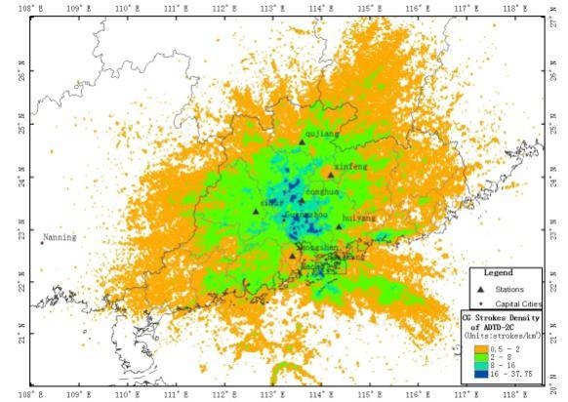
(a)
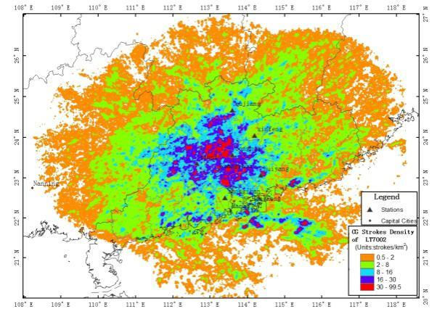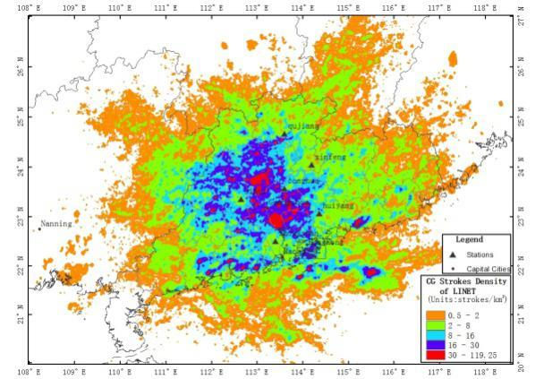
(b) (c)

Fig. 13 The CG stroke density of the networks. The unit is strokes/km². (a)ADTD-2C, (b)LT7002, (c)LINET

The CG stroke density of LT7002 and LINET is higher than that of ADTD-2C within the center of the network. There are high CG stroke density areas for the networks in Guangzhou and southern Qingyuan, but the distribution of the areas is different. Moreover, there are high CG stroke density areas for LT7002 and LINET in the coastal and offshore areas of Guangdong province.

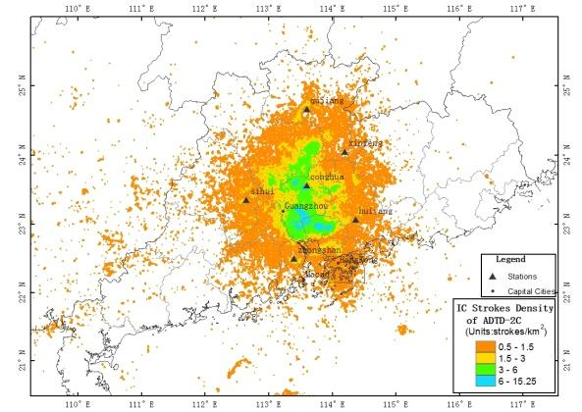
(a)
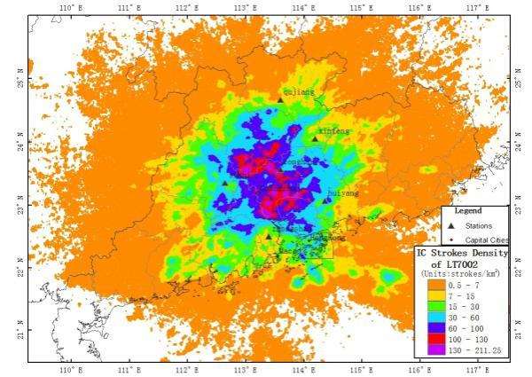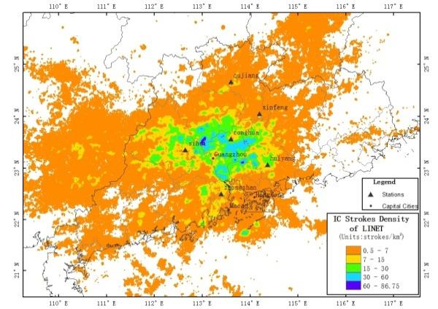
(b) (c)

Fig.14 The IC stroke density of the networks. The unit is strokes/km². (a)ADTD-2C, (b)LT7002, (c)LINET

The maximum IC stroke density of LT7002 is 211.25 strokes /km², which is much higher than that of other two networks, and the IC stroke density of ADTD-2C is the lowest in the networks, whose maximum is 15.25 strokes /km².

4.2.4 Comparison of the CG stroke Intensity

The CG stroke intensity of the networks is shown in Fig. 15.

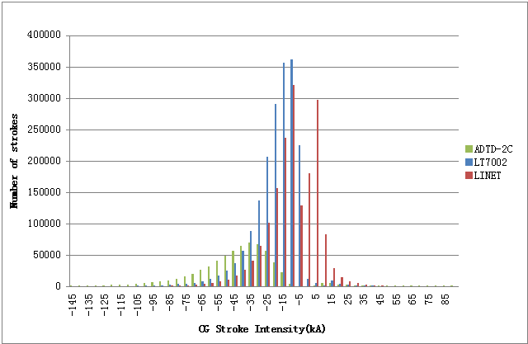

Fig.15 The CG stroke intensity of the networks. The current interval is 5kA.

ADTD-2C has detected the maximum positive CG strokes with peak current between 10kA and 15kA and the minimum negative CG stroke with peak current range from -35kA to -30kA. LT7002 has detected the maximum positive CG strokes with peak current between 0 and 5kA and the minimum negative CG stroke with peak current range from -10kA to -5kA. LINET has detected the maximum positive CG strokes with peak current between 5 and 10kA and the minimum negative CG stroke with peak current range from -10kA to -5kA. Therefore, the peak current of CG strokes observed by LT7002 and LINET is less than that of ADTD-2C. It is implied that LT7002 and LINET can detect more weak CG strokes.

4.3 Superposition of the lightning location and radar echo data

The strongest relationship between radar observations and lightning activity was found to be the area of 40dBZ at -10. Taking the thunderstorm on 23 May 2015 as an example, CG and IC flashes of the networks are superposed on CREF images as shown in Fig .16.

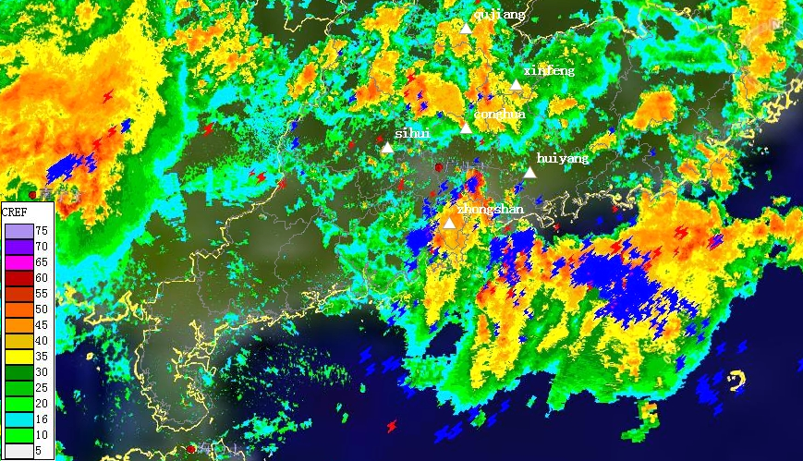
(a)
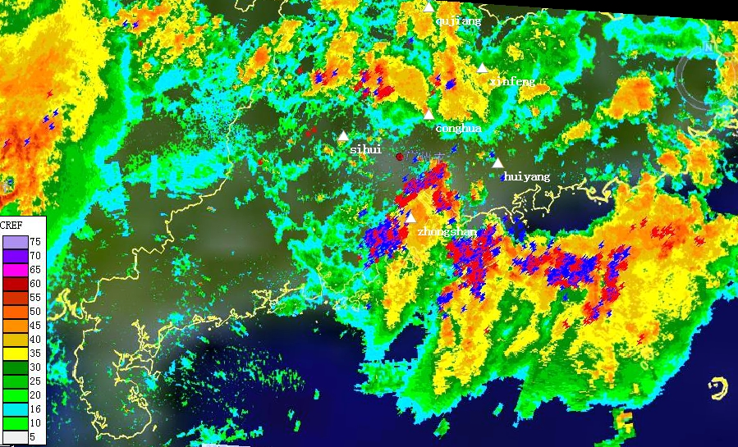
(b)

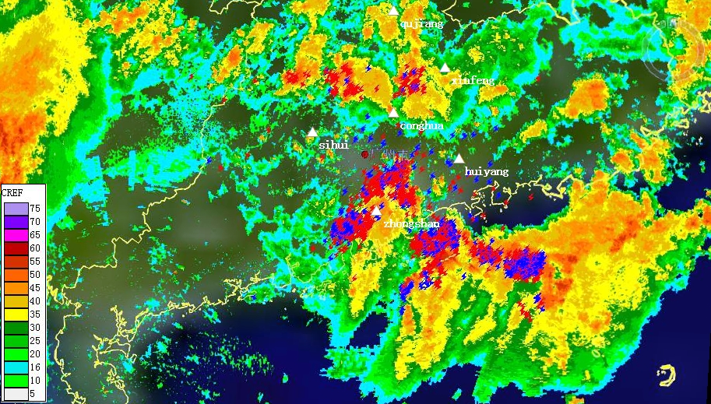
(c)

Fig.16 Superposition of the lightning location and radar echo data on 23 May 2015 at 5:00(Beijing Time). (a) ADTD-2C, (b) LINET, (c) LT7002

传感器
观测室

A few strokes detected by ADTD-2C and LT7002 occur in the offshore and coastal areas of Guangdong province, respectively. However, almost all of strokes detected by LINET occur in the high radar reflectivity region of the thunderstorm.

Authors:

Sun xiubin, PHD, Associate Professor, Chengdu University of Information Technology, Mobile: (86)18086801283, Email: sunbine@cuit.edu.cn
Chen Yao, master, China Meteorological Administration, Email: CYaoc@cma.gov.cn

