World Meteorological Organization  Commission for Instruments and Methods of Observation  Joint Session of the Expert Team on Operational In Situ Technologies (ET-OIST) and the Expert Team on Developments in In Situ Technologies (ET-DIST)  Geneva, Switzerland, 21-23 June 2017 | CIMO/ET_A1_A2/Doc. 6.1
Submitted by:
Jane Warne
18.06.2017

Evaluation of Enviromental Impact of Radiosondes in an Australian Context

Summary and purpose of document
This document provides and introduction to some work being undertaken in Australia looking into the environmental impact of radiosondes under Australian climatic conditions.

Action proposed

The Meeting is invited to take notice of the findings reported in this document and to provide feedback on the contents. Also the Meeting should decide whether the document is suitable for publication as a separate IMOP report or whether information should be included in the CIMO guide.

Evaluation of the Environmental Impact of Radiosondes in an Australian Context

BacKound to the Trial
The Australian Bureau of Meteorology in has undertaken in the first quarter of this year undertook a series of trial flight of radiosondes from its training site in Broadmeadows in Melbourne's outer suburbs. The trial flew 79 sondes in total two different types, one with an outer casing protecting the polystyrene, and one without. The initial intent of the trial was to determine if the sondes without an outer casing completed as many flights to the same height as those with the outer coating.
The second aim of the trial was to look at the environmental impacts of the two sonde types.
The considerations were
- the total mass of material left as waste
- the way the sondes decomposed under Australian conditions
- what fire hazards lithium batteries, which both sondes contain, present
- verify capacity to track and identify the final location of sondes
This second element of the study was in part triggered by a paper by O'Shea (O'Shea, 2014) which made a number of claims about the amount of pollution the Bureau's sondes were causing in the Great Barrier Reef. There is a desire to see if it is possible to track and monitor these flights more accurately can determine the impact.
Each flight was tracked from launch until it landed or communication was lost. The number of flights that failed to reach burst height; reached burst height, i.e. completed; and those that are considered verifiable because they reached the ground are listed in the table below and shown in.
 | Number of flights
Total | 79
Fail | 16
Complete | 35
Verifiable | 27

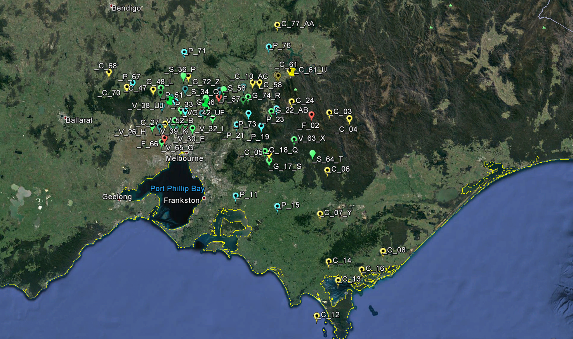
450kmm
Figure 1 – Plot of the location of sondes where they landed or lost communication.
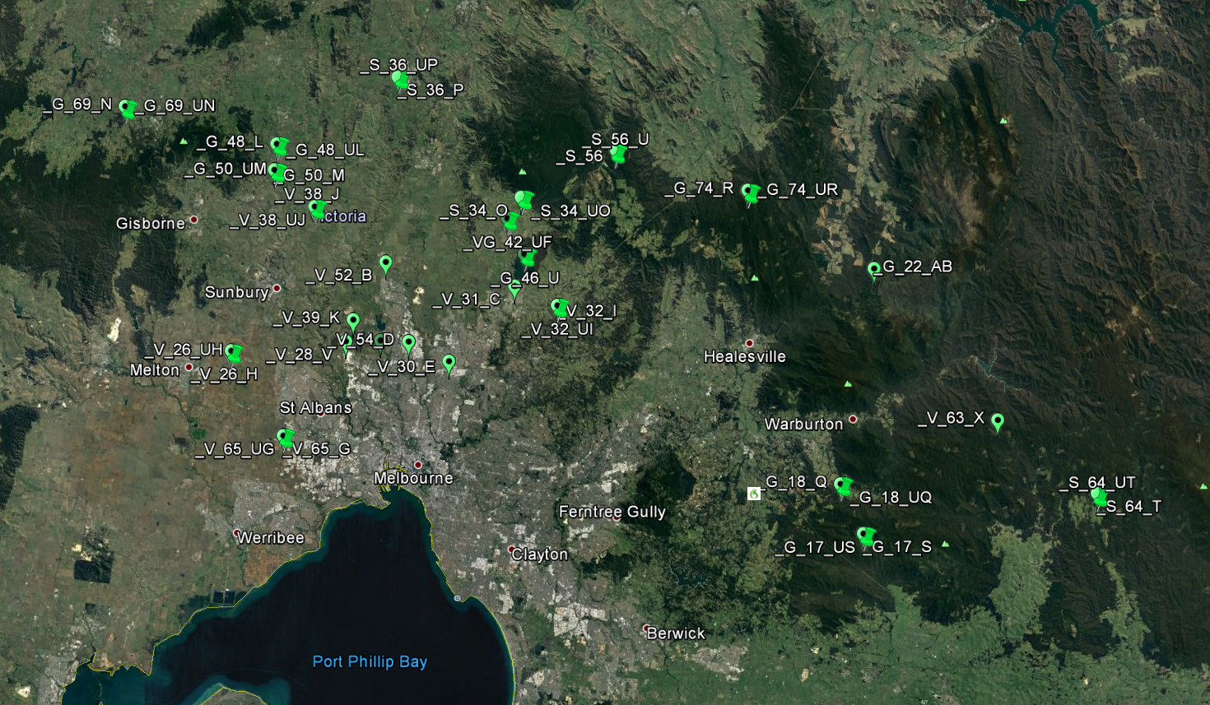
Figure 2 - The locations of sondes we expect to be able to find
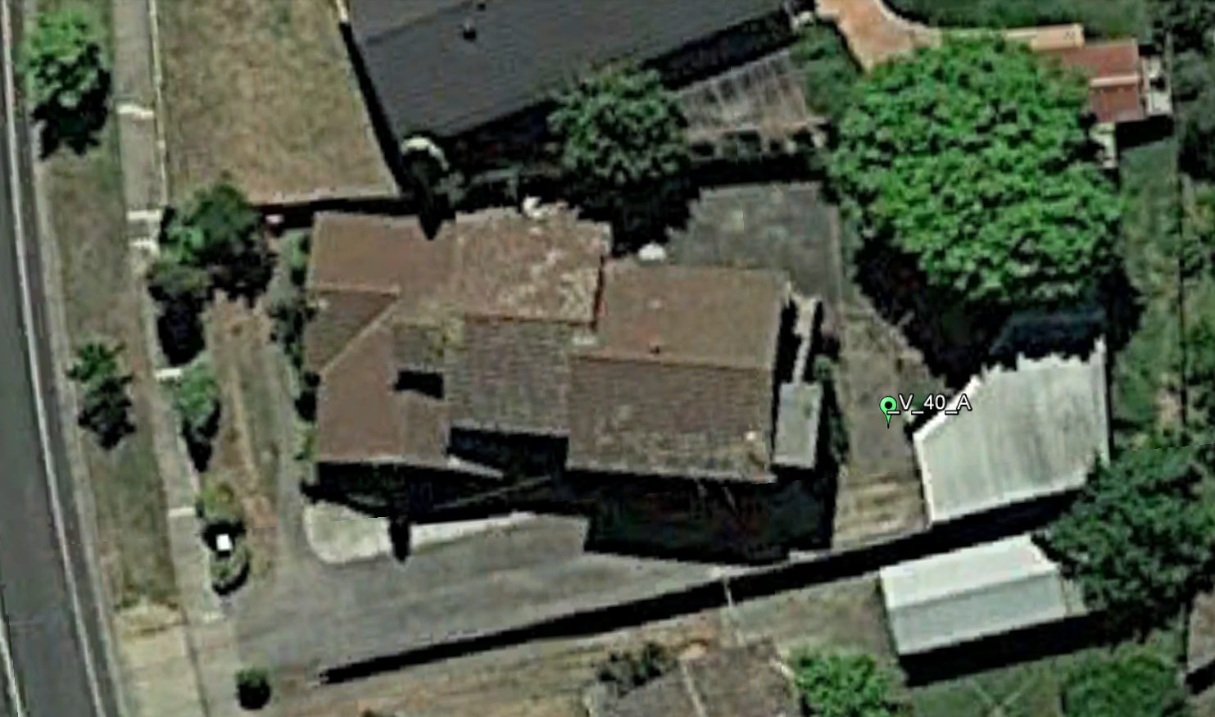
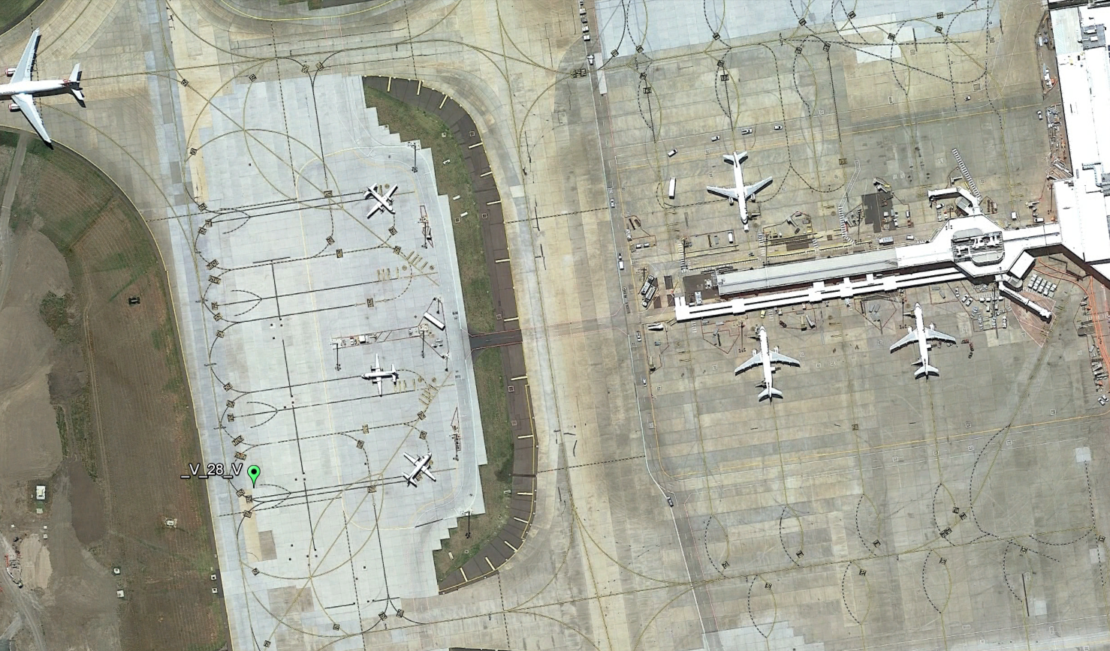
Figure 3 - Two locations where we tracked the sonde to the ground and are confident of where it landed, but doubt we will be able to recover it.
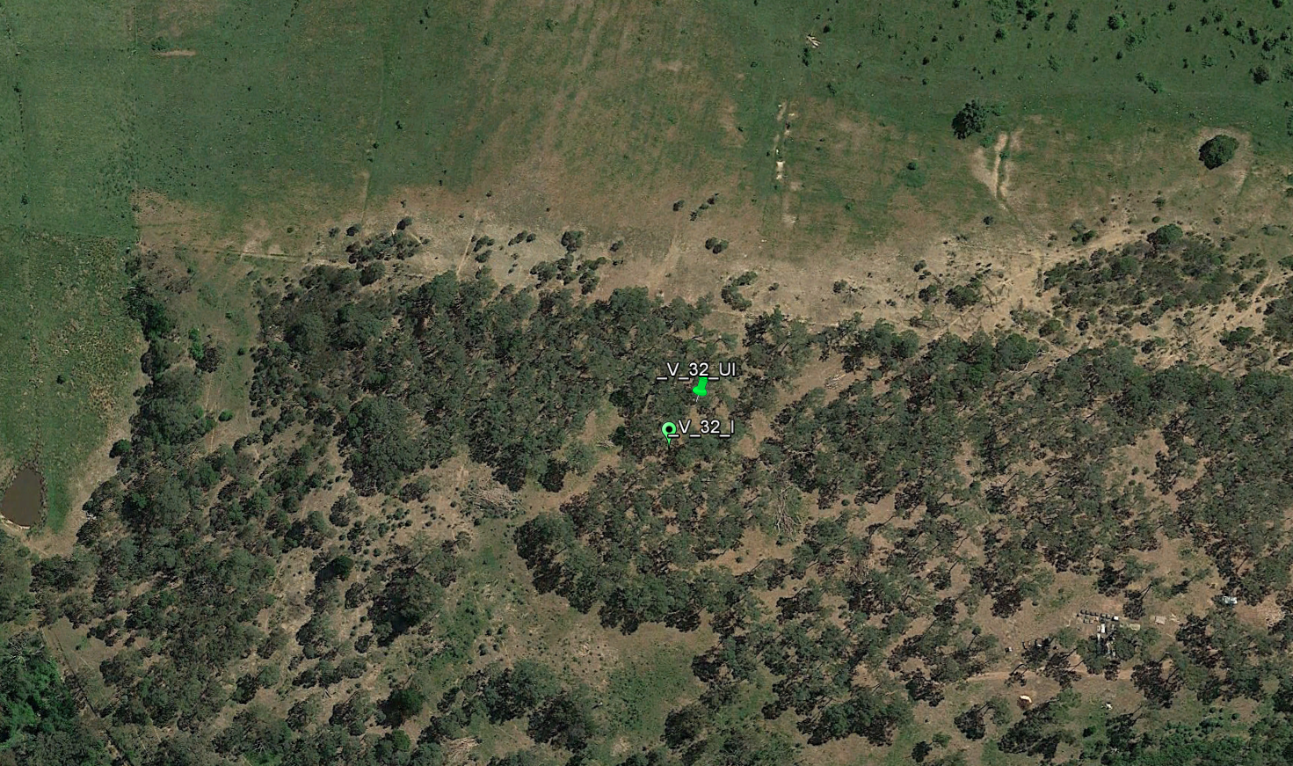
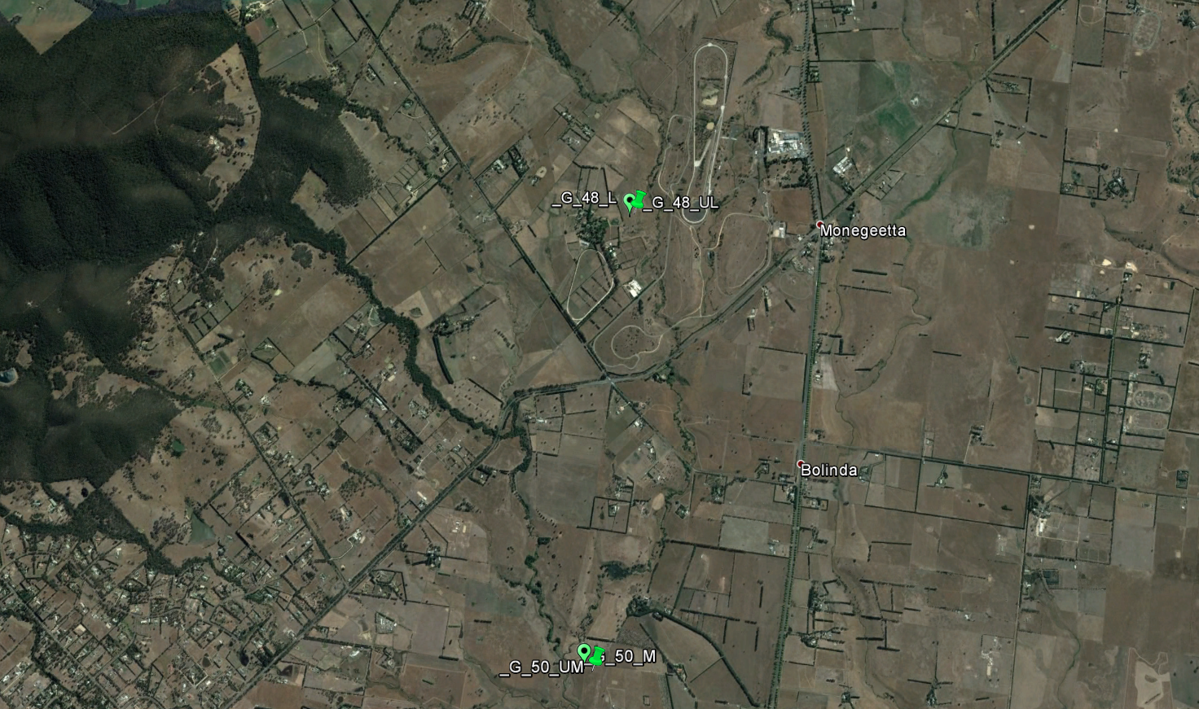
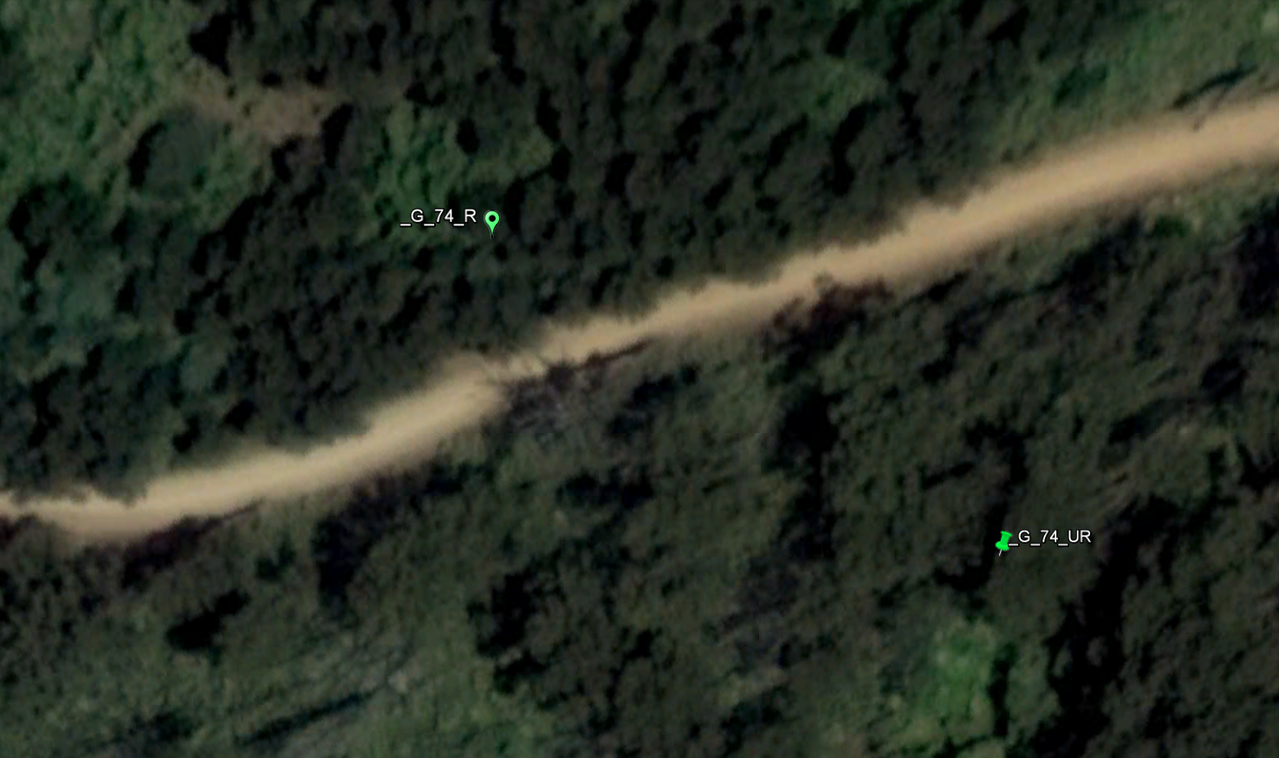
Figure 4 - A selection of sites that we expect a possible to recover sondes from but each of which presents challenges even in a small area
There are a series of questions we are hoping this study will address. At this point it is not clear what Hazard the sonde debris presents to animals. Do animals attempt to eat it and does it present a different hazard to farming animals as distinct native animals? We also don't understand the process of decomposition. In this study we have two different sondes being launched which may decompose differently. It is quite possible that the sonde without a casing shatters on landing. In Australia this good as introduce an additional hazard exposing lithium batteries to the sun in our hot dry summers.
Over the coming months we will identify as many as possible and track their decomposition through winter and into the following summer

Recommendation
2.1 That the meeting note the study is ongoing and provide any guidance or support.

References

O'Shea, O. H. (2014). Predictable pollution: An assessment of weather balloons and associated. Marine Pollution Bulletin.

