World Meteorological Organization  Commission for Instruments and Methods of Observation  Joint Session of the Expert Team on Operational In Situ Technologies (ET-OIST) and the Expert Team on Developments in In Situ Technologies (ET-DIST)  Geneva, Switzerland, 21-23 June 2017 | CIMO/ET-A1-A2/Doc. 8.1
Submitted by:
Toshihiro Hayashi
9.6.2017

GUIDELINES ON COMBINING INFORMATION

FROM COMPOSITE OBSERVING SYSTEMS

Summary and purpose of document

This document provides information on current development status of guidelines on combining information from composite observing systems.

Action proposed

The meeting is invited to:
- Review the document (Appendix I) for organization, texts, figures and length. A review for grammar will be done after the meeting.
- Provide documents on QC procedures on precipitation amounts measured by precipitation gauges.
- Review proposed milestones (p. 4).
- Decide about appropriate form for its publication (either as an IOM (Instruments and Observing Methods) report or as a part in the CIMO Guide).

________________

Appendices: I Draft guidance material for QC procedures on precipitation amounts measured by precipitation gauges

Guidelines on combining information
from composite observing systems

Toshihiro Hayashi and Fukiko Takehi
Japan Meteorological Agency (JMA)

- Background

The task assigned by the CIMO (Commission for Instruments and Methods of Observation) MG (Management Group) is to newly develop “Guidelines on combining information from composite observing systems” during the CIMO intersessional period from 2014 to 2018. This task is in collaboration with the task “Integration of observations from different rainfall observation systems” assigned to the CIMO ET-ORST (Expert Team on Operational Remote Sensing Technologies). There are many kinds of combined meteorological information from composite observing systems. Among them, precipitation is one of the most important monitoring indices for our disaster prevention and reduction activities. In some WMO Members, precipitation amounts from precipitation gauges and weather radars are combined as QPE (Quantitative Precipitation Estimation) and QPF (Quantitative Precipitation Forecast) products. The CIMO ET-OIST (Expert Team on Operational In-Situ Technologies) discussed and recognized that quality control (QC) procedures on precipitation amounts measured by precipitation gauges are quite important for ensuring high quality QPE and development of a guidance material for QC procedures is also quite important. This activity mentioned above to develop the guidance material was proposed by the ET-OIST and approved by the thirteen session of the CIMO MG in December 2014.

- Objectives

The guidance material introduces QC procedures on precipitation amounts measured by precipitation gauges such as quality management, standardization, system, implement structure in NMHSs, collaboration with partner organizations, siting environment, exposure, automated QC, human QC, characteristics of precipitation catch loss and adjustment procedures as a function of wind speed. It stresses importance of these techniques to reduce uncertainty of precipitation amounts for QPE and QPF products.

- Draft Guidance Material of This Task

The draft version of the guidance material for QC procedures on precipitation amounts measured by precipitation gauges is being developed as Appendix I.

- Existing Materials
4.1. Existing WMO Materials

The standard and recommended sets of QC procedures on precipitation amounts measured by precipitation gauges are described in the following WMO documents. They can be useful for the development of the guidance material.

WMO No. 8 - The Guide to Meteorological Instruments and Methods of Observation (CIMO Guide)
Part I Chapter 6 measurement of precipitation, Annex 6.B suggested correction procedures for precipitation measurements.
Part II Chapter 1 measurements at automatic weather stations

WMO No.168 - The Guide to Hydrological Practices
Part I Chapter 3 Precipitation Measurement

WMO No. 488 - Guide to the Global Observing System
Part VI Data Quality Control
Appendix VI.2 Guidelines for QC procedures applying to data from automatic weather stations

WMO No.544 - Manual on the Global Observing System VOLUME I (Annex V to the WMO Technical Regulations))
Part V Quality Control

WNO/TD No. 1160 - IOM Report No.78 - Algorithms Used in Automatic Weather Stations - Evaluation of Questionnaire

WMO/CIMO Knowledge-sharing portal: http://www.wmo.int/pages/prog/www/IMOP/Knowledge-sharing_Portal.html

4.2. Existing JMA Material

Outline of QC procedures for surface weather observation of JMA is described in the following text book for the JICA (Japan International Cooperation Agency) training course on reinforcement of meteorological services. It is useful for the development of the guidance material.

Japan Meteorological Agency, 2013: 2013 JICA Group Training “Reinforcement of Meteorological Services” Course “Quality Assurance and Quality Control of Surface Observation Data” (Nov 22, 2013).

- Deliverables

According to the work plan of the ET-OIST, this guidance material (APPENDIX I) is expected to be published such as an IOM (Instruments and Observing Methods) report or other kind of documents. Further discussion on the form of deliverables is required.

- Progress

Date | Progress
Jul. 2014 | CIMO-16 / CIMO TECO-2014 (St.-Petersburg, Russian Federation)
Dec. 2014 | ET-OIST work plan was approved by CIMO MG-13 (Offenbach, Germany).
Apr. 2015 | Task 1 actions were discussed by ET-OIST experts at 2nd Webex (8th Apr.).
Dec. 2015 | Draft report was made by Toshihiro Hayashi and Fukiko Takehi (JMA).
Jan. to Mar. 2016 | Draft report was reviewed by ET-OIST experts.
Apr. 2016 | ET-OIST progress reporting to CIMO MG-14 (Offenbach, Germany)  ET-OIST requested CIMO MG and secretariat:  1) to liaise with ET-ORST (B1 Operational remote sensing) in QPE using Radar and Space-based remote sensing experts in rainfall estimation using Satellites  2) to decide to publish final report on precipitation gauge QC as an IOM report independently or integrate it into reports on rainfall estimation using Radar and Satellite.
Sep. 2016 | CIMO TECO-2016 (Madrid, Spain)

- Proposed Milestones

Date | Proposed Milestones
Jun. 2017 | Joint Session of CIMO A1. ET-OIST and A2. ET-DIST (Geneva, Switzerland)
Jun. 2017 | CIMO Strategic Management Meeting (Geneva, Switzerland)
Jul. to Dec. 2017 | Further develop and enhance quality of draft report.
Jan. to Mar. 2018 | Final review, revision and check of draft report.
Jun. 2018 | Final report will be made..
Jul. 2018 | Submit final report to the WMO/CIMO Secretariat.
2018 | Publication of final report as an IOM report
2018 | CIMO-17 / CIMO TECO-2018

APPENDIX I:
Draft guidance material for QC procedures
on precipitation amounts measured by precipitation gauges

Abstract

Precipitation amount data measured by precipitation gauges and weather radars are combined in order to produce combined precipitation amount products such as QPE (Quantitative Precipitation Estimation) and QPF (Quantitative Precipitation Forecast). They are utilized for weather information, advisory, warning, and disaster risk management, thus helpful for prevention and mitigation of weather related hazards. Therefore uncertainty of precipitation amounts measured by precipitation gauges has adverse impacts on reliability of those products. This guidance material explains quality control (QC) procedures to reduce uncertainty and it covers characteristics of precipitation amount data and factors which induce uncertainty, quality management, standardization, siting environment, exposure, automated QC (AQC), human QC (HQC), characteristics of precipitation catch loss and adjustment procedures as a function of wind speed.

- Introduction

Precipitation is one of the most important meteorological elements affecting human activities. The combined precipitation amount information such as QPE (Quantitative Precipitation Estimation) and QPF (Quantitative Precipitation Forecast) is typically made from precipitation amounts measured by precipitation gauges and weather radars. They help us to provide spatial distribution of estimated precipitation amounts. In addition, precipitation amounts measured by precipitation gauges are used as the ground truth to validate or verify QPE and QPF in order to improve their accuracy. However, precipitation amounts measured by precipitation gauges have uncertainty induced by various factors. Figure 1.1 shows uncertainty of precipitation amounts and its chain reaction. Uncertainty of precipitation amounts adversely affects reliability of QPE and QPF that made from precipitation amounts. Uncertainty of QPE and QPF spoils reliability of weather information, advisory, warning and weather risk management for prevention and mitigation of weather disasters. This document introduces QC procedures on precipitation amounts measured by precipitation gauges in order to reduce uncertainty of precipitation amounts and obtain reliable precipitation amounts for QPE and QPF products. This guidance material explains characteristics of precipitation amounts and factors inducing uncertainty in chapter 1, quality management in chapter 2, standardization of observation method, siting environment, installation, maintenance, inspection, calibration, metadata and training in chapter 3, QC in chapter 4, siting environment in chapter 5, QC procedures such as automated QC (AQC) and human QC (HQC) in chapter 6, characteristics of precipitation catch loss and adjustment procedures as a function of wind speed in chapter 7.

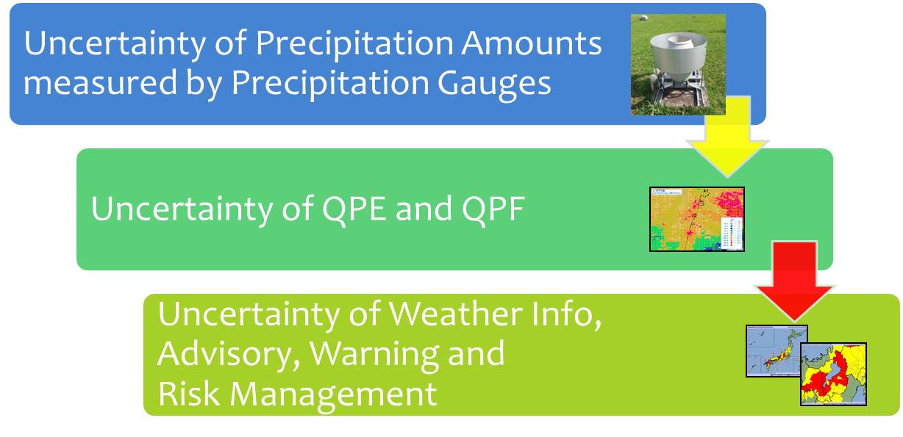
Figure 1.1 Uncertainty of precipitation amounts measured by precipitation gauges and its chain reaction

  - Characteristics of Precipitation Gauge Data and Weather Radar Data

Figure 1.1.1 shows pictures of a tipping bucket precipitation gauge with wind shield and a weather radar. Figure 1.1.2 illustrates precipitation observations using a precipitation gauge and a weather radar. Figure 1.1.3 shows examples of precipitation gauge data and weather radar data. Table 1.1.1 shows characteristics of precipitation amounts measured by precipitation gauges and weather radars. Comparing characteristics, precipitation gauge data is discrete point data and more quantitatively accurate while weather radar data is spatially continuous and less quantitatively accurate. In addition, it is important to understand that precipitation gauges are in-situ surface observation directly sampling precipitation amounts by its orifice while weather radars are remote sensing observation estimating precipitation amounts by aerial sampling volume of typically several hundred meters or several km from the ground.

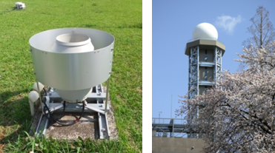

Figure 1.1.1 A tipping bucket precipitation gauge with wind shield (Left)

and a weather radar (Right)

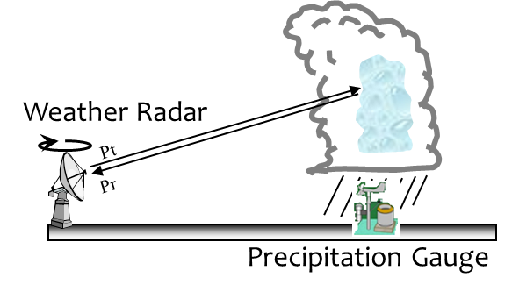

Figure 1.1.2 Precipitation observations using a precipitation gauge and a weather radar

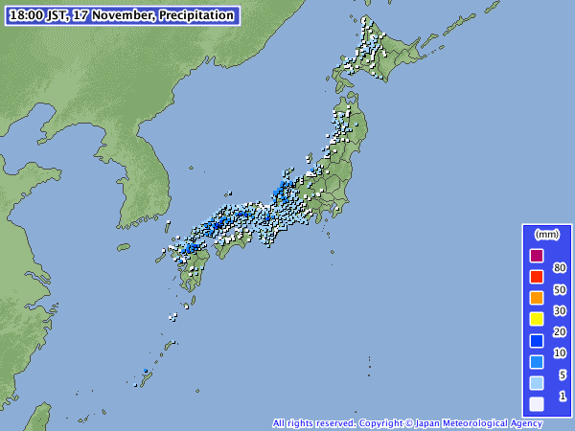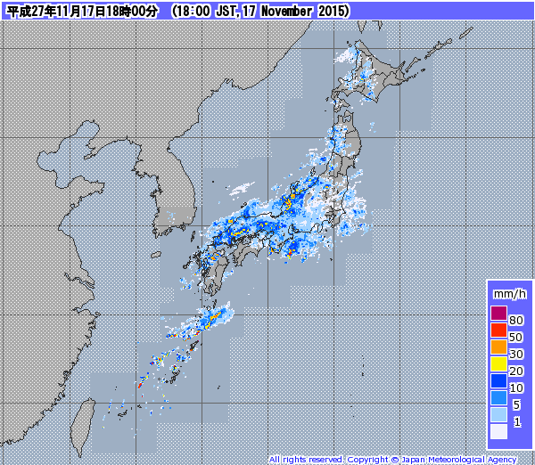

Figure 1.1.3 Examples of precipitation gauge data (Left) and weather radar data (Right)

Table 1.1.1 Characteristics of precipitation amounts from each precipitation observing system

Precipitation observing systems | Quantitative reliability of precipitation amounts | Spatial distribution of observation data
Precipitation gauge | Relatively more reliable | Spatially discrete point data
Weather radar | Relatively less reliable | Spatially continuous data

  - QPE Made by Combining Precipitation Gauge Data and Weather Radar Data

This section explains a kind of QPE (e.g. The Radar/Raingauge-Analyzed Precipitation of JMA) made by calibration of weather radar precipitation amount with precipitation gauges. Figure 1.2.1 shows an example of simple QPE. QPE is made by combining spatially discrete precipitation amounts measured by precipitation gauges and continuously distributed precipitation amounts measured by weather radars. In terms of data usage, QPE is expected to be quantitatively accurate and spatially continuous. Therefore precipitation gauge data is expected to support quantitative accuracy of QPE. However, if QPE is made by combining precipitation gauge data with some uncertainty, QPE becomes less quantitatively accurate. It is important to use reliable precipitation gauge data in order to make reliable QPE.

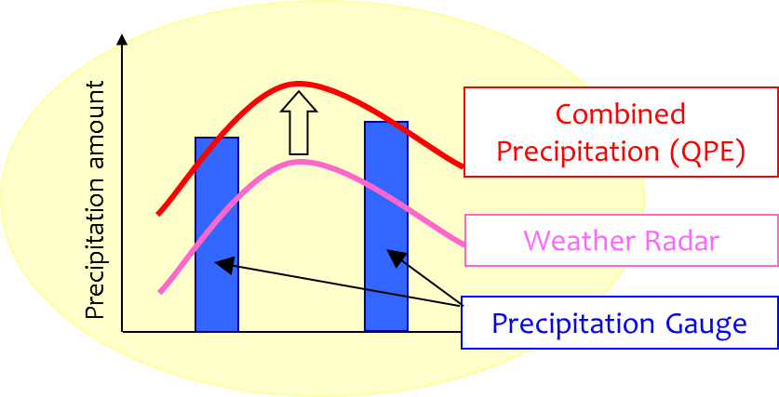

Figure 1.2.1 An example of simple QPE

  - Precipitation Gauge Data with Uncertainty and Their Adverse Impacts on QPE

Uncertainty of precipitation gauge data is caused by various factors such as inappropriate siting environment, maintenance, inspection and calibration of precipitation gauges, installation configuration of precipitation gauges (shield and heating), wind-induced precipitation catch loss and distribution of test precipitation amount data in maintenance mode. Table 1.3.1 shows a list of suspicious precipitation amounts and their estimated factors that induce uncertainty of precipitation amounts measured by precipitation gauges. Figure 1.3.1 shows an example of QPE made by combining too high precipitation amounts from precipitation gauges in maintenance mode. Too high precipitation amounts are locally found in the QPE map. It is important to estimate uncertainty and its inducing factors and improve quality of precipitation amounts measured by precipitation gauges.

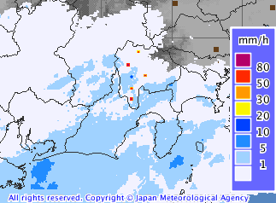
Figure 1.3.1 An example of QPE made by combining too high precipitation amounts from precipitation gauges in maintenance mode (red circle)

Table 1.3.1 Types of suspicious precipitation amounts measured by precipitation gauges and their estimated factors

Types of suspicious precipitation amounts | Estimated factors at stations
Temporarily too high precipitation amounts at a station | Test precipitation amount data from precipitation gauges in maintenance mode  False counter values
Temporarily too low precipitation amounts at a station | Temporarily clogging
Continuously or intermittently too high precipitation amounts at a station | Precipitation gauge failure  Site environment (obstacles)
Continuously or intermittently too low precipitation amounts at a station | Leaves and branch clogging (Only valid for tipping bucket gauges, not for weighing gauges)  Telecom failure  Freezing  Snow fall  Site environment (obstacles)  Wind-induced precipitation catch loss
Temporarily too high precipitation amounts at many stations over a large area | System failure  Earthquake
Temporarily too high precipitation amounts at many stations over a large area | System failure  Snow melting
Continuously or intermittently too low precipitation amounts at many stations over a large area | Freezing  Wind-induced precipitation catch loss

- Framework of Quality Management

Figure 2.1 shows the framework of quality management (QM) of surface weather observation system. Quality control (QC) is the best-known component and core part of the framework of quality management. Quality control indicates the methods and processes to find suspicious observation data in order to maintain the quality of observation value including precipitation amount. Processes include the measures for prevention of recurrence and the procedure for improvement of the quality control techniques. Quality assurance (QA) controls the contributing factors which affect the observation value before the data are provided to the users, consisting of management of measurement procedure, maintenance of siting environment, inspection of meteorological instruments, and so on. Quality assurance becomes possible by applying the standards of working methods and operational processes.

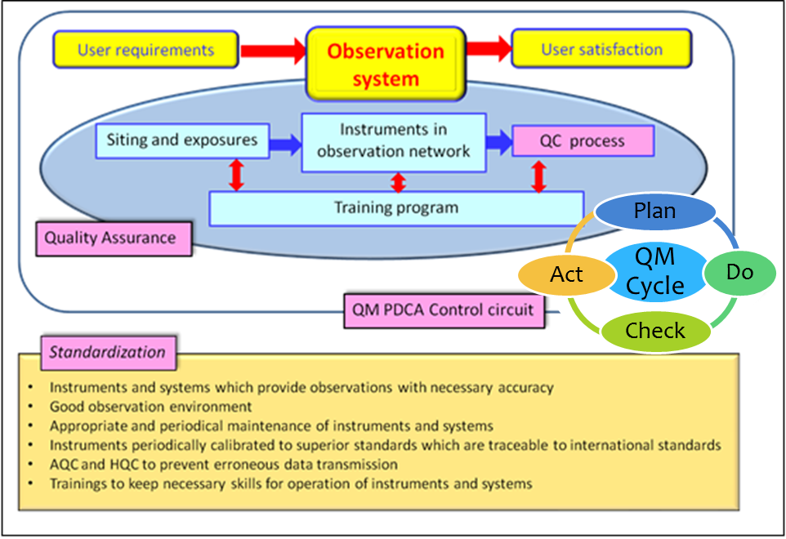
Figure 2.1 Framework of quality management of surface weather observation system

- Standardization
  - Observation Method

The World Meteorological Organization (WMO) has established internationally-agreed standards (Technical Regulations, Annex, Manual, Guide, Standard practices and procedures, and Recommended practices and procedures) about the weather observation implemented by NMHSs. All NMHSs have an obligation to implement the observation based on them.

  - Siting Environment and Installation Condition of Precipitation Gauges

Quality of precipitation amount data depends not only on precipitation gauges but also on siting environment and installation condition of precipitation gauges. NMHSs need to procure for management and control of siting environment and installation condition, as well as decide the standards of siting environment and installation condition in order to acquire the regional representativeness of precipitation amount data.

  - Maintenance and Inspection

Although robust precipitation gauges and equipment are used for precipitation observation, abnormal data can still be output sometimes due to device failures and other reasons. Therefore, for function confirmation and functional maintenance of precipitation gauges and equipment, checkout and inspection are necessary at suitable frequency. Especially, since the sensors of precipitation gauges installed outside are exposed to a natural environment, they need appropriate maintenance and inspection. As for precipitation gauges with electrical parts and precision parts which require to be managed with the meticulous care, maintenance and inspection need to be carried out in accordance with a specified operation procedure. Also, observation site and its surroundings need to be maintained and controlled in suitable manners at suitable frequency so that obstacles such as overgrown weeds would not affect the observation.
When abnormality is found in the observation equipment and instruments, it is necessary to take measures immediately to stop the dissemination of abnormal data, as well as perform cause investigation and recovery efforts.

  - Calibration of Precipitation Gauges

Precipitation gauges used for precipitation observation need to be periodically calibrated by using standards traceable to SI units at suitable frequency. Standards instruments for the calibration need to be periodically calibrated by higher national standards or standards of the WMO Regional Instrument Centres (RICs) at suitable frequency.

  - Metadata

Metadata provide additional information regarding the conditions and siting environment under which the observation is carried out. It is indispensable information for accurate use of observation data since the observation is affected by the observation conditions and siting environment. Metadata consist of station name, address, latitude, longitude, altitude and gravitational acceleration of the station, manufacturer, model and installation height of the precipitation gauge, availability of heater, availability and type of wind shield and operation period. In addition to these elements, it is important to regularly record and keep figure information such as maps of the surrounding area of the observation site, schematic layouts of the precipitation gauge inside the observation site, and pictures of surroundings of the station.

  - Training

To be in charge of quality control for observation data including precipitation amount data, acquirement of wide range of knowledge and techniques for the observation site manager is necessary. For this reason, trainings regarding principles and methods, maintenance and inspection, data handling, system and quality control in surface observation need to be operated in stages, repeatedly, depending on each observation site manager’s skills. These knowledge and techniques make it possible to find suspicious observation value and failure of precipitation gauges at earlier stage and improve quality of precipitation amount data.

- Quality Control
  - Quality Control

Quality control is an activity to check observation data, stop distribution of suspicious observation data, improve factors adversely influencing observation in order to maintain quality of observation data. By checking observation data, observation site managers can monitor if standardization of observation is maintained, judge them valid, suspicious or invalid and reduce uncertainty of precipitation amounts. Quality flags based on results of various checks indicate characteristics and problems of the station, help to understand if standardization is maintained, investigate and improve problems in the station. Quality flags are sent along and stored with observation data itself. With quality flags, data users can judge how they use suspicious observation data.

  - Central Data Processing Systems for QC

NMHSs need central data processing systems for quality control that automatically, continuously and promptly execute series of processes such as data receiving from AWSs, data processing, displaying, archiving, distributing. Figure 4.2.1 shows central data processing systems in JMA. Precipitation amounts measured by precipitation gauges of AWSs network are automatically examined using HK information and AQC methods and judged valid, suspicious or invalid in each AWS. Then they are collected to central processing systems through telecommunication lines and precipitation amounts from AWSs network are automatically and manually examined using various quality control methods and judged validation, such as valid, suspicious or invalid. Precipitation amounts examined in AWSs and central data processing systems are provided to users inside and outside of each country. Results of QC are fed back to observation site managers and utilized to maintain and improve instruments, equipment and siting environment.

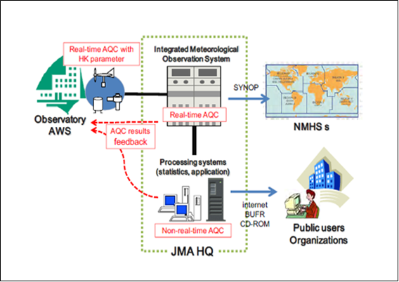
Figure 4.2.1 Operational systems of quality control and data flow in JMA

  - Implementation Structure in NMHSs

NMHSs need to execute quality control of observation data at various stages. As for the implementation structure of quality control of observation data, there are two aspects: administration and operation. Figure 4.3.1 shows the organizational frameworks in the Japan Meteorological Agency (JMA). Operation is conducted by local meteorological offices and issues that local meteorological offices could not address are addressed by regional headquarters and headquarters, administrative parts of JMA. It is important for NMHSs to improve quality control procedures using the PDCA (plan-do-check-act) cycle in order to continue quality management.

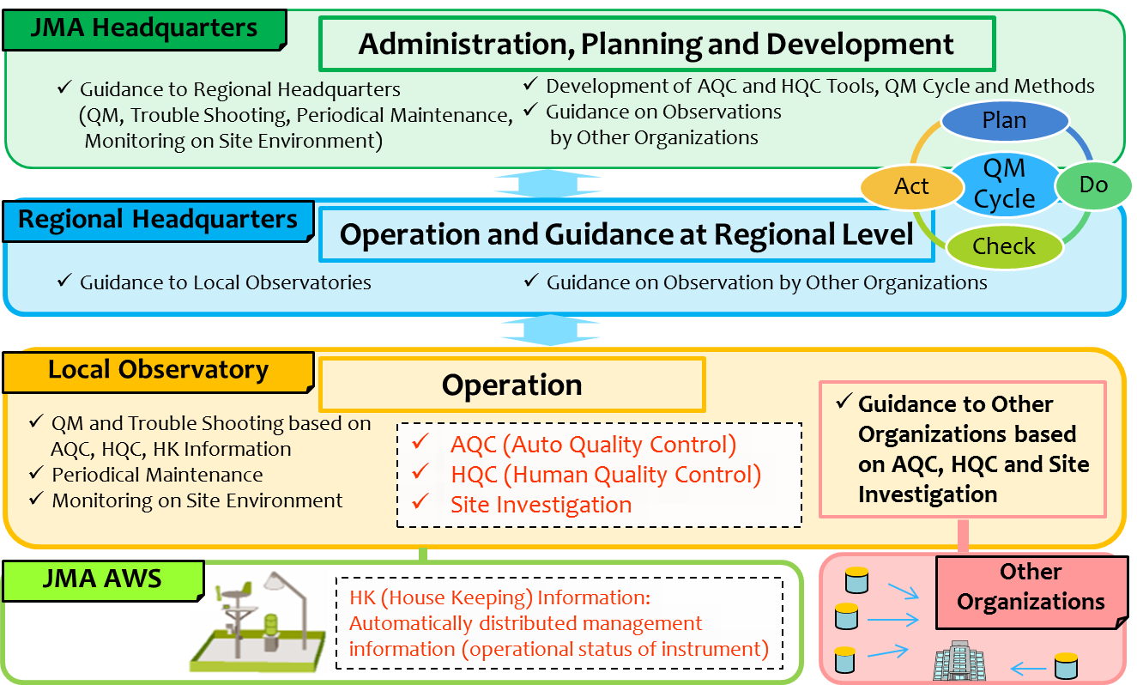

Figure 4.3.1 Organizational frameworks of quality control on AWSs in JMA

  - Cooperation Structure with Partner Organizations

NMHSs need to build and maintain collaboration relationship with partner organizations if NMHSs use their observation data. Figure 4.4.1 shows an example of collaboration relationship for data exchange between JMA and partner organizations in Japan. If NMHSs find facts that observation data from partner organizations are judged as suspicious or invalid by checking observation data or siting and exposures of stations are judged as inappropriate by conducting site investigations, NMHSs need to tell partner organizations results of checks and site investigations. In addition, if it is necessary for partner organizations, NMHSs need to help them to improve site conditions by easy advice regarding technical issues such as maintenance, calibration and siting environment in order to maintain and improve quality of precipitation amounts measured by precipitation gauges operated by partner organizations.

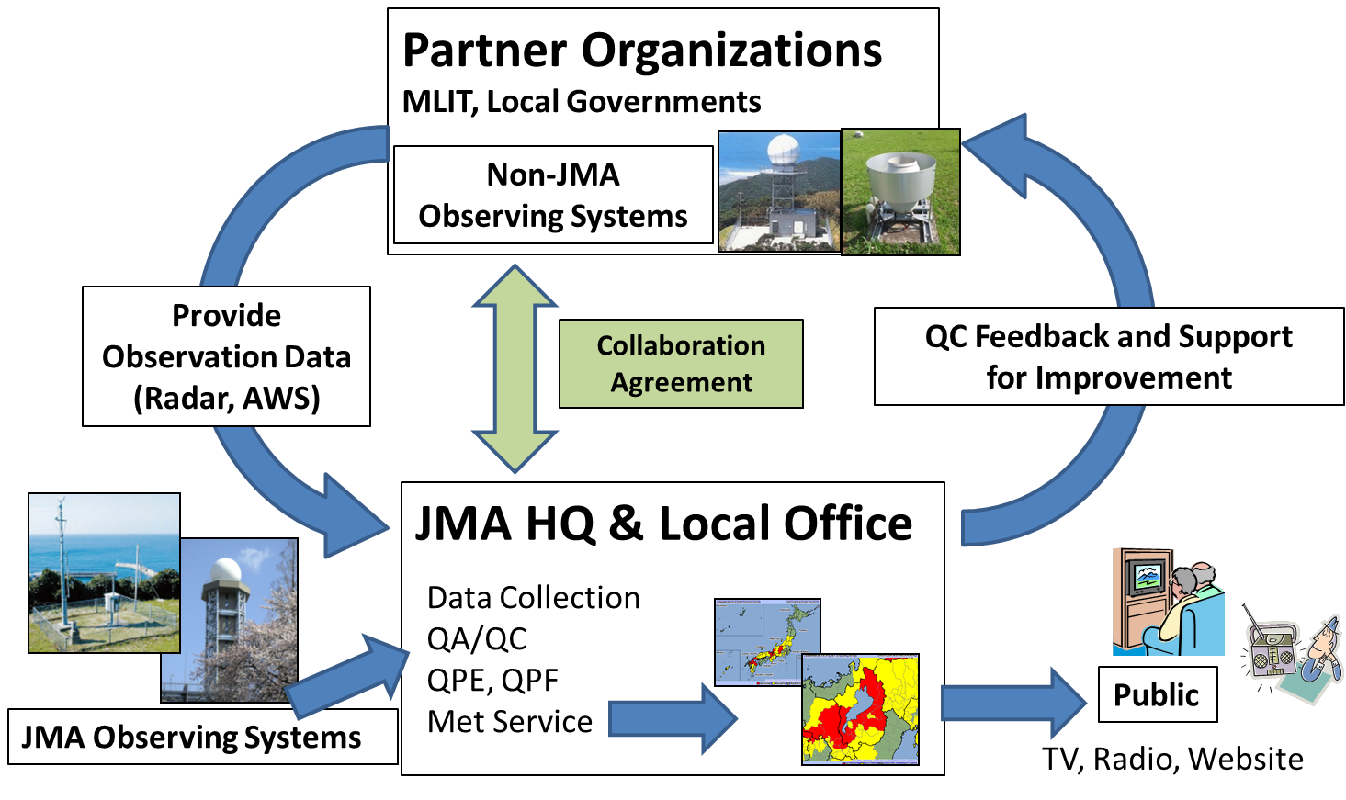
Figure 4.4.1 JMA’s cooperation with partner organizations

- Siting Environment
  - Siting and Exposure

Precipitation amounts measured by precipitation gauges are affected by site environment that consists of neighbouring obstacles such as plants, trees or buildings, and surface shape (slope). JMA (2006) explains that its field observation experiment using several precipitation gauges quantitatively showed obstacle-induced uncertainty of precipitation amounts measured by precipitation gauges near obstacles. Its experiment indicated that precipitation amounts measured by precipitation gauges located nearer to obstacles were smaller than those measured by precipitation gauges located further away to obstacles. Especially, precipitation gauges located nearest to obstacles observed smallest precipitation amounts when it was very windy. WMO (2010a) (CIMO Guide, Part I, Chapter 6) recommends that precipitation gauges are equipped with wind shield in order to reduce precipitation catch loss effect induced by turbulent flow triggered by wind around orifice of precipitation gauges and sites on a slope, the roof top of a building or the place closer to obstacles than a distance of twice their height above the gauge orifice are avoided in order to have regional representative. It also recommends that precipitation gauges for snowfall measurement are installed where obstacles act as an effective wind-break for winds from all directions. The siting classifications for surface observing stations on land showed by WMO (2010b) (CIMO Guide, Part I, Chapter 1) is also helpful to understand siting induced effects.

  - Site Investigation and Improvement

NMHSs need to periodically investigate siting environment such neighbouring obstacles as plants, trees, buildings, surface and terrain in addition to maintenance and inspection of precipitation gauges. The best investigation frequency for each station needs to be estimated by consideration of changing speeds of siting environment. Figure 5.2.1 shows examples of inappropriate siting environment for precipitation gauges. The left figure shows the precipitation gauge is too near to the building to capture precipitation amounts properly. The middle figure shows a case where the precipitation gauge doesn’t have enough sky exposure to capture precipitation amounts since it is installed too near to the elevated highway. The right figure shows that the orifice of the precipitation gauge is covered with overgrown plant and it cannot capture precipitation amounts properly. Figure 5.2.2 shows an example of improved siting environment by removal of neighbouring trees that adversely affects observation by precipitation gauges. This station with the improved siting environment can observe precipitation amounts not affected by neighbouring trees and have better regional representative. Metadata including siting environment information that are based on series of periodical site investigations for years are effective for understanding of local characteristics of precipitation amount data, choice for data utilization of each station, improvement of siting environment, adjustment of precipitation catch loss, estimation of period adversely affected by siting environment and relocation planning of the station for better siting environment.

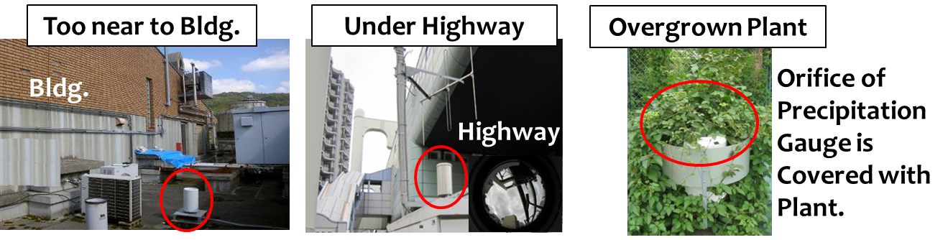
Figure 5.2.1 Examples of inappropriate siting environment for precipitation gauges

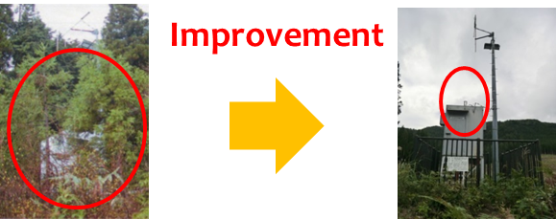
Figure 5.2.2 An example of improved siting environment around a precipitation gauge

- Quality Control Methods

Precipitation amount data are exchanged among countries and regions worldwide. Quality control of precipitation amount data is a basic and necessary activity which the observation site managers should work on so that the users of precipitation amount data can acquire coherent and accurate data and use them as the most appropriate precipitation amount data. The responsibilities regarding the quality of precipitation amount data and quality determination are taken by NMHSs as providers of those data. There are two keys in quality control of precipitation amount data: correction and invalidation. NMHSs need to implement quality control of precipitation amount data at various stages. The result of quality control will be fed back as quality enhancement of precipitation amount data.

  - Characteristics of Automated Quality Control (AQC) and Human Quality Control (HQC)

Quality control of observation data can be categorized into automated quality control (AQC), a method which automatically makes judgment according to the pre-determined conditions, and human quality control (HQC), a method that humans take control of judgment. AQC is a method to automatically discriminate whether the observation value coincides with the pre-determined conditions or not. Since AQC can implement its procedures into computers, instantaneous check is possible without delaying the publication and distribution of observation data. Methods of AQC include spatial check, range check, upper limit check and logical check. HQC is a method to evaluate the cases for which preliminary conditioning is difficult, through comprehensive judgment by humans. It is used for detecting phenomena which AQC is not good at, such as abnormal data accompanying the change of site environment and inadequacy in the instrument installation. A representative case of HQC is the comparison of observation values before and after the replacement of meteorological instruments. Figure 6.1.1 shows the characteristics of both methods. It is important to perform the quality control of observation data by taking advantage of both methods.

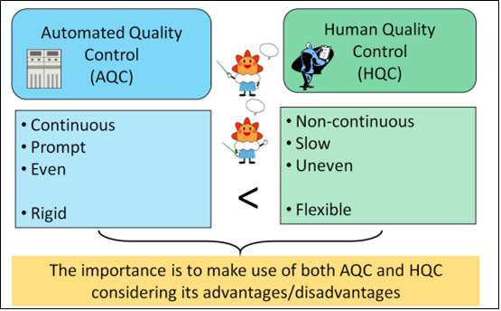
Figure 6.1.1 Characteristics of AQC and MQC

  - AQC Methods

AQC is the procedures to automatically distinguish observation data suspicious or not. Central data processing systems for AWSs receive observation data from each AWS of surface observation network at constant time intervals (e.g. 6 sec., 10 sec., 1min., 10min., 1 hour). Central systems are monitoring observation data by various AQC methods. If they are suspicious, they automatically add flags that means suspicious for use or stop distribution of suspicious data. Table 6.2.1 shows a list of AQC methods. This subsection explains about AQC methods.

Table 6.2.1 List of AQC methods for precipitation gauge data

Check items | Contents
Self-Diagnosis check | A check to self-diagnose functions of precipitation gauge.
HK (House Keeping) check | A monitoring check to see working status of each part of precipitation gauge.
Range check | A check to see if output values from the precipitation gauge are not within the designed range.
Upper limit check | A check to see if precipitation value is above the climatological thresholds.
Spatial check (Too low) | A check to see if precipitation value is too low compared to neighbouring precipitation gauges.
Spatial check (Too high) | A check to see if precipitation value is too high compared to neighbouring precipitation gauges.
No-heater check | A check to avoid the possibility of icing or snow melting for precipitation gauge without heater.
Logical check | A check to see if sunshine is observed when precipitation is observed.
Blacklist check | A check function to avoid to use precipitation amounts from stations listed in the black list. This black list is manually configured.

- Self-Diagnosis Check

Self-Diagnosis check is a monitoring function that the instruments and equipment installed in the station self-diagnose the existence of abnormalities. This function enables the observation site managers to be aware of the abnormalities in the processing unit of equipment at the early stage. Self-diagnosis check is automatically inputting the reference signal into the A/D (Analog-to-digital) converter and confirming converted results from the A/D converter. Self-Diagnosis needs to be configured to be periodically executed at constant intervals to satisfy the operational requirements of the instruments and equipment. If the converted results are out of acceptable range, it is automatically reported to the observation site managers as a part of HK information.

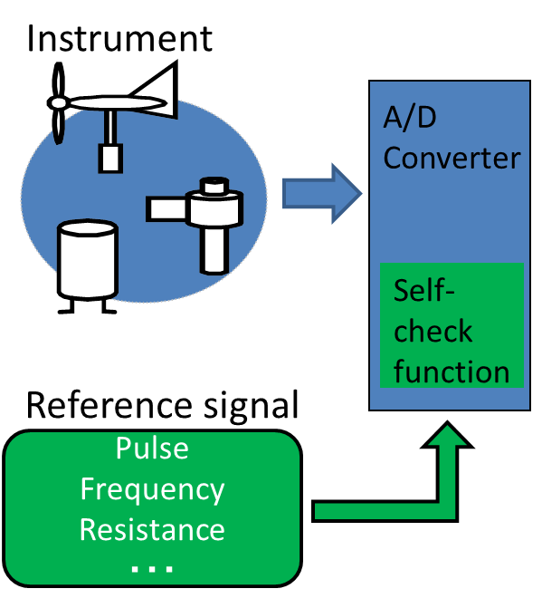
Figure 6.2.1 Self-diagnosis check

- HK (House Keeping) Check

HK (House Keeping) check is a monitoring function to see if the instruments and equipment installed in the station are working without problem. When there are abnormalities in the instruments and equipment such as power supply and heater, the observation site managers can remark the abnormalities from the information acquired by this function. HK information is effective for prompt identification and early recovery of faulty instruments, along with the confirmation of generation of abnormal data. Table 6.2.2 shows example of HK check items for precipitation gauge. The target events are categorized into failures directly not affecting observation such as heater stop and failures directly affecting continuity or accuracy of observation such as discontinuity of power supply.

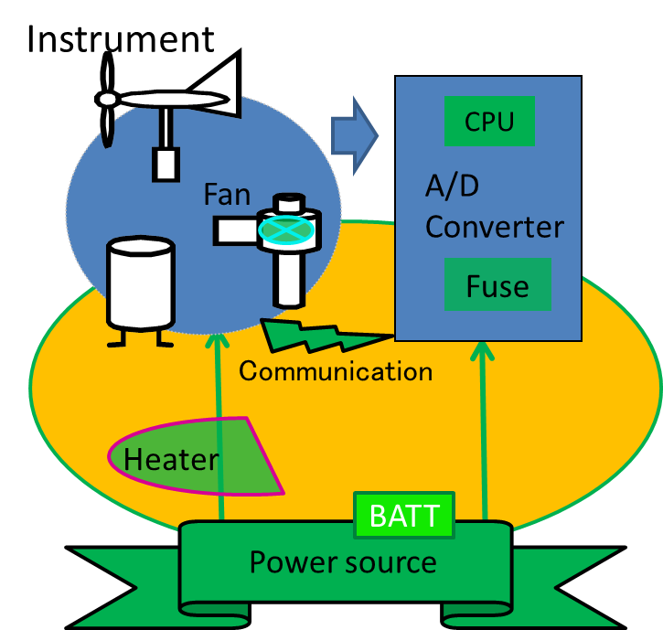
Figure 6.2.2 HK check

Table 6.2.2 Example of HK check items for precipitation gauge

HK Check Items for Precipitation Gauge

Discontinuity of power supply

Discontinuity of utility power supply

Battery voltage drop

Heater check

Contact failure check

Failure of self-diagnosis board

Fuse blow of power supply unit

- Range Check

Range check verifies if the output values from precipitation gauges such as counter value of tipping bucket rain gauge are within the designed range. For a tipping bucket precipitation gauge, the counter values from the gauges should be within the designed range from 0mm to 9995 mm or the output values are false and invalid.

Criteria for false counter value

Counter Value < 0 mm
Counter Value > 9995 mm

- Upper Limit Check

Upper limit check is a monitoring function to see if precipitation amounts measured by precipitation gauges are above the climatological threshold values based on extreme values. Upper limit check for hourly and 10-min precipitation amounts is explained in this subsection. It is known that the distribution of extreme values of maximum precipitation amounts can be modeled by the Gumbel distribution. Return period values of extreme precipitation amounts can be obtained by assuming that the distribution of extreme values of daily maximum hourly precipitation amounts are explained by the Gumbel distribution. The threshold values for hourly precipitation amounts can be obtained by multiplying the maximum hourly precipitation amount of each country or area by a factor that can be obtained by dividing the return period value of extreme precipitation amount for the 500-year return period by the return period value of extreme precipitation amount for the observed-year return period. For example, maximum and minimum of monthly factors for each area in Japan was 1.86 and 1.30 respectively. Therefore, threshold values for hourly precipitation amounts in Japan are set to the values obtained by multiplying monthly extreme values for each local area or all areas of Japan by the maximum factor of 1.86. The threshold values for 10-min precipitation amounts are obtained by adding an extra value of more than 5mm to monthly extreme values for each area categorized by meteorological characteristics or they are obtained by multiplying extreme values by a factor of 1.86.

Criteria for too high hourly precipitation amounts

R > R_{UPPERLIMIT}

R: Target hourly precipitation amounts
R_{UPPERLIMIT}: Extreme value of maximum hourly precipitation amounts x 1.86
If R_{UPPERLIMIT} is below 40mm/hour, R_{UPPERLIMIT} is set to 40mm/hour.

Criteria for too high 10-min precipitation amounts

R > R_{UPPERLIMIT}

R: Target 10-min precipitation amounts
R_{UPPERLIMIT}: Monthly thresholds values or extreme value of maximum hourly precipitation amounts x 1.86

Table 6.2.3 shows examples of monthly threshold values of R_{UPPERLIMIT} for each area categorized by frequency of heavy rain events in Japan. They are obtained by adding monthly extreme values for each area to an extra value of more than 5mm. Common monthly threshold values are applied to all areas during the flood season in Japan from May to October

Table 6.2.3 Examples of monthly threshold values for 10-min precipitation amounts
(Unit: mm/10 min.)

 | JAN | FEB | MAR | APR | MAY | JUN | JUL | AUG | SEP | OCT | NOV | DEC
Area A | 20 | 25 | 35 | 35 | 45 | 45 | 50 | 50 | 55 | 50 | 40 | 20
Area B | 35 | 35 | 40 | 40 | 45 | 45 | 50 | 50 | 55 | 50 | 40 | 35
Area C | 40 | 45 | 45 | 45 | 45 | 45 | 50 | 50 | 55 | 50 | 45 | 40

Area A: Hokkaido, Aomori, Akita, Morioka
Area B: Honshu (except for Aomori, Akita, Morioka), Kagawa, Ehime
Area C: Tokushima, Kouchi, Kyushu and Nansei Islands

- Spatial Check (Too High or Too Low)

Spatial check (Too high and too low) is a monitoring function to see quantitatively if one station is observing too high or too low precipitation amounts. Surface weather observation value including precipitation amount is considered to have high relativity with data from stations close in a distance. Using this characteristic, through comparison with the observation values at the surrounding observation stations, observation data of the objective observation station can be checked. Figure 6.2.3 shows an example layout of the objective precipitation gauge and neighboring precipitation gauges. This check can be conducted by spatially comparing 24-hour precipitation amounts of the objective precipitation gauge and 24-hour precipitation amounts of neighbouring precipitation gauges in order to assess suspiciousness of precipitation amounts measured by the objective precipitation gauge. If no precipitation is observed at the objective precipitation gauge for a long time and certain precipitation amounts are observed at neighboring precipitation gauges, it can be concluded that the precipitation amounts measured by the objective precipitation gauge are suspicious. For the stations where too high or too low precipitations are detected by spatial check, the observation site managers need to carefully check siting environment and conditions of precipitation gauges. In addition to results of spatial check, it is necessary to take into account that siting environment and difference between altitudes of precipitation gauges are affecting precipitation amounts.

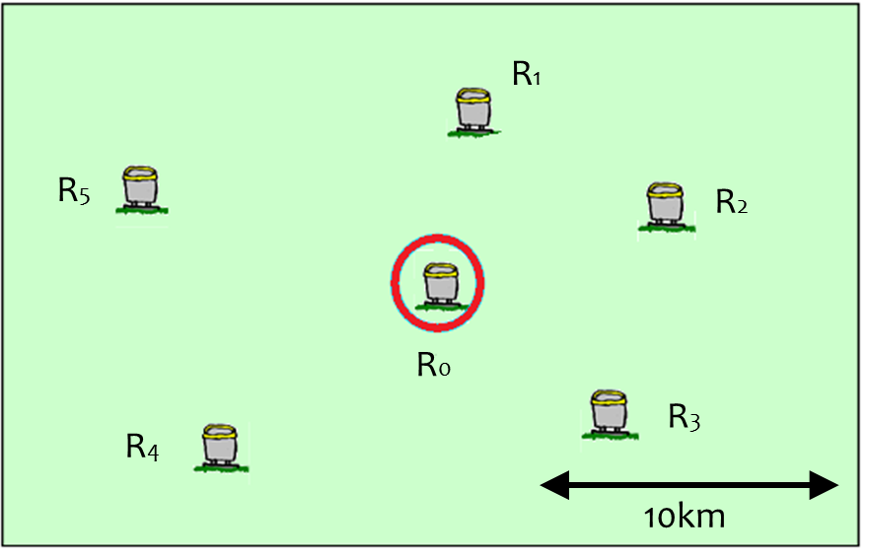
Figure 6.2.3 An example layout of the objective precipitation gauge (Red circle) and neighboring precipitation gauges

- No-heater Check

Precipitation amounts measured by precipitation gauges that are not equipped with heater can be affected by icing or snow melting. When temperature near the precipitation gauge is below the threshold values of 9°C, no-heater check invalidates precipitation amounts that are measured at no-heater precipitation gauges. It is based on metadata of table 6.2.4 and avoids to be affected by icing or snow melting below 9°C. However, no-heater check doesn’t need to be applied to precipitation amounts measured by no-heater precipitation gauges installed at the place where there isn’t any possibility of icing or snow melting.

Table 6.2.4 Metadata on availability of heater of precipitation gauge

Information on heater | Contents
With heater | Precipitation gauge is equipped with heater.
Without heater | Precipitation gauge isn’t equipped with heater.
With weak effect heater | Precipitation gauge is equipped with heater but weak effect.
With failed heater | Precipitation gauge is equipped with heater but failed.
Unknown | Precipitation gauge is unknown to be equipped with heater.

- Logical Check

Logical check examines the existence of meteorological inconsistency among meteorological parameters. If the precipitation gauge observed some precipitation amount and the sunshine recorder observed some sunshine duration simultaneously in a station, it can be judged that the precipitation amount is suspicious.

- Blacklist Check

Blacklist check is a function to invalidate precipitation amounts of listed stations inappropriate for use. The list is manually decided and it is based on consideration of reliability of siting environment, instruments and precipitation amounts in the stations. Table 6.2.5 shows an example of blacklist of stations inappropriate for use.

Table 6.2.5 An example of blacklist of stations inappropriate for use

Station Name | Status
Station A | Appropriate for use
Station B | Inappropriate for use
Station C | Appropriate for use
Station D | Appropriate for use

  - HQC Methods

HQC is a method that humans comprehensively judge the observation value and it is based on meteorological knowledge and past experiences they have. This method is effective for checking the meteorological elements which are difficult to be detected by criteria with certain condition and cannot be dealt with by AQC, and the fluctuation of observation values over a long period of time. In order that humans can make a comprehensive judgment, supporting document like figures and graphs of observation data and observational statistic data are necessary. With standard judgment tools and estimation procedures, objectivity of judgment can be enhanced. Table 6.3.1 shows a list of HQC methods. They need to be conducted by judgement based on the information such as the AQC results, siting environment and conditions of instruments.

Table 6.3.1 A list of HQC methods

Check items | Contents
Double-mass analysis | An analysis to see the change in inclination of cumulative precipitation amounts of two stations.
Snow water equivalent check | A check using snow water equivalent calculated from precipitation amount and snow fall depth.

- Double Mass Analysis

For precipitation, when precipitation amounts are measured less or more than the expected amounts for a long period due to the faults of meteorological instruments and/or changes of siting environment, observation site managers can estimate its quality by comparing with a surrounding station. A representative method is double-mass analysis. This is the method to compare the cumulative rainfall of a certain period of time with the integration value at surrounding station and inspect the homogeneity between both observations. As shown in Figure 6.3.1, they indicate the rainfall at the station of inspection object by Y-axis, show the rainfall at the reference station by X-axis, and illustrate the integration values into the scatter chart, investigating the change in inclination of cumulative rain quantity of both stations. When there is a change in inclination of cumulative straight line, there is a possibility that the siting environment has changed. In this case, the fact that the precipitation gauge is getting difficult to catch the precipitation and the affected period could be estimated. When using this method, it is necessary to confirm in advance that there is no siting environment change around the reference station.

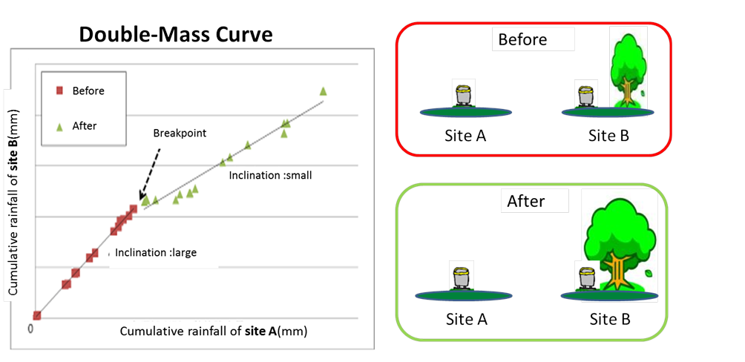
Figure 6.3.1 Double-mass analysis for precipitation amounts

- Snow Water Equivalent Check

Snow water equivalent (SWE) is the ratio of snow fall depth (cm) to equivalent rain amount (mm) in a station. Snow water equivalent check is a monitoring function to see if the ratio of snow fall depth to precipitation amount is within range of criteria. Figure 6.3.2 shows the ratio of snow fall depth to precipitation amount depends on surface temperature. If snow water equivalent is within 0.2 to 2.2 as shown in Figure 6.3.2, precipitation amount and snowfall depth are considered to be valid. If not, precipitation amount or snowfall depth can be suspicious. However, JMA (2012) shows that snow water equivalent was higher than 2.2 in many stations of Tohoku region of Japan. It also shows that average and median of day snow water equivalent in Sukayu station, located at one of the heaviest snowfall areas in Japan, in Aomori of Tohoku region was 5.7 and 4.0 respectively. Therefore, reasonable range of snow water equivalent for this check is 0.25 to 4.0 in Japan. Based on this range, more higher and lowear value of snow water equivalent are estimated watch, warning or invalid status as table 6.3.2 shows.

When precipitation gauges measure solid precipitation such as snow, the precipitation observation is affected by snow catch loss induced by wind and eavpolation loss caused by heating of precipitation gauge. The snow fall depth observation is affected by snow-sinking and snow-drift. NMHSs need to judge reliablity of observation data with consideration of not only SWE but also temperature, wind and general conditions of weather, instruments and siting environment.

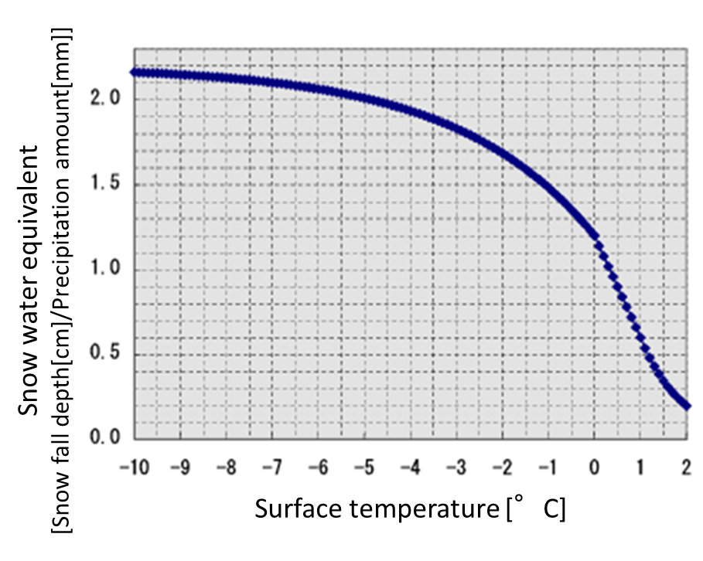
Figure 6.3.2 The relationship between snow water equivalent and surface temperature

Table 6.3.2 Criteria for snow water equivalent (SWE)

Criteria for  Snow Water Equivalent (SWE) | Estimated status | Judgement
SWE = 0.0 | Snow fall depth is  relatively too low | Invalid
0.0 < SWE ≤ 0.125 |  | Warning
0.125 < SWE ≤ 0.25 |  | Watch
0.25 < SWE < 4.0 | Precipitation amount and snow fall depth are appropriate | Appropriate
4.0 ≤ SWE < 8.0 | Precipitation amount is  relatively too low | Watch
8.0 ≤ SWE < 12.0 |  | Warning
12.0 ≤ SWE |  | Invalid
- Wind-induced Uncertainty Adjustment

This chapter describes wind-induced precipitation measurement uncertainty, uncertainty due to wind field deformation above the gauge orifice caused by the elevated body of a gauge itself. This uncertainty is considered as the most important uncertainty for precipitation measurement, and therefore adjustment procedures have been developed based on precipitation measurement intercomparison or CFD simulation (Sevruk et al. 2009). Although adjustment procedures have great uncertainties and precise adjustments are challenging, adjusting wind-induced uncertainty could be beneficial for combining information from composite observing systems.

In section 7.1, basic ideas about wind-induced uncertainty are explained, and a description about specific adjustment procedures appears in section 7.2. For possible future works for improvement of adjustment procedures, brief explanation about estimation of wind at the level of the gauge orifice using CFD simulation is given in section 7.3, and adjustment of wind-induced precipitation measurement uncertainty using DSD (Drop Size Distribution) information is briefly described in section 7.4.

  - Wind-induced Uncertainty

Overview

Wind-induced precipitation measurement uncertainty is due to wind field deformation above the gauge orifice caused by the elevated body of a gauge itself, which is an obstacle to wind (Sevruk et al. 2009; WMO 2010a) (Fig. 7.1.2a). It typically becomes 2 to 10 percent systematic loss for rain and 10 to 50 percent systematic loss for snow (WMO 2010a). Generally, the loss tends to be larger in weaker rain for the same wind speed because the proportion of smaller rain drops, which are more sensitive to the wind field deformation, to all rain drops becomes larger (WMO 1984; Nešpor and Sevruk 1999; Chvíla et al. 2005). Thus many studies have focused on weak rainfall events. For example, Chvíla et al. (2005) reported that wind-induced loss increases as precipitation intensity decreases, particularly for intensities smaller than 3 mm h⁻¹. In contrast, in the view of disaster risk reduction, there is room for more consideration about wind-induced uncertainty associated with a heavy rainfall event. Provided that strong turbulence near the ground associated with strong surface wind increases the number of collisions between rain drops, which may decrease the size of the drops and then the terminal velocity of the drops, the wind-induced uncertainty increases also for heavy rainfall events accompanied with strong wind (JMA 2014). In fact, Duchon and Essenberg (2001) reported that a singular event where loss became more than 10 percent had occurred during the passage of an intense squall line when wind speed at the gauge orifice height (1 m above ground) of 12.5 m s⁻¹ and precipitation intensity of approximately 200 mm h⁻¹ recorded. Wind-induced uncertainty associated with intense precipitation events seems to be important also in the perspective of climatology or hydrology. Figure 7.1.1 shows the precipitation amount from precipitations of intensities more than 2 mm (10-min) ⁻¹ (corresponds to 12 mm h⁻¹) accounts for approximately 30 percent of the amount of all precipitation observed in Japan during January 2011 – October 2015. That indicates that uncertainty of precipitation measurements associated with heavy rainfall events is not negligible even for the precipitation amount accumulated for a long period such as a year.

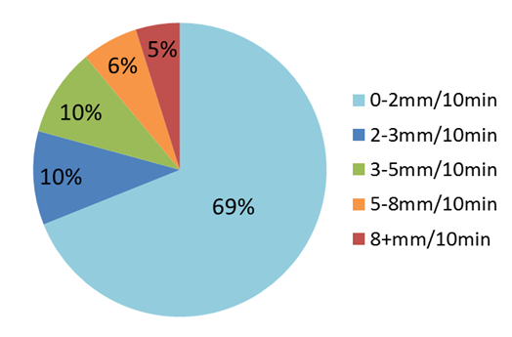
Figure 7.1.1 Proportion of precipitation amount from precipitation of each intensity class to the amount of all precipitation observed by JMA’s precipitation gauges during January 2011 – October 2015.

Precipitation measurement intercomparisons to evaluate the wind-induced uncertainty and to develop better adjustment techniques have been conducted from many perspectives and in many areas throughout the world (WMO 1984; WMO 1998; Sevruk et al. 2009). For rainfall measurements, the “pit gauge”, which is placed in a pit with the gauge rim at ground level and surrounded by an anti-splash protection, has been defined as the WMO standard reference because its measurement is hardly affected by wind (WMO 1984; Sevruk et al. 2009; WMO 2010a). Wind-induced uncertainty is evaluated by comparison of rainfall measurements between aboveground (elevated) gauges and the reference gauge. Table 7.1.1 shows some examples of precipitation measurement intercomparisons for rain. Some uncertainty and inconsistency among various investigations are found in terms of proportion of loss or its dependence on wind speed. Relationship between the wind-induced uncertainty and wind speed has been discussed in association with precipitation intensity or DSD. WMO (1984) reported that the effect of wind speed was more evident at stations with large proportion of rainfall amount from rains at intensities lower than 0.03 mm min⁻¹ (corresponds to 1.8 mm h⁻¹) to the total rainfall, while that the correlation between wind-induced uncertainty and wind speed at the level of gauge orifice did not appear at a station where the average rainfall intensity was considerably large (approximately 7.7 mm h⁻¹). Duchon and Essenberg (2001) concluded that establishing the relationship between loss and wind speed was not possible from the analysis of 1-miniute wind speed and rainfall data and considered that this was due to unavailability of DSD information in their study. Chvíla et al. (2005) reported non-linear dependence of wind-induced loss on precipitation intensity and smaller loss in convective precipitation as compared with in non-convective precipitation under the same wind speed and the same precipitation intensity. They also mentioned that this result consistent with the theory that the DSD of convective precipitation contains more big particles than in the case of non-convective precipitation so that the average falling velocity of drops become higher and thus the wind effect was reduced. For solid precipitation (snowfall) measurement, the Double Fence Intercomparison Reference (DFIR), a Tretyakov gauge encircled by two octagonal fences, was selected as the WMO reference gauge (WMO 1998; Sevruk et al. 2009) and comparisons with various types of gauges have been conducted. Most field intercomparisons found a certain relationship of the catch ratio to wind speed. Some intercomparisons also found that to temperature. Relationships found in intercomparisons will be described in the following section 7.2. The WMO/CIMO SPICE project (Solid Precipitation Intercomparison Experiment) is currently investigating this problematic, and will deliver recommendations and guidance on good practices to measure snowfall and snow on the ground with automatic systems.

Table 7.1.1 Examples of precipitation measurement intercomparisons for rain with the reference pit gauge.

 | Proportion of loss | Dependence on wind speed | Countries | Types of aboveground gauges | Accumulation periods for intercompari-sons
Sevruk and Hamon (1984) | 0-20 %  Ave. 3%¹ | Not observed | Worldwide (except for East Asia) | Australian, Hellman, USA, Bulgarian(wild) (unshielded) / Finish, Tretyakov  (shielded) | One month
 | Ave. 3-11% | Yes | Australia, Denmark, Finland, Papua New Guinea, USA | Australian, Hellman, USA (unshielded) / Finish  (shielded) | Half day
Duchon and Essenberg (2001) | Ave. 4% (Tipping, unshielded) Ave. 5% (Weighing, unshielded) | No | USA (At an airport in Oklahoma) | Tipping-bucket (unshielded/  shielded)  Weighing-bucket (unshielded/  shielded) | Precipitation event (divided by a period with no precipitation longer than one hour)
Chvíla et al. (2005) | 0-40% | Yes | Slovakia | Electronic Weighing | 15 or 60 minutes
1 The value is including wetting and evaporation losses (Fig. 7.1.2b).

A long observation period and measurements at high temporal resolution are required to obtain sufficient data for better understanding of relationship between wind-induced uncertainty and influencing meteorological variables such as wind speed. Particularly, it is more difficult to obtain sufficient data for less-frequently occurring weather such as unusually strong wind or precipitation. In contrast, numerical simulation gives complex and detailed information about flow field for various conditions, such as for wind speed or for gauge shapes, in more convenient, faster, and less expensive way (Nešpor and Sevruk 1999). In Nešpor and Sevruk (1999), trajectories of rain particles were numerically calculated and dependence of wind-induced loss on wind speed and rain drop diameter was derived based on the results of the numerical simulation. They concluded that wind-induced loss increases with the increase of wind speed or the proportion of small particles. Thériault et al. (2012) estimated catch ratio of snow particles through numerical simulations similar to Nešpor and Sevruk (1999) and obtained the result that catch ratio of dry snow particles, which have smaller terminal velocity, is smaller as compared with that of wet snow particles, which have larger terminal velocity, for the same size distribution of particles and the same wind speed. Although investigations with numerical simulations has limitations which depends on simplifications made in the physical description of the processes leading to the wind-induced uncertainty as well as on the precision of the procedures used (Nešpor and Sevruk 1999), it could be applicable in verification of proposed adjustment factors.

Other error sources for precipitation amount measurements

WMO (2010a) (CIMO guide) explained about error sources for precipitation measurement other than wind-induced error.
1) Error due to wetting on the internal walls of the collector or in the container when it is emptied (Fig. 7.1.2b);
2) Error due to evaporation from the container (most important in hot climates) (Fig. 7.1.2b);
3) Error due to blowing and drifting snow;
4) Error due to the in- and out-splashing of water (Fig 7.1.2c);
5) (For a tipping-bucket gauge) loss of water during the tipping action in heavy rain (Fig. 7.1.2d);
For non-recording gauges, average wetting loss can be up to 0.3 mm per observation and evaporation loss over 0.8 mm per day was reported in the late spring at the mid-latitudes (WMO 1998). For tipping-bucket gauges, wetting on the internal walls of the collector contributes to uncertainty associated with the statistical boarders of an accumulation period (e.g. day, event) rather than to loss, in the case that precipitation events are frequently observed. Evaporation loss is small because a tipping-bucket gauge has a funnel so that the measuring device is not exposed to outer atmosphere (Yokoyama et al. 2003). Although errors due to blowing and drifting snow and the in- and out- splashing water are generally difficult to quantify, this can be controlled by maintaining appropriate siting environment (Section 1.3 and 3.3, and Chapter 5). Loss of water during the tipping action in heavy rain can be controlled by selecting a gauge with a sufficient measurable range for precipitation intensity and by calibrating gauges periodically (section 3.4).

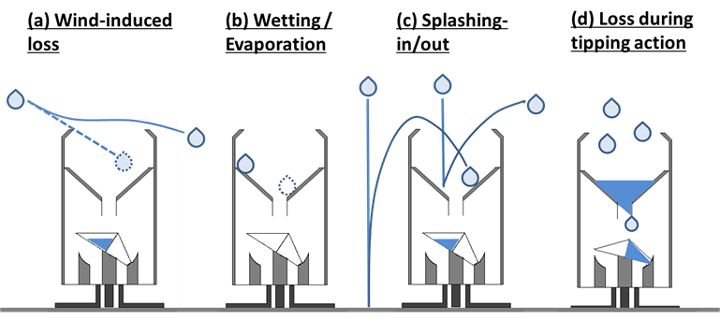
Figure 7.1.2 Various error sources for precipitation amount measurement. (a) loss due to wind field deformation above the gauge orifice, (b) uncertainty due to wetting on the internal walls of the collector and loss due to evaporation from the collector, (c) error due to the in- and out-splashing of water, (d) (for a tipping-bucket gauge) loss of water during the tipping action in heavy rain.

  - Wind-induced Uncertainty Adjustment

Adjustment factor estimation

Adjustment for wind-induced uncertainty by using an adjustment factor has been proposed and discussed mainly from hydrological and climatological perspectives (e.g. WMO 1984; WMO 1998; WMO 2010a). The general model for adjusting data takes the following form (WMO 2010a):
P_{k} = k · P_{c} = k · ( P_{g} + ∆P ) (7.2.1)
where P_{k} is the adjusted precipitation amount; k is the adjustment factor for wind-induced uncertainty; P_{c} is the amount of precipitation caught by the gauge collector; P_{g} is the measured amount of precipitation in the gauge; and ∆P is the adjustment amount for uncertainty caused by sources other than wind. Previous studies and reports proposed an adjustment factor k for each type of gauge as a function of wind speed, wind speed and precipitation intensity (for rain), or wind speed and temperature (for snow and mixed precipitation) based on the results of their measurement intercomparisons. Table 7.2.1 shows examples of adjustment factors for rain, snow, and mixed precipitation estimated from the data of measurement intercomparisons between the DFIR and aboveground gauges.

Table 7.2.1 Examples of adjustment factors k based on precipitation measurement intercomparisons with DFIR.
u_{h}: wind speed at the level of gauge orifice [m s⁻¹], u_{hp}: wind speed at the level of gauge orifice (the mean for the precipitation period) [m s⁻¹], u_{hd}: wind speed at the level of gauge orifice (daily mean) [m s⁻¹], T_{g}: temperature at the gauge height, T_{mean}: daily mean temperature [°C], T_{max}: daily maximum temperature [°C], T_{min}: daily minimum temperature [°C].

 | Adjustment factor | Types of aboveground gauges | Wind shield | Countries
Rain
Yang et al. (1998) ¹ | k = 100·exp(-4.605+0.062·u_{hd}^{0.58}) | US NWS 8” | No | Russia and USA
 | k = 100·exp(-4.606+0.041·u_{hd}^{0.69}) | US NWS 8” | Yes | Russia and USA
Yokoyama et al. (2003)^{1,2} | k = 1 + 0.0454·u_{hp} | RT-1 | No | Japan
Yokoyama et al. (2003)^{1,2} | k = 1 + 0.0856·u_{hp} | RT-3 | No | Japan
Yokoyama et al. (2003)^{1,2} | k = 1 + 0.0192·u_{hp} | RT-4 | Yes | Japan
Snow
Førland and Hanssen-Bauer (2000) | k = exp(b₀+ b₁·u_{h}+b₂·T_{g}+b₃·u_{h}·T_{g})  (for 1 < u_{h} < 7 m s⁻¹)  k = 1  (for u_{h} ≤ 1 m s⁻¹) | All Nordic gauges³ | Yes/  No³ | Finland
WMO (1998)^{1,4} | k = 100·exp(-4.61+0.16·u_{hd}^{1.28}) | US NWS 8” | No | Russia and USA
 | k = 100·exp(-4.61+0.04·u_{hd}^{1.75}) | US NWS 8” | Yes | Russia and USA
WMO (1998) ¹ | k = 100·(100.00+1.13·u_{h}²  -19.45·u_{h}) ⁻¹ | Hellman | No | Russia, Finland, Germany, Croatia
 | k = 100·(100.00-0.04·u_{h}²  -1.98·u_{h}) ⁻¹ | Nipher | Yes | Russia, Finland, USA, Canada
 | k = 100·(103.10-8.67·u_{hd}  +0.30·T_{max}) ⁻¹ | Tretyakov | Yes | Canada, Croatia, Finland, Germany, Romania, Russia, USA
Yokoyama et al. (2003)^{1,2} | k = 1 + 0.213·u_{hp} | RT-1 | No | Japan
Yokoyama et al. (2003)^{1,2} | k = 1 + 0.346·u_{hp} | RT-3 | No | Japan
Yokoyama et al. (2003)^{1,2} | k = 1 + 0.128·u_{hp} | RT-4 | Yes | Japan
Mixed Precipitation
WMO (1998)^{1,4} | k = 100·(100.77-8.34·u_{hd}) ⁻¹ | US NWS 8” | No | Russia and USA
 | k = 100·(101.04-5.62·u_{hd}) ⁻¹ | US NWS 8” | Yes | Russia and USA
WMO (1998) ¹ | k = 100·(96.63+0.41·u_{h}²  -9.84·u_{h}+5.95·T_{mean}) ⁻¹ | Hellman | No | Russia, Finland, Germany, Croatia
 | k = 100·(97.29-3.18·u_{h}  +0.58·T_{max}-0.67·T_{min})⁻¹ | Nipher | Yes | Russia, Finland, USA, Canada
 | k = 100·(96.99-4.46·u_{hd}  +0.88·T_{max}+0.22·T_{min}) ⁻¹ | Tretyakov | Yes | Canada, Croatia, Finland, Germany, Romania, Russia, USA
1 The original formula appeared in the form of a catching ratio (%), the inversion of an adjustment factor. For the purpose of adjusting systematic wind-induced loss, WMO (1998) suggested that it is preferable to use an adjustment factor which should be derived independently from derivation of a formula for catching ratio.

2 The basic information of the measurement also appeared in Ohno et al. (1998).

3 Coefficients b_{0~3} depend on the gauge type and whether gauge has a wind shield. (For a Tretyakov gauge with a wind shield, b₀=-0.04816, b₁=0.13383, b₂=0.009064, and b₃=-0.005147 are suggested.)

4 The same formula was proposed also in Yang et al. (1998).

High-resolution Precipitation Nowcasts (HRPNs) operated by Japan Meteorological Agency (JMA), a type of close-up and high-precision precipitation analysis and short-term prediction derived from weather radar data and other meteorological observation data including surface observations (JMA 2014, 2015), conducts the wind-induced uncertainty adjustment for the precipitation measured by aboveground gauges using the following adjustment factor and uses the adjusted data for the analysis of current precipitation intensity:
k = exp( c₁·(ln I) + c₂·u_{H}·(ln I) + c₃·u_{H} + c₄ ) (7.2.2)
where I is precipitation intensity [mm h⁻¹], and u_{H} is wind speed at the level of the wind speed measuring instrument. Coefficients c₁₋₄ was determined based on consideration for the result of numerical simulations conducted by Nešpor and Sevruk (1999) and the result of the measurement intercomparison using gauges used by JMA (RT-1, RT-3, RT-4) (Yokoyama et al. 2003) and assumption that significant loss appeared in heavy rainfall events accompanied with strong wind. c₁=-0.00101, c₂=-0.0012177, c₃=0.034331, and c₄=0.007697 (the same coefficients as those adopted in Sieck et al. (2007) before the correction) are adopted for the all gauges.

Figure 7.2.1 shows dependence of various adjustment factors on wind speed. It is indicated that the value of k and its dependence on wind greatly vary with the type of gauge, precipitation intensity (for rain), or temperature (for snow). In general, the adjustment factor k for a shielded gauge type tends to be smaller than that for an unshielded type. These adjustment factors derived from data obtained by measurement intercomparisons under the condition where wind speed at the level of gauge height ≤ 8 m s⁻¹. In fact, the limitation of wind speed (7-8 m s⁻¹) in the application of the proposed adjustment factor was mentioned in some studies (Førland and Hanssen-Bauer 2000; Yokoyama et al. 2003). There is room for investigation into applicability of proposed adjustment factors under a wind condition such that wind speed is beyond 8 m s⁻¹.

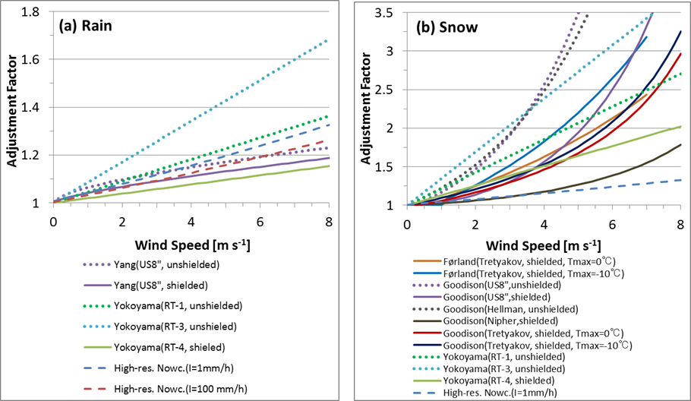
Figure 7.2.1 Wind-speed dependence of adjustment factors for various types of gauges for (a) rain and (b) snow. Adjustment factors for shielded (unshielded) gauge types are indicated by solid (dotted) lines. The adjustment factor used for HRPNs (Precipitation Intensity I =1 mm h⁻¹, 100 mm h⁻¹) is indicated by dashed lines.

Reduction of wind speed to the level of gauge orifice

WMO (2010a) (CIMO guide) mentions that wind speed data for the adjustment of wind-induced uncertainty must be derived from standard meteorological observations at the site, and that wind speed at the gauge orifice level can be derived by using a mean wind speed reduction procedure after having knowledge of the roughness of the surrounding surface and the angular height of surrounding obstacles even if wind speed is not measured at the level of gauge orifice (Fig. 7.2.2). A wind reduction scheme recommended by the CIMO-XI, which is based on wind measurement intercomparison studies (e.g. Sevruk, 1988), is represented by the following equation:
u_{h} = (log hz₀⁻¹)·(log Hz₀⁻¹)⁻¹·(1-0.024α) u_{H} (7.2.3)
where u_{h} is the wind speed at the level of gauge orifice; h is the height of the gauge orifice above ground; z₀ is the roughness length (0.01m for winter and 0.03m for summer); H is the height of wind speed measuring instrument above ground; u_{H} is the wind speed measured at the height of H above ground. Based on the study of Sevruk and Zahlavova (1994), the averaged vertical angle of obstacles around the gauge, α, can be based on either the average value of direct measurements, the vertical angle of obstacles (in 360°) around the gauge in one of the eight main directions of the wind rose, or the classification of the exposure (four classes are shown in Annex 6.B in CIMO guide (WMO 2010a)) using metadata as stored in the archives of NMHSs.

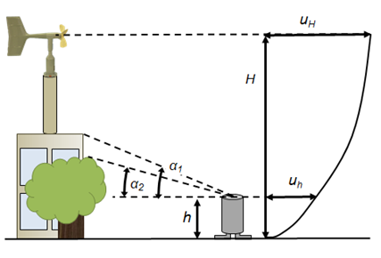
Figure 7.2.2 A schematic view about reduction of wind speed to that at the level of gauge orifice u_{h} from the measured wind speed u_{H}. h: the height of gauge orifice above ground; H: the height of the wind speed measuring instrument above ground; α_{n}: vertical angle for one of the obstacles around the gauge. (Based on Sevruk and Zahlavova (1994))

The aforementioned procedure requires metadata about measurement environment of observation sites, which cannot be obtained sufficiently for reduction of wind speed in some cases. For these cases, gust factor, ratio of peak gust to mean wind speed, can be utilized for estimation of roughness length with consideration of windward environment, given that data of peak gust is available. An estimation method of roughness length using gust factor has been introduced in Haginoya (2015), to investigate long-term trend of roughness length around JMA observation stations. JMA is exploring possibility of estimation of roughness length using gust factor for reduction of wind speed to the level of gauge orifice, which is described below.

Kuwagata (1993) supposed that peak gust u_{max} is associated with turbulence of wind speed and it can be related to mean wind speed u_{H} and turbulent intensity σ_{u} (standard deviation of wind velocity component along the main stream direction) as follows:
u_{max} = u_{H} + A·σ_{u} (7.2.4)
The coefficient A is supposed to range approximately from 2 to 4, depending on response characteristics of the measurement instrument and status of turbulence. Here it is assumed that atmospheric stability is nearly neutral and the following log wind profile is applicable.
u_{H} = (u* k₀⁻¹) · (ln H z₀⁻¹) (7.2.5)
where k₀ = 0.4 is the von Karman constant and u* is frictional velocity. The latter is related to turbulent intensity, σ_{u}, which is assumed to be invariant with height, as follows (Counihan, 1975).
u* = B·σ_{u} (7.2.6)
where typical value of the coefficient B is approximately 2.5 (Counihan, 1975), although the value can be larger (~3) in relatively unstable condition (Kondo and Kuwagata, 1984) and can be smaller (~2) for large roughness length, particularly for length larger than 0.1 m (Counihan, 1975; Choi and Kanda, 1990). By eliminating u* and σ_{u} from (7.2.4)-(7.2.6), a formula to estimate roughness length z₀ can be derived as a function of gust factor, (u_{max}/u_{H}), and height of the measurement instrument, H, as follows:
z₀ = H·exp( -(kAB)·((u_{max}/u_{H})-1)⁻¹ ) (7.2.7)

To consider characteristics and validity of roughness length derived by gust factor, roughness length were estimated by applying equation (7.2.7) for gust factor observed at the JMA local office in Ishigakijima Island (Ishigakijima; 47918) as well as an adjacent AWS (Ibaruma) in a farmland and the adjacent airport under strong wind condition associated with an approaching tropical cyclone. Roughness length was derived for every 10 minutes from the ratio of peak gust in the 10 minutes to the 10-minute mean wind speed, to capture change of windward surface environment associated with change of wind direction. For applying equation (7.2.7), A=3 was assumed based on the assumption that distribution of wind speed turbulence follows the Gaussian distribution together with consideration of the ratio of the measuring period for the peak gust (3s) to that of the mean wind speed (10 minutes), and the coefficient B was assumed to be 2.5. The result is shown in Fig. 7.2.3, together with a typical value for the terrain type around each site (Stull, 1988). It is indicated that time series of estimated roughness length at the three stations show large scatter. As compared with a typical value, roughness length tends to be overestimated at the AWS and underestimated at the airport for the period (a), while that at the local office tends to be underestimated for the period (b). The dominant wind direction of the three stations is northeasterly for the period (a), while that is southeasterly for the period (b). This difference of wind direction can be related to the difference of estimated roughness lengths between the period (a) and (b). For the local office and the AWS, a mountain is located in the northeast of each station while the southeastern side of each station faces to the sea. Therefore, northeasterly wind coming over the mountain to each station might have increased gust factor and that made estimated roughness length relatively large for the period (a), while wind from the sea to each station might have supressed gust factor and that kept estimated roughness length relatively small. At the airport, the runway stretches along the northeast-southwest direction and the northeastern edge of it faces to the sea. In contrast, in the southeastern side of the runway, there are some buildings. Therefore, wind blowing along the runway from the sea might have suppressed gust factor and that kept estimated roughness length small for the period (a), while wind blowing over the buildings might have increased gust factor and that make estimated roughness length relatively large for the period (b). As compared with the time series of 10-minute mean wind speed, u_{H}, estimated roughness length tended to be large when u_{H} was relatively small or rapidly changes. It appears to be important for application of this estimation procedure to consider about an appropriate definition of gust factor and to evaluate uncertainty of estimated roughness length.

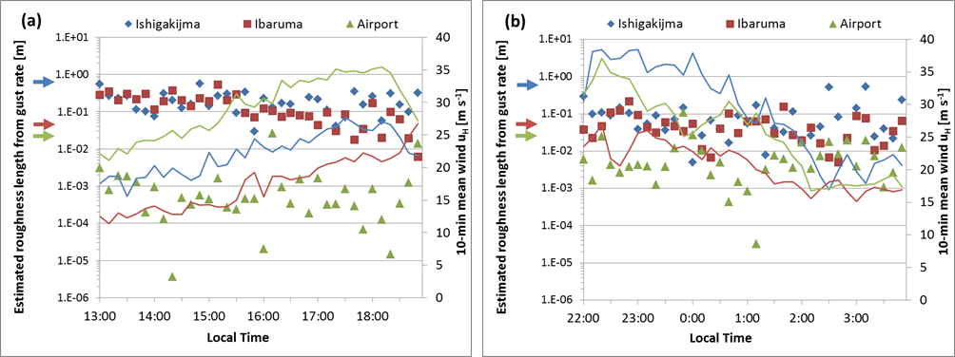
Figure 7.2.3 Time series of 10-mininute mean wind u_{H} (line) and estimated roughness length z₀ from gust factor (u_{max}/u_{H}; u_{max}: peak gust in 10 minutes) (dots) by application of equation (7.2.7) with assumption of A=3 and B=2.5, at the JMA local office (Ishigakijima) in Ishigaki-jima Island (blue), at an adjacent AWS station (Ibaruma) in a farmland (red), and at the adjacent airport (green) when a tropical cyclone approaches Ishigaki-jima. A typical value for the terrain type around each site (Stull, 1988) is pointed by the same color arrow. The dominant wind was northeasterly for the period (a) and southeasterly for the period (b).

Roughness length estimated by the aforementioned procedure can be larger than the height of gauge orifice above ground, h, especially in an urban area. That means that the log wind profile cannot be applied for estimation of wind speed at the level of gauge orifice. For such a case, application of the power-law form can be considered.
u_{h} = u_{H}·(h·H⁻¹)^{β} (7.2.8)
A Formula for estimating exponent, β, from roughness length, z₀, has been proposed in some studies, and some examples are shown in Table 7.2.2. It should be noted that many of them were determined to fit the general wind profile of the atmospheric boundary layer above 10 m from ground. In fact, Counihan (1975) pointed out that β appeared to be overestimated in many studies because they were based on measurements made too close to ground. Consideration about applicable range for wind speed might be needed. For this, Meng (1995) derived a formula to estimate β from z₀, based on numerical experiments of the atmospheric boundary layer under strong wind (geostrophic wind speed: 25 m s⁻¹) and Meng (1997) confirmed that this formula can satisfactorily estimate β for the profile in a typhoon atmospheric boundary layer (maximum gradient wind speed: 70 m s⁻¹) in numerical simulations, for the area outside the radius of the maximum gradient wind speed.

Table 7.2.2 Examples of formulas to estimate exponent β from roughness length z₀ [m]

 | Formula | Applicable z₀ range [m] | Applicable height range
Counihan (1975) | β = 0.096·log₁₀ z₀+0.016·(log₁₀ z₀)²+0.24 | 0.0001-7.50 | Greater height range (> 50 m) in the boundary layer
Choi and Kanda (1990) | β = (ln((z_{T}·z_{B})^{0.5}/ z₀))⁻¹ | Depends on z_{T} and z_{B}¹ | z_{T} < z < z_{B}¹
Meng et al. (1995) | β = 0.27+0.09·log₁₀ z₀+0.018·(log₁₀ z₀)²  +0.0016·(log₁₀ z₀)³ | 0.001-3.0 | 10 m -1000 m
1 In their study, z_{T} = 200, z_{B} = 10, and (z_{T}·z_{B})^{0.5} ~ 50 [m] were assumed and it was confirmed that the formulation is applicable for 0.001 < z₀ < 4.0 [m]. The upper limit of applicable roughness length decreases as the value of (z_{T}·z_{B})^{0.5} decreases.

  - Estimation of Wind at the Level of the Gauge Orifice using CFD simulation

At the section 7.2, reduction procedures of wind speed to that at the level of gauge orifice was described, although they have uncertainties associated with uncertainty of coefficients or parameters. From numerical experiments (e.g. Baskaran, 1996), it was suggested that vertical wind profile can be affected by windward obstacles. Detailed investigations by numerical simulations about wind environment surrounding a certain precipitation measurement site can be applied for verification and precision improvement of the conventional reduction procedures of wind speed to the level of gauge orifice.

  - Wind-induced Uncertainty Adjustment using DSD Information

As mentioned in section 7.1, wind-induced uncertainty will vary with precipitation intensity, precipitation type (rain/snow), or the size distribution of precipitation particles, as well as wind speed. Nešpor and Sevruk (1999) derived wind-induced loss as a function of wind speed and the diameter of rain drops, and then estimated loss as a function of precipitation intensity, precipitation type (orographic rains/convective rains), and wind speed under a certain assumption about DSD. Regard to this study, Sieck et al. (2007) pointed out that there is uncertainty for assumption of DSD, based on their measurement of DSD with a disdrometer. More precise precipitation measurements adjusting effects for various types of precipitation particles can be realized by including information about the size distribution of precipitation particles observed by disdrometers or dual-polar radars.

References

Baskaran, A., and A. Kashef, 1996: Investigation of air flow around buildings using computational fluid dynamics techniques. Engineering Structures, 18, pp. 861-875.

Choi, H., and J. Kanda, 1990: Characteristics of the vertical wind profile for wind load estimation. Journal of Wind Engineering, 45(1990), pp. 23-43.

Chvíla, B., B. Sevruk, and M. Ondrás, 2005: The wind-induced loss of thunderstorm precipitation measurements. Atmospheric Research, 77, pp. 29-38

Counihan, J., 1975: Adiabatic atmospheric boundary layers: A review and analysis of data from the period 1880-1972. Atmospheric Environment, 9, pp. 871-905.

Duchon, C.E., and G.R. Essenberg, 2001: Comparative rainfall observations from pit and aboveground rain gauges with and without wind shields. Water Resources Research, 37, pp. 3253-3263.

Førland, E.J. and I. Hanssen-Bauer, 2000: Increased precipitation in the Norwegian Arctic: True or false? Climatic Change, 46, pp. 485-509.

Japan Meteorological Agency, 2006: Rain measurements with raingauges installed in various locations. [Available online at http://www.jma.go.jp/jma/jma-eng/jma-center/ric/material/4_Reports/1_JMA%282006%29_rainfall.pdf]

Japan Meteorological Agency, 2012: Quality control on observation data using snow water equivalent in Tohoku region (heavy snow region). [Presentation presented at the observation technologies meeting of the Japan Meteorological Agency, Tokyo] (in Japanese).

Japan Meteorological Agency, 2014: Techniques of precipitation analysis and prediction for High-resolution Precipitation Nowcasts. Weather Service Bulletin, 81, pp. 55-76 (in Japanese).

Japan Meteorological Agency, 2015: Techniques of Precipitation Analysis and Prediction for High-resolution Prediction Nowcasts. [Available online at http://www.jma.go.jp/jma/en/Activities/Techniques_of_Precipitation_Analysis_and_Prediction_developed_for_HRPNs.pdf]

Kondo, J., and T. Kuwagata, 1984: On the unusual dryness and strong wind weather which caused a large number of forest fires over the Tohoku district on 27 April 1983 (Part 2). TENKI, 31, pp. 37-44 (in Japanese).

Kuwagata, T., 1993: Long term variation of gust factor at the Japanese meteorological station under wind storm condition of strong Typhoon. TENKI, 40, pp. 91-97 (in Japanese).

Meng, Y., M. Matsui, and K. Hibi, 1995: Characteristics of the vertical wind profile in neutrally atmospheric boundary layers, Part 1: Strong winds during non-typhoon climates. Journal of Wind Engineering, 65(1995), pp. 1-15 (in Japanese).

Meng, Y., M. Matsui, and K. Hibi, 1997: A numerical study of the wind field in a typhoon boundary layer. Journal of Wind Engineering and Industrial Aerodynamics, 67-68, pp. 437-448.

Nešpor, V. and B. Sevruk, 1999: Estimation of wind-Induced error of rainfall gauge measurements using a numerical simulation. Journal of Atmospheric and Oceanic Technology, 16, pp. 450-464.

Haginoya, S., 2012: Long-term trend of aerodynamic roughness estimated from gust factor. TENKI, 62, pp. 17-24 (in Japanese).

Ohno, H., K. Yokoyama, Y. Kominami, and S. Inoue, 1998: Annex 5 Country Reports; Annex 5.G.1 Hokuriku, Japan. In: WMO Solid Precipitation Measurement Intercomparison: Final Report (B.E. Goodison, P.Y.T. Louie and D. Yang). Instruments and Observing Methods Report No. 67, WMO/TD-No. 872, Geneva.

Sevruk, B., 1988: Wind speed estimation at the precipitation gauge orifice level. In: WMO Technical Conference on Instruments and Methods of Observation (TECO-1988). WMO Instruments and Observing Methods Report No. 33, WMO/TD-No. 222, Geneva.

Sevruk, B., M. Ondrás, and B. Chvíla, 2009: The WMO precipitation measurement intercomparisons. Atmospheric Research, 92, pp. 376-380.

Sevruk, B. and L. Zahlavova, 1994: Classification system of precipitation gauge site exposure: Evaluation and application. International Journal of Climatology, 14(b), pp. 681-689.

Sieck, L.C., S.J. Burges, and M. Steiner, 2007: Challenges in obtaining reliable measurements of point rainfall. Water Resources Research, 43, W01420.

Stull, R.B., 1988: An introduction to boundary layer Meteorology, Kluwer Academic Publishers, Dordrecht, 666p.

Thériault, J.M., R. Rasmussen, K. Ikeda, and S. Landolt, 2012: Dependence of snow gauge collection efficiency on snowflake characteristics. Journal of Applied Meteorology and Climatology, 51, pp. 745-762.

World Meteorological Organization, 1984: International Comparison of National Precipitation Gauges with a Reference Pit Gauge (B. Sevruk and W.R. Hamon). Instruments and Observing Methods Report No. 17, WMO/TD-No. 38, Geneva.

World Meteorological Organization, 1998: WMO Solid Precipitation Measurement Intercomparison: Final Report (B.E. Goodison, P.Y.T. Louie and D. Yang). Instruments and Observing Methods Report No. 67, WMO/TD-No. 872, Geneva.

World Meteorological Organization, 2010a: Part I. Measurement of meteorological variables; Chapter 6. Measurement of precipitation. The Guide to Meteorological Instruments and Methods of Observation (CIMO Guide). WMO-No. 8, Geneva.

World Meteorological Organization, 2010b: Part I. Measurement of meteorological variables; Chapter 1.General. The Guide to Meteorological Instruments and Methods of Observation (CIMO Guide). WMO-No. 8, Geneva.

Yang, D.Q., B.E. Goodison, J.R. Metcalfe, V.S. Golubev, R. Bates, T. Pangburn, and C.L. Hanson, 1998: Accuracy of NWS 8” standard nonrecording precipitation gauge: Results and application of WMO intercomparison. J. Atmos. Oceanic Technol., 15, pp. 54-68.

Yokoyama, K., H. Ohno, Y. Kominami, S. Inoue, and T. Kawakata, 2003: Performance of Japanese precipitation gauges in winter. Journal of the Japanese Society of Snow and Ice, 65, pp. 303-316 (in Japanese).

