Rev. 01/09/13
Note: This is a fully revised chapter

Chapter 7
Electromagnetic Methods of Lightning Detection
V.A. Rakov

7.1. Introduction
7.2. Lightning Discharge
7.2.1. Lightning types, processes, and parameters
7.2.2. Lightning electromagnetic signatures
7.2.3. Glossary

7.3. Principles of Lightning Location
7.3.1. General
7.3.2. Magnetic field direction finding (MDF)
7.3.3. Time-of-arrival (TOA) technique
7.3.4. Interferometry
7.4. Performance Characteristics
7.5. Examples of Modern Lightning Locating Systems
7.5.1. Lightning Mapping Array (LMA), 60-66 MHz
7.5.2. U.S. National Lightning Detection Network (NLDN), 400 Hz-400 kHz
7.5.3. LIghtning detection NETwork (LINET), 1-200 kHz
7.5.4. U.S. Precision Lightning Network (USPLN), 1.5-400 kHz
7.5.5. Earth Networks Total Lightning Network (ENTLN), 1 Hz-12 MHz
7.5.6. World Wide Lightning Location Network (WWLLN), 6-18 kHz
7.5.7. Global Lightning Dataset (GLD360), VLF
7.6. Applications (not rewritten)
7.7. Summary
References

7.1. Introduction
There are many individual physical processes in cloud and ground lightning flashes. Each of these processes has associated with it characteristic electric and magnetic fields. Lightning is known to emit significant electromagnetic energy in the radio frequency range from below 1 Hz to near 300 MHz, with a peak in the frequency spectrum near 5 to 10 kHz for lightning at distances beyond 50 km or so. Further, electromagnetic radiation from lightning is detectable at even higher frequencies, for example, in the microwave, 300 MHz to 300 GHz and, obviously, in visible light, roughly 10¹⁴ to 10¹⁵ Hz. At frequencies higher than that of the spectrum peak, the spectral amplitude varies roughly inversely proportional to the frequency up to 10 MHz or so and inversely proportional to the square root of frequency from about 10 MHz to 10 GHz. Also, lightning is known to produce x-rays (up to 10²⁰ Hz or more), although, at ground level, they are usually not detectable beyond a kilometer or so from the source. In general, any observable electromagnetic signal from a lightning source can be used to detect and locate the lightning process that produced it. In addition to electromagnetic radiation, lightning produces the acoustic radiation that can be also used for lightning location. The acoustic locating techniques, acoustic signal time of arrival and acoustic ray tracing, are not further discussed here.

7.2. Lightning Discharge
Lightning can be defined as a transient, high-current (typically tens of kiloamperes) electric discharge in air whose length is measured in kilometers. As for any discharge in air, lightning channel is composed of ionized gas, that is, of plasma, whose peak temperature is typically 30,000º K, about five times higher than the temperature of the surface of the Sun. Lightning was present on Earth long before human life evolved and it may even have played a crucial role in the evolution of life on our planet. The global lightning flash rate is some tens to a hundred per second or so. Each year, some 25 million cloud-to-ground lightning discharges (note that, on average, about three-quarters of lightning discharges are confined to the cloud, that is, do not involve ground) occur in the United States alone, killing more people than tornadoes and hurricanes. Lightning initiates many forest fires, and over 30% of all electric power line failures are lightning related. Each commercial aircraft is struck by lightning on average once a year. A lightning strike to an unprotected object or system can be catastrophic.

7.2.1. Lightning types, processes, and parameters
About 90% or more of global cloud-to-ground lightning is accounted for by negative (negative charge is effectively transported to the ground) downward (the initial process begins in the cloud and develops in the downward direction) lightning. Other types of cloud-to-ground lightning include positive downward, negative upward, and positive upward discharges. There are also bipolar lightning discharges sequentially transferring both positive and negative charges during the same flash. The basic elements of the negative downward lightning discharge are termed component strokes or just strokes. Each discharge (or flash) typically contains 3 to 5 strokes, the observed range being 1 to 26. Roughly half of all lightning discharges to earth strike ground at more than one point with the spatial separation between the channel terminations being up to many kilometers. The two major lightning processes comprising a stroke are termed the leader and the return stroke, which occur as a sequence with the leader preceding the return stroke. The following discussion considers lightning discharges in more detail. Rakov and Uman (2003) and references therein contain more details.
Two photographs of a negative cloud-to-ground discharge are shown in Figs.1a and 1b. The image in Fig. 1a was obtained using a stationary camera, while the image in Fig. 1b was captured with a separate camera that was moved horizontally during the time of the flash. As a result, the latter image is time resolved showing seven distinct luminous channels between the cloud and ground. The dark intervals between these channels are typically of the order of tens of milliseconds and explain why lightning often appears to the human eye to “flicker”. Each luminous channel corresponds to an individual stroke, the first stroke being on the far right (time advances from right to left). The first two strokes are branched, and the downward direction of branches indicates that this is a downward lightning flash.

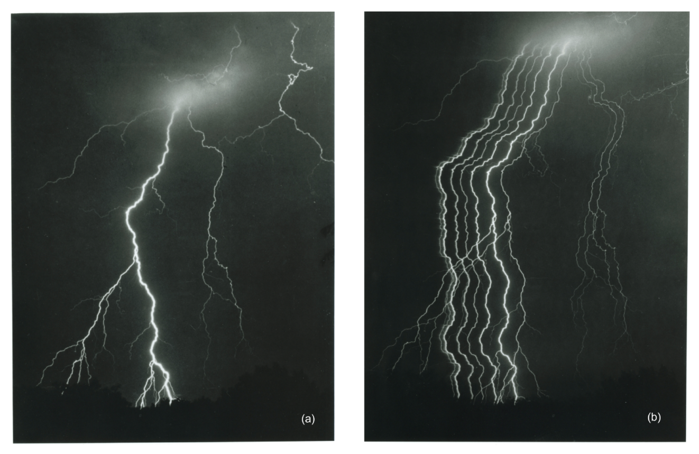
Fig. 1.Lightning flash which appears to have at least 7 (perhaps as many as 10) separate ground strike points: (a) still photograph, (b) streaked photograph. Some of the strike points are associated with the same stroke having separate branches touching ground, while others are associated with different strokes taking different path to ground. Adapted from Hendry (1993).

Sketches of still and time-resolved images of the three-stroke lightning flash are shown in Figs. 2a and 2b, respectively. A sketch of the corresponding current at the channel base is shown in Fig. 2c. In Fig. 2b, time advances from left to right, and the time scale is not continuous. Each of the three strokes in Fig. 2b, represented by its luminosity as a function of height above ground and time, is composed of a downward-moving process, termed a leader, and an upward-moving process, termed a return stroke. The leader creates a conducting path between the cloud charge source region and ground and distributes negative charge from the cloud source region along this path, and the return stroke traverses that path moving from ground toward the cloud charge source region and neutralizes the negative leader charge. Thus, both leader and return stroke processes serve to effectively transport negative charge from the cloud to ground. As seen in Fig. 2b, the leader initiating the first return stroke differs from the leaders initiating the two subsequent strokes (all strokes other than first are termed subsequent strokes). In particular, the first-stroke leader appears optically to be an intermittent process, hence the term stepped leader, while the tip of a subsequent-stroke leader appears to move continuously. The continuously moving subsequent-stroke leader tip appears on streak photographs as a downward-moving “dart”, hence the term dart leader. The apparent difference between the two types of leaders is related to the fact that the stepped leader develops in virgin air, while the dart leader follows the “pre-conditioned” path of the preceding stroke or strokes. Sometimes a subsequent leader exhibits stepping while propagating along a previously-formed channel; it is referred to as dart-stepped leader. There are also so-called “chaotic” subsequent-stroke leaders. All types of leaders produce bursts of x-ray emission with energies typically up to 250 keV (twice the energy of a chest x-ray) (Dwyer, 2005).

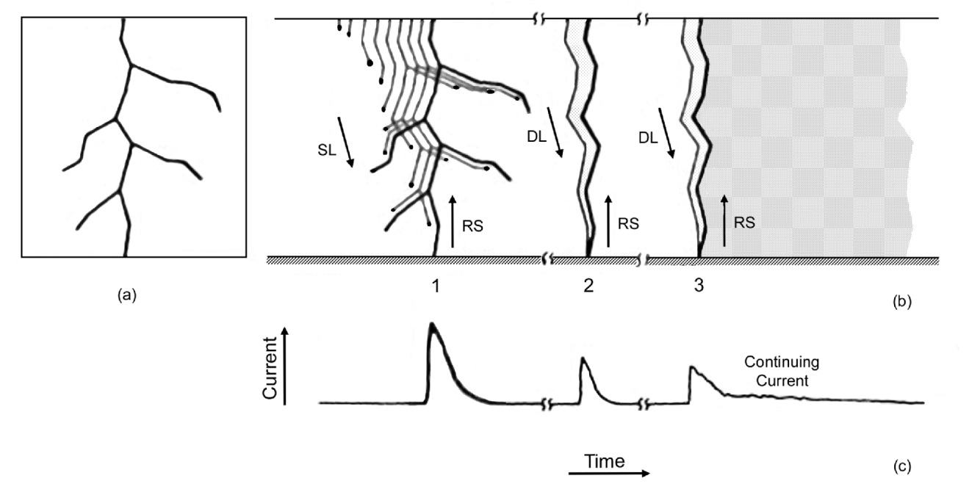
Fig.2. Drawing showing the luminosity of a three stroke ground flash and the corresponding current at the channel base. (a) Still-camera image, (b) streak-camera image, and (c) channel-base current.

The electric potential difference between a downward-moving stepped-leader tip and ground is probably some tens of megavolts, comparable to or a considerable fraction of that between the cloud charge source and ground. The magnitude of the potential difference between two points, one at the cloud charge source and the other on ground, is the line integral of electric field intensity between those points. The upper and lower limits for the potential difference between the lower boundary of the main negative charge region and ground can be estimated by multiplying, respectively, the typical observed electric field in the cloud, 10⁵ V/m, and the expected electric field at ground under a thundercloud immediately prior to the initiation of lightning, 10⁴ V/m, by the height of the lower boundary of the negative charge center above ground, 5 km or so. The resultant range is 50 to 500 MV.
When the descending stepped leader attaches to the ground, the first return stroke begins. The first return-stroke current measured at ground rises to an initial peak of about 30 kA in some microseconds and decays to half-peak value in some tens of microseconds. The return stroke effectively lowers to ground the several coulombs of charge originally deposited on the stepped-leader channel including all the branches, as well as any additional cloud charge that may enter the return-stroke channel.
Once the bottom of the dart leader channel is connected to the ground, the second (or any subsequent) return-stroke wave is launched upward, which again serves to neutralize the leader charge. The subsequent return-stroke current at ground typically rises to a peak value of 10 to 15 kA in less than a microsecond and decays to half-peak value in a few tens of microseconds.
The high-current return-stroke wave rapidly heats the channel to a peak temperature near or above 30,000ºK and creates a channel pressure of 10 atm or more, resulting in channel expansion, intense optical radiation, and an outward propagating shock wave that eventually becomes the thunder (sound wave) we hear at a distance.
The impulsive component of the current in a return stroke (usually subsequent) is often followed by a continuing current which has a magnitude of tens to hundreds of amperes and a duration up to hundreds of milliseconds. Continuing currents with a duration in excess of 40 ms are traditionally termed long continuing currents. Between 30% and 50% of all negative cloud-to-ground flashes contain long continuing currents. Current pulses superimposed on continuing currents, as well as the corresponding enhancements in luminosity of the lightning channel, are referred to as M-components.
There is a special type of lightning that is thought to be the most intense natural producer of HF-VHF (3 – 300 MHz) radiation on Earth. It is referred to as Compact Intracloud Discharge (CID). CIDs were first reported by Le Vine (1980) and received their name (Smith et al. 1999) due to their relatively small (hundreds of meters) spatial extent. They tend to occur at high altitudes (mostly above 10 km), appear to be associated with strong convection (however, even the strongest convection does not always produce CIDs), tend to produce less light than other types of lightning discharges, and produce single bipolar electric field pulses (Narrow Bipolar Pulses or NBPs) having typical full widths of 10 to 30 μs and amplitudes of the order of 10 V/m at 100 km, which is comparable to or higher than for return strokes in cloud-to-ground flashes. As an illustration of intensity of wideband electromagnetic signature of CIDs, 48 CIDs examined in detail by Nag et al. (2010) were recorded by 4 to 22 (11 on average) stations of the U.S. National Lightning Detection Network (NLDN), whose average baseline is 300-350 km.

7.2.2. Lightning electromagnetic signatures
Both cloud-to-ground and cloud lightning discharges involve a number of processes that produce characteristic electromagnetic field signatures. Salient characteristics of measured electric and magnetic fields generated by various lightning processes at distances ranging from tens to hundreds of kilometers are briefly reviewed below. The emphasis is put on those processes which produce substantial microsecond- and submicrosecond-scale field variations.
Table 1 summarizes essentially all identifiable lightning radiation field signatures as recorded at ground. Note that apparently there is no characteristic microsecond-scale field signature associated with lightning K and M processes. Besides return strokes (the first row) and so-called compact intracloud discharges (the last row), the pulses produced by lightning processes represented in Table 1 occur in sequences with submillisecondinterpulse intervals. Leader pulses (rows 2 and 3) are presumably emitted by the lower portion of the channel to ground just prior to the initiation of a return stroke, while both initial breakdown pulses (rows 4 and 5) and regular pulse bursts (row 6) are produced by lightning processes occurring inside the cloud. Characterization given below concerns both the overall pulse sequences and individual pulses.

Table 1. Characterization of microsecond-scale electric field pulses associated with various lightning processes. Adapted from Rakov(1999).
Type of pulses | Dominant polarity (atmospheric electricity sign convention) | Typical total pulse duration, µs | Typical time interval between pulses, µs | Comments
Return stroke in negative ground flashes | Positive | 30-90 (zero-crossing time) | 60x10³ | 3-5 pulses per flash
Stepped leader in negative ground flashes | Positive | 1-2 | 15-25 | Within 200 µs just prior to a return stroke
Dart-stepped leader in negative ground flashes | Positive | 1-2 | 6-8 | Within 200 µs just prior to a return stroke
Initial breakdown in negative ground flashes | Positive | 20-40 | 70-130 | Some milliseconds to some tens of milliseconds before the first return stroke
Initial breakdown in cloud flashes | Negative | 50-80 | 600-800 | The largest pulses in a flash
Regular pulse burst in both cloud and negative ground flashes | Both polarities are about equally probable | 1-2 | 5-7 | Occur later in a flash; 20-40 pulses per burst
Compact intracloud discharge (narrow bipolar event) | Both polarities occur with negative being more frequent | 10-30 | - | Typically not preceded or followed by any other lightning process within hundreds of milliseconds

Notes: | 1. The polarity of the initial half cycle in the case of bipolar pulses.  2. According to the atmospheric electricity sign convention, a downward directed electric field vector is assumed to be positive.

Negative Ground Flashes.The typical microsecond-scale pulse structure of naturally-occurring negative ground discharges, as observed at ground, includes an initial sequence of pulses (usually called initial or preliminary breakdown pulses) followed, typically some milliseconds to some tens of milliseconds later, by 3 to 5 relatively large return-stroke pulses spaced several tens of milliseconds apart. The duration of the initial sequence of pulses is typically a few milliseconds. Individual pulse waveforms characteristic of the preliminary breakdown in negative ground flashes are shown in Fig. 3a. The initial polarity of the preliminary breakdown pulses is usually the same as that of the following return stroke pulse. The initial breakdown pulses can have amplitudes comparable to or even exceeding that of the corresponding return-stroke pulses. Just prior to the first return-stroke pulse and prior to some subsequent return-stroke pulses there are pulse sequences, in the former case associated with stepped leader process and in the latter case with dart-stepped (regular pulse train) or "chaotic" (irregular pulse train) leader processes. These pulse sequences have been observed to last for some tens of some hundreds of microseconds, and the pulse amplitudes are one to two orders of magnitude smaller than the corresponding return-stroke pulse amplitude. The stepped-leader pulses are seen just prior to the return-stroke pulse in Fig. 4a, before t = 0. A rather irregular pulse train, indicative of "chaotic" leader, is seen prior to the subsequent return-stroke pulse (before t = 0) in Fig. 4b. Usually there is a relatively quiet millisecond-scale gap between the preliminary breakdown pulse sequence and the beginning of pronounced stepped-leader pulses. The intervals between the return-stroke pulses, and the time interval of some tens of milliseconds or so following the last return-stroke pulse, contain regular pulse bursts of relatively small amplitude and some other, usually irregular, pulse activity. Pulse peaks in regular pulse bursts are approximately two orders of magnitude smaller than return-stroke initial field peaks in the same flash. As seen in Table 1, the regular pulse bursts are very similar in their characteristics to the pulse sequences associated with dart-stepped leaders. The geometric mean initial electric field peak normalized to 100 km for negative first strokes, about 6 V/m, is about a factor of two larger than for negative subsequent strokes, about 3 V/m. The geometric mean time interval between return-stroke pulses is 60 ms.
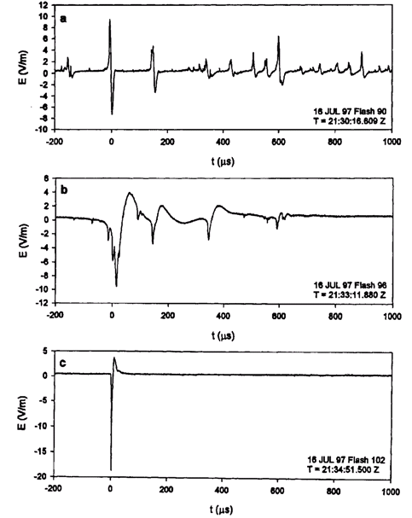
CG
IC
CID
Fig. 3. Examples of electric field pulse waveforms characteristic of (a) the initial breakdown in negative ground flashes (CGs), (b) the initial breakdown in cloud flashes (ICs), and (c) compact intracloud discharges (CIDs). Positive electric field (atmospheric electricity sign convention) deflects upward.Adapted from Rakov (1999).
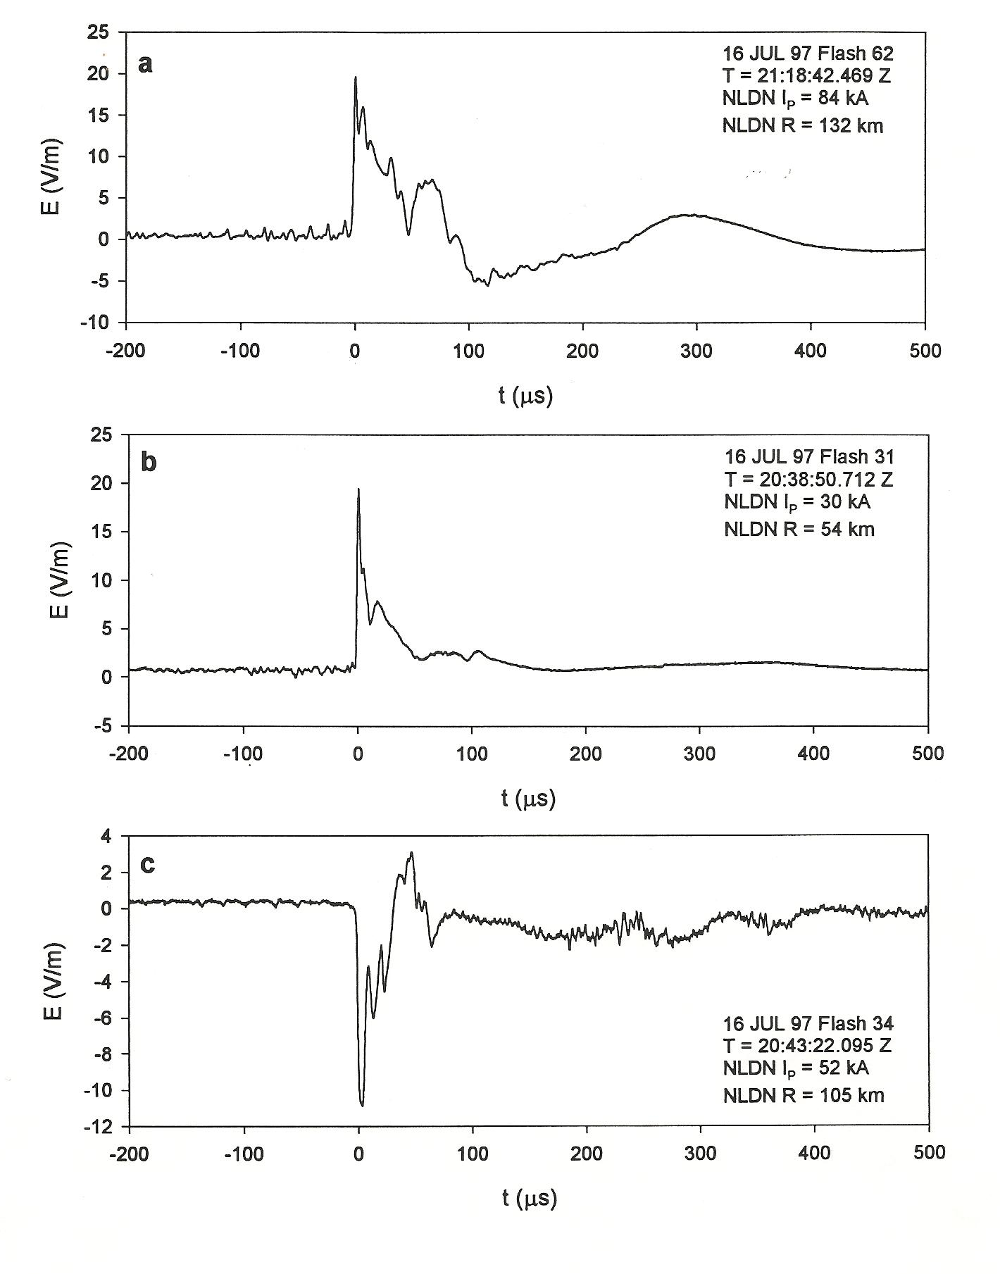
Fig. 4. Examples of electric field pulse waveforms for (a) the negative first stroke, (b) the negative subsequent stroke, and (c) the positive first stroke. All three events have been detected by the U.S. National Lightning Detection Network (NDLN), and their NDLN reported characteristic (estimated peak current I, and distance R) are given on the plots. See also caption of Fig. 3.Adapted from Rakov (1999).

Positive Ground Flashes. Positive flashes usually contain a single return stroke (although up to four strokes per flash were observed) whose microsecond-scale electric and magnetic field waveforms are similar to those characteristic of negative first return strokes, except for the initial polarity. An example of positive return stroke electric field waveform is given in Fig. 4c. Small pulses seen before t = 0 in Fig. 4care indicative of a stepped-leader process. As opposed to negative first strokes, these pulses are detected only in about one-third of field waveforms. The mean initial electric field peak normalized to 100 km for positive first strokes is about a factor of two larger than for negative first strokes. Positive strokes to ground can be initiated in theway similar to that negative lightning flashes are initiated (see above) or be byproducts of extensive cloud discharges.
Cloud Flashes. The typical pulse structure that is observed in naturally-occurring cloud discharges includes an initial sequence (or sequences) of pulses of relatively large amplitude, spaced some hundreds of microseconds apart and occurring within the first several to a few tens of milliseconds, followed by a number of regular pulse bursts of significantly smaller amplitude. Pulses within the burst are several microseconds apart with each burst lasting for some hundreds of microseconds. Individual pulse waveforms characteristic of the initial breakdown in cloud flashes are shown in Fig. 3b. The initial polarity of these pulses tends to be opposite to that of the initial breakdown pulses in negative ground flashes. There are also microsecond-scale pulses with amplitudes appreciably lower than those of the initial breakdown pulses which are dispersed, as opposed to clustering in bursts, throughout the flash. Some of these smaller and often irregular pulses are associated with step-like K changes (field signatures of K-processes). K changes typically occur in the late stage of the cloud flash and are separated by many tens of milliseconds.
Compact Intracloud Discharges (CIDs). An example of electric field signature of compact intracloud discharges (also called narrow bipolar events) is given in Fig. 3c. These pulses have peaks and peak time derivatives comparable to those of return strokes in ground flashes.

7.2.3. Glossary
Atmospheric electricity sign convention: Electric field sign convention according to which a downward-directed field vector is defined as positive.
Bipolar lightning: Lightning discharges sequentially transferring both positive and negative charges to ground during the same flash.
Cloud lightning: Lightning discharges that do not involve ground.
Compact Intracloud Discharge (CID): A small-spatial-scale (typically hundreds of meters) lightning discharge in the cloud that is thought to be the most intense natural producer of HF-VHF (3 – 300 MHz) radiation on Earth.
Continuing current: A steady current immediately following some return-stroke current pulses.
Downward cloud-to-ground lightning: Lightning discharges to ground initiated by descending leaders from the cloud.
Ground flash density: The number of ground flashes per unit area per unit time (usually per square kilometer per year).
K-processes: Transient processes occurring in a previously conditioned lightning channel that is not connected (or lost its connection) to ground. They can occur in both ground and cloud flashes.
Leader: Lightning process that creates a conducting path between the cloud charge source region and ground (in the case of downward cloud-to-ground lightning) and distributes charge from the cloud source region along this path.
Lightning or lightning flash: It can be defined as a transient, high-current (typically tens of kiloamperes) electric discharge in air whose length is measured in kilometers.
M-components: Transient processes occurring in a grounded lightning channel while it carries continuing current.
Negative lightning: Lightning discharges that effectively lower negative charge from the cloud to ground.
Positive lightning: Lightning discharges that effectively lower positive charge from the cloud to ground.
Return stroke: Lightning process that traverses the previously created leader channel, moving from ground toward the cloud charge source region, and neutralizes the leader charge.
Rocket-triggered lightning: Lightning discharges artificially initiated from natural thunderclouds using the rocket-and-wire technique.
Thunderstorm cell: A unit of convection, typically some kilometers in diameter, characterized by relatively strong updrafts (>10 m/s). The lifetime of an ordinary cell is of the order of 1 hour.
Upward cloud-to-ground lightning: Lightning discharges to ground initiated by ascending leaders from grounded objects.

7.3. Principles of Lightning Location
7.3.1. General
For the three most common multi-station electromagnetic radio frequency locating techniques, magnetic direction finding (MDF), time of arrival (TOA), and interferometry, the type of locating information obtained depends on the frequency f (or equivalently on the wavelength λ = c/f, where c is the speed of light) of the radiation detected (Rakov and Uman, 2003). For detected signals whose wavelengths are very short compared to the length of a radiating lightning channel, for example, the very high frequency (VHF) range where f = 30 to 300 MHz and λ = 10 to 1 m, the whole lightning channel can, in principle, be imaged in two or three dimensions. For wavelengths that exceed or are a significant fraction of the lightning channel length, for example, the very low frequency (VLF) range where f = 3 to 30 kHz and λ = 100 to 10 km and the low frequency (LF) range where f = 30 to 300 kHz and λ = 10 km to 1 km, generally only one or a few locations can be usefully obtained for each lightning channel . In the case of single location for a cloud-to-ground returnstroke, it is usually interpreted as some approximation to the ground strike point. The best electromagnetic channel imaging methods at VHF and the best ground strike-point locating techniques at VLF and LF have accuracies (actually location errors or uncertainties) of the order of a hundred meters. On the other end of the accuracy scale, long range VLF systems which operate in a narrow frequency band, usually somewhere between 5 and 10 kHz, and detect lightning at distances up to thousands of kilometers have uncertainties in locating individual lightning flashes of the order of 10 km or more. These latter systems are often called thunderstorm locators.
For those electromagnetic locating techniques involving the measurement of field change amplitudes at multiple stations, the bandwidth of the measurement is not directly related to the locating accuracy: it is only necessary to have a measurement system that can reproduce the field changes of the process of interest faithfully. Hence, for example, from measuring the electrostatic field change in the frequency range from a fraction of a hertz to a few hertz at multiple stations, one can locate an “average” position for the charge source of a complete cloud-to-ground flash; and with a system bandwidth from a few hertz to a few kilohertz, so as to be able to resolve electrostatic field changes on a millisecond time scale, one can locate the charge sources for individual strokes in the flash as well as for continuing current. Lightning location using the return-stroke electric or magnetic radiation field peaks, similar to the case of location using the electrostatic field change, only requires that the system faithfully reproduces those peaks. The electric and magnetic field amplitude lightning locating techniques are not further discussed here.
Accurate lightning locating systems, whether they image the whole lightning channel or locate only the ground strike points or the cloud-charge centers, necessarily employ multiple sensors. Single station ground-based sensors, such as the lightning flash counters, detect the occurrence of lightning, but cannot be used to locate it on an individual flash basis, nor are they designed to do so, because of the wide range of amplitudes and waveshapes associated with individual events. Nevertheless, with single-station sensors one can assign groups of flashes to rough distance ranges if data are accumulated and “averaged” for some period of time. There are many relatively simple commercially-available single-station devices that purport to locate lightning. Most operate like AM radios with the amplitude of the radio static being used to gauge the distance to the individual lightning flashes, a technique inherently characterized by large errors. In addition to field amplitude detectors, some commercial single-station devices employ optical detectors, magnetic direction finders, and/or characteristics of lightning waveforms to allow estimate of distance of cloud-to-ground return strokes from the sensor.
Single-station optical sensors on Earth orbiting satellites detect the light scattered by the volume of cloud that produces the lightning and hence cannot locate to an accuracy better than about 10 km, about the diameter of a small cloud. Additionally, satellite-based sensors cannot distinguish between cloud and ground discharges. The next-generation series of Geostationary Operational Environmental Satellite (GOES-R) is planned to carry a Geostationary Lightning Mapper (GLM), which will monitor lightning continuously over a wide field of view. The launch of the first GOES-R series satellite is scheduled for 2015.
The followingsubsections discuss how individual sensors measuring various properties of the lightning electromagnetic radiation have been combined into systems to provide practical lightning locating. More details can be found in the reviews by Rakov and Uman (2003) and Cummins and Murphy (2009) and in references therein.

7.3.2. Magnetic field direction finding (MDF)
Two vertical and orthogonal loops with planes oriented NS and EW, each measuring the magnetic field from a given vertical radiator, can be used to obtain the direction to the source. This is the case because the output voltage of a given loop, by Faraday's law, is proportional to the cosine of the angle between the magnetic field vector and the normal vector to the plane of the loop. For a vertical radiator the magnetic field lines are circles coaxial with respect to the source. Hence, for example, the loop whose plane is oriented NS receives a maximum signal if the source is north or south of the antenna, while the orthogonal EW loop receives no signal. In general, the ratio of the two signals from the loops is proportional to the tangent of the angle between north and the source as viewed from the antenna.
Crossed-loop magnetic direction finders (DFs) used for lightning detection can be divided into two general types: narrow band (tuned) DFs and gated wideband DFs. In both cases the direction-finding technique involves an implicit assumption that the radiated electric field is oriented vertically and the associated magnetic field is oriented horizontally and perpendicular to the propagation path.
Narrow-band DFs have been used to detect distant lightning since the 1920s. They generally operate in a narrow frequency band with the center frequency in the range 5 to 10 kHz where attenuation in the earth-ionosphere waveguide is relatively low and where the lightning signal energy is relatively high. Before the development of weather radars in the 1940s, lightning locating systems were the primary means of identifying and mapping thunderstorms at medium and long ranges.
A major disadvantage of narrow-band DFs is that for lightning at ranges less than about 200 km, those DFs have inherent azimuthal errors, called polarization errors, of the order of 10º. These errors are caused by the detection of magnetic field components from non-vertical channel sections, whose magnetic field lines form circles in a plane perpendicular to the non-vertical channel section, and by ionospheric reflections, skywaves, whose magnetic fields are similarly improperly oriented for direction finding of the ground strike point.
To overcome the problem of large polarization errors at short ranges inherent in the operation of narrow-band DFs, gated wideband DFs were developed in the early 1970s. Direction finding is accomplished by sampling (gating on) the NS and EW components of the initial peak of the return-stroke magnetic field, that peak being radiated from the bottom hundred meters or so of the channel in the first microseconds of the return stroke. Since the bottom of the channel tends to be straight and vertical the magnetic field is essentially horizontal. Additionally, a gated DF does not record ionospheric reflections since those reflections arrive long after the initial peak magnetic field is sampled. The operating bandwidth of the gated wideband DF is typically from a few kilohertz to about 500 kHz. Interestingly, although an upper frequency response of many megahertz is needed to assure accurate reproduction of the incoming radiation field peak, particularly if the propagation is over salt water, practical DFs only need an upper frequency response of a few hundred kilohertz in order to obtain an azimuthal error of about 1º. This is the case because the ratio of the peak signals in the two loops is insensitive to the identical distortion produced by the identical associated electronic circuits of the two loops. Similarly, with proper calibration and correction for propagation effects, practical DFs only need an upper frequency response of a few hundred kilohertz in order to obtain a peak current estimationerror of 15-20%. Thus, the gated wideband DF can operate at frequencies below the AM radio band and below the frequencies of some aircraft navigational transmitters, either of which could otherwise cause unwanted directional noise.
Gated wideband DFs, as well as narrow-band DFs, are susceptible to site errors. Site errors are a systematic function of direction but generally are time-invariant. These errors are caused by the presence of unwanted magnetic fields due to non-flat terrain and to nearby conducting objects, such as underground and overhead power lines and structures, being excited to radiate by the incoming lightning fields. In order to eliminate site errors completely, the area surrounding a DF must be flat and uniform, without significant conducting objects, including buried ones, nearby. These requirements are usually difficult to satisfy, so it is often easier to measure the DF site errors and to compensate for any that are found than to find a location characterized by tolerably small site errors. Once corrections are made, the residual errors have been reported (using independent optical data) to be usually less than two to three degrees.
Since it is not known a priori whether a stroke to ground lowers positive or negative charge, there is an 180º ambiguity in stroke azimuth from the measurement of only the orthogonal magnetic fields. That ambiguity is resolved in all wideband DF systems by the measurement of the associated electric field whose polarity indicates the sign of the charge transferred to ground.

7.3.3. Time-of-arrival (TOA) technique
A single time-of-arrival sensor provides the time at which some portion of the lightning electromagnetic field signal arrives at the sensing antenna. Time-of-arrival systems for locating lightning can be divided into three general types: (1) very short baseline (tens to hundreds of meters), (2) short baseline (tens of kilometers), and (3) long baseline (hundreds to thousands of kilometers). Very short and short baseline systems generally operate at VHF, that is, at frequencies from 30 to about 300 MHz, while long baseline systems generally operate at VLF and LF, 3 to 300 kHz. It is generally thought that VHF radiation is associated with air breakdown processes, while VLF signals are due to current flow in conducting lightning channels. Short baseline systems are usually intended to provide images of lightning channels and to study the spatial and temporal development of discharges. Long baseline systems are usually used to identify the ground strike point, cloud lightning events in predominantly vertical channels, or the “average” location of the flash.
A very-short-baseline (tens to hundreds of meters)system is composed of two or more VHF time-of-arrival (TOA) receivers whose spacing is such that the time difference between the arrival of an individual VHF pulse from lightning at those receivers is short compared to the time between pulses, which is some microseconds to hundreds of microseconds. The locus of all source points capable of producing a given time difference between two receivers is, in general, a hyperboloid, but if the receivers are very closely spaced, the hyperboloid degenerates, in the limit, into a plane on which the source is found. Two time differences from three very closely spaced receivers yield two planes whose intersection gives the direction to the source, that is, its azimuth and elevation. To find source location, as opposed to the determination of direction to the source, two or more sets of three closely spaced receivers, the sets being separated by tens of kilometers or more, must be used. Each set of receivers is basically a TOA direction finder, and the intersection of two or more direction vectors yields the location.
Short-baseline TOA systems are typically networks of 5 to 15 stations that make use of time-of-arrival information for three-dimensional (3D) mapping of lightning channels. A portable version of such system has been developed by researchers at the New Mexico Institute of Mining and Technology. This system is presently referred to as the Lightning Mapping Array (LMA) and has recently become a major tool for both lightning research and operational applications. The short-baseline VHF TOA systems provide electromagnetic images of the developing channels of any type of lightning flash.
The first long-baseline (hundreds to thousands of kilometers)TOA system operated at VLF/LF. It employed a pair of receiving stations in Massachusetts with a bandwidth of 4 to 45 kHz and separated by over 100 km (the overall network was composed of four stations) to compare differences in the times of arrival of the signals at each station and hence to determine directions to the causative lightning discharge in western Europe. The two-station system was basically a direction finder similar to the very-short-baseline systems described above, but operating at lower frequencies and longer baseline. The resultant “directions” compared favorably with the locations reported by the British Meteorological Office's narrow-band DF network. Spherical geometry was used to account for propagation over the Earth's surface in finding the locus of points for a constant measured arrival time difference between receivers.
Another long-baseline TOA system, called the Lightning Positioning and Tracking System (LPATS), was developed in the 1980s. The LPATS, operating at LF/VLF, used electric field whip antennas at stations 200 to 400 km apart to determine locations via the measured differences between signal arrival times at the stations. In the frequency band used, return stroke waveforms were generally the largest and hence most easily identified. In principle, responses from four stations (three time differences) are needed to produce a unique location since the hyperbolae on the Earth’s surface from only two time differences can, in general, intersect at two different points. For cloud-to-ground lightning near or within the network, there is often only one solution, so in this case the three-station solution suffices.

7.3.4. Interferometry
In addition to radiating isolated pulses, lightning also produces noise-like bursts of electromagnetic radiation lasting for tens to hundreds of microseconds. These bursts are difficult to locate using TOA techniques due to the difficulty in identifying the individual pulses. In the case of interferometry, no identification of individual pulses is needed, since the interferometer measures phase difference between narrow-band signals corresponding to these noise-like bursts received by two or more closely spaced sensors. The simplest lightning interferometer consists of two antennas some meters apart, each antenna being connected via a narrow-band filter to a receiver. The antennas, filters, and receivers are identical. The outputs of the two receivers are sent to a phase detector that produces a voltage that is proportional to the difference in phase between the two quasi-sinusoidal signals. The phase difference defines, as does the time difference in very short baseline TOA systems, a plane on which the source is located, that is, one direction angle to the VHF source. To find the azimuth and elevation of a source, three receiving antennas with two orthogonal baselines are needed, at minimum. To locate the source in three dimensions, two or more synchronized interferometers, each effectively acting as a direction finder, separated by a distance of the order of 10 km or more, are needed. The principles of interferometric lightning location are described in detail by Lojou et al. (2008).
Most interferometric systems operate over very narrow frequency bands (a few hundred kilohertz to a few megahertz in the VHF/UHF bands), since this allows the system to have high sensitivity in a specific “quiet” band of operation. However, it also makes the system performance subject to local broadband interference, may not provide the highest possible signal-to-noise ratio (SNR), and places a specific limitation in the spacing of the antenna array elements to avoid arrival-time (phase) ambiguity. There is a recent trend toward using broadband interferometry (Shao et al., 1996; Mardiana and Kawasaki, 2000; Morimoto et al., 2004). This trend is made possible by the advent of affordable broadband RF and digital signal processing electronics.

7.4. Performance Characteristics
Generally, a modern VLF-MF lightning locating system is expected to record (in separate categories) and locate over a certain area all cloud-to-ground strokes of either polarity, as well as cloud discharges. Also expected for each discharge is a measure of its intensity, usually in the form of peak current inferred from measured electric or magnetic fields. Accordingly, system’s performance can be evaluated using the following characteristics:
(a) cloud-to-ground (CG) flash detection efficiency;
(b) CG stroke detection efficiency;
(c) cloud flash detection efficiency;
(d) percentage of misclassified events (particularly cloud discharges assigned to the positive or negative CG stroke category);
(e) location accuracy (or location error);
(f) peak current estimation error.

In general, the detection efficiency is the fraction (usually expressed in percent) of the total events occurred that are detected by the system and is ideally equal to 100%. While the CG stroke detection efficiency can be readily defined (since these strokes involve a unique and observable feature – luminous channel to ground – and the total number of occurred events can be practically determined), the cloud flash detection efficiency concept is rather uncertain. Indeed, there are many cloud discharge processes (some of them poorly understood) occurring on different spatial and time scales and apparently exhibiting no unique and readily observable features. As a result, the total number of occurred events is generally unknown. In practice, if all cloud discharge events are accepted as “counts”, the number of detected cloud discharges may be largely determined by the local noise level and system’s signal transmission rate limit.
In defining the CG flash detection efficiency, probably the most important performance characteristic for lightning locating systems used for determination of ground flash density, a flash is considered to be detected if at least one stroke of the flash was detected. A similar approach could be applied to cloud flashes, although one would need to decide if a single “count” constitutes a flash and how to assign multiple “counts” to individual flashes.
The location error is the distance between the actual location and that reported by the system. In general, the location error consists of random and systematic components. The latter in some cases can be accounted for (e.g., site errors in MDF systems).
The peak current estimation error is the difference between the actual peak current value and that reported by the system, usually expressed in percent of the actual peak current. Peak currents are estimated by lightning locating systems using either an empirical or model-based field-to-current conversion equation. There are reasonable field-to-current conversion equations for CG strokes, but not for cloud discharge processes.
In order to evaluate the performance characteristics listed above, independent (ground-truth) data are needed. For example, discharges occurring at a precisely known location equipped with a current-measuring device (tall tower or lightning-triggering facility) can be used for estimating the location accuracy and peak current estimation error. Detection efficiencies and percentage of misclassified events are usually estimated based on time-resolved optical recordings. Sometimes lightning-related damage to various objects (buildings, trees, etc.) is used in estimating location errors, although identification of causative lightning event in this approach is not unique due to insufficient accuracy of timing information (usually not known within better than a minute). Less definitive evaluations of lightning locating system’s performance characteristics are possible via modeling or comparison with a more accurate system operating in the same area. As of today, only a limited number of ground-truth studies have been performed, particularly for first strokes in negative CG flashes, positive CG flashes, and cloud discharges.
In some applications (e.g., tracking of thunderstorm cells), the tracking ability may be more important than detection of individual lightning discharges. Performance of the systems intended primarily for such applications is often tested against radar or infrared satellite imagery, with a good correspondence between detected lightning and regions of high radar reflectivity or low cloud-top temperatures being viewed as the system’s output validity criteria. For early warning, the ability to detect the first lightning is probably the most important performance characteristic.
It is not clear how to define the performance characteristics for VHF lightning channel imaging systems. Surely, they cannot locate all the VHF sources in the cloud. Limitations in sensitivity prevent these systems from regularly detecting and mapping positive leaders. Thus, the resultant VHF images are necessarily “partial”. Further, supplementary information about return strokes is usually needed to reliably distinguish between cloud and CG flashes, because the VHF radiation directly associated with subsequent return strokes is limited and difficult to detect. Also, no peak current estimates are possible. Nevertheless, VHF lightning channel imaging systems represent a very valuable tool for studying detailed lightning morphology and evolution, particularly inside the cloud, and are often used in testing other types of lightning locating systems.

7.5. Examples of Modern Lightning Locating Systems
One VHF lightning channel imaging system (LMA) and, three VLF/LF (NLDN, LINET, and USPLN), one ELF/VLF/LF/MF/HF (ENTLN), and two VLF (WWLLN and GLD360) systems, are briefly reviewed here as representative examples of modern lightning locating systems. Information about these and other systems can be found in Rakov and Uman (2003, Ch. 17), Cummins and Murphy (2009), Betz et al.(2009) and references therein. There are more than 60 lightning locating networks worldwide that operate in the VLF/LF range.
Besides general characterization of each system, the available information on its performance characteristics is given with emphasis on those based on formal ground-truth studies published in the peer-reviewed literature. Generally, the amount of such information for “older” systems is greater than for more recent ones.

7.5.1. Lightning Mapping Array (LMA), 60-66 MHz
LMA networks typically consist of 10-15 stations separated by 15-20 km and connected by wireless communication links to a central location (Thomas et al., 2004). Each station receives the lightning signals (from both cloud and CG flashes) in a locally unused television channel (usually TV channel 3, 60-66 MHz). Typical time resolution (measurement time window) is 80-100 us. A larger time window, typically 400 us, is used for real-time processing and display.
The location accuracy of the New Mexico LMA hasbeen investigated experimentally using a sounding balloon carrying a VHF transmitter, airplane tracks,and observations of distant storms(Thomas et al., 2004). Simple geometric models forestimating the location uncertainty of sources both over and outside the network have also been developed. Themodel results were found to be a good estimator of the observed errors. Sources over the network at altitudes ranging from 6 to 12 km were located with an uncertainty of 6–12 mrms in the horizontal and 20–30 m rms in the vertical, resulting in less than a 100-m 3D error for most located sources.Outside the network the location uncertainties increasewith distance.

7.5.2. U.S. National Lightning Detection Network (NLDN), 400 Hz-400 kHz
The NLDN consists of more than 100 stations separated by typically 300-350 km and covering the contiguous United States (e.g., Cummins and Murphy, 2009). A combination of TOA and MDF locating techniques is employed. Both cloud and CG lightning discharges are reported. Classification is accomplished by applying field waveform criteria. Peak currents are estimated from measured fields using an empirical formula based on rocket-triggered lightning data, with the field peaks being adjusted to account for propagation effects (stronger than the inverse proportionality distance dependence). Further information on the evolution of the NLDN, its enabling methodology, and applications of NLDN data can be found in Rakov and Uman (2003, Ch. 17), Orville (2008), Cummins and Murphy (2009) and references therein.
CG stroke and flash detection efficiencies have been investigated, using video cameras, in Southern Arizona, Oklahoma, and Texas (Biagi et al., 2007). The stroke detection efficiency in Southern Arizona was estimated to be 76% (N = 3620) and in Texas/Oklahoma it was 85% (N = 885). The corresponding flash detection efficiencies were 93% (N = 1097) and 92% (N = 367). Additionally, classification of lightning events as cloud of CG discharges was examined in this study, as well as in a similar study (but additionally using independent electric field waveform measurements) in the Colorado-Kansas-Nebraska region (Fleenor et al., 2009).
CG stroke and flash detection efficiencies have been also investigated, using as the ground-truth rocket-triggered lightning, in the Florida region (Jerauld et al., 2005; Nag et al., 2011). From the latest (2004-2009) study, the CG stroke and flash detection efficiencies were found to be 76% (N = 139) and92% (N = 37), respectively. Strokes in rocket-triggered flashes are similar to regular subsequent strokes (following previously formed channels) in natural lightning, and hence the 76% stroke detection efficiency is applicable only to regular negative subsequent strokes in natural lightning. The flash detection efficiency derived using rocket-triggered lightning is expected to be an underestimate of the true value for natural negative lightning flashes, since first strokes typically have larger peak currents than subsequent ones.
Nag and Rakov (2012) examined electric field waveforms produced by 45 positiveflashes containing 53 strokes. Out of these 53 strokes, the NLDN located51 (96%), of which 48 (91%) were correctly identified and 3return strokes were misclassifiedas cloud discharges.

According to Cummins and Murphy (2009), the NLDN cloud flash detection efficiency (a flash was considered detected if at least one VLF/LF pulse produced by that flash was detected) is in the range of 10% to 20%, depending on local differences in distances between stations. Nag et al. (2010) examined wideband electric fields, electric and magnetic field derivatives, andnarrowband VHF (36 MHz) radiation bursts produced by 157 compact intraclouddischarges (CIDs). The NLDN located 150 (96%) of those CIDs, and correctly identified 149 (95%) of them as cloud discharges.

Nag et al. (2011) estimated, from comparison of NLDN-reported locations with the precisely-known locations of triggered-lightning ground attachment points, the median absolute location error to be 308 m, with the largest error being 4.2 km (N = 105). These results are applicable only to regular negative subsequent strokes in natural lightning.
Peak current estimation errors have been estimated from comparison of NLDN-reported peak currents with directly-measured currents at the triggered-lightning channel base. In 2004-2009, the median absolute valueof current estimation error was 13% (N = 96) (Nag et al., 2011). The current estimationerrors never exceeded 129% in absolute value (60% if twooutliers are excluded).These results are applicable only to regular negative subsequent strokes in natural lightning.

7.5.3. LIghtning detection NETwork (LINET), 1-200 kHz
The basic location method used in this system is TOA, although the magnetic field sensors provide arrival-angle information that is employed as a “plausibility check” on computed locations. Height information derived from the arrival time at the nearest reporting sensor is employed to assist in classification of processes in cloud flashes and in-cloud processes (e.g., preliminary breakdown) in CG flashes on the one hand and CG strokes on the other hand (near-ground locations are assumed to be associated with CG strokes and elevated ones with all the other processes). It is stated that the reliable separation of return strokes and cloud pulses can be achieved as long as the closest sensor is within 100 km of the lightning discharge, which requires baselines of 200-250 km or less. Emphasis is placed on detection of low-amplitude signals of both cloud and CG lightning. Peak currents for processes in cloud flashes, in-cloud processes (e.g., preliminary breakdown) in CG flashes, and CG strokes are estimated assuming direct proportionality between the peak current and peak magnetic (or electric) field and inverse distance dependence of field peak. More information about LINET can be found in Betz et al. (2009) and references therein.
Similar to VHF channel imaging systems, it is not clear how to define the detection efficiency for LINET which, in a sense, also maps evolution of lightning channels, although with a considerably smaller number of located sources per flash. Additionally, in-cloud processes (e.g., preliminary breakdown) in CG flashes are assigned to the cloud lightning category, which is apparently inconsistent with the traditional definitions of cloud flash as a lightning discharge without CG strokes and CG flash as a lightning discharge that consists of both in-cloud processes and CG strokes. This is probably immaterial for a number of applications, such as cell tracking and detection of severe weather.
The random location error is claimed to be approximately 150 m, but the existence of systematic errors is acknowledged. Betz et al. (2009) showed an example of 58 located strokes apparently terminated on an instrumented tower with an average location error of less than ∼100 m, after compensating systematic errors that caused a location bias of ∼200 m.
Peak current estimation errors for LINET are unknown (no comparison with ground-truth data has been performed to date).

7.5.4. U.S. Precision Lightning Network (USPLN), 1.5-400 kHz
This network employsthe VLF/LF TOA technique and consists of 100 electric field sensors covering the continental U.S.and other parts of North America. No formal performance testing studies regarding this system have been reported, butthe operators of the system claim, apparently from the network simulation analysis, 95% stroke detectionefficiency and 250-m typical location error throughout most on North America (> 80% detection efficiency and < 1km location error in “key deployment areas” elsewhere in the world). Differentiation between cloud and CG processes is apparently accomplished by examining the frequency content and amplitude of the received signals. The field-to-current conversion procedure has not been formally described, nor is any information about testing its validity available.

7.5.5. Earth Networks Total Lightning Network (ENTLN), 1 Hz-12 MHz
The ENTLN sensors operate in a frequency range from 1 Hz to 12 MHz (spanning the ELF, VLF, LF, MF, and HF ranges). The TOA method is employed by this network of more than 700 sensors as of 2013. Both cloud and CG lightning discharges are reported.
According to Heckman and Liu (2010), the whole electric field waveforms are transmitted from the sensor to the data processing unit and used in both locating the lightning events and differentiating between cloud and CG processes. Strokes (or individual cloud events) are clustered into a flash if they are within 700 ms and 10 km of the first detected stroke (or cloud event). A flash that contains at least one return stroke is classified as a CG flash, otherwise it is classified as a cloud flash. In the cell tracking and thunderstorm alert generation, only flashes (which are less likely than strokes to be missed by the system) are used.
No formal performance testing studies regarding this system have been reported in the peer reviewed literature, but the operators of the system claim that performance testing studies conclude the ENTLN achieves 40-50% cloud flash detection efficiency across much of the U.S. and up to 95% in the U.S. Midwest and East (Heckman and Liu, 2010). Maximizing the detection efficiency for cloud flashes appears to be the primary focus of this system. By extending the frequency range of detection into the MF and HF spectrums, the ENTLN aims to detect and report weaker pulses at longer distances than other VLF/LF systems with similar baselines.
The field-to-current conversion procedure has not been formally described to date, nor is any information about testing its validity yet available.

7.5.6. World Wide Lightning Location Network (WWLLN), 6-18 kHz
The WWLLN utilizes a time-of-group-arrival (TOGA) method tolocate lightning strikes. This method is based on the fact that lightning VLF signals (sferics) propagating in the Earth-ionosphere waveguide experience dispersion, in that the higher-frequency components arrive earlier than the lower-frequency components. The TOGA, a quantity that can be derived from the measured sferic waveform, is related to the distance traveled by the sferic. As of March 2012, WWLLN employed 57 sensors located onall continents, although, according to Dowden et al. (2002), global coverage could be in principle provided by as few as 10 sensors. Distances between the sensors are of the order of thousands of kilometers. Presently, only those lightning events that triggered at least five sensors and that had residuals (uncertainties in the stroke timing) less than or equal to 30 us are regarded as located with acceptable accuracy.
In the latest study of WWLLN performance characteristics, Abarca et al. (2010) used NLDN data as the ground truth and found that the CG flash detection efficiency increased from about 3.88% in 2006-2007 to 10.3% in 2008-2009, as the number of sensors increased from 28 in 2006 to 38 in 2009. For events with NLDN-reported peak currents of 130 kA or higher the detection efficiency was 35%. The average location error was estimated to be 4-5 km.
Interaction of lightning signals with the ionosphere spectrally distorts the received waveform so that it is not straightforward to infer the peak current and even polarity of lightning. Nevertheless, Hutchins et al. (2012) developed a method to convert the stroke radiated power in the 6-18 kHz band to peak current. Errors involved in such conversion are presently unknown.

7.5.7. Global Lightning Dataset (GLD360), VLF
The Global Lightning Dataset (GLD360), also referred to as the Global Lightning Detection Network (GLDN), employs an unspecified number of VLF sensors strategically placed around the world. Locations are obtained using both TOA and MDF methods in conjunction with a lightning waveform recognition algorithm. The latter relies on a bank of “canonical” waveforms corresponding to propagation distances of the order of thousands of kilometers (Said et al., 2010).
According to the network operators, the expected CG flash detection efficiency is 60-70% and the median location error is 5 to 10 km. Demetriades et al. (2010) evaluated the GLD360 performance characteristics using NLDN data as the ground truth and found that the CG flash detection efficiency was 86% to 92%, and the median location error was 10.8 km. From a similar study, but using the Brazilian lightning detection network, Naccarato et al. (2010) reported the CG flash detection efficiency of 16% and the mean location error of 12.5 km. Using synchronized electric field and high-speed video camera measurements of cloud-to-ground lightning in Belgium as ground truth, Poelman et al. [2012] found the CG flash and stroke detection efficiencies for the GLD360 to be96% and 70%, respectively with the median location error of 900 m. Using NLDN data as ground truth, Said et al. [2013] reported a CG flash detection efficiency of 57% and a median location accuracy of 2.5 km.
The GLD360 also reports the peak current and polarity. Relative to the NLDN, Said et al. [2013] found the arithmetic and geometric mean peak current magnitude error for the GLD360 to be 21% and 6%, respectively. GLD360 reported the same polarity for 96% of the matched strokes as the NLDN.

7.6 Utilization of Lightning Location Systems by Meteorological Services

As described in section 7.1.2, lightning data have utility in different areas of importance to public and private meteorological service organizations. Typically, National Meteorological Agencies use LLS data to help accomplish their national duties to protect life and property, and commercial entities use lightning data to provide improved severe weather warnings, forecasts and guidance to clients for specialized applications including aviation, agriculture, energy, and mass media.

    - Storm Recognition and Alarms for Severe Weather

One of the important duties of the meteorological services is to provide reliable warnings for severe weather conditions. As a rule, the best severe weather forecast skill and lowest false alarm rates are achieved when several data sources are exploited, but since thunderstorms storms are typically accompanied by an increase of IC, LLS data by it self can usually serve as a very clear indicator of the strength and extent of storm cells. This points to the importance of total lightning networks, such as those that detect in the LF/MF/HF frequency ranges, since CG detection alone will not suffice for this application.

Although an alarm can be issued as soon as a stroke occurs in the vicinity of an instrumented area, a more reliable procedure involves the definition of a storm cell and tracking it as it moves inside or toward an area of interest. Some LLS allow for short-term extrapolation (nowcasting) of cell displacements on the order of 1 hour or so. By monitoring the total flash rates and the rate changes, lightning cells with the potential to produce severe weather can be identified. When a cell is identified and the total lightning rate exceeds a given threshold, an alert can be generated.

Except for certain storms generated along frontal boundaries, forecasting over longer durations with acceptable skill requires the use of numerical weather prediction models. Finally, it may be pointed out that lightning, in combination with cell tracking, not only indicates the initiation of heavy thunderstorm activity but also signals the end of a threat in a given area.

Although storm reports from spotters on the ground or in the air are an invaluable source of information during severe weather, information derived from remote sensing techniques (including lightning detection) is becoming more important all the time. One can now use radar reflectivity, cloud images, passive microwave brightness temperatures, and lightning data (alone or in combination) to identify thunderstorm activity with high accuracy and reliability even in remote regions. Of all these techniques, global and/or local networks of LLS systems and stand-alone detectors on the ground or in aircraft are clearly the most definitive when it comes to identifying significant thunderstorm activity for the reasons discussed above. While the simple detection of a thunderstorm is feasible with any LLS, more complete measurements require advanced systems and techniques that are capable of providing early detection and identification of thunderstorm activity while at the same time reducing false alarms to an acceptable level.

    - Nowcasting, Forecasting, and Derived Products

Nowcasting is a widely used technique for very short-range weather forecasting. A nowcast starts with information about the current (weather) state of the atmosphere as expressed by one-or-more observed parameters, and then uses an estimate of their movement to predict their location and extent a short time in the future. Nowcast accuracy depends on the validity of the assumption that the weather associated with the observed parameter(s) will persist during that period without significant change. Of course, certain lightning parameters are indicative of the phase of a storms’ life cycle and this may also be exploited for nowcasting. These are a reasonable assumption for short (~1 hour) periods, but its validity diminishes with time. As a consequence, extrapolations over periods longer than about 1 hour require the use of data assimilation and numerical weather prediction techniques.

Qualitative evaluations of LLS data commonly involve the display of lightning data on maps (with or without other information) in real or near-real time. These products can be used for many purposes such as localizing or limiting an area likely to be effected by a storm and aiding in the decision to issue an alarm. Beyond qualitative evaluation, high quality LLS data is highly amenable to quantitative treatment including statistical evaluations of stroke rates to estimate storm intensity and can greatly enhance its utility.

A number of projects are underway that are aimed at developing automated procedures for thunderstorm cell tracking and the evaluation of lightning parameters in these areas. Refined interpretations, analysis, and animations of results from cell tracking should greatly enhance the nowcasting potential of LLS data. The combination of cell tracking involving both lightning and radar represents another type of potentially useful derived product.

Finally, lightning data, as well as other observations such as radar reflectivity, can be used to generate Model Output Statistics (MOS) for objective forecasting (Glahn and Lowry 1972, and Knüpffer 1966) that are appropriate for use in probabilistic post-processing techniques like those described for the hourly Rapid Refresh NWP model developed by NOAA’s Earth System Research Laboratory (Weygandt et al., 2008).

    - Lightning and Climate

Recent climate studies have noted the connection between lighting and climate change (Williams 2005; Price, 2006, 2008). As surface and lower tropospheric temperatures rise, lightning rates are predicted to increase in the range of 10-100% for every one degree of surface warming, depending on the model and assumptions used. There is also a clear relationship between temperature, water vapour, and lightning activity; thunderstorms carry large amounts of water vapour into the upper troposphere and lower stratosphere and this in turn influences the greenhouse effect affecting the climate of the earth. Further, lightning discharges produce nitrogen oxides that impact the production of the greenhouse gas ozone. It must be recognized, however, that even though the underlying mechanisms linking global climate change to lightning are well understood, different processes may dominate in unanticipated ways. For example, climate simulations by Grewe, 2008 suggest that global warming can actually lead to the worldwide occurrence of fewer but more intense convective events. As such, lightning decreases in total flash frequency, but individual storms are predicted to produce more lightning.

In any case, lightning activity is one of the factors that should be taken into account in any detailed climate model or predictions of climate change. Consequently it follows therefore that it is important to monitor lightning activity at different scales over large areas, and establish or extend the database of lightning events over long time periods. Relationships are also studied on short time scales, ranging from daily and diurnal variations, 5-day waves, intra-seasonal, semi-annual, and annual to longer periods. To achieve this goal local high-precision LLS should be expanded, global LLS must be completed, and standards for lightning detection must be introduced and implemented.

    - Verification of Lightning-Induced Ground Damage

An early motivation for the development of LLS was to have an objective way to verify the cause of lightning-Induced damage in legal disputes, and most insurance companies use lightning data to verify or reject lightning damage claims. To be useful in this regard, LLS must exhibit both excellent DE and location accuracy at all thresholds. Location accuracy should be better than ~1 km so that a reliable correlation between lightning and damage can be demonstrated, and relatively weak strokes must be detected because even a 5 kA stroke can produce significant damage or over-voltage. Even higher location accuracy is needed for the power industry to determine if the interruption of a high-voltage transmission line could have been caused by a lightning stroke. Since heavy storms can produce high stroke rates and lightning flashes may be composed of many strokes with differing strike points, an accuracy of 100-200 m is desired for the establishment of a reliable spatial correlation. Of course, this requirement is relaxed when precise event timing of both the power failure and the strokes are available, and tools for automatic recognition of these incidents are now available commercially.
7.7. Summary
There exists a variety of lightning locating techniques that are based on the detection of lightning electromagnetic signals, with accurate locating being possible only by using multiple-station systems. When a single location per cloud-to-ground lightning stroke, typically the ground strike point, is required, magnetic field direction finding, the time-of-arrival technique, or a combination of the two can be employed. Location accuracies of the order of hundreds of meters and flash detection efficiencies approaching 90% are possible. When electromagnetic imaging of the developing channels of any type of lightning flash is required, the VHF time-of-arrival technique or VHF interferometry can be used. The use of satellite-based optical sensors is probably the most promising approach to global monitoring of overall lightning activity, although presently existing sensors cannot distinguish between cloud and cloud-to-ground flashes.
Generally, a modern VLF-MF lightning locating system is expected to record (in separate categories) and locate over a certain area all cloud-to-ground strokes of either polarity, as well as cloud discharges. Also expected for each discharge is a measure of its intensity, usually in the form of peak current inferred from measured electric or magnetic fields. Accordingly, system’s performance can be evaluated using the following characteristics:
(a) cloud-to-ground (CG) flash detection efficiency;
(b) CG stroke detection efficiency;
(c) cloud discharge detection efficiency;
(d) percentage of misclassified events (particularly cloud discharges assigned to the positive or negative CG stroke category);
(e) location accuracy (or location error);
(f) peak current estimation error
Representative examples of modern lightning locating systems are briefly reviewed here. Those include one VHF lightning channel imaging system (LMA) and six single location per lightning event networks, three VLF/LF (NLDN, LINET, and USPLN), one ELF/VLF/LF/MF/HF (ENTLN), and two VLF (WWLLN and GLD360) systems.Actually, LINET can report multiple locations per flash in 3D and, hence, in a sense, can be viewed as a kind of imaging system. Besides general characterization of each system, the available information on its performance characteristics is given with emphasis on those based on formal ground-truth studies published in the peer-reviewed literature.

References
Abarca, S. F., K. L. Corbosiero, and T. J. Galarneau Jr. (2010), An evaluation of the Worldwide Lightning LocationNetwork (WWLLN) using the National Lightning Detection Network (NLDN) as ground truth, J. Geophys. Res., 115, D18206,doi:10.1029/2009JD013411.
H.-D. Betz, K. Schmidt, andW. P. Oettinger, “LINET—An internationalVLF/LF lightning detection network in Europe,” in Lightning: Principles,Instruments and Applications, H.-D. Betz, U. Schumann, andP. Laroche, Eds. Dordrecht, NL: Springer-Verlag, 2008, ch. 5.
C. J. Biagi, K. L. Cummins, K. E. Kehoe, and E. P. Krider, “NLDNperformance in Southern Arizona, Texas and Oklahoma in 2003–2004,”J. Geophys. Res., vol. 112, p. D05208, 2007. DOI: 1029/2006JD007341.
K.L. Cummins, and M.J. Murphy, “An Overview of Lightning Locating Systems:History, Techniques, and Data Uses, With anIn-Depth Look at the U.S. NLDN”, IEEE Trans. On EMC, Vol. 51, No. 3, Aug. 2009, pp. 499-518.
Demetriades, N.W.S., M.J. Murphy, and J.A.Cramer, 2010: Validation of Vaisala’sGlobalLightning Dataset (GLD360) over thecontinental United States. Preprints, 29thConf. Hurricanes and Tropical Meteorology,May 10-14, Tucson, AZ, 6 p.
Dowden, R.L., Brundell, J.B.; Rodger, C.J. “VLF lightning location by time of group arrival (TOGA) at multiple sites”, Journal of Atmospheric and Solar-Terrestrial Physics, vol. 64, no. 7, May 2002, pp. 817-830.
Dwyer, J.R. (2005). A Bolt Out of the Blue, Scientific American, Vol. 292, No. 5, May 2005, pp. 64-71.
S. A. Fleenor, C. J. Biagi, K. L. Cummins, E. P. Krider, and X.-M. Shao, “Characteristics of cloud-to-ground lightning in warm-seasonthunderstorms in the great plains,” Atmos. Res., vol. 91, pp. 333–352,2009.
Heckman, S. and C. Liu, “The application of total lightning detection and cell tracking for severe weather prediction”, in Proc. of GROUND’2010 & 4th LPE, Salvador, Brazil, November 2010, pp. 234-240.
Hendry, J. (1993). Panning for lightning (including comments on the photos by M.A. Uman).Weatherwise 45(6): 19.
Hutchins, M. L., R. H. Holzworth, C. J. Rodger, and J. B. Brundell (2012),Far field power of lightning strokes as measured by the World WideLightning Location Network, J. Atmos. Oceanic Technol., doi:10.1175/JTECH-D-11-00174.1, vol. 29, pp. 1102-1110.
Jerauld, J., V. A. Rakov, M. A. Uman, K. J. Rambo, D. M. Jordan,K. L. Cummins, and J. A. Cramer (2005), An evaluation of the performancecharacteristics of the U.S. National Lightning Detection Networkin Florida using rocket‐triggered lightning, J. Geophys. Res., 110,D19106, doi:10.1029/2005JD005924.
Le Vine, D. M. (1980).Sources of the strongest RF radiation from lightning, J. Geophys. Res., 85, 4091–4095.
J.-Y. Lojou, M. J. Murphy, R. L. Holle, and N. W. S. Demetriades,“Nowcasting of thunderstorms using VHF measurements,” in Lightning:Principles, Instruments and Applications, H.-D. Betz, U. Schumann, andP. Laroche, Eds. Dordrecht, NL: Springer-Verlag, 2008.
Mardiana, R. and Z-I. Kawasaki, Broadband radio interferometer utilizing a sequential triggering technique for locating fast-moving electromagnetic sources emitted from lightning, IEEE Trans. lnstrum. Meas., 49, 376-381, 2000.
T.Morimoto, A.Hirata, Z.Kawasaki, T.Ushio, A.Matsumoto, and J.H.Lee, "Anoperational VHF broadband digital interferometer for lightningmonitoring," IEEJ Transactions on Fundamentals and Materials, vol.124,no.12, pp.1232-1238,2004.
K. P. Naccarato, O. Pinto Jr., S. A. M. Garcia, M. Murphy, N. Demetriades, J. Cramer, “Validation of the new GLD360 dataset in Brazil: Firstresults”, ILDC, Orlando, Florida, July 19-22, 2010, 6 p.
Nag, A., and V. A. Rakov (2012), Positive lightning: An overview, new observations, and inferences, J. Geophys. Res.,117, D08109, doi:10.1029/2012JD017545.
Nag, A., et al. (2011), Evaluation of U.S. National Lightning Detection Network performance characteristics usingrocket‐triggered lightning data acquired in 2004–2009, J. Geophys. Res., 116, D02123, doi:10.1029/2010JD014929.
Nag, A., V. A. Rakov, D. Tsalikis, and J. A. Cramer (2010), On phenomenology of compact intracloudlightningdischarges, J. Geophys. Res., 115, D14115, doi:10.1029/2009JD012957.
R. E. Orville, “Development of the National Lightning Detection Network,”Bull. Amer. Meteorol. Soc., vol. 89, no. 2, pp. 180–190, Feb.2008.
Poelman, D. R., W. Schulz, C. Vergeiner, 2013: Performance Characteristics of Distinct Lightning Detection Networks Covering Belgium. J. Atmos. Oceanic Technol., 30, 942–951. doi: http://dx.doi.org/10.1175/JTECH-D-12-00162.1.
V.A. Rakov, "Lightning Electric and Magnetic Fields", in Proc. of the 13th Int. Zurich Symp. on EMC, Zurich, Switzerland, February 16-18, 1999, pp. 561-566.
V.A. Rakov and M.A. Uman, "Lightning: Physics and Effects", Cambridge University Press, 687 p., 2003.
Said, R. K., U. S. Inan, and K. L. Cummins (2010), Long‐range lightning geolocation using a VLF radioatmosphericwaveform bank, J. Geophys. Res., 115, D23108, doi:10.1029/2010JD013863.

Said, R.K., M. B. Cohen, and U. S. Inan (2013), Highly intense lightning over the oceans: Estimated peak currents from global GLD360 observations,DOI: 10.1002/jgrd.50508, accepted, in press.

X. M. Shao, D. N. Holden, and P. R. Krehbiel, “Broadband radio interferometryfor lightning observation,” Geophys. Res. Lett., vol. 23, pp.1917–1920, 1996.

Smith, D. A., X. M. Shao, D. N. Holden, C. T. Rhodes, M. Brook, P. R. Krehbiel, M. Stanley, W. Rison, and R. J. Thomas (1999). A distinct class of isolated intracloud discharges and their associated radio emissions, J. Geophys. Res., 104(D4), 4189–4212, doi:10.1029/1998JD200045.

Thomas, R. J., P. R. Krehbiel, W. Rison, S. J. Hunyady, W. P. Winn, T. Hamlin, and J. Harlin (2004), Accuracy of theLightning Mapping Array, J. Geophys. Res., 109, D14207, doi:10.1029/2004JD004549.

