WORLD METEOROLOGICAL ORGANIZATION  __________________  COMMISSION FOR INSTRUMENTS AND  METHODS OF OBSERVATION  EXPERT TEAM ON REGIONAL INSTRUMENT CENTRES, CALIBRATION AND TRACEABILITY  First Session  Nairobi, Kenya  23 – 26 September 2013 |  | CIMO/ET-RIC-1/Doc. 4.3(3)  (13.9.2013)  _______  ITEM: 4.3  Original: ENGLISH

Report on RIC intercomparisons of RA VI

(Submitted by Drago Groselj)

Summary and purpose of document

This document presents a review of recent intercomparisons in RAVI and proposal for upcoming intercomparison in RAVI

Action Proposed

The meeting is invited to review this document and make recommendations towards the completion of this task.

- Introduction
Interlaboratory comparison (ILC) serves as a tool for comparison of measurement results carried out by accredited or non-accredited calibration laboratories in the relevant field of measurement. ILC represents very effective means to demonstrate technical competence of the participant and also serves as a technical base for accreditation. Furthermore, it is the most important element for monitoring of quality of measurement results as required by ISO/IEC 17025:2005 standard for laboratories in part 5.9.
According to the CIMO Guide, valid observational data can only be obtained when a comprehensive quality control system is applied to the instruments and the network. Inherent elements of such quality system are the calibration and testing of instruments. On an international scale, the extension of quality control systems to include inter-comparisons is important to the establishment of compatible datasets.
Regional Instrument Centres have been established for calibration and maintenance needs. According to the Terms Of Reference, a RIC must participate in, or organize inter-laboratory comparisons of standard calibration instruments and methods.
- review of recent interlaboratory comparisons in RAVI
  - Intercomparison between Météo-France (RAVI RIC) and Australian Bureau of Meteorology (RAII RIC)
The Australian Bureau of Meteorology has developed a suitable set of instruments to allow such inter-comparisons to take place in the field of temperature, relative humidity and air pressure.
The analysis of data using normalized bias (En) showed quality of the provided results is of high level. The ILC report was published at TECO-2008 in St. Petersburg, Russian Federation in November 2008.
  - Intercomparisons between RAVI regional instrument centers
The French Metrology Laboratory of Météo-France subsequently organized an inter-comparison in the field of temperature, relative humidity and air pressure within the RAVI with RIC Slovakia and RIC Slovenia to demonstrate the use of such a set in 2008.
Conclusions of the ILC:
- From the results made by the participants as well as from the analysis of the results, it can be concluded that quality of the provided results is of high order. The RICs of RA VI are operating within their stated uncertainties with respect to temperature, pressure and humidity.
- The instruments chosen for the inter-comparison are stable for international transport by air and are therefore suitable for future inter-comparisons betweens RICs and NMHS.
- The procedures adopted for this inter-comparison are suitable for international inter-comparisons.
The ILC report was published at TECO-2008 in St. Petersburg, Russian Federation in November 2008.
  - Intercomparison between Calibration Laboratories of Central and Eastern European Countries
ILC was organized by RIC Bratislava (Calibration Laboratory of SHMU) as a pilot laboratory in the field of temperature, barometric pressure and relative humidity for Meteo services calibration laboratories in the Central and Eastern European Countries. There were six participant involved: Czech Hydrometeorological Institute (Czech Republic), IMGW (Poland), Estonian Meteorological and Hydrological Institute (Estonia), Latvias Vides Geologijasun meteorologijas agentura, (Latvia), Lithuanian Hydrometeorological Service (Lithuania) and Slovakian RIC. The ILC took place from 10.2007 to 6.2008.
The ILC report was published at TECO-2008 in St. Petersburg, Russian Federation in November 2008.
  - Intercomparison of meteorological service calibration laboratories in South Eastern Europe
ILC was organized by the Slovenian RIC in 2008. RIC has invited National Hydrometeorological Services (NHMS) in the South Eastern part of Europe to take part in the ILC: Austria, Croatia, Hungary, Bosnia and Herzegovina, Serbia, Montenegro, Macedonia, Albania, Greece, Turkey, Romania, Bulgaria and Moldova. Additionally, Laboratory of Metrology and Quality (LMQ - holder of a Slovenian national standard for temperature and relative humidity) was also invited to participate in calibration and data analysis. The LMQ is accredited as a provider of proficiency testing/interlaboratory comparisons by the Dutch Accreditation Council (RvA) under the number R-014. Three NHMSs participared in the ILC: Meteorological and Hydrological Institute of Croatia, Hungarian Meteorological Service and RIC Slovenia and Slovenian Laboratory of Metrology and Quality.
In all three fields of ILC (pressure, relative humidity and temperature), typical meteorological ranges, where majority of the measurements and calibrations are made, has been chosen.
From the results made by the participants as well as from the analysis of the results, it can be concluded that quality of the provided results is of high order.
The ILC report was published at TECO-2008 in St. Petersburg, Russian Federation in November 2008.
- Proposed intercomparison in RAVI
In the frame of Working Group on Technology Development and Implementation (WG-TDI) of the Regional Association VI, Task team on Regional Instrument Center proposed organization of round-robin interlaboratory comparison for Meteo services (not just RICs) in RAVI. The interlaboratoy comparison is in initial phase: transfer standards (for temperature, relative humidity and air pressure) are selected and calibrated:

- Air pressure: Vaisala PTB220
- Temperature: Vaisala DTS12G (four fire resistance)
- Relative humidity: Vaisala HMP155

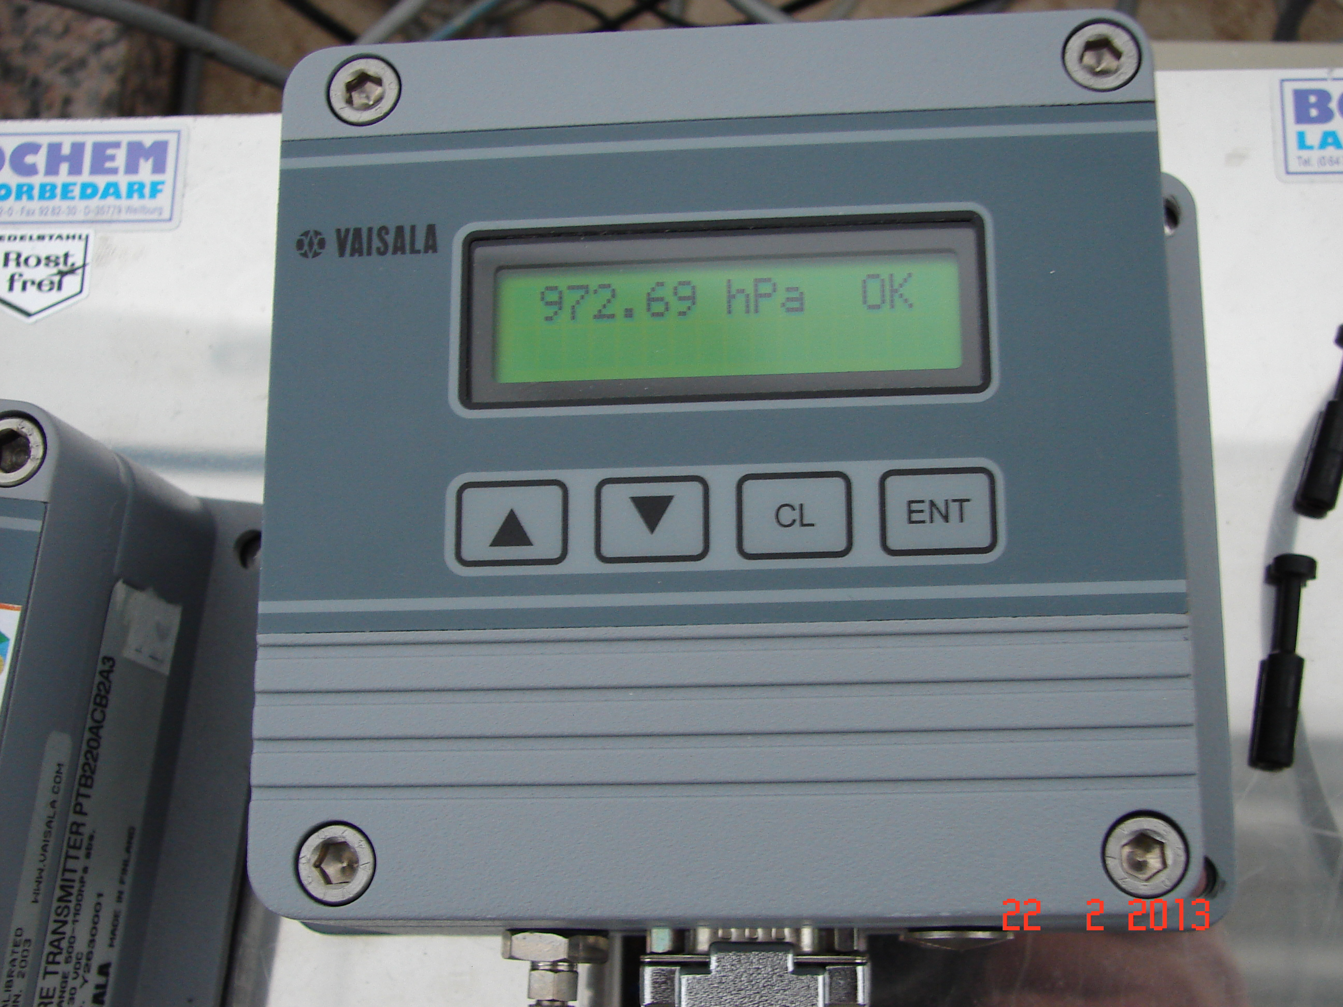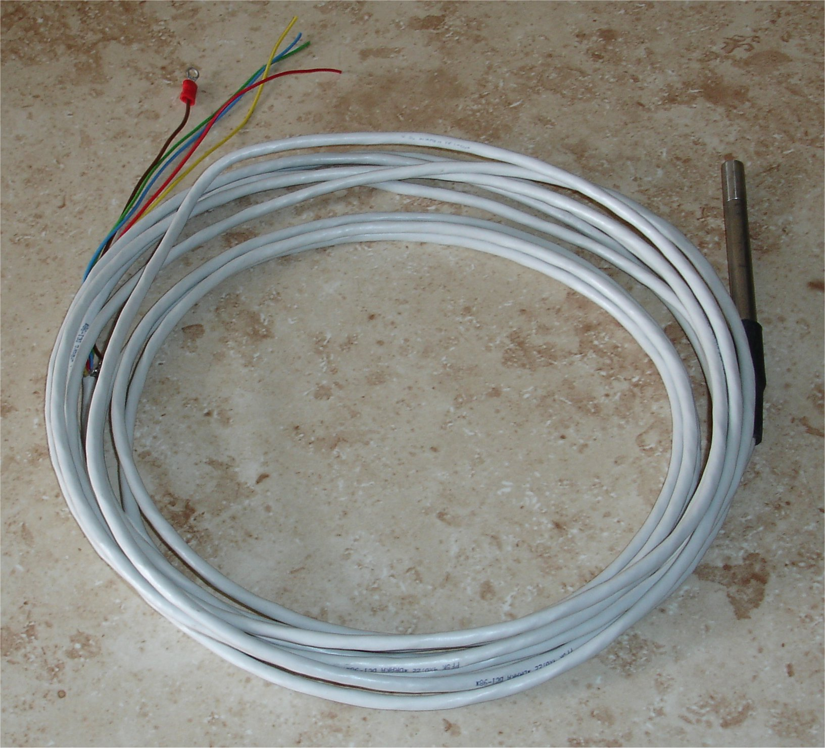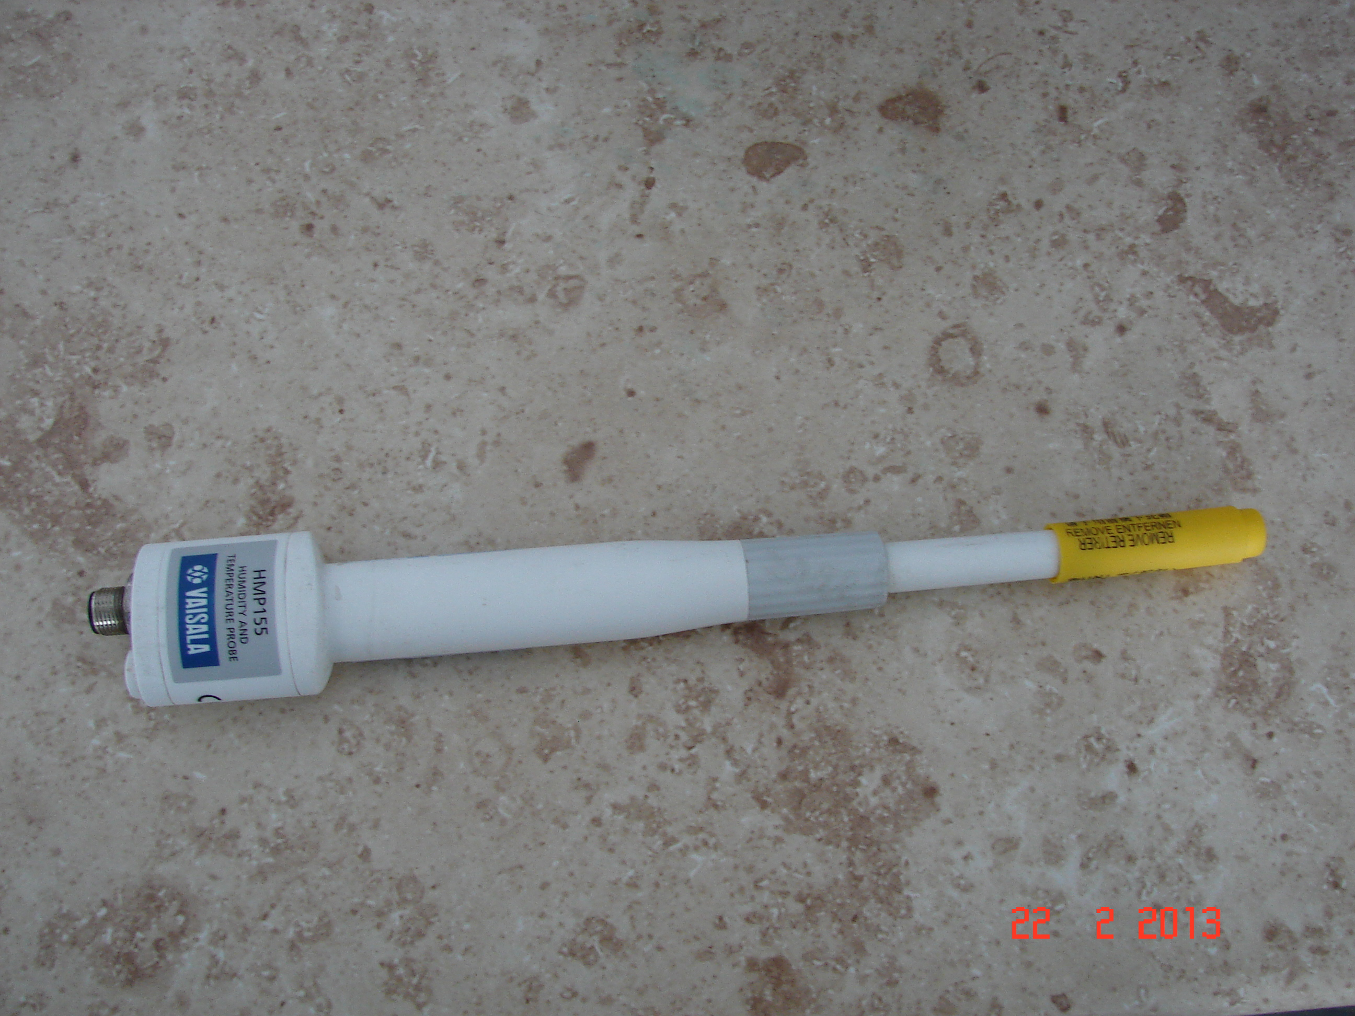

The invitation letter to PRs will be issued (together with calibration capability questionnaire for Meteo services) in one or two months time.

.

Lab5
RIC ARSO
Ljubljana
RIC
Meteo France
RIC Bratislava
Lab2
Lab4
Lab3
Lab1
Lab
10
Lab9
Lab8
Lab7
Lab6
Lab
11
Lab
12
Lab
13
Lab
14

The ILC could be expanded to other interested RICs or Meteo services worldwide.

