**Interlaboratory Comparison (ILC) in RA-II, V and VI**

Kouichi Nakashima1, Ferdinand Barcenas2, Gaber Beges3, Ian Dollery4, Drago Groselj5, Andrea Merlone6, Nan Xuejing7, Satoshi Hagiya1, Hiroumi Shigeoka1

1 Japan Meteorological Agency, Japan (JMA, RIC Tsukuba, RA-II)

2 Philippine Atmospheric, Geophysical and Astronomical Services, Philippines

(PAGASA, RIC Manila, RA-V)

3 University of Ljubljana, Faculty of Electrical Engineering, Slovenia (UL-FE, RA-VI)

4 Bureau of Meteorology, Australia (BoM, RIC Melbourne, RA-V)

5 Slovenian Environment Agency, Slovenia (ARSO, RIC Ljubljana, RA-VI)

6 Istituto Nazionale di Ricerca Metrologica, Italy (INRiM)

7 China Meteorological Administration, China (CMA, RIC Beijing, RA-II)

**Abstract**

Based on the crucial nature of technical competence conformable to ISO/IEC17025 (General requirements for the competence of testing and calibration laboratories) in laboratory work, the Terms of Reference of WMO Regional Instrument Centres (RICs) requires RICs to organize interlaboratory comparison (ILC).

In this regard, the first ILC in WMO Regional Association (RA) II (Asia) was started in early 2018. The Japan Meteorological Agency (JMA) coordinates the initiative with laboratories in RA II, V (South-West Pacific) and VI (Europe) : RIC Tsukuba (Japan), RIC Beijing (China), RIC Melbourne (Australia), RIC Manila (the Philippines), RIC Ljubljana (Slovenia) and the University of Ljubljana (Slovenia). The ILC follows RA VI initiative conducted within the MeteoMet project, to prepare the procedure and the protocol for the ILC. The ILC was organized following outcomes of the MeteoMet project, coordinated by RIC Ljubljana and the University of Ljubljana, and uses the same measurement equipment.

JMA plans to summarize the results of the new ILC in a WMO IOM Report, which will be the first of its kind for RA II. The intercomparison is expected to confirm the calibration capability of RICs in different regions and increase the reliability of their observation data.

1. **Introduction**

ILC is highly effective in determining technical competence and monitoring measurement quality, as required for the acquisition and maintenance of ISO/IEC 17025 accreditation. The Terms of Reference for RICs also state that RICs must participate in or organize interlaboratory comparison of standard calibration equipment and methods.

However, no ILC between RICs in RA II and RA V has yet been conducted. RIC Tsukuba (RA II) conducted a trial ILC with RIC Manila (RA V) in 2016, but no official results were published. RIC Melbourne (RA V) conducted an ILC initiative with Meteo France (RIC in RA VI) in 2008.

Discussions on ILC between RIC Tsukuba and RA VI began in May 2017, and RIC Tsukuba confirmed its intention to participate in ILC for RICs in RA II and V. Extensive discussions were held among the partners in this ILC toward the finalization of a related Memorandum of Cooperation (MOC) and an ILC protocol. After agreement was reached, an invitation letter was issued by WMO to all potential participants in February 2018. The ILC was officially approved and implemented in March 2018 once all partners had signed the MOC. This was the first official ILC among RICs in RA II and RA V except for RIC Melbourne.

This ILC is an extension of the similar interlaboratory comparison conducted in RA VI according with a protocol and procedure which was prepared in scope of European Metrology Research Project, ENV58 MeteoMet2 and accepted by WMO. The comparison in RA VI, titled “MM-ILC-2015-THP”, was conducted among 18 NMHSs in RA VI and MeteoMet2 project partner in 2016 focused on temperature, humidity and pressure measurements. Results of the comparison were published as an IOM report No. 128.

The results of the completed ILC will be delivered in an IOM report following the example of MM-ILC-2015-THP. From a WMO perspective, ILC reporting in line with MM-ILC-2015-THP content is expected to be highly beneficial for its potential to support worldwide linkage of results.

This ILC is organized by RIC Tsukuba with participation by RIC Ljubljana (RA VI), the University of Ljubljana, Faculty of Electrical Engineering (UL-FE) (RA VI), RIC Tsukuba (RA II), RIC Beijing (RA II), RIC Melbourne (RA V) and RIC Manila (RA V), and related equipment was provided by UL-FE and RIC Ljubljana. Coordination on the European side is provided by UL-FE. INRiM is involved as a partner institution associated with activities relating to the MeteoMet project but not playing a direct part in the ILC.

1. **Activities and related scheduling**

Related ILC activities and scheduling are shown in Tables 1 and 2. Details of associated equipment, calibration, reference-value determination and shipping procedures are described in the agreed ILC protocol (WMO-MM-ILC-2018-THP-2), which essentially follows the principles of MM-ILC-2015-THP and the requirements of the ISO/IEC 17043:2010 standard.

Table 1: Activities

|  |  |  |  |
| --- | --- | --- | --- |
| **Activity** | **Activity description** | **Partners involved** | **Month**  **(Details are in the Table 2.)** |
| A1 | ATA Carnet preparation | UL-FE | Feb 2018 |
| A2 | Measurements/calibration of the equipment | UL-FE | Feb 2018 |
| A3 | Measurements/calibration of the equipment | ARSO | Mar 2018 |
| A4 | Shipping from UL-FE to JMA | JMA, UL-FE | Mar 2018 |
| A5 | Measurements/calibration of the equipment & shipping to the next participant laboratory | JMA | Mar/Apr 2018 |
| A6 | Measurements/calibration of the equipment & shipping to the next participant laboratory | BoM | May/Jun 2018 |
| A7 | Measurements/calibration of the equipment & shipping to the next participant laboratory | PAGASA | Jun/Jul 2018 |
| A8 | Measurements/calibration of the equipment & shipping to the next participant laboratory | CMA | Aug/Sep 2018 |
| A9 | Measurements/calibration of the equipment & shipping to the next participant laboratory | JMA | Sep/Oct 2018 |
| A10 | Shipping from JMA to UL-FE | JMA, UL-FE | Nov 2018 |
| A11 | Measurements/calibration of the equipment | UL-FE | Nov 2018 |
| A12 | Measurements/calibration of the equipment | ARSO | Nov 2018 |
| A13 | Preparation of ILC report | JMA | Dec 2018 - Feb 2019 |
| A14 | Approval of ILC results and if all participants approve, the results are treated as non-anonymous | All participants | Dec 2018 - Feb 2019 |
| A15 | The ILC results correlation with the RA-VI (MM-ILC-2015-THP) results and preparation of final ILC report | JMA, (UL-FE if needed/approved) | Dec 2018 - Feb 2019 |
| A16 | Submission of the report to WMO | JMA | in 2019 |
| A17 | Presentation of results at CCT-BIPM | INRiM | End of ILC and 2019 CCT XXIV meeting |
| A18 | Publication of the ILC results in a Scientific Journal, conference | UL-FE, All participants | in 2019 |

Table 2: Schedule

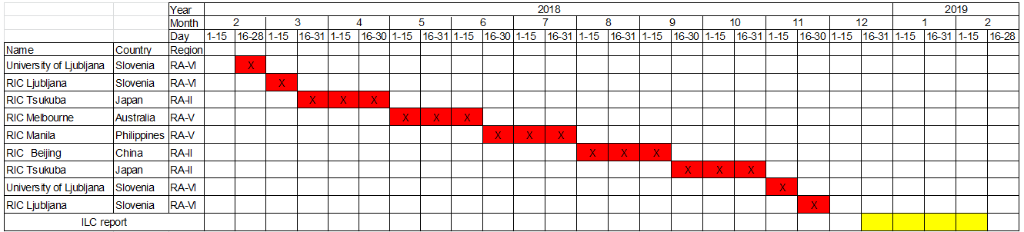

1. **Equipment, measurement and transportation**

The details of the equipment and measuring points for this ILC are shown in Table 3.

Table 3: Details of equipment and measuring points



Participants bear the costs of customs and transportation inside the country, and cover expenses involved in shipping equipment to the next destination. RIC Tsukuba covers the costs of transportation from and back to Europe. ATA Carnet documentation is used for customs clearance to simplify transport within signatory countries, and short-term import procedures are implemented in non-signatory countries. ATA Carnet documentation for equipment in this case is created by UL-FE as the owner of the majority of the equipment. The routing plan is shown in Figure 1.

Participants ensure that equipment is covered by insurance within the responsibility of its transportation.

Methods of measurement and calibration applied by each participant are described in the ILC protocol. The results are delivered to RIC Tsukuba within four weeks of measuring completion.

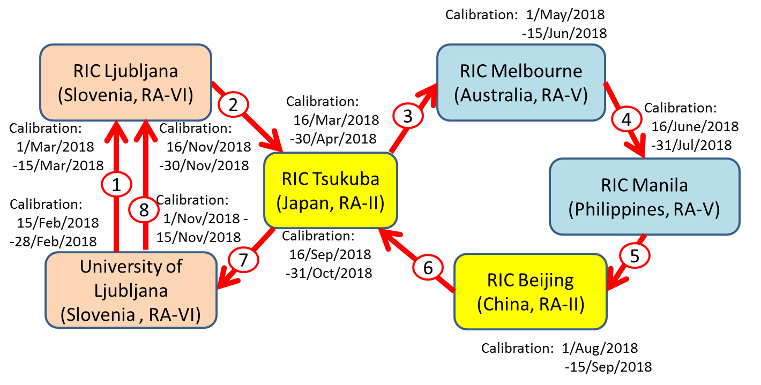

Figure1: Routing plan

**4. Results and reporting**

Equipment drift will be evaluated via pre- and post-calibration by RIC Ljubljana (RA VI), UL-FE (RA VI) and RIC Tsukuba (RA II) in order to identify any changes that may occur during transportation and handling. Once the ILC measurement is complete, RIC Tsukuba will conduct En number-based evaluation and report the outcomes to participants. The reference values used to calculate the results are defined by the weighted mean of RIC Tsukuba, UL-FE and RIC Ljubljana values.

ILC results are expected to correlate with those of MM-ILC-2015-THP, and will be submitted to WMO for issuance in an IOM report. The outcomes will also be presented to the CCT1 Working Group for Environment and at the CCT plenary at BIPM2 as a key activity in line with WMO’s signing of the MRA in 2010.

The ILC results for individual participants will in principle be published anonymously, but may be made non-anonymous with the agreement of all participants. In this regard, RIC Tsukuba will determine participants’ wishes regarding anonymity before the report is created. All partners will collaborate in writing an article on the results of the whole ILC (RA II, RA V and RA VI) to be submitted for publication in a scientific journal.

**5. Conclusion**

This will be the first official ILC for RICs in RA II and RIC Manila, and the first to be conducted among three regions. The ILC report, which will include correlation with the comparison in RA VI, is expected to be highly beneficial in its potential for worldwide linkage of results. The outcomes will help to clarify the calibration capability of RICs in different regions and increase the reliability of their observation data.

**6. Reference**

J. Duvernoy (France) et al. (2008): Intercomparison between Meteo-France (RA-VI RIC) and Australian Bureau of Meteorology (RA-V RIC). TECO 2008.

D. Groselj (Slovenia) et al.(2016): Concept of interlaboratory comparison in RA-VI. CIMO TECO 2016.

A. Merlone (Italy) et al. (2018): The MeteoMet2 project-highlights and results. Measurement Science and Technology 29, No.2, 025802.

J. Bojkovski (Slovenia) et al. (2018): Interlaboratory Comparison in the field of Temperature, Humidity and Pressure, in the WMO Regional Association VI (MM-ILC-2015-THP). WMO IOM Report, No.128.

1 Consultative Committee for Thermometry of the International Committee for weights and measures (Comité International des Poids et Mesures)

2 Bureau International des Poids et Mesures