Excerpt from the Joint Meeting of the
CIMO Expert Team on Surface-Based Instrument Intercomparisons and Calibration Methods
and
International Organizing Committee (IOC) on Surface-Based Instrument Intercomparisons
Trappes, France, 24-28 November 2003

- LABORATORY INTERCOMPARISONS OF RAINFALL INTENSITY (RI) GAUGES, IN TWO INDEPENDENT CERTIFIED LABORATORIES
In addition to the general rules and procedures for WMO Intercomparisons as defined in the Guide to Instruments and Methods of Observation, WMO - No.8, Part III, Chapter 5, Annex 5.A and 5.B, the ET/IOC agreed to the following rules and procedures:
  - Main objective, place(s), date and duration
    - In defining the main objectives, the meeting took into account proposals made by the Expert Meeting on Rainfall Intensity Measurements (Bratislava, Slovak Republic, 23-25 April 2001) that were endorsed by CIMO-XIII. These proposals were further elaborated taking into account present knowledge and capabilities of recognized laboratories.
Objectives
    - The main objective of this laboratory intercomparison is to test the performances of catchment type rainfall intensity gauges of different measuring principles under documented conditions.
    - ET/IOC agreed on further objectives as follows:
- To define a standardized procedure for laboratory calibration of catchment type rain gauges, including uncertainty of laboratory testing devices within the range from 2 to 2000 mm/h.
- To evaluate the performance of the instruments under test.
- To comment on the need to proceed with a field intercomparison of catchment type of rainfall intensity gauges.
- To identify and recommend the most suitable method and equipment for reference purposes within the field intercomparison of catching and non-catching types of gauges.
- To provide information on different measurement systems relevant to improving the homogeneity of rainfall time series with special consideration given to high rainfall intensities.
- To make available the executive summary of the intercomparison within three months after the end of the testing period and to publish the Final Report of the intercomparison within the WMO IOM Report Series within 9 months after the testing is finished;
- To draft recommendations for consideration by CIMO-XIV.
Place
    - The Italian Meteorological Service (IMS) presented an invitation to host the WMO Laboratory Intercomparison of Rainfall Intensity (RI) gauges at the laboratory of the Department of Environmental Engineering (DIAM) of the University of Genova. The Director of DIAM presented a letter of willingness to host the intercomparison at the conditions specified in this document.
    - Other two potential candidate laboratories have been identified during the meeting as being the Météo France and the Royal Netherlands Meteorological Institute (KNMI).
    - Mr Lanza, on behalf of the Italian Meteorological Service, presented a description of the proposed intercomparison site and facilities. The ET/IOC examined the suitability of the proposed site and facilities, and agreed on using the DIAM laboratory for the intercomparison.
    - Mr Leroy, on behalf of Météo France, presented the potential intercomparison site, including the infrastructure available. Participants paid a visit to laboratories in Trappes and examined testing devices to be used for intercomparison. The ET/IOC agreed on the suitability of Trappes laboratories for the intercomparison. Mr Leroy informed the meeting that Météo France would soon inform WMO on its decision to host laboratory intercomparison of RI gauges in Trappes.
    - Mr van der Meulen, on behalf of KNMI, presented facilities of KNMI laboratories and their appropriateness for the intercomparison. The ET/IOC examined the suitability of the proposed site and facilities, and tentatively agreed on using the KNMI laboratory for the intercomparison. In this regard, Mr van der Meulen proposed that WMO requests PR of Netherlands with WMO to consider hosting the laboratory intercomparison of RI gauges in KNMI laboratories.
    - In discussing the overall management of the laboratory intercomparisons, the ET/IOC nominated Mr Luca Lanza as the Project Leader (PL) for the laboratory intercomparisons of RI gauges, responsible for the overall laboratory intercomparisons’ management.
    - Representatives of the above laboratories informed the meeting on the names of Site Managers (SMs) responsible for the proper conduct of the intercomparison. The names of SMs will be confirmed to WMO later by the PRs of host countries. The following SMs were suggested by representatives of the above laboratories:
    - Mr Luigi Stagi, DIAM laboratory, Italy
    - Mr Christophe Alexandropoulos, Météo France, France
    - Mr André van Londen, KNMI, Netherlands
Date and duration
    - The meeting considered the earliest possible starting dates given the restrictions of sending appropriate letters, awaiting responses and allowing for the decision process of which instruments will be included. In consultation with the PL, the ET/IOC decided that the laboratory intercomparison will begin no earlier than September 15th, 2004 and is expected to continue through the end of March 2005.

  - Procedures for intercomparisons

Conditions for participation, type of instruments
    - The meeting considered technical and operational aspects, desirable features and preferences, restrictions, priorities and descriptions of different instrument types for the laboratory intercomparison. In this regard, the meeting agreed on the following conditions for participation:
- Only catchment type of instruments that are currently being used in national networks or being considered for use in national networks will be considered.
- Only instruments that are capable of measuring rainfall intensity of at least 200 mm/h at a time resolution of 1 minute will be accepted.
- Preference will be given to instruments with uncertainty less than 5% over the range of measurement.
- Appropriate documentation on participating instruments (see item 4.2.10) must be provided in advance in order to evaluate the feasibility of the test.
- Once the intercomparison begins, assistance in operation must be provided by participants, if requested by SM, to allow the test to be carried out properly.
- Due to laboratory acquisition system restrictions, only instruments with digital output (serial or pulse) can be tested. Instruments with other types of outputs may only be accepted with appropriate adaptor interface.
- To achieve more confidence in the results, preferences will be given to testing of two identical instruments, however this is not a condition for participation.
    - Due to limited resources, the number of instruments will be limited to a maximum of twelve pairs of gauges. In case of higher demand, based on the proposal of the project leader, the ET/IOC will select instruments taking into account the following criteria:
- Instruments will be selected in a way to cover a variety of measurement techniques;
- Preference will be given to new promising measuring techniques;
- Preference will be given to instruments that are widely used.
    - It will be the responsibility of the participating Members to calibrate their instruments against any suitable recognized standard before shipment and to provide appropriate calibration certificates. Participants are requested to provide, if possible, two identical instruments of each type in order to increase confidence in the data.
    - The ET/IOC agreed on a questionnaire to be sent to PRs in order to obtain the required information on each instrument proposed for the intercomparison (see Appendix I). The PL shall provide further detail and prepare the final version of the questionnaire as soon as possible. Participants will be requested to specify very clearly the hardware connections and software characteristics in their reply and to supply adequate documentation. A detailed questionnaire (see Questionnaire II in Appendix I) will be sent to potential participants before the final selection, as technical constraints may restrict the selection.
    - Participants are requested to arrange for the transportation of their instruments between the three laboratories involved according to a schedule to be provided by the PL in coordination with the SMs by the end of June 2004. It was estimated that the intercomparison of one batch of instruments at one intercomparison site would last approximately two months, after which instruments will have to be transported by participants to a next intercomparison site and so forth.
    - The ET/IOC requested Secretariat to invite, at the earliest convenience, Members of WMO and Association of the Hydro-Meteorological Equipment Industry (HMEI) to participate in the laboratory intercomparisons and to propose instruments to be tested. The invitation should include all relevant information agreed by this meeting.
    - All further contacts with the participants will be handled by PL and SMs.

Responsibilities of participants
    - Appropriate documentation including all detailed instructions and manuals needed for installation, operation, calibration, and routine maintenance have to be provided in advance in order to evaluate the feasibility of the test.
    - The presence of participant’s staff is not required during the intercomparison, however assistance in operation has to be provided on request in order to allow the test to be carried out properly and with minimum effort by the host country.

Host country support
    - A reasonable amount of auxiliary equipment for installation in the laboratory will be provided by the host country.
    - Necessary electrical power for all instruments shall be provided. The participants will be informed of the network voltage and frequency and their stability. The connection of instruments to the data acquisition system and the power supply will be done in collaboration with the participants. The Site Manager will agree with each participant on the provision, by the participant or the host country, of power and signal cables of adequate length (and with appropriate connectors).
    - The host country will provide information on accommodation, travel, local transport, daily logistic support, etc.

Host country servicing
    - The host country will provide normal operator servicing for each instrument, such as cleaning, and routine adjustments as specified in the participant’s operating instructions;
    - The SM will maintain regular records of performance of all equipment participating in the intercomparison in a log. This log should contain notes on everything at the site that may have an effect on the intercomparison, all events concerning participating equipment, and all events concerning equipment and facilities provided by the host country.

Rules during the intercomparison
    - The PL shall exercise general control of the intercomparison on behalf of the ET/IOC.
    - No changes to the equipment hardware or software shall be permitted without the concurrence of the PL.
    - Minor repairs, such as the replacement of fuses, will be allowed with the concurrence of the SM, and recorded in a log as from Item 4.2.17.
    - Any problems that arise and concern the participants’ equipment shall be addressed to the PL.

  - Data acquisition, processing and analysis methodology and publication of results

Equipment set-up
    - The layout of the testing devices and the instruments’ installation in the three proposed laboratories has been evaluated and agreed by the ET/IOC, according to the following scheme:

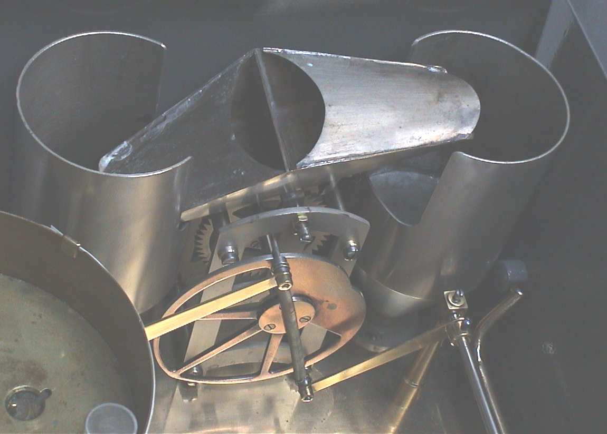
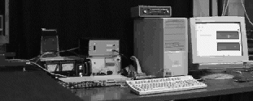
Water source
Water collector
Constant flow rate
Weighing device
Weighing device
Fixed head or pump
Computer control
Rain gauge

    - Each laboratory will use its own calibration system, based on the same principle:
- Generation of a constant flow.
- Measurement of the flow by weighting the used water over a given period of time.
- Measurement of the output of the tested instrument at regular periods of time or when a pulse occurs (typical for a majority of tipping-bucket rain gauges).
The calibration system and the way it is used, is designed to get an uncertainty below 1%. The calculation of the flow rate is based on the measurements of mass and time. The measurement of mass is made with at least one order of magnitude better than 1%. Duration of the test will be large enough to guarantee an uncertainty lower than 1%, taking into account the measurement principle of the sensor tested and the requirement to test instrument based on rainfall intensity over periods of 1 minute. Rainfall intensity values, from 2 mm/h up to 2000 mm/h, will be generated.
    - Full documentation about the layout of the instrument installation shall be prepared by the SMs and provided to the chairman of ET/IOC by the end of March 2004.
    - The PL will consider and approve, if acceptable, on behalf of the IOC, any specific request of participants for equipment installation.

Standards and references
    - The reference rainfall rate is determined by the equipment described under Item 4.3.1. The calibration of this instrument can be traced to international standards as far as the measurement of mass and time are concerned. A description and specification of the calibration procedures including uncertainty estimates of calibration will be provided by the laboratories to the chairman of ET/IOC before the end of March 2004.

Related observations and measurements
    - The ET/IOC agreed on related measurements at the laboratories during the intercomparisons. The temperature of the water will be measured by thermometer with uncertainty of 0.5 °C maximum. The water temperature will be measured at the beginning and the end of the test and recorded in a suitable format. Ambient humidity, air temperature and pressure will also be measured; uncertainty of these measurements will be provided. Vibration will not be measured, however all precautions will be taken to assure that vibrations do not influence the results.

Data acquisition system
    - The host country shall provide the necessary data acquisition system capable of recording the required pulse and digital (serial) signals from all participating instruments.
    - The data acquisition system hardware and software will be well tested before the comparison is started and measures will be taken to prevent gaps in the data record during the intercomparison period.

Data acquisition methodology
    - The appropriate data acquisition procedure for the laboratory intercomparisons is defined as follows:
      - Measurements based on constant flows:
- Whenever possible, each rain gauge will be tested over the range of intensities declared by the manufacturer by generating a set of at least seven fixed water flow rates that are compared with the recording of the instrument under test.
- At any given constant flow rate, the duration of the single test is determined based on the type of instrument under examination, and will allow reducing the sampling error to less than 1%.
- Per each of the seven constant flow rates generated, the measured rainfall rate I_{r} is recorded based on the output of the instrument under test, while the reference rainfall rate I (the “true” rainfall intensity) is determined by weighting the total amount of water actually given as input to the instrument, using an independent device.
- An error curve is determined by interpolating the seven data obtained above, using a second order polynomial. Parameters will be derived as follows:
Polynomial 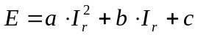
- Five tests will be performed in the same conditions, resulting in obtaining five different calibration curves. The best performing and the worst performing curves will be discarded and an average curve is obtained from the remaining three tests.
      - Measurements to determine the step response of weighing gauges:
- The internal software of weighing gauges uses averaging algorithms for purposes of reducing possible errors induced by environmental factors. (vibrations due to wind etc.) The time period of this averaging algorithms can influence the result of the measurement heavily especially for short high intensity rainfalls. High peaks of rainfall intensity can be " smoothed" by the averaging procedure.
- It should be proved, that the basic requirement of the intercomparison, namely the time resolution of 1 minute can be fulfilled by the tested weighing gauges also when using averaging algorithms.
- The step response of the weighing gauges will be measured by switching between two different constant flows, namely from flow 0 mm/h and 200 mm/h and back to 0 mm/h. The constant flow will be applied until the output signal of the weighing raingauge is stabilized. The time resolution of the measurement should be higher as 1 minute, e.g. 10 seconds.

    - An example of the final error curves to be provided per each investigated instrument is in the figure below for a sample rain gauge.

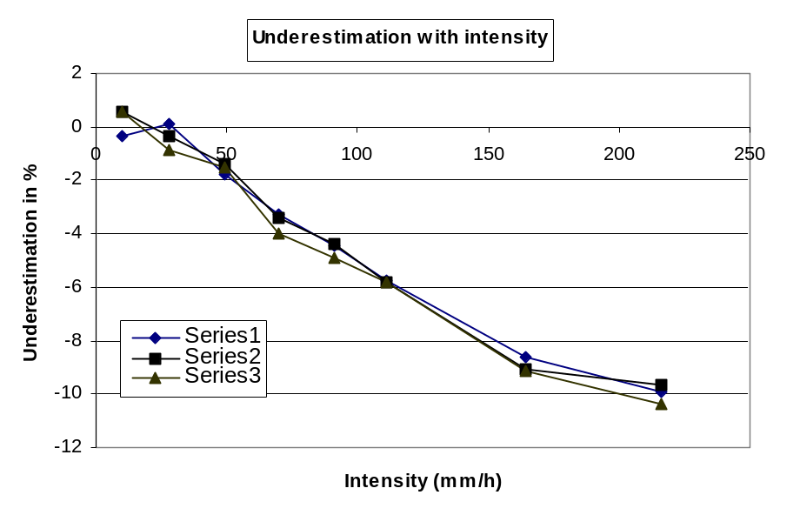

Schedule of intercomparison
    - The ET/IOC agreed on the time schedule of the laboratory intercomparison as synthesized in the following time chart.
Year | 2004 |  |  |  |  |  |  |  |  |  |  |  |  |  |  |  | 2005
Month | 1 | 2 | 3 | 4 | 5 | 6 | 7 | 8 | 9 |  | 10 |  | 11 |  | 12 |  | 1 |  | 2 |  | 3 |  | 4 |  | 5 |  | 6 |  | 7 |  | 8 |  | 9 |  | 10 |  | 11 |  | 12

Invitation to Members
Selection of instruments
Shipping of instruments and installation
Testing period
SM report to PL
Executive summary
Draft Final Report
Final Report

Database and data availability
    - All essential data of the intercomparison, including related environmental data, will be stored in a database for further analysis under the supervision of the PL. He will also define, in collaboration with the SMs, a format for all data, including those reported by participants during the intercomparison. A format does not need to be unique for all three laboratories, provided compatibility is ensured.
    - After completion of the intercomparison, the host country will provide to each participating Member, if requested, full dataset related to participating instrument(s). This dataset will also contain related environmental, and reference data.

Data analysis
    - Based on the Site Managers proposals, the PL will prepare a framework for data analysis and processing and for the presentation of results to be submitted for approval by the chairman of the ET/IOC by May 2004. This will include a comprehensive description of statistical methods to be used and correspond to the intercomparison objectives, according to the data acquisition methodology described under item 4.3.9 and 4.3.10.
    - The SMs will be responsible for the data processing and analysis. The PL will, as early as possible, verify the appropriateness of the selected analysis procedures and, as necessary, prepare interim reports for comment by the members of the ET/IOC. Changes will be considered, as necessary, on the basis of these reviews.
    - After completion of the intercomparison, the ET/IOC will review the results and analysis prepared by the PL in the form of an executive summary to be provided by the end of June 2005.

Publication of results
    - The SMs will submit to the PL, not later than by the end of April 2005, the results of the intercomparisons performed, detailed information describing the facilities used, data processing, analysis and storage at each laboratory according to the framework defined under item 4.3.14.
    - The ET/IOC agreed on the following procedures for approval of the final report:
a) The draft final report will be prepared by the PL before the end of July 2005 and submitted by electronic mail to all ET/IOC members and, if appropriate, also to participating Members and the HMEI Association.
b) Comments and amendments will be sent back to the PL by the end of October 2005, with a copy to the chairman of the ET/IOC.
c) In case of only minor amendments proposed, the report is completed by the PL. Final report, approved by the chairman of ET/IOC, will be sent to the WMO Secretariat for publication before the end of December 2005.
d) In case of major amendments or if serious problems arise that cannot be resolved by correspondence, an additional meeting of the ET/IOC will be convened in order to resolve deficiencies and have a Final Report not later than May 2006.
    - The ET/IOC agreed that any approved intermediate and final results could be presented by the PL with the SMs at technical conferences, or in journals and other technical/scientific publications. A paper will be prepared for the nearest CIMO/TECO event.
__________________

