SWISS CONTRIBUTION TO THE ANNUAL JOINT WMO
TECHNICAL PROGRESS REPORT ON THE GLOBAL DATA-PROCESSING AND FORECASTING SYSTEM (GDPFS) AND
NUMERICAL WEATHER PREDICTION RESEARCH ACTIVITIES (NWP) FOR 2009

Summary of highlights
AUTHOR: Alex Rubli
MeteoSwiss is running limited-area models at two spatial scales: The regional model COSMO-7 with a horizontal resolution of about 6.6.km is driven by the ECMWF global model IFS. The local model COSMO-2, having a horizontal grid spacing of about 2.2 km, is nested in COSMO-7. Furthermore MeteoSwiss contributes to the improvement of the limited-area ensemble prediction system COSMO-LEPS and to COSMO priority projects, e.g. KENDA (Km-scale Ensemble-based Data Assimilation).
MeteoSwiss issues long range forecasts on the basis of the ECMWF seasonal forecast model “System 3”. The model data are post-processed, evaluated and disseminated by MeteoSwiss. The operational products include climagrams, probability charts and tercile data for surface temperature, precipitation and geopotential height, which are available for customers
MeteoSwiss has developed a wide range of meteorological and climatological applications. One of the ongoing projects has the objective to develop methods to exploit advances in the areas of building technologies, weather forecasting, and model predictive control of dynamical systems for improving the indoor climate control of buildings. An other project is aimed at delivering a better wind and energy forecast for wind farms at specific locations in Switzerland.
In the next four years the current MeteoSwiss data processing system shall be developed into a national „Meteorological and Climate Data Warehouse“. The integration of different measurement technologies and platforms is envisaged, as well as the integration of measuring systems of public and private partners. Measured data und metadata will be integrated.
In line with its relevant strategy MeteoSwiss is continuously investing in the modernization of the ICT infrastructure: A new line of HP desktop PCs has been introduced to replace Dell PCs and Sun Intel workstations. These clients are used by forecasters and administrative personnel likewise. Sun Sparc workstations are still in operation but are due to being phased out in the years to come. The server infrastructure mainly consists of Sun Solaris servers and a growing HP Cluster Windows server environment. The Sun Solaris servers are continuously renewed and step-by-step migrated to the Solaris 10 Operating System.

Equipment in use at the Centre
AUTHOR: Stefan Sandmeier
For the client infrastructure, a new line of HP desktop PCs has been introduced to replace Dell PCs and Sun Intel workstations. These clients are used by forecasters and administrative personnel likewise. Sun Sparc workstations are still in operation but are due to being phased out in the years to come.
The server infrastructure mainly consists of Sun Solaris servers and a growing HP Cluster Windows server environment. The Sun Solaris servers are continuously renewed and step-by-step migrated to the Solaris 10 Operating System. The Hitachi data storage systems and the CISCO based computer network were partly enhanced. With the renewal of the internet mail server infrastructure, the increasing flood of spams is handled more efficiently.
A new cooling infrastructure was installed at the main computer center of MeteoSwiss to ensure proper temperature and humidity conditions. In the aviation forecast center at Zurich Airport, we moved the local server equipment to a different room in order to leverage security.
On the internet, a new web shop offering a wide variety of weather products was launched (https://shop.meteoswiss.ch/).

Data and Products from GTS in use
AUTHOR: Marlene Kube
At present nearly all observational data from GTS are used. Further in use are GRIB data from Bracknell, Washington and Offenbach as well as T4-charts from Bracknell and Washington. Additionally most of MOTNE and OPMET data are used as well.
The number of incoming messages of the different types has increased since 2008, especially for aviation and BUFR messages. The number of METAR messages has doubled. The number of T4 increased enormously. Typical figures on message input for 24 hours are:
SYNOP, SYNOP Ship | 31'000
TEMP Part A + B | 4'300
PILOT Part A + B | 1'100
METAR | 110'000
TAF short/long | 40'000
AIREP/AMDAR | 4'700
GRIB | 30'400
T4 (BUFR, FAXG3) | 27’600
BATHY/TESAC | 6'500
DRIFTER | 5'000

Forecasting system

System run schedule and forecast ranges
AUTHOR: Philippe Steiner
Medium and extended range forecasting are based on external NWP sources, but MeteoSwiss runs its own short-range forecasting system. The core of this system is the non-hydrostatic Local Model COSMO (of the Consortium for Small-Scale Modelling currently composed of the national weather services of Germany, Switzerland, Italy, Greece, Poland ,Romania and Russia – see www.cosmo-model.org).
On February 27th, 2008, MeteoSwiss operationally introduced its new COSMO-suite, in which the model is running at two spatial scales: The regional model COSMO-7 with a horizontal resolution of about 6.6.km is driven by the ECMWF global model IFS. The local model COSMO-2, having a horizontal grid spacing of about 2.2 km, is nested in COSMO-7. The nesting of NWP models is illustrated in figure 4.1.
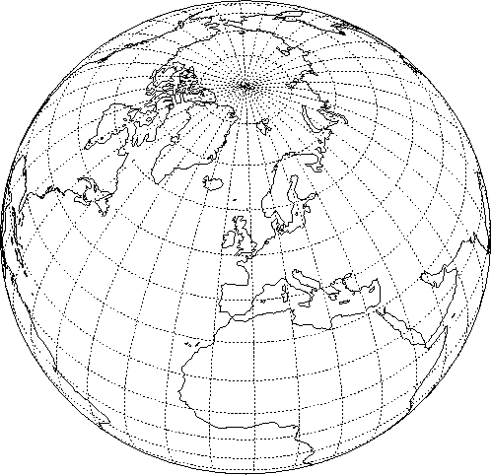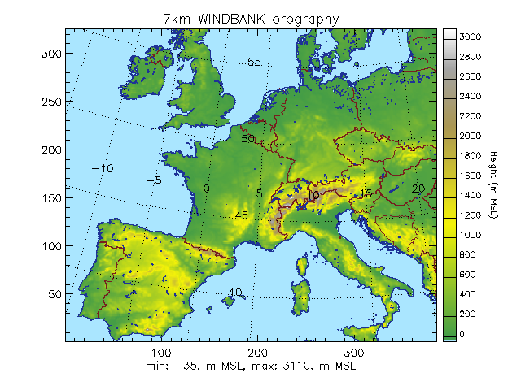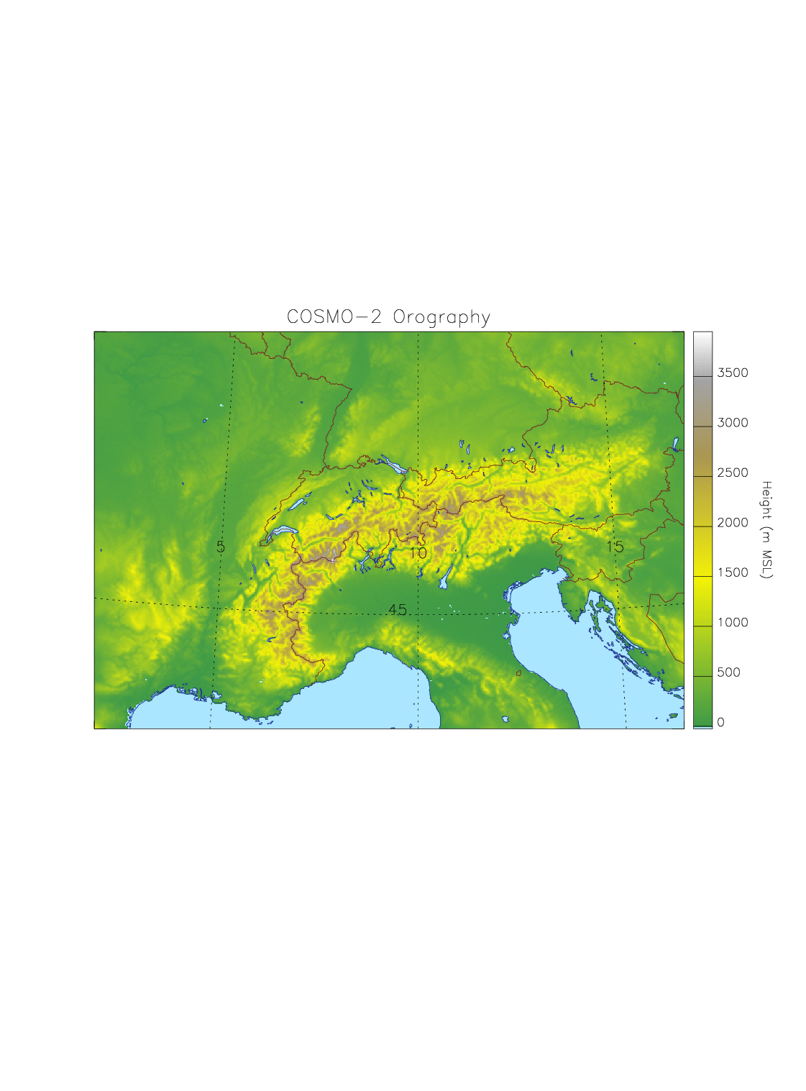
ECMWF IFS
COSMO-7
COSMO-2
Figure 4.1 new NWP system of MeteoSwiss
The primary aim of COSMO-2 is to provide forecasts from nowcasting to very short-range time scale, whereas COSMO-7 is used for the short-range time scale.
Both COSMO-7 and COSMO-2 have their own assimilation cycle, which is updated in intervals of 3 hours. 72 hours COSMO-7 forecasts are calculated, based on the 00, 06 and the 12 UTC analyses. Starting with the analysis at 00 UTC, one 24 hours COSMO-2 forecast is computed every 3 hours. The cut-off time for all forecasts is 45 minutes.
The time critical forecast products for COSMO-7 are available in about 55 minutes. For COSMO-2 they are produced approximately within 36 minutes.
An on-demand mode can be activated, e. g. in case of incident in nuclear power plants. COSMO-2 is then computed hourly with at least 4 hours assimilation and 6 hours forecast.
A sophisticated set of scripts controls the whole operational suite, and allows for a very high reliability of the system, with less than 2 % of the forecasts requiring manual intervention. This same environment is also used to run parallel suites, to validate proposed modifications to the system, and to facilitate experimentation by the modelling group.
The computing resources and expertise are provided by the Swiss National Supercomputing Centre (CSCS, see www.cscs.ch). COSMO-7 and COSMO-2 are calculated on a Cray XT4 equipped with AMD Opteron Quad Core processors, and achieve a sustained performance of 226 GFlops on 984 computational cores. Pre- and post-processing run on the service nodes of the machine. A similar machine with 688 computational cores is available as fail-over. A large multi-terabytes long term storage is used for archiving purposes and a 1 GBit/s link connects the MeteoSwiss main building with the CSCS (on the other side of the Alps!).

Medium range forecasting system (4-10 days)
AUTHOR: Philippe Steiner

Ensemble Prediction System (EPS) (Number of members, initial state, perturbation method, model(s) and number of models used, perturbation of physics, post-processing: calculation of indices, clustering)
      - In operation
MeteoSwiss does not run a medium range forecasting system, but contributes to the improvement of the limited-area ensemble prediction system COSMO-LEPS based on global ECMWF Ensemble forecasts (EPS) and on the COSMO Model. COSMO-LEPS has been developed at ARPA-SIM, Bologna, and runs operationally at ECMWF. It makes probabilistic high-resolution short to early-medium range (5.5 days) forecasts available at MeteoSwiss.
4.2.1.2 Research performed
A new method of calibrating the COSMO-LEPS forecast using reforecasts has been developed, focusing on the probabilistic warning of extreme precipitation events. Several warning products based on this method are produced. Furthermore, a more cost efficient way of using reforecasts was analysed.
4.2.1.3 Operationally available EPS products
COSMO-LEPS products are visualized in the form of probability maps, stamp maps and meteograms for various parameters. The maps complement the deterministic COSMO products, while the meteograms combine the output from both systems for a single point.
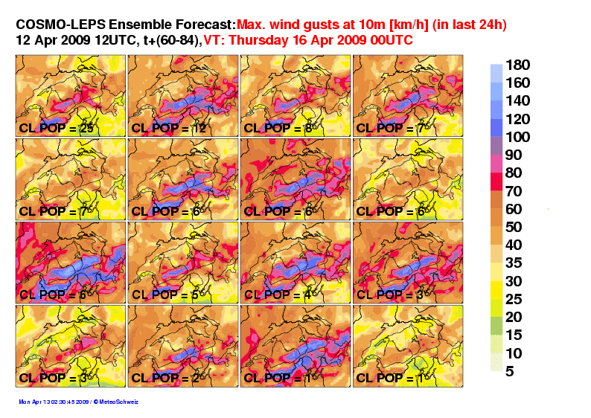
Figure 4.2: stamp map of COSMO-LEPS members for wind gusts over Switzerland.
CL_POP indicates the size of the built EPS cluster which provides the initial and boundary
conditions; it is also the weight of the member in the calculation of the probabilities.

Operational techniques for application of NWP products (MOS, PPM, KF, Expert Systems, etc.
4.2.2.1 In operation
Kalman filtering of 2m temperature on ECMWF high resolution model.
A MOS (MOSMIX) based on the ECMWF and GME models is provided by DWD.
4.2.2.2 Research performed in this field
A MOS based on analogues is under development.

Ensemble Prediction System (EPS) (Number of members, initial state, perturbation method, model(s) and number of models used, perturbation of physics, post-processing: calculation of indices, clustering)
4.2.5.1 In operation
The ECMWF EPS is mainly used.
4.2.5.2 Operationally available EPS Products
Basically everything which is available in the MARS database at ECMWF. Ensemble mean and spread are routinely presented. A clustering is performed allowing the computation of a confidence index and the provision maximum four different scenarios. The temperatures up to 15 days are Kalman filtered. Probabilities and Extreme Forecast Index are also used.

Short-range forecasting system (0-72 hrs)
AUTHOR: Philippe Steiner

Data assimilation, objective analysis and initialization
4.3.1.1 In operation
Data assimilation of COSMO is based on the nudging or Newtonian relaxation method, where the atmospheric fields are forced towards direct observations at the observation time. Balance terms are also included: (1) hydrostatic temperature increments balancing near-surface pressure analysis increments, (2) geostrophic wind increments balancing near-surface pressure analysis increments, (3) upper-air pressure increments balancing total analysis increments hydrostatically. A simple quality control using observation increments thresholds is in action.
Currently, the following conventional observations are assimilated both for COSMO-7 and COSMO-2: synop/ship/buoys (surface pressure, 2m humidity, 10m wind for stations below 100 m above msl), temp/pilot (wind, temperature and humidity profiles), airep/amdar (wind, temperature) and wind profiler data. COSMO-2 additionally assimilates radar data, using the 2-dimension latent heat nudging scheme.
MeteoSwiss uses its own snow analysis which is derived from MSG satellites combined with dense observations. A multi-layer soil model with 8 layers for energy and 6 for moisture is used; moisture is updated every 24h from IFS in the lowest levels. Finally, the vegetation and ozone fields are based on climatic values.
In addition to the MARS retrieval system, the full ECMWF decoding, quality control and database software are used on the front end machine. Non supported observations are stored in a flat file system, with a set of RUBY scripts providing minimal database-like functionalities. Observation increment statistics is monitored as an additional quality control check.
      - Research performed in this field
MeteoSwiss is currently contributing to two COSMO priority projects (see www.cosmo-model.org):
The project KENDA (Km-scale Ensemble-based Data Assimilation) aims at the devel-opment of a novel ensemble-based data assimilation system for the convective (1-3 km) scale. Current research activities at MeteoSwiss are related to the evaluation of obser-vation minus background statistics of the convection permitting COSMO model with re-spect to the Gaussian assumption. Furthermore, work has been devoted to the devel-opment of a Sequential Importance Resampling (SIR) filter (van Leeuwen, 2003), a novel Ensemble or Monte Carlo type approach that uses an ensemble of very-short range forecasts (as given by COSMO-DE-EPS of the German Weather Service) and se-lects the most likely members by comparing them to observations (Bayesian weighting). From the selected members, a new ensemble is created for the next analysis time.
The COLOBOC (COnsolidation of LOwer BOundary Conditions) project has the objec-tive to incorporate all activities related to the lower boundary conditions which have al-ready reached an advanced state, and to consolidate these developments into well tested and documented software packages readily usable by the COSMO community. Software packages comprise the database of external parameters, the soil module, the snow analysis, the urban module, and the parameterization of land surface heterogene-ity by a tile/mosaic approach, allowing the use of the same soil at different spatial scales.

Model
4.3.2.1 In operation
A thorough description of the COSMO Model itself can be found on the COSMO web site. It is a primitive equation model, non-hydrostatic, fully compressible, with no scale approximations. The prognostic variables both for COSMO-7 and COSMO-2 are the pressure perturbation, the Cartesian wind components, the temperature, the specific humidity, the liquid water content, cloud ice, rain, snow and turbulent kinetic energy. COSMO-2 furthermore uses a prognostic graupel hydrometeor class in the microphysi-cal parameterization. COSMO-7 uses the Tiedtke scheme to parameterize convection, whereas in COSMO-2 convection is parameterized by a shallow convection scheme, and the deep convection is explicitly computed.
The model equations are formulated on a rotated latitude/longitude Arakawa C-grid, with generalized terrain-following height coordinate and Lorenz vertical staggering. Fi-nite difference second order spatial discretization is applied, and time integration is based on a third order Runge-Kutta split-explicit scheme. Fourth order linear horizontal diffusion with an orographic limiter is in action. Rayleigh-damping is applied in the upper layers.
COSMO-7 is calculated on a 393 x 338 mesh with a 3/50° mesh size (about 6.6 km), on a domain covering most of Western Europe. In the vertical a 60 layers configuration is used; the vertical resolution in the lowest 2 km of the atmosphere increases from about 10 m up to 250 m. The main time step is 60 seconds. COSMO-2 is calculated on a 520x350 mesh, with a 1/50° mesh size (about 2.2 km), on a domain which is centred on the Alps. The COSMO-7 mesh is chosen in such a way that on the integration domain of COSMO-2, each COSMO-7 grid point coincides with a grid point of COSMO-2. COSMO-2 uses the same vertical configuration as COSMO-7. The main time step is 20 seconds. Table 4.1 summarizes the specifications of the new COSMO system.
 | COSMO-7 | COSMO-2
Number of grid points and levels | 393 x 338, 60L | 520x350, 60L
Horizontal mesh size | 3/50° ~ 6.6km | 1/50° ~ 2.2km
Time step | 60s | 20s
Data Assimilation | Conv. Observations | Conv. Observations + Radar
Table 4.1: Specification of COSMO-7 and COSMO-2
      - Research performed
MeteoSwiss contributes to two COSMO priority projects:
- The project UTCS (towards Unified Turbulence-shallow-Convection Scheme). aiming at parameterising boundary-layer turbulence and shallow non-precipitating convection in a unified framework, and achieving a better coupling between turbulence, convection and radiation. Research results are published in Buzzi, 2008, and Szintai and Fuhrer, 2008.
- The project CDC (conservative dynamical core) aiming at delivering a dynamical core with at least explicit conservation of mass and tailored for resolutions O(1km). Current dynamical cores (RK and LF) don’t have any explicit conservation properties for mass, momentum or energy. Resolved topography will also get steeper with increasing reso-lution and future numerical method must behave well over very steep terrain.

Operationally available numerical weather prediction products
4.3.3.1 In operation
- A suite of post processing modules is available:
- Kalman filtering of model output for 2 meter temperature and dew point temperature;
- thunderstorm prediction derived by a learning system (with the boosting method),
- probabilistic precipitation forecasts using the neighbourhood method,
- visualization software based on the ECMWF MetView package and on in-house developments at MeteoSwiss and at CSCS; static maps, 2- and 3-dimensional loops with texture based flow visualization are created;
- a trajectory model providing guidance on transport route (hot air balloons, pollutants);
- a Lagrangian particle dispersion model to calculate dispersion and deposition of radioactive materials, having also a backward mode to calculate the origin of pollutants or of pollen.
Based on these modules, a standard set of products is provided to the MeteoSwiss bench forecasters and used as guidance for short-range forecasts. In case of necessity the two last modules can be run by the on-duty forecasters at any time (on-demand mode).
Besides that a large quantity of tailor made products, based on direct model output, are disseminated to internal and external clients.
4.3.3.2 Research performed
Currently, Kalman filtering techniques for temperature, radiation, and wind data have been developed. This research is performed within the two projects OptiControl and Wiforch. OptiControl has the objective to develop methods to exploit advances in the areas of building technologies, weather forecasting, and model predictive control of dynamical systems for improving the indoor climate control of buildings. Wiforch, (WInd energy FOR Switzerland CH) aimed at delivering a better wind and energy forecast for wind farms at specific locations in Switzerland.

Nowcasting and Very Short-range Forecasting Systems (0-6 hrs)
AUTHORS: Urs Germann/Alessandro Hering/Igor Giunta

Nowcasting system in operation
4.4.1.1 Tracking and characterization of convective cells by radar (system TRT)
MeteoSwiss runs operationally the real-time object-oriented nowcasting tool TRT (Thunder-storms Radar Tracking), as a part of its severe thunderstorms nowcasting, warning and in-formation system.
For a detailed description see “WMO_GDPS-Report_2006”.
4.4.1.2 Quantitative precipitation estimation by radar (product RAIN)
The quantitative precipitation estimate (QPE) nowcasting radar product RAIN is the best radar estimation of precipitation amount on the ground in Switzerland.
For a detailed description see “WMO_GDPS-Report_2006”.
4.4.1.3 Automatic heavy precipitation alert system (system NASS)
The multiple-radar-based nowcasting application NASS is specifically designed for situations with heavy precipitation. NASS was implemented to generate automatic alerts whenever accumulated radar rainfall exceeds a predefined threshold for periods of 3, 6, 12 and 24 hours.
For a detailed description see “WMO_GDPS-Report_2006”.

Research performed in this field
4.4.2.1 Ensemble technique for radar precipitation fields (technique REAL)
As part of the WMO-WWRP forecast demonstration project MAP D-PHASE and the European concerted research action COST-731 MeteoSwiss developed an ensemble technique to characterize the residual errors in radar precipitation fields. Each member of the radar ensemble is a possible realization of the unknown true precipitation field given the observed radar field and knowledge of the space-time error structure of radar precipitation estimates. Feeding the alternative realizations into a hydrological model yields a distribution of response values, the spread of which represents the sensitivity of runoff to uncertainties in the input radar precipitation field. The presented ensemble generator is based on singular value decomposition of the error covariance matrix, stochastic simulation using the LU decomposition algorithm, and autoregressive filtering. The real-time implementation of the radar ensemble generator coupled with a semi-distributed hydrological model in the framework of MAP DPHASE is one of the first experiments of this type worldwide.
For a detailed description see Germann et al, Q. J. R. Meteorol. Soc., 135, 445-456, 2009.
4.4.2.2 Nowcasting heavy orographic precipitation using Doppler radar and radiosounding (project COST-731)
MeteoSwiss is currently developing as part of COST-731 a novel heuristic system for now-casting heavy precipitation in the Alps. The system uses as input estimates of the mesoscale wind field as derived from real-time Doppler radar measurements and information on air mass stability from radiosoundings and ground stations. Both mesoscale flow and upstream air mass stability are predictors of the amounts and geographic distribution of heavy orographic precipitation, and can therefore be exploited for nowcasting.
For a detailed description see:
Panziera L, Germann U. 2010. The relation between airflow and orographic precipitation on the southern side of the Alps as revealed by weather radar. Q. J. R. Meteorol. Soc. 136: 222–238. DOI:10.1002/qj.544
4.4.2.3 Context and Scale Oriented Thunderstorm Satellite Predictors Development
(project COALITION)
Through a 3-year fellowship funded by EUMETSAT MeteoSwiss is developping nowcasting applications into an entity-oriented model, which merges severe convection predictors re-trieved from different sources (MSG, MetOp/IASI, Weather-Radars and NWP) with evolving thunderstorm properties. The heuristic model will calculate probabilistic information about time, space and intensity evolution of severe convection for use by decision makers. Focus is given to severe storms over the European Alpine region. The project is progressing in coordination with EUMETSAT and is at prototyping stage.
4.4.2.4 Improving Preparedness and Risk Management for Flash Floods and Debris Flow Events (project IMPRINTS)
Over complex terrain such as the Alps current nowcasting systems based on Lagrangian persistence of radar precipitation fields fail to produce useful forecasts, because the orography interferes with the evolution of precipitation, in particular by means of blocking and enhancement. As part of the FP7 research project IMPRINTS, which started in January 2009, MeteoSwiss will investigate orographic forcing of precipitation and incorporate the findings into current Lagrangian persistence nowcasting systems. If successful, the resulting radar nowcasting system will be implemented in the Swiss radar data processing chain and will be extended by ensemble techniques and an algorithm for blending radar nowcasts with NWP model output.

Specialized numerical predictions
AUTHOR: Mathias Rotach

UV-Forecast
A marked increase in the incidence of skin cancers has been observed in fair-skinned populations world-wide since the early 1970s. This is strongly associated with personal habits in relation to sun exposure and its ultraviolet (UV) component, and the societal view that a tan is desirable and healthy.
The Global Solar UV Index (UVI) is a simple metric for the UV radiation level at the earth’s surface and an indicator of the potential for skin damage. It serves as an important means to raise public awareness and to alert people on the need to adopt protective measures when exposed to UV radiation.
MeteoSwiss provides daily operational UV forecasts for a variety of regions and altitudes using a par-ticular model. Input parameters for this model are the ozone forecast from IFS (ECMWF’s global model) and the cloudiness estimation of the local model of MeteoSwiss (COSMO-7).

Products (MOS, PPM, KF, Expert Systems, etc.) (as appropriate related to 4.5)
4.5.2.1 Operational trajectory and dispersion forecasts at MeteoSwiss
AUTHOR: BERND KONANTZ
From the beginning of the nineties, a comprehensive array of trajectory and dispersion models is operated by MeteoSwiss in Zurich. In case of environmental emergencies, a 24/7 service is provided for the National Emergency Operations Centre (NEOC) including information on fallout, pollutant trajectories and additional weather forecasts.
The TRAJEK (trajectory) and LPDM (Lagrange Particle Dispersion) model can be run with COSMO-2 and COSMO-7 data. The model outputs are delivered at different resolution scales from Swiss domain up to alpine and COSMO-7 (covering almost Europe) domain. MeteoSwiss is able to compute trajectory and dispersion forecasts every three hours using the high resolution model COSMO-2. Along with the local area models TRAJEK and LPDM global trajectory and dispersion models (e.g. FLEXPART) are considered.
MeteoSwiss has participated at one ENSEMBLE exercise, where the global FLEXPART model was in use.
Further improvements in handling of our dispersion and trajectory models are expected in 2010 with introducing a digital input file including all required parameters for the models. Additionally the computed trajectory and deposition forecasts will be published on the intranet, to give the meteorologists an easy and fast access to them.

Extended range forecasts (10 days to 30 days) (Models, Ensemble, Methodology and Products)
AUTHOR: Andreas Fischer
Within the framework of the national NCCR climate research program, MeteoSwiss established a quasi-operational monthly forecasting system over the past years. This is based on forecast data from the ECMWF monthly prediction system VarEPS. The system was deployed in autumn 2008 and has since become fully operational. Calibration and visualization techniques are applied in a similar way as in the long range seasonal forecasts. Products include maps of weekly categorical probability forecasts of surface temperature, precipitation and geopotential height over various regions as well as tercile data as tables for selected station locations and regional averages. These products are provided to customers of MeteoSwiss. The background, technical basis and the quality of global monthly forecasts have been published by MeteoSwiss in a technical report as well as in a peer-reviewed international journal paper.

Long range forecasts (30 days up to two years) (Models, Ensembles, Methodology and Products)
AUTHOR: Andreas Fischer
MeteoSwiss issues long range forecasts on the basis of the ECMWF seasonal forecast model “System 3”. The model data are post-processed, evaluated and disseminated by MeteoSwiss. The operational products include climagrams, probability charts and tercile data for surface temperature, precipitation and geopotential height, which are available for customers. For the wider public, probabilistic seasonal forecast information is issued as a quarterly climate outlook bulletin for Switzerland. Within the framework of the national NCCR climate research program a recalibration has been developed to improve the reliability of the seasonal forecasts (Weigel et al., 2009). Recalibrated seasonal temperature forecasts are now available for customers as an additional product.

Verification of prognostic products
AUTHOR: Heinz Maurer

Annual verification summary

MeteoSwiss Verification Report for the Short and Medium Range Weather Forecast in 2009
Since roughly 25 years MeteoSwiss operationally verifies its weather forecasts for the short and medium range period. To do so, two different verification schemes are in use. Concerning the short range period MeteoSwiss uses the “Objektive Prognosekontrolle (OPKO)”. Within this scheme Switzerland is divided into 14 forecast regions. Further has to be mentioned that this verification control is made three times a day. The investigated parameters are minimum and maximum temperature, 10 minutes wind, precipitation and the relative sunshine duration. To assess the forecasts, they are compared with the values of the automatic weather stations of MeteoSwiss. In order to get a feeling about the value of such a forecast, the verification results are compared with the persistency.
For the medium range forecast the so called “Kontrolle Mittelfristprognose (KOMIFRI)” scheme is used. Within this scheme Switzerland is divided in 3 regions: Western, Eastern and Southern part. Due to the fact, that forecasts are made up to day 5, the same has been done with the verification. Analogously to the short term verification, persistency is used too as the reference value.
With this two verification schemes the different weather forecasts of MeteoSwiss has been also assessed in 2009. It could be shown that the quality of the forecasts was good. More precisely, in the short term forecasts we reached an overall value for the whole country of 85 % (86 % in 2008). In the same period, persistency was of 67 % (66 % in 2008). To give an impression of the best and worst forecasted regions “Westliches und Oestliches Mittelland” with 87 % and “Engadin” with 82 % have to be mentioned. For an overview see figure 1 below:
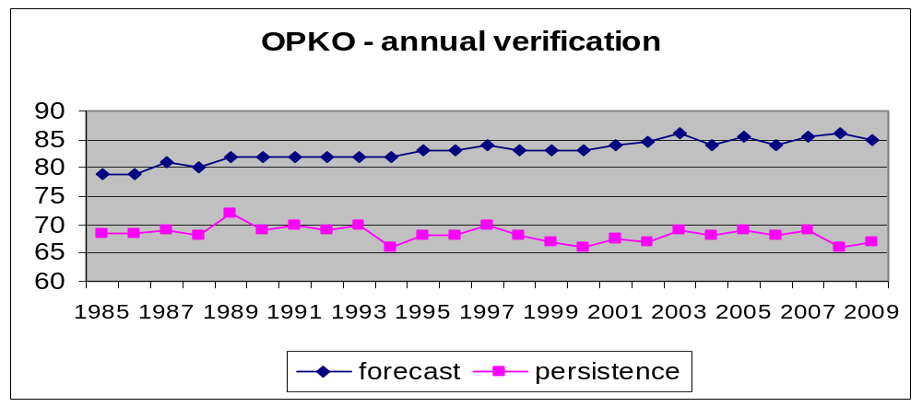
Figure 1: Annual development of MeteoSwiss OPKO-Verification results
In the medium range we could reach a value of 75.6 % (as a medium value over day 2 up to day 5). Additionally should be mentioned, that this value could be reached in the absence of a very high persistency value. It can be shown that since the early days of the use of KOMIFRI, the quality values could be increased by about 10 % (see figure 2). This progress can be set into relation to the progress of numerical models, mainly the IFS model of the ECMWF. As a short outlook of future verification actvities of MeteoSwiss, it is planned to establish a new verification scheme approximately until the end of 2010. This new system will be tested and assessed up to then in parallel with the below presented scheme.
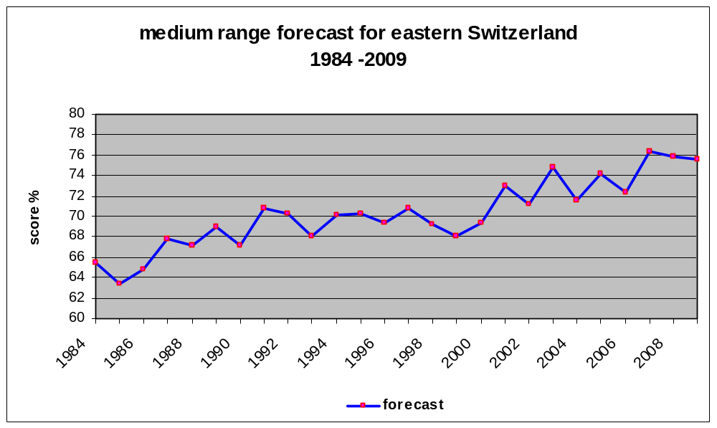
Figure 2: Evolution curve of the medium range weather forecasts quality of MeteoSwiss

Plans for the future (next 4 years)

Development of the GDPFS
AUTHOR: Marlene Kube

Major changes in the operational DPFS which are expected in the next year
An intensive data exchange and delivery of data via XML with other governmental platforms is further promoted. Data are mainly on natural risks. The national meteorological, hydrological, avalanche and snow warning regions will be accorded. One of the highest priorities will be the integration of meteorological data from representative places in each of these regions, in order to approve the official warning systems.
A generic solution for the delivering of real-time DWH data will be implemented by the end of 2010.
Control data processing tools will be further developed and implemented as service oriented infrastructures.
The storage of grid point data and linking of interpolation packages will go operational. It is foreseen to link GIS and to integrate the GIS coordination of MeteoSwiss. The integration of gridded data products and grid point data sets is in process. The DWH will provide an experimental analytical grid database as basis for climate analysis, amongst others.
For better meeting the needs of climatologic research and homogenization of historical data, a first version of a systematic information system for historical metadata of stations will be implemented.

Major changes in the operational DPFS which are envisaged within the next 4 years
The processing system, having a data ware house structure (DWH) since 2002, shall be the basis for the national „Meteorological and Climate Data Warehouse“.
The integration of different measurement technologies and platforms is further envisaged, as well as the integration of measuring systems of public and private partners. Moreover, the further integration of measured data und metadata will be promoted.
Another important step in the future development is the use of the DWH for numerical weather predictions in models such as COSMO (notably probabilistic predictions). This means assimilation of observation data into the model, verification and analysis of predictions with the help of observation data and the storage of selected data in the DWH.
Running applications using ECMWF Data shall be migrated to official dissemination (RMDCN) that is made for business relevant cases.
A superordinated architecture will be created for production tools using meteorological and climate data. This means running applications will be taken into account and adapted to the future needs for data extraction and product creation within this architecture. There will be an overall evaluation of climatologic and meteorological production tools in terms of operational costs and utility. This will be combined with a future business strategy of MeteoSwiss. In the long term, some of these tools will be consolidated some removed. Maybe some commercial of the shelf tools (such as scheduling tools and reporting tools) will be implemented, if ever they are more cost efficient. In addition, a solution will be developed to store, archive and administer products.
New implemented tools for forecasting and warning will be consolidated in terms of business relevance.
A systematic and long-term archiving of data will be prepared and delivered to the Swiss Federal Archives. Therefore the Swiss Federal Archives are developing solutions.

Planned Research Activities in NWP, Nowcasting and Long-range Forecasting
AUTHORS: Philippe Steiner
The developments related to COSMO-2 are tightly linked to the project CN-MET (Centrale Nucléaire et METéorologie), which aims at providing an integrated observing and forecasting system for monitoring and emergency preparedness in the vicinity of the Swiss nuclear power plants.
With the CN-MET project, a new measurement network has been set up including:
- three remote sensing sites measuring wind and temperature profiles within the planetary boundary layer (PBL) downwind, upwind and in the center of the domain (green dots in Figure 6.1)
- surface weather stations from the new SwissMetNet (SMN) network, with additional turbulence measurements, at each of the four nuclear power plants,
- four SMN boundary layer stations in order to add information on wind and temperature measurement within the PBL, which are integrated in the MeteoSwiss measurement network.
In case of a nuclear accident, the necessary atmospheric data used to calculate the diffusion of a contaminated air mass will be provided by COSMO-2. The new measurement network within CN-MET depicted in Figure 6.1 is adapted to provide the best information (initial and boundary conditions) for this model. COSMO-2 is prepared to run in an emergency mode, activated on demand by the Swiss Federal Nuclear Safety Inspectorate.
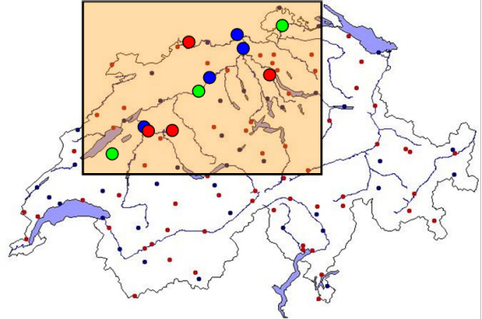
Figure 6.1: The CN-MET measurement network, including 3 remote sensing sites (green), 4 SMN stations at the nuclear power plants (blue) and 4 SMN Surface Layer stations (red).

Planned Research Activities in Nowcasting
AUTHORS: Alessandro Hering/Urs Germann/Paolo Ambrosetti
Plans for future research activities are related to an intensification of usage of satellite information for nowcasting in the Alps, a successive increase of the multi-sensors capabilities of TRT, the quasi operational use of the radar ensemble generator in hydrological applications, further development of the COST-731 nowcasting system, the renewal of the MeteoSwiss weather radar network, the increase in spatial and temporal resolution of the radar systems, and the investigation of snow and hail by the radar network.
The nowcasting analysis and forecasting system INCA, developed by the Austrian NWS ZAMG is currently evaluated at MeteoSwiss and will be introduced operationally later. This novel approach produces high time and space meteorological fields (gridded values), incorporating available information like numerical model fields and all kind of observation (both ground and remote), as well as high resolution orography.

Planned Research Activities in Long-range Forecasting

Planned Research Activities in Specialized Numerical Predictions

References
AUTHORS: ALL
P. J. van Leeuwen. 2003. A variance-minimizing filter for large-scale applications. Monthly Weather Review 131, 2071-2084
M. Buzzi. 2008. Challenges in operational numerical weather prediction at high resolution in complex terrain. Dissertation Swiss Federal Institute of Technology (ETH) Zurich
B. Szintai, O. Fuhrer. 2008. Component testing of the COSMO model’s turbulent diffusion scheme. COSMO Newsletter 9, 37-41
A. P. Weigel, M.A. Liniger and C. Appenzeller. 2009. Seasonal ensemble forecasts: Are recalibrated single models better than multi-models? Mon. Wea. Rev., 137, 1460-1479.

