WORLD METEOROLOGICAL ORGANIZATION  COMMISSION FOR BASIC SYSTEMS  OPAG DPFS  EXPERT TEAM ON LONG-RANGE FORECASTING (INFRASTRUCTURE AND VERIFICATION)  GENEVA, 16-19 NOVEMBER 2004 |  | CBS-OPAG/DPFS/  ET/LRF/Doc. 5(4)  (10.XI.2004)  _______  ENGLISH ONLY

EXCHANGE OF ENSEMBLE PRODUCTS AND DEVELOPMENT OF MULTI-MODEL ENSEMBLES

Recalibrating and Combining Ensemble Forecasts

(Submitted by Simon Mason, representative of the International Research Institute for Climate Prediction on the CCl Expert Team for verification)

Summary and purpose of document

This document contains an overview of recent developments in multi-model ensembling methods used at the International Research Institute for Climate Prediction (IRI).

ACTION PROPOSED

The Meeting is invited to study this document and consider this information when making any necessary appropriate recommendations for promoting the development of multi-model seasonal forecasting systems.
Multi-Model Ensembling: Refining and Combining

1. Introduction

Although dynamical models are increasingly the prediction tool of choice by seasonal climate forecasting centers, the dynamical models or general circulation models (GCMs) have their limitations, primarily associated with the parameterizations necessary to describe physical processes occurring on spatial and temporal scales smaller than are resolved by the GCMs. Individual models each have regions where they do better or worse than the other models, but by simply combining all models into one super-ensemble, deficiencies seen in individual models are reduced (Figure 1). However, by taking into account which models work where, and perhaps under what conditions, the straightforward pooling of models can be improved upon.

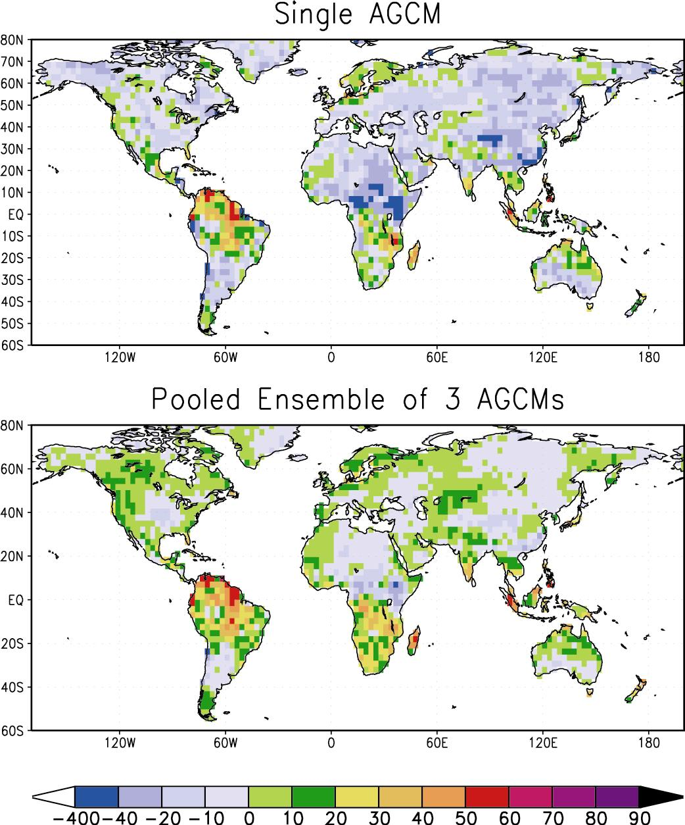

Figure 1. Ranked probability skill scores for 3-category January – March 2 m temperature forecasts over the period 1950 – 1995. (Top) individual AGCM ensemble; (Bottom) pooled combination of the raw AGCM probabilities, which is considered the “baseline” approach for the multi-model ensemble combination.

2. Data & Verification

The model data are taken from three atmospheric GCMs. The CCM3.6 (Kiehl et al., 1998) and the ECHAM4.5 (Roeckner et al., 1996) AGCMs are configured at T42L18. The NSIPP1 AGCM (Bacmeister et al., 2000) is a gridpoint model with a horizontal resolution of 2x2.5 degrees and 34 vertical levels; NSIPP1 data was interpolated to T42 for the multi-model ensembling. All AGCM predictions(/simulations) are cast as probabilistic 3-category forecasts for 3-monthly seasonal values of mean temperature and total rainfall, where the prior probability of any one category is 1/3.

The observations for temperature and precipitation, against which the model combinations are validated, come from the Climate Research Unit of the University of East Anglia (New et al., 2000). The data are provided at 0.5x0.5 degree resolution, and were upscaled to T42 for use in the validation.

The ranked probability skill score (RPSS) is used to validate the forecast system against the observations. The RPSS measures the squared error between the cumulative forecast and observed probabilities, then weights that score against a reference forecast of climatology. A RPSS of 100% implies that the observed category was always predicted with 100% probability. A RPSS of 0 implies that the prediction performs as well as if climatological probabilities were always issued. A RPSS less than 0 implies the prediction system performs worse than climatology, but does not necessarily mean that the forecasts are not potentially useful (Mason 2004). Another perspective on probabilistic performance of the prediction system is gained through reliability diagrams. The goal is to produce reliable forecasts with good resolution, as this is necessary for forecasts to be useful in applications. Perfect reliability is achieved when a given probability is assigned to an event or a category it occurs in the observations with that relative frequency. However, a forecast system should also display sharpness, or have good resolution, meaning that the forecast probabilities should be able to deviate from climatological probabilities.

3. Multi-Model Recalibration and Combination Techniques

Two approaches are considered here for recalibrating the probabilistic forecasts from individual models and also for combining the forecasts from the individual models.

3.1. Recalibration

In the simplest case, the model forecasts are calibrated only against the model, rather than the observed, climatology. The model probabilities are taken straight from the AGCMs. This approach is referred to as “Raw Probabilities”.

A more complex approach calibrates each model individually based on its ensemble mean: the frequencies with which the observed category was below-normal, near-normal, and above-normal are tabulated for those times when the model’s ensemble mean indicated a specific category. These calculations are performed seasonally for each variable at each gridpoint. A perfect deterministic forecast system would result in a purely diagonal matrix of 1s; a perfectly random prediction system would yield values of approximately 1/3 in every box (assuming 3 a priori equiprobable categories). With this matrix of conditional frequencies, one can construct a probabilistic forecast based on the current ensemble mean forecast at a given location. This approach is referred to as “Corrected Probabilities”.

3.2. Combination

The simplest approach for combining forecasts is to weight each model equally. This approach is referred to as “Pooled Ensemble”.

A more complex approach weights the models spatially and seasonally based on past model performance for the variable of interest. The Bayesian approach to multi-model combination of AGCMs (Rajagopalan et al., 2002; Robertson et al., 2004) determines the relative weights, pointwise, of each AGCM with climatology as the prior. The weights are chosen to maximize the likelihood score of the posterior (i.e., combined) probabilities. The climatology forecast has 33.3% probabilities for each category always. The AGCM probabilities change in each case. The result is that if the models have little or no skill over a particular region, climatology receives more or all the weight, and the resulting forecast for that location is closer to climatology. If one or more models frequently predict the observed category with high confidence, then the model(s) receive more or all the weight, and the forecast appears closer to the models’ probabilities. This approach is referred to as the “Bayesian Ensemble”.

4. Results

In comparing the more and less simple approaches to multi-model combination, reliability diagrams are used for an overall comparison. An example of the differences in reliability is illustrated in Figure 2 for precipitation. The individual models are all over-confident in their probabilities, as evidenced by the near-horizontal slopes of the reliability curves. Little difference exists in the frequency of observed outcomes for either category shown whether the models indicate that the category is 20% likely or 80% likely. Simple pooling of the AGCM ensembles leads to greater reliability (a more positive slope in the reliability curve).

For both temperature and precipitation, either correcting the PDF before combination, or using the Bayesian approach with the raw probabilities dramatically improves over the pooling of the raw AGCM probabilities (which is itself an improvement over the individual AGCMs). The corrected probabilities are almost perfectly reliable across the range of probabilities issued, which indicates excellent recalibration of the forecasts. For the corrected probabilities, the additional improvement of the Bayesian multi-model combination does not provide much additional improvement to the reliability. The one potential shortcoming of the corrected probabilities is that the tails of the distribution are not represented; the forecasts are less sharp.

The apparent improvements in overall reliability also impact the local probabilistic skill (not shown). As the models perform better for temperature, the relative improvements from sophisticated recalibration and combination schemes are less obvious than they are for precipitation. In general, for temperature, most of the improvements are seen to bring negative RPSS regions closer to 0; although there are a handful of regions for which positive skill increases in the more sophisticated treatment relative to the baseline of pooled raw AGCM ensembles. For the precipitation, not only are negative values neutralized, but many coherent areas of positive skill in the baseline (raw pooled MM) improve, such as over western Africa, northern South America, and even Indonesia.

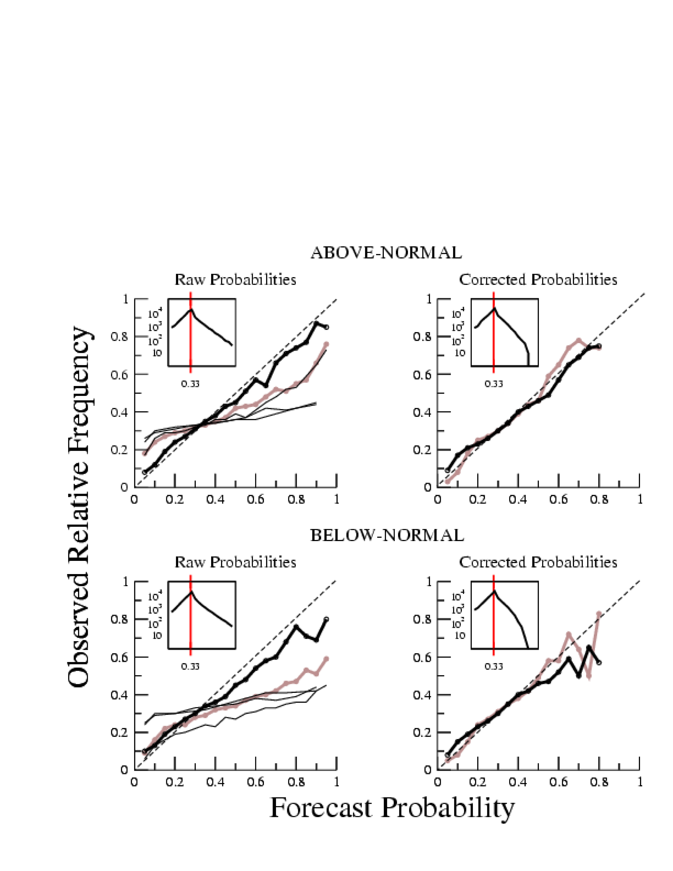

Figure 2. Reliability diagrams for July – September precipitation forecasts (30°S-30°N). Each graph plots the forecast probability versus the observed relative frequency for a given category (above-normal, upper row; below-normal, lower row). Different forecast methods are compared: individual AGCMs (thin black lines); Pooled MM probabilities (heavy grey line); Bayesian MM probabilities (heavy black line). In the left column, the “raw probabilities” from the models are used; in the right column, the “corrected probabilities” are used. The inset graphs show the frequency with which the forecast probabilities were assigned for the Bayesian MM ensemble.
5. Conclusions

A preliminary investigation into possible methods for recalibrating probabilistic forecasts from dynamical models and combining them into a multi-model forecast has been conducted. The baseline against which more sophisticated techniques were compared consists of straight pooling of the raw ensemble probabilities from the individual models.

Several conclusions emerge:
- AGCMs are over-confident in their probability distributions, and dynamical predictions benefit in skill and reliability from combining several models together.
- Further improved reliability of seasonal climate forecasts can be achieved by recalibrating the forecasts either by directly “correcting” the models using a simple contingency table approach, or by weighting the models according to historical probabilistic performance as in the Bayesian multi-model ensemble.
- For the techniques applied in this preliminary study, the sharpest reliable forecasts are obtained from the Bayesian multi-model approach rather than from the corrected probabilities approach.

References

Bacmeister, J., P.J. Pegion, S.D. Schubert, and M.J. Suarez, 2002: Atlas of Seasonal Means Simulated by the NSIPP 1 Atmospheric GCM. NASA/TM-2000-104505, Vol. 17, 190pp.
Kiehl, J.T., J.J. Hack, G.B. Bonan, B.A. Boville, D.L. Williamson, and P.J. Rasch, 1998: The National Center for Atmospheric Research Community Climate Model. J. Climate, 11, 1131-1149.
Mason, S. J., 2004: On using “climatology” as a reference strategy in the Brier and ranked probability skill scores. Mon. Wea. Rev., 137, 1891-1895.
New, M., M. Hulme, and P.D. Jones, 2000: Representing twentieth-century space-time climate variability. Part II: Development of a 1901-96 monthly grid of terrestrial surface climate. J. Climate, 13, 2217-2238.
Rajagopalan, B., U. Lall, and S.E. Zebiak, 2002: Categorical climate forecasts through a regularization and optimal combination of multiple GCM ensembles. Mon. Wea. Rev., 15, 1792-1811.
Robertson, A.W., U. Lall, S. E. Zebiak, and L. Goddard, 2004: Improved combination of atmospheric GCM ensembles for seasonal prediction. Mon. Wea. Rev., in press.
Roeckner, E., and co-authors, 1996: Simulation of the Present-Day Climate with the ECHAM Model: Impact of Model Physics and Resolution. Report No. 93, Max-Planck-Institut fur Meteorologie, Hamburg, Germany, 171 pp.

