WORLD METEOROLOGICAL ORGANIZATION  COMMISSION FOR BASIC SYSTEMS  OPAG on DPFS  Expert team on modelling of atmospheric transport for non-nuclear emergency response activities  Toulouse, France, 14-17 December 2009 |  | CBS-DPFS/ ET-nNERA/Doc. 4(9)  (1.XII.2009)  _______  Agenda item : 4  ENGLISH ONLY

METEOROLOGICAL PROVISION FOR CALCULATIONS OF CONTAMINANT AIR DISPERSION IN CASE OF EMERGENCY RELEASES IN THE SYSTEM RECASS NT

(Submitted by V. Shershakov)

Summary and purpose of document

This document presents the new capability of RSMC Obninsk for ERA

Action Proposed

No action

I Integration of regional weather forecast data
- Input meteorological data
The system RECASS NT receives, through communication links, from the operational units of Roshydromet and World Weather Watch the following input meteorological data:
_data of standard near-surface meteorological observations at meteorological stations and posts,
_data of the global objective analysis and numerical predictions (prepared by Hydrometeocenter of Russia) at standard isobaric surfaces with spatial resolution 1,25°×1,25°.
Based on these data, the metprocessor in the system RECASS NT promptly calculates characteristics of the atmospheric boundary and near-surface layers on the spatial-temporal grids of required dimensions.

- Regional model
To improve the credibility of calculations in the system RECASS NT, as to estimates of emergency environmental contamination in the area of a potentially hazardous facility, it is desirable to use meteorological parameters predicted by regional models. In view of this, work is now under way to integrate data of regional prediction system COSMO.
The numerical weather prediction system COSMO developed in Germany has been implemented by the Hydrometeocenter of RF. Calculations in the system are performed once a day with the lead time 72 hours and 3-hour resolution. The calculation domain is the European part of Russia and a part of Western Siberia (Priuralie) with the horizontal resolution of 7 km and the vertical resolution of 20 km near the earth surface up to 1 km near the troposphere boundary. The available prediction meteorological parameters are sufficient for operations of RECASS NT.
By now, COSMO data have been transformed to the formats of RECASS NT. Fig 1 and 2 provide the examples of wind, temperature and relative humidity fields obtained by the COSMO system.
In 2010 COSMO data are planned to be assimilated and RECASS NT will be prepared for using these data in calculations.

Examples of fields obtained by the system COSMO
03 February 2009

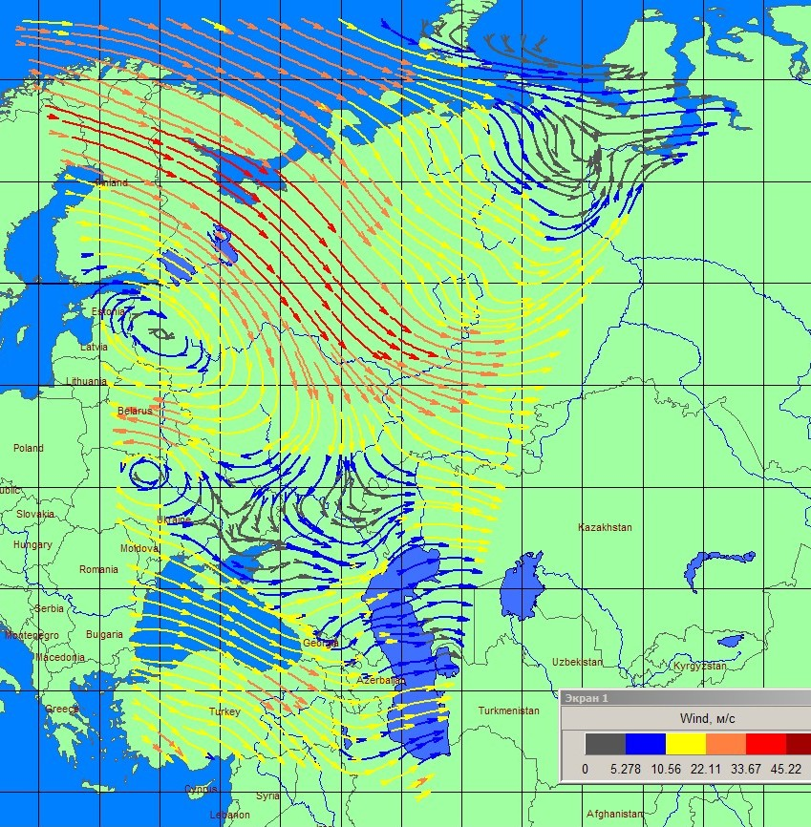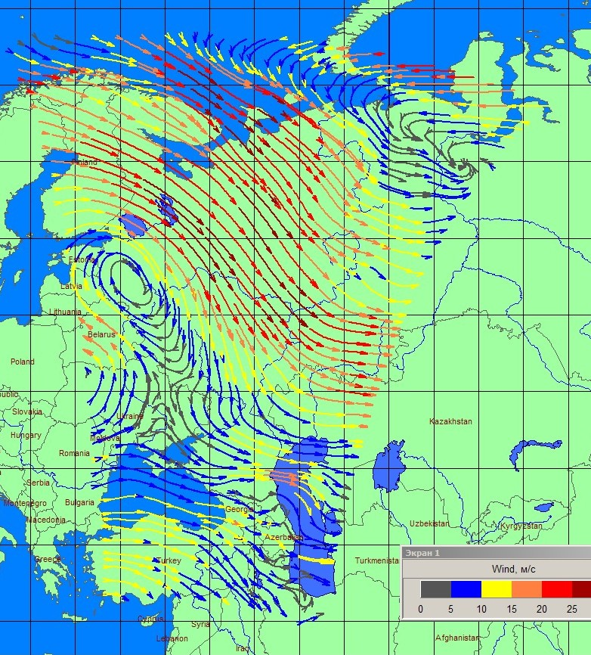
6 o’clock. GMT 12 o’clock.GMT
Wind field at the height Н₉₅₀
Figure 1
03 February 2009 12 o’clock. GMT

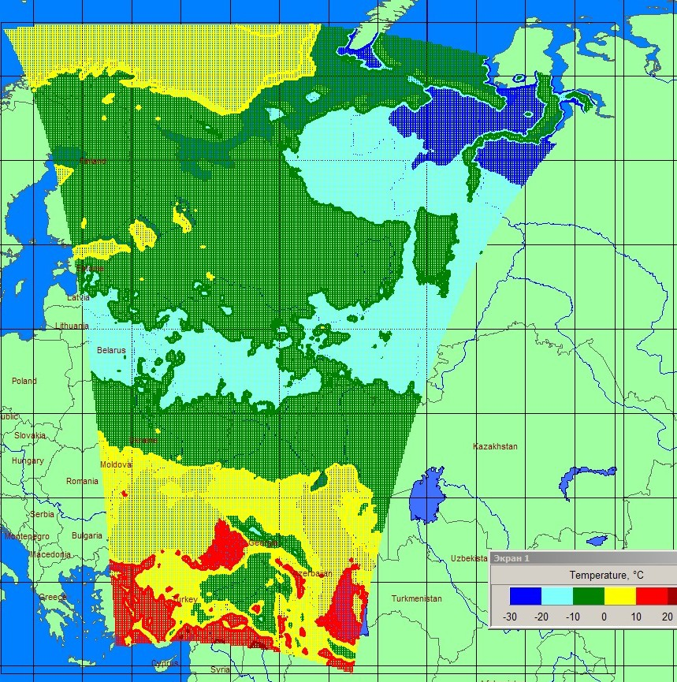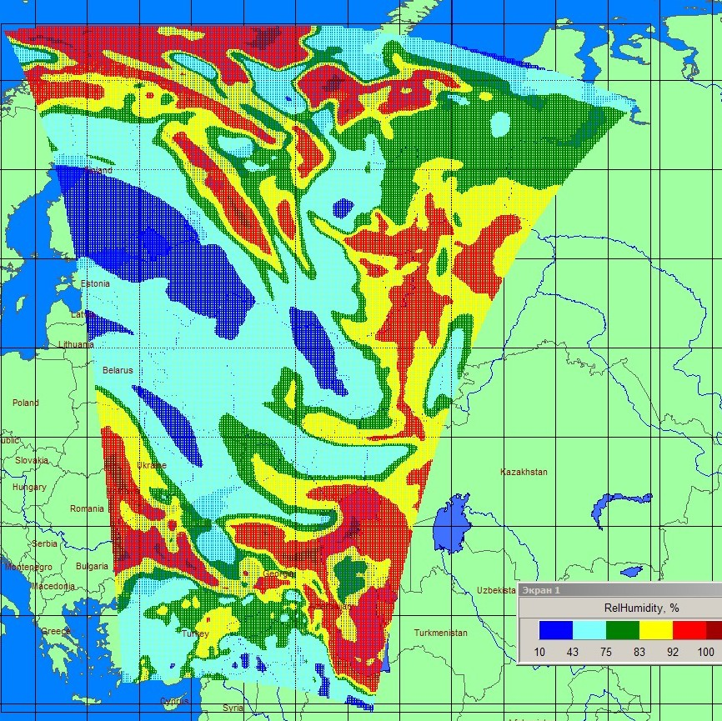

Temperature at the height 30 m Relative humidity at the height 1000 m
Figure 2

II Accounting for precipitation in the system RECASS NT
One of most effective mechanisms of atmosphere self-cleaning is washout of contaminants with precipitation, which depends on precipitation time and intensity. Therefore, the calculations of contaminant deposition in case of atmospheric transport require precipitation fields with the smallest possible temporal resolution.
The metprocessor in the system RECASS NT currently uses two sets of initial data to account for deposited atmospheric precipitation.
The first consists of data about total precipitation measured at meteorological stations. The main distinction of precipitation measurements at meteorological stations from other atmospheric characteristics is that this is cumulative precipitation, i.e. the amount of precipitation is measured after its accumulation during a long time period. The precipitation accumulation period length can vary from 1 hour to 24 hours, depending on the national observation protocol. In Russia, for example, the precipitation is 12 hours.
The second set of data is represented by the fields of global forecast of 6-hour sums of precipitation on the grid 1,25^{о} х 1,25^{о}.
The metprocessor in the system RECASS NT currently uses the algorithm which, depending on season and amount of precipitation and using climatic data, provides precipitation length and intensity which are required for calculating contaminant wash-out from the atmosphere. The method for accounting deposited precipitation implemented in the metprocessor represents the temporal distribution of precipitation with insufficient accuracy.
For improving precipitation calculations work was undertaken to obtain short-period sums of precipitation based on the current measurements of precipitation sums over long time periods at meteorological stations.
In 2009 the algorithm and software were developed splitting the 12- hour sums of precipitation into 3-hour intervals. For this purpose, data about cloudiness and weather events (past and current weather) coded in meteorological telegrams are used indicating the precipitation type and quality characteristics of precipitation intensity. Besides, averaged values of precipitation intensity and length (by Alibegova data) for the former USSR stations are used. According to the literature, globally 5 characteristic zones exist in terms of precipitation length and intensity required for calculations on these territories using this algorithm.
Figure 3 compares the actual data and 3-hour precipitation sums during 10 days, as reconstructed by two methods for one of the meteorological station in Germany. Germany was selected because in this country 3-hour precipitation sums are transmitted in meteorological telegrams and these sums can be used for comparison and obtaining 12-hour sums, which is consistent with measurements at the meteorological stations in Russia. Moreover, Germany lies in the same climatic zone by precipitation as Russia.
It can be seen that the algorithm under development provides much better results than the one currently used in the metprocessor with respect to precipitation. This is also testified by the calculated deviations of the reconstructed sums from the actual ones. According to the metprocessor methodology the deviations over the considered period are twice as great as those by the new algorithm under development.
The new algorithm was tested with data of 120 meteorological stations of Germany over 3 months. The results of testing are found to be acceptable: the root-mean-square deviation < 1 mm, the correlation coefficient ≥ 0,5, the Piercy-Obukhov criterion >0,7.
The plan is to bring the algorithm under task 1 to the technology level in 2010-2011.

Note:
The root-mean-square deviation shows to what extent realization of one process is away from the other.
The correlation coefficient accounts for the similarity of two processes: the closer the CC value to 1, the more similar the processes are.
The Piercy-Obukhov criterion indicates the adequacy of reproducing the precipitation fact by the reconstructed data. Here again, the closer PCC to 1, the better the precipitation fact has been reconstructed.

Comparison of the actual and reconstructed three-hours sums of precipitation
for the station Aachen (Germany) in June 2003

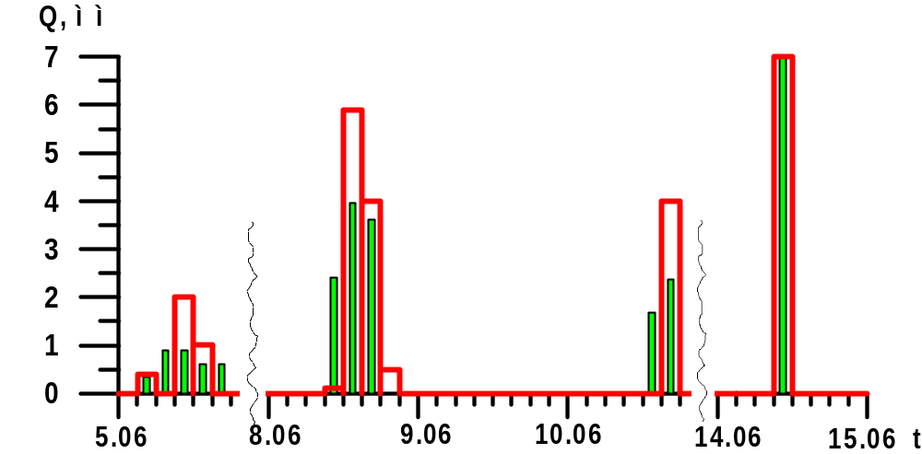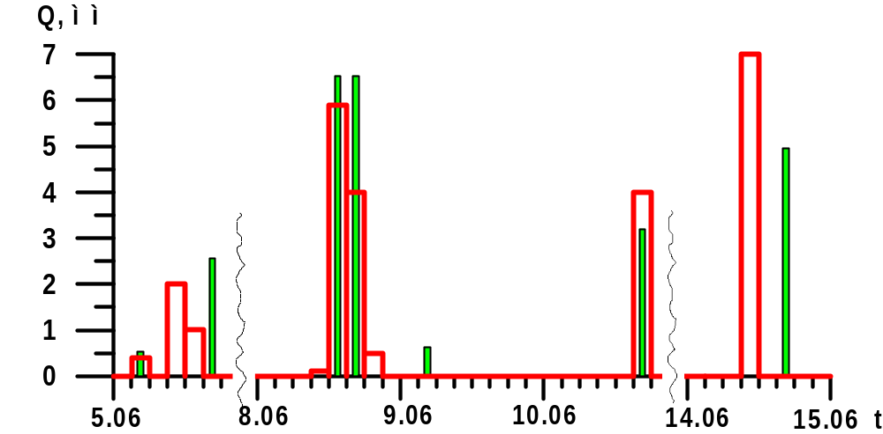
Reconstruction with the currently used algorithm
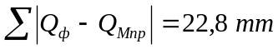
Reconstruction by the algorithm under development
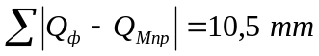
Testing of the new algorithm has shown:
- root-mean-square-deviation < 1 mm
- correlation coefficient ≥ 0,5
-Piercy-Obukhov criterion > 0,7

Figure 3

