WORLD METEOROLOGICAL ORGANIZATION  ________  COMMISSION FOR BASIC SYSTEMS  EXPERT TEAM ON  EMERGENCY RESPONSE ACTIVITIES  COLLEGE PARK (MD), USA, 21-25 OCTOBER 2013 |  | CBS/ET-ERA/Doc. 6  (16.X.2013)  _______  Agenda item : 6  Original: ENGLISH

ERA WEBSITE AND STRUCTURE

(René Servranckx, Canada)

Summary and purpose of document

This document looks at the existing WMO ERA website and proposes a possible way forward on adjust it to address the expansion of the ERA programme to non-nuclear emergencies.

Action Proposed

The meeting is invited to 1) Review and comment on the proposal and suggest other approaches as needed, 2) Take into account the discussions / decisions arising from agenda items 3 to 5 of the present meeting to suggest specific items to add to the ERA website, 3) Identify who may be assigned to work on the revision / expansion of the website, and 4) Establish appropriate timelines.

Annex 1: Summary structure of the current WMO Emergency Response Activities (ERA)

References: 1- WMO website on Emergency Response Activities (ERA) available at:
http://www.wmo.int/pages/prog/www/DPFSERA/EmergencyResp.html

2- Outcomes of Cg-16 (2011), and CBS-15 (2012) including DPFS Structure and Task Team Terms of Reference. Agenda 3 document of present meeting, available at:
http://www.wmo.int/pages/prog/www/DPFSERA/Meetings/ET-ERA_College-Park2013/documents/Doc-3-1_CBS-15_and_EC-65.doc

3- Report of the meeting of the Task Team on Development of Operational Procedures for non-Nuclear ERA, available at: http://www.wmo.int/pages/prog/www/CBS-Reports/documents/TT-DOP-nNERA-final-report.pdf
1. INTRODUCTION AND BACKGROUND

1.1 The WMO website on ERA as it stands today (reference 1, summarized in Annex 1 to this paper) is the result of many years or hard work by members of the ERA coordination group and expert team.

1.2 It is comprehensive with respect to nuclear ERA. Some additions have been done in recent years to address non-nuclear ERA questions but overall, the website is focussed on nuclear ERA.

1.3 A revision of the website is needed to address the changes recently approved by CBS-15 with regards to the expansion of the ERA programme for non-nuclear emergencies.

2. DISCUSSION AND PROPOSED ACTIONS

2.1 The web site is summarized in Annex 1 where sections specific to nuclear ERA are identified by **. The following points are worth noting and are based on the structure of website and our long experience with the nuclear side of ERA:

2.1.1 The nuclear ERA information is mature and does not require significant changes, except for regular updates.

2.1.2 On the other hand, the non-nuclear ERA aspects, procedures, etc are new and being developed as part of this meeting / follow up work that will result. The discussions and decisions resulting from agenda items 3 to 5 of our meeting may influence the website update strategy. The website structure must be flexible enough to easily accommodate new information and procedures with a minimum of restructuring.

2.1.3 Developing, maintaining and updating the website requires regular work. The more specific and detailed web pages are, the more work is needed to maintain them. We this in mind, it is important to keep our expectations and corresponding workload reasonable and achievable.

2.1.4 The basic structure of the website and its main sections is sound and could easily be adapted to include non-nuclear ERA information such as new procedures, documentation, references, case studies, etc.

2.2 In light of the above points, the following approach is perhaps the simplest, easiest and most flexible way to restructure the website:

2.2.1 Keep the main sections as they are now:
Emergency Response Activities (ERA) Overview (main page)
1- Procedures
2- Resources and Tools
3- Background and reference material
4- Case Studies & examples of ERA events and products
5- Purpose, objectives and organization of the ERA programme
6- Contacts

2.2.2 Where possible, keep / adapt the existing text to include nuclear and non-nuclear ERA. For example, pages that describe in general terms the ERA programme, such as the main page Emergency Response Activities (ERA) Overview.

2.2.3 Where not possible or desirable, keep / create separate links for nuclear and non-nuclear (or other) activities. For example, in the main section Procedures, move things dealing with nuclear ERA in a ‘’nuclear’’ web link; create a non-nuclear (or other) web link. That will permit to populate the corresponding new web pages with information, procedures, etc. at they become available.

2.2.4 A similar approach is suggested with respect to document 3E in Annex 1 (Technical Document No. 778 – RSMC SUPPORT FOR ENVIRONMENTAL EMERGENCY RESPONSE Documentation for meteorologists at NMSs). The document title does not refer specifically to nuclear emergencies.

2.3 With this in mind, the meeting is invited to

1) Review and comment on the proposal and suggest other approaches as needed
2) Take into account the discussions / decisions arising from agenda items 3 to 5 of the present meeting to suggest specific items to add to the ERA website
3) Identify who may be assigned to work on the revision / expansion of the website
4) Establish appropriate timelines

2. EXCERPT OF THE MELBOURNE’S MEETING REPORT (NOV 2012)

9. ERA WEBSITE CONTENT AND STRUCTURE

9.1 With respect to the structure of the ERA website and based on the long experience with the nuclear side of ERA, the Team noted that:

- The nuclear ERA information is mature and does not require significant changes, except for regular updates.

- The non-nuclear ERA aspects, procedures, etc need to be added. The website structure must be flexible enough to easily accommodate new information and procedures with a minimum of restructuring.

- Developing, maintaining and updating the website require regular work. The more specific and detailed web pages are, the more work is needed to maintain them.

- The basic structure of the website and its main sections is sound and can be easily adapted to include the non-nuclear ERA aspects such as procedures, capacity building, case studies, etc.

9.2 The Team agreed that the following approach would be taken with respect to the development of non-nuclear ERA web pages and documentation in WMO-TD 778:

- Keep the main sections as they are now:
Emergency Response Activities (ERA) Overview (main page)
1- Procedures
2- Resources and Tools
3- Background and reference material
4- Case Studies & examples of ERA events and products
5- Purpose, objectives and organization of the ERA programme
6- Contacts

- Where possible, keep / adapt the existing text to include nuclear and non-nuclear ERA. For example, pages that describe in general terms the ERA programme, such as the main page.

- Where not possible or desirable, keep / create separate links for nuclear and non-nuclear (or other) activities. For example, in the main section Procedures, move things dealing with nuclear ERA in a ‘’nuclear’’ web link; create a non-nuclear (or other) web link. That will permit the population of the corresponding new web pages with information, procedures, etc. as they become available.

9.3 Some of the modifications identified under agenda items 6 to 8 include:

Add new relevant sections from the Manual on the GDPFS for non-nuclear ERA. For example, Appendix A.II.2.2.9d (Characteristics of atmospheric transport modelling system) and Appendix A.II.2.2.9f (Users interpretation guide for non-nuclear atmospheric transport model products provided by RSMCs).

- Add documentation on capacity building and training for non-nuclear ERA (agenda item 8).

- Include examples of modelling for non-nuclear events: forest fire smoke and corresponding satellite imagery; chemical fires, etc.

- Document what the parameters in the request for support form mean (base and top of release, etc.).

- Document NMHSs’ responsibility for information flow to users within their State.

9.4 The ET-ERA Chairperson and Co-chairperson will prepare a list of changes needed, identify TT members of the team that can contribute to specific sections and establish timelines.

ANNEX 1

SUMMARY STRUCTURE OF CURRENT WMO WEBSITE ON EMERGENCY RESPONSE ACTIVITIES (ERA) – See reference 1 on cover page

Sections that are specific to nuclear ERA are identified by **

- Emergency Response Activities (ERA) Overview

1- Procedures
A) **Regional and Global Arrangements (Appendix I-3 of the Manual on the GDPFS)
B) **Delegated Authority Request for RSMC Support
C) **IAEA Request for RSMC Support
D) **Standards of Service by RSMCs (Appendix II-7 of the Manual on the GDPFS)
Related items menu on right hand side:
E) Technical Document No. 778 – RSMC SUPPORT FOR ENVIRONMENTAL EMERGENCY RESPONSE (see 3E below for details)
F) **Role of WMO Secretariat in nuclear accident

2- Resources and Tools
A) Contains report of activities of all RSMCs / RTH Offenbach for 2010 and 2011
Related items menu on right hand side:
B) Links to Modelling Tools
C) Overview of Modelling Tools
D) Training Resources
E) Real-Time Remote Sensing of Large Fires

3- Background and reference material
A Bibiliography (sic)
B) Meetings & Reports
C) Coordination Group on Nuclear Emergency Response Activities (CG-ERA)
D) Requirements for Support of Chemical ERA
E) Technical Document No. 778 – RSMC SUPPORT FOR ENVIRONMENTAL EMERGENCY RESPONSE (Documentation for meteorologists at NMSs)
**Section 1 - Introduction to the RSMC specialization for the provision of atmospheric transport model products for environmental emergency response
** Section 2 - Arrangements for requesting and receiving atmospheric transport model products from an RSMC
Section 3 - Aim of an atmospheric transport model in connection with numerical weather prediction (NWP) model (scientific information)
**Section 4 - Users' interpretation guide for atmospheric transport model products provided by RSMCs
Section 5 – Annexes
**Annex 1 - Regional and global arrangements for the provision of transport model products for environmental emergency response
Annex 2 - Designated RSMCs with specialization in atmospheric transport modelling for environmental emergency response and International Organizations
**Annex 3 - Request forms for WMO RSMC support from Delegated Authorities and IAEA
**Annex 4 - Information on RSMC models and specific outputs
**Annex 5 - Scenarios demonstrating RSMC support for ERA
**Annex 6 - Principles of environmental emergency response exercises
Annex 7 - Announcement about a planned EER exercise
Annex 8 - Guidance on response to chemical incidents - definitions of requirements concerning chemical incidents
Annex 9 - Role of national meteorological services (NMSs) in response to chemical incidents
Annex 10 - Guidance for development of the interface between a national meteorological service and other emergency response agencies in case of chemical incidents
Annex 11 - KNMI experience in setting up an emergency response organization on serious chemical accidents
Annex 12 - Procedures to integrate and activate NMSs/RSMCs in case of chemical incidents or forest fires

4- Case Studies & examples of ERA events and products
Note: contains old and outdated information

5- Purpose, objectives and organization of the ERA programme
- Purpose and scope
- Main long-term objectives
- Programme organization

6- Contacts
a) CG - Nuclear ERA & ET - Non-nuclear ERA
b) **Delegated Authorities for ERA
c) **NMHS Operational Contact Points for ERA
d) **Nuclear Accidents (RSMCs and International Agencies)
e) Transport Model Products (RSMCs and International Agencies)
f) Atmospheric Transport Modelling Backtracking Support (RSMCs)
g) Weather and Disaster Risk Reduction Services Department
Related items menu on right hand side:
- Websites (RSMCs and International Agencies)

7- Questionnaires
- Delegated Authority and NMHS' Operational Contact Point (Feb. 2012)
The following are screen captures of the main page and the 7 sections:

Emergency Response Activities (ERA) Overview

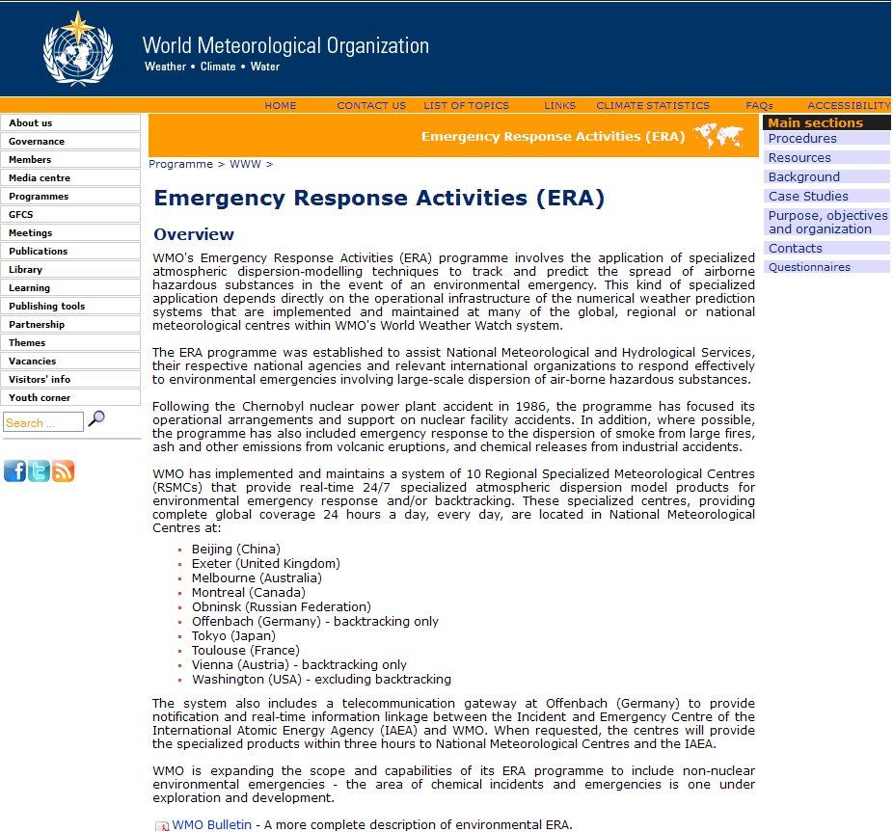

The links given in the upper right corner of main page lead to the following:

1. Procedures

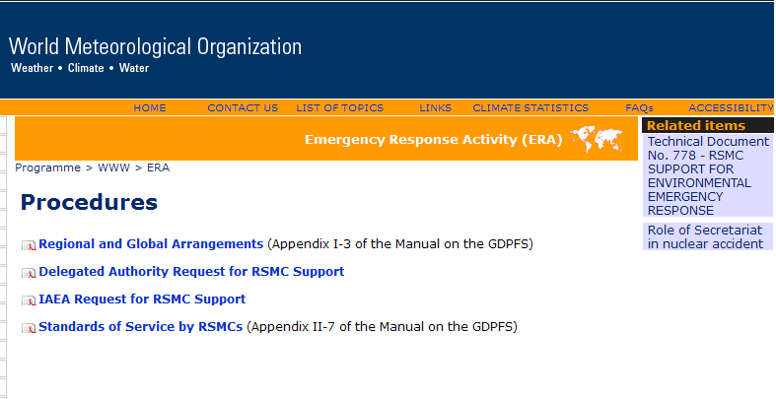

2. Resources

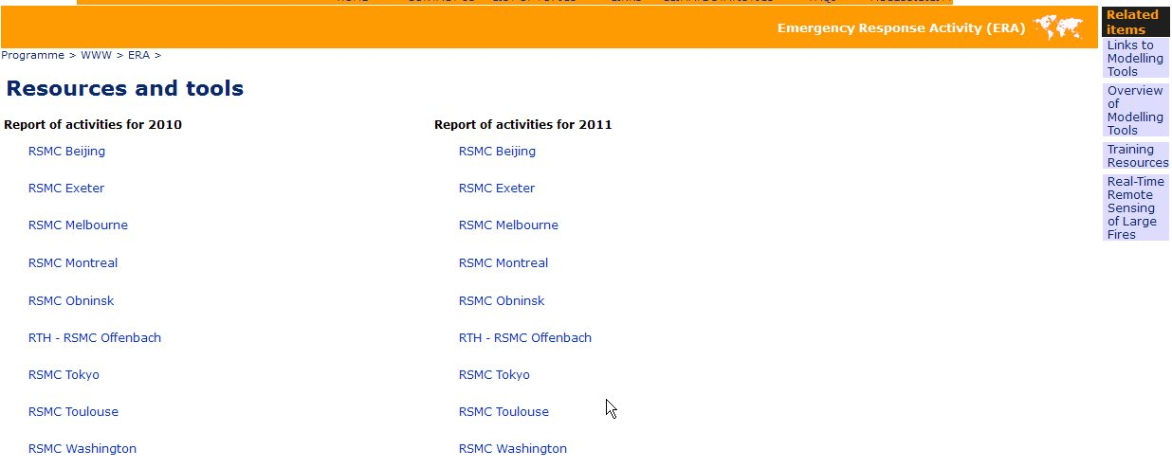

3. Background

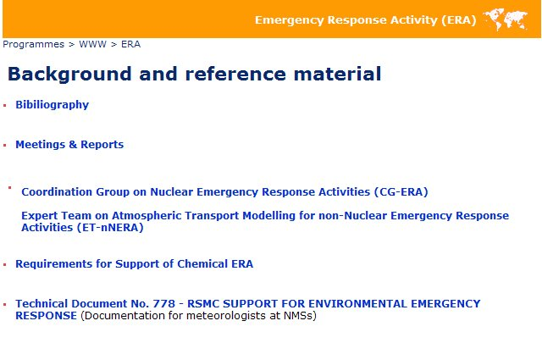

4. Case Studies

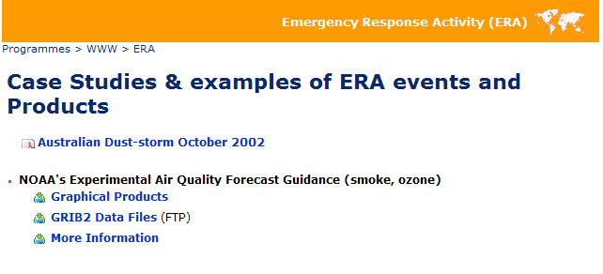

5. Purpose, objectives and organization

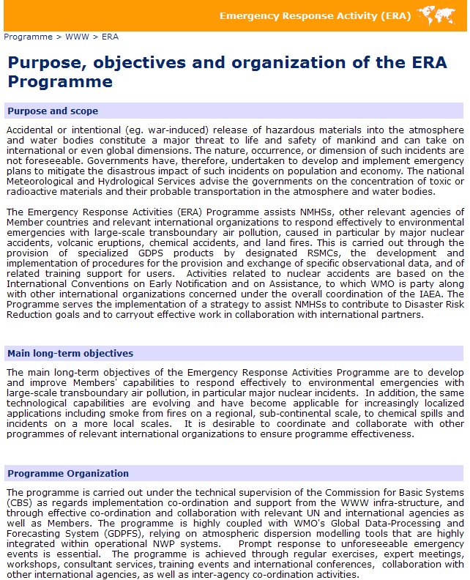

6. Contacts

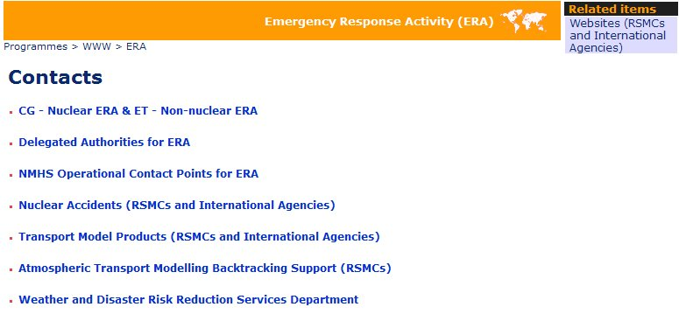

7. Questionnaires



