WORLD METEOROLOGICAL ORGANIZATION  COMMISSION FOR BASIC SYSTEMS  OPAG on DPFS  Expert Task Team to Update the WMO Technical Note 170 |  | CBS-DPFS/ET-Review-TN170/  (11.10.2013)  _______  Agenda item : TN 170 Update  ENGLISH ONLY

3. Introduction and Background

TN 170 Revision of sections 3.3, 4.4 and 9.3

(Submitted by Jeff McQueen, NOAA/NWS/NCEP)

Summary and purpose of document

This document provides a draft on TN No. 170 sections
3.3: Meteorological (NWP) Reanalysis
4.4: Transport, dispersion and deposition of airborne radioactivity
9.3: Operational atmospheric deposition and emergency response.

WMO/TN-No. 170 – 3.3, 4.4, 9.3

- Necessary Information
  - Observations
  - Data Analysis
  - Meteorological (NWP) Re-Analysis

The atmospheric planetary boundary layer (PBL) height and winds and temperature in the boundary layer are critical weather components that drive dispersion decision support tools to assess contaminant concentration at a particular location. Therefore, accurate assessment of complex boundary layer processes at finer scales should improve a nuclear power plant operator’s ability to assess the effects of a potential toxic release. Three dimensional dispersion models coupled with high resolution meteorological model can now be used to provide improved estimate of the temporal and spatial structure of the PBL and a plume dispersion assessment forecast models to protect life and property. If possible, observations off the PBL should be used for the analysis or dispersion model (White, et al., 2009).

Previous reports overview NPP recommendations for power plant siting and operations (eg: ARSC, 1990; Bishnoi, L.R. and P. C. Basu, 1995; IAEA, NS-RG 3-2, 2003). This section summarizes techniques to create an atmospheric analysis that can be used for NPP siting.

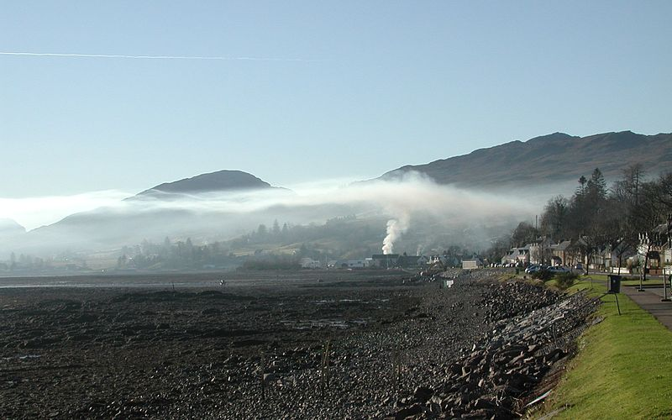

A region’s NMC may produce high resolution analysis and prediction system that can be leveraged to to capture local-scale flows around an NPP. Otherwise, several downscaling techniques may be employed from diagnostic statistical techniques to running a mesoscale numerical analysis and prediction systems. Observations described in section 3.2 would be used to produce these retrospective or real-time analyses.

    - Available Meteorological Analyses

Mountain-Valley winds in complex topography, sea and lake breezes, and urban heat islands are all examples of commonly occurring wind circulations that can influence atmospheric dispersion (See Fig. 3.3.2.1), Features that drive these flows should be resolved in the meteorological analysis if the NPP site is located in complex terrain, near coast-lines or urban areas. Detailed training modules on these atmospheric boundary layer processes can be found at the COMET/METED training web page:

- PBL processes in complex terrain:
  - https://www.meted.ucar.edu/training_module.php?id=258
  - https://www.meted.ucar.edu/training_module.php?id=259
- Sea Breezes:
  - https://www.meted.ucar.edu/training_module.php?id=8
- Mountain-Valley Breezes:
  - https://www.meted.ucar.edu/training_module.php?id=55

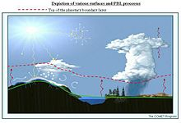
Figure 3.3.1-1 Example of atmospheric circulations forced by terrain or land-sea temperature gradients. Red-dashed line shows the top of the atmospheric boundary layer.

Several NMHS now provide long-term meteorological analyses that can be used for evaluating an NPP site location. These analysis assimilate standard and remotely sensed measurement to determine a consistent analysis. Parameters needed to evaluate site such as typical wind, temperature and rainfall can be retrieved from these analyses for various dates and hours. A climatology can then be created by averaging these parameters over a number of years, a season, or time-periods.
Flows such as land-sea breezes, mountain valley flows or other orographically induced flows often require high resolution meteorological analyses or predictions (under 10 km grid spacing), which have been made to a number of NMHSs within the framework of the Global Data-processing and Forecasting System (GDPFS) programme, including through the implementation of the Severe Weather Forecasting Demonstration Project (SWFDP). Even when such grids are available, they may not be coupled with available dispersion models for easy use. the list of meteorological model outputs available through the GDPFS is summarized in the following documents:

- Individual Annual WWW Technical Progress Reports on the GDPFS and the Annual Numerical Weather Prediction (NWP) Progress Reports
http://www.wmo.int/pages/prog/www/DPFS/ProgressReports/2012/2011_GDPFS-NWP.html
- Status the WMO Forecasting Centres relative to Numerical Models
ftp://ftp.wmo.int//Documents/PublicWeb/www/gdpfs/GDPFSNWP_Annualreports10/STATUSTA2010.doc

A review of currently available and continuingly updated global meteorological analyses was summarized in Draxler, et al. (2013) and reproduced here. These analyses could be used to develop a meteorological climatology for a region or downscaled to account for high resolution orographic effects. Several downscaling methodologies are described below.

Centre + Data name | Plane | Num of layers | Method | Domain size | Map project-ion | Resolution (Long-Lat degrees) | Output  interval |  | Data amount  (Daily) | Lowest 10 levels | Elements
JMA, Global analysis  (Global) | Pressure | 18  up to 10 hPa | 4DVAR | 720x361 | LL | 0.5  (surface-100hPa)  1.0  (70hPa-10hPa) |  | 6 hourly | 33MB  (132MB) | SURF, 1000, 925, 850, 700, 600, 500, 400, 300, 250 hPa | U V T Z RH OMG P(surface) PHI(surface)
ECMWF, Global analysis | Hybrid or press |  | 4DVAR |  | LL |  |  |  |  | SURF, 1000, 925, 850, 700, 600, 500, 400, 300, 250 hPa
UK Met Office, Global UM analysis | Hybrid height above ground | 70  up to 80km | 4DVAR | 1024 x 769 | LL | 0.3515625, 0.234375 |  | 3 hourly |  | SURF, 10.0, 36.7, 76.7, 130.0, 196.7, 276.7, 370.0, 476.7, 596.7 m.
NOAA, Global analysis | Hybrid or press | Up to 64 | 3DVAR + ETKF | 720x361 | LL | 0.5 |  | 3 hourly | 65 MG | SURF, 1000, 925, 850, 700, 600, 500, 400, 300, 250 hPa

Table XX.1 Description of Operational Global Meteorological Analyses

    - Methods for creating a representative analysis

      - Prototype Meteorological Analysis and Forecast System
The NPP may choose to develop its own high resolution analysis if the available global or regional analyses are considered too coarse to represent important meteorological processes. There are many techniques (statistical, physical, dynamical) to downscale coarser scale meteorological analyses to the meso (10s to a few km) or micro-scale (100s of meters). Excellent training modules on downscaling Numerical Weather Prediction models are found on the COMET/METED web site: https://www.meted.ucar.edu/training_module.php?id=794

Recognizing the amount of effort needed to develop a thoroughly tested and validated dispersion analysis and forecasting system, this document recommends a range of capabilities. As described above, an NPP can leverage global meteorological analyses run at an NMC. Regional and specialized analyses at higher resolution and targeted for near surface weather are also available from some NMCs. For example, Fig. XX.2 overviews the configuration of the U.S. NWS boundary layer analysis system is illustrated below. For example, the NOAA/NWS variational Real-Time Mesoscale Analysis (RTMA) is executed at high resolution (2.5 km) to produce time continuous
3-D distributions of boundary layer products, calibrated by measurements. More detailed information on using RTMA is found on the COMET/METED web page:
https://www.meted.ucar.edu/training_module.php?id=272

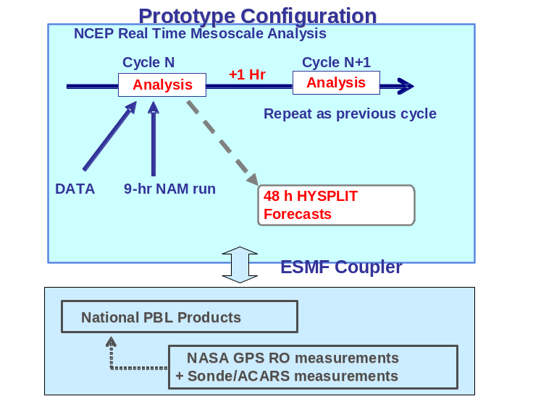
Figure XX.2. Overview of prototype configuration for RTMA boundary layer analyses using profile measurements. The analysis can be used to drive plume dispersion models.
      - Data collection for an atmospheric boundary layer observation network *SEE SECTION 3.2, D. Ruffieux, Meteo Swiss.

Nearby Lidar Measurements
In addition to on-site date discussed in section 3.2, Lidar data such as the NASA Micro-Pulse Lidar Network (MPLNET) (Welton et al., 2001) Micro-Pulse Lidar (MPL) systems can be used and are designed to measure aerosol and cloud vertical structure continuously, day and night, over long time periods required to contribute to climate change studies and provide ground validation for models and satellite sensors in the NASA Earth Observing System (EOS). MPLNET sites and various field campaigns, and planned and proposed future sites are shown at http://mplnet.gsfc.nasa.gov and provides up-to-date information on the project and access to data products.

MPLNET and other lidar sites can identify site PBL growth during morning into afternoon and the timing of boundary layer collapse during the evening. These data are assimilated into the operational NOAA/NWS RTMA. Aerosol layers in the free troposphere are visible during the previous night, and the PBL eventually reaches high enough to entrain the material in the afternoon. Entrainment of transported material by the local PBL is directly impact surface concentration measurements. MPLNET collect data continuously, day and night. These boundary layer processes are important for determining the fate and transport of potential releases of radiological material. Therefore, a meteorological analysis should capture boundary layer flows by combining high resolution analyses with surface and boundary layer measurements (eg: Meteo Swiss system, Section 3.2).

The Real-Time Mesoscale Analysis (RTMA) run at NOAA/NWS production over the U.S. is an example of a high resolution meteorological analysis. The RTMA suite of analyses comes from three sources with two running at NCEP. An Effective Cloud Amount (ECA) is produced from GOES data at and by NOAA/NESDIS. An hourly analysis of gage observations and radar estimates of precipitation accumulation over the contiguous United States (CONUS) is produced at NCEP and is called the Stage II National Precipitation Analysis. For the RTMA, this analysis is converted and interpolated to the 2.5 km NWS National Digital Forecast Database (NDFD grid) used by all NWS Forecast offices to produce gridded forecast products

3.3.3. Variational Assimilation

The primary RTMA system component, is based on a 2-dimensional application of EMC’s unified 3-dimensional variational analysis system called Grid-point Statistical Interpolation (GSI). The GSI runs in both the North American Mesoscale (NAM & NDAS) and Global Forecast System (GFS & GDAS). Using a first-guess obtained by downscaling a 1-hour Rapid Update Cycle (RUC) forecast from 13- to 5-km, the RTMA performs an analysis of all surface observations (surface-synoptic, metar, mesonet, ship, buoy etc) of temperature and dew point at 2 m and wind at 10 m. In addition, estimates of analysis uncertainty for each variable are also produced. Reducing the assimilation process to two dimensions enables the development of high resolution analysis in real-time for various applications. A high horizontal resolution analysis is essential for dispersion and air quality applications which are very sensitive to fine scale boundary layer processes driven by fine scale orogrophy such as land-sea breezes, flows in complex terrain and urban heat island effects.

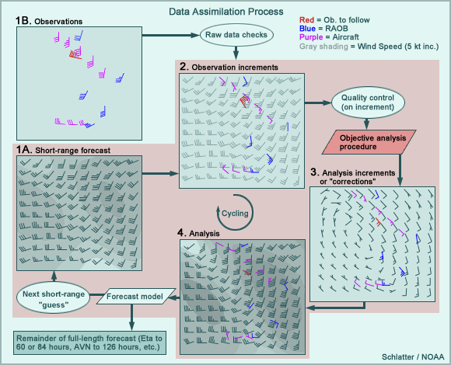
Fig. XX.3 Example of the 4 dimensional variational assimilation process where model first guess fields(1A) are adjusted by observations (1B) by computing differences or increments (2) between observations and the first guess to correct (3) the 1st guess, thereby producting a final analysis (4).

    - Diagnostic Mass Consistent Wind field Analyses.

Diagnostic mass consistent wind field analysis techniques are often used by air quality regulatory agencies to capture complex wind flows affecting transport and diffusion of pollutants. A description of this type of downscaling is found here:
http://www.meted.ucar.edu/nwp/pcu2/DNG/nam_dng1.htm

Surface winds are interpolated to a regular grid and some type of interpolation is performed that accounts for the effect of orography. Some mass consistent downscaling techniques are highlighted below:
- Inverse distance-squared weighting (Goodin et al. 1979)
- Inverse elevation difference weighting (Palomino and Martin 1995)
- Upper-level wind data interpolated to the three-dimensional grid
- Topographic effects, slope winds and blocking are parameterized (e.g.: CALMET, Scire, et al. 2000).
- Three-dimensional wind fields adjustments to ensure the conservation of mass (Moussiopoulos and Flassak 1986; Brocchini et al. 1995)

    - Examples (CALMET, CALWRF)

The CALMET, CALWRF (Scire, et al. 2000) downscaling technique uses coarse-grid input of meteorological fields, and makes adjustments to wind field based on coarse versus fine-grid terrain and land use fields. This technique is extremely efficient compared to running a full high resolution dynamic mesoscale model (See. Section 3.2). The flow is forced to be terrain-parallel and modulated by thermal stability. The along-terrain flow is required when the Froude number < 1. The resultant 3D divergence is then with an iterative procedure . Finally, the underlying terrain roughness is adjusted using similarity theory. An example of downscaled winds over the Central Pennsylvania valley in the U.S. is shown in Fig. XX.4. More information on this approach is found at: http://www.enviroware.com/calmet/

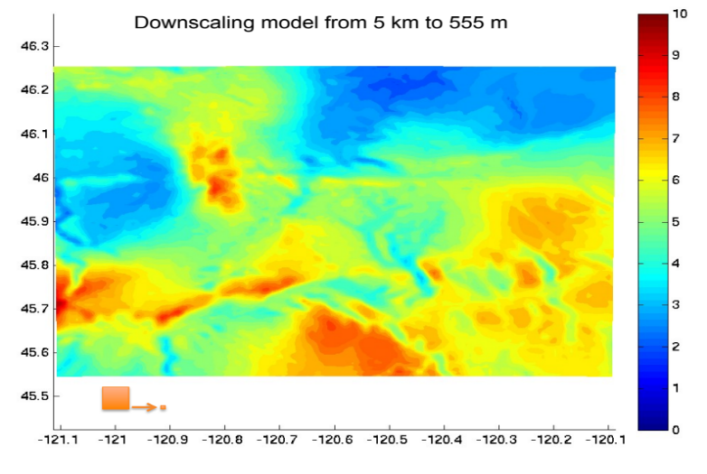
Fig. XX.4 CALMET downscaled winds (550 m resolution)over the central PA valley

    - Combined Physical and Statistical Downscaling

A combined approach utilizes the physical adjustment techniques described in section 3.3.4 and 3.3.5 with statistical corrections based on a climatology. Verkaik, et al. (2006) described a combined technique based on a simple model of the Planetary Boundary-Layer (PBL) and on high-resolution surface roughness information. The PBL model consists of two layers: the Ekman layer covering the upper PBL and the surface layer accounting for air surface interactions. Roughness lengths determined by averaging geographical variations in surface roughness over the upstream area of the airflow. These resulting high-resolution roughness lengths are wind direction dependent applied to the winds through the PBL model. An example of adjusted wind fields over the Netherlands is shown in Fig. XX.5

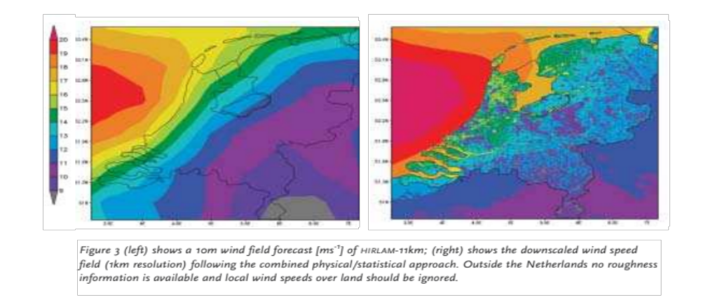
Figure XX5. 10 m winds from KNMI HILAM mesoscale model (left); downscaled (1km) wind speeds using combined physical/statistical approach (right). From Verkaik, et al. (2006).

    - Uncoupled high resolution land surface model (Canada)

Bernier, et al.(2011) applied an uncoupled high resolution land surface model over Vancouver for the 2010 winter Olympics. This External high- resolution prognostic surface model is driven from regional atmospheric model. Interactions between Surface, Biosphere, and Atmosphere (ISBA) land surface scheme is integrated to downscale atmospheric fields on a 100-m grid (140 km × 180 km). Local land characteristics are defined with the following data sets:
  - microscale topo- graphic information from the Shuttle Radar Topography Mission Digital Elevation Model (SRTM-DEM).
  - GlobCover global data- base at 300 m and several Canadian databases.

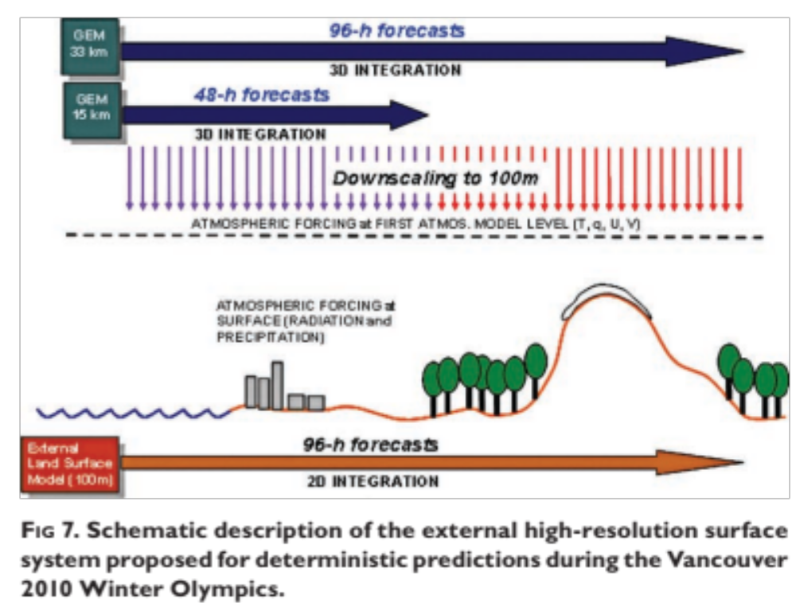
Fig. XX.6 Canadian Land Surface Model downscaling technique.

Height differences between the high-resolution (100 m) grid and the low-resolution atmospheric forcing grid are computed and constant atmospheric lapse rate of 0.0060 K m−1 to adjust key meteorological fields to high resolution elevation grid. The downscaled fields include surface pressure and temperature while low-level air humidity, by assuming conservation of relative humidity, and to possibly change precipitation phase. Initial conditions of surface variables (e.g., snow surface temperature, snow depth, etc.) from the 24-h external microscale forecast of the previous day (Fig. XX.6). This system is run operationally for all of Canada by the Canadian Meteorological Service (CMC) at a coarser resolution.

- Assessment of Meteorological Hazards
  - Extremes
  - Rare
  - Other
  - Transport, Dispersion and Deposition of Airborne Radioactivity

The atmospheric planetary boundary layer (PBL) height and associated winds and temperature in are critical weather components that drive dispersion decision support tools to assess contaminant concentration at a particular location. Numerous studies have shown model concentrations to be very sensitive to boundary layer information. For example, Hanna (1989) showed that doubling the PBL height led to a reduction in plume concentrations by a factor of two. Therefore, small errors in boundary layer heights can lead to large errors in plume concentration forecasts.

Therefore, accurate assessment of complex boundary layer processes at finer scales should improve a nuclear power plant operator’s ability to assess the effects of a potential toxic release. As discussed in section 3.3, a high resolution meteorological analysis could be used to an assess and respond to a potential release of toxic materials form a nuclear power plant to the atmosphere. These high resolution analyses will better capture important atmospheric boundary layer processes that influence the toxic plume dispersion are summarized. The following recommendations are made to improve these assessments:

- Basic weather and atmospheric turbulence monitoring to capture atmospheric planetary boundary layer processes derived from surface and upper level instruments.

- Integrating these observations into a retrospective or Real Time Mesoscale weather Analysis (RTMA) around the site through recent downscaling technologies (described in section 3.2, 3.3). A planetary boundary layer (PBL) analysis can be created by ingesting on-site or nearby surface mesonets and upper level ACARS, profiler or lidar measurements through dynamic or statistical downscaling. Adequate meteorological analyses may also be obtained through the regional NMC who may already run higher horizontal resolution (~ 4km) weather analysis and forecast models. Typically high vertical resolution (50-100 m) meteorological fields are also desired to accurately resolve boundary layer information.

- Outputting important meteorological parameters from the analysis including:
  - Surface and boundary layer winds, temperature, moisture, pressure
  - Mixed layer depth
  - Precipitation
Also useful would be:
  - Cloud fraction, base and heights.
  - Surface momentum, heat and moisture fluxes
  - Estimates of mixed layer turbulence (e.g: turbulent kinetic energy, energy dissipation rates…) and stability.

- Regular verification of basic meteorological downscaled predictions would be performed to determine strength and weaknesses of the modeling system that could be conveyed to the model developer or modeling center where the predictions were performed.

- Utilizing these analyses and forecasts to drive an Atmospheric Transport and Diffusion Model (ATM) to produce surface estimates of realistic toxic concentrations if source term estimates are known. Otherwise relative concentration factors (eg: Draxler and Rolph, 2012; Draxler, et al., 2013) could be produced to help emergency managers identify areas conducive for weak dispersion (stable atmospheric conditions) that would be particularly vulnerable to high toxic pollutant concentrations if a release did occur.

- Using the emergency response dispersion capability for power plant siting evaluations by conducting an assessment of areas vulnerable to higher concentrations from atmospheric dispersion processes.

    - Recommendations on assessing dispersion for site planning or operations

There are two main purposes of a local meteorological investigation at an NPP site:
(a) Evaluation of dispersion in normal NPP operation; and
(b) Evaluation of dispersion in emergency situations.

(a) will be achieved by making meteorological measurements and analyses during periods covering a wide range of diffusion conditions and by determining the average frequencies of these conditions. This is usually solved by making special continuous measurements during one year or more. Later, these data can be used in diffusion models.
(b) will be achieved by using data from the special continuous measurements and also data from additional special case-study measurements of diffusion in complicated weather situations. In using these two kinds of data for establishing the meteorological part of the emergency service for
operation of the NPP, a minimum number of key parameters are obtained, sufficient for describing the spread of an emergency release. Emergency response can include use of same or similar meteorological and dispersion observations, analysis, prediction used for assessment. Operational emergency response to a hazardous release is described in more detail in section 9.5.

The IAEA has summarized key meteorological and dispersion needs for siting nuclear power plants (See IAEA Doc 3-4, 2003, IAEA-Doc 4-17, 2011):

- The atmosphere is a major exposure pathway by which radioactive materials that are either routinely discharged under authorization or accidentally released from a nuclear power plant could be dispersed in the environment and transported to locations where they may reach the public.
- The evaluation of the transport in the atmosphere of radioactive materials discharged from a nuclear power plant under normal operational or accidental conditions is a requirement of design and licensing. A meteorological investigation should be carried out to evaluate regional and site specific meteorological parameters. These data should be collected from appropriate elevations above ground in order to obtain realistic dispersion parameters.
- Contamination in the air, on the ground and in water over short and long time periods should be described in the atmospheric dispersion models, with account taken of diffusion conditions in the region. Orographic elevations having significant slopes should be considered in the models.
- The type and extent of acquired and stored meteorological data should allow for reliable statistical analyses to determine the distribution of radiation exposures.
- The effects and consequences for the public and the environment of short term or long term radioactive discharges should be assessed on the basis of meteorological information and site specific conditions relating to land and water uses, population distribution, infrastructure in the vicinity of the site and relevant radiological parameters.
- A detailed meteorological investigation should be carried out in the region. The calculations of the dispersion and concentrations of radioactive materials should show whether the radiological consequences of routine discharges and potential accidental releases of radioactive materials into the atmosphere are acceptable. The results of these calculations may be used to establish authorized limits for radioactive discharges from the plant into the atmosphere.
- The results of the meteorological investigation should be used to confirm the suitability of a site; to provide a baseline for site evaluation; to determine whether local meteorological characteristics have altered since the site evaluation was made and before operation of the plant commences; to select appropriate dispersion models for the site; to establish limits for radioactive discharges into the atmosphere; to establish limits for design performance (for example, containment leak rates and control room habitability); and to assist in demonstrating the feasibility of an emergency plan.
- The warning system should be used in connection with forecasting models since the time period that would be necessary for operator actions to put the installation into a safe status may necessitate acting on the basis of extrapolations of trends in phenomena without waiting for the actual occurrence of the hazardous event. Typical emergency response system for atmospheric dispersion is overviewed in section 9.5

4.4.2 Dispersion models for creating concentration analyses and forecasts

These high resolution meteorological analysis would then be used in an atmospheric dispersion model to account for atmospheric turbulence and stability for relatively turbulent, convective or unstable and conditions where less turbulence and a more stable atmosphere exists. Atmospheric stability can have a large effect on the predicted or analyzed plume footprint or concentration amount. Under unstable conditions, for example, a dispersing gas will mix rapidly with the air around it. The plume cloud will extend less far downwind than it would under more stable conditions, because the pollutant would more be diluted faster. Several types of dispersion models are used as part of the WMO EER RSMC capability and are described in WMO Technical Note 778. The NOAA Hysplit dispersion model (Draxler and Hess, 1997) forecast of a hypothetical plume over New York City is shown in Fig. XX1. Uncertainty estimates can also be obtained (eg: the HPAC model) Fig. 4.XX2.

Training on atmospheric dispersion and dispersion models can be found at the COMET/METED web page:
https://www.meted.ucar.edu/training_module.php?id=33

or the NOAA/Air Resources Laboratory:
http://www.arl.noaa.gov/atmosDisp.php

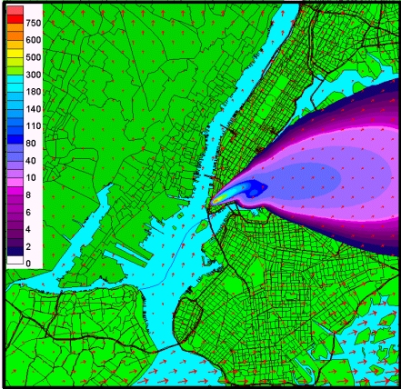

Fig 4.XX.1. Example of a HYSPLIT Dispersion Model forecast of a hypothetical atmospheric release of contaminent.

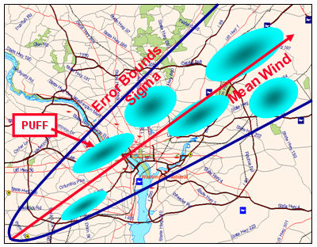

Fig. 4.XX.2 Use of U.S. Defense Threats Reduction Agency (DTRA) Hazard Prediction and Assessment Capability (HPAC, Sykes, et al. 2007) dispersion model to compute uncertainty bounds for a hypothetical atmospheric release.

If source terms are not known a dispersion analysis of a unit release can be created by computing a transfer coefficient matrix that accounts for the atmospheric transport of a general tracer (Draxler and Rolph, 2012). A gridded concentration analysis of various emission scenarios can then be quickly calculated without rerunning the ATM (eg: Draxler, et al. 2013).

9.1 Meteorological Forecasts and Warnings

9.2 Hydrological Forecasts and Warnings

9.3 Operational Atmospheric Dispersion and Emergency Response

As a result of the poor communications between countries following the Chernobyl accident in the Spring of 1986, the World Meteorological Organization (WMO) was asked by the International Atomic Energy Agency (IAEA) and other international organizations to arrange for early warning messages about nuclear accidents to be transmitted over the Global Tele-communications System (GTS). In addition some WMO member countries lacking extensive forecasting capability requested that specialized pollutant transport and dispersion forecasts be provided during these emergencies.

In 1989, Regional Specialized Meteorological Centers at Toulouse (Meteo-France), Bracknell and Montreal were set up under interim arrangements between the WMO and the IAEA. Under these arrangements Meteo-France was to provide global coverage (with Bracknell as the backup center) until each WMO region had at least two RSMCs for transport model products. Currently 9 RSMCs have been set up covering all WMO regions. Detailed information on RSMCs and real-time atmospheric transport and diffusion models can be found at:
http://www.wmo.int/pages/prog/www/DPFSERA/td778.html

For example, The HYSPLIT (HYbrid Single-Particle Lagrangian Integrated Trajectory) model is used by RSMC-Washington to respond to a nuclear emergency. HYSPLIT is the newest version of a complete system for computing simple air parcel trajectories to complex dispersion and deposition simulations. It is the primary NOAA decision support tool for plume dispersion and RSMC support. The dispersion of a pollutant is calculated by assuming either puff or particle dispersion. In the puff model, puffs expand until they exceed the size of the meteorological grid cell (either horizontally or vertically) and then split into several new puffs, each with it's share of the pollutant mass. In the particle model, a fixed number of initial particles are advected about the model domain by the mean wind field and a turbulent component. The model's default configuration assumes a puff distribution in the horizontal and particle dispersion in the vertical direction. In this way, the greater accuracy of the vertical dispersion parameterization of the particle model is combined with the advantage of having an ever expanding number of particles represent the pollutant distribution. Other RSMC centers have similar real-time 24 by 7 ATM capabilities in the event of a radiological event.

REFERENCES
ATOMIC ENERGY REGULATORY BOARD, AERB/SC/S, “Code of Practice on Safety in Nuclear Power Plant Siting”, 1990.

Bernier, Natacha B., Stéphane Bélair, Bernard Bilodeau, Linying Tong, 2011: Near-Surface and Land Surface Forecast System of the Vancouver 2010 Winter Olympic and Paralympic Games. J. Hydrometeor, 12, 508–530. doi: http://dx.doi.org/10.1175/2011JHM1250.1

Bishnoi, L.R. and P. C. Basu, “Siting of Nuclear Installations”, Nuclear India, Vol 38, No.7-8, Page 8-10, Jan-Feb. 2005.

Brocchini, Maurizio, Morton Wurtele, Georg Umgiesser, Stefano Zecchetto, 1995: Calculation of a Mass-Consistent Two-Dimensional Wind Field with Divergence Control. J. Appl. Meteor., 34, 2543–2555. doi: http://dx.doi.org/10.1175/1520-0450(1995)034<2543:COAMCT>2.0.CO;2

Draxler, R.R., Dèlia Arnold, Stefano Galmarini, Matthew Hort, Andrew Jones, Susan Leadbetter, Alain Malo, Christian Maurer, Glenn Rolph, Kazuo Saito, René Servranckx, Toshiki Shimbori, Efisio Solazzo and Gerhard Wotawa, World Meteorological Organization’s Model Simulations of the Radionuclide Dispersion and Deposition from the Fukushima Daiichi Nuclear Power Plant Accident, accepted Journal of Environmental Radioactivity, 2013.
http://www.wmo.int/pages/prog/www/CBS -Reports/documents/WMO_fnpp_final_AnnexIII_4Feb2013_REVISED_17June2013.pdf

Draxler, R.R, and G.D. Rolph (2012): Evaluation of the Transfer Coefficient Matrix (TCM) approach to model the atmospheric radionuclide air concentrations from Fukishima. J. Geophys.. Res., 117, D05107, doi:10.1029/2011JD17205. http://dx.doi.org/10.1029/2011JD17205

Draxler, R.R., and G.D. Hess, 1997, Description of the HYSPLIT_4 modeling system. NOAA Technical Memo ERL ARL-224, December, 24 p.

Goodin, William R., Gregory J. McRa, John H. Seinfeld, 1979: A Comparison of Interpolation Methods for Sparse Data: Application to Wind and Concentration Fields. J. Appl. Meteor., 18, 761–771. doi: http://dx.doi.org/10.1175/1520-0450(1979)018<0761:ACOIMF>2.0.CO;2

Hanna, S.R., 1989: Confidence limits for air quality model evaluations as estimated by bootstrap and jackknife resampling methods. Atmos. Environ., 23, 1385-1398.

IAEA Safety Guide: “Meteorological and Hydrological Hazards in Site Evaluation of Nuclear Installations” (IAEA/DS-No. 417) 201. Jointly sponsored by IAEA and WMO, under the series Specific Safety Guide (No. SSG-18). This volume is available through the IAEA Publications Website:
http://www-pub.iaea.org/books/iaeabooks/8635/Meteorological-and-Hydrological-Hazards-in-Site-Evaluation-for-Nuclear-Installations-Specific-Safety-Guide

International Atomic Energy Agency SAFETY STANDARDS SERIES, NS-R-3, “Site Evaluation for Nuclear Installations”, (2003).

INTERNATIONAL ATOMIC ENERGY AGENCY, Meteorological Events in Site Evaluation for Nuclear Power Plants, Safety Standards Series No. NS-G-3.4, IAEA, Vienna (2003).

INTERNATIONAL ATOMIC ENERGY AGENCY, Dispersion of Radioactive Material in Air and Water and Consideration of Population Distribution in Site Evaluation for Nuclear Power Plants, Safety Standards Series No. NS-G-3.2, IAEA, Vienna (2002).

Moussiopoulos, N., Th Flassak, 1986: Two Vectorized Algorithms for the Effective Calculation of Mass-Consistent Flow Fields. J. Climate Appl. Meteor., 25, 847–857.
doi: http://dx.doi.org/10.1175/1520-0450(1986)025<0847:TVAFTE>2.0.CO;2

Palomino, I. and F. Martin, 1995: A simple method for spatial interpolation of the wind in complex terrain., J. Appl. Met., 34, 1678-1694.

Parrish, D. F. and J. C. Derber, 1992: The National Meteorological Center's spectral statistical interpolation analysis system., Mon. Wea. Rev., 120, 1747 - 1763.

Scire J.S., Robe F.R., Fernau M.E. and Yamartino R.J. (2000) A user’s guide for the CALMET meteorological model (Version 5.0). - See more at: http://www.enviroware.com/calmet/#sthash.pSYrqSR4.dpuf

Sykes, R.I., S. Parker, D. Henn and B. Chowdhury, 2007: SCIPUFF Version 2.3 Technical
Documentation. L-3 Titan Corp, POB 2229, Princeton, NJ 08543-2229, 336 pages

Tsidulko, M., G. Dimego, M. Ek, J. McQueen, and P. C. Lee: PBL and ozone verification in NAM-CMAQ modeling system at NCEP, 9th Conference on Atmospheric Chemistry, San Antonio, TX, 14-18 January, 2007.

Verkaik, J.W., A.J.M. Jacobs, A.B.C. Tijm and J.R.A. Onvlee, Local Wind Speed Estimation by Physical Downscaling of Weather model forecasts J. Wind Eng. and Ind. Aerodyn., 2006. Abstract (html) Complete text (pdf: 1 MB)

Welton, E. J., J. R. Campbell, J. D. Spinhirne, and V. S. Scott, 2001: Global monitoring of clouds and aerosols using a network of micro-pulse lidar systems, in Lidar Remote Sensing for Industry and Environmental Monitoring, U. N. Singh, T. Itabe, N. Sugimoto, (eds.), Proc. SPIE, 4153, 151-158.

White, J.M., J.F. Bowers, S.R. Hanna, and J.K. Lundquist, 2009: Importance of using observations
of mixing depths in order to avoid large errors by a transport and dispersion model. J. Atmos. and
Oceanic Technol., 26, 22-32.

Winker, D. M., J. R. Pelon, and M. P. McCormick, 2002: The CALIPSO mission: spaceborne lidar for observation of aerosols and clouds. in Lidar Remote Sensing for Industry and Environmental Monitoring III, U. N. Singh, T. Itabe, Z. Liu, (eds.), Proc. SPIE, 4893, 1-11.

World Meteorological Organization. Technical document no. 778. RSMC SUPPORT FOR ENVIRONMENTAL EMERGENCY RESPONSE: Documentation for Meteorologists at NMSs.
http://www.wmo.int/pages/prog/www/DPFSERA/td778.html

Wu, W.-S., R. J. Purser, and D. F. Parrish, 2002: Three-dimensional variational analysis with spatially inhomogeneous covairances, Mon. Wea. Rev., 130, 2905-2916.

.

