**RSMC Exeter Users’ Interpretation Guidelines and**

**Atmospheric Transport Model Outputs November 2015**

**1. Introduction**

The Meteorological Office in the United Kingdom (hereafter referred to as the Met Office) became a WMO-designated RSMC following the International Workshop on Users’ Requirements for the provision of Atmospheric Transport Model Products for Environmental Emergency Response held in Montreal in September 1993. Together with Meteo-France, Exeter has responsibility for WMO Regions I and VI. This article gives a description of the Met Office emergency response operation and the dispersion model products.

**2. The Met Office**

The Met Office, which became a Ministry of Defence (MOD) agency in 1990 and started operating as a MOD owned trading fund on 1stApril 1996, is the UK National Meteorological Service, observing the weather and providing forecast services to a wide range of customers. In 2012 the “owning” department of the Met Office within UK Government changed from MOD to BIS (Business, Innovation and Skills).

The main operations room is the Operations Centre (Ops Centre) at the Met Office headquarters in Exeter, Devon, which is continuously staffed and operational. The Ops Centre has responsibility for the RSMC operation which, since 1999, has been carried out by an emergency cell within the Ops Centre called EMARC (see below) along with a wide range of other emergency response duties.

The weather forecasting service is underpinned by the UK numerical weather prediction model, the Unified Model. This has global and local-scale versions. The Global Model currently has a resolution of 17km in the horizontal and 70 levels in the vertical. A number of smaller-scale models are also maintained and utilised including EURO4 model (covering a domain across much of Europe and the northeast Atlantic with a resolution of 4km and 70 vertical levels) and UKV model (covering the British Isles with a resolution of 1.5km and 70 vertical levels).

The Unified Model is also used as a source of winds and meteorology for the UK dispersion model, the ‘NAME’ model. Research and development in numerical weather prediction and atmospheric processes (including atmospheric dispersion) is carried out at the main office in Exeter. Research is currently organised under three divisions, Numerical Weather Prediction, Climate Research and Atmospheric Processes Research. Research into atmospheric dispersion is done by the Atmospheric Dispersion and Air Quality Group. The methods used to predict the movement of airborne pollutants have become increasingly rigorous, the Chernobyl disaster of 1986 giving long range transport and dispersion studies a new impetus. In January 1988, the UK Government unveiled its National Response Plan which included RIMNET (the Radioactive Incident Monitoring Network, many of whose sensors are positioned at regional met. observing sites) and the development by the UKMO of an advanced plume dispersion model, the **N**umerical **A**tmospheric-dispersion **M**odelling **E**nvironment (NAME-III).

**3. The Met Office Emergency Response Model ‘NAME’**

The Met Office’s Numerical Atmospheric-dispersion Modelling Environment, NAME, is a Lagrangian particle-trajectory model designed to predict the atmospheric dispersion and deposition of gases and particulates. A large number of particles are used to represent releases from pollution sources. Each model particle can have its own characteristics, represent different compounds or chemicals and represent real particulate sizes. These particles are advected by the temporally varying, three-dimensional model winds and dispersed using random walk techniques that take into account the atmospheric turbulent velocity structures.

Several deposition processes remove particles from the atmosphere; i) impaction with the surface, ii) washout where particles are `swept out' by falling precipitation, iii) rainout where particles are absorbed directly into cloud droplets as they form and, iv) fall out due to gravity.

A modular code design offers the user flexibility in configuring model runs and provides an infrastructure onto which extra modules could be added. NAME is capable of utilising meteorological data from a variety of sources: fields from a numerical weather prediction model, radar rainfall estimates, and single-site observations, with the available data used in a nested sense.

Other effects, such as plume-rise (for buoyant or momentum-driven releases), radioactive decay of radionuclides, and chemical transformations, can also be included. At short ranges, NAME functionality includes modelling of short-period concentration fluctuations and the effects of small-scale terrain or isolated buildings on dispersion.

**4. The Emergency Monitoring and Response Centre, EMARC**

During 1999, the UKMO established a fully operational, 24 hours per day, 7 days per week, specialised national environmental emergency monitoring and response centre within the Ops Centre. It is staffed by meteorologists with specialised training and handles all UK MO operational atmospheric dispersion products, including national nuclear and chemical incidents, airborne animal diseases, smoke from large oil fires, and all international ERA, such as RSMC for nuclear emergency and London VAAC, for volcanic ash. The EMARC bench also provides support to the Maritime and Coastguard Agency (MCA) for support in marine pollution incidents.

In 2012, the EMARC cell was expanded to include a Space Weather capability and given the collective name “Hazard Centre” such that “Hazard Centre” refers to the wider Emergency Response and Space Weather capability whilst “EMARC” refers more to the atmospheric dispersion capability.

**5. Description of the NAME output charts for the default scenario.**

An example of NAME RSMC output is given in figures 1 to 7. The default release scenario is used for a notional release at UK MO headquarters in Exeter. The numbered comments (see Figure 1) are as follows:

1. Identification of output---Dosage between the surface and 500m.

2. Validity Time.

3. The maximum computed Dosage. The position is not given but can be identified from the contour pattern.

4. Legend showing the number and value of the contours. The unit is Bqsm-3, i.e. Bq seconds per cubic metre.

5. Simulation Description

a. Start time of the release

b. End time of the release, 6 hr after the start for the default scenario.

c. Release rate of 1 Bq over the 6 hr, i.e. 4.6305558E-5 Bqhs-1.

d. Source location in degrees latitude and longitude, expressed to 4 decimal places

e. The release height, 250m above ground level, i.e. the half way point between surface to 500m above ground level as prescribed by the default scenario

f. Identification of the isotope simulated.

g. The source of the winds and meteorology used in the integration: in this case the global version of the Unified Model

h. The time and date of the model run

6. The originating centre, the UK Met Office.

Figures 2 and 3 are similar charts for two succeeding 24 hr periods.

In figures 4, 5 and 6 the charts show total (wet and dry) deposition to the surface over periods T+24, T+48 and T+72 respectively. The details are analogous to those for the Dosage fields, the units in Bqm-2.

Figure 7 shows corresponding 3-dimensional trajectories at 500, 1500 and 3000m above ground released at 12UTC on 12/04/2011 and continued for 3 days. The paths are labelled at 12 and 00UTC each day. Also shown in a panel below the chart is the vertical projection of the trajectories in metres above ground level plotted against date and time.

**6. Other services provided by the UKMO Operations Centre.**

The Ops Centre acts as a control and co-ordination centre for all UK meteorological forecasts, both local and overseas, and both military and civil. It offers a wide range of forecasts, from very short range up to the medium range for military, public, media and commercial customers, including international and national aviation, local and global shipping. The Operations Centre also hosts one of only two World Area Forecast Centres (WAFC) on behalf of ICAO. North Atlantic marine forecasts are also issued to support the Global Maritime Distress and Safety System (GMDSS) and Safety of Life at Sea (SOLAS).

Along with the Hazard Centre, as described above, there is also a dedicated Flood Forecasting Centre (FFC) hosted within Ops Centre. The FFC is a partnership between the Environmental Agency (EA) in England and Wales and the Met Office. Meteorologists within the FFC are co-trained in both meteorology and hydrology, working closely with the Guidance Team in the Met Office and EA personnel elsewhere to ensure that the impact of rainfall on the environment is clearly understand, enabling timely warnings to be issued to Emergency Responders and the general public in the UK.



6

4

3

5

2

1

Figure 1

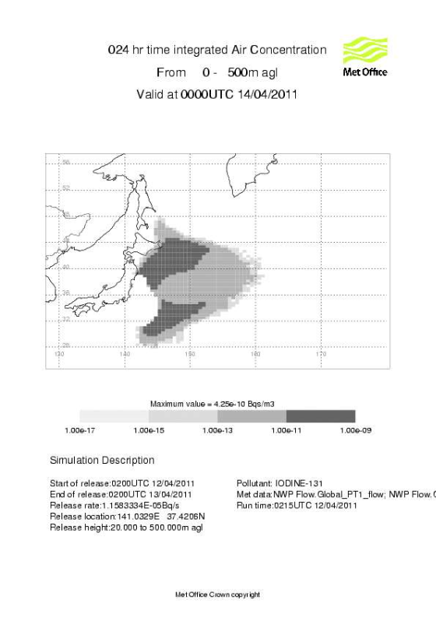

Figure 2

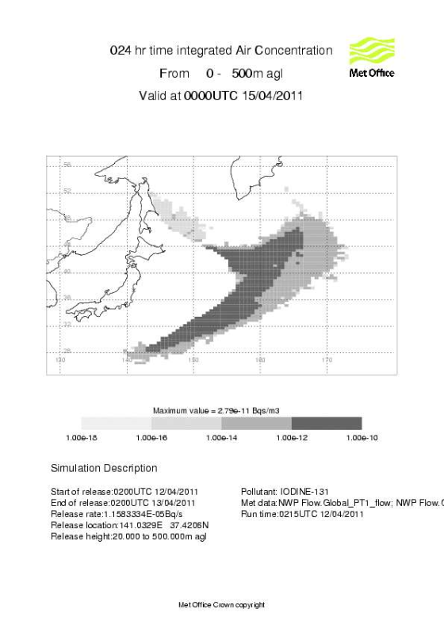

Figure 3

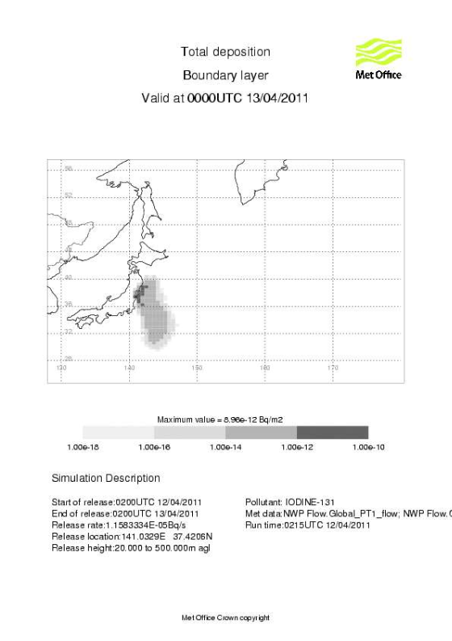

Figure 4

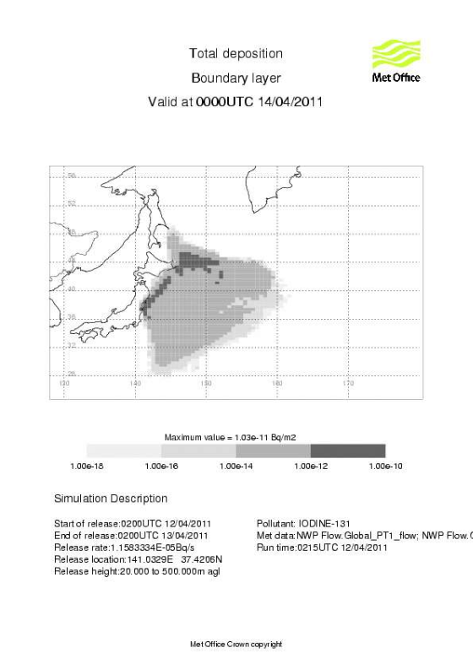

Figure 5

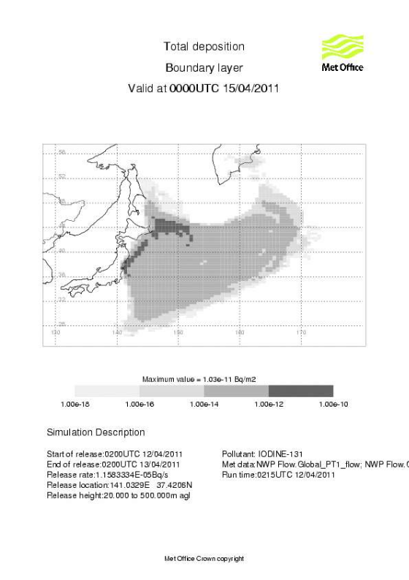

Figure 6



Figure 7