WORLD METEOROLOGICAL ORGANIZATION  COMMISSION FOR BASIC SYSTEMS  OPAG on DPFS  EXPERT TEAM ON EMERGENCY RESPONSE ACTIVITIES (ET-ERA)  BUENOS AIRES, ARGENTINA, 30 NOVEMBER – 4 DECEMBER 2015 |  | CBS-DPFS/ET-ERA/Doc. 5.2  (27.XI.2015)  _______  Agenda item : 5.2  ENGLISH ONLY

Report on the 2014 Non-Nuclear Exercise

(Submitted by James Fraser, RSMC Melbourne and Martina Suaya, SMN-Argentina)

Summary and purpose of document

This document describes the objectives, the assumed scenario and the results of a second WMO non-nuclear exercise to test the draft operational procedures for request/reply for RSMC support for a significant chemical incident. The exercise took place on 3 September 2014 and again involved the RSMC Montreal and the National Meteorological Service of Argentina (Servicio Meteorológico Nacional)

Action Proposed

The meeting is invited to review the results of the Exercise, and to consider and discuss further steps for improvement of the draft procedures and a future full exercise involving all possible scenarios specified in the draft operational procedures for Non-Nuclear Emergency Response Activities.

Purpose of the exercise

One of action items from the CBS Expert Team on Emergency Response Activities (ET-ERA) meeting in College Park, Maryland in October 2013 was that a second non-nuclear exercise, comprising a simulated request from NMHS to RSMC for assistance during a large chemical fire, was to be held to further test the draft non-nuclear ERA RSMC support procedures. The main objectives of the exercise would be to test the revised operational procedures for request/reply for RSMC support for a significant chemical incident, involve other NMHSs, and demonstrate to CBS the practicability of the developed procedures.

Scenario

A similar scenario to that used in the first exercise (which was conducted on 1 October 2013) was proposed, i.e. smoke from industrial fire scenario from the Campana-Zarate petrochemical plant in Argentina, which is located close to the Uruguay border.

The Expert Team originally envisaged the exercise to be carried out in November 2013 and the incident scenario was expected to include the following features:

- Use a real scenario, and run with real weather data on the decided date;
- Involve NMHSs of Argentina, Uruguay and Brazil; inform other NMHSs in RA III and ICAO (to highlight the potential impacts to aviation);
- NMHS in Argentina will make one request, and one RSMC only (Montreal) will provide its products for one model run.

Unfortunately, due to competing time demands at work and home (including the arrival of a new baby for the Co-Chair tasked with organising the exercise), development of the exercise did not progress in a timely manner and as the deadline for approval of the draft procedures in the new Manual approached it was decided that a full test was not feasible within the available time. It was decided it would be necessary to hold a reduced test involving only NMHSs of Argentina and Uruguay and RSMC Montréal. Unfortunately, on the day of the exercise NMHS Uruguay (through Mrs Vania Méndez) sent an apology saying they were too busy finalising performance protocols to be involved with the experiment that week.

The limited test was conducted on 3 September 2014, with NMHS Argentina sending a request form to RSMC Montreal for an incident scenario involving a chemical fire at the Campana-Zarate petrochemical plant (located at 34.158° S, 58.948° W) commencing from 1545 UTC. The submitted request form is included in Appendix I.

RSMC response

Timeline

16:29 UTC - email from SMN Argentina to RSMC Montreal with attached RSMC non-nuclear request form
16:35 UTC - email from RSMC Montreal acknowledging receipt of the request
16:53 UTC - MLDP0 model started
16:54 UTC - MLDP0 model finished running
17:14 UTC - MLDP0 results posted to web-pages
17:20 UTC - email from RSMC Montreal to SMN Argentina notifying of availability of results on web pages
17:32 UTC - email from SMN Argentina to RSMC Montreal acknowledging reception of the results.

Output products

Two types of products were generated by RSMC Montreal for the release scenario. The first was a set of charts showing surface to 500m relative concentrations (dilution factors) as a function of time. These show the pollution plume dispersion every 10 minutes for the duration of the 11 hour forecast. Samples of these plots at ~3-hourly intervals are shown in Figure 1 of Appendix II.

The full set of animated images can be seen at
http://eer.cmc.ec.gc.ca/people/eer/qKjtpkwO0YYyZ5FNOa0n/64_ZARATE/anim.html
and the individual images can be seen at
http://eer.cmc.ec.gc.ca/people/eer/qKjtpkwO0YYyZ5FNOa0n/64_ZARATE/
Also supplied were charts showing Lagrangian particle height and position as a function of time, ~3-hourly snapshots of which are shown in Figure 2 of Appendix II
http://eer.cmc.ec.gc.ca/people/eer/30KQ9tdN6p97Mmms1OqY/64_ZARATE/anim.html
and the Individual images can be seen at:
http://eer.cmc.ec.gc.ca/people/eer/30KQ9tdN6p97Mmms1OqY/64_ZARATE/
These charts are colour-coded to indicate the height of the individual particles (blue near the surface, cyan 100-200m, green 200-300m, orange 300-400m and red 400-500m. These charts indicate some wind direction variation with altitude (i.e. wind shear) with the upper levels of the plume being advected much further southwards than the primarily WSW flow seen in the lower levels.

Discussion

Request Timeline

Timeliness of the provision of output products to the requester was reasonable, taking 51 minutes from the initial request (compared to an overall response time of 65 minutes for the previous 2013 exercise). This was within the 2 hour time limit specified in the request form. Nevertheless, timeliness in a real event could most likely be significantly improved by generation of 1-hourly charts rather than 10 minute charts produced for this exercise.

Products

Self-contained dispersion maps are a basic product that would be viewable by any NMHS. However, some users may also be capable of displaying shapefiles for display in GIS systems (or possibly KML/KMZ files in Google Maps). Shapefiles are specified in the minimum list of products in the current draft procedures but no GIS products were generated for this particular exercise.

Notification of NMHSs

In this particular exercise, the south-westerly flow meant the hypothetical pollutant plume remained entirely within the national boundaries of Argentina for the duration of the modelling simulation, so there was no practical need for notification of neighbouring NMHSs. However, the site of the Campana-Zarate petrochemical plant used for this exercise is located close to the Uruguay border and trans-boundary impacts are a very real possibility, as evidenced by the modelled results in the previous 2013 exercise for which the plume immediately crossed the border into Uruguay.

The email from RSMC Montreal to SMN Argentina included the statement "These products are intended for the use of NMHS, who may re-distribute them to other NMHSs if appropriate". This seems more preferable than the RSMC being responsible for notifying other NMHSs in their Regional Association. It should be noted however that the redistribution of requested forecasting results to other NMHSs is, in fact, the subject of ongoing debate within the ET-ERA, with one member questioning the advisability of specifically mentioning this in the draft non-nuclear operational procedures to be incorporated in the new Manual on the GDPFS. This topic will be discussed in further detail in agenda item 5.3 of the present meeting.
Request Form

For this second exercise, a simple text-based request form was used that was little changed from to the form used for the original September 2013 exercise. However, Action Item 1.1 from the College Park 2013 meeting requested that the next draft of operational procedures use improved formatting and possibly including check boxes to select options describing the incident. Feedback from the member from NMHS Argentina was also keen on the use of checkboxes.

Attempts were made by the Co-Chair in April 2015 to improve the formatting of the non-nuclear request form, first by condensing it down to a single page (see Appendix III) which was rejected by the Chairperson as appearing too dense, and then rewritten as a Word 2010 docx document utilising the "fillable form fields" feature in which users can enter information which then clears any pre-existing dots or default explanatory text in the form entry boxes. However, this was also rejected by the Chairperson and the members from NMHS Argentina and RSMC Montreal as it was not backwardly compatible with older versions of Word that may still be in use in some NMHSs, so for the time being we have reverted to a simpler two-page text document similar to the original draft version but incorporating the use of some checkboxes to assist in the selection of scenario type (refer to Appendix A.II.2.2.-e in Doc-5-3_New-Manual-non-Nuclear.zip in the Doc Plan of the present meeting.)

Recommendations for further work

The member for RSMC Tokyo has rightly pointed out that the two non-nuclear exercises so far have only tested one of the four possible request scenarios covered in the draft non-nuclear procedures, viz. Smoke from forest, grass or peat fires; Smoke from industrial fire; Chemical releases not involving fire; and Backtracking trajectories; and that these exercises only involved a single RSMC and NMHS.

It is recommended that a further exercise (or series of exercises) be held covering each of the four scenarios that are covered by the draft procedures. Each exercise could involve multiple RSMCs, each responding to requests from an NMHS in their Regional Association. Demonstration of an RSMC's ability to respond to these request scenarios would be an important requirement for any RSMC seeking designation for non-Nuclear Emergency Response Activities.

Reference:

College Park, 2013: Meeting of the CBS Expert Team on Emergency Response Activities (ET-ERA). College Park, MD, USA, 21-25 October 2013

APPENDIX I: Request form used for September 2014 non-Nuclear exercise
REQUEST FORM TO ACTIVATE RSMC SUPPORT

ENVIRONMENTAL EMERGENCY RESPONSE ALERT REQUEST FOR WMO RSMC SUPPORT BY AUTHORIZED PERSON

- This form should be sent by e-mail to the RSMC operational contact in the Regional Association when support is needed for releases that have the potential for long-range impacts (distances greater than 50 km). The RSMC operational contact information is available on
http://www.wmo.int/pages/prog/www/DPFSERA/transport_model_products.htm
rsmc.montreal@ec.gc.ca

- The requester shall confirm reception of email at RSMC by phone.

- The RSMC shall make available its products as soon as possible but within 2 hours.

DATE AND TIME OF REQUEST: 3 September 2014, 16:30utc

1) MANDATORY INFORMATION:

- Name, title, organization, Country, phone number and email of requester:

Senior forecaster on duty: MS MARTINA SUAYA
EMAIL: msuaya@smn.gov.ar, martinasuaya@hotmail.com
National Weather Service, Argentina
54 11 51676767 ext: 18236

- Brief description of event: Petrochemical fire at Zarate.

- Date and Start time of release (specify local time or UTC): 3 September 2014, 15:45utc

- Location of release (as accurately as possible) in order of preference:
Latitude and longitude coordinates 34.1580 South, 58.9480 West

Address, city, Country Zarate, Argentina

2) OTHER INFORMATION: If known, the following would be useful for the modelling and should be provided as well:

- Name of location (name of chemical plant, factory, etc.)
Zárate Campana petrochemical complex

- Meteorological conditions at location at the start of the release (wind speed and direction / weather / cloudiness):
07/12kt, light rain, N=8/8 Cl=5 h=300mt
- Name of pollutant(s) to be modelled if known. If unknown, a tracer will be used.
Unknown, but a large smoke cloud is drifting from the complex

- Quantity (mass) or release rate (mass per unit time) of pollutant. If unknown, one unit mass will be used.
Unknown

- Expected release duration. If unknown, modeller will use default parameters or make a reasonable assumption.
8 hours

- Duration of simulation for the dispersion model run. If not provided, modeller will use default parameters or make a reasonable assumption.
18 hours

- Size of area of interest (for example, within 300 km of source). If not provided, modeller will use default parameters or make a reasonable assumption.
500km

- Base above the surface, dimension of release area and maximum height in meters reached by the pollutant (top of smoke plume for example). If not provided, modeller will make a reasonable assumption.

Base is near surface. Maximum height estimated at 600 m.

- If quantity (mass) and name of pollutant(s) are provided, what concentrations should be displayed on modelling outputs? Please specify.

- Any other information that may be useful:
THIS IS A TEST

Appendix II: Examples of products for a smoke cloud from a simulated explosion at the Zárate Campana petrochemical complex near Buenos Aires, Argentina.
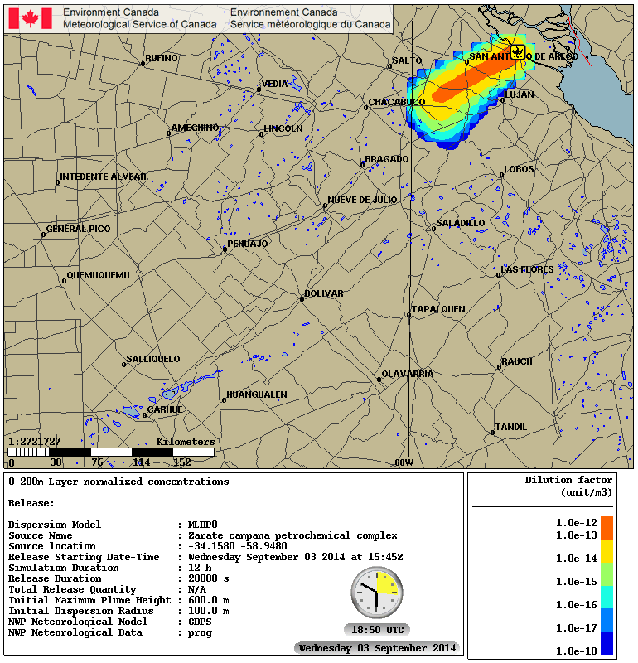 | 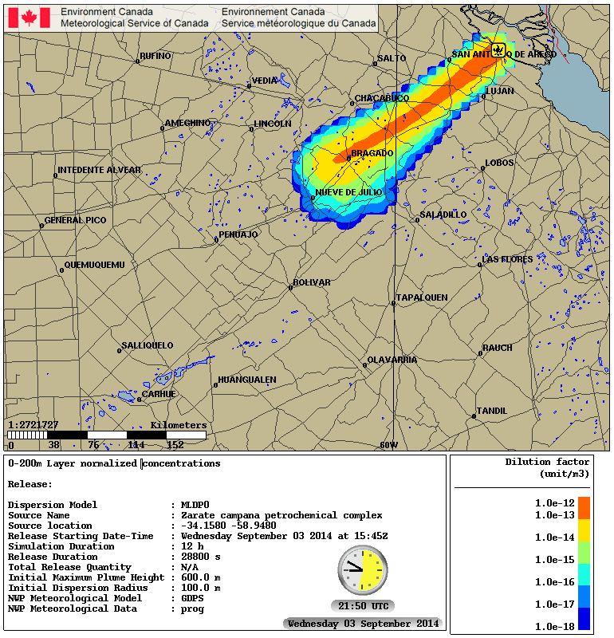
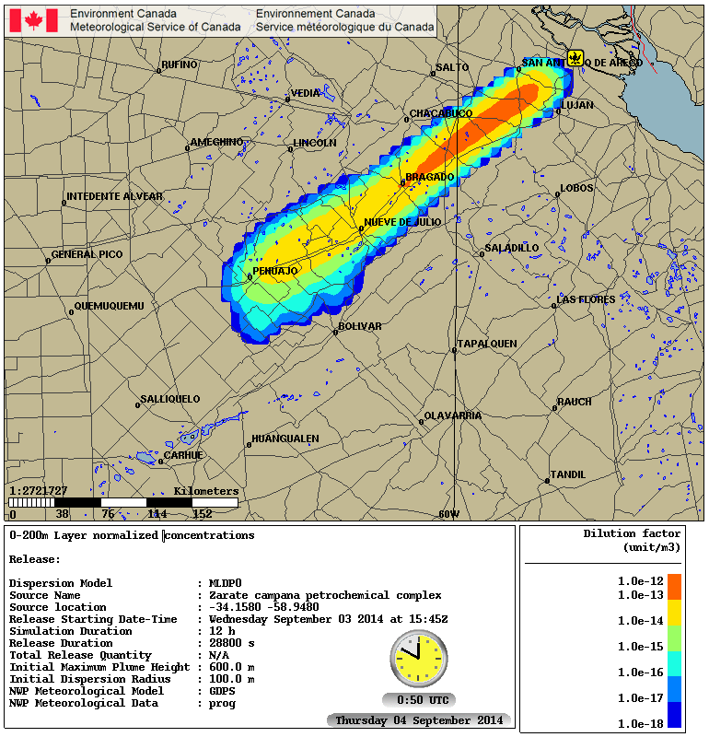 | 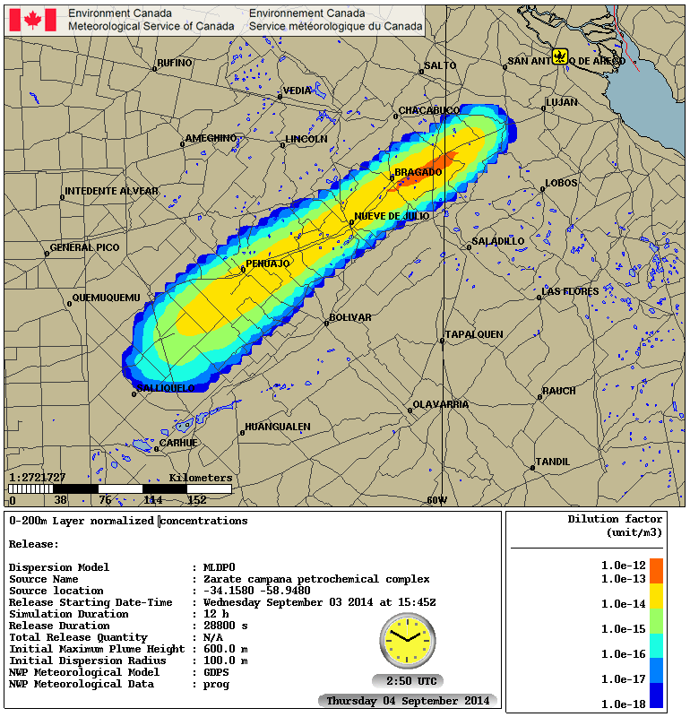

Figure 1: Dispersion charts showing the relative smoke concentrations (i.e. dilution factors) averaged between the surface and 500m for selected times after the start of the exercise a) +3 hours, b) +6 hours, c) +9 hours and d) +11 hours. The specified release duration was for the first 8 hours of the 11 hour simulation.
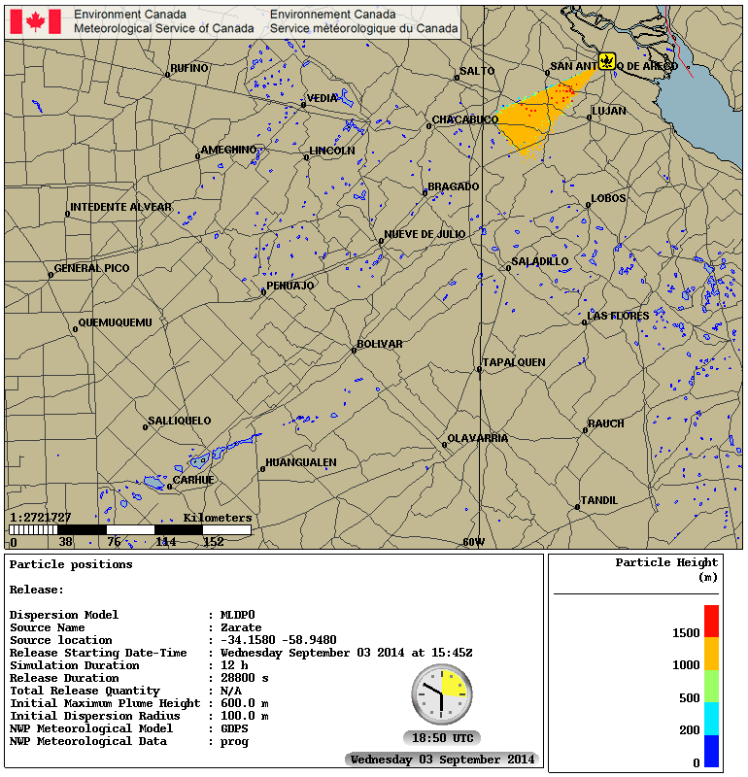 | 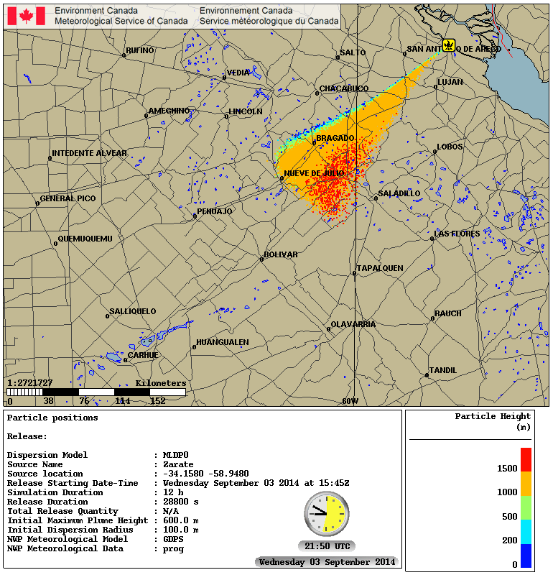
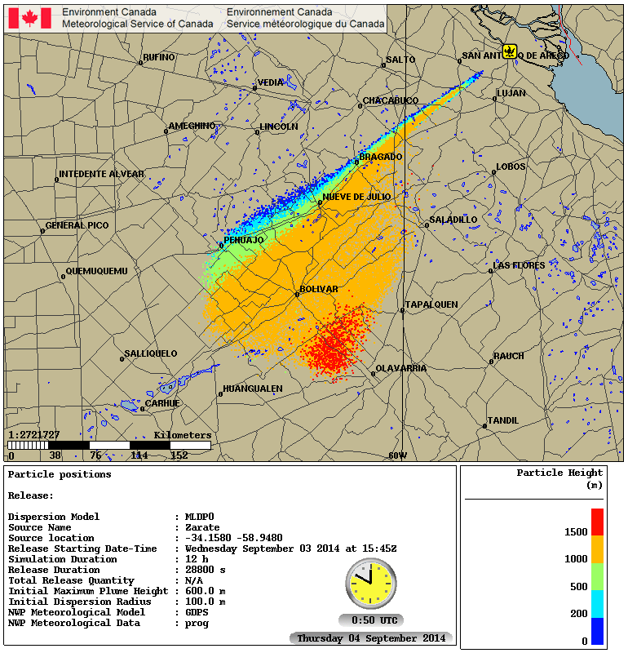 | 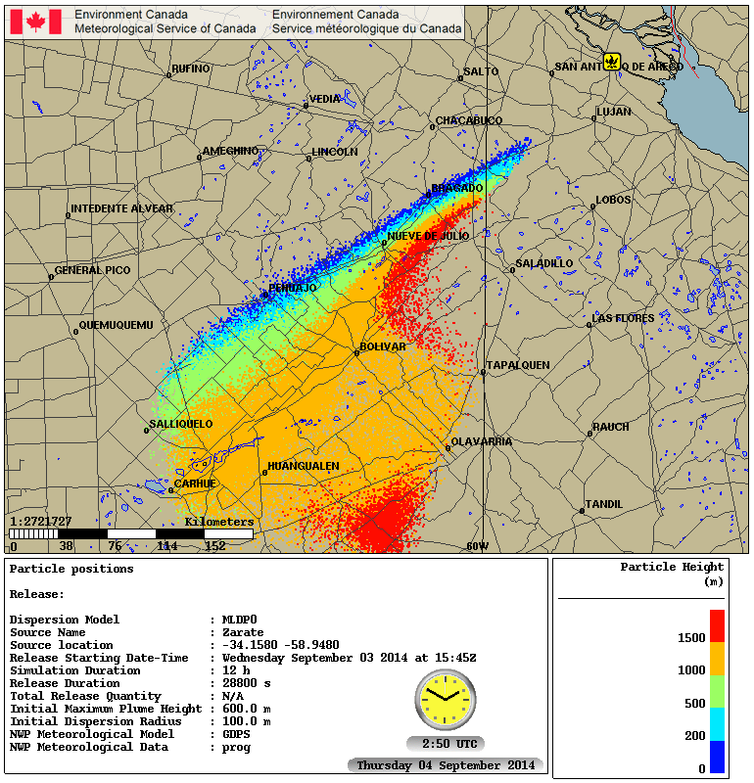
Figure 2: Dispersion charts showing parcel positions with heights indicated by color for selected times after the start of the exercise a) +3 hours, b) +6 hours, c) +9 hours and d) +11 hours.

APPENDEX III – Rejected single-page version of non-Nuclear Request Form
REQUEST FORM TO ACTIVATE RSMC SUPPORT

ENVIRONMENTAL EMERGENCY RESPONSE ALERT
REQUEST FOR WMO RSMC SUPPORT BY AUTHORIZED PERSON

- This form should be sent by e-mail to the RSMC operational contact in the Regional Association when support is needed for releases that have the potential for long-range impacts (distances greater than 50 km). The RSMC operational contact information is available on http://www.wmo.int/pages/prog/www/DPFSERA/transport_model_products.htm
- The requester shall confirm reception of email at RSMC by phone.
- The RSMC shall make available its products as soon as possible but within 2 hours.

1) MANDATORY INFORMATION:
- Date and time of request: ……….…………………………...(specify local time or UTC)
- Name, title of requester: ………………….……………….………………………………..
- Requester organization: ..………………………………….……………………………….
- Requester phone number: (…..)…………………………………..………………………..
- Requester country: …………………………………………….…………………………….
- Brief description of event:……………………………...………………………………..…..
☐Smoke from Forest or Grass Fire ☐Smoke/Chemical from Industrial Fire
☐Chemical Release not involving fire ☐Backtracking Request ☐Other
- Date and Start time of release: …………………………..….(specify local time or UTC)
- Location of release (as accurately as possible) in order of preference:
- Latitude and longitude coordinates ……………………………………….................
(as precise as possible; in decimal degrees OR degrees, minutes and seconds)
- Address, City, Country ………………………………………………………………….
…………………………………………………………………………………………….

2) OTHER INFORMATION: If known, the following would be useful for the modelling and should be provided as well:

- Name of location (name of chemical plant, factory, etc) ….………………………………...
…………………………………………………………………………………………………….
- Meteorological conditions at location (wind speed and direction / weather / cloudiness):
……………………………………………………………………………………………………
- Name of pollutant(s) to be modelled, if known. (If unknown, a tracer will be used):
……………………………………………………………………………………………………
- Quantity (mass) or release rate (mass per unit time) of pollutant. (If unknown, one unit mass will be used)………………………………………………………………………………
- Expected release duration (hours). (If unknown, modeller will use default parameters or make a reasonable assumption)…………………………..………………………………….
- Required duration (hours) of simulation for the dispersion model run. (If not provided, modeller will use default parameters or make a reasonable assumption)……….………..
- Size of area of interest (e.g, within 300 km of source). (If not provided, modeller will use default parameters or make a reasonable assumption) …………………………………….
- Base above the surface, dimension of release area and maximum height in meters reached by the pollutant (top of smoke plume for example). If not provided, modeller will make a reasonable assumption…………………………………………………………..
- If quantity (mass) and name of pollutant(s) are provided, what concentrations should be displayed on modelling outputs? Please specify……………………………………………
- Any other information that may be useful: …………………………………………………..

The person authorized by the Permanent Representative of the WMO Member to request RSMC Support or from a relevant international organization
The person authorized by the Permanent Representative of the WMO Member to request RSMC Support or from a relevant international organization

