WORLD METEOROLOGICAL ORGANIZATION  ________  COMMISSION FOR BASIC SYSTEMS  OPAG on DPFS  COORDINATION GROUP FOR  NUCLEAR EMERGENCY RESPONSE ACTIVITIES  Vienna, Austria, 31 October - 4 November 2011 |  | CBS-DPFS/CG-NERA/Doc. 6(4)  (27. X.2011)  _______  Agenda item : 6  Original: ENGLISH

CTBTO-WMO cooperation in the aftermath of the Fukushima release

Submitted by CTBTO

Summary and purpose of document

This document gives an overview of the support received by CTBTO in the aftermath of the Fukushima radioactive release from the RSMCs of WMO.

Aspects of the CTBTO-WMO co-operation relevant to the atmospheric transport modelling in the aftermath of the Fukushima release
An important aspect of co-operation between the Preparatory Commission for the Comprehensive Nuclear-Test-Ban Treaty Organization (CTBTO) and the World Meteorological Organization (WMO) is focussed on modelling atmospheric transport of airborne radionuclides. The joint CTBTO-WMO Level 5 Response System in atmospheric backtracking is consequently the thrust of the co-operation. The Response System provides CTBTO with the results of backtracking calculations performed by the co-operating RSMCs and obtained with independent atmospheric transport models and meteorological fields.

The calculations are requested to support abnormal detections in the CTBTO radionuclide network. It is important to bear in mind that classification as abnormal depends on the underlying radionuclide categorisation scheme which has been designed to support the CTBT (Comprehensive Nuclear-Test-Ban Treaty) monitoring regime. The Response System takes advantage of linearity of a link between a source of airborne radionuclides and the activity concentrations. Consequently, the source receptor relationship can be computed exclusively on the basis of spatio-temporal characteristics of the measurements without disclosing measurements to third parties.

The outputs of those calculations are crucial to the process of specifying possible source regions and are made available to the CTBTO Stats Signatories through the IDC secure website. They constitute an input to in-depth analyses performed by the CTBTO and the National Data Centres assisting the State Signatories in monitoring compliance with the treaty. The analyses take advantage of the capacities of Web connected Graphics Engine (Web-GRAPE) which is a platform-independent analysis tool developed at CTBTO.

The joint CTBTO-WMO response system for atmospheric backtracking has been in operation since 1 September 2008. It is currently, as of 28 October 2011, composed of 9 meteorological centres:

RSMC Beijing (China)
RSMC Exeter (United Kingdom)
RSMC Melbourne (Australia)
RSMC Montreal (Canada)
RSMC Obninsk (Russian Federation)
RSMC Offenbach (Germany)
RSMC Tokyo (Japan)
RSMC Toulouse (France)
RSMC Vienna (Austria)

Detections and requests for support in the aftermath of Fukushima release
The CTBTO particulate radionuclide network is designed to detect very small amounts of radionuclides. Obtaining measurements in the CTBTO particulate network is a 3-day process, with a 24-h sampling interval, 24-h interval necessary to allow decay of natural short-lived radionuclides, and subsequent 24-h measurement interval. Therefore, particulate radionuclide measurements are only available on the third day after a collection stop time for each sample.

In the aftermath of the release from the Fukushima nuclear power plant a considerable number of abnormal detections has been made by the CTBTO radionuclide network. With one exception, those measurements resulted from the standard sample processing procedure. The exception to this is the first detection following the Fukushima release for which the time of arrival of the plume with a 2-hour precision is known.

In a normal operational mode all of the abnormal detections would give rise to notifications issued to the RSMCs. Bearing in mind a considerable number of those detections and after consulting the Chairman of the CG for NERA, CTBTO refrained from issuing requests for all the Fukushima related detections in order not to overburden the RSMCs with the requests.

CTBTO issued the first request for support on 18 March 2011 and this request reflected the knowledge on the time of arrival of the plume to one of the stations. 5 more notifications were issued on 5 consecutive days: 21-25 March 2011. As informed in an e-mail sent to the RSMCs through the Chairman of the CG for NERA on 25 March 2011, subsequent notifications increased in size but decreased in frequency. Consequently, the habitual 24-h upload requirement was extended to 72 or 96 hours. Altogether 13 notifications in support of 245 samples, i.e. 245 SRS fields, have been issued between 18 March and 18 April 2011, in the immediate aftermath of the Fukushima release. From May 2011 onwards and up to 24 October 2011 included, 31 additional notifications were issued (one of those was invalid and had to be re-issued) for 177 samples.

CTBTO would like to use this opportunity to sincerely thank all the RSMCs and their staff involved in responding to our requests for their complete, timely, and diligent services during this period.

Post-processing of the information uploaded by the RSMCs
These are just examples of what we are doing by post-processing the information uploaded by the RSMCs.

15 March 2011
14 March 2011
13 March 2011
12 March 2011

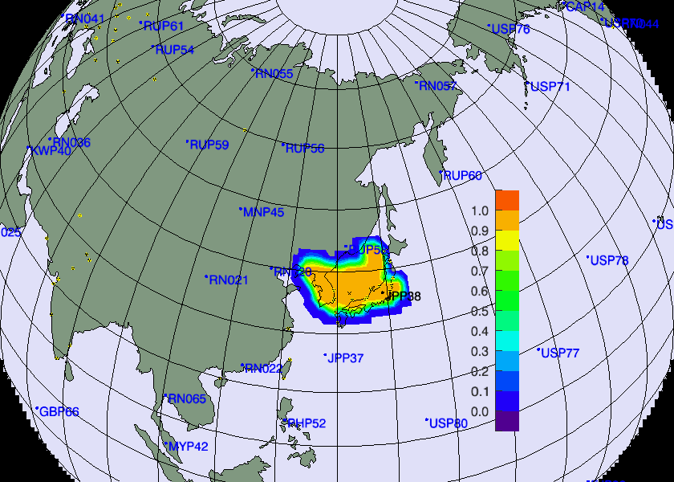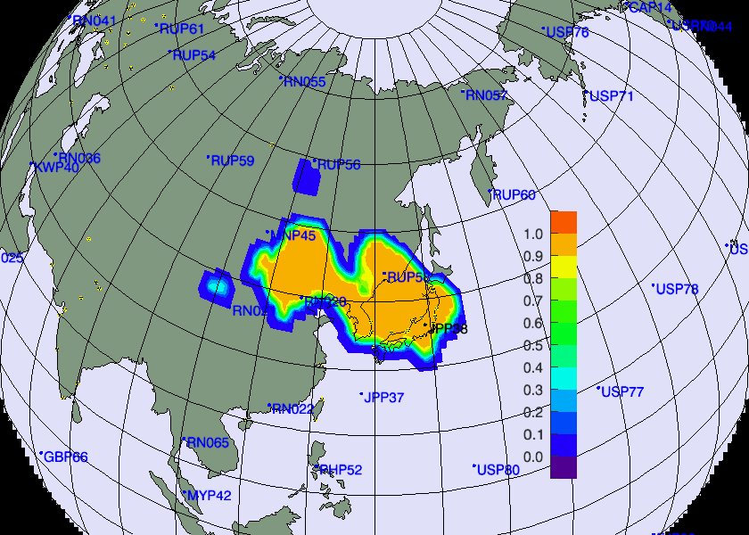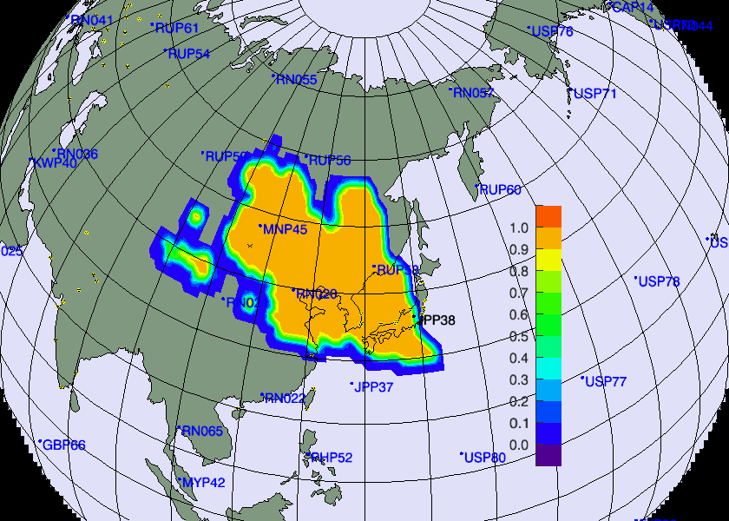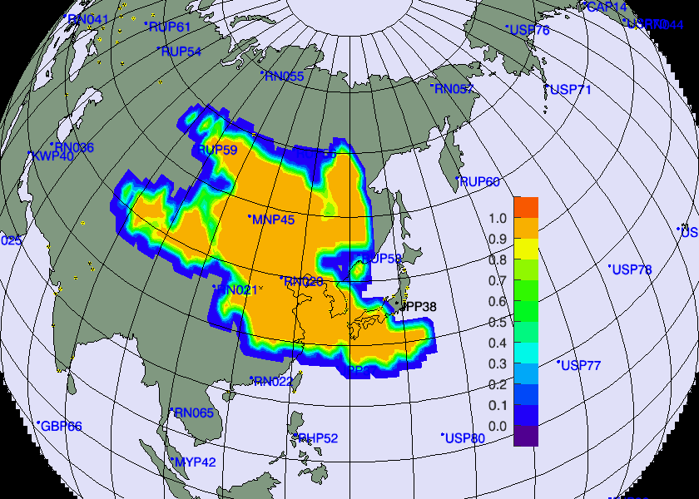

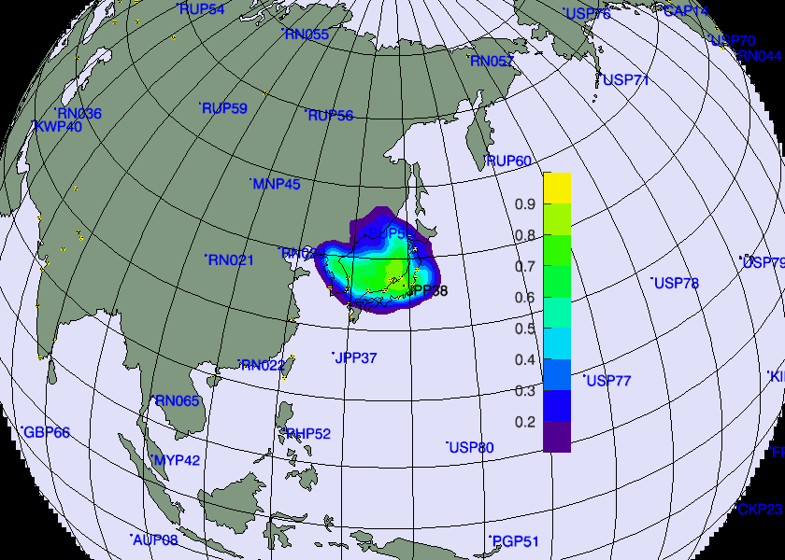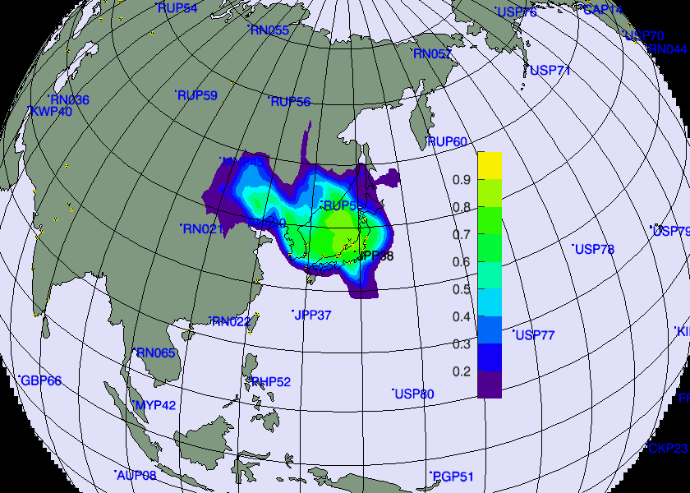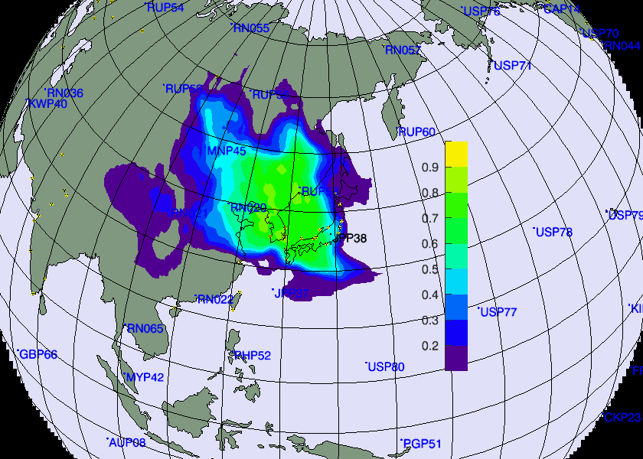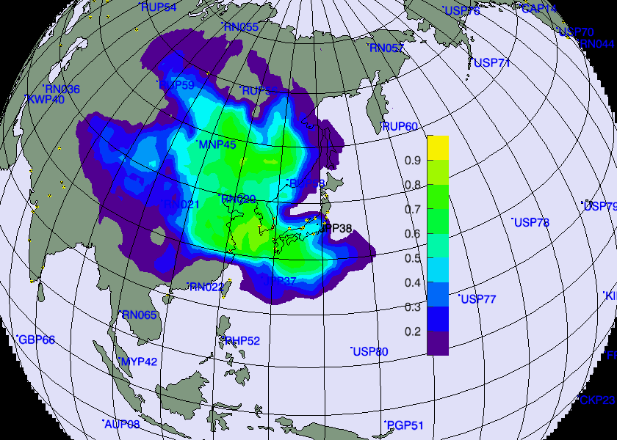

Fig1: Possible source regions built using detections at JPP38 station during the period 15 and 19 March 2011. Top row: PSRs built using the SRS fields from CTBTO. Bottom row: PSRs built using an ensemble of the SRS fields computed by the RSMCs.

Forward modeling
In the aftermath of the Fukushima release, between 16 March and 3 May 2011, CTBTO performed a number of forward ATM runs on a daily basis. Those simulations were done using a default configuration designed to support monitoring compliance with the CTBT and were of qualitative nature. They aimed at predicting radionuclide stations where the abnormal detections may occur next (using US NCEP GDAS/GFS meteorological fields) and confirming past detections (ECMWF analyses). The resulting animations were published on the IDC secure website for the needs of State Signatories.

