WORLD METEOROLOGICAL ORGANIZATION  ________  COMMISSION FOR BASIC SYSTEMS  OPAG on DPFS  COORDINATION GROUP FOR  NUCLEAR EMERGENCY RESPONSE ACTIVITIES  Vienna, Austria, 31 October - 4 November 2011 |  | CBS/CG-NERA/Doc. 6(3-2)  (24.IX.2011)  _______  Agenda item: 6  Original: ENGLISH

THE PROVISION OF GUIDANCE TO METEOROLOGICAL WATCH OFFICES IN SUPPORT OF THE ISSUANCE OF RADIOACTIVE CLOUD SIGMET

Submitted by Canada as Rapporteur for ICAO’s International Airways Volcano watch Operations group Conclusion 6/29 on the provision of information on radioactive material into the atmosphere

Summary and purpose of document

This document
1) Reports on Conclusion 6/29 of the last meeting of ICAO’s International Airways Volcano watch Operations Group on the provision of information on radioactive material released into the atmosphere
2) Addresses the need for guidance and products that are specifically designed to help Meteorological Watch Offices (MWOs) issue SIGMET to inform aviation of the presence of a radioactive cloud in the atmosphere
3) Seeks the expert advice of the Meeting on how to proceed

Action Proposed

The Meeting is invited to

1) Determine how to contribute to IAVWOPSG Conclusion 6/29
2) Consider and provide advice on the scientific / practical challenges presented in the paper in Annex 1
3) Evaluate the merits of what is proposed for the guidance
4) Discuss the possible role of existing WMO RSMCs or other WMO Centres in this area
5) Propose possible ways to proceed

- INTRODUCTION
- The paper Provision of information about the accidental release of radioactive material into the atmosphere to the International Civil Aviation submitted by the International Civil Aviation Organization to this meeting provides a detailed overview on how this issue is covered under existing international arrangements. The paper also highlights the need for the development of guidance to help Meteorological watch Offices (MWO) issue radioactive cloud SIGMET (Significant Meteorological Information) to aviation.

- The need for guidance designed for aviation purposes was clearly identified during the Fukushima Daiichi nuclear power plant (NPP) accident in March 2011. This topic was the subject of a Working Paper entitled The provision of guidance to Meteorological Watch Offices in support of the issuance of radioactive cloud SIGMET that was discussed at the 6th Meeting of ICAO’s International Airways Volcano Watch Operations Group (IAVWOPSG) in Dakar, Sénégal, 19 to 23 September 2011. For convenience, the Working Paper is reproduced in Annex 1 at the end of this document.

- The IAVWOPSG formulated the following:

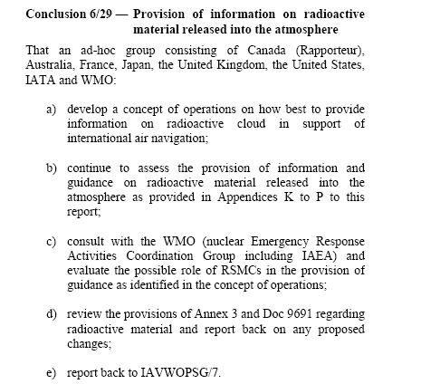
- Discussion
- Under existing arrangements between the IAEA and the WMO, the RSMC products that are produced for nuclear emergencies can only help assess what is happening at or near the surface: total deposition and 24-hr time integrated air concentrations in the first 500 metres. The trajectories map at 500, 1500 and 3000 metres can provide some information about what is going on aloft but clearly this is insufficient guidance for aviation.

- The Fukushima Daiichi nuclear power plant accident in March 2011 has shown that in addition to these products, there is a clear need for guidance / products tailored for aviation to deal with the potential dangers of a radioactive cloud in the atmosphere. In practice, States are concerned about what is happening in the biosphere. Given that most IAEA Member States are also ICAO Member States, the guidance and products need to be extended beyond the surface / near surface to cover the rest of the atmosphere as well. This need has been clearly expressed by ICAO Member States.

- The paper presented in Annex 1 makes proposals on guidance and products for the rest of the atmosphere. It covers 3 main areas: scientific and practical aspects related to radiation exposure and health impacts (Section 2); a concept of operations for the provision of guidance for radioactive cloud SIGMET (section 3); and possible products that could be generated as guidance for the MWOs (section 4).

- The scientific and practical aspects need to be addressed first, since the others are dependant on first defining and quantifying the parameters that would be used to produce the guidance.

- ACTIONS PROPOSED
- With this in mind, the Meeting is invited to

1) Determine how to contribute to IAVWOPSG Conclusion 6/29

2) Provide advice on the scientific / practical challenges discussed in Annex 1, in particular section 2 and the proposed actions in paragraphs 2.5 to 2.7

3) Evaluate the merits of what is proposed for the guidance

4) Discuss the possible role of existing WMO RSMCs or other WMO Centres in this area

5) Propose possible ways forward

ANNEX 1: The provision of guidance to Meteorological Watch Offices in support of the issuance of radioactive cloud SIGMET , Working Paper presented at the 6th Meeting of the International Airways Volcano Watch Operations Group, Dakar, Sénégal, 19 to 23 September 2011. All papers and the report of the meeting are available here: http://www2.icao.int/en/anb/met/iavwopsg/Lists/Meetings/AllItems.aspx

— — — — — — — —

 | International Civil Aviation Organization  WORKING PAPER
  IAVWOPSG/6-WP/17
  26/7/11
INTERNATIONAL AIRWAYS VOLCANO WATCH OPERATIONS GROUP (IAVWOPSG)

SIXTH MEETING

Dakar, Senegal, 19 to 23 September 2011

Agenda Item | 7: | Improved notification concerning the accidental release of radioactive material into the atmosphere

THE PROVISION OF GUIDANCE TO METEOROLOGICAL WATCH OFFICES IN SUPPORT OF THE ISSUANCE OF RADIOACTIVE CLOUD SIGMET

(Presented by ad-hoc group, Canada, Rapporteur)

SUMMARY
This paper discusses a way forward on how to provide guidance on radioactive material released into the atmosphere to the Meteorological Watch Offices in support of the issuance of the radioactive cloud SIGMET.

- INTRODUCTION
  - This paper addresses Conclusion 5/24 of the fifth meeting of the International Airways Volcano Watch Operations Group (IAVWOPSG/5).
Conclusion 5/24 — Development of guidance on the issuance of SIGMET for accidental release of radioactive material into the atmosphere

That an ad hoc working group consisting of Australia, Canada (Rapporteur), France, New Zealand, United Kingdom, United States, IATA and WMO be tasked to:
a) develop draft guidance material for MWOs in view of assisting them to issue SIGMET for radioactive cloud, for inclusion in Doc 9691, Manual on Volcanic Ash, Radioactive Material and Toxic Chemical Clouds; and
b) provide a report back to the IAVWOPSG/6 Meeting.
  - This paper addresses addressed 3 main topics:
a) the development of Atmospheric Transport and Dispersion Modeling (ATDM) guidance to help the writing of radioactive cloud SIGMET (R-SIGMET) issued by Meteorological Watch Offices. Various documents were consulted and many discussions / advice seeking took place with health physicists, experts in radioactivity, meteorologists and other colleagues at Health Canada, the International Commission on Radiation Protection, the International Atomic Energy Agency, members of ICAO’s International Airways Volcano Watch Operations Group and others.;
b) a concept of operations that covers the production of the guidance to the writing of the R-SIGMET by the meteorological watch offices (MWOs); and
c) proposals for Radioactive Cloud Graphic and Radioactive Cloud Advisories that would be sent to the MWOs to write the R-SIGMET.
  - In what follows, efforts have been made to present complex issues in a simple way, some of which are not in our area of training / expertise (dose calculations for example). The objective is to come up with practical solutions to provide guidance. In the course of doing if errors or inaccuracies may have been introduced, they should be attributed solely to the authors of this paper and not to the organizations and agencies that are referenced. It should also be noted that this document has not been thoroughly reviewed at the international level. Additional consultation will be needed with international organizations if international standards are to be defined for this guidance.
  - The need for guidance specifically designed for aviation is clearly expressed in a paper entitled SUMMARY OF SURVEY RESULTS – RADIOACTIVE CLOUD and presented at the FIFTEENTH MEETING OF THE COMMUNICATIONS/NAVIGATION/SURVEILLANCE AND METEOROLOGY SUB-GROUP (CNS/MET SG/15) OF APANPIRG (Bangkok, Thailand, 25 – 29 July 2011. See Working Paper 51 of that Meeting.
  - At the present time no guidance exists for use by MWO for the issuance of R-SIGMET even though Annex 3 — Meteorological Service for International Air Navigation requires the issuance of R-SIGMET when notified by the RSMC. An important point to keep in mind is that the vast majority of staff at MWOs and National meteorological Services has no experience or expertise in dealing with radioactive clouds and their hazard to health. It is therefore of prime importance that the information provided by the guidance be readily usable directly by the person writing the R-SIGMET. The guidance must be presented in such way that it can be used directly for the R-SIGMET without a need for complex interpretation. We believe that what we propose in this paper will achieve this.
- SCIENTIFIC AND PRACTICAL ASPECTS RELATED TO RADIATION EXPOSURE AND HEALTH IMPACTS
  - When ionizing radiation penetrates the human body or an object, it deposits energy. The energy absorbed from exposure to radiation is called a dose. The dose can be received either from exposure to radiation outside of the body, or from radioactive material taken into the body through inhalation or ingestion. Radiation dose and its potential impact on the body are quantified by different dose quantities: absorbed dose, equivalent dose, and effective dose. The effective dose, which provides an indication of how a particular radiation exposure can affect overall health, is measured in Sievert (Sv).
  - The effective dose rate calculation takes into consideration the type of radiation and the specific organs exposed. It is calculated using defined coefficients that depend on the specific isotope(s) that produce the radioactivity and physiological parameters such as age group. The calculation of total dose should consider all relevant exposure pathways including external exposure from the radioactivity in the air (‘’cloudshine’’) or deposited on surfaces (‘’groundshine’’), and internal exposure from inhalation and ingestion of radioactive contamination. Ideally, we would like to have an international standard on what dose coefficients should be used and how to best determine the effective dose rates for the modeling. For this, we will have to consult with international organizations such as the Inter-Agency Committee on Radiological and Nuclear Emergencies, (IACRNE lead by the IAEA) and the International Commission on Radiation Protection (ICRP). It is also possible that different States would want to apply different standards according to their specific regulations. This can be easily accommodated in what we propose for the development of guidance.
  - People are constantly exposed to small amounts of background radiation from the environment, from medical treatments and through activities involving radioactive material. Naturally-occurring background radiation is the main source of exposure for most people, and doses at the earth’s surface typically range from about 1 to10 millisievert/year (mSv/yr) depending on altitude, soil type, etc. The global yearly average value at the surface is 2.4 mSv/year. The dose rate at cruising altitudes is significantly higher than at ground level due to the increased contribution of cosmic radiation dose (for example, the average dose rate for long-haul (e.g. trans- Atlantic) flights is about 4 μSv/h; annual doses to air crew range from about 0.2 to 5 mSv, depending on flight routes and number of hours flown per year).
  - The International Commission on Radiological Protection (ICRP) has recommended an effective dose limit for the public resulting from planned exposure situations , excluding background radiation, of 1 mSv per year (a constant exposure of 0.114 microSv per hour (i.e. 1.14E-07 Sv per hour) for one year would result in a dose reaching this limit). This annual value has been adopted by most regulatory bodies worldwide, and represents the maximum dose that an individual would be allowed to receive from all regulated activities. Actual doses from these activities should be kept as low as reasonably achievable below this value.
  - The public dose limit of 1 mSv/yr is a regulatory limit for exposures from regulated activities, and does not include exposures from background radiation or emergency situations. However, due its level of protection, the value of 1 mSv/yr has also been used as a basis for setting various guidelines for exposures from other types of situations. This value, or some other value to be defined in consultation with health physicists and radiation protection experts, can then be used as the basis of an international standard for guidance for R-SIGMET. It would serve to define what airspace is to be avoided by aircraft following a release of radioactivity from an accident at a nuclear power plant (NPP) or some other event. National Governments / States may also have different values based on their specific regulations2.
PROPOSED ACTION RESULTING FROM PARAGRAPH 2.5: Consult IACRNE / ICRP to establish a total dose value that could serve as an international standard and to define what parameters should be used (cloudshine, inhalation, etc.).
  - DOSE RATES FROM CLOUDSHINE AND INHALATION: Let us assume here that, following consultation with IACRNE / ICRP, we have determined a value for the hourly total dose rate (for the discussions that follow, we will assume that it is 0.114 microSv per hour) and that the dose rate is that resulting from the contributions of cloudshine and inhalation (we will not consider the dose resulting from groundshine for the reasons discussed in section 2.8). The next challenge is that we need an estimate of all the isotopes and amounts released by the NPP accident in order to calculate realistic total effective dose rates. This depends on the type of reactor and inventory of fuel (in use or spent), the nature of the accident (explosion, controlled venting, etc.) and many other factors. Based on past events, including the March 2011 accident at the Fukushima Daiichi NPP, it is reasonable to assume that it will take many hours (24+) before some realistic quantitative estimate of the radioactivity released becomes available. Given this, we need to define a set of default values to be used in order to calculate a meaningful total effective dose, until an actual estimate of what has been released is produced.
  - As an example, we could use the estimates for Iodine 131 and Cesium 137 provided by the International Atomic Energy Agency (reference: IAEA EMERCON message ‘’Provisional INES Level 7 rating for the accident at Fukushima Daiichi’’, dated 12 April 2011 at 04:30 UTC). They are based on the total activity released to the atmosphere as determined by Nuclear and Industrial Safety Agency in Japan (NISA) and the Nuclear Safety Commission of Japan (NSC). Other agencies reported similar estimates for this event. The values are estimated at 1.0E+17 Bq for I-131 and 1.0E+16 Bq for Cs-137 and correspond to approximately 10% of what was released during the Chernobyl accident. Should we also consider Xenon 133 (Xe-133, with a half-life of 5.24 days) which is a noble gas that does not deposit at the ground and therefore stays in higher concentrations in the atmosphere? These numbers could be used as a default values to calculate groundshine and inhalation dose rates if not other information is provided. From the resulting dose rate calculations with these isotopes, is there a multiplying factor that can be used to obtain a realistic, ‘’ball park’’ total dose estimate for all isotopes released?
PROPOSED ACTIONS RESULTING FROM PARAGRAPHS 2.6 and 2.7: Consult the IACRNE / ICRP on how to do this.
  - DOSE RATES FROM GROUNDSHINE: Because of the high volume of air that flows in the engines, the intake of air into the airplane and the speed of the aircraft, radioactivity may collect on the aircraft and engines. This could present a hazard, beyond what has already been discussed from groundshine and inhalation dose rates to passengers and crew. The contaminated surfaces could pose a hazard for crews servicing the aircraft upon arrival. We did some research in scientific publications and consulted various experts about this. We were not able to come up with a practical way to estimate / quantify the accumulation and deposition of radioactivity on aircraft and engines during an encounter with a radioactive cloud. We believe that this problem cannot be resolved in the foreseeable future and that it is beyond the scope of what can be reasonably achieved in this paper. It should be mentioned however that if an aircraft passes / is suspected to have passed through airspace that is contaminated with a radioactive material, other actions would kick in regardless of the amount of exposure because the aircraft has to be inspected after it lands. With respect to that last point, guidelines already exist regarding actions to be taken if radioactive contamination is suspected / detected on aircraft and engines. For example, the Association of European Airlines published in June 2002 the 3rd edition of a document called Radioactive Contamination of Aircraft and Engines that provides specific actions to be taken as a function of the level of radioactive contamination (Bq/m2) detected on aircraft surfaces. National regulations may also require that national authorities be involved. In what follows, we will assume that the problem of the potential contamination of the aircraft surfaces is a ground issue, not a not a question to be considered when issuing the R-SIGMET.
- CONCEPT OF OPERATIONS: PROVISION OF GUIDANCE FOR RADIOACTIVE CLOUD SIGMET
  - Based on the discussions in the previous sections, we develop here a concept of operations. An important point to keep in mind: the vast majority of staff at MWOs and National Meteorological Services has no experience or expertise in dealing with radioactive clouds and their hazard to health. It is therefore of prime important that the information provided by the guidance be readily usable directly by the person writing the R-SIGMET. The guidance must be presented in such a form that it can be used directly for the R-SIGMET without a requirement for complex interpretation. This concept is similar to the volcanic ash advisories produced by VAACs and that are used directly by the MWOs to write the volcanic ash cloud SIGMET.
  - Let us assume that we have answers to the points in section 2 (which isotopes to use, amounts, etc). In what follows we now consider the effective dose rate for passengers and crew onboard aircraft in flight. We make the assumption that the cabin offers no protection from the radioactive cloud and that passengers and crew are exposed to the radioactivity from cloudshine and inhalation as if they were outside the aircraft. This is a conservative approach that errs on the side of safety but that can be reviewed / modified as needed.
  - With respect to guidance, we believe that 2 types of products should be used. Since the R-SIGMET must be issued quickly, even little or no information is available about the nature of the accident, we suggest to use low level trajectories as a first guess to define a section (piece of pie) to be avoided by aircraft. The details of this need to be documented, but the concept is explained in IAVWOPSG/5 Working Paper 39. At the same time, the second part of the response would consist of effective dose calculations based on ATDM modeling using default parameters initially. The guidance would identify in time and space the airspace where the dose rate exceeds the threshold value and thus to be covered by the R-SIGMET. The guidance (chart and text bulletin) would then be used verbatim by the MWO to encode the R-SIGMET. The modelling guidance would be rerun as needed based, for example, on new / better information on the actual release when it becomes available.
  - The basic steps to produce guidance in response to a release of radioactivity to the atmosphere for MWOs writing radioactivity cloud SIGMET are:
a) calculate the total effective dose rate from cloudshine and inhalation in the atmosphere using an Atmospheric Transport and Dispersion Model (ATDM) using default or actual source term values;
b) identify the airspace (3D) where the total effective dose rate is equal to or exceeds the threshold effective total dose rate (for example 0.114 microSv per hour) as a function of time (for example, for the next 18 hours);
c) produce corresponding graphical (Radioactive Cloud Graphic) and text guidance (Radioactive Cloud Advisory) showing valid with time, latitude, longitude, base and top (see next section for details). This will define the airspace to be covered in the radioactive cloud SIGMET; and
d) update the guidance (every 6 hours for example), using updated information on the release at the NPP, new Numerical Weather Prediction forecasts, etc.
  - As the radioactive cloud disperses and diluted in the atmosphere, the threshold total effective dose will eventually no longer be reached and the radioactive cloud SIGMET will then be terminated.
  - The parallel to the approach taken for volcanic eruptions is striking: Volcanic Ash Advisory Centers run ATDM based on actual or default eruption parameters, the produce graphical / text guidance that can be used verbatim by the MWOs to write volcanic ash SIGMET.
  - Ideally, an international standard in the modeling guidance should be developed, akin to what the WMO RSMCs designated for nuclear and radiological emergencies provide to the IAEA and the National Meteorological and Hydrological Services in Member States and to the guidance that the VAACs provide to MWOs for volcanic ash. We will need to discuss and determine what National Meteorological Centres and Agencies have or could develop the capability to calculate total effective doses and identify those that would be ready to undertake the role of producing modeling guidance for the MWOs. Obviously, the National Meteorological Centres that are already designated as WMO RMSCs for nuclear and radiological emergencies could develop this capability. However, they are not mandated currently to provide guidance for aviation. If it is felt that this is worth examining, this possibility should be discussed at the next meeting of the IAVWOPSG and, depending on the outcome, passed on the WMO nuclear Emergencies Activity Coordination Group that coordinates the activities of the RSMCs designated for nuclear and radiological emergencies.
  - In the meantime, as a proof of concept, we propose that a few National Meteorological Centers that have the ATDM capabilities experiment with effective total dose rate calculations and produce test modeling guidance, graphical products and text bulletins. As a starting point, the United States (NCEP /ARL) and Canada (Canadian Meteorological Centre) will work on this as part of their national capability. For the time being, this will be done outside of their WMO RMSC designations but as already mentioned, this could be referred to the WMO nuclear Emergency Response Activities Coordination Group later if the IAVWOPSG feels that this is an appropriate action to take.
  - We have not addressed here the details of what the trigger would be to produce the guidance because it depends on whether or not international arrangements are established to produce the guidance. For example, it the WMO RSMCs designated for nuclear and radiological emergencies were to produce it, the trigger could be the same as what is already in place: a formal request from the IAEA as defined in the WMO Manual on the Global Data Processing and Forecasting System.
- RADIOACTIVE CLOUD GRAPHIC (RCG) AND RADIOACTIVE CLOUD ADVISORY (RCA)
  - An initial going in position would be to follow the existing Volcanic Ash procedures and recommended practices in Annex 3 regarding Volcanic Ash Advisories (text and graphic) and volcanic ash SIGMET to tailor in a similar way the products for radioactivity. This would also have the advantage for States to leverage existing MWO/User training and practices for an easier implementation of the Radioactive Cloud SIGMET as well as for States producing the modelling guidance. However, our experience is that many MWOs have difficulties in issuing volcanic ash SIGMET and it is likely that similar problems would be encountered with the issuance of R-SIGMET. With this in mind, the IAVWOPSG should give serious consideration to the WP submitted by the United States under agenda item 7 and entitled ''THE PROVISION OF RADIOACTIV CLOUD SIGMET INFORMATION BY METEOROLOGICAL WATCH OFFICES''. It proposes that an ad hoc group study possible alternative provisions for radioactive cloud information to replace the radioactive cloud SIGMET issued by MWOs.
  - The Volcanic Ash Advisory (VAA text and graphic) is created by a Volcanic Ash Advisory Centre (VAAC). Similarly a designated National Meteorological Center (perhaps eventually a WMO RSMC), could produce an equivalent product for a radioactive cloud. This product could have the same look of the current VAA and would mirror the current Annex 3 template. It must be noted that radioactivity can only be detected with in situ instruments and not by remote sensing (e.g. satellites). Some measurements of radioactivity either at the ground or from specially equipped aircraft may be available to help adjust the modelling guidance at the initial time. However, in general, it is expected that the guidance will be based largely on the modelling results. In the case of volcanic ash, remote sensing from satellites normally plays an important role in defining the location of the cloud in combination with modelling.
  - Appendix F presents an example of modelling guidance / dose rate calculations that could serve as the basis for producing the Radioactive Cloud Graphic (RCG) and Radioactive Cloud Advisory (RCA). The RCG (we have not yet produced an example) would be modeled on the VAG template in Annex 3. Similarly, the RCA would be adapted from the VAA. An example is shown below:
FXXX20 KWNO 042118
RDOACT ADVISORY
DTG: 20100804/2100Z
(Issuing Center, example): NCEP WASHINGTON
RDOACT RELEASE: PEARL HARBOR HI
LOC: N2121 W15759
AREA: HAWAIIAN ISLANDS
RELEASE ELEV: UNKNOWN BUT ESTIMATED AT FROM NR SFC TO 500 FT
ADVISORY NR: 2010/003
INFO SOURCE: DEPT OF DEFENSE. HYSPLIT MODEL.
RELEASE DETAILS: INITIAL RELEASE OCCURRED 04/2038Z
EST RDOACT DTG: 04/2100Z
EST RDOACT CLD: SFC/FL080 N2122 W15755 - N2117 W15749 - N2110 W15758 -
N2117 W15805 - N2122 W15755 MOVING SW 15KT

FCST RDOACT CLD +6HR: 05/0300Z SFC/080 N2122 W15755 - N2117 W15749 -
N2058 W15815 - N2114 W15832 - N2122 W15755
RMK: ESTIMATED OBS AND FCST POSITIONS BASED ON INCOMPLETE INITIAL RELEASE DETAILS AND HYSPLIT MODEL. NOTE THAT IT IS IMPOSSIBLE TO DETECT RADIOACTIVITY WITH SATELLITES IRRESPECTIVE OF CLOUD CONDITIONS
NXT ADVISORY: 20100805/0300Z
  - The RCG and RCA products would follow identical dissemination paths as VAG and VAA. The MWOs receiving the information would then prepare the RDOACT SIGMET by encoding, basically verbatim, the RCA information. Below is an example based on the RAA example above:
KZAK SIGMET N4 VALID 042120/050120 PHFO-
KZAK OAKLAND OCEANIC FIR RDOACT CLD FCST AT 2100Z WI N2122 W15755 - N2117 W15749 - N2110 W15758 - N2117 W15805 - N2122 W15755 SFC/FL080 MOV SW 15KT NC
  - It is recognized that new WMO headers etc would have to be created for this. This will require some work in addition to setting up the new products to be issued by the designated guidance producing center. However, it is anticipated that emulating the VAA program in Annex 3 and the related Standards and Procedures will help reduce the amount of work required and provide a more seamless and consistent approach to implementing these new products for aviation.
  - Some other technical points would need to be worked out with respect to the format of the RCA and R-SIGMET. For example, should we limit the number of coordinates defining the radioactive cloud to limit the length of the RCA and the R-SIGMET?
- ROAD MAP AND NEXT STEPS
  - Based on what we have presented, we suggest the following road map and next steps:
  - Refer to the appropriate international experts and organizations the questions on quantification of the parameters (section 2) needed to run the ATDM and to calculate the threshold effective total doses to be used for the guidance. Canada is volunteering to do this.
  - Once (a) is answered, Canada and the United States will produce a detailed example for a specific event; generate guidance products; work on examples of the corresponding RCG and RCA; consult and work with selected MWOs in Canada and the United States to produce the corresponding Radioactive Cloud SIGMET; iron out difficulties identified.
  - Consult the IAVWOPSG on what is proposed in this document, including guidance, concept of operations, format of the RCG and RCA and decide if the question of guidance production should be referred to the WMO nuclear Emergency Response Activities Coordination Group (if there is interest in having the WMO RSMCs involved)
  - If needed, create an IAVWOPSG ad-hoc group to examine the details of products, possible inclusion in Annex 3, the development of guidance material (for example, ICAO Doc 9691 Manual on Volcanic Ash, Radioactive Material and Toxic Chemical Clouds and / or WMO Technical document 778 ) and training material for meteorologists. The latter could perhaps be provided via computer base training and could be included for example in the ICAO Regional SIGMET Guides.
- CONCLUSIONS
  - In this regard, the following actions are proposed:
Conclusion 6/xx — Provision of information on radioactive material released into the atmosphere
That, the IAVWOPSG be invited to:

a) adopt the proposed roadmap and consider the option of defining a concept of operations as a way forward to further assess and evaluate the feasibility of how best to provide information on accidental release of radioactive material into atmosphere to MWO and AOC;

b) further coordinate the proposed radioactive cloud advisory text message and assess if it could be included in ICAO Doc 9691 Manual on Volcanic Ash, Radioactive Material and Toxic Chemical Clouds as an interim step to provide information to the MWO and AOC;

c) evaluate the possibility of including the information provided in Appendices 1 to 6 of the Working Paper or a revised version for inclusion in ICAO Doc 9691 Manual on Volcanic Ash, Radioactive Material and Toxic Chemical Clouds;

d) endorse the actions identified in paragraphs 2.5 and 2.7; and

e) continue to assess the provision of information and guidance on radioactive material released into the atmosphere and report back to the next meeting (IAVWOPSG/7).
- ACTION BY THE IAVWOPSG
  - The IAVWOPSG is invited to:
a) note information in this paper: and
b) decide on the draft conclusions proposed for the group’s consideration.
ACKNOWLEDGEMENT
We thank the many people that helped with the preparation and review of this paper and in particular Brian Ahier of the Radiation Protection Bureau at Health Canada.
— — — — — — — —
IAVWOPSG/6-WP/17
Appendix A

APPENDIX A

DEFINITIONS AND GLOSSARY

BECQUEREL (Bq): The SI*-derived unit of radioactivity. One Bq is defined as the activity of a quantity of radioactive material in which one nucleus decays per second. The Bq unit is therefore equivalent to s⁻¹. * International System of Units.

CLOUDSHINE DOSE: external irradiation dose arising primarily from the actual passage of the radioactive plume.

GROUNDSHINE DOSE: external irradiation dose arising from the radioactive material deposited on the ground.

HALF-LIFE: The period of time it takes for a substance undergoing radioactive decay to decrease by half. Therefore, after one half-life, 50% of the substance remains. After two half-lifes, 25% remain, etc. Half-lives range from very small values (fractions of a second) to 4.7 billion of years for uranium 238. In the case of a nuclear accident, a few of the isotopes of interest are Cesium 137 (half-life 30.17 years), Iodine 131 (half-life 8.02 days) and Xenon 133 (half-life 5.25 days).

IACRNE: Inter-Agency Committee on Radiological and Nuclear Emergencies. It is chaired by the International Atomic Energy Agency and meets regularly. Currently its members are representatives from the European Commission (EC), the European Police Office (EUROPOL), the Food and Agriculture Organization of the United Nations (FAO), the International Atomic Energy Agency (IAEA), the International Civil Aviation Organization (ICAO), the International Maritime Organization (IMO), the United Nations Scientific Committee on the Effects of Atomic Radiation (UNSCEAR), the International Criminal Police Organization (INTERPOL), the Nuclear Energy Agency of the Organisation for Economic Co-operation and Development (OECD/NEA), the Pan American Health Organization (PAHO), the United Nations Environment Programme (UNEP), the United Nations Office for the Co-ordination of Humanitarian Affairs (UN/OCHA), the United Nations Office for Outer Space Affairs (UN/OOSA), the World Health Organization (WHO), and the World Meteorological Organization (WMO).

ICRP: International Commission on Radiological Protection. ICRP is an independent, international organization with more than two hundred volunteer members from approximately thirty countries across six continents. These members represent the leading scientists and policy makers in the field of radiological protection.

INHALATION DOSE: internal irradiation dose arising from breathing radioactive gases and aerosol particles.

IONIZING RADIATION: Radiation consisting of particles or electromagnetic waves that are energetic enough to detach electrons from atoms and molecules, therefore ionizing them.

NATURAL BACKGROUND RADIATION: Ionizing radiations from naturally occurring radionuclide as they exist in nature plus cosmic radiation (definition taken from http://www.epa.gov/rpdweb00/docs/federal/frc_rpt4.pdf)

NPP: Nuclear Power Plant.

PROGENY: A term that is used to describe new isotopes that are produced by a parent isotope. Example: uranium-238 will decay into thorium-234; uranium-238 is the parent isotope and thorium-234 is the progeny isotope — thorium-234 is also an unstable radioactive isotope and now a parent; it will decay into protactinium-234 which is now the progeny of thorium-234. In fact, this decay chain of uranium-238 continues through a total of 14 progenies before it ends up at lead-206, which is stable.

REM: A derived unit of dose of equivalent radiation equal to .01 Sv (See SIEVERT). It is a non-SI unit still used in the United States of America.

R-SIGMET: Radioactive cloud SIGMET, identified as RDOACT CLD in ICAO’s Annex 3.

SI: International System of Units.

SIEVERT (symbol Sv; 1 Sv = 1 J / kg = 100 rem): The SI derived unit of dose equivalent radiation. It attempts to quantify the biological effects of ionizing radiation as opposed to the physical aspect which are characterized by the absorbed dose, measured in Gray (1 Gy = 1 J / kg).

TOTAL EFFECTIVE DOSE: A measure of the overall health risk due to any combination of radiation received through defined exposure pathways.

TOTAL EFFECTIVE DOSE RATE: The total effective dose per unit time

TOTAL EFFECTIVE DOSE RATE CALCULATION FROM CLOUDSHINE: The sum of the contribution of cloudshine iradiation dose rate from all isotopes in the radioactive cloud.

TOTAL EFFECTIVE DOSE FROM GROUNDSHINE: The sum of the contribution of groundshine irradiation dose rate resulting from all isotopes deposited on the ground.

TOTAL EFFECTIVE DOSE (RATE) FROM INHALATION: The sum of the contribution of inhalation irradiation dose rate from all isotopes breathed in.

— — — — — — — —
IAVWOPSG/6-WP/17
Appendix B

APPENDIX B

INFORMATION ON DOSE OF IONIZING RADIATION

Taken from Chernobyl’s Legacy: Health, Environmental and Socio-economic Impacts and Recommendations to the Governments of Belarus, the Russian Federation and Ukraine
The Chernobyl Forum: 2003–2005, second revised version, Printed by the IAEA in Austria, April 2006
IAEA/PI/A.87 Rev.2 / 06-09181.Printed by the IAEA in Austria, April 2006
IAEA/PI/A.87 Rev.2 / 06-09181
Interaction of ionizing radiation (alpha, beta, gamma and other kinds of radiation) with living matter may damage human cells, causing death to some and modifying others. Exposure to ionizing radiation is measured in terms of absorbed energy per unit mass, i.e., absorbed dose. The unit of absorbed dose is the gray (Gy), which is a joule per kilogram (J/kg). The absorbed dose in a human body of more than one gray may cause acute radiation syndrome (ARS) as happened with some of the Chernobyl emergency workers.

Because many organs and tissues were exposed as a result of the Chernobyl accident, it has been very common to use an additional concept, that of effective dose, which characterizes the overall health risk due to any combination of radiation. The effective dose accounts both for absorbed energy and type of radiation and for susceptibility of various organs and tissues to development of a severe radiation-induced cancer or genetic effect. Moreover, it applies equally to external and internal exposure and to uniform or non-uniform irradiation. The unit of effective dose is the sievert in the International Systems of Units (SI). One sievert is a rather large dose and so the millisievert or mSv (one thousandth of a Sv) is commonly used to describe normal exposures. (Note: The CGS unit used for the dose equivalent is roentgen equivalent man (rem), where 1 Sv = 100 rem).

Living organisms are continually exposed to ionizing radiation from natural sources, which include cosmic rays, cosmogenic and terrestrial radionuclides (such as 40K, 238U, 232Th and their progeny including 222Rn (radon)). UNSCEAR has estimated annual natural background doses of humans worldwide to average 2.4 mSv, with a typical range of 1–10 mSv. Lifetime doses due to natural radiation would thus be about 100–700 mSv. Radiation doses to humans may be characterized as low-level if they are comparable to natural background radiation levels of a few mSv per year.

2007 Recommendations of the International Commission on Radiological Protection for the effective dose
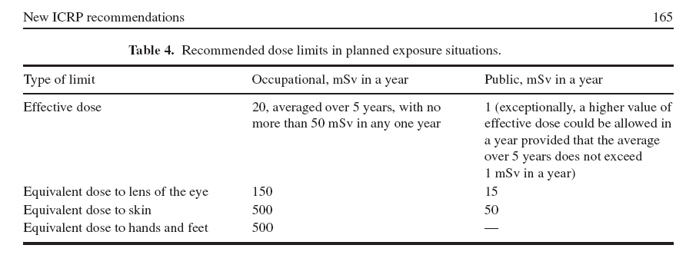
(Reference: A D Wrixon 2008 J. Radiol. Prot. 28 161 doi: 10.1088/0952-4746/28/2/R02)

Note that for comparison purposes, the following are equivalent:
1mSv in a year = 0.1 rem in a year = 1.1eE-05 rem per hour = 1.14E-04 mSv per hour =
1.14E-01 microSv per hour

— — — — — — — —

IAVWOPSG/6-WP/17
Appendix C

APPENDIX C

EXAMPLES OF EFFECTIVE DOSE VALUES

- A dental x-ray could expose a patient to an estimated 10 microSv (.01 mSv)
- A long-haul flight from Tokyo to Vancouver could expose a person to about 50 microSv (.05 mSv) of cosmic radiation
- A chest X-ray could expose a patient to an estimated 100 microSv (.1 mSv)
- Radiation dose in Guarapari (Brazil) per year due to soil composition: 10000 microSv (10 mSv)
- A CT scan can expose a person to between 5000 – 30 000 microSv (5 - 30 mSv), depending on the area being scanned

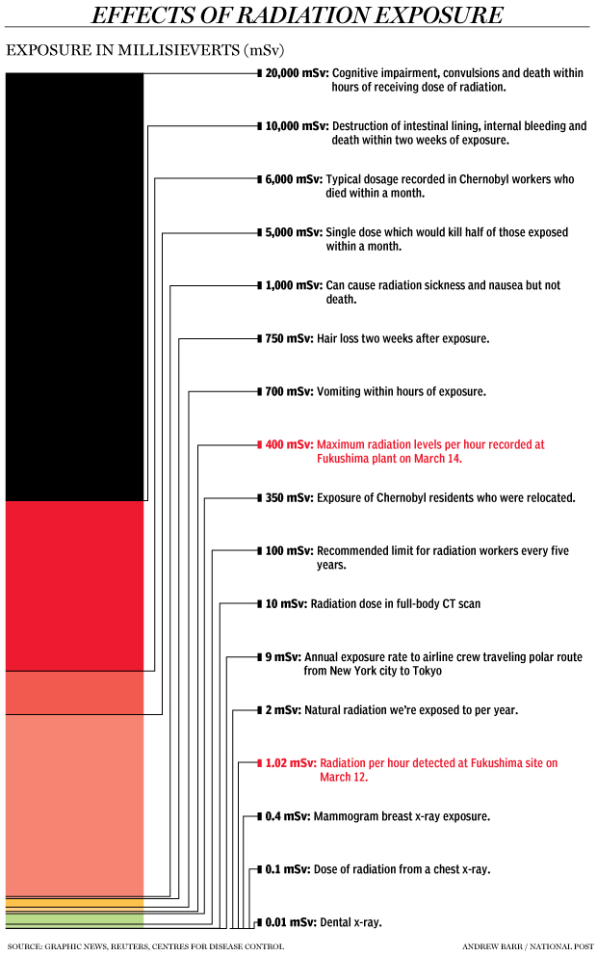
IAVWOPSG/6-WP/17
Appendix D

APPENDIX D

EFFECTIVE DOSE COEFFICIENTS

In what follows, we present how doses and dose rates are determined in Canada, based on the following guidelines from Health Canada*:

- Canadian Guidelines for Intervention During a Nuclear Emergency – Health Canada, November 2003: http://www.hc-sc.gc.ca/ewh-semt/pubs/radiation/guide-03/intervention-eng.php

- Recommendations on Dose Coefficients for Assessing Doses From Accidental Radionuclide Releases to the Environment - Joint Working Group of Radiation Protection Bureau, Health Canada, 1999: http://www.hc-sc.gc.ca/ewh-semt/pubs/radiation/dose/index-eng.php

*NOTE: The coefficients present below are for whole body exposure. However, some organs are much more sensitive to specific radiation. For example, the thyroid in the case of Iodine 131. With this in mind discussions are underway with Health Canada to determine if / what organ specific coefficients should be used to best calculate dose and dose rate in the case of a radioactive cloud released to the atmosphere following an accident at a NPP. In addition, an international standard for modeling guidance involving dose rate calculations will require consultation with international organizations such as the World Health Organization and the International Commission on Radiation Protection.

CLOUDSHINE GROUNDSHINE
COEFFICIENTS COEFFICIENTS
(Sv m³) / (Bq s) (Sv m²) / (Bq s)

ADULT
Cesium 137 2.55E-14 5.51E-16
Iodine 131 1.69E-14 3.64E-16
Xenon 133 3.70E-16 ----

3-MONTH AND 1 YEAR AGE GROUPS
Cesium 137 3.83E-14 5.51E-16
Iodine 131 2.54E-14 3.64E-16
Xenon 133 ---- ----

Table 1: Recommended breathing rates for the six ICRP age groups (m³ day⁻¹).Taken from http://www.hc-sc.gc.ca/ewh-semt/pubs/radiation/dose/index-eng.php:
3 months (0-1 year) 2.86
1 year (1-2 years) 5.16
5 year (2-7 years) 8.72
10 year (7-12 years) 15.3
15 year (12-17 years) 20.1
Adult (> 17 years) 22.2

INHALATION DOSE COEFFICIENTS
(Sv Bq⁻¹)
 | AGE
NUCLIDE | 3 months | 1 year | 5 years | 10 years | 15 years | adult
CS-137 | 8.80E-09 | 5.40E-09 | 3.60E-09 | 3.70E-09 | 4.40E-09 | 4.60E-09
I-131 | 7.20E-08 | 7.20E-08 | 3.70E-08 | 1.90E-08 | 1.10E-08 | 7.40E-09

Note1: For Cesium 137, the coefficients include contributions from the progeny, assuming ‘’secular equilibrium’’, i.e. a situation in which the quantity of radioactive isotope remains constant because its production rate (due, e.g., to decay of the parent isotope) is equal to its decay rate. This can only occur in a radioactivity chain in which the half-life of the progeny is much shorter than the half-life of the parent radionuclide.

Note 2: Xenon 133 is a noble gas that does not deposit on the ground. It is inhaled in the lungs, but does not accumulate there because it is exhaled.

— — — — — — — —

APPENDIX E

EXAMPLES OF EFFECTIVE DOSE AND EFFECTIVE DOSE RATE CALCULATIONS

It is obviously important to take in to account radioactive decay in the air and on the ground, since the radioactivity will decrease by a factor of 2 after each time period corresponding to the half-life. For long lived isotopes (Cesium 137 has a half-life of 30.17 years), this is not important in the first few days or weeks following the release. However, this is very significant for isotopes with short half lives (for example, 8.02 days for Iodine 131).

For a specific isotope, the effective dose from various contributions at a specific location in the atmosphere is obtained in the following way:

FOR CLOUDSHINE:

DOSE in Sv = Cloudshine coefficient (Sv m³ Bq⁻¹ s⁻¹) X Concentration of radioactivity in the air (Bq m⁻³) X duration over which this concentration is encountered (s)

DOSE RATE in Sv hr⁻¹ = Cloudshine coefficient (Sv m³ Bq⁻¹ s⁻¹) X Concentration of radioactivity in the air (Bq/m³) X 3600 s / hour

Example: If the one hour average concentration of Cs-137 is 10893 Bq m⁻³ , the effective dose rate from cloudshine after one hour is 2.55E-14 Sv m³ Bq⁻¹ s⁻¹ X 10893 Bq m⁻³ X 3600 s/hr = 9.99E-07 Sv per hour which is equivalent to 1 microSv/hr. Assuming that this concentration lasts for 2 hours, the effective dose is is then 1 microSv/hr * 2 hr = 2 microSv. For a dose rate of 1 microSv/hr over a 10-hr period, the effective dose will be 10 microSv/hr, etc.

The total dose or dose rate from cloudshine is the sum of the contribution for all isotopes.

FOR GROUNDSHINE:

DOSE in Sv = Groundshine coefficient (Sv m² Bq⁻¹ s⁻¹) X Total deposition on the ground (Bq/m²) X duration over which the radioactive material remains on the ground (s)

Example: If 1.0E+05 Bq m⁻² of Cs-137 are deposited (assume very quickly for this discussion), the effective dose from groundshine is

After 1 hour: 1.0E+05 Bq m⁻² X 5.51E-16 Sv m² Bq⁻¹ s⁻¹ X 3600 s
= 1.98E-04 mSv or 1.98E-01 microSv

After 10 days: 1.0E+05 Bq m⁻² X 5.51E-16 Sv m² Bq⁻¹ s⁻¹ X 3600 s / hr 24 hr/day * 10 days
= 4.76 mSv or 47.6 microSv

FOR INHALATION:

DOSE in Sv = Inhalation coefficient for the age group (Sv Bq⁻¹) X concentration of radioactivity in the air (Bq m⁻³) X volume of air breathed in per hour for that age group (m³ hr⁻¹) X duration for which this concentration of radioactivity is inhaled (hr)

DOSE RATE in Sv hr⁻¹ = Inhalation coefficient for the age group (Sv Bq⁻¹) X concentration of radioactivity in the air (Bq m⁻³) X volume of air breathed in per hour for that age group (m³ hr⁻¹)

Example: If the concentration of Cs-137 in the air is 10893 Bq m⁻³, the effective inhalation dose rate is

For a 3-month old
8.8e-09 Sv Bq⁻¹ X 10893 Bq m⁻³ X 2.86 m³ day⁻¹/24 (hr day⁻¹) = 1.14e-05 Sv hr⁻¹ = 1.14e-02 mSv hr⁻¹ = 11.4 microSv hr⁻¹. If that concentration is breathed in for a period of 24 hours, the effective dose will be 24 hr X 11.4 microSv hr⁻¹ = 273.6 microSv

For a 10-year old
3.7e-09 Sv Bq⁻¹ X 10893 Bq m⁻³ X 15.3 m³ day⁻¹/24 (hr day⁻¹) = 2.56e-05 Sv hr⁻¹ = 2.56e-02 mSv hr⁻¹ = 25.6 microSv hr⁻¹. If that concentration is breathed in for a period of 24 hours, the effective dose will be 24 hr X 25.6 microSv hr⁻¹ = 614.4 microSv

For an adult
4.6e-09 Sv Bq⁻¹ X 10893 Bq m⁻³ X 22.2 m³ day⁻¹/24 (hr day⁻¹) = 4.63e-05 Sv hr⁻¹ = 4.63e-02 mSv hr⁻¹ = 46.3 microSv hr⁻¹. If that concentration is breathed in for a period of 24 hours, the effective dose will be 24 hr X 46.3 microSv hr⁻¹ = 1111.2 microSv or 1.1 mSv.

TOTAL EFFECTIVE DOSE:

The total effective dose would be the sum of the contributions from cloudshine, groundshine and inhalation for all isotopes. For radioactivity that is in the air, it is clear that the inhalation component is very important. This is due to the fact that the radioactivity remains in the body after inhalation.

— — — — — — — —

APPENDIX F

EXAMPLE OF MODELLING GUIDANCE

The following images show an example of the guidance that could be used to produce the Radioactive Cloud Graphic / Advisory and the Radioactive Cloud SIGMET. They are based on the results of ATDM modeling calculations for the dose rate (microSv per hour) in the layer from the surface to 500 meters and resulting from the sum of cloudshine and inhalation for I-131 and Cs-137. We simulated an accident at Fukushima NPP starting at 12 UTC 19 April 2011 with 1.0E+16 Bq of I-131 and 1.0E+17 Bq of Cs-137 released from the surface to 500 meters in 6 hours. The total amounts released for this simulation are similar, but over a much shorter time period, than the estimated releases from the Fukushimi Daiichi NPP accident. This example is therefore for rapid and very significant release of radioactivity. The threshold contour value is 0.114 microSv per hour and the forecast covers 48 hours (to show how far the cloud could go in that time period). Guidance for R-SIGMET would cover perhaps up to 18 hours, similar to what is done for the VAA. However, the critical information is the first 4-6 hours for support of a RAD-SIGMET. The images are valid 12, 24, 36 and 48 hours after the start of the release. In reality, the guidance will have to consider the effective total dose at all levels in the vertical, but this is not technically difficult.
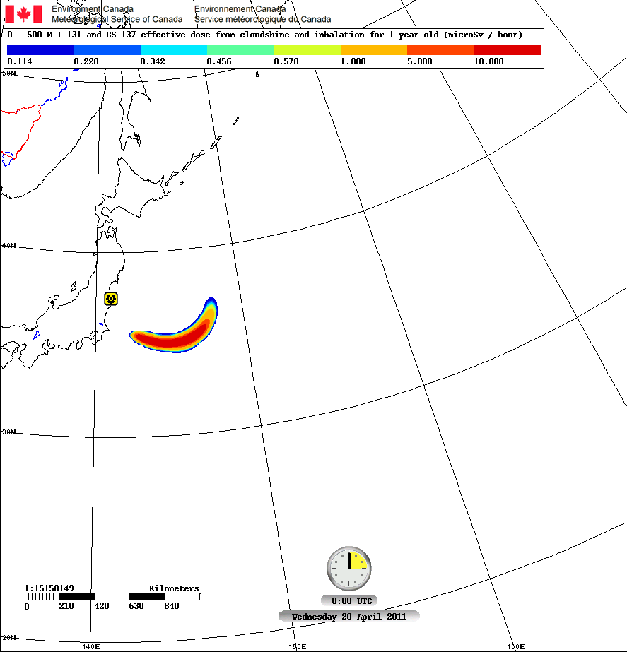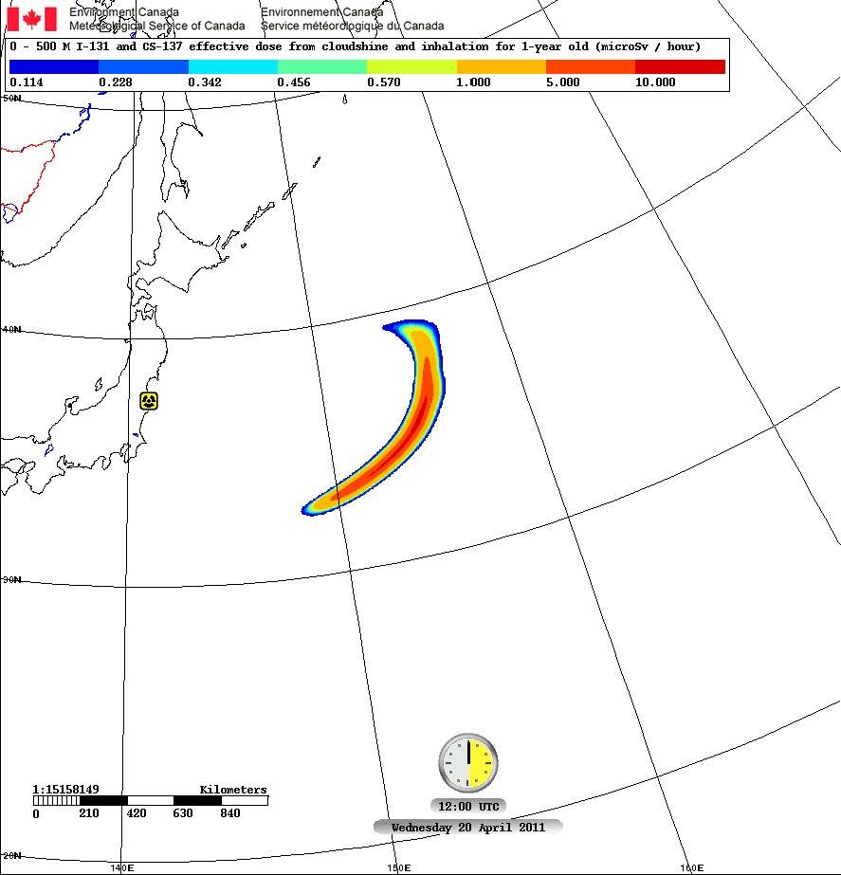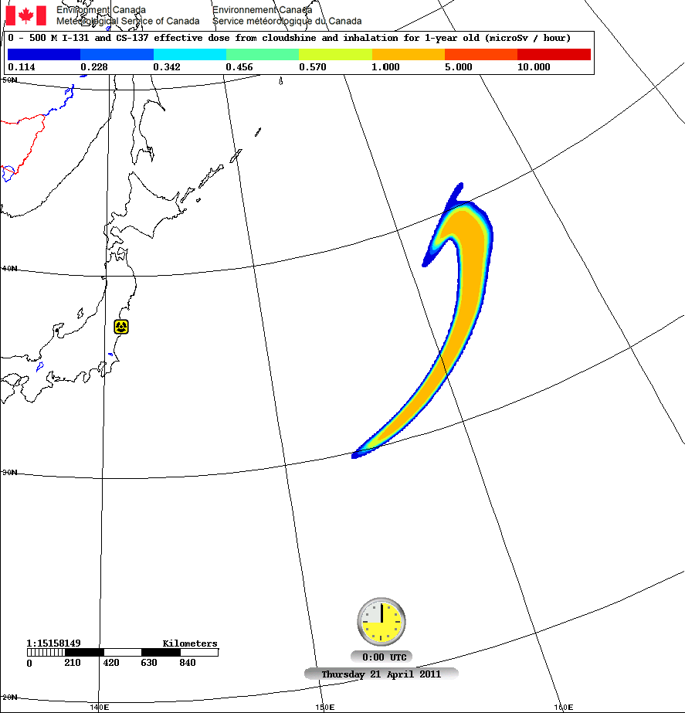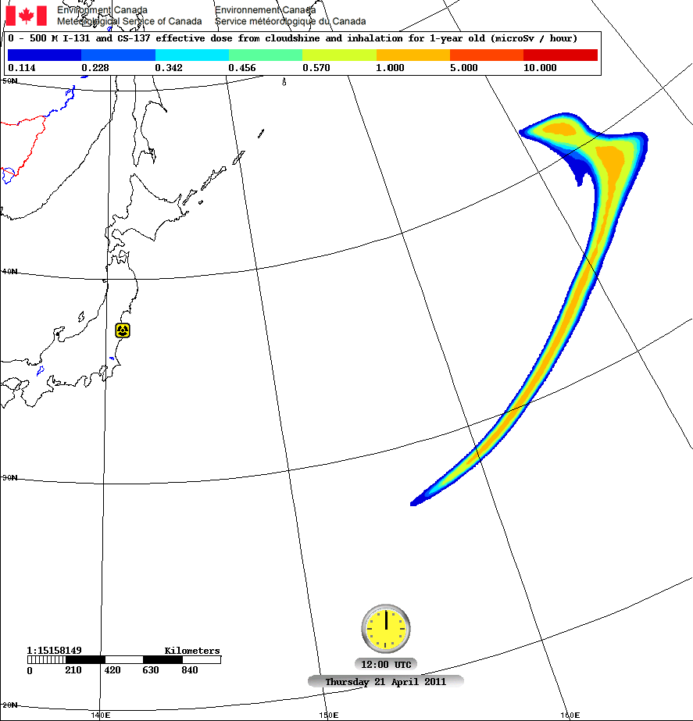

— END —

