WORLD METEOROLOGICAL ORGANIZATION  ________  COMMISSION FOR BASIC SYSTEMS  OPAG on DPFS  COORDINATION GROUP FOR  NUCLEAR EMERGENCY RESPONSE ACTIVITIES  Vienna, Austria, 31 October - 4 November 2011 |  | CBS/CG-NERA/Doc. 5(1)  (24.X.2011)  _______  Agenda item: 5.1  Original: ENGLISH

THE RSMC MELBOURNE RESPONSE TO THE FUKUSHIMA DAIICHI NPP ACCIDENT, TRIGGERED BY THE GREAT EAST JAPAN EARTHQUAKE AND TSUNAMI OF 11 MARCH 2011

(Submitted by James Fraser, RSMC Melbourne, Australia)

Summary and purpose of document

This document describes the response of RSMC Melbourne (in its capacity as the WMO RA-V Regional Specialized Meteorology Centre responsible for Environmental Emergency Response) to the Fukushima Daiichi NPP accident, triggered by the great east-Japan earthquake and tsunami of 11 March 2011.

Action Proposed

The meeting is invited to consider this document

1. Introduction

The National Meteorological and Oceanographic Centre (NMOC) in Melbourne is a Regional Specialised Meteorological Centre (RSMC) for Environmental Emergency Response (EER), with responsibility for the Regional Association V (South-West Pacific) area. As part of its responsibility, RSMC Melbourne provides advice, in the form of a basic set of products, on the atmospheric transport of pollutants resulting from nuclear disasters and possibly other causes.

NMOC Melbourne is part of the Bureau of Meteorology, Australia's national weather service. In addition to being an RSMC for EER, NMOC also hosts the Joint Australian Tsunami Warning Centre (JATWC), operated in conjunction with Geoscience Australia, which provides a comprehensive 24/7 tsunami monitoring and analysis capacity for Australia, as well as providing Regional Tsunami Watch Provider (RTWP) services for the Indian Ocean.

Because of these dual roles, NMOC was keenly focussed on the initial 11 March 2011 magnitude 9.0 Tōhoku earthquake, the passage of the resulting tsunami throughout the Pacific Ocean and the subsequent nuclear pollutant release from the damaged Fukushima Daiichi Nuclear Power Plant in the Fukushima Prefecture of Japan.

2. The RSMC Melbourne Environmental Emergency Response System

The RSMC Melbourne EER system is currently based around HYSPLIT, a hybrid Lagrangian-Eulerian particle/puff Atmospheric Transport Model (ATM), developed by Roland Draxler at NOAA’s Air Resources Laboratory. The meteorological input for HYSPLIT is derived from the output of the Bureau of Meteorology’s “ACCESS” Numerical Weather Prediction (NWP) systems also run in RSMC Melbourne. The current N144L50 global version of ACCESS uses a horizontal grid resolution of approximately 80km. Refer to WMO-TD/No.778 Annex 4.3 for further details regarding our EER system.

During 2010, the various systems run in RSMC Melbourne underwent considerable changes with the installation of a new Oracle supercomputer, operational switchover to the new ACCESS NWP models, upgrading to HYSPLIT version 4.9 and a substantial rewrite and streamlining of the operational suite of scripts used to produce our transport modelling forecasts. Numerous teething problems were encountered following the upgrade of all our systems in 2010. The monthly RSMC tests held in conjunction with RSMCs Montreal and Washington proved invaluable for identifying and rectifying many of these problems. However, the system had not been run in response to a real emergency event until the Fukushima accident on 11 March 2011.

3. Response to standard IAEA Requests

The first communication from the IAEA was received at 20:52 (Melbourne local time EDT) on Fri 11 March 2011. This was a request for only the designated lead RSMCs (Beijing, Tokyo and Obninsk) to provide products to the IAEA. Although many of the operational staff in RSMC Melbourne were involved at the time with the JATWC tsunami warning services, it was decided that our operator should also run the HYSPLIT dispersion model using the release parameters provided by the IAEA, although this was for internal test purposes only and the results were not distributed to any external users. Two further requests for products from the designated lead RSMCs were received during the following day but no action was taken by RSMC Melbourne in response to these requests.

The first request from IAEA requiring non-lead RSMCs to run their dispersion models and distribute products to the NMSs in their region of responsibility was received at 03:16EDT on Sun 13 March 2011. Unfortunately, several hours delay occurred before RSMC Melbourne could successfully generate the requested products, as our existing configuration was only capable of modelling releases that began within the forecast range of the most recent run of our NWP model, whereas the specified release for this request started several hours prior to this. Some urgent programming work was required in the early hours of Sunday morning to fix this problem and products were eventually distributed to all recipients after a delay of approximately 7 hours.

Over the following four weeks, a total of 29 requests were received from the IAEA. Of these, 20 requests required all RSMCs (including Melbourne) to generate products & distribute within their regions. The last request for products from the IAEA was received on 15 April 2011. A message from IAEA, formally ending the response for the Fukushima event, was received on 23 May 2011. Some details about the IAEA requests are shown in Annex 1.

4. CTBTO Requests for backtracking support

From 19 March to 25 October, RSMC Melbourne has responded to 41 requests from CTBTO. Some details about the CTBTO requests are shown in Annex 2.

5. RA-V National Met Service Requests
In addition to the official IAEA requests, a number of special requests for EER products were also received from RA-V NMSs. These were from the Philippines and Singapore - nations in relatively close proximity to Japan. In response to these requests, special runs of our dispersion model were done and the results were sent by email and fax to the requesting NMS only. Products were also uploaded to a password-protected general EER webpage on the Bureau of Meteorology’s web server but were not uploaded to the standard WMO Joint EER webpages. Since these NMS requests were simply for updates regarding a pre-existing event, notification of the requests were not passed on to WMO, IAEA or the other RSMCs.

Individual RA-V country requests for updated EER products received were
- Wed 16 March, Philippines
- Tue 29 March, Singapore
- Sat 9 Apr – Singapore
- Sun 17 Apr – Singapore
- Fri 22 Apr – Singapore
- Sat 23 Apr – Singapore
- Sun 24 Apr – Singapore

Due to the frequent update requests coming from Singapore, an automatic script was set up to routinely produce updated trajectory and dispersion charts over Japan twice a day and upload them to our password-protected general EER webpage (but not the WMO Joint EER webpages). This was stopped on 13 July but Singapore requested on 19 July that the routine updates be reinstated, as the products assist with their routine reporting of the Fukushima situation. Details of these routinely updated charts are shown in Annex 3.
Additionally, on Thu 17 March Singapore requested high-resolution products from RSMC Tokyo. RSMC Tokyo forwarded this request on to RSMC Melbourne on Sun 20 March. On Mon 21 March, Rene Servranckx suggested it was appropriate that the WMO PR for Singapore send a request directly to RSMC Melbourne. A direct request was received from Singapore Met Service (Chiam Keng Oon) on Fri 25 March. However, due to key staff being on leave and difficulties encountered with modifying the HYSPLIT plotting package to produce zoomed-in high-resolution plots, this request was unable to be filled immediately, although the automatically updated dispersion charts set up in late April were zoomed in over a smaller domain than that used for our standard products.

6. Special products for Australian Government agencies
Special Japanese wind forecast charts and HYSPLIT trajectory plots were produced daily and regularly presented by Chris Ryan, Centre Director of NMOC, to a high-level Australian Government “Inter-Departmental Emergency Task Force” in the weeks following the accident. Special wind charts were also routinely generated for the Australian Radiation Protection and Nuclear Safety Agency (ARPANSA), the agency which formulates detailed advice on nuclear issues to the Australian Government and its departments. The standard RSMC dispersion products are also sent to ARPANSA whenever an IAEA request is received.

ARPANSA maintain their own separate dispersion modelling capability in the form of their Accident Reporting and Guidance Operating System (ARGOS) which was used extensively (especially in the first week after the accident) within ARPANSA to help formulate detailed advice to other government departments. ARGOS uses the Riso Gaussian Puff model (RIMPUFF) to calculate atmospheric transport and dispersion over a short-medium scale ~300km and relied on the use of the ACCESS-T (tropical) and in some cases ACCESS-G (global) weather data produced by the Bureau of Meteorology.

According to ARPANSA, the standard RSMC EER products that were received during this period ”were used as a comparison to the modelling done within ARGOS for plume direction. The product in its current form has limited application in the provision of advice supporting the protective actions set out in [the ARPANSA operational guidelines]. To provide this advice requires an estimate of the source term (including radionuclides and release rates) in order to provide outputs of Dose, Dose rate or surface contamination... A benefit to ARPANSA of the EER product is that is provides outputs on a long-range scale, which is currently not available for ARPANSA’s version of ARGOS”.

7. RSMC Melbourne Experiences/Challenges/Changes

Request response times

In general, the RSMC Melbourne EER system ran fairly smoothly over the duration of the Fukushima event. Our system was considerably streamlined during the ACCESS/HYSPLIT4.9 upgrade in 2010 and, for most requests, the only operator intervention required is the extraction of the release parameters upon receipt of an IAEA fax/email and entry into a web-based form – subsequent dispersion model runs, chart production and distribution is mostly automated.

The average RSMC Melbourne response time following the receipt of an IAEA request was 43 minutes for distribution of products by fax and email (fastest individual response was 10 minutes), 55 minutes for uploading of products to the WMO Joint web pages and 112 minutes for the production of the Joint Statements.

Response times could be improved and the chance of transcription errors reduced if IAEA requests were transmitted via a standardized format ASCII text email or possibly even an XML file. This would allow improved automation of the system – the current process of manually entering the release parameters from a fax is relatively slow and prone to errors.

System Changes

A few changes were required to our system to fix problems encountered during the Fukushima event:

- As mentioned earlier, our original configuration was unable to process the first all-RSMC request on the evening of 12 March and required changes to cope with release start times occurring earlier than the basetime of the current NWP model run. At the present time, the system is configured to cope with releases starting up to 72 hours prior to the basetime of the current model run.
- Our original suite of scripts and procedures was not set up to easily distribute products to a single NMS in the event of a special update request. The first special request from the Philippines NMS had to be faxed and emailed manually – additional logic had to be added to our EER system to make this more automated.
- The increasingly long CTBTO backtracking requests eventually exceeded our 30-day historical model data disk archive. This archive has now been increased to 40 days and could be increased further if necessary.

Issues

Early during the Fukushima event, queries were received by forecast staff in RSMC Melbourne from a regional NMS regarding the interpretation of the standard EER dispersion products with regard to aviation safety. There were also general questions within RSMC Melbourne regarding the applicability of the standard products if we were required to issue aviation radiation sigmets. Some definite guidelines and training and more appropriate dispersion products would need to be developed and more realistic release parameters would need to be supplied before we would be able to deal with such issues.

Some confusion arose over the identity of the Delegated Authority for the Philippines after the operational contact requested some changes to the Philippine recipients of the standard EER products. The Delegated Authority listed in WMO contacts webpage had actually retired several years beforehand but a replacement had not been arranged with WMO. It would be wise for the contact details for all member states to be checked regularly.

Reference(s):

WMO-TD/No.778.: Documentation on RSMC Support for Environmental Emergency Response.
Available online at http://www.wmo.int/pages/prog/www/DPFSERA/td778.html
Annex 1 Details of IAEA requests during the Fukushima incident

Date and Time (EDT)  of Request  Reception | RSMCs  involved | Pollutant  amount & type | Release duration  and start time (UTC)
Fri 11 March 20:52 | Lead RSMCs only | 1e+12Bq I-131 | 24hr from 2011-03-11/09:29
Sat 12 March 03:15 | Lead RSMCs only | 1Bq I-131 | 24hr from 2011-03-11/16:00
Sat 12 March 11:57 | Lead RSMCs only | 1Bq I-131 | 24hr from 2011-03-12/03:00
Sun 13 March 03:16 | All RSMCs | 1Bq I-131 & Cs-137 | 72hr from 2011-03-12/06:29
Sun 13 March 20:30 | Lead RSMCs only | 1Bq I-131 & Cs-137 | 72hr from 2011-03-13/12:00
Mon 14 March 02:22 | Lead RSMCs only | 1Bq I-131 | 72hr from 2011-03-13/16:00
Mon 14 March 14:50 | Lead RSMCs only | 1Bq I-131 | 24hr from 2011-03-14/03:00
Tue 15 March 04:25 | All RSMCs | 1Bq I-131 & Cs-137 | 72hr from 2011-03-14/16:01
Tue 15 March 14:08 | All RSMCs | 1Bq I-131 & Cs-137 | 72hr from 2011-03-15/03:00
Tue 15 March 19:33 | Lead RSMCs only | 1Bq Cs-137 | 3hr from 2011-03-15/00:00 *
Wed 16 March 21:17 | All RSMCs | 1Bq Cs-137 | 10hr from 2011-03-16/01:11
Thu 17 March 13:02 | Lead RSMCs only | 1Bq Cs-137 | 24hr from 2011-03-17/06:00
Thu 17 March 22:36 | Lead RSMCs only | 1Bq I-131 & Cs-137 | 30:30hr from 2011-03-14/22:00*
Fri 18 March 03:54 | All RSMCs | 1Bq Cs-137 | 30:30hr from 2011-03-14/22:00
Fri 18 March 19:57 | All RSMCs | 1Bq Cs-137 | 72hr from 2011-03-16/04:30
Sun 20 March 20:23 | All RSMCs | 1Bq I-131 | 72hr from 2011-03-20/07:30
Wed 23 March 02:14 | All RSMCs | 1Bq I-131 | 72hr from 2011-03-22/14:30
Thu 24 March 09:36 | All RSMCs | 1Bq I-131 | 72hr from 2011-03-23/22:30
Sun 27 March 04:15 | All RSMCs | 1Bq I-131 | 72hr from 2011-03-26/17:00
Wed 30 March 23:12 | All RSMCs | 1Bq I-131 | 72hr from 2011-03-30/12:00
Sun 3 April 02:55 | All RSMCs | 1Bq I-131 | 72hr from 2011-04-02/12:00
Mon 4 April 18:44 | All RSMCs | 1Bq I-131 | 72hr from 2011-04-04/06:00
Thu 7 April 00:57 | All RSMCs | 1Bq I-131 | 72hr from 2011-04-06/06:00
Sun 10 April 14:51 | All RSMCs | 1Bq I-131 | 72hr from 2011-04-10/00:00
Mon 11 April 13:58 | All RSMCs | 1Bq I-131 | 72hr from 2011-04-11/03:10
Tue 12 April 12:01 | All RSMCs | 1Bq I-131 | 24hr from 2011-04-12/02:00
Wed 13 April 17:56 | All RSMCs | 1Bq I-131 | 24hr from 2011-04-13/00:00
Thu 14 April 13:48 | All RSMCs | 1Bq I-131 | 72hr from 2011-04-14/00:00
Fri 15 April 11:19 | All RSMCs | 1Bq I-131 | 72hr from 2011-04-15/01:00
Mon 23 May 22:36 | All RSMCs |  | End of requests

* The requests on 15 March 19:33 EDT and 17 March 22:36 EDT were specifically for local products for short to medium ranges.

Annex 2 - Details of CTBTO Requests for backtracking support

From 19 March to 25 October, RSMC Melbourne has responded to 41 requests from CTBTO.

Date and Time (EDT)  of Request Reception | Request details
Sat 19 March 03:11 | 7 stations ~4 day backtracks from ~15 March back to 11 March
Tue 22 March 01:46 | 9 stations ~ 5 day backtracks from ~16 March back to 11 March
Wed 23 March 12:37 | 7 stations ~ 6 day backtracks from ~16 March back to 11 March
Thu 24 March 01:02 | 10 stations ~7 day backtracks from ~18 March back to 11 March
Fri 25 March 02:29 | 14 stations ~8 day backtracks from ~19 March back to 11 March
Sat 26 March 02:30 | 19 stations ~9 day backtracks from ~20 March back to 11 March
Mon 28 March 23:57 | 18 stations ~10 day backtracks from ~21 March back to 11 March
Fri 1 April 12:47 | 18 stations ~11 day backtracks from ~22 March back to 11 March
Mon 4 April 22:18 | 31 stations ~12 day backtracks from ~23 March back to 11 March
Fri 8 April 12:20 | 29 stations ~13 day backtracks from ~24 March back to 11 March
Tue 12 April 12:14 | 23 stations ~15 day backtracks from ~26 March back to 11 March
Thu 14 April 22:43 | 24 stations ~19 day backtracks from ~30 March back to 11 March
Mon 18 April 22:14 | 36 stations ~25 day backtracks from ~5 April back to 11 March
Mon 2 May 20:58 | 6 stations ~3 day backtracks from ~21 April back to 18 April
Tue 3 May 21:59 | 5 stations ~4 day backtracks from ~22 April back to 18 April
Wed 4 May 23:18 | 5 stations ~5 day backtracks from ~23 April back to 18 April
Thu 26 May 23:30 | 7 stations ~5 day backtracks from ~24 May back to 19 May
Tue 31 May 23:30 | 5 stations ~13 day backtracks from ~25 May back to 12 May
Wed 1 June 22:17 | 7 stations ~10 day backtracks from ~30 May back to 20 May
Fri 3 June 20:23 | 7 stations ~5 day backtracks from ~31 May back to 26 May
Mon 27 June 22:30 | 14 stations ~15 day backtracks from ~11 June back to 27 May
Wed 29 June 22:33 | 12 stations ~16 day backtracks from ~15 June back to 31 May
Fri 1 July 19:48 | 7 stations ~15 day backtracks from ~17 June back to 2 June
Mon 4 July 19:48 | 7 stations ~5 day backtracks from ~13 June back to 8 June
Tue 5 July 19:08 | 6 stations ~4 day backtracks from ~27 June back to 23 June
Wed 6 July 19:51 | 7 stations ~5 day backtracks from ~1 Jul back to 26 Jun
Wed 13 July 16:37 | 7 stations ~2 day backtracks from ~10 Jul back to 8 Jul
Thu 14 July 16:27 | 7 stations ~6 day backtracks from ~10 Jul back to 4 Jul
Fri 15 July 23:27 | 7 stations ~11 day backtracks from ~3 Jul back to 22 Jun
Wed 20 July 18:34 | 7 stations ~11 day backtracks from ~18 Jul back to 7 Jul
Thu 21 July 18:00 | 7 stations ~11 day backtracks from ~17 Jul back to 6 Jul
Wed 27 July 23:15 | 7 stations ~11 day backtracks from ~23 Jul back to 12 Jul
Fri 29 July 17:04 | 7 stations ~11 day backtracks from ~27 Jul back to 16 Jul
Thu 4 August 20:03 | 7 stations ~9 day backtracks from ~30 Jul back to 21 Jul
Tue 6 September 23:14 | 7 stations ~7 day backtracks from ~2 Sep back to 26 Aug
Fri 9 September 23:14 | 9 stations ~7 day backtracks from ~3 Sep back to 26 Aug
Mon 12 September 17:46 | 7 stations ~16 day backtracks from ~6 Sep back to 20 Aug
Mon 3 October 22:48 | 7 stations ~13 day backtracks from ~29 Sep back to 16 Sep
Mon 17 October 16:45 | 7 stations ~11 day backtracks from ~7 Oct back to 26 Sep
Tue 18 October 17:08 | 7 stations ~12 day backtracks from ~6 Oct back to 29 Sep
Tue 25 October 00:10 | 7 stations ~11 day backtracks from ~22 Oct back to 11 Oct

Annex 3 - Details of routine automatic trajectory & dispersion runs posted to a password protected web page

TRAJECTORY PRODUCT:
The following parameters are used in these simulations:
- Forecast duration: 72 hr
- Starting heights: 10m, 500m, 1500m
- Starting release hours:
  - 00 UTC using forecast wind fields of the global ACCESS-G 00 UTC model run
  - 12 UTC using forecast wind fields of the global ACCESS-G 00 UTC model run
- Graphical output:
  - 1 chart displaying full domain of trajectories over 72 hours
(see example in Fig. 1 below)
DISPERSION PRODUCTS:
- Forecast duration: 72 hr
- Release duration: 72 hr
- Release quantity: 3E+14 Bq of Cs-137 (to be changed to 1 Bq Cs-137 as soon as possible)
- Starting release hours:
  - 00 UTC using forecast wind fields of the global ACCESS-G 00 UTC model run
  - 16 UTC using forecast wind fields of the global ACCESS-G 12 UTC model run
- Initial plume vertical distribution: Uniform between 30m and 200 m
- Graphical output (limited domain showing Japan region only)
  - 3 charts showing exposure (Bq-s/m3) averaged between 0m and 500m, valid at +24 hr, +48hr and +72 hr
  - 1 animation showing 6-hourly exposure charts out to +72 hours
  - 1 chart showing deposition (Bq/m2) at ground-level valid at +72 hr hours
(see example in Fig. 2 below)
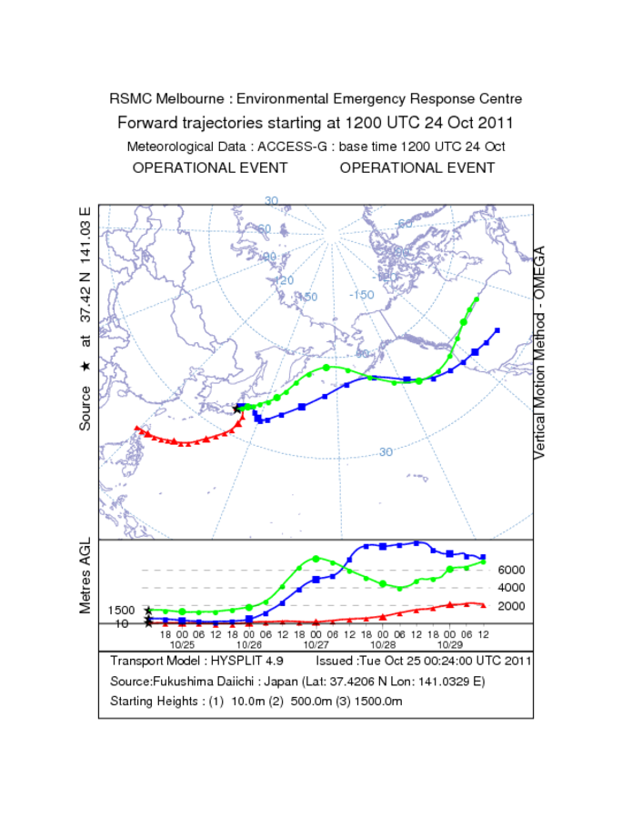
Figure 1. Routine automatic trajectory chart produced twice daily by RSMC Melbourne
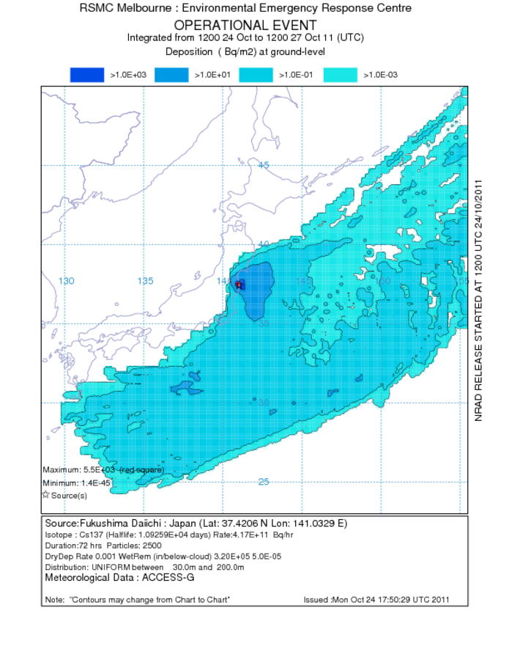
Figure 2. Routine automatic dispersion chart produced twice daily by RSMC Melbourne

