WORLD METEOROLOGICAL ORGANIZATION  COMMISSION FOR BASIC SYSTEMS  OPAG DPFS  COMMISSION FOR BASIC SYSTEMS  NUCLEAR EMERGENCY RESPONSE ACTIVITIES  COORDINATION GROUP  BEIJING, CHINA, 24-28 MAY 2008 |  | CBS-DPFS/CG-NERA/Doc. 8.1(3)  (20. V.2010)  _______  Agenda item : 8.1  ENGLISH ONLY

(Report on the CTBTO-WMO operational activities and periodic exercises of the joint response system)

(Submitted by CTBTO)

Summary and purpose of document

This document reports on the details of support received from the CTBTO since the previous meeting ERA meeting held in May 2008.

CTBTO-WMO Level 5 Support System
CTBTO performs atmospheric backtracking computations on a daily basis. The backtracking results provided by the Regional Specialised Meteorological Centres (RSMCs) of the WMO constitute support for the CTBTO’s computations. The broad spectrum of these results is crucial in providing a diversified view of the source attribution problem.

Already since 1998 the RSMCs of the WMO have been actively participating in the periodic exercises of the atmospheric transport modelling (ATM) system operating at CTBTO. During the ERA meeting in 2001 a concept of the CTBTO-WMO response system was put forward for the first time. The requirements and subsequent assessment of its technical feasibility were worked out at a technical workshop in Vienna in 2002. The details were presented to the Nuclear ERA-CG in the past papers by Wotawa et al. (2004), Wotawa et al. (2006) and Becker et al. (2006).

On the technical side, each occurrence of a detection categorised as level 5 in the CTBTO’s radionuclide network is accompanied by a semi-automated notification e-mail to the co-operating meteorological centres. The e-mail has a pre-defined format and contains geographical location of several radionuclide stations for which the backtracking computations are requested. The interval of the measurement duration as well as the time of validity of the SRS fields is specified. The meteorological centres perform backtracking calculations using their own means as far as the atmospheric transport modelling and the input meteorological fields are concerned. As the centres are the recognised experts in these domains, the results aspire to form a basis of a measurement of uncertainty of the CTBTO’s in-house computations, but also of the computations provided by any other centre participating in the system. All the backtracking computations are consequently made available to all the participating centres. Moreover, as exhibited in a twin experiment (source location for a fictitious scenario of radionuclide measurements) reported below, the results produced by the joint response system have a capacity of improving source attribution.

The system is operational since 1 September 2008. The operational phase was preceded by three tests done on 29 August, 1 September and 20 October 2009. Between 1 September 2008 and 15 May 2010 there were in total 10 notifications issued.

In the last four months of 2008 the notifications were issued on four days: 20 October, 28 October, 29 October, and 12 November. They were e-mailed to 8 fully participating RSMCs or National Meteorological Centres (NMCs) and to the RSMC Tokyo which, until 1 December 2009, played only an observer role. The scope of the requests for support as well as the response is detailed in Tables 1 -3.

Some confusion in the understanding of the CTBTO’s request for support submitted on 29 October 2008 is to be noted. Each of the eight participating centres uploaded an additional RUP61 file with a collection start time mistakenly taken for a collection stop time.

Date of request | End of the sampling time | RSMCs | Requested SRS | Received SRS | Comments
20 Oct | 2,3,4 Oct | 8+1 | 6*8=48 | all requested
28 Oct | 22,23,24 Oct | 8+1 | 7*8=56 | all requested
29 Oct | 24,25 Oct | 8+1 | 5*8=45 | all requested | 8 additional SRSs received
12 Nov | 9,10,11 Nov | 8+1 | 7*8=56 | all requested
Table 1. Response of the RSMCs to four Level 5 notifications issued in 2008.

In 2009, the notifications were issued on five days: 5 January, 21 July, 24 July, 20 August, 27 November and the details are presented in Table 2. It is worth mentioning that the last among these requests dated 27 November 2007 was submitted late after the end of the sampling time and the date the notification e-mail is sent out. On the CTBTO side this late notification was linked to a delayed data transmission and consequently delayed analysis of one of the samples.

Nevertheless, the meteorological centres proved capable of dealing with such a request:
- 3 centres ensured full (time and content) response
- 1 centre responded on time and delivered all requested SRS fields although covering shorter than the requested time period
- 2 centres delivered all the requested SRS fields with a delay (on 30 November 2009)
- 1 centre uploaded 6 out of 7 requested files with a delay (on 30 November 2009)

Date of request | End of sampling time | RSMCs | Requested SRS | Received SRS | Comments
5 Jan | 26,27,28 Dec | 8+1 | 7*8=56 | all requested
21 July | 15,16,17 July | 8+1 | 7*8=56 | all requested
24 July | 20,21,22 July | 8+1 | 7*8=56 | all requested
20 Aug | 12,13,14 Aug | 8+1 | 4*8=32 | all requested
27 Nov | 4,5,6 Nov | 8+1 | 7*8=56 | 32 (duly) +  23 (delayed) | 1 file missing
Table 2. Response of the RSMCs to five level 5 notifications issued in 2009.

So far one request for support was issued in 2010 (until 15 May 2010 included). It is to be noted that the entry ‘Date Issued’ of the notification e-mail (29 April 2010) was inconsistent with the date the message was sent out (3 May 2010). As a result one of the centres felt unable to meet the deadline understood to be 30 April 2010. Consequently, a second request for support with the same content was sent out to the requesting centre on 4 May 2010 and the 24 hour time interval for date upload was appropriately shifted for this centre.

Although the Manual on the Global Data-Processing and Forecasting System specifies that the upload of the results is expected ‘within 24 hours of reception’ CTBTO is aware of the confusion the abovementioned inconsistency have caused and will make every effort in the future to ensure coherence between the entry ‘Date Issued’ and the date the notification is sent out.

Date of request | End of sampling time | RSMCs | Requested SRS | Received SRS | Comments
3 and 4 May | 19,20,21 April | 9 | 7*9=63 | 52 (duly)+  2(delayed) | 9 files missing
Table 3. Response of the RSMCs to the only level 5 notification issued in 2010 before and including 15 May 2010.

Overall, CTBTO acknowledges an excellent response to its requests for support from all the cooperating meteorological centres.

Periodic exercises
Once per year National Data Centres (NDCs), whom the utmost judgment on breaching compliance with the treaty is reserved, perform an NDC Preparedness Exercise (NPE). In such exercises an event detected by either seismic, infrasound, or hydroacoustic network, referred to as waveform, is scrutinized. In order to test source location for the atmospheric transport modeling a fictitious radionuclide scenario needs to be generated in the first place. The source term is constituted by an instantaneous release of 10¹⁵ Bq coinciding in space and time with a scrutinised wavefrom event. The resulting detections in the radionuclide network constitute the required measurement scenario which is in turn an input into a source location algorithm.

The periodic tests of the joint CTBTO-WMO response system have been involved in both NPEs held since the previous Nuclear ERA-CG meeting in May 2008. The details can be found in the two sections which follow.

NPE 2008
A fictitious radionuclide scenario created for the needs of the NPE 2008 was spanned over a period of 5 days. There were 5 radionuclide stations involved. Only one of them reported fictitious detections, the remaining four were non-detecting neighbours. First notification for support was issued on 31 October and the last one on 4 November 2009. Over this period there were 25 backtracking calculations (SRS fields) requested from 9 meteorological centres. These requests amounted to 225 SRS fields which were uploaded with the response rate of 100%.

The SRS fields constitute inputs to a source location algorithm. The resulting Possible Source Regions indicate where the source of the fictitious release of radionuclides could have been located. During an NPE each PSR is produced in two copies. One is based on the SRS produced exclusively by the CTBTO, the other represents an average over all the contributions provided by the RSMCs. Both results are checked for consistency (Fig. 1). At the last stage of the analysis of the backtracking results suspected waveform events (those overlapping with the PSRs) are identified in a data fusion procedure. At the end of the NPE 2008 there were two suspected waveform events indicated by both types of PSRs. One of the suspected events was the event scrutinised during the exercise and hence at origin of the simulated release of radionuclides.

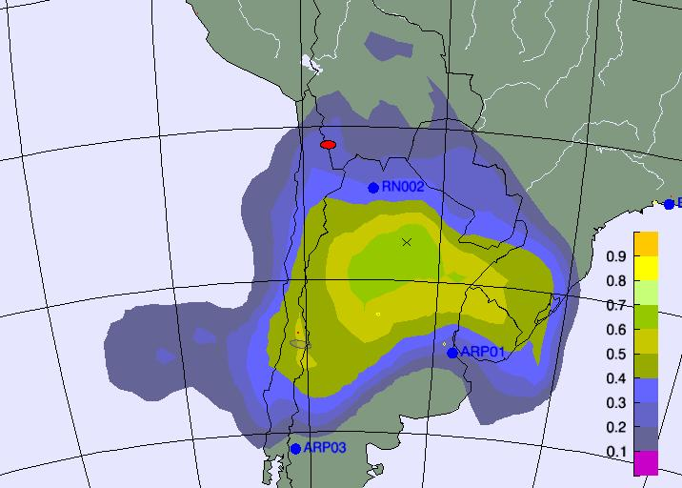 | 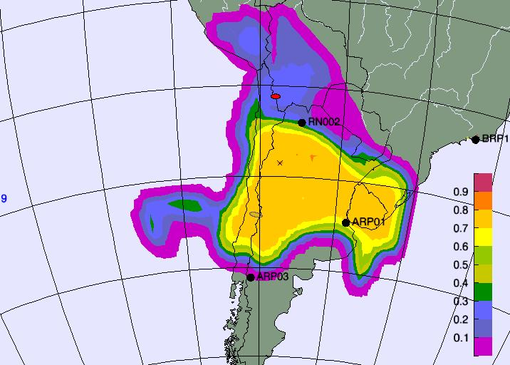
Figure 1. PSRs for 27 October 2008 obtained exclusively from the CTBTO SRSs (RHS) and averaged over the RSMCs’ contributions (LHS). Both fields have been built on the basis of all the measurements of the fictitious scenario.

NPE 2009
A notification e-mail about an incoming NPE was issued on 1 October 2009. The constraints imposed on the scrutinised event, and in particular the fact that an accompanying fictitious release should generate a sufficiently rich measurement scenario, narrowed down the choice and it was not until the end of November that an appropriate event could have been selected.

First notification for support was issued on 3 December and the last one on 11 December 2009. The detection scenario was spanned over a period of 9 days (with detections present on 7 days). There were 16 radionuclide stations involved either as a detecting one or a neighbour of such a station. Over this period there were 48 backtracking calculations (SRS fields) requested from 9 meteorological centres. These requests amounted to 432 SRS fields expected to be uploaded in response. Despite a long waiting period and a considerable number of requested computations the exercise turned out to be a great success. The rate of full and timely response was highly impressive. In the end 431 (99.8%) SRS fields were received, among them 418 (96.8%) arrived in due time.

Days 1,4,5,6 of the scenario witnessed full and timely response from all the centres. Two of the SRS fields requested for days 7 and 8 were uploaded with a delay on each of those days. 9 SRS fields were uploaded with a delay to answer a request issued on day 9. Only one single SRS field was missing at the end of the exercise. It is remarkable that among 9 participants as many as 7 ensured full (content and time) response throughout the exercise.

The response statistics is illustrated in Table 4.

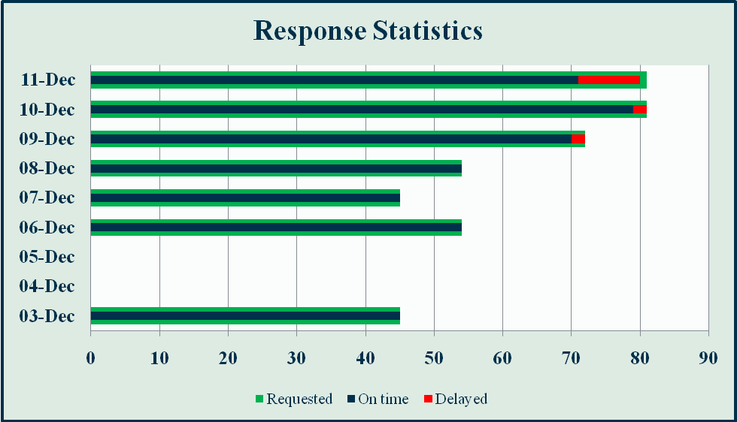
Table 4. Response statistics for the NPE 2009.

Consistency between the PSRs obtained exclusively for the CTBTO results and the results averaged over the RSMCs’ contribution is illustrated in Fig. 2.

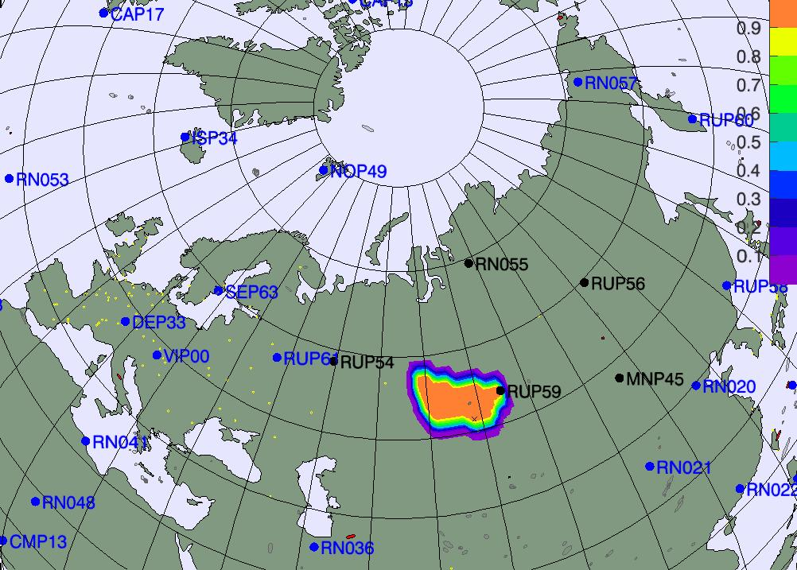 | 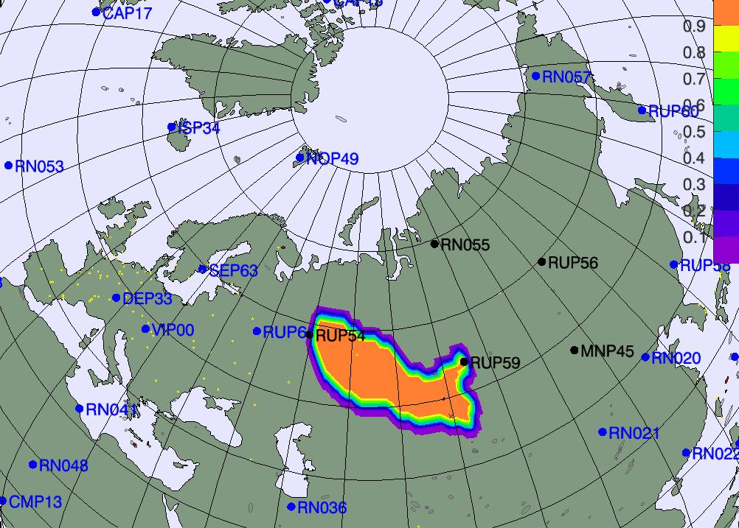 | 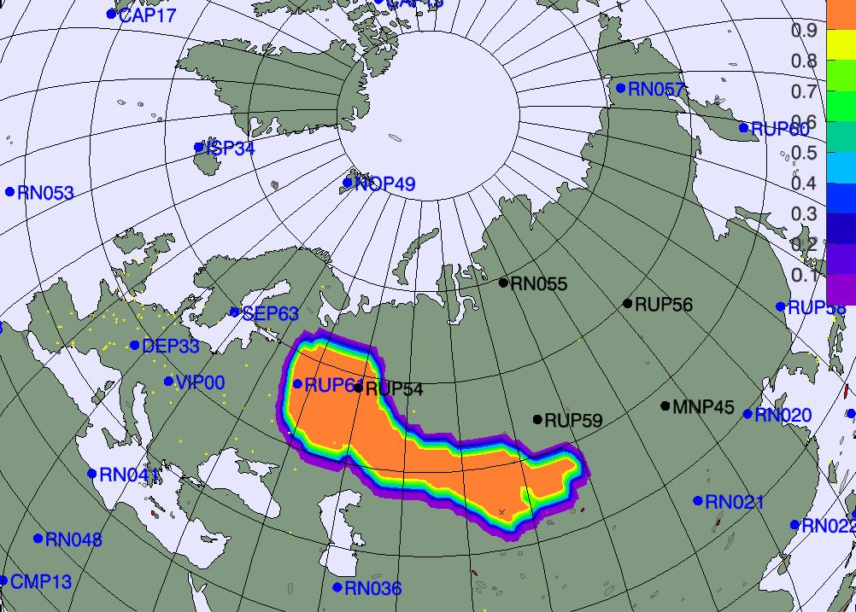 | 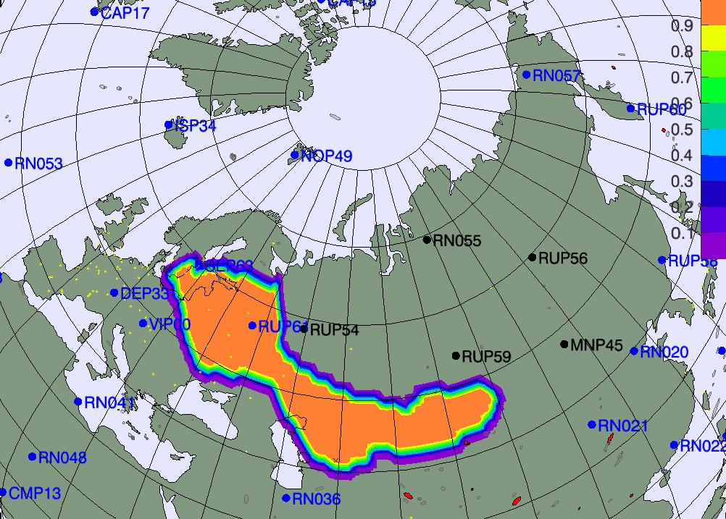 |  | 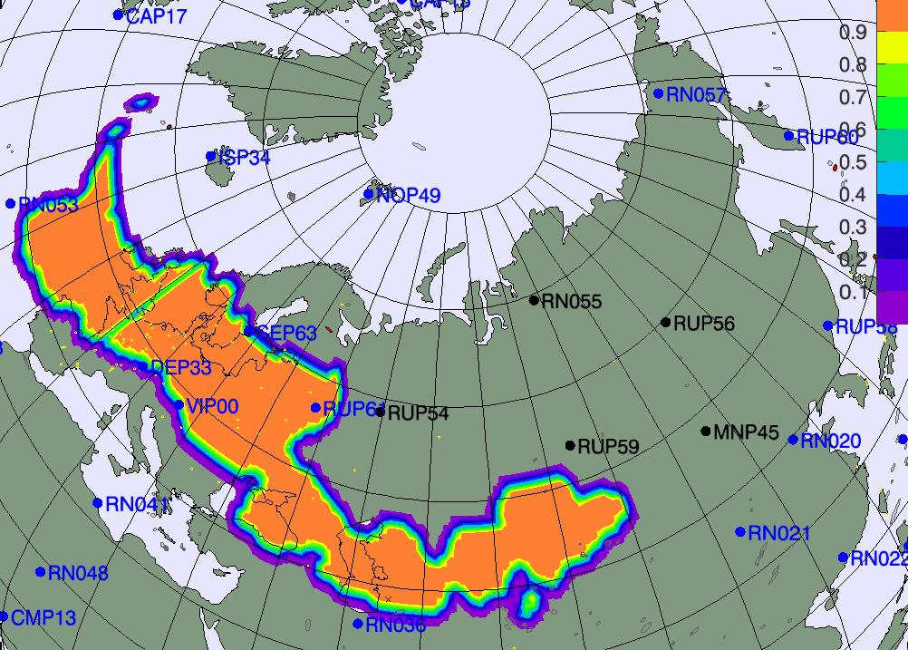
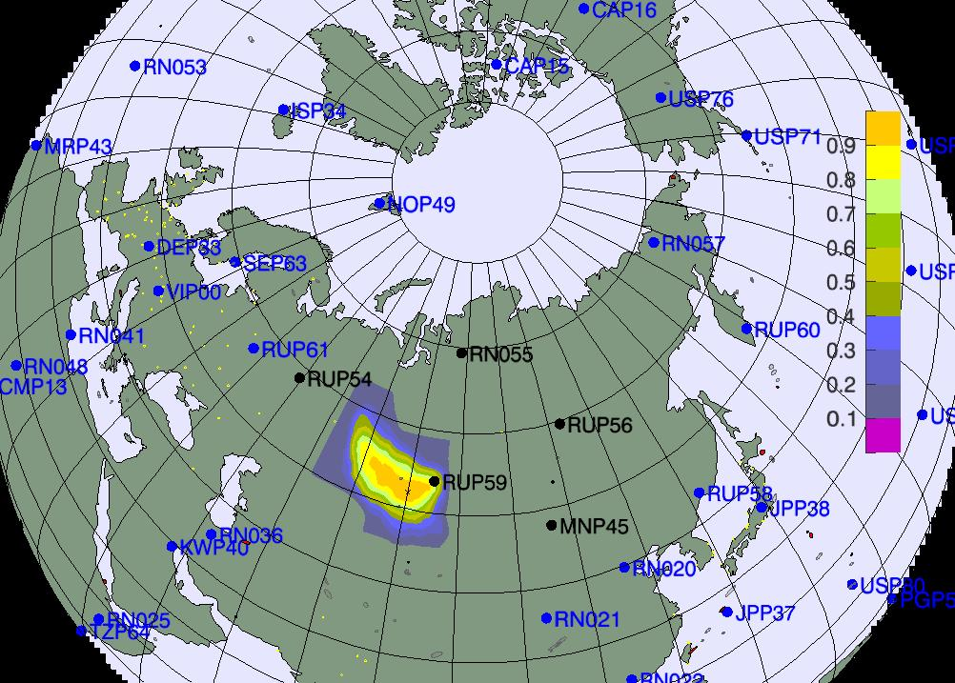 | 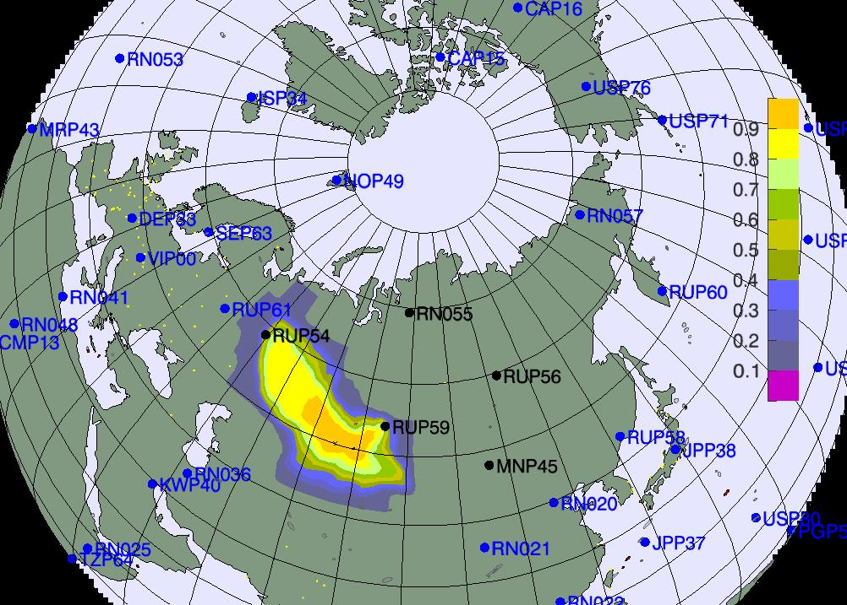 | 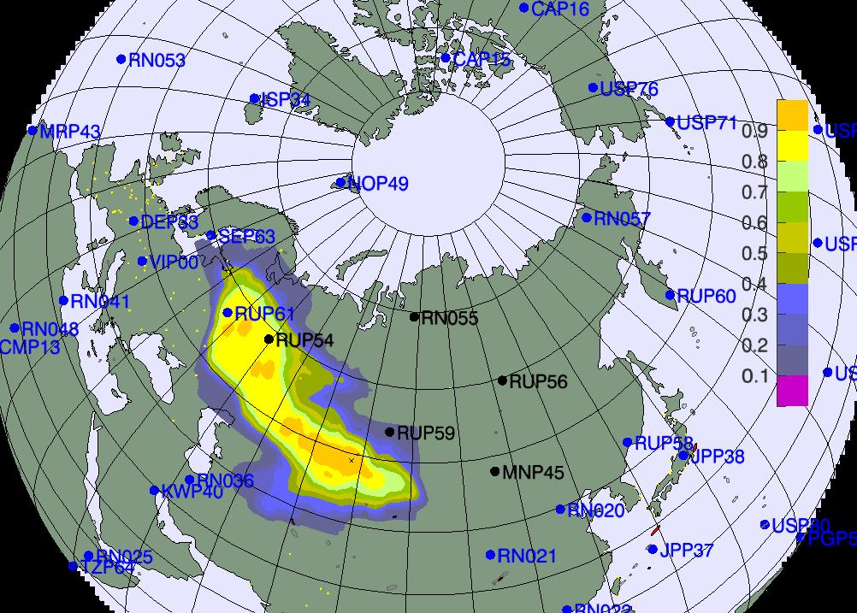 | 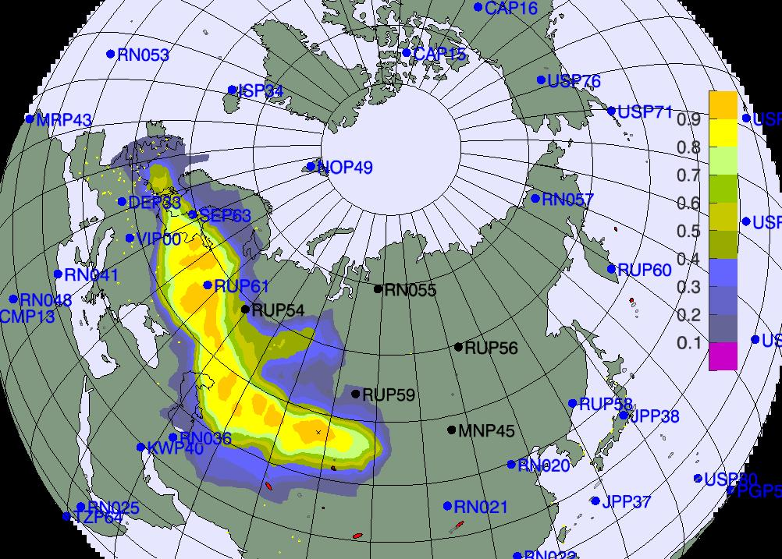 | 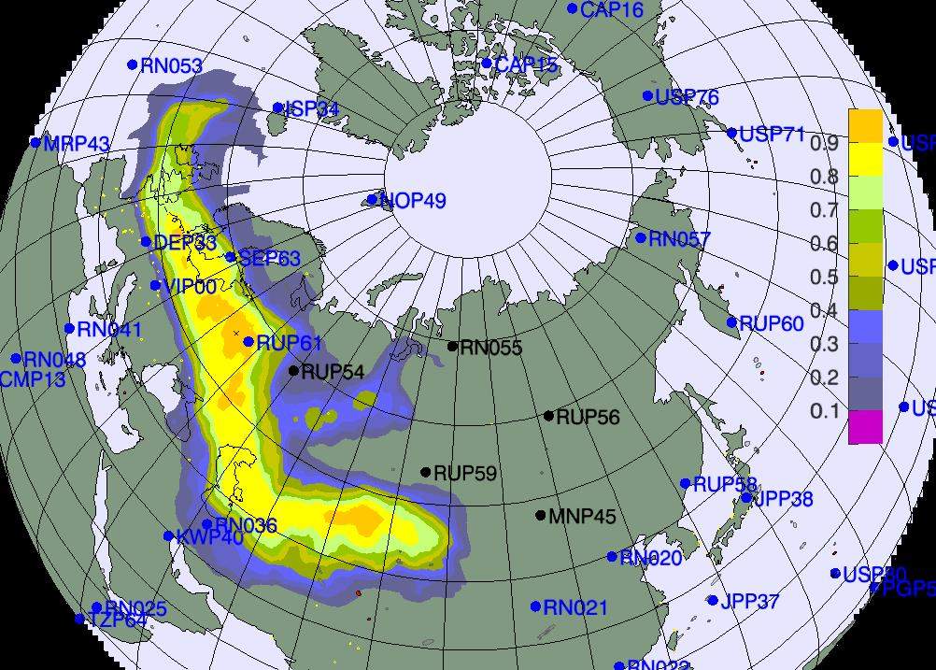 | 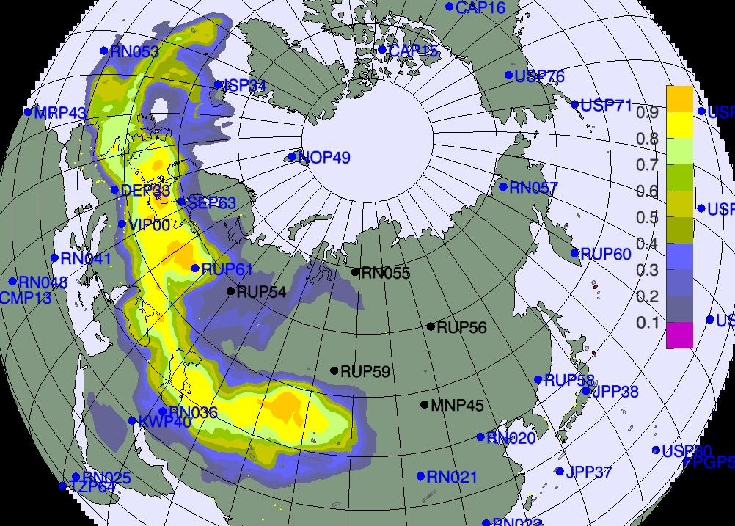
Figure 2. PSR obtained exclusively from the CTBTO SRSs (top row) and averaged over the RSMCs’ contributions (bottom row). The SRSs involved refer to the first detection of the fictitious scenario and four non-detecting neighbouring stations, all on 30 November 2009. Each plot represents one of the six 24-hour intervals directly preceding first fictitious detection on 30 November 2009. A period from 29 November (first column) to 24 November (last column) is thus spanned.

The PSRs are subsequently overlaid with the waveform events. The aim of such a data fusion procedure is to indicate those waveform events which could have been at the origin of a fictitious release of radionuclides. For the NPE2009, the final data fusion results turned out to be similar for the PSRs computed for the PTS’ results and for the PSRs computed from the RSMCs’ contributions. There was one suspected event (the source of the fictitious release of radionuclides) in the first case and, due to a larger spatial spread of the RSMCs’ contribution, two events in the second case. One of the two suspected events in the latter case was, nevertheless, the one used as the source of the fictitious radionuclide release. Moreover, should source location by measured by the distance between the maximum of the PSR and the location of the waveform event, the RSMCs’ results (Fig. 3, left-hand side) produced PSRs having a maximum closer to the location of the fictitious release of radionuclides, and, hence, a better source estimation, than the CTBTO results alone (Fig.3, right-hand side).

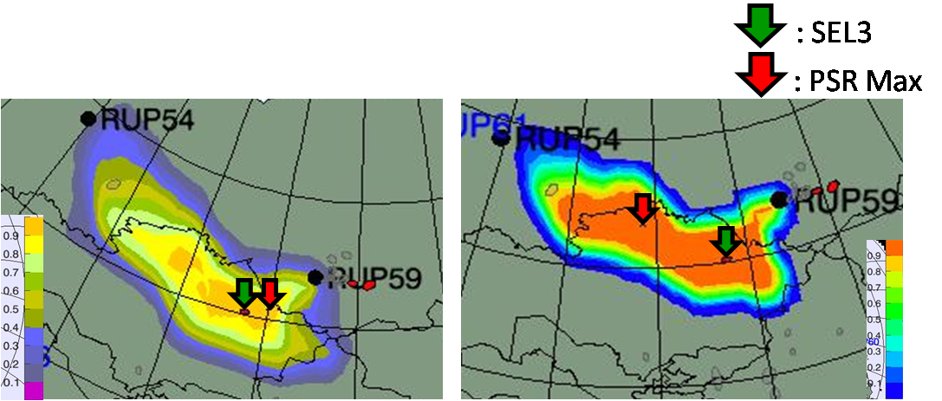

Figure 3. PSRs on 28 November 2009 built using all the measurements of the fictitious scenario until 8 December 2009. The wavefrom event (coming from SEL3 CTBTO’s bulletin) is indicated with the green arrow while the location of the maximum of the PSR field with the red arrow. Comparison of the results obtained for the averaged RSMCs’ results (LHS) and solely CTBTO contribution (RHS) illustrate the benefit drawn from the computations performed by the RSMCs.

References
Becker, A., Wotawa, G., and De Geer, L.-E. (2006), Summing up several CTBTO-WMO experiments in preparation for a CTBTO-WMO response system, CBS/CG-NERA/Doc.8(2)

Wotawa, G., Becker, A., and De Geer, L.-E., 2006: Cooperation between CTBTO and WMO: The first co-ordinated CTBTO-WMO Experiment 2003 – Summary, Lessons learned and steps towards a future operational implementation, WMO Document CBS/ERA/CG/Doc. 8.2

Wotawa, G., Becker, A. and De Geer, L.-E. (2006), Proposal for a technical implementation of the CTBTO-WMO atmospheric backtracking response system for CTBT verification purposes, WMO Document CBS/CG-NERA/Doc.8

