WORLD METEOROLOGICAL ORGANIZATION  COMMISSION FOR BASIC SYSTEMS  OPAG DPFS  COMMISSION FOR BASIC SYSTEMS  NUCLEAR EMERGENCY RESPONSE ACTIVITIES  COORDINATION GROUP  BEIJING, CHINA, 24-28 MAY 2010 |  | CBS-DPFS/CG-NERA/Doc. 7.4  (14. V. 2010)  _______  Agenda item : 7  ENGLISH ONLY

‘’Plume Time of Arrival’’ Products

(Submitted by Canada, Russia and the United-States)

Summary and purpose of document

This document 1) shows examples of ‘’Plume Time of Arrival’’ products 2) invites the meeting to discuss the merits of these products and if appropriate 3) define the specific parameters for these products and make recommendations / define actions for the next steps

Action Proposed

The meeting is invited to discuss this paper and make recommendations

- INTRODUCTION

At the last meeting of the nERA-CG (Melbourne, Australia, May 2008), the Group agreed that additional RMSC products would be useful and that we would start with a ‘’plume time of arrival’’ product. This would help answer some of the first questions a responder might ask such as ‘’how much time is left before the plume arrives?’’ and ‘’where should we place the monitoring teams to identify that the plume has arrived?’’.

The Meeting formulated the following the following in the report:
ACTION 20: RMSCs Obninsk, Montréal, Toulouse, Washington and IAEA:
Define parameters and format for new experimental ‘’time of arrival of pollutant’’ product to be posted on meta-data directory.

- EXAMPLES OF PRODUCTS

Examples of a ‘’Plume Time of Arrival’’ products are shown in Annex 1 to show visually what such products might look like (for these, what is displayed, contouring values, etc. are not really important).

- THE ROAD FORWARD

The Meeting is invited to
  - discuss the merits of these products
  - If appropriate, define the specific parameters (what should be displayed, formatting details, colors, whether corresponding text bulletins would be useful, where to post the results, etc).
  - Make recommendations / define actions for the next steps

ANNEX 1: Examples of ‘’Plume Time of Arrival’’ Products

From RSMC OBNINSK:

Here are 2 examples of the 'time of arrival' products. We added this feature in our software as additional RSMC product which is produced automatically together with other RSMC products. First 2 examples are relative 'fresh' - we were requested by our national authority (Roshydromet) to make a set of calculations for Eyjafjallajokull volcano eruption. Third example was produced during an internal exercise in March 2010. This is a reason why you can see some Russian letter on pictures. For RSMC calculations we are using another map to generate products.

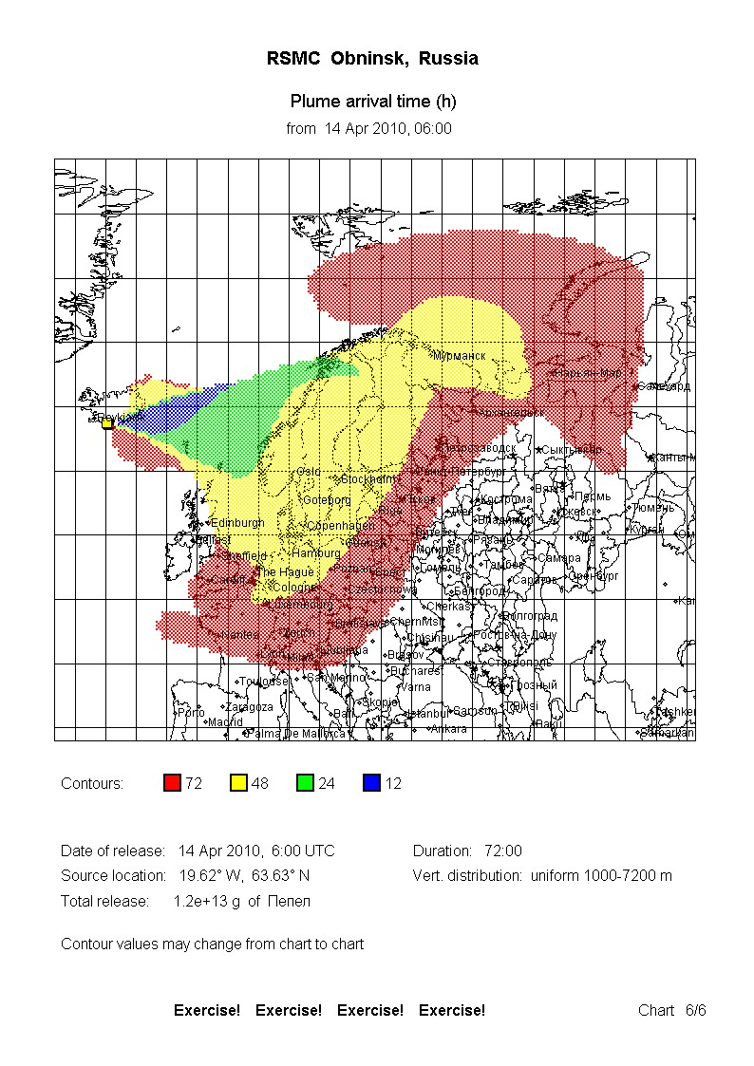
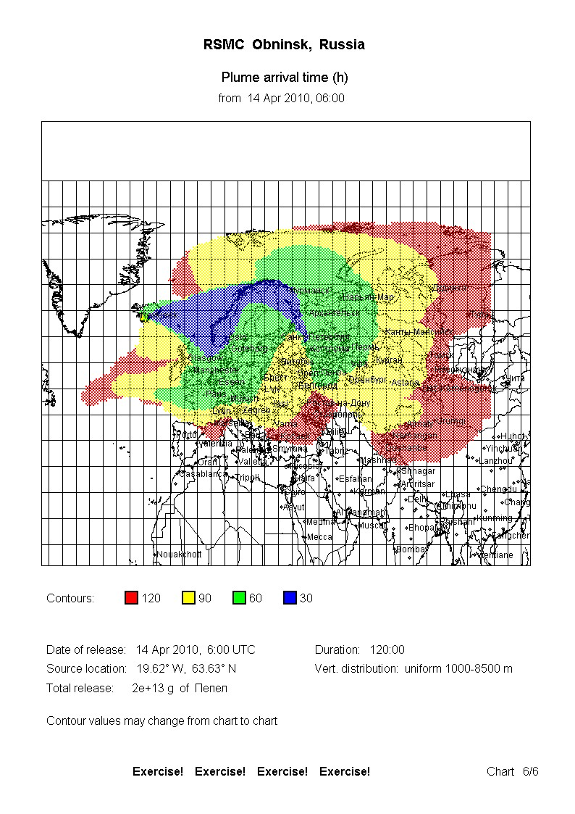
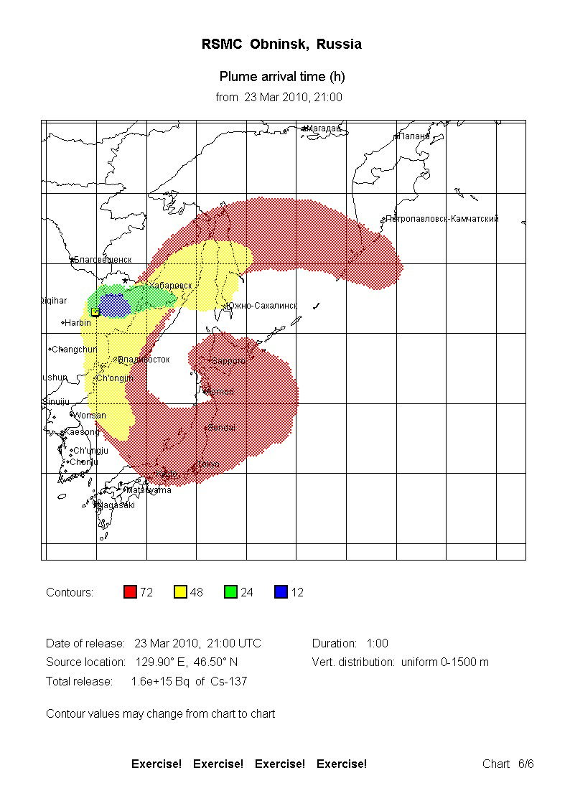
From RSMC WASHINGTON:

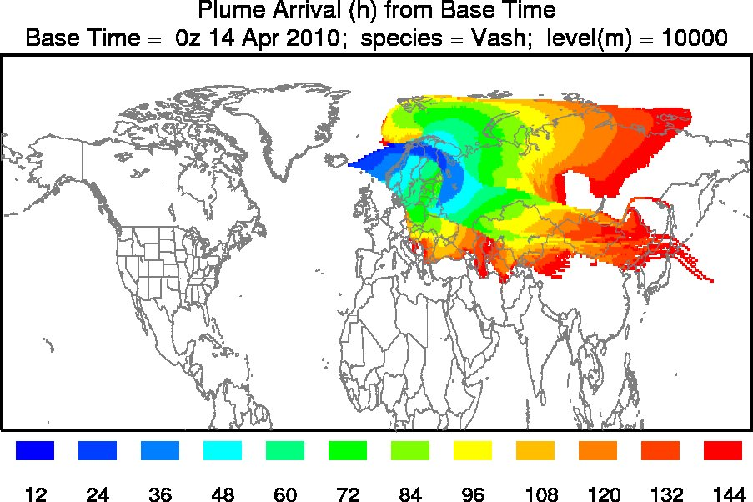

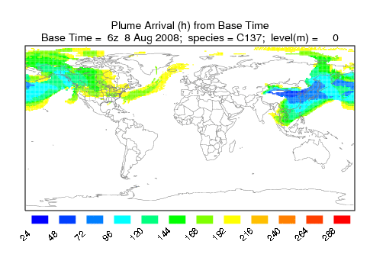

Here are the command line arguments to generate these. This gives you some ideas of the possible options and the concept of setting a threshold concentration below which values are considered to be zero:
USAGE: isochron -[options(default)]
-i[input file name (cdump)]
-o[output name (chron)]
-t[threshold value (1.0E-36)]
-c[color fill no:0 yes:(1)]
-f[Frames: (0)-all frames one file, 1-one frame per file]
-n[number of contours (10)]
-d[difference (h) between contours (24), -1 to use conc interval]
-j[Graphics map background file name: (arlmap)]
EXAMPLES FROM RSMC MONTREAL:



