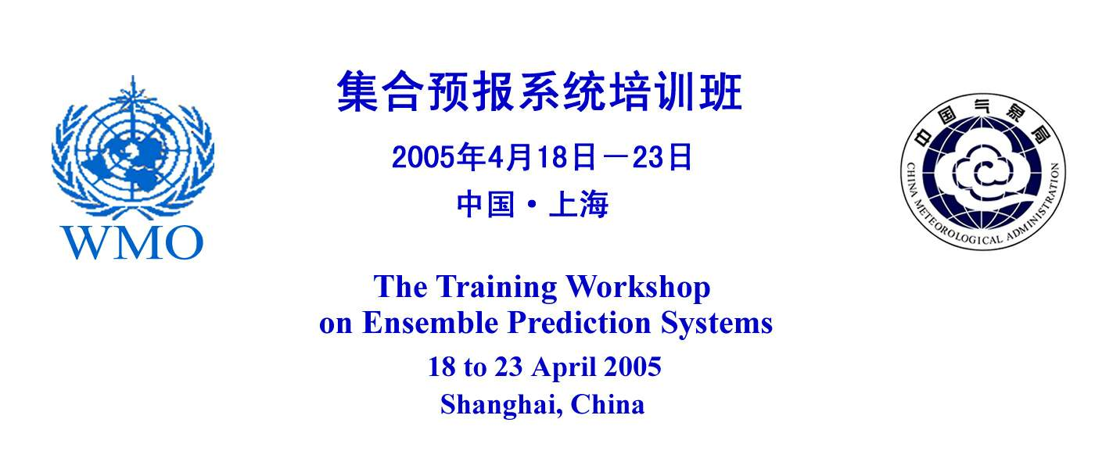
Report on the Training Workshop on EPS, RA II and RA V

The Regional Training Workshop on Ensemble Prediction Systems (EPS) for RA-II and RA-V was held in Shanghai, China at the kind invitation of the China Meteorological Administration (CMA) and the Shanghai Meteorological Bureau (SMB), from 18 to 23 April 2005. Twenty participants from 18 countries, 16 from RA-II and 4 from RA-V, 14 from CMA (NMC, SMB, other regional offices) and 6 resource persons, including from JMA (Japan), KMA (Korea), SHMI (Sweden), Met Office (UK), NCEP (USA) and myself, were present. The final list of participants is found in Annex I.

The Director General of Shanghai Meteorological Bureau (SMB), Mr Xu TANG, and the Deputy Director General of CMA International Cooperation, Mr Xianhua XIN opened the workshop on Monday 23rd April at 9:30 am. He recognized WMO’s role in promoting technical cooperation and the transfer of technology to developing countries, and noted the importance of this training event on EPS in these contexts. Mr Tang noted that the SMB is organizationally both a part of the CMA as well as a department of the Shanghai Municipal Government and as such has been able to modernize its meteorological services. During the week, the participants made a short visit of the facilities of SMB’s impressive operational forecasting centre. On behalf of WMO, I expressed much thanks to the CMA and SMB. I also emphasized the importance of training on the EPS, in particular the access and practical use of products already available from various producing centres, that new knowledge and practical methods learned at this training event should be shared with other colleagues on their return to their home offices, and that EPS producing centres will welcome feedback.

The final programme of the Training Workshop is found in Annex II. In addition to the presentations and case studies made by the resource people, several participants spoke about their own forecasting operations (China, Hong Kong, Korea, Nepal, Mongolia, Indonesia, Vietnam). Two special discussions also took place, one on Computer Assisted Learning (summary found in Annex III), and a second on Regional product database for EPS (summary found in Annex IV). While the programme of the training was carried out largely as planned, daytime Internet access (e.g. to EPS producing centres, WMO, or various home servers) essentially unavailable, or for brief periods very slow. This meant that one live “web surfing” session could not be delivered, while some case studies and Internet-access demonstrations had to be done by large file transfers outside of the main working hours, assisted efficiently by local IT personnel, and then installed on the local server for “off-line” use. Hence the effectiveness of some of the sessions was unfortunately reduced.

The participants were in general very reserved, however, enthusiastic during the hands-on and case study sessions. They were asked to present the results of their case study work. While I believe that the lecture materials should not have been overly difficult for weather forecasters, some expressed difficulty in keep up with the presentation material, in part due language difficulties (English only). It is possible that if pre-session materials had been made available, that the situation could have been somewhat alleviated. All presentations and case studies were assembled during the week, and provided on CDs to the participants at the closing session. It was very clear that these CDs were very much appreciated.

A post-session questionnaire was conducted to assess the level of satisfaction of the participants. Based on 28 replies, the number of replies in each category and the most frequent category of reply to each of the questions are marked in the summary of results, found in Annex V. The overwhelming conclusion is that objectives of the training were well met. During the closing discussions, there were additional comments:
- Internet access is available to all the participants at their NMCs except for one;
- Some felt insufficient geographical coverage of the products from the EPS producing centres;
- Some felt that there should be more case studies and examples that are relevant to their respective region (either as CAL cases, or used in the sessions);
- Some lectures were too difficult to follow; others felt the balance of lectures and case studies was excellent;
- A lecture session on “Probability” would have been useful;
- Useful to set up a list-server or e-network for participants to exchange on EPS.

My overall assessment is that this EPS Training Workshop was a very good event for supporting the implementation and application of EPS technology in developing countries. It benefited NMHSs that do not have their own EPS products but could access routine products from producing centres, via the Internet. Most of these participants are “novice” users of EPS. Producing centres could potentially benefit from the feedback of these NMHSs, for quality assurance and future enhancement of their own products. I believe that benefits would be longer lasting if, through the coordination of the Secretariat, RSMCs and/or EPS producing centres could maintain contact (e.g. e-networking) with participants and users and provide them some technical support (e.g. web interface). Perhaps in the terms for RSMC designations, there could be developed minimum standards for product support. In principle, these are components of quality assurance and quality management system for production.

Peter Chen
C/DPFS,
19 May 2005
Annex I – RA II/V Training Workshop on Ensemble Prediction Systems
Shanghai, China, 18-23 April 2005

LIST OF PARTICIPANTS

LECTURERS

Mr Masayuki KYOUDA
Japan Meteorological Agency (JMA)
Japan

Mr Hee-Dong YOO
Korean Meteorological Administration (KMA)
Republic of Korea

Mr Anders PERSSON
Swedish Meteorologial and Hydrological Institute (SMHI)
Sweden

Dr Alberto ARRIBAS
Met Office
United Kingdom

Mr Richard H. GRUMM
National Weather Service
United States of America

RA II

Mr Basem AL-ASFOOR
Directorate of Meteorology
Bahrain

Mr Abdur RAHMAN
Meteorological Department
Bangladesh

Mr Kwok-chung YEUNG
Hong Kong Observatory
Hong Kong, China

Mrs BouaNgeun OUDOMCHIT
Ministriy of Agriculture and Forestry
Lao, People's Dem. Rep.

Ms Ka Cheng LEONG
Meteorological and Geophysical Bureau
Macau, China

Mrs Oyunjargal LAMJAV
Institute of Meteorology and Hydrology
Mongolia

Mr Khin MAUNG LWIN
Department of Meteorology and Hydrology
Myanmar

Mr Zaheer Ahmad BABAR
Natioanl Weather Forecasting Centre
Pakistan

Mr Abdullah AL-SABRI
Civil Aviation & Meteorological Authority (CAMA)
Republic of Yemen

Mr Prawit JAMPANYA
Weather Forecast Bureau
Thailand

Mr Dong-Eon CHANG
Meteorological Research Institute, KMA
Korea

Mr Yong Hee LEE
Meteorological Research Institute, KMA
Korea

Mrs Chi Mai NGUYEN
National Centre for Hydro-meteorological Forecasting
Vietnam

Mr Mani Ratna SHAKYA
Department of Hydrology and Meteorology
Nepal

Mr Khalid Al WAHAIBI
Department of Meteorology
Oman

Mr Kehelella H. M. Sarath PRENALAL
Department of Meteorology
Sri Lanka

Mr Xianhua XIN
Department of International Cooperation (CMA)
China

Dr Yihong DUAN
Shanghai Meteorological Bureau
China

Mr Dehui CHEN
Centre for Numerical Prediction Research (CMA)
China

Mr Jinnan YUAN
Institute of Tropical and Marine Meteorology (CMA)
China

Mr Guo DENG
National Meteorological Centre (CMA)
China

Ms Ning PAN
Fujian Meteorological Observatory (CMA)
China

Ms Liqing HAO
Hainan Meteorological Bureau (CMA)
China

Ms Hua TIAN
National Meteorological Centre (CMA)
China

Mr Yonghui WENG
Department of Forecast Service and Disaster Mitigation (CMA)
China

Mr Jianwei YU
Jiangsu Meteorological Bureau (CMA)
China

Ms Yan TAN
Centre for Numerical Prediction Research (CMA)
China

RA V

Mr Yunus SWARINOTO
National Meteorological & Geophysical Agency
Indonesia

Mr Vicente MALANO
Philippine Atmospheric Geophysical & Astronomical Services Administration (PAGASA)
Philippines

Mr Keng Oon CHIAM
Meteorological Services Division
Singapore

Mr Mohan Kumar Sammathuria
Numerical Weather Prediction Department
Malaysia

WMO SECRETARIAT

Mr Peter CHEN
World Meteorological Organization
Switzerland

LOCAL ARRANGEMENTS

Mr Zhaoguo YU
Shanghai Meteorological Bureau (CMA)
China

Ms Jianping SHI
Shanghai Meteorological Bureau (CMA)
China

Ms Jing CHENG
Shanghai Meteorological Bureau (CMA)
China

Annex II – Final EPS Training Workshop Programme
Annex III – Summary of Special Discussion on
Computer Assisted Learning (CAL) for Capacity Building
17:30 – 18:30, 20 April 2005

1. The Training Workshop on EPS, Shanghai, China, 18-23 April was an opportunity to obtain views of participants on the question of CAL for building capacity in developing NMHSs, in particular on U.S. COMET on the subject of EPS.

2. Participants were pleased to have information about EPS that they can access via the Internet. The information is considered useful and helpful in their learning and application of EPS technology. Regarding COMET on EPS, the general comment is that while the approach is excellent, there are insufficient number of study cases and exercises to facilitate the understanding of concepts and products. Case studies could better cover the use of all forecast parameters.

3. Cases should not be limited to examples that are the “big” cases, which already have “obvious” solutions. Cases should include more difficult situations where no obvious solution is apparent to the forecasters.

4, Need more regionalized cases. There is but one case for the Southern Hemisphere.

5. The identification and study of cases need volunteer participation at the regional level, by operational forecasters. Perhaps there is a way that the task of gathering data and information in quasi-real-time is made easier, cases could be collected quickly and with less effort, and then shared for study by forecasters from neighbouring NMCs. The “case studying system” could also be connected with the function (e.g. web-based) of gathering intelligence on the case from forecasters of a particular region that have common interests in the case. Today’s Internet technologies and practices should provide some good ideas. Note that case study materials are quite perishable, and lost.

6. The COMET modules could include hyperlinked multi-media segments to better animate (e.g. video segments), point out and illustrate concepts and terminology, better than text and still images.

My notes:
The question of language was mentioned, that COMET is U.S. based, and modules are exclusively in English. It could be explored with the EPS producing centres to produce case studies in CAL approach, implemented for their own Web-pages, possibly with help for an experienced CAL centre like COMET. Regionalized case studies and language issues would be naturally handled.

PC20.04.05

Annex IV – Summary of Special Discussion on Regional Product Database for EPS

18:00 – 18:30, 21 April 2005

1. The Training Workshop on EPS, Shanghai, China, 18-23 April was an opportunity to obtain views of participants of RA II on the issues related to the design and planning for the establishing a regional database of data, products and information related to EPS. The participants were informed by Mr Masayuki Kyouda (JMA) about the THORPEX research project, in part includes EPS-related R&D in RA II, for which an organizing framework has already been developed: Asian THORPEX Regional Committee, ARC.

2. The ARC had developed the Asia THORPEX Implementation Plan, where its Chapter 4-1 (2), 5-1 and 5-2 statements make reference to data sets and products could be shared/exchanged among participating Asian THORPEX Operation Centers (ATOCs).

3. The majority of the Forum participants had little or no knowledge of THORPEX and were not in the position to contribute their thoughts or concerns on the establishing of a regional data base of EPS data and products.

4. Mr Dong-Eon CHANG (KMA/METRI) noted that the regional project of THORPEX is not limited to data collection but also includes access to data sets and products.

5. Mr Hee-Dong YOO (KMA) suggested that perhaps KMA and JMA could first construct and establish a demonstration database for EPS related data and products on a server as part of the Asian THORPEX Implementation Plan, and then invite NMCs in RA II to conduct trial access to these data and products. After some experience NMCs could contribute to its further development, including to identify issues and considerations for the database design.

PC21.04.05
Annex V – Summary of Questionnaire Results of EPS Training Workshop,
Shanghai 18-23 April 2005
(Conducted at the end of workshop)
Do you understand, now, what an ensemble prediction system (EPS) is?
I understand now: Very well well average no
11 X 15 2 0

Do you know, now, how to access EPS products on INTERNET? From:
JMA (Japan): I know: Very well about no
X 17 10 1
KMA (South Korea): I know: Very well about no
X 19 9 0
NCEP (USA): I know: Very well about no
X 19 9 0
ECMWF: I know: Very well about no
X 19 8 1

When you will be back in your meteorological service, do you know, now, how you will use the EPS products, which will be available to you?
I know: Very well well about no
7 X 18 3 0
When you will be back in your meteorological service, will you share with your colleagues your knowledge of EPS?
Yes, I will easily It will be difficult for me I will not be able to do it
X 24 1 1 2 no reply

How do you rate in overall the quality of the lectures presented?
Excellent good average bad
X 15 12 1 0

How do you rate in overall the appropriateness of the case studies?
Excellent good average bad
10 X 17 1 0

Would you like more case studies in such a workshop?
Yes, absolutely it was enough too many
X 21 6 1

How do you rate the usefulness of this training workshop for your work?
Very good good average useless
X 14 13 1 0

How do you rate the organization of this training workshop?
Excellent good average bad
X 20 8 0 0

