SWISS CONTRIBUTION TO THE ANNUAL JOINT WMO TECHNICAL PROGRESS REPORT ON THE GLOBAL DATA-PROCESSING AND FORECASTING SYSTEM (GDPFS) AND NUMERICAL WEATHER PREDICTION RESEARCH ACTIVITIES (NWP) FOR 2008

Index
1 Summary of highlights 3
2 Equipment in use at the Centre 4
3 Data and Products from GTS in use 4
4 Forecasting system 5
4.1 System run schedule and forecast ranges 5
4.2 Medium range forecasting system (4-10 days) 6
4.2.1 Data assimilation, objective analysis and initialization 6
4.2.1.1 In operation 6
4.2.1.2 Research performed 6
4.2.1.3 Operationally available EPS products 6
4.3 Short-range forecasting system (0-72 hrs) 7
4.3.1 Data assimilation, objective analysis and initialization 7
4.3.1.1 In operation 7
4.3.1.2 Research performed in this field 7
4.3.2 Model 7
4.3.2.1 In operation 7
4.3.2.2 Research performed 8
4.3.3 Operationally available numerical weather prediction products 8
4.3.3.1 In operation 8
4.3.3.2 Research performed 9
4.4 Nowcasting and Very Short-range Forecasting Systems (0-6 hrs) 9
4.4.1 Nowcasting system 9
4.5 Specialized numerical predictions 10
4.5.1 MeteoSwiss operational Trajectory- and Dispersion-forecasts 10
4.6 Extended range forecasts (10 days to 30 days) (Models, Ensemble, Methodology and Products) 11
4.6.1 In operation 11
4.6.2 Research performed in this field 11
4.6.3 Operationally available EPS products 11
4.7 Long range forecasts (30 days up to two years) (Models, Ensembles, Methodology and Products) 11
4.7.1 In operation 12
4.7.2 Research performed in this field 12
4.7.3 Operationally available products 12
5 Verification of prognostic products 13
5.1 Annual verification summary 13
5.1.1 MeteoSwiss Verification Report for the Short and Medium Range Weather Forecast in 2008 13
6 Plans for the future (next 4 years) 14
6.1 Development of the GDPFS 14
6.1.1 Major changes in the operational DPFS which are expected in the next year 14
6.1.2 Major changes in the operational DPFS which are envisaged within the next 4 years 15
6.2 Planned Research Activities in NWP, Nowcasting and Long-range Forecasting 16
6.2.1 Planned Research Activities in Nowcasting 17
7 References 17

Summary of highlights
author: alex rubli
MeteoSwiss has been and is successfully working in a various fields in order to further advance its observing, data-processing and forecasting system:
In 2008 MeteoSwiss operationally introduced its new COSMO Small Scale Modelling-suite, in which the model is running at two spatial scales: the regional model COSMO-7 with a horizontal resolution of about 6.6.km is driven by the ECMWF global model IFS. The local model COSMO-2, having a horizontal grid spacing of about 2.2 km, is nested in COSMO-7.
The real-time implementation of a radar ensemble generator coupled with a semi-distributed hydrological model is aimed to improve the nowcasting and very short-range forecasting systems. Further progress is expected from various other projects in this field.
During the past years and within the framework of the national NCCR climate research programme, MeteoSwiss had established a quasi-operational monthly forecasting system, using forecast data of the ECMWF monthly prediction system VarEPS. Since September 2008, this system is deployed and fully operational.
The results of the verification of the operational forecasts are considered to be very good for 2008.

Equipment in use at MeteoSwiss
author: Alessandro cecconi
The Information and Communication (ITC) infrastructure at MeteoSwiss remains still to consist mainly of Sun Solaris and Windows servers, as well as Hitachi data storage systems for the production chain. From server communication side enhancements were made within the entire security level of the whole system.
Furthermore most of our client infrastructure Sun Solaris workstations and PC desktop have been renewed and a project has been started, to assure the migration of the Solaris Operating System. One of the core activities of the year has been the introduction of the new remote access software (F5 firepass) that passed off successfully. As an ongoing process old desktops and notebooks are continuously replaced by a new hardware that guaranties a better performance and larger screens are set up.

Data and Products from GTS in use
AUTHOR: OC MD
At present nearly all observational data from GTS are used. Further in use are GRIB data from Bracknell, Washington and Offenbach as well as T4-charts from Bracknell and Washington. Additionally most of MOTNE and OPMET data are used as well.
The number of incoming messages of the different types has slightly increased since 2007. Typical figures on message input for 24 hours are:
SYNOP, SYNOP Ship 30'000
TEMP Part A + B 3'900
PILOT Part A + B 1'250
METAR 55'000
TAF short/long 25'000
AIREP/AMDAR 6'000
GRIB 30'000
T4 (BUFR, FAXG3) 900
BATHY/TESAC 3'300
DRIFTER 3'600

Forecasting system

System run schedule and forecast ranges
AUTHOR: Petra Baumann
Medium and extended range forecasting are based on external NWP sources, but MeteoSwiss runs its own short-range forecasting system. The core of this system is the non-hydrostatic Local Model COSMO (of the Consortium for Small-Scale Modelling currently composed of the national weather services of Germany, Switzerland, Italy, Greece, Poland and Romania (see www.cosmo-model.org).
On February 27th, 2008, MeteoSwiss operationally introduced its new COSMO-suite, in which the model is running at two spatial scales: the regional model COSMO-7 with a horizontal resolution of about 6.6.km is driven by the ECMWF global model IFS. The local model COSMO-2, having a hori-zontal grid spacing of about 2.2 km, is nested in COSMO-7. The nesting of NWP models is illustrated in figure 4.1.
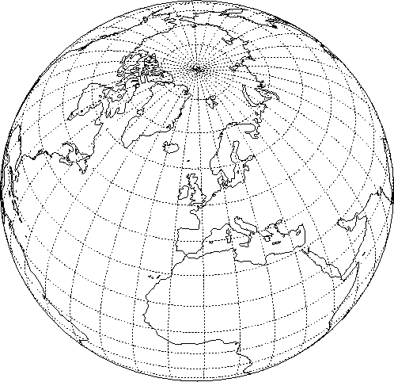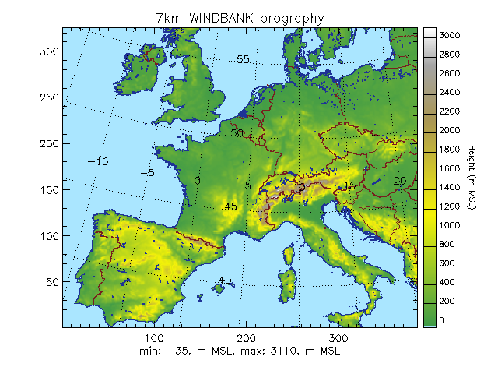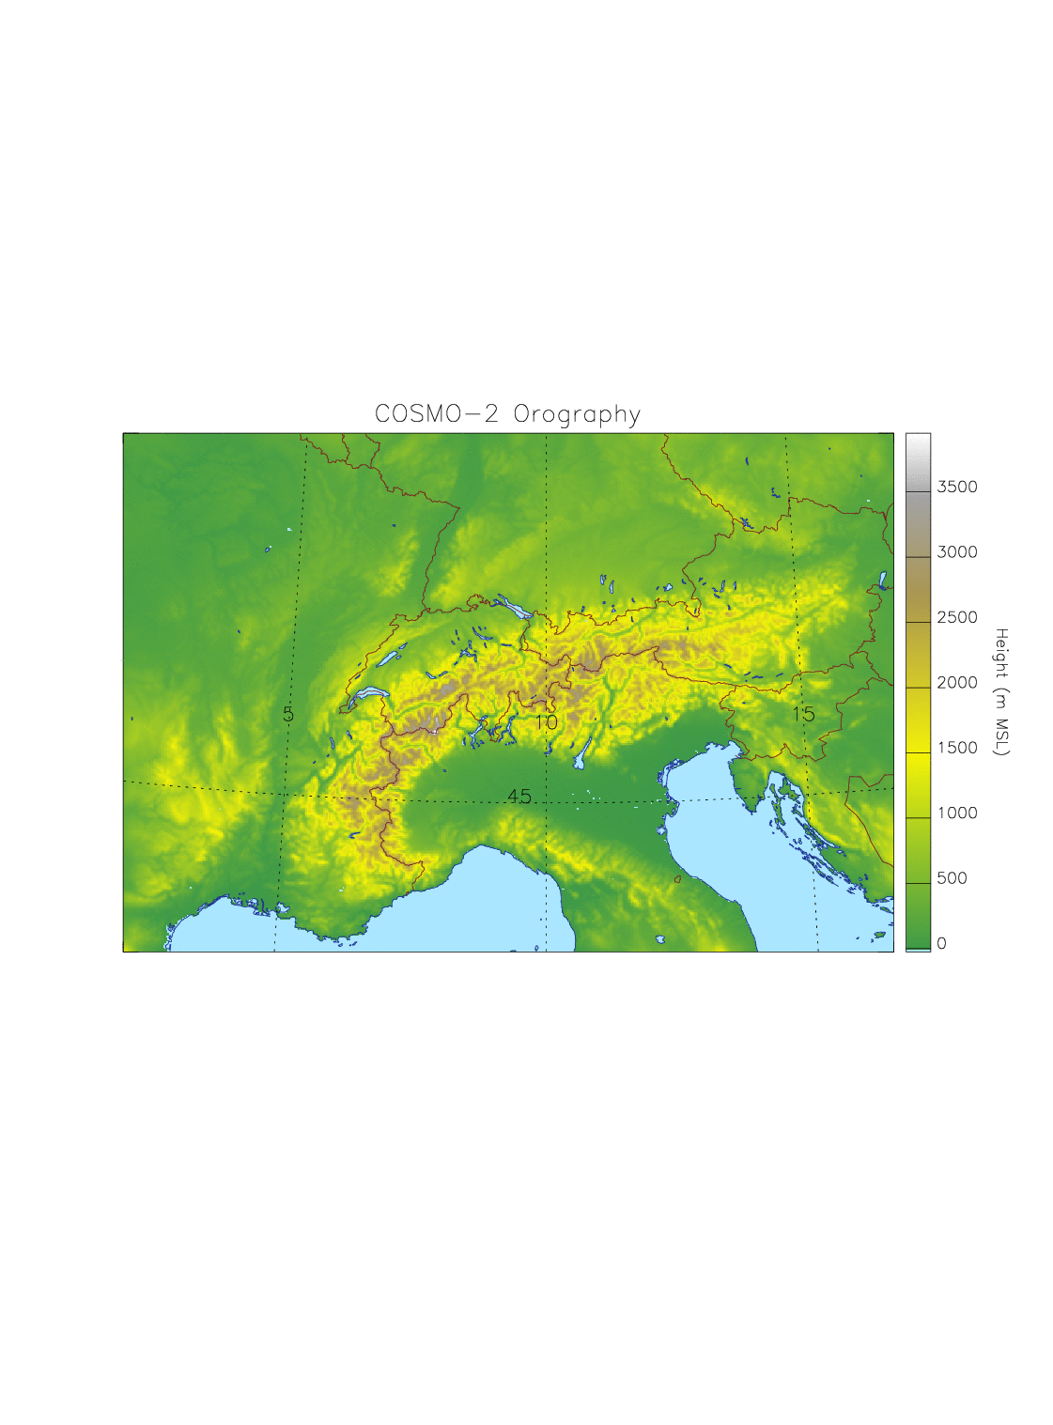Figure 4.1 new NWP system of MeteoSwiss
ECMWF IFS
COSMO-7
COSMO-2

The primary aim of COSMO-2 is to provide forecasts from nowcasting to very short-range time scale, whereas COSMO-7 is used for the short-range time scale.
Both COSMO-7 and COSMO-2 have their own assimilation cycle, which is updated in intervals of 3 hours. Two daily 72 hours COSMO-7 forecasts are calculated, based on the 00 and the 12 UTC analyses. Starting with the analysis at 00 UTC, one 24 hours COSMO-2 forecast is computed every 3 hours. The cut-off time for all forecasts is 45 minutes.
The time critical forecast products for COSMO-7 are available in about 55 minutes. For COSMO-2 they are produced approximately within 36 minutes.
A sophisticated set of scripts controls the whole operational suite, and allows for a very high reliability of the system, with less than 2 % of the forecasts requiring manual intervention. This same environ-ment is also used to run parallel suites, to validate proposed modifications to the system, and to facili-tate experimentation by the modelling group.
The computing resources and expertise are provided by the Swiss National Supercomputing Centre (CSCS, see www.cscs.ch). COSMO-7 and COSMO-2 are calculated on a Cray XT4 equipped with AMD Opteron Dual Core processors, and achieve a sustained performance of 390 GFlops, (9 % of the peak performance) on 804 computational cores. Pre- and post-processing run on the service nodes of the machine; a large multi-terabytes long term storage is used for archiving purposes, and a 1 GBit/s link connects the MeteoSwiss main building with the CSCS (on the other side of the Alps).

Medium range forecasting system (4-10 days)
AUTHOR: Petra Baumann

Data assimilation, objective analysis and initialization
4.2.1.1 In operation
MeteoSwiss does not run a medium range forecasting system, but contributes to the improvement of the limited-area ensemble prediction system COSMO-LEPS based on global ECMWF Ensemble forecasts (EPS) and on the COSMO Model. COSMO-LEPS has been developed at ARPA-SIM, Bologna, and runs operationally at ECMWF. It makes probabilistic high-resolution short to early-medium range (5.5 days) forecasts available at MeteoSwiss.
4.2.1.2 Research performed
A new method of calibrating the COSMO-LEPS forecast using reforecasts has been developed, focusing on the probabilistic warning of extreme precipitation events. Several warning products based on this method are produced. Furthermore, a more cost efficient way of using reforecasts was analyzed.
4.2.1.3 Operationally available EPS products
COSMO-LEPS products are visualized in the form of probability maps, stamp maps and meteograms for various parameters. The maps complement the deterministic COSMO products, while the meteograms combine the output from both systems for a single point.
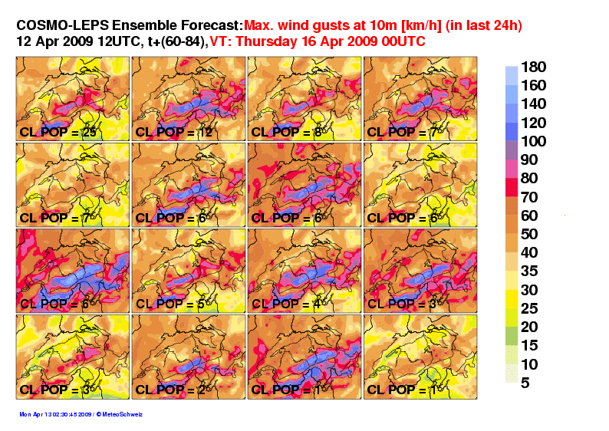
Figure 4.2: stamp map of COSMO-LEPS members for wind gusts over Switzerland. CL_POP indicates the size of the built
EPS cluster which provides the initial and boundary conditions; it is also the weight of the member in the calculation of the probabilities.

Short-range forecasting system (0-72 hrs)
author: petra baumann

Data assimilation, objective analysis and initialization
4.3.1.1 In operation
Data assimilation of COSMO is based on the nudging or Newtonian relaxation method, where the atmospheric fields are forced towards direct observations at the observation time. Balance terms are also included: (1) hydrostatic temperature increments balancing near-surface pressure analysis increments, (2) geostrophic wind increments balancing near-surface pressure analysis increments, (3) upper-air pressure increments balancing total analysis increments hydrostatically. A simple quality control using observation increments thresholds is in action.
Currently, the following conventional observations are assimilated both for COSMO-7 and COSMO-2: synop/ship/buoys (surface pressure, 2m humidity, 10m wind for stations below 100 m above msl), temp/pilot (wind, temperature and humidity profiles), airep/amdar (wind, temperature) and wind profiler data. COSMO-2 additionally assimilates radar data, using the 2-dimension latent heat nudging scheme.
MeteoSwiss uses its own snow analysis which is derived from MSG satellites combined with dense observations. A multi-layer soil model with 8 layers for energy and 6 for moisture is used; moisture is updated every 24h from IFS in the lowest levels. Finally, the vegetation and ozone fields are based on climatic values.
In addition to the MARS retrieval system, the full ECMWF decoding, quality control and database software are used on the front end machine. Non supported observations are stored in a flat file system, with a set of RUBY scripts providing minimal database-like functionalities. Observation increment statistics is monitored as an additional quality control check.
4.3.1.2 Research performed in this field
MeteoSwiss is currently contributing to two COSMO priority projects (see www.cosmo-model.org):
The project KENDA (Km-scale Ensemble-based Data Assimilation) aims at the development of a novel ensemble-based data assimilation system for the convective (1-3km) scale. Current research activities at MeteoSwiss are related to the evaluation of observation minus background statistics of the convection permitting COSMO model with respect to the Gaussian assumption. Furthermore, work has been devoted to the development of a Sequential Importance Resampling (SIR) filter (van Leeuwen, 2003), a novel Ensemble or Monte Carlo type approach that uses an ensemble of very-short range forecasts (as given by COSMO-DE-EPS of the German Weather Service) and selects the most likely members by comparing them to observations (Bayesian weighting). From the selected members, a new ensemble is created for the next analysis time.
The COLOBOC (COnsolidation of LOwer BOundary Conditions) project has the objective to incorporate all activities related to the lower boundary conditions which have al-ready reached an advanced state, and to consolidate these developments into well tested and documented software packages readily usable by the COSMO community. Software packages comprise the database of external parameters, the soil module, the snow analysis, the urban module, and the parameterization of land surface heterogeneity by a tile/mosaic approach, allowing the use of the same soil at different spatial scales.

Model
4.3.2.1 In operation
A thorough description of the COSMO Model itself can be found on the COSMO web site. It is a primitive equation model, non-hydrostatic, fully compressible, with no scale approximations. The prognostic variables both for COSMO-7 and COSMO-2 are the pressure perturbation, the Cartesian wind components, the temperature, the specific humidity, the liquid water content, cloud ice, rain, snow and turbulent kinetic energy. COSMO-2 furthermore uses a prognostic graupel hydrometeor class in the microphysical parameterization. COSMO-7 uses the Tiedtke scheme to parameterize convection, whereas in COSMO-2 convection is parameterized by a shallow convection scheme, and the deep convection is explicitly computed.
The model equations are formulated on a rotated latitude/longitude Arakawa C-grid, with generalized terrain-following height coordinate and Lorenz vertical staggering. Finite difference second order spatial discretization is applied, and time integration is based on a third order Runge-Kutta split-explicit scheme. Fourth order linear horizontal diffusion with an orographic limiter is in action. Rayleigh-damping is applied in the upper layers.
COSMO-7 is calculated on a 393 x 338 mesh with a 3/50° mesh size (about 6.6 km), on a domain covering most of Western Europe. In the vertical a 60 layers configuration is used; the vertical resolution in the lowest 2 km of the atmosphere increases from about 10 m up to 250 m. The main time step is 60 seconds. COSMO-2 is calculated on a 520x350 mesh, with a 1/50° mesh size (about 2.2 km), on a domain which is centred on the Alps. The COSMO-7 mesh is chosen in such a way that on the integration domain of COSMO-2, each COSMO-7 grid point coincides with a grid point of COSMO-2. COSMO-2 uses the same vertical configuration as COSMO-7. The main time step is 20 seconds. Table 4.1 summarizes the specifications of the new COSMO system.
 | COSMO-7 | COSMO-2
Number of grid points and levels | 393 x 338, 60L | 520x350, 60L
Horizontal mesh size | 3/50° ~ 6.6km | 1/50° ~ 2.2km
Time step | 60s | 20s
Data Assimilation | Conv. Observations | Conv. Observations + Radar
Table 4.1: Specification of COSMO-7 and COSMO-2
4.3.2.2 Research performed
MeteoSwiss contributes to the COSMO priority project UTCS (towards Unified Turbu-lence-shallow-Convection Scheme). This project is aimed at parameterising boundary-layer turbulence and shallow non-precipitating convection in a unified framework, and achieving a better coupling between turbulence, convection and radiation. Research re-sults are published in Buzzi, 2008, and Szintai and Fuhrer, 2008.
4.3.3 Operationally available numerical weather prediction products
4.3.3.1 In operation
A suite of post processing modules is available:
- Kalman filtering of model output for 2 meter temperature and dew point temperature;
- thunderstorm prediction derived by a learning system (with the boosting method),
- probabilistic precipitation forecasts using the neighborhood method,
- visualization software based on the ECMWF MetView package and on in-house developments at MeteoSwiss and at CSCS; static maps, 2- and 3-dimensional loops with texture based flow visualization are created;
- a trajectory model providing guidance on transport route (hot air balloons, pollutants);
- a Lagrangian particle dispersion model to calculate dispersion and deposition of radioactive materials, having also a backward mode to calculate the origin of pollutants or of pollen.
Based on these modules, a standard set of products is provided to the MeteoSwiss bench forecasters and used as guidance for short-range forecasts. In case of necessity the two last modules can be run by the on-duty forecasters at any time (on-demand mode).
Besides that a large quantity of tailor made products, based on direct model output, are disseminated to internal and external clients.
4.3.3.2 Research performed
Currently, Kalman filtering techniques for temperature, radiation, and wind data are being developed. This research is performed within the two projects OptiControl and Wi-forch. OptiControl has the objective to develop methods to exploit advances in the areas of building technologies, weather forecasting, and model predictive control of dynamical systems for improving the indoor climate control of buildings. Wiforch, (WInd energy FOR Switzerland CH) aims at delivering a better wind and energy forecast for wind farms at specific locations in Switzerland.

Nowcasting and Very Short-range Forecasting Systems (0-6 hrs)

Nowcasting system
Authors: Alessandro Hering/Urs Germann
Tracking and characterisation of convective cells by radar (system TRT)
MeteoSwiss runs operationally the real-time object-oriented nowcasting tool TRT (Thunderstorms Radar Tracking), as a part of its severe thunderstorms nowcasting, warning and information system.
For a detailed description see “WMO_GDPS-Report_2006”.
Quantitative precipitation estimation by radar (product RAIN)
The quantitative precipitation estimate (QPE) Nowcasting radar product RAIN is the best radar estimation of precipitation amount on the ground in Switzerland.
For a detailed description see “WMO_GDPS-Report_2006”.
Automatic heavy precipitation alert system (system NASS)
The multiple-radar-based Nowcasting application NASS is specifically designed for situations with heavy precipitation. NASS was implemented to generate automatic alerts whenever accumulated radar rainfall exceeds a predefined threshold for periods of 3, 6, 12 and 24 hours.
For a detailed description see “WMO_GDPS-Report_2006”.
Ensemble technique for radar precipitation fields (technique REAL)
As part of the WMO-WWRP forecast demonstration project MAP D-PHASE and the European concerted research action COST-731 MeteoSwiss developed an ensemble technique to characterise the residual errors in radar precipitation fields. Each member of the radar ensemble is a possible realisation of the unknown true precipitation field given the observed radar field and knowledge of the space-time error structure of radar precipitation estimates. Feeding the alternative realisations into a hydrological model yields a distribution of response values, the spread of which represents the sensitivity of runoff to uncertainties in the input radar precipitation field. The presented ensemble generator is based on singular value decomposition of the error covariance matrix, stochastic simulation using the LU decomposition algorithm, and autoregressive filtering. The real-time implementation of the radar ensemble generator coupled with a semi-distributed hydrological model in the framework of MAP D-PHASE is one of the first experiments of this type worldwide.
For a detailed description see Germann et al, Q. J. R. Meteorol. Soc., 135, 445-456, 2009.
Nowcasting heavy orographic precipitation using Doppler radar and radiosounding
(project COST-731)
MeteoSwiss is currently developing as part of COST-731 a novel heuristic system for nowcasting heavy precipitation in the Alps. The system uses as input estimates of the mesoscale wind field as derived from real-time Doppler radar measurements and information on airmass stability from radiosoundings and ground stations. Both mesoscale flow and upstream airmass stability are predictors of the amounts and geographic distribution of heavy orographic precipitation, and can therefore be exploited for nowcasting.
Context and Scale Oriented Thunderstorm Satellite Predictors Development (project COALITION)
Through a 3-year fellowship funded by EUMETSAT MeteoSwiss will develop current nowcasting applications into an entity-oriented model, which merges severe convection predictors retrieved from satellite information with evolving thunderstorm properties with focus on storms over the European Alps. The heuristic model will calculate probabilistic information about time, space and intensity evolution of severe convection for use by decision makers.
Improving Preparedness and Risk Management for Flash Floods and Debris Flow Events (project IMPRINTS)
Over complex terrain such as the Alps current nowcasting systems based on Lagrangian persistence of radar precipitation fields fail to produce useful forecasts, because the orography interferes with the evolution of precipitation, in particular by means of blocking and enhancement. As part of the FP7 research project IMPRINTS, which started in January 2009, MeteoSwiss will investigate orographic forcing of precipitation and incorporate the findings into current Lagrangian persistence nowcasting systems. If successful, the resulting radar nowcasting system will be implemented in the Swiss radar data processing chain and will be extended by ensemble techniques and an algorithm for blending radar nowcasts with NWP model output.

Specialized numerical predictions
AUTHOR: thomas egli

MeteoSwiss operational Trajectory- and Dispersion-forecasts
The operational weather service of MeteoSwiss located in Zurich operates ever since beginning of the nineties a comprehensive array of trajectory and dispersion models. They are aimed at providing on a 24/7 basis the National Emergency Operation Centre (NEOC) with information related to pollutants trajectories and fallouts occurring in case of environmental emergencies.
Model outputs delivered at different resolution scales and domain sizes, operated on local as well as on global frames, are taken into consideration. Operated at 2.2 km grid-scale on the Alpine Domain, our numerical forecasting model COSMO-2 delivers to dedicated TRAJEK and LPDM models (Trajec-tory and Lagrangian Particle Dispersion) since the end of 2008 meteorological information enabling the computation at that grid scale of trajectories and dispersion patterns at temporal resolution of three hours.
MeteoSwiss participated in several dispersion simulations held in 2008 under the auspices of JRC (Ispra) within the ENSEMBLE-Group, where our LPDM and the global FLEXPART model where then in use.
Improvements in the handling of our dispersion and trajectory forecasts are expected in 2009 with the optimization of the devolution of mandates from NEOC to our forecasting services.

Extended range forecasts (10 days to 30 days) (Models, Ensemble, Methodology and Products)
AUTHOR: Andreas Weigel
During the past years and within the framework of the national NCCR climate research programme, MeteoSwiss had established a quasi-operational monthly forecasting system, using forecast data of the ECMWF monthly prediction system VarEPS. Since September 2008, this system is deployed and fully operational. Products include maps of weekly categorical probability forecasts of surface temperature, precipitation and geopotential height over various regions as well as tercile data for selected station locations. Calibration and visualization techniques are thereby applied in a similar way as in the long range seasonal forecasts.
In line with this operational task, a detailed probabilistic verification was carried out for temperature, quantifying prediction skill in function of lead-time, season and location. The results have been published in a peer-reviewed scientific journal (Weigel et al. 2008). The authors have shown that monthly forecasts are skillful beyond a lead time of 18 days over some ocean regions and parts of tropical Africa and South America, and that the extratropical continental predictability vanishes after 18 days of integration. However, even when the average predictability is low there can nevertheless be climatic conditions under which the forecasts contain useful information (e.g. during negative phases of NAO).

In operation

Research performed in this field

Operationally available EPS products

Long range forecasts (30 days up to two years) (Models, Ensembles, Methodology and Products)
AUTHOR: andreas weigel
MeteoSwiss issues long range forecasts on the basis of the ECMWF seasonal forecast model “System 3”. The operational products (climagrams, probability charts and tercile data for surface temperature, precipitation and geopotential height) are available for customers. The wider public receives the seasonal forecast information by means of a quarterly climate outlook bulletin for Switzerland.
Within the framework of the NCCR Climate project, a method has been developed to improve the seasonal forecasts by a suitable statistical post-processing of the ensemble distributions. With this so-called CCR-technique (climate conserving recalibration), the reliability of the seasonal forecasts and thus their value for applications in climate risk management could be significantly improved. The method has been described and evaluated in a peer-reviewed journal paper (Weigel et al. 2009), and it has been implemented experimentally into MeteoSwiss’s seasonal forecast routines. CCR-corrected seasonal temperature forecasts will soon become available for customers.
Also within the NCCR Climate, and in collaboration with the International Research Institute for climate and society (IRI, Columbia University, Palisades), a new verification framework has been developed which is considered particularly useful for communicating seasonal forecast quality to the general public. This verification concept, the so-called Generalized Discrimination Score, has been published in Mason and Weigel (2009) and is now routinely used by MeteoSwiss to communicate the quality of the seasonal forecasts.

In operation

Research performed in this field

Operationally available products

Verification of prognostic products
AUTHOR: Heinz maurer

Annual verification summary

MeteoSwiss Verification Report for the Short and Medium
Range Weather Forecast in 2008
Since approximately 25 years, MeteoSwiss operationally verifies their weather forecasts for the short and medium range period. To do so, two different verification schemes are in use. Concerning the short range period we use the “Objektive Prognosekontrolle (OPKO)”. In there, Switzerland is divided into 14 forecast regions. Further has to be mentioned that this verification control is made three times a day. The investigated parameters are minimum and maximum temperature, 10-minutes wind, precipitation and the relative sunshine duration. To assess the forecasts, they are compared with the values from the automatic weather stations of MeteoSwiss. In order to get a feeling about the value of such a forecast, the verification results are compared with the persistency.
For the medium range forecast the so called “Kontrolle Mittelfristprognose (KOMIFRI)” scheme is used. In it the whole of Switzerland is divided in 3 regions: Western, Eastern and Southern part. Due to the fact, that forecasts are made up to day 5, the same has been done with the verification. Analogously to the short term verification, persistency is used too as the reference value.
With this two verification schemes the different weather forecasts of MeteoSwiss has been also assessed in 2008. It could be shown that the quality of the forecasts was very good. More precisely, in the short term forecasts we reached an overall value for the whole country of 86 % (85,5 % in 2007). The persistency was in the same period 66 % (69 % in 2007). That means, that together with a lower persistency in 2008, the quality or the worth of the forecasts became 2008 higher than the year before and reached a new record value. To give an impression of the best and worst forecasted regions, “westliches Mittelland” with 88 % and “Engadin” with 83 % have to be mentioned. For an overview see figure 1 below:
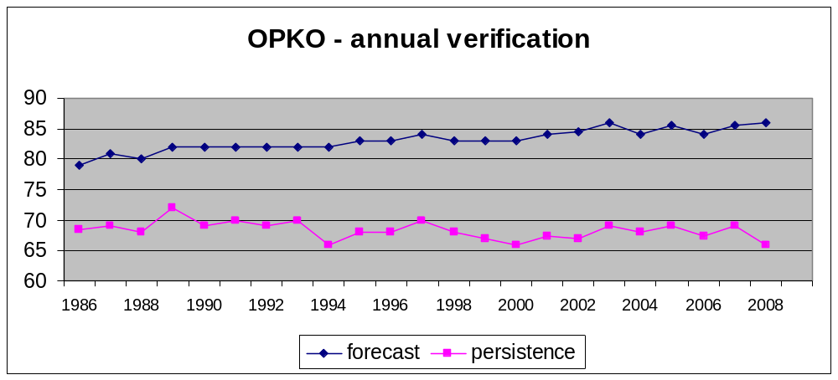
Figure 1: Annual development of MeteoSwiss OPKO-Verification results
In the medium range we could reach a value of 75.9 % (as a medium value over day 2 up to day 5). Additionally should be mentioned, that this value could be reached in the absence of a very high persistency value. It can be shown that since the early days of the use of KOMIFRI, the quality values could be increased by about 10 % (see figure 2). This progress can be set into relation to the progress of numerical models, where mainly the IFS-Model of the ECMWF has to be mentioned.
As a short outlook of future verification activities at MeteoSwiss, it is planned to establish a new verification scheme approximately until the end of 2010. This new system will be tested and assessed until then in parallel with the here presented scheme.
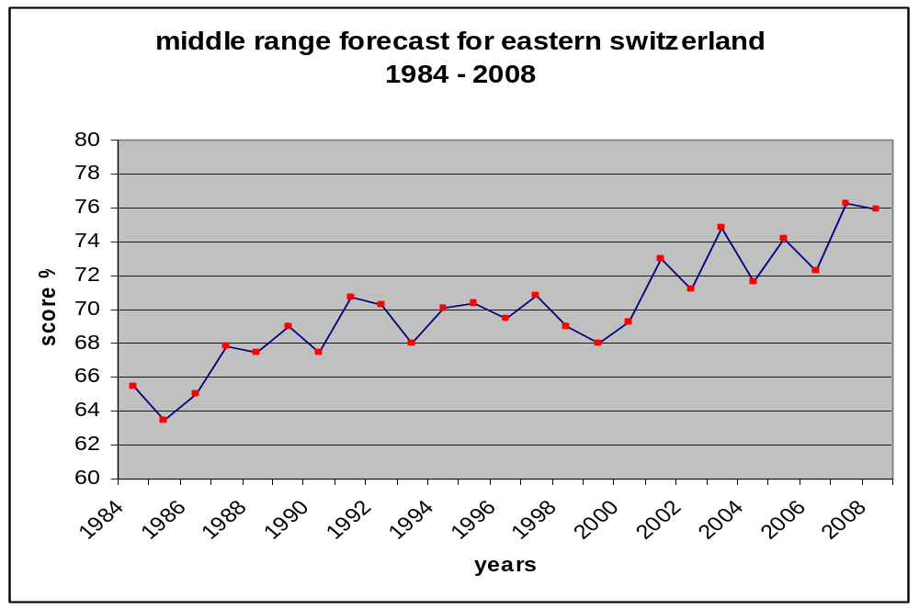
Figure 2: Evolution curve of the medium range weather forecasts quality of MeteoSwiss

Plans for the future (next 4 years)

Development of the GDPFS
AUTHOR: marlen kube

Major changes in the operational DPFS which are expected in the next year
An intensive data exchange and deliverance data via XML with other governmental platforms is promoted. The data is mainly about natural risks.
The storage of grid point data and linking of interpolation packages will be implemented. Control data processing tools will be further developed and implemented as service oriented Infrastructures.
New implemented tools for forecasting and warning will be consolidated in terms of business relevance.
In addition MeteoSwiss plans to have the GloBUS system on the production site by August 2009. Then SYNOP, TEMP and PILOT Messages can be send in BUFR to the GTS and MeteoSwiss will thus able to read BUFR messages.

Major changes in the operational DPFS which are envisaged within the next 4 years
The processing system, having a data ware house structure (DWH) since 2002, will be the basis for the national „Meteorological and Climate Data Warehouse“.
The integration of different measurement technologies and platforms is envisaged, as well as the integration of measuring systems of partners. Moreover, the further integration of measured data und metadata will be promoted. A generic solution for the delivering of real-time DWH-Data shall be developed
It is foreseen to link GIS and to integrate the GIS coordination of MeteoSwiss. There will be the integration of gridded data products and grid point datasets. The DWH will provide an experimental analytical database as basis for climate analysis, amongst others.
Another important step in the future development is the use of the DWH for numerical weather predictions in models such as COSMO (notably probabilistic predictions). This means assimilation of observation data into the model, verification and analysis of predictions with the help of observation data and the storage of selected data in the DWH.
Running applications using ECMWF Data shall be migrated to official dissemination (RMDCN) that is made for business relevant cases.
A superordinated architecture will be created for production tools using meteorological and climate data. Running applications will be taken into account and adapted to the future needs for data extraction and product creation within this architecture.
In addition, a solution will be developed to store, archive and administer products.

Planned Research Activities in NWP, Nowcasting and
Long-range Forecasting
AUTHORS: petra baumann
The developments related to COSMO-2 are tightly linked to the project CN-MET (Centrale Nucléaire et METéorologie), which aims at providing an integrated observing and forecasting system for monitoring and emergency preparedness in the vicinity of the Swiss nuclear power plants.
With the CN-MET project, a new measurement network is being set up including:
• three remote sensing sites measuring wind and temperature profiles within the planetary boundary layer (PBL) downwind, upwind and in the center of the domain (green dots in Figure 6.1)
• surface weather stations from the new SwissMetNet (SMN) network, with additional turbulence measurements, at each of the four nuclear power plants,
• four SMN boundary layer stations in order to add information on wind and temperature measurement within the PBL, which are integrated in the MeteoSwiss measurement network.
In case of a nuclear accident, the necessary atmospheric data used to calculate the diffusion of a contaminated air mass will be provided by COSMO-2. The new measurement network within CN-MET depicted in Figure 6.1 is adapted to provide the best information (initial and boundary conditions) for this model. COSMO-2 is prepared to run in an emergency mode, activated on demand by the Swiss Federal Nuclear Safety Inspectorate.

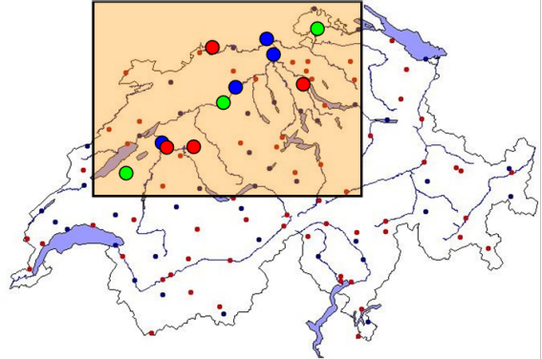
Figure 6.1: The CN-MET measurement network, including 3 remote sensing sites (green), 4 SMN stations at the nuclear power plants (blue) and 4 SMN Surface Layer stations (red).

Planned Research Activities in Nowcasting
Authors: Alessandro Hering/Urs Germann,
Plans for future research activities are related to an intensification of usage of satellite information for nowcasting in the Alps, a successive increase of the multi-sensors capabilities of TRT, the quasi-operational use of the radar ensemble generator in hydrological applications, further development of the COST-731 nowcasting system, the renewal of the MeteoSwiss weather radar network, the increase in spatial and temporal resolution of the radar systems, and the investigation of snow and hail by the radar network.
The nowcasting analysis and forecasting system INCA, developed by the Austrian NWS ZAMG is currently evaluated at MeteoSwiss. This novel approach produces high time and space meteorological fields (gridded values), incorporating available information like numerical model fields and all kind of observation (both ground and remote), as well as high resolution orography.

References
AUTHORS: ALL
P. J. van Leeuwen. 2003. A variance-minimizing filter for large-scale applications. Monthly Weather Review 131, 2071-2084
M. Buzzi. 2008. Challenges in operational numerical weather prediction at high resolution in complex terrain. Dissertation Swiss Federal Institute of Technology (ETH) Zurich
B. Szintai, O. Fuhrer. 2008. Component testing of the COSMO model’s turbulent diffusion scheme. COSMO Newsletter 9, 37-41
W Mason S.J. and A.P. Weigel. 2009. A generic forecast verification framework for administrative purposes. Mon. Wea. Rev., 137, 331-349

Weigel A.P., D. Baggenstos, M.A. Liniger, F. Vitart and C. Appenzeller. 2008. Probabilistic verification of monthly temperature forecasts. Mon. Wea. Rev., 136, 5162-5182.
Weigel A.P., M.A. Liniger and C. Appenzeller. 2009. Seasonal ensemble forecasts: Are recalibrated single models better than multi-models? Mon. Wea. Rev., in press.

