Annual WWW Technical Progress Report on the
Global Data - Processing System 2008


REPUBLIC HYDROMETEOROLOGICAL SERVICE

OF SERBIA

REPUBLIC OF SERBIA
(Belgrade, Kneza Višeslava 66)

1. Summary of highlights

- Weather Research and Forecasting model WRF-NMM, non-hydrostatic meso model is used for 72 hours of forecast. Operational suite is twice a day with
Boundary Condition from European Centre for Medium range Weather Forecast (ECMWF). Horizontal resolution is about 10km and 4km.
- Monthly forecast. The monthly weather forecast at RHMS of Serbia based on ECMWF Monthly forecast products and analogue method of RT500/1000mb anomaly. Monthly forecast for Serbia is updated four times a month.
- ECMWF Seasonal forecast. RHMS of Serbia use seasonal weather forecast from ECMWF. Seasonal weather forecast is made in the form of textual bulletin and graphics for 7 months in advance. Updated once a month.
- SMS-ECMWF in use.
- RMDCN migration to MPLS. Connecting through RMDCN with ECMWF, Offenbach, Wien, Budapest (512Kbps + ISDN back up).
- Virtualization LAN and RMDCN & FTP servers.
- Weather Warning System, Meteo-alarm
- Climate change, “Southeastern Europe Sub-regional Virtual Climate Change Centre in Serbia”

2. Equipment in use at the Centre

2.1 Computers, Work stations and PC Pentiums

Table 1: Servers, LAN & other computers in use
Internal network | Characteristics
Symantec Client Security Server-Administration | HP Pentium 4, 1.6GHz, Windows XP Professional
Local Area Network 300 WorkStation and PC | LAN 100/1000 Mbps, Cisco routers (series 2500, 2600) & Cisco Catalyst Switch 2950x9, Cisco Switch 3750x2, Cisco Switch 2970
MSS-Messir-Comm | HP ProLiant Servers DL380x2, Windows 2003 Server
RMDCN Host | HP Proliant as virtual server
HP rx3600 | Integrity servers based on Intel Itanium 2 dual core 64 bits processors
HP XC Cluster 128 Xeon 220c | 8 HP Blade, BL2x220c with InfiniBand
HP EVA 4400 | DATA Storage

2.2 The Hardware Characteristics of Telecommunications

Table 2: DMZ Subnet and characteristics

DMZ Subnet | Characteristics
WWW | HP DL 380, Intel Xeon 3GHz, 2Mb cash, 1Gb RAM  Linux CentOS 4.4 (GPL)
FTP | HP DL 380, Intel Dual Core 3 GHz, 2Mb cash, 2Gb RAM  Linux CentOS 4.4, Virtual server
E-mail | HP DL 380, Intel Xeon 3GHz, 2Mb cash, 4Gb RAM Linux CentOS 4.4 , Applications: postfix mail server and web mail service (Round Cube)
Firewall-Server with Gateway functions | HP DL 360, Linux CentOS 4.4 (GPL), Application Shore wall with NET (External network), LOC (Internal network) and DMZ

2.3 Data Receiving Processing and Data Distribution System

The core of DRP & DDS is based on COROBOR with the adequate Data Base Management System (DBMS) and consists of the two SERVERS with automatic change - over.

The DRP & DDS MSS are providing:

- Protocol conversions capabilities;
- Data (meteo/hydro bulletins/messages) reception, storage, prioritization, routing and forwarding;
- Messages (bulletins) creation and validation;
- Routing and storage of graphical products (NWP,WAFS of different graphical formats charts, satellite, radar, scanned and other images);
- Routing and storage locally produced images;
- Messages and graphical products reply;
- Multiple addressed messaging capabilities;
- Messages rerouting;
- Local & Remote Retrieval.

Additional Specific Data Processing Tasks on DRP & DDS server are performed / supported:

- The received Data/Products classification and storage into appropriate folders;
- SYNOP, TEMP, PILOT,…, METAR data encoding into single data elements (meteorological parameters) and coding into BUFR;
- The same parameters encoding from BUFR (single or group of parameters);
- Graphical products ( FAX – DFX, System Offered Specific Graphical Products – (SOSGP), Radar & Satellite Data – R&SD) coding/encoding into/from BUFR;
- NWP products coding/encoding into/from GRIB;

Required Attributes/Objects within DRP & DDS DBMS supports

- Meteorological/Hydrological bulletin/message described by WMO No 386 & ICAO Doc No 10;
- Single Station report described by WMO or ICAO documents and Validity Time ;
- Station Lists that includes Geographical Coordinates, Observing Parameters, Observing Times and Remarks;
- The time ordered encoded single Meteorological/Hydrological parameters extracted from reports (SYNOP, TEMP, PILOT, METAR);
- Imaged products (e.g. satellite & radar images, scanned images);
- BUFR, GRIB data/products (Bulk Data Files with Time Stamp).

2.3.1 Uniform Data Collection System (UDCS) and Climate Data Bases System (CLDB)

UDCS and CLDB were established as an integral part of the Integrated Meteorological System of RHMS of Serbia.

UDSC provides all necessary function for the work and maintenance of great meteorological networks and automated and non automated stations with manual observations. The number of stations that can be linked by one UDCS is restricted only by the communication infrastructure in use.

Data from the stations can be collected in several ways by using various communication protocols, and UDCS fully support standard WMO codes SYNOP, METAR/SPECI, CLIMAT, GRIB, BUFR, and is open for the support to the own/national codes.

3. Data and products from GTS in use

GTS data are received directly through RMDN MPLS network.
Data in use: SYNOP 10000 - 12000 / day; TEMP 360 - 430 / day

3.1 Products from the Internet in use

DWD products in GRIB (GRIB KWBC 360 / model output).

3.2 Products from the RMDCN in use

Table 3: ECMWF products in GRIB (model output, bitmap) & BUFR
Name | Data type | No. of products | Volume
SZS | BC – regional Eta | 1,868 | 14.47MB
S1D | Deterministic  forecast 0.5°x0.5° | 1,372 | 52.65MB
S2F | Monthly forecast – raw data | 13,172 | 3.58MB
S2H | Hindcast 32 days in advance | 13,172 | 3.58MB
S2L | Seasonal Forecast | 13,172 | 3.58MB
S3D | CAPE | 594 | 2.92MB
S4D | Initial and BC for WRF-NMM | 2,656 | 7.49MB
S5D | Deterministic forecast 0.25°x0.25° | 4,514 | 5.77MB
SBA | BUFR - Weather Parameters | 3,626 | 3.83MB
SZ, S1, S2, S3, S4, S5 & SB | Total | 27,802 | 90.71MB

4. Data input system

Fully automated system.

5. Quality control system

Automated quality control system.

5.1 Quality control of national data prior to transmission on the GTS

There is quality control system in use.

5.2 Quality control of incoming data

The formats of all coded reports are checked.

Surface and upper air reports are checked for internal consistency before storing and exchange.

Checks on temporal consistency.
Checks against the model background values.
Buddy checks.

6. Monitoring of the observing system

Surface observations and upper air observations are monitored on the national
Level.

7. Forecasting system

The main components of the forecasting system are the Eta limited area model and WRF-NMM, non-hydrostatic meso model.

7.1 System run schedule

- 120−hours forecasts based on 00 and 12 UTC observational data are produced twice a day (DWD boundary condition).

- WRF-NMM, non-hydrostatic meso model is used for 72 hours of forecast. Operational suite is twice a day on Boundary Condition from European Centre for Medium range Weather Forecast (ECMWF). Horizontal resolution is about 10km and 4km.

7.1.1 The Eta Numerical weather prediction products in use

Table 4: The Eta NWP products in use
geopotential
mean sea level pressure
temperature
wind
precipitation (total and convective)
relative humidity
convective cloud top and depth
total cloud cover
frontogenetic parameter
turbulence
frizing

7.1.2 The WRF-NMM numerical weather prediction products in use

Table 5: WRF NMM products in use
geopotential
mean sea level pressure
temperature
wind
precipitation (total and convective)
relative humidity
convective cloud top and depth
CAPE
cloud cover (total and convective)
Radar’s reflectivity
Cloud water and ice

Regional the Eta and WRF-NMM models products are distributed internationally through Internet as the primary means of distribution (address: www.hidmet.gov.rs). They are also distributed nationally on the National Telecommunication System.

7.1.3 The Meteo - alarm

The Meteo - alarm system is based on the WRF-NMM products.

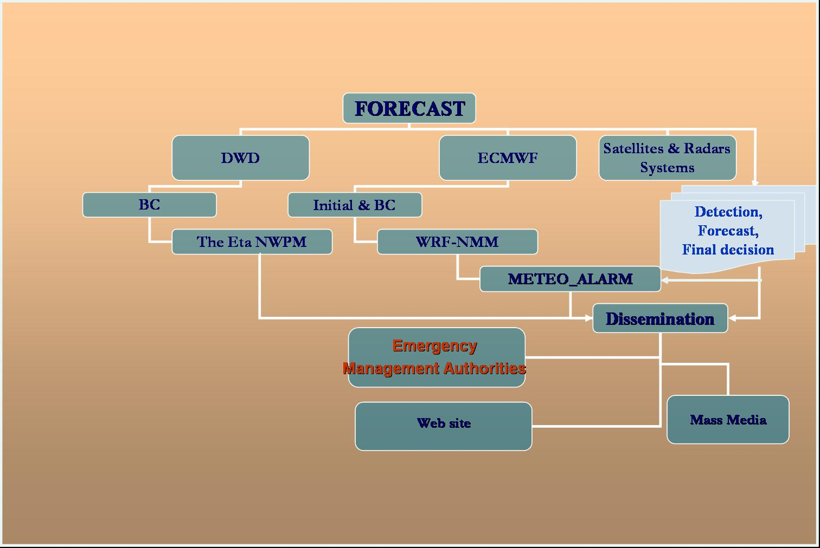
Figure 1: Scheme of meteo – alarm system

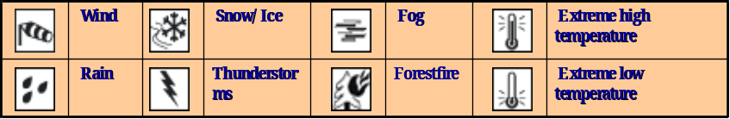
Figure 2: Severe weather warning services

Meteo-alarm system products are distributed internationally through Internet as the primary means of distribution (address: www.hidmet.gov.rs and www.meteoalarm.rs ). They are also distributed nationally on the National Telecommunication System.

7.2 Medium-range forecasting system (up to 15 days)

- ECMWF Deterministic forecast and Ensemble Prediction System
- DWD products, GME, LM & MOS

7.3 Monthly forecast (up to 30 days)

The monthly weather forecast at RHMS of Serbia based on ECMWF Monthly forecast products and analogue method of RT500/1000mb anomaly. Monthly forecast for Serbia is updated twice a month.

The Monthly weather forecast is distributed internationally through Internet as the primary means of distribution (address: www.hidmet.gov.rs). They are also distributed nationally on the National Telecommunication System.

8. Verification of forecasting

The objective verification of subjective forecasts based on the direct ECMWF models output are presented. Also ECMWF model output compared to other NWP models verification are presented.

The verification system includes the comparison of forecasts with observations of minimum and maximum temperature. The verification of precipitation is also included.

ME and MAE are used for Tmin and Tmax forecast verification. Verification parameters HIR – Hit Rate; FAR – False Alarm Rate; BS – Bias Score; SS – Skill Score TS – Threat Score (the first category); V = HIR+FAR are used for precipitation forecast.

8.1 The objective verification of subjective forecasts based on the Ditect ECMWF model output 2007/2008

The 00 UTC run of ECMWF deterministic forecast is verified against SYNOP observations. Input forecast values for ECMWF were taken from 0.5°x0.5° grid, using grid points closest to chosen synoptic stations. The verification is carried out for nine synoptic stations (Fig 3.).
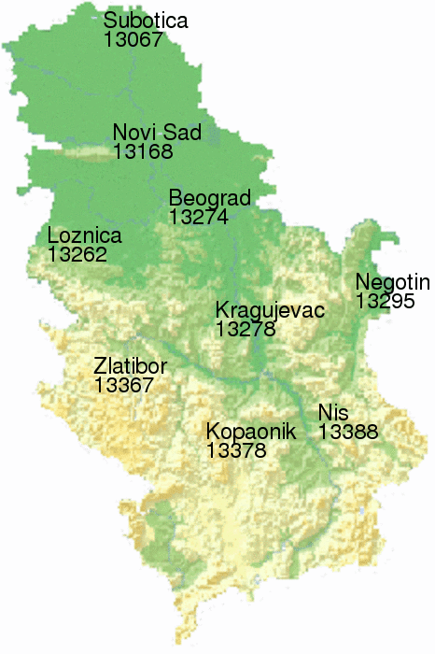
Fig.3 Location of synoptic stations used in verification
Verified parameters are:

- 2m minimum temperature (between 18 and 06 UTC).
- 2m maximum temperature (between 06 and 18 UTC).
- daily accumulated amount of precipitation (between 06 and 06 UTC).
- 24h precipitation existence with various thresholds (between 06 and 06 UTC).

In general, basic statistical scores (ME, MAE and RMSE) for 2m minimum and maximum temperature forecast do not show significant differences compared to last year.
The benchmark forecast used in mean absolute error skill score calculation is climatology, prepared on a 23-year sample (1983-2005). Daily climate values are obtained averaging values from ±13 day vicinity of the actual day.

Values of skill score (MAE) for 2m minimum and maximum temperature forecast during 2006 and 2007, Beograd-Karađorđev park, are presented in Fig. 4. Higher values are reached for maximum temperature. Seasonal variation of the skill score for 2m minimum and maximum temperature forecast is shown in Fig. 5 and Fig. 6. Plots show that minimum temperature skill is highest in the summer and maximum temperature skill was the best during two last winters.

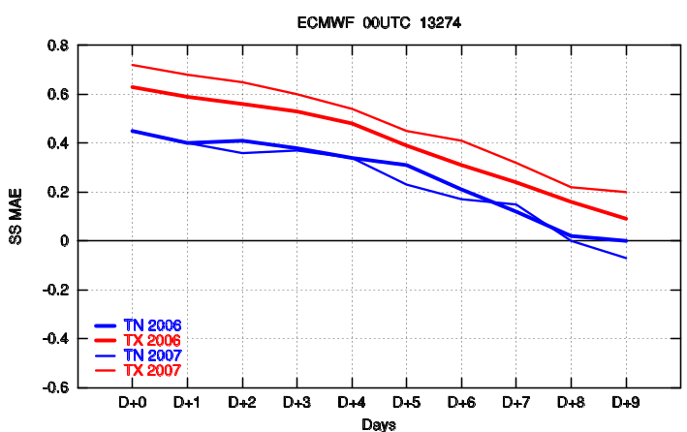

Fig.4 The mean absolute error skill score for 2m minimum and maximum temperature forecast for Beograd.

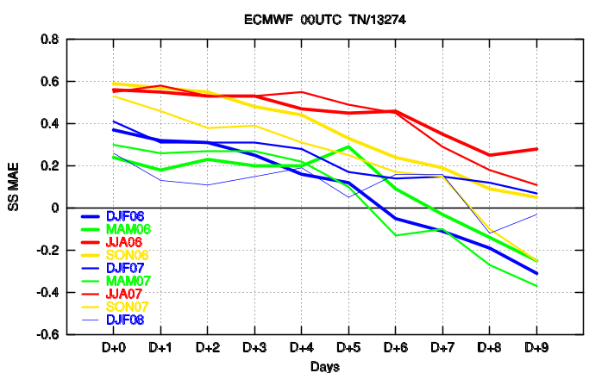

Fig.5 The mean absolute error skill score for 2m minimum temperature forecast for Beograd.
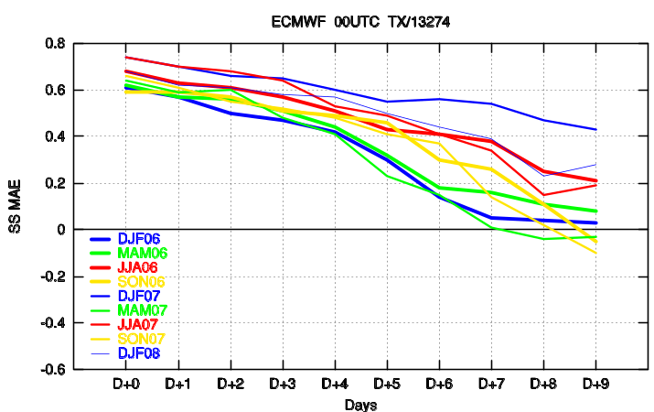

Fig.6 The mean absolute error skill score for 2m maximum temperature forecast for Beograd.
Precipitation forecast is verified as categorical (precipitation existence) and continuous (daily accumulated) variable. According to verification results averaged over nine stations, larger amounts of 24h precipitation are underestimated and smaller amounts are overestimated. Precipitation forecast is unbiased for threshold close to 2mm/24h (Fig.7, a) and b)). Heidke Skill Score approaches zero skill after approximately 8 days for threshold of 20mm/24h (Fig.7, c) and d)).

a)  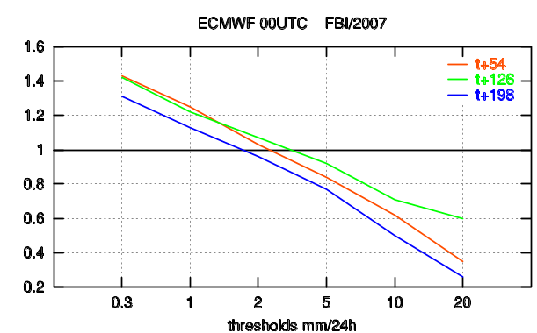 | b)  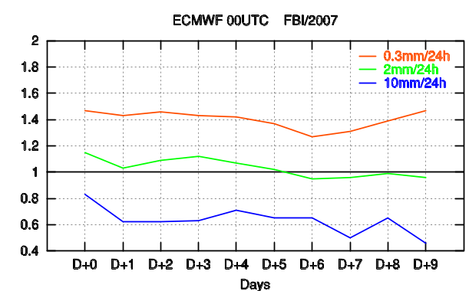
c)  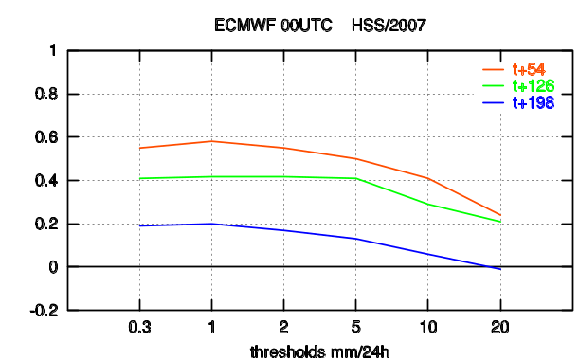 | d)  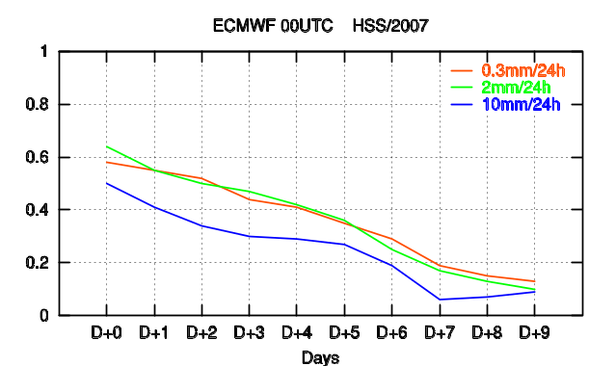

Fig.7 Verification of 24h precipitation existence forecast averaged over nine stations: FBI (a) and b)) and HSS (c) and)) for different thresholds and forecast ranges.

Examples of 24h accumulated precipitation forecast verification for three locations are presented in Figure 8 (a), b) and c)). Underestimation of larger amounts of precipitation can be obtained in scatterplots and forecast errors versus observations plots.

a)
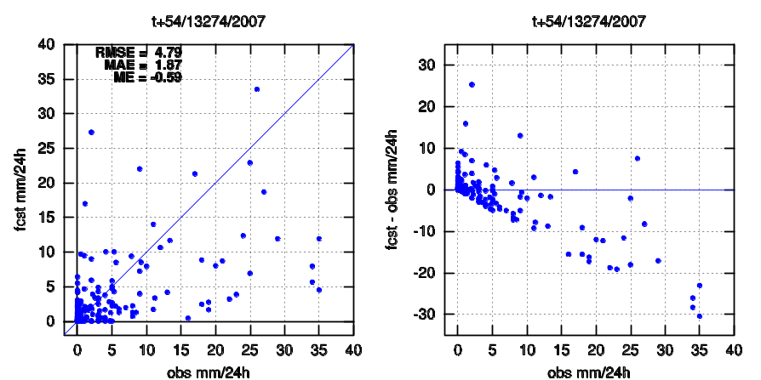

b)
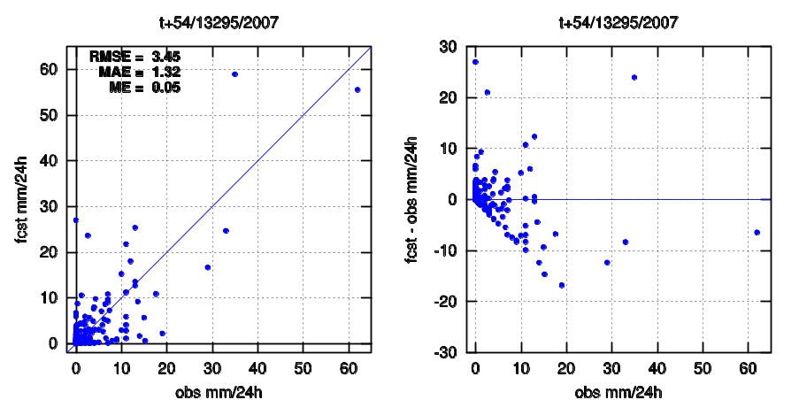
c)
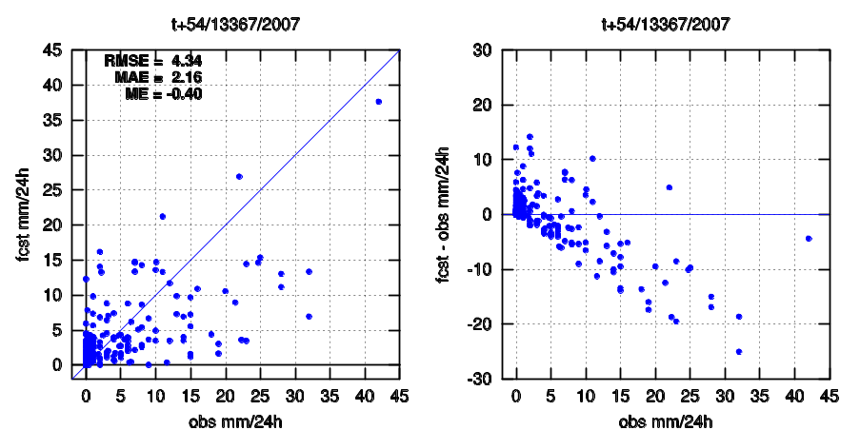

Fig.8 Scatterplots, forecast errors versus observations and statistical scores for the 24h accumulated precipitation forecast for a) Beograd (13274), b) Negotin (13295) and c) Zlatibor (13367).

8.2. ECMWF model output compared to other NWP models

Comparison of ECMWF model and WRF-NMM model has been made only for 2m minimum and maximum temperature forecast during winter 2007/2008. 00 UTC runs were considered. The verification results are presented in Figure 9.
a)  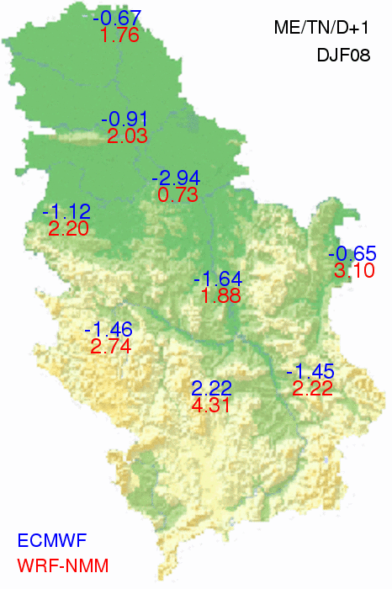 | b)  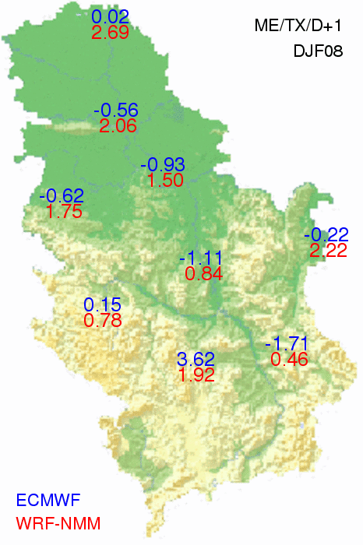
c)  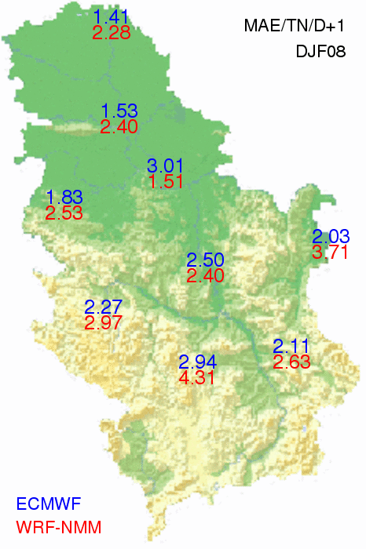 | d)  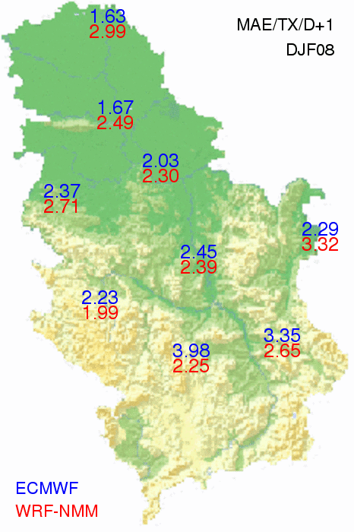

Fig.9 Mean error and mean absolute error of 2m minimum and maximum temperature forecast during winter 2007/2008.
For most of locations ECMWF model forecast underestimates while NMM overestimates values of 2m minimum and maximum temperature during last winter. Exceptions are mountain regions in southwest and south part of the country. Results that are more representative will be available after at least one-year forecast data verification.

9. Future plans

- Continuation of development of Weather Warning System (Severe weather phenomena, other hazardous weather conditions, air quality hazards, climatic hazards, hydrological hazards).

- Nesting of WRF NMM nonhydrostatic model

- Implementation on the project on new data management system for non real time data.

- Establishing of “Sub regional centre for climate change in Belgrade”.

SEE Sub regional Virtual Climate Change Centre in Serbia was established in according with decisions of the Sixth Ministerial Conference UNECE “Environment for Europe, held in Belgrade, Serbia, 10-12 October 2007.

Described infrastructure systems and the participation of RHMS of Serbia in the World Climate Program, Global Climate Observation System, Global Atmospheric Watch and other operative systems and scientific technical programs of WMO, as well as in the work of the Intergovernmental Panel on Climate Change, represent the foundation for establishment and rapid development of the function of the National Climate Centre “Milutin Milankovic” that will also perform the functions of a Sub regional Virtual Centre for Climate Changes in according with the Belgrade initiative for strengthening of the regional cooperation in Southeastern Europe in the field of climate change.

C O N T E N T S

1. Summary of highlights 1
2.1 Computers, Work stations and PC Pentiums 2
2.2 The Hardware Characteristics of Telecommunications 2
2.3 Data Receiving Processing and Data Distribution System 2
2.3.1 Uniform Data Collection System (UDCS) and Climate Data Bases System (CLDB) 3
3. Data and products from GTS in use 4
3.1 Products from the Internet in use 4
3.2 Products from the RMDCN in use 4
4. Data input system 4
5. Quality control system 4
5.1 Quality control of national data prior to transmission on the GTS 4
5.2 Quality control of incoming data 5
6. Monitoring of the observing system 5
7. Forecasting system 5
7.1 System run schedule 5
7.1.1 The Eta Numerical weather prediction products in use 5
7.1.2 The WRF-NMM numerical weather prediction products in use 6
7.1.3 The Meteo - alarm 6
7.2 Medium-range forecasting system (up to 15 days) 7
7.3 Monthly forecast (up to 30 days) 7
8. Verification of forecasting 7
8.1 The objective verification of subjective forecasts based on the Ditect ECMWF model output 2007/2008 7
8.2. ECMWF model output compared to other NWP models 11
9. Future plans 13

