ANNUAL JOINT WMO TECHNICAL PROGRESS REPORT
ON THE GLOBAL DATA PROCESSING AND FORECASTING SYSTEM (GDPFS) INCLUDING NUMERICAL WEATHER PREDICTION (NWP) RESEARCH ACTIVITIES for 2008

Hellenic National Meteorological Service (HNMS)

GREECE

1. Summary of highlights
Two high performance computing systems (HP based on Itanium-type and IBM
based on Power4-type processors), a high level visualization tool
(Visual Weather) as well as data storage systems and software (MARS and
Web-MARS) are in use. New Radar Servers and Lightings are in the
process of being operationally integrated.

- Equipment in use at the center
  - Message Switching System (MSS)
Servers 2 x RX2600 2 x Itanium 1,3 Ghz
Gb RAM 2 x 36 Gb HD, 1Gb 2 x FC Connection
Cluster configuration Service Guard
O.S. Linux Red Hat A.S. 3.0

Preprocessing
Servers 2 x RX 2600 2 x Itanium 1,3 Ghz
4 Gb RAM 2 x 36 Gb HD, 1Gb 2 x FC Connection
Cluster configuration Service Guard
O.S. Linux Red Hat A.S. 3.0
- Web Mars Intranet
Servers 2 x RX 2600 2 x Itanium 1,3 Ghz
4 Gb RAM 2 x 36 Gb HD, 1Gb 2 x FC Connection
Cluster configuration Service Guard
O.S. Linux Red Hat A.S. 3.0
- MARS
Servers 2 x RX 5670 4 x Itanium 1,3 Ghz
16 Gb RAM 2 x 36 Gb HD, 1Gb 2 x FC Connection
Cluster configuration Service Guard
O.S. HPUX 11.22
- Graphical Servers
Servers 2 x RX 5670 4 x Itanium 1,3 Ghz
16 Gb RAM 2 x 36 Gb HD, 1Gb 2 x FC Connection
Cluster configuration Service Guard
O.S. HPUX 11.22
- MSG Processing
5 x Intel Based Servers
DELL.NAS 1Tb
O.S. Linux Red Hat 9.0
- Radar Processing
2 x Intel Based Servers
O.S. Linux Red Hat 9.0
SuSe Linux
4xIntel Zeon CPU@3.2GHz
OS Red Hat Enterprise Linux ES release 4 (Nahant)
1xIntel Pentium4 CPU@2.8GHz
Windows XP Professional with Service Pack
- Lightnings
3xIntel Pentium4 CPU@2.8GHz
Microsoft Windows XP
1xIntel Pentium@3.0GHz
Microsoft Windows Server 2003 Dell Server
1xDual Core 3.0GHz
Red Hat Linux Dell Power Edge 1950
1xSingle Dual Core 2.8 Ghz
Red Hat Linux Dell Power Edge 860
- Web Server Farm
24 Servers Intel Based Xeon
1 Gb RAM 1 x 36 Gb HD
O.S. Linux Red Hat 9.0
2 x SUN480
4 Gb RAM 2x36 Gb HD
NAS Storage
80 Gb HD
Sun Cluster 3.0
4 X SUN V120
- High Performance Facilites
- Current System HP Cluster
- Computer Nodes
28 x RX2600 2 CPUs Itanium 1.3 Ghz
4 Gb RAM
2 x 36 Gb Internal Disks (Mirroring)
1 Myrinet Card
O.S. HPUX
- I/O Nodes
2 x RX2600 2 CPUs Itanium 1.3 Ghz
4 Gb RAM
2 x 36 Gb Internal Disks (Mirroring)
1 Myrinet Card
2 x Gb Copper Ports
2 x Fiber Channel Cards
O.S. HPUX
- Parallel Environment
MPI
HP Cluster Pack
- Interconnection Switch
Myrinet 32 Ports
- Control Nodes
1 x RX2600 2 CPUs Itanium 1.3 Ghz
4 Gb RAM
3 x 36 Gb Internal Disks
1 Myrinet Card
2 x Gb Copper Ports
2 x Fiber Channel Cards
O.S. HPUX
- New System IBM Cluster 1600
- 28 Compute Nodes 7039-651 pSeries 655
8-way 1.7 Gh power 4+
16 Gb Memory
2 Link Switch Interface
- 2 I/O – Front - End Compute Nodes 7039-651 pSeries 655
8-way 1.7 Gh power 4+
16 Gb Memory
2 Link Switch Interface
Shared 7040-61D I/O drawer with 1 Gb Ethernet/Server and
2 FC/Server

- Disk SubSystem
1 FASt600 Server
14 146.8 Gb Disks
2 links FC Switches
- 6 Hight Performance Swithes (HPS) 7045-SW4
Federation Switches
- Total 240 Power 4+ Processors
- Parallel Environment
MPI
GPFS V2.1.0
Loadleveler V3.1
- Operating System
AIX 5L V5.2

- Data and Products from GTS in use (along with their average number of messages by day)
SYNOP 8051
TEMP 675
SHIP 2894
GRID from DWD 944
GRIB aero from EXETER 9408
GRIB from ECMWF 10160
Aeronautical Charts from Exeter (PNG-BUFR) 145
JASON 298
AIRC 1641
PILO 193
OCEA 1364
AMDAR 2566

4. Forecasting System

4.1 System run schedule and forecast ranges
Following a strong commitment towards a forecasting system of high standards as it stems from the raising need to the quality of meteorological products for the highly complex bas-relief of Greece, the Hellenic National Meteorological Service (HNMS) follows up-to-date developments for the three local numerical weather prediction models that run in operational mode using local computational resources.
The first Local Model is a modified version of the ETA model. Its hydrostatic version was initially set in operation in 1995 under the project “SKIRON” in collaboration with the University of Athens. The current non-hydrostatic version runs twice a day with a prognostic range of 72 hours.
Next, is the Non-Hydrostatic Local Model COSMO-GR (formerly named LM), that has been developed by the German Meteorological Service (DWD). This model is in operational use since 1998 through the Consortium for Small Scale Modeling (COSMO) that includes the National Meteorological Services of Germany, Greece, Italy, Poland, Switzerland and Romania. It runs 2 times a day locally with a prognostic range of 72 hours.
Third is the Non-Hydrostatic RAMS model that has been operationally available under the “NHREAS” project in collaboration with the University of Athens. RAMS runs once a day with a range of 36 hours.
Finally, HNMS runs a sea-wave model (WAM) that uses the results of ETA model. WAM runs once a day with a prognostic range of 72 hours.

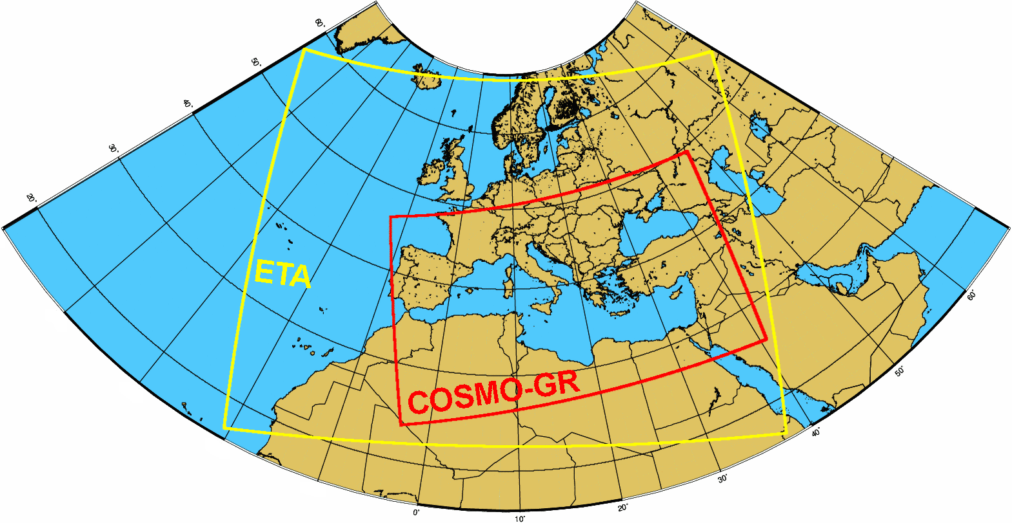
The COSMO-GR and ETA integration domains at HNMS

4.2 Medium range forecasting system (4-10 days)
As a founding member of ECMWF, HNMS makes full operational use of all the ECMWF meteorological products both for its operational mesoscale weather forecasting as well as for data assimilation, objective analysis and initialization of the local models in use.

4.3 Short range forecasting system (0-72 hrs)

4.3.1 Data assimilation, objective analysis and initialization
Regarding Local Models, data assimilation for the LM is based on the Nudging Analysis Scheme developed at DWD. Correspondingly, for RAMS, the Local Analysis and Prediction Section (LAPS) is used. SYNOP, SHIP, TEMP and AIREP type of messages are currently assimilated.

4.3.3 Operationally available NWP products

Numerical Weather Prediction Model ETA
Time prediction range and step | Initialization from ECMWF analysis of 00 UTC and 12 UTC with prediction range of 72 hours from analysis hour. Data production every 3 prediction hours.
Computer system | IBM Power4 architecture
Surface data parameters | Mean Sea Level Pressure  Wind 10m  Temperature 2m  Specific Humidity  Precipitation
Upper-level data parameters | Geopotential height  Temperature  Wind  Specific Humidity
Vertical Resolution (hPa) | 100, 150, 200, 250, 300, 400, 500, 700, 850, 1000 and Surface
Horizontal Resolution | 0.062ºX0.062º in rotated grid with geographical center lon=8, lat=46.5 and width 61 degrees in longitude and 45 degrees in latitude.
Covered area | East Atlantic and Europe
Results form | Binary which are converted to GRIB

Numerical Weather Prediction COSMO-GR Model
Time prediction range and step | Locally (2 runs a day): Initialization from the Global Model of ECMWF (IFS) or DWD (GM), based on analysis of 00 UTC and 12 UTC. Data assimilation is done using the Nudging Analysis scheme developed at DWD. The prognostic range is 72 hours and data production is available every prediction hour.
Computer system | IBM Power4-based system
Surface data parameters | Mean Sea Level Pressure  Wind 10m  Maximum wind 10 m  Temperature 2m  Dew point temperature 2m  Maximum temperature 2m  Minimum temperature 2m  Total cloud cover  High cloud cover (0-400 hPa)  Medium cloud cover (400-800 hPa)  Low cloud cover (800 hPa-Surface)  Specific humidity  Precipitation  Convective precipitation  Snowfall
Upper-level data parameters | Geopotential height  Temperature  Omega parameter of vertical motion  Wind  Specific Humidity
Vertical Resolution (hPa) | 200, 250, 300, 400, 500, 600, 700, 850, 950, 1000
Horizontal Resolution | 0.0625ºX0.0625º in rotated grid with South Pole lon=24, lat=-52 and width 40.5 degrees in longitude and 24 degrees in latitude.
Covered area | Mediterranean and Black Sea
Results form | GRIB

Numerical Weather Prediction Model RAMS (Non-Hydrostatic) & WAM
Time prediction range and step | Initialization from ECMWF analysis of 12 UTC and corrected with LAPS. Prediction range of 36 hours from analysis hour. Data are displayed for every prediction hour.
Computer system | IBM Power4 architecture
Surface data parameters | Mean Sea Level Pressure  Wind 10m  Temperature 2m  Total cloud cover  Precipitation  Wave height and direction (WAM)
Upper-level data parameters | Geopotential height  Temperature  Wind  Relative humidity  Specific humidity
Vertical Resolution (hPa) | 100, 150, 200, 250, 300, 400, 500, 700, 850, 1000
Horizontal Resolution  (Three nested Grids) | Grid 1: 48 Km  Grid 2: 12 Km  Grid 3: 3 Km
Covered area | Grid 1: Europe, North Africa, Black Sea  Grid 2: Balkans  Grid 3: Central Greece
Results form | GRIB

4.3.4 Operational techniques for application of NWP products

Automatisation of the maritime bulletin at HNMS
The Hellenic National Meteorological Service (HNMS) is responsible for the dis semination of maritime bulletins for shipping for the eastern Mediterranean Sea and the Black Sea. A program for the automatic creation of the maritime bulletins has been developed aiming at being an important tool providing the basis for the bulletin text as well as concentrating the necessary data for the forecaster.
Specifically, this program is a post-processing application to the NWP data of COSMO-GR. The horizontal resolution of the model is 0.0625º (~7km) enabling the detailed description of the meteorological data in even small geographical regions. The program focuses on PART 3 of the bulletin describing wind, precipitation and visibility in three periods (two 6-hours and a 12-hour) during its validity. As COSMO-GR does not diagnose visibility, an algorithm based on the Forecast Systems Laboratory algorithm has been implemented in the program. Apart from the bulletin text the program provides the necessary graphical outputs in the form of wind roses of mean wind as well as graphs of maximum mean wind indicating its location, for each sea sector and period.

Kalman filtering on temperature numerical predictions
The Hellenic National Meteorological Service (HNMS) operates daily a method improving the temperature minimum and maximum forecast values for 50 locations in Greece. This method is based on Kalman filtering using the available quality controlled observations together with the corresponding NWP data of three different models, namely, COSMO-GR, SKIRON and ECMWF.

The reliability of the filtered results is investigated with their statistical evalua
tion at the end of each month or season (e.g. Fig.1) .

Before filtering | After filtering
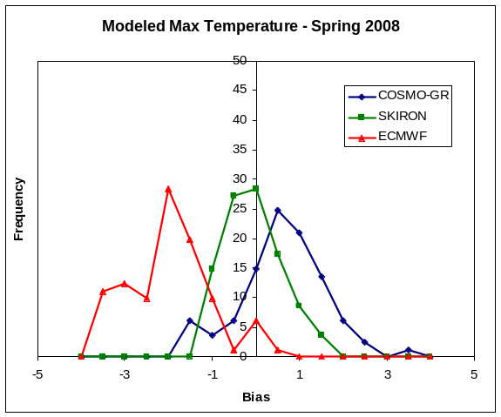 | 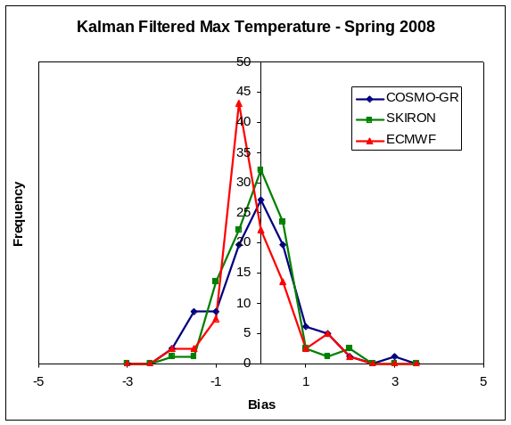
Figure 1: Bias of maximum Spring temperature related with the frequency of its appearance for all stations before and after the application of Kalman filtering.

4.5 Specialized numerical predictions(on sea waves,storm surge,sea ice, marine pollution transport and weathering, tropical cyclones, air pollution transport and dispersion , solar ultraviolet (UV) radiation, air quality forecasting, smoke, sand and dust,etc.)

Marine Pollution Emergency Response Support System at HNMS
The Hellenic National Meteorological Service (HNMS) operates the Marine Pollution Emergency Response Support System (MPERSS) for the Marine Pollution Incident (MPI) area III East, which includes the eastern Mediterranean Sea.
HNMS operates the sea pollution model, based on the French model (MOTHY), which is applied in cases of oil spills (or items) in the eastern Mediterranean. This trajectory model uses NWP data either of the ECMWF model or COSMO-GR model for higher resolution results. The data used as input are the surface wind speed and the sea surface pressure. The location (latitude and longitude) and the time of the incident are specified as well as the type of the spilled fluid or the released item. The duration of the forecast for the dispersion of the oil (or the item transport) is declared. The maximum possible forecasting period is a function of the availability of the NWP data, the specific forecast cycle, and the time of the incident. The model will provide the possible trajectories (locations) of oil (or item) transport as well as the percentage of the oil spill that will reach the coast or the seabed. These results are given either in graphic files depicting the extent of the sea pollution or in tables.
HNMS can apply the model for any specific incident of oil spillage (or item release) in the Eastern Mediterranean.

5. Verification of prognostic products

5.1 Annual verification summary
In order to determine the quality of the NWP products and to gain insight into their accuracy and usefulness, a verification process is essential. At HNMS, a versatile, automated verification system was developed and has been in operation, in order to provide objective statistics for the performance of the different NWP models. The forecast values of weather parameters are compared with synoptic meteorological data from the HNMS operational network of stations and a range of statistical scores is calculated on a daily, monthly and yearly basis. The model variables used for the verification are: 2m temperature (T2m), dew-point temperature (Td2m), mean sea-level pressure (MSLP), cloud cover, precipitation and 10m wind speed and direction.

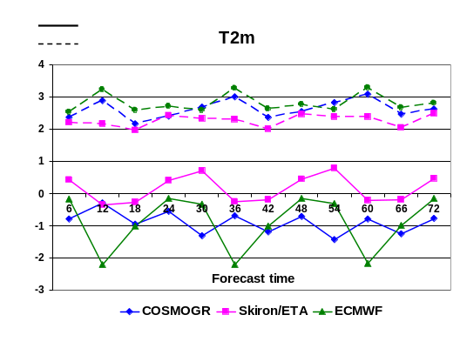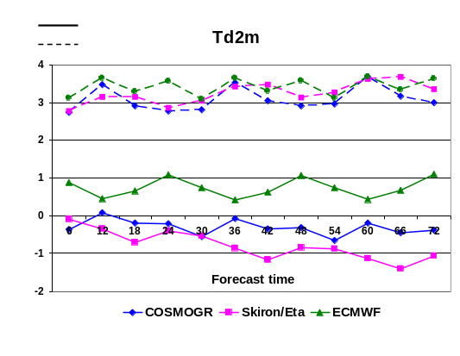
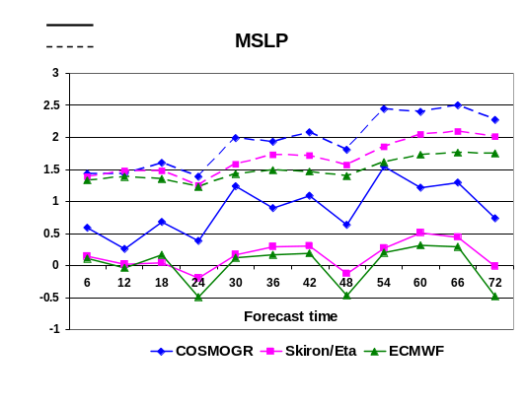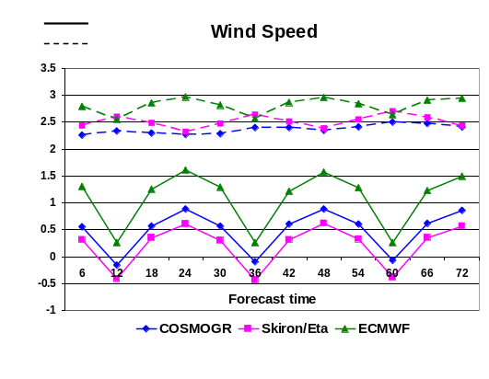

Figure 1. BIAS/RMSE results for the four weather parameters averaged over the year 2008 over all stations

For the continuous weather parameters, 6-hourly forecast values for a horizon of 72h of the 00UTC model runs were compared to the respective SYNOP data. At HNMS, data from over 90 weather stations are received daily and included in the verification process. A selection of the verification results for the surface parameters for the year 2008 are presented above (Fig.1). In addition, the performance of COSMO-GR, which is the main forecasting tool for the short range forecast of the local weather at HNMS is presented below for all the seasons with respect to 2m temperature (Fig.2). For the dichotomous parameters (precipitation) the statistical analysis includes the calculation of all the relevant scores as POD, FAR, ETS, FBI etc. in 6h intervals (Fig.3).

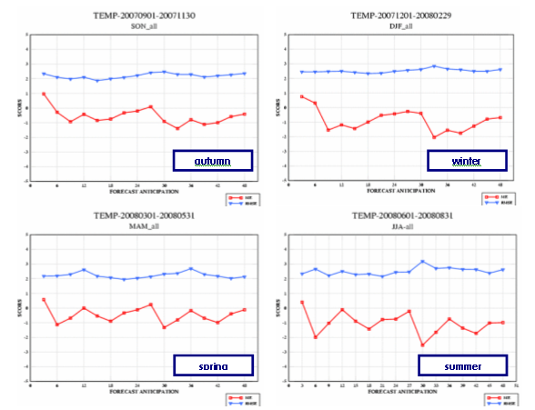
Figure 2. Seasonal representation of BIAS/RMSE for temperature at 2m for COSMO-GR

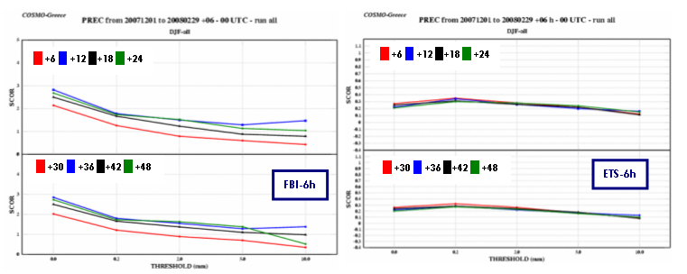
Figure 3. Precipitation statistical scores for the winter 2007-2008 period for COSMO-GR.

In order to determine the quality of the NWP products and to gain insight into their accuracy and usefulness, a verification process is essential. At HNMS, a versatile, automated verification system was developed and has been in operation since the end of 2006 in order to provide objective statistics for the performance of the different NWP models. The forecast values of weather parameters are compared with synoptic meteorological data from the HNMS operational network of stations and a range of statistical scores is calculated on a daily, monthly and yearly basis. The model variables used for the verification are: 2m temperature (T2m), dew-point temperature (Td2m), mean sea-level pressure (MSLP), cloud cover, precipitation and 10m wind speed and direction.

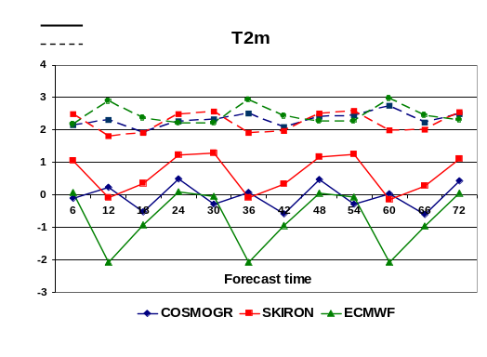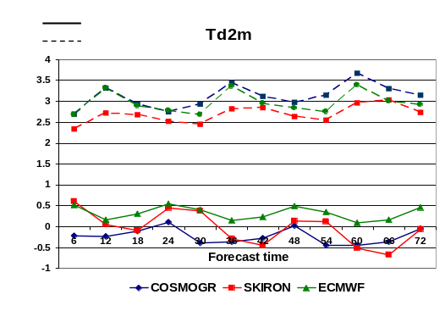
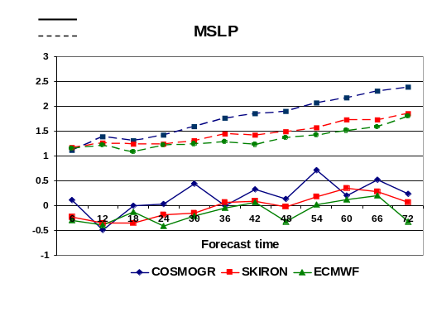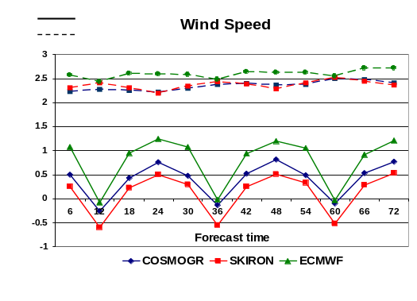
Figure 1. BIAS/RMSE results for the four weather parameters averaged over the year 2007 over all stations

For the continuous weather parameters, 6-hourly forecast values for a horizon of 72h of the 00UTC model runs were compared to the respective SYNOP data. At HNMS, data from over 90 weather stations are received daily and included in the verification process. A selection of the verification results for the surface parameters for the year 2007 are presented below (Fig.1). In addition, the performance of COSMO-GR and Skiron/Eta over time is presented regarding the prediction of temperature at 2m and wind speed for the period January 2006 to December 2007 (Fig.2).
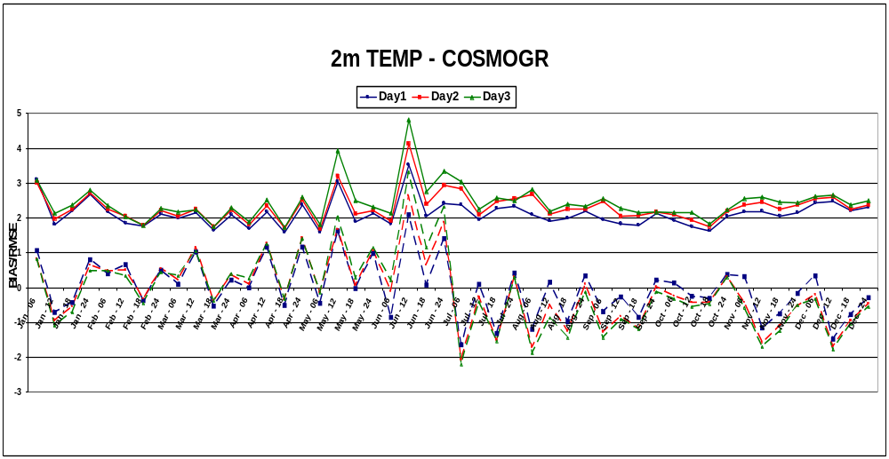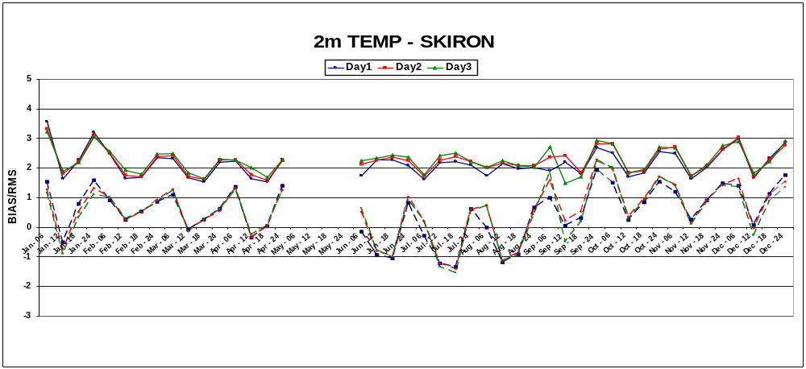
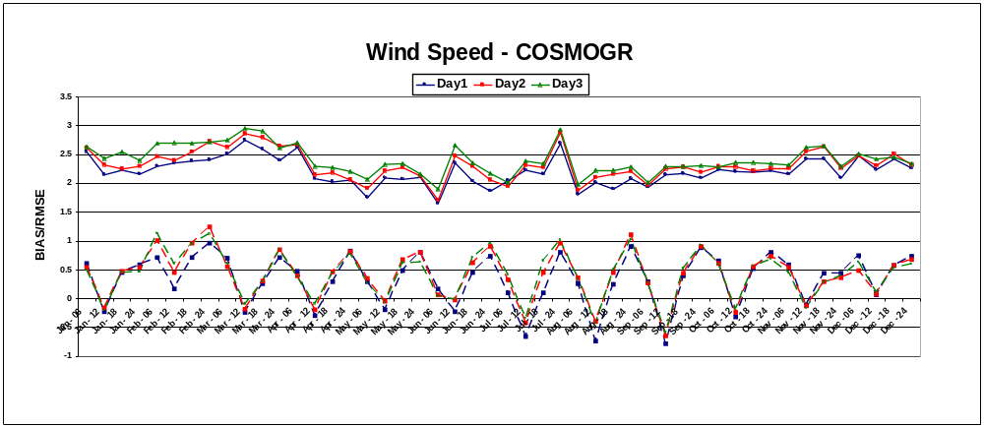
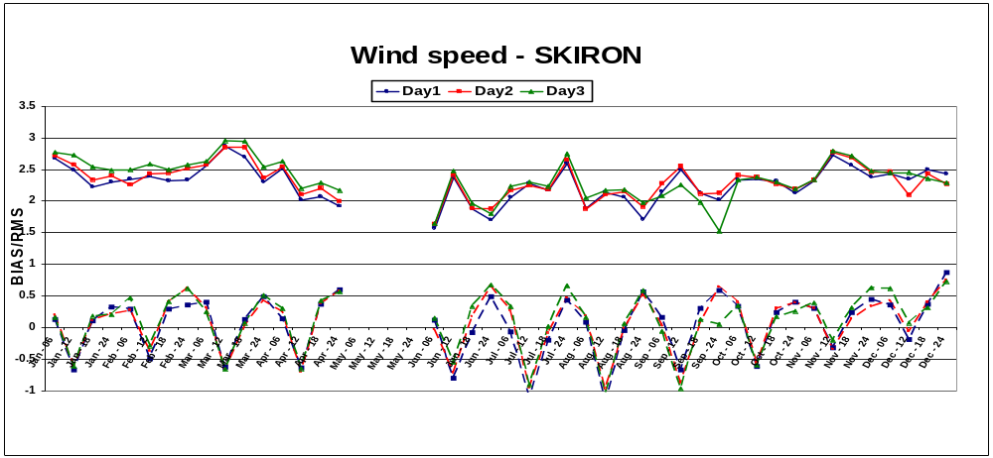
Figure 2. Month by month evolution of BIAS/RMSE for temperature at 2m and wind speed at 10m

6. Plans for the future (next 4 years)

6.2 Planned research activities in NWP, Nowcasting and Long-range Forecasting
- Develop an Ensemble-type forecast cycle using COSMO-GR.
- Add remote sensing data to the model assimilation process.
- Run a local climatological model.

6.2.1 Planned Research Activities in NWP

Installation and Operational use of a Model for dust transfer
Every year episodes of dust transfer mainly from Sahara desert are usual events in Greece. For this reason, HNMS has become a member of the Regional Steering Group (RSG) of WMO for Sand and Dust Storm Warning Advisory and Assessment System (SDS-WAS) of the regional node for North Africa, Middle East and Europe (SDSWAS RC NA-ME-EU).
For this reason, main activity of HNMS within 2009-2010 will be the installation and operational use of a numerical model for dust transfer in the Mediterranean Region. Specifically, HNMS runs at its premises high resolution atmospheric models, namely COSMO-GR and SKIRON/Eta (~6 km) which can be enriched with a dust module. Through the close collaboration of HNMS with the University of Athens (UoA) a dust module running already at UoA will be adapted and implemented on SKIRON/Eta in order to provide dust forecasts (concentration, load, dry/wet deposition) operationally for the Mediterranean Region.

Subgrid Processes
A subgrid cloud scheme is investigated against the default scheme based on
grid-point relative humidity within the context of the COSMO model code.
Aside from their justification, both approximations turn out to have their
shortcomings. Therefore, the possibility of mixing the two schemes is also
explored as well as the issue of an optimal combination of the two schemes

6.2.4 Planned Research Activities in Specialized Numerical Predictions

Currently HNMS is experimenting on running a high-resolution version of COSMO, with 0.025deg/60 levels resolution. The high-res version receives initial conditions produced by the operational COSMO run of 0.0625 deg resolution.
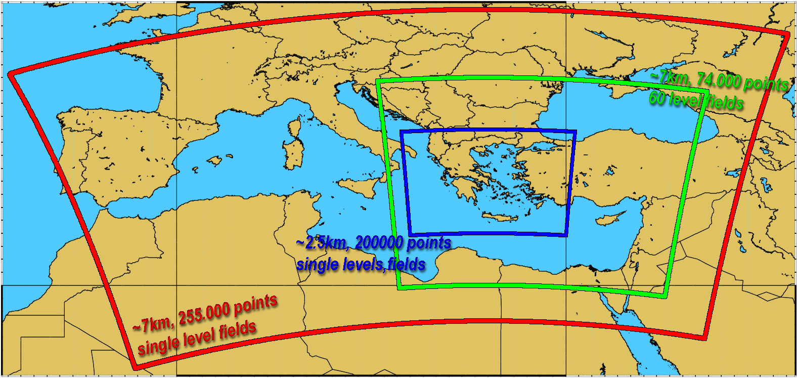
Red area: operational run (0.625deg)
Green area: operational output used as boundary conditions for the high-resolution run
Blue area: area of high-resolution run
The high-resolution run uses it’s own orography and extermnal-fields data. The pictures below compare the normal (0.0625deg) and the high-resolution (0.025deg) elevation fields
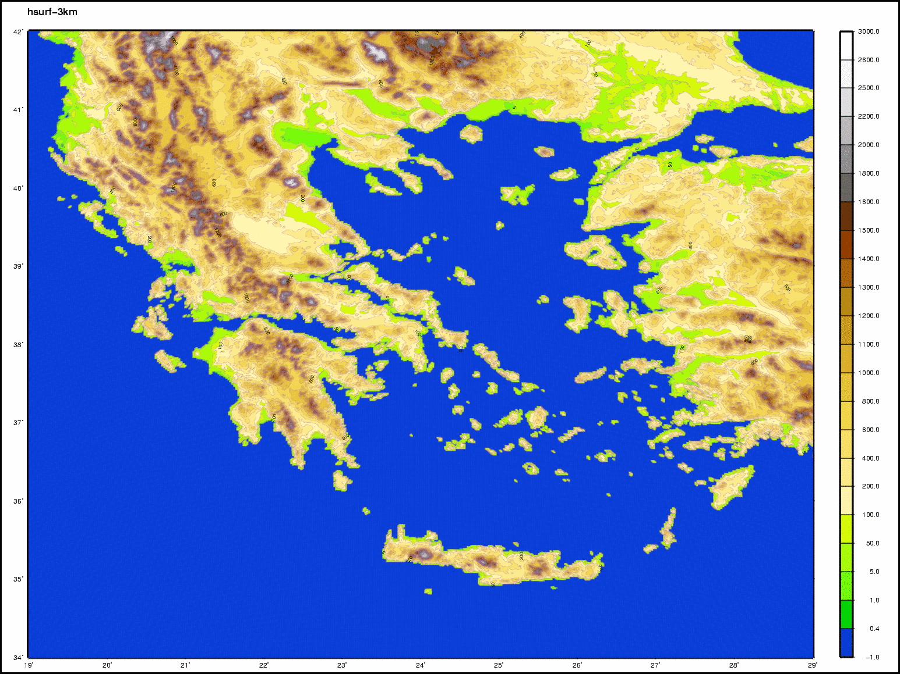 | 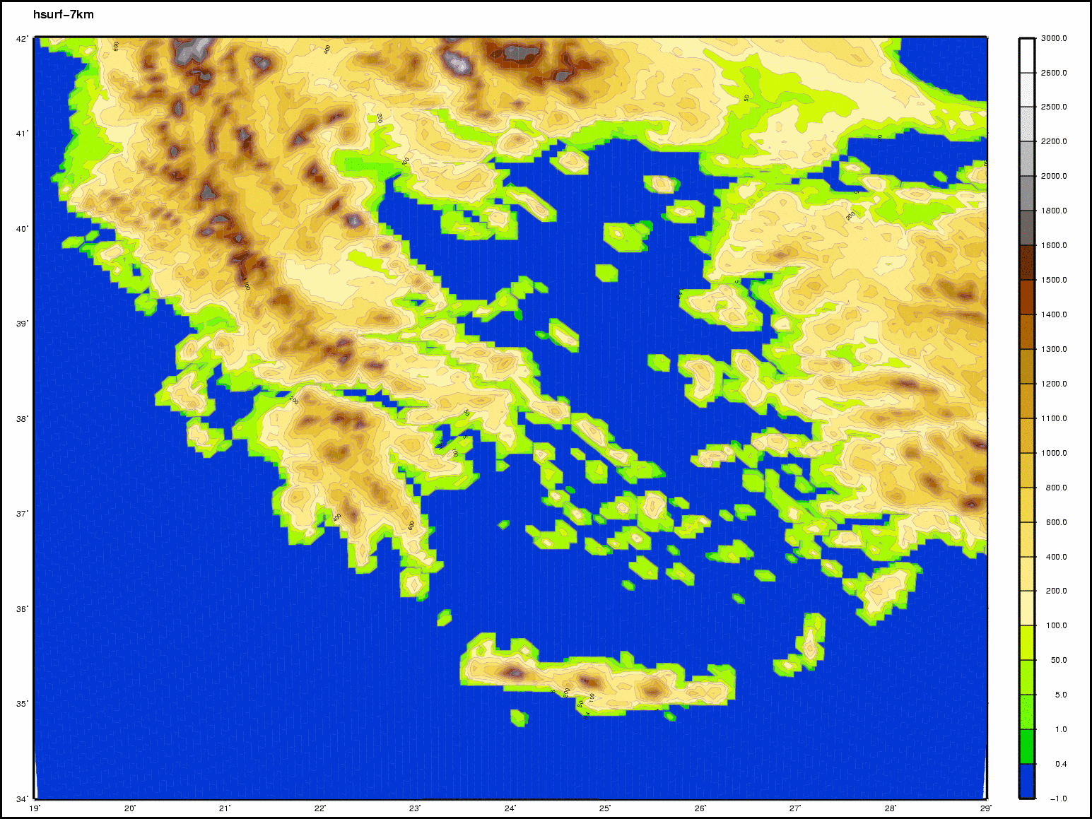
Orography 0.025 deg | Orography 0.065 deg
The immediate plans of HNMS is to estimate the accuracy of the new high-resolution run. It’s output can have considerable differences compared to the currently operational one (see pictures below), so careful inspection, comparison and verification are necessary.
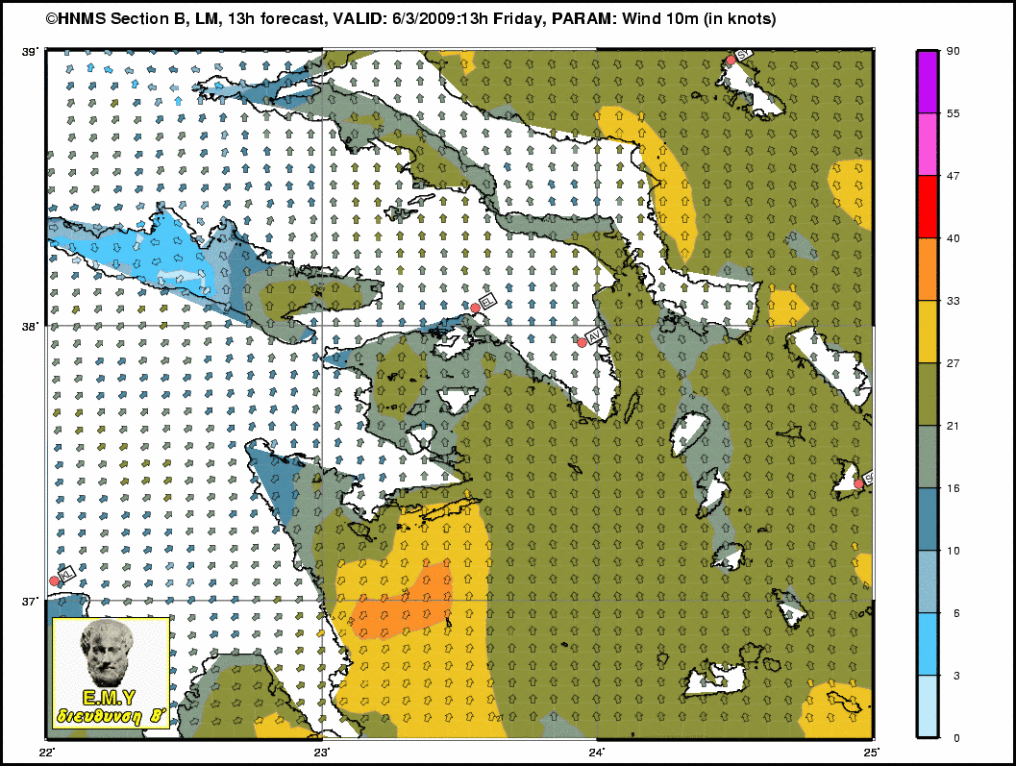 | 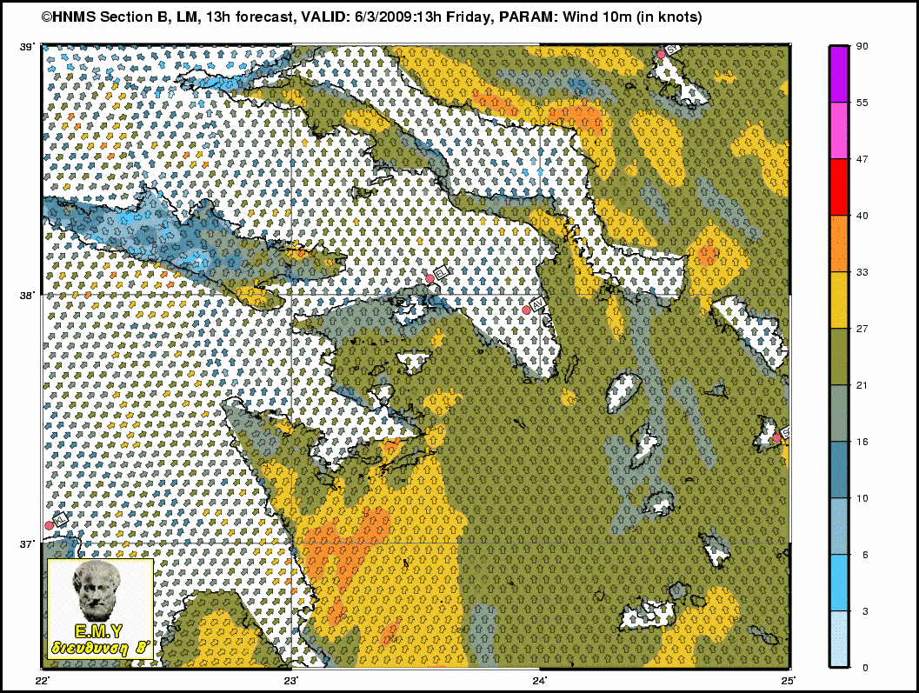
operational run | high resolution run
Comparison of wind10m field:

7. References

- “Application of the Z-Coordinate Version vs. the Terrain Following Version of LM Nonhydrostatic Model over Greece”, E. Avgoustoglou, T. Tzeferi, V. Tirli, and I. Papageorgiou, COSMO Newsletter Nr. 6, July 2006 p. 74-80.
- “Implementation of the Statistical Cloud Scheme Option: Preliminary Testsl”, E. Avgoustoglou, T. Tzeferi, and I. Papageorgiou, COSMO Newsletter Nr. 6, July 2006 p. 88-93.
- “Prediction of Clouds and Rain Using a z-Coordinate Nonhydrostatic Model”, J. Steppeler, U. Schättler, P. Prohl, U. Gjertsen, U. Damrath, L. Torrisi, J. Parfinievic, E. Avgoustoglou, Monthly Weather Review, 134, 2006, p.3265-3643.
- “Application of non-linear Kalman filters to numerical weather predictions”, G. Galanis, P. Louka, P. Katsafados, G. Kallos, I. Pytharoulis, Annales Geophysicae, 24, 2006, p. 2451–2460.
- “First results of the COSMO Priority Project ’Tackle deficiencies in quantitative precipitation forecasts”, S. Dierer, J. Achimowicz, T. Andreadis, M. Arpagaus, E. Avgoustoglou, M. Baldauf, C. Cacciamani, U. Damrath, R. Dumitrache, V. Fragkouli, A. Fuccello, F. Grazzini, T. La Rocca, P. Louka, P. Mercogliano, P. Mezzasalma, M. Milelli, E. Oberto, A. Parodi, I.V. Pescaru, U. Pflüger, P. Prohl, I. Pytharoulis, A. Sanna, Ch. Schraff, F. Schubiger, A. Seifert, K. Starosta, J.Steppeler, M. S. Tesini, E. Zala, COSMO User Seminar, BTZ Langen 5-7 March 2007.
http://www.cosmo-model.org/content/consortium/userSeminar/seminar2007/agenda2007.htm
- “Improvements in wind speed forecasts for wind power prediction purposes using Kalman filtering”, P. Louka, G. Galanis, N. Siebert, G. Kariniotakis, P. Katsafados, G. Kallos, I. Pytharoulis, Journal of Wind Engineering and Industrial Aerodynamics (accepted).

