JOINT WMO TECHNICAL PROGRESS REPORT ON THE GLOBAL DATA PROCESSING AND FORECASTING SYSTEM AND NUMERICAL WEATHER PREDICTION RESEARCH ACTIVITIES FOR 2015

Finland / Finnish Meteorological Institute (FMI)

1. Summary of highlights
This report describes the essential features of the numerical weather prediction (NWP) systems operational at the Finnish Meteorological Institute (FMI) during the year 2015. The systems are based on mesoscale ALADIN-HIRLAM forecasting system HARMONIE-AROME (hereafter HARMONIE) and synoptic scale HIRLAM (Undén et al., 2002) NWP system, maintained by the international HIRLAM-C consortium (http://hirlam.org/), which is formed by the national meteorological agencies of Denmark, Estonia, Finland, Iceland, Ireland, Lithuania, the Netherlands, Norway, Spain, and Sweden. The development of HARMONIE is a joint effort of two European modelling consortia: HIRLAM-C and ALADIN.

HARMONIE is a non-hydrostatic meso-gamma scale model with horizontal resolution of 2.5 km. In March 2015, HARMONIE version aro38h12 was introduced into operational use at FMI.

HIRLAM is a hydrostatic model with 7.5 km horizontal resolution. It is maintained at version 7.4, but is not developed further by HIRLAM-C. During 2015, FMI has continued to work as the lead centre for operational running of the common reference version of HIRLAM (RCR). In this capacity, FMI uses operationally the reference version, and makes all forecast products available to the whole consortium in a common archive at the ECMWF. The lead centre duties also include maintaining a comprehensive technical and meteorological monitoring of the system, which can be followed in real time on the project web pages (Kangas and Sokka, 2005). An on-line model intercomparison showing forecast v. measurements for a set of meteorological measurement masts is also included in the monitoring suite (Kangas, 2011, 2016). The monitoring also includes HARMONIE forecasts.

Several research projects address development and improvements of specific features of the NWP models, such as surface interactions especially over snow/ice surfaces and lakes. Some products of the reference runs are shared within the EUMETNET SRNWP-PEPS project.

2. Equipment in use
The operational HARMONIE and HIRLAM forecasts are run on FMI's own Cray XC30 computer with 2 x 3420 cores and peak power of 70 TFlops. The computer consists of two identical units, one being the main operational platform and the other one acting as a backup and research system.

3. Data and Products from GTS in use
The GTS data used by FMI models include:

HARMONIE | HIRLAM
SYNOP  SHIP  BUOY  AIREP  AMDAR  ACARS  TEMP  PILOT | SYNOP  SHIP  BUOY  AIREP  AMDAR  ACARS  TEMP  PILOT  ATOVS-AMSU-A  ATOVS-AMSU-B  ATOVS-MHS

4. Forecasting system

4.1 System run schedule and forecast ranges
FMI is using ECMWF global products for medium range forecasting. In addition, FMI maintains two nested data-assimilation/forecasting suites for limited area short range forecasting: HARMONIE and HIRLAM. As well as serving domestic needs, the HIRLAM-suite serves as a reference (RCR) run for the whole HIRLAM consortium,. HARMONIE is mainly used for domestic forecast needs and research.

The run schedules and forecast ranges of the models are shown in Table 1, while the integration areas of the suites are visualized in Figure 1. HIRLAM covers a larger "Atlantic area", HARMONIE Scandinavia.

Figure 2 illustrates the computers and data flows of the FMI HIRLAM system. The observations from various sources including Baltic SST/ice data from the FMI Marine Service group and Finnish lake surface temperature observations from Finnish Environmental Administration are first collected to an auxiliary operational server, processed, and then transferred to the main computing platform for the actual computations. The same applies to the boundary data obtained from the ECMWF. After computations, the numerical results are loaded into the FMI real time data base for various uses by duty forecasters, researchers, and automated forecast post-processing applications. Likewise, the graphical products are made available through the FMI intranet. A local archiving on an FMI server also takes place. Finally, in accordance with the RCR status, input and output data of the HIRLAM are made available to the HIRLAM community by archiving the data to the ECMWF's ECFS using the ecaccess gateway. A graphical interface for monitoring the system is provided to the HIRLAM community through a common web portal at http://hirlam.org/.

For HARMONIE, a similar system is used. Main differences are that no Baltic or lake data is used as input and that only local archiving of the results takes place.

4.3 Short-range forecasting system (0-72 hrs)

4.3.1 Data assimilation, objective analysis and initialization
4.3.1.1 In operation
HARMONIE
Upper air analysis
- 3-dimensional variational data assimilation (3DVAR)
- Version: HARMONIE aro38h12
- Parameters: surface pressure, temperature, wind components, specific humidity

Surface analysis
- Optimal interpolation
- Parameters: SST, snow depth, screen level temperature and humidity, soil temperature and humidity in two layers

Levels
- 65 hybrid levels

Observation types
- SYNOP, SHIP, BUOY, AIREP, AMDAR, ACARS, TEMP, PILOT

Boundaries:
- Time dependent lateral boundary conditions from the ECMWF received four times each day on the HARMONIE grid with a temporal resolution of 3 hrs, obtained via the ECMWF boundary conditions optional project

First guess:
- Three hour forecast of the previous cycle valid at the beginning of the date window

Cut-off time:
- 1h 45 min (00 and 12 UTC), 1h 30min (03, 06, 09, 15, 18, and 21 UTC)

Cycling:
- 3h cycle

HIRLAM
Upper air analysis
- 4-dimensional variational data assimilation (4DVAR) with no explicit initialization
- Version: HIRLAM 7.4
- Parameters: surface pressure, temperature, wind components, specific humidity

Surface analysis
- Separate analysis, consistent with the mosaic approach of the surface/soil treatment
- Parameters: SST, fraction of ice, snow depth, screen level temperature and humidity, soil temperature and humidity in two layers
- Finnish lake surface temperature observations (from Finnish Environmental Administration)

Levels
- 65 hybrid levels

Observation types
- SYNOP, SHIP, BUOY, AIREP, AMDAR, ACARS, TEMP, PILOT, ATOVS-AMSU-A, ATOVS-AMSU-B, ATOVS-MHS

Boundaries:
- Time dependent lateral boundary conditions from the ECMWF received four times each day on the RCR grid with a temporal resolution of 3 hrs, obtained via the ECMWF boundary conditions optional project

First guess:
- Three hour forecast of the previous cycle valid at the beginning of the date window

Cut-off time:
- 2h

Cycling:
- 6h cycle
- Reanalysis step every 6 h, before the main run, to blend with large-scale features of the ECMWF analysis

4.3.1.2 Research performed in this field
Lake data-assimilation
In operational HIRLAM system, the lake water surface in-situ measurements are used for the analysis, but not for the initialisation of the new lake parameterisation model run. Model experiments to employ also satellite measurements (MODIS, AATSR) for the analysis are presently being performed. The impact of both manual and satellite-measured lake surface temperatures is studied (Rontu et al., 2012, Eerola et al., 2014, Kheyollarh Pour et al. 2014). For the initialisation of the new run of the lake parameterisation scheme, the EKF-based algorithm for both HARMONIE and HIRLAM has been proposed and tested in offline mode (Kourzeneva, 2014). In the lake analysis, the structure functions for the sea surface temperature are currently used, but the new structure functions based on the lake water surface temperature observations were obtained and used experimentally. An overview of lake activities may be found in the Workshop "Parameterisation of Lakes in NWP and climate modelling"(http://www.lake15.cge.uevora.pt/).

Snow data assimilation
The implementation of satellite-based snow data to the HARMONIE and HIRLAM surface data assimilation system has been continued in international cooperation. Snow extent data provided by the GLOBSNOW project will be used in addition to the SYNOP snow depth observations. Assimilation of the spaceborne microwave radiometer data with the snow emission model as forward operator using of EUMETSAT SAF project data and applying of EKF algorithm to initialise the snow density, temperatures and albedo are being discussed. FMI NWP research group actively participates in COST Action ES1491 HarmoSnow. The main purpose of the Action is the harmonization of snow observations, with the perspective to advance snow data assimilation in European NWP and hydrological models and show its benefit for relevant applications.
Table 1. Run schedules and forecast ranges of the FMI LAM suites.
 | HARMONIE |  | HIRLAM
 | range | available | range | available
1 | 00 + 54 h | 02:15 UTC | 00 + 54 h | 03:00 UTC
2 | 03 + 54 h | 05:15 UTC
3 | 06 + 54 h | 08:15 UTC | 06 + 54 h | 09:00 UTC
4 | 09 + 54 h | 11:15 UTC
5 | 12 + 54 h | 14:15 UTC | 12 + 54 h | 15:00 UTC
6 | 15 + 54 h | 17:15 UTC
7 | 18 + 54 h | 20:15 UTC | 18 + 54 h | 21:00 UTC
8 | 21 + 54 h | 23:15 UTC

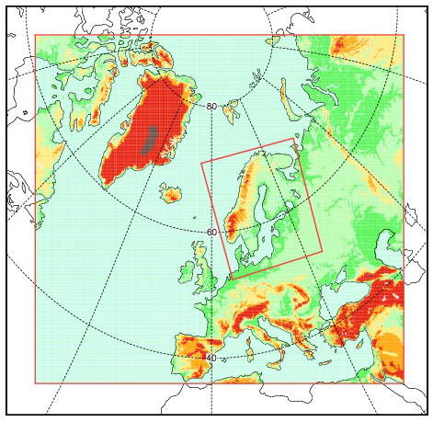
Figure 1. Integration areas of the operational LAM suites (RCR > HARMONIE).

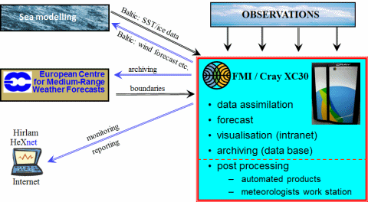
Figure 2. Computers and data flows of the FMI LAM system (RCR-HIRLAM shown here).

4.3.2 Models

4.3.2.1 In operation
HARMONIE
Basic equations:
- Non-hydrostatic fully compressible Euler equations

Independent variables:
- Bi-fourier wave numbers, hybrid level, time

Dependent variables:
- Horizontal wind vector, vertical divergence, non-hydrostatic pressure departure, temperature, specific humidity, 5 species of condensed water, cloud cover, turbulent kinetic energy

Integration domain:
- 720 x 800 grid points in in a Lambert conformal conic projection grid, 65 vertical hybrid levels

Grid length:
- 2.5 km

Grid:
- Arakawa-A (unstaggered)

Time-integration:
- Two-time level semi-implicit semi-Lagrangian

Orography:
- GTOPO30 database

Physical parameterisation:
- SW radiation : ECMWF Morcrette radiation scheme with 6 spectral bands
- LW radiation : ECMWF RRTM scheme with 16 spectral bands
- Shallow convection using combined eddy diffusivity mass flux scheme
- Pinty-Jabouille microphysics including five categories of micrometeros
- 1D prognostic Cuxart-Bougeault TKE scheme
- SURFEX surface scheme with four ground tile types

Horizontal diffusion:
- SLHD (Semi-Langrangian-Horizontal diffusion) non-linear scheme

Forecast length:
- 54 hours at 00, 03, 06, 09, 12, 15, 18, and 21 UTC

Output frequency:
- 15 minutes

Boundaries:
- Boundaries from the ECMWF optional BC runs
- Projected onto the HARMONIE grid at ECMWF
- Boundary file frequency 3 hours
- Updated four times daily

HIRLAM (RCR)
Basic equations:
- Primitive equations in flux form

Independent variables:
- λ,θ (transformed latitude-longitude coordinates, with the south pole at 30° S, 0°Ε), η (hybrid level), t (time)

Dependent variables:
- Logarithm of surface pressure, temperature, wind components, specific humidity, specific cloud condensate, turbulent kinetic energy

Integration domain:
- 1036 x 816 grid points in transformed latitude-longitude grid, 65 vertical hybrid levels

Grid length:
- 0.068° (~7.5 km)

Grid:
- staggered grid (Arakawa C)

Time-integration:
- 2 time level semi-Lagrangian semi-implicit (time step 2.5 min)

Orography:
- HIRLAM physiographic data base, filtered

Physical parameterisation:
- Savijärvi radiation scheme
- Orographic radiation parameterisation
- Kain-Fritsch convection scheme
- Rasch-Kristjansson microphysics
- Turbulence based on turbulent kinetic energy
- Surface fluxes according to drag formulation
- Surface and soil processes using mosaic approach; specially treated interactions between forest canopy and snow: double energy balance formulation
- Meso-scale orographic drag parameterisation
- Lake parameterisation, freshwater lake scheme FLAKE

Horizontal diffusion:
- Implicit fourth order

Forecast length:
- 54 hours at 00, 06, 12, and 18 UTC

Output frequency:
- 1 hour

Boundaries:
- Frame boundaries from the ECMWF optional BC runs
- Projected onto the HIRLAM grid at ECMWF
- Boundary file frequency 3 hours
- Updated four times daily

4.3.2.2 Research performed in this field
Validation of wind gust parameterizations against aircraft observations in the marine Arctic
The possibilities to measure wind gusts on-board a research aircraft were studied by Suomi et al. (2016). Traditionally wind gusts have only been measured at weather stations, where high response instrumentation can be deployed. However, in remote regions such as the marine Arctic, the deployment of such instruments is costly and challenging, sometimes even impossible. In these conditions, aircraft can potentially be used to measure wind gusts. The challenge with aircraft measurements is that due to the high speed of the aircraft relative to the Earth's surface the turbulence measurements represent rather the spatial distribution of the wind field instead of a time series as measured at fixed locations. Therefore, the definition of a gust cannot be based on time averaging but on spatial averaging. Suomi et al. (2016) developed a new methodology to derive wind gusts from aircraft measurements such that these gusts correspond to those measured at weather stations. The resulting gusts compared well with the ones derived using existing wind gust parameterizations originally developed for weather stations. These parameterizations represented the effects of static stability, surface aerodynamic roughness and height above surface on wind gusts realistically and hence the results show that the parameterizations are applicable also in the marine Arctic environment.

Interaction processes in the Arctic climate system
A major international effort was made to assess the Arctic freshwater system; its processes and state, as well as recent and projected changes (Prowse et al., 2015). The role of FMI was to lead the atmospheric component of the work (Vihma et al., 2016). The main findings of the assessment include the following. During recent decades, specific humidity and precipitation have generally increased in the Arctic, while trends in clouds vary depending on the region and season. Feedbacks associated with the increase in atmospheric moisture and decrease in sea ice and snow cover have contributed to the Arctic amplification of global warming. Climate models have captured the overall wetting trend but have limited success in reproducing regional details. Climate models project strong warming and increasing precipitation, but different models yield different results for changes in cloud cover. Evapotranspiration is projected to increase in winter but in summer to decrease over the oceans and increase over land. Increasing net precipitation increases river discharge to the Arctic Ocean. Over sea ice in summer, projected increase in rain and decrease in snowfall decrease the surface albedo and, hence, further amplify snow/ice surface melt. Improvements are needed in observations, process understanding, and modelling capabilities to better quantify the atmospheric role in the Arctic water cycle and its changes.

Boundary layer structure and processes
The Weather Research and Forecasting (WRF) mesoscale model was applied to study large shore-parallel, quasi-stationary snow bands over the Gulf of Finland in winter (Mazon et al., 2015). The snow bands occurred during cold easterly large-scale flow along the gulf and a cold local flow from the opposite coastlines of Estonia and Finland in the form of two land-breeze cells which collided offshore. The associated fronts had strong rising motions, maintained by the convergence of the land-breeze cells. A line of convective precipitation composed of several cells was formed along the Finnish coast. The WRF simulations also showed two low-level jets generated by the combined effects of the land-breeze cells and baroclinicity over the coast of Finland and Estonia.

Stable boundary layer in high latitudes
The performance of two 1.5-order boundary layer parameterization schemes, the quasi-normal scale elimination (QNSE) and Mellor–Yamada–Janji´c (MYJ) scheme, was studied in the WRF model (Tastula et al., 2015). The QNSE stability functions yielded better error statistics for 2 m virtual temperature but higher up the errors related to QNSE were slightly larger for virtual temperature and mixing ratio. The model results were sensitive to the choice of the turbulent Prandtl number for neutral stratification. The WRF model was also evaluated for stable conditions in clear skies with low wind speeds, applying data from different snow-covered surfaces in the Netherlands, Finland, and Antarctica (Sterk et al., 2015). The WRF model produced good results overall for wind speed, but the near-surface temperatures and specific humidity were overestimated for the mid-latitude study sites and underestimated for Antarctica. Detailed prescription of the surface characteristics, e.g. adjusting the snow cover and vegetation fraction, improved the 2m temperature simulation. For all three sites, the simulated temperature and moisture inversion were underestimated, though this improved when prescribing advection in single-column experiments.

Considering alternative methods to parameterize the sensible heat flux, Stanislawska et al. (2015) presented a method based on genetic programming (GP). Heat flux data collected in the Arctic and Antarctic sea ice zones were utilized, and GP models were obtained that are more accurate, robust, and conceptually novel from the viewpoint of meteorology. Contrary to the Monin-Obukhov theory, the GP equations are not solely based on the air-surface temperature difference and wind speed, but include also radiative fluxes that improve the performance of the method. These results open the door to a new class of approaches to heat flux prediction with potential applications in weather and climate models.

Tuononen et al. (2015) produced a wintertime climatology of the occurrence and characteristics of low-level jets (LLJs) in the Northern Hemisphere mid-latitudes and polar regions. The highest occurrence of LLJs was associated with strong gradients in topography and with the sea-ice edge. Sea areas fully covered with sea ice also favoured the occurrence of LLJs, however, these areas, including the central Arctic, had fewer LLJs than along the sea-ice edge. LLJs also occurred frequently in the seldom studied Sea of Okhotsk area.

Jonassen et al. (2015) addressed novel methods to observe ABL in remote high-latitude regions. Measurements from fixed- and rotary-wing remotely piloted aircraft systems (RPAS) were combined to complement data sets from radio soundings as well as ship and sea-ice-based instrumentation for ABL profiling. A total of 86 RPAS flights over Antarctic sea ice in winter showed a strongly varying ABL structure ranging from slightly unstable temperature stratification near the surface to conditions with strong surface-based temperature inversions. The fixed-wing and quadcopter temperature profiles agreed very well and, excluding cases with strong temperature inversions, under which the quadcopter, with its slower climb rate and faster sensor, was very useful in obtaining accurate temperature profiles in the lowest 100 m above the sea ice.

Snow and sea ice modelling
Pirazzini et al. (2015a) illustrated a method to measure the size distribution of a snow particle parameter, which roughly corresponds to the smallest snow particle dimension, from two-dimensional macro photos of snow particles taken in Antarctica at the surface layer of a melting ice sheet. We demonstrate that this snow particle metric corresponds well to the optically equivalent effective radius utilized in radiative transfer modelling, in particular when snow particles are modelled with the droxtal shape. The surface albedo modelled on the basis of the measured snow particle metric showed an excellent match with the observed albedo when there was fresh or drifted snow at the surface. Our results indicate that more than just one particle metric distribution is needed to characterize the snow scattering properties at all optical wavelengths, and suggest an impact of millimetre-scale surface roughness on the shortwave infrared albedo.

Zhang et al. (2015) investigated the effect of using relatively high-resolution (∼20 km) near-surface wind fields of two different operational analyses (from the ECMWF and the Antarctic Mesoscale Prediction System (AMPS) to force a sea-ice - ocean model. Even though the horizontal resolution of both analyses was about the same, striking differences emerge in simulated coastal sea ice and thus the representation of coastal polynyas and net freezing rates. In AMPS, offshore winds are up to 10 ms⁻¹ stronger than those of ECMWF. This led to major differences in simulated coastal ice drift, concentration, and thickness, as well as discrepancies in the annual net freezing rate of up to 5 m per year. Differences between the ECMWF and AMPS in the parameterization of subgrid-scale orographic effects explained most of the discrepancies along steep coastlines. The data assimilation and initialization procedure biased the AMPS wind fields toward those of the NCEP analyses, which probably overestimate offshore winds as a result of coarse-resolution orography.

Urban modelling
Validation of urban surface parameterizations continued within the framework of the Helsinki Urban Meteorological Network (Wood et al., 2013). Koop et al. (2016) compared radiative and turbulent surface heat fluxes hind cast by the operationally-used Harmonie configuration (cy38h12), to in situ measurements at two locations in central and suburban Helsinki. By comparing output from several grid cells in the vicinity of the observation sites over one year, it was found that HARMONIE can provide a realistic estimate of the surface energy balance, provided that the physiographic details and snow cover in the model are correct. However, turbulent heat fluxes were found to be generally too weak during winter.

Radiation parametrization
The development of NWP model radiation parametrization has been continued with the ALADIN-HIRLAM community. Several minor improvements to the default IFS radiation scheme were suggested and tested in HARMONIE cycles 38h1 and 40h1 (Gleeson et al., 2015). 3D and 1D (MUSC) experiments were run to compare the results of IFS, HLRADIA and ACRANEB2 radiation schemes in the framework of AROME physics. The importance of a correct definition of aerosol optical properties for solar radiation was demonstrated (Gleeson et al., 2015 and Toll et al., 2016). Long-wave radiation fluxes by three radiation schemes were tested against Sodankylä observations and shown to agree generally well with each other and with the observations. In the case of optically thick clouds, the HLRADIA scheme seemed to overestimate the downwelling radiation (Kangas et al., 2016). Orographic radiation parameterizations were suggested and shown to influence significantly the local radiation fluxes over slopes and mountains but to have a minor impact on screen-level temperatures (Wastl et al., 2015a, 2015b, Rontu at al., 2015, 2016). A discussion paper by Räisänen et al. (2015) reports new parametrizations for the optical properties of blowing snow. The approach may open perspectives for a proper parametrization of radiative effects of precipitating snow and graupel, which are presently handled in an ad-hoc way by treating them as a part of cloud ice crystal.

Lake and sea ice modelling
FMI scientists continue research and developments to represent lakes in NWP and climate models. Monitoring and development of the global lake database continue: the bathymetry for 1400 Finnish lakes was included into the database and a technical problem with rivers was fixed. A prototype of for the lake database with better resolution (300m, based on the land-use map Globcover) was developed. FMI researchers actively participated in the 4th workshop "Parameterization of lakes in NWP and climate modelling", presenting studies of the lake EKF behaviour, modelling of Arctic lakes and the lake database developments. Technical testing of the lake model FLake in SURFRX/ECOCKIMAPII and in HARMONIE is in progress. A gap in SURFEX PGD interpolation/aggregation methods with grids of different resolution was recognized; developments to improve this are planned. In international cooperation, FMI participates in the development of the new sea ice model block for HARMONIE.

4.3.3 Operationally available NWP products
All HARMONIE and HIRLAM products on both model and constant pressure levels are available for applications in the FMI real-time data base with a frequency of one hour. In compliance with the European Directive on the re-use of public sector information (Directive 2003/98/EC, known as the 'PSI Directive'), HIRLAM data is freely available via the FMI Open Data interface (https://en.ilmatieteenlaitos.fi/open-data).

HARMONIE and HIRLAM forecasts are available to duty forecasters on workstations. The geopotential, temperature, relative humidity and three dimensional wind fields are available on constant pressure levels (1000, 925, 850, 700, 500, 400, 300 and 250 hPa). In addition, surface pressure, 10-metre wind, 2-metre temperature, intensity of precipitation and accumulated large-scale and convective precipitation, surface fluxes of sensible and latent heat and net radiation are available. Also several derived parameters such as type of precipitation, stability index, fog, cloudiness, visibility, icing index, lightning intensity, CAPE etc. are computed from every forecast.

The nearest grid point values are picked up to produce forecasted vertical soundings of temperature, dew point deficit and wind at selected points.

4.3.4 Operational techniques for application of NWP products
4.3.4.1 In operation
HARMONIE and HIRLAM forecasts provide guidance to duty forecasters, and are used as a basis for a large number of automated forecasts distributed to the general public and various authorities. They are also used as input (forcing) for many specialized applications, such as forecasting road conditions, waves and currents in the Baltic Sea, potential dispersion of radioactive pollutants, toxic chemicals, forest fire smoke, volcanic ash, pollen, and air quality.

4.4 Nowcasting and Very Short-range Forecasting Systems (0-6 hrs)

4.4.2 Models for Very Short-range Forecasting Systems
4.4.2.2 Research performed in this field
The development of LAPS (Local Analysis and Prediction System; Albers et. al., 1996) has been continued for utilization in now-casting activities and within other operational products at FMI. The system is in daily operational use, producing 3D-analysis at every hour. The model area covers both the Finland and the whole Scandinavian domain with 3 km grid size. Measurements utilized within the analysis are taken from MSG9-satellite, NWCSAF products, radars, NORDLIS-lightning data, lidars, air-reports (AMDAR), SYNOP, METAR, road-weather stations and the dense measurements network in and around Helsinki (http://testbed.fmi.fi/). New observational data sources are investigated as ingest for the LAPS analysis; scatterometer data, IASI sounder profiles, GPS etc.

The LAPS system does generate a fine-scale analyses of weather elements such as 2D surface analysis and 3D cloud-, temperature- and wind analysis. These products are used for now-casting activities, post-processed radiation calculations and for the determination of wind power potential (including losses due to icing) etc. The LAPS-analysed upper air fields are ingested by HARMONIE in order to generate a short-term forecasts (0-12 hours), a system which is running 4 times per day.

Special focus has been on developing the LAPS 1-hour precipitation accumulation analysis. To accomplish this, LAPS assimilates radar and lightning data, together with surface rain-gauge observations (Gregow et. al., 2013, Gregow et. al., 2016). The LAPS precipitation accumulation output is applied in FMI operational products, such as fire-weather index and road weather model, and delivered to end-users within hydrological applications (e.g. the Finnish Environmental Administration).

4.5 Specialized numerical predictions
FMI operates a set of air-quality/pollution dispersion models. Forecasts of sea waves and sea ice, water levels and currents as well as river runoff are produced in cooperation with the Finnish Environmental Administration. A re-analysis of European and Fennoscandian pollution by particulate matter (2000->) is going on. A road weather model based on weather forecast model output to produce traffic and pedestrian walking conditions and warnings as well as road maintenance advice is run operationally several times a day during wintertime.

4.5.1 Assimilation of specific data, analysis and initialization
4.5.1.1 In operation
A 3D-VAR based chemical data assimilation system is in use with the SILAM model for near-real time analysis of the previous day concentrations of ozone and NO₂.

4.5.2 Specific Models
4.5.2.1 In operation
Meso-to-global scale dispersion models at FMI
- SILAM. Lagrangian and Eulerian, meso-to-continental, research and operational (Sofiev et al., 2006)
  - size-segregated aerosol, up to several hundred radioactive nuclides
  - forest fire smoke, probabilities
  - natural pollen: European wide flowering and dispersion model for multiple species (Sofiev et al., 2015)
  - for more up-to-date details, see Sofiev et al., 2106
- HILATAR. Eulerian, regional, research; SOx, NOx, NHx, toxic metals, mineral dust. (Hongisto, 2002)

Road weather model RoadSurf and its derivatives (Kangas et al., 2015).
- road surface temperature and road condition ; traffic warnings
- pedestrian walking condition and warnings ; also a hi-res version employing LAPS analysis
- road maintenance timing advice
- road surface friction; a statistical model for friction between road surface and tires (Juga et al., 2011)
- snowdrift index (Hippi et al., 2014b)

Icing-model for predicting risk of atmospheric icing on wind turbines
- based on ISO STANDARD 12494. Previously used to create Finnish Icing Atlas (Hämäläinen and Niemelä, 2016).
- frequency and intensity of icing is post-processed from HARMONIE (AROME) output: wind, temperature, liquid water content.
- pre-operational predictions for atmospheric icing have been run during winter 2015 – 2016.
- test users (wind energy producers) will report on their experience

Storm surge models
- OAAS and WETEHINEN 2D water level models. Forecast the sea level at the Finnish coast of the Baltic Sea, level correction to the forecasts is made utilising Finnish tide gauge observations. Forecast length +54h using HIRLAM RCR forcing and +120h with ECMWF forcing.

Wave model WAM
- Wave forecasts for the Baltic Sea with wave model WAM cycle 4.5.1 (e.g. Komen et al. 1994)
- Horizontal resolution of 4 nmi for the Baltic Sea and nested grid with 0.5 nmi for the Archipelago Sea; the model grid is built to take into account the specific characteristics of the dissected shorelines of the northern Baltic Sea (e.g. Tuomi et al. 2012, Tuomi et al. 2014)
- Forecasts are made four times a day using wind forcing from FMI's NWP system HIRLAM with forecast length of 54 hours and two times a day using wind forcing from ECMWF deterministic NWP system with forecast length of 5 days
- Seasonal ice cover is taken into account by excluding from calculation grid points having over 30% ice concentration; the ice conditions are updated daily based on data produced by FMI's Ice Service

Circulation model HBM
- Temperature, salinity, and current forecasts for the Baltic Sea with 3D circulation model HBM. Provides also forecasts for sea ice and sea level
- Horizontal resolution of 1 nmi for the Baltic Sea with two-way nested grid at the Danish Straits with 0.5 nmi resolution
- Forecasts made two times a day (00 and 12 UTC) using meteorological forcing from FMI's NWP system HIRLAM with forecast length of 54 hours and two times a day using meteorological forcing from ECMWF deterministic NWP system with forecast length of 3 days

Ice model HELMI
- Forecast of ice concentration and ice drift for different ice classes for the Northern Baltic Sea with 1 nmi resolution
- Forecasts made four times a day using meteorological forcing from FMI's NWP system HIRLAM with forecast length of 54 hours

4.5.2.2 Research performed in this field
Intelligent transportation systems
In WiSafeCar project, an intelligent wireless traffic safety network between vehicles and infrastructure as well as between vehicles is being developed, with a possibility to use sensor and observation data to offer secure and reliable real-time services for vehicles. Weather and weather-related data measured by the car can also be transferred from vehicles to infrastructure, enabling a more precise initial state definition for road weather modelling. The data includes parameters such as air temperature, precipitation (wipers on), fog or dense snowfall (fog lights on) (Sukuvaara et. al, 2011).

In another project (D2I - Data to Intelligence), a braking distance application is being developed (Hippi et. al. 2014a). The application informs if a car is driving too close to another car ahead of it. The system takes into account the speed of vehicles, distance between cars and the measured or calculated road surface friction. The application is developed in co-operation with a number of Finnish companies and research institutes working on traffic sector.

In the EU-FP7 project FOTsis (Field Operational Test on safe, intelligent, and sustainable road operations), FMI road weather model (RWM) RoadSurf (Kangas et al., 2015) has been applied for operational road weather condition forecasting over eleven European road segments, which were selected in FOTsis to test the road infrastructure management systems of seven different end-user dedicated Services (www.fotsis.com). FMI's weather alert service is a part of the FOTsis ITS. It is based on the output of the FMI's RWM and HIRLAM weather forecast model. Weather alert service provides real-time information on current road weather conditions supported by short-range forecasts, and issues warnings on potentially adverse weather events. Detailed road segmentation information employing GIS and GPS based algorithms have been developed in cooperation with GeoVille (www.geoville.com) to assign vehicle location with the provided road weather data. For the FOTsis Service 2, weather warnings were provided for areas of expected adverse weather events and sent to the Traffic Control Centre together with a recommendation text message intended for drivers.

Road weather model has been further developed to utilize road station observation more seamlessly e.g. by using iterative coupling to use road surface temperatures in the model initialization phase (Karsisto, 2015; Karsisto et al., 2016).

Wave modelling
Wave modelling in coastal archipelagos has been studied with emphasis on wave refraction and depth-induced wave breaking on shoals in order to improve the forecast accuracy near the coastal fairways. Ways to increase the accuracy of the wave forecast by improving the methods to treat seasonal ice cover in wave model and to couple the wave model with the ice forecast model are studied. Upgrade of wave model system to WAM version cycle 4.5.4 with higher resolution (1 nmi) for the Baltic Sea is under way.

Ocean modelling
3D ocean-ice model NEMO-LIM3 is used as a research model for the Baltic Sea and for limited areas in the Arctic Sea. Development work is also being done to implement NEMO for operational forecasting in both areas.

4.5.3 Specific products operationally available
- 48-hour forecast of air quality in Northern Europe based on HARMONIE forecasts, resolution 0.022°
- 120-hour forecast with 24 hour hindcast of air quality in Europe based on IFS forecast dissemination, resolution 0.1°
- 120-hour forecast of air quality in Asia based on IFS forecast dissemination, resolution 0.1°
- 120-hour forecast of global atmospheric composition based on IFS forecast dissemination, resolution 0.5°
- Several times/day (during wintertime): 48 hour forecast of road traffic and pedestrian walking conditions as well as road maintenance advice.
- Wave forecast 4 times a day: +54 hour forecast to the Baltic Sea region with nested high-resolution grid in the Archipelago Sea using HIRLAM model wind forcing.
- Wave forecast 2 times a day: +120 hour forecast to the Baltic Sea region using ECMWF IFS model wind forcing.
- Sea Surface Temperature and Salinity forecasts: +48h forecast to the Baltic Sea region.
- Sea Ice forecast: ice movement, thickness, concentration, pressure areas +48h forecast four times a day to the Baltic Sea region at http://haavi.fimr.fi/polarview/forecast.php

4.6 Extended range forecasts (10 days to 30 days)

4.6.2 Research performed in this field
First steps towards probabilistic forecasting and stochastic model correction has been taken. FMI has participated to GLAMEPS working group under HIRLAM-C, to enhance verification tools and develop calibration tool for ensemble prediction systems (EPS). Verification tool HARP has been installed to the FMI Cray computer and system testing has been started.

As the energy production is shifting towards renewable energy, the need for accurate weather forecasts up to 15 days is increasing. Production of wind and solar energy is highly sensitive to weather conditions. The variation in wind and solar energy production can be smoothened with hydro power as long as the reservoirs are filled up. Ensemble prediction fields produced by ECMWF (ECEPS) are verified and statistically calibrated for the northern Europe for test period 1.1.2013 – 31.12.2014. These probabilistic weather forecasts are provided to VTT (Technical Research Centre of Finland), the research of which is focused on models of energy production balance sustainment.

4.7 Long range forecasts

4.7.2 Research performed in this field

Better understanding on the effects of changes in the Arctic on weather and climate in mid-latitudes may provide potential to improve long-range forecasts. Overland et al. (2015) reviewed this complex and controversial topic, which included considerable uncertainty, as time series of potential linkages are short and understanding involves the relative contribution of direct forcing by Arctic changes on a chaotic climatic system. A way forward is through further investigation of atmospheric dynamic mechanisms. Overland et al. (2015) emphasize multiple linkage mechanisms that are regional, episodic, and based on amplification of existing jet stream wave patterns, which are the result of a combination of internal variability, lower-tropospheric temperature anomalies, and mid-latitude teleconnections.

Uotila et al. (2015) addressed the atmospheric and oceanic conditions that allowed in winter 2014/2015, for the first time in the known history, the case that the northernmost embayment of the Baltic Sea, the Bothnian Bay, remained partially ice-free. In winter 2014/2015 the North-Atlantic Oscillation was at a record high level and resulted in a northerly storm track associated with vigorous southwesterlies that drove ice toward the northeastern end of the bay. Based on climate projections, it is very likely that in the next 50 years partially ice-free Bothnian Bay will go from being an extremely rare event to a new normal.

5. Verification of prognostic products

5.1 Annual verification summary
The figures below show the monthly bias (lower curves) and rms-error (upper curves) of 500 hPa geopotential height, 850 hPa temperature, and surface pressure for HIRLAM RCR version V74 starting for 2015. The verification is done against observations of the so-called EWGLAM station list. The forecast length is 48 hours.
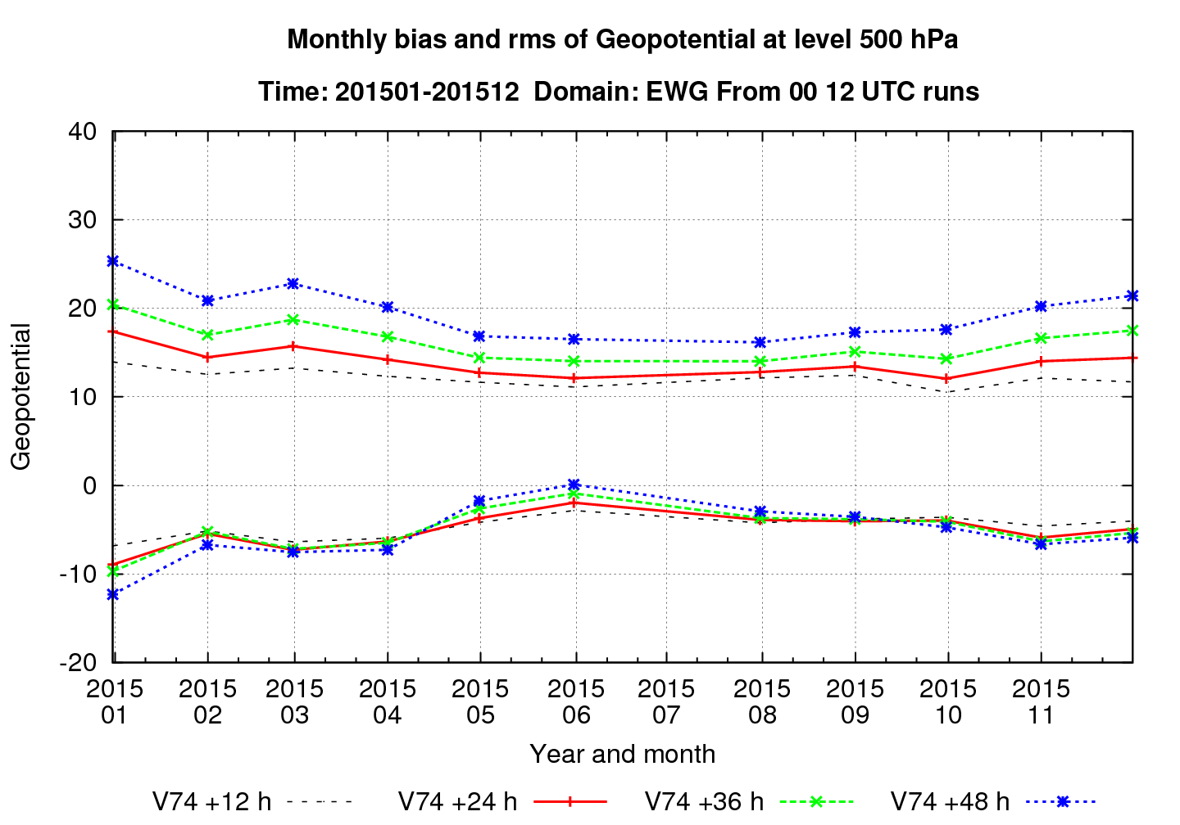

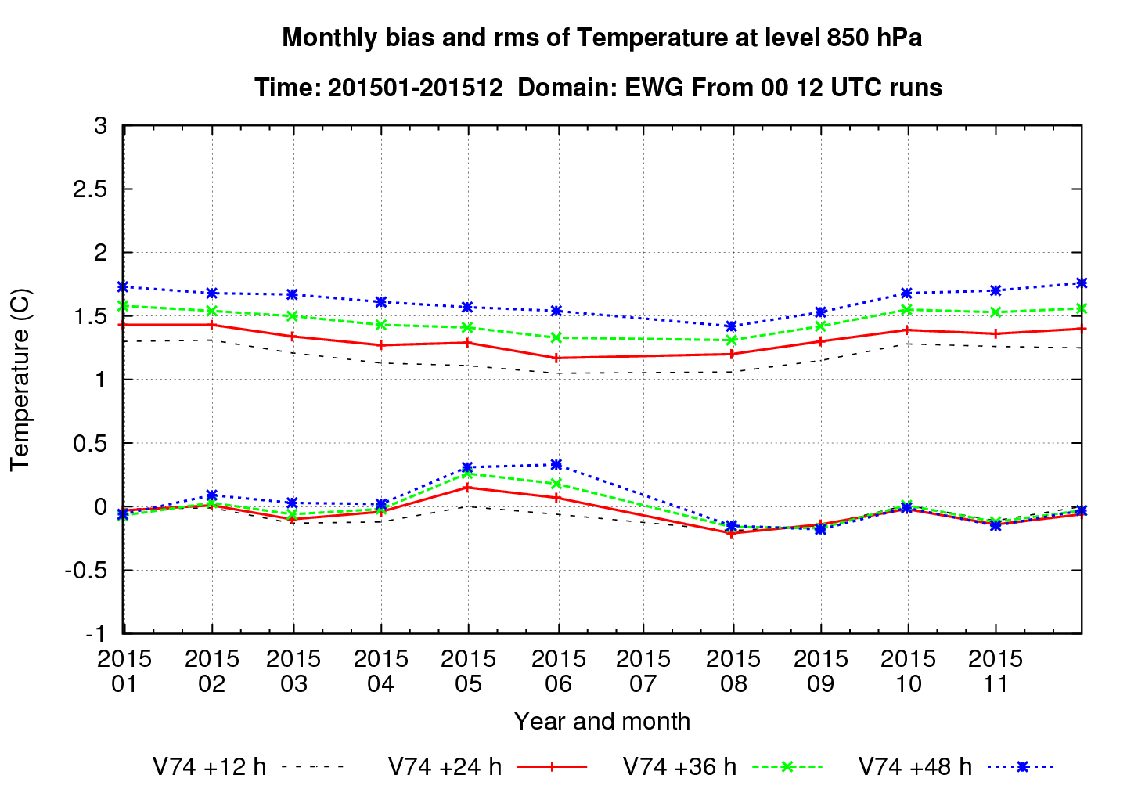

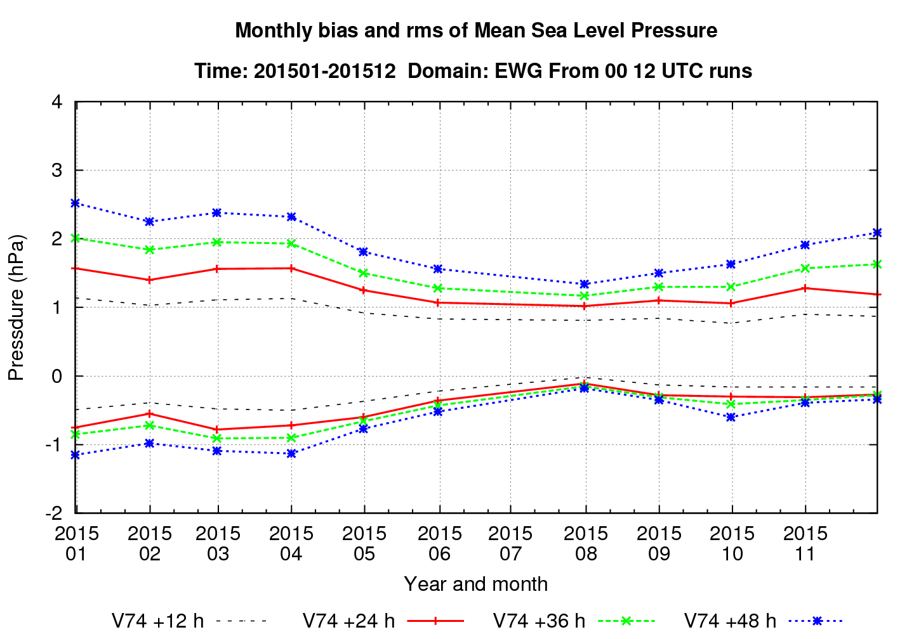

5.2 Research performed in this field
Boisvert et al. (2015b) compared ERA-Interim reanalysis against remote-sensing based results on surface latent heat flux, and found differences up to 55 Wm⁻² in the Beaufort-East Siberian Seas (BESS). The quality of the input data, above all the surface skin temperature, was the main cause for the differences.

6. Plans for the future

6.1 Development of the GDPFS
As a first step of realizing common Nordic NWP (NORDNWP), FMI is preparing to join the MetCoOp joint NWP production between Norway and Sweden. The observation usage in HARMONIE is planned to be extended to include remotely sensed observations (ATOVS, IASI, radar, Mode-S etc.) paving the way towards Rapid Update Cycling (RUC) type of data assimilation interval (1-3h). The lake scheme FLAKE (already in use in HIRLAM) will be implemented into HARMONIE

6.2 Planned research Activities in NWP, Nowcasting and Long-range Forecasting
Current research activities in atmospheric modelling include
- the assimilation of remote sensing data
- surface data assimilation
- utilization of probabilistic forecasting for renewable energy production (HARMONIE-EPS)
- lake modelling
- effects of orography and aerosols
- modelling of built environment and related forecasting

7. References
Atlaskin E, Nurmi P, Dimov D (2015): Final Outcome of the FOTsis Project: Intelligent Road Weather &amp; GIS Services for End-users. 22nd ITS World Congress, Bordeaux, France, 5-9 October 2015.

Baklanov A, Schluenzen H, Joffre S, Suppan P, Baldasano J, Brunner D, Gauss M, Maurizi A, Seigneur C, Kong X (2015a): Seamless Meteorology-Chemistry Modelling: Status and Relevance for Numerical Weather Prediction, Air Quality and Climate Research. EGU2015-15842, EGU2015, Vienna, Austria, 13-17 April 2015. Session AS4.13/HS12.12/NH1.12/OS4.8, 1 pp.

Baklanov A, Schuenzen H, Joffre S, Suppan P, Baldasano J, Brunner D, Gauss M, Maurizi A, Seigneur C, Kong XIN (2015b): Coupled meteorology-chemistry models: needs and benefits for numerical weather prediction, air quality and climate communities. World Weather Open Science Conference 2014, August 16-21, 2014 Montréal, Canada. Paper SCI-PS129.01, p.142. http://wwosc2014.org/pdf/20140825-WWOSC-FinalBookofAbstracts.pdf.

Boisvert L, Wu D, Vihma T, Shie C-L, Susskind J (2015a): Moisture flux increases seen in the Arctic between 2003-2013. Geophysical Research Abstracts, Vol. 17, EGU2015-3996, EGU General Assembly 2015, http://meetingorganizer.copernicus.org/EGU2015/EGU2015-3996.pdf.

Boisvert L.N, Wu D.L, Vihma T, Susskind J (2015b): Verification of air/surface humidity differences from AIRS and ERA-Interim in support of turbulent flux estimation in the Arctic, J. Geophys. Res. Atmos., 120, 945–963, DOI:10.1002/2014JD021666.

Bundel A, Muraviev A, Nurmi P, Kiktev D, Smirnov A, Montani A (2015): Performance of deterministic numerical weather forecasts during the FROST-2014 project field campaign. EMS2015-364. 15th EMS Annual Meeting / 12th European Conference on Application of Meteorology (ECAM), Sofia, Bulgaria, 7-11 September 2015.

Ebert B, Brown B, Chen J, Coelho C, Dorninger M, Göber M, Haiden T, Mittermaier M, Nurmi P, Wilson L, Zhu Y (2015a): Numerical Prediction of the Earth System: Cross-cutting Research on Verification Techniques. In: Seamless Prediction of the Earth System: From Minutes to Months, WMO No. 1156, Chapter 20.

Ebert B, Haiden T, Brown B, Göber M, Mittermaier M, Nurmi P (2015b): Challenge to Develop and Demonstrate the Best New User-Oriented Forecast Verification Metric. EMS2015-105. 15th EMS Annual Meeting / 12th European Conference on Application of Meteorology (ECAM), Sofia, Bulgaria, 7-11 September 2015.

Eerola, K., Rontu, L., Kourzeneva E., Kheyrollah Pour, H. and Duguay, C. (2014): Impact of partly ice-free Lake Ladoga on temperature and cloudiness in an anticyclonic winter situation - a case study using a limited area model. Tellus A 2014, 66, 23929, http://www.tellusa.net/index.php/tellusa/article/view/23929.

Eloranta P, Jämsä J, Nurmi P, Ortiz P, Kauvo K (2015): Co-operative ITS Deployment - Experience and Future Views. 22nd ITS World Congress, Bordeaux, France, 5-9 October 2015.

Gascard J.C, Vihma T, Doscher R (2015): General introduction to the DAMOCLES special issue. Atmospheric Chemistry and Physics Vol. 15 p. 5377-5379. DOI: 10.5194/acp-15-5377-2015.

Gleeson E, Nielsen K. P., Toll V, Rontu L, Whelan E (2015): Shortwave Radiation Experiments in HARMONIE: Tests of the cloud inhomogeneity factor and a new cloud liquid optical property scheme compared to observations. ALADIN-HIRLAM Newsletter, no. 5, August 2015, pp. 92-106. Report is available from http://www.cnrm.meteo.fr/aladin/IMG/pdf/nl5.pdf.

Gregow E, Saltikoff E, Albers S, and Hohti H (2013): Precipitation accumulation analysis – assimilation of radar-gauge measurements and validation of different methods, Hydrol. Earth Syst. Sci. 17, 4109-4120, DOI:10.5194/hess-17-4109-2013.

Gregow E, Pessi A, Mäkelä A (2015a): Lightning data assimilation for nowcasting applications. Proceedings for the 2015 EUMETSAT Meteorological Satellite Conference, 21-25 September 2015, Toulouse, France. Available from: http://www.eumetsat.int/website/home/News/ConferencesandEvents/DAT_2305526.html.

Gregow E, Pessi A, Mäkelä A, Saltikoff E (2015b): Improving the precipitation accumulation analysis for the benefit of hydrological and environmental forecast and management applications. Rainfall in Urban and Natural Systems (UrbanRain) conference proceedings. 10th International Workshop on Precipitation in Urban Areas. http://www.ifu.ethz.ch/urbanrain/proceedings/index.

Gregow E, Bernstein B, Wittmeyer I, Hirvonen J (2015c): LAPS-LOWICE: A Real-Time System for the Assessment of Low-Level Icing Conditions and Their Effect on Wind Power. Journal of Atmospheric and Oceanic Technology, Volume 32, Issue 8 (August 2015) pp. 1447-1463, DOI: http://dx.doi.org/10.1175/JTECH-D-14-00151.1.

Gregow E, Pessi A, Mäkelä A., and Saltikoff E (2016): Improving the precipitation accumulation analysis using radar-, gauge- and lightning measurements, Hydrol. Earth Syst. Sci. Discuss., DOI:10.5194/hess-2016-113, in review, 2016

Hippi M, Miettinen J, Jämsä J, Pahkala J (2014a): Braking distance application developed on Finnish D2I project. Proceedings of SIRWEC 17th International Road Weather Conference, Andorra. Available from http://www.sirwecandorra2014.ad/images/0029%20Hippi.pdf.

Hippi M, Thordarson S and Thorsteinsson H (2014b): Snowdrift forecast for roads based on NWP data. Proceedings of SIRWEC 17th International Road Weather Conference, Andorra. Available from http://www.sirwecandorra2014.ad/images/0038%20Hippi.pdf.

Hippi M (2015): Safer walking during winter time. Walk21-conference, Wien, Austria, 20.-23.10.2015. http://walk21vienna.com/.

Hippi M, Solin O (2015): Winter time road traffic accidents compared to weather in Finland. 15th EMS Annual Meeting &amp; 12th European Conference on Applications of Meteorology (ECAM), 07-11 September 2015, Sofia, Bulgaria. Available at: http://meetingorganizer.copernicus.org/EMS2015/EMS2015-495.pdf.

Hämäläinen K and Niemelä, S (2016): Production of a Numerical Icing Atlas for Finland. Wind Energy., DOI: 10.1002/we.1998, http://onlinelibrary.wiley.com/doi/10.1002/we.1998/full.

Jonassen M.O, Tisler P, Altstädter B, Scholtz A, Vihma T, Lampert A, König-Langlo G, Lüpkes C (2015): Application of remotely piloted aircraft systems in observing the atmospheric boundary layer over Antarctic sea ice in winter. Polar Res., 34, 25651, http://dx.doi.org/10.3402/polar.v34.25651.

Juga I, Nurmi P, Hippi M (2011): Statistical modelling of wintertime road surface friction. Meteorological Applications, DOI: 10.1002/met. 1285.

Juga I (2015): Some aspects of recent weather forecasting procedures at the Finnish Meteorological Institute. UEF2015 (Using ECMWF Forecasts), ECMWF, Reading, UK, 8-10 June 2015. The poster is available at: http://www.ecmwf.int/sites/default/files/UEF2015_Juga.pdf.

Jung T, Bauer P, Goessling H, Gordon N, Klebe S, Bromwich D, Doblas F, Day J, Fairall C, Holland M, Iversen T, Lemke P, Mills B, Nurmi P, Perovich D, Reid P, Renfrew I, Smith G, Svensson G, Tolstykh M (2015): The WWRP Polar Prediction Project (PPP). In: Seamless Prediction of the Earth System: From Minutes to Months, WMO No. 1156, Chapter 19.

Järvi L, Karsisto P, Fortelius C, Demuzere M, Grimmond S, Oleson KEITH, Kouznetsov R, Masson V (2015): Seasonal comparison of three urban land surface schemes in a high-latitude city of Helsinki. CUC9 – 9. Internat. Conf. on Urban Climate jointly with 12. Symposium on Urban Environment. 20-24.7.2015, Toulouse, France. https://www.conftool.com/icuc9/index.php?page=browseSessions&amp;form_session=134.

Kaartinen H, Jämsä J, Hippi M, Pahkala J (2015): Fact and friction. Thinking Highways, vol. 10, no. 1 (2015) pp 40-44. Available at: http://edition.pagesuite-professional.co.uk//launch.aspx?eid=6285215e-ee41-4d26-8e57-b1475875c6e6&amp;pnum=42.

Kangas M and Sokka N (2005): Operational RCR HIRLAM at FMI. Hirlam Newsletter 48, pp. 14-20. Available at: http://hirlam.org/.

Kangas M (2011): On-line boundary layer verification of weather models. Joint ASM 2011 and 21th ALADIN Wk, 5-8 April 2011, Norrkoping, Sweden. HIRLAM Newsletter n. 58, November 2011, 5 pp. Available from http://hirlam.org/index.php?option=com_docman&amp;task=cat_view&amp;gid=263&amp;Itemid=70.

Kangas M, Heikinheimo M, Hippi M (2015: RoadSurf - a modelling system for predicting road weather and road surface conditions. Meteorol. Appl. 22(3): 544-553 (2015), DOI: 10.1002/met.1486.

Kangas M, Rontu L, Fortelius C, Aurela M, and Poikonen A (2016): Weather model verification using Sodankylä mast measurements. Geosci. Instrum. Method. Data Syst., 5, 75–84, 2016, doi:10.5194/gi-5-75-2016. www.geosci-instrum-method-data-syst.net/5/75/2016/.

Karsisto P, Fortelius C, Demuzere M, Grimmond C.S.B., Oleson K. W., Kouznetsov R, Masson V, Järvi L (2015): Seasonal surface urban energy balance and wintertime stability simulated using three land-surface models in the high-latitude city Helsinki. Q.J.R. Meteorol. Soc., DOI: 10.1002/qj.2659

Karsisto V (2015): Improving road weather model forecasts by adjusting the radiation input. Proceedings of 15th annual meeting of EMS (European Meteorological Society) / 12th ECAM (European Conference on Applications of Meteorology), Available at: http://meetingorganizer.copernicus.org/EMS2015/EMS2015-9.pdf

Karsisto V, Nurmi P, Kangas M, Hippi M, Fortelius C, Niemelä S, and Järvinen H (2016): Improving road weather model forecasts by adjusting the radiation input. Meteorol. Appl. 23: 503–513, DOI: 10.1002/met.1574, 2016.

Kheyrollah Pour H, Rontu L, Duguay C, Eerola K, Kourzeneva E (2014): Impact of satellite-based lake surface observations on the initial state of HIRLAM. Part II: Analysis of lake surface temperature and ice cover. Tellus A 2014 66, 21395, http://dx.doi.org/10.3402/tellusa.v66.21395.

Komen G.J, Cavaleri L, Donelan M, Hasselmann K, Hasselman S,Janssen P.A.E.M (1994): Dynamics and modelling of ocean waves. Cambridg University Press, Cambrigde, 532 pp.

Koop, D, Wood, C, and Fortelius C (2016): Urban heat fluxes from Arome-Harmonie compared to eddy-covariance data, Joint 26th ALADIN Workshop & HIRLAM All Staff Meeting 2016, 4-8/04/2016, Lisbon, Portugal, http://www.cnrm-game-meteo.fr/aladin/spip.php?article287.

Kourzeneva E. (2014): Assimilation of lake water surface temperature observations using an extended Kalman filter. Tellus A 2014 66, 21510, http://dx.doi.org/10.3402/tellusa.v66.21510.

Kouznetsov, R, Sofiev, M (2012): A methodology for evaluation of vertical dispersion and dry deposition of atmospheric aerosols. JGR,117, DOI: 10.1029/2011JD016366

Kukkonen J, Olsson T, Schultz D, Baklanov A, Klein T, Miranda A, Monteiro A, Hirtl M, Tarvainen V, Boy M, Peuch V, Poupkou A, Kioutsioukis I, Finardi S, Sofiev M, Sokhi R, Lehtinen K, Karatzas K, San José R, Astitha M, Kallos G, Schaap M, Reimer E, Jakobs H, Eben K. (2012): A review of operational, regional-scale, chemical weather forecasting models. In Europe. Atmos. Chem. Phys., 12, 1-87, www.atmos-chem-phys.net/12/1/2012/, DOI:10.5194/acp-12-1-2012.

Li D, Katul G.G, Zilitinkevich S.S (2015): Revisiting the Turbulent Prandtl Number in an Idealized Atmospheric Surface Layer. Journal of the Atmospheric Sciences Vol. 72, p. 2394-2410. DOI: 10.1175/JAS-D-14-0335.1.

Lu P, Leppäranta M, Cheng B, Li Z (2015): Modeling of albedo and transmittance of ponded Arctic sea ice.
Cold Reg. Sci. Technol., in press.

Mazon J, Niemelä S, Pino D, Savijärvi H, Vihma T (2015): Snow bands over the Gulf of Finland in wintertime.
Tellus A, 67, 25102, http://dx.doi.org/10.3402/tellusa.v67.25102.

Mylne K, Petty K, Nurmi P (2015): Weather-related Hazards and Impacts: Improved Understanding of and Techniques for Decision Making. In: Seamless Prediction of the Earth System: From Minutes to Months, WMO No. 1156, Chapter 22.

Niemelä S (2015): Highlights of NWP activities at FMI in 2014. ALADIN-HIRLAM Newsletter, No. 4, Feb. 2015, 36-38. Available online: http://www.cnrm.meteo.fr/aladin/spip.php?article260.

Nikitina L, Mostmandy S, Nurmi P (2015): End-user focused verification of precipitation nowcast systems during the Sochi 2014 Winter Olympics. EMS2015-576. 15th EMS Annual Meeting / 12th European Conference on Application of Meteorology (ECAM), Sofia, Bulgaria, 7-11 September 2015.

Nurmi P, Bundel A, Dmitrieva T, Kiktev D, Muraviev A, Smirnov A, Vasilyev E, Nikitina L, Bazlova T, Bocharnikov N, Mostmandy S (2015): The Framework of the WMO/WWRP FROST-2014 Forecast Verification Setup and Activities. EMS2015-577. 15th EMS Annual Meeting / 12th European Conference on Application of Meteorology (ECAM), Sofia, Bulgaria, 7-11 September 2015.

Nurmi P (2015a): Road Wise: The latest road-weather modeling system. Meteorological Technology International Journal, April 2015 issue, pp. 28-31.

Nurmi P (2015b): High-impact, end-user focused forecasts and their verification during the Sochi 2014 Winter Olympics. 26th IUGG General Assembly, Praha, July 2015.

Nygård T, Vihma T, Birnbaum G, Hartmann J, King J, Lachlan-Cope T, Ladkin R, Lüpkes C, Weiss A (2015a): Validation of eight atmospheric reanalyses in the Antarctic Peninsula region. Quarterly Journal of the Royal Meteorological Society, published online: 10.1002/qj.2691.

Nygård T, Valkonen T, Vihma T (2015b): Humidity inversions - a key to understand polar clouds better? Dynamics of Atmosphere-Ice-Ocean Interactions in the High Latitudes, 23-27 March, 2015 Rosendal, Norway.

Overland J, FrancisJ, Hall R, Hanna E, Kim S-J, and Vihma T (2015). The Melting Arctic and Mid-latitude Weather Patterns: Are They Connected? Journal of Climate, 28, 7917-7932, DOI: 10.1175/JCLI-D-14-00822.1.

Pirazzini R, Räisänen P, Vihma T, Johansson M, Tastula E-M (2015a): Measurements and modelling of snow particle size and shortwave infrared albedo over a melting Antarctic ice sheet. The Cryosphere, 9, 2357-2381, DOI:10.5194/tc-9-2357-2015.

Pirazzini R, Räisänen P, Vihma T, Johansson M, Tastula E-M (2015b): Snow particle size and shortwave infrared albedo over a melting ice sheet: observations and modelling. Abstract. Ilulissat Climate Days, Ilulissat, Greenland 2 - 5 June 2015, http://www.polar.dtu.dk/english/Ilulissat-Climate-Days.

Prowse T, Bring A, Mård J, Carmack E, Holland M, Instanes A, Vihma T, and Wrona F.J (2015): Arctic Freshwater Synthesis: Summary of key emerging issues, J. Geophys. Res. Biogeosci., 120, 1887–1893, DOI:10.1002/2015JG0031 28.

Rontu L, Eerola K, Kourzeneva E, Vehvilainen B (2012): Data assimilation and parametrisation of lakes in HIRLAM. Tellus Series A - Dynamic Meteorology And Oceanography 64. doi: 10.3402/ tellusa.v64i0.17611, 2012.

Rontu L, Niemelä S, Wastl C, Mary A, Seity Y (2015): OLYMPIC HARMONIE 2014 - Influence of the details of topography in a NWP model. Poster in 33rd International Conference on Alpine Meteorology (ICAM), 31.8 -4.9.2015, Innsbruck, Austria,. http://streaming.uibk.ac.at/medien/c707/c707101/icam2015/poster/P2.44.pdf.

Rontu L, Wastl C, and Niemelä S (2016): Influence of the Details of Topography on Weather Forecast – Evaluation of HARMONIE Experiments in the Sochi Olympics Domain over the Caucasian Mountains. Front. Earth. Sci., 12 February 2016. http://dx.doi.org/10.3389/feart.2016.00013.

Räisänen P, Kokhanovsky A, Guyot G, Jourdan O, and Nousiainen T (2015): Parameterization of single-scattering properties of snow. The Cryosphere, 9, 1277–1301, 2015, DOI:10.5194/tc-9-1277-2015, http://www.the-cryosphere.net/9/1277/2015/tc-9-1277-2015.pdf.

Saltikoff E, Lopez P, Taskinen A, Pulkkinen S (2015a): Comparison of quantitative snowfall estimates from weather radar, rain gauges and a numerical weather prediction model. Boreal Env. Res. 20: 667?678.

Saltikoff E, Cho J, Tristant P, Huuskonen A, Allmon L, Cook R, Becker E, Joe P (2015b): The Threat to Weather Radars by Wireless Technology. Bulletin of the American Meteorological Society.

Savunen T, Kivi R, Poikonen A, Kangas M, Säntti K, Hyvönen R, Mammarella I, Gregow E, Tammelin B (2015): CEOP reference site - Sodankylä, Finland. Finnish Meteorological Institute, reports 2014:9

Schäfer M, Möller M, Zwinger T, Moore J C (2015): Dynamic modelling of future glacier changes: mass-balance/elevation feedback in projections for the Vestfonna ice cap, Nordaustlandet, Svalbard. Journal of Glaciology, 61, 1121-1136 DOI:10.3189/2015JoG14J184.

Siljamo N, Hyvärinen O (2015): Recent developments of the H-SAF MSG/SEVIRI and Metop/AVHRR based snow extent products. 2015 EUMETSAT Meteorological Satellite Conference, Toulouse, France.

Smith G, Jung T, Gordon N, Klebe A, Goessling H, Bauer P, Bromwich P, Chevallier M, Day J, Doblas F, Holland M, Inoue J, Iversen T, Lemke P, Makstash A, Mills B, Nurmi P, Renfrew I, Reid P, Svensson G, Tolstykh M, Yang Q (2015): The Year of Polar Prediction (2017-19). CMOS/AMS Conference on Polar Meteorology and Oceanography, Whistler, Canada, June 2015.

Sofiev, M: Extended resistance analogy for construction of the vertical diffusion scheme for dispersion models. J. Geophys. Res., 107(D12), DOI: 10.1029/2001JD001233, 2002.

Sofiev M, Siljamo P, Valkama I, Ilvonen M, Kukkonen J (2006): A dispersion system SILAM and its evaluation against ETEX data. Atmospheric Environment 40, 674-685.

Sofiev, M, Berger, U, Prank, M, Vira, J, Arteta, J, Belmonte, J, Bergmann, K-C, Chéroux, F, Elbern, H, Friese, E, Galan, C, Gehrig, R, Khvorostyanov, D, Kranenburg, R, Kumar, U, Marécal, V, Meleux, F, Menut, L, Pessi, A.-M, Robertson, L, Ritenberga, O, Rodinkova, V, Saarto, A, Segers, A, Severova, E, Sauliene, I, Siljamo, P, Steensen, B.M, Teinemaa, E, Thibaudon, M, and Peuch, V-H (2015a): MACC regional multi-model ensemble simulations of birch pollen dispersion in Europe, Atmos. Chem. Phys., 15, 8115-8130, DOI:10.5194/acp-15-8115-2015, http://www.atmos-chem-phys.net/15/8115/2015/.

Sofiev, M, Vira, J, Kouznetsov, R, Prank, M, Soares, J, Genikhovich, E (2015b): Construction of an Eulerian atmospheric dispersion model based on the advection algorithm of M.Galperin: dynamic cores v.4 and 5 of SILAM v.5.5, Geosci.Model Developm. Discuss., 8, 2905-2947, DOI:10.5194/gmdd-8-2905-2015.

Sofiev, M, Vira J, Plu M, Parmentier, J (2016): Quarterly report on the daily analyses and forecasts activities, and verification of the SILAM performances. September-October-November 2015. ECMWF Copernicus Report, Copernicus Atmosphere Monitoring Service, 28/01/2016. Available from https://atmosphere.copernicus.eu/sites/default/files/FileRepository/Resources/Documentation/Regional_System/CAMS50_2015SC1_D50.5.1.SILAM_201601.pdf.

Stanislawska K, Krawiec K, Vihma T (2015): Genetic programming for estimation of heat flux between the atmosphere and sea ice in Polar regions. GECCO '15 Proceedings of the 2015 Genetic and Evolutionary Computation Conference, p. 1279-1286, DOI: 10.1145/2739480.2754675

Stenberg P, Manninen T (2015): The effect of clumping on canopy scattering and its directional properties: a model simulation using spectral invariants. International Journal of Remote Sensing, 36, 19-20, s. 5178-5191.

Sterk H.A.M, Steeneveld G.J, Vihma T, Anderson P.S, Bosveld F C, Holtslag A A M (2015): Modelling stable boundary layers with low winds over snow Part I: A WRF model evaluation. Q. J. R. Meteorol. Soc., 141: 2165–2184, July 2015 B DOI:10.1002/qj.2513.

Sukuvaara T, Nurmi P, Hippi M, Ylitalo R, Stepanova D, Eloranta P, Riihentupa, L and Kauvo K (2011): Wireless Traffic Safety Network for Incident and Weather Information, 14th ACM International Conference on Modeling, Analysis and Simulation of Wireless and Mobile Systems, October 31 – November 4, 2011Miami Beach, FL, USA.

Suomi I, Lüpkes C, Hartmann J, Vihma T, Gryning S-E, Fortelius C (2016). Gust factor based on research aircraft measurements: a new methodology applied to the Arctic marine boundary layer. Quarterly Journal of the Royal Meteorological Society (accepted).

Tastula E-M, Galperin B, Dudhia J, LeMone M.A, Sukoriansky S, Vihma T (2015): Methodological assessment of the differences in the physics and performance Methodical comparison of the QNSE and MYJ PBL schemes for stable conditions. Q. J. R. Meteorol. Soc., 141: 2077–2089, July 2015 B DOI:10.1002/qj.2503.

Tijm S, Molendijk M, Karsisto V, Atlaskin E, Nurmi P, Dekker J (2015): Applicability of the FMI Road Weather Model for use in winter maintenance activities for the Dutch highways. In proceedings of Applicability of 15th annual meeting of EMS (European Meteorological Society) / 12th ECAM (European Conference on Applications of Meteorology), Available at: http://meetingorganizer.copernicus.org/EMS2015/EMS2015-393.pdf.

Tuomi, L, Kahma K.K, and Fortelius C (2012): Modelling fetch-limited wave growth from an irregular shoreline. Journal of Marine Systems, 105: 96-105.

Tuomi, L., Pettersson, H., Fortelius C., Tikka, K., Björkqvist, J.-V., Kahma, K. (2014): Wave modelling in archipelagos. Coastal Engineering, 83:205-220.

Tuononen V, Sinclair A, Vihma T (2015): A climatology of low-level jets in the mid-latitudes and polar regions of the Northern Hemisphere, Atmospheric Science Letters, 16, 492-499, DOI: 10.1002/asl.587.

Undén, P , Rontu L, Järvinen H, Lynch P, Calvo J, Cats G, Cuxart J, Eerola K, Fortelius C, Garcia-Moya J.A, Jones C, Lenderlink G, McDonald A, McGrath, Navascues, Woetman Nielsen N, Odegaard V, Rodriguez E, Rummukainen M, Room R, Sattler K, Hansen Sass B, Savijärvi H, Wichers Schreur B, Sigg R, The H, Tijm A (2002):. HIRLAM-5 scientific Documentation. Available from http://hirlam.org/.

Uotila P, Vihma T, and Haapala J (2015): Atmospheric and oceanic conditions and the extremely low Bothnian Bay sea ice extent in 2014/2015, Geophys. Res. Lett., 42, 7740–7749, DOI:10.1002/2015GL064901.

Vihma T, Uotila P (2015): Effects of Arctic sea ice decline on Eurasian climate. Proceedings of the 1st Pan-Eurasian Experiment (PEEX) Conference and the 5th PEEX Meeting, Report Series in Aerosol Science, University of Helsinki, No 163, p. 461-465.

Vihma T, Overland J E, Francis J, Hall R, Hanna E, Kim S-J (2015a): Arctic sea ice melt, the Polar vortex, and mid-latitude weather: Are they connected? Geophysical Research Abstracts, Vol. 17, EGU2015-7297-1, 2015, EGU General Assembly 2015, http://meetingorganizer.copernicus.org/EGU2015/EGU2015-7297.pdf

Vihma T, Screen J, Deser C, Holland M, Newton B, Popova V, Prowse T, Tjernstrom M, Walsh J, Zhang X (2015b): The Arctic atmospheric water cycle: past and future changes and their impacts. 4th Internat. Sympos. on Arctic Research (ISAR-4) / 3th Internat. Confer. on Arctic Research Planning (ICARP III), Toyama, Japan, 23-30 April 2015. http://www.assw2015.org/program/pdf/Abstract/Oral/C_Oral
/C07_O/C07_O04.pdf

Vihma T, Screen J, Tjernström M, Zhang X, Popova V, Newton B, Deser C, Holland M, Walsh J, Prowse T (2015c): Air moisture, clouds and precipitation in the Arctic: processes, changes and research challenges. Dynamics of Atmosphere-Ice-Ocean Interactions in the High Latitudes, 23-27 March, 2015 Rosendal, Norway.

Vihma T, Screen J, Tjernström M, Newton B, Zhang X, Popova V, Deser C, Holland M, Prowse T (2016): The atmospheric role in the Arctic water cycle: A review on processes, past and future changes, and their impacts. J. Geophys. Res. Biogeosci., 121, DOI:10.1002/2015JG003132.

Vira, J, Sofiev, M (2012): On variational data assimilation for estimating the model initial conditions and emission fluxes for the short-term forecasting of SOx concentrations. Atmosph. Environ., 46, pp.318-328, DOI:10.1016/j.atmosenv.2011.09.066.

Vira, J, Sofiev, M (2015): Assimilation of surface NO2 and O3 observations into the SILAM chemistry transport model, Geosci. Model Dev., 8, 191–203, www.geosci-model-dev.net/8/191/2015/, DOI:10.5194/gmd-8-191-2015.

Välisuo I, Kohler J, Vihma T, Zwinger T (2015): Surface mass balance modelling and velocity inversion for Midtre Lovénbreen. International Glaciological Society Nordic Branch Meeting, Copenhagen, Denmark, 29-31 October 2015, https://sites.google.com/site/igsnordicbranch2015/home (access date 13.1.2016).

Walsh J E, Vihma T (2015): Arctic impacts on mid-latitude weather and climate: the research challenge. 4th Internat. Sympos. on Arctic Research (ISAR-4) / 3th Internat. Conf. on Arctic Research Planning (ICARP III), Toyama, Japan, 23-30 April 2015. http://www.assw2015.org/program/pdf/Abstract/Oral/B_Oral/B01_O
/B01_O04.pdf

Wang C, Cheng B, Wang K, Gerland S, Pavlova O (2015a): Modelling snow ice and superimposed ice on landfast sea ice in Kongsfjorden, Svalbard. Ny-Ålesund Seminar, 23 September 2015 - 25 September 2015,Venue Fram Centre, Tromsø, Norway.

Wang C, Cheng B, Wang K, Gerland S, Pavlova O (2015b): Modelling snow ice and superimposed ice formation in an Arctic fjord. Polar Research 2015, 34, 20828, http://dx.doi.org/10.3402/polar.v34.20828.

Wastl C, Mary A, Seity Y, Rontu L, Wittmann C (2015a): Parameterization of orographic effects on surface radiation in AROME-SURFEX. ALADIN-HIRLAM Newsletter no.5, August 2015. http://www.cnrm-game-meteo.fr/aladin/IMG/pdf/nl5.pdf (p.81).

Wastl C, Wittmann C, Mary A, Seity Y, Rontu L, Dian M (2015b): Parameterization of orographic effects on surface radiation in AROME. http://streaming.uibk.ac.at/medien/c707/c707101/icam2015/poster/P2.43.pdf.

Wood C.R, Järvi L, Kouznetsov R, Nordbo A, Drebs A, Vihma T, Hirsikko A, Suomi I, Fortelius C, O’Connor E, Moiseev D, Haapanala S, Moilanen J, Kangas M, Karppinen A, Joffre S, Vesala T, Kukkonen J. (2013): An Overview of the Urban Boundary Layer Atmosphere Network in Helsinki. Bull. American Meteorological Society 94 (11), p. 1675-1690. DOI:10.1175/BAMS-D-12-00146.1.

Yang Y, Li Z, Leppäranta M, Cheng B, Shi L, Lei R (2015): Model simulations of the annual cycle of the thickness of landfast sea ice in the Prydz Bay, East Antarctica. Antarctic Science, 1-12, ©Antarctic Science Ltd 2015, DOI:10.1017/S0954102015000449.

Zhang Z, Vihma T, Stössel A, and Uotila P (2015): The Role of Wind Forcing from Operational Analyses for the Model Representation of Antarctic Coastal Sea Ice. Ocean Modelling, 94, 95-111, DOI:10.1016/j.ocemod.2015.07.019.

