W O R L D M E T E O R O L O G I C A L O R G A N I Z A T I O N
=====================================================

ANNUAL JOINT WMO TECHNICAL PROGRESS REPORT ON THE GLOBAL DATAPROCESSING AND FORECASTING SYSTEM (GDPFS) INCLUDING NUMERICAL WEATHER PREDICTION (NWP) RESEARCH ACTIVITIES FOR 2015

Switzerland
1. Summary of highlights
- COSMO-NExT: The project targets two objectives. Firstly, a 1.1-km, convection permitting version of the COSMO Model is in pre-operation on an area covering the broad alpine region. Secondly, a 20 member ensemble version of the COSMO model, operated at 2.2 km grid on the same domain, was put in pre-operation by the end of the year. Initial conditions will be provided for both systems by a Local Ensemble Transform Kalman Filter (LETKF) and ECMWF HRES for COSMO-1, ENS for COSMO-E boundaries.

- COSMO Code for future HPC: Weather prediction codes has been rewritten in order to match new architectures provided on the supercomputers available on the market. To this end, a specific project is close to completion, aimed at re-implementing the COSMO code on massively parallel multi-core machines as well as on heterogeneous systems with many-core accelerators such as GPUs (Graphics Processing Units).

2. Equipment in use at the Centre
While the majority of MeteoSwiss’ application servers have meanwhile been migrated from Solaris to Linux (with now over 120 servers running on Ubuntu (V.12), quite some on RedHat), still quite many applications still remain on Solaris (V.10). Most of them will be migrated during their next application lifecycle. Also, in 2015 MeteoSwiss has started a project to migrate it’s meteorological software systems (NinJo) from Solaris to Ubuntu in 2016 after completion of the 1.9 version upgrade.

With regards to server hardware, there was little to no change in 2015, it still consists of a few SPARC Enterprise M-Series servers for Solaris based applications, while HP blades and Cisco UCS are used for both Linux and Windows based servers. Virtualization of servers is done on a great extent, using VMware for Linux and Windows – however, some investigations started to use a less expensive virtualization layer, a POC with Proxmox is considered for 2016. Hitachi based SAN/NAS is used for storage, for some very special cases and small amounts of data, a few Qnap NAS devices have been put in place.
Overall, MeteoSwiss continues to consider Open Source software where it makes sense, stability, price and ease of use/handling being some major factors when considering replacements.

Ubuntu 12.04 LTS is still the preferred Linux distribution – there’s plans to migrate to V. 16 starting somewhere towards end of 2016. As for RedHat, we still use RedHat Enterprise Linux 6. Sun Solaris 10 is still in use for legacy applications, like e. g. the Data Warehouse, which is based on Oracle Database (11gR2). Windows Servers are on 2008 R2, migration to Windows 2012 is planned to start in 2016. SCCM 2012 is used for client SW deployment.

All workplace machines are still based on Windows 7 SP1 (x64), along with MS Office 2010.
Migration to newer versions are postponed, as an outsourcing to a central governmental provider is considered, and thus migration would be part of the outsourcing. MeteoSwiss uses HP laptops, however, after some Microsoft updates in late 2014, there’s been issues with the hardware with regard to wireless connections.
Access to Solaris and Linux machines from client PC’s is via X-Windows, using Xmanager and/or X2go.

Application middleware is still mainly based on Oracle Weblogic 12.4c. We use Informatica PowerCenter as ETL tool. Icinga is used as open source monitoring tool, and BMC ARS Remedy (V.8) workflow tool for incidents, problems, and new requests.
Network responsibility has been outsourced to a central governmental provider in 2015, transition was smooth and without any major issues, however no cost reduction resulted for MeteoSwiss.

3. Data and Products from GTS in use
[Author: Estelle Grüter ]
At present nearly all observational data from GTS are used. Further in use are GRIB data from Bracknell, Washington and Offenbach as well as T4-charts from Bracknell and Washington. Additionally most of MOTNE and OPMET data are used as well.
The migration from traditional ASCII Codes to BUFR messages, which has to be done country by country due to different quality of the BUFR messages, has been completed to 34 % for SYNOP and to 30% for TEMP messages from European countries.
An increase can be reported for SYNOP, METAR, TAF, GRIB and DRIFTER, while the number of TAF and AIREP/AMDAR has decreased slightly, BATHY/TESAC and BUFR even to a remarkable amount. The decreasing number of BUFR message compared with 2014 can be explained with the discontinuation of parallel dissemination of GRIB1 via SADIS and WIFS/ISCS.
Typical figures on message input for 24 hours are:

SYNOP : 31730
TEMP A + B : 2871
PILOT A + B : 1069
METAR : 230513
TAF FT + FC : 66451
AIREP, AMDAR : 30858
GRIB : 9978
BUFR : 32582
BATHY/TESAC : 3603
DRIFTER : 8370

4. Forecasting system
4.1 System run schedule and forecast ranges
[Author: Philippe Steiner/Eugen Müller]
In the operational forecasting service of MeteoSwiss several numerical models are used, depended on the forecasting range. For the very short range Cosmo-2 (non-hydrostatic) and Cosmo-7 (hydrostatic) are available. Cosmo-2 has a horizontal resolution of 2.2 km and Cosmo-7 has 6.6 km. Cosmo-7 is driven by the IFS (Boundary conditions) of ECMWF. Cosmo-2 is nested in Cosmo-7. Cosmo-7 runs three times a day, based on the 00, 06 and 12 UTC boundary conditions. Cosmo-2 runs every 3 hours and has a lead time of 33 h, respectively 45 h for the 03 UTC run. In 2015 the new models Cosmo-1 (1.1 km) and Cosmo-E (Ensemble, 2.2 km, 21 members) ran in a preoperational mode. The Comso-1 runs every 3 hours and has a lead time of 33 h, respectively 45 h for the 03 UTC run. The Cosmo-E runs twice a day (00 and 12 UTC) with a lead time of 120 hours.

For the medium range forecasts and in part also for the short range the IFS of ECMWF with the high resolution model HRES and the ensemble system ENS are mainly used. Additionally the IFS results are compared with the US model GFS.

Furthermore the forecasters have access to post processed data such as Kalman Filter and Model Output Statistics (MOSMIX by DWD) and INCA by ZAMG.

For the interpretation by the forecasters the model data are presented with the visualization system Ninjo (developed by a consortium of several meteorological services). In addition the Cosmo fields can be visualized with a browser tool, and the ECMWF fields with ecCharts (an ECMWF webtool).

In the case of an incident the forecasters can start trajectory and diffusion calculations. For trajectories the so called Lagranto model provides calculations with input data of Cosmo-2, Cosmo-7 and ECMWF. And similar for diffusions there’s the Flexpart model based on Cosmo-2, Cosmo-7 and ECMWF input data. Additionally NOAA hysplit calculations are available.
Short range
Medium and extended range forecasting are based on external NWP sources, but MeteoSwiss runs their own short-range forecasting system. The core of this system is the non-hydrostatic model COSMO (of the Consortium for Small-Scale Modelling, see section 7).
At MeteoSwiss, the model is running operationally at two spatial scales: The regional model COSMO-7 with a horizontal resolution of about 6.6.km is driven by the ECMWF global model IFS. The local model COSMO-2, having a horizontal grid spacing of about 2.2 km, is nested in COSMO-7. The nesting of NWP models is illustrated in Figure 1.
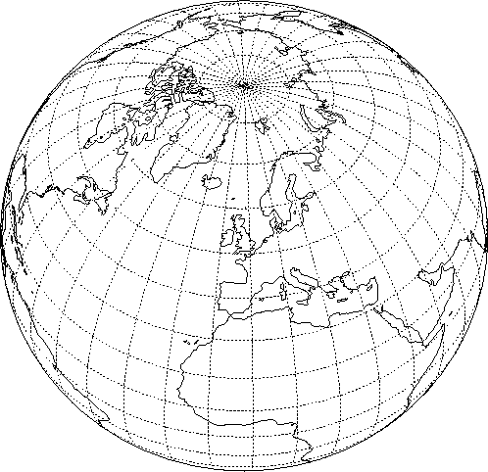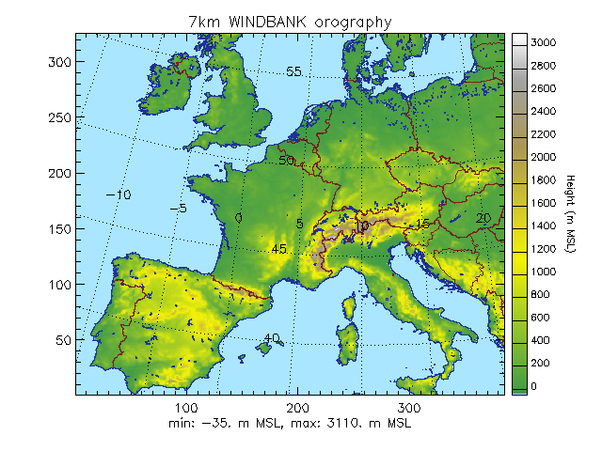Figure 1 NWP system of MeteoSwiss
ECMWF IFS
COSMO-7
COSMO-2

The primary aim of COSMO-2 is to provide forecasts from nowcasting to very short-range time scales, whereas COSMO-7 is used for the short-range time scale.
Both COSMO-7 and COSMO-2 have their own assimilation cycle, which is updated in intervals of 3 hours. Three daily 72 hours COSMO-7 forecasts are calculated, based on the 00, 06 and the 12 UTC IFS (main or boundary conditions) runs. One COSMO-2 forecast is computed every 3 hours in parallel to the computation of the necessary COSMO-7 boundary conditions. The lead time of the COSMO-2 forecast starting at 03 UTC is 45h, and 33h otherwise. The cut-off time for all forecasts is 45 minutes.

An on-demand mode can be activated, e.g. in case of incident in nuclear power plants. COSMO-2 is then computed hourly with at least 3 hours assimilation and 6 hours forecast.
A sophisticated set of scripts controls the whole operational suite, and allows for a very high reliability of the system, with less than 2% of the forecasts requiring manual intervention. This same environment is also used to run parallel suites, to validate proposed modifications to the system, and to facilitate experimentation by the modelling group.

The computing resources and expertise are provided by the Swiss National Supercomputing Centre (CSCS, see www.cscs.ch). COSMO-7 and COSMO-2 are calculated on a Cray XE6 equipped with AMD Opteron 12-core processors, and achieve a sustained performance of 270 GFlops on 1079 computational cores for COSMO-2. Pre- and post-processing run on the service nodes of the machine. An additional machine same architecture and with 4032 computational cores is available for as fail-over and for R&D. A large multi-terabytes long term storage is used for archiving purposes and a 1 GBit/s link connects the MeteoSwiss main building with the CSCS (Swiss Center for Scientific Computing, located in Lugano, on the southern side of the Alps).

4.2 Medium range forecasting system (4-10 days)
-

4.2.1 Data assimilation, objective analysis and initialization
-
4.2.1.1 In operation
-
4.2.1.2 Research performed in this field
-
4.2.2 Model
-
4.2.2.1 In operation
-
4.2.2.2 Research performed in this field
-
4.2.3 Operationally available Numerical Weather Prediction (NWP) Products
-
4.2.4 Operational techniques for application of NWP products (MOS, PPM,
KF, Expert Systems, etc.)
-
4.2.4.1 In operation
-
4.2.4.2 Research performed in this field
-

4.2.5 Ensemble Prediction System (EPS) (Number of members, initial state, perturbation method, model(s) and number of models used, number of levels,main physics used, perturbation of physics, post-processing: calculation of indices, clustering)

4.2.5.1 In operation
MeteoSwiss does not yet run any medium range forecasting system in operational mode, but makes use of the limited-area ensemble prediction system COSMO-LEPS based on global ECMWF Ensemble forecasts (EPS) and on the COSMO Model. COSMO-LEPS has been developed at ARPA-SIMC, Bologna, and runs operationally at ECMWF (see section 7.1.1). It delivers probabilistic high-resolution short to early-medium range (5.5 days) forecasts available at MeteoSwiss.

4.2.5.2 Research performed in this field
A 20 member ensemble version of the COSMO model, operated at 2.2 km grid on the broad alpine area, up to 120 hours. This system will be put in operation in the first semester 2016.

4.2.5.3 Operationally available EPS Products
A neural classification scheme is in application based on ECMWF/IFS-ENS to provide forecasters with guidance related to medium range forecasts up to 240 hours.

4.3 Short-range forecasting system (0-72 hrs)

4.3.1 Data assimilation, objective analysis and initialization

4.3.1.1 In operation
Data assimilation of COSMO is based on the nudging or Newtonian relaxation method, where the atmospheric fields are forced towards direct observations at the observation time. Balance terms are also included: (1) hydrostatic temperature increments balancing near-surface pressure analysis increments, (2) geostrophic wind increments balancing near-surface pressure analysis increments, (3) upper-air pressure increments balancing total analysis increments hydrostatically. A simple quality control using observation increments thresholds is in action.
Following conventional observations are currently assimilated both for COSMO-7 and COSMO-2: synop/ship/buoys (surface pressure, 2m humidity, 10m wind for stations below 100 m above msl), temp/pilot (wind, temperature and humidity profiles), airep/amdar (wind, temperature) and wind profiler data. COSMO-2 additionally assimilates radar data, using the 2-dimensional latent heat nudging scheme. An empirical quality function for radar quantitative precipitation estimates is in operation, which is based on the frequency of signal occurrence of a particular radar pixel (D. Leuenberger et al, 2010, and references therein).
MeteoSwiss uses its own snow analysis which is derived from MSG satellites combined with dense observations. A multi-layer soil model with 8 layers for energy and 6 for moisture is used. Finally, the vegetation and ozone fields are based on climatic values.
The MeteoSwiss Data Warehouse (DWH) is the operational data base for conventional observations. Data from DWH is retrieved at CSCS in BUFR format, and converted to the NetCDF format with the bufrx2netcdf software of DWD. The number of assimilated conventional observations is monitored.

4.3.1.2 Research performed in this field
An ensemble based data assimilation system with a convection-permitting mesh-size of about 2 km is in development in the framework of the MeteoSwiss project “COSMO-NExT” in collaboration with DWD. The data assimilation system employs a Local Ensemble Transform Kalman Filter (LETKF) and will use about 40 members for the first guess ensemble. Members are perturbed using stochastic algorithms for the physical tendencies (SPPT). The data assimilation system will provide the initial data for an ensemble forecasting system (COSMO-E) at the same resolution as well as a deterministic forecast (COSMO-1) at 1 km mesh-size. It will also provide the initial condition perturbations for COSMO-E.

4.3.2 Model
-
4.3.2.1 In operation
A thorough description of the COSMO Model itself can be found on the COSMO web site (see section 7.1). It is a primitive equation model, non-hydrostatic, fully compressible, with no scale approximations. The prognostic variables both for COSMO-7 and COSMO-2 are the pressure perturbation, the Cartesian wind components, the temperature, the specific humidity, the liquid water content, cloud ice, rain, snow and turbulent kinetic energy. COSMO-2 furthermore uses a prognostic graupel (ice pellets) hydrometeor class in the microphysical parameterization. COSMO-7 uses the Tiedtke scheme to parameterize convection, whereas in COSMO-2 convection is parameterized by a shallow convection scheme, and the deep convection is explicitly computed.
The model equations are formulated on a rotated latitude/longitude Arakawa C-grid, with generalized terrain-following height coordinate and Lorenz vertical staggering. Spatial discretization is done using finite differences of at least second-order; time integration is based on a third-order Runge-Kutta split-explicit scheme. Advection of dynamic variables is performed using a fifth-order upstream discretization. Fourth-order linear horizontal diffusion with an orographic limiter is active for wind in COSMO-7 only. Rayleigh-damping is applied in the upper layers. For the advection of the humidity constituents, a symmetric, Strang-splitted positive-definite advection scheme after Bott is used is used at each time step.
COSMO-7 is calculated on a 393 x 338 mesh with a 3/50° mesh size (about 6.6 km), on a domain covering most of Western Europe. 60 layers are implemented in the vertical, whereas the vertical resolution in the lowest 2 km of the atmosphere increases from about 10 m up to 250 m. The main time step is 60 seconds. COSMO-2 is calculated on a 520 x 350 mesh, with a 1/50° mesh size (about 2.2 km), on a domain which is centred on the Alps. The COSMO-7 mesh is chosen in such a way that on the integration domain of COSMO-2, each COSMO-7 grid point coincides with a grid point of COSMO-2. COSMO-2 uses the same vertical configuration as COSMO-7. The main time step is 20 seconds. Table 1 summarizes the specifications of the new COSMO system.
 | COSMO-7 | COSMO-2
Number of grid points and levels | 393 x 338, 60L | 520 x 350, 60L
Horizontal mesh size | 3/50° ~ 6.6km | 1/50° ~ 2.2km
Time step | 60s | 20s
Data Assimilation | Conv. Observations | Conv. Observations  + Radar
Table 1 Specification of COSMO-7 and COSMO-2
MeteoSwiss provides pollen forecasts which are based on the numerical pollen dispersion model COSMO-ART of the Karlsruhe Institute of Technology (KIT) (Vogel et al, 2009, and Vogel et al, 2008). Simulated species include birch (since 2011), grass (since 2012), Ambrosia (since 2014). Alder will be implemented in 2016. COSMO-ART provides spatially and temporally highly resolved pollen forecasts hitherto not available.

4.3.2.2 Research performed in this field

Development of a deterministic 1 km implementation of COSMO
Many of the key physical processes of Alpine meteorology (valley winds, orographically influenced/triggered precipitation, convection, fog) are still only partly resolved in COSMO-2, which employs 2.2 km horizontal grid spacing. Apart from the canonical improvement of the resolution of topography and land-use, evidence from research (e.g. Langhans et al. 2012, Bryan et al. 2007) also suggests improvements in near-surface winds as well as convection and entailing precipitation. Thus, since beginning of 2012 and within the framework of the COSMO-NExT project, MeteoSwiss is developing a deterministic 1.1 km implementation of COSMO named COSMO-1. The domain is 25% larger than the previous COSMO-2 domain, and spans the broader Alpine region. The model will be implemented using a rapid update cycle (RUC) with a new forecast every 3h. Research currently focusses on shallow convection parametrization (representation of shallow convection in the “grey-zone”), improved external parameters (new datasets for topography and soil-type), as well as the tuning and validation of 1.1 km simulations against measurements in complex topography and LES (Large Eddy Simulations) references.
Redesign of the COSMO model code for future HPC architectures
The computing power available is the major constraint limiting the horizontal resolution, the complexity of the model system and the number of ensemble members. This is true for weather prediction and climate modelling. The numerous compute cores on current day chips competing for shared resources such as memory and communication bandwidth allow only marginal performance improvements. In this respect, emerging supercomputing architectures such as heterogeneous computing nodes equipped with many-core GPU accelerators (Graphical Processor Units) are expected to bring breakthroughs. However, current weather prediction codes have to be accordingly updated in order to leverage such architectures.
The priority project POMPA (Performance on Massively Parallel Architectures) aims at implementing the COSMO numerical weather prediction and regional climate model on massively parallel multi-core machines and heterogeneous GPU systems. The code redesign, now completed, enables a portable implementation that improves the available memory bandwidth on CPUs and GPUs.
The GPU version of COSMO, making use of compiler directives in some parts and a domain-specific embedded language (DSEL) named STELLA, is now regularly integrated for weather forecasting and climate research on a hybrid system named Piz Kesch (Cray CS Storm). This GPU-version of the code brings significant benefits both in terms of time-to-solution as well as in energy-impact for typical use-cases of the COSMO model.

4.3.3 Operationally available NWP products

4.3.4 Operational techniques for application of NWP products (MOS, PPM, KF, Expert Systems, etc..)
MeteoSwiss has developed and maintains "fieldextra", a tool aimed at producing and delivering complex packages of numerical weather forecasts. An official COSMO software, fieldextra is used both as a pre- and post-processing instrument on the MeteoSwiss NWP production suite.

Designed as a toolbox, robustly written and thoroughly tested, fieldextra supports the manipulation of NWP model data, especially COSMO model data, and gridded observations. Input data is read once by the execution of the software, as many products as desired can be delivered. In between, a set of operators that can be combined in any meaningful way allows the construction of the aforementioned products. The program is controlled by a collection of Fortran namelists, stored in a control data file. Checks are performed on user defined parameters, with a diagnostic report delivered by the end of each execution. Simple data operations, as well as demanding processing is supported. As for example, selection of data satisfying convoluted constraints, the comparison and/or merging of multiple fields, horizontal and vertical re-gridding, computation of regional conditions, stability indices or EPS derived quantities are easily performed. Both point values and gridded fields can be generated. GRIB 1, GRIB 2, NetCDF and a rich set of ASCII formats are offered. Last but not the least, a major effort is continuously devoted to the optimization of both the memory footprint and the execution time. Fieldextra is increasingly used as a standard software among the COSMO community.

4.3.4.1 In operation

4.3.4.2 Research performed in this field
Post-processing algorithms aimed at improving local forecasts, tailored to operate on limited area NWP models with frequent version releases are developed in the frame of the “COSMO-MOS” MeteoSwiss project. Two statistical approaches are implemented so far. Firstly, multiple linear regression schemes automatically selecting relevant predictors target variables (predictands) that can be transformed in approximate normal distributions (e.g. temperature, wind speed etc). Secondly, the extended logistic regression approach (as being suggested by Wilks, Meteorological Applications, 2009) is engaged for target variables related to hazard assessment, transforming deterministic forecasts in calibrated probability distributions. An array of sensitivity studies allows the definition of optimally suited set-ups for these systems, including sampling strategies, length of training period, selection of potential predictors and updating cycle.

4.3.5 Ensemble Prediction System (Number of members, initial state, perturbation method, model(s) and number of models used, perturbation of physics, postprocessing: calculation of indices, clustering)

4.3.5.1 In operation
-
4.3.5.2 Research performed in this field
An 20 member ensemble, convection-permitting system operated at mesh-size of 2.2 km is in development within the frame of the MeteoSwiss project “COSMO-NExT”. Ensemble initial conditions are provided firstly by a Local Ensemble Transform Kalman Filter (LETKF), secondly by ECMWF ENS (boundaries). They are consecutively submitted to a stochastic perturbation of their physical tendencies during the integration. The system shall be run on a forecast range of 120 hours twice a day and start operational production in 2016.

4.3.5.3 Operationally available EPS products
-

4.4 Nowcasting and Very Short-range Forecasting Systems (0-12 hrs)

4.4.1 Nowcasting system

4.4.1.1 In operation

Tracking and characterization of convective cells by radar (system TRT)
MeteoSwiss runs operationally the real-time object-oriented nowcasting tool TRT (Thunderstorms Radar Tracking), as a part of its severe thunderstorms nowcasting, warning and information system. TRT is a multiple-radars nowcasting system that uses heuristic and centroid-based methods for the automatic detection, tracking and characterisation of intense convective cells.
During the summer season, based on the TRT, MeteoSwiss starts the diffusion, by local and national radio stations, of heavy thunderstorms warnings in whole Switzerland for the general public as well as to civil protection authorities, with simple flash-news, with a lead time of 30-120 min (Hering et al., 2005).
TRT is based on a dynamic thresholding scheme applied on the reflectivity data of multiple-radar composites (Hering et al., 2004). The dynamic scheme is able to identify each storm object at individual thresholds, depending on the stage of its life cycle. A detected storm cell is tracked in successive images using the method of the geographical overlapping of cells. It is then possible to create the time history of cell displacement, and tracks are created from a sequence of radar images. Since TRT is tuned to identify individual cells rather than storm systems, the evolution of cell-based characteristics is available to the forecasters. Complex cases with several cells, splits and merges are also taken into account.
As input the TRT uses the reflectivity data of the Swiss composite image of 4 volumetric, dual-polarization, C-Band Doppler radars with a time resolution of 5 minutes. A 20-elevation volume scan between -0.2° and 40° is performed operationally. For the cell detection we use the vertical maximum projection between 1 and 18 km.
In order to explore the capability of the tool to assess the severe weather potential of thunderstorms, TRT fully exploits 3D-radar data and has been expanded to a multiple-sensors system including cloud-to-ground lightning data with both polarities (Hering et al., 2006). Cell characteristics describing the 3D storm structure and properties as well as the accompanying time series, are computed from the volumetric radar data. These parameters include grid- and cell-based 15/45 dBZ echo tops, VIL (Vertically Integrated Liquid), as well as the altitude of the maximum storm reflectivity. To compute the multiple-radar severe storms detection products TRT uses the 3D Cartesian composite image of the Swiss radar network.
TRT also runs a heuristic cell severity ranking algorithm (Hering et al. 2008). This algorithm integrates the most significant radar-based severity attributes from the 3D storm structure into a single numerical parameter, in order to assess the potential danger posed by the individual cells. The severity rank is computed by integrating the cell-based attributes VIL, the EchoTop 45dBZ altitude, the maximum cell reflectivity, and the area above 55 dBZ with a fuzzy-logic-like scheme.

For a detailed description see:
Hering, A. M., C. Morel, G. Galli, S. Sénési, P. Ambrosetti, and M. Boscacci, 2004: Nowcasting thunderstorms in the alpine region using a radar based adaptive thresholding scheme. Proceedings, Third ERAD Conference, Visby, Sweden, 206-211. www.copernicus.org/erad/2004/online/ERAD04_P_206.pdf
Hering, A. M., S. Sénési, P. Ambrosetti, and I. Bernard-Bouissières, 2005: Nowcasting thunderstorms in complex cases using radar data. Proceedings, World Weather Research Programme's Symposium on Nowcasting and Very Short Range Forecasting (WSN05), Toulouse, France, September 5-9, 7 pp. www.meteo.fr/cic/wsn05/resumes_longs/2.14-73.pdf
Hering, A. M., U. Germann, M. Boscacci, and S. Sénési, 2006: Operational nowcasting of thunderstorms in the Alpine region using 3D-radar severe weather parameters. Proceedings, Fourth ERAD Conference, Barcelona, Spain, 453-456. www.grahi.upc.edu/ERAD2006/proceedingsMask/00122.pdf
Hering, A. M., U. Germann, M. Boscacci, and S. Sénési, 2008: Operational nowcasting of thunderstorms in the Alps during MAP D-PHASE. In Proceedings of 5th European Conference on Radar in Meteorology and Hydrology (ERAD), 30 June–4 July 2008, Helsinki, Finland. pp. 5. Copernicus: Goettingen, Germany.

Quantitative precipitation estimation by radar (product RAIN)
The quantitative precipitation estimate (QPE) Nowcasting radar product RAIN was developed to meet both the meteorologist’s and the hydrologist’s requirements. It is the best radar estimation of precipitation amount on the ground in Switzerland. The RAIN product is the result of sophisticated correction algorithms for radar operation in the Alps. Data processing includes automatic hardware calibration, adjustment with gauge measurements, 8-step dynamic elimination of ground echoes, frequency-based residual ground echo removal, and correction for beam shielding and vertical reflectivity profile (Germann et al. 2006).

For a detailed description see:

Germann, U., G. Galli, M. Boscacci, and M. Bolliger, 2006: Radar precipitation measurement in a mountainous region. Q. J. R. Meteorol. Soc., 132, 1669-1692.

Real-time radar-raingauge merging (CombiPrecip)
CombiPrecip aims to produce accurate precipitation estimation maps by combining raingauges and radar data in real-time. The underlying technology is geostatistical in nature, where both spatial and temporal information has been taken into account in a so called co-kriging with external drift modelling scheme. The technique is coupled with innovative engineering to mitigate artifacts in the extrapolation regime and in the presence of strong convective cells where lack of sufficient representativeness of raingauge data typically causes problems. CombiPrecip is running operationally at MeteoSwiss and shows a significant improvement over radar-only rainfall maps especially in terms of bias.

For a detailed description see:

Sideris I.V., M. Gabella, R. Erdin and U. Germann, 2014. Real-time radar-raingauge merging using spatiotemporal co-kriging with external drift in the alpine terrain of Switzerland, Q. J. Roy. Meteor. Soc. 140: 1097-1111.

Context and Scale Oriented Thunderstorm Satellite Predictors Development (COALITION)
Through a 3-year fellowship funded by EUMETSAT MeteoSwiss has developped a nowcasting applications into an entity-oriented model, which merges severe convection predictors retrieved from different sources (MSG, Weather Radars, NWP, lightning climatology and orographic gradients) with evolving thunderstorm properties. The heuristic model calculates probabilistic information about time, space and intensity evolution of severe convection for use by decision makers. Focus is given to early detection of severe storms over the European Alpine region. The project was terminated in 2012 and at MeteoSwiss the system runs now in real-time, in an operational mode.

For a detailed description see:

L. Nisi, P. Ambrosetti and L. Clementi, 2014. Nowcasting severe convection in the Alpine region: the COALITION approach. Q. J. R. Meteorol. Soc. 140: 1684–1699. DOI: 10.1002/qj.2249.

Automatic precipitation alerts: NowPAL
MeteoSwiss recently introduced NowPAL (NOWcasting of Precipitation AccumuLations), a novel operational nowcasting system specifically designed to issue heavy rainfall alerts over pre-defined geographical regions in Switzerland.
Since the impact of heavy precipitation strongly depends on the immediate past rainfall, the tool combines the past observed precipitation accumulation with the forecast rainfall field. The total rainfall is then evaluated within pre-defined geographical regions and compared with threshold values in order to issue the alerts. The thresholds used for the alerts are the rainfall values corresponding to specific return periods. Since it is fully configurable, the system is appropriate to issue automatic alerts for different customers and applications, ranging from the general alerts for the 159 Swiss official warning regions to more specific alerts for small urban areas or alpine catchments.

For a detailed description see:

Panziera L., Gabella M., Zanini S., Hering A., Germann U., and Berne A., 2016: A radar-based regional extreme rainfall analysis to derive the thresholds for a novel automatic alert system in Switzerland. Hydrol. Earth Syst. Sci., 20, 2317–2332.

Automatic heavy thunderstorm alerts: Flash-O-matic
In case of severe thunderstorms MeteoSwiss alerts authorities and the population by means of flash-news warnings with a lead-time of some tens of minutes. These short-term warnings are based mainly on the operational, multi-sensor nowcasting system TRT (see Chap. 4.4.1.1). Although the current nowcasting systems run automatically, the final decision for the warning and its release are taken by the forecaster on duty. To speed up the whole warning process and to allow the final users (such as emergency services, authorities, and the general public) to save several minutes to take action, MeteoSwiss recently introduced the short-term, small-scale fully automated operational thunderstorm warning system Flash-O-matic. The full warning chain is completely automatized, including decision making and warning issuing by SMS. The tool allows a user to receive thunderstorm information for a given specific location directly and automatically on his phone whenever the system detects an approaching cell.
The new Flash-O-matic algorithm integrates the cell severity ranking product and the latest cell motion vectors from the TRT system to extrapolate cell position; it also accounts for the forecast uncertainty. Alerts are characterized by four intensity levels. They are computed every 5 minutes for the next 30 minutes and are issued for every ZIP code (mean size of about 10 km² in populated areas).

For a detailed description see:

Hering A., Nisi L, Della Bruna G., Gaia M., Nerini D., Ambrosetti P., Hamann U., Trefalt S., and Germann U., 2015: Fully automated thunderstorm warnings and operational nowcasting at MeteoSwiss. Proceedings European Conference on Severe Storms (ECSS), 14–18 September 2015, Wiener Neustadt, Austria, ECSS2015-80-1.

4.4.1.2 Research performed in this field

Ensemble technique for radar precipitation fields (technique REAL)
As part of the WMO-WWRP forecast demonstration project MAP D-PHASE and the European concerted research action COST-731 MeteoSwiss developed an ensemble technique to characterize the residual errors in radar precipitation fields. Each member of the radar ensemble is a possible realization of the unknown true precipitation field given the observed radar field and knowledge of the space-time error structure of radar precipitation estimates. Feeding the alternative realizations into a hydrological model yields a distribution of response values, the spread of which represents the sensitivity of runoff to uncertainties in the input radar precipitation field. The presented ensemble generator is based on singular value decomposition of the error covariance matrix, stochastic simulation using the LU decomposition algorithm, and autoregressive filtering. The real-time implementation of the radar ensemble generator coupled with a semi-distributed hydrological model in the framework of MAP DPHASE is one of the first experiments of this type worldwide.

For a detailed description see:

Germann, U., Berenguer M., Sempere-Torres, D. and Zappa M., 2009: REAL – Ensemble radar precipitation estimation for hydrology in a mountainous region. Q. J. R. Meteorol. Soc., 135, 445-456.

Nowcasting heavy orographic precipitation using Doppler radar and radiosounding (project COST-731)
MeteoSwiss developed as part of COST-731 a novel heuristic system for nowcasting heavy precipitation in the Alps. The system uses as input estimates of the mesoscale wind field as derived from real-time Doppler radar measurements and information on air mass stability from radio-soundings and ground stations. Both mesoscale flow and upstream air mass stability are predictors of the amounts and geographic distribution of heavy orographic precipitation, and can therefore be exploited for nowcasting. Since 2012 the system runs at MeteoSwiss in real-time, in a pre-operational mode.

For a detailed description see:

Panziera L, Germann U. 2010. The relation between airflow and orographic precipitation on the south-ern side of the Alps as revealed by weather radar. Q. J. R. Meteorol. Soc. 136: 222–238. DOI:10.1002/qj.544

Improving Preparedness and Risk Management for Flash Floods and Debris Flow Events (project IMPRINTS)
Over complex terrain such as the Alps current nowcasting systems based on Lagrangian persistence of radar precipitation fields fail to produce useful forecasts, because the orography interferes with the evolution of precipitation, in particular by means of blocking and enhancement. As part of the FP7 research project IMPRINTS (2009-2012), MeteoSwiss investigates orographic forcing of precipitation and incorporate the findings into current Lagrangian persistence nowcasting systems. If successful, the resulting radar nowcasting system will be implemented in the Swiss radar data processing chain and will be extended by ensemble techniques and an algorithm for blending radar nowcasts with NWP model output.

For a detailed description see:

Panziera, L., U. Germann, M. Gabella and P. V. Mandapaka, 2011. NORA–Nowcasting of Orographic Rainfall by means of Analogues. Q. J. R. Meteorol. Soc. 137: 2106–2123
Mandapaka, P.V., U. Germann, L. Panziera and A. Hering, 2011. Can Lagrangian Extrapolation of Radar Fields Be Used for Precipitation Nowcasting over Complex Alpine Orography?, Weather and Forecasting, 27: 28-49
Mandapaka, P.V., U. Germann, L. Panziera, 2013. Diurnal cycle of precipitation over complex Alpine orography: inferences from high resolution radar observations. Quarterly Journal Royal Met. Soc. 139: 1025-1046. DOI: 10.1002/qj.2013.
Panziera, L., C. N. James and U. Germann, 2015. Mesoscale organization and structure of orographic precipitation producing flash floods in the Lago Maggiore region. Q. J. R. Meteorol. Soc., 141: 224-248. DOI: 10.1002/qj.2351.

4.4.2 Models for Very Short-range Forecasting Systems

4.4.2.1 In operation

Integrated Nowcasting through Comprehensive Analysis (INCA)
The nowcasting analysis and forecasting system INCA, developed by the Austrian NWS ZAMG is run operationally at MeteoSwiss. This novel approach produces meteorological fields, with high resolution in time and space (gridded values) for several parameters, incorporating available information like numerical models and diverse kinds of observation (both in-situ and remote sensed), as well as high resolution orography. Several customer oriented products have been developed und made operational, particularly for the rain and snow forecast of in the Nowcasting range (both internally and externally).

4.4.2.2 Research performed in this field
Integrated Nowcasting through Comprehensive Analysis (INCA)
The interpolation algorithm between NWP model and INCA 3D-grid has been further optimized for use with very high resolution NWP models data (horizontal grid size 1-2 km). The vertical interpolation weights for temperature and humidity corrections have been modified. The overall performance for temperature and humidity has been improved. The update frequency has been increased to 10 min for all the parameters.

4.5 Specialized numerical predictions (on sea waves, storm surge, sea ice, marine pollution transport and weathering, tropical cyclones, air pollution transport and dispersion, solar ultraviolet (UV) radiation, air quality forecasting, smoke, sand and dust, etc.)
-

4.5.1 Assimilation of specific data, analysis and initialization (where applicable)

4.5.1.1 In operation

4.5.1.2 Research performed in this field

4.5.2 Specific models (as appropriate related to 4.5)
[Authors: Philippe Steiner / Andreas Pauling/Dominique Ruffieux]

- COSMO-ART provides spatially and temporally highly resolved pollen forecasts.
- The dispersion of airborne radioactive nuclides is modelled using the FLEXPART model. FLEXPART is a freely available Lagrange particle dispersion model that has been adapted for use with the COSMO model input by the Swiss institute EMPA. The dispersion calculations are based on the two operational resolutions of the COSMO model at MeteoSwiss and are run in both routine and on-demand mode.
- CN-MET is an integrated analysis and forecasting system consisting of a high resolution numerical weather prediction model and a dense surface and upper air observation network. Upper air observations are performed with three radar windprofilers and 3 microwave radiometers for temperature and humidity profiling. CN-MET provides meteorological information for dispersion calculations in the case of an accident in a nuclear power plant.
- End of 2014 started the Swiss National Fund-funded project investigating the effects from intermittent and chronic UV exposure on skin cancer risk, based on a detailed simulation tool relating the UV radiation at the Earth surface to exposure on the human body (SimUVEx). A summary description of this project is given in section 4.5.2.2, part C) of the WDS/DFS 2014 report.

4.5.2.1 In operation
The pollen module of the numerical dispersion model COSMO-ART (Vogel et al. 2008) was developed by the Karlsruhe Institute of Technology (KIT) in collaboration with MeteoSwiss. Daily runs with COSMO-ART performed by MeteoSwiss provide high-resolution pollen forecasts. The current resolution of the operational forecasts is 7 km. In 2014, Ambrosia pollen dispersion was calculated for the first time on an operational basis and provided to pollen forecasters in various European countries along with birch and grass pollen simulations. Alder will be provided in the operational pollen forecasts by COSMO-ART in 2016.

Meteorological monitoring of the four Swiss nuclear power plants is crucial in an area as densely populated as the Swiss Plateau. The CN-MET (“Centrales Nucléaires et Météorologie“) system is a security tool based firstly on the high resolution numerical weather forecasting COSMO-2 model, and secondly on a dedicated network of surface and upper air observations including remote sensing instruments (wind profilers and temperature/humidity passive microwave radiometers). This network is built upon three sites optimally located for measuring the inflow/outflow and central conditions of the main wind field in the planetary boundary layer over the Swiss Plateau, and additionally a number of automatic surface weather stations (AWS). Data provided by the network is assimilated in real-time into the COSMO-2 model using the rapid update cycle described in section 4.1. It generates the input data for the dispersion models locally operated at the Swiss federal nuclear safety inspectorate ENSI. The CN-MET system is operational since 2009 with a product availability of more than 98%.

4.5.2.2 Research performed in this field
A) The teams of numerical weather prediction (NWP) and ground-based remote sensing are working together on the assimilation of newly available remote-sensing data. Observation minus background (O-B) statistics have been produced for temperature profiles from microwave radiometers and for humidity profiles from Raman lidar taking into account the averaging kernels of the microwave radiometer but not of the lidar. The standard deviation of differences between radiometer temperature retrievals and the model analysis is 0.5 K at 500 m agl, only marginally greater than compared to radiosondes. The standard deviation of O-B grows from 0.5 to 1 K at 500 m agl with a lead time increasing from 0 (analysis) to 6 h (see Figure 1) for the run at 12h UTC. Note, that at 00 and 12h UTC the radiosonde launched next to the radiometer has been assimilated into the model. This evolution of the standard deviation with increasing lead time is only visible below 1 km agl and hence we conclude that particularly this portion of the microwave radiometer profile has the potential to have a positive impact on NWP.

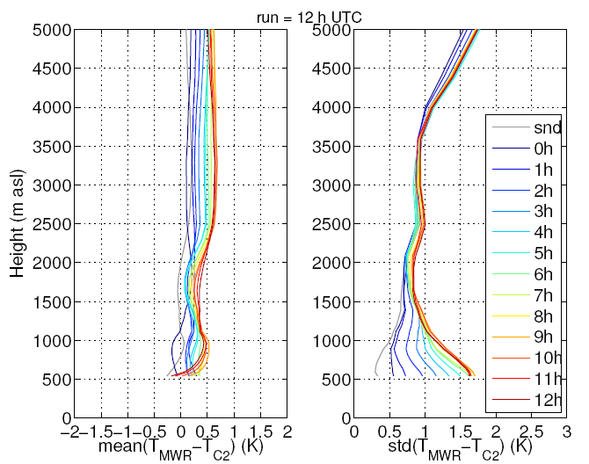
Figure 1: Bias (left panel) and standard deviation (right panel) of O-B for microwave radiometer temperature profiles for the 12h UTC run. The lead time is color coded and ranges from 0 to 12h. As a benchmark, the bias and standard deviation between microwave radiometer and radiosonde is displayed in grey.
The same analysis has been performed for absolute humidity profiles obtained from the operational Raman lidar of MeteoSwiss. The standard deviation of O-B increases from 20 to 30% at 3.5 km agl for lead times increasing from 0 to 3h (not shown) for the 00h UTC run. Note, that at 00 and 12h UTC the radiosonde launched next to the Raman lidar has been assimilated into the model. For the 21h UTC run no error evolution is visible and the standard deviation for O-B is larger by a factor of 2-3 compared to the radiosonde (see Figure 2). This shows that no update of the water vapor field takes place in the assimilation process if no radiosonde is available. We expect that humidity data from Raman lidar could be particularly beneficial for NWP for runs when no radiosonde is available. As a next step we will try to assimilate lidar humidity data into the NWP model in a passive mode and generate model feedback files.

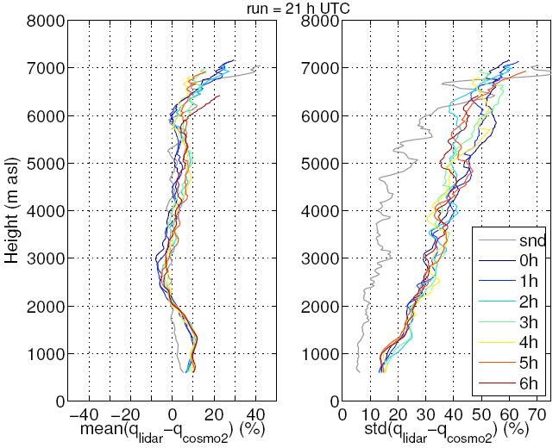
Figure 2: Bias (left panel) and standard deviation (right panel) of O-B for Raman lidar water vapor profiles for the 21h UTC run. The lead time is color coded and ranges from 0 to 6h. As a benchmark, the bias and standard deviation between Raman lidar and radiosonde is displayed in grey.
B) The SimUVEx simulation tool allowing deducing realistic human skin UV exposure from real UV irradiance data has been improved to allow 1) a quicker processing of high resolution UV data, typically allowing treating 1-min resolution data for multi-year datasets; 2) using parameterization for a wider set of UV irradiance data as input such as global UV irradiance instead of the previously necessary separation in direct, diffuse and reflected irradiance; 3) introducing shading objects such as head caps or umbrellas.
High spatial and temporal resolution satellite estimates of broadband solar radiation have been acquired for Switzerland, and one particular location in the south of Spain. These estimates are based on Meteosat Second Generation data and allow reaching a ~1km spatial and 15 minutes temporal resolution. The processing is based on Heliomont, a Swiss version of the Heliosat method. A thorough validation of these satellite estimates has been performed based on high accuracy ground-based solar radiation measurements from Switzerland and Spain. The ground-based solar radiation data are measured following the guideline of the Baseline Surface Radiation Network (Ohmura et al., 1998). The procedure for estimating, in a similar way, the UV radiation data from the MSG satellite data is currently being developed. The large regional coverage (potentially most of Europe) and the unprecedented temporal and spatial resolution for UV satellite estimates should enable meaningful epidemiological research relating UV exposure and skin cancer.
Reference: Ohmura, A., E. G. Dutton, B. Forgan, C. Fröhlich, H. Gilgen, H. Hegner, A. Heimo, G. König Langlo, B. McArthur, G. Müller, R. Philipona, R. Pinker, C. H. Whitlock, K. Dehne, and M. Wild (1998), Baseline Surface Radiation Network (BSRN/WCRP): New precision radiometry for climate research. B. Am. Meteorol. Soc., 79, 2115–2136, doi: 10.1175/1520-0477(1998)079<2115:BSRNBW>2.0.CO;2.

C) MeteoSwiss is involved in a number of research activities within the frame of continuous development of COSMO-ART, focused on the modelling of pollen emission. As species react differently to meteorological conditions, the parameterization of the pollen season is required for each species, including a precise prediction of the start and the end of the pollen season, as well as knowledge about the seasonal course. The reduced pollen production with increasing altitude is taken into account as well. Detailed plant distribution being a prerequisite for successful application of COSMO-ART, Pauling et al. (2012) developed a set of methods aimed at providing such inputs to COSMO-ART. They depend on cadastral databases of plant distributions provided by the GLOBCOVER dataset since 2014. Successful tests have been made to include the simulation of pollen in COSMO at 1 km resolution.

D) The data quality of the windprofiler observations has recently been assessed based on a three year period. The obtained uncertainty estimate is an important input in the new Kalman Filter based assimilation system to give the correct weight to the observations.

Reference: Haefele, A., and Ruffieux, D., 2015: Meteorol. Appl., doi: 10.1002/met.1507.
4.5.3 Specific products operationally available
Daily maps of mean pollen concentrations for Switzerland were available on the Website of MeteoSwiss. Similar maps were available for France and Italy on the Website of the aerobiological network of France (RNSA) and Italy (AIA) respectively.
The FLEXPART model results are delivered to the authorities for emergency response as geographical representations of affected area, time-integrated concentration, averaged concentration, and deposition on the ground.

4.5.4 Operational techniques for application of specialized numerical prediction products (MOS, PPM, KF, Expert Systems, etc.) (as appropriate related to 4.5)

4.5.4.1 In operation
-

4.5.4.2 Research performed in this field
Weather services with customer-tailored products for aviation (Clear Air Turbulence), energy management (photovoltaic, hydro-electricity) and decisional tools for surface transportation (road gridding: snow, icing), or even genetic algorithms for gale warnings further developed in 2014, started their operation in 2015.

4.5.5 Probabilistic predictions (where applicable)
-
4.5.5.1 In operation
-

4.5.5.2 Research performed in this field
-

4.5.5.3 Operationally available probabilistic prediction products
-

4.6 Extended range forecasts (10 days to 30 days) (Models, Ensemble, Methodology)
[Authors: Jonas Bhend / Christoph Spirig / Irina Mahlstein / Samuel Monhart/ Mark Liniger]

4.6.1 In operation
For about 10 years now, MeteoSwiss is processing monthly forecasts. The forecasts are based on forecast data from the ECMWF extended range prediction system. The system was deployed in autumn 2008 and has since become fully operational since then.
4.6.2 Research performed in this field
To improve the usability of extended range forecasts, MeteoSwiss is currently investigating the provision of climate index forecasts based on daily forecast data. While the resulting indices forecasts are still presented in time-aggregated (weekly) form, it requires post-processing of daily forecast data (Mahlstein et al, 2015). A comprehensive skill analysis against surface observations in Europe was carried out in order to investigate different bias-correction techniques. Figure 1 shows a skill analysis of weekly temperature forecasts based on bias-corrected daily data for the winter season (DJF) as verified against the ECA&D observation data set (www.ecad.eu, Klein-Tank et al., 2002).

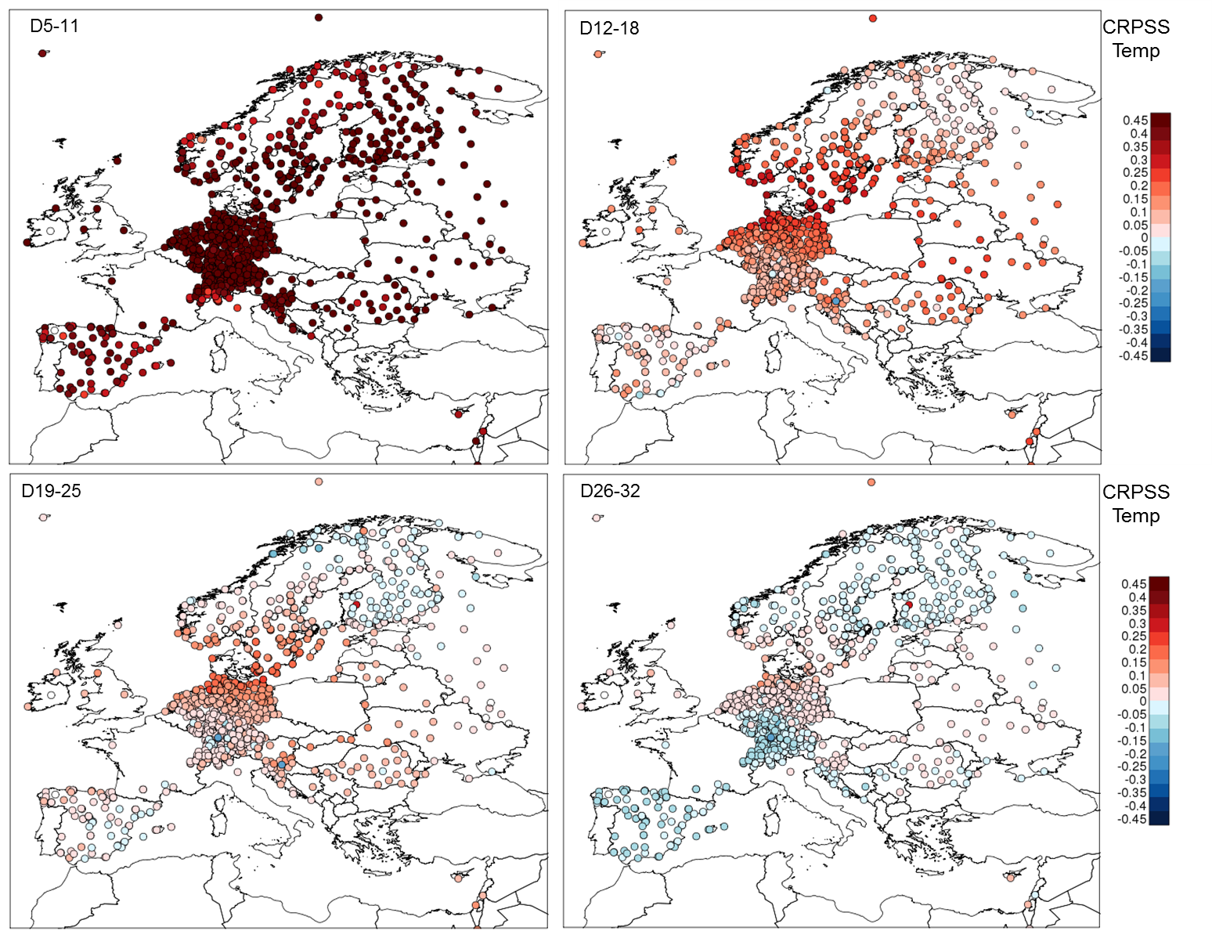
Figure 1: Continuous ranked probability skill score (CRPSS, reference = climatological forecast) of weekly mean temperature forecasts after bias-correction of daily data with a quantile mapping technique, topleft: days 5-11, bottomright: days 26-32 (bottomright).

4.6.3 Operationally available EPS products
Operational products based on the ECMWF ensemble forecast system include maps of weekly categorical probability forecasts of surface temperature, precipitation and geopotential height over various regions. A monthly outlook for Switzerland is publicly available on the MeteoSwiss website. New presentation formats combining forecasts and skill information are currently being tested and are operationally produced for internal use (Figure 2).

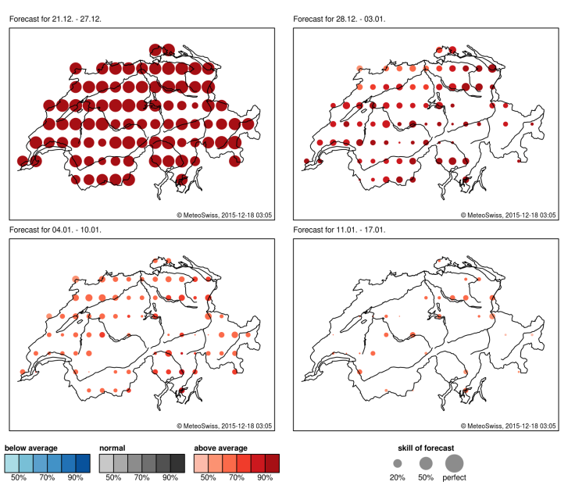
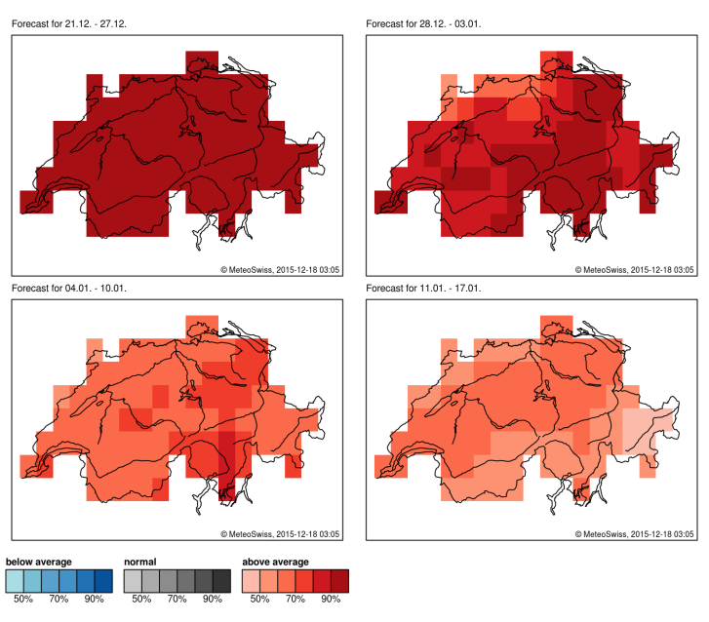
Figure 2: Monthly tercile probability forecasts of weekly mean temperatures. Maps with dominating terciles (left) and same information including RPSS skill information (right).

4.7 Long range forecasts (30 days up to two years) (Models, Ensemble, Methodology)
[Authors: Jonas Bhend / Christoph Spirig / Irina Mahlstein / Mark Liniger]

4.7.1 In operation
Since 2012, MeteoSwiss issues long range forecasts (up to 7 months) on the basis of the ECMWF seasonal forecast model system (currently System 4). The model data are post-processed, evaluated and disseminated by MeteoSwiss. The post-processing technique of climate model output includes a climate-conserving recalibration technique (CCR, Weigel et al., 2009), which has been developed by MeteoSwiss.

4.7.2 Research performed in this field
MeteoSwiss is part of the EU-FP7 project EUPORIAS (www.euporias.eu) aiming at improving the usability of climate services based on long range forecasts. As part of EUPORIAS, MeteoSwiss has developed a software package for forecast verification. The package called easyVerification provides functionality to simplify and standardise the computation of verification scores and skill scores for large datasets of ensemble forecasts. easyVerification also links to novel skill scores developed by other institutions in the framework of the EU FP7 project SPECS (SpecsVerification). easyVerification, is open source and available from the central R repository (https://cran.r-project.org/web/packages/easyVerification/index.html).

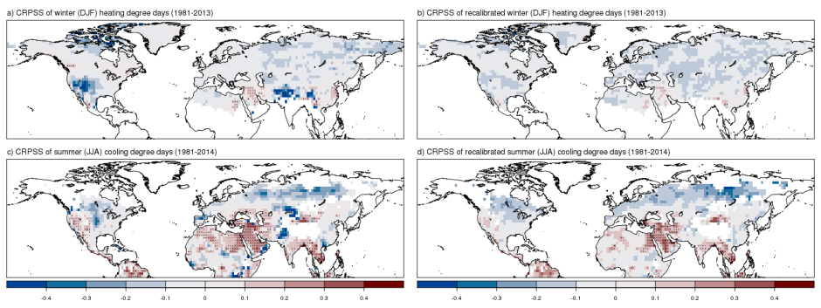
Figure 3: Continuous ranked probability skill score of winter (DJF) heating degree days (a, b) and summer (JJA) cooling degree days (c, d) computed from forecasts with ECMWF System4 initialized on the 1st of November and May respectively. The seasonal forecasts in b and d have been recalibrated using the climate conserving-recalibration (Weigel et al., 2009) previous to evaluation. Warm colours indicate that the forecasts outperform a constant climatological probabilistic forecast; stippling indicates CRPSS significantly (at 5% level) larger than zero. Calibration of daily inputs and recalibration have been performed following a leave-one-out cross-validation procedure.

MeteoSwiss has computed and analysed forecasts of application-relevant climate information indices, such as frost days, or cooling and heating degree days (see Figure 3). Generally, the predictive skill of forecasts of indices is found to be similar or slightly reduced compared to the skill of forecasts of the seasonal mean of the meteorological input variable used to compute the index. The enhanced relevance of forecasts of indices for applications, however, adds value to such forecasts despite some loss in predictive skill.

4.7.3 Operationally available products
The operational products of seasonal forecasts (up to 7 months) include climagrams, probability charts and tercile data for surface temperature, precipitation and geopotential height. The skill of seasonal temperature forecasts is also monitored and is provided in the form of skill maps. The recalibrated seasonal forecast products (using the method of CCR, Weigel et al., 2009) are available for surface temperature and issued as climagrams, probability charts and tercile data. For the general public, a seasonal outlook for regional mean temperature analogous to the monthly outlook is published on the MeteoSwiss website.

5. Verification of prognostic products
[Author : Daniel Murer]
Accurate warnings of severe weather events do represent a major issue in daily operational forecasting. Even very high-resolution numerical models are still challenged when required to precisely forecast heavy precipitation or storm events in the complex alpine terrain. For best warning approach, the forecaster needs to know the strength and weaknesses of the forecast models in combination with his experience of past related events and in using ensemble forecast systems to evaluate the uncertainty of the severe weather event. The area of Switzerland is divided into 159 warning regions. The warning tool is integrated into the powerful visualization system “NinJo”. This happens to be an efficient platform, enabling a comprehensive management and dispatching of weather warnings.
The warnings are issued over a set of warning regions depending on the extent of the expected severe event. Depending on the lead time and certainty a “warning outlook”, a “pre-warning” or a “warning” is issued. The danger levels starts by 1 (minimal or no hazard) and ends at 5 (very severe hazard) on the base of different warning thresholds.
For government purposes the wide spread severe warnings with danger level 3 to 5 are assessed in a verification and reported annually.

5.1 Verification methods for weather warnings
The aim is to capture all severe weather events as well as all warnings issued.
Each event must be assigned if it has been warned.
Each warning must be determined whether it was true.
Table 1 shows the classical contingency table for verification measurements.
 | event observed | no event observed
warning issued | A (hits) | B (false alarms)
no warning issued | C (misses) | D (correct rejections)
Table 1: contingency table for verifications.
Meaning of the categories:
A represents the number of cases in which an event has been warned correctly
B represents the number of cases in which a warning was unnecessary
C denotes the number of cases in which the warning of an event has been missed
D denotes the number of cases without an event and without a warning
A + C is the total number of events
A + B is the total number of warnings
From this the usual verification measurements are calculated:
i. POD = probability of detection = A / (A + C)
ii. FAR = false alarm ratio = B / (A + B)
D is not a relevant measurement and therefore not considered
A perfect warning performance would be if B and C are equal to zero, thus POD=100% and FAR=0%
The following warning events are periodically assessed:
• severe windstorm
• heavy and continuous rainfall
• Heavy and continuous snowfall
• heavy freezing rain
• heat wave
Severe thunderstorms storms are not assessed due to low predictability in time and space.

The warnings are quantitatively analyzed in relation to:
• warning event
• danger level
• warning type: warning, cancellation
• time: issue time of the warning, beginning and ending of the event
• extension: which regions were affected
• formal control: for example, completeness of the warn description, no contradictions

5.2 Annual (2015) verification summary
This sections describes the summary of the verification results. The annual warning verification period lasts from December the 1st to November the 30th. It should be noted that not in every year the same number of severe weather events occur. Therefore large annual variations in the verification results are common and do not directly reflect a better or worse performance of the forecasts.
Concerning severe weather the year 2015 was showing great variations:
- heavy snowfall north of the Alps before New Year 2015
- continuous rainfall with flooding in the southwest of Switzerland and in northern alpine slope in Mai
- severe thunderstorm events north of the Alps in June
- two heatwaves all over Switzerland in July
- severe windstorm in the northern part and heavy precipitation in the south of Switzerland
All over Switzerland there had been 69 severe weather warning events issued with the following performance (according to section 5.1):
Probability of detection (POD) = 87%
False alarm ratio (FAR) = 20%
Over the last ten years up to 2015 an improvement in warning performance was achieved. The percentage of POD (hits) was less significantly improved than the percentage of FAR (false alarms) which could be reduced by almost 50%.
Figure 1 shows the performance of severe weather warnings from 2005 to 2015 with the trend line (dashed red and blue lines) for POD and FAR.

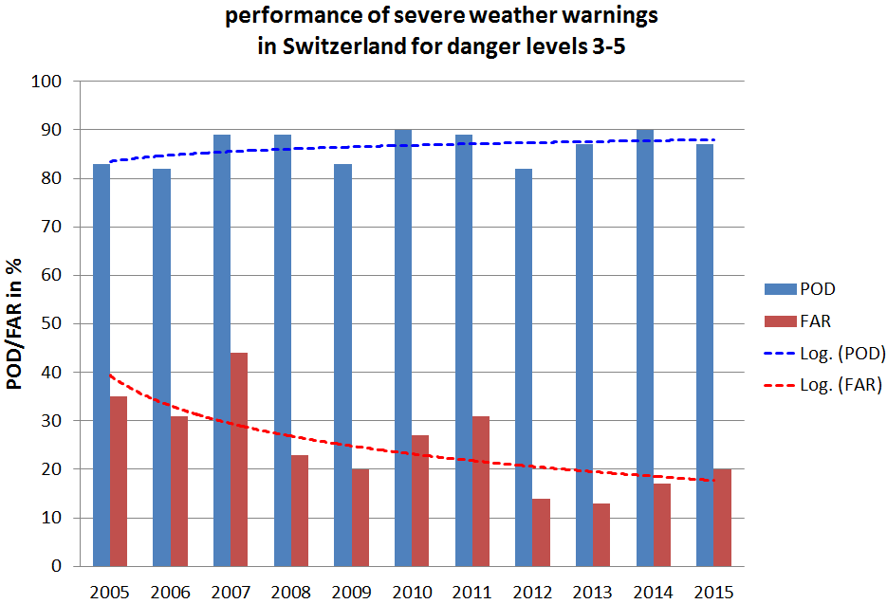
Figure 1: performance of severe weather warnings in Switzerland for danger level 3 to 5.

6. Plans for the future (next 4 years)
-
6.1 Development of the GDPFS
-
6.1.1 Major changes in the operational DPFS which are expected in the next year
-
6.1.2 Major changes in the operational DPFS which are envisaged within the next 4 years
-
6.2 Planned Research Activities in NWP, Nowcasting, Long-range Forecasting and Specialized Numerical Predictions
-
6.2.1 Planned Research Activities in NWP
-
6.2.2 Planned Research Activities in Nowcasting
We have several developments in nowcasting and VSRF: improvement of existing algorithms and introducing new ones, integrating new data sources and types, operationalisation of mature systems with special attention to end user needs. Some keywords:
- Improvement of hail, rain, and snow nowcasting by using radar dual-polarisation information
- Estimation of convective wing gusts (downdraft)
- Improving early detection of heavy thunderstorms
- Introducing uncertainty estimation by ensemble techniques/probability for relevant variables.
- Merging object and gridded precipitation nowcasting
- INCA: Improvement of the ground temperature analysis and evaluation of possibilities for improvements of wind analysis. Introduction of non Euclidean distances for temperature and humidity corrections Introduction of a new interpolation routine included in the software fieldextra.
- Expanding seamless forecast for most relevant variables from nowcasting- VSRF to SRF
- Automatic hail warning.

6.2.3 Planned Research Activities in Long-range Forecasting
Development and provision of user oriented long term forecasts will continue to be a focus in the upcoming years. We thereby rely on dynamical models and will continue to optimize our post-processing techniques.

6.2.4 Planned Research Activities in Specialized Numerical Predictions
-

7. Consortium (if appropriate)

7.1 System and/or Model
The COSMO Model (http://cosmo-model.org/content/model/general/default.htm) is a nonhydrostatic limited-area atmospheric prediction model. It has been designed for both operational numerical weather prediction (NWP) and various scientific applications on the meso-β and meso-γ scale. The COSMO Model is based on the primitive thermo-hydrodynamical equations describing compressible flow in a moist atmosphere. The model equations are formulated in rotated geographical coordinates and a generalized terrain following height coordinate. A variety of physical processes are taken into account by parameterization schemes.
Besides the forecast model itself, a number of additional components such as data assimilation, interpolation of boundary conditions from a driving model, and postprocessing utilities are required to run the model in NWP mode, climate mode or for case studies.

7.1.1 In Operation
Regional numerical weather prediction at Deutscher Wetterdienst is based on the COSMO Model. COSMO-EU (see sections 4.3.1 and 4.3.2) covers Europe with 665x657 grid points/layer at a grid spacing of 7 km and 40 layers, and the convection-resolving model COSMO-DE, covers Germany and its surroundings with a grid spacing of 2.8 km, 421x461 grid points/layer and 50 layers. Based on COSMO-DE, a probabilistic ensemble prediction system on the convective scale, called COSMO-DE-EPS, became operational with 20 EPS members on 22 May 2012. It is based on COSMO-DE with a grid spacing of 2.8 km, 421x461 grid points/layer and 50 layers. See also section 7.3 for COSMO members.

On behalf of COSMO, ARPA-SIMC operates the regional ensemble prediction system COSMO-LEPS (http://www.cosmo-model.org/content/tasks/operational/leps/default.htm) at the European Centre for Medium Range Weather Forecasts (ECMWF) in the “Framework for Member-State time-critical applications”. COSMO-LEPS is the Limited Area Ensemble Prediction System developed within the COSMO consortium in order to improve the short-to-medium range forecast of extreme and localized weather events. It is made up of 16 integrations of the COSMO model, which is nested in selected members of ECMWF EPS.
COSMO-LEPS covers Central and Southern Europe with 511x415 grid points/layer at a grid spacing of 7 km and 40 layers. The system runs twice a day, starting at 00 and 12UTC with a forecast range of 132 hours.

7.1.2 Research performed in this field
The joint research and development is mainly undertaken in the eight working groups (http://cosmo-model.org/content/consortium/structure.htm) and a number of priority projects and priority tasks. The current priority projects are: “Km-Scale Ensemble-Based Data Assimilation for High-Resolution Observations” (KENDAO), see section 7.4.1, “COSMO-EULAG Operationalization” (CELO) which aims at an operational version of COSMO model employing compressible dynamical core with explicit conservative properties for very-high model resolutions, “Comparison of the Dynamical Cores of ICON and COSMO” (CDIC) tests the new ICON dynamical core for regional applications and paves the way to its implementation into the COSMO consortium model, “Testing and Tuning of Revised Cloud Radiation Coupling” (T²(RC)²) tests and optimizes representation of radiation interactions with cloud and aerosol, “Calibration of COSMO Model” (CALMO) which aims at development of automatic, multivariate and based on objective methods calibration of parameterizations of physical processes for the model, “Verification System Unified Survey 2” (VERSUS2) developing an operational verification package for deterministic and ensemble forecasting, “Intercomparison of Spatial Verification Methods for COSMO Terrain” (INSPECT) aims at evaluation of spatial verification schemes for convection-permitting deterministic and ensemble products, “Performance On Massively Parallel Architectures” (POMPA) for preparation of the COSMO model code for future high performance computing systems and novel architectures including GPU systems, “Studying Perturbations for the Representation of Modelling Uncertainties in Ensemble Development” (SPRED) for development of convection-permitting ensembles and especially methodologies for near-surface model perturbations. The priority task “Consolidation of Surface to Atmosphere Transfer” (ConSAT) continues with improvements of the turbulence scheme and atmosphere-surface interactions, while the priority task “TERRA Stand Alone” (TSA) will provide an updated, stand-alone version of COSMO surface model. Environmental prediction aspects of the model involving chemistry, aerosol effects and transport (COSMO ART) are developed in close cooperation with the Karlsruhe Institute for Technology (KIT) in Germany.

7.2 System run schedule and forecast ranges

See section 4.1.

7.3 List of countries participating in the Consortium
COSMO stands for COnsortium for Small-scale MOdelling. The general goal of COSMO is to develop, improve and maintain a non-hydrostatic limited-area atmospheric model, the COSMO model, which is used both for operational and for research applications by the members of the consortium.
The consortium was formed in October 1998 at the regular annual DWD (Germany) and MeteoSwiss (Switzerland) meeting.
A Memorandum of Understanding (MoU) on the scientific collaboration in the field of non-hydrostatic modeling was signed by the Directors of DWD (Germany), MeteoSwiss (Switzerland), USAM (Italy, then named UGM) and HNMS (Greece) in March/April 1999. The MoU has been replaced by an official COSMO Agreement, which was signed by the Directors of these four national meteorological services on 3 October 2001. Recently a new COSMO Agreement aiming at future challenges in high resolution regional numerical weather prediction as well as climate and environmental applications was accepted by the Directors of the COSMO members and was s igned on 7 August 2014.
In 2002, the national weather service of Poland (IMGW) joined the Consortium in effect from 4 July. The National Institute of Meteorology and Hydrology (NMA) of Romania and the Federal Service for Hydrometeorology and Environmental Monitoring of the Russian Federation joined the Consortium in effect from 21 September 2009.
Currently, the following national meteorological services are COSMO members:
Germany | DWD | Deutscher Wetterdienst
Switzerland | MCH | MeteoSchweiz
Italy | ReMet | Aeronautica Militare-Reparto per la Meteorologia
Greece | HNMS | Hellenic National Meteorological Service
Poland | IMGW | Institute of Meteorology and Water Management
Romania | NMA | National Meteorological Administration
Russia | RHM | Federal Service for Hydrometeorology and Environmental  Monitoring

These regional and military services within the member states are also participating:
Germany | AGeoBw | Amt für GeoInformationswesen der Bundeswehr
Italy | CIRA | Centro Italiano Ricerche Aerospaziali
Italy | ARPAE-SIMC | ARPAE Emilia Romagna
Italy | ARPA Piemonte | Agenzia Regionale per la Protezione Ambientale  Piemonte

The Meteorological Service of Israel (IMS) became officially applicant member of COSMO in September 2014.
Six national meteorological services, namely Botswana Department of Meteorological Services, INMET (Brazil), DHN (Brazil), Namibia Meteorological Service, DGMAN (Oman) and NCMS (United Arab Emirates) use the COSMO model in the framework of an operational licence agreement including a license fee.
National meteorological services in developing countries (e.g. Egypt, Indonesia, Kenya, Mozambique, Nigeria, Philippines, Rwanda, Tanzania, Vietnam) are entitled to operate the COSMO model free of charge.

7.4 Data assimilation, objective analysis and initialization

7.4.1 In operation
The data assimilation system for the COSMO model is based on the observation nudging technique. The variables nudged are the horizontal wind, temperature, and humidity at all model layers, and pressure at the lowest model level. The other model variables are adapted indirectly through the inclusion of the model dynamics and physics in the assimilation process during the relaxation. At present, radiosonde, aircraft, wind profiler, surface synoptic, ship, and buoy data are used operationally. For model configurations at the convection-permitting scale, radar-derived precipitation rates are included additionally via the latent heat nudging method. If nudging is used for data assimilation, an extra initialization is not required. Separate two-dimensional analysis schemes based on the successive correction technique are deployed for the depth of the snow cover and the sea surface temperature, and a variational scheme for the soil moisture.
Gradually, the default data assimilation system based on nudging technique is being replaced with Local Ensemble Transform Kalman Filter (see section 7.4.2).
As for COSMO-LEPS, the following initialization is performed: the upper-level initial conditions of the individual members are interpolated from the ECMWF EPS elements providing the boundaries. On the other hand, the initialization at the lower boundary is performed by taking the surface fields of COSMO-EU, including soil temperature and humidity, and blending them with those provided by ECMWF.

7.4.2 Research performed in this field
The focus of research efforts lies on the development of a novel data assimilation scheme based on the Local Ensemble Transform Kalman Filter technique in the frame of the KENDAO priority project. Its main purpose is to deliver perturbed initial conditions for convection-permitting ensemble prediction systems as well as initial conditions for such deterministic systems. For more information, see
http://www.cosmo-model.org/content/tasks/priorityProjects/kendaO/default.htm.
Following encouraging test results, including comparison with nudging, the project aims at operationalization and further development of the LETKF assimilation system. The current research includes, in between,:
- use of remote sensing data and observations related to the boundary layer, humidity, cloud and precipitation, and surface
- algorithmic developments and extensions of the system, including multi-scale multi-step approaches
- exploratory research towards hybrid extensions of the system.
After pre-operational testing, the system was already implemented for operational use in MeteoSwiss in 2016 and its operational implementation at DWD is expected in late 2016 / early 2017.

7.5 Operationally available Numerical Weather Prediction (NWP) Products

See section 4.3.3.
As for COSMO-LEPS, the available operational products include the following:
- “deterministic products”: different weather scenarios (one per member) for the model variables, at several forecast ranges
- “probabilistic products”: probability of exceedance of user-defined thresholds for the different model variables, at several forecast ranges
- “pointwise products”: meteograms over station points in terms of the main model variables.

7.6 Verification of prognostic products

See section 5 in reports of COSMO members.

7.7 Plans for the future (next 4 years)

7.7.1 Major changes in operations
See section 6.1 in reports of COSMO members

7.7.2 Planned Research Activities

The 6-year science plan covering the period 2015 – 2020
- (http://cosmo-model.org/content/consortium/reports/sciencePlan_2015-2020.pdf) summarizes the current strategy and defines the main goal of the joint development work within COSMO. The main goal is the development of a model system for short to very short range forecasts with a convective-scale resolution to be used for operational forecasting of mesoscale weather, especially high impact weather. The research-oriented strategic elements to achieve the goal are: an ensemble prediction system, an ensemble-based data assimilation system and a verification and validation tool for the convective scale, extension of the environmental prediction capabilities of the model, use of massively parallel computer platforms. The actions for achieving the goal are undertaken within the current priority projects and task (see section 7.1.2), most of which were already defined based on the recent version of the Science Plan.

Moreover, until 2020 a gradual transition of the COSMO model system to the regional mode of the ICON modelling framework is planned.
The science plan has been accepted by the COSMO Steering Committee in March 2015. In 2016-2017, a review of the COSMO scientific strategy is planned with the aim to prepare plans of new priority projects for the period 2018-2020.

8. References
Germann, U., G. Galli, M. Boscacci, and M. Bolliger, 2006a: Radar precipitation measurement in a mountainous region. Q. J. R. Meteorol. Soc., 132, 1669-1692.
Germann, U., Berenguer M., Sempere-Torres, D. and Zappa M., 2009: REAL – Ensemble radar precipitation estimation for hydrology in a mountainous region. Q. J. R. Meteorol. Soc., 135, 445-456.

Hering, A. M., C. Morel, G. Galli, S. Sénési, P. Ambrosetti, and M. Boscacci, 2004: Nowcasting thunderstorms in the alpine region using a radar based adaptive thresholding scheme. Proceedings, Third ERAD Conference, Visby, Sweden, 206-211. www.copernicus.org/erad/2004/online/ERAD04_P_206.pdf

Hering, A. M., S. Sénési, P. Ambrosetti, and I. Bernard-Bouissières, 2005: Nowcasting thunderstorms in complex cases using radar data. Proceedings, World Weather Research Programme's Symposium on Nowcasting and Very Short Range Forecasting (WSN05), Toulouse, France, September 5-9, 7 pp. www.meteo.fr/cic/wsn05/resumes_longs/2.14-73.pdf

Hering, A. M., U. Germann, M. Boscacci, and S. Sénési, 2006: Operational nowcasting of thunderstorms in the Alpine region using 3D-radar severe weather parameters. Proceedings, Fourth ERAD Conference, Barcelona, Spain, 453-456. www.grahi.upc.edu/ERAD2006/proceedingsMask/00122.pdf

Hering, A. M., U. Germann, M. Boscacci, and S. Sénési, 2008: Operational nowcasting of thunderstorms in the Alps during MAP D-PHASE. In Proceedings of 5th European Conference on Radar in Meteorology and Hydrology (ERAD), 30 June–4 July 2008, Helsinki, Finland. pp. 5. Copernicus: Goettingen, Germany.

Hering A., Nisi L, Della Bruna G., Gaia M., Nerini D., Ambrosetti P., Hamann U., Trefalt S., and Germann U., 2015: Fully automated thunderstorm warnings and operational nowcasting at MeteoSwiss. Proceedings European Conference on Severe Storms (ECSS), 14–18 September 2015, Wiener Neustadt, Austria, ECSS2015-80-1.

Klein Tank, A.M.G. and Coauthors, 2002. Daily dataset of 20th-century surface air temperature and precipitation series for the European Climate Assessment. Int. J. Climatol., 22, 1441-1453.

L. Nisi, P. Ambrosetti and L. Clementi, 2013. Nowcasting severe convection in the Alpine region: the COALITION approach. Q. J. R. Meteorol. Soc., published online. DOI: 10.1002/qj.2249.
Germann et al, Q. J. R. Meteorol. Soc., 135, 445-456, 2009.

Mahlstein, I., C. Spirig, M. A. Liniger, and C. Appenzeller (2015), Estimating daily climatologies for climate indices derived from climate model data and observations, J. Geophys. Res. Atmos., 120(7), 2808–2818, doi:10.1002/2014JD022327.

Mandapaka, P.V., U. Germann, L. Panziera and A. Hering, 2011. Can Lagrangian Extrapolation of Radar Fields Be Used for Precipitation Nowcasting over Complex Alpine Orography?, Weather and Forecasting, 27: 28-49

Mandapaka, P.V., U. Germann, L. Panziera, 2013. Diurnal cycle of precipitation over complex Alpine orography: inferences from high resolution radar observations. Quarterly Journal Royal Met. Soc. 139: 1025-1046. DOI: 10.1002/qj.2013.

Panziera, L., C. N. James and U. Germann, 2015. Mesoscale organization and structure of orographic precipitation producing flash floods in the Lago Maggiore region. Q. J. R. Meteorol. Soc., 141: 224-248. DOI: 10.1002/qj.2351.

Panziera L, Germann U. 2010. The relation between airflow and orographic precipitation on the south-ern side of the Alps as revealed by weather radar. Q. J. R. Meteorol. Soc. 136: 222–238. DOI:10.1002/qj.544

Panziera L., Gabella M., Zanini S., Hering A., Germann U., and Berne A., 2016: A radar-based regional extreme rainfall analysis to derive the thresholds for a novel automatic alert system in Switzerland. Hydrol. Earth Syst. Sci., 20, 2317–2332.

Panziera, L., U. Germann, M. Gabella and P. V. Mandapaka, 2011. NORA–Nowcasting of Orographic Rainfall by means of Analogues. Q. J. R. Meteorol. Soc. 137: 2106–2123

Sideris I.V., M. Gabella, R. Erdin and U. Germann, 2014. Real-time radar-raingauge merging using spatiotemporal co-kriging with external drift in the alpine terrain of Switzerland, Q. J. Roy. Meteor. Soc. 140: 1097-1111.

Weigel, A. P., M. A. Liniger, and C. Appenzeller (2009), Seasonal ensemble forecasts: Are recalibrated singlemodels better than multimodels? Mon. Weather Rev., 137(4), 1460–1479, doi:10.1175/2008MWR2773.

