# JOINT WMO TECHNICAL PROGRESS REPORT ON THE GLOBAL DATA PROCESSING AND FORECASTING SYSTEM AND NUMERICAL WEATHER PREDICTION RESEARCH ACTIVITIES FOR 2015

Sultanate of Oman, Directorate General of Meteorology (PACA)

## Summary of highlights

Oman National Weather Service, located in Muscat, is part of the Directorate General of Meteorology (DGMET) under the Public Authority of Civil Aviation.

Oman National Weather Service is operationally running an Atmospheric High Resolution Models (COSMO + HWRF), called Oman Regional Model (ORM). The COSMO model was obtained from the Deutscher Wetterdienst (DWD) of the Federal Republic of Germany and HWRF from NOAA (US). The German global model ICON is used to provide necessary initial and lateral boundary conditions for COSMO and also use GFS global model for HWRF. Currently, COSMO model is run operationally with two resolution: 07 and 2.8 km. HWRF model is running during the Tropical Cyclone events and provide the forecast with three resolution: 27, 9 and 3 km. DGMET is also running a regional wave model called WAM, with two resolution: 14 and 3.5 km, which was obtained from HZG (former GKSS) of Germany.

## Meteorological Facilities

* 1. Equipment in use:
* Old PC-CLUSTER

|  |  |
| --- | --- |
| Item | Description |
| Master | 1 Master + 1 login server |
| Computational nodes | 72 nodes |
| Processors (each node) | 2 Quad-Core AMD Opteron 2.6 Ghz |
| Total cores | 576 |
| Memory | 16G |
| Operating system | Red Hat 4.1.2-44 |
| MPI | openMPI (Intel/PGI) |
| Interconnection | Infiniband (Mellanox - ConnectX 3, 40GBit) |
| Compilers | Intel Fortran/C  PGI Fortran/C |
| Queuing system | PBS/ torque |

Table 1

* NEW PC-CLUSTER

|  |  |
| --- | --- |
| Item | Description |
| Master | 1 Master + 1 login server |
| Computational nodes | 80 nodes |
| Processors (each node) | 2x Intel Xeon E5-2630 (2.30 GHz Hexacore) |
| Total cores | 960 |
| Memory | 32G |
| Operating system | CentOS release 6.3 (Final) |
| MPI | openMPI (GNU/PGI) |
| Interconnection | Infiniband (Mellanox - ConnectX 3, 40GBit) |
| Compilers | Intel Fortran/C  PGI Fortran/C  GNU gfortran/gcc |
| Queuing system | PBS/ torque |

Table 2

* 1. Upper Air Observation

The Sultanate of Oman operates two upper air-observing stations located at Muscat (41256) and Salalah (41316). Both these are equipped with Vaisala’s Digicora GPS wind finding system. The radiosonde used is Vaisala RS92 equipment. One flight is launched from each of these stations in a day.

* 1. Ship Weather Reports

Weather Reports from Ships are received through GTS as well as from Muscat Coastal Radio Station. In addition Ship reports are also received from the Royal Oman Navy.

* 1. Wave Measurements

One wave radar measurement station was installed offshore of Qalhat (Sur)- Oman liquid Gas Company- and other two wave measurement stations located offshore of Sohar Station and Mina Salalah Station. Seven tide gauges were installed at Diba, Sohar, Wudam, Quriyat, Sur, Alashkhara and Duqm as part of Tsunami Network.

* 1. Synoptic Land Stations

There are a total of 60 meteorological stations out of which 23 are listed in the WMO’s Regional Basic Synoptic Network (RBSN) including 2 radiosonde stations, 12 Regional Basic Climatological Network (RBCN) stations out of which 3 listed in Global Climate Observing System Surface Network. Additional 13 Automatic Weather Stations will be installed during this year.

* 1. Doppler Weather Radars

Four Dual Polarization S-Band Doppler Weather Radar have been commissioned and one more is expected to be commissioned during May of this year. The Radars are supplied by Selex Gematroniks.

## Data and Products from GTS in use

* Global Numerical Weather Prediction NWP products are received via Internet, GTS, DWD Sat. Other products are received from ECMWF, UK met office and German Weather Service DWD.
* All the meteorological stations operated by the Meteorological Department are connected to the MSS computer located at the Central Forecasting Office at Muscat International Airport by a reliable Telephone lines and GSM Network links
* The MSS is connected to the RTH Jeddah by a dedicated link at 64 kbps based on TCP/IP protocol.
* In addition a 4 mbps Internet leased line has been established as well as for transmitting and receiving meteorological data with different meteorological centres as New Delhi and Abu Dhabi.
* A bilateral Internet Circuit, which was established between these centres and Muscat for the exchange of meteorological data, has proved to be very effective, useful and most stable.
* Beside, this connection is used to receive the initial and boundary condition data initiated from the German weather service global model to be used for the local limited area model.
* The Department installed Second Generation Satellite ground receiving station and the ground-receiving stations for intercepting the geostationary satellites operated by EUMETSAT. Also meteorological data are being received through Satellite distribution (SADIS) receiver. Moreover High Resolution images from Polar Orbiting satellites operated by NOAA and EUMETSAT as well as images from Chinese satellite are received operationally.

## Forecasting system

## System run schedule and forecast ranges

The operation suite runs two times a day, at 00 and 12 UTC. An hourly output is generated for 120 hours. The system generates output on Grib1 format and then it distributes the output to the visualization system and the website. The flowing figure shows dataflow of the one of the operational model.

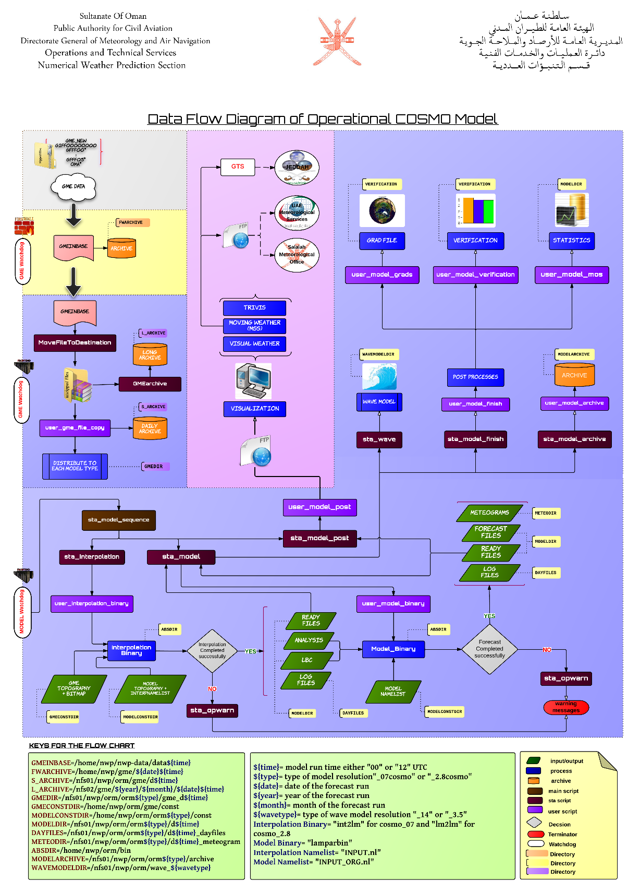

Figure 1: Dataflow diagram of NWP suits at DGMET

## Short-range forecasting system (0-120 hrs)

#### *Data assimilation, objective analysis and initialization*

#### Implementation: Data assimilation system was implemented in DGMET with the default namelist of COSMO-Nudging process Initialized using ICON model and run 4 times daily each 6 hours, with 2 full run at 00, 12 UTC..In addition, the observational data which was collected for use are; SYNOP, TEMP, Wind Profiler Plus, ship, buoy and Radar which was still in progress to solve some formatting issue.

#### In operation: Currently, no data assimilation system is run operationally. It still in the validation stage to attain to suitable namelist input.

#### *Numerical Models*

#### Consortium for Small-scale Modeling COSMO: is a non-Hydrostatic limited-area numerical weather prediction model for meso-α and meso-β. Main prognostic variables are: pressure perturbation  (p‘), Temperature (T), specific humidity (qv) Cloud water (qc), Cloud ice (qi), Horizontal/virtical wind (u, v) and Several surface/soil parameters. More details are available on the model website (<http://cosmo-model.cscs.ch> )

DGMET runs COSMO with two model resolutions:

* **ORM_07**: 07x07 km resolution. It covers the area between 30.0 E, 7.0 N (lower left corner) to 78.0E, 35.25 N (Upper right corner) with mesh size of 0.0625degree. There are 769x453 grid points and 40 vertical layers. The model is running on 64 nodes from the PC Cluster. It produces up to 120-h forecast at 00 and 12 UTC. The following figure shows the domain area.

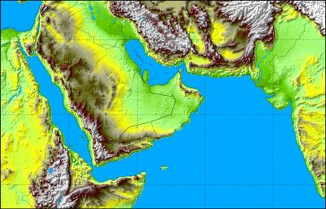

Figure 2: Model domain for ORM_07 with 14km resolution

* **ORM_2.8cosmo:** 2.8x2.8 km resolution. It covers the same area between 52.0 E, 16.5 N (lower left corner) to 60.0E, 26.5 N (Upper right corner) with mesh size of 0.025degree. There are 321x401 grid points and 40 vertical layers. The model is running on 64 nodes from the PC Cluster. It produces up to 120-h forecast at 00 and 12 UTC. The following figure shows the domain area.

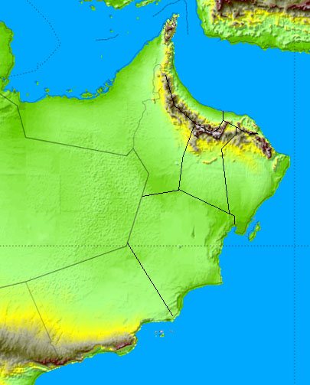

Figure 3: Model domain for COSMO model with 2.8km resolution

#### HWRF: for tropical cyclone events and it works with three different resolution: 27, 9 and 3 km. It produces up to 120-h forecast at 00 and 12 UTC.

#### Research performed in this field:

## *Available NWP products operationally:*

#### For Model Levels: T_G, W_SNOW, QV_S, T_2M, TD_2M, TMIN_2M , TMAX_2M , U_10M, V_10M, CLCH, CLCM, CLCL,CLCT, ASOB_S, ATHB_S, ASOB_T, ATHB_T, SNOW_GSP , SNOW_CON , AUMFL_S , AVMFL_S , ASHFL_S , ALHFL_S , PS , Z0 , FIS , FR_LAND, T , QV , QC, U, V , T_S,W_I,RAIN_GSP , RAIN_CON , HTOP_DC, HBAS_CON , HTOP_CON , VMAX_10M , CLCT_MOD , CLDEPTH, HZEROCL , CLC , FI , CAPE_ML , CIN_ML.

* **For Pressure Levels:** T , FI , U , V , PS , RELHUM , OMEGA , TD,

**Available Levels:** 1000, 975, 950, 900, 850, 700, 600, 500, 400, 300, 250, 200, 150, 100 hpa

## Specialized numerical predictions

* **WAM:** based wave model was established with the kind cooperation of HZG (former GKSS) of Germany, which covers the Arabian Sea, gulf of Oman and Arabian Gulf at 14km resolution. A 3.5km resolution of WAM is nested within the course resolution domain. The 3.5km resolution covers the area shown in Figure 4.

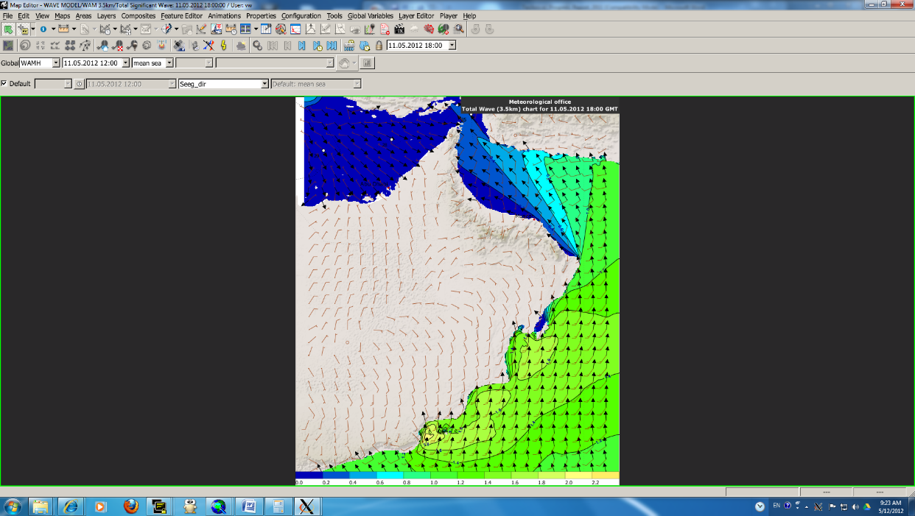

Figure : 3.5km resolution WAM model forecast

* **COMCOT**(Cornell Multi-grid Coupled Tsunami Model) is a tsunami modeling package, capable of simulating the entire lifespan of a tsunami, from its generation, propagation and run-up in coastal regions. The model is used for earthquakes within Oman Sea and India Ocean region.

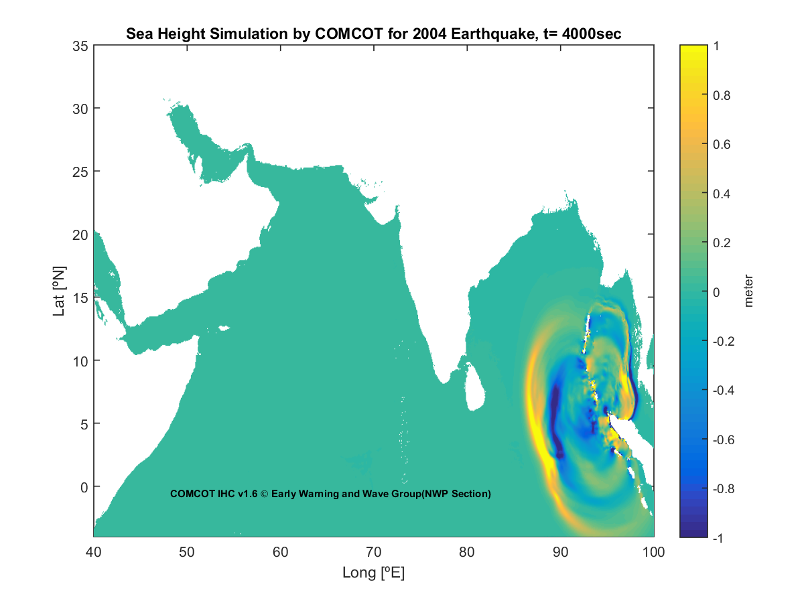

Figure 5: Sea Surface height simulation for 2004 Earthquake Mw=9.1 by COMCOT

* **Strom Surge model** is an Indian model that calculates storm surge, stress and current due to tropical cyclone events by inserting the track location, pressure drop, time step and distance of maximum wind from the center.

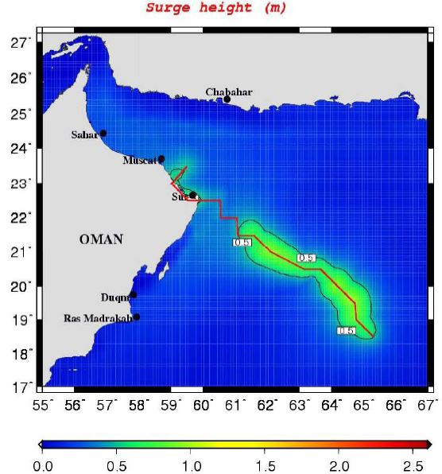

Figure 6: Storm Surge output during Guno Cyclone, 2007 modelled by IIT storm surge model

## Verification of prognostic products

## Atmospheric model verification summary:

The department started early at the end of 2015 to prepared monthly verification including 2m temperature, dew point , mean sea level pressure and 2m wind speed and direction for some selected stations. The forecast was done for 00UTC from different runs. In general the model fluctuate the forecast between underestimation and overestimation but it tends more to underestimate 2m temperature and 2m dew point. The model did well in forecast mean sea level pressure generally but in Saiq station the model tends to underestimate the values strongly and this was due to wrong observation. The points concentrate at the top right corner in the figure of MSLP are belong to Saiq station as shown in Figure 7. Similar results were found for December 2015 verification as shown in Figure 7.

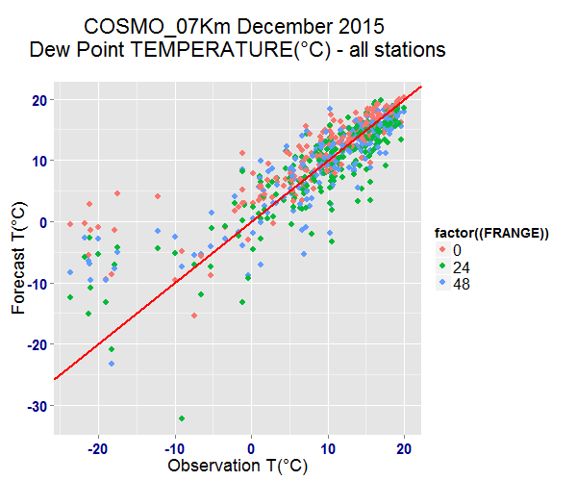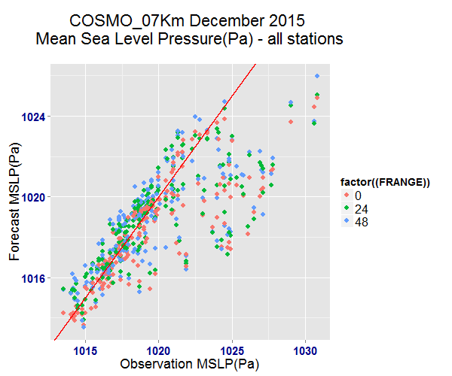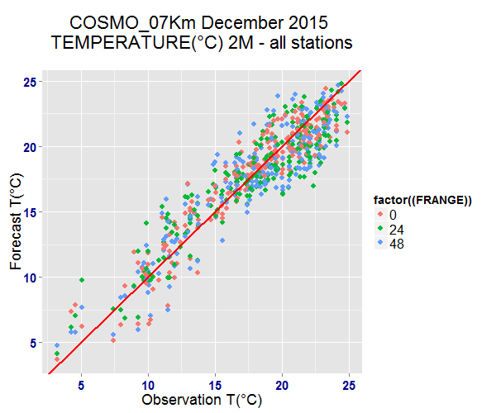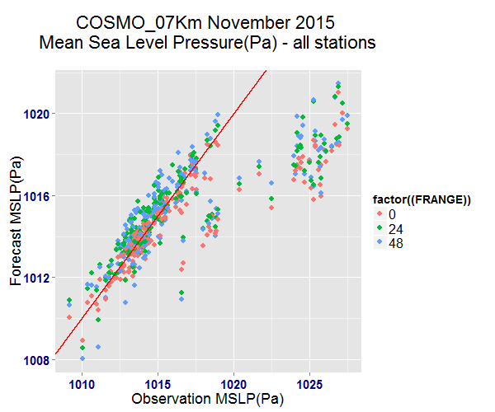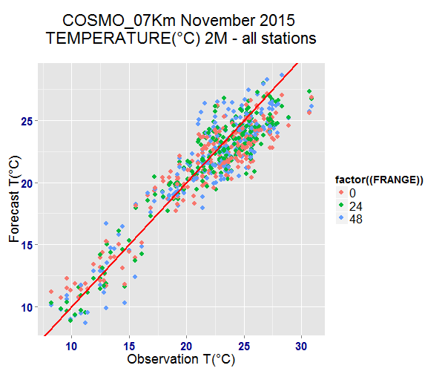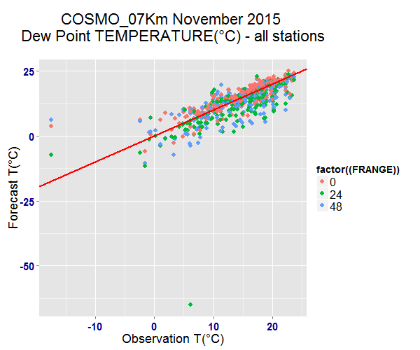

Figure 7: November and December, 2015 verification results

## Plans for the future (next 4 years)

## Development of the GDPFS

## *Major changes in Operational DPFS which are expected in the next year:*

* WRF Model installation and testing
* Running 1km resolution over Oman
* Running a seasonal/climate forecast system

## *Major changes in Operational DPFS which are expected in the next 4 years:*

* Experimenting Short range ensemble forecast system

## References

## For more details, please Contact:

1. Said AL Sarmi, Director of Reasearch and Devlopment of Oman Meterology
2. Email: [s.alsarmi@met.gov.om](mailto:s.alsarmi@met.gov.om), Tel:+96824354646,
3. Mr.Khalifa Al Sudairi@met.gov.om, Chief of NWP Section

Email: [k.alsudairi@met.gov.om](mailto:k.alsudairi@met.gov.om) , Tel: +96824351693