ECMWF Contribution to the WMO Technical Progress Report on the Global Data-processing and Forecasting System (GDPFS) and related Research Activities on Numerical Weather Prediction (NWP) for 2016

- Summary of highlights

In operation
On 12 May 2015, cycle 41r1 was implemented. It introduced a lake parametrization, based on the FLake model, which is applied to all resolved and sub-grid scale lakes. The work on lakes resulting benefitted from a multi-year collaboration with the lake-NWP (Numerical Weather Prediction) community in Europe and recognized the scientific co-ordination of the Deutsche Wetterdienst. This implementation improves 2-metre temperature forecasts in the vicinity of small lakes and near coastlines not represented in the previous model.
Ocean wave forecasts benefitted from the extension of the high-resolution wave model from the European and North Atlantic region to the whole of the globe. These stand-alone forecasts are driven by the high resolution forecast (HRES), are run at a higher resolution than the coupled wave model, and include a forcing by ocean currents.
New land-sea mask, orography and climate fields (glacier information, surface albedo) were introduced, as well as new data for lake depth and other lake parameters. The new model also uses new CO2, O3 and CH4 climatologies from the latest MACC-II reanalysis.
A revised vertical interpolation in the semi-Lagrangian advection scheme reduced gravity wave noise during sudden stratospheric warming events.
The inner-loop resolutions of the high-resolution 4-dimensional variational data assimilation system (4DVar) were upgraded to T_{L}255 (80 km) for each of the three iterations of the outer loops to produce finer scale increments. The background error covariances were made more flow-dependent by reducing the sampling window and averaging the statistics over shorter past periods, these dynamical statistics being used jointly with a climatology. A range of additional satellite observations improved the representation of land surface, sea ice and ocean wave parameters.
Monthly ensemble forecasts and re-forecasts were extended from 32 to 46 days. The extended forecasts should be used with care but results have shown that there is positive skill in some aspects of forecasts in the 30–46 day range. The medium-range/monthly ensemble (ENS) re-forecast dataset was significantly enhanced, with re-forecasts running twice a week, for Mondays and Thursdays (previously just Thursdays), and with the size of each re-forecast ensemble increased from 5 to 11 members. This provides a substantial increase in the sample size for the model climates for the medium-range Extreme Forecast Index (EFI)/Shift of Tails (SOT) and the extended-range (monthly) forecast anomaly products.
Cycle 41r1 improved both HRES and ENS forecasts throughout the troposphere and in the lower stratosphere. Improvements were detected both in verification against the model analysis and verification against observations.
Cycle 41r1 brought consistent gains in forecast performance at the surface for total cloud cover and precipitation. Improvements in the modelling of cloud and precipitation reduced the predicted occurrence of drizzle in situations where large-scale precipitation dominates, and they increased the amount of rainfall in forecasts of intense events, leading to a better match with observations. Improvements were seen for 2-metre temperature and 2-metre humidity in parts of the northern hemisphere and the tropics. Cycle 41r1 also introduced a number of new output parameters, such as precipitation type, including freezing rain.
The average position error for tropical cyclones was slightly reduced, with tropical cyclones generally forecast to be more intense. For example, IFS Cycle 41r1 performed better than Cycle 40r1 in predicting the track of tropical cyclone Pam, which devastated Vanuatu in the South Pacific in March 2015. In the HRES, the sea level pressure minimum at the centre of tropical cyclones was on average slightly lower at all lead times. Up to and including day 3 this makes the forecast better, by reducing the slight positive bias. From day 5 onwards, however, the pre-existing bias towards over-deepening has increased slightly.
On 8 March 2016, cycle 41r2 was implemented. Cycle 41r2 represented a significant step forward in accuracy and resolution, and since its implementation ECMWF has been running the highest-resolution global forecasting system in the world. The cycle included an increase in horizontal resolution in most components of the ECMWF Integrated Forecasting System (IFS). For HRES and ENS the grid-point resolution was roughly doubled to 9 km and 18 km, respectively, while for the Ensemble of Data Assimilations (EDA) it was tripled to 18 km. In combination with several other scientific and technical changes, this led to a significant increase in forecast accuracy and computational efficiency.
ENS forecasts were also improved by moving the step-decrease in resolution of the forecast from day 10 out to day 15, thus ensuring consistent high forecast resolutions throughout the medium range to 15 days.
Since its implementation in March 2016, routine evaluation has indicated that this cycle has been performing very well with improved skill at most levels and parameters well into the medium range. Figure 1 shows the impact of the resolution upgrade on the performance of the single,
It is worth mentioning that one of the key benefits of the upgrade has been the decision to move the resolution truncation in the ensemble forecasts from day 10 to day 15. This has removed inconsistencies between forecasts valid across the truncation time, especially for surface variables such as precipitation or wind speed, thus making it easier for users to exploit fully the available ENS forecasts.
The tracks and in particular the intensity of tropical cyclones are now more accurate especially for the ENS due to the increased resolution, which enables more accurate modelling of smaller and deeper tropical cyclones.
In February 2016, work started to prepare the next cycle 43r1, planned to be implemented in operation in Q4-2016. This cycle will include a major change to the ocean model used in ENS. The new ocean configuration, labelled ORCA025_Z75, includes a higher vertical (75 instead of the 42 layers used in operation) and horizontal (1/4 instead of 1 degree) resolution for the ocean model (NEMO 3.4), and the introduction of a dynamical sea-ice model (LIM 2.0). The introduction of the sea-ice model means that the sea-ice cover will evolve dynamically rather than being persisted for 15 days, followed by a relaxation towards the climatology of the last 5 years over next 31 days. As a result, the sea-ice cover will be able to respond to the changes to the atmosphere and ocean states leading to, e.g., melting of sea-ice during atmospheric warming in spring. With all the ensemble members dynamically evolving the sea-ice cover due to different atmosphere and/or ocean, a more realistic spread in the sea-ice cover region is expected. The new, higher-resolution ocean and sea-ice is going to be initialized by the new ocean reanalysis version 5 (ORAS5). ORAS5, which includes 5 members, has completed 35 years of reanalysis. It is now running daily, producing near-real-time ocean and sea-ice states that can be used to initialize the 43r1 ENS members. ORAS5 will be run in parallel with ORAS4 at least until the end of 2017, when the seasonal system is planned to be upgraded to use also the new, ORCA025_Z75 ocean model with the LIM2 sea-ice.
Cycle 43r1 will also include changes in other aspects of the operational suites: in the atmosphere (e.g. inclusion of a scaling of convective mass fluxes for high resolution and change to mass flux limiter), land surface (e.g. in the coupling coefficients to reduce diurnal cycle T2m errors), wave (e.g. limitation on the ocean wave spectral steepness for high winds) and model uncertainty simulation (introduction of a global fix for tendency perturbations to improve conservation of humidity). There will be upgrades also to the data assimilation (e.g. increase in the resolution of EDA variance calculation) and the way observations are assimilated (e.g. the implementation of a slant-path radiative transfer for all clear-sky sounder radiances and the explicit handling of correlated observation error for hyperspectral sounders). Preliminary results indicate that all these changes will bring slightly positive to positive impacts.
Work has also started to define the configuration of the next version of the ECMWF seasonal system, system-5. S5 will be based on model cycle 43r1 with the ORCA025_Z75 ocean and sea-ice. If all experimentation proceeds well, the plan is to define its configuration by the end of 2016, and start running S5 in parallel with the operational S4 at the beginning of 2017, with a switch over towards the end of 2017.
On 15 June 2016, cycle 41r2-B was implemented. This cycle included technical changes required to be able to run the ECMWF operational suites on the upgraded Cray supercomputer.

In research
A new organisation of the Research Department was implemented in January 2016, including newly appointed section heads and team leaders. Research has been re-organized around four main areas, as reflected in the new section names:
- Earth System Assimilation
- Earth System Modelling
- Earth System Predictability
- Integrated Forecasting Systems
The first three sections cover the main science areas whereas the Integrated Forecasting Systems section will work on implementing new developments into the IFS as well as work on coding efficiency. The newly formed structure will enable a focus on vital strategic areas of research and also provide a clear interface between the Research Department on the one hand and the Forecast and Copernicus departments on the other. In Earth System Assimilation a major focus has been on the further development of hybrid assimilation methods and coupled ocean-land-atmosphere assimilation. The Earth System Modelling section has delivered novel numerical methods that has enabled the recently implemented resolution upgrade. The Earth System Predictability section is identifying potentials for improvement in predictive skill coming from stratospheric processes, atmospheric composition parameterisations and atmosphere-ocean-land couplings including sea-ice. The coding efficiency work in the Integrated Forecasting Systems section is closely linked to the Scalability programme and an area receiving increased attention is the I/O efficiency.
Examples of very recent accomplishments are:
- Earth System assimilation: Microwave radiances are assimilated in an all sky framework and contribute to a substantial improvement in initial state accuracy. The introduction of microwave humidity sounders contributes significantly to recent forecast skill improvements.
- Atmospheric model uncertainty: A new method to represent model uncertainty has been developed in order to improve the reliability of ensemble forecasts. First results show some beneficial improvements but more work is needed to further develop the method.
- Atmosphere-ocean interactions: The interactions between low level wind fields and ocean surface currents are a crucial component of atmosphere-ocean exchange. An example of model verification is the calculation of sea surface drifts taken from the backtracking of debris in connection with the Malaysian Airlines MH370 disappearance over the Indian Ocean.
In the forthcoming years, research at ECMWF will be broadening its focus to making advances in science and innovation in the area of Earth System modelling and data assimilation. The development of Earth System forecast models and assimilation methods will still have the overall goal of improving the accuracy and reliability of weather forecasts.
In the past year, advances in research and development have been made in several areas. In data assimilation, new hybrid methods that include the EDA as well as Ensemble Kalman Filters are showing promising results. The model physics has been improved, in particular in the area of radiation calculations. The numerical developments have focussed on the introduction of an increased horizontal resolution in the IFS and research work on the future dynamical core. In the ensembles, the formulation of model error parameterisations has been revisited and new formulations of stochastic physics parameterisation has been studied using perturbed parameter methods. In the area of ocean modelling, the coupling to the atmosphere through surface waves and sea-ice has been further studied, and a sea-ice module is going to be introduced operationally in Q4-2016. Reanalyses of the ocean and the atmosphere are being produced, and a weakly coupled ocean-atmosphere assimilation scheme has been used to generate the first coupled reanalysis of the 20th century (1900-2010). In the area of atmospheric composition, further work on the integrated Carbon-version of the IFS (C-IFS) has shown the potential for aerosol impact on weather forecasts and has demonstrated a successful assimilation of retrieved profiles of SO2, CO2 and other constituents.
A very important numerical development that has enabled the resolution upgrade was the introduction of a cubic, octahedral grid in the spectral model. This grid has a higher accuracy for third and second order nonlinearities than the currently used linear grid and gives a much better utilisation of shorter length scales in the resolved part of the spectra.

- Equipment in use at the Centre
Following the upgrade of June 2016, the ECMWF's High Performance Computing Facility (HPCF) comprises two identical Cray XC systems. This configuration continues the ECMWF's successful design of having two self-sufficient clusters with their own storage, but with equal access to the high performance working storage of the other cluster. This cross-connection of storage allows most of the benefits of having one very large system but dual clusters add significantly to the resiliency of the system, allowing flexibility in performing maintenance and upgrades; when combined with separate resilient power and cooling systems they provide protection against a wide range of possible failures.
The Cray HPCF has two identical Cray XC40 clusters. Each has 20 cabinets of compute nodes and 13 of storage and weighs more than 50 metric tonnes. The bulk of the system consists of compute nodes with two Intel Xeon EP E5-2695 V4 “Broadwell” processors each with 18 cores. Four compute nodes sit on one blade, sixteen blades sit in a chassis and there are three chassis in a frame. This gives a maximum of 192 nodes or 6,912 processor cores per cabinet. The number of actual compute nodes in a cabinet will sometimes be less than the maximum since as well as compute nodes, each cluster has a number of “Service Nodes”. These have space for a PCI-Express card to support a connection to external resources such as storage or networks and are consequently twice the size of a compute node, and only two fit on one blade.
In terms of data handing, for many years, ECMWF has operated a large-scale data handling system (DHS), in which all ECMWF users can store and retrieve data that is needed to perform weather modelling, research in weather modelling and mining of weather data. Since spring 2014, the DHS hardware includes:
- Many servers are used to execute the HPSS, MARS and ECFS applications. Most are now Intel-based running RHEL6 (MARS and most HPSS data handling) which are replacing earlier IBM pSeries servers running AIX (still used for ECFS and the core HPSS services);
- A set of four Oracle (Sun) SL8500 tape libraries provide access to tape cartridges on which the bulk of the DHS data is stored;
- Many IBM V7000 subsystems provide disk storage that is used to cache data being stored into, or retrieved from, the tape libraries, as well as the metadata needed by HPSS, MARS and ECFS.
The DHS servers are connected to each other, to the DHS clients including the HPC, and to the Centre's general purpose servers and desktops through the Centre's main 10-gigabit network. On an average day the system handles requests for about 11,500 tape mounts (increased from 6,000 in 2010), and on some days this can peak at around 15,000. In a typical day the archive grows by about 130TB.

- Data and Products from GTS in use
A new scalable acquisition and pre-processing system (SAPP) was introduced into operations in June 2014. This system is designed to provide scalability and to improve monitoring, administration and continuous processing of observations. Scalability is required for the continually increasing volume of satellite data, while improved monitoring and administration is needed for the growing variety of data coming from a multitude of remote sensing and in situ platforms. The improvement of the continuous processing is a pre-requisite for the Continuous Observation Processing Environment (COPE) framework.
SAPP scalability and improved performance has made possible the re-processing of decades of data from several satellite instruments for the ERA-5 reanalysis (the forthcoming reanalysis that will replace ERA-Interim by the beginning of 2018). The following data have been reprocessed with the new SAPP system:
- MTSAT - Clear Sky radiances (CSR );
- AMSRE - Brightness Temperature (BT);
- TMI - Brightness Temperature (BT);
- GMS - Atmospheric Motion Vectors (AMV) and Clear Sky radiances (CSR);
- METEOSAT - Atmospheric Motion Vectors (AMV) and Clear Sky radiances (CSR);
- ERS/SCAT - Soil Moisture;
- SSMI - Brightness Temperature (BT);
- GPSRO - Bending Angle from METOPA, CHAMP, GRACE, SAC-C and TERRASAR-X satellites;
- ERS-1 and ERS-2 – Soil Moisture.
Internal and external support has been provided for the transition from WMO Traditional Alphanumeric Codes to BUFR by providing updates to the BUFR decoding software, which is freely available for download. A wiki was made available to the Member States and the broader WMO community with the purpose of providing a common space for numerical weather prediction (NWP) centres and data providers to discuss any migration issues and this was widely used. New BUFR data received via the Global Telecommunications System are already being processed and provided to the assimilation system.
The third stage of the COPE project started in 2015 as part of the Scalability Programme, and good collaboration with partners from Météo-France and the HIRLAM and ALADIN/LACE communities is expected to continue. COPE will provide the components for quasi-continuous, incremental observation processing and will lead to an operational implementation of a more scalable, robust and timely observation processing system.
The provision of observations in BUFR format to Member States as backup for their operational runs has continued as an immediate call-out service.
Several new data types and/or formats are processed in operations. A selection is listed below:
- BUFR SYNOP, BUFR SHIP, BUFR TEMP, BUFR PILOT and AMDAR;
- Additional radiosondes from the Indian Ocean (Project R/V Sonne call sign DFCG);
- TerraSAR-X and TanDEM-X GPS Radio Occultation;
- FY-3C / MWRI, MWHS and MWTS;
- FY-2G - Atmospheric Motion Vectors (AMV);
- Global Precipitation Measurement (GPM) Microwave Imager (GMI);
- GOES-E / Full Disk - N Hem - Clear Sky Brightness temperature (CSBT);
- GOES-W / Full Disk - N Hem - Clear Sky Brightness temperature (CSBT);
- SSMIS/UPP - F19;
- High density observations from ECA&D (European Climate Assessment & Data) Project;
- Ensemble Forecast and Re-forecast for Sub-seasonal to Seasonal prediction project (S2S).

- Forecasting system
Three cycles were implemented between January 2015 and the time of writing this report (August 2016), and a new cycle has been prepared, and it is planned to be implemented in Q4-2016:
- Cycle 41r1, in May 2015;
- Cycle 41r2, in March 2016;
- Cycle 41r2-B, in June 2016;
- Cycle 43r1, planned to be implemented in Q4-2016.

Cycle 41r1 (implemented on 12 May 2015)
The cycle improved both HRES and ENS throughout the troposphere and in the lower stratosphere. Improvements were seen both in verification against the model analysis and verification against observations.

Cycle 41r2 (implemented on 8 March 2016)
This was a major step forward with a horizontal model resolution of 9 km in the high-resolution forecast and 4DVar, and 18 km resolution in the EDA and ENS, made it possible thanks to the introduction of a cubic, octahedral grid. The main contents of IFS cycle 41r2 were:
- The horizontal resolution was increased by using a cubic octahedral reduced Gaussian grid (with spectral truncation denoted by Tco) instead of the current linear reduced Gaussian grid (denoted by T_{L}). With the cubic reduced Gaussian grid the shortest resolved wave is represented by four rather than two grid points. In addition, a new form of the reduced Gaussian grid, the octahedral grid, is used. The octahedral grid is globally more uniform than the previously used reduced Gaussian grid.
- The realism of the kinetic energy spectrum was significantly improved with more energy in the smaller scales due to a reduction of the diffusion and removal of the dealiasing filter, enabled by the change to using a cubic truncation for the spectral dynamics.
- There was a significant revision to the specification of background error covariances (B) used in the HRES data assimilation due to the increased resolution of the EDA and the introduction of scale-dependence of the hybrid B (climatological and EDA), thereby relying more on the EDA "errors of the day" for the smaller scales.
- There were improvements in the use and coverage of assimilated satellite data due to changes in observation selection and error representation (for GPS radio occultation data, all-sky microwave, AMSU-A, IASI and AMVs) and improved observation operators for radiance data from microwave sounders.
- The stability of the semi-Lagrangian scheme near strong wind gradients was improved, reducing noise downstream of significant orography and in tropical cyclones.
- The radiative heating/cooling at the surface was improved by introducing approximate updates on the full resolution grid at every timestep. This leads to a reduction in 2-metre temperature errors, particularly near coastlines.
- Additionally there were changes to the triggering of deep convection, non-orographic wave drag and improvements to the linear physics in the data assimilation (for gravity wave drag, vertical diffusion and the surface exchange).
Following this implementation, since 8 March 2016 the ECMWF operational suite (see section below) now includes the most detailed, global:
- Atmosphere/land/wave, single analysis and forecast, run with a 9-km resolution up to forecast day 10, twice daily (at 00 and 12 UTC);
- Atmosphere/land/wave, 25-member ensemble of analyses, run with an 18-km resolution twice daily (at 00 and 12 UTC);
- Atmosphere/land/waves/ocean, 51-member ensemble, run with an 18-km resolution up to forecast day 15 twice daily (at 00 and 12 UTC); the forecasts are extended with a 36-km resolution up to forecast day 46 twice weekly (at 00 UTC on Mondays and Thursdays).
As part of the Boundary Condition (BC) special project, the single high-resolution analysis and 10-day forecast are also generated at 06 and 18 UTC, and ensemble forecasts up to 6.5 days are generated at 06 and 18 UTC (only Member States funding this project can access these operational data).

Cycle 41r2-B (implemented on 15 June 2016)
This cycle included technical changes required to be able to run all models on the upgraded super-computer clusters.

Cycle 43r1 (planned to be implemented in Q4 2016)
This cycle is going to include changes in data assimilation (both in the EDA and the high-resolution 4DVar, with a weak-constraint formulation in the stratosphere); in the use of observations (e.g. slant-path radiative transfer for all clear-sky sounder radiances will be used when interpolating model fields to observation locations); and in modelling (e.g. to boundary-layer cloud for marine stratocumulus and at high latitudes, in the surface coupling for 2m temperature, and in the stochastic model uncertainty schemes). With this cycle upgrade, the medium-range/monthly ensemble will see a major upgrade in the dynamical ocean model (NEMO, the Nucleus of European Modelling of the Ocean); the resolution will increase from 1 degree and 42 layers to ¼ degree and 75 layers (ORCA025z75). Furthermore, NEMO model version v3.4 with the interactive sea-ice model (LIM2) will be implemented. The ocean and sea-ice components of the ENS ICs will be provided by the new ocean analysis and reanalysis suite ORAS5, which uses the new ocean model and revised ensemble perturbation method (it covers the period 1975 to date).

Operational suite (status in August 2016)
Since June 2016, cycle 41r2-B has been used in operation by all suites apart for ERA-I and seasonal system-4, which both use cycles that were frozen when they started production (cycle 31r2 for ERA-Interim, which started its operational production in 2006; and cycle 36r4 for S4, which started its operational production in Nov 2011).
ECMWF medium-range/monthly forecasts are generated by a combination of a high-resolution analysis (4DVar) and a 10-day forecast (HRES) with a 9 km horizontal resolution, and multi-member ensembles with an 18 km horizontal resolution analysis (EDA) and forecasts up to day 15 (ENS). ENS is extended to 46 days twice a week with a 36-km resolution up to forecast day 46. ENS also includes also a reforecast suite, with an 11-member ENS run twice a week for the past 20 years, with initial conditions (ICs) generated by the ERA-Interim reanalysis: the ENS reforecast suite is used to generate some calibrated/post-processed products. ENS uses a couple model, with ocean initial conditions generated by an ensemble of ocean analyses (ORAS4).
Only the two forecast ensembles run with the ECMWF atmosphere/land/wave model (the IFS) coupled to the ocean model (NEMO).
ENS forecast initial conditions are generated as follows:
- For the atmosphere/land/waves: they are generated by adding to the unperturbed, 4DVar analysis, perturbations generated by a combination of EDA-based perturbations and singular vectors (SVs).
- For the ocean: they are generated using the 5-member ORAS4 analyses.
Singular vectors are computed at a T42L91 resolution, with a 2-day optimisation time, to maximize a dry, total energy norm over few areas:
- The northern hemisphere extra-tropics;
- The southern hemisphere extra-tropics;
- Up to 6 tropical areas.
S4 initial conditions are generated as follows:
- For the atmosphere/land/waves: they are generated by adding to the unperturbed, 4DVar analysis, perturbations generated by a combination of EDA-based perturbations and singular vectors (SVs).
- For the ocean: they are generated using by the 5-member ORAS4 analyses.
The two coupled ensembles include, as part of their suites, reforecasts that are run routinely to compute the climatological distributions required to generate some of their products. These are the configuration of the two reforecast suites:
- ENS reforecast suite: 11-members, run at 00 UTC on Mondays and Thursday, up to 46 days with the same resolution as ENS, for the past 20 years; the unperturbed atm/land/wave analysis is given by ERA-Interim (instead of the operational analysis);
- S4 reforecast suite: 15-members, run at 00 UTC of the 1st of the month, up to 7 months (13 months every quarter) with the same resolution as S4, for the past 30 years; the unperturbed atm/land/wave analysis is given by ERA-Interim (instead of the operational analysis).

  - System run schedule and forecast ranges
Table 1 summarizes the production schedule. It is worth to point out that some analyses and forecasts are available only to member states supporting the Optional Programme ‘Boundary Conditions for Limited Area Modelling (BC project)’. In terms of availability, forecast products are available 7 hours after the initial condition time (e.g., at 7am for the 00 UTC runs), unless unforeseen problems are encountered.

Suite | Cycle | 00 | 06 | 12 | 18
4DVar – Atm/land/wave, single, 9-km, L137 analysis | 41r2-B | Y | (BC) | Y | (BC)
EDA – Atm/land/wave, 25 member, 18-km, L137 ensemble of analyses | 41r2-B | Y | -- | Y | --
ORAS5 – Ocean, 5 member, 1-degree, 42-layer, ensemble of analyses and reanalyses (1975-to date) | V5 | Y | -- | Y | --
ERA-I – Atm/land/wave, single, 80-km, L60 reanalyses (1975-to date) | 31r2 (2006) | Y | Y | Y | Y
HRES – Atm/land/wave, single, 9-km, L137, 10d forecast | 41r2-B | Y | (BC) | Y | (BC)
ENS – Atm/land/wave/ocean, 51 member, 18-km, L91, 15d forecasts | 41r2-B | Y | (BC to 6.5d) | Y | (BC, to 6.5d)
ENS – Atm/land/wave/ocean, 51 member, 36-km, L91, 15-46d forecasts | 41r2-B | Mon, Thu | -- | -- | --
S4 – Atm/land/wave/ocean, 51-member, 80-km, L91, 7-month forecast | 36r4 (2011) | 1st on month | -- | -- | --
S4 – Atm/land/wave/ocean, 51-member, 80-km, L91, 13-month forecast | 36r4 (2011) | 1st of Feb, May, Aug, Nov | -- | -- | --
Table 1. ECMWF production schedule and forecast ranges.

  - Medium-range and monthly forecasting systems (0-46 days)
In this Section we briefly summarize the key characteristics of all ECMWF forecasts up to forecast 46 (and not just 10 as suggested in the WMO template), since single and ensemble analyses and forecasts are all integrated and considered as different components of the ECMWF suites, which are used to generate medium-range/monthly forecasts up to 46 days. The activities linked to this forecast range are discussed in this Section, while the reader is referred to Section 4.7 for activities covering the seasonal forecast range.
Figure 1 is a schematic of the 7 key components (including also the seasonal system, S4, which will be discussed in section 4.6) of the ECMWF Integrated Forecasting System suite. The suite includes (moving clockwise, starting from the top):
- EDA²⁵: the 25-member, 18-km, L137 (137 vertical levels) Ensemble of Data Assimilation, which provides flow-dependent statistics and estimates of the analysis PDF;
- 4DVar: the single, 9-km single L137 analysis;
- ORAS4⁵: the 5-member ensemble of ocean analyses, version S4 with a 1-degree resolution and 42 vertical layers;
- ERA-I: the 80-km, L60 ERA-Interim reanalysis, which is used to generate the ICs for the ENS and S4 reforecast suites;
- HRES: the single, 9-km resolution, L137, 10-day forecast;
- ENS⁵¹: the 51-member, L91 coupled ensemble, which provides forecasts at 18-km resolution up to day 15, and at 36-km resolution from day 15 to 46 (only at 00 UTC, on Mondays and Thursdays);
- S4⁵¹: the 51-member, L91, 80-km coupled seasonal ensemble System-4 (S4), which provides forecasts and estimates of the forecast PDF for the seasonal time scale.

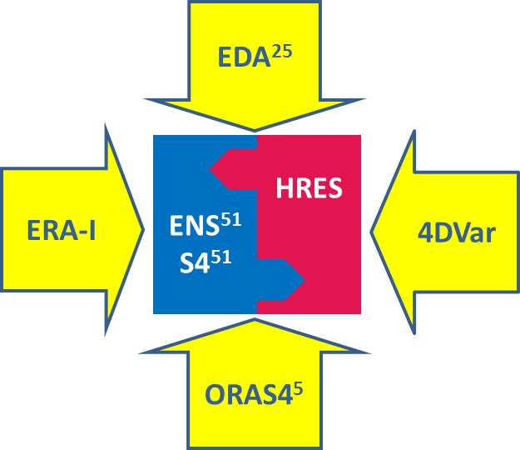

Figure 1. The six main components of the ECMWF Integrated Forecasting System (IFS) suite, operational in 2016. The probability distribution function (PDF) of forecast states is given by the high-resolution forecast (HRES), the 51-member medium-range/monthly ensemble (ENS) and the 51-member seasonal ensemble System-4 (S4). The PDF of analysis states is given by the 25-member Ensemble of Data Assimilation (EDA), which also provides the background error statistics to the high-resolution analysis (4DVar) and the EDA itself. The EDA is also used to generate initial conditions for the medium-range/monthly ensemble (ENS). The high-resolution 4DVar analysis provides the initial conditions of the high-resolution forecast (HRES) and the centroid analysis of ENS. The 5-member Ocean Re-Analysis System-4 (ORAS4) provides the ocean initial conditions for ENS and the seasonal ensemble S4. The ECMWF Re-Analysis Interim version (ERA-I) provides the centroid analysis for the reforecast suites of ENS and S4.

Table 2 lists the key characteristics of the 7 components of the ECMWF operational suite run at 00 and 12 UTC at the time of writing (August 2016).
As part of the ‘Boundary Condition’ optional project, funded only by some Member States (and thus accessible to them only), some suites (4DVar, HRES, and ENS up to 6.5 days) are run also at 06 and 18 UTC, mainly to provide initial and boundary conditions to national meteorological services running limited area single and ensembles, nested into the ECMWF global analyses and forecasts. As highlighted in the last column of Table 2, only the ensembles (EDA, ORAS4, ENS and S4) include a simulation of observation, initial condition, and/or model uncertainties:
- Observations are randomly perturbed in the EDA and in ORAS4;
- Initial-condition uncertainties are simulated in ENS and S4 by adding to the unperturbed ICs a combination of EDA-based perturbations and singular vectors (SVs)
- Model uncertainties are simulated by activating the Stochastically Perturbed Parameterized Tendency (SPPT) scheme, with either 1 or 3 spatial scales [SPPT(1) or SPPT(3)], and/or the Stochastic Kinetic Energy back-scatter (SKEB) scheme.

IFS component | Description | # | Horizontal and vertical resolution | FC length | Ocean | Uncertainty simulation
4DVar | Atm/land/wave  High-resolution  analysis | 1 | Tco1279 (9 km)  L137  (TOA 0.01 hPa) | - | no | no
EDA | Atm/land/wave  Ensemble of Data Assimilation | 25 | Tco639 (18 km)  L137  (TOA 0.01 hPa) | - | No | Yes:  - Observations  - Model: SPPT(1)
ORAS4 | Ocean  Ensemble of analyses | 5 | 1 degree  42 layers | - | NEMO | Yes:  - Observation
ERA-I | Atm/land/wave  Reanalysis | 1 | TL255  (80 km)  L60  (TOA 0.1 hPa) | - | no | No
HRES | Atm/land/wave  High-resolution land/wave/atmo  forecast | 1 | Tco1279 (9 km)  L137 | 10 days | no | no
ENS | Atm/land/wave/ocean  Medium-range and monthly ensemble | 51 | Tco639 (18 km)  L91  (TOA 0.01 hPa) | 15 days | NEMO  1 degree  42 layers | Yes:  - ICs: EDA, SVs, ORAS4;  - Model: SPPT(3), SKEB;
 |  |  | Tco319 (36 km)  L91  (TOA 0.01 hPa) | 15-46 days
S4 | Atm/land/wave/ocean  Seasonal ensemble | 51 | TL255 (80 km)  L91  (TOA 0.01 hPa) | 7 months | NEMO  1 degree  42 layers | Yes:  - ICs: EDA, SVs, ORAS4;  - Model: SPPT(3), SKEB;
 |  |  |  | 13 months
Table 2. Key configuration of the 7 components of the ECMWF operational suite run at 00 and 12 UTC at the time of writing (August 2016).

    - Data assimilation and initialisation
Numerical Weather Prediction (NWP) is an initial value problem. This is fundamentally true for every forecast range for which ECMWF produces forecasts. So good quality atmospheric, land surface and ocean initial conditions will continue to be essential to be able to generate accurate and reliable forecasts.
In data assimilation, the goal is to continue to develop a balanced NWP assimilation system, where the High Performance Computing (HPC) resources are used in three dimensions, namely complexity, resolution and ensemble size, such that the best estimate of the initial state and the initial state uncertainty is produced. The key target is to develop a more realistic and accurate assimilation system comprising the 4-dimensional variational system, with flow-dependent statistics obtained from ensemble methods.
The ECMWF data-assimilation system can be considered as a hybrid system with a 9-km, 4-dimensional variational analysis (4DVar) that uses flow-dependent background error statistics from a 25-member Ensemble of Data Assimilation (EDA). The EDA members are also generated with a 4-dimensional variational system, which also uses flow-dependent statistics computed from earlier EDA cycles. Both the high-resolution 4DVar and the lower-resolution EDA use a 12-hour assimilation window.
Every day, this hybrid system generates a 9-km analysis, which is used to initialize the 9-km, 10-day high-resolution forecast (HRES), and the initial conditions (ICs) of the medium-range/monthly ensemble (ENS) and the seasonal ensemble (S4).
The 51-member ENS, which uses the coupled NEMO-IFS model, uses ocean ICs computed from ORAS4, a 5-member ensemble of ocean analysis, generated by the 3-dimensional variational NEMOVAR system.

      - In operation
See Tables 1 and 2 for a summary of the key characteristics of the operational suites.

      - Research performed in this field
The main components of the research work tin this area are the following.

The 4-dimensional variational data-assimilation technique
The 4-dimensional variational assimilation technique is expected to continue to be a cornerstone of ECMWF’s assimilation strategy for the next decade. So improving the core components of this technique is one of the main priorities. This involves working in areas like: accuracy of adjoint/tangent linear model, preconditioning, minimization algorithms, non-linear observation operators, cloud condensate control variable, balance operator, inner-loop resolution, and multi-variate ozone. In the past year, promising results were obtained with the overlapping 12h high-resolution 4DVar configuration. This new configuration is currently evaluated further, and it could lead to an operational change in one of the forthcoming cycles.

Hybrid Ens-4DVar configuration
The current hybrid Ens-4DVar system, where an Ensemble of Data Assimilations (EDA) is used to provide flow-dependent description of background errors in the high-resolution 4DVar, was implemented in 2011. Results continue to confirm the validity of this approach. During the last year, the hybrid EDA-4DVar has been further improved and made more efficient, so that increasing the horizontal resolution is affordable. Furthermore the EDA is now cycling its own background errors. These upgrades have resulted in significant improvements in EDA performance, 4DVar analysis accuracy and forecast skill. Other hybrid methods (e.g., EnKF, Ensemble-Variational Integrated Lanczos (EVIL), alpha control variable, 4D-Ens-Var, Hybrid Gain-EnDA) will also be explored in the future. Progress on 4D-Ens-Var at other NWP centres will be monitored closely. The EnKF will continue to be supported and developed to evaluate EDA related research activities.

EDA
The EDA has been used since 2010 to provide initial state uncertainty estimates for the ENS (in combination with singular vectors), and since 2012 to provide flow-dependent statistics to the high-resolution 4dVar. This has been beneficial. Because NWP is an initial value problem, improved initial state uncertainty estimation is crucial for improving ENS. One of the possible future changes under evaluation is to merge EDA and ENS into a single ensemble analysis‐forecast system, where ENS forecasts start directly from EDA analyses without using singular vector perturbations. Such a merged EDA-ENS could be developed and tested during 2016-19, and implemented on the next-generation HPC in 2020-2021. Stochastic model uncertainty schemes used in the EDA, and diagnostic methods to assess its performance will also be improved.

Long-window 4-dimensional variational method
A long window 4-dimensional variational system makes better use of observations and relies less on the background error specification. This is based on theoretical arguments and studies with simplified systems. Recent results has indicated that a weak-constraint 4-dimensional variational formulation with an explicit formulation of both systematic and random model-error components is required before operational implementation of a longer (say 24 hour) window. This requires technical changes in the IFS and further model-error research, so the earliest possible operational implementation will be in 2017. A long window, weak-constraint, 4-dimensional variational technique could be the best building block for medium-range NWP, and this is why it remains a cornerstone of our data assimilation strategy. This is not in conflict with also focussing on improving the representation of background error statistics through hybrid Ens-4DVar, because computationally feasible assimilation windows are unlikely to be long enough that background errors can be neglected. A long-window, 4-dimensional variational method should also be explored for reanalysis.

Coupled land-atmosphere assimilation
Land-atmosphere assimilation is already performed using a coupled simplified extended Kalman filter (SEKF) for the surface analysis. It uses in-situ and ASCAT observations. SMOS is expected to be used operationally late 2016. SMAP soil moisture data will also be used operationally during the reporting period. The SEKF will be extended to more surface and soil variables. During the past year, significant progress was made with EDA-based SEKF Jacobians. This will facilitate a tighter and more frequent coupling between the atmospheric and surface analyses, by tighter coupling at the 4-dimensional variational outer‐loop level. Coupled data assimilation is a complex long-term project at ECMWF. Attention will be focused on defining better the scientific case for coupled DA, in order to answer questions like: What, precisely, are the expected benefits? What are the dangers, e.g. for cross-contamination between components of coupled systems? In a coupled system how do we perform the trade off if a change improves one aspect (e.g. weather parameters) but degrades another (e.g. seasonal products)?

Coupled ocean-atmosphere assimilation
In the framework of the FP7 EU-funded ERA-CLIM2 project, a considerable amount of work has been completed to develop a weakly coupled data assimilation system, CERA (the Coupled ECMWF Re-Analysis system). CERA will be used for the production of ECMWF next generation reanalyses, and may be regarded as the prototype for the initialisation of the next generation operational coupled forecasting system. In the weakly coupled approach the first guess is provided by the coupled system, while the atmosphere and ocean/ sea-ice do separate analyses steps and the ocean waves analysis is performed during one of the trajectory runs.
As part of ERA-CLIM2, CERA has been used to generate the first European coupled reanalysis of the 20th century, CERA-20C. CERA-20C is based on a 10-member ensemble of coupled analysis, with a T_{L}159L91 resolution (about 120 km) in the atm/land/wave, and a 1-degree and 42 layers in the ocean (NEMOVAR). CERA-20C was been completed in June 2016: the 110-year 10-member ensemble of reanalyses (1900-2010) is being consolidated, and data should be made available by the end of 2016.

Observation use
The core priorities for research and development with satellite data will continue to focus on continuous optimisation and improvement of the backbone observing system, consisting of microwave and infrared sounders and imagers, radio-occultation observations and Level-2 wind products. Effort will continue to be given to the exploitation of new and innovative satellite observations as quickly as possible.
Effective use of frequent and dense observational data in the 4-dimensional variational system is an important goal. Improved specification of observation errors, including inter‐channel correlations and better quality control of observations will be developed during the reporting period. We will also work on non-Gaussian observation errors and unification of observation bias correction, evaluate thinning of observations (e.g., to improve the use of high-resolution BUFR radiosonde data), and investigate the use of citizen data. An important task is to increase the use of new and existing conventional observing systems, such as screen-level observations and ground‐based GNSS in the assimilation system. A cloud condensate analysis enabling the extraction of more information from cloud affected satellite data will be implemented in the reporting period. Observation types with highly nonlinear observation operators will be increasingly used. Novel use of EDA flow‐dependent B is envisaged in this area. We will evaluate various observing system scenarios, e.g., in support of EUMETNET and in collaboration with Vaisala.

Software infrastructure
The IFS core infrastructure development and integration has been essential for ensuring the data assimilation (DA) progress and for enabling the data assimilation plans. OOPS, COPE and generalized scripts will be the technical framework for DA, including coupled model and coupled DA aspects, hybrid formulations, and for testing various perturbations in ENS, with/without re-centering. Optimizations, OOPS and COPE are central to making the DA system efficient and scalable. Scalability of the DA suites is important. The scalability improvements expected from OOPS (saddle-point method, single executable, reduced I/O, coupled models) and COPE (observation handling), together with the improved scalability resulting from increased ensemble size and increased resolution, means DA scalability will likely not be a real concern before 2030.
The number of satellite observations being assimilated is comparable to one year ago (around 80 instrument products operationally monitored of which 50 are actively assimilated). The most notable landmarks were the introduction of CrIS from Suomi-NPP, taking the number of hyperspectral sounders being used to four, and the first operational use of observations from the Chinese FY3 satellite programme, following the introduction of the MWHS humidity sounder. The last year also saw the move of MHS from clear sky to all-sky assimilation, almost doubling its impact on vector wind scores. This success vindicated the effort put into all-sky over many years. Effort towards an improved description of observation error has made progress, including better treatment of correlated error and scene dependent error variance.
The core priorities for research and development with satellite data continue to be focused on four key areas: Maximising the benefit of the existing satellite observation network for operational NWP through the continuous optimisation and improvement of the baseline assimilation system; Exploiting new satellite observations as quickly as possible; Working in close collaboration with satellite agencies to support the development of new observing systems; Undertaking innovative research to support future operational activities of ECMWF.
The main science areas currently being progressed include efficient assimilation of infrared sounder data, better handling of cloud, precipitation and land surface emission and making effective use of and also contribute to tuning of the EDA system. In the next 2-4 years, thoughts will turn to future systems such as Meteosat Third Generation and EPS Second Generation, as well as effective use of data for ozone, aerosol, land surface and the cryosphere, with more focus on observations needed for Earth System data assimilation

Reanalyses
Reanalysis continues to be an important activity for ECMWF and its Member States, with today many ECMWF operational products using directly or indirectly one the ECMWF reanalyses (ERA-Interim, ORAS4 and soon ORAS5, and in the near future ERA-5). Furthermore, reanalyses contribute to the evaluation and improvement of forecast products, and serve numerous users in academic research and applied science.
In addition, development of the Copernicus Climate Change Service (C3S) will rely on ECMWF global reanalysis data for climate monitoring and for development of information products needed to assess societal impacts of climate change. As part of its role as a data provider to C3S, ECMWF is required to develop state-of-the-art reanalyses of the coupled climate system that extend back in time a 100 years or more. In return the European Commission (EC) has committed substantial resources for production of global reanalyses at ECMWF, including the cost of high-performance computing and data handling systems.
A key objective for research, therefore, is to strengthen the work on coupled Earth-system reanalysis that has been initiated at ECMWF in recent years. This work requires dedicated effort on observations in many different areas, including exploration of early satellite data records and historic in-situ observations, development of improved observation operators, and attention to quality control and bias correction methods appropriate for climate reanalysis. It also requires special attention to various difficult research challenges in data assimilation methodology that are specific to reanalysis. Many of these are related to the complexity and heterogeneity of the observation systems as they have evolved over time, the performance of data assimilation methods when observations are sparse, the impact of systematic model biases on trends and low-frequency variability of the reanalysis estimates, and the general issue of uncertainty estimation. Progress in these areas involves a great deal of work on scientific quality assessment, development of diagnostics for this purpose, identification of strengths and limitations of reanalysis data, and diagnosis of special problems encountered in reanalysis production.
As mentioned above, ECMWF has been co-ordinating the European FP7 project ERA-CLIM2, and in June 2016, has part of its involvement it has completed a new, innovative reanalysis ensemble of the global climate in the 20th century, CERA-20C. CERA-20C covers 110 years (the period 1900-2010), has a resolution of about 120 km in the atmosphere (T_{L}159L91) and 1-degree and 42 vertical layers in the ocean model NEMO, and includes 10 members, each simulating observation and model uncertainties.

    - Model

      - In operation
See Tables 1 and 2 for a summary of the key characteristics of the operational suites.
In addition to the introduction of the new model cycles, all operational suites have been migrated to ecFlow, which is ECMWF’s workflow management software. This removes any dependencies on the old SMS software, which had to be replaced because of performance and support issues. ecFlow is provided to the Member and Co-operating states, if they wish to use it for their own purposes.
The new Linux cluster LXOP, dedicated to serial operational workload, has gone into production and the majority of operational non-HPC applications have been migrated. This new LINUX cluster environment has significantly improved performance and resilience and allows for up-scaling the available resources to increasing workloads should this become necessary.
ECMWF continues to support operational suites for the BC Programme. At its 84th session in December 2014 the Council approved the extension of BC Programme by an ensemble component. Consequently, the members of BC Programme agreed on a modified allocation of resources addressing the concerns of France regarding its contribution. Following this agreement, the additional ENS BC runs for 06 and 18 UTC were implemented in production and the availability of products in dissemination was announced to members of the BC programme on 8 July 2015.

      - Research performed in this field
Work on the model physics aims to improve the ECMWF forecasting systems with emphasis on severe weather and extended range predictions. Short-term activities will address operational issues, ingest feedbacks from users, and support the development of new products. Longer-term activities consist of developing future Earth system configurations, support higher resolution, and enable maximum usage of state-of-the-art observations. Reduction of systematic errors and exploration of the latest results from the research community will remain an ongoing task.
Considering the numerical aspect of the ECMWF model, the performance of the current hydrostatic dynamical core will continuously be reviewed and upgraded. Attention will be paid to enhancing the conservation of quantities such as mass of air, moisture and chemical species. Moreover, work will continue on the physics-dynamics coupling. In support of improved scalability on future massively parallel, heterogeneous architectures, the development of an efficient, scalable non-hydrostatic model will also be pursued.
Research and development work on ensemble forecasting will continue to aim at improving both the simulation of the initial and the model uncertainties for all forecast ranges, from the medium-range, to the monthly and seasonal one. To further improve the simulation of initial uncertainties, the plan is to re-evaluate the benefit of starting ENS members directly from EDA conditions rather than from the perturbed high-resolution analysis, and to re-assess the role of the singular-vector component. To advance in the simulation of model uncertainties, a new Stochastically Perturbed Parametrisations (SPP) scheme has been coded in the IFS to facilitate the introduction of perturbations within the physical parametrisations, and tests have started.
Considering the marine aspects of the ECMWF model, the main goal for the coming four years is to have a closer integration of the atmospheric forecast system and the ocean wave and ocean circulation models, including sea ice dynamics. The main target is to have in four years time a comprehensive fully coupled atmosphere, ocean wave, ocean circulation system, including a sea-ice model, in all ECMWF forecasts. Developments in ocean and coupled data assimilation will continue, initially for reanalysis applications but later on also in the context of medium-range/monthly and seasonal forecasting.
Reanalysis continues to be an important activity for ECMWF and its Member States, contributing to generation, evaluation and improvement of forecast products, and serving numerous users in academic research and applied science. A key objective for research, therefore, is to strengthen the work on coupled Earth System reanalysis that has been initiated at ECMWF in recent years. This work requires dedicated effort on observations in many different areas, including exploration of early satellite data records and historic in-situ observations, development of improved observation operators, and attention to quality control and bias correction methods appropriate for climate reanalysis.
In terms of atmospheric composition, the past year has been marked by retiring the former coupled global system and by exploiting the on-line C-IFS system. The analysis and forecast system for greenhouse gases has come to maturity providing specific products (high-resolution CO2 forecasts and delayed-mode CO2 and CH4 analyses) that are getting increasing visibility and recognition in the carbon community. Significant effort has been put on developing a higher resolution (T_{L}511L91) version of C-IFS: this resolution change will be a big step forward in global modelling and data assimilation of atmospheric composition and will facilitate the use of C-IFS’s direct outputs as input to regional and local air quality systems worldwide.

Model physics
Work on the model physics aims to improve the ECMWF forecasting systems with emphasis on severe weather and extended range predictions. Short-term activities will address operational issues, follow feedback from the diagnostic and evaluation of the operational forecasts, develop new products on request by the users, and produce cycles’ upgrade. Longer-term activities consist of developing future Earth system configurations, support higher resolution, and enable maximum usage of state-of-the-art observations. Reduction of systematic errors and exploration of the latest results from the research community will remain an ongoing task. This is reflected in the description of progress and plans below.
Convection plays a central role in both severe weather and tropical predictability on a wide range of space and time scales. With horizontal resolutions beyond the 10 km scale, convective motions become gradually more resolved, requiring special attention for microphysics and the scaling of convective fluxes. The resolution dependence, both horizontal and vertical, is already apparent in the gravity wave momentum fluxes that strongly affect the upper-tropospheric jets and the stratospheric circulation. Therefore, advanced wave diagnostics are becoming an essential tool in analysing the interaction between the convection, the waves and the mean flow.
Research on clouds will improve the microphysics and make it more resolution independent. It will be inspired by and benefit from modern, ground-based and space-borne cloud profiling observations. Radiation work will lead to more flexible and scalable code that could take advantage of future computer technology. At the same time, it will benefit from the MACC/Copernicus improved climatologies for aerosols and trace gases. Improvement in cloud optical properties and sub grid-scale variability will benefit from diagnostics based on satellite observations. The turbulence scheme will be redesigned in view of new ideas on how to interact with shallow convection and cloud schemes. Also new ideas on stable diffusion will be explored including the Turbulent Kinetic Energy (TKE) formulation. It is planned to increase the resolution of the land surface scheme in the horizontal to better describe sub grid-scale variability and in the vertical to have a better description of the different time scales, and to obtain a better match with satellite observations of soil moisture and temperature. An improved representation of vegetation and interaction with hydrology is also expected to improve the land surface fluxes.
Observations and verification are an essential component of all research activities. Of particular relevance is the physics related data assimilation work making use of ground based precipitation observations (radar networks, gauges) and cloud radar/lidar. It not only improves the analysis but also provides a wealth of information on the quality and realism of the moist physics

Model numerics
Forecasting global weather and climate has achieved a high degree of proficiency over the past 30 years. This owes much to advances in computer hardware, observational networks and data assimilation techniques as well as numerical methods for integrating hydrostatic primitive equations (HPE). One particular numerical approach embraced widely by NWP combines semi-implicit semi-Lagrangian (SISL) time stepping with spectral-transform spatial discretisation of the governing HPE. The SISL time stepping enables integrations for Courant numbers with respect to fluid flow and wave motions much larger than unity, while the spectral transform discretisation facilitates the efficient solution of elliptic equations induced by the SISL approach. Moreover, it circumvents the computational expense of the latitude-longitude (lat-lon) coordinate framework where the meridians converge towards the poles, as spectral transforms can operate on a reduced Gaussian grid with a quasi-uniform distribution of nodes on the surface of a sphere.
Many operational NWP models include non-hydrostatic options either for regional predictions or for research. However, to date no NWP model runs globally in operations at non-hydrostatic resolutions. Such high resolutions are still computationally unaffordable and too inefficient to meet the demands of the limited time window for distributing global forecasts to regional NWP recipients.
The ECMWF IFS is no exception, and it will be mandatory for this planning period to maintain the SISL spectral transform model formulation for efficiency and timeliness. In particular, it will also be mandatory to keep the semi-Lagrangian advection scheme, which will be maintained and further developed, in view of multi-tracer transport requirements in Earth-System modelling for O(100) advected quantities, and in view of the large time steps the semi-Lagrangian scheme permits at the horizontal and vertical resolutions used by all applications run at ECMWF. Attention will be paid to reducing the non-conservation of quantities such as mass of air, moisture and chemical species. Moreover, work continues on the physics-dynamics coupling.
In support of improved scalability on future massively parallel, heterogeneous architectures, the development of an efficient, scalable non-hydrostatic model is pursued. The investigations in the CRESTA project demonstrated that the energy cost for producing global, high-resolution forecasts and for quantifying their uncertainty is unaffordable with current high-performance computing (HPC) technologies and existing algorithms. As a result, ECMWF has established the priority area scalability. Under the auspices of the scalability programme and the PolyMitos project in particular, the parallel data structure framework Atlas has been further consolidated, facilitating the use of unstructured meshes with locally compact stencils as a module to augment the spectral transform model. The developments in the context of the ERC funded PantaRhei project have advanced to a full 3D non-hydrostatic module based on the fully compressible Euler equations. The module features a conservative, flexible horizontal and vertical discretisation operating on local stencils, with parallelization provided by Atlas (see ECMWF/SAC/44(15)7 for details).
There have been numerous technical developments in 20115 to prepare for the March-2016 horizontal resolution upgrade, to facilitate external collaboration using OpenIFS, and to prepare for a more scalable and flexible code/development infrastructure. Flexibility is of paramount importance to be able to adapt to a variety of heterogeneous computing architectures in the future. These exciting developments will and must continue in the coming years, in particular in collaboration with the partners in the ECMWF led H2020 funded project on energy-efficient scalable algorithms for weather prediction at exascale (ESCAPE).

Ocean circulation and wave modelling
In this area, research and development activities are performed in the following seven main topics:
- Development of the ocean/sea-ice/atmosphere coupled system;
- Ocean and sea-ice data assimilation for ocean and coupled reanalyses;
- General developments of the wave model;
- Wave data assimilation;
- Wind and wave observations;
- Wind, wave, ocean and sea-ice diagnostics;
- Maintenance of operational applications.
Overall, the main goal for the coming four years is to have a closer integration of the atmospheric forecast system and the ocean wave and ocean circulation models. The beneficial impact of the ocean-atmosphere coupling in the representation of the tropical convection, and in particular of the MJO, has been the major reason for the operational implementation of the coupling to the ocean in the first leg of the medium-range/monthly ensemble (ENS) since Autumn 2013. Nowadays, there is also ample evidence that ocean waves affect the mixing processes that occur in the upper ocean and therefore there is a need for a tighter coupling of the ocean waves and the ocean circulation. Furthermore, atmosphere and ocean enjoy a strong interaction during extreme events such as hurricanes and typhoons. Work has started in 2015 to investigate the impact of coupling to the ocean model NEMO also in the single, high-resolution forecast. Finally, sea ice dynamics during the forecast needs to be taken into account as well, even in the medium range, since the ice edge can shift quite rapidly, while there are also important effects of sea ice dynamics on the monthly and seasonal time scale.
The main target is to have in four year time a comprehensive fully coupled atmosphere, ocean wave, ocean circulation system, including a sea-ice model, in all ECMWF forecasts. The first step will be increasing the ocean model resolution from 1 to ¼ of degrees in all the operational coupled ensembles, planned to be completed in ENS by Q4-2016 and in the next seasonal system by the end of 2017. This involves both the ocean model in coupled mode and in the data assimilation, with special emphasis on the improvement of the analyses of ocean surface variables, such as the sea surface temperature (SST), sea-ice concentration, and sea-ice thickness. Developments in ocean and coupled data assimilation will continue, initially for reanalysis applications but later on also in the context of medium-range/monthly and seasonal forecasting. In the first instance, the analysis will be done separately for the ocean, the waves and the atmosphere, with the trajectory provided by the coupled model. Further integration of the data assimilation is envisaged in the longer term, as part of the development of the ocean model data assimilation in the Object Oriented Prediction System (OOPS). Other methods (such as hybrid gain), which allow tighter coupled analysis, can also be explored with a modified CERA system. The possibility of producing our own SST/Sea-Ice analysis will also be investigated in the context of both coupled and ocean data assimilation. For instance, retrievals of SMOS sea-ice thickness from SMOS need information from ocean, sea-ice and atmospheric variables, which can be provided by the coupled model. Also, the advantage of such an approach is that the satellite retrievals may be done using our best knowledge of the atmospheric state, while at the same time the resulting SST field will be consistent with the best knowledge of the ocean state.

Ensembles (including the simulation of model uncertainties)
Work on developing and testing a representation of model uncertainties that is integrated into the parameterisation of physical processes has progressed during the last year. In the previous reporting period, work had focused on representing uncertainties associated with the interaction of radiation and cloud through perturbations of three parameters in the Monte Carlo Independent Column Approximation (McICA) scheme. In the current reporting period, this approach, which introduces perturbations within the parametrisations by making some parameters stochastic, has been considerably extended to cover a wider range of processes. A new Stochastically Perturbed Parametrisations (SPP) scheme has been coded in the IFS to facilitate the introduction of perturbations within the physical parametrisations, and is under testing.
The SPP methodology could be seen as a generalisation of the concept of perturbed parameters; however, in SPP the parameters vary in space and time instead of using a fixed global value. Stochastic perturbations involve the introduction of a new parameter that modifies an input variable or prognostic variable in the unperturbed model (e.g. the standard deviation of sub-grid orography or the convective momentum flux). The stochastic parameter values are drawn from a distribution, which converges to the unperturbed parameter value in the limit of small variance. To date, the SPP scheme has been developed to perturb up to 20 different parameters in the parametrisations of i) the vertical mixing and surface drag, ii) cumulus convection, iii) cloud processes, and iv) radiation. Scientists working on the individual parametrisations were involved in identifying suitable parameters and variables for stochastic uncertainty representations, and provided guidance concerning the degree of uncertainty for each perturbed component.
Work is in progress to explore the impact of the SPP scheme on the ENS and how this depends on the configuration of the stochastic perturbations. To permit a comparison of a range of configurations, the initial development work uses a computationally less demanding configuration than the operational ENS: TL399 resolution and 20 perturbed members. So far, the behaviour of the SPP scheme has been studied in the medium-range ENS with initial state perturbations enabled and no other representation of model uncertainties. Among the tested spatial and temporal decorrelation scales, a configuration with fairly large-scale (2000km) and slowly evolving perturbations (72h) appears to result in the largest improvement in probabilistic skill. All SPP configurations generate more ensemble spread than initial state perturbations alone. In the extra-tropics, parameter perturbations in the vertical mixing and surface drag generate the most spread, although perturbing parameters from the cumulus convection scheme generates almost the same amount of spread in longer forecast lead times. In the tropics, the increase in ensemble spread is dominated by perturbations of the cumulus convection. In terms of the impact on the ensemble mean RMSE, the schemes are more even. For both extra-tropics and tropics, the perturbations in the cumulus convection result in most improvements in the ensemble mean RMSE. SPP results in statistically significant improvements in probabilistic skill (measured with the Continuous Ranked Probability Score) compared to initial perturbations only up to Day 10 (extra-tropics) and beyond (tropics) for 850 hPa temperature. Similar changes to the ensemble spread are also observed for other upper air variables: vertical mixing and surface drag and cumulus convection are most active in extra-tropics, cumulus convection dominates in the tropics. Perturbations in the different parametrisations have a more varied range of effects on the ensemble mean RMSE. Overall, probabilistic skill is improved by activating SPP across different variables and regions.

Sub-seasonal time scale: contribution to the WWRP/WCRP S2S project
To bridge the gap between medium-range weather forecasts and seasonal forecasts, the World Weather Research Program (WWRP) and World Climate Research Program (WCRP) have launched a joint new research initiative, the Sub-seasonal to Seasonal prediction project (S2S) (www.s2sprediction.net; ECMWF acts as co-chair). This 5-year project started in November 2013 and its main goal is to improve forecast skill and understanding of the sub-seasonal to seasonal timescale, and to promote its uptake by operational centres and exploitation by the applications communities.
One of the main deliverables of this project is the establishment of an extensive database that contains sub-seasonal (up to 60 days) forecasts and reforecasts (sometimes known as hindcasts) from 11 centres: BoM, CMA, ECMWF, Environment Canada, ISAC-CNR, HMCR, JMA, KMA, Météo-France, NCEP and UKMO. Most of these systems consist of a coupled ocean-atmosphere model, and some include an active sea ice model. The near real-time forecasts are available with a 3-week delay. About 80 fields are archived, including ocean variables, soil moisture and temperature. Pressure level fields are available in the stratosphere at 50 and 10 hPa to allow the diagnostic of sudden stratospheric events and their downward propagation. Access to the database opened on 6th May, initially with 4 models available (in the summer of 2015, 7 models were available).
In order to monitor the S2S data, a basic set of products, including ensemble mean anomalies for few meteorological parameters and some atmospheric indices, has been developed. Products from each individual forecast system and for a multi-model ensemble are produced routinely and verified at ECMWF.

    - Operationally available NWP products
Since January 2015, the product generation and dissemination system was further developed in order to support more products, in particular the extra ENS BC runs for 06 and 18 UTC. In August 2015, the total daily dissemination amounted to 100 million products with a volume of 7.5 terabytes. In addition, ECMWF disseminated 360 gigabytes of monthly forecast products twice per week and 310 gigabytes of seasonal forecast products once per month.
The meteorological archival and retrieval system (MARS) has been upgraded to support the hardware and data requirements of the past year. An upgrade to the High Performance Storage System (HPSS) was performed in June 2015. The main feature of this new version is the support of a fully 64-bit architecture, which will allow the product to continue supporting the growth in capacity and performances that MARS and ECFS require. More data movers and an extra ½ petabyte of disk storage have been assigned to the clusters that provide the service for operational and research data. This has increased the throughput required for the introduction of the new Cray supercomputer and the resolution increase of March 2016. In August 2015, the MARS archive reached 80 petabytes of primary data.
ECMWF established a working group to review and update the archive growth projections, review the archive policy of the Centre and in general prepare the ECMWF archive for future activities such as Copernicus. The working group analysed the level of monitoring and the management tools to be developed to support the archive policy, examined the impact of the growth in data volume and number of files on the performance of the system and reviewed and updated the Key Performance Indicators for the MARS service.
To support the new software strategy, all software packages have been moved successfully to the Git version control system. This enables ECMWF to open direct access to software codes to collaborators using Git, co-ordinated through a web interface based on the Atlassian Stash web application. All software packages now also offer the same, CMake-based, installation routines to harmonise the building of ECMWF software.
A new graphical user interface to ecFlow, called ecFlowUI, is being developed. It offers many improvements to the current application (xcdp), e.g. a more modern look-and-feel. The software is currently undergoing internal testing to replace the ageing xcdp and will be made available to external users in the following months.
ecCodes is a new encoding and decoding software designed to decode different types of WMO messages with a key-value approach allowing access to GRIB and BUFR with the same functions using documented vocabulary and syntax for the key names. It is an evolution of the GRIB-API decoding engine and GRIB-API users will find it easy to transfer their knowledge of the library and tools to decode BUFR. It is also much easier to read, use and modify than the previously used software. A first beta version of ecCodes was released to external users in Q1 2015 and is expected to replace the existing BUFR and GRIB decoders (BUFRDC and GRIB-API).
EMOSLIB is a general purpose Fortran library that help users make use of the Centre’s data: GRIBEX for encoding and decoding WMO GRIB messages, BUFRDC for encoding and decoding WMO BUFR messages, and INTF to transform and interpolate meteorological fields.
GRIBEX has been replaced by grib_api and is no longer supported by the Centre. As mentioned above, ecCodes will cover the functionalities of BUFRDC and will supersede it. Versions of EMOSLIB starting from 000420, which will be required to handle appropriately the new octahedral grid, will no longer provide GRIBEX support.
Although users can make use of INTF routines directly, they often use them indirectly when running MARS retrieval requests or requesting real-time model results via the dissemination system; in both cases, users can specify the representation (e.g. regular latitude/longitude grid), the resolution (e.g. 2 by 2 degrees) and the area (e.g. over North Atlantic) which best fit their needs. Both MARS and the dissemination system rely on INTF to transform the direct model outputs, which are mostly global fields, into the requested tailored output.
Most of the routines in EMOSLIB date from the early days of the Centre, and it has become more and more costly and error prone to update them to cater for changes in resolution, additions of new products or new user requirements.
As a result, ECMWF started a project to replace INTF with a new interpolation package called MIR (Meteorological Interpolation and Re-gridding). MIR is a ground up implementation in C++, based on the following requirements:
- To provide all functionalities available from EMOSLIB with the addition of implementing mass-conserving interpolations;
- To re-use spectral transforms form the IFS;
- To provide more controls to the end-user on how interpolations are parameterized;
- To be maintainable and extensible: addition of new interpolation methods, addition of new grids, addition of new data formats;
- To support hardware accelerators (e.g. GPUs) when available.
To achieve the last requirement, the MIR architecture clearly separates the interpolation methods and algorithms from the geometries of the grids as well as from the input and output formats. One benefit of this design is that MIR can interpolate from any grid to any grid, and this has been validated by interpolating DWD’s icosahedral grid to ECMWF’s upcoming octahedral grid with no code change, only the addition of code describing the distribution of points for each grid. Another advantage is that MIR can be used to interpolate fields encoded in a format different from GRIB, such as NetCDF. Finally, new interpolation methods can be easily added with no side effects for the rest of the code.
For spectral to grid transformations, MIR uses the same routines as the IFS, guaranteeing consistency of results. Furthermore, the IFS code makes use of Message Passing Interface (MPI) when available, and can transform many fields at once. MIR will therefore benefit from that capability. All linear interpolation methods are implemented using linear algebra libraries, such as LAPACK or EIGEN, which themselves can make use of hardware acceleration when available. Furthermore, these methods allow for the processing of many fields in parallel, making MIR ready for the upcoming scalability challenges. MIR implements a per parameter selection of interpolation methods (e.g. bi-linear, nearest-neighbour, use of land-sea mask, etc.) and allows the user to override this decision. MIR is undergoing a thorough validation process: first internally with the Research Department and the Evaluation Section, then with a selected number of Member State and Co-operating State users (alpha test phase), finally with all users of MARS and the dissemination (beta test phase). MIR will then be introduced in operations in a staged fashion: for a period of six months, users of the dissemination will be given the ability to choose between EMOSLIB and MIR for selected dissemination streams. At the end of that period, they will be asked to complete the migration of all their dissemination streams to the new interpolation package. During the same period, users will be able to select between EMOSLIB and MIR for their MARS retrievals. After that, ECMWF will provide older versions of the EMOSLIB-based MARS client and phase them out by not migrating them onto new systems. ECMWF will be in a position to provide its users with a firm implementation date once the internal validation and the alpha test phase have taken place.

    - Operational techniques for applications of NWP products (MOS, PPM, KF, Expert systems, etc ..)
ECMWF disseminates to its users forecast data, and provides a web-access to a range of forecast products to address different user requirements. These present key aspects of the forecast evolution and the associated uncertainty. Specific products designed to highlight potential severe weather events include the Extreme Forecast Index and tropical cyclone activity. Although the bulk of ECMWF data and products are raw, ECMWF continues to generate some ‘calibrated’ products, whereby either fields are expressed in terms of anomalies computed with respect to the model climate (estimated using the reforecast suites), or indices are defined by comparing a forecast cumulative distribution function computed using the most recent ENS forecast, with the model climatological distribution function computed using the ENS reforecasts.

      - In operations
For the medium-range, as highlighted above an ensemble of 52 individual ensemble members are created twice a day. One member is at a higher spatial resolution (9 km) than the other members (called the HRES at ECMWF) and is run up to forecast day 10. The other 51 members are run with a lower resolution (18 km) up to forecast day 15, and are continued up to 46 days twice a week at a reduced horizontal resolution (36 km). Most of the extended-range (say beyond week 2) products are expressed in terms of anomalies, and/or ‘calibrated’ products.
ECMWF has not implemented any statistical post-processing and/or calibration techniques in operation, with the exceptions of few, ensemble-based products. Example of operational products that can be considered ‘post-processed and calibrated’ and are accessible from the ECMWF web site, are:
- The Extreme Forecast Index (EFI), Shift Of Tails (SOT) index, and maps of model climate quantiles are produced for forecasts up to 10 days ahead for 10-metre wind (daily mean), 10-metre wind gusts (daily maximum), 2-metre temperature (daily mean, minimum, maximum), precipitation (daily accumulations), snowfall, significant wave height.
- Extended-range (say beyond week 2) forecasts expressed in terms of anomalies relative to climate (for example showing if the weather is likely to be warmer or colder than average for the time of year), mainly as 7-day means (for calendar weeks Monday-Sunday).
- Probability maps of terciles
- Calibrated plumes (e.g. of sea surface temperature anomaly in canonical El Nino areas)

      - Research performed in this field
Up to now, research and development efforts have focused on ensemble calibration, with for example Hagedorn (2008, QJRMS; published also as an ECMWF Research Department Technical Memorandum), having studied the application of ensemble calibration techniques for the ECMWF IFS with notable success. They reported gains in lead time of two to four days for predictions of surface temperature when a nonhomogeneous regression technique is applied to the ECMWF’s ENS, with the improvement generally being stronger at locations where the original forecast skill is low, such as in regions with complex terrain and along coastlines.

    - Ensemble Prediction System
As already mentioned above, since ECMWF sees its ensembles of analyses (EDA, ORAS4) and forecasts (ENS, S4) as an integral part of its operational suites, their characteristics have been discussed in Section 4.2. Ensembles are used in conjunction to the single high-resolution analysis (4DVar) and 10-day forecast (HRES) to provide users with an estimate of the probability distribution function (PDF) of analysis and forecast states (see sections above and Figure 1). Operational implementation and research on the ensembles are fully and completely integrated with all other ECMWF activities, and thus advances in this area has been reported in the sections above.

  - Short-range forecasting system (0-72 hours)
Although this is not a focus area for ECMWF, to generate accurate and realiable medium-range/monthly and seasonal forecasts, integrations have to go through the first 3-day forecasts. Poor short-range forecasts can contaminate the medium-range, and thus ECMWF forecasts are also evaluated for this forecast range. Therefore, the reader is referred to the sections above to read about activities in data assimilation and modelling that also cover this forecast range.

  - Nowcasting and very short-range forecasting systems (0-12 hours)
See comment on section 4.3.

  - Specialized numerical predictions
For probabilistic prediction, since they are generated using all operational suites, see sections above. Two further specialized predictions are worth being mentioned below:
- Ocean waves and currents;
- Atmospheric composition.

Ocean waves and currents
As documented above, the ECMWF IFS model includes the free atmosphere, the continental surfaces (land and lakes) and the ocean waves. The ocean wave model is WAM, with a resolution that varies depending on which atmospheric model version is coupled to:
- When coupled to the HRES, it has a 0.125 degree horizontal resolution;
- When coupled to ENS, it has a 0.25 degree resolution;
- When coupled to the seasonal system, it has a 1-degree horizontal resolution.
Forecasts for the variables relevant for all these components are routinely generated in operation, and research and development is performed to further improve them. (It is worth reminding the reader that the forecast ensembles also include a dynamical ocean, NEMO.)

Atmospheric composition
ECMWF has been entrusted by the European Commission to operate the Copernicus Atmosphere Monitoring Service (CAMS) and the Copernicus Climate Change Service (C3S). As entrusted entity, ECMWF is procuring externally by means of open competition the contributions to CAMS that it will not do itself (around 2/3 in terms of budget). Also, the Copernicus operational programme will only fund R&D activities that are in direct support of continuous service upgrades, and not more ambitious or “riskier” research activities, with the objective for operational implementation that go beyond two to three years. These activities are expected to be funded under Horizon2020.
The pre-operational assimilation and forecasting system for atmospheric composition has continued to be produced within the Research Department as part of MACC-III/CAMS funded activities. In parallel, a similar test system has been set up and run in the Forecast Department in preparation for the transition to full operations as part of the Copernicus Atmosphere Monitoring Service. During the reporting period one new cycle was implemented, cycle 40R2. This cycle introduced the Composition-IFS (C-IFS) as the new pre-operational system. The cycle also included adjustments to ozone background errors, introduced DMS emissions, and adjusted the fire emissions for organic matter. An e-suite based on cycle 41R1 was implemented in 2015. This version includes the new UV processor, assimilation of MODIS Deep Blue and GOME-2 SO₂ observations, and an adjustment to the GFAS emission estimates for aerosols. High-resolution forecasts of CO₂ and CH₄ have been provided in a dedicated production stream and a data assimilation system for CO₂ and CH₄ using GOSAT observations has been put in place as well. MACC-III/CAMS has also continued to provide its field campaign support with dedicated forecasts for specific scientific field campaigns. Over the last year this service was provided to DACCIWA dry runs (southern West Africa), OMO (Asian monsoon), AROMAT-2 (pre-launch campaign for Sentinel-5p), and ICE-D (Atlantic and West-Africa). The GFAS fire emission system (version 1.2) has continued to produce fire emissions and injection heights based on MODIS FRP observations
Regarding research and development activities, the past year has been marked by retiring the former coupled global system and by exploiting the on-line C-IFS system. Developed in collaboration with external partnership, C-IFS is a very well-adapted modelling and data assimilation platform both for “composition” applications (Copernicus) and for looking into Composition/NWP interactions, possibly with simpler/lighter options for representing composition. Four chemical schemes (including a new stratospheric chemistry scheme) and two aerosol schemes can now be selected in C-IFS. The analysis and forecast system for greenhouse gases has come to maturity providing specific products (high-resolution CO₂ forecasts and delayed-mode CO₂ and CH₄ analyses) that are getting increasing visibility and recognition in the carbon community. Significant effort has been put on developing the higher resolution (T_{L}511L91) version of C-IFS (new background errors, emissions, tuning of parameterized processes), which was implemented in operation in the summer of 2016. This resolution change was a big step forward in global modelling and data assimilation of atmospheric composition and will facilitate the use of C-IFS’s direct outputs as input to regional and local air quality systems worldwide

  - Extended range forecasts (from 10 to 30 days)
As mentioned above, since ECMWF forecasts for this range are generated by the same ensembles used to generate medium-range forecasts, all operational and research activities in this area are reported in section 4.2.

  - Long range forecasts (from 46 days to 13 months)
In this section we discuss ECMWF operational and research activities in seasonal prediction (for the medium-range and monthly time scale, see section 4.2).

    - In operation
Since November 2011, the ECMWF operational seasonal forecasts have been generated by System-4 (S4). S4 is based on cycle 36r4, which was used in all operational systems at that time. The reader is referred to Tables 1 and 2 for few, key characteristics of S4.

    - Research performed in this field
Work has been progressing towards the definition of the configuration of the next system-5 (S5), which is planned to include:
- An updated IFS cycle (possibly Cy43t1, planned to be implemented in Q4-2016);
- An increased resolution of the atmospheric component (most likely Tco319L19, as it is used in the ENS monthly extension beyond day 15);
- A new and higher-resolution version of the ocean model NEMO, with a 0.25 degree horizontal resolution and 75 vertical layers and the LIM-2 dynamical sea-ice model with initial conditions from ORAS5 (all planned to be implemented in ENS in Q4-2016);
- The use of ORA-S5 for ocean initial conditions, together with a suitable SST perturbation strategy to give a 51 member ensemble;
- Improved consistency in the specification of land-surface initial conditions between re-forecast and real-time runs, possibly through the use of an off-line land-surface analysis.
It is expected that the S5 configuration will be defined towards the end of 2016, with production starting in the second half of 2017.

- Verification of prognostic products
The overall performance of the operational forecasts uses the revised set of headline scores proposed by the ECMWF Technical Advisory Committee (TAC) at its 42nd Session in October 2010 and adopted by Council as part of the ECMWF Strategy 2011–2020. Figures 1-3 show three examples of scores that are routinely computed to monitor performance and progress.
In Figure 1:
- The top panel shows, for each month, the range at which the monthly mean (blue line) or 12-month mean centred on that month (red line) of forecast anomaly correlation dropped below 80% (or 60%). The vertical axis stops at day 10 which is the maximum forecast range of the current ECMWF HRES; if the monthly mean correlation remains above 80% (or 60%) throughout the 10-day forecast range, this is indicated by the absence of a blue symbol for that month. This is a primary headline score of the ECMWF HRES. Anomaly correlation scores are spatial correlation between the forecast anomaly and the verifying analysis anomaly; anomalies are computed with respect to ERA-Interim-based climate.
- The bottom plot shows, for each month, the range at which the 3-month mean (blue line) or 12-month mean (red line) centred on that month of the continuous ranked probability skill score of the 850hPa temperature ENS dropped below 25%. This is a primary headline score for the ECMWF ENS. The continuous ranked probability score (CRPS) compares the probability distribution of the quantity forecasted by ENS to its analysed value. Both forecast and analysis are expressed by cumulative distribution functions; the CRPS skill score then compares CRPS of the verified forecast to a reference unskilled forecast. As a reference forecast the re-analysis-based climatology is used.

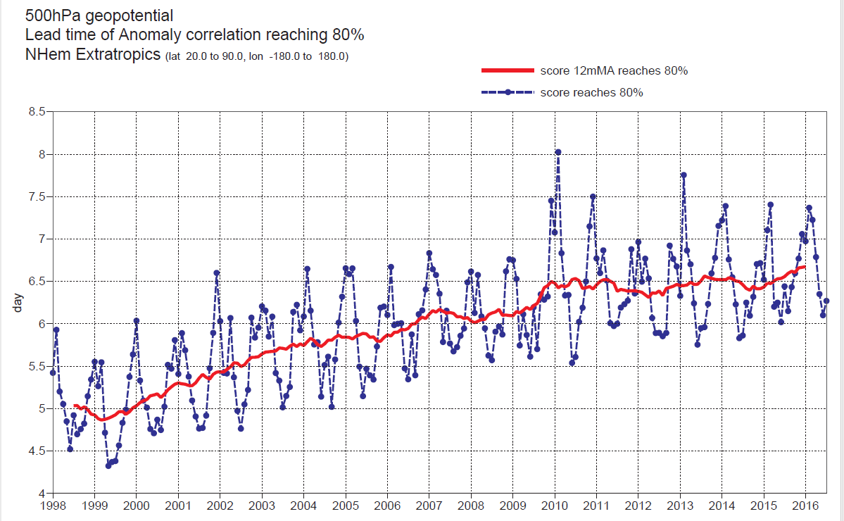
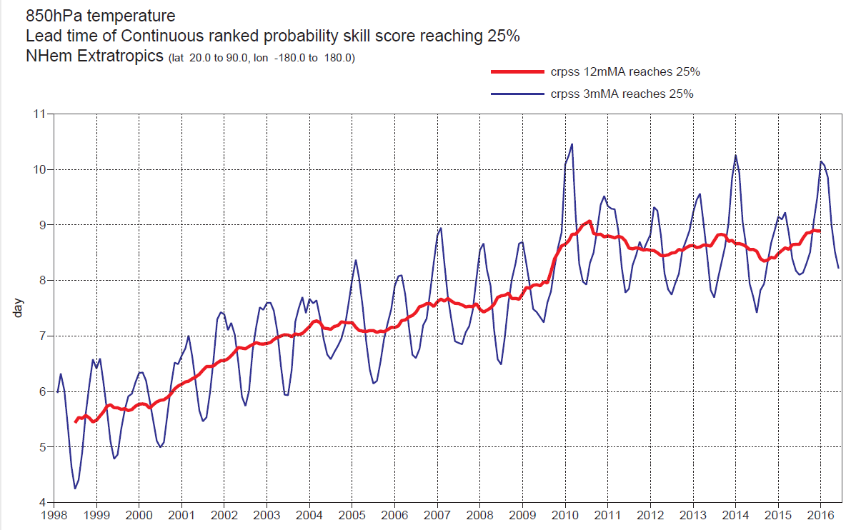
Figure 1. Time evolution of two of the headline scores used to monitor long-term trends in forecast performance of the HRES and ENS forecasts, adopted by Council in 2011.

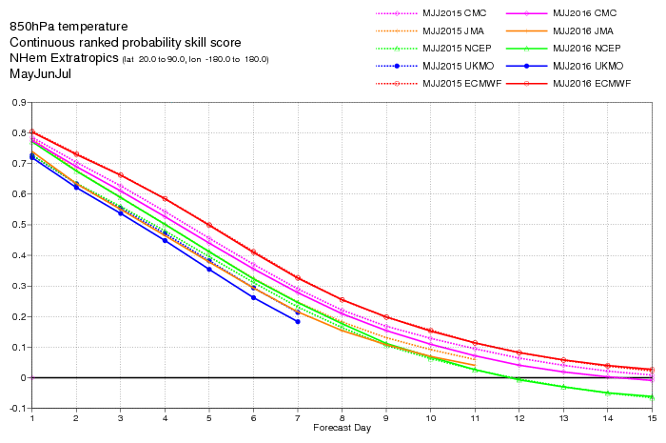
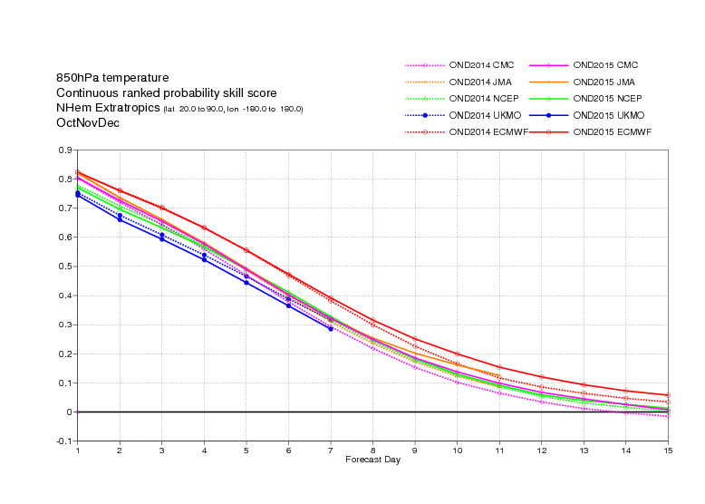
Figure 2. Comparison of probabilistic forecasts of the 850 hPa temperature (T850) for ECMWF (red), the Met Office (UKMO, blue), NCEP (green), the Japan Meteorological Agency (JMA, orange) and Canada (CMC, magenta), using the headline, for summer (May-June-July, top panel) and winter (December-January-February) of the two most recent verifiable years.

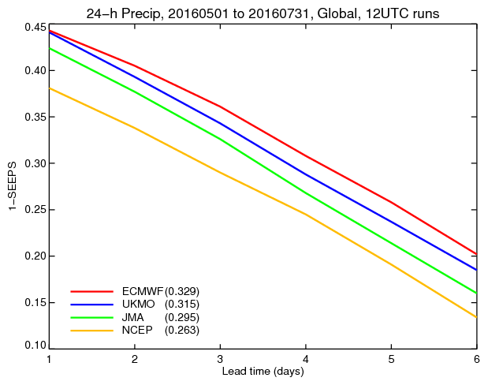 | 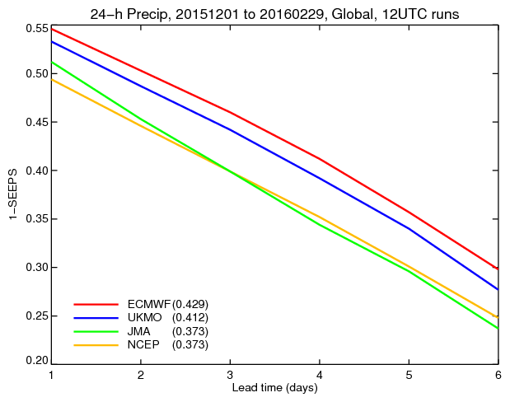
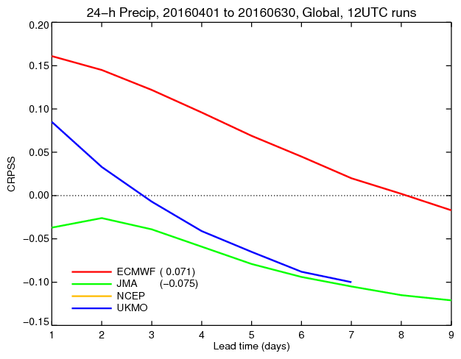 | 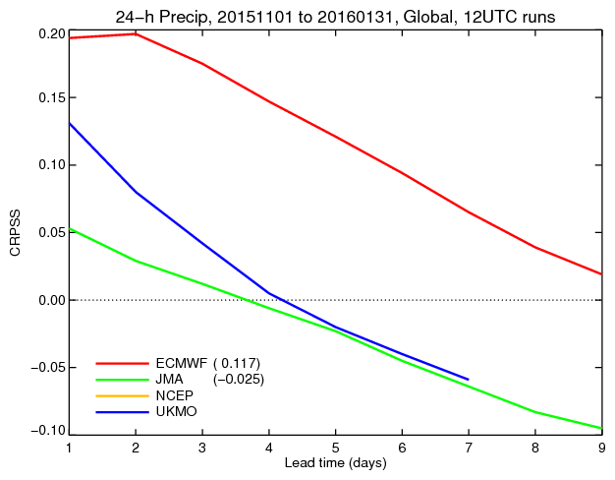
Figure 3. Comparison of precipitation forecast skill for ECMWF (red), the Met Office (UKMO, blue), Japan Meteorological Agency (JMA, magenta) and NCEP (green) using the headline score for precipitation probabilistic skill, routinely computed over the Globe against synop observations:
- Top-left panel: single HRES forecasts, verified using the SEEPS score in MJJ16;
- Top-right panel: single HRES forecasts, verified using the SEEPS score in D15JF16;
- Bottom-left pane; ENS probabilistic forecasts, verified using the CRPSS score in MJJ16;
- Bottom-right pane; ENS probabilistic forecasts, verified using the CRPSS score in D15JF16.

Upper-air scores (Figure 1) indicate skill consistently at a level that was previously experienced only during the period of anomalously high predictability in 2010–11. The slight decrease in 12-month running average values seen in 2014 can be attributed to inter-annual atmospheric variability. Comparison with ERA-Interim confirms that recent variations are due to atmospheric variability.
ECMWF performs a routine comparison of the forecast skill of ECMWF and other centres for both the HRES and the ENS using the TIGGE data archived in the Meteorological Archival and Retrieval System (MARS). Few examples are shown in Figures 2 and 3. Results for precipitation over the last 12 months show a consistent clear lead for the ECMWF ENS over the whole lead time range both for upper-air variables (Figure 2) and for precipitation (Figure 3).

  - Annual verification summary
As requested in the template, averages of the monthly WMO/CBS standard scores for 2015 and for reference also for 2014 are summarised in Tables 3, 4 and 5.

VERIFICATION AGAINST ANALYSIS in 2015 (2014)
 |  | 24 hour |  | 72 hour |  | 120 hour
 |  | 2015 | 2014 | 2015 | 2014 | 2015 | 2014
Northern Hemisphere | 500-hPa height RMS (m) | 5.3 | 5.3 | 17.6 | 17.6 | 38.6 | 38.3
 | Wind RMSVE 250 hPa (m/s) | 3.3 | 3.3 | 7.4 | 7.4 | 12.3 | 12.3
Southern Hemisphere | 500-hPa height RMS (m) | 6.0 | 6.3 | 21.1 | 21.6 | 45.7 | 46.8
 | Wind RMSVE 250 hPa (m/s) | 3.3 | 3.3 | 7.5 | 7.6 | 12.8 | 12.9
Tropics | Wind RMSVE 850 hPa (m/s) | 1.9 | 2.0 | 2.9 | 2.9 | 3.7 | 3.6
 | Wind RMSVE 250 hPa (m/s) | 3.6 | 3.6 | 5.9 | 5.9 | 7.5 | 7.5
Table 3. Annual scores against analyses (HRES)

VERIFICATION AGAINST RADIOSONDES in 2015 (2014)
 |  | 24 hour |  | 72 hour |  | 120 hour
 |  | 2015 | 2014 | 2015 | 2014 | 2015 | 2014
Asia | 500-hPa height RMS (m) | 12.0 | 12.0 | 18.7 | 19.0 | 32.8 | 33.6
 | Wind 850 hPa (m/s) | 3.5 | 3.5 | 4.8 | 4.8 | 6.3 | 6.3
 | Wind 250 hPa (m/s) | 5.5 | 5.3 | 8.4 | 8.3 | 11.9 | 11.9
Australia New Zealand | 500-hPa height RMS (m) | 9.3 | 12.6 | 15.5 | 17.9 | 30.2 | 33.0
 | Wind 850 hPa (m/s) | 3.6 | 3.7 | 4.6 | 4.7 | 6.1 | 6.3
 | Wind 250 hPa (m/s) | 4.9 | 5.0 | 7.3 | 7.4 | 11.0 | 11.0
Europe | 500-hPa height RMS (m) | 10.8 | 10.3 | 21.3 | 19.7 | 46.0 | 41.9
 | Wind 850 hPa (m/s) | 3.5 | 3.4 | 4.9 | 4.7 | 6.9 | 6.8
 | Wind 250 hPa (m/s) | 4.9 | 4.8 | 8.8 | 8.6 | 15.3 | 14.5
North America | 500-hPa height RMS (m) | 9.6 | 9.6 | 18.8 | 19.3 | 37.2 | 38.8
 | Wind 850 hPa (m/s) | 3.7 | 3.7 | 5.1 | 5.0 | 7.1 | 7.1
 | Wind 250 hPa (m/s) | 5.4 | 5.3 | 9.0 | 9.0 | 13.9 | 14.0
Northern Hemisphere | 500-hPa height RMS (m) | 11.6 | 11.4 | 20.3 | 20.0 | 39.7 | 38.8
 | Wind 850 hPa (m/s) | 3.6 | 3.5 | 4.9 | 4.8 | 6.7 | 6.7
 | Wind 250 hPa (m/s) | 5.0 | 5.0 | 8.3 | 8.3 | 13.1 | 12.8
Southern Hemisphere | 500-hPa height RMS (m) | 11.6 | 11.7 | 19.5 | 19.1 | 35.9 | 35.3
 | Wind 850 hPa (m/s) | 4.0 | 4.0 | 5.1 | 5.0 | 6.7 | 6.7
 | Wind 250 hPa (m/s) | 5.4 | 5.3 | 8.0 | 7.9 | 12.2 | 11.8
Tropics | Wind 850 hPa (m/s) | 3.4 | 3.4 | 3.9 | 3.9 | 4.4 | 4.4
 | Wind 250 hPa (m/s) | 4.9 | 4.9 | 6.4 | 6.4 | 7.7 | 7.6
Table 4. Annual scores against radiosondes measurements (HRES)

ENS VERIFICATION AGAINST ANALYSIS in 2015 (2014)
 |  |  | 72 hour |  | 120 hour |  | 192 hour
 |  |  | 2015 | 2014 | 2015 | 2014 | 2015 | 2014
Northern Hemisphere | 500-hPa height | Ensemble mean RMSE (m) | 17.3 | 17.0 | 35.2 | 34.7 | 62.1 | 61.8
 |  | Spread/EM error (%) | 104.9 | 103.5 | 99.4 | 98.5 | 96.6 | 96.1
 |  | CRPS (m) | 8.4 | 8.3 | 16.7 | 16.6 | 30.2 | 30.1
 | 850-hPa temperature | Ensemble mean RMSE (K) | 1.26 | 1.26 | 1.97 | 1.97 | 3.04 | 3.03
 |  | Spread/EM error (%) | 94.5 | 92.8 | 95.4 | 94.0 | 95.0 | 94.6
 |  | CRPS (K) | 0.65 | 0.65 | 1.00 | 1.00 | 1.55 | 1.54
Southern Hemisphere | 500-hPa height | Ensemble mean RMSE (m) | 20.7 | 20.9 | 41.6 | 41.8 | 71.7 | 71.4
 |  | Spread/EM error (%) | 100.4 | 99.0 | 96.4 | 96.4 | 96.5 | 97.9
 |  | CRPS (m) | 10.0 | 10.1 | 20.1 | 20.1 | 35.6 | 35.4
 | 850-hPa temperature | Ensemble mean RMSE (K) | 1.40 | 1.39 | 2.09 | 2.07 | 3.01 | 2.98
 |  | Spread/EM error (%) | 93.0 | 91.9 | 93.7 | 93.9 | 94.2 | 95.3
 |  | CRPS (K) | 0.71 | 0.70 | 1.06 | 1.04 | 1.57 | 1.55
Table 5. Annual scores against analyses (ENS)

The reader is referred to publications available online from the ECMWF web site to read about the accuracy and reliability of the ECMWF forecasts (see, e.g., Haiden et al, 2015..

  - Research performed in this field
At its 47th session (2015), the ECMWF TAC established a subgroup on ‘Verification measures’ to look at forecast performance measures and targets for the 2016-2025 ECMWF Strategy, with the following terms of reference:
- To review the current ECMWF headline measures and provide recommendations to adjust them to the new strategy;
- To recommend verification procedures for ensemble forecasts matching the most important end users requirements for high impact weather up to two weeks ahead;
- To recommend verification procedures suitable to evaluate ensemble forecasts of large scale patterns and regime transitions up to four weeks ahead;
- To make recommendations on the way key performance indicators and targets can be set for the period of the strategy taking into account the large year-to-year variability of atmospheric predictability.

Various options for a headline score for 2 m temperature are being explored, focussing on large-scale skill in week 2. Another topic investigated by the Subgroup is end-user related scores such as the weighted CRPS, which allows proper evaluation of extremes. Also, the generalized discrimination score and the potential economic value were considered in this context. Follow-up work will directly compare these scores with respect to their usefulness in long-term performance monitoring.
In extended-range verification the focus has been on how best to use the regime (transition) concept in verification, and how it can be applied to performance monitoring. An overview of the main sources of predictability in the extended-range [Madden-Julian Oscillation (MJO), Sudden Stratospheric Warmings, Rossby Wave Packets] was presented, and the possibility of using MJO skill as an extended-range headline score was discussed.

- Plans for the future (next 4 years)
In June 2016, the ECMWF Council has approved its next 10 year strategy, that will cover the period from 2016 to 2025 (the strategy will soon to be published on the ECMWF web site).
The strategy sets as ECMWF goals for the next decade to provide forecast information needed by weather service providers and others to help save lives, protect infrastructure and promote economic development through:
- Research at the frontiers of knowledge to develop an integrated global model of the Earth system to produce forecasts with increasing fidelity on time ranges up to one year ahead. This will tackle the most difficult problems in numerical weather prediction such as the currently low level of predictive skill of European weather for a month ahead.
- Operational ensemble-based analyses and predictions that describe the range of possible scenarios and their likelihood of occurrence and that raise the international bar for quality and operational reliability. Skill in medium-range weather predictions in 2015, on average, extends to about one week ahead. By 2025 the goal is to make ensemble predictions of high-impact weather up to two weeks ahead. By developing a seamless approach, we also aim to predict large-scale patterns and regime transitions up to four weeks ahead, and global-scale anomalies up to a year ahead.

Advancing weather science and improving numerical weather prediction to meet these goals over the life of the next Strategy will require a balance of talent and technology, which will rely on:
- A powerful, energy-efficient and resilient infrastructure including a high-performance computing facility;
- Attractive working terms and environment to attract and retain the required talent;
- ECMWF inspiring and attracting international scientific and computing collaboration across the Member States and beyond;
- Scalable and efficient modelling and processing codes that encompass a comprehensive Earth system approach.

The Strategy will also see an enhancement of the services that ECMWF develops and provides its Member and Co-operating States, as well as the wider meteorological community, especially in the areas of:
- Dedicated supercomputer capacity and specialist software for members;
- A comprehensive meteorological data archive available within and outside of ECMWF;
- Initial and boundary conditions for regional fine-scale weather prediction models;
- Global reanalyses and re-forecasts;
- An enduring partnership with the World Meteorological Organization (WMO), allowing the poorest nations in the world access to life-critical data;
- Advanced training in Earth system modelling and forecasting;
- Additional operational activities, such as atmosphere monitoring, flood forecasting and climate change services, supported by third parties.

- Consortium
N/A.

- References
For high-level information, readers are referred to ECMWF programmatic documents, including:
- The ECMWF Annual Reports (http://www.ecmwf.int/en/about/news-centre/media-resources);
- The Media Center communications (http://www.ecmwf.int/content/about/media-centre/news);
- The ECMWF 2016-2025 10-year Strategy (http://www.ecmwf.int/en/about/media-centre/news/2016/ecmwf's-council-approves-new-strategy).

For more detailed information on research and development, readers are referred to the ECMWF Internal publications:
- ECMWF Research Department Technical Memoranda (http://www.ecmwf.int/en/elibrary/technical-memoranda)
- ECMWF Newsletters (http://www.ecmwf.int/search/elibrary/?solrsort=ts_biblio_year%20desc&keywords=Newsletter);
For recent performance scores, readers are referred to:
- Haiden, T, Janousek, M, Bauer, P, 2015: Evaluation of ECMWF forecasts, including 2014-2015 upgrades. ECMWF Research Department Technical Memorandum n. 765, pp 53 (http://www.ecmwf.int/sites/default/files/elibrary/2015/15275-evaluation-ecmwf-forecasts-including-2014-2015-upgrades.pdf)

- List of acronyms
Hereafter, the meaning of some key acronyms used in the text is explained:
- BC project: the ECMWF optional Boundary Condition project.
- CERA: the Coupled ECMWF Coupled Re-Analysis system.
- CERA-20C: the ECMWF 10-member, 20th coupled reanalysis, generated with funding from the EU FP7 ERA-CLIM2 project.
- COPE: the ECMWF Continuous Observation Processing Environment.
- CRPS/CRPSS: the Continuous Ranked Probability Score and Skill Score.
- C3S: Copernicus Climate Change Service.
- C-IFS: the ECMWF Chemistry in the IFS model.
- DA: data assimilation.
- DHS: Data Handling System.
- EC: European Commission.
- EDA: the ECMWF Ensemble of Data Assimilation.
- EFI: the Extreme Forecast Index.
- EnKF: Ensemble Kalman Filter.
- ENS: the ECMWF medium-range/monthly ensemble.
- ERA: ECMWF Re-Analysis.
- ERA-Interim: ERA, Interim version.
- ERA5: ERA, version 5.
- ERA-CLIM2: the EU FP7 project (http://www.ecmwf.int/en/research/projects/era-clim2).
- ESCAPE: the Energy-efficient Scalable Algorithms for Weather Prediction at Exascale EU project (http://www.ecmwf.int/en/research/projects/escape).
- HPC: High Performing Computing.
- HPE: hydrostatic primitive equations.
- HRES: the ECMWF high-resolution single forecast.
- ICs: Initial Conditions.
- IFS: the ECMWF Integrated Forecasting System.
- LIM: the Louvain-la-Neuve sea-ice model used in NEMO (https://www.uclouvain.be/teclim.html).
- MACC: the Monitoring Atmospheric Composition and Climate project (http://www.ecmwf.int/en/research/projects/macc-ii).
- MARS: the ECMWF Meteorological Archive and Retrieval System.
- McICA: Monte Carlo Independent Column Approximation radiation scheme.
- MIR: the new ECMWF Meoteorological Interpolation Re-gridding package.
- MPI: Message Passing Interface.
- MJO: the Madden Julian Oscillation.
- NEMO: the Nucleus of European Modelling of the Ocean (http://www.nemo-ocean.eu/).
- NEMOVAR: the NEMO variational assimilation system.
- NWP: Numerical Weather Prediction.
- ORAS4/ORAS5: the ocean analysis/reanalysis system, version 4/5.
- ORCA: the NEMO tri-polar grid.
- SAC: the ECMWF Scientific Advisory Committee.
- SAPP: the ECMWF Scalable Acquisition and Pre-Processing system.
- SEEPS: the Stable Equitable Error in Probability Space.
- SISL: Semi-Implicit Semi-Lagrangian numerical method.
- SPP: the ECMWF Stochastically Perturbed Parameterisation, model-error scheme.
- SKEB: the ECMWF Stochastic Kinetic-Energy Back-scatter model-error scheme.
- SOT: the Shift Of Tail index.
- SPPT: the ECMWF Stochastically Perturbed Parameterized Tendency model-error scheme.
- S2S; the WWR/WCRP WMO Sub-seasonal to Seasonal project.
- S4/S5: the ECMWF Seasonal System-4/System-5.
- TAC: the ECMWF Technical Advisory Committee.
- TcoXXX: spectral triangular truncation XXX with cubic-octahedral grid.
- TKE: Turbulent Kinetic Energy.
- T_{L}XXX: spectral triangular truncation XXX with linear grid.
- TOA: Top Of the Atmosphere.
- 4DVar: the ECMWF high-resolution, 4-dimensional variational analysis.

*** ***

This report has been prepared in August 2016 by Roberto Buizza, with input from David Richardson and Martin Janousek. It has been compiled by inserting extracts of material presented to the ECMWF Scientific Advisory Committee (SAC) in October 2015, to the ECMWF Technical Advisory Committee (TAC) in October 2015 and to the ECMWF Council in June 2016. It also includes some updates using from more recent ECMWF publications and internal reports.

