JOINT WMO TECHNICAL PROGRESS REPORT ON THE GLOBAL DATA PROCESSING AND FORECASTING SYSTEM AND NUMERICAL WEATHER PREDICTION RESEARCH ACTIVITIES FOR 2015

Hong Kong Observatory, Hong Kong, China

- Summary of highlights

- The webpage on Automatic Regional Weather Forecast was enhanced with station-specific probability of precipitation and weather icon forecasts. Subsequently in 2016, these new elements were also integrated into location-specific forecasts of the MyObservatory app.
- The nowcasting system called the Short-range Warning of Intense Rainstorms in Localized Systems (SWIRLS) was enhanced to generate probabilistic quantitative precipitation nowcast (PQPN) products, to adopt co-Kriging analysis for rainfall distribution maps, and to support progressive verification of rainstorm warnings and those from “Automatic Rainstorm Related Objective Warnings (ARROW)”. A community version of SWIRLS (com-SWIRLS) was made available to NMHs with training provided.
- The extended domain version of mesoscale model called Meso-NHM was put into operation in the first quarter of 2015. Research was undertaken to enhance its convective parameterization scheme. The new convective parameterization scheme is expected to be put into operation in mid-2016.
- A sub-kilometre resolution NWP suite, the Aviation Model (AVM), continued supporting detailed weather forecasts for the Hong Kong International Airport. The system will be extended to provide full coverage of the Hong Kong territory at an unprecedented 200-m resolution in 2016. Meanwhile, near real-time experiments were being conducted on mesoscale ensemble forecasts, which demonstrated some benefits in a number of recent high impact weather cases in Hong Kong, China.

- Equipment in use

Machine | Quantity | Peak performance | No. of CPU | Memory | Year of Installation
Dell R720 Cluster | 1 | 3.0 TFLOPS (CPU)  9.4 TFLOPS (GPU) | 18 CPU  8 GPU | 1,728 GB (CPU)  40 GB (GPU) | 2014
Dell HPC Cluster | 1 | 18.7 TFLOPS | 119 | 3,504 GB | 2013
Dell HPC Cluster | 1 | 12 TFLOPS | 74 | 2,368 GB | 2013
HP Cluster | 1 | 1.8 TFLOPS (CPU)  15.2 TFLOPS (GPU) | 16 CPU  21 GPU | 1,056 GB (CPU)  120 GB (GPU) | 2012-14
Dell R510 Server | 1 | 68.0 GFLOPS | 8 | 12 GB | 2012
IBM BladeCenter JS23 | 1 | 64.0 GFLOPS | 4 | 16 GB | 2012
Dell R710 Cluster | 1 | 1.3 TFLOPS | 16 | 384 GB | 2011
Dell HPC Cluster | 1 | 7.7 TFLOPS | 186 | 2,120 GB | 2010
IBM BladeCenter JS22 | 1 | 64.0 GFLOPS | 4 | 12 GB | 2009
IBM p630 Cluster | 1 | 48.0 GFLOPS | 12 | 28 GB | 2004
IBM SP Cluster | 1 | 36.0 GFLOPS | 24 | 13.5 GB | 2001

A Dell R720 Cluster comprising 9 nodes were installed in 2014 for research and development of SWIRLS. It also functions as a backup to the operational platform that is made up of Dell R710 Cluster and HP Cluster.

Migration of NWP applications to a new high performance computing (HPC) cluster (a total of 61 nodes with an aggregated peak performance of 18.7 TFLOPS) for supporting HKO’s operational mesoscale NWP model system (Section 4.1) and related R&D activities was completed in May 2015. The old HPC cluster with an aggregated peak performance of 7.7 TFLOPS acquired in 2010 was deployed for various NWP R&D activities.

A HPC system with 37 computational nodes and an aggregated peak performance of 12 TFLOPS continued to support HKO’s high-resolution Aviation Model (AVM) for fine-scale forecasts around the Hong Kong International Airport (HKIA).

With all jobs in an IBM SP cluster migrated to new servers, the old cluster was retired on 30 June 2015.

- Data and Products from GTS in use

The approximate number of bulletins of observations received from GTS (in both alphanumeric and BUFR messages) on a typical day in 2015 is given below:

 | Alphanumeric | BUFR
SYNOP/SHIP/BUOY | 25,000 | 6,000
Radiosonde (TEMP/PILOT) | 1,100 | 600
AIREP | 500 | --
AMDAR | 1,800 | 4,000
SATEM/SATOB | 200 | 1,500
ATOVS | -- | 3,500
Scatterometer wind (ASCAT) | -- | 14,000
Wind Profiler | -- | 250
Drifting Buoy | 2,500 | --
Other observations and reports, such as RADOB, SAREP and DROPSONDE are also gathered through the GTS during the passage of tropical cyclones.

The approximate number of bulletins or files of NWP products received from GTS on a typical day in 2015 is given below:

Centre | Type | Number
China Meteorological Administration (CMA) | GRIB | 120*
Deutscher Wetterdienst (DWD) | GRIB | 2,000#
European Centre for Medium Range Weather Forecasts (ECMWF) | GRIB | 6,500
Japan Meteorological Agency (JMA) | GRIB | 9,000
United Kingdom Meteorological Office (UKMO) | GRIB | 3,000
*CMA NWP products are grouped by forecast hour and comprise multiple forecast elements.
#DWD NWP products changed significantly with products for Western Hemisphere
replaced by global coverage products since 24 July 2015.

NWP products from the US National Centers for Environmental Prediction (NCEP), ECMWF, JMA, Korea Meteorological Administration (KMA) and Canadian Meteorological Centre (CMC) are also acquired through the Internet.

- Forecasting system

  - System run schedule and forecast ranges

    - AIR/NHM

The Atmospheric Integrated Rapid-cycle (AIR) forecast model system is operated in two forecast domains with horizontal resolution at 10 km and 2 km (Wong, 2011) using the Non-Hydrostatic Model (NHM) developed by the Japan Meteorological Agency (JMA) (Saito et al. 2006).

The outer 10-km resolution model, named as Meso-NHM, is run 8 times a day to generate 72-hour forecasts. The domain of the model covers the area 7.3 – 42.2 °N, 89.9 – 146.6 °E for model runs before 30/3/2015. The model domain was extended on 30/3/2015 and the map projection was changed to Lambert Conformal Conic with the lower left corner at 0.91ºN, 84.42ºE and the upper right corner at 37.48ºN, 168.13ºE. The initial condition is based on the 3-dimensional variational data assimilation (3DVAR) analysis at 00, 03, 06, 09, 12, 15, 18 and 21 UTC with observation cut-off time of about 2.5 hours. The boundary conditions are extracted from the ECMWF Integrated Forecast System (IFS) forecasts. Additional Meso-NHM runs using GSM forecasts from JMA are conducted at 00 and 12 UTC with a view to capturing various scenarios on the development of synoptic and mesoscale systems under different model boundary conditions.

The inner 2-km resolution model, known as RAPIDS-NHM, is run on an hourly basis covering an area 19.5 – 25.0 °N, 111.2 – 117.1 °E with forecast range of 15 hours. The initial condition is obtained from the 3DVAR analysis at 00, 01, …, 23 UTC with observation cut-off time of about 35 minutes, and the boundary conditions are prescribed by ECMWF IFS forecasts.

    - Operational Regional Spectral Model (ORSM) (decommissioned in mid-2015)

ORSM system was a model originally developed by JMA and adapted for short-range weather forecasting at 20-km and 60-km resolutions for an inner and an outer domain respectively.

Following the extension of the domain of the Meso-NHM (section 4.1.1), the ORSM was decommissioned on 26 May 2015.

    - Aviation Model (AVM)

The AVM is a high-resolution implementation of the Weather Research and Forecast (WRF) model (Skamarock, 2008) in support of fine-scale aviation weather forecasts for the HKIA.

AVM is operated in two single-nested forecast domains with horizontal resolution of 600 m and 200 m, covering respectively the Pearl River Estuary region (AVM-PRD) and the immediate vicinity of the HKIA (AVM-HKA). The outer domain covers an area of about 350 km × 350 km (20.8 – 23.8 °N, 112.2 – 115.6 °E) while the inner domain covers about 50 km × 50 km (22.08 – 22.53 °N, 113.68 – 114.16 °E).

Forecasts of both domains are updated at hourly intervals and currently cover up to T+7 hours. Initial conditions are obtained from 3D-VAR analysis performed hourly with observation cut-off time of about 15 minutes. Boundary conditions, as well as first guesses for 3D-VAR analysis, for AVM-PRD and AVM-HKA are based on the latest available output from RAPIDS-NHM and the concurrent forecast of AVM-PRD respectively.

  - Medium range forecasting system (4-10 days)

Operationally, forecasts up to 9 days ahead are formulated by forecasters and are made available for public consumption based on a subjective assessment of the prognostic forecast products from the global models of ECMWF, JMA, NCEP, CMA, KMA and UKMO with horizontal resolution as high as 0.125 degrees. Forecast of various meteorological elements are presented to forecasters in various formats, including weather maps, time series, time cross-section and forecast tephigrams to facilitate forecast formulation.

An automated medium-range forecasting system, running twice a day based on 00- and 12-UTC model output primarily from ECMWF, JMA, NCEP and Meso-NHM as well as some of the local forecasting rules, provides objective forecast guidance on local winds, state of sky, weather, temperature and relative humidity up to 9 days ahead. Besides, probabilities of precipitation for each day are computed based on the output of ECMWF EPS. In addition to the use of direct model output, key post-processing techniques employed in the system include linear regression, Kalman–filtering, logistic regression and poor-man’s ensemble averaging.

Following the work of Engel and Ebert (2007), a system called the Objective Consensus Forecast (OCF) has been developed. Forecast time-series of temperature, daily minimum and maximum temperatures, wind speed and wind direction, dew point, relative humidity, weather icon (describing the state of sky and rainfall) and daily probability of precipitation for various locations in Hong Kong up to 240 hours (and extended to 384 hours in 2016) ahead are generated based on an ensemble of post-processed outputs from Meso-NHM (Section 4.3 below), global deterministic model forecasts from ECMWF, JMA, NCEP and CMA (with UKMO being included in 2016), as well as EPS from ECMWF. Time-lagged ensembles of the maximum and minimum temperature forecasts from OCF are also made available to facilitate forecasters’ assessment on the regional temperatures over Hong Kong in the following 9 days.

    - Operational techniques for application of NWP products (MOS, PPM, KP, Expert Systems, etc.)

      - In operation

        - Tropical Cyclone Information Processing System (TIPS)

The Tropical Cyclone Information Processing System (TIPS) has been in operation since 2005, integrating various information for use by forecasters in the preparation of tropical cyclone forecasts and warnings, including a) NWP products from Meso-NHM operated by HKO (see Section 4.3 below), global models of ECMWF, JMA, UKMO, NCEP, CMA, KMA and CMC, as well as the Hurricane Weather Research and Forecast (HWRF) modelling system of NCEP; b) subjective forecasts and warning from meteorological centres; and c) satellite and radar fixes and imageries from meteorological centres. TIPS can generate ensemble tracks up to 9 days ahead from model forecasts for reference by the forecasters. In addition to position-based consensus method, a motion vector consensus method was available in TIPS to handle incomplete model forecasts in generating ensemble TC tracks. Ensemble mean tracks and TC strike probability information derived from the EPS forecast data of various centres were also available to facilitate the construction of warning tracks.

    - Ensemble Prediction System (EPS)

Meteograms from the EPS of ECMWF, JMA and KMA for the grid points in the vicinity of Hong Kong are generated for forecasters’ reference. Other ECMWF EPS products, such as Extreme Forecast Index, probability of precipitation, probability of high winds, spaghetti diagrams and stamp maps of MSLP and geopotential height at 500hPa level, are also available.

  - Short-range forecasting system (0-72 hrs)

    - Data assimilation, objective analysis and initialization

      - In operation

        - AIR/NHM

Meteorological data assimilated by the 3-dimensional variational data assimilation system (3DVAR) of AIR/NHM are as follows:

(A) | From GTS
 | SYNOP, BUOY, SHIP | surface and ship data
 | TEMP, PILOT | radiosonde and pilot data
 | AMDAR and AIREP | aircraft data
 | ATOVS | retrieved temperature profile from polar-orbiting satellites
 | AMV | atmospheric motion vector from MTSAT-2/MTSAT-1R/HIMAWARI-8
 | Ocean surface wind | scatterometer wind retrieval data from ASCAT/RapidScat/HY-2A
 | IASI | temperature and humidity retrieval profile data from EUMETSAT Metop IASI (Infrared Atmospheric Sounding Interferometer)
(B) | Through regional data exchange
 | Data from automatic weather stations and weather radars in Guangdong
(C) | Local observations
 | Automatic weather station data
 | Doppler weather radar data
 | Retrieved wind data from mosaic of weather radars in Hong Kong and Guangdong
 | Wind profiler data
 | Ground-based Global Positioning System (GPS) reception network
(D) | From NCEP data server
 | Daily high resolution sea surface temperature (HR-SST) analysis at 0.083-degree resolution in latitude/longitude

Initial conditions of Meso-NHM and RAPIDS-NHM are generated using 3DVAR analysis running at full horizontal resolution and model vertical levels. The first guess of 3DVAR analysis in Meso-NHM is obtained from the ECMWF IFS/JMA GSM. In RAPIDS-NHM 3DVAR system, the Meso-NHM forecast is used as the background.

Total precipitable water vapour (PWV) retrieved from SSM/I is assimilated in Meso-NHM 3DVAR. To prescribe the sea-surface temperature field in Meso-NHM, SST analysis from ECMWF is used.

In RAPIDS-NHM, PWV from the local ground-based GPS stations and Doppler velocity data from the two weather radars in Hong Kong are assimilated in the 3DVAR analysis. 3-dimensional variational wind retrieval is applied to generate upper level wind data over Hong Kong and nearby regions using Doppler velocity and reflectivity data from the weather radars in Hong Kong and Guangdong. The retrieved wind data are used to support the monitoring and nowcast of severe weather, and they are ingested in RAPIDS-NHM 3DVAR as additional upper-air wind observations (Wong et al. 2011).

RAPIDS-NHM 3DVAR is used to provide the hourly mesoscale analysis of wind, temperature, relative humidity on surface and upper levels at full horizontal resolution (2 km). Diagnostic fields including instability indices, equivalent potential temperature, moisture transport and moisture flux convergence are generated for forecasters’ reference on analysis of mesoscale weather process and nowcasting of severe weather systems.

        - AVM

Meteorological data assimilated by the 3-dimensional variational data assimilation system (3DVAR) of AVM are as follows:

(A) | From GTS
 | SYNOP, BUOY, SHIP | surface and ship data
 | TEMP, PILOT | radiosonde and pilot data
 | AMDAR and AIREP | aircraft data
(B) | Local observations
 | Dense surface observations from the automatic weather station networks from Hong Kong and Guangdong, including weather buoys
Wind observations from wind profilers in Hong Kong
Temperature and humidity profiles from microwave radiometer

Initial conditions of AVM-PRD and AVM-HKA are generated using 3D-VAR analysis running at full horizontal resolution and model vertical levels. The first guess of 3D-VAR analysis in AVM-PRD is based on the output from the latest available run of the 2-km RAPIDS-NHM, normally at a time lag of 1 – 2 hours. For AVM-HKA, the background field is taken from the concurrent AVM-PRD output.

      - Research performed in this field

Fine-tuning of data assimilation algorithm, surface and boundary layer physical processes were carried out throughout 2015 to improve performance in winds and temperature forecasts, particularly over the HKIA region and urban areas in Hong Kong.

    - Model

      - In operation

        - AIR/NHM

Specification of Meso-NHM and RAPIDS-NHM in AIR forecast model system:

 | Meso-NHM | RAPIDS-NHM
Horizontal resolution | 10 km | 2 km
Horizontal grid | Arakawa-C
Map projection | Mercator (before 30/3/2015)  Lambert Conformal Conic (from 30/3/2015 onwards) | Mercator
No. of grid points | 585×405 (before 30/3/2015)  841×515 (from 30/3/2015 onwards) | 305×305
Vertical coordinates | Terrain following height coordinates using Lorenz grid
No. of vertical levels | 50 | 60
Time step | 30 s | 8 s
Initial time | 00, 03, 06,…, 21 UTC (for using ECMWF IFS forecast as boundary)  00 and 12 UTC (for using JMA GSM forecast as boundary) | Every hour
Forecast range | 72 hours | 15 hours
Initial condition | 3DVAR using background from ECMWF IFS/JMA GSM forecast | 3DVAR using background from Meso-NHM forecast
Boundary condition | ECMWF IFS forecast data  (00 and 12 UTC)  at 0.125 degree resolution in lat/lon  Boundary data including:  pressure, horizontal wind components (U and V), temperature (T) and relative humidity (RH) on surface; and U,V,T,RH and geopotential height at 21 pressure levels (1000,975,950,925,900,850,800,  700,600,500,400,300,250,200,150,100, 70, 50, 30, 20, 10 hPa )  JMA GSM forecast data  (00 and 12 UTC)  at 0.5 degree resolution in lat/lon  Boundary data including:  pressure, horizontal wind components (U and V), temperature (T) and relative humidity (RH) on surface; and U,V,T,RH and geopotential height at 21 pressure levels (1000,975,950,925,900,850,800,  700,600,500,400,300,250,200,150,100, 70, 50, 30, 20, 10 hPa ) | Meso-NHM forecast on 50 model levels
Nesting configuration | One-way nesting
Topography | USGS GTOPO30 (30 second data smoothed to 1.5 times horizontal resolution) with modifications over Hong Kong areas based on USGS-SRTM (Shuttle Radar Topography Mission) dataset
Land-use characteristics | USGS Global Land Cover Characterization (GLCC) 30 second data and 24 land-use types with modifications over Hong Kong
Dynamics | Fully compressible non-hydrostatic governing equations solved by time-splitting horizontal-explicit-vertical-implicit (HEVI) scheme using 4th-order centred finite differencing in flux form
Cloud microphysics | 3-ice bulk microphysics scheme
Convective parameterization | Kain-Fritsch scheme  (JMA version) | -
Surface process | Flux and bulk coefficients: Beljaars and Holtslag (1991), Donelan et al. (2004); Roughness length: Beljaars (1995) and Fairall et al. (2003); Stomatal resistance and temporal change of wetness included;  4-layer soil model to predict ground temperature and surface heat flux.
Turbulence closure model and planetary boundary layer process | Mellor-Yamada-Nakanishi-Niino Level 3 (MYNN-3) (Nakanishi and Niino, 2004) with partial condensation scheme (PCS) and implicit vertical turbulent solver  Height of PBL calculated from virtual potential temperature profile
Atmospheric radiation | Long wave radiation process following Kitagawa (2000)  Short wave radiation process using Yabu et al. (2005)  Prognostic surface temperature included; Cloud fraction determined from PCS.
For further details on NHM and AIR forecast model system, please refer to Saito et al. (2006) and Wong (2011) respectively.

        - AVM

The characteristics of AVM are shown as follows:

 | AVM-PRD | AVM-HKA
Horizontal resolution | 600 m | 200 m
Horizontal grid | Arakawa-C
Map projection | Mercator
No. of grid points | 581×581 | 253×253
Vertical coordinates | Terrain-following eta coordinates
No. of vertical levels | 42
Initial time | Every hour
Forecast range | 7 hours
Initial condition | 3D-Var using background from RAPIDS-NHM forecast | 3D-Var using background from AVM-PRD forecast
Boundary condition | Latest available RAPIDS-NHM forecast interpolated onto 42 pressure levels | Concurrent AVM-PRD forecast on full model levels
Nesting configuration | One-way nesting
Topography | USGS GTOPO30 (30 second data) with local adaptations
Land-use characteristics | USGS Global Land Cover Characterization (GLCC) 30 second data and 24 land-use types with local adaptations
Dynamics | Fully compressible non-hydrostatic governing equations in flux form
Cloud microphysics | WRF double-moment 6-class scheme
Convective parameterization | -
Surface processes and boundary layer | Noah LSM; LES PBL scheme with local adaptations
Atmospheric radiation | Longwave radiation: RRTMG scheme  Shortwave radiation: RRTMG shortwave scheme
Please refer to Skamarock (2008) for technical details of the Weather Research and Forecast (WRF) Model (Version 3.4.1).

      - Research performed in this field

        - Extended domain Meso-NHM

Research on convective parameterization in Meso-NHM was carried out. A new convective parameterization, based on the formation in Tiedtke (1989) and ECMWF IFS Documentation – Cy41r1, was developed for JMA-NHM. Positive impact of the new convective parameterization scheme was observed in studies with a handful of cases of tropical cyclones affected Hong Kong in year 2014 and 2015. It is expected that the new NHM using the new convective parameterization scheme would be put into operation in mid-2016 after a parallel run trial on testing its impact on forecasting heavy rain in early rain season of year 2016 and verification of its numerical stability.

        - Extended domain AVM

In the current configuration of AVM, the inner AVM-HKA domain, which is centred around HKIA, covers only the southwestern portion of Hong Kong. With a view to better supporting detailed regional weather forecasts as well as aviation applications, the AVM-HKA domain would be extended to provide full coverage of Hong Kong territory at 200-m resolution in 2016. Forecasts experiments using the extended domain indicated small but positive benefits in surface temperature and upper-air wind forecasts by verification against AWS and aircraft observations.

    - Operationally available NWP products

      - AIR/NHM

For Meso-NHM, 3-hourly prognostic charts on surface (3-hour accumulated rainfall, mean sea level pressure, temperature, relative humidity, wind, CAPE) and upper levels (925, 850, 700, 500 and 200 hPa for elements including geopotential height, wind, relative humidity, divergence, relative vorticity), time series, time cross section, vertical cross section and tephigram for grid points at strategic locations in Hong Kong are generated every 3 hours. For RAPIDS-NHM, similar products are generated but at hourly intervals and hourly output frequency. In addition, simulated radar reflectivity products such as maximum reflectivity, reflectivity at 3 km altitude, isothermal reflectivity at -10°C and vertically integrated ice content; as well as the mesoscale diagnostic products including moisture transport, moisture flux convergence and updraft helicity for RAPIDS-NHM are routinely generated for forecasters’ reference in significant convection forecasting.

      - AVM

Routinely available products from AVM-PRD include prognostic charts of upper-air (wind, humidity, divergence and vorticity) and surface elements (pressure, temperature, dew point and relative humidity) at hourly intervals. Upper-air charts are provided at standard pressure levels of 925, 850, 700, 500 and 200 hPa.

In addition to forecast rainfall accumulated at hourly intervals, a suite of mesoscale diagnostic parameters (including CAPE, K-Index, vertical windshear and storm-relative helicity) are developed in support of short-term forecasts of severe convection. Specialised products for aviation applications are mentioned in Section 4.3.4.1. Simulated 3-km radar reflectivity images are also routinely generated to provide guidance on mode of convection.

      - Products for other meteorological services

TC track forecast guidance from Meso-NHM is routinely generated and disseminated via GTS. The guidance is issued and updated twice a day based on the 00 and 12 UTC model runs whenever a TC reaching tropical depression strength occurs in the area of responsibility of HKO (10 – 30 º N, 105 – 125 ºE). The information provided in the guidance includes forecast TC positions and intensity changes at 6-hourly intervals up to 72 hours ahead. TC warning position and intensity analysed by HKO at 00 and 12 UTC are also included as initial values.

Up to the end of 2015, HKO is providing city-specific forecast times series and time cross sections for a total of 173 cities of the RA II Members under the RA II Project on City-Specific NWP Products, via a password-protected web site maintained by HKO. The products are generated using the direct model output of 60-km ORSM before its decommissioning and the extended domain Meso-NHM. Table 4.3.3.1 summarised the forecast elements provided in the RA II project.

Table 4.3.3.1 Forecast of meteorological elements provided in the RAII project on City-Specific NWP Products
Content | Levels | Initial Time | Forecast Hours | Display Format
Sea level pressure | Sea level | 00 and 12 UTC | 3-hourly intervals from 3 to 72 hours | Graphical and tabulated data formats
3-hourly precipitation | Surface | 00 and 12 UTC | 3-hourly intervals from 3 to 72 hours | Graphical and tabulated data formats
Surface relative humidity | Surface | 00 and 12 UTC | 3-hourly intervals from 3 to 72 hours | Graphical and tabulated data formats
Total cloud amount | - | 00 and 12 UTC | 3-hourly intervals from 3 to 72 hours | Graphical and tabulated data formats
Air temperature | Surface, 925, 850, 700, 600, 500, 400, 300, 250, 200, 150 and 100 hPa | 00 and 12 UTC | 3-hourly intervals from 3 to 72 hours | Graphical and tabulated data formats
Dew point temperature
Wind speed and direction
Geopotential height | 500 hPa | 00 and 12 UTC | 3-hourly intervals from 3 to 72 hours | Graphical and tabulated data formats

Selected model products derived from Meso-NHM are also disseminated in graphical format via the Internet (Table 4.3.3.2) for public consumption (URL: http://www.weather.gov.hk /nhm/nhme.htm).

Table 4.3.3.2 Meso-NHM-based model forecast charts available on the Internet
Levels | Content | Initial Time | Forecast Hours | Area
Surface | Simulated IR imageries overlaid with rain areas | 00, 06, 12 and 18 UTC | 06, 12, 18, …72 | 8 – 42 °N,  90 – 146 °E
Surface | Air temperature | 00, 06, 12 and 18 UTC | 00, 06, 12, …72 | 8 – 42 °N,  90 – 146 °E
Surface | Mean sea level pressure | 00, 06, 12 and 18 UTC | 00, 06, 12, …72 | 8 – 42 °N,  90 – 146 °E
Surface | Wind | 00, 06, 12 and 18 UTC | 00, 06, 12, …72 | 8 – 42 °N,  90 – 146 °E
Surface | Relative humidity and streamline | 00, 06, 12 and 18 UTC | 00, 06, 12, …72 | 8 – 42 °N,  90 – 146 °E
850 hPa | Wind | 00, 06, 12 and 18 UTC | 00, 06, 12, …72 | 8 – 42 °N,  90 – 146 °E
850 hPa | Relative vorticity and streamline | 00, 06, 12 and 18 UTC | 00, 06, 12, …72 | 8 – 42 °N,  90 – 146 °E
700 hPa | Wind | 00, 06, 12 and 18 UTC | 00, 06, 12, …72 | 8 – 42 °N,  90 – 146 °E
700 hPa | Relative humidity and streamline | 00, 06, 12 and 18 UTC | 00, 06, 12, …72 | 8 – 42 °N,  90 – 146 °E
500 hPa | Wind | 00, 06, 12 and 18 UTC | 00, 06, 12, …72 | 8 – 42 °N,  90 – 146 °E
500 hPa | Geopotential height | 00, 06, 12 and 18 UTC | 00, 06, 12, …72 | 8 – 42 °N,  90 – 146 °E
200 hPa | Wind | 00, 06, 12 and 18 UTC | 00, 06, 12, …72 | 8 – 42 °N,  90 – 146 °E
200 hPa | Jet stream and streamline | 00, 06, 12 and 18 UTC | 00, 06, 12, …72 | 8 – 42 °N,  90 – 146 °E

      - Products from global models

Forecast products based on the global models from ECMWF, JMA, NCEP, UKMO, CMA and KMA were presented to the forecasters in higher temporal resolution (down to 3-hourly intervals) over the first 3- to 5-day of the forecast range.

    - Operational techniques for application of NWP products

      - In operation

        - AIR/NHM

Post-processed maximum and minimum temperatures from Meso-NHM based on Kalman filtering and linear regression for various locations in Hong Kong were routinely generated for reference of the forecasters.

A vortex tracker specially designed to work on the high resolution model outputs of Meso-NHM is in operation. Taking the mean sea level pressure field and circulation at 850 hPa as inputs, the vortex tracker can effectively distinguish between lee lows and tropical cyclones from the high resolution model outputs of Meso-NHM.

A tropical cyclone forecasting tool called Meso-NHM TC Nowcast was in operation. By extrapolating the movement of the tropical cyclone vortex extracted from Meso-NHM along the warning track, forecast time series of wind strength and pressure at various locations in Hong Kong are produced to facilitate forecasters’ assessment of the risk of occurrence of strong and gale force winds over the territory in the next 24 hours.

A TC structure forecasting tool based on the outputs from Meso-NHM was providing predicted evolution of various TC wind radii, presented in both textual and graphical formats for the ease of user digestion.

Time-lagged ensemble QPF products were produced by using rainfall forecasts from successive runs of Meso-NHM and RAPIDS-NHM. In each NHM domain, direct model output of QPF at a given forecast time from all available model runs were combined to generate gridded time-lagged ensemble rainfall. Forecast rainfall maps of the ensemble mean and 75th-percentile were generated where the latter showed an improved skill over individual runs when verified against gridded quantitative precipitation estimates (QPE) using satellite or radar data.

        - AVM

In support of short-term aviation weather forecasts for HKIA, a novel suite of aviation-specific products were developed taking advantage of the very high spatial resolution of the inner AVM-HKA domain. These include (i) forecast potential of significant low-level windshear for each arrival and departure runway corridor; and (ii) forecast spatial distribution of low-level turbulence intensity around HKIA as represented by the eddy dissipation rate (EDR).

        - Automatic Regional Weather Forecast in Hong Kong

The “Automatic Regional Weather Forecast in Hong Kong” (ARWF) webpage (http://maps.weather.gov.hk/ocf/index_e.html) was enhanced in December 2015 with the addition of the station-specific probability of precipitation and weather icon forecasts. The forecasts were based on the Objective Consensus Forecast (OCF) system using the consensus of the outputs from the global deterministic models of ECMWF, JMA and NCEP, HKO’s Meso-NHM and ECMWF EPS. Using web-based geographic information system (GIS) display, site-specific forecasts of temperature, relative humidity, wind direction and wind speed and the daily chance of rain over Hong Kong for the next nine days are made available and updated twice a day.

        - Digital Weather Forecast

Based on the output from Meso-NHM, a Digital Weather Forecast (DWF) webpage has been in operation for use by the general public since 2010. The service provides hourly forecasts of temperature, wind and relative humidity, in both time series and map formats, up to 72 hours ahead at a resolution of 10 km over Hong Kong and the nearby Pearl River Estuary region. It was integrated into ARWF in early 2015.

        - Significant Convection Forecast Products in support of Air Traffic Management

Using QPF output from ECMWF model at 0.125-degree resolution as basis together with modifications by aviation weather forecasters, significant convection forecasts up to 12 hours over key air traffic control areas of the Hong Kong Flight Information Region (HKFIR) are provided at 3-hourly intervals in support of air traffic management (ATM) (Cheung and Lam 2011a). Blending radar-based extrapolation nowcast with phase-adjusted model QPF from RAPIDS-NHM was implemented since 2012 for the airspace within 128km from Hong Kong. RAPIDS forecasts were used to generate 6-hour forecasts of significant convection over selected critical Air Traffic Control (ATC) regions including 20 nautical miles of HKIA and the closest holding areas for arrival flights. It was updated every 12 minutes to cope with changeable weather situations. This product was merged with the 12-hour significant convection forecast to support airport operations, as well as the airport and airspace capacity forecasts by local ATC.

        - Others

The Analogue Forecast System (AFS) for precipitation forecasting is used to support rainfall forecast using ECMWF’s ERA Interim re-analysis data since 1979 with special focus put on capturing the heavy rainfall events in the vicinity of Hong Kong. It outperformed the direct model outputs in forecasting heavy rainfall events by being able to capture their occurrences at a higher detection rate and lower false alarm ratio.

Utilizing global and regional NWP model outputs, a post-processing algorithm is used to produce site-specific objective consensus total cloud cover forecast. The algorithm employs downscaling and model output statistics weighting techniques. The cloud cover forecast is ingested into an empirical sea breeze forecast model used at the Hong Kong International Airport and it improves the accuracy of sea breeze forecast with higher detection rate and lower false alarm ratio.

The statistical-dynamical TC intensity forecast (TINT) guidance makes use of relationships drawn between the HKO best track data and ECMWF’s ERA Interim re-analysis to provide TC intensity forecasts. Verification statistics showed that TINT outperformed direct model outputs and was comparable to the skill of HKO subjective warnings.

Probability forecasts of wind speed and crosswind at HKIA exceeding pre-defined thresholds for up to 36 hours ahead during TC situations, generated using the ECMWF EPS (Cheung and Lam 2011b), continued under trial operation to support aviation users in risk assessment for flight planning. To facilitate user interpretation of uncertainty information, the wind forecasts were accompanied by probabilistic forecasts of tropical cyclone distance from HKIA.

      - Research performed in this field

A study on the performance of model TC tracks in 2015 was conducted. In terms of direct positional error, ECMWF deterministic model and the multi-model consensus (comprising the deterministic model of ECMWF, JMA, NCEP and EGRR) outperformed the other member models.

The Scenario Temperature Integrated Forecast (STIF) tool was developed based on a recent study of the biases displayed by JMA, NCEP and the ECMWF deterministic and EPS models in forecasting the daily minimum temperatures under different weather scenarios in the cold season. It was put to trial near end of December 2015 and was observed to perform well to capture the minimum temperatures under extreme cases.

The ECMWF EPS rainfall forecast at 75-th percentile was found to have better POD and higher CSI over the respective ECMWF deterministic forecast. Subject to further investigation, the EPS rainfall forecast could be used operationally for the generation of significant convection forecast products in support of Air Traffic Management for the HKIA.

Representation of surface and boundary layer processes in AVM-HKA were fine-tuned in 2015 with the aim of better resolving terrain-induced flow features at the sub-kilometre length scale. Performance of AVM-HKA forecasts, including comparison against LIDAR observations, in a prolonged episode of severe windshear occurrence at HKIA was reported in Hon and Chan (2015b) while the capability of AVM-HKA in reproducing some interesting, observed microscale flow features was reported in Chan and Hon (2016).

Additionally, feasibility studies were carried out on extending the forecast domain of AVM-HKA to provide full coverage of the Hong Kong territory at horizontal resolution of 200 m. Preliminary verification indicated small but positive impact on detailed upper-air wind forecasts near HKIA.

    - Ensemble Prediction System

Near-real-time trials on mesoscale ensemble forecasting were carried out by dynamical downscaling of NCEP GEFS output using the WRF model at a horizontal resolution of 10 km up to 3 days ahead. A suite of probabilistic forecast products were developed and made available for forecasters’ reference including exceedance probabilities of rainfall, wind speed and temperature, as well as tropical cyclone strike probability. Initial verification and case studies indicated comparable performance to and occasional benefits over existing available deterministic and ensemble NWP products, particularly regarding possible occurrence of high-impact weather (Hon, 2015). The use of ensemble-based data assimilation methodology, including remote-sensing observations, would be explored next.

  - Nowcasting and Very Short-range Forecasting Systems (0-12 hrs)

    - Nowcasting system

      - In operation

        - SWIRLS

SWIRLS (Short-range Warning of Intense Rainstorms in Localized Systems) (Li & Lai 2004) is a multi-function nowcasting system with applications in the warning of floods, landslips, thunderstorms and rainstorms. Major algorithms and products of SWIRLS include:

- ROVER (Real-time Optical flow by Variational methods for Echoes of Radar) which tracks radar-echo motion by variational optical flow with enhanced imaging techniques;
- radar QPE which estimates the rainfall distribution from radar reflectivity data with the Z-R relationship calibrated dynamically using real-time rain gauge data;
- radar – rain gauge co-kriging QPE technique for rainfall analysis and rain gauge data quality control (Yeung et al. 2010; Yeung et al. 2011). In 2015, the technique was incorporated into the operational system for generation of rainfall distribution maps for internal use and for the public;
- radar QPF which extrapolates the radar QPE according to the ROVER echo motion field using a semi-Lagrangian advection scheme to produce rainfall accumulations out to 6 hours over the Pearl River Delta region including Hong Kong;
- TephiViewer which provides an interactive tephigram and calculates a number of atmospheric instability indices based on radiosonde data and various NWP model outputs to alert forecasters of the potential of severe weather;
- GTrack which identifies and tracks thunderstorm cells embedded in the radar echoes;
- DELITE (detection of electrification and lightning based on isothermal thunderstorm echoes) which detects and predicts the initiation and intensity of cloud-to-ground lightning based on isothermal reflectivity data with reference to the 3-dimensional temperature analyses from RAPIDS-NHM 3DVAR;
- BLAAST (buoyancy contribution and loading effect of rain water to air parcel acceleration in squally thunderstorms) which detects and predicts downbursts and associated severe wind gusts from severe thunderstorms based on radar-estimated vertically integrated liquid (VIL) water and radiosonde data;
- BRINGO (buoyancy-supported rimed ice nugget and graupel overhang) which detects and predicts the occurrence of hail associated with severe thunderstorms based on the 60-dBZ contour and VIL in the lowest 2 km;
- Probability of lightning over the next 12 hours based on instability indices extracted from upper-air ascents, radiometer and surface wind convergence;
- GIS-based rainfall nowcast for the public through Internet website, which provides two hour predictions in the form of animated sequence of 60-minute accumulated rainfall maps covering the Pearl River Delta region (a geographical area of about 240 km × 240 km centred at Hong Kong). In 2015, the website was enhanced to enhance user experience and to facilitate access with mobile devices;
- a personalised rainfall nowcasting service for the public on HKO’s mobile app “MyObservatory”, which provides rain forecast at users’ actual or selected locations in Hong Kong within the next two hours and supports highly customisable notification feature;
- STIR (Special Tips on Intense Rainfall), a tool that automatically generates text descriptions of actual and forecast rainfall distribution from QPE and QPF to assist forecasters in compiling message for special weather for the public. In 2015, it was enhanced to feature automatically determined rainfall intensity thresholds based on k-means clustering, paving the way for routine generation of textual description of rainfall distribution for public;
- SIP (SWIRLS Integrated Panel) that provides a consolidated view of essential tools supporting rainstorm nowcast/warning, including ARROW (Automatic Rainstorm Related Objective Warnings) that offers objective and best-verified warning guidance;
- “Multi-Sensor Module” that provides rainfall nowcast for extended forecast range (from 6 to 9 hours) and expanded domain (from 256 km to 480 km per side) based on multiple radar and satellite data; and
- “TC Module” that handles rainfall nowcast brought by TC through separation of motions on various scales, which was found capable of better preserving the TC structure and enhancing forecast skills (Woo et al. 2014).

In 2015, SWIRLS was enhanced as follows:

- A community version of SWIRLS (com-SWIRLS) was developed and assembled ;
- The Probabilistic Quantitative Precipitation Nowcast (PQPN) products based on “SWIRLS Ensemble Rainstorm Nowcast” (SERN) commenced. A tool named as “SWIRLS Time-series and Mapped Probabilities (STAMP)” viewer was developed to visualize PQPN charts and SERN time series;
- A progressive verification scheme of rainstorm warnings was developed to verify the performances of operationally issued warnings and those of ARROW; and
- A diagnostic tool for identifying orographic rainfall cases based on the necessary conditions constructed from previous case studies was developed and put on trial operation.

        - ATNS

The Aviation Thunderstorm Nowcasting System (ATNS) (Li 2009) is used to provide thunderstorm nowcasting products for HKIA and HKFIR. Tracking algorithm is based on TREC, and semi-Lagrangian advection scheme is used to generate the forecast radar reflectivity field. Time series on the severity of the forecast reflectivity in 6-minute interval at strategic locations (air traffic control “way-points”) up to the next hour are also generated. Users from ATM and airlines could make reference to the storm severity at various way-points from a web-based display integrating GIS information, forecast reflectivity distribution and the aforementioned time series products. “Amber” and “Red” alerts that correspond to radar reflectivity exceeding 33 dBZ and 41 dBZ respectively affecting the way-points are also provided on the web display. Further development work were underway to enhance its capabilities and performance including providing route and trajectory based nowcasting products as well as fine-tuning the alerting thresholds to warn more effectively air traffic manager regarding the impacts to air traffic over HKFIR.

        - Airport Thunderstorm and Lightning Alerting System (ATLAS)

ATLAS provides cloud-to-ground (C-G) lightning alerts over HKIA for the protection of the personnel working on apron based on actual lightning strikes recorded by the lightning detection systems, as well as forecast lightning by storm tracking algorithm (TREC) and time-lag-ensemble storm tracking method (Li and Lau, 2008). “Amber” alert will be issued if cloud-to-ground lightning with intense radar echo (34 dBZ or above) is detected within 10km or predicted within 5 km from the centre of the airport. Commencing April 2013, zoning of the “Red” alerts becomes operational. Separate “Red” alerts will be issued for zone A (comprising the passenger and cargo terminal) and zone B (the rest of the airport island) when C-G lightning occurs or is predicted to occur within 1 km of the zones. Wireless Headset Procedure was introduced in early 2015 to alert ground operators to switch to Bluetooth headsets in place of wired headset when cloud-to-ground lightning was detected within 16km from the airport.

        - Lightning Nowcasting System (LiNS)

LiNS provides C-G lightning strokes forecast to specialized users or corporate clients for assessing the needs for early preventive actions due to lightning threats. Forecasts of regional lightning strokes up to 2 hours ahead are generated using TREC and its ensemble motion vectors, semi-Lagrangian advection scheme and the temporal trend of the lightning intensity. Both graphical products and text alerts are distributed to the users in every 6 minutes interval. Optimization on defining thresholds for the LiNS alert levels due to increased resilience of the power lines has been completed and new, higher thresholds have been put to operation.

      - Research performed in this field

        - SWIRLS

A community version of SWIRLS for collaborating organisations was developed with a view to promoting knowledge exchange on rainfall nowcasting techniques, as well as streamlining the deployment of SWIRLS. The community version of SWIRLS was being deployed for testing at Shanghai Honqiao airport of China and Johannesburg airport of South Africa to demonstrate the capability of nowcasting technique under the Aviation Research Demonstration Project (AvRDP) in support of the development of the next generation aviation initiative.

A research project to develop an algorithm that forecasts the evolution of radar echoes based on past sequence using convolutional Long Short-term memory (ConvLSTM), a special kind of recurrent neural network (RNN), was developed and published (Shi et al., 2015). Verification with three-year data showed promising results.

Another research project to generate probabilistic rainfall nowcast based on perturbation of motion field by climatological variability was completed. Verification with one-year data shows improvements to Brier skill scores at various thresholds.

        - ATNS

Parallel testing to evaluate the performance of different echo tracking algorithms, namely, TREC and ROVER was started. Preliminary verification results showed that ROVER might perform better than TREC in some cases. Further confirmation and longer testing were undergoing to determine if the default tracking algorithm needs to be replaced.

        - ATLAS

Use of data from multiple lightning detection networks and exploration of the potential of employing the cloud-to-cloud (C-C) lightning information for improving the prediction component as well as storm growth/dissipation continued.

        - LiNS

The use of LiNS to provide lightning alerting service for a cable car company was undergoing. Evaluation of the feasibility of adapting the system for use by the general public continued.

    - Models for Very Short-range Forecasting Systems

      - In operation

        - Rainstorm Analysis and Prediction Integrated Data-processing System (RAPIDS)

RAPIDS, introduced in 2005, provides QPF for the next 6 hours at 2 km resolution (Wong and Lai 2006, Wong et al. 2009). The system blends the outputs from SWIRLS and RAPIDS-NHM at 6-minute intervals with respective weightings determined from real-time verification of their precipitation predictions. Phase correction to correct spatial errors in the forecast precipitation field in RAPIDS-NHM was included. To correct the biases in rainfall intensity occasionally found in RAPIDS-NHM forecast, an intensity correction scheme, which is based on comparing cumulative distribution of rainfall intensity from SWIRLS rainfall analysis and RAPIDS-NHM short-term forecast, was also implemented. Using the time-lagged ensemble approach, probability forecasts of precipitation out to 6 hours are also generated by the system.

        - Six-hourly Short-term QPF System

The short-term QPF system, launched for trial in 2011, facilitates forecaster’s preparation of a 6-hourly rainfall forecast over Hong Kong out to 30 hours. Inputs included the QPF from SWIRLS, RAPIDS, RAPIDS-NHM, Meso-NHM, global models of JMA and ECMWF, and ECMWF EPS. QPF from ECMWF model, JMA GSM and Meso-NHM in heavy rain are calibrated for improved performance. A “blended” QPF derived as the average of constituent objective guidance was also provided.

      - Research performed in this field

        - Significant convection forecast

Testing of a trend-based blending of ATNS and RAPIDS-NHM simulated reflectivity produced promising results (Cheung, et al. 2014). The algorithm will be put to routine running to collect more cases to demonstrate its performance.

  - Specialized numerical predictions

    - Assimilation of specific data, analysis and initialization

      - In operation

        - SLOSH (Storm Surge Model)

The forecast position, minimum pressure and storm size of tropical cyclones at 6-hourly intervals from 48 hours before the time of closest approach to Hong Kong to 24 hours after are used as input to the SLOSH.

        - WAVEWATCH III (Wave Model)

Forecast surface wind data from JMA based on 00 and 12 UTC are used as input for the areas:
(1) 5 – 35 °N, 105 – 135 °E with grid resolution 1.25° × 1.25°,
(2) 21.25 – 22.5 °N, 113.75 – 115 °E with grid resolution 0.25° × 0.25°.

        - Accident Consequence Assessment System

The RODOS (Real-time Online DecisiOn Support) system, which was developed under the European Commission’s Framework Programmes, has been adopted by HKO as the Accident Consequence Assessment System. The system can be used to assess the consequence of nuclear accident occurring at nuclear power plants at Daya Bay and other places in Guangdong, China. The current version of RODOS installed at HKO is the Java-based RODOS (JRODOS February 2013 Release).

The system was configured and initialised with fixed background data including land use, nuclear reactor sites information, dose intervention levels for countermeasures, and source term library. The following data is assimilated during a model run:
- Source term of the radioactive release including quantity of different nuclides and their release durations.
- Meteorological data ingested from prognostic NWP data or via manual input. Prognostic model data at multiple levels for the area 18 – 28 °N, 108 – 118 °E from Meso-NHM based on 00 and 12 UTC runs are available regularly as input. Alternatively, the user can manually input the meteorological data including wind speed and direction, atmospheric stability condition and precipitation rate.

    - Specific models

      - In operation

        - SLOSH(Storm Surge Model)

A general description of SLOSH is summarised as follows:

Governing equation | Transport equations of motion
Prognostic variables | Horizontal components of transport, water height
Spatial grid and resolution | A curvilinear polar grid, from 1 km resolution near the centre of the Hong Kong Basin to 7 km in open sea, 83 × 146 grid points
Terrain and bathymetry | Land topography and water depth at sea points
Initialization | Initialization time proposed by Jelesnianski et al. (1992). Static height elevations due to storm’s pressure drop at the initial time are added to the initial quiescent water level.
Boundary conditions | Scheme proposed by Jelesnianski et al. (1992) to cater for different water depths
Driving forces | Simplified model storm (Jelesnianski and Taylor, 1973)
Numerical technique | Explicit finite difference scheme
Further details can be found in Jelesnianski et al. (1992).

        - WAVEWATCH III (Wave Model)

A general description of WAVEWATCH III is summarised as follows. Nested model runs are implemented for the areas:
(1) 5 – 35 °N, 105 – 135 °E with grid resolution 1.25° × 1.25°,
(2) 21.25 – 22.5 °N, 113.75 – 115 °E with grid resolution 0.25° × 0.25°.

Governing equation | Spectral action density balance equation
Prognostic variables | Wave action density spectrum
Spatial grid and resolution | Mercator projection for the areas:  (1) 5 – 35 °N, 105 – 135 °E, 1.25° × 1.25° resolution, 27 × 27 grid points including boundary data zone  (2) 21.25 – 22.5 °N, 113.75 – 115 °E, 0.25° × 0.25° resolution, 8 × 8 grid points including boundary data zone
Bathymetry | Water depth at sea points (SRTM)
Intra-spectral grid | 24 directions with 15° increment, 25 logarithmic frequency grid points
Initial conditions | Parametric fetch-limited JONSWAP spectrum
Boundary conditions | (1) For the large area run, initial conditions applied as constant boundary conditions  (2) For the small area run, model outputs from the large area run are used as input boundary conditions
Source term (input and dissipation) | Tolman and Chalikov parameterization
Source term (nonlinear interactions) | Discrete interaction approximation
Source term (bottom friction) | JONSWAP parameterization
Propagation scheme | Ultimate Quickest scheme with averaging
Numerical technique | Fractional step method
Further details can be found in Tolman (2002).

        - Accident Consequence Assessment System

RODOS employs an atmospheric dispersion and deposition model called ATSTEP (Päsler-Sauer, J, 2007), which is a short range Gaussian puff model developed especially for quick simulations of accidental releases of airborne radioactive materials.

In ATSTEP, time-integrated elongated puffs are released. The transport of each elongated puff is achieved by two trajectories attached to both ends of the puff. These pairs of trajectories follow the inhomogeneous and variable 2-dimensional wind fields step by step. The elongated puffs perform all the necessary changes in position, shape, and orientation, such as stretching, rotations, shrinking, and sideways drift.

Because of the large size of the elongated puffs, the plume can be represented by a relatively small number of puffs. Correspondingly, the number of time steps needed for the simulation of the release and the transport is small. The elongated puff approximation reduces the computing time of the model. Less than 10 minutes is required for a complete dispersion and contamination prognosis with releases over several hours.

In ATSTEP, the following phenomena are considered in the modelling of atmospheric dispersion and the radiological situation: time dependent meteorology data, time dependent nuclide-group specific release rates, thermal energy and rise of the puffs released, dry and wet deposition and corresponding depletion of the cloud, gamma radiation from cloud and from ground, radioactive decay and build-up of daughter nuclides, and potential doses.

Regarding the spatial resolution of the results, the size of the grid cells is 1 km² in the innermost square region with highest resolution. Three square frames containing cells with double size, 4-fold, and 8-fold size, surround this region. In the outermost cell, there are 21 × 21 grid cells each of 8 × 8 km².

      - Research performed in this field

An updated version of RODOS (JRODOS July 2014 version 3), which can support a higher spatial resolution, is under testing. A project to post-process JRODOS output data and display tailor-made products automatically is in progress.

The FLEXPART (FLEXible PARTicle dispersion model), a Lagrangian transport and dispersion model for the simulation of long range atmospheric transport process of radioactive plume, has been installed and is under testing. The version of FLEXPART installed is 9.02. Comparison studies with HYSPLIT for some cases of local interest have been carried out. The possibility of coupling with NCEP GFS data to support emergency operations is being explored.

  - Extended range forecasts (ERF) (10 days to 30 days)

No extended range model is being operated at the moment.

  - Long range forecasts (LRF) (30 days up to two years)

    - In operation

HKO operates a suite of global-regional spectral climate models (2-tier) adapted from the Experimental Climate Prediction Center, USA. The model suite generates seasonal temperature and rainfall forecasts for Hong Kong, China. Products are made available to the general public via HKO’s Internet website.

    - Research performed in this field

Various post-processing methods were developed to calibrate direct model output from major climate prediction centres to produce categorical and quantitative forecasts of monthly/seasonal temperature and rainfall. These calibrated forecasts generally perform better than the direct model output.

    - Operationally available products

Graphical representation of seasonal temperature and rainfall anomaly forecasts over southern China are available on HKO’s website.

- Verification of prognostic products

  - Annual verification summary

Verifications of forecasts generated by Meso-NHM are conducted on a routine basis. Forecast parameters including zonal and meridional winds, temperature, pressure/geopotential heights and relative humidity at a number of model levels are verified against respective model analyses and rawinsonde observations for the area 10 – 40 °N, 95 – 135 °E. The monthly verification results of Meso-NHM 12 UTC runs for 2015 are presented in Appendix I. Verification of the performance of SLOSH during the passage of tropical cyclone Linfa and Mujigae in 2015 is shown in Appendix II. Verification of Prognostic Products Generated by WAVEWATCH III is shown in Appendix III.

- Plans for the future (next 4 years)

  - Development of the GDPFS

    - The convective parameterization scheme in Meso-NHM would be changed to Tiedtke scheme in mid-2016. AVM-HKA domain would be extended in 2nd half of 2016 to provide full coverage of Hong Kong territory at horizontal resolution of 200 m.

    - The next-generation TIPS system will be developed on a GIS-enabled platform to facilitate efficient ingestion of various TC-related observations and information.

  - Planned Research Activities in NWP, Nowcasting, Long-range Forecasting and Specialized Numerical Predictions

    - Planned Research Activities in NWP

- Research on nowcasting lightning based on radiometer retrieved profiles would be undertaken.

- Research on model processing technique on the forecasts of tropical cyclone rapid intensification / rapid weakening will be carried out.

- The use of EPS spread in determining the uncertainty levels in tropical cyclone track prediction will be investigated.

- EPS products such as the Extreme Forecast Index and Shift of Tails from ECMWF will be studied with respect to extreme climatic events.

- The model processing techniques of wind and temperature will be reviewed and studied to better represent the orographic or land-surface effects.

- To enable forecasters to compare the predicted storm surges under different scenarios of fast and slow moving tropical cyclone tracks, leftward and rightward bias tracks and the operational forecast track, enhancement would be implemented in SLOSH to compile the storm surges under the aforementioned scenarios for trial operation in the 2016 typhoon season. Storm surge predictions for more ensemble member tracks from JMA and EGRR NWP models would also be generated in the enhanced system.

- It is planned to develop a sophisticated and integrated operational marine forecasting system to support CFO’s operation on provision of marine meteorological services.

- Development and fine-tuning of model physical parameterisation in relation to boundary layer and cumulus convection processes.

- Assimilation of remote-sensing observations including satellite radiance and radar reflectivity through conventional and ensemble-based methods.

    - Planned Research Activities in Nowcasting

- Research and development for location-specific thunderstorm nowcast would continue with the aim of providing alerts for the public.

- Research would be conducted for more effective use of dual-polarization radar data and Himawari-8 satellite data in nowcasting.

- The WMO WWRP 4th International Symposium on Nowcasting and Very-short-range Forecast 2016 (WSN16), aimed at examining the current state-of-art nowcasting and very short range forecast capabilities, the emerging observation technologies, applications and services, verification and societal impacts in the 0-6 hour time frame would be held in July 2016.

- Enhanced blending of NWP-derived radar product and nowcasting output for aviation application was being explored for the generation of seamless forecast from 1-12 hours. Its performance will be further tested under the AvRDP.

    - Planned Research Activities in Long-range Forecasting

Efforts to utilise digital data provided by WMO GPCs and to investigate various statistical downscaling and post-processing techniques to improve the skill of monthly/seasonal temperature and rainfall forecasts of Hong Kong would continue.

- References

Arakawa, A. and W.H. Schubert, 1974: Interaction of a cumulus cloud ensemble with the large-scale environment, Part I. J. Atmos. Sci., 31: 674-701.

Beljaars, A., 1995: The parametrization of surface fluxes in large-scale models under free convection. Quart. J. Roy. Meteor. Soc., 121, 255-270.

Beljaars, A. C. M. and A. A. M. Holtslag, 1991: Flux parameterization and land surfaces in atmospheric models. J. Appl. Meteor., 30, 327-341.

Chan, P.W. and K.K. Hon, 2015: Performance of super high resolution numerical weather prediction model in forecasting terrain-disrupted airflow at the Hong Kong International Airport: case studies. Meteorol. Appl., 23, 101-114.

Cheung, P. and C.C. Lam, 2011a: Development of significant convection forecast product and service for air traffic flow management in Hong Kong. Second Aviation, Range and Aerospace Meteorology Special Symposium on Weather-Air Traffic Management Integration, Seattle, WA, 23-27 January 2011.

Cheung, P. and C.C. Lam, 2011b: Objective calibrated wind speed and crosswind probabilistic forecasts for the Hong Kong International Airport. Second Aviation, Range and Aerospace Meteorology Special Symposium on Weather-Air Traffic Management Integration, Seattle, WA, 23-27 January 2011.

Cheung, P., P.W. Li and W.K. Wong, 2014: Blending of Extrapolated Radar Reflectivity with Simulated Reflectivity from NWP for a Seamless Significant Convection Forecast up to 6 Hours. 17th Conference on Aviation, Range, and Aerospace Meteorology, Phoenix, Arizona, USA, 4-8 January 2015.

Donelan, M.A., B.K. Haus, N. Reul, W.J. Plant, M. Stiassnie, H.C. Graber, O.B. Brown and E.S. Saltzman, 2004: On the limiting aerodynamic roughness of the ocean in very strong winds. Geophys. Res. Let., 31, L18306.

Engel, C. and E. Ebert, 2007: Performance of hourly operational consensus forecasts (OCF) in the Australian region. Wea. Forecasting, 20, 101-111.

Fairall, C.W., E.F. Bradley, J.E. Hare, A.A. Grachev and J.B. Edson, 2003: Bulk parameterization of air-sea fluxes: Updates and verification for the COARE algorithm. J. Climate, 16, 571-591.

Hon, K.K., 2015: First studies on mesoscale ensemble prediction over the South China coastal areas. 29th Guangdong-Hong Kong-Macao Technical Seminar on Meteorological Technology, 20 – 21 April 2016.

Hon, K.K. and P.W. Chan, 2014: Sub-kilometer simulation of terrain-disrupted airflow at the Hong Kong International Airport – Aviation applications and inter-comparison with LIDAR observations. Conference on Mountain Meteorology 2014, San Diego, CA, 22 – 25 August 2014.

Hon, K.K. and P.W. Chan, 2015: Sub-kilometre simulation of terrain-disrupted airflow associated with aircraft diversion at the Hong Kong International Airport. 33rd International Conference on Alpine Meteorology, Innsbruck, Austria, 31 August – 4 September 2015.

Jelesnianski, C.P., J. Chen and W.A. Shaffer, 1992: SLOSH Sea, Lake and Overland Surges from Hurricanes. NOAA/NWS Technical Report NWS 48.

Jelesnianski, C.P. and A.D. Taylor, 1973: A preliminary view of storm surges before and after storm modifications. NOAA Technical Memorandum ERL WMPO-3.

Kitagawa, H., 2000: Radiation process. Report of Numerical Prediction Division, 46, 16-31 (in Japanese).

Li, P.W. and E.S.T. Lai, 2004 : Short-range Quantitative Precipitation Forecasting in Hong Kong, J. Hydrol. 288, 189-209.

Li, P.W. and D.S. Lau, 2008 : Development of a Lightning Nowcasting System for Hong Kong International Airport. Presented in the 13th Conference on Aviation, Range and Aerospace Meteorology, 20-24 January 2008, New Orleans, Louisiana, USA.

Li, P.W., 2009: Development of a thunderstorm nowcasting system for Hong Kong International Airport, AMS Aviation, Range, Aerospace Meteorology Special Symposium on Weather-Air Traffic Management Integration, Phoenix, Arizona, 11-15 Jan 2009.

Nakanishi, M. and H. Niino, 2004: Improvement of the Mellor-Yamada level 3 model with condensation physics: Its design and verification. Boundary-Layer Meteorol., 112, 1-31.

Päsler-Sauer, J., 2007: Description of the Atmospheric Dispersion Model ATSTEP – Version RODOS PV 6.0 Final, RODOS(RA2)-TN(04)-03, Forschungszentrum Karlsruhe GmbH, Karlsruhe.

Saito, K., T. Fujita, Y. Yamada, J. Ishida, Y. Kumagai, K. Aranami, S. Ohmori, R. Nagasawa, S. Kumagai, C. Muroi, T. Kato, H. Eito and Y. Yamazaki, 2006: The operational JMA nonhydrostatic model. Mon. Wea. Rev., 134, 1266-1298.

Shi, X.J., Z.R. Chen, H. Wang, D.Y. Yeung, W.K. Wong and W.C. Woo, 2015: Convolutional LSTM Network: A Machine Learning Approach for Precipitation Nowcasting, Advances in Neural Information Processing Systems 28, arXiv:1506.04214 [cs.CV]

Skamarock, W. C. and J. B. Klemp, 2008: A Time-Split Nonhydrostatic Atmospheric Model for Weather and Forecasting Applications. J. Comp. Phys., 227, 3465-3485

Tiedtke M., 1989: A comprehensive mass flux scheme for cumulus parameterization in large-scale models. Mon. Wea. Rev., 117, 1779-1800.

Tolman H.L., 2002: User manual and system documentation of WAVEWATCH-III version 2.22. NOAA/NWS/NCEP/MMAB Technical Note 222.

Troen I. and L. Mahrt, 1986: A simple model of the atmospheric boundary layer: Sensitivity to surface evaporation. Boundary Layer Meteorl., 37, 129-148.

Woo, W.C., K.K. Li, Michael Bala, 2014: An Algorithm to Enhance Nowcast of Rainfall Brought by Tropical Cyclones Through Separation of Motions. Tropical Cyclone Research and Review, 3(2), 111-121.

Wong, W.K., 2011: Development of Operational Rapid Update Non-hydrostatic NWP and Data Assimilation Systems in the Hong Kong Observatory, Technical Reports of the Meteorological Research Institute No. 65: "International Research for Prevention and Mitigation of Meteorological Disasters in Southeast Asia", p.87-100.

Wong, W.K. and E.S.T. Lai, 2006: RAPIDS – Operational Blending of Nowcast and NWP QPF. presented in the 2nd International Symposium on Quantitative Precipitation Forecasting and Hydrology, 4-8 June 2006, Boulder, Colorado, USA.

Wong, W.K., C.S. Lau and P.W. Chan, 2013: Aviation Model: a fine-scale numerical weather prediction system for aviation applications at the Hong Kong International Airport. Advances in Meteorology, Vol. 2013, Article ID 532475, 11 pages.

Wong W.K., M.K. Or, P.W. Chan and C.M. Cheng, 2011: Impact of Radar Retrieval Winds on Data Assimilation and Forecast of a Mesoscale Convective Storm using Non-Hydrostatic Model. 14th Conference on Mesoscale Process, American Meteorological Society, Los Angeles, USA, 1-4 August 2011

Wong, W.K., S.M. Tse and P.W. Chan, 2013: Impacts of Reconnaissance Flight Data on Numerical Simulation of Tropical Cyclones over South China Sea, Met. Application DOI: 10.1002/met.1412.

Wong, W.K., L.H.Y. Yeung, Y.C. Wang and M. Chen, 2009: Towards the Blending of NWP with Nowcast — Operation Experience in B08FDP, WMO Symposium on Nowcasting, 30 Aug-4 Sep 2009, Whistler, B.C., Canada.

Yabu, S., S. Murai and H. Kitagawa, 2005: Clear sky radiation scheme. Report of Numerical Prediction Division, 51, 53-64 (in Japanese).

Yeung, H.Y., C. Man, A. Seed and S.T. Chan, 2010: Development of a localized radar-rain gauge co-kriging QPE scheme for potential use in quality control of real-time rainfall data. The Third WMO International Conference on Quantitative Precipitation Estimation and Quantitative Precipitation Forecasting and Hydrology, 18-22 October 2010, Nanjing, China.

Yeung, H.Y., C. Man, S.T. Chan and A. Seed, 2011: Application of radar-raingauge co-kriging to improve QPE and quality control of real-time rainfall data. International Symposium on Weather Radar and Hydrology, 18-21 April 2011, Exeter, U.K.

Appendix I — Summary of Verification of Prognostic Products Generated by
Meso-NHM 12 UTC Runs for 2015 (Verification Area: 10 – 40 °N, 95 – 135 °E)

Table 1a. RMS error of mean sea level pressure against analysis (in hPa)

Hours | Jan | Feb | Mar | Apr | May | Jun | Jul | Aug | Sep | Oct | Nov | Dec | Average
24 | 1.9 | 1.8 | 1.7 | 1.5 | 1.7 | 1.3 | 1.4 | 1.3 | 1.4 | 1.1 | 1.3 | 1.5 | 1.5
72 | 2.9 | 2.6 | 2.5 | 2.0 | 2.1 | 2.0 | 2.6 | 2.2 | 2.7 | 2.0 | 2.6 | 3.0 | 2.4

Table 1b. RMS error of mean sea level pressure against observations (in hPa)

Hours | Jan | Feb | Mar | Apr | May | Jun | Jul | Aug | Sep | Oct | Nov | Dec | Average
24 | 1.6 | 1.7 | 1.5 | 1.3 | 1.3 | 1.2 | 1.3 | 1.1 | 1.2 | 1.1 | 1.3 | 1.6 | 1.3
72 | 2.9 | 2.7 | 2.5 | 2.0 | 1.9 | 2.1 | 2.4 | 2.1 | 2.6 | 1.9 | 2.9 | 3.3 | 2.3

Table 2a. RMS error of geopotential height at 500 hPa against analysis (in m)

Hours | Jan | Feb | Mar | Apr | May | Jun | Jul | Aug | Sep | Oct | Nov | Dec | Average
24 | 9.1 | 9.2 | 9.3 | 8.5 | 10.6 | 7.6 | 9.2 | 8.4 | 8.2 | 7.8 | 9.2 | 10.4 | 9.0
72 | 15.3 | 14.1 | 13.7 | 14.2 | 14.0 | 15.0 | 18.3 | 15.6 | 20.4 | 15.2 | 17.7 | 21.0 | 16.2

Table 2b. RMS error of geopotential height at 500 hPa against observations (in m)

Hours | Jan | Feb | Mar | Apr | May | Jun | Jul | Aug | Sep | Oct | Nov | Dec | Average
24 | 13.6 | 13.3 | 14.0 | 11.8 | 9.7 | 9.6 | 10.5 | 11.0 | 11.1 | 10.1 | 14.0 | 15.6 | 12.1
72 | 22.2 | 19.3 | 18.9 | 17.9 | 14.3 | 18.2 | 20.3 | 19.1 | 22.3 | 18.0 | 22.3 | 27.0 | 20.5

Table 3a. RMS error of vector wind at 850 hPa against analysis (in m/s)

Hours | Jan | Feb | Mar | Apr | May | Jun | Jul | Aug | Sep | Oct | Nov | Dec | Average
24 | 3.3 | 3.2 | 3.3 | 3.2 | 3.4 | 3.2 | 3.7 | 3.2 | 3.3 | 3.1 | 2.9 | 3.2 | 3.3
72 | 4.6 | 4.5 | 4.7 | 4.6 | 4.7 | 4.9 | 6.3 | 5.6 | 6.1 | 4.9 | 4.6 | 5.2 | 5.1

Table 3b. RMS error of vector wind at 850 hPa against observations (in m/s)

Hours | Jan | Feb | Mar | Apr | May | Jun | Jul | Aug | Sep | Oct | Nov | Dec | Average
24 | 4.1 | 4.1 | 4.2 | 4.2 | 4.2 | 4.3 | 4.3 | 4.1 | 3.8 | 3.7 | 4.2 | 4.6 | 4.2
72 | 5.2 | 5.2 | 5.1 | 5.5 | 5.2 | 5.6 | 5.9 | 5.5 | 5.4 | 4.9 | 5.7 | 6.0 | 5.5

Table 4a. RMS error of vector wind at 250 hPa against analysis (in m/s)

Hours | Jan | Feb | Mar | Apr | May | Jun | Jul | Aug | Sep | Oct | Nov | Dec | Average
24 | 5.8 | 5.6 | 5.7 | 6.2 | 6.1 | 6.4 | 6.2 | 6.0 | 6.0 | 5.4 | 5.8 | 5.5 | 5.9
72 | 8.6 | 8.1 | 8.1 | 9.4 | 8.3 | 9.8 | 9.4 | 9.3 | 10.5 | 8.8 | 10.2 | 9.5 | 9.2

Table 4b. RMS error of vector wind at 250 hPa against observation (in m/s)

Hours | Jan | Feb | Mar | Apr | May | Jun | Jul | Aug | Sep | Oct | Nov | Dec | Average
24 | 7.8 | 7.9 | 7.4 | 7.9 | 7.6 | 7.8 | 6.8 | 6.9 | 7.4 | 7.9 | 8.6 | 9.7 | 8.4
72 | 10.0 | 9.8 | 9.6 | 10.9 | 9.7 | 10.1 | 9.6 | 9.9 | 11.3 | 11.1 | 11.5 | 11.9 | 10.9

Table 5a. RMS error of temperature at 850 hPa against analysis (in degree Celsius)

Hours | Jan | Feb | Mar | Apr | May | Jun | Jul | Aug | Sep | Oct | Nov | Dec | Average
24 | 1.6 | 1.6 | 1.6 | 1.3 | 1.3 | 1.1 | 0.9 | 0.9 | 1.0 | 1.0 | 1.4 | 1.5 | 1.3
72 | 2.5 | 2.3 | 2.3 | 1.8 | 1.7 | 1.5 | 1.3 | 1.3 | 1.4 | 1.5 | 2.4 | 2.8 | 1.9

Table 5b. RMS error of temperature at 850 hPa against observation (in degree Celsius)

Hours | Jan | Feb | Mar | Apr | May | Jun | Jul | Aug | Sep | Oct | Nov | Dec | Average
24 | 1.8 | 1.5 | 1.7 | 1.5 | 1.3 | 1.2 | 1.1 | 1.0 | 1.2 | 1.4 | 1.6 | 1.7 | 1.4
72 | 2.4 | 2.1 | 2.0 | 1.8 | 1.6 | 1.6 | 1.4 | 1.3 | 1.6 | 1.7 | 2.1 | 2.3 | 1.8

Table 6a. RMS error of relative humidity at 850 hPa against analysis (in %)

Hours | Jan | Feb | Mar | Apr | May | Jun | Jul | Aug | Sep | Oct | Nov | Dec | Average
24 | 14.7 | 15.0 | 14.8 | 13.5 | 13.3 | 11.9 | 10.4 | 10.4 | 11.8 | 13.3 | 14.1 | 15.0 | 13.2
72 | 20.0 | 19.5 | 20.9 | 18.3 | 18.4 | 15.9 | 14.0 | 14.0 | 16.8 | 18.5 | 19.5 | 22.3 | 18.2

Table 6b. RMS error of relative humidity at 850 hPa against observation (in %)

Hours | Jan | Feb | Mar | Apr | May | Jun | Jul | Aug | Sep | Oct | Nov | Dec | Average
24 | 12.6 | 12.9 | 13.0 | 12.7 | 12.5 | 12.1 | 11.7 | 12.5 | 12.5 | 13.1 | 13.2 | 12.7 | 12.6
72 | 13.8 | 13.5 | 13.9 | 13.4 | 13.5 | 13.6 | 12.8 | 13.8 | 13.9 | 14.1 | 14.1 | 13.8 | 13.6

Figure 1. RMS error of mean sea level pressure (in hPa) against analysis (solid lines) and observations (dotted lines) at selected forecast hours.
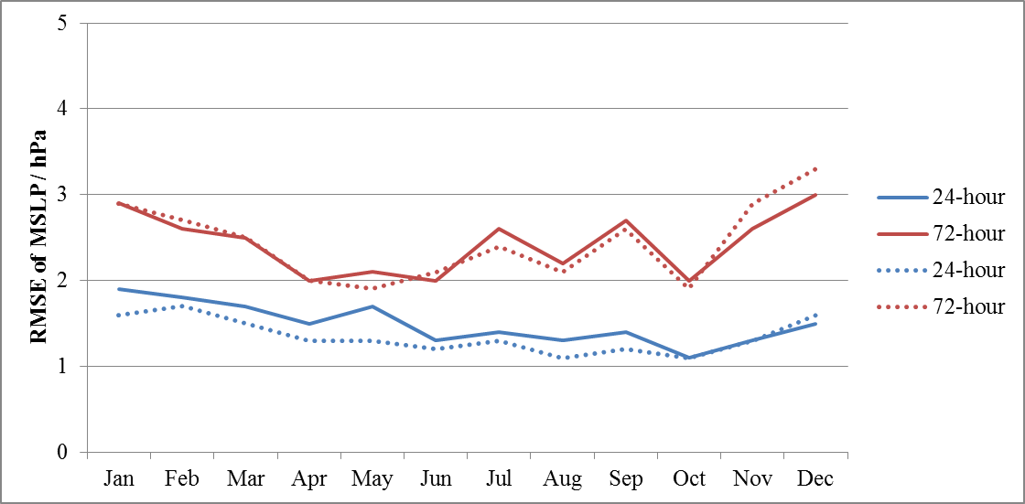

Figure 2. RMS error of geopotential height at 500 hPa (in m) against analysis (solid lines) and observations (dotted lines) at selected forecast hours.
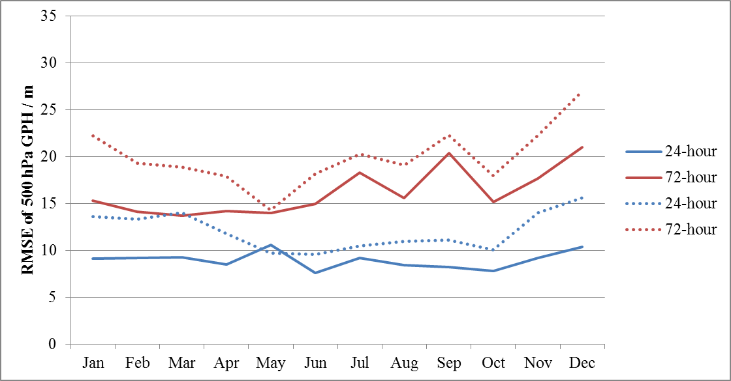

Figure 3. RMS error of vector wind at 850 hPa (in m/s) against analysis (solid lines) and observations (dotted lines) at selected forecast hours.
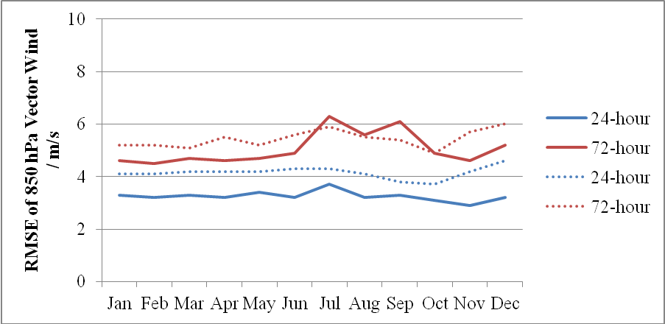
Figure 4. RMS error of vector wind at 250 hPa (in m/s) against analysis (solid lines) and observations (dotted lines) at selected forecast hours.
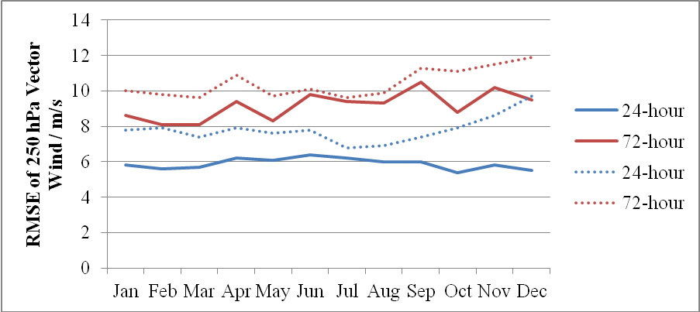

Figure 5. RMS error of temperature at 850 hPa (in degree Celsius) against analysis (solid lines) and observations (dotted lines) at selected forecast hours.
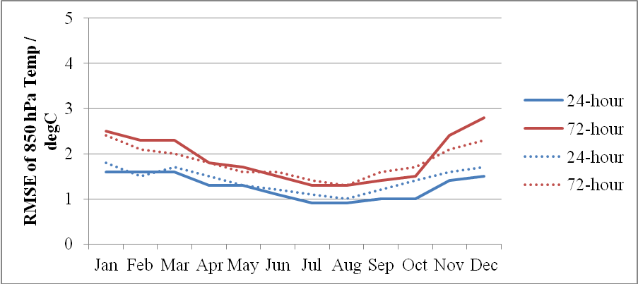

Figure 6. RMS error of relative humidity at 850 hPa (in %) against analysis (solid lines) and observations (dotted lines) at selected forecast hours.
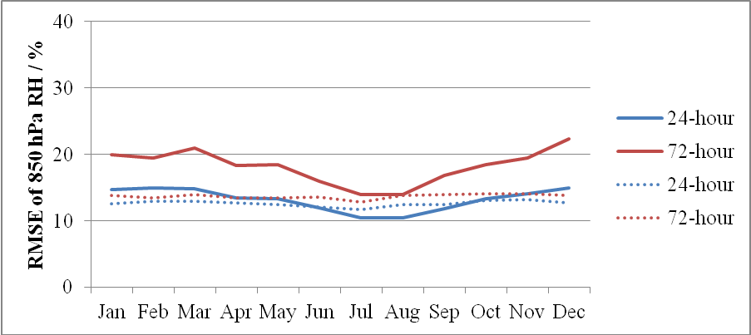
Appendix II – Summary of Verification of Prognostic Products Generated by SLOSH for 2015

Tropical cyclone | Year and Month | Observed maximum storm surge/sea level at Quarry Bay (m) | Predicted maximum storm surge/sea level at Quarry Bay (m) | SLOSH error (observed – Predicted storm surge/sea level (m)
Linfa | 2015 Jul | 0.42/2.22 | 0.40/1.60 | 0.02/0.62
Mujigae | 2015 Oct | 0.47/2.62 | 0.37/2.22 | 0.10/0.40

Appendix III – Summary of Verification of Prognostic Products Generated by WAVEWATCH III
00 UTC and 12 UTC Runs for 2015
RMS error of 24-hour significant wave height forecast against observations (in m)
Jan-Mar | Apr-Jun | Jul-Sep | Oct-Dec | Year
1.3  (4037) | 1.3  (3676) | 1.1  (4305) | 1.4  (4197) | 1.3  (16215)
(Number of ship reports in brackets)

