JOINT WMO TECHNICAL PROGRESS REPORT ON THE GLOBAL DATA PROCESSING AND FORECASTING SYSTEM AND NUMERICAL WEATHER PREDICTION RESEARCH ACTIVITIES FOR 2016

Egypt
Egyptian Meteorological Authority
Cairo Numerical Weather prediction centre

1. Summary of highlights
High-resolution run of WRF (NMM core), 6km grid distance.
Running COSMO ( with cooperation with DWD), 14km grid distance.
Running MOZART Model for Ozone and related chemical Tracers.
Running Flex part air dispersion Model.
Issue of seasonal forecast over North Africa and arab world
New website for NWP products (www.nwp.gov.eg).

2. Equipment in use
Table 1: Computer equipment in use for operational models
Machine | Processors | Memory (GB) | Storage
Sun Cluster | 12× 2 × 2218 AMD dual core | 12×4GB | 2 TB
Dell Precision | 8× 3.2GHz | 12 GB | 4.5TB
IBM workstation | 32× 1.2 GHz | 32 GB | 2 TB
IBM Workstation | 32 ×1.2 GHZ | 32 GB | 2 TB
workstations | 8 intel Xeon workstations | 8×2.4 GHZ dual core | 8 ×1 TB
IBM x3650 M4 | 2 X 2.4 GHZ/ 8-core/ 20MB cache | 32 GB, DDR3 RAM

3. Data and Products from GTS in use
- SYNOP
- TEMP
- BUOY
- SHIP
- METAR

4. Forecasting system

4.1 System run schedule and forecast ranges

The general structure of a prognostic system of our NWP system is illustrated in figure 1. In our system there are three operational models used for short range and medium range forecasts; WRF, Workstation ETA, COSMO. They run twice per days, based on initial conditions at 00 UTC and 12 UTC. As illustrated in the figure there some modules and models coupled with our limited area models; Dust module to predict dust, WAM model used to predict the sea waves over Mediterranean and red sea.
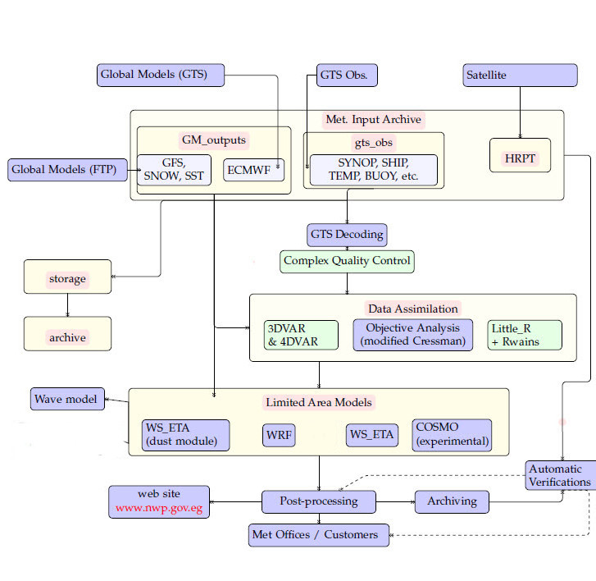
Figure 1: Operational NWP

4.2 Medium range forecasting system (4-10 days)

As result of limitation of our computational power, our medium range forecast covers only 5 days forecasts by using the models, described in section 4.3

4.3 Short-range forecasting system (0-120 hrs)

4.3.1 Data assimilation, objective analysis and initialization

WRF 3DVAR ( in experimental Mode)

4.3.2 Model
4.3.2.1 In operation

Workstation ETA

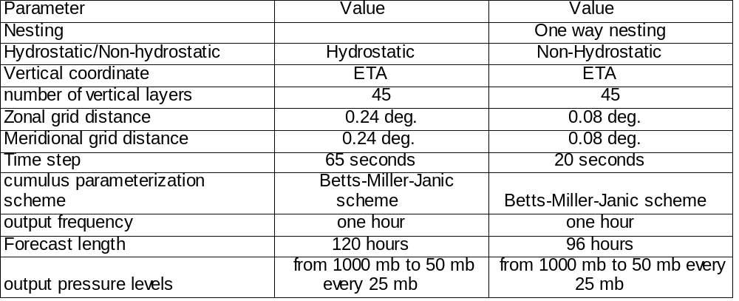

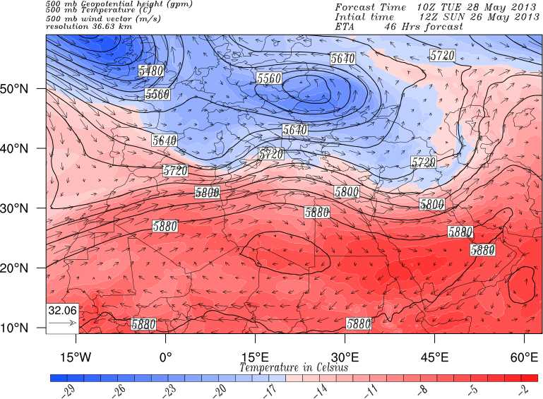

WRF Model (NMM CORE)

Microphysics : Eta microphysics
radiation scheme : GFDL scheme
Land surface scheme : Unified NCEP/NCAR/AFWA scheme
Boundary Layer scheme: Mellor-Yamada-Janjic scheme
Cumulus Parameterization: Betts-Miller-Janjic scheme
Mother Domain: ( 19.12 N to 42.8 N, 15.76 E to 45.16E, Resolution = 0.15 deg.)
Nested Domain: ( 21.53 N to 32.44N, 23.22 E to 41. E, Resolution=0.05 deg.)

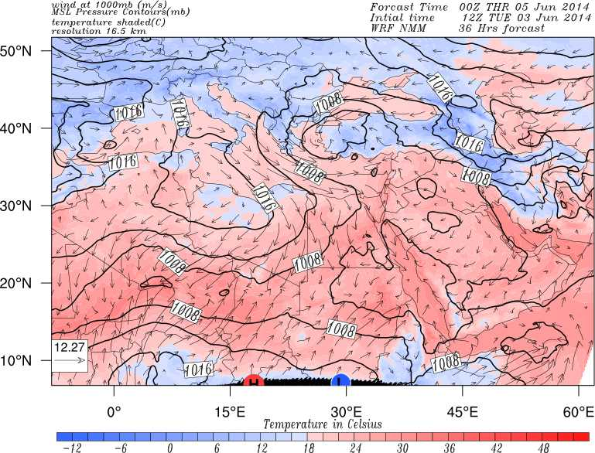
COSMO
Radiation scheme: Ritter and Geleyn (1992)
Convection scheme: Tiedtke 1989
Model Resolution 13.75 km
Domain (20N-23N and 20E to 40E)

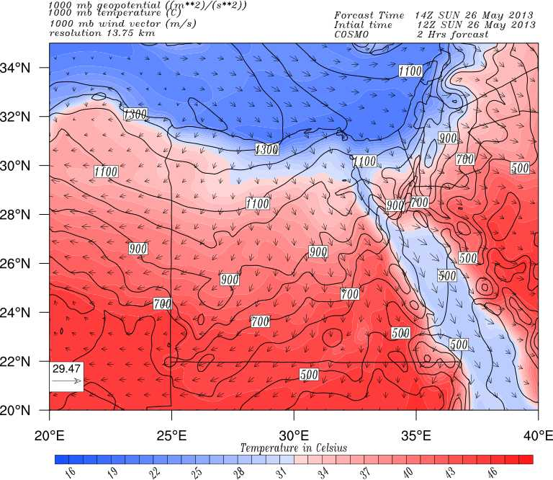

4.3.3 Operationally available NWP products

- The Geopotential height at the standard levels
- Mean sea level pressure.
- Horizontal wind components (U.V).
- Temperature (T).
- Specific Humidity (q).
- Surface pressure (Ps).
- Soil temperature.
- Soil moisture content.
- Surface temperature.
- Connective precipitation.
- Layer cloud amount.
- Vertical velocity.
- Thunderstorm and sandstorm

4.4 Now casting and Very Short-range Forecasting Systems (0-6 hrs)

Our Now casting and very short-range forecasting depend on models on section 4.3 and on some subjective methods, which used both model products and observations.

4.5 Specialized numerical predictions
Sea Wave, dust prediction, and air quality system

4.5.1 Assimilation of specific data, analysis and initialization (where applicable)
The initial and boundary fields for sea wave prediction are provided by the output from workstation ETA and WRF models (described in section 4.3).

4.5.2 Specific Models (as appropriate related to 4.5)
4.5.2.1 In operation

Dust Module coupled with WS_ETA
This dust module is based on scheme developed by S. NICKOVIC (from Athens University).
The area coverage is : ( -1S to 62N , -12W to 77E, with resolution 0.5 deg.)

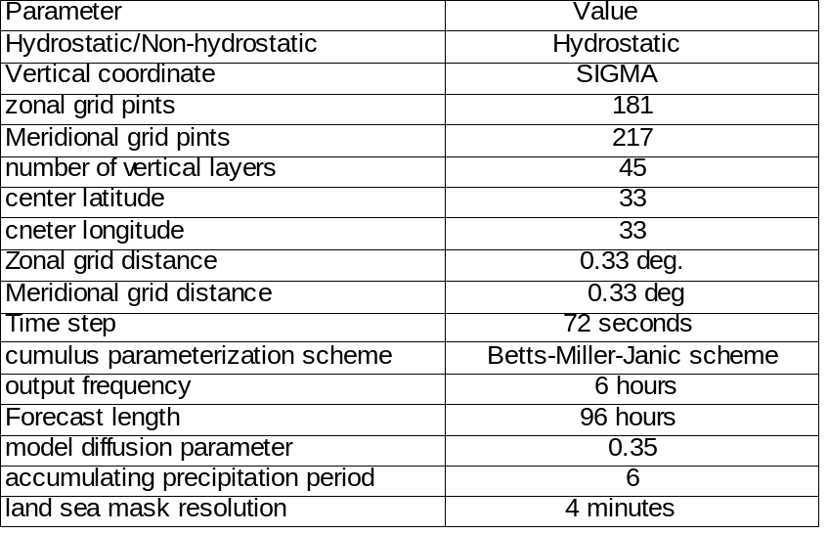

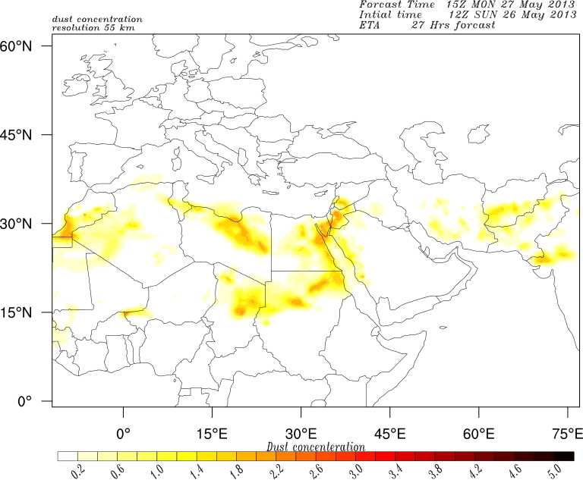

WAM Model
Used to predict significant wave heights, swell, wave periods, and wave spectrum over
Mediterranean (30.2N to 45.N, -5.5W, 35.42E, with resolution 0.33 deg ),
Red Sea ( 12.5N to 29N, 32.3 E to 42.52E, with resolution 0.33 deg ), and
Suez Gulf (27N to 29.96N, 32E to 36 E, with resolution 0.039deg)

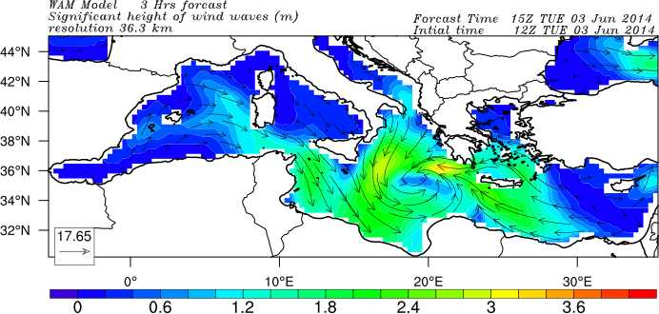
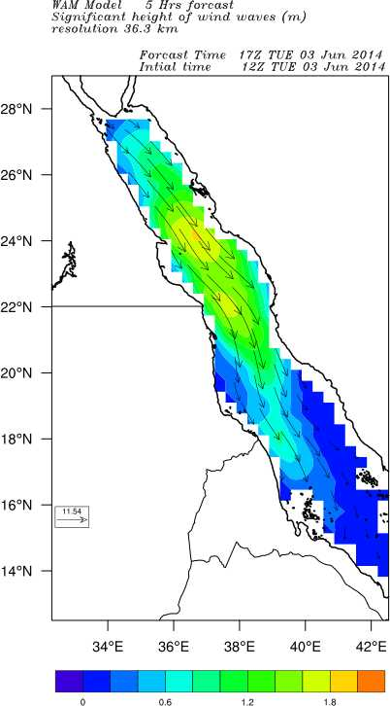
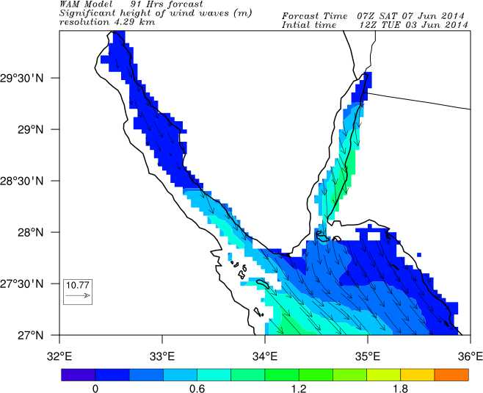

MOZART (Model for Ozone and Related chemical Tracers)
A chemistry transport model used to predict the concentrations of atmospheric gases and aerosols over the globe, with resolution 2.8 deg.

Parameter | Value
Vertical coordinate | Hybrid
Zonal grid points | 128
Meridional grid points | 64
Zonal grid distance | 2.8 deg
Number of Vertical layers | 28
Time step | 20 minutes
Output frequency | 6 hours
Forecast length | 96 hours

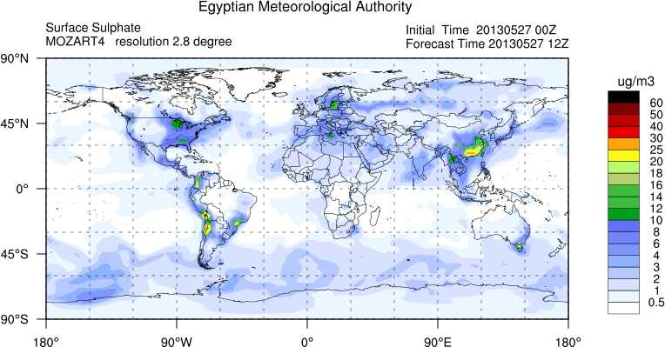
RegCM4 (Regional Climate model)

Our group modified the RegVM4 to be used as an air quality model, and to predict the concentrations of dust and atmospheric gases over Egypt, Arabic countries and North Africa.

EMA-RegCM4 (Dust model)

Parameter | Value
Vertical coordinate | Sigma
Zonal grid points | 200
Meridional grid points | 154
Zonal grid distance | 45 km
Number of Vertical layers | 18
Center latitude | 30 N
Center longitude | 18 E
Time step | 150 seconds
Output frequency | 3 hours
Forecast length | 120 hours
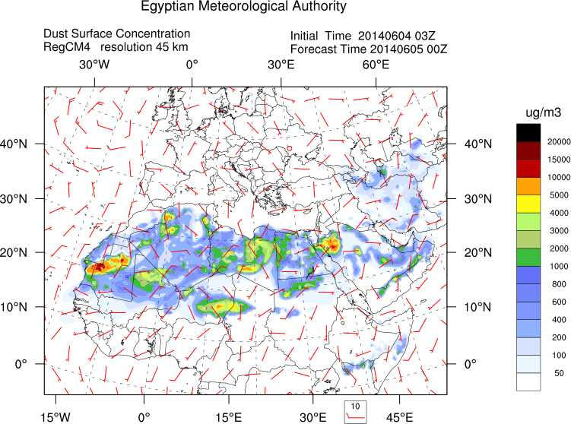
EMA-RegCM4 (Air quality model)

Parameter | Value
Vertical coordinate | Sigma
Zonal grid points | 96
Meridional grid points | 56
Zonal grid distance | 50 km
Number of Vertical layers | 18
Canter latitude | 30 N
Center longitude | 35 E
Time step | 150 seconds
Output frequency | 6 hours
Forecast length | 72hours
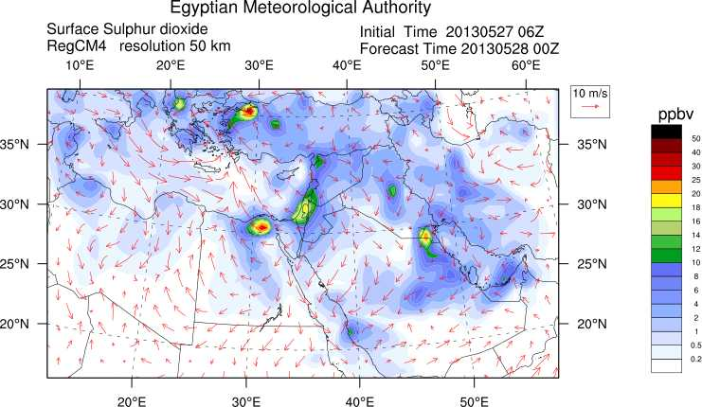

4.5.3 Specific products operationally available
Dust module predicts the dust load (gram per meter square) over the domain.
WAM model predicts significant wave height, wave period, and directions of wind wave and swell, also provide us with wave spectrum over some specified locations.
MOZART predicts the concentration of gases (O3, CO, SO2, NOx) and aerosols (sulphate, black carbon, secondary organic aerosols) over the globe.
RegCM4 predicts the concentration of dust and gases (O3, CO, SO2, NOx) over Egypt. Arabic countries, and North Africa.

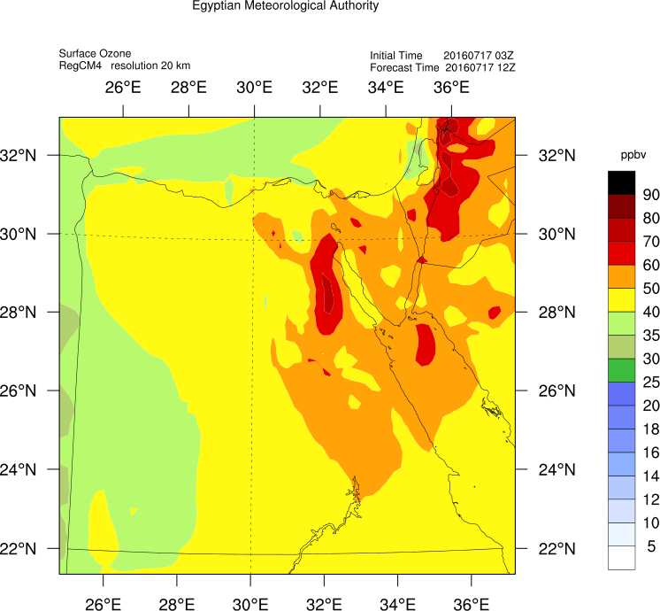

RegCM- Agro

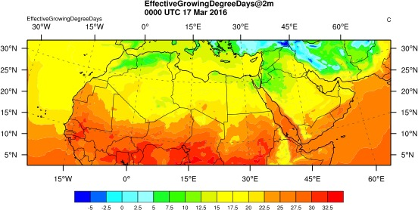

4.6 Extended range forecasts (ERF) (10 days to 30 days)
We don't provide ERF as an operational product.

4.7 Long range forecasts (LRF) (30 days up to two years)
4.7.1 In operation
We use a statistical model using Climate Prediction Tools (CPT) to predict the precipitation and temperature over the North Africa and Nile basin. We produce a probabilistic map for the precipitation and temperature using the WMOLC GPCs products.
Our long range forecast is periodically publish on website (www.nwp.gov.eg/index.php/rcc)

Research performed in this field
Using the regional climate model (ICTP-RegCM4) to downscale over our region by using the initial field from the climate forecast system model version 2 (CFSv2).

4.7.2 Operationally available EPS LRF products
We use the EPS LRF from the WMOLC GPCs.

6. Plans for the future (next 4 years)

6.2 Planned research Activities in NWP, Nowcasting, Long-range Forecasting and Specialized Numerical Predictions
6.2.1 Planned Research Activities in NWP
- Developing Multi-model ensemble Prediction system to be used in our system.
6.2.4 Planned Research Activities in Specialized Numerical Predictions
- Developing flex part air dispersion model for north coast of Egypt and Suez golf.

