JOINT WMO TECHNICAL PROGRESS REPORT ON THE GLOBAL DATA PROCESSING AND FORECASTING SYSTEM AND NUMERICAL WEATHER PREDICTION RESEARCH ACTIVITIES FOR 2015

Central Institute for Meteorology and Geodynamics, Austria

1. Summary of highlights

One of the main focal points in 2015 was the development of an NWP based nowcasting system including an hourly 3DVAR assimilation system using the AROME model. The new nowcasting system is designed to support the current conventional nowcasting system INCA in the future and help to increase the forecast quality within the first 1 to 6 hours, in particular for summer convection.
The INCA system itself has been further revised with respect to improved simulation of convective processes. A first version has been implemented which specifically takes into account uncertainties in the analysis and in the nowcasting range. As a major contribution to this system, a probabilistic extrapolation method is revised with the concept of error motion vectors. The INCA system has been further refined with respect to the model background, where the convection-resolving model AROME replaces ALARO.

2. Equipment in use
Computers used for the forecasting system are SGI and several Linux clusters for post-processing purpose:

Computer | Memory | Storage
SGI ICE X (252 nodes a 16 cores) | 8 TB | 120 TB
10 Linux (a 8-16 cores) for post-  processing | 8 - 32GB | 100 TB

3. Data and Products from GTS in use
- SYNOP
- TEMP
- AMDAR
- SHIP
- FAX
- GRIB

4. Forecasting system

4.1 System run schedule and forecast ranges

At ZAMG, two deterministic short range forecast models and one limited area ensemble prediction systems are operated: ALARO (5km horizontal resolution, 4 runs per day) and AROME (2.5km, 8 runs per day), LAEF (11km, 2 runs per day)

ALARO (5km, 60 Levels):

Suite | Analysis time + forecast range | Product availability
1 | 00UTC + 72 h | 2:45 UTC
2 | 06UTC + 72 h | 8:45 UTC
3 | 12UTC + 72 h | 14:45 UTC
4 | 18UTC + 72 h | 20:45 UTC

AROME (2.5km, 90 Levels):

Suite | Analysis time + forecast range | Product availability
1 | 00UTC + 60 h | 03:30 UTC
2 | 03UTC + 60 h | 06:30 UTC
3 | 06UTC + 60 h | 09:30 UTC
4 | 09UTC + 60 h | 12:30 UTC
5 | 12UTC + 60 h | 15:30 UTC
6 | 15UTC + 60 h | 18:30 UTC
7 | 18UTC + 60 h | 21:30 UTC
8 | 21UTC + 60 h | 00:30 UTC

LAEF (11km, 47 Levels):

Suite | Analysis time + forecast range | Product availability
1 | 00 UTC + 72 h | 04:00 UTC
2 | 12 UTC + 72 h | 16:00 UTC

4.2 Medium range forecasting system (4-10 days)

4.3 Short-range forecasting system (0-72 hrs)

4.3.1 Data assimilation, objective analysis and initialization

Within the ALARO system at ZAMG, the initialisation for surface fields is done using an Optimal Interpolation method (called CANARI) for soil assimilation (soil temperature and soil moisture) by assimilating 2m relative humidity and 2m temperature observations from GTS synop stations and from the Austrian high density observation network TAWES. No assimilation is performed for upper air fields, so the initial conditions are provided by the IFS HRES model.
For AROME, an incremental 3D-Var system is used to create initial state of 3D atmospheric variables. The background error matrix B was defined by using 78 downscaled ensemble forecast differences of the Austrian ensemble system LAEF. For surface, as it is the case for ALARO, an Optimum Interpolation method is used to initialize surface fields.

Observation type | assimilated fields | Data source
SYNOP+TAWES | T2m,RH2m,U10m,V10m,f | ZAMG+OPLACE
AMDAR (aircraft) | U,V,T | ZAMG+OPLACE
GEOWIND (SAT-winds) MSG3 | U,V | OPLACE
TEMP (radio soundings) | U,V,T,Q,f | ZAMG+OPLACE
PILOT | U,V | ZAMG
WINDPROFILER [test mode] | U,V | ECMWF MARSARCHIVE/OPLACE
MSG2->MSG3-SEVIRI | WV-radiances | OPLACE
NOAA16/18/19+MetOp-A-B  AMSU-A,-B,MHS,HIRS | radiances | OPLACE
MetOp-A IASI | radiances | OPLACE
ASCAT 10m sea winds | U10m,V10m (25km) | ZAMG/EUMETSAT
GPS [test mode] | zenith total delay (ZTD) | TU-Vienna
RADAR [test mode] | Reflectivity, doppler winds | Austrocontrol
Lake surface temperatures [test mode] | TS_WATER in OIMAIN | Hydrological services
MODIS-snow cover [test mode] | snow yes/no | ENVEO-CRYOLAND

Table 1: Observations entering AROME assimilation system

The use of GPS and Radar is not yet part of the operational AROME runs at ZAMG. The Transformation of the model variables to satellite radiances and vice versa is done by using the radiative transfer model RTTOV.

4.3.2 Model

4.3.2.1 In operation

ALARO:

The spectral limited area model ALARO is the further development of the ALADIN model for horizontal resolutions around 5km. ALARO is being developed within the international numerical weather prediction project ALADIN and RC LACE in cooperation with HIRLAM community. The main differences between ALARO and its precursor ALADIN can be found in the model physics, whereas convection and microphysics should be named in the first place. In order to handle convection properly on horizontal scales around 5km, the prognostic convection scheme called 3MT (Gerard et. al. 2009) was developed. In ALARO cloud condensate originating from resolved condensation processes and condensate produced in the convection scheme are combined before they enter the microphysical part in the model. Beside convection and microphysics several further changes are planned for ALARO, mainly in the radiation scheme and in the turbulence parameterization major developments are to be expected to enter the operational system soon.
ALARO is used in operational mode at ZAMG since March 2011, while the system has undergone several updates recently. It runs on a horizontal resolution of 4.8km and uses 60 levels in the vertical. The model is run four times per day, whereas the integration is performed up to 72 hours lead time. ALARO (the configuration run at ZAMG is also named ALARO5-AUSTRIA) is coupled to the global IFS HRES model of ECMWF. For ALARO5-AUSTRIA, the initial state for the free atmosphere is provided by interpolation of the IFS model fields to 4.8km model grid. A surface assimilation system is run at ZAMG and fed with SYNOP and high-density TAWES (Semi-automatic weather stations in Austria) data to produce the initial state for the surface fields using an optimum interpolation method. Details about the model characteristics can be also read from Table 2.

Horizontal resolution: 4.8 km
Number of levels: 60, pressure-based, hybrid coordinate
Number of grid points: 600 x 540
Time-step: 180 sec, 2-time-level SLSI time integration
Coupling model: IFS (time lagged)
Coupling frequency: 3 hours, Davies-Kallberg relaxation scheme
Forecast range: 72h
Output every: 1 hour
Physics: ALARO-0 physics (prognostic large scale cloud and precipitation scheme + prognostic convection scheme 3MT, pseudo-prognostic TKE scheme, ...), Boer-type scheme of gravity wave drag; ISBA surface scheme;
Orography: mean
Grid: linear
Initialization: OI for surface, IFS for upper air (DFI applied)

Table 2: ALARO model characteristics

AROME:
The non-hydrostatic spectral convection permitting limited area model AROME (Applications of Research to Operations at Mesoscale, Seity et al. 2010) is especially designed to run on very high resolutions with 2.5km grid space and beyond. At ZAMG it was set to operations by the end of 2013, after an intense testing and evaluation phase. It uses the non-hydrostatic dynamical core developed by Bénard et al. 2009. The Turbulence scheme is a 1.5 order 1D prognostic TKE scheme by Cuxart et al. 2010. Deep convection is treated explicitly, while shallow convection is parameterised with a massflux approach (Pergaud et al. 2009). The one moment bulk microphysics scheme ICE3 (Pinty and Jabouille 1998) can handle mixing ratios of five prognostic hydrometeor classes: cloud water, cloud ice, rain, snow and graupel and simulates also complex interactions between them. Different to ALADIN and ALARO, AROME uses by default a three layer soil model SURFEX with a tile approach including also parameterisations of town and sea effects. The radiation scheme follows the approaches of the European Centre for Medium Range Forecast (ECMWF) by Morcrette (1991) and Mlawer et al. (1997). Orographic effects (reduced sky view, slope angle, orographic shadowing) on surface radiation fluxes have been recently added.

Horizontal resolution: 2.5 km
Number of levels: 90, pressure-based, hybrid coordinate
Number of grid points: 600 x 320
Time-step: 60 sec, 2-time-level SLSI time integration
Coupling model: IFS (time lagged)
Coupling frequency: 3 hours, Davies-Kallberg relaxation scheme
Forecast range: 30h
Output every: 1 hour
Physics:
Orography: mean
Grid: linear
Initialization: OI for surface, 3DVAR for upper air

Table 3: AROME model characteristics

4.3.2.2 Research performed in this field
During 2015, the main work was dedicated to the development of an AROME nowcasting version which is planned to become operational in addition to the current operational AROME forecasting system (Table 3).
The key characteristics of the AROME nowasting system can be summarized as:
- hourly rapid update assimilation system (3DVAR) followed by 12 hour forecasts
- lateral coupling to operational AROME system
- 25min cut-off time
- additional observations in assimilation: radar reflectivity and radial winds
- latent heat nudging of INCA 2D precipitation analysis included
- initial condition for surface from operational AROME
- horizontal resolution 2.5km, will be increase to 1.2km soon

First results with the AROME nowcasting system show rather promising results (Fig. 1). An operational implementation of the system is expected for 2018.

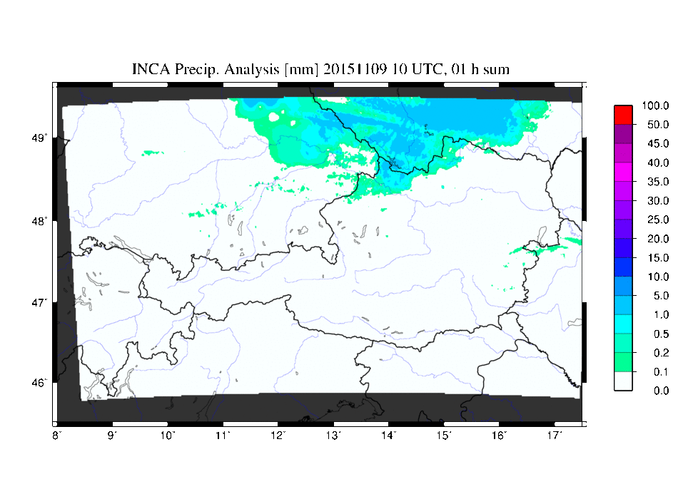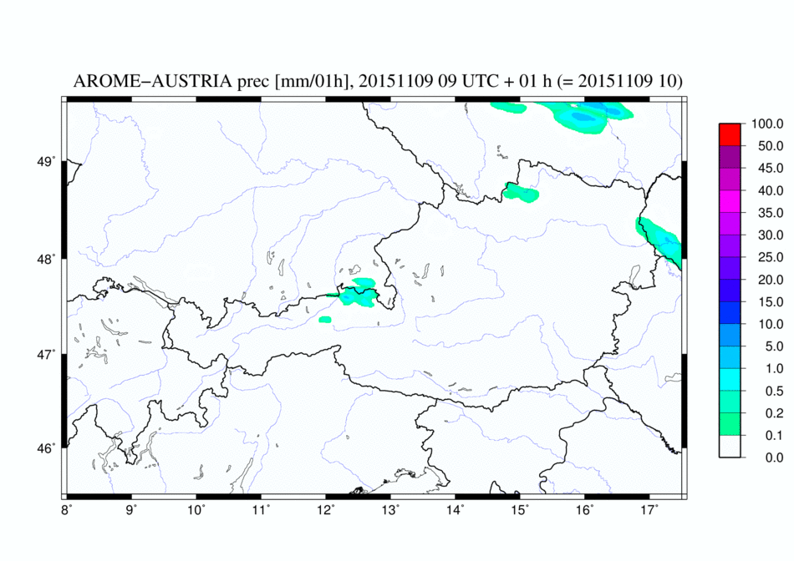
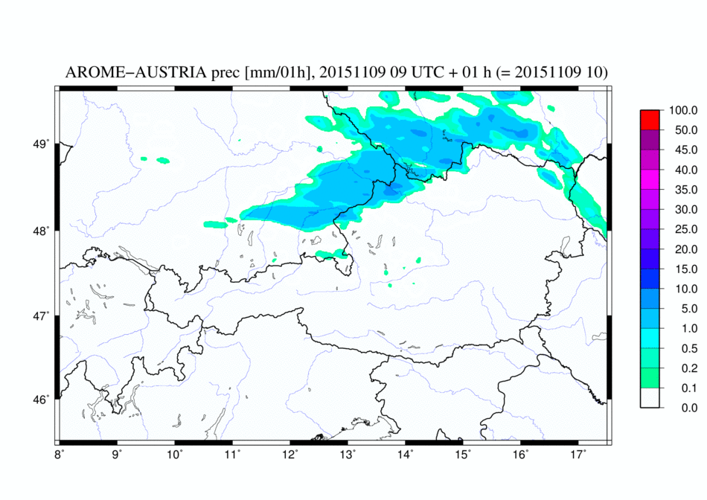

Figure 1: INCA precipitation analysis (upper left) and corresponding +1h forecasts from the AROME nowcasting system using 3DVAR (upper right) and 3DVAR+Latent Heat Nudging (bottom) .

4.3.3 Operationally available NWP products

4.3.4 Operational techniques for application of NWP products
4.3.4.1 In operation
A so-called ‘META’-forecast system is in operation for short and medium range forecasts. It utilizes the output of global and limited-area models (ECMWF, ALARO, AROME, GME, COSMO, UKMO, GFS) available at ZAMG to generate bias-corrected, optimized, weighted point forecasts of standard meteorological quantities at surface station locations. It has been extended to further NWP models and a regime-dependant experimental set up has been implemented.

4.3.4.2 Research performed in this field
Ensemble systems aim at representing a range of possible future states of the atmospheric system. However, ensemble forecasts still tend to be underdispersive and biased. Thus, they should be post-processed with statistical models such as the nonhomogenous Gaussian regression (NGR, Gneiting et al. 2005). For temperature, NGR returns a Gaussian predictive density distribution where the location and scale parameters depend on the raw ensemble.
Following Scheuerer and König (2014), the original NGR approach is modified using local observation and forecast anomalies to remove site-specific characteristics. Therefore, a single model can be fitted for all available stations simultaneously. Observation and forecast anomalies are calculated by subtracting site-specific climatological means from the observations and forecasts, respectively. Thus, the improvement of the calibrated ensemble system strongly depends on the quality of climatological means.
The method is implemented for a multi-model ensemble consisting of the LAEF (Limited Area Ensemble Forecasting) System and high resolution deterministic forecasts, and adapted for gridded 2 m temperature forecasts. As observational background the 1 km gridded INCA 2 m temperature analyses were used taking advantage of calibrating the ensemble data with highly resolved observations.

4.3.5 Ensemble Prediction System
4.3.5.1 In operation
The operational LAMEPS system at ZAMG, ALADIN-LAEF (Wang et al. 2010), was upgraded in July 2013. The generation of Initial perturbations in the ALADIN-LAEF system is implemented as follows: 1) Upper air perturbations to initial conditions are calculated by blending the large scale perturbation generated by the ECMWF, using the Singular Vector method, with the small scale perturbation generated by ALADIN-Breeding; 2) To represent uncertainties in the surface fields a surface assimilation scheme with perturbed observations is implemented. To consider perturbations due to model uncertainties a multi-physics scheme is applied as well.

Currently ALADIN-LAEF is running under the SMS (Supervisor Monitoring Scheduler) environment on high computer facility of ECMWF twice per day (00 and 12UTC), consisting of 16 perturbed members and one control member, on 11 km horizontal resolution, with 45 levels in the vertical. The domain of the perturbed members and the control run covers Europe and a large part of the North Atlantic (Fig. 2). Hourly output of the forecasts is provided and selected data are archived in MARS at ECMWF. Data are also archived in the framework of TIGGE-LAM. ALADIN-LAEF forecasts are operationally distributed to Czech Republic, Slovakia, Slovenia, Romania and Turkey.

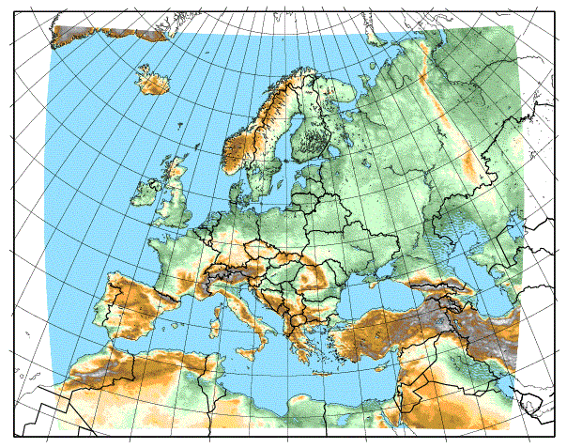

Figure 2: ALADIN-LAEF domain and model topography.

4.3.5.2 Research performed in this field
LAMEPS is a major field of research in the NWP group at ZAMG. The focus of research is on system developments for an ALADIN-LAEF upgrade to a resolution of 5km and of a 2.5km AROME-EPS. First studies have been carried out to find optimum setups for stochastic perturbation of physics tendencies both for AROME-EPS and ALADIN-LAEF on 5km resolution.

The implementation of stochastic perturbation of surface fields was investigated in ALADIN-LAEF. Results showed that the stochastic perturbation of physical tendencies in the model surface add skill to the probabilistic forecasts for near surface parameter. The combination of surface ensemble data assimilation and the perturbation of surface fields during the forecasts lead to a superior performance compared to the operational setup.

4.3.5.3 Operationally available EPS Products
The following ALADIN-LAEF products are available at 1h time resolution
- Probability-charts:
2m Temp, 10m Wind, Total Precipitation
  - EPS-meteograms

4.4 Nowcasting and Very Short-range Forecasting Systems (0-6 hrs)

4.4.1 Nowcasting system
4.4.1.1 In operation
The high-resolution analysis and nowcasting system INCA (Integrated Nowcasting through Comprehensive Analysis) developed at ZAMG provides three-dimensional fields of temperature and humidity on an hourly basis, and of wind in 10 min intervals. Two-dimensional fields of precipitation rate, precipitation type, and cloudiness are provided at 5 - 15 minute intervals.
The system is operated with a horizontal resolution of 1 km and a vertical resolution of 100-200 m on the region shown in Fig. 3. INCA combines surface station data, remote sensing data (radar, satellite), forecast fields of the numerical weather prediction model ALADIN, and high-resolution topographic data (Haiden et al., 2011).

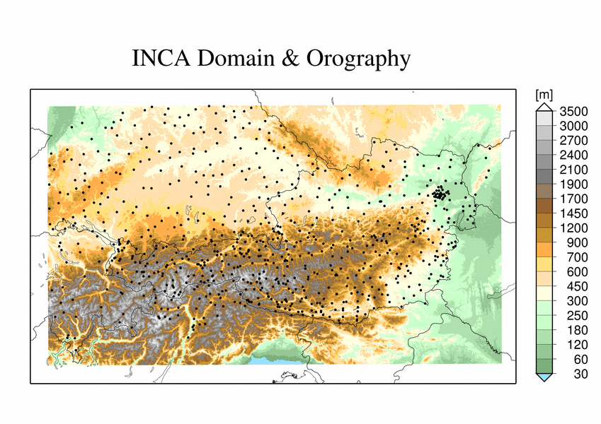

Figure 3: Austrian domain, topography and the locations of the stations of the nowcasting system INCA.

Table 4: Meteorological fields analyzed and nowcasted in INCA (SFC = surface station data, SAT = satellite data, RAD = radar data)

Nowcasting field | Required observations | Update
Temperature | SFC: 2m temperature  SAT: MSG cloud types (optional) | 1 hour
Humidity | SFC: 2m humidity | 1 hour
Wind | SFC: 10m wind and gusts | 10 min
Precipitation | SFC: precipitation  RAD: radar precipitation | 5-15 min
Precipitation type | Derived from precipitation  and temperature nowcast | 15 min
Cloudiness | SAT: MSG cloud types  SFC: sunshine% (optional) | 15 min
Global radiation | SAT: MSG cloud types  SFC: global radiation | 1 hour
Convective diagnostics | Derived from temperature, humidity and wind nowcast | 1 hour

The most important applications of INCA products are flood prediction and warning (Komma et al., 2007), road weather prediction, and predictions for the energy sector. Verification shows that the average performance of INCA as measured by MAE significantly exceeds that of NWP models (ALADIN, ECMWF) during the first 2-3 hours of the forecast in the case of precipitation (not shown), and even further in the case of temperature (Fig. 4).
Precipitation nowcasting includes a parameterization of elevation effects on the precipitation distribution in mountainous terrain as for the short durations typical in nowcasting (15 min), the intensity-dependence of the elevation effect has to be taken into account (Haiden and Pistotnik, 2009).

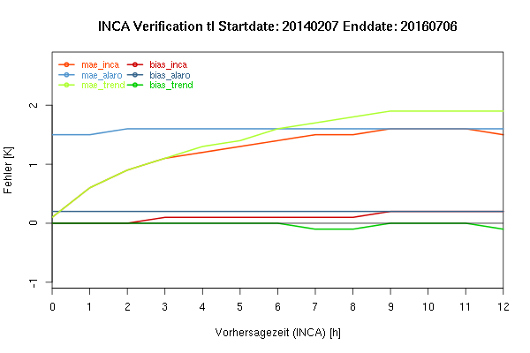

Figure 4: Mean absolute error and bias of the INCA temperature forecast for all Austrian stations as a function of lead time for the period 07-02-2014 to 06-07-2016 (in red). Also shown, for comparison, corresponding values for the ALARO model (blue) and persistency (green)

4.4.1.2 Research performed in this field
The INCA system has been further refined with respect to the model background. Operationally, the ALARO model (on 5km horizontal resolution) is used, and it has been tested if a convection resolving model provides improved model backgrounds. Generally, the higher the NWP skill the higher is the analysis and nowcasting skill. However, the double penalty effect which becomes more evident on higher resolution potentially introduces problems which have to be solved adequately before an operational implementation.
There were also developments in the improvement of data filter algorithms, data quality control, and verification issues.

4.4.2 Models for Very Short-range Forecasting Systems
4.4.2.1 In operation
The INCA system smoothly combines the nowcast with classical NWP forecasts using a pre-defined weighting function. For most quantities, this weighting function gives full weight to the nowcast for the first 2 hours, and decreases linearly between +2 and +6 hours.

4.4.2.2 Research performed in this field

4.5 Specialized numerical predictions

4.6 Extended range forecasts (ERF) (10 days to 30 days)

4.6.1 Models
4.6.1.1 In operation
Locally none (ECMWF products are used).

Extended range forecast products are generated with special respect to Austria. 2m temperature, 10m wind speed, precipitation and cloudiness are visualized for major Austrian cities as a function of forecast projection (Fig. 5).
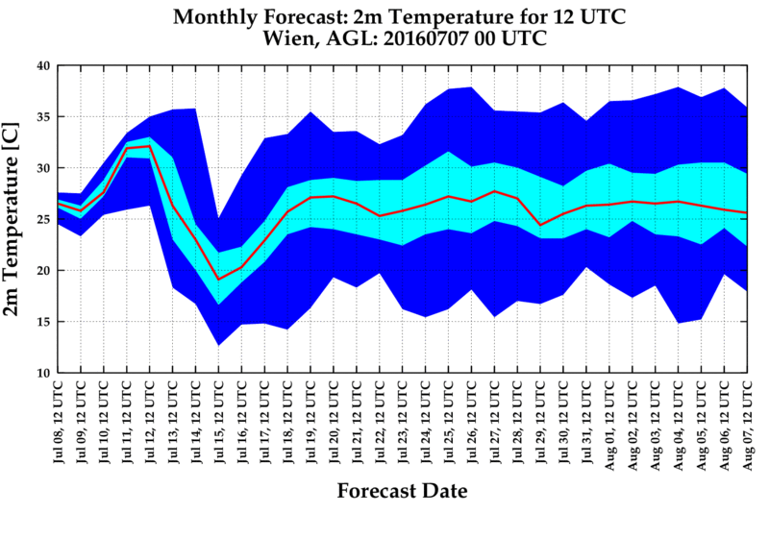
Figure 5: 5%, 25%, 50%, 75% and 95% percentiles of ECMWF 2m temperature as a function of forecast range. Initialization date: 07.07.2016, 00UTC. Forecast for Vienna.

4.6.2 Operationally available NWP model and EPS ERF products

4.7 Long range forecasts (LRF) (30 days up to two years)
4.7.1 In operation
ECMWF’s seasonal forecast system 3 is obtained and post-processed to satisfy local requirements. Among others, probabilities for negative, neutral and positive temperature anomalies for the coming season are calculated (see Fig 6).
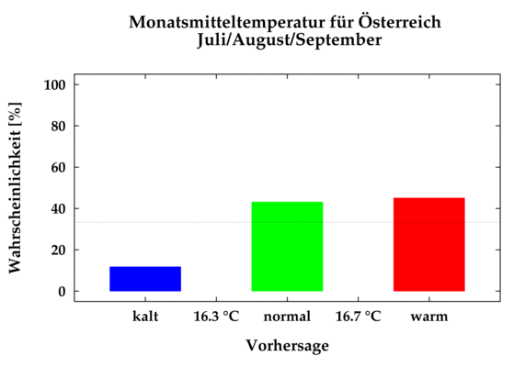
Figure 6: Probability [%] for predicted mean temperature anomalies for the coming season (JJA) for Austria: The probabilities for negative (blue box), neutral (green) and positive (red) anomalies are shown. The anomalies have been calculated with respect to a hindcast period from 1981 onwards

4.7.2 Research performed in this field

4.7.3 Operationally available EPS LRF products

5. Verification of prognostic products
Verification is done for the prognostics products of the operational ALARO, AROME and INCA model and other available models:

- Point forecast vs. synop: 2m temperature, 2m relative humidity, 10m wind speed, 10m wind direction, 10m gust speed, mean sea level pressure, total cloudiness, global radiation
- Precipitation forecast: Verification is done on rectangular domains using INCA precipitation analysis as a reference. Beside traditional grid-point and areal mean scores (POD, FAR, HSS, etc) the object based method SAL is used.
- Cloud cover: Similar to what is done for precipitation, SAL is used to evaluate the cloud cover forecast for different models. INCA cloud cover analysis is used as observation (combination of ground radiation measurements and satellite products)
- Free atmosphere: Verification of model fields (temperature, geopotential, wind speed, relative humidity) on several standard pressure heights is done against the models own analysis and alternatively radiosoundings.
- Long term scores: ZAMG NWP Index (see Fig. 7) is used to monitor the long term evolution of the forecast quality. The index represents a weighted combination of MAE, RMSE and ETS for different forecast parameters (2m temperature, 2m relative humidity, 10m wind speed and direction, mean sea level pressure, precipitation, global radiation)

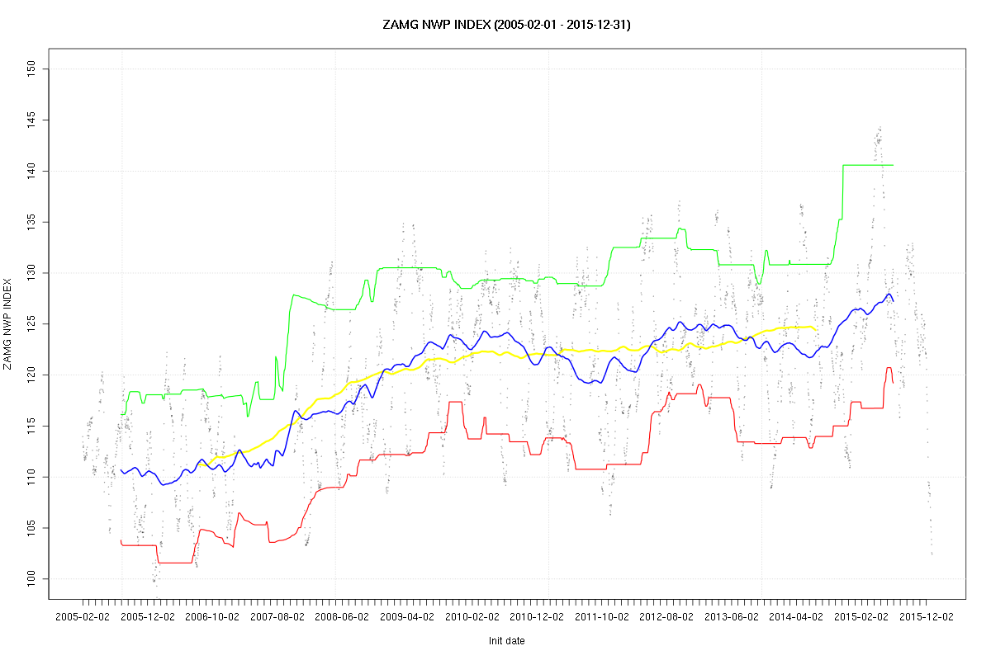

Figure 7: Running average for mean (blue), 90% percentile (green) and 10% percentile (red) for ZAMG NWP Index from 2005 to 2015. Higher values indicate increase of performance.

6. Plans for the future (next 4 years)

6.1 Development of the GDPFS

6.2 Planned research Activities in NWP, Nowcasting and Long-range Forecasting
6.2.1 Planned Research Activities in NWP

- Stochastic physics for LAEF/AROME EPS: Extension of the current stochastic physics scheme (acting on total tendencies by implementing perturbation on partial tendencies (physics) and parameter based
- Radar assimilation: Continuation of work towards an operational implementation of radar data (reflectivity and Doppler winds) in the AROME system and combine it with latent heat nudging using INCA gridded precipitation analysis
- Gathering experience using a very fine resolution version of AROME (approx. 500 - 1000m grid resolution)
- Continuation of development of AROME nowcasting system
- Implementation of an convection resolving EPS system (based on AROME)

6.2.2 Planned Research Activities in Nowcasting
- Coupling INCA with the AROME nowcasting system
- The Ensemble INCA system will be refined by adding more perturbations (analysis, nowcasting)
- A seamless probabilistic system will be developed, integrating nowcasting and calibrated NWP models in an optimized, blended way.

6.2.3 Planned Research Activities in Long-range Forecasting

7. References

Bénard P., J. Vivoda, J. Masek, P. Smolikova, K. Yessad, Ch. Smith, R. Brozkova and J.-F. Geleyn, 2009: Dynamical kernel of the Aladin-NH spectral limited-area model: formulation and sensitivity experiments. Quart. Jour. Roy. Meteor. Soc., 136, 155-169.

Cuxart, J., Ph. Bougeault, and J.L. Redelsperger, 2000: A turbulence scheme allowing for
mesoscale and large eddy simulations. Q. J. R. Meteorol. Soc., 126, 1-30.

Gerard L, Piriou JM, Brozkova R, Geleyn J-F, Banciu D. 2009. Cloud and precipitation parameterization in a meso-gamma scale operational weather prediction model. Mon. Weather Rev. 137: 3960–3977.

Haiden, T., and G. Pistotnik, 2009: Intensity-dependent parameterization of elevation effects in precipitation analysis. Adv. Geosci., 20, 33-38.
Haiden T, Kann A, Wittmann C, Pistotnik G, Bica B, Gruber C. 2011. The Integrated Nowcasting through Comprehensive Analysis (INCA) System and Its Validation over the Eastern Alpine Region. Weather and Forecasting 26: 166-183.

Komma, J., C. Reszler, G. Blöschl, and T. Haiden, 2007: Ensemble prediction of floods - catchment non-linearity and forecast probabilities. Nat. Haz. Earth Syst. Sci., 7, 431-444.

Pinty, J.P. & P. Jabouille, 1998 : A mixed-phased cloud parameterization for use in a
mesoscale non-hydrostatic model: simulations of a squall line and of orographic
precipitation. Preprints of Conf. On Cloud Physics, Everett, WA, Amer. Meteor. Soc.,
217-220.

Pergaud, J., Masson,V., Malardel, S., Couvreux, F. (2009). A Parameterization of Dry Thermals and Shallow Cumuli for Mesoscale Numerical Weather Prediction. Bound.-Layer Meteor., 132, 83-106.

Mlawer, E. J., Taubman, S. J., Brown, P. D., Iacono, M. J. and CLough, S. A. (1997). Radiative transfer for inhomogeneous atmospheres: RRTM, a validated correlated-k model for the longwave. J. Geophys. Res., 102D, 16663–16682.

Morcrette, J.-J. (1991). Radiation and cloud radiative properties in the ECMWF operational weather forecast model. J. Geophys. Res., 96D, 9121–9132.

Masson V., Seity Y., 2009: Including atmospheric layers in vegetation and urban offline surface schemes., J. Applied. Met. and Clim., 48, 1377–1397.

Seity, Y., P. Brousseau, S. Malardel, G. Hello, P. Bénard, F. Bouttier, C. Lac and V. Masson, 2010: The AROME-France Convective-Scale Operational Model. Mon. Wea. Rev., 139, 976–991.

Wang Y, Haiden T, Kann A. 2006a. ‘The operational limited-area modelling system at ZAMG: ALADIN-Austria’. Osterreich. Beitr. Meteorol. Geophys. 37: ISSN 1016–6254.

Wang Y, Bellus M, Wittmann C, Steinheimer M, Weidle F, Kann A, Ivatek- Sahdan S, Tian W, Ma X, Tascu S, Bazile E. 2011. The Central European limited-area ensemble forecasting system: ALADIN-LAEF. Q. J. R. Meteorol. Soc. 137: 000–000. DOI:10.1002/qj.751

