JOINT WMO TECHNICAL PROGRESS REPORT ON THE GLOBAL DATA PROCESSING AND FORECASTING SYSTEM AND NUMERICAL WEATHER PREDICTION RESEARCH ACTIVITIES FOR 2013

Republic Hydrometeorological Service of Serbia/RHMSS

1. Summary of highlights
[Major changes in the data processing and forecasting system during the last year]
- Migration to RMDCN-New Generation. IP bandwidth is raised to 1 Mbps.
- Virtualization of network and operational servers with VMWare and QEMU
- LAN and WAN improvement
- Placement of WIS DCPC-NC Serbia portal
- Upgrade of HPC clusters
- Implementation automated system ASU-MRL for radar data from MRL-5 radar
- Installed new radar Gematronik, S-band, dual polarization on Jasterbac mountain in Southern Serbia.

2. Equipment in use
[information on the major data processing units]
 | Characteristics
LAN | LAN 100/1000 Mbps, Cisco routers (series 2500, 2600) , Cisco Catalyst Switch 2950 x9, Cisco Switch 3750 x2, Cisco Switch 2970, Cisco Catalyst Switch 4500,about 300 personal computers
LAN-WAN | Alix system board with 4 GB RAM as ADSL router at 28 Main Meteorological Stations - 4 Mbps; Wireless link to SMATSA - 8 airports at Serbia and MonteNegro;Wireless link to military users; Internet connections to Hydrometeorological service of Republika Srpska and Hydrometeorological service of Montenegro;Connection to airport Banja luka (Republic of Srpska); RMDCN-NG Connection with ECMWF, DWD-Offenbach, Austro-Control-Wiena, Hydrometeorological service of Hungary-Budapest and Hydrometeorological service of Bulgaria-Sofia
MSS servers | HP ProLiant Server DL380 x2, Windows Server 2008, HP Storageworks MSA 500,Messir-Comm (Corobor)
HPC Cluster-“new“ | 32 Blade servers BL 2x220c generation 7, 2 Blade C7000 enclosure
HPC Cluster-“old“ | 16 HP Blade servers BL 2x220c generation 5 and 16 Blade servers BL 2x220c generation 6
Primary data storage | NetApp model FAS2240 data storage with 60 hard drives
Secondary data storage | HP EVA 4400 data storage with 36 hard drives
Operational servers | 5 HP Bladeservers, C3000 Enclosure, HP P2000 G3 Storage
VMWare virtual infrastructure | 3 HP Blade servers BL 460c, C3000 enclosure, VMWare vSphere environment, Veeam backup and replication, 40 VMWare virtual machines
MARS archive server | Quantum tape library with 40 ultrium 5 tapes
IMS UDCS for data from AWS and data loggers | HP Proliant DL380G5,Windows Server 2003, Microstep Unified Data Collection System, 28 AWS, 18 data loggers
Proxmox virtual infrastructure | 8 HP DL 1000 multinode servers, Proxmox virtual environment, 40 KVM virtual machines
WIS-GEO.HIDMET.GOV.RS | KVM virtual machine, 1,5 GB RAM,30 GB HD, Geonetwork v2.6.4
Satellite receiving system DWDSAT/Eumetcast | PC Pentium 4,2 GB RAM,140 GB HD, Red Hat Linux release 9,tellicast
Satellite receiving system Meos MSG ground station | 2 x PC Pentium 4,2 GB RAM,80 GB HD, Red Hat Linux release 9, MEOS-MSG -Kongsberg
Antivirus Server | VMWare virtual machine,Windows Server 2008, Kaspersky Antivirus
HP rx3600 Itanium | Integrity servers based on Intel Itanium 2 dual core 64 bits processors

Table 2: Network servers
 | Characteristics
WWW server | HP DL 380, 2x Intel Xeon 3GHz, 4GB RAM, 70 GB HD,  Linux CentOS 4.9, Apache Web server
FTP server | VmWare virtual machine, 1,5GB RAM, 40 GB HD, CentOS4, ProFTPD server
Mail server | KVM virtual machine, 4 GB RAM, 500 GB HD, CentOS6.5,  Zimbra mail server
Firewall Server | HP Z400 workstation, 16 GB, RAM 500 GB HD, PFSense firewall software, OpenVPN, IPSec

3. Data and Products from GTS in use
- SYNOP-500 (please modify according to your situation)
- …………….
- ………..……
GTS data are received through RMDCN network, satellite receiving system DWDSAT and Internet connection.

3.1. DWDSAT

Daily is received about:
- 1300 files with synop bulletins,150 files with temp bulletins, 2100 files with OPMET bulletins.That is about 80 000 received bulletins in TAC;
- 230 files with synop bulletins in BUFR code,115 files with temp bulletins in BUFR code, 3 files with climat bulletins in BUFR code. That is about 3500 received bulletins in BUFR code;
- 417 files with Wind/Temperature charts;
- 41 files with Significant Weather Charts;
- 1500 files with analytic-forecasts charts;
- 815 files with forecasts in GRIB code;
- 45 files with forecasts in BUFR code
- 10500 files with satellite pictures in HRIT;
- 3130 files with satellite pictures in LRIT

3.2. RMDCN

- Channel with DWD

Daily is received about:
- 1400 files in ASCII. That is about 75 500 OPMET and GTS bulletins in TAC;
- 1000 files with bulletins in BUFR code. That is about 10 000 OPMET and GTS bulletins in BUFR code;

2. Channel with Hungary

Daily is received about:
- 300 files in ASCII. That is about 7 500 GTS bulletins in TAC

3. Channel with Austria

Daily is received about:
- 13500 OPMET bulletins in TAC;
- 3800 OPMET bulletins in BUFR

4. Channel with ECMWF

Daily is received about:
- 30 000 files with boundary conditions for NWP

3.3 Internet connection with DWD-OFFENBACH

Daily is received about:
- 160 000 bulletins in TAC;
- 1000 bulletins in BUFR

3.4 FTP server at DWD-OFFENBACH

Daily is received about:
- 126 files with boundary conditions from DWD

3.5 Message Switching System - MSS

Message switching system is based on Messir-Comm software from COROBOR and consists of two servers with automatic change - over.

The DRP & DDS MSS (Data Receiving and Processing & Data Distribution System) are providing:

- Protocol conversions capabilities;
- Data (meteo/hydro bulletins/messages) reception, storage, prioritization, routing and forwarding;
- Messages (bulletins) creation and validation;
- Routing and storage of graphical products (NWP,WAFS of different graphical formats charts,satellite, radar, scanned and other images);
- Routing and storage locally produced images;
- Messages and graphical products reply;
- Multiple addressed messaging capabilities;
- Messages rerouting;
- Local & Remote Retrieval.

Additional Specific Data Processing Tasks on DRP & DDS server are performed / supported:

- The received Data/Products classification and storage into appropriate folders;
- SYNOP, TEMP, PILOT,…, METAR data encoding into single data elements (meteorological parameters) and coding into BUFR;
- The same parameters encoding from BUFR (single or group of parameters);
- Graphical products (FAX – DFX, System Offered Specific Graphical Products – (SOSGP), Radar & Satellite Data – R&SD) coding/encoding into/from BUFR;
- NWP products coding/encoding into/from GRIB;

Required Attributes/Objects within DRP & DDS DBMS (Data Base Management System) supports

- Meteorological/Hydrological bulletin/message described by WMO No 386 & ICAO DocNo 10;
- Single Station report described by WMO or ICAO documents and Validity Time;
- Station Lists that includes Geographical Coordinates, Observing Parameters, Observing Times and Remarks;
- The time ordered encoded single Meteorological/Hydrological parameters extracted from reports (SYNOP, TEMP, PILOT, METAR);
- Image products (e.g. satellite & radar images, scanned images);
- BUFR, GRIB data/products (Bulk Data Files with Time Stamp).

3.6 Uniform Data Collection System (UDCS) and Climate Data Bases System (CLDB)

UDCS and CLDB were established as an integral part of the Integrated Meteorological System of RHMS of Serbia.

UDSC provides all necessary functions for the work and maintenance of great meteorological networks and automated and non-automated stations with manual observations. The number of stations that can be linked by one UDCS is restricted only by the communication infrastructure in use.

Data from the stations can be collected in several ways by using various communication protocols, and UDCS fully support standard WMO codes SYNOP, METAR/SPECI, CLIMAT, GRIB, BUFR, and is open for the support to the own/national codes.

4. Forecasting system

4.1 System run schedule and forecast ranges
[general structure of a prognostic system, models in operational use, run schedule, forecast ranges]
4.1 Forecasting system is based on three global models results from outer centers:
- ECMWF, IFS model
- Ensemble (51 member) from ECMWF
- DWD model
- GFS model from NCEP,
- NMMB global model which runs within RHMSS, and three regional models: NMMB-regional, WRF_NMM, ETA on different initial and boundary conditions

4.2 Medium range forecasting system (4-10 days)

4.2.1 Data assimilation, objective analysis and initialization
Initialization of all models is done via simple bilinear interpolation from global model grid to regional model grid.

4.2.1.1 In operation
[information on Data assimilation, objective analysis and initialization]
n/a

4.2.1.2 Research performed in this field
[Summary of research and development efforts in the area]
n/a

4.2.2 Model
[Model in operational use, (resolution, number of levels, time range, hydrostatic?, physics used)]
NNMB global:
240h forecasting period, initial conditions – GFS analysis 00UTC and120h forecasting period, initial conditions – GFS analyses 00 and 12 UTC, horizontal resolution 0.47*0.33 degrees, 64 sigma-p vertical levels, model top is at 10mb time step 80 sec, global domain, finite differences method with application of spherical filters around poles, non hydrostatic, geog data resolution 2m, NCEP's Gravity Wave Drag taken from GFS model, 2nd order diffusion in horizontal and vertical, PBL is Mellor-Jamada-Janjic with NOAH land surface sheme, GFDL shortwave and long-wave radiation schemes, Betts-Miller-Janjic convection scheme (table 4.2.2.1).

NMMB regional:
120h forecasting period, initial and boundary conditions – NMMB-global (RHMS) 00 and 12 UTC, horizontal resolution 10 km, 64 sigma-p vertical levels, model top 10mb timestep 20 sec, Euro-Atlantic domain 20W-35E and 32N-67N, non hydrostatic, geog data resolution 1m, gravity wave drag off, 2nd order diffusion in horizontal and vertical, PBL is Mellor-Jamada-Janjic with NOAH land surface sheme, GFDL shortwave and long-wave radiation schemes, Betts-Miller-Janjic convection scheme.

ETA:
120h forecasting period, initial and boundary conditions – DWD model, 00 and 12 UTC, horizontal resolution 26km, vertical resolution 32η layers, Euro-Atlantic domain 24N-70N and 40W-55E, hydrostatic.

WRF-NMM:
192h forecasting period, initial and boundary conditions – GFS model 00 and 12 UTC, horizontal resolution 10km, vertical resolution 38 sigma-p levels, model top 50mb time step 30 sec, Euro-Atlantic domain 20W-35E and 32N-63N, non hydrostatic, geog data resolution 30s, gravity wave drag off, 2nd order diffusion in horizontal and vertical, PBL is Mellor-Jamada-Janjic with NOAH land surface sheme, GFDL shortwave and long-wave radiation schemes, Betts-Miller-Janjic convection scheme.

WRF-NMM:
120h forecasting period, initial and boundary conditions – DWD model 00 and 12 UTC, horizontal resolution 10km, vertical resolution 38 sigma-p levels, model top 50, time step 30 sec, Euro-Atlantic domain, 20W-35E and 32N-63N, non hydrostatic, geog data resolution 30s, gravity wave drag off, 2nd order diffusion in horizontal and vertical, PBL is Mellor-Jamada-Janjic with NOAH land surface sheme, GFDL shortwave and long-wave radiation schemes, Betts-Miller-Janjic convection scheme.

4.2.2.1 In operation

 | NMMB | WRF-NMM | ETA
Domain | Global / Regional ( 20W-35E, 32N-67N) | Regional, Euro-Atlantic (20W-35E, 32N-63N) | Regional, Euro-Atlantic (40W-55E, 24N-70N)
BC | GFS analyses / NMMB-global | DWD / GFS | DWD
Forecasting period | 240h/120h | 120h/192h | 120h
Start run | 00UTC / 00 and 12 UTC | 00 and 12 UTC | 00 and 12 UTC
Horizontal resolution | 0.47*0.33 degrees / 10km | 10 km | 26 km
Vertical resolution | 64 sigma-p vertical levels | 38 sigma-p vertical levels | 32 eta levels
Model top | 10mb | 50mb | 100mb
Time step | 80 sec / 20 sec | 30 sec | 60 sec
Numerical technique | Finite differences method with application of spherical filters around poles for global run | Finite differences method | Finite differences method
Hydrostatic | NO | NO | YES
Geog data resolution | 2m / 1m | 30 sec | 30 sec
Gravity Wave Drag | NCEP's GWD, originaly from GFS model / NO | NO | NO
Diffusion | 2nd order diffusion in horizontal and vertical | 2nd order diffusion in horizontal and vertical | 2nd order diffusion in horizontal and vertical
PBL | Mellor-Jamada-Janjic | Mellor-Jamada-Janjic | Mellor-Jamada-Janjic
Land-surface | NOAH | NOAH | NOAH
Long wave radiation | GFDL | GFDL | GFDL
Short wave radiation | GFDL | GFDL | GFDL
Convection | Betts-Miller-Janjic | Betts-Miller-Janjic | Betts-Miller-Janjic

4.2.2.2 Research performed in this field
[Summary of research and development efforts in the area]
n/a

4.2.3 Operationally available Numerical Weather Prediction Products
[brief description of variables which are outputs from the model integration]

Products in operational use from NMMB-global model:
parameters
MSLP
Total precipitation
Temp (2m, 925mb 850mb, 700mb)
Wind (10m, 925mb, 500mb, 300mb)
Relative humidity (925mb, 850mb, 700mb)
Geopotential (850mb, 700mb, 500mb, 300mb)
Snow height
Zero degrees isotherm height

Products in operational use from NMMB-regional model:
parameters
MSLP
Total precipitation
Temperature (2m, 925mb, 850mb, 500mb)
Wind (10m, 925mb, 500mb, 300mb, PV=2)
Relative humidity (925mb, 850mb, 700mb)
Geopotential (850mb, 700mb, 300mb, PV=2)
Composite radar reflectivity
PV=2 surface height (potential vorticity)
Snow height
Freezing index (850mb, 700mb, 500mb)
Potential temperature (PV=2)

Products in operational use from WRF-NMM (GFS, DWD and ECMWF boundary conditions) model:
Parameters
MSLP
Total precipitation
Convective precipitation
Total cloud cover
Total convective cloud cover
Cloud thickness
Temperature (2m, 850mb, 700mb)
Relative humidity (2m, 700mb)
Wind (10m, 500mb, 300mb)
Wind gust
Geopotential (850mb, 700mb, 500mb, 300mb)
Zero degree isotherm height
Tropopause heihgt
CAPE
Cloud water
Cloud ice
Composite radar reflectivity
Freezing index (850mb, 700mb, 500mb)

Products in operational use from ETA model:
Parameters
Geopotential
MSLP
Temperature
Wind
Precipitation (total and convective)
Relative humidity
Convective cloud top height and depth
Total cloud cover
Frontogenetic parameter
Turbulence
Frizing level (850mb, 700mb, 500mb)

4.2.4 Operational techniques for application of NWP products (MOS, PPM, KF, Expert Systems, etc..)
MOS prepared at DWD is in operational use as NWP product

4.2.4.1 In operation
[brief description of automated (formalized) procedures in use for interpretation of NWP ouput]

4.2.4.2 Research performed in this field
[Summary of research and development efforts in the area]

4.2.5 Ensemble Prediction System (EPS)
4.2.5.1 In operation
[Number of runs, initial state perturbation method, perturbation of physics?] (Describe also: time range, number of members and number of models used: their resolution, number of levels, main physics used, perturbation of physics, post-processing: calculation of indices, clustering)

4.2.5.2 Research performed in this field
[Summary of research and development efforts in the area]

4.2.5.3 Operationally available EPS Products
[brief description of variables which are outputs from the EPS

4.3 Short-range forecasting system (0-72 hrs)

4.3.1 Data assimilation, objective analysis and initialization
4.3.1.1 In operation
[information on Data assimilation (if any), objective analysis and initialization,] (Indicate boundary conditions used)

4.3.1.2 Research performed in this field
[Summary of research and development efforts in the area]

4.3.2 Model
WRF-NMM:
72h forecasting period, initial and boundary conditions – ECMWF, IFS 00 and 12 UTC, horizontal resolution 4 km, vertical resolution 45 sigma-p layers,model top 50mb, time step 8 sec, Balkan-Adriatic domain, 40N-48N and 11.5E-26E, non hydrostatic, geog data resolution 30s, gravity wave drag off, 2nd order diffusion in horizontal and vertical, PBL is Mellor-Jamada-Janjic with NOAH land surface sheme, GFDL shortwave and long-wave radiation schemes, Betts-Miller-Janjic convection scheme (tabele 4.3.2.1)

4.3.2.1 In operation
[Model in operational use, (domain, resolution, number levels, range, hydrostatic?, physics used)]
 | WRF-NMM
Domain | Regional, Balkan-Adriatic (20W-35E, 32N-63N)
BC | DWD / GFS
Forecasting period | 120h/192h
Start run | 00 and 12 UTC
Horizontal resolution | 10 km
Vertical resolution | 38 sigma-p vertical levels
Model top | 50mb
Time step | 30 sec
Numerical technique | Finite differences method
Hydrostatic | NO
Geog data resolution | 30 sec
Gravity Wave Drag | NO
Diffusion | 2nd order diffusion in horizontal and vertical
PBL | Mellor-Jamada-Janjic
Land-surface | NOAH
Long wave radiation | GFDL
Short wave radiation | GFDL
Convection | Betts-Miller-Janjic

4.3.2.2 Research performed in this field
[Summary of research and development efforts in the area]

4.3.3 Operationally available NWP products
[brief description of variables which are outputs from the model integration]
Products in operational use form WRF-NMM (GFS and DWD and ECMWF boundary conditions) model:
Parameters
MSLP
Total precipitation
Convective precipitation
Total cloud cover
Total convective cloud cover
Cloud thickness
Temperature (2m, 850mb, 700mb)
Relative humidity (2m, 700mb)
Wind (10m, 500mb, 300mb)
Wind gust
Geopotential (850mb, 700mb, 500mb, 300mb)
Zero degrees isotherm height
Tropopause height
CAPE
Cloud water
Cloud ice
Composite radar reflectivity
Freezing index (850mb, 700mb, 500mb)

4.3.4 Operational techniques for application of NWP products
4.3.4.1 In operation
[brief description of automated (formalized) procedures in use for interpretation of NWP ouput]
(MOS, PPM, KF, Expert Systems, etc..)

4.3.4.2 Research performed in this field
[Summary of research and development efforts in the area]

4.3.5 Ensemble Prediction System
4.3.5.1 In operation
[Number of runs, initial state perturbation method, perturbation of physics?] (Describe also: time range, number of members and number of models used: their domain, resolution, number of levels, main physics used, for post-processing: calculation of indices, clustering)

4.3.5.2 Research performed in this field
[Summary of research and development efforts in the area]

4.3.5.3 Operationally available EPS Products
[brief description of variables which are outputs from the EPS

4.4 Nowcasting and Very Short-range Forecasting Systems (0-12 hrs)

4.4.1 Nowcasting system
4.4.1.1 In operation
[information on processes in operational use, as appropriate related to 4.4]
(Note: please also complete the CBS/PWS questionnaire on Nowcasting Systems and Services, 2013)
Nowcasting based on data from manual and automatic stations, rain gauges, satellite data (every 15 minutes, SAFC products), NWP products (see 4.2 and 4.3), and radar data.
Radar data available from three Gematronik radar (S-band, two are dual polarization) using Rainbow software, composite, every 5 min, with among other products usefully for nowcasting such as: hail detection, cell tracking, precipitation accumulation, etc.
Also, in using is MRL5 radar (S and X band) via ASU-MRL5 software, every 4 min, with among other products usefully for nowcasting such as: type of weather phenomena, precipitation accumulation, hail intensity, direction of movement, etc.

4.4.1.2 Research performed in this field
[Summary of research and development efforts in the area]

Some experimentation is done at RHMSS with the LAPS system (Local Analysis and Prediction System, Laps-0-47-8 version) developed at NOAA (US National Oceanic and Atmospheric Administration). LAPS is a mesoscale meteorological data assimilation tool that utilizes all available data sources: different background models (ECMWF, GFS, WRF-ARW,...), surface (SYNOP, METAR data and data from automatic weather stations), soundings, satellite and dual-polarized radar data.
LAPS can be used standalone as an advanced nowcasting system and it can also serve as a procedure to initialize local-to-mesoscale limited area atmospheric models. The aim at RHMSS is to create analyzed fields with the focus on the mesoscale systems in a computationally efficient manner. It is based on the traditional objective analysis scheme using the cost function approach in order to minimize differences between the analysis and the observational fields.
Beside radar reflectivity and Doppler velocity parameters LAPS accepts dual-pol parameters such as differential reflectivity, differential phase and correlation coefficient between horizontal and vertical polarized radar signal which give additional information about microphysics field inside clouds. Also, derived parameter is calculated named specific differential phase which is used in quantitative precipitation estimation with the aim to avoid many disadvantages originating from using standard relation based on radar reflectivity. ECMWF GRIB fields (at 16 km), as background fields, are assimilated directly.

4.4.2 Models for Very Short-range Forecasting Systems
4.4.2.1 In operation
[information on models in operational use, as appropriate related to 4.4]
n/a
4.4.2.2 Research performed in this field
[Summary of research and development efforts in the area]
n/a

4.5 Specialized numerical predictions
[Specialized NP on sea waves, storm surge, sea ice, marine pollution transport and weathering, tropical cyclones, air pollution transport and dispersion, solar ultraviolet (UV) radiation, air quality forecasting, smoke, sand and dust, etc.]

4.5.1 Assimilation of specific data, analysis and initialization (where applicable)
4.5.1.1 In operation
[information on the major data processing steps, where applicable]

4.5.1.2 Research performed in this field
[Summary of research and development efforts in the area]

4.5.2 Specific Models (as appropriate related to 4.5)

4.5.2.1 In operation
[information on models in operational use, as appropriate related to 4.5]

DREAM dust model
In collaboration with the University of Belgrade, Dust regional atmospheric model (DREAM) (Nickovic et al., 2001; Nickovic, 2005; Perez et al., 2006) is in operational function since 2009 . http://www.seevccc.rs/?p=8 . RHMSS participate with its dust forecasts in the WMO SDS-WAS model intercomparison/validation initiative http://sds-was.aemet.es/forecast-products/dust-forecasts/compared-dust-forecasts

DREAM is a regional model designed to predict the atmospheric flow of mineral dust aerosol. DREAM solves the Euler-type equation for dust mass continuity. Wind erosion of soil in DREAM is controlled by the type of soil (soil texture), type of vegetation (land cover), soil moisture content, and surface atmospheric turbulence. Dust emission originates from model computational points recognized as dust productive soils. Such dust source points are defined according to the USGS (United States Geological Survey) global 1 km land cover data. Unlike most other dust models, DREAM includes a viscous sub-layer between the surface and the lowest model layer (Janjic, 1994) in order to regulate dust emission as a function of the near-surface turbulence intensity. The model parameterizes the dry particle deposition (Georgi, 1986) taking into account dependence of deposition on turbulent and Brownian diffusion, gravitational settlement, and interception and impaction on surface roughness objects. The wet deposition parameterization is based on a below-cloud scavenging by precipitation. The dust concentration is driven online as a passive tracer by the NCEP/NMME regional atmospheric model (Janjic et al, 2001).The DREAM governing equation dust concentration includes turbulent mixing, vertical and horizontal advection, and wet and dry deposition. The size distribution of the dust particles is described by eight bins with effective radii of 0.15, 0.25, 0.45, 0.78, 1.3, 2.2, 3.8, and 7.1 μm. The first four bins are considered as clay particles and the remaining four as silt particles.

Initial atmospheric conditions are updated every day and boundary values of model variables are specified every six hours using the ECMWF global model. Dust concentration is initialized by merging 24-h dust forecasts from a previous day and the MACC/MODIS daily dust analyses, using a dynamic relaxation assimilation approach. Figure 1 shows an example of the operational forecast of dust load.

Currently, several other organizations are using DREAM as an operational prognostic model:
- Tel Aviv University
- Turkish Meteorological Institute
- Egyptian Meteorological Authority
- Barcelona Supercomputing Centre
- Meteorological Service of Montenegro

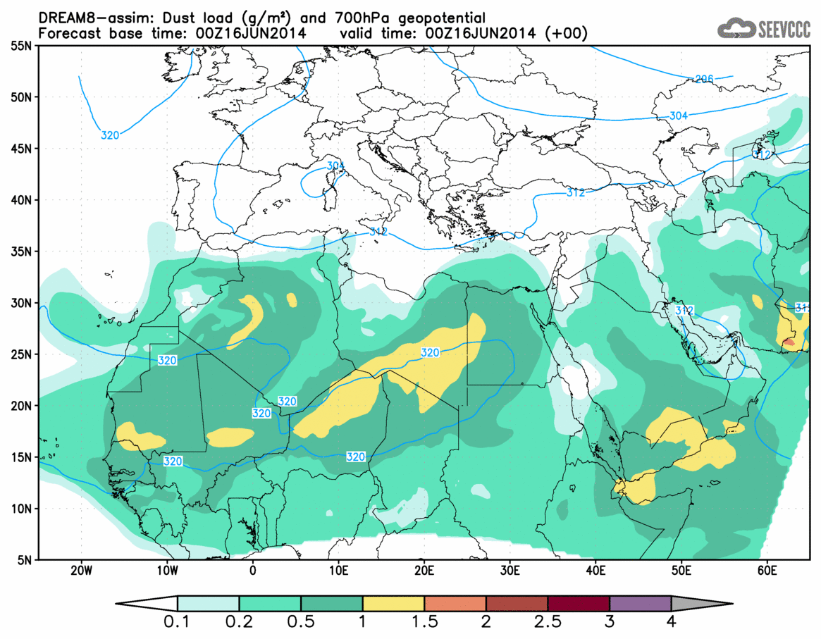
Figure 1. DREAM operational forecast of dust load http://www.seevccc.rs/?p=8

Schematic summary of the DREAM dust model

Domain | Northern Africa, Europe and Middle East
Initial data time | 00 UTC
Forecast range | 72 h
Atmospheric driver | NCEP/NMM regional model
Prognostic variables | Dust concentration, Aerosol optical depth, wet and dry deposition, dust vertical profiles for selected lidar observation sites
Vertical coordinate | Hybrid sigma-p, 50 layers
Vertical discretization | Finite-difference, xx vertical layers
Horizontal grid | 421 x 461 points (0.025° x 0.025°) on a rotated latitude/longitude grid; Arakawa-E grid, see Fig. 1.
Horiz. discretization | Finite-difference, second order mass conserving positive-definite advection)
Geo-spatial data | USGS 1-km topography and landcover; STATSGO 5km soil textures
Parameterization | Dust emission based on a viscous sub-layer model (Janjic 1994; Nickovic et al, 2001, 2004; Shao et al, 1998); Dry deposition (Georgi 1988); Wet deposition – simple precipitation scavenging; interactive feedback dust-radiation scheme (Perez et al, 2006)
Data assimilation | Dynamic relaxation assimilation of the MACC dust analysis based on AOD MODIS

4.5.2.2 Research performed in this field
[Summary of research and development efforts in the area]
In preparations for the operational runs, the Serbian version of DREAM was tested over different geographic areas Serbian version of the DREAM model, and was used for different impact studies:
- Validating DREAM in high-resolution mode (Vukovic et al., 2013). We verified the model in details for the American haboob case occurred in July 2011, running it with 3.7km horizontal resolution. This case was selected because dust sources in this region are highly heterogeneous and of point-like nature. The dust storm was generated by a convective cold air downdraft, therefore it was an opportunity to test the non-hydrostatic cloud-resolving dynamics of the atmospheric NMM model dynamics
- Use of DREAM in studying ice nucleation process (Klein et al, 2010). A major intrusion of Saharan dust (May 2008) was simulated by DREAM into Western Europe, in support of ice nucleation observations in Frankfurt performed by the Goethe-University, Frankfurt am Main, Germany. This study was performed knowing the fact that ice nuclei and mineral dust are significantly correlated, and that such studies could in the future provide a basis for improving cloud/precipitation parameterizations in NWP.
- Dust model – lidar comparison. This ongoing experiment initiated by WMO has an objective to compare retrievals from lidar co-located with sun photometers for set of stations belonging th the EARLINET European lidar network. The Belgrade group, as one of several others participate by executing DREAM over the period 2011-2013 and produce vertical dust concentration profiles for the selected lidar stations. This study would help to better understanding how dust models represent the vertical structure of dust clouds – the information that could help for further improvements of dust models in the future.

4.5.3 Specific products operationally available
[brief description of variables which are outputs from the model integration]
The output from the dust model is:
- Dust concentration,
- Dust aerosol optical depth,
- Wet and dry deposition,
- Dust vertical profiles for selected lidar observation sites
The frequency of the output is 6 hours, the length of the daily forecasts is 72 hours.

4.5.4 Operational techniques for application of specialized numerical prediction products (MOS, PPM, KF, Expert Systems, etc..) (as appropriate related to 4.5)
4.5.4.1 In operation
“[brief description of automated (formalized) procedures in use for interpretation of specialized NP output]”

4.5.4.2 Research performed in this field
[Summary of research and development efforts in the area]

4.5.5 Probabilistic predictions (where applicable)
4.5.5.1 In operation
“[Number of runs, initial state perturbation method etc.]” (Describe also: time range, number of members and number of models used: their resolution, main physics used etc.)
4.5.5.2 Research performed in this field
[Summary of research and development efforts in the area]

4.5.5.3 Operationally available probabilistic prediction products
“[brief description of variables which are outputs from probabilistic prediction techniques]”

4.6 Extended range forecasts (ERF) (10 days to 30 days)

4.6.1 Models
4.6.1.1 In operation
[information on Models and Ensemble System in operational use, as appropriate related to 4.6]

4.6.1 Model
ECMWF IFS coupled global atmosphere-ocean model 00 UTC every Monday-Thursday, variable horizontal resolution, 62 model levels, with the 51 members. All detailed information could be found on the www.ecmwf.int

4.6.1.1 In operation

[Model in operational use, (domain, resolution, number levels, range, hydrostatic?, physics used)]
 | ECMWF IFS
Domain | Global
Forecasting period | 1 month ahead
Start run | Every Monday and Thursday on 00 UTC
Horizontal resolution | Variable 32/65 km
Vertical resolution | 62 vertical levels
Ensemble | 51 members

Meteorological parameters in operational use
Parameters
Minimum, Maximum temperature on 2m (daily, weekly mean)
Total precipitation
(daily, weekly mean and monthly mean)

Statistical model by analogy of the RT500/1000 hPa field of the North Hemisphere for the historical period 1949-2014, twice per month.
 | Statistical model by analogy RT500/1000 hPa
Domain | Global
Forecasting period | 1 month ahead
Start run | Twice per month  (at the end and in the middle of the month

Parameters
Minimum, Maximum and daily mean temperature on 2m (daily, weekly mean)
Total precipitation
(daily, weekly mean and monthly mean)
Weather phenomenon (thunderstorms, snow, rain, …)

The ECMWF monthly forecasting system data has been used to issue weekly and monthly forecast for South Eastern Europe region on weekly basis. Beside basic parameters such as maximal and minimal temperature and precipitation anomalies and probabilities, SPI forecast is also produced. Statistical downscaling is used to match observed and forecast values over territory of Serbia as shown in Figure 2.
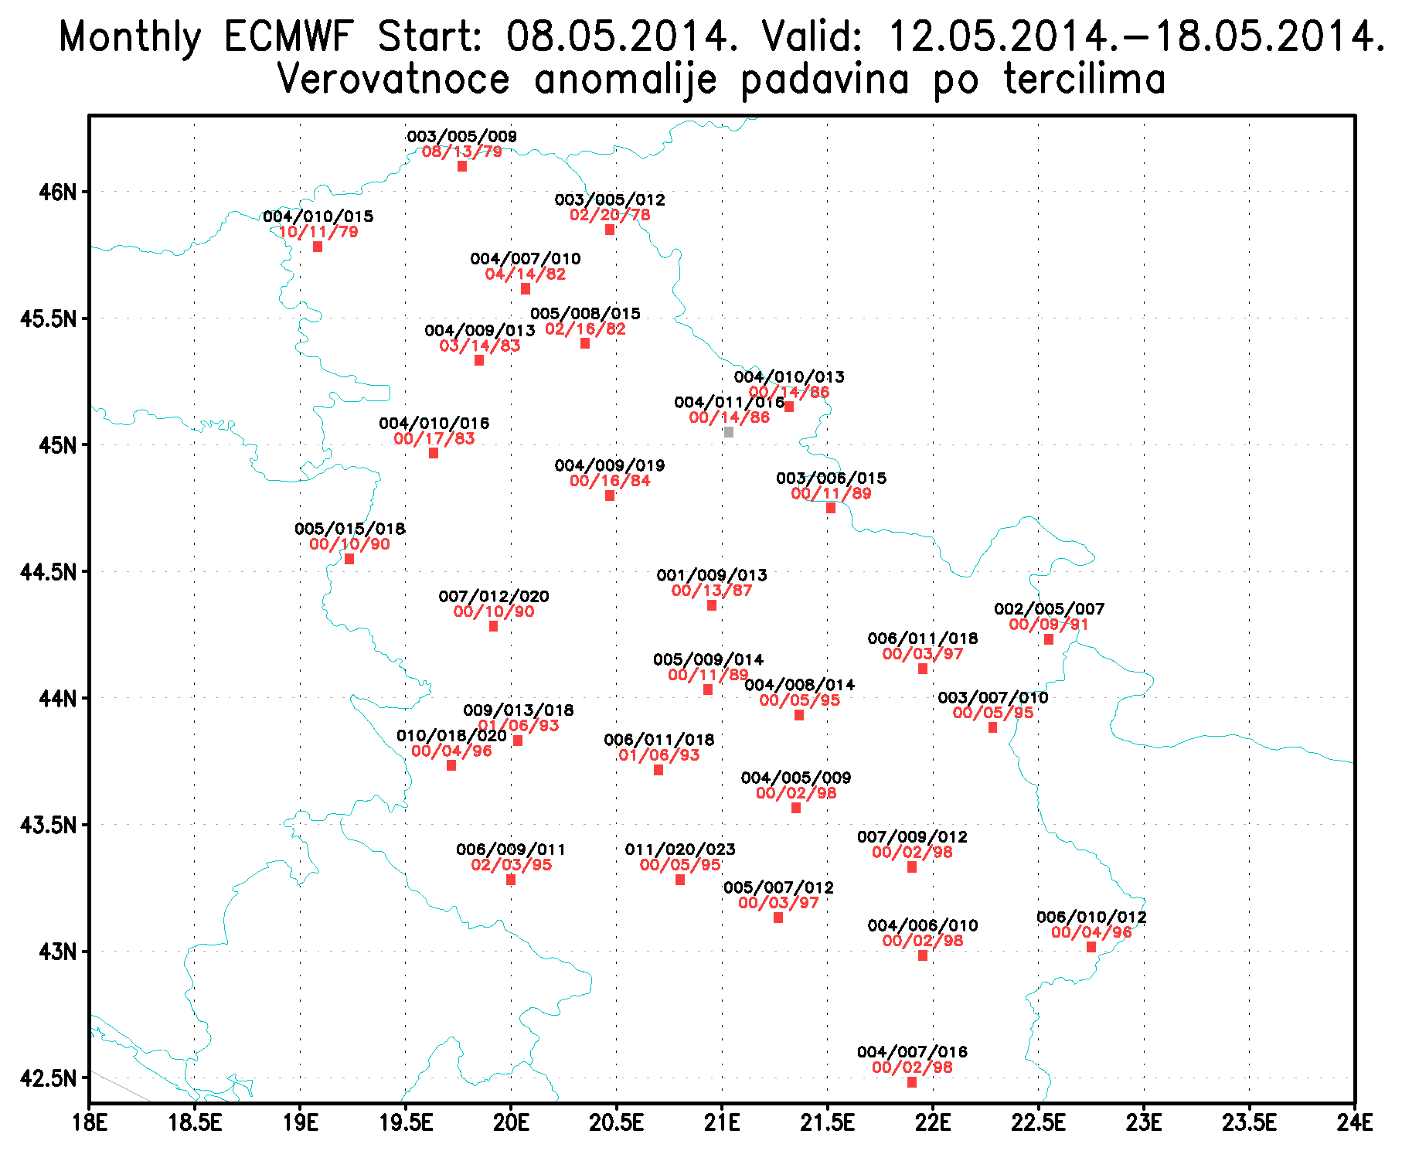
Figure 2: Forecast probabilities for equiprobable tercile categories (red) and observed climatological terciles (black)

4.6.1.2 Research performed in this field
[Summary of research and development efforts in the area]

Dynamical downscaling of monthly ECMWF monthly forecast is performed using a NMMB-regional model. Model has been tested over period of 30 years, on 8km and 15km horizontal resolution with ERA-INTERIM and ERA40 initial and boundary conditions. Encouraging results for daily rainfall rate forecast are obtained, as shown in Figure below for spring season (March-April-May).

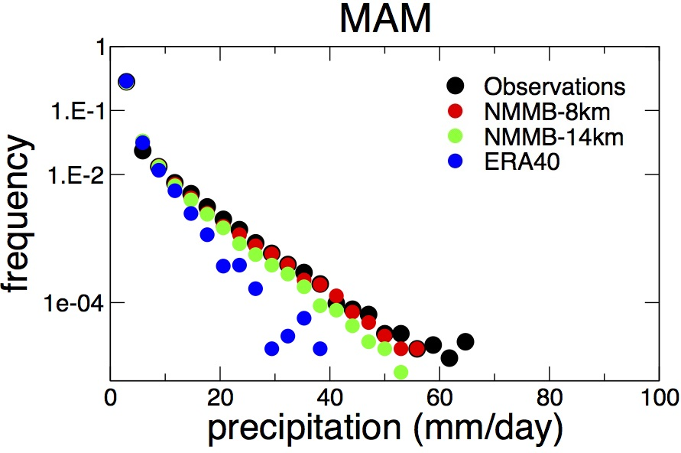
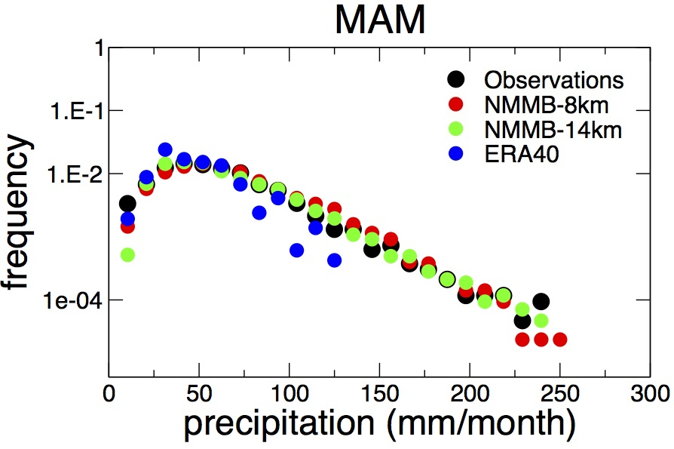

4.6.2 Operationally available NWP model and EPS ERF products
[brief description of variables which are outputs from the model integration]

4.7 Long range forecasts (LRF) (30 days up to two years)
4.7.1 In operation
[Describe: Models, Coupled? (1 tier, 2 tiers), Ensemble Systems, Methodology and Products]

The system is based on dynamical downscaling of ECMWF seasonal forecast, using a regional atmosphere-ocean coupled model (RCM-SEEVCCC). The forecast consists of 48 ensemble members and is issued ones per month between 15th and 20th of a current month. The forecast run is for 7 months. Horizontal resolution is 0.25 degrees for atmospheric model and 0.2 degrees for the ocean model. Atmosphere is resolved with 32 and ocean with 21 vertical levels. The connection between the two components is through a coupler that performs the exchange of atmospheric surface fluxes and SST after every atmospheric physical time step. Exchanged fluxes are calculated using the atmospheric component and are used directly, without any additional parametrization.

ECMWF Sys4 seasonal forecasting model, Ocean-Atmosphere coupled Global model with 51 ensemble members. All detailed information could be found on the www.ecmwf.int

 | ECMWF Sys4
Domain | Global
Forecasting period | 7 months ahead
Start run | First day of the month on 00 UTC
Horizontal resolution | ~ 80 km
Vertical resolution | 91 vertical levels
Ensemble | 51 members
Hindcast period | 1981-2010

4.7.2 Research performed in this field
[Summary of research and development efforts in the area]
n/a

4.7.2 Operationally available EPS LRF products
[brief description of variables which are outputs from the model integration]

Regional atmosphere-ocean coupled model (RCM-SEEVCCC) products

Monthly precipitation
Monthly precipitation anomaly
Monthly temperature
Monthly temperature anomaly
Seasional precipitaion
Seasional precipitation anomaly
Seasional temperature
Seasional temperature anomaly
Monthly Mediterranean sea surface temperature
Parameters prepared by post processing of the ECMWF Sys4 outputs.
Parameters
Minimum, Maximum and Daily mean temperature on 2m
(monthly mean, seasonal mean)
Minimum, Maximum and Daily mean temperature anomalies on 2m
(monthly mean, seasonal mean)
Total precipitation
(monthly mean, seasonal mean)
Total precipitation anomalies
(monthly mean, seasonal mean)

5. Verification of prognostic products
5.1 [annual verification summary to be inserted here]

ECMWF model output compared to WRF-NMM model
ECMWF model forecast, which horizontal resolution is about 16km, is compared to the regional non hydrostatic WRF-NMM model. WRF-NMM version 3.0 is running from June 2008 using ECMWF as BC. Horizontal resolution of the model is about 10 km and 00 UTC run is considered.
Comparison of the forecast quality of ECMWF model and WRF-NMM model is presented in figs. 1-6. Seasonal averaged values for 2 meter temperature and 10 meter wind speed 60h(midday) and 72h(midnight) forecast and 24 hour precipitation occurrence are taken in consideration.
Values of ME and MAE show advantage of ECMWF forecast for 2 metre temperature at midday (especially during winters), while WRF-NMM 2 meter temperature forecast have better scores at midnight. Both scores are very good for ECMWF's 2 metre temperature for last winter DJF13 (Fig. 3-4).
ECMWF scores better in 10 meter wind speed forecast for both midday and midnight forecast and during all seasons. Also, significant improvement can be seen in ECMWF's 10 meter wind speed forecast scores during last year (Fig. 5-6).
Regarding two presented scores, evaluation of precipitation forecast is similar for both models with minimum skill in spring and maximum in autumn, except the last years when for ECMWF's forecast minimum was in winter and maximum in summer (Fig. 7-8).

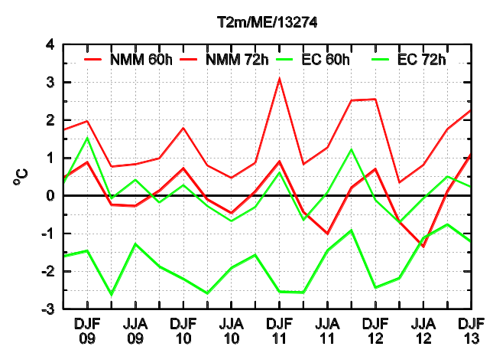 | 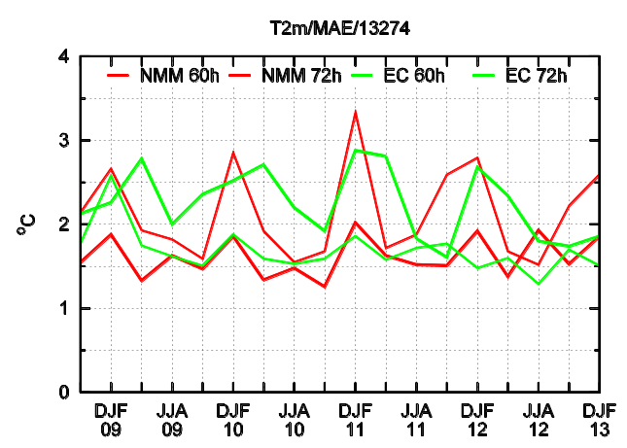
Fig.3-4 ME and MAE of ECMWF midday and midnight (60h, 72h) 2 meter temperature forecast for seasons SON09 to DJF13. Comparison to WRF-NMM forecast (Beograd - Karađorđev park).
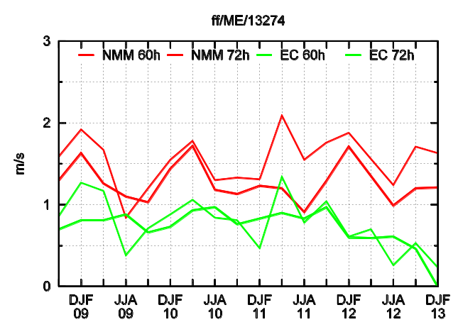 | 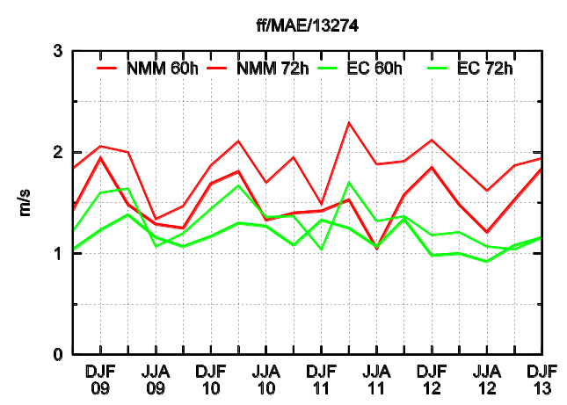

Fig.5-6 ME and MAE of ECMWF midday and midnight (60h, 72h) 10 meter wind speed forecast for seasons SON09 to DJF13. Comparison to WRF-NMM forecast (Beograd - Karađorđev park).

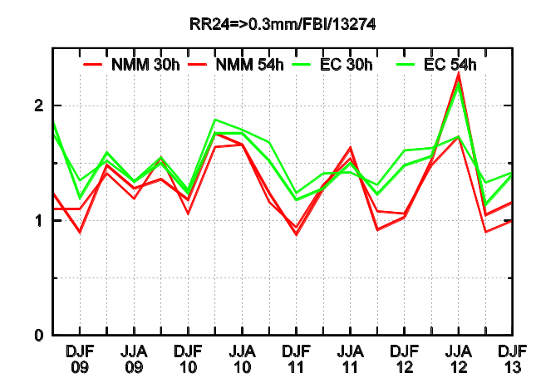 | 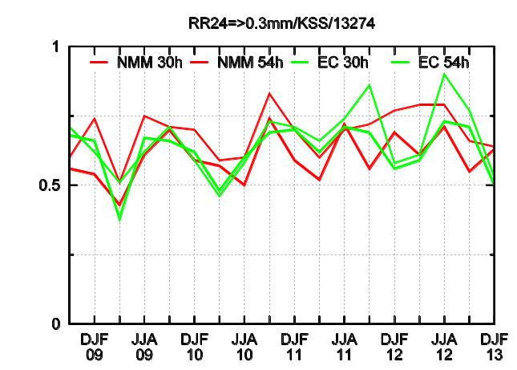

Fig.7-8 FBI and KSS of ECMWF 24h precipitation forecast (30h, 54h) for seasons SON09 to DJF13. Threshold is 0.3mm/24h. Comparison to WRF-NMM forecast (Beograd - Karađorđev park).
Monthly forecast verification

Statistical model by analogy outputs of the daily mean temperature on 2 m for Belgrade-Karadjordjev Park (13274) for 2013 compared to the referent climatology 1981-2010 on the daily level.
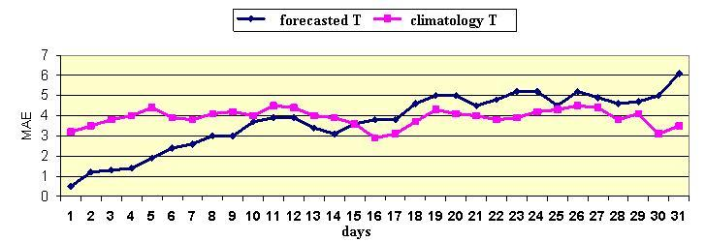
Fig 9. MAE of the statistical model by analogy of the daily mean temperature on 2m for Beograd for 2013. Comparison to the referent climatology (1981-2010) on the daily level. MAE of the model analogy outputs and referent climatology are compared to the observed values of the temperature.
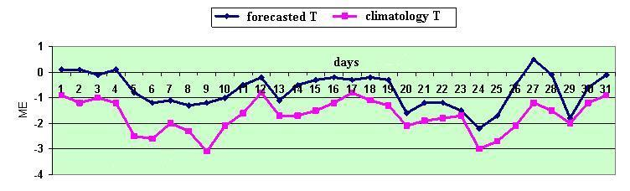
Fig 10. ME of the statistical model by analogy of the daily mean temperature on 2m for Belgrade for 2013. Comparison to the referent climatology (1981-2010) on the daily level. ME of the model analogy outputs and referent climatology are compared to the observed values of the temperature.

Long range forecast verification (RCM-SEEVCCC regional climate model)

LRF is verified in hindcast mode, as well as in real-time operating mode. Since December 2013 limited hindcast dataset is available.

Hindcast mode
Given limited computer resources, there is only one hindcast set produced starting from December, covering period from 1981-2010. There are 15 ensemble members. Forecast is 7 months in length. Verification is done at stations, using BUFR station dataset, for four different lead times. Forecast period is one month.
Produced scores and diagrams:
- Reliability diagram and frequency histogram
- ROC curve and ROC score
- Talagrand diagram (rank histogram)

The below scores and diagrams are produced for equiprobable tercile categories for two parameters: monthly temperature and monthly precipitation.
Example of diagrams and scores calculated for both RCM-SEEVCCC and ECMWF seasonal forecast (hindcast mode):
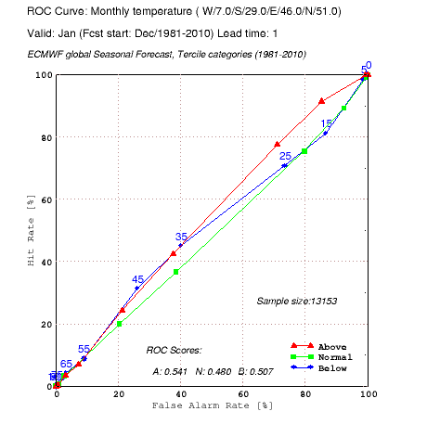
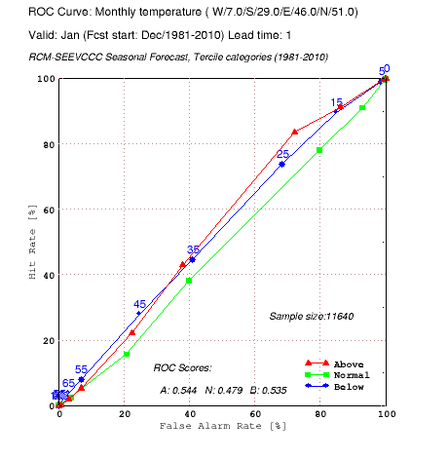
Figure 11: ROC curve, Lead time: 1 month, Parameter: temperature, Period: 1981-2010

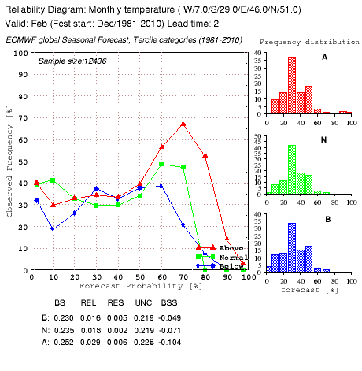
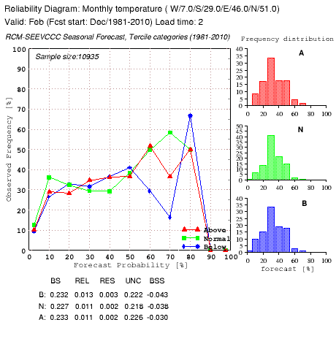
Figure 12: Reliability diagrams, Lead time: 2 months, parameter: temperature, period 1981-2010

Real-time monitoring of forecast performance

Regular monitoring of real-time seasonal forecast is done every month. Produced scores over few different regions are:
- root mean square error - RMSE
- mean absolute error - MAE
- pearson correlation coefficient (spatial) - CC
- mean error (bias) - BIAS

Above scores are derived for ensemble mean of monthly temperature and precipitation, for four lead times.

Four maps are available, showing comparison between observations and climatology, observations and forecasts, valid forecast and past year forecast, and forecast and climatology.

Example of operational forecast verification diagrams
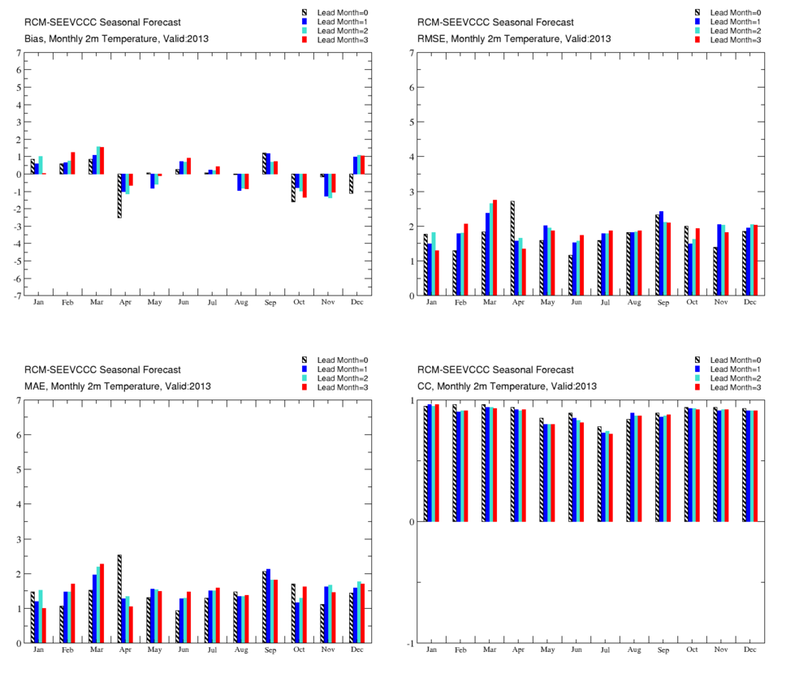
Figure 131: a. bias b. root mean square error c. mean absolute error d. pearson correlation coefficient

Example of operational forecast verification maps

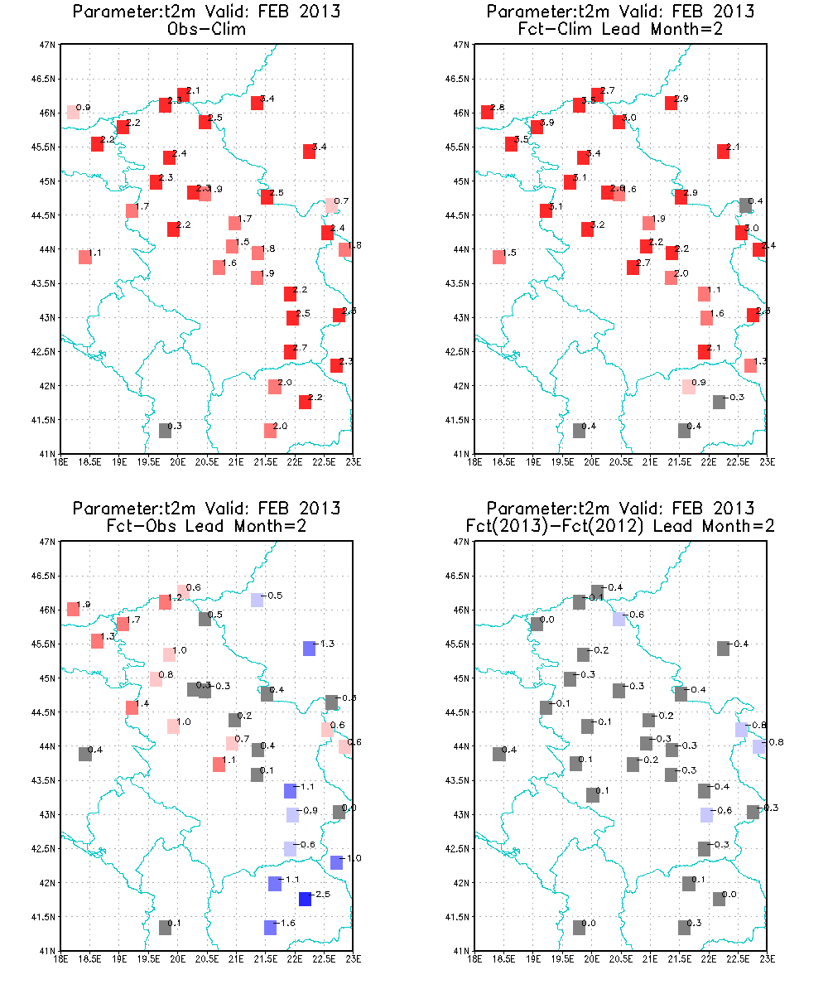
Figure 14: a. observed anomaly; b. forecast anomaly; c. difference between forecast and observation; d. difference between valid and past forecast

5.2 Research performed in this field

6. Plans for the future (next 4 years)

6.1 Development of the GDPFS

6.1.1 [major changes in the Operational DPFS which are expected in the next year]
The first pre-operational run is expected with the application of data assimilation method with numerical model as well as development of new projections of regional climate changes using regional climate model SEEVCCC/RHMSS and new IPCC scenarios (application of the Representative Concentration Pathway-RCP8.5 scenario in the first phase).

6.1.2 [major changes in the Operational DPFS which are envisaged within the next 4 years]

Within the next 4 years, among the expected changes is to significantly improve hydrometeorological early warning system on the occurrence of meteorological, climate and hydrological extreme events and disasters establishing seamless prediction weather and climate system in RHMSS

6.2 Planned research Activities in NWP, Nowcasting, Long-range Forecasting and Specialized Numerical Predictions
“[Summary of planned research and development efforts in NWP, Nowcasting, LRF and Specialized Numerical Predictions for the next 4 years]”
With the Regulation on establishing Program for meteorological and hydrological development and research activities for the period 2013 – 2017 ("Official Gazette of RS", no.106/2013) the priorities are determined for the development and research activities in the field of numerical weather forecast (NWP), climate forecast (LRF), climate modeling and climate change projections. The abovementioned Program for development and research activities includes: improvement of the Nowcasting system (0 to 2 hours) and very short-term weather forecasts (up to 12 hours) through development of specialized data bases and through assimilation of radar and satellite data WITH numerical models, improvement of short-term (12 – 72 hours) and medium-term weather forecast (72 – 240 hours), further development of climate monitoring and climate forecast system (up to seven month ahead) and improvement of verification system of forecast products, development of regional climate model of new generation and scenarios of regional climate changes using new IPCC scenarios, further development of Subregional South East European virtual climate change center and Republic Hydrometeorolgical service as its host in accordance with the binding operational and highly recommended development and research functions established in the Guideline on GDPFS for WMO RA VI RCC Network (Manual on the Global Data-Processing and Forecasting System/GDPFS, WMO No. 485).

6.2.1 Planned Research Activities in NWP
Among the planned activities are also development and application of data assimilation method using numerical model.
6.2.2 Planned Research Activities in Nowcasting

We plan to implement and use for nowcasting high resolution, very short-term numerical model with included radar and satellite data, and also to improve observation network (automatic station, rain gauges, …)
Among planned activities is to develop program for pre-processing and quality control of data as well as to establish specialized, weather limited (for the period of the last 30 years) base of available data for the needs of operational functioning and development of Nowcasting system and very short-term weather forecasts.

We also plan to improve COROBOR software for visualisation meteorological data and using in nowcasting process.

6.2.3 Planned Research Activities in Long-range Forecasting
Among planned activities is to improve climate forecast system (for the period up to seven months ahead) through development and operational use of sub-system monthly forecasts and methodology for the creation of probabilistic forecasts, as well as development of monthly and seasonal model climatology for the territory of Serbia and the region of South-East Europe.

Moreover, it is planned to develop regional climate model of new generation based on the regional numerical NMMB model and its adaption on long-term integration and development of climate monthly, seasonal, annual and decadal forecasts and climate change scenarios for the 21 century for the region of South-East Europe.

Among the future activities is the further development of Subregional South East Virtual Climate Change Center through implementation of Medium-term Program for Center development (South East European Research and Development Programme of regional climate modeling for 2012-2017), particularly through further development of Earth Modeling system and its subsystems linking regional climate model with DREAM numerical model for forecast of sand transport, volcano dust, aerosols and with HYPROM hydrological numerical model.

6.2.4 Planned Research Activities in Specialized Numerical Predictions
It is also planned to further develop and meet the requirements of the most relevant end users (aviation, hydrology, civil protection and disaster risk management, transport, energy, public health) for Nowcasting system along with short-term forecasts as well as to experimentally issue specialized forecasts and warnings.

6.2.4.1 Planned Research Activities in developing components of the Earth Modelling System
We plan to continue with integrating different components of the Earth natural system affecting the weather in which NMMB plays a role of a module that will drive other components of the natural system, such as aerosol, ocean, soil and hydrology, and including feedback mechanisms whenever possible and useful (e.g. interactions between aerosol-atmosphere, ocean-atmosphere, aerosol-ocean, etc).

6.2.4.1 Planned Research Activities in Aerosol Modelling
Dust mineralogy. A global 1km data set on 8 minerals (+ phosphorus) in arid soils (Nickovic et al, 2012)is developed as a first step in providing input to dust model for predicting transport of mineral fractions in dust. Our plans are to include prediction based on the DRAM dust model of selected minerals which contribute to dust impact to weather and environment, including: direct effects due to dust-radiation interaction; indirect effects due to dust-cloud interactions; predicting environmental effects due to Fe deposition in dust into ocean. Special emphasis will be to parameterize generation of ice nuclei process caused by dust aerosol, as a precondition for improvement in treating the physics of cold clouds in the NMMB model.
High resolution dust modelling. In the next 4 year period, we plan to improve the treatment of dust sources in DREAM model using the satellite observations (land cover; NDVI), so replacing the current static geospatial data for dust sources specification.
Assimilation of dust-related observations. Initial experiences to use the ECMWF analyses based on MODIS satellite data as input for the DREAM model assimilation based on dynamic relaxation is positive, showing increase of the model performances. In the next period, we plan to develop an assimilation system that combines satellite data from different sources (MSG, MODIS, CALIPSO) combined with data on vertical aerosol profiling (lidars, ceilometers).
Other aerosols. In addition to dust, we plan to add to the DREAM aerosol modelling system other major aerosol components: sea salt aerosol, biomass burning and pollution/sulphates.

6.2.4.2 Planned Research Activities in integrated atmospheric-hydrology modelling
The focus of this research will be coupling of the HYPROM hydrology model (Nickovic et al, 2010) with the NMMB atmospheric model HYPROM is based on fully dynamic governing equations. It is developed to simulate overland watershed hydrology processes based on advanced numerical and parameterization methods. The model solves grid point-based shallow water equations with numerical approaches that include an efficient explicit time-differencing scheme for the gravity wave components and a physically based and numerically stable implicit scheme for the friction slope terms. NMMB precipitation forecasts will be used to provide water sources for HYPROM. HYPROM will be tested for the major Serbian watersheds and its capabilities to provide operational forecast for hydrology conditions will be assessed.

7. References
[information on where more detailed descriptions of different components of the DPFS can be found]
(Indicate related Internet Web sites also)
[information on where more detailed descriptions of different components of the DPFS can be found]
(Indicate related Internet Web sites also)

Manual on the Global Data-Processing and Forecasting System/GDPFS, WMO No. 485, Appendix II-10: Designation and mandatory functions of Regional Climate Centres; Appendix II-11: Detailed criteria for RCC mandatory functions; Attachment II-11: Additional highly recommended functions of designated RCC or RCC-Networks
WMO No 386 & ICAO Doc No 10;
South East European Reseasrch and Development Programme of regional climate modeling for 2012-2017, Joint Statement by the participants in the Ministerial Meeting “ Climate Change Research for Environmental Protection, Adaptation and Risk Reduction”, Belgrade, Serbia, April 13, 2011 (www.sevccc.rs/md/JOINT_Statement_final.doc)
Janjic, Z. I., 1994: The step–mountain eta coordinate model: further developments of the convection, viscous sublayer and turbulence closure schemes. Mon. Wea. Rev., 122, 927–945.
Nickovic, S., Kallos, G., Papadopoulos, A., and Kakaliagou, O. ,2001: A model for prediction of desert dust cycle in the atmosphere, J. Geophys. Res., 106, 18113-18130, doi: 10.1029/2000JD900794.
Nickovic, S., G. Pejanovic, E. Ozsoy, C. Pérez and J.M. Baldasano, 2004: Interactive Radiation-Dust Model: A Step to Further Improve Weather Forecasts. International Symposium on Sand and Dust Storm. September 12-14. 2004, Beijing, China.
Nickovic, S., Vukovic, A., and Vujadinovic, M.: Atmospheric processing of iron carried by mineral dust, Atmos. Chem. Phys., 13, 9169-9181, doi:10.5194/acp-13-9169-2013, 2013
Nickovic, S., A. Vukovic, M. Vujadinovic, V. Djurdjevic, and G. Pejanovic, Technical Note: High-resolution mineralogical database of dust-productive soils for atmospheric dust modeling Atmos. Chem. Phys., 12, 845–855, 2012 www.atmos-chem-phys.net/12/845/2012/ doi:10.5194/acp-12-845-2012,
Nickovic, S., Djurdjevic, V., Vujadinovic, M., Janjic, Z.I., Curcic, M., Rajkovic, B. (2011): “Method for efficient prevention of gravity wave decoupling on rectangular semi-staggered grids”. Journal of Computational Physics, 230(5), 1865-1875.
Nickovic, S., G. Pejanovic, V. Djurdjevic, J. Roskar, and M. Vujadinovic (2010), HYPROM hydrology surface-runoff prognostic model, Water Resour. Res., 46, W11506, doi:10.1029/2010WR009195,
Pérez, C., S. Nickovic, G. Pejanovic, J. M. Baldasano, and E. Ozsoy (2006), Interactive dust-radiation modeling: A step to improve weather forecasts, J. Geophys. Res., 111, D16206, doi:10.1029/2005JD006717.
Shao, Y., M. R. Raupach, and P. A. Findlater, Effect of saltation bombardment on the entrainment of dust by wind, J. Geophys. Res., 98, 12719-12726, 1993.
Vukovic, A., Vujadinovic, M., Pejanovic, G., Andric, J., Kumjian, M. R., Djurdjevic, V., Dacic, M., Prasad, A. K., El-Askary, H. M., Paris, B. C., Petkovic, S., Nickovic, S., and Sprigg, W. A.: Numerical simulation of "an American haboob", Atmos. Chem. Phys., 14, 3211-3230, doi:10.5194/acp-14-3211-2014, 2014.
Albers, S., McGinley, J., Birkenheuer, D., Smart, J. (1996): The Local Analysis and Prediction System (LAPS): Analyses of clouds, precipitation, and temperature. Weather and forecasting, 11, 273-287
http://laps.noaa.gov/
Rajkovic B., Markovic J. 2012: Cloud detection and analysis using LAPS system, International Environmental Modelling and Software Society (iEMSs), 2012 International Congress on Environmental Modelling and Software, Leipzig, Germany, 1-5 July 2012.
Markovic J., Rajkovic B., 2012: Cloud analysis using LAPS in Serbia, LAPS Users Workshop, Boulder, Colorado, USA, 23-25 October 2012.

