ANNUAL JOINT WMO TECHNICAL PROGRESS REPORT
ON THE GLOBAL DATA PROCESSING AND FORECASTING SYSTEM (GDPFS) INCLUDING NUMERICAL WEATHER PREDICTION (NWP) RESEARCH ACTIVITIES for 2011

Hellenic National Meteorological Service (HNMS)

GREECE

1. Summary of highlights

HNMS has introduced a high resolution wave model run cycle (currently in pre-operational mode) based on the nested version of the ECMWF wave model (CYCLE 37r2). It employs a coarse run over Mediterranean sea at 0.04 deg , a nested run 0.02 deg resolution over the entire Greece area, and another nested run at a 0.01 deg resolution over Southwest Aegean. The objective of the project is the development of a reliable - wave forecasting system including wave propagation in shallow waters. Forecasts are produced twice a day (00,12) for a 72h period, forced by the wind fields produced by the operational COSMO 0.025 deg run .

- Equipment in use at the center

  - Message Switching System (MSS)
Operating Software : Linux Red Hat AS 3.0
Software : Moving Weather (IBLsoft)
Hardware : High availability server
Cluster configuration of two servers with Service Guard of HP consisting of :
2 x CPUs RX2600 Itanium 1,3 Ghz
RAM 8Gb
2 x Hard Disks of 36 Gb
Connection : 1Gbps (2 x FC)

- Preprocessing
Operating Software : Linux Red Hat AS 3.0
Software : ECMWF
Hardware : High availability server
Cluster configuration of two servers with Service Guard of HP consisting of :
2 x CPUs RX2600 Itanium 1,3 Ghz
RAM 8Gb
2 x Hard Disks of 36 Gb
Connection : 1Gbps (2 x FC)

- Preprocessing BUFR to TAC
Operating Software : Linux SuSE 10.3
Software : IBLsoft TDCFTAC 3.3.16
Hardware : High availability server. HP

1x CPU Intel Xeon at 2.5 GHz
RAM 4Gb
2 x Hard Disks of 300 Gb
Connection: 1Gbps (2 x FC)
Connection: 1Gb (2 x FC)

Web Mars Intranet
Operating Software : Linux Red Hat AS 3.0
Software : ECMWF
Hardware : High availability server
Cluster configuration of two servers with Service Guard of HP consisting of :
2 x CPUs RX2600 Itanium 1,3 Ghz
RAM 4Gb
2 x Hard Disks of 36 Gb
Connection: 1Gb (2 x FC)

- MARS
Operating Software : HPUX 11.22
Software : ECMWF
Hardware : High availability server :
Cluster configuration of two servers with Service Guard of HP consisting of :

4 x CPUs RX5670 Itanium 1,3 Ghz
RAM 16 Gb
2 x Hard Disks of 36 Gb
Connection : 1Gb (2 x FC)

- Graphical Servers
Operating Software: Linux Red Hat AS 3.0
Software : Visual Weather (IBLsoft)
Hardware : High availability server
Cluster configuration of two servers with Service Guard of HP consisting of :
4 x CPUs RX 5670 Itanium at1,3 Ghz
RAM 16Gb
2 x Hard Disks 36 Gb
Connection: 1Gb (2 x FC)

- MSG Processing
5 servers :
Operating Software: Linux Red Hat 9.0
Hardware : 5 Intel based servers
with NAS 1Tb (DELL)

- Radar Processing
Operating Software: Linux Red Hat 9.0
Hardware : 5 Intel based servers

Operating Software: Linux Red Hat ES 4.0
Hardware : 4x Intel Xeon at 3.2 GHz

Operating Software: Microsoft Windows XP Pro
Hardware : Intel Pentium 4 at 2,8 GHz

- Lightning
Operating Software: Microsoft Windows XP Pro
Hardware : 3 x Intel Pentium 4 at 2.8 GHz

Operating Software: Microsoft Windows XP Pro
Hardware : 1 x Intel Pentium at 3.0 GHz
Operating Software: Microsoft Windows Server 2003 Dell Server
Hardware : 1x Dual Core 3.0 GHz
Operating Software: Red Hat Linux
Hardware : Dell Power Edge 1950
Operating Software: Red Hat Linux
Hardware : Dell Power Edge 860

- Web Server Farm
17 x HTTP servers
Operating Software: Red Hat Linux
Software: Internal s/w based on ZOPE
Hardware: CPU Intel Based Xeon
RAM 1 Gb
Hard Disk 36 Gb
Data Base Server
Operating Software: olaris 8 with Sun Cluster 3.0
Software MySQL
Hardware: 2 servers SUN480 with 4Gb RAM and 2x36 HD
NAS with 80 Gb HD
4 servers SUN V120 with 1Gb RAM and 1x36 HD

- System IBM Cluster 1600
8-way 1.7 Gh power 4+
16 Gb Memory
28 Compute Nodes 7039-651 pSeries 655
2 Link Switch Interface
2 I/O – Front - End Compute Nodes 7039-651 pSeries 655
8-way 1.7 Gh power 4+
16 Gb Memory
2 Link Switch Interface
Shared 7040-61D I/O drawer with 1 Gb Ethernet/Server and
2 FC/Server
Disk SubSystem
1 FASt600 Server
14 146.8 Gb Disks
2 links FC Switches
6 Hight Performance Swithes (HPS) 7045-SW4
Federation Switches
Total 240 Power 4+ Processors
Pararallel Environment:
MPI
GPFS V2.1.0
Loadleveler V3.1
Operating System: AIX 5L V5.2

- Data and Products from GTS in use (along with their average number of messages by day)

SYNOP 11143
TEMP 496
SHIP 1541
GRIB from ECMWF 12092
Aeronautical Charts from Exeter (PNG-BUFR) 164
JASON 628
AIREP/PIPER 149
PILOT 77
AMDAR 1952

4. Forecasting System

4.1 System run schedule and forecast ranges
Following a strong commitment towards a forecasting system of high standards as it stems from the raising need to the quality of meteorological products for the highly complex bas-relief of Greece, the Hellenic National Meteorological Service (HNMS) follows up-to-date developments for the three local numerical weather prediction models that run in operational mode using local computational resources.
The first Local Model is a modified version of the ETA model. Its hydrostatic version was initially set in operation in 1995 under the project “SKIRON” in collaboration with the University of Athens. The current non-hydrostatic version runs twice a day with a prognostic range of 72 hours.
Next, is the Non-Hydrostatic Local Model COSMO-GR (formerly named LM), that has been developed by the German Meteorological Service (DWD). This model is in operational use since 1998 through the Consortium for Small Scale Modeling (COSMO) that includes the National Meteorological Services of Germany, Greece, Italy, Poland, Switzerland, Russia and Romania. It runs 2 times a day locally with a prognostic range of 72 hours.
Finally, HNMS runs a sea-wave model (WAM) that uses the results of COSMO-GR model. WAM runs once a day with a prognostic range of 48 hours.

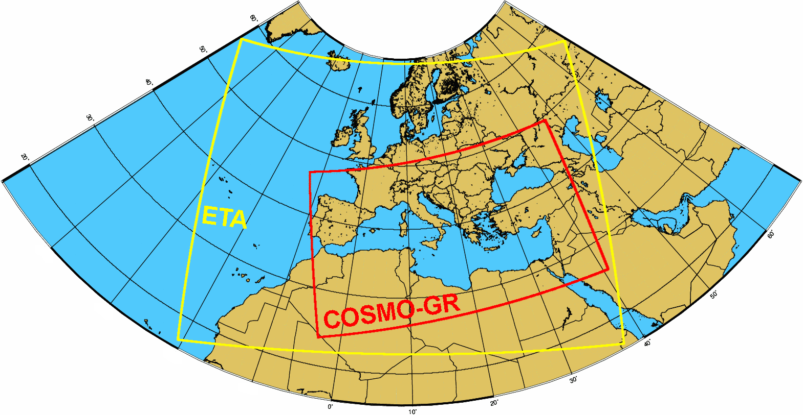
The COSMO-GR and ETA integration domains at HNMS

4.2 Medium range forecasting system (4-10 days)

As a founding member of ECMWF, HNMS makes full operational use of all the ECMWF meteorological products both for its operational meso-scale weather forecasting as well as for data assimilation, objective analysis and initialization of the local models in use.

4.3 Short range forecasting system (0-72 hrs)

4.3.1 Data assimilation, objective analysis and initialization
Regarding Local Models, data assimilation for the COSMO-GR is based on the Nudging Analysis Scheme developed at DWD.

4.3.2 Model
4.3.2.1 In operation
HNMS runs a high-resolution version of COSMO, with 0.025deg/60 levels resolution. The high-res version receives initial conditions produced by the operational COSMO run of 0.0625 deg resolution.

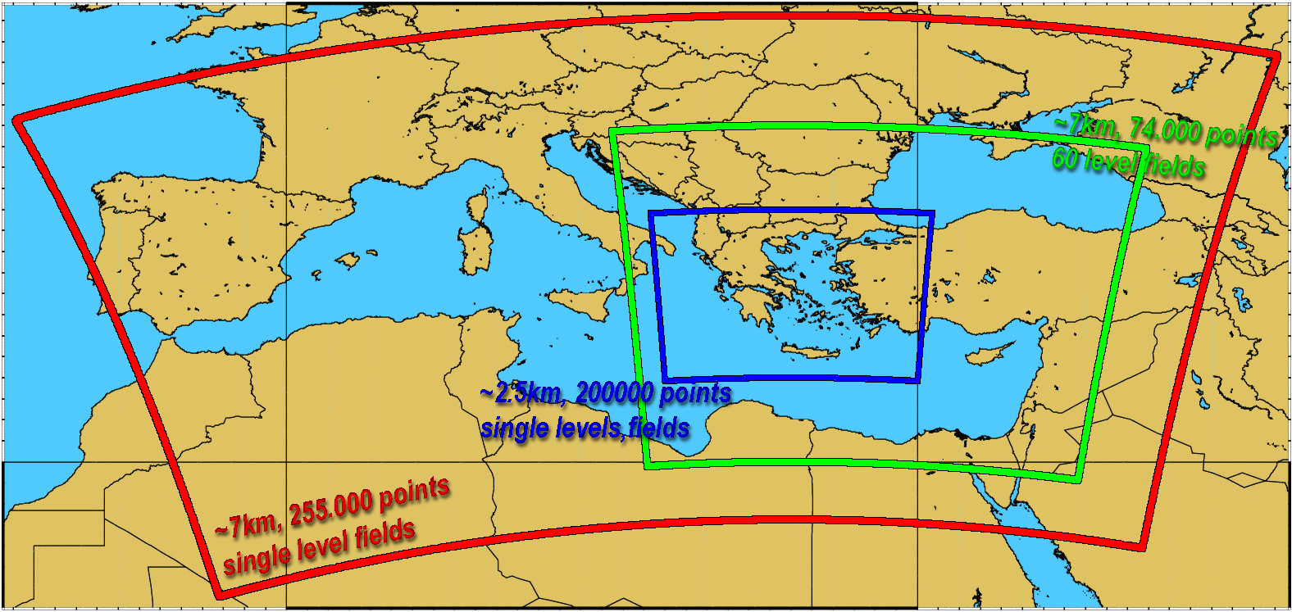
Red area: operational run (0.625deg)
Green area: operational output used as boundary conditions for the high-resolution run
Blue area: area of high-resolution run
The high-resolution run uses its own orography and external-fields data. The pictures below compare the normal (0.0625deg) and the high-resolution (0.025deg) elevation fields

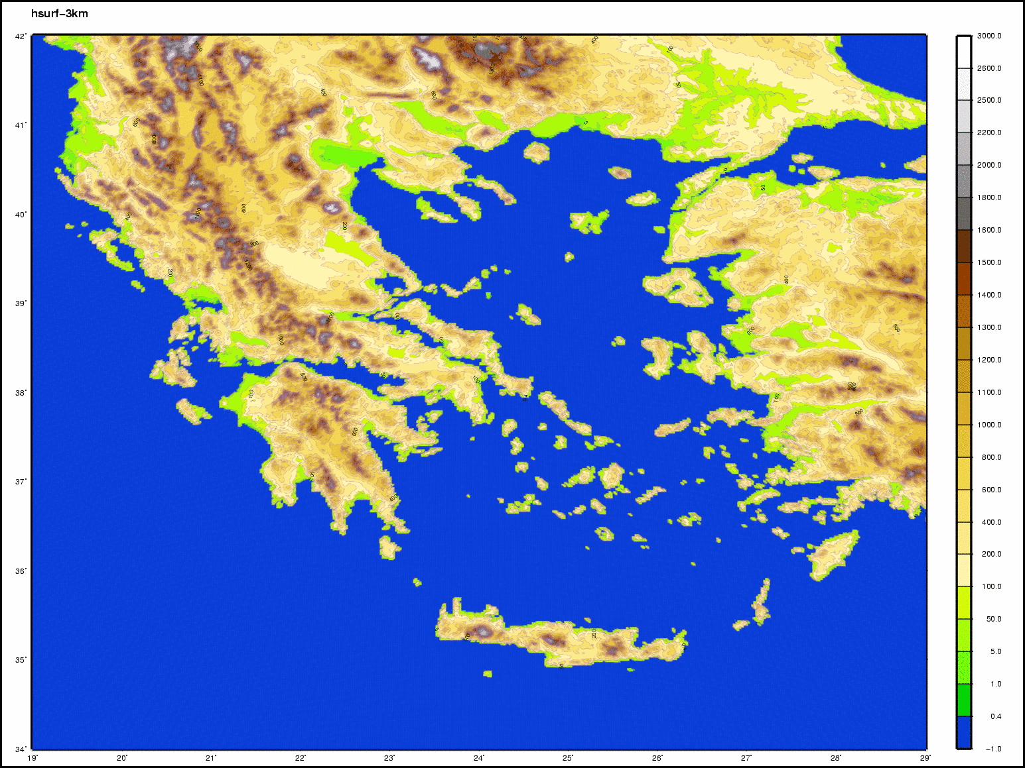 | 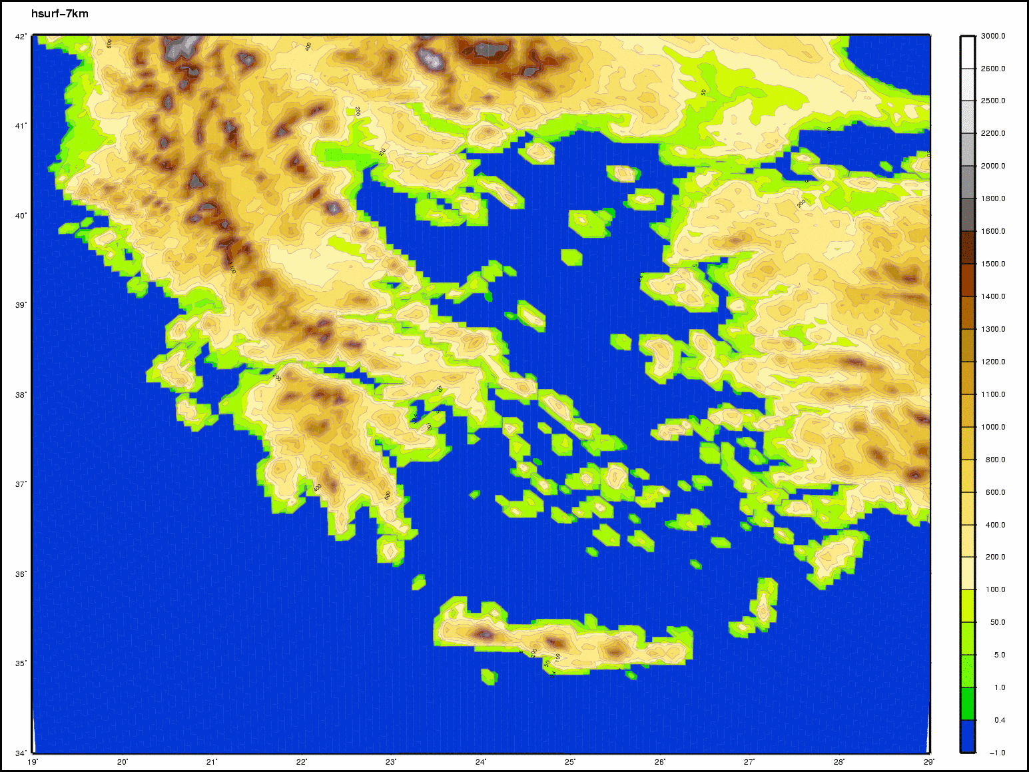
Orography 0.025 deg | Orography 0.065 deg

4.3.3 Operationally available NWP products

Numerical Weather Prediction Model ETA
Time prediction range and step | Initialization from ECMWF analysis of 00 UTC and 12 UTC with prediction range of 72 hours from analysis hour. Data production every 3 prediction hours.
Computer system | IBM Power4 architecture
Surface data parameters | Mean Sea Level Pressure  Wind 10m  Temperature 2m  Specific Humidity  Precipitation
Upper-level data parameters | Geopotential height  Temperature  Wind  Specific Humidity
Vertical Resolution (hPa) | 100, 150, 200, 250, 300, 400, 500, 700, 850, 1000 and Surface
Horizontal Resolution | 0.062ºX0.062º in rotated grid with geographical center lon=8, lat=46.5 and width 61 degrees in longitude and 45 degrees in latitude.
Covered area | East Atlantic and Europe
Results form | Binary which are converted to GRIB

Numerical Weather Prediction COSMO-GR Model
Time prediction range and step | Locally (2 runs a day): Initialization from the Global Model of ECMWF (IFS) or DWD (GM), based on analysis of 00 UTC and 12 UTC. Data assimilation is done using the Nudging Analysis scheme developed at DWD. The prognostic range is 72 hours and data production is available every prediction hour.
Computer system | IBM Power4-based system
Surface data parameters | Mean Sea Level Pressure  Wind 10m  Maximum wind 10 m  Temperature 2m  Dew point temperature 2m  Maximum temperature 2m  Minimum temperature 2m  Total cloud cover  High cloud cover (0-400 hPa)  Medium cloud cover (400-800 hPa)  Low cloud cover (800 hPa-Surface)  Specific humidity  Precipitation  Convective precipitation  Snowfall
Upper-level data parameters | Geopotential height  Temperature  Omega parameter of vertical motion  Wind  Specific Humidity
Vertical Resolution (hPa) | 200, 250, 300, 400, 500, 600, 700, 850, 950, 1000
Horizontal Resolution | 0.0625ºX0.0625º in rotated grid with South Pole lon=24, lat=-52 and width 40.5 degrees in longitude and 24 degrees in latitude.
Covered area | Mediterranean and Black Sea
Results form | GRIB

Numerical Weather Prediction Model RAMS (Non-Hydrostatic) & WAM
Time prediction range and step | Initialization from ECMWF analysis of 12 UTC and corrected with LAPS. Prediction range of 36 hours from analysis hour. Data are displayed for every prediction hour.
Computer system | IBM Power4 architecture
Surface data parameters | Mean Sea Level Pressure  Wind 10m  Temperature 2m  Total cloud cover  Precipitation  Wave height and direction (WAM)
Upper-level data parameters | Geopotential height  Temperature  Wind  Relative humidity  Specific humidity
Vertical Resolution (hPa) | 100, 150, 200, 250, 300, 400, 500, 700, 850, 1000
Horizontal Resolution  (Three nested Grids) | Grid 1: 48 Km  Grid 2: 12 Km  Grid 3: 3 Km
Covered area | Grid 1: Europe, North Africa, Black Sea  Grid 2: Balkans  Grid 3: Central Greece
Results form | GRIB

4.3.4 Operational techniques for application of NWP products
Automatisation of the maritime bulletin at HNMS
The Hellenic National Meteorological Service (HNMS) is responsible for the dissemination of maritime bulletins for shipping for the eastern Mediterranean Sea and the Black Sea. The program for the automatic creation of the maritime bulletins already developed at HNMS is an important tool providing the basis for the bulletin text as well as concentrating the necessary data for the forecaster. Main features of this program running operational at HNMS include post-processing application to the NWP data of COSMO-GR with horizontal resolution of the model is 0.0625º (~7km), enabling the detailed description of the meteorological data in even small geographical regions, description of wind, precipitation and visibility in three periods (two 6-hours and a 12-hour) during its validity. Apart from the bulletin text the program provides the necessary graphical outputs in the form of wind roses of mean wind as well based on the as graphs of maximum mean wind indicating its location, for each sea sector and period. Latest model developments include the description of the sea state. The sea state characteristics will be implemented into the bulletin text. This will be made through post processing of WAM output operationally available at HNMS.

Kalman filtering on temperature numerical predictions
The Hellenic National Meteorological Service (HNMS) operates daily a method improving the temperature minimum and maximum forecast values for 50 locations in Greece. This method is based on Kalman filtering using the available quality controlled observations together with the corresponding NWP data of three different models, namely, COSMO-GR, SKIRON and ECMWF. The reliability of the filtered results is investigated with their statistical evaluation at the end of each month or season

4.5 Specialized numerical predictions(on sea waves,storm surge,sea ice, marine pollution transport and weathering, tropical cyclones, air pollution transport and dispersion , solar ultraviolet (UV) radiation, air quality forecasting, smoke, sand and dust,etc.)

Hellenic Wave Forecasting System
The objective of the project is the development of a reliable - wave forecasting system including wave propagation in shallow waters
It is a system of coupled atmospheric and wave numerical models aiming to a more detailed and accurate sea state forecast in an operational level. It consists of the best combination of atmospheric and wave models ie:.
- Atmospheric model COSMO
- WAM model.
- SWAN model (Simulating WAves Nearshore TU delft www.swan.tudelft.nl)

The basic componenet of the system is the latest version of ECMWF Nested WAVE model (CYCLE 37r2) During the last years the European Centre for Medium-
Range Weather Forecasts (ECMWF) released new editions of the wave model WAM. The latest model version has been evaluated on both wave height and spectrum in close and shallow seas as well as in open oceans. The new version of WAM model (cycle 37r2) released from ECMWF has introduced important modifications including the employment of a new advection scheme, as well as new parametrization of shallow water effects.

Regarding SWAN it is a third-generation wave model that computes random, short-crested wind-generated waves in coastal regions and inland waters for simulating wave propagation in shallow waters SWAN accounts for the following physics: Wave propagation in time and space, shoaling, refraction due to current and depth, frequency shifting due to currents and non-stationary depth etc

Coarse area WAM is driven with 10m forecast wind fields available every 3 hour from COSMO model with horizontal resolution of 0.06 degrees.
Nested area WAM and SWAN are driven with 10m forecast wind fields available every 3 hour from HNMS high resolution COSMO model (0.02 X 0.02 degrees.)

CONFIGURATION
Model | Area covered | Resolution  (degrees) | Wind input and resolution | Bathymetry data
WAM coarse | Mediterranean  Sea  -6W - 42E  29N - 47 N | 0.04x 0.04 | Coarse COSMO (hourly)  0.06x0.06 degrees | ETOPO 2 (0.05 degrees)
WAM 1st nest | Greek seas  19.4W - 30E  30.2 N - 41 N | 0.02 x 0.02 | Nested COSMO (hourly)  0.02x0.02 degrees | ETOPO 2
WAM 2nd nest | Saronicos Gulf  22.4W – 24.2E  30.2 N - 41 N | 0.01 x 0.01 | Nested COSMO (hourly)  0.02x0.02 degrees | HCMR* 0.01  (*Hellenic Center for Marine Research)
SWAN | Saronicos Gulf  22.4W – 24.2E  30.2 N - 41 N | 0.01 x 0.01 | Nested COSMO (hourly)  0.02x0.02 degrees | HCMR 0.01

WAM areas configuration
Model | Area covered |  | Resolution  (degrees)
Coarse area Mediterranean  Sea | -6W - 42E  29N - 47 N | 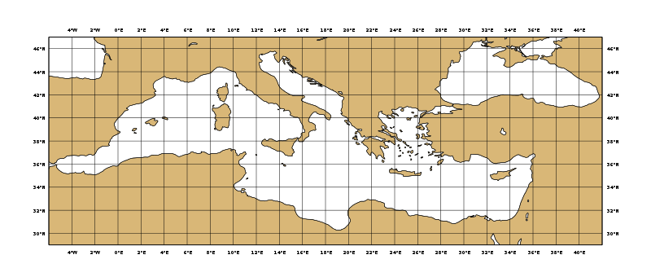 | 0.04x 0.04
1st nested area  Greek seas  (1st nest) | 19.4W - 30E  30.2 N - 41 N | 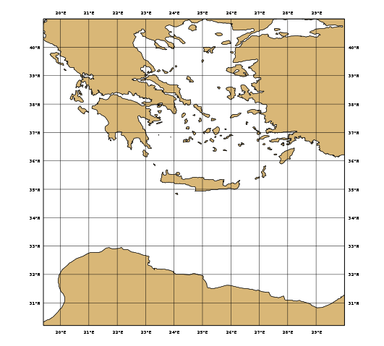 | 0.02 x 0.02
  2nd nested area  Saronicos Gulf | 22.4W – 24.2E  30.2 N - 41 N | 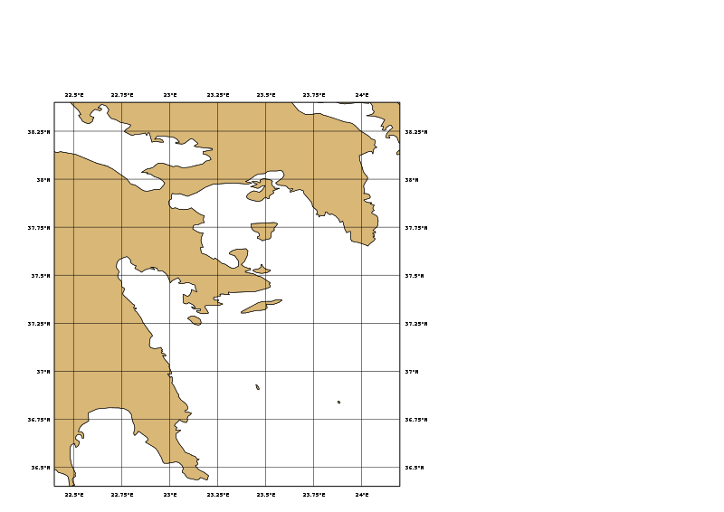 | 0.01 x 0.01
  2nd nested area  Saronicos Gulf | 22.4W – 24.2E  30.2 N - 41 N |  | 0.01 x 0.01
  2nd nested area  Saronicos Gulf | 22.4W – 24.2E  30.2 N - 41 N |  | 0.01 x 0.01
  2nd nested area  Saronicos Gulf | 22.4W – 24.2E  30.2 N - 41 N |  | 0.01 x 0.01

WAM products

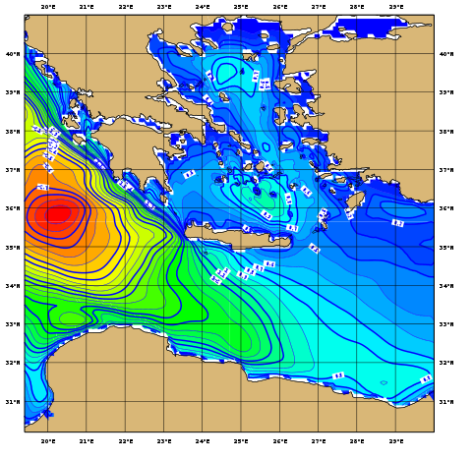

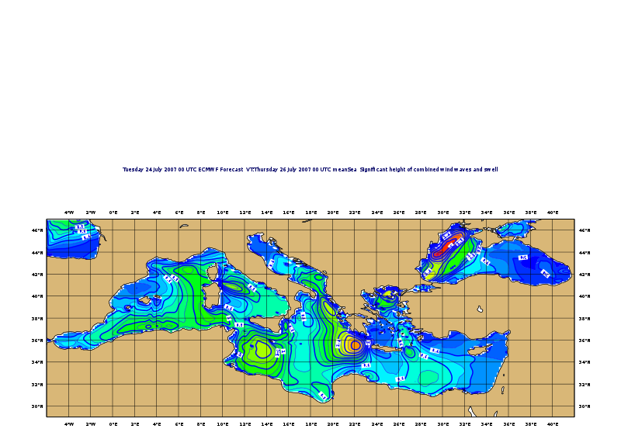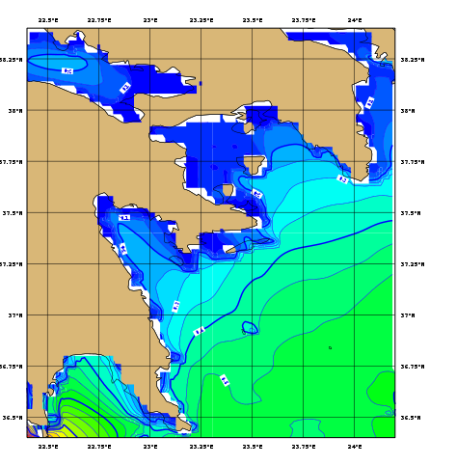

Marine Pollution Emergency Response Support System at HNMS
The Hellenic National Meteorological Service (HNMS) operates, in the framework of WMO, the Marine Pollution Emergency Response Support System (MPERSS) for the Marine Pollution Incident (MPI) area III East, which includes the eastern Mediterranean Sea. This system implements a sea pollution model based on the French model (MOTHY), which is applied in cases of oil spills (or floating items) in the eastern Mediterranean. This trajectory model uses NWP data either of the ECMWF model or COSMO-GR model for higher resolution results. The data used as input are the surface wind speed and the sea surface pressure. The location (latitude and longitude) and the time of the incident are specified as well as the type of the spilled fluid or the released item. The duration of the forecast for the dispersion of the oil (or the floating item transport) is declared. The maximum possible forecasting period is a function of the availability of the NWP data, the specific forecast cycle, and the time of the incident. The model will provide the possible trajectories (locations) of oil (or item) transport as well as the percentage of the oil spill that will reach the coast or the seabed. These results are given either in graphic files depicting the extent of the sea pollution or in tables. HNMS can apply the model for any specific incident of oil spillage (or item release) in the Eastern Mediterranean.

4.7 Long-range forecasts
HNMS participates in the Southeastern Europe Climate Outlook Forum (SEECOF) supported by WMO, providing twice per year, every fall and spring an outlook of the regional climate for the forthcoming winter and summer respectively. A predominantly consensus-based approach is used based on seasonal forecasts for 2m temperature and precipitation anomalies archived both from the European Centre for Medium-Range Weather Forecasts (ECMWF) as well as the NCEP coupled forecast system model (CFS). Furthermore the actual climate monthly bulletins for qualitative assessment of the forecasts providing the general trend of the long-term weather in the country are used.

5. Verification of prognostic products

5.1 Annual verification summary
Verification is an integral element of operational forecasting systems. It is necessary not only to monitor forecast quality, but also to choose between alternative forecasting systems, to guide their improvement and to inform forecast users regarding uncertainty levels in order to help them in their decision making.

The verification is performed with state-of-the art software called VERification System Unified Survey (Gofa 2010). The VERSUS software was developed as a unified tool capable of performing standard operational verification, conditional operational verification as well as experimental verification, in both batch and interactive model and is currently used by the HNMS for all verification activities.

The forecast values of weather parameters derived both from the local weather models (COSMO-GR 7 and 3km version, Eta/Skiron) and the IFS ECMWF global model, are compared with synoptic meteorological data from the HNMS operational network of stations and a range of statistical scores is calculated on a daily, monthly, seasonally and yearly basis. Data from around 80 weather stations are received daily and included in the verification process. The verification of continuous variables (T2m, Td2m, MSLP, wind speed, total cloud cover) is typically performed using statistics that show the degree to which the forecast values differ from the observations. Examples of the seasonal verification performed for the 2013 period for COSMO and ECMWF are presented below for some parameters.

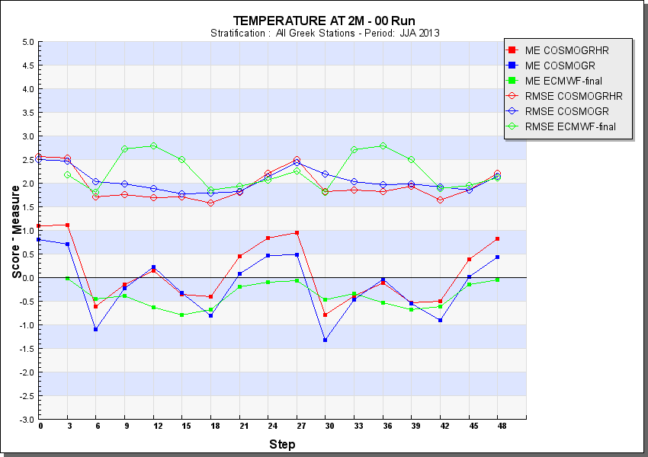 | 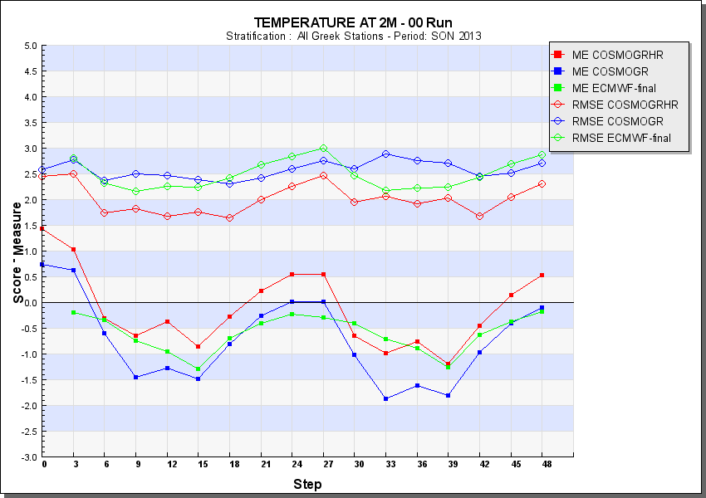
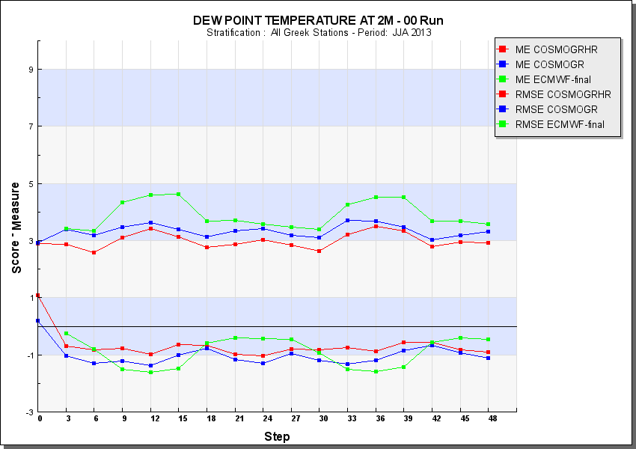 | 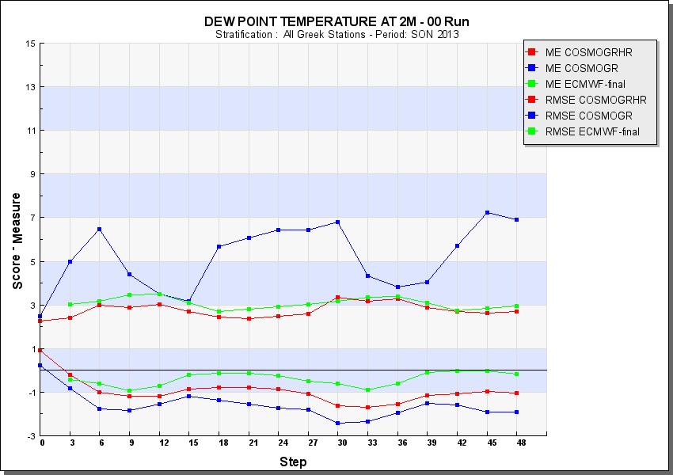
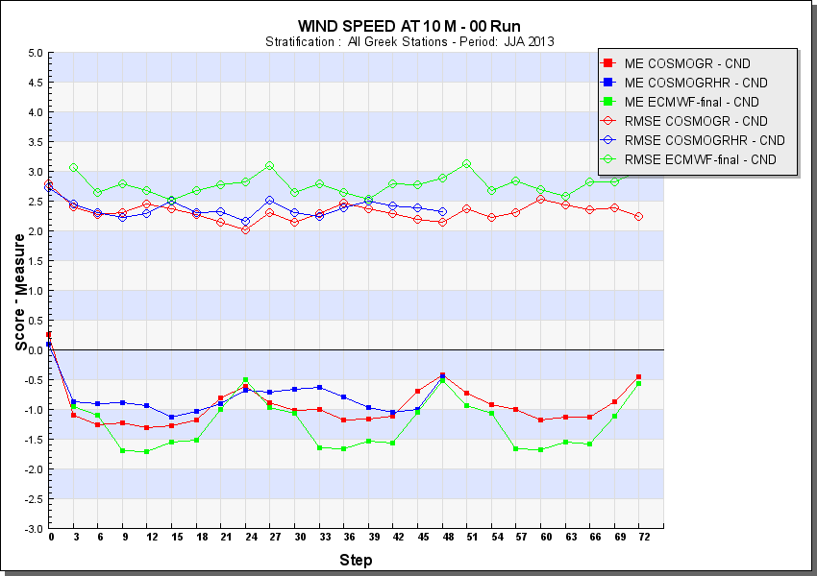 | 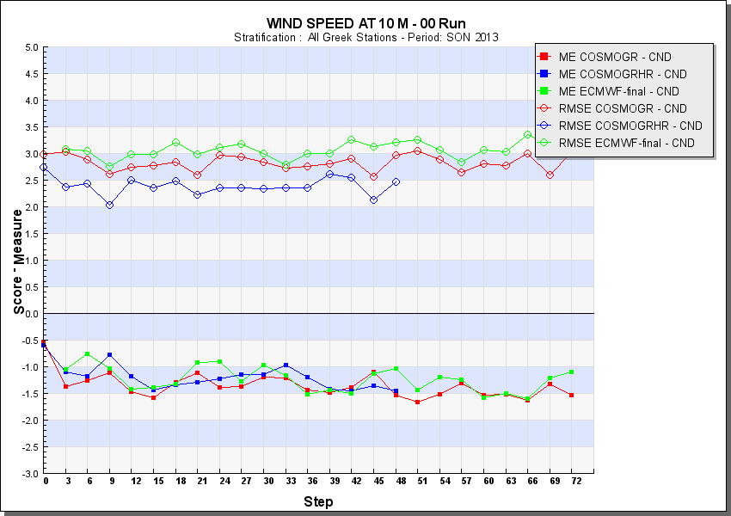
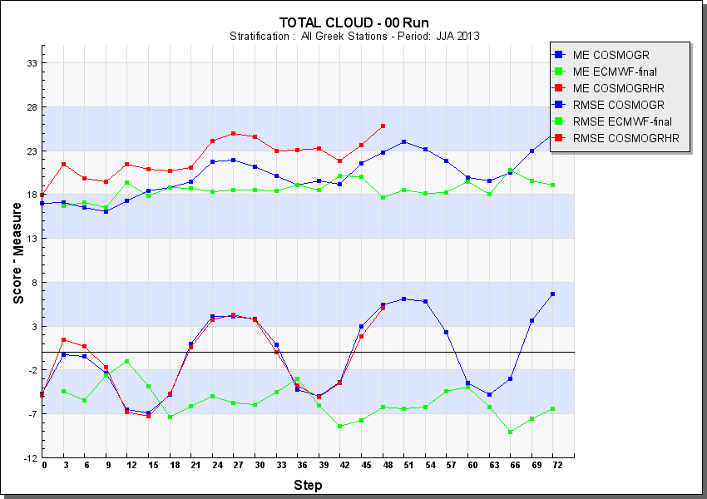 | 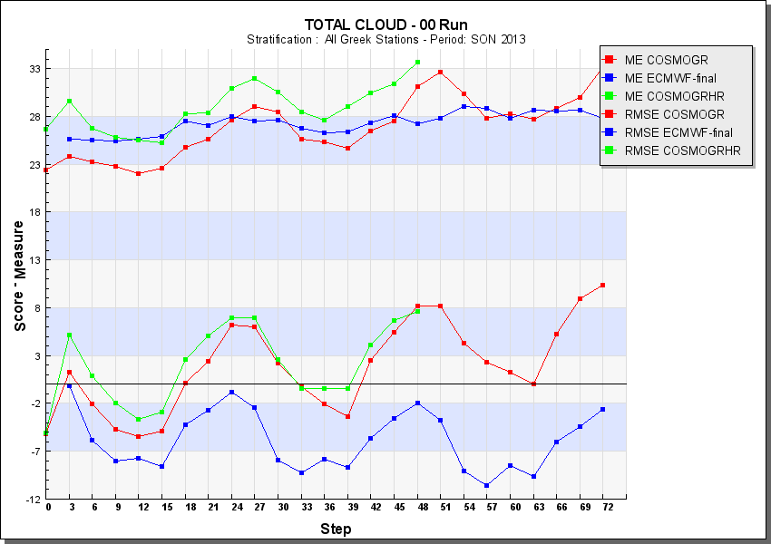
Examples of seasonal verification of COSMOGR 7km & 3km and ECMWF for continuous parameters( Temperatures for summer and fall 2013)

For the non-continuous parameters, the 6, 12 24h-hour precipitation amounts are verified using indices from the respective contingency tables for the 72-hour forecast horizon for each season and annually. The thresholds for the precipitation amounts used are ranging from 0.2mm up to 30mm for every time interval selected. For each threshold a number of scores are calculated providing insight into model behaviour and the most representative are shown in the following graphs.

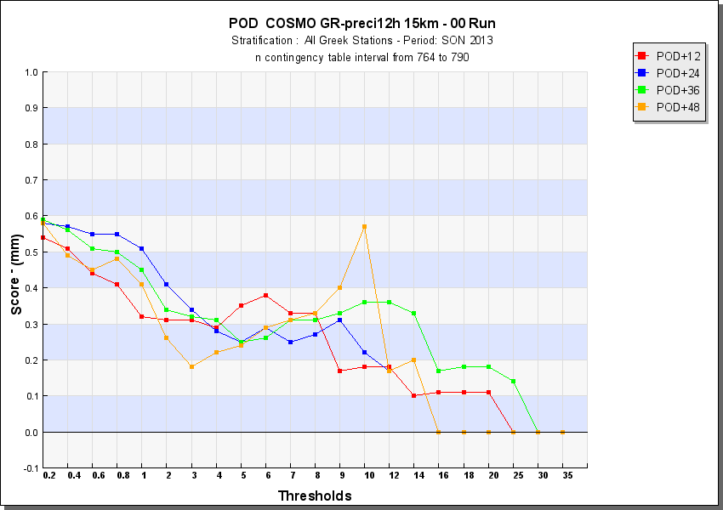 | 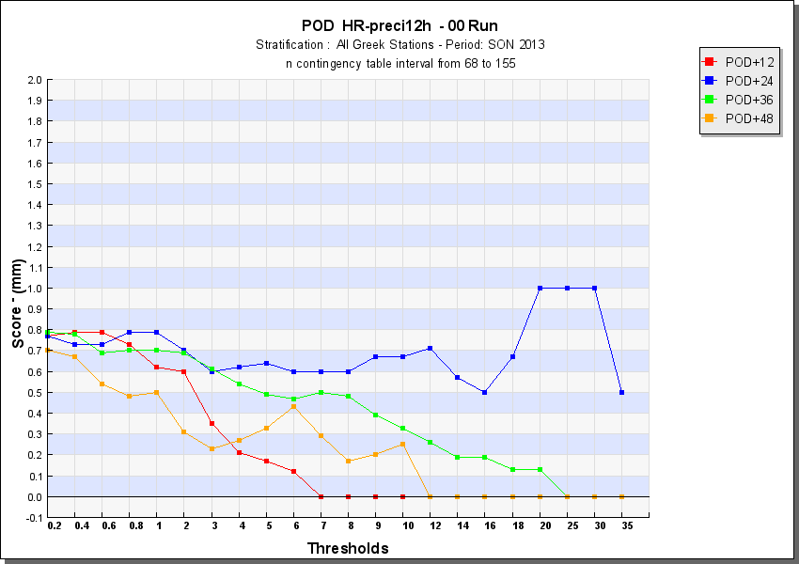
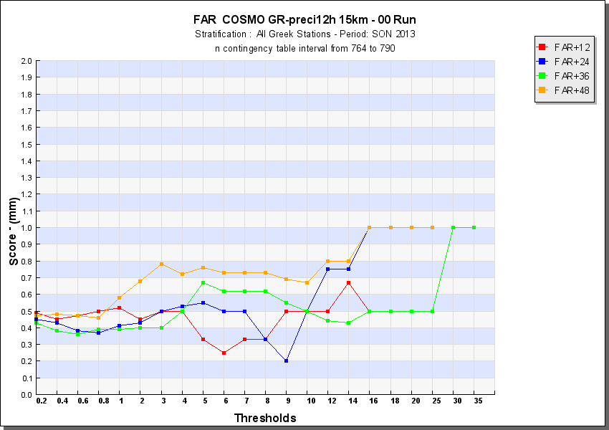 | 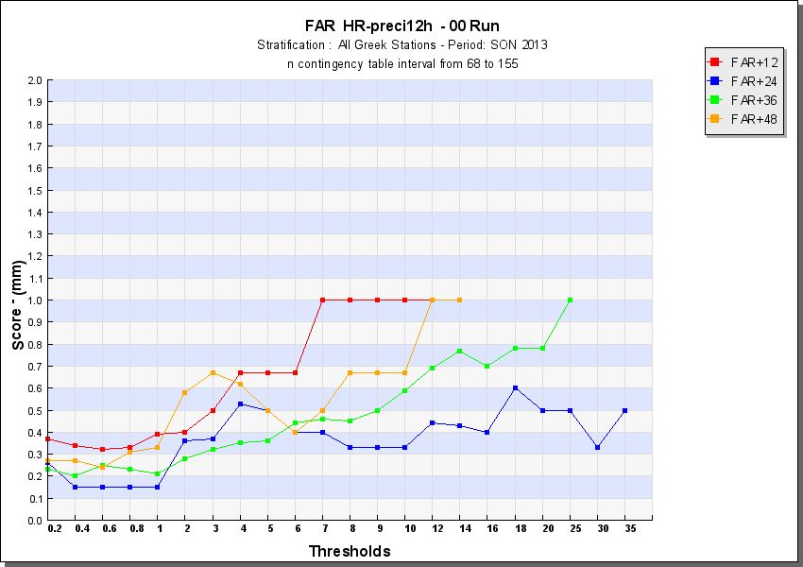
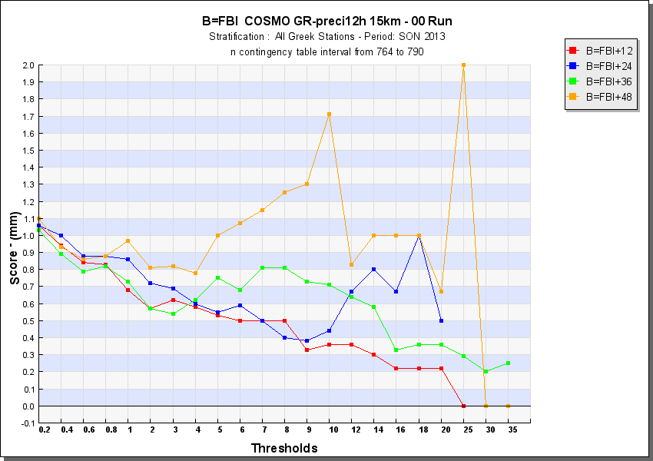 | 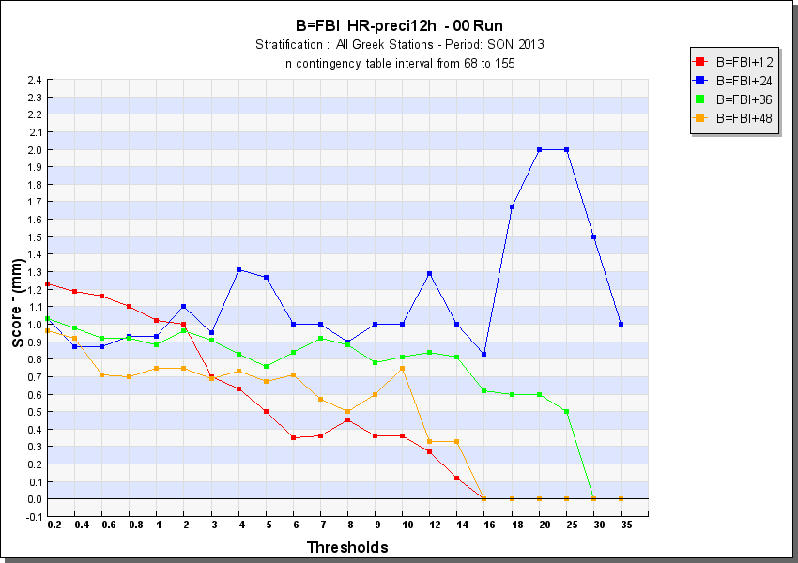
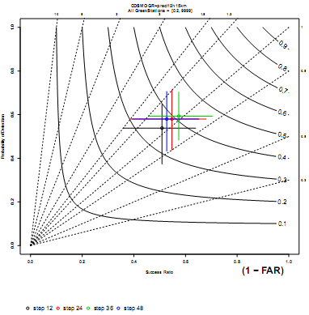 | 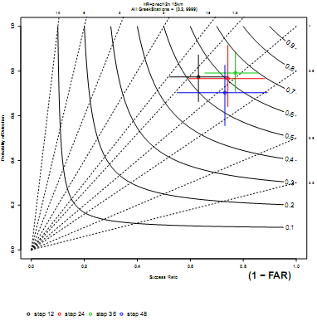

Statistical scores and performance diagrams for 12h precipitation forecasts during fall for COSMOGR 7&3km

For the upper atmosphere, similar analysis is performed operationally, comparing values from TEMP observation reports with the respective forecast values from COSMO-GR 7km and 3km version. Geopotential height, temperature, relative humidity and wind speed predictions are verified on certain pressure levels and an example graph is given below.

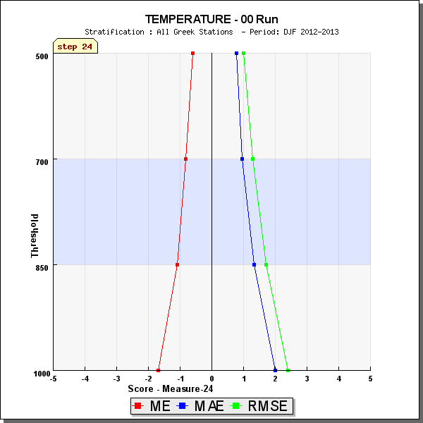 | 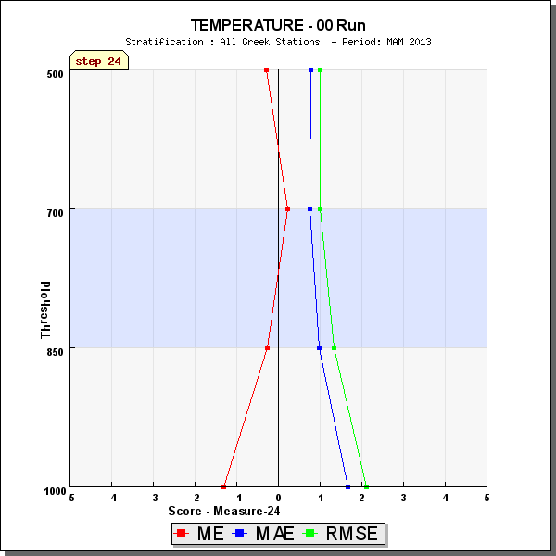
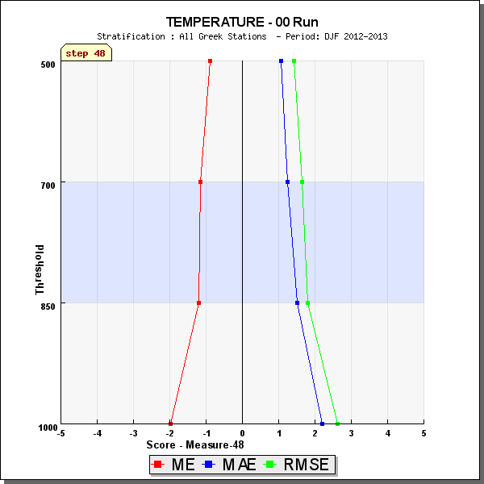 | 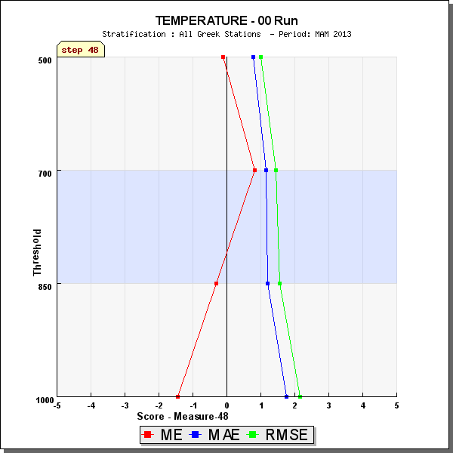
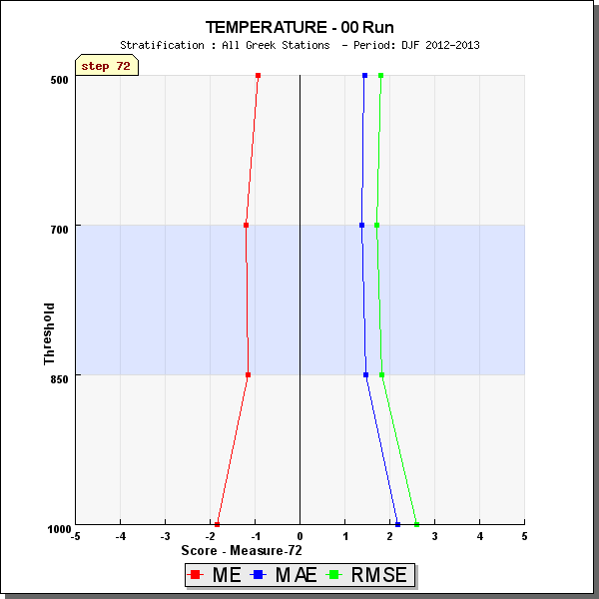 | 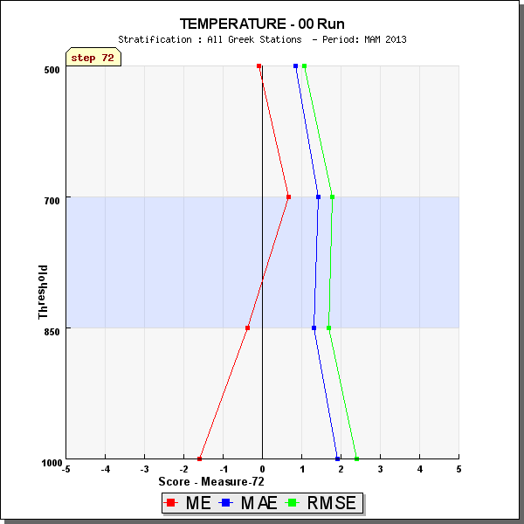

Temperature statistics for upper atmosphere for winter and spring 2013-
COSMOGR

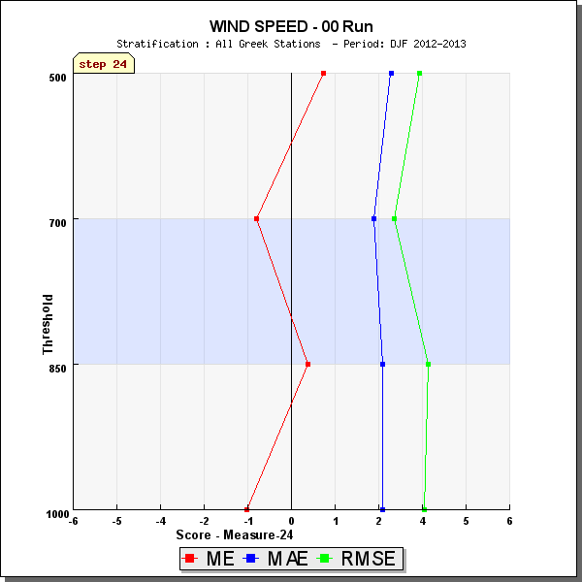 | 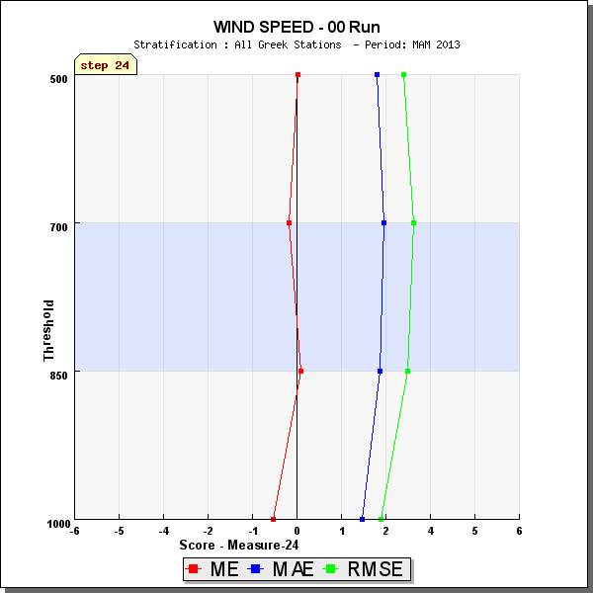
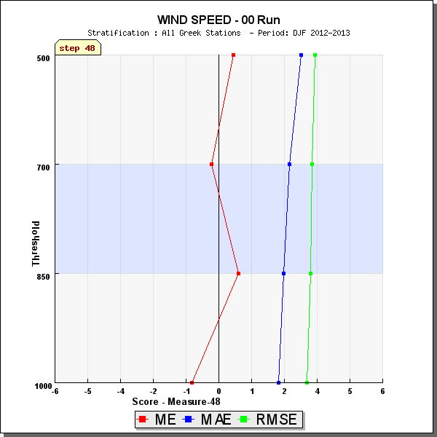 | 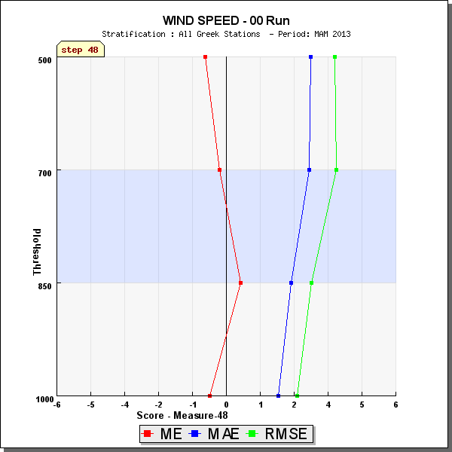
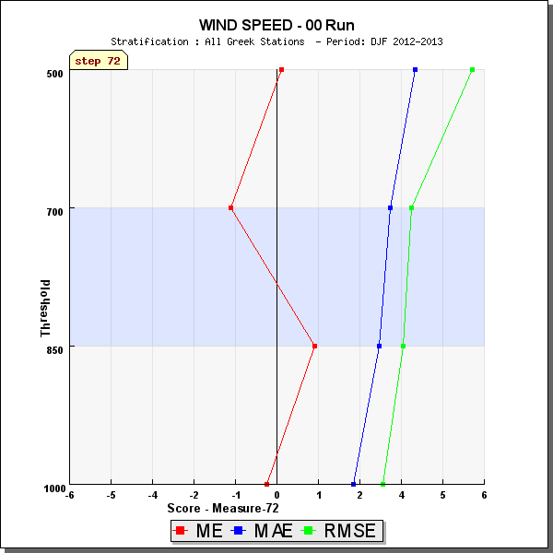 | 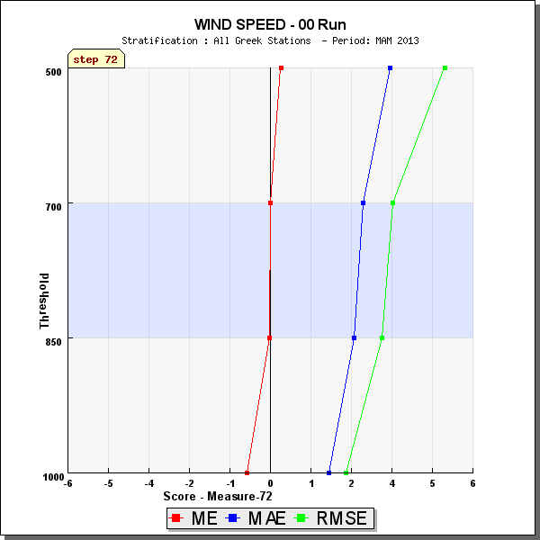
Wind speed statistics for upper atmosphere for winter and spring 2013-
COSMOGR

5.2 Research performed in this field

With the aim of gaining a better understanding of model behaviour for the various types of weather that influence our area, a subjective classification was adopted that is based mainly on the basic circulation patterns that the forecasters at HNMS come across in their daily experience. This tailor-made classification scheme comprises 12 different weather classes which describe the synoptic situation of the 500hPa at 12 UTC on a daily basis, with a geographical focus on the Greek region. The categories used are presented below with an example of the graphical representation of the circulation.

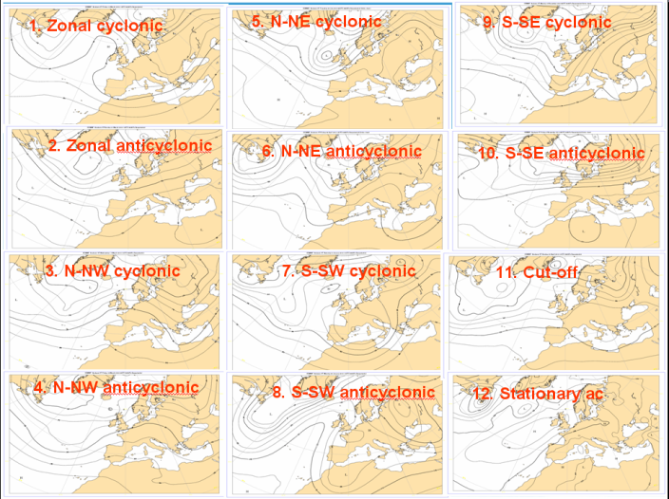
Graphical representation of the weather classes used.
On a second step, verification is performed in each weather class separately as in this way, systematic model errors during the various synoptic situations can be identified. The verification of continuous variables (e.g. T2m, Td2m, MSLP, wind speed) is typically performed using statistics that show the degree to which the forecast values differ from the observations.
Example graphs of the analysis that is regularly performed on the growing sample of each weather synoptic situation, is given below. The statistics are performed on temperature, wind speed and precipitation, as these are the main variables that weather models exhibit variable behaviour in the performance for each weather class.

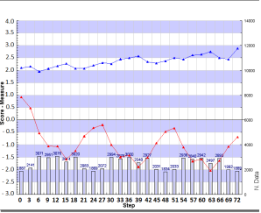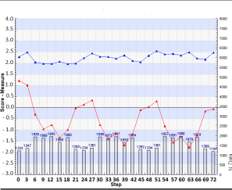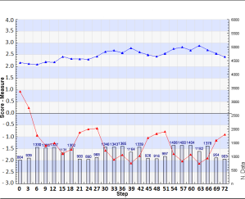
1. Z-Cycl
5. N-NE Cycl
9. S-SE Cycl
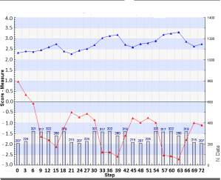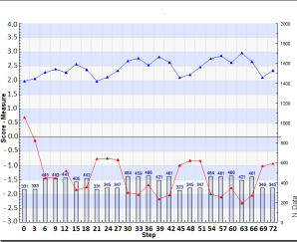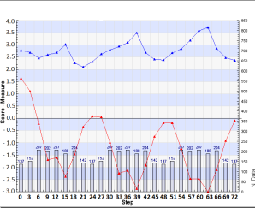
2. Z-Acycl
6. N-NE Acycl
10. S-SE Acycl
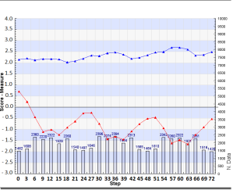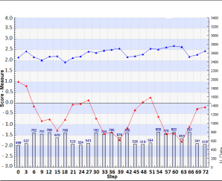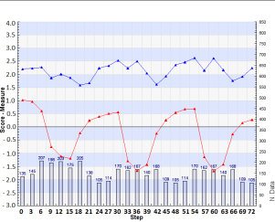
3. N-NW Cycl
7. S-SW Cycl
11. Cut Off
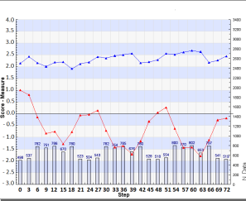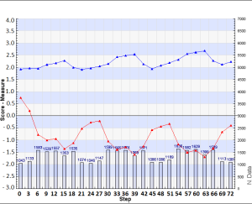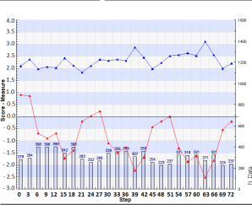
4. N-NW Acycl
12. St-Acycl
8. S-SW Acycl
2m Temp RMSE (blue) ME (red) for stratified forecasts against 80 weather stations

Weather defined verification, together with conditional verification (selection of one or more forecast products and one or more mask variables, which are used to define thresholds for the product verification) are the main verification research areas that have the potential to provide to the forecasters and to the modelers, valuable information of the forecast products.

6. Plans for the future (next 4 years)

6.2 Planned Research Activities in NWP , Nowcasting, Long-range Forecasting and Specialized Numerical Predictions

6.2.1 Planned Research Activities in NWP

Short-range high-resolution ensemble predictions
Within the framework of the close collaboration with the COSMO community towards the development of a short-range high-resolution EPS based on COSMO model, the research work is focused on exploring the impacts of the developed soil perturbation technique on the variability of the members for the different forecasted surface parameters (e.g. 2m air temperature, accumulative precipitation) and fluxes (e.g. sensible and latent heat fluxes).

Research on Cloud Schemes

The main assumption considering the implementation of cloud cover in numerical weather prediction model is that air inside all grid box volume is either saturated or unsaturated. From the physics aspect however, this assumption is practically only a first estimate since cloud cover might be affected by the entrainment through the grid box boundaries. Moreover, latent heat is released when condensation process occurs inside the grid box only after all its volume is at least saturated, which might lead to an incorrect treatment to the initial cloud growth. In order to partially account for these processes, a modification to the default cloud cover scheme of COSMO model is under investigation by assuming Gaussian quasi-conservative properties. Various versions of the resulting sub-grid cloud scheme in reference to cloud-ice and cloud water content are applied over the wider area of Greece and are examined against the default scheme of COSMO model which is based on grid-point relative humidity. Extensive use of satellite data are used for verification purposes in order to reveal the relative operational value of the tested schemes.

7. Consortum

7.1 System and/or Model

The COSMO-Model is a nonhydrostatic limited-area atmospheric prediction model. It has been designed for both operational numerical weather prediction (NWP) and various scientific applications on the meso-β and meso-γ scale. The COSMO-Model is based on the primitive thermo-hydrodynamical equations describing compressible flow in a moist atmosphere. The model equations are formulated in rotated geographical coordinates and a generalized terrain following height coordinate. A variety of physical processes are taken into account by parameterization schemes.
Besides the forecast model itself, a number of additional components such as data assimilation, interpolation of boundary conditions from a driving model, and postprocessing utilities are required to run the model in NWP-mode, climate mode or for case studies.

7.1.1 In operation
On behalf of COSMO, ARPA-SIMC operates the regional ensemble prediction system COSMO-LEPS at the European Centre for Medium Range Weather Forecasts (ECMWF) in the “Framework for Member-State time-critical applications”. COSMO-LEPS is the Limited Area Ensemble Prediction System developed within the COSMO consortium in order to improve the short-to-medium range forecast of extreme and localized weather events. It is made up of 16 integrations of the COSMO model, which is nested on selected members of ECMWF EPS.
COSMO-LEPS covers Central and Southern Europe with 511x415 grid points/layer at a grid spacing of 7 km and 40 layers. The system runs twice a day, starting at 00 and 12UTC with a forecast range of 132 hours.

7.1.2 Research performed in this field

The joint research and development is mainly undertaken in the eight working groups and a number of priority projects and priority tasks. The current priority projects are: “Kilometre-Scale Ensemble-Based Data Assimilation” (KENDA), see section 7.4.1, “Conservative Dynamical Core” (CDC) which aim is to get a dynamical core with explicit conservative properties for very-high model resolutions, “Towards Unified Turbulence-Shallow Convection Scheme” (UTCS) which aims at development of unified turbulence/subscale convection parameterization for very high resolution convection-resolving model, “Verifiction System Unified Survey 2” (VERSUS2) developing an operational verification package for deterministic and ensemble forecasting, “Performance On Massively Parallel Architectures” (POMPA) for preparation of the COSMO model code for running on future high performance computing systems and architectures, and “Consolidation of Operation and Research Results for the Sochi Olimpic Games” (CORSO) for enhancing and demonstrating COSMO-based NWP systems in winter conditions and for mountainous terrain. The priority task “Mire Parameterization’ focuses on parameterization of mire effects for heat and water balances for land surface scheme. Environmental prediction aspects of the model involving chemistry, aerosol effects and transport (COSMO ART) are developed in close cooperation with University of Karlsruhe in Germany.

System run schedule and forecast ranges

See sections 4.1 and 4.3.2.1 for COSMO-GR

7.3 List of countries participating in the Consortium
COSMO stands for COnsortium for Small-scale MOdelling. The general goal of COSMO is to develop, improve and maintain a non-hydrostatic limited-area atmospheric model, the COSMO-model, which is used both for operational and for research applications by the members of the consortium.
The consortium was formed in October 1998 at the regular annual DWD (Germany) and MeteoSwiss (Switzerland) meeting.
A Memorandum of Understanding (MoU) on the scientific collaboration in the field of non-hydrostatic modeling was signed by the Directors of DWD (Germany), MeteoSwiss (Switzerland), USAM (Italy, then named UGM) and HNMS (Greece) in March/April 1999. The MoU has been replaced by an official COSMO Agreement, which was signed by the Directors of these four national meteorological services on 3 October 2001.
In 2002, the national weather service of Poland (IMGW) joined the Consortium in effect from 4 July. The National Institute of Meteorology and Hydrology (NMA) of Romania, joined in effect since …… and the Federal Service for Hydrometeorology and Environmental Monitoring of the Russian Federation joined the Consortium in effect from 10 October 2010 (?).
Currently, the following national meteorological services are COSMO members:
Germany DWD Deutscher Wetterdienst
Switzerland MCH MeteoSchweiz
Italy USAM Ufficio Generale Spazio Aereo e Meteorologia
Greece HNMS Hellenic National Meteorological Service
Poland IMGW Institute of Meteorology and Water Management
Romania NMA National Meteorological Administration
Russia RHM Federal Service for Hydrometeorology and Environmental
These regional and military services within the member states are also participating:
Germany | AGeoBw | Amt für GeoInformationswesen der Bundeswehr
Italy | CIRA | Centro Italiano Ricerche Aerospaziali
Italy | ARPA-SIMC | ARPA Emilia Romagna Servizio Idro Meteo Clima
Italy | ARPA Piemonte | Agenzia Regionale per la Protezione Ambientale Piemonte

Four national meteorological services, namely INMET (Brazil), DHN (Brazil), DGMAN (Oman) and NCMS (United Arab Emirates) as well as the regional meteorological service of Catalunya (Spain) use the COSMO model in the framework of an operational licence agreement including a license fee. National meteorological services of developing countries (e.g. Egypt, Kenya, Rwanda) can use the COSMO model free of charge. Lateral boundary conditions based on the global model GME of Deutscher Wetterdienst are provided free of charge to all COSMO users.

7.4 Data assimilation, objective analysis and initialization

7.4.1 In operation
The data assimilation system for the COSMO model is based on the observation nudging technique. The variables nudged are the horizontal wind, temperature, and humidity at all model layers, and pressure at the lowest model level. The other model variables are adapted indirectly through the inclusion of the model dynamics and physics in the assimilation process during the relaxation. At present, radiosonde, aircraft, wind profiler, surface synoptic, ship, and buoy data are used operationally. For model configurations at the convection-permitting scale, radar-derived precipitation rates are included additionally via the latent heat nudging method. If nudging is used for data assimilation, an extra initialization is not required. Separate two-dimensional analysis schemes based on the successive correction technique are deployed for the depth of the snow cover and the sea surface temperature, and a variational scheme for the soil moisture.
As for COSMO-LEPS, the following initialization is performed: the upper-level initial conditions of the individual members are interpolated from the ECMWF EPS elements providing the boundaries. On the other hand, the initialization at the lower boundary is performed by taking the surface fields of COSMO-EU, including soil temperature and humidity, and blending them with those provided by ECMWF.

7.4.2 Research performed in this field

The focus of research efforts lies on the development of a novel data assimilation scheme based on the Local Ensemble Transform Kalman Filter technique in the frame of the KENDA priority project. Its main purpose will be to deliver perturbed initial conditions for convection-permitting ensemble prediction systems. For more information, see In the framework of the nudging scheme, work is in progress to assimilate also the following observations:

- radial velocity from Doppler radars, by nudging only the radial wind component

- integrated water vapour derived from ground-based GNSS (GPS) data

- 10-m horizontal wind vector data derived from scatterometers (ASCAT, OSCAT)

- 2-m temperature data, by adjusting both the atmospheric and soil temperatures.
Furthermore, the assimilation of radar-derived precipitation rates by a 1DVAR plus nudging approach is being developed and tested in comparison to the latent heat nudging scheme.

7.5 Operationally available Numerical Weather Prediction (NWP) Products

See section 4.3.3.

As for COSMO-LEPS, the available operational products include the following:
- “deterministic products”: different weather scenarios (one per member) for the model variables, at several forecast ranges;
- “probabilistic products”: probability of exceedance of user-defined thresholds for the different model variables, at several forecast ranges;
- “pointwise products”: meteograms over station points in terms of the main model variables.

7.6 Verification of prognostic products

See section 5 .

7.7 Plans for the future (next 4 years)

7.7.2 Research performed in this field

A 5-year science plan summarizes the strategy and defines the main goal of the joint development work with COSMO. The main goal is to develop a model system for the short to very short range with a convective-scale resolution to be used for operational forecasting of mesoscale weather, especially high impact weather. The research-oriented strategic elements to achieve the goal are: an ensemble prediction system, an ensemble-based data assimilation system and a verification and validation tool for the convective scale, extension of the environmental prediction capabilities of the model, use of massively parallel computer platforms. The actions for achieving the goal are undertaken within the current priority projects and task (see section 7.1.3) which will be complemented by the future projects, e. g. on convective-scale ensembles.

In the near future, the planned research activity relative to COSMO-LEPS will include the following:
- revision of the methodology used to select the ECMWF EPS members providing initial and boundary conditions to COSMO-LEPS;
- investigation of the added value obtained by adding new members (driven by a set of global deterministic runs) to the present configuration of COSMO-LEPS.

8. References

1.“The Investigation of a Statistical Cloud Scheme in COSMO.GR Local Numerical Weather Prediction Model”, E. Avgoustoglou, Th. Charantonis and T. Tzeferi, Proceedings of the 10th Conference on Meteorology, Climatology and Atmospheric Physics, University of Patras, 25-28 May 2010, p.169-177.
2. “Various Implementations of a Statistical Cloud Scheme in COSMO model”, E. Avgoustoglou, 11th COSMO Newsletter, March 2011, p.61-68.
oceedings of the 10th COMECAP, Patras.
3. Raspanti A. and Celozzi A, 2009:"VERSUS: Unified Verification Package in COSMO". Proceedings of the 4th International Verification Methods Workshop, Helsinki
4.Gofa F., A. Raspanti, and T. Charantonis, 2010. Assessment of the performance of the operational forecast model COSMOGR using a conditional verification tool. Proceedings of the 10th Conference on Meteorology, Climatology and Atmospheric Physics, University of Patras, 25-28 May 2010, p.110-118.

