JOINT WMO TECHNICAL PROGRESS REPORT ON THE GLOBAL DATA PROCESSING AND FORECASTING SYSTEM AND NUMERICAL WEATHER PREDICTION RESEARCH ACTIVITIES FOR 2013

Country: Germany Centre: NMC Offenbach

Summary of highlights

The operational deterministic modelling suite of DWD consists of three models, namely the global icosahedral-hexagonal grid point model GME (grid spacing 20 km, i.e. 1.474.562 grid points/layer, 60 layers), the non-hydrostatic regional model COSMO-EU (COSMO model Europe, grid spacing 7 km, 665x657 grid points/layer, 40 layers), and finally the convection-resolving model COSMO-DE, covering Germany and its surroundings with a grid spacing of 2.8 km, 421x461 grid points/layer and 50 layers.

The probabilistic ensemble prediction system on the convective scale, called COSMO-DE-EPS, became operational with 20 EPS members on 22 May 2012. It is based on COSMO-DE with a grid spacing of 2.8 km, 421x461 grid points/layer and 50 layers. Four global models, namely GME (DWD), IFS (ECMWF), GFS (NOAA-NCEP) and GSM (JMA) provide lateral boundary conditions to intermediate 7-km COSMO models which in turn provide lateral boundary conditions to COSMO-DE-EPS. To sample the PDF and estimate forecast uncertainty, variations of the initial state and physical parameterizations are used to generate additional EPS members. The forecast range of COSMO-DE-EPS is 27 h with new forecasts every three hours.

The COSMO model (http://cosmo-model.org/) is used operationally at the national meteorological services of Germany, Greece, Italy, Poland, Romania, Russia and Switzerland, and at the regional meteorological service in Bologna (Italy). The military weather service of Germany operates a relocatable version of the COSMO model for worldwide applications. Recently the Meteorological Service of Israel (IMS) became applicant member of COSMO. Six national meteorological services, namely Botswana Department of Meteorological Services, INMET (Brazil), DHN (Brazil), Namibia Meteorological Service, DGMAN (Oman) and NCMS (United Arab Emirates) as well as the regional meteorological service of Catalunya (Spain) use the COSMO model in the framework of an operational licence agreement including a license fee.

National meteorological services in developing countries (e.g. Egypt, Indonesia, Kenya, Mozambique, Nigeria, Philippines, Rwanda, Tanzania, Vietnam) use the COSMO model free of charge.

For lateral boundary conditions, GME data are sent via the internet to the COSMO model users up to four times per day. Each user receives only data from those GME grid points (at the grid spacing of 20 km for all 60 model layers plus all 7 soil layers) which correspond to the regional COSMO model domain. Currently DWD is sending GME data to more than 40 COSMO model users.

The main improvements of DWD’s modelling suite included:

For GME:
14/02/2013: Replacement of RTTOV07 by RTTOV10 for the assimilation of satellite radiances in the 3D-Var.

14/02/2013: Introduction of online bias correction scheme for aircraft temperature measurements.

24/04/2013: Assimilation of radiance data from the instrument HIRS (6 channels on Metop-A7-B, NOAA-17/-19). Assimilation of Metop-B data (AMSU-A radiances, AMV winds and radio occultation).

25/09/2013: Extension of the forecast range of the 06 and 18 UTC forecasts from 48 to 78 hours.

09/10/2013: Assimilation of humidity measurements from aircrafts over North America. Assimilation of additional wind profiler stations in Canada.

For COSMO-EU:
16/01/2013: Improved fast wave solver with higher accuracy and stability in regions of steep terrain.

24/04/2013: Introduction of a new shortwave albedo based on MODIS satellite data over land.

25/09/2013: Extension of the forecast range of the 06 and 18 UTC forecasts from 48 to 78 hours.

09/10/2013: Correction of the water loading in the buoyancy term. The quality control of surface pressure observations was extended by a check against the fields which provide the lateral boundary conditions, i.e. the interpolated GME or IFS fields. This was mainly to address rare cases of analysis failures where other checks were not able to reasonably detect increasingly large observations errors from a single buoy, when these data have been presented to the nudging scheme for continuous assimilation at high frequency.

For COSMO-DE:
16/01/2013: Improved fast wave solver with higher accuracy and stability in regions of steep terrain.

06/03/2013: Extension of the forecast range from 21 to 27 hours.

24/04/2013: Introduction of a new shortwave albedo based on MODIS satellite data over land.

09/10/2013: Correction of the water loading in the buoyancy term. Improved quality control of surface pressure observations.

For COSMO-DE-EPS:

06/03/2013: Extension of the forecast range from 21 to 27 hours.

11/12/2013: Extension of the operational ensemble products (probabilities, quantiles, mean, spread, min, max) by additional thresholds and variables.

29/01/2014: Enlargement of the setup of model physics perturbations by variation of the minimum diffusion coefficient for heat and momentum.

29/01/2014: Introduction of initial soil moisture perturbations derived from differences between COSMO-EU and COSMO-DE soil moisture analyses.

29/01/2014: Extension of the forecast range from 21 to 27 hours for all ensemble products (probabilities, quantiles, mean, spread, min, max).

2. Equipment in use

2.1 Main computers

2.1.1 Two NEC SX-8R Clusters

Each Cluster:
Operating System NEC Super-UX 20.1
7 NEC SX-8R nodes (8 processors per node, 2.2 GHz, 35.2 GFlops/s peak processor
performance, 281.6 GFlops/s peak node performance)
1.97 TFlops/s peak system performance
64 GiB physical memory per node, complete system 448 GiB physical memory
NEC Internode crossbar switch IXS (bandwidth 16 GiB/s bidirectional)
FC SAN attached global disk space (NEC GFS), see 2.1.4

Both NEC SX-8R clusters are used for climate modelling and research; one being de-
commissioned end of August 2013.

    - Two NEC SX-9 Clusters

Each cluster:
Operating System NEC Super-UX 20.1
30 NEC SX-9 nodes (16 processors per node, 3.2 GHz, 102.4 GFlops/s peak processor
performance, 1638.4 GFlops/s peak node performance)
49.15 TFlops/s peak system performance
512 GiB physical memory per node, complete system 15 TiB physical memory
NEC Internode crossbar switch IXS (bandwidth 128 GiB/s bidirectional)
FC SAN attached global disk space (NEC GFS), see 2.1.4

One NEC SX-9 cluster is used to run the operational weather forecasts; the second one serves as research and development system.

2.1.3 Two SUN X4600 Clusters

Each cluster:
Operating System SuSE Linux SLES 10
15 SUN X4600 nodes (8 AMD Opteron quad core CPUs per node, 2.3 GHz, 36.8 GFlops/s
peak processor performance, 294.4 GFlops/s peak node performance)
4.4 TFlops/s peak system performance
128 GiB physical memory per node, complete system 1.875 TiB physical memory
Voltaire Infiniband Interconnect for multinode applications (bandwidth 10 GBit/s bidirectional)
Network connectivity 10 Gbit Ethernet
FC SAN attached global disk space (NEC GFS), see 2.1.4

One SUN X4600 cluster is used to run operational tasks (pre-/post-processing, special
product applications), the other one research and development tasks.

2.1.4 NEC Global Disk Space

Three storage clusters: 51 TiB + 240 TiB + 360 TiB
SAN based on 4 GBit/s FC-AL technology
4 GiB/s sustained aggregate performance
Software: NEC global filesystem GFS-II
Hardware components: NEC NV7300G High redundancy metadata server, NEC Storage D3-10

The three storage clusters are accessible from systems in 2.1.1, 2.1.2, 2.1.3.

2.1.5 Three SGI Altix 4700 systems

SGI Altix 4700 systems are used as data handling systems for meteorological data.

Two Redundancy Cluster SGI_1/2 each consisting of 2 SGI Altix 4700 for operational tasks and research/development each with:
Operating System SuSE Linux SLES 10
96 Intel Itanium dual core processors 1.6 GHz
1104 GiB physical memory
Network connectivity 10 Gbit Ethernet
680 TiB (SATA) and 30 TiB (SAS) disk space on redundancy cluster SGI_1 for meteorological data

Backup System SGI_B: one SGI Altix 4700 for operational tasks with
Operating System SuSE Linux SLES 10
24 Intel Itanium dual core processors 1.6 GHz
288 GiB physical memory
Network connectivity 10 Gbit Ethernet
70 TiB (SATA) and 10 TiB (SAS) disk space for meteorological data

2.1.6 IBM System x3650 Server

Operating System RedHat RHEL5
9 IBM System x3640 M2 (2 quadcore processors, 2.8 GHz)
24 GB of physical memory each
480 TB of disk space for HPSS archives
50 Archives (currently 14.7 PB)
connected to 2 Storage-Tek Tape Libraries via SAN

This high-available cluster is used for HSM based archiving of meteorological data and forecasts.

2.1.7 STK SL8500 Tape Library

Attached are 60 Oracle STK FC-tape drives

20 x T10000B (1 TB, 120 MB/s)
40 x T10000C (5 TB, 240 MB/s)

2.2 Networks

The main computers are interconnected via Gigabit Ethernet (Etherchannel) and connected to the LAN via Fast Ethernet.

2.3 Special systems

2.3.1 RTH Offenbach Telecommunication systems

The Message Switching System (MSS) in Offenbach is acting as RTH on the MTN within the WMO GTS. It is called Weather Information System Offenbach (WISO) and based on a High-Availability-Cluster with two IBM x3650 M3 Servers running with Novell Linux SLES11 SP1 system software and Heartbeat/DRBD cluster software.

The MSS software is a commercial software package (MovingWeather by IBLsoft). Applications are communicating in real time via the GTS (RMDCN and leased lines), national and international PTT networks and the Internet with WMO-Partners and global customers like, EUMETSAT, ECMWF and DFS.

2.3.2 Other Data Receiving / Dissemination Systems

Windows 2008 R2 Server

A Windows based Server System is used for receiving HRPT Data (direct readout) from (EUMETCast Ku-Band) and for receiving XRIT data. There are two Windows servers at DWD, Offenbach and a backup receiving and processing system at AGeoBW, Euskirchen.

LINUX Server

LINUX servers are also used for receiving data (EUMETCast Ku-Band and C-Band)
There are four servers at DWD, Offenbach and 19 servers at Regional Offices.

Another LINUX server system is used for other satellite image processing applications.
The images and products are produced for several regions world wide with different resolution from 250 m to 8 km. There are internal (NinJo, NWP) and external users (e.g. Internet). Five servers used for operational services and two servers for backup service.

FTP

Aqua and Terra MODIS data (2 to 3 passes per day) DWD get from AGeoBW, Euskirchen.

2.3.3 Graphical System

The system NinJo (NinJo is an artificial name) has bee operational since 2006. It is based on a JAVA-Software and allows for a variety of applications far beyond of the means of MAP. As development of the software is very laborious and expensive the NinJo Project was realized in companionship with DWD, the Meteorological Service of Canada, MeteoSwiss, the Danish Meteorological Institute and the Geoinformation Service of the German Forces. The hardware consists of powerful servers combined with interactive NinJo-client workstations.

NinJo is an all-encompassing tool for anybody whose work involves the processing of meteorological information, from raw data right to the forecasting.
For the user the main window is just the framework around the various areas of work. Of course it is possible to divide up the displayed image over several screens. All products generated interactively on the screen can be generated in batch mode as well. Besides 2D-displays of data distributed over an extensive area also diagrams (e.g. tephigrams for radio soundings, meteograms or cross sections) can be produced.
Depending on the task to be accomplished it is possible to work with a variable number of data layers. There are layers for processing observational data such as measured values from stations, radar images etc. right through to finished products such as weather maps, storm warnings etc. Data sources are generally constantly updated files in the relevant formats.
The NinJo workstation software comprises an

- modern meteorological workstation system with multi-window technology
- easily integrated geographical map displays
- meteograms, cross-sections, radiosoundings as skew-T-log-p or Stüve-diagrams
- a subsystem for monitoring of incoming data called Automon
- flexible client-server architecture
- high configurability via XML and immediate applicability without altering code

Tools for interactive and automatic product generation like surface prognostic charts and significant weather charts are in use.

A typical installation of the NinJo workstation on the forecasters desktop uses two screens. On a wide screen the weather situation can be presented in an animation.

3. Data and Products from GTS in use

At present nearly all observational data from the GTS are used. GRIB data from France and GRIB data from the UK, the US and the ECMWF are used. In addition most of the OPMET data are used.

Typical number of observation data input per day in the global 3D-Var data assimilation: The following data have been recorded on 2013-12-01 over 24 hours.

No. | Obstype | Used | Percent | Monitored | Comment
1 | TEMP | 56189 | 4.1% | 202637 | TEMP A+B+C+D
2 | PILOT | 10510 | 0.8% | 39864 | PILOT+Wind profiler
3 | SYNOP | 125832 | 9.1% | 130070 | SYNOP LAND + SHIP
4 | DRIBU | 5000 | 0.4% | 5385 | BUOYs
5 | AIREP | 308593 | 22.3% | 335575 | AIREP+ACARS+AMDAR
6 | SATOB | 133130 | 9.6% | 142288 | Satellite winds geostat.+polar
7 | SCATT | 275842 | 20.0% | 376208 | Scatterometer ASCAT,OSCAT
8 | RAD | 369072 | 26.7% | 14496278 | Radiances (AMSU-A, HIRS)
9 | GPSRO | 97925 | 7.1% | 112166 | GPS Radio occultations
 | TOTAL | 1382093 | 100.0% | 15840471

4. Forecasting system

4.1 System run schedule and forecast ranges

Preprocessing of GTS-data runs on a quasi-real-time basis about every 6 minutes on Sun Opteron clusters. Independent 4-dim. data assimilation suites are performed for all three NWP models, GME, COSMO-EU and COSMO-DE. For GME, analyses are derived for the eight analysis times 00, 03, 06, 09, 12, 15, 18 and 21 UTC based on a 3D-Var (PSAS) scheme. For COSMO-EU and COSMO-DE, a continuous data assimilation system based on the nudging approach provides analyses at hourly intervals.

Deterministic system
Forecast runs of GME and COSMO-EU with a data cut-off of 2h 14 min after the main synoptic hours 00, 06, 12 and 18 UTC consist of 78-h forecasts for COSMO-EU and 174-h forecasts (78-h for 06 and 18 UTC) of the GME. 27-h forecasts are performed for COSMO-DE eight times per day with a very short data cut-off of 30 minutes after 00, 03, 06, …, 18 and 21 UTC. Additionally, two ocean wave models (3rd generation WAM, see Section 4.5.2.1.2), the global GWAM and a European wave model (Mediterranean, North, Baltic and Adriatic Sea areas) EWAM provide guidance about wind sea and swell based on 00 and 12 UTC wind forecasts of GME and COSMO-EU.

Probabilistic system
27-h forecasts are performed for COSMO-DE-EPS with 20 ensemble members eight times per day with a data cut-off of 60 minutes after 00, 03, 06, …, 18 and 21 UTC.

4.2 Medium range forecasting system (4-10 days)

4.2.1 Data assimilation, objective analysis and initialization

4.2.1.1 In operation

As far as GME is in use for medium range forecasting, the same procedures are applied as for short range forecasting described in item 4.3

4.2.1.2 Research performed in this field

See 4.3.1.2

4.2.2 Model

      - In operation

Medium range forecasts at the DWD are mainly based on the ECMWF system (deterministic model and EPS). Additionally, GME (see 4.3) forecasts up to 7 days augment the model guidance available.

4.2.2.2 Research performed in this field

Nonhydrostatic global model ICON with local zooming option

DWD and the German Climate Research Centre MPI-M in Hamburg are jointly developing a new global dynamical core. It solves the non-hydrostatic atmospheric equations on a triangular icosahedral C-grid and offers options for two-way and one-way grid nesting combined with the possibility of vertical nesting. The dynamical core and its coupling to the transport scheme provides exact local conservation of air and tracer mass including mass-consistent transport. Its computational efficiency and scalability on massively parallel computer architectures constitute a major improvement with respect to the present GME. The physics parametrizations are partly taken over from the COSMO-EU and partly imported from ECMWF's IFS, whereas the 3D-Var data assimilation scheme is shared with the GME. Although tuning the coupled ICON - 3D-Var system is still ongoing, preliminary results available so far already indicate a notable improvement of the forecasting skills over the GME. DWD plans to start the operational use of ICON with a single-domain global configuration with a grid spacing of 13 km by the end of 2014 in order to replace the GME. Around mid-2015, a nested domain with a mesh size of 6.5 km over Europe shall be activated to replace the regional model COSMO-EU. MPI-M will use ICON as the atmospheric part of a complete Earth System Model.

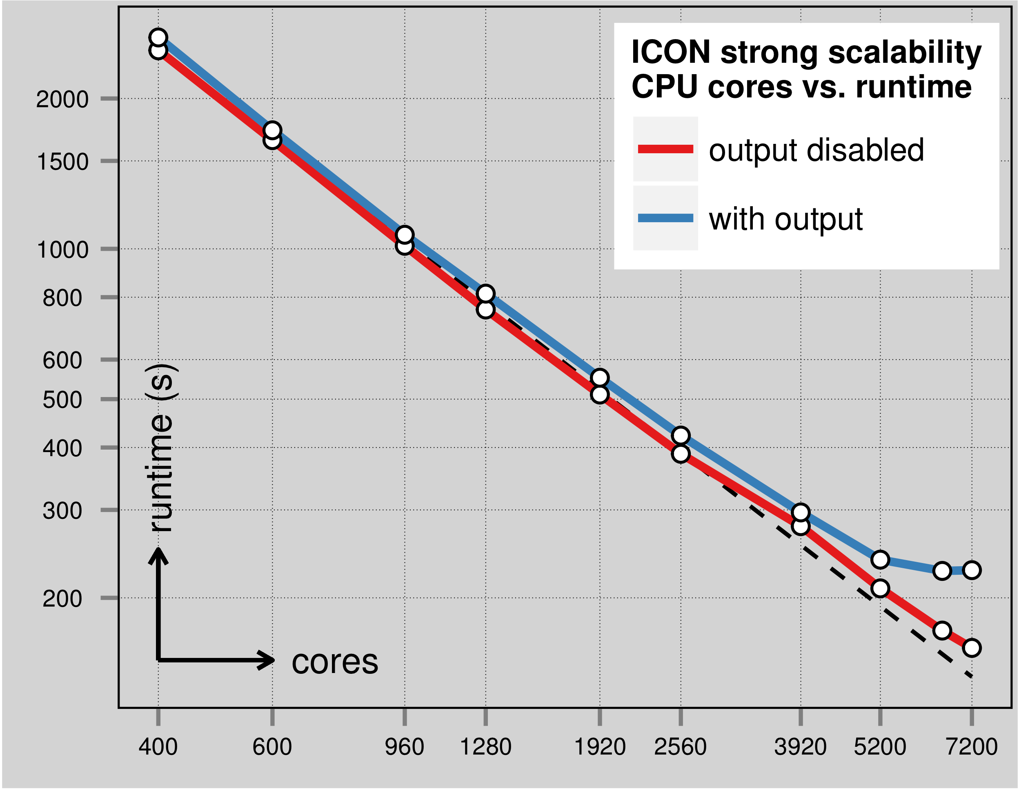

Scaling of ICON 13 km grid spacing, 90 layers, 24-h forecast on Cray XC30

(G. Zängl, F. Prill, D. Reinert, M. Köhler)

Operationally available Numerical Weather Prediction Products

ECMWF and GME global forecasts are available up to day 7.
See Section 4.3.1.1 for GME products.

4.2.4 Operational techniques for application of NWP products

      - In operation

ECMWF-EPS-data and MOS applied to the GME and ECMWF model are in use to produce medium-range forecasts up to day 7 (MOS: 10 days). Forecasts are provided for the public both in tabular form and in plain language. The forecasts in tabular form comprise the parameters daily maximum and minimum temperatures, relative sunshine duration, daily precipitation amount and probability, probability of snow, wind speed and direction, probability of thunderstorm, probability of fog. Medium-range forecasts in plain language are produced by forecasters in the Central Forecast Office in Offenbach. In addition to this the automatic text production is in use for worldwide forecasts, which are available by dialling a premium rate number on a fax machine, on a telephone answering device or on mobile telephones using short message system (SMS). The latter ones are produced however without forecasters’ intervention.

Progress was made in medium range forecasting concerning the risk assessment of extreme weather for the forecast interval 120 hours down to 36 hours by synoptic interpretation of model results in combination with the evaluation of the COSMO-LEPS (Limited Area Ensemble Prediction System) and EFI- (extreme forecast index) charts, provided by ECMWF. COSMO-LEPS is a dynamical downscaling of the ECMWF EPS, and was developed by the COSMO-Consortium (Members are Germany, Greece, Italy, Poland, Romania, Russia and Switzerland; see Section 7). The risk-assessment is made available as a bulletin called “5 day forecast of weather risks” and includes the probability of certain severe weather events like storm, heavy precipitation, severe thunderstorm situations, widespread snowfall or freezing precipitation, heat and cold waves. The bulletin is produced once a day in the late morning with actualisation according to new model results in the evening or night hours if necessary. It is available for the regional offices within DWD and for the public via the internet.

Agrometeorological forecasts cover a wide range of applications aiming at a reduction of the use of insecticides and fungicides or at an optimization of the water supply to plants. NWP results are combined with additional models which calculate the drying of leaves or the temperature and water balance in the ground.

4.2.4.2 Research performed in this field

Further refinement of physical modelling.

4.2.5 Ensemble Prediction System (EPS)

See also section 4.3.5.2.

4.2.5.1 In operation

The EPS of ECMWF is in use for operational forecasting. A downscaling-system of the EPS with the name COSMO-LEPS (Limited Area Ensemble Prediction System) is in operation. COSMO-LEPS has been developed by the COSMO consortium (Consortium for Small Scale Modelling) under the leadership of ARPA-SIMC, Bologna, see Section 7. From an ensemble of 16 forecasts for middle and southern Europe computed twice daily with a horizontal grid distance of 7 km, probability forecasts can be derived. The input data for COSMO-LEPS are provided by 16 representative members taken from the EPS of ECMWF.

4.2.5.2 Research performed in this field

10-day forecasts for Road Weather Information System (SWIS)

A 10 day regional forecast based on the 50 ensemble members of the ECMWF EPS data has been re-designed for SWIS. The forecast includes daily maximum/minimum temperatures as well as snow and precipitation probabilities. Regions consists of 7 lowland and 7 mountain regions.
The upper and lower limits for the maximum and minimum temperatures are calculated from the mean values and the standard deviations. Precipitation and snow probabilities are also calculated by the mean values of the regions.

In addition, a 15 day regional forecast for the DWD website (7 lowland regions) has been re-designed. Forecast variables are the daily maximum/minimum temperatures also based on ECMWF EPS data and calculated like the previous product.

Further research is done by ARPA-SIMC, Bologna, see Section 7!

4.2.5.3 Operationally available EPS Products

Primarily ECMWF EPS products like EPS-Meteograms and a variety of parameters derived like maximum and minimum temperatures and probabilities of snow are available. The Extreme Forecast Index (EFI) is in use for early warning.

From COSMO-LEPS probability charts are available for middle and southern Europe which give information whether accumulated rain or snow, wind gusts, temperatures or CAPE values will exceed thresholds defined by warning requirements. The products are available up to 120 hours.

4.3 Short-range forecasting system (0-72 hrs)

Operational short-range forecasting is based on the products available from the global model GME (grid spacing of 20 km, 60 layers) and the non-hydrostatic limited area model COSMO-EU (grid spacing of 7 km, 665x657 grid points/layer, 40 layers), where COSMO-EU covers the time period up to 78 hours from 00, 06, 12 and 18 UTC. COSMO-EU is nested in the GME with an updating of the lateral boundary values at hourly intervals.
For nowcasting and very short range forecasts (up to 27 hours) the convection-permitting meso-gamma scale model COSMO-DE (grid spacing of 2.8 km, 421x461 grid points/layer and 50 layers) provides numerical guidance eight times per day with a very short data cut-off of 30 minutes. Lateral boundary conditions of COSMO-DE are derived from COSMO-EU forecasts.
Ensemble forecasts on the convective scale are provided by COSMO-DE-EPS (see Section 4.3.5.1).

Fig. 1 shows the domains and topographies of the three operational deterministic models of DWD, namely the global model GME and the regional models COSMO-EU and COSMO-DE.

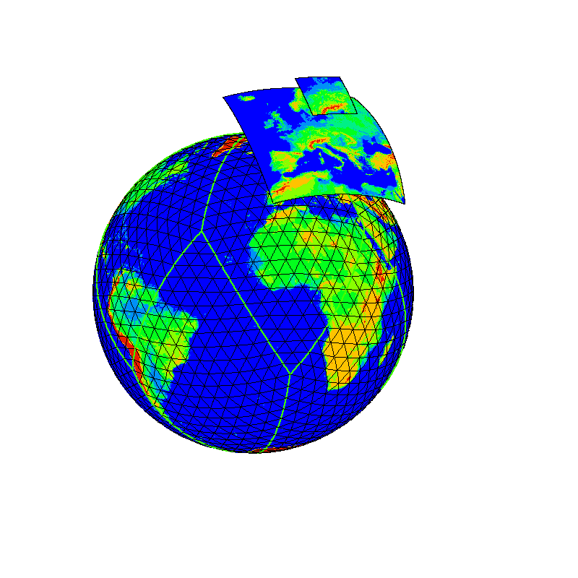

Figure 1:

Model domains and topographies of the three operational models of DWD,
namely the
global model GME (grid spacing 20 km) and the regional models
COSMO-EU (grid spacing 7 km) and COSMO-DE (grid spacing 2.8 km).

4.3.1 Data assimilation, objective analysis and initialization

4.3.1.1 In operation

Global Model (GME)

- Global analysis of mass, wind field and humidity

Analysis method Three-dimensional variational assimilation in observation space.
Background error covariance matrix in wavelet representation.
Direct use of satellite radiances.

Analysed variables p_{s}, T, u, v, Rel. Hum.; Ozone from ECMWF analysis (12 UTC)

Horizontal anal. grid Icosahedral grid of the GME (average mesh size of 20 km)

Vertical resolution 60 hybrid layers (see GME)
Products a) On icosahedral-hexagonal grid of the GME
(1.474.562 grid points/layer, 60 layers)
Variables: p_{s}, T, u, v, q_{v}, q_{c}, q_{i}, q_{rain}, q_{snow}, o₃

b) On a regular geographical grid, 1440 x 721 points (0.25° x 0.25°)
14 pressure levels 1000, 950, 850, 700, 500, ..., 50, 10, 5 hPa
Variables: p_{msl}, T, Φ, u, v, Rel. Hum.

Assimilation scheme Intermittent data assimilation. Insertion of data every 3 hours. 3-h forecast used as first guess. All observations within a ± 1.5-h window used as synoptic. Cut-off time is 2 h 14 min for main forecast runs.

Initialization Incremental digital filtering initialization (Lynch, 1997) consisting of
a 1.5-h adiabatic backward run and a 1.5-h diabatic forward run centered
at the initial time. The filtering is performed in vertical mode space; only the external mode plus the first nine internal ones are filtered.

- Global analysis of surface parameters

Analysis method Correction method

Analysed variables Sea surface temperature (SST), sea ice and snow cover

Horizontal anal. grid On icosahedral-hexagonal grid of the GME (average mesh size of 20 km)

Data used SST, sea ice: Synop-Ship, NCEP-SST analysis as background,
NCEP analysis of sea ice distribution.
Snow cover: Snow depth, present and past weather, precipitation amount,
temperature analysis. History taken into account.
NCEP analysis of snow cover.

Analysis method Optimal Interpolation using height correction

Analysed variables Temperature and relative humidity at 2 m

Horizontal anal. grid On icosahedral-hexagonal grid of the GME (average mesh size of 20 km)

Data used Model first guess T2m, Rh2m and observations T2m, Td2m from reports of
synop stations, aircrafts, ships and bouys

Analysis method Variational method

Analysed variables Soil moisture content

Horizontal anal. grid On icosahedral-hexagonal grid of the GME (average mesh size of 20 km)

Data used Analyses of 2m temperature, forecast of 2m temperature, soil moisture,
surface fluxes relevant to surface energy balance from GME

Limited area model COSMO-EU

- Limited-area analysis of atmospheric fields

The data assimilation system for the COSMO-EU is based on the observation nudging technique (Schraff, 1997). The variables nudged are the horizontal wind, temperature, and humidity at all model layers, and pressure at the lowest model level (ke). The other model variables are indirectly adapted through the inclusion of the model dynamics and physics in the assimilation process during the nudging period. The lateral spreading of the observational information is horizontal, or optionally along model layers or isentropic surfaces. At present, the scheme uses operationally only conventional data of type TEMP, PILOT, SYNOP, BUOY, AMDAR and wind profiler.

Analysis method Observation nudging technique

Directly analysed variables p_{ke}, T, u, v, Rel. Hum.

Horizontal anal. grid 665 x 657 points (0.0625° x 0.0625°) on a rotated latitude/longitude grid

Vertical resolution 40 hybrid layers

Products All analysis products are given on the 665 x 657 grid and available at
hourly intervals.

a) On the 40 layers
Variables: p, T, u, v, w, q_{v}, q_{c}, q_{i}, q_{rain}, q_{snow}, TKE

b) On 10 pressure levels (1000, 950, 850, 700, 500, ..., 200 hPa)
Variables: p_{msl}, Φ, T, u, v, ω, Rel. Hum.

c) On 4 constant height levels (1000, 2000, 3000, 5000 m)
Variables: p, T, u, v, w, Rel. Hum.

Assimilation scheme Continuous data assimilation in 3-h cycles.
Cut-off time is 2 h 14 min for COSMO-EU runs.

Initialization None

- Limited-area analysis of soil moisture

Analysis method 2-dimensional (vertical and temporal) variational technique

Analysed variables Soil moisture content at 00 UTC

Horizontal anal. grid 665 x 657 points (0.0625° x 0.0625°) on a rotated latitude/longitude grid

Data used 2-m temperature analyses at 12 and 15 UTC

- Limited-area analysis of other surface parameters

Analysis method Correction methods

Analysed variables Sea surface temperature (SST) and sea ice cover, snow cover,
temperature and relative humidity at 2 m

Horizontal anal. grid 665 x 657 points (0.0625° x 0.0625°) on a rotated latitude/longitude grid

Data used SST: Synop-Ship, US-data of ice border, sea ice cover analysis from BSH (German Institute for shipping and hydrology) for the Baltic Sea and indirectly satellite data (via NCEP-SST and GME_SST analyses).
Snow cover: Snow depth, present and past weather, precipitation amount,
2-m temperature analysis (plus model prediction).

Convection-resolving model COSMO-DE

- Limited-area analysis of atmospheric fields

The data assimilation system for the COSMO-DE is based on the observation nudging technique (Schraff, 1997). The variables nudged are the horizontal wind, temperature, and humidity at all model layers, and pressure at the lowest model level (ke). The other model variables are indirectly adapted through the inclusion of the model dynamics and physics in the assimilation process during the nudging period. The lateral spreading of the observational information is horizontal, or optionally along model layers or isentropic surfaces. At present, the scheme uses operationally conventional data of type TEMP, PILOT, SYNOP, BUOY, AMDAR and wind profiler. Additionally, precipitation rates derived from radar observations (5-min precipitation scans) are included via the latent heat nudging method (Stephan et al., 2008).

Analysis method Observation nudging technique and latent heat nudging method

Directly analysed variables p_{ke}, T, u, v, Rel. Hum.

Horizontal anal. grid 421x461 points (0.025° x 0.025°) on a rotated latitude/longitude grid

Vertical resolution 50 hybrid layers

Products All analysis products are given on the 421x461 grid and available at
hourly intervals.

a) On the 50 layers
Variables: p, T, u, v, w, q_{v}, q_{c}, q_{i}, q_{rain}, q_{snow}, q_{graupel}, TKE

b) On 10 pressure levels (1000, 950, 850, 700, 500, ..., 200 hPa)
Variables: p_{msl}, Φ, T, u, v, ω, Rel. Hum.

c) On 4 constant height levels (1000, 2000, 3000, 5000 m)
Variables: p, T, u, v, w, Rel. Hum.

Assimilation scheme Continuous data assimilation in 3-h cycles.
Cut-off time 30 min for COSMO-DE runs.

Initialization None

- Limited-area analysis of other surface parameters

Analysis method Correction methods

Analysed variables Sea surface temperature (SST) and sea ice cover, snow cover,
temperature and relative humidity at 2 m

Horizontal anal. grid 421 x 461points (0.025° x 0.025°) on a rotated latitude/longitude grid

Data used SST: Synop-Ship, US-data of ice border, sea ice cover analysis from BSH (German Institute for shipping and hydrology) for the Baltic Sea and indirectly satellite data (via NCEP-SST and GME_SST analyses).
Snow cover: Snow depth, present and past weather, precipitation amount,
2-m temperature analysis (plus model prediction)

4.3.1.2 Research performed in this field

Assimilation of satellite radiances in the global model GME
Work is in progress to assimilate more remote sensing data. Work is carried out on a variety of new instruments and satellites. It includes different infrared radiances (e.g. IASI) as well as humidity information of the microwave sensors, microwave sensors over land and under cloudy conditions. A new variational bias correction is under development.
(C. Köpken-Watts, O. Stiller, E. Lange, R. Gray, R. Faulwetter, A. Fernandes del Rio)

Assimilation of cloud-affected and cloudy radiances
The assimilation of cloud related information from satellite radiances is an important topic of international research. We work on the reconstruction of cloud information within an atmospheric column based on a 1dvar-type approach, which is then integrated into our 3dVar and VarEnKF systems. In this framework, appropriate regularization methods which take care of the particular statistics of the data and states under consideration (e.g. non-Gaussian statistics) are under investigation.
(C. Köpken-Watts, O. Stiller, E. Lange, R. Gray, R. Faulwetter, A. Fernandes del Rio, R. Potthast)

Assimilation of other observation types in the COSMO-EU and / or COSMO-DE
Work is in progress to assimilate also the following observations in the current nudging framework:
- radial velocity from Doppler radars, by nudging only the radial wind component
- integrated water vapour derived from ground-based GNSS (GPS) data (see research project below)
- 10-m horizontal wind vector data derived from scatterometer (ASCAT) data.
Assimilation of satellite radiances by a 1DVar plus nudging approach was not found beneficial, and the work on it has been ceased. The same applies to the radar VAD profiles of horizontal wind vector.
(K. Stephan, C. Schraff, A. Cress, H.-W. Bitzer)

Ensemble Transform Kalman Filter assimilation for GME and COSMO models
An Ensemble Transform Kalman Filter (ETKF) Data Assimilation system is under development for both the regional convection-permitting COSMO-DE and the global GME and its successor ICON. The implementation is based on the Local Ensemble Transform Kalman Filter (LETKF) proposed by Hunt et al., 2007. For the global system a hybrid 3D-Var/LETKF is being developed (see below). The global ensemble data assimilation and prediction system provides boundary conditions for the COSMO-DE system. The COSMO LETKF itself will provide initial perturbations to the COSMO ensemble prediction system. The quality of the basic EnKF system for COSMO has reached the break even with the current nudging system, further improvements are on the way.
(C. Schraff, H. Reich, A. Rhodin, J. Ambadan et al.)

Hybrid Variational and EnKF
A hybrid VarEnKF method is under development for the global model of DWD to combine the strength of variational methods with the capabilities of the ensemble approach. Our VarEnKF consists of an Ensemble Kalman Filter with slightly reduced resolution and a 3dVar type variational assimilation approach which combines climatological (NMC) based covariance matrices and the dynamic covariance information provided by the EnKF.
- Rhodin, J. Ambadan, R. Potthast)

Stability Estimates
Basic work on stability of cycled data assimilation systems has been investigated in a joint project with the University of Reading. In particular, the control of the stability and uncertainty by regularization has been investigated both on a theoretical level as with the help of different practically relevant numerical models. A Moodey has finished his PhD in 2013.
- Moodey, R. Potthast, A. Lawless, P.-J. van Leeuwen)

Adaptive Localization and Transformed Localization
The Ensemble Kalman Filter employs localization to control spurious correlations and to enhance the number of degrees of freedom. Adaptive localization choices in its dependence on the number of observations, the observation error and the degrees of freedom of the system have been investigated. In particular, a limiting theory for small localization radius has been formulated and tested for its practical relevance. Within a PhD project in collaboration with the University of Göttingen a transformed localization algorithm for radiance assimilation has been developed.
- Perianez, H.Reich, C. Schraff, A.Nadeem, R. Potthast)

Multi-Step EnKF and Relaxation Methods
A Multi-Step procedure for the Ensemble Kalman Filter has been implemented, h different observation types which have strongly varying density and different properties. A theoretical study has been carried out to relate the multi-step approach to a wider framework of Bayes data assimilation. Further, formulas for the choice of the localization radius in a multi-step EnKF are under development and test.
- Perianez, H. Reich, R. Potthast and A. Rhodin)

GNSS ZTD and Slant Delay
The assimilation of GNSS slant delays and GNSS ZTD is under development by two projects in cooperation with the Geo Research Center (GFZ) in Potsdam. We investigate the assimilation of ZTD into the global model by the 3dVar and our global ensemble data assimilation. Further, in the EnKF framework both direct assimilation and the use of tomographic methods on the slant delay data for the high-resolution COSMO model is under investigation in a cooperation project with the University of Göttingen. In a tomographic framework new regularization methods which are adaptive with respect to the ray density need to be developed.
(M. Bender, E. Altuntac, A. Rhodin, R. Potthast, R. Luke)

RADAR forward operator
A radar forward operator for the COSMO Model has been developed by a research project with the Karlsruhe Institute of Technology (KIT), which calculates radial velocities and reflectivities as well as polarization information as is measured with the new radar network of DWD. The assimilation of radar volumetric data is investigated and tested in the EnKF framework.
(Yufei Zeng, U. Blahak, K. Stephan, C. Schraff)

SEVIRI Cloud Products and Seviri Radiances
Supported by a EUMETSAT Fellowship and Special Research Area we work on the assimilation of SEVIRI cloud products and SEVIRI radiances within the COSMO model based on the EnKF framework. In particular, cloud type and cloud top height information is fed into the assimilation scheme with the help of innovative discrepancy functions to enhance the sensitivity of measurements towards the model state increments.
- Schomburg, C. Schraff, A. Perianez, R.Faulwetter, R.Potthast)

Observation Impact and Targeted Observation Systems
In collaboration with the University of Reading a research project to formulate and test a framework for the adaption of remote sensing observations to improve reconstructions of states and parameter functions has been carried out. A general meta-inverse problem framework has been formulated and tested for source reconstruction and parameter retrieval tasks. N. Udosen has finished her PhD in 2013.
(N. Udosen and R. Potthast)

4.3.2 Model

4.3.2.1 In operation

a) Schematic summary of the Global Model GME

Domain Global

Initial data time 00, 06, 12, 18 UTC

Forecast range 174 h (from 00 and 12 UTC), 78 h (from 06 and 18 UTC)

Prognostic variables p_{s}, T, u, v, q_{v}, q_{c}, q_{i}, q_{rain}, q_{snow}, o₃

Vertical coordinate Hybrid sigma/pressure (Simmons and Burridge, 1981), 60 layers

Vertical discretization Finite-difference, energy and angular-momentum conserving

Horizontal grid Icosahedral-hexagonal (Sadourny et al., 1968), mesh size between
18 and 22 km, average mesh size 20 km; Arakawa-A grid

Horiz. discretization Finite-difference, second order

Time integration 3-time-level, leapfrog, split semi-implicit scheme, Δt = 66.67 s, time filter.
For moisture variables (water vapour, cloud water, cloud ice, rain, snow):
Positive-definite, shape-preserving horizontal advection (SL-scheme).

Horizontal diffusion Linear, fourth order

Orography Grid-scale average based on a 1-km data set

Parameterizations Surface fluxes based on local roughness length and stability (Louis, 1979)

Free-atmosphere turbulent fluxes based on a level-two scheme
(Mellor and Yamada, 1974)

Sub-grid scale orographic effects (blocking and gravity wave drag) based
on Lott and Miller, 1997

Radiation scheme (two-stream with two solar and five longwave intervals)
after Ritter and Geleyn (1992), full cloud-radiation feedback based on
predicted clouds

Mass flux convection scheme after Tiedtke (1989)

Kessler-type grid-scale precipitation scheme with parameterized cloud
microphysics

7-layer soil model (Heise and Schrodin, 2002) including simple vegetation
and snow cover; prescribed climatological value for temperature at about
14 m depth.

Over water: Fixed SST from SST analysis over open water; for ice-covered
ocean areas a sea ice model (Mironov et al., 2012) provides ice thickness
and temperature;
roughness length according to Charnock´s formula in ice-free areas.

Analyses and forecasts (up to 174 h) data of GME are sent up to four times per day (for 00, 06, 12 and 18 UTC) via the Internet to several other national meteorological services (Armenia, Bosnia-Herzegovina, Botswana, Brazil, Bulgaria, Catalunya, Egypt, Georgia, Greece, Indonesia, Israel, Italy, Jordan, Kenya, Madagascar, Malaysia, Mozambique, Nigeria, Oman, Pakistan, Philippines, Poland, Qatar, Romania, Russia, Rwanda, Serbia, South Africa, Spain, Switzerland, Tanzania, Ukraine, United Arab Emirates and Vietnam). These data serve as initial and lateral boundary data for regional modelling. For a detailed description of GME, see Majewski, 1998 and Majewski et al., 2002.

b) Schematic summary of the limited area model COSMO-EU

Domain Europe

Initial data time 00, 06, 12, 18 UTC

Forecast range 78 h

Prognostic variables p, T, u, v, w, q_{v}, q_{c,} q_{i}, q_{rain,} q_{snow}, TKE

Vertical coordinate Generalized terrain-following, 40 layers

Vertical discretization Finite-difference, second order

Horizontal grid 665 x 657 points (0.0625° x 0.0625°) on a rotated latitude/longitude grid,
mesh size 7 km; Arakawa-C grid, see Fig. 1.

Horiz. discretization Finite-difference, third order upwind advection;
For the advection of moisture variables: Bott (1989) scheme with Strang-
splitting

Time integration Two-time-level, 3rd order Runge-Kutta, split explicit
(Wicker and Skamarock, 2002), Δt = 66 s.

Horizontal diffusion Implicit in advection operators. Explicit horizontal hyperdiffusion (4th order)
for the velocity components and Smagorinsky-type diffusion In the full
domain.

Orography Grid-scale average based on a 1-km data set. Topography has been filtered to remove grid-scale structures

Parameterizations Surface fluxes based on a resistance model by vertical integration of a flux-gradient representation along a constant-flux transfer layer using a surface layer TKE equation (Raschendorfer, 1999)

Free-atmosphere turbulent fluxes based on a level-2.5 scheme with prognostic TKE (Mellor and Yamada, 1974) with contributions from non-turbulent processes (Raschendorfer, 1999)

Radiation scheme (two-stream with three solar and five longwave intervals)
after Ritter and Geleyn (1992), full cloud-radiation feedback based on
predicted clouds

Mass flux convection scheme after Tiedtke (1989)

Kessler-type grid-scale precipitation scheme with parameterized cloud
microphysics

7-layer soil model (Heise and Schrodin, 2002) including simple vegetation
and snow cover; prescribed climatological value for temperature at about
14 m depth.

Over ocean: Fixed SST from SST analysis over open water; for ice-covered
ocean areas a sea ice model (Mironov et al., 2012) provides ice thickness
and temperature;
roughness length according to Charnock´s formula in ice-free areas.

Over inland lakes: Lake model FLake, see
http://lakemodel.net.

c) Schematic summary of the limited area model COSMO-DE

Domain Germany and surroundings

Initial data time 00, 03, 06, 09, 12, 15, 18 and 21 UTC

Forecast range 27 h

Prognostic variables p, T, u, v, w, q_{v}, q_{c,} q_{i}, q_{rain,} q_{snow}, q_{graupel,} TKE

Vertical coordinate Generalized terrain-following, 50 layers

Vertical discretization Finite-difference, second order

Horizontal grid 421x461 points (0.025° x 0.025°) on a rotated latitude/longitude grid,
mesh size 2.8 km; Arakawa-C grid, see Fig. 1.

Horiz. discretization Finite-difference, fifth order upwind advection;
For the advection of moisture variables: Bott (1989) scheme with Strang-
splitting

Time integration Two-time-level, 3rd order Runge-Kutta, split explicit
(Wicker and Skamarock, 2002), Δt = 25 s.

Horizontal diffusion Implicit in advection operators. Explicit horizontal hyperdiffusion (4th order)
for the velocity components and Smagorinsky-type diffusion In the full
domain.

Orography Grid-scale average based on a 1-km data set. Topography has been filtered to remove grid-scale structures

Parameterizations Surface fluxes based on a resistance model by vertical integration of a flux-gradient representation along a constant-flux transfer layer using a surface layer TKE equation (Raschendorfer, 1999)

Free-atmosphere turbulent fluxes based on a level-2.5 scheme with prognostic TKE (Mellor and Yamada, 1974) with contributions from non-turbulent processes (Raschendorfer, 1999)

Radiation scheme (two-stream with three solar and five longwave intervals)
after Ritter and Geleyn (1992), full cloud-radiation feedback based on
predicted clouds

Mass flux convection scheme after Tiedtke (1989) for shallow convection
only. Deep convection is resolved explicitly by COSMO-DE.

Kessler-type grid-scale precipitation scheme with parameterized cloud
microphysics

7-layer soil model (Heise and Schrodin, 2002) including simple vegetation
and snow cover; prescribed climatological value for temperature at about
14 m depth.

Over ocean: Fixed SST from SST analysis over open water; for ice-covered
ocean areas a sea ice model (Mironov et al., 2012) provides ice thickness
and temperature;
roughness length according to Charnock´s formula in ice-free areas.

Over inland lakes: Lake model FLake, see
http://lakemodel.net.

4.3.2.2 Research performed in this field

Soil-vegetation atmosphere transfer adaptions in COSMO
A critical issue in soil-vegetation atmosphere transfer models is the limited knowledge of the physical surface properties in the form of the so-called external parameters. External parameters describing land-surface properties (e.g. roughness length and vegetation characteristics) are denoted as land-use parameters.
These parameters have been derived from global remote sensing land-use data sets. Since April 2012 the high-resolution limited-area model COSMO-DE uses land-use parameters derived from the latest GlobCover data set and replaced the former land-use parameters from GLC2000. Based on the experiences in COSMO-DE with this data set numerical experiments with land-use parameters from GlobCover in COSMO-EU have been performed. The goal is to replace the GLC2000 data set in the numerical weather prediction models of DWD.
(J. Helmert, G. Vogel, H. Asensio, M. Lange, B. Ritter)

Modification of atmospheric aerosols and surface albedo in COSMO
The radiation budget at Earth surface forces the energy fluxes into the atmosphere and to the ground. The magnitude of these fluxes depends on the surface albedo and the amount of incoming solar radiation. The latter is altered primarily by clouds and aerosols. While the global model GME uses an aerosol climatology, the COSMO model employs a fixed distribution of aerosols with a known overestimation of desert dust aerosol in Europe. Neglecting the impact of clouds it was shown in numerical experiments that especially in clear-sky conditions the incoming solar radiation in COSMO with aerosol climatology is improved compared to remote-sensing retrievals.
(J. Helmert, F. Brenner, B. Fay, B. Ritter)

Multi-layer snow model
The multi-layer snow model differs mainly in two points from the current one-layer snow model. These are, 1) an arbitrary number of layers in snow instead of one bulk layer and 2) the possibility of water phase changes, existence of liquid water content, water percolation and refreezing within snowpack. The explicit vertical stratification (multi-layer structure) of various properties of snow (temperature, density etc.) allows a more correct representation of the temperature at the soil-snow and snow-atmosphere interface which is important for calculation of snow melting rate and surface turbulent fluxes. The accounting for liquid water and water phase changes within snowpack allows a more accurate calculation of the evolution of the snow properties, in particular, snow water-equivalent depth and snow density, which in turn determines snow heat conductivity.
An improved version of the model became available in the latest COSMO model version. In this version, some issues related to numerical stability are solved and some bugs are corrected.
(E. Machulskaya)

Tile approach
Tile approach is a means to account for surface heterogeneity within each model grid box. Within the framework of the tile approach, each model grid box is divided into a number of sub-grid elements characterised by different surface types. The surface types (e.g. forest, bare soil or water) and the fractional area of the sub-grid elements are specified by external-parameter fields. The fractional snow cover is considered separately for each element. Individual values of surface temperature and humidity and, importantly, individual vertical profiles of soil temperature and moisture are computed for each tile, where snow-covered and snow-free parts of each sub-grid element are treated as separate tiles. The algorithm takes particular care of the conservation of soil heat and moisture when the fractional snow cover changes with time. The grid-box mean fluxes of sensible and latent heat are determined by means of averaging of fluxes over different tiles weighted with the tile fractional areas. It should be emphasised that these weighted-mean fluxes differ from the fluxes computed on the basis of grid-box mean values of surface temperature and humidity.

The tile approach to compute surface fluxes was implemented into the COSMO model. Currently, there is no link between an external parameter database and the COSMO model code, so that only snow-covered/snow-free tiles and inland water tiles may be considered, because the information about the corresponding grid-box fractions of these surface types is available within the COSMO model itself. These two configurations of the tile approach were successfully tested through parallel experiments (see the GDPS Report 2011). The results indicate that if snow is considered as a tile, the surface temperature of the snow-free tile can rise above freezing point independently of the surface temperature of the snow tile, which is physically plausible. Various case studies from the years 2011-2012 show that in the regions with fractional snow cover, the COSMO model without the tile approach keeps the surface temperature at freezing point, whereas with the tile approach the COSMO model is indeed able to reproduce the grid-box aggregated surface and air temperature several degrees higher than freezing point which is close to observations.

The tile approach is implemented into the new ICON model and is currently being tested. As compared to COSMO, the tiled surface scheme implemented into ICON operates with the full set of land surface types. Inland water, open ocean water and see ice are also treated as tiles. The approach selects a prescribed number of dominating surface types for each grid box. Further, each land tile can be divided into two, one for snow-covered part and the other one for snow-free part. Some useful features and findings related to the tile approach which are being revealed during the testing of the ICON model will be transferred to the COSMO model.
(E. Machulskaya, D. Mironov, J. Helmert)

Determination of required soil physical parameters for the COSMO soil model TERRA using new basic soil data

Numerical weather prediction (NWP) models need information about the soil state that is the lower boundary for atmospheric processes over land. Soil physical properties and soil moisture have an impact on the surface flux budget and therefore on the exchange of heat and moisture between land surface and atmosphere.

Besides the influence of hydrological inputs, the observed high variability of soil moisture over space is partly due to soil properties and land surface characteristics (Ashton, 2012). The transport of moisture in the soil is controlled by soil hydraulic parameters. The NWP COSMO model uses these parameters for 6 aggregated soil types + information about glaciers, rocks, and sea water/ice, based on the FAO Digital Soil Map of the World (FAO-DSMW) in 5 arcminutes resolution.

Since 2008 the global Harmonized World Soil Database (HWSD) in 30 arc-second raster, provides over 16000 different soil mapping units that combines existing regional and national updates of soil information (Nachtergaele, 2012). With this comprehensive global data set it is possible to derive the soil types for the Soil-Vegetation-Atmosphere Transfer (SVAT) model TERRA of the NWP COSMO model as from the FAO-DSMW. However, the HWSD offers additionally a link between soil units and soil properties (e.g., fractions of sand, silt, clay, and organic carbon together with bulk density). By employing pedotransfer functions using these soil properties (e.g., Wösten et al., 1999) the required soil hydraulic parameters can be determined in TERRA from HWSD soil units together with a look-up table of soil properties.

Some benefit for the COSMO model can be derived from this approach. It preserves the high horizontal variability contained in the HWSD soils for the SVAT model and allows with a flexible look-up table of soil properties a quick adaptation for other soil data sets.
(J. Helmert, E.-M. Gerstner, G. Smiatek)

4.3.3 Operationally available NWP products

Short-range forecasts are based on direct model output (DMO) of the GME, COSMO-EU and COSMO-DE, and on MOSMIX and WarnMOS guidance based on GME and ECMWF data is provided, too.

4.3.4 Operational techniques for application of NWP products

      - In operation

Forecasts are produced partly automatically, based on the data listed in 4.3. Forecasts in plain language and warnings for the public and for aviation are produced by meteorologists. Any kinds of fields, DMO, ensemble based data and MOS-data are available and used in combination with nowcasting techniques. Forecasts of significant weather (SWC) for Middle Europe are produced on the base of COSMO-EU and special techniques. NWP results are used for a variety of further applications. Some of these applications are briefly described below.
DMO is used for the production of any weather situation imaginable in 2-D or 3-D modules as still picture, dynamic graphics, or as a complete film. A graphics system developed for the visualization of meteorological data supports the interactive or automatic presentation of DMO in single images or image sequences.

Short range forecasts of weather and temperature in pictorial form are automatically produced for online presentation on the Internet using MOS-MIX forecasts of GME and ECMWF (worldwide and national).
The state of road surfaces (road surface temperature and road surface condition) is predicted by a road weather forecast system (AutoSWIS – Automatisches Strassenzustands- und Wetter-Informations-System) using MOS MIX data based on GME and ECMWF and an energy balance model of the road surface.
The influence of weather on human health is forecasted using a bio-synoptical weather classification scheme and the predicted vorticity, temperature and humidity in the surfaces - 850- and 500 hPa. The thermal strain on a prototype human being is calculated by a physiologically relevant energy balance model which employs forecasted temperature, humidity, wind and short- and long-range irradiances derived from predicted cloudiness. Both weather classification and thermal strain data are calculated for all grid-points of the COSMO-EU. Heat warnings are produced on the basis of GMOS-data. They base on both, the thermal strain outdoors during daytime and the nocturnal thermal strain indoors. Latter is calculated using a thermal building simulation model. UV Index and resultant UV-warnings are forecasted within COSMO-EU derived from the large scale UV Index forecasts. The large-scale UV Index is calculated depending on solar zenith angle and the column ozone forecast. Subsequently the large scale UV Index is adjusted by factors to variable aerosol amount and type, altitude, surface albedo of predicted snow cover and cloud optical thickness of predicted cloudiness of COSMO-EU.

The aviation community needs for the planning and safe management of flights forecasts of wind, temperature, air density and QNH. These are provided as direct model output. Apart from the 2D QNH, the parameters are available in 3D for different height levels: for the lower atmosphere on geometric height levels, higher up on flight levels.

Two of DWD’s meteorological watch offices (MWOs) issue the low-level significant weather chart (LL-SWC) for the middle European area from the surface up to FL245. LL-SWCs are in use as general guidance for the aeronautical consulting business and in the general aviation. They contain information on the expected significant weather, jet axes, visibility, clouds, turbulence, icing and cloud coverage. The aeronautical meteorological forecaster interactively produce the charts on meteorological work-stations based on COSMO-EU results combined with conventional synoptic methods.

For the planning of gliding flights in Germany and most parts of Middle Europe, the software package TOPTHERM is used. TOPTHERM calculates the development of thermal lift for specific areas based on COSMO-DE. Aviation users can visualize the TOPTHERM results with the TOPTASK application available on DWD’s online briefing platform http://www.flugwetter.de.
Access to this platform requires registration with DWD. During the gliding season an advice for gliding pilots is prepared which may be received via facsimile. It presents charts of the lowest cloud base or the height of thermal activity, precipitation, wind direction and wind speed for several times during the day. It is based on COSMO-EU and COSMO-DE data.

Furthermore, the COSMO-EU model output provides the data base for the visualization software SkyView and the icing forecast algorithm ADWICE. SkyView visualizes forecasts of convection, cloudiness and wind at different levels on grid points in time steps of one hour up to 70h. Users can zoom into different areas in Europe. The flash application allows users to combine several parameters in the same map depiction. In this way, a common analysis of the requested parameters is possible.
The model ADWICE forecasts and diagnoses the atmospheric icing between surface and FL 300. In current operational use ADWICE provides hourly prognostic products up to 24h and 6 hourly forecasts up to 78h, updated twice a day. Furthermore there is an hourly updated diagnostic product that provides the actual risk of aircraft icing using METAR, SYNOP and RADAR information in addition to COSMO-EU model output data. At the moment results are visualised in NinJo (both, prognostic and diagnostic products) and in the Selfbriefing system pc_met Internet (only prognostic products up to 48h).

An additional automated MOS system is used for the calculation of worldwide international and regional airport forecasts. The system is now based on the ECMWF model, SYNOP and METAR observations. For German stations radar and lightning remote sensing observations as well as the advection of these quantities are included into the MOS equations. The forecasts are distributed hourly as guidance and in a TAF coded format (AutoTAF) up to +30h. Many of the forecasting elements are adapted for aviation purpose and give probabilistic information.

All aviation meteorological products are offered to a closer user group over the web site: http://www.flugwetter.de.

Agrometeorological forecasts cover a wide span of applications aiming at a reduction of the use of insecticides and fungicides or at an optimization of the water supply to plants. NWP results are combined with additional models which calculate the drying of leaves or the temperature and water balance in the ground. These forecasts are presented in http://www.agrowetter.de.

In the maritime department programs are run to extract globally direct model grid point information from the weather and sea state models for German research vessels and other ships or yachts. The data is distributed by automatic e-mail.

WarnMOS is a grid-based MOS-System for the territory of Germany. On a 1x1km² grid an hourly updated warning guidance for the next 24h is calculated. Input data are the NWP models GME and IFS, SYNOP data and remote sensing observations from precipitation radar and lightning. The forecasts are visualised in NinJo and serve as input data for AutoWARN.

4.3.4.2 Research performed in this field

Project OOG/OMG

A system “Objective Optimization“ (OOG) has been developed which serves to continuously generate a single consensus forecast from different site specific forecast guidances, nowcasting products, and recent observations (Rohn and Heizenreder, 2007). The system is fully integrated within the meteorological workstation NinJo of DWD. The system has been extended in order to additionally integrate results of the meso-gamma scale model COSMO-DE.
The system has been extended such that site specific forecast guidances can be manually modified by using DWD’s meteorological workstation NinJo. A new process for merging these modified model outputs with latest OOG forecasts (which contain current observations) has been developed to provide one optimized and latest forecast guidance “approved by the forecaster” (OMG).

Project AutoWARN

As part of its overall strategy, the German Weather Service (DWD) is undertaking further automation of its weather warning processes and a centralization of the warning service from the existing offices in the German regions to the headquarters in Offenbach. In order to achieve these goals the system AutoWARN has been developed (Reichert, 2009; 2011; 2013).
In a first step available NWP model and ensemble forecasts (COSMO-DE-EPS, ECMWF-EPS, GME/ICON) are to be combined into a single warning forecast product (ModelMIX) using an Ensemble Model Output Statistics (EnsembleMOS) approach. DWD Nowcasting Products (KONRAD, CellMOS, RADVOR-OP, VIL derived from 3D-Radar data) are combined with observations and model output (COSMO-DE) to obtain a robust Nowcasting Warning Product (NowCastMIX), updated every 5 minutes. These products with a spatial resolution of 1 km are integrated by AutoWARN in order to generate automatic warning proposals that can be manually controlled and modified by forecasters within the meteorological workstation NinJo (figure below). Forecasters then generate a final warning status which is used to produce the full range of individual textual and graphical warning products for customers in a fully automatic mode.
Version AutoWARN 1.6 with limited ModelMIX-input (GME/ECMWF-based only) became operational at DWD in October 2013 and replaced the legacy system EPM (Editing, Production and Monitoring of Warnings). Version AutoWARN 2.0 is planned for April 2015 including a full version of ModelMIX (including ensemble forecasts from COSMO-DE-EPS and ECMWF-EPS).

.

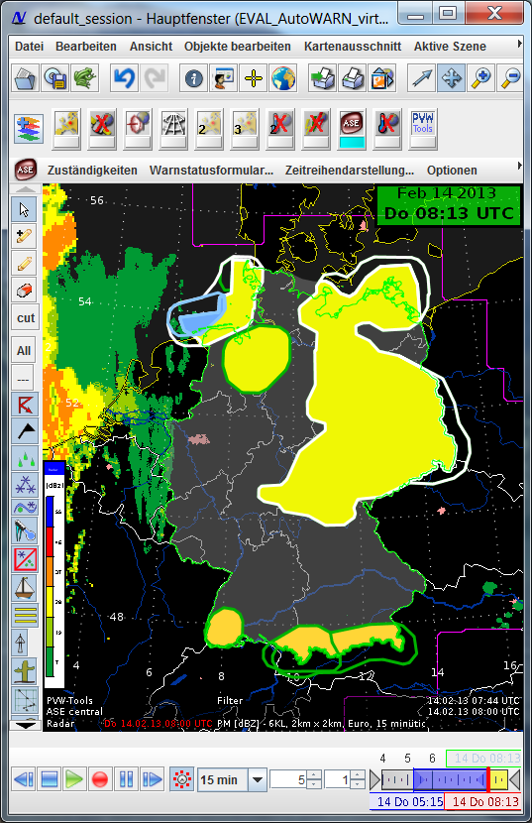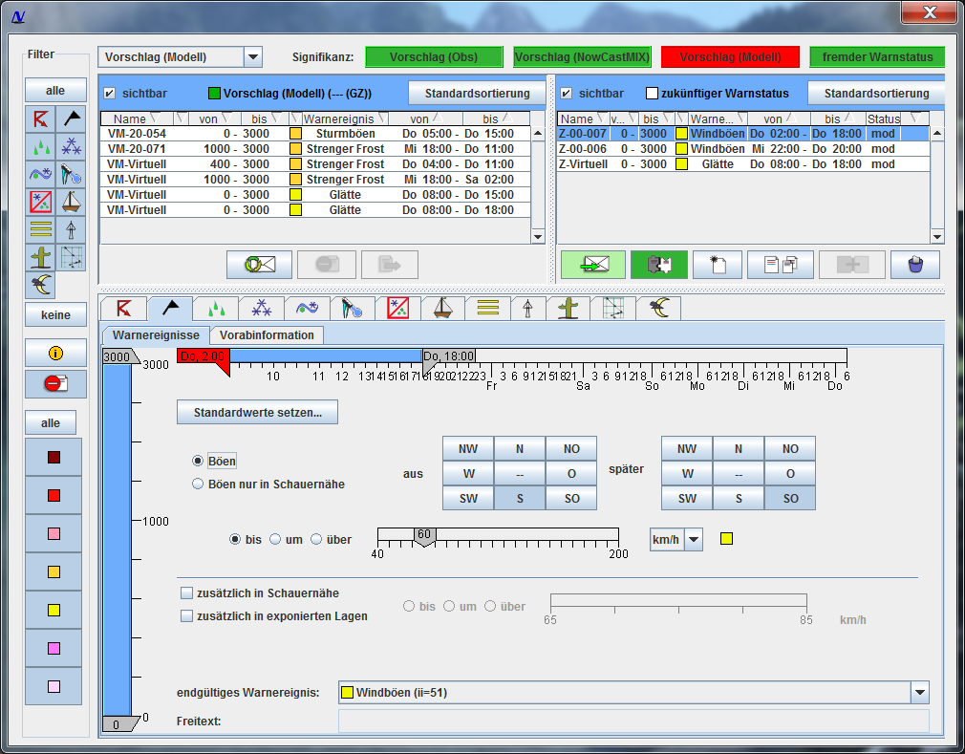

Figure 2: Graphical User Interface for AutoWARN 1.5 within NinJo

Project EnsembleMOS

As MOS Systems for GME and ECMWF are operational, a system to statistically optimize and calibrate ensemble data is currently in development. The new EnsembleMOS system is enhanced for the special requirements and application of ensemble models such as COSMO-DE-EPS and EZMWF-EPS (later ICON-EPS as well). Based on the WarnMOS setup with a new logistic regression approach it is prepared to provide statistically optimized and calibrated probabilistic forecasts as input for AutoWARN 2.0 (see above).

Project further development of ADWICE

In 2009 DWD has started together with the University of Hannover a three years running project for further development of the ADWICE model (Advanced Diagnosis and Warning system for aircraft Icing Environment). Goals of the project are the implementation of modern satellite data, the improvement of the modelled liquid water content and the inclusion of noveldata analysis products. First modifications within this project – namely the implementation of Meteosat-10 satellite data – are currently beeing tested and expected to get operational by the end of 2013.
Since the end of 2012 DWD is modifying the COSMO-EU / ICON microphysics scheme to improve the prediction of supercooled liquid water (SLW). Aim of this work is to extent the usage of SLW prediction within the ADWICE framework to improve aircraft icing prognosis. Currently, SLW is strongly underpredicted by the COSMO-EU model und therefore ADWICE does not rely on the model SLW prediction but uses its own parameterisation (parcel model).
This project will be continued until 2014.

Project Turbulence Forecast for aircrafts

At DWD is running a project to develop a prediction system for Eddy Dissipation Rate (EDR) based on COSMO-EU model. EDR is used for aviation warnings required by the ICAO.

Project Integrated Terminal Weather System (ITWS) / Low Level Wind Shear Alert System (LLWAS)

At DWD is running a project to develop an Integrated Terminal Weather System (ITWS) for the hubs Frankfurt and Munich. In the first step analysis and NowCast of convective weather events with the System NowCastMix/ITWS will be considered. The NowCastMix/ITWS-System will be improved by implementation of a cell-cyclus module. Furthermore, the NowCastMix/ITWS-System for convective weather will be extended in a third-party funded project (LuFo WeAC – Weather for ATM and CDM) to winter weather situations. In an EC funded project within FP7 the benefit of using a high resolution airport model as NowCast Tool will be investigated (COSMO-MUC).
Further, a Low Level Wind Shear Alert System based on remote sensing measurement sensoric (combination of X-Band Radar and LIDAR) will be implemented at this both airports.

SESAR WP11.2 Meteorological Information Services and SESAR Flight Trials and Demonstration Activities (IFTDA)

The DWD participates within an EUMETNET EIG consortium in both SESAR (Single European Sky Air Traffic Management Research Programme) projects in SESAR WP11.2 and SESAR IFTDA. The goal of SESAR is to support the realisation of a homogenous European Sky.
The aim of the first project is to develop standardised, consolidated aviation meteorology fields / parameter for the local and en-route situations. Issues are convective weather situations (analysis, nowcasting and ensemble-based methods), icing, turbulence, winter weather and capacity studies. Beside DWD Météo France, UK Met Office, FMI, SMHI, Met Norway and KNMI join the project as EUMETNET member.
In the second project current national meteorological products will be validated during fight trials, starting in the second half of 2013. DWD is engaged with ADWICE and NowCastMIX/ITWS. Météo France and UK Met Office join the project with high level wind and temperature fields as well as convective weather products. Those three national weather services are considered as one project member (labelled as EUMETNET consortium).

Project Met Alliance AutoTAF

The MOS AutoTAF system described above (4.3.4) has been redesigned for the use at the DWD and as a common AutoTAF forecasting system within the Met Alliance. The driving model GME has been replaced by the IFS (ECMWF) deterministic model due to an agreement within the Met Alliance and due to verification results. Further, the inclusion of a nearly Europe covering remote sensing input field of radar and lightning observations improve precipitation and thunderstorm forecasts at many European airports and stations.

Projects EWeLiNE and ORKA
In the research projects EWeLiNE (2012-2016) and ORKA (2012-2015), the overarching objective is to improve the power forecasts of the power production from renewable energies. Both projects focus on forecasts for wind energy and photovoltaic (PV) since these energy sources are highly weather dependent and as such fluctuating in time. A very high potential for improving the power forecasts, lays in the improvement of the quality of the underlying weather forecasts. In both projects, the collaboration with external partners in research and industry plays a major role.
In EWeLiNE, the main focus lies on achieving better forecasts for the current and following day. DWD is aiming both to improve the deterministic and probabilistic weather forecasts and to develop new user optimized products. To begin with, COSMO-DE and COSMO-DE-EPS will be the main focus of the work. However, during the project, ICON will be integrated into the research activities. The research aspects include optimized treatment of the parameterized processes, assimilation of newly available observations from wind or PV power plants and satellites, optimized ensemble generation and post-processing methods, and thereby in particular potential enhancements of MOS on the DMO. When optimizing weather forecasts towards renewable energies, the verification of the forecasts needs to be extended from traditional parameters (e.g., temperature, precipitation, and surface wind speed) to e.g., global radiation and wind speed at different altitudes. The verification of renewable energy relevant parameters is ongoing work for both the deterministic and the probabilistic forecasts to identify error characteristics of the forecasts compared to measurements (e.g., surface based pyranometer measurements, satellite retrieved data and wind towers). For renewable energies, weather conditions that are critical, i.e. particularly known to be related to substantial forecast errors include for wind: frontal passages (lows), pronounced diurnal cycles, and wind speed biases in winter. For PV these critical weather conditions include: low stratus clouds, convective events and clear sky conditions. Especially in the summer, wind speeds in hub height exhibit strong daily cycles. The COSMO-DE model underestimates the amplitude of the daily wind speed cycle including Low Level Jets (LLJs) and additionally exhibits a temporal shift (transition from/to stable to/from unstable situations is too slow, see Fig. 1). Due to the nonlinearity of power curves such errors may have significant impact on wind power production (see Fig. 2). Considering one example in August 2012 (stable situation), the LLJ in the model was underestimated and persisted for too long, even after sunrise (see Figure 3). By adjusting turbulence parameters in order to allow for more stable conditions during night and by artificially increasing vertical mixing after sunrise, better results are achieved (see Fig. 4). Further work will focus on how to implement a more realistic mixing after sunrise in the turbulence- and transfer scheme of COSMO-DE.
Verification of shortwave radiation (SWR) COSMO-DE for such critical weather conditions reveals that e.g., on clear sky days SWR is underestimated by the model, likely due to the high optical thickness of aerosols in the model. Further work is conducted to improve SWR on cloudy days, where clouds appear to be too transparent.
Further more, ongoing work deals with improved ensemble generation. The first step considers the coupling of COSMO-DE-EPS to the LETKF scheme that is being developed within the KENDA project. In this way, COSMO-DE-EPS gains an ensemble of initial conditions directly from the data assimilation. Moreover, statistical post-processing of COSMO-DE-EPS for wind at e.g., 100m height and global radiation will be performed. For global radiation, a calibration technique will be developed and further verification is required. Ongoing work focuses on quantile verification of global radiation based on pyranometer measurements. For wind speed, there are existing methods available that can be considered. Statistical post-processing of wind speed based on bivariate Ensemble Model Output Statistics (EMOS) is being extended from surface winds to wind speeds at 100m height. First results are promising and deliver a more reliable calibrated wind forecast at this height. The MOS of DMO is has been extended to renewable energy relevant parameters. Ongoing work deals with an increase in temporal resolution from 3 h to 1 h. During the whole project, the requirements of the users, i.e. the Transmission System Operators (TSO), will be integrated into the research activities to obtain user optimized products. An effort is especially put on the development of probabilistic products and the integration of these into the systems of the users.
The focus of the project ORKA lies on improving probabilistic forecasts on the forecast range of 0-8 h, in particular by optimizing the generation of ensembles and by improving the representation of parameterized physical processes of the COSMO-DE-EPS. For improving the ensemble spread within the first few hours of the forecast, the vertical filter of the initial condition perturbations has been modified. In the modified setup, initial condition perturbations are allowed within the boundary layer dependent on the variance of the topography. This leads to an improved ensemble spread in the first forecast hours for regions with comparably flat terrain.
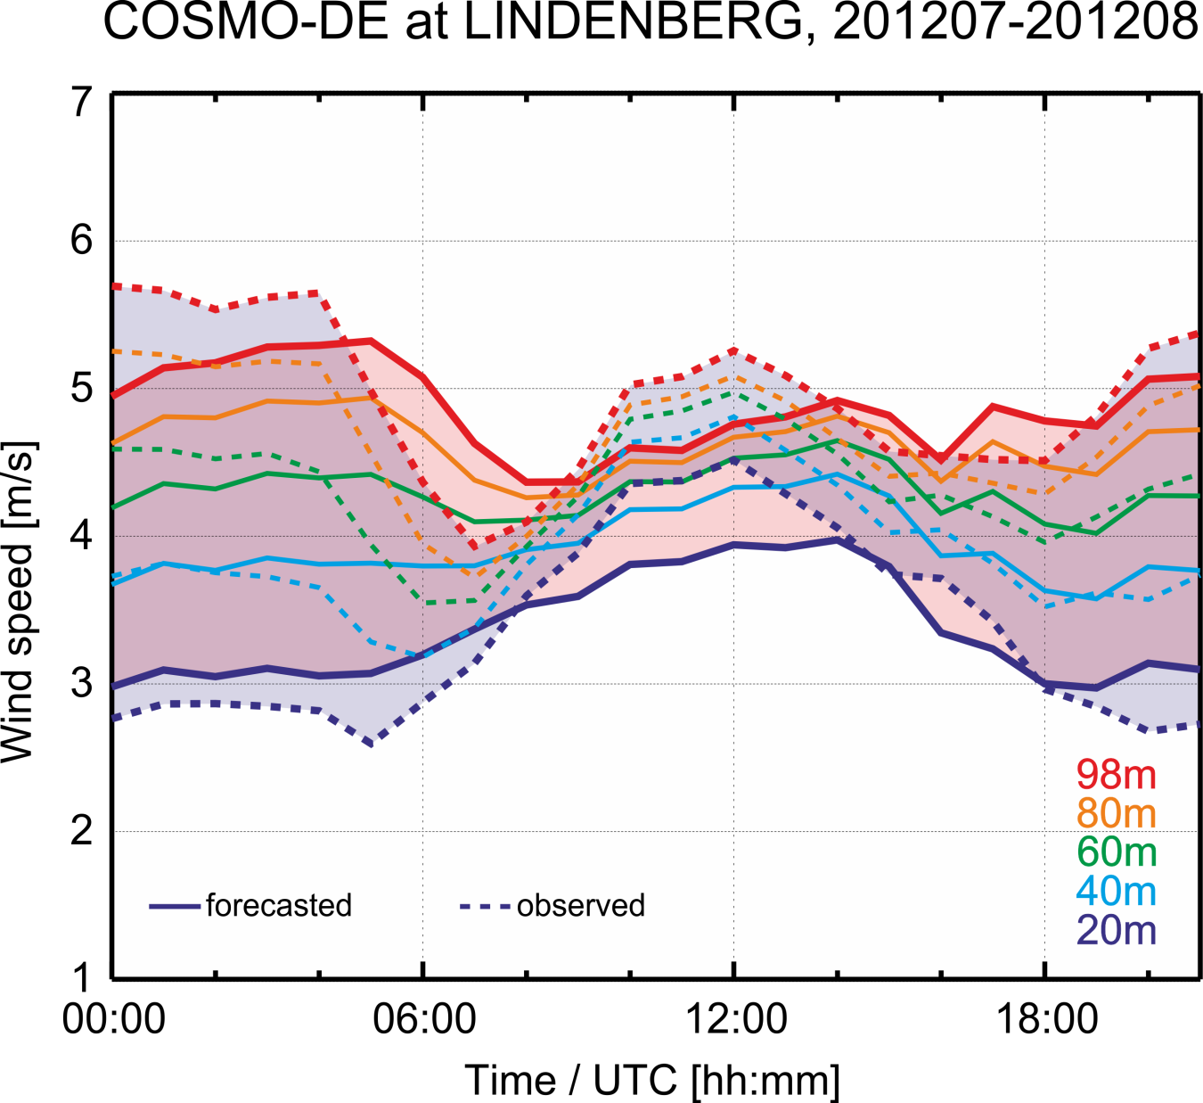
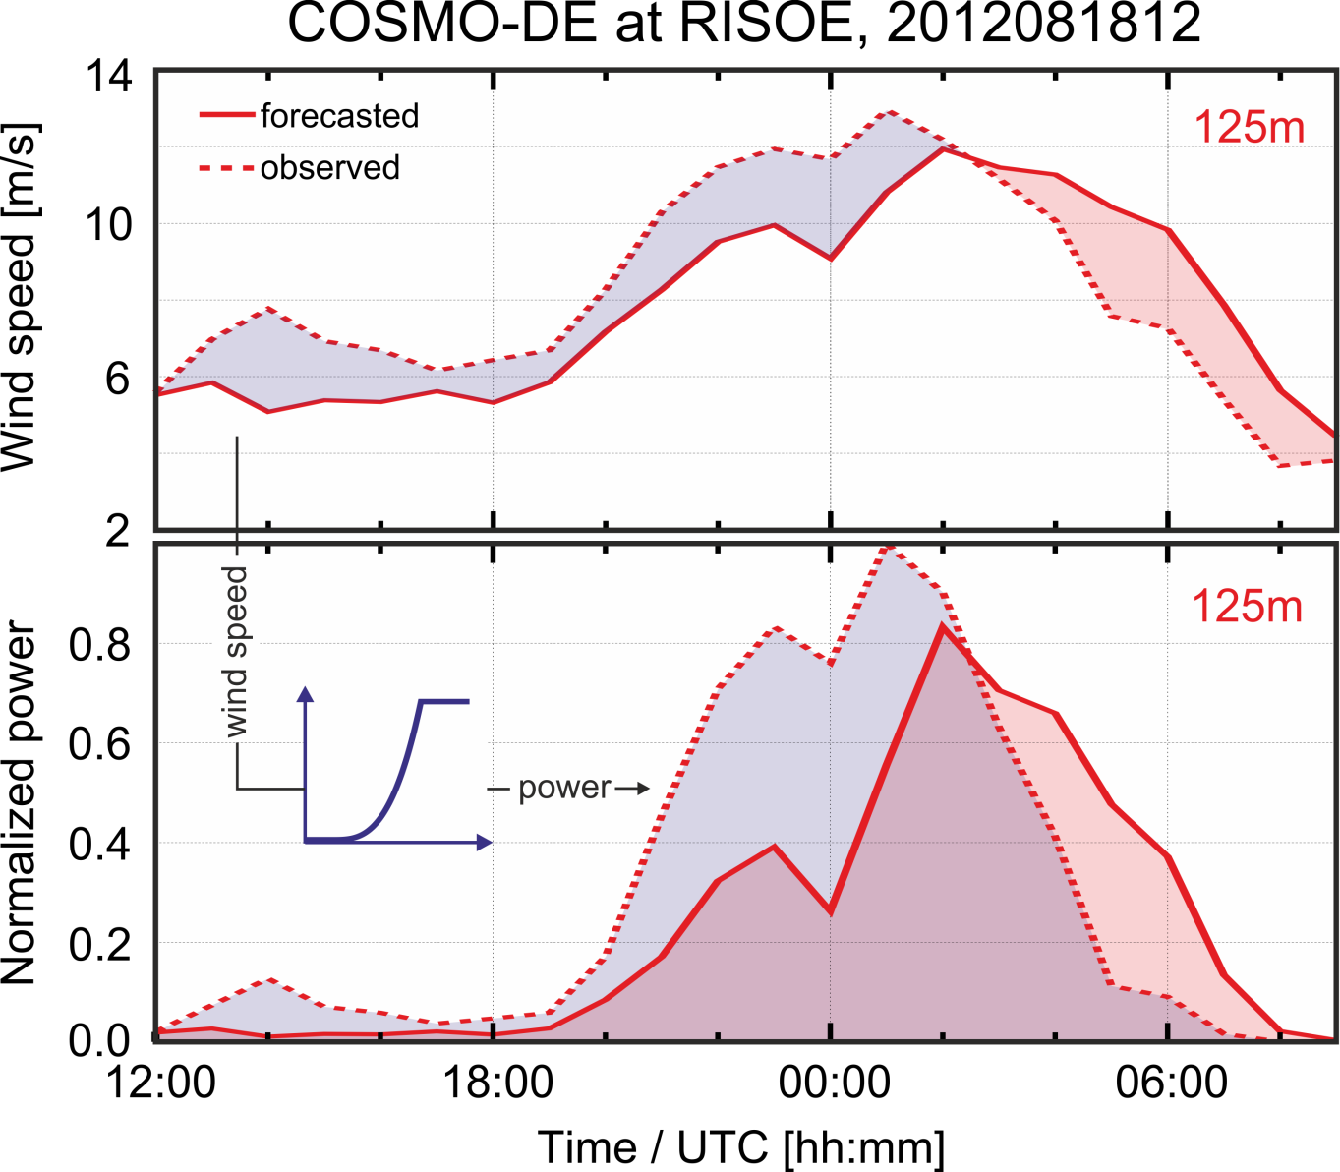

Fig.1) Mean daily cycle of observed (dotted) and forecasted (solid, 00:00 UTC forecast runs) wind speed at Lindenberg for July and August in 2012. Forecasted u and v values were carefully interpolated to measurement height. After sunrise, a strong decrease of wind speed aloft is observed, whereas the model fails to represent such sharp transition from stable to mixed conditions and vice versa.
Fig.2) Risø, 18. August. 2012; Top: forecasted (solid) and observed (dotted) wind speed at 125 m. Note that the model simulates the Low Level Jet too weak and too late. Bottom: forecasted and observed wind speed converted to power. Within the critical range of the power curve, errors amplify significantly.

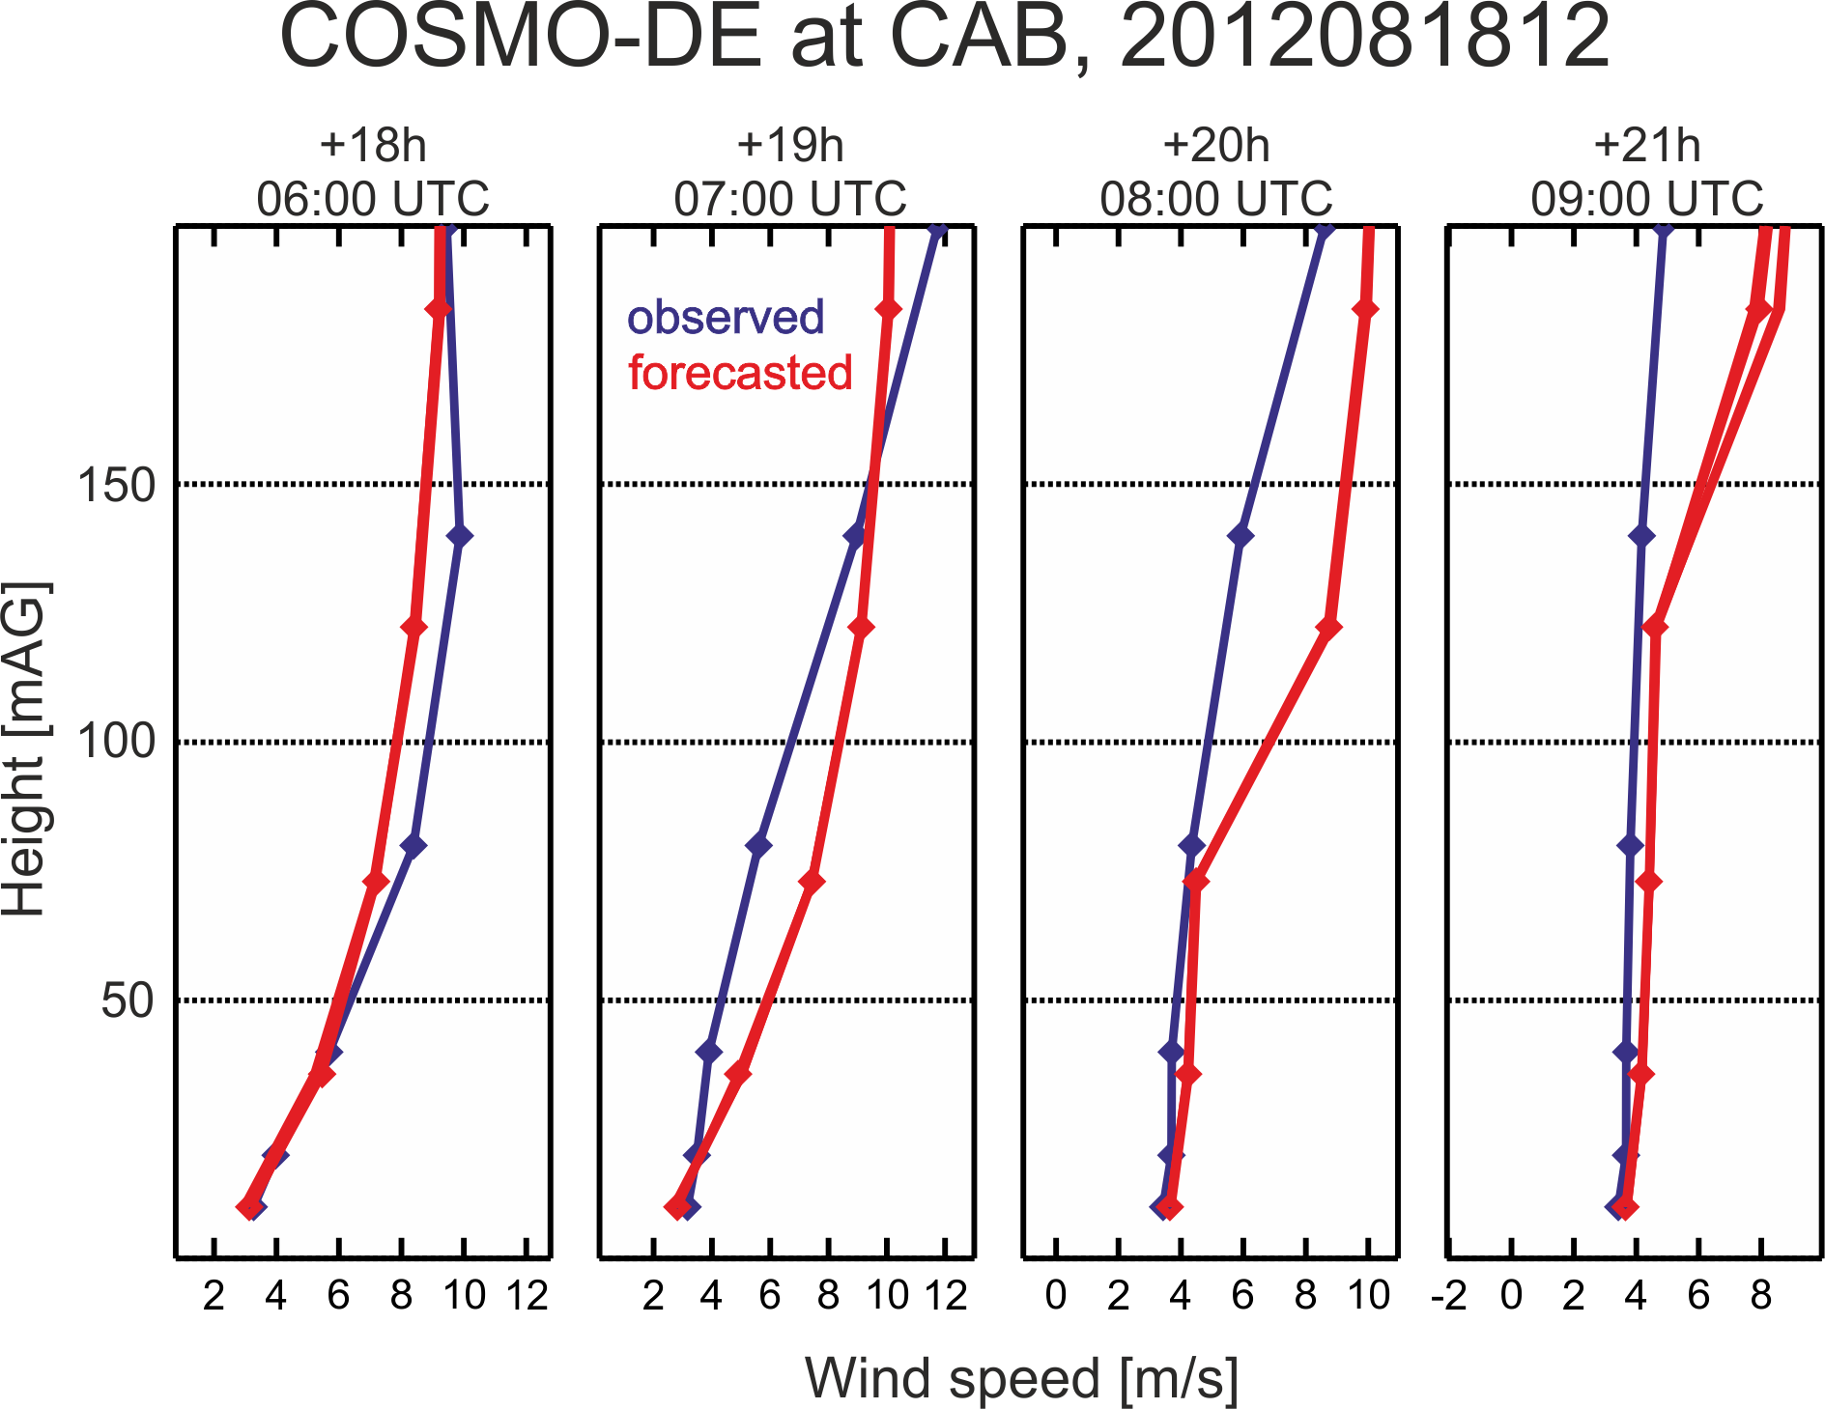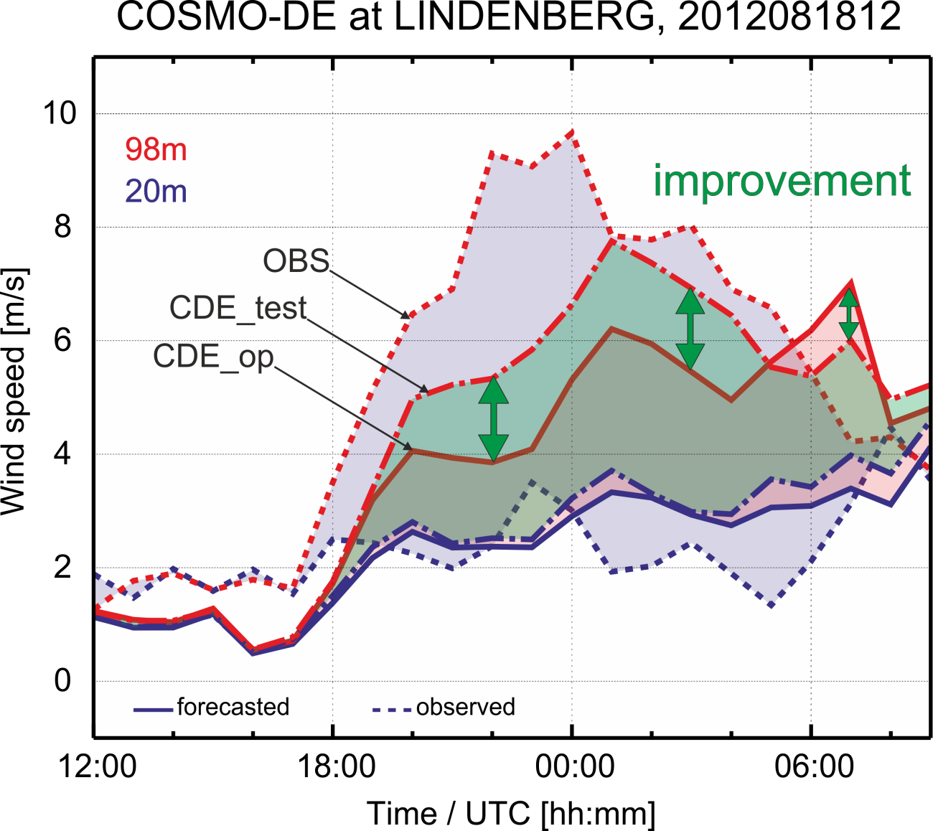
Fig.3) Cabauw, 18. August. 2012; Observed (blue) and fore-casted (red) wind speed profiles for lead times +18 up to +21 hours, corresponding to 06:00 UTC up to 09:00 UTC. Note the persistence of a decoupled layer in the forecasted profiles after sunrise (04:30 UTC). Similar profiles can be found for Lindenberg and Risø for the same date.
Fig.4) Lindenberg, 18. August. 2012; Observed (dotted) and operationally forecasted (solid) wind speed in 20 and 98 m. Note that the LLJ is too weak and too long-living in the model. A test run (dash dotted lines; momentum flux at the ground was slightly reduced, stability during night as well as mixing after sunrise were increased) shows better results.

Fig.3) Cabauw, 18. August. 2012; Observed (blue) and fore-casted (red) wind speed profiles for lead times +18 up to +21 hours, corresponding to 06:00 UTC up to 09:00 UTC. Note the persistence of a decoupled layer in the forecasted profiles after sunrise (04:30 UTC). Similar profiles can be found for Lindenberg and Risø for the same date.
Fig.4) Lindenberg, 18. August. 2012; Observed (dotted) and operationally forecasted (solid) wind speed in 20 and 98 m. Note that the LLJ is too weak and too long-living in the model. A test run (dash dotted lines; momentum flux at the ground was slightly reduced, stability during night as well as mixing after sunrise were increased) shows better results. (namelist settings: tur_len=150, a_stab=1, pat_len=200, rlammom= 0.5, tk[h,m]min= 0.001, if sobs .gt. 5 tk[h,m]min=1.5)

4.3.5 Ensemble Prediction System (EPS)
4.3.5.1 In operation

Operational systems based on models with parameterized convection

EPS products from the ECMWF and COSMO-LEPS as described in 4.2.5.3 are in use also for short range forecasting as far as applicable. In addition to this, SRNWP-PEPS (Poor Man’s Ensemble Prediction System) is in use since 2006.

SRNWP-PEPS (“Poor man’s” Ensemble Prediction System of the Short Range Numerical Weather Prediction Program) is running in operational mode. The SRNWP-PEPS combines most of the operational LAM forecasts of the European weather services. The products are generated on a grid with a horizontal resolution of approximately 7km (see figure 3).

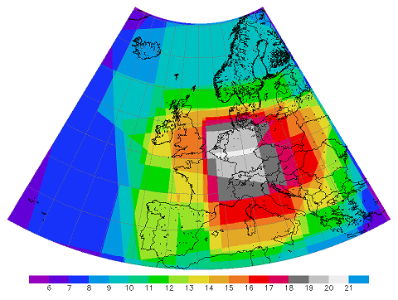

Figure 3: Domain and maximum ensemble size of the SRNWP-PEPS.

In Europe there are four different main operational limited area models (LAM) developed by different consortia. These four models are all representatives of today's state of the art in the Short-Range Numerical Weather Prediction field and are used by more than 20 national weather services to produce their operational forecasts (EUMETNET SRNWP = Short Range Numerical Weather Prediction Prgramme). The weather services run their models on different domains with different grid resolutions using different model parameterizations, data assimilation techniques and different computers producing a huge variety of different forecasts. Bringing together these deterministic forecasts, the SRNWP-PEPS provides an estimate of forecast uncertainty. Of course, this estimate is biased, e.g. due to model clustering in consortia, and some sources of uncertainty are still missing. However, ensemble post-processing would be able to generate calibrated probability forecasts from the PEPS. The main purpose of the SRNWP-PEPS is the improvement of European severe weather warning systems.

Table 1 Models contributing to SRNWP-PEPS.

Meteorological  Service | Regional Model | Coupling Model | Resolution (km) | Forecast Period (h) | Time interval (h) | Main Runs (UTC)
Belgium | ALADIN-BE | ARPEGE | 15 | +60 | 1 | 0, 6, 12, 18
France | ALADIN | ARPEGE | 11 | +48 | 3 | 0, 12
Austria | ALARO5 | ECMWF | 4.8 | +72 | 1 | 0, 6, 12, 18
Croatia | ALADIN | ARPEGE | 9 | +72 | 1 | 0, 12
Czech. Repub. | ALADIN-LACE | ARPEGE | 11 | +48 | 1 | 0, 6, 12, 18
Hungary | ALADIN-LACE | ARPEGE | 11 | +48 | 1 | 0, 6, 12, 18
Slovakia | ALADIN-LACE | ARPEGE | 11 | +48 | 3 | 0, 12
Slovenia | ALADIN-LACE | ARPEGE | 9.4 | +48 | 3 | 0, 12
Denmark | HIRLAM | ECMWF | 16 | +60 | 1 | 0, 6, 12, 18
Finland | HIRLAM | ECMWF | 16 | +54 | 1 | 0, 6, 12, 18
Spain | HIRLAM | ECMWF | 18 | +48 | 1 | 0, 6, 12, 18
Netherlands | HIRLAM | ECMWF | 22 | +48 | 1 | 0, 6, 12, 18
Ireland | HIRLAM | ECMWF | 11 | +54 | 3 | 0, 6, 12, 18
Norway I | HIRLAM | ECMWF | 8 | +48 | 1 | 0, 12
Norway II | HIRLAM | ECMWF | 12 | +48 | 1 | 0, 12
Sweden | HIRLAM | ECMWF | 11 | +48 | 3 | 0, 6, 12, 18
Germany | COSMO-EU | GME | 7 | +78 | 1 | 0, 6, 12, 18
Switzerland | COSMO-7 | ECMWF | 7 | +72 | 1 | 0, 12
Poland | COSMO | GME | 14 | +72 | 3 | 0, 12
Italy | EuroLM | EuroHRM | 7 | +48 | 1 | 0, 12
United Kingdom | UM-EU | UM-Global | 11 | +48 | 1 | 0, 6, 12, 18

Very short range convection-permitting COSMO-DE-EPS

COSMO-DE-EPS is a very short range ensemble prediction system (EPS) based on the convection-permitting model COSMO-DE. The model COSMO-DE has a horizontal grid-spacing of 2.8 km, produces forecasts with a lead time of 0-27 hours, covers the area of Germany and has been in operational mode at DWD since April 2007 (section 4.3.2).

The aim of COSMO-DE-EPS is the quantification of forecast uncertainties on the convective scale where the predictability is limited to very short forecast ranges. An estimate of uncertainties provides an added value compared to a single deterministic forecast, because it allows for an interpretation of the forecast in probabilistic terms. Such probabilistic information is essential in decision-making processes and risk management.

With the aim to quantify forecast uncertainties, variations are introduced to COSMO-DE model physics, initial conditions, and lateral boundary conditions (Peralta et al., 2012, Gebhardt et al., 2011). Variations of model physics are realized by non-stochastic perturbations of parameters in the parameterization schemes. Initial conditions and lateral boundary conditions are varied by nesting the COSMO-DE ensemble members into a boundary-condition EPS (BC-EPS). The BC-EPS consists of different COSMO 7 km simulations which are nested into forecasts from different global models (GME of DWD, IFS of ECMWF, GFS of NOAA/NCEP and GSM of JMA). Perturbations of the initial soil moisture fields have been included in the operational COSMO-DE-EPS since January 2014. They are derived from differences between COSMO-EU und COSMO-DE soil moisture analyses in layers down to a depth of 1m below surface.

Since December 2010, the ensemble prediction system COSMO-DE-EPS has been running in pre-operational mode. Operational production with 20 members started on 22 May 2012. The current version comprises 20 ensemble members, with a horizontal grid-spacing of 2.8 km. COSMO-DE-EPS is started 8 times a day (00 UTC, 03 UTC, …), and each ensemble run has a lead time of 27 hours. Probabilistic products (e.g. exceedance probabilities and quantiles) are calculated for parameters and thresholds relevant for the warnings issued by the DWD forecasters.

      - Research performed in this field
Plans for the ICON short range EPS: The ensemble will provide 20 members up to 72h lead time and the intension is to start operation in 2017. The initial ensemble perturbations will be based on the Ensemble Data Assimilation system developed at DWD, which is described in 4.3.1.2. A local Ensemble Transform Kalman Filter (LETKF), proposed by Hunt et al., (2007) is embedded in a hybrid VarEnKF combining climatological (NMC) based 3dVar co-variance matrices and the dynamic covariance information of the EnKF. First experiments show that the ensemble started from the VarEnKF analysis states is still underdispersive. To overcome this problem the intension is to combine breeding and fast growing Singular Vector (SV) perturbations. Instead of doing a complete SV analysis we try to find local estimates of the fastest growing modes by approximation of the Jacobian wherever the breeding ensemble is degenerated. In addition we inted to use lagged forecasts to identify and filter baroclinic unstable modes, which may be added to the analysis ensemble of the VarEnKF. A stochastic physics package is developed in our physical aspects section that uses stochastic mode reduction (Majda et al., 2001).

Verification results for COSMO-DE-EPS indicate that the perturbations have a beneficial effect on the probabilistic precipitation forecast when compared to the deterministic forecast. This benefit is most effective for convective summer precipitation. However, the ensemble forecasts are underdispersive and overconfident.
Current research focuses on two aspects. The first aspect is a better representation of forecast uncertainty to reduce underdispersion for precipitation, near-surface temperature and wind gusts. The second aspect is the calibration of the probabilistic products to improve their statistical properties, e.g. in terms of reliability and sharpness.
Regarding the representation of forecast uncertainty, work is in progress for an upgrade to 40 members by use of COSMO-LEPS members as additional lateral boundaries. Furthermore, additional physics perturbations have been tested in order to increase the ensemble spread in 2m-temperature and wind-speed. Successful tests have been carried out by including members of consecutive start times in the product generation (LAF, ‘lagged average forecast’).
This leads to a better quantification of forecast uncertainty and improves the probabilistic products (Ben Bouallègue et al., 2013). To further improve those products research focuses on the development of ensemble calibration methods. Good results for precipitation have been achieved by an extended logistic regression method (Ben Bouallègue, 2013). The approach by Schuhen et al. (2012) has been successfully tested for 10m wind of COSMO-DE-EPS.
(S. Theis, Z. Ben Bouallegue, M. Buchhold, A. Röpnack, C. Gebhardt, N. Schuhen)

Operationally available EPS Products

Similar to COSMO-LEPS (see 4.2.5.3), also SRNWP-PEPS and COSMO-DE-EPS provide probability charts for Europe which give information whether accumulated rain or snow, wind gusts, temperatures or CAPE values will exceed thresholds defined by warning requirements. Products based on SRNWP-PEPS are available up to 42 hours and those based on COSMO-DE-EPS up to 27 hours Exceeding probabilities, quantiles, ensemble mean, spread, min, max are calculated for total precipitation, total snowfall, 10m wind gusts, 2m temperature, cloud cover, CAPE, and simulated radar reflectivities. For precipitation, also “upscaled” probabilities are provided. They refer to predefined regions which are substantially larger than the model grid (Ben Bouallègue and Theis, 2013).
The products of COSMO-DE-EPS are visualized within the visualization tool NinJo. The NinJo system has been complemented by an “ensemble layer”. This layer is also used to visualize other ensemble systems such as COSMO-LEPS, PEPS and ECMWF EPS.

4.4 Nowcasting and Very Short-range Forecasting Systems (0-6 hrs)

4.4.1 Nowcasting system

      - In operation

The nowcasting is based mainly on the COSMO-DE-model.

In addition to this since 2001 the system KONRAD (Konvektion in Radarprodukten) is an important tool for the warning business concerning thunderstorms. It was developed by the DWD observatory at Hohenpeissenberg, Bavaria. It allows for cell tracking and warnings based on radar reflectivities. Cores of thunderstorms with a characteristic scale of 15 km² and a precipitation rate of 23 mm/h which is equivalent to more than 46 dbz’s are identified at a time interval of 5 minutes. Primary cells of different scales are tracked, numbered and the track will be extrapolated up to 60 minutes and up to a radius of 100 km.

Beginning in autumn 2008 the new forecast tool CellMOS is running at DWD in operational mode. CellMOS is a MOS-based system for thunderstorm tracking and related severe weather warnings. Using radar reflectivities, observations of lightning and GME model data over Germany all cells having a maximum reflectivity greater than 37 dBZ, an area size greater than 9 km² and at least one lightning are detected. Then a statistical 2h-forecast of the cell tracks and several weather elements like wind gusts, precipitation amount, hail and frequency of lightning is made. The domain of forecast uncertainty is considered by applying Gauss-functions for errors in cell shape and position. These functions are also used for superposition of cells and for the resulting probabilistic forecasts.

      - Research performed in this field

Project AutoWARN with NowCastMIX

The automated warning process in AutoWARN utilizes outputs from various nowcasting methods and observations, combined with NWP model data, to generate.a forecast-time dependant automatic warning status. This is permanently manually controlled and modified by the forecaster before text and graphical warning products are generated. In order to provide a generic optimal solution for nowcast warnings in AutoWARN all nowcast input data is pre-processed together in a single grid-based system: the NowCastMIX. This provides an ongoing real-time synthesis of the various nowcasting and forecast model system inputs to provide a single, consolidated set of most-probable short-term forecasts, focussing on thunderstorm and heavy rain events.
NowCastMIX combines data intelligently from various radar-based sources with lightning strike data and NWP model output. The speed and direction of storm cells is assessed and used to forecast regions at imminent risk of storm developments. The potential severity of the storms is estimated by deploying a fuzzy logic system to assess the relative risk of each of the attributes involved: hail, severe guts and torrential rain. The operational use started in october 2013.

4.4.2 Models for Very Short-range Forecasting Systems

      - In operation

Schematic summary of the convection-resolving model COSMO-DE

Domain Germany and surrounding

Initial data time 00, 03, 06, 09, 12, 15, 18, 21 UTC

Forecast range 27 h

Prognostic variables p, T, u, v, w, q_{v}, q_{c,} q_{i}, q_{rain,} q_{snow}, q_{graupel}, TKE

Vertical coordinate Generalized terrain-following, 50 layers

Vertical discretization Finite-difference, second order

Horizontal grid 421 x 461 points (0.025° x 0.025°) on a rotated latitude/longitude grid,
mesh size 2.8 km; Arakawa-C grid, see Fig. 1.

Horiz. discretization Finite-difference, fifth order upwind advection
For the advection of moisture variables: Bott (1989) scheme with Strang-
splitting

Time integration Two-time-level, 3rd order Runge-Kutta, split explicit
(Wicker and Skamarock, 2002), Δt = 25 s.

Horizontal diffusion Implicit in advection operators. Explicit horizontal hyperdiffusion (4th order) in
the boundary zones and in the full model domain for the velocity components. Smagorinsky-type diffusion In the full domain.

Orography Grid-scale average based on a 1-km data set. Topography has been filtered to remove grid-scale structures

Parameterizations Surface fluxes based on a resistance model by vertical integration of a flux-gradient representation along a constant-flux transfer layer using a surface layer TKE equation (Raschendorfer, 1999)

Free-atmosphere turbulent fluxes based on a level-2.5 scheme with prognostic TKE (Mellor and Yamada, 1974) with contributions from non turbulent processes (Raschendorfer 1999)

Radiation scheme (two-stream with three solar and five longwave intervals)
after Ritter and Geleyn (1992), full cloud-radiation feedback based on
predicted clouds

Mass flux convection scheme after Tiedtke (1989) only for shallow convection

Kessler-type grid-scale precipitation scheme with parameterized class-6
cloud microphysics

7-layer soil model (Heise and Schrodin, 2002) including simple vegetation
and snow cover; prescribed climatological value for temperature at about
14 m depth.

Over sea/ocean water: Fixed SST from SST analysis; roughness length according to Charnock´s formula.
Over inland water bodies: the lake parameterization scheme Flake (http://lakemodel.net) is used to predict the water surface temperature; for frozen lakes the ice surface temperature and the ice thickness are predicted. The Charnock formula for the water aerodynamic roughness is used over sea/ocean and inland water bodies.

      - Research performed in this field

Influence of diabatic processes on the pressure and temperature equation
In the COSMO model, the continuity equation is transformed to a pressure equation via the equation of state. At the moment, the contributions Q_h to the pressure tendency due to diabatic heating (phase changes, turbulent/convective transports, divergence of radiation fluxes) and the contributions Q_m due to mass transfer (internal exchange to/from hydrometeors by phase changes, external diffusion over the grid box boundaries changing system composition) are neglected in the pressure equation, which also affects the temperature equation via its pressure term. Effectively, this leads to a temperature equation which does not contain Q_m and which employs c_p as the relevant heat capacity.
Consistent to that, it is assumed that the "saturation adjustment" (an "infinitely fast" phase change process with corresponding temperature change towards vapor/liquid equilibrium) happens at constant pressure, which leads to the usual formulation of the adjustment equations . Note that one has to specify such an additional constraint otherwise the adjustment problem would not have a unique solution.
As a consequence, mass is not conserved during diabatic change processes. For example, during microphysical phase changes, there is locally a spurious mass loss during condensation / sublimation and a mass gain during evaporation / sublimation, equal in relative terms for all gaseous species including water vapour. Because normally there is more condensation than evaporation (thanks to precipitation) we expect a net mass loss in the model, and loss of water vapour might decrease subsequent precipitation.

In a new model version, the terms Q_h and Q_m due to diabatic processes (except turbulent dissipation and one thermodynamical cross-effect term) are included in the pressure equation. Correspondingly this influences the temperature equation in a way that now simply c_v replaces the former c_p as relevant heat capacity and a new contribution due to the Q_m term appears on the right hand side. For the saturation adjustment, this means that we now have to assume locally constant density during this process and that the relevant heat capacity is now c_v instead of c_p.
Experiments have been conducted to investigate the influence of including the Q_h and Q_m terms on the precipitation forecast. The results suggest that there is a slight increase in total precipitation (1-3 %) and an insignificant shift in fine structure of precipitation patterns. Also we observe a slight enhancement of local precipitation maxima, which has a positive influence on our “fuzzy” precipitation verification scores. Also, there is a (weak) positive influence on geopotential and surface pressure. All other quantities and scores seem to behave neutral.
(U. Blahak, A. Seifert)

Revision of the fast waves solver in the Runge-Kutta time integration scheme
Most of the operational setups of the COSMO model now use the so-called Runge-Kutta time integration scheme (Wicker, Skamarock, 2002). The basic idea of this time-splitting procedure is to treat the slow parts like advection or Coriolis force with a large time step, whereas the 'fast waves' modes sound and gravity wave expansion are treated with a small time step. As in the original proposal of Wicker, Skamarock (2002) the fast waves are treated horizontally with a forward -backward scheme and vertically implicit to allow larger values for the small time step. An additional filter process must stabilize this whole time-splitting procedure; usually a divergence damping is used in the fast waves solver (Skamarock, Klemp (1992), Baldauf (2010)). Properties of the new fast waves solver compared to the current one are:
1. Improvement of the accuracy of all vertical derivatives and averages.
2. Use of the divergence operator in strong conservation form
3. Optional: an isotropic treatment of the artificial divergence damping
4. Optional: Mahrer (1984) discretization of the (explicit) horizontal pressure gradient terms
5. slope dependent strength of the divergence damping
Mainly items 1 and 5 (and in future also item 4) allow to run the dynamical core over steeper slopes than with the old fast waves solver, which is an important aspect if one wants to further increase the horizontal resolution of convection-resolving models. The generally higher stability could be shown in several real case simulations which crashed before.
This new fast waves solver is in operational use since 16 January 2013 for COSMO-DE and COSMO-EU.
(M. Baldauf)

Development of a TKE-Scalar Variance turbulence-shallow convection scheme for the COSMO model

The TKE-Scalar Variance (TKESV) turbulence-shallow convection scheme for the COSMO model is developed within the framework of the COSMO priority project UTCS. The TKESV scheme carries prognostic equations for the turbulence kinetic energy (TKE) and for the scalar variances (variances of total water specific humidity and of the liquid water potential temperature and their covariance). These prognostic second-moment equations include the turbulent diffusion terms (divergence of velocity-velocity and velocity-scalar triple correlations) that are parameterised though the down-gradient approximation. Recall that the current COSMO-model turbulence scheme (referred to as the TKE scheme) computes the scalar variances from the diagnostic relations that are obtained from the respective second-moment equations by neglecting the turbulent diffusion and the time-rate-of-change terms. One more essential difference between the new and the current schemes is in the computation of scalar fluxes. The current scheme is based on the down-gradient approximation whereas the new scheme accounts for non-gradient terms (among other things, this allows for up-gradient scalar transfer). The non-gradient corrections to scalar fluxes stem from the buoyancy terms in the scalar-flux budget equations; those terms are parameterised with regard for the turbulence anisotropy. The formulation for the turbulence length (time) scale used within the TKESV scheme accounts for the effect of static stability (current operational COSMO model uses a Blackadar-type turbulence length scale formulation independent of static stability).

The TKESV scheme was successfully tested through single-column numerical experiments. The TKESV scheme outperforms the TKE scheme in dry convective PBL. The PBL is better mixed with respect to potential temperature. An up-gradient heat transfer that is known to occur in the upper part of the dry convectively-mixed layer is well reproduced. For cloudy PBLs, the application of the TKESV scheme leads to a better prediction of the scalar variances and TKE and to slight improvements with respect to the vertical buoyancy flux and to the mean temperature and humidity. Both schemes tend to overestimate fractional cloud cover in the cumulus-topped PBL. This error is attributed primarily to the shortcoming of quasi-Gaussian sub-grid scale (SGS) statistical cloud parameterization scheme used by both TKESV and TKE schemes to determine fractional cloudiness and the buoyancy production of TKE.

The TKESV scheme is implemented into the COSMO model and tested through a series of parallel experiments with the COSMO-EU and COSMO-DE configurations including the entire COSMO-model data assimilation cycle. Verification of results from parallel experiments indicate improvements as to some scores, e.g.\ two-metre temperature and humidity and fractional cloud cover. A detailed scientific documentation of the TKESV scheme is in preparation. Modifications associated with the TKESV scheme will soon be included into the official COSMO-model code (for details, see the Priority Project UTCS Reports and the Model Development Plan at the COSMO web site).
(D. Mironov and E. Machulskaya)

Plans to achieve a consistent description of SGS processes by scale separation

On the way towards a scale separated set of SGS parameterizations, we already have introduced additional scale interaction source terms in our prognostic TKE equations related to separated non- turbulent horizontal shear modes and to wake modes generated by SSO. Finally, we introduced a first version of a similar scale interaction term from our convection parameterisation closely related to the buoyant production of SGS kinetic energy by the convection process. Recently we also introduced TKE-advection as well as horizontal diffusion by means of the separated horizontal shear eddies.

While the TKE-production by SSO is switched on in our operational version, the other two terms need to be verified in the next future. However, they are still used as diagnostic source terms in order to derive an improved EDR forecast for aviation purposes.

Besides operational testing, we are going to use EDR-measurements by aircrafts in order to estimate the value of undetermined parameters in the formulations of those additional TKE source terms.

We are further planning to reformulate our current version of a scale interaction term caused by non-turbulent thermals related to surface inhomogeneity using input parameters of the present SSO scheme. Further we want to test now the contribution of TKE-advection and of TKE-production by separated vertical shear modes, as well as the impact of mixing by the additional non turbulent modes themselves (starting with horizontal diffusion by the separated shear eddies).

Finally it is aimed to reformulate in particular the current convection scheme in order to account for the counterpart of the scale interaction term in the convection scale budgets and to come along with a consistent overall description of SGS cloud processes. These last aims however belong to a longer time scale.

(M. Raschendorfer)

Plans to consolidate our surface-to atmosphere transfer and to account for inhomogeneity of surface roughness and tall effective roughness layers

We started with implementing some reformulations of the transfer scheme allowing for a stronger influence of the resulting transfer coefficients on thermal surface layer stratification. We aim to continue this work and hope to remove some of our systematic errors related to the diurnal cycle of near surface variables.

This task also includes the introduction of the vertically resolved roughness layer already mentioned in earlier plans, based on the concept of a spectral separation of equivalent topography described by an associated surface area index and a roughness height. By this procedure the large scale part of topographic land use structures are represented by additional source terms in all budget equations on the model levels being within the roughness layer, which is a generalization of the SSO approach. This includes a description of the roughness layer built by the change of land use within a grid box surface, being important for the aggregation of roughness parameters available for a couple of surface tiles within a grid box. We formally implemented these related extensions into the running test version of our turbulence scheme. However the description of the external input parameters is an issue for future investigation.

(M. Raschendorfer)

Adoption of the turbulence- and transfer-scheme for use in the ICON model

In order to run our COSMO turbulence scheme in ICON, we implemented a couple of modifications related to numerical stability and efficiency, modularity of the source code, as well as improvements in the way how to achieve positive definiteness of TKE and the stability functions.

Further we reformulated the code for implicit vertical diffusion in order to call a single subroutine for arbitrary tracers with a flexible setting of boundary conditions and of options related to the degree of implicitness and the treatment of vertical fluxes given not in a flux-gradient representation.

All these changes have been introduced to the ICON model and are running there as the default configuration. As a next step we want to merge this version with some further development of the COSMO version in order to produce a common turbulence package for both models, COSMO and ICON.

(M. Raschendorfer)

4.5 Specialized numerical predictions

4.5.1 Assimilation of specific data, analysis and initialization

4.5.1.1 In operation

None

4.5.1.2 Research performed in this field

None

4.5.2 Specific Models

4.5.2.1 In operation

4.5.2.1.1 Trajectory Models

Trajectory model:
Forecast variables r (λ, ϕ, p or z, t)
Data supply u, v, w, p_{s} from NWP forecasts (or analyses)
Numerical scheme 1st order Euler-Cauchy with iteration (2nd order accuracy)
Interpolation 1st order in time, 2nd (GME) or 3rd (COSMO-EU) order in space

- Daily routine (ca. 1500 trajectories)

Trajectories based on COSMO-EU forecasts:
Domain Domain of COSMO-EU (see Fig. 1)
Resolution 0.0625° (as COSMO-EU)
Initial data time 00, 12 UTC
Trajectory type Forward trajectories for about 110 European nuclear and 4 chemical installations, backward trajectories for scientific investigations
Forecast range 72-h trajectories, optional start/arrival levels

Trajectories based on GME forecasts:
Domain Global
Resolution ~ 20 km (as GME)
Initial data time 00, 12 UTC
Trajectory type 168-h forward trajectories for ca. 120 European nuclear sites and 8 German regional forecast centers, backward trajectories for 37 German radioactivity measuring sites and 8 forecast centres using consecutive +6h to +18h forecast segments.
168-h backward trajectories for all GAW stations and to the German meteorological observatories.
72-h backward trajectories for 5 African cities in the framework of the METEOSAT-MDD program, disseminated daily via satellite from Exeter.
168-h backward trajectories for the German polar stations Neumayer (Antarctica) and Koldewey (Spitzbergen) and the research ships Polarstern and Meteor, disseminated daily.
Mainly backward trajectories for various scientific investigations.
Forecast range 168-h forward and backward trajectories, optional start/arrival levels

b) Operational emergency trajectory system, trajectory system for scientific investigations:
Models COSMO-EU or GME trajectory models
Domain COSMO-EU or global
Data supply u, v, w, p_{s} from COSMO-EU or GME forecasts or analyses,
from current data base or archives
Trajectory type Forward and backward trajectories for a choice of offered or freely
eligible stations at optional heights and times in the current period
of 7 to 14 days.
Forecast range 72-h (COSMO-EU) or 168-h (GME)
Mode Interactive menu to be executed by forecasters

        - Sea wave models
Domain | Global  (GWAM) | European Seas (south of 66°N)  (EWAM)
Numerical scheme | Shallow water, 3rd generation WAM
Wind data supply | GME: u, v at 10 m | COSMO-EU: u, v at 10 m
Grid | geographical (reduced lat/lon for global; regular lat/lon for regional)
Resolution | 0.25° x 0.25° | 0.05° x 0.10
Initial data time | 00 and 12 UTC
Forecast range | 174 h |  | 78 h
Model output | 18 integrated spectral parameters (e.g. significant wave height, peak period and direction of wind sea and swell), as well as wave spectra at selected positions
Initial state | sea state adapted to predicted wind field over last 12 h
Verification | Available on request

4.5.2.1.3 Lagrangian particle dispersion model

As a part of the German radioactive emergency system a Lagrangian Particle Dispersion Model (LPDM) is employed at the DWD. The LPDM calculates trajectories of a multitude of particles emitted from a point source using the grid-scale winds and turbulence parameters of the NWP-model and a time scale based Mark-chain formulation for the dispersion process. Concentrations are determined by counting the number and mass of particles in a freely eligible grid. Dry deposition parameterisation follows a deposition velocity concept and wet deposition is evaluated using isotope-specific scavenging coefficients. Also included is radioactive decay, a vertical mixing scheme for deep convection processes and optionally particle-size depending sedimentation coefficients. Additionally, an assimilation scheme for measured concentration data can be activated. Starting from these observed fields or from selected receptor points the LPDM can be employed also in a backward mode to determine unknown source positions. The LPDM was successfully validated using data of the ANATEX and ETEX tracer experiments. In the ATMES-II report of the 1st ETEX release the model took the first rank of the 49 participating models. During the follow-up project RTMOD an evaluation of an accidental Cs-137 release (Algeciras, May 1998) was performed. The transport and dispersion of the cloud and the calculated dose rates were found to be in good agreement with the measurements. In the ENSEMBLE-ETEX reanalysis (2003) the ranking of the model was again excellent.
The LPDM can be run on basis of the DWD's operational weather forecast models (GME, COSMO-EU/COSMO-DE). In case of emergency the model output will be transmitted to the national 'Integrated Measurement and Information System' (IMIS) using slightly modified WMO codes. The calculations are also part of the European real-time decision system RODOS in Germany. In this context data transfer and coupling with the operational RODOS system is tested several times a year. The model consistently assimilates the provided local scale source information, and calculates the transport and dispersion of selected (currently 9) standard nuclides simultaneously. LPDM simulations are also part of the EU-activity "ENSEMBLE" (weather services in Europe and North America), which combines the forecast of different emergency dispersion models to a multi-model ensemble. The model simulations can be also driven by COSMO-DE data. In this context snow pellets are included as a separate precipitation form in the wet deposition procedure. On request the LPDM is operationally running in a backward mode to participate in the multi-model backtracking ensemble of the CTBTO (Comprehensive Nuclear-Test-Ban Treaty Organization).
The LPDM code is optimised for MPP/Vector computers (e.g. IBM P5 575, NEC SX9). For this purpose the code is supplemented by MPI-based parallelisation features. The model is also implemented at Meteo Swiss based on the Swiss COSMO-version.
In the context of the Fukushima-Daiichi catastrophe the model was extensively utilized. During the release phase of the accident (March/April 2011) the DWD provided dispersion forecasts for the public mainly based on GME-data. Additionally, the COSMO-LPDM (7 km grid spacing) was run in a quasi-operational mode for the relevant region covering Japan and its surroundings.
In 2013 the model code was supplemented for GRIB2 data by employing a GRIB-API interface. Additionally preparations were made to adapt the model to the DWD new global model ICON. As a member of the WMO multi-model backtracking ensemble of the CTBTO (Comprehensive Nuclear-Test-Ban Treaty Organization) the LPDM was run for about 20 CTBTO-requests in backward mode. In this context tests for new data transfer procedures were performed.. Routinely, the operational model system was applied in several emergency tests at national (IMIS/RODOS) and international level (IAEA-WMO exercises).
(H. Glaab, A. Klein)

      - Research performed in this field

4.5.2.2.1 COSMO-ART

The COSMO-ART system, where ART stands for ‘Aerosols and Reactive Trace gases’, is an extension of the operational COSMO model. The complete set of ART modules developed at the Institute for Meteorology and Climate Research at the Karlsruhe Institute of Technology (KIT) is online coupled in a tightly integrated way to the COSMO model. I.e. the same routines for transport and diffusion of the gas phase and aerosol tracers are used as for the prognostic moisture quantities in NWP. The possible applications of COSMO-ART range from simple tracer dispersion problems to complete aerosol-radiation and aerosol-cloud interaction studies including the formation of secondary aerosol particles from the gas phase.

At DWD the model system is mainly employed for the dispersion modelling of volcanic ash and mineral dust.
In case of a volcanic eruption with relevance for the German air space COSMO-ART is run on an enlarged domain, the model results are made available on the NinJo workstations of and used by the aviation forecasters as a secondary source of information. To parameterise the emission of volcanic ash an empirical relation between observed plume height and mass eruption rate is used. To get to quantitative results for the mass concentration of volcanic ash in the atmosphere, aircraft measurements of the particle size distribution and number concentration are used. At the University of Hohenheim a LIDAR forward operator is developed. This operator will ease the comparison of model results and observations of the ceilometer network of DWD and is a prerequisite for the data assimilation of such measurements.
Different institutions use COSMO-ART to run forecasts of mineral dust. For example the United Arabian Emirates have set up daily model runs in their operational cycle.
The strong Saharan dust event beginning of April 2014 is currently investigated in a joint effort of DWD and KIT. Runs including the aerosol-radiation interaction of the simulated dust showed a significant reduction of the short-wave radiation at the surface. This for example had a big impact on the power produced by solar energy. Further studies will also include the aerosol-cloud interaction parts.
(J. Förstner, H. Glaab)

4.5.2.2.2 ICON-ART

Following the explanation of COSMO-ART in the previous section the ICON-ART system is the likewise extension of ICON (ICOsahedral Nonhydrostatic model; developed at the Deutscher Wetterdienst DWD and the Max-Plank-Institute of Meteorology Hamburg). ICON-ART is currently under development at the IMK of KIT and the DWD, aiming at the complete functionality mentioned above. New developments for the ART modules will actually first be implemented with ICON before to be taken over also for COSMO. At DWD the model will be employed for dispersion modelling of volcanic ash, mineral dust and radionuclides.
Nearly completely implemented are the modules for volcanic ash, radionuclides, sea salt and mineral dust. These modules will be ready when ICON becomes operational at DWD.
The ART modules have been restructured at KIT to streamline further expansions and developments using the object oriented capabilities of FORTRAN 2003. For example it is planned to introduce the treatment of volcanic ash also in the 2-moment cloud-microphysics framework, i.e. to use prognostic equations for the 0th and 3rd moment and different modes to represent the particle size distribution.
The (internally mixed) aerosol modes for the interaction with the gas phase chemistry will be implemented. For a flexible configuration of the gas phase chemistry the Kinetic Pre-processor KPP will be used. Aerosol-radiation and aerosol-cloud feedback processes will be implemented, where the later is realized in combination with the 2-moment cloud-microphysics scheme which is now also available in ICON.
(J. Förstner, H. Glaab)

4.5.3 Specific products operationally available

The forward and backward trajectories are an important tool for emergency response activities. In addition to these forecasts for concentration and deposition of radionuclides are produced using a Lagrangian Particle Dispersion Model.
Based on the Sea wave models charts are produced for swell and significant wave height, frequency and direction.
Forecasts of the optimal (shortest and/or safest) route of ships are evaluated using the results of the global sea wave model and of NWP in the ship routing modelling system of the DWD. The system calculates isochrones taking into account the impact of wave and wind on different types of ships.
A special application of the NWP result is a hydrological model-system called SNOW 4. It estimates and forecasts snow-cover development. The model calculates and forecasts grid-point values of the snow water equivalent and melt water release every six hours. The snow cover development is computed with the help of physically-based model components which describe accumulation (build-up, increase), metamorphosis (conversion, change) and ablation (decrease, melting).

The model input data are
- hourly averages of air temperature, water vapour pressure and wind velocity for the last 30 h
- solar surface radiation/sunshine duration/cloud cover and precipitation totals of the last
30h
- daily amounts of snow cover depth and three times a week water equivalent of snow cover
- output data of the COSMO-EU model
- radar data of hourly precipitation depth
- satellite data of snow coverage

The model output contains

- Daily values of gridded snow depth observations (reference point 06.00 UTC)
- Analysis values of snow cover development (30 h backward, 1-h-intervals):
- snow depth (in cm)
- water equivalent (in mm)
- specific water equivalent (in mm/cm)

- forecast values of snow cover development (forecast interval 72 hours, forecasting for 1-h-intervals):
- snow depth (in cm)
- water equivalent (in mm)
- precipitation supply, defined as the sum of snowmelt release and rain (in mm)
- in addition forecast values of snow temperatureand ice content can be derived

The results are provided grid-oriented and with a coverage for Germany and the surrounding basins of rivers flowing through Germany.

The UV Index for all effective atmospheric conditions is operationally forecasted for up to 3 days with a global coverage and a high resolution European coverage. The UV Index on a global scale is forecasted in post-processing to DWD’s global model GME. The forecast is based on column ozone forecasts that are provided by the Royal Dutch Meteorological Institute KNMI in an hourly resolution and interpolated to the GME grid. The ozone forecast is backed up by the dynamic prediction of ozone within GME that uses ECMW forecasts for initialisation.
First a large-scale UV Index is calculated depending on solar zenith angle and the column ozone forecast. Subsequently the large scale UV Index is adjusted by factors to variable aerosol amount and type, altitude, surface albedo of predicted snow cover and cloud optical thickness.
The large-scale UV-Index forecasts are suited to interpolation to the grids of national higher resolution models (HRM). They can then be adjusted to the HRM topography and HRM forecasts of snow cover and cloudiness. The DWD UV Index forecast on a high resolution European scale is done in post-processing to COSMO_EU that provides the detailed forecasts for the above mentioned adjustments of the large scale UV Index. Additionally site specific forecasts are available and are presented WHO-conform in the web.

All forecasts are supplied to the interested WMO member states of the Regional Association VI (Europe) by the RSMC Offenbach via its server ftp-outgoing.dwd.de. For more information see http://www.uv-index.de.

The department agrometeorology of DWD provides agrometeorological warnings on the basis of NWP:
- forest fire danger prognoses
- grassland fire index
- warnings for heat stress in poultry
- forecast of potato late blight
and other indices of plant pests and plant diseases.
These are part of the advisory system AMBER.

4.6 Extended range forecasts (ERF) (10 days to 30 days)

4.6.1 Models
4.6.1.1 In operation

None

4.6.1.2 Research performed in this field

None

4.6.2 Operationally available NWP model and EPS ERF products

Use of ECMWF Var-EPS products.

4.7 Long range forecasts (LRF) (30 days up to two years)
4.7.1 In operation

Planned end 2014 / beginning 2015

4.7.2 Research performed in this field

Based on research at University of Hamburg and Max-Planck-Institute for Meteorology and in cooperation with both institutions DWD is setting up an operational system for seasonal forecasts. The coupled climate model MPI-ESM (Max-Planck-Institute-Earth System Model) is prepared for this purpose. The model components are the atmospheric model ECHAM, the ocean model MPIOM with sea ice parameterisations, the land and vegetation model JSBACH and a runoff model to close the hydrological cycle. The current resolution of the ECHAM model is 1.9°x1.9° while the ocean has around 1.5° grid width. More details on the model description can be found in Stevens et al (2013) and Jungclaus et al. (2013).
The operational set up is as follows: the model needs to produce reforecasts of the last 30 years and forecasts which are then assessed on the basis of the reforecast statistics.
The initial conditions are produced in an assimilation run in which ECMWF-reanalyses data for atmosphere and ocean and sea-ice data from NSIDC are nudged for the reforecasts. ECMWF-IFS analyses are nudged in the forecast mode.
An ensemble is set up mainly by using the method of breeding in the ocean (Baehr and Piontek, 2013). The ensemble is complemented by additional members undergoing perturbations in the atmospheric physics.

The system is currently implemented into the workflow management at ECMWF and will start preoperational runs soon. Once everything is running in a stable mode with reasonable forecast quality an application will be submitted to join the EUROSIP project at ECMWF.

Reference:
Baehr J, Piontek R (2013) Ensemble initialization of the oceanic component of
a coupled model through bred vectors at seasonal-to-interannual time scales.
Geoscientic Model Development Discussions 6:5189{5214, DOI 10.5194/gmdd-
6-5189-2013

Jungclaus J, Fischer N, Haak H, Lohmann K, Marotzke J, Matei D, Mikolajewicz
U, Notz D, von Storch J (2013) Characteristics of the ocean simulations in
MPIOM, the ocean component of the MPI-Earth System Model. Journal of
Advances in Modeling Earth Systems pp 422{446, DOI 10.1002/jame.20023

Stevens B, Giorgetta M, Esch M, Mauritsen T, Crueger T, Rast S, Salzmann
M, Schmidt H, Bader J, Block K, Brokopf R, Fast I, Kinne S, Kornblueh L,
Lohmann U, Pincus R, Reichler T, Roeckner E (2013) The atmospheric component
of the MPI-M Earth System Model: ECHAM6. Journal of Advances in
Modeling Earth Systems 5:146{172, DOI 10.1002/jame.20015

4.7.3 Operationally available EPS LRF products

Use of ECMWF Var-EPS products.

5. Verification of prognostic products

5.1.1.

Verification results of prognostic products are shown in the tables 1a - f.

Table 1a: Verification of the DWD Global Model GME, RMS error (m),
geopotential height at 500 hPa, northern hemisphere, 00 UTC, 2013

 | Jan | Feb | Mar | Apr | May | Jun | Jul | Aug | Sep | Oct | Nov | Dec | Mean
24.h | 11 | 10 | 11 | 10 | 10 | 9 | 8 | 8 | 9 | 9 | 10 | 11 | 9.7
48.h | 21 | 18 | 20 | 18 | 17 | 16 | 15 | 14 | 17 | 17 | 18 | 19 | 17.5
72.h | 34 | 27 | 31 | 29 | 27 | 25 | 22 | 22 | 27 | 27 | 29 | 30 | 27.4
96.h | 49 | 38 | 46 | 42 | 40 | 35 | 32 | 31 | 39 | 38 | 42 | 42 | 39.6
120.h | 66 | 50 | 61 | 59 | 55 | 46 | 44 | 40 | 51 | 50 | 58 | 56 | 53.0
144.h | 79 | 62 | 76 | 74 | 69 | 58 | 55 | 49 | 63 | 63 | 72 | 71 | 65.9
168.h | 91 | 75 | 92 | 87 | 81 | 68 | 64 | 58 | 73 | 74 | 85 | 86 | 77.7

Table 1b: Verification of the DWD Global Model GME, RMS error (m),
geopotential height at 500 hPa, southern hemisphere, 00 UTC, 2013

 | Jan | Feb | Mar | Apr | May | Jun | Jul | Aug | Sep | Oct | Nov | Dec | Mean
24.h | 11 | 11 | 12 | 12 | 13 | 14 | 13 | 13 | 13 | 12 | 13 | 11 | 12.4
48.h | 21 | 21 | 21 | 22 | 24 | 26 | 25 | 25 | 24 | 22 | 24 | 20 | 22.8
72.h | 32 | 31 | 33 | 35 | 37 | 40 | 39 | 38 | 37 | 33 | 36 | 31 | 35.1
96.h | 45 | 43 | 46 | 49 | 52 | 57 | 57 | 54 | 52 | 47 | 50 | 43 | 49.5
120.h | 59 | 56 | 61 | 65 | 68 | 76 | 76 | 70 | 68 | 62 | 65 | 58 | 65.3
144.h | 71 | 68 | 74 | 80 | 86 | 92 | 95 | 84 | 84 | 76 | 79 | 72 | 80.1
168.h | 81 | 77 | 88 | 93 | 102 | 104 | 110 | 99 | 99 | 89 | 92 | 84 | 93.1

Table 1c: Verification of the DWD Global Model GME, RMS error (hPa),
mean sea level pressure, northern hemisphere, 00 UTC, 2013

 | Jan | Feb | Mar | Apr | May | Jun | Jul | Aug | Sep | Oct | Nov | Dec | Mean
24.h | 1.4 | 1.3 | 1.3 | 1.3 | 1.1 | 1.1 | 1.1 | 1.1 | 1.1 | 1.2 | 1.3 | 1.4 | 1.21
48.h | 2.3 | 2.1 | 2.1 | 2.0 | 1.8 | 1.7 | 1.6 | 1.7 | 1.8 | 1.9 | 2.1 | 2.2 | 1.95
72.h | 3.5 | 3.1 | 3.2 | 2.9 | 2.6 | 2.4 | 2.2 | 2.3 | 2.7 | 2.8 | 3.1 | 3.2 | 2.83
96.h | 4.9 | 4.0 | 4.5 | 4.1 | 3.7 | 3.2 | 2.9 | 3.1 | 3.7 | 3.8 | 4.3 | 4.3 | 3.88
120.h | 6.5 | 5.1 | 5.9 | 5.5 | 5.0 | 4.1 | 3.7 | 3.8 | 4.7 | 4.9 | 5.8 | 5.6 | 5.02
144.h | 7.7 | 6.1 | 7.2 | 6.7 | 6.0 | 4.9 | 4.4 | 4.4 | 5.7 | 6.1 | 7.0 | 7.0 | 6.10
168.h | 8.6 | 7.1 | 8.4 | 7.7 | 6.8 | 5.5 | 5.0 | 5.0 | 6.5 | 7.1 | 8.1 | 8.5 | 7.02

Table 1d: Verification of the DWD Global Model GME, RMS error (hPa),
mean sea level pressure, southern hemisphere, 00 UTC, 2013

 | Jan | Feb | Mar | Apr | May | Jun | Jul | Aug | Sep | Oct | Nov | Dec | Mean
24.h | 1.2 | 1.3 | 1.3 | 1.4 | 1.5 | 1.6 | 1.6 | 1.6 | 1.5 | 1.4 | 1.4 | 1.2 | 1.41
48.h | 2.0 | 2.2 | 2.3 | 2.4 | 2.7 | 2.8 | 2.8 | 2.7 | 2.6 | 2.4 | 2.4 | 2.0 | 2.42
72.h | 3.0 | 3.1 | 3.4 | 3.5 | 3.9 | 4.2 | 4.1 | 4.0 | 3.9 | 3.5 | 3.5 | 2.9 | 3.56
96.h | 4.1 | 4.0 | 4.6 | 4.7 | 5.1 | 5.8 | 5.8 | 5.5 | 5.3 | 4.8 | 4.6 | 4.0 | 4.87
120.h | 5.3 | 5.1 | 5.9 | 6.2 | 6.6 | 7.5 | 7.6 | 6.9 | 6.8 | 6.2 | 5.9 | 5.1 | 6.27
144.h | 6.2 | 6.1 | 6.8 | 7.5 | 8.3 | 8.9 | 9.3 | 8.2 | 8.2 | 7.4 | 7.0 | 6.3 | 7.51
168.h | 7.1 | 6.9 | 7.8 | 8.4 | 9.7 | 9.9 | 10.4 | 9.5 | 9.5 | 8.4 | 8.1 | 7.1 | 8.57

Table 1e: Verification of the DWD Global Model GME, RMS error (m), geopotential
height at 500 hPa. Area: Europe-Atlantic, 00 UTC, 2013

 | Jan | Feb | Mar | Apr | May | Jun | Jul | Aug | Sep | Oct | Nov | Dec | Mean
24.h | 12 | 11 | 11 | 10 | 10 | 10 | 9 | 9 | 10 | 10 | 11 | 12 | 10.5
48.h | 23 | 20 | 20 | 18 | 19 | 18 | 17 | 16 | 19 | 19 | 21 | 23 | 19.4
72.h | 39 | 30 | 33 | 30 | 31 | 29 | 27 | 26 | 32 | 31 | 35 | 33 | 31.3

Table 1f: Verification of the DWD Global Model GME, RMS error (hPa), mean sea
level pressure. Area: Europe-Atlantic, 00 UTC, 2013

 | Jan | Feb | Mar | Apr | May | Jun | Jul | Aug | Sep | Oct | Nov | Dec | Mean
24.h | 1.4 | 1.3 | 1.4 | 1.3 | 1.2 | 1.1 | 1.1 | 1.1 | 1.1 | 1.2 | 1.4 | 1.4 | 1.2
48.h | 2.5 | 2.2 | 2.2 | 2.1 | 2.0 | 1.8 | 1.7 | 1.8 | 1.9 | 2.0 | 2.4 | 2.5 | 2.1
72.h | 3.8 | 3.3 | 3.4 | 3.1 | 3.0 | 2.6 | 2.5 | 2.6 | 3.0 | 3.1 | 3.7 | 3.7 | 3.1

5.1.2.

Verification results of the Global-Model GME, for the region where forecasts are submitted
via facsimile, 2013.

RMS -ERROR Tendency correlation

Surface pressure (hPa)
Time | GME | GME
T+24 | 1.24 | 0.981
T+48 | 2.08 | 0.971
T+72 | 3.14 | 0.946

Geopotential at 500 hPa (gpm)
Time | GME | GME
T+24 | 10.5 | 0.988
T+48 | 19.4 | 0.980
T+72 | 31.3 | 0.960

Temperature at 850 hPa (K)
Time | GME | GME
T+24 | 1.0 | 0.960
T+48 | 1.5 | 0.947
T+72 | 1.9 | 0.922

Temperature at 500 hPa (K)
Time | GME | GME
T+24 | 0.8 | 0.973
T+48 | 1.3 | 0.957
T+72 | 1.8 | 0.927

Relative Humidity at 700 hPa (%)
Time | GME | GME
T+24 | 14.6 | 0.907
T+48 | 21.4 | 0.822
T+72 | 25.9 | 0.751

Wind at 850 hPa (m/s)
Time | GME | GME
T+24 | 3.0 | 0.927
T+48 | 4.5 | 0.883
T+72 | 5.9 | 0.826

Wind at 250 hPa (m/s)
Time | GME | GME
T+24 | 4.7 | 0.959
T+48 | 7.4 | 0.930
T+72 | 10.2 | 0.889

5.2 Research performed in this field

A Global Skill Score called “COSI” to judge the long term trend of the models’ performance was introduced by the COSMO group in 2007. The Score combines scores for different forecast parameters like 2-m-temperature, 10-m-winds and 6-hour precipitation. Further investigation goes on in order to make the score more significant.

6. Plans for the future (next 4 years)

6.1 Development of the GDPFS

6.1.1

None

6.1.2

None

6.2 Planned research Activities in NWP, Nowcasting and Long-range Forecasting

6.2.1 Planned Research Activities in NWP

In 2014 an upgrade of DWD’s main supercomputers by a factor of three is planned. The increased computer performance will allow to extend the model domain of the convection-permitting regional model COSMO-DE (and its ensemble system COSMO-DE-EPS) to the west, north and south, and to reduce the grid spacing from 2.8 km to about 2.2 km.
Moreover, ensemble based data assimilation schemes will be introduced for the global model ICON and the regional model COSMO-DE.

6.2.2 Planned Research Activities in Nowcasting

Project RADOLAN

A new quantitative precipitation nowcasting method based on extrapolated real-time precipitation radar data hourly adjusted with rain gauge measurements (RADOLAN: Radar-Online-Adjustment) is in an experimental state at DWD. This Radar-Online-Forecasting (RADVOR-OP) is extrapolating the quantitative precipitation radar products in 15 minute time steps for the next two hours into the future. Basis of this method is the combination of two different extrapolation modules – one only for strong convective fields, the second especially for stratiform precipitation fields. In research is the application of a module to use the COSMO-DE NWP windfield for tracking the radar data. This might extend the radar based quantitative precipitation forecast time until up to four hours into the future.

Project Optimization of NowCastMIX within AutoWARN

Within project AutoWARN (automatic support for the weather warning service) the new nowcasting system CellMOS has been introduced (see 4.4.1.1). It is a Model Output Statistics-based cell identification and tracking system delivering probability information on potential cell tracks for the next two hours. The automated warning process in AutoWARN exploits the CellMOS output and combines it with NWP models, other nowcasting methods and observations. A forecast-time dependant automatic warning status is generated that is permanently manually controlled and modified by the forecaster before text and graphical warning products are generated.
In order to provide a generic optimal solution for nowcast warnings in AutoWARN all nowcast input data is being pre-processed together in a single grid-based system: the NowCastMIX. This runs at the DWD to provide a single optimal set of gridded warning fields every 5 minutes. The goal of NowCastMIX is thus to provide and optimize an ongoing real-time synthesis of the various nowcasting and forecast model system inputs to provide a single, consolidated set of most-probable short-term forecasts.
A spatial clustering technique has been introduced in NowCastMIX to reduce noise and short-term temporal variations in the warning outputs, providing an optimal balance between forecast accuracy and practical usability. NowCastMIX has run over three summer convective seasons, yielding a comprehensive, high resolution dataset of thunderstorm analyses and corresponding warnings. This provides a valuable research resource for developing methods to improve quality. A verification of NowCastMIX forecasts against its own analyses shows that the predicted cell speeds for generating downstream warnings are already close to optimal, but that newly developing cells tend to form somewhat rightwards of existing trajectories. This result provides the basis for implementing a systematic rightward bias to all cell trajectories, leading to a measureable improvement in overall quality.

6.2.3 Planned Research Activities in Long-range Forecasting

None

Consortium

7.1 System and/or Model
The COSMO Model (http://cosmo-model.org/content/model/general/default.htm) is a nonhydrostatic limited-area atmospheric prediction model. It has been designed for both operational numerical weather prediction (NWP) and various scientific applications on the meso-β and meso-γ scale. The COSMO Model is based on the primitive thermo-hydrodynamical equations describing compressible flow in a moist atmosphere. The model equations are formulated in rotated geographical coordinates and a generalized terrain following height coordinate. A variety of physical processes are taken into account by parameterization schemes.
Besides the forecast model itself, a number of additional components such as data assimilation, interpolation of boundary conditions from a driving model, and postprocessing utilities are required to run the model in NWP mode, climate mode or for case studies.

7.1.1 In operation

Regional numerical weather prediction at Deutscher Wetterdienst is entirely based on the COSMO Model. COSMO-EU (see sections 4.3.1 and 4.3.2) covers Europe with 665x657 grid points/layer at a grid spacing of 7 km and 40 layers, and the convection-resolving model COSMO-DE, covers Germany and its surroundings with a grid spacing of 2.8 km, 421x461 grid points/layer and 50 layers. Based on COSMO-DE, a probabilistic ensemble prediction system on the convective scale, called COSMO-DE-EPS, became operational with 20 EPS members on 22 May 2012. It is based on COSMO-DE with a grid spacing of 2.8 km, 421x461 grid points/layer and 50 layers. See also section 7.3 for COSMO members.

On behalf of COSMO, ARPA-SIMC operates the regional ensemble prediction system COSMO-LEPS (http://www.cosmo-model.org/content/tasks/operational/leps/default.htm) at the European Centre for Medium Range Weather Forecasts (ECMWF) in the “Framework for Member-State time-critical applications”. COSMO-LEPS is the Limited Area Ensemble Prediction System developed within the COSMO consortium in order to improve the short-to-medium range forecast of extreme and localized weather events. It is made up of 16 integrations of the COSMO model, which is nested in selected members of ECMWF EPS.
COSMO-LEPS covers Central and Southern Europe with 511x415 grid points/layer at a grid spacing of 7 km and 40 layers. The system runs twice a day, starting at 00 and 12UTC with a forecast range of 132 hours.

7.1.2 Research performed in this field

The joint research and development is mainly undertaken in the eight working groups (http://cosmo-model.org/content/consortium/structure.htm) and a number of priority projects and priority tasks. The current priority projects are: “Kilometre-Scale Ensemble-Based Data Assimilation” (KENDA), see section 7.4.1, “COSMO-EULAG Operationalization” (CELO) which aim is to get an operational version of COSMO model employing dynamical core with explicit conservative properties for very-high model resolutions, “Calibration of COSMO Model” (CALMO) which aims at development of automatic, multivariate and based on objective methods calibration of parameterizations of physical processes for the model, “Verification System Unified Survey 2” (VERSUS2) developing an operational verification package for deterministic and ensemble forecasting, “Performance On Massively Parallel Architectures” (POMPA) for preparation of the COSMO model code for running on future high performance computing systems and architectures, “COSMO Towards Ensemble at the Km-scale in our Countries” (COTEKINO) for development of convection-permitting ensembles, and “Consolidation of Operation and Research Results for the Sochi Olimpic Games” (CORSO) for enhancing and demonstrating COSMO-based NWP systems in winter conditions and for mountainous terrain. The priority task “Consolidation of Surface to Atmosphere Transfer” (ConSAT) aims at improving diurnal and annual cycles of near surface model variables, while the priority task “NWP Test Suite’ focuses on preparation of software environment to perform controlled and thorough testing for any released version of the COSMO model, according to the “COSMO Standards for Source Code Development”. Environmental prediction aspects of the model involving chemistry, aerosol effects and transport (COSMO ART) are developed in close cooperation with Karlsruhe Institute for Technology (KIT) in Germany.

7.2 System run schedule and forecast ranges

See section 4.3.2 for COSMO-EU and 4.4.2 for COSMO-DE and COSMO-DE-EPS and for other COSMO members.

7.3 List of countries participating in the Consortium
COSMO stands for COnsortium for Small-scale MOdelling. The general goal of COSMO is to develop, improve and maintain a non-hydrostatic limited-area atmospheric model, the COSMO model, which is used both for operational and for research applications by the members of the consortium.
The consortium was formed in October 1998 at the regular annual DWD (Germany) and MeteoSwiss (Switzerland) meeting.
A Memorandum of Understanding (MoU) on the scientific collaboration in the field of non-hydrostatic modeling was signed by the Directors of DWD (Germany), MeteoSwiss (Switzerland), USAM (Italy, then named UGM) and HNMS (Greece) in March/April 1999. The MoU has been replaced by an official COSMO Agreement, which was signed by the Directors of these four national meteorological services on 3 October 2001. Recently a new COSMO Agreement aiming at future challenges in high resolution regional numerical weather prediction as well as climate and environmental applications was accepted by the Directors of the COSMO members and will be signed before the end of 2014.
In 2002, the national weather service of Poland (IMGW) joined the Consortium in effect from 4 July. The National Institute of Meteorology and Hydrology (NMA) of Romania and the Federal Service for Hydrometeorology and Environmental Monitoring of the Russian Federation joined the Consortium in effect from 21 September 2009.
Currently, the following national meteorological services are COSMO members:
Germany | DWD | Deutscher Wetterdienst
Switzerland | MCH | MeteoSchweiz
Italy | USAM | Ufficio Generale Spazio Aereo e Meteorologia
Greece | HNMS | Hellenic National Meteorological Service
Poland | IMGW | Institute of Meteorology and Water Management
Romania | NMA | National Meteorological Administration
Russia | RHM | Federal Service for Hydrometeorology and Environmental  Monitoring

These regional and military services within the member states are also participating:
Germany | AGeoBw | Amt für GeoInformationswesen der Bundeswehr
Italy | CIRA | Centro Italiano Ricerche Aerospaziali
Italy | ARPA-SIMC | ARPA Emilia Romagna Servizio Idro Meteo Clima
Italy | ARPA Piemonte | Agenzia Regionale per la Protezione Ambientale  Piemonte

Recently the Meteorological Service of Israel (IMS) became applicant member of COSMO.
Six national meteorological services, namely Botswana Department of Meteorological Services, INMET (Brazil), DHN (Brazil), Namibia Meteorological Service, DGMAN (Oman) and NCMS (United Arab Emirates) as well as the regional meteorological service of Catalunya (Spain) use the COSMO model in the framework of an operational licence agreement including a license fee.
National meteorological services in developing countries (e.g. Egypt, Indonesia, Kenya, Mozam-bique, Nigeria, Philippines, Rwanda, Tanzania, Vietnam) can use the COSMO model free of charge.

7.4 Data assimilation, objective analysis and initialization

7.4.1 In operation
The data assimilation system for the COSMO model is based on the observation nudging technique. The variables nudged are the horizontal wind, temperature, and humidity at all model layers, and pressure at the lowest model level. The other model variables are adapted indirectly through the inclusion of the model dynamics and physics in the assimilation process during the relaxation. At present, radiosonde, aircraft, wind profiler, surface synoptic, ship, and buoy data are used operationally. For model configurations at the convection-permitting scale, radar-derived precipitation rates are included additionally via the latent heat nudging method. If nudging is used for data assimilation, an extra initialization is not required. Separate two-dimensional analysis schemes based on the successive correction technique are deployed for the depth of the snow cover and the sea surface temperature, and a variational scheme for the soil moisture.
As for COSMO-LEPS, the following initialization is performed: the upper-level initial conditions of the individual members are interpolated from the ECMWF EPS elements providing the boundaries. On the other hand, the initialization at the lower boundary is performed by taking the surface fields of COSMO-EU, including soil temperature and humidity, and blending them with those provided by ECMWF.

7.4.2 Research performed in this field
The focus of research efforts lies on the development of a novel data assimilation scheme based on the Local Ensemble Transform Kalman Filter technique in the frame of the KENDA priority project. Its main purpose will be to deliver perturbed initial conditions for convection-permitting ensemble prediction systems. For more information, see
http://www.cosmo-model.org/content/tasks/priorityProjects/kenda/default.htm.
The current research includes, in between, work on assimilation of high-resolution observations:
- assimilation of radar reflectivity and radial velocity from Doppler radars and development of radar observation operator
- assimilation of GPS slant path delay data
- assimilation of SEVERI-based cloud top height.
The new assimilation system undergoes extensive testing, including comparison with nudging, showing promising characterisitics.

7.5 Operationally available Numerical Weather Prediction (NWP) Products

See section 4.3.3.

As for COSMO-LEPS, the available operational products include the following:
- “deterministic products”: different weather scenarios (one per member) for the model variables, at several forecast ranges;
- “probabilistic products”: probability of exceedance of user-defined thresholds for the different model variables, at several forecast ranges;
- “pointwise products”: meteograms over station points in terms of the main model variables.

7.6 Verification of prognostic products

See section 5 in reports of COSMO members.

7.7 Plans for the future (next 4 years)

7.7.1 Major changes in operations

See section 6.1 in reports of COSMO members

7.7.2 Research performed in this field

A 5-year science plan

(http://cosmo-model.org/content/consortium/reports/sciencePlan_2010-2014.pdf) summarizes the current strategy and defines the main goal of the joint development work within COSMO. While the Science Plan undergoes a thorough revision process, at the moment, its main goal remains stable: to develop a model system for short to very short range forecasts with a convective-scale resolution to be used for operational forecasting of mesoscale weather, especially high impact weather. The research-oriented strategic elements to achieve the goal are: an ensemble prediction system, an ensemble-based data assimilation system and a verification and validation tool for the convective scale, extension of the environmental prediction capabilities of the model, use of massively parallel computer platforms. The actions for achieving the goal are undertaken within the current priority projects and task (see section 7.1.2) which will be complemented by the future projects.
In the near future, the planned research activity will include a new priority project on convective-scale ensembles involving, in between:
- Application of results of KENDA for definition of the ensemble initial conditions
- Methodology of physics perturbations including a new stochastic physics scheme.

A new science plan covering the period 2015 – 2020 is in the external review process and will be finalized before the end of 2014.

References

Ament, F. and C. Simmer, 2006:
Improved Representation of Land-Surface Heterogeneity in a Non-Hydrostatic Numerical Weather Prediction Model, Boundary-Layer Meteorology, 121, 153-174.

Anlauf, H., D. Pingel and A. Rhodin, 2011:
Assimilation of GPS radio occultation data at DWD, Atmos. Meas. Tech., 4, 1105-1113,
doi:10.5194/amt-4-1105-2011.

Ashton, H., 2012:
New Soil Physical Properties Implemented into the UKPP MOSES-PDM-RFM at PS25, Weather Science Report, 563, MetOffice.

Baldauf, M., 2010:
Linear stability analysis of Runge-Kutta based partial time-splitting schemes for the Euler equations, Mon. Wea. Rev. 138, 4475-4496.

Boone, A., F. Habets and J. Noilhan, 2001:
The Rhone-Aggregation Experiment. GEWEX, News, WCRP, 11(3), 3-5.

Bott, A., 1989:
A positive definite advection scheme obtained by nonlinear renormalization of the advective fluxes. Monthly Weather Review 117, 1006 - 1015.

Dutra, E., G. Balsamo, P. Viterbo, P.M.A. Miranda, A. Beljaars, C. Schär, K. Elder, 2010:
An improved snow scheme for the ECMWF land surface model: description and offline validation.
J. Hydrometeor.11, 899-916. doi: 10.1175/2010JHM1249.1.

Freitag, M. and Potthast, R. 2013:
Synergy of inverse problems and data assimilation techniques, in M. Cullen, M.A. Freitag, S. Kindermann and R. Scheichl (Editors) (2013), Large Scale Inverse Problems: Computational Methods and Applications in the Earth Sciences, to appear in Radon Series on Computational and Applied Mathematics, Vol. 13, De Gruyter, Berlin (http://www.degruyter.com/view/product/182025).

Gebhardt, C., Theis, S.E., Paulat, M. and Z. Ben Bouallègue, 2011:
Uncertainties in COSMO-DE precipitation forecasts introduced by model perturbations and variation of lateral boundaries. Atmospheric Research, Vol 100, 168-177.
DOI: 10.1016/j.atmosres.2010.12.008.
Available online: http://dx.doi.org/10.1016/j.atmosres.2010.12.008.

Heise, E. and R. Schrodin, 2002:
Aspects of snow and soil modelling in the operational short range weather prediction models of the German Weather Service. Journal of Computational Technologies, Vol. 7, Special Issue: Proceedings of the International Conference on Modelling, Databases and Information Systems for Atmospheric Science (MODAS), Irkutsk, Russia, June 25-29, 2001, 121-140.

Hess, R., 2001:
Assimilation of screen-level observations by variational soil moisture analysis.
Meteorol. Atmos. Phys., 77, 155 – 166.

Hunt,B.R., E.J.Kostelich, and I.Szunyogh, 2007:
Efficient Data Assimilation for Spatiotemporal Chaos: A Local Ensemble Transform Kalman Filter.
Physica D,230,112-126.

Klemp, J. and Wilhelmson, 1978:
The simulation of three-dimensional convective storm dynamics. J. Atmos. Sci., 35, 1070-1096.

Kirillin, G., J. Hochschild, D. Mironov, A. Terzhevik, S. Golosov, and G. Nützmann, 2011:
FLake-Global: Online lake model with worldwide coverage. Environ. Modell. Softw., 26, 683-684. doi:10.1016/j.envsoft.2010.12.004.

Kourzeneva, E., 2009:
Global dataset for the parameterization of lakes in Numerical Weather Prediction and Climate modeling. ALADIN Newsletter, No 37, July-December, 2009, F. Bouttier and C. Fischer, Eds., Meteo-France, Toulouse, France, 46-53.

Kourzeneva, E., 2010:
External data for lake parameterization in Numerical Weather Prediction and climate modeling. Boreal Env. Res., 15, 165-177.

Lott, F. and M. Miller, 1997:
A new sub-grid scale orographic drag parameterization: its formulation and testing. Quart. J. Roy. Meteor. Soc., 123, 101-128.

Louis, J.-F., 1979:
A parametric model of vertical eddy fluxes in the atmosphere. Boundary layer Meteor., 17, 187-202.

Lynch, P., 1997:
The Dolph-Chebyshev window: A simple optimal filter. Mon. Wea. Rev., 125, 655-660.

Majewski, D., 1998:
The new icosahedral-hexagonal global gridpoint model GME of the Deutscher Wetterdienst. ECMWF Seminar “Numerical Methods in Atmospheric Models”, Sept. 1998.

Majewski, D., D. Liermann, P. Prohl, B. Ritter, M. Buchhold, T. Hanisch, G. Paul, W. Wergen and
J. Baumgardner, 2002:
The operational global icosahedral-hexagonal gridpoint model GME: Description and high-resolution tests. Mon. Wea. Rev., 130, 319-338.

Marx, B. and Potthast, R.:
On Instabilities for Data Assimilation Algorithms, GEM - International Journal on Geomathematics 2012, DOI: 10.1007/s13137-012-0034-5.
Mellor, G. L. and T. Yamada, 1974:
A hierarchy of turbulent closure models for planetary boundary layers. J. Atmos. Sci., 31, 1791-1806.

Mironov, D. and B. Ritter, 2004:
Testing the new ice model for the global NWP system GME of the German Weather Service. In: J. Cote (Ed.), Research Activities in Atmospheric and Oceanic Modelling, Rep. 34, WMO/TD 1220, WMO, Geneve, 4.21-4.22.

Mironov, D., E. Heise, E. Kourzeneva, B. Ritter, N. Schneider, and A. Terzhevik, 2010:
Implementation of the lake parameterisation scheme FLake into the numerical weather prediction model COSMO. Boreal Env. Res., 15, 218-230.

Mironov, D. V., 2008:
Parameterization of lakes in numerical weather prediction. Description of a lake model. COSMO Technical Report, No. 11, Deutscher Wetterdienst, Offenbach am Main, Germany, 41 pp.

Mironov, D. V., and P. P. Sullivan, 2010:
Effect of horizontal surface temperature heterogeneity on turbulent mixing in the stably stratified atmospheric boundary layer. Proc. 19th Amer. Meteorol. Soc. Symp. on Boundary Layers and Turbulence, Keystone, CO, USA, paper 6.3, 10 pp.

Mironov, D., B. Ritter, J.-P. Schulz, M. Buchhold, M. Lange, and E. Machulskaya, 2012:
Paramterization of sea and lake ice in numerical weather prediction models of the German Weather Service. Tellus A, 64, 17330. doi:10.3402/tellusa.v64i0.17330.

Moodey, Alexander J F, Amos S Lawless, Roland W E Potthast and Peter Jan van Leeuwen
Nonlinear error dynamics for cycled data assimilation methods, 2013 Inverse Problems 29 025002 doi:10.1088/0266-5611/29/2/025002.

Nachtergaele, F.O.; Velthuizen, van H.; Verelst, L.; Wiberg, D.; Batjes, N.H.; Dijkshoorn, J.A.; Engelen, van V.W.P.; Fischer, G.; Jones, A.; Montanarella, L.; Petri, M.; Prieler, S.; Teixeira, E.; Shi, X., 2012:
Harmonized World Soil Database (version 1.2), Report, Food and Agriculture Organization of the UN, International Institute for Applied Systems Analysis, ISRIC - World Soil Information, Institute of Soil Science - Chinese Academy of Sciences, Joint Research Centre of the EC, http://webarchive.iiasa.ac.at/Research/LUC/External-World-soil-database/HWSD_Documentation.pdf.

Peralta, C., Z. Ben Bouallegue, S. E. Theis, C. Gebhardt and M. Buchhold, 2012:
Accounting for initial condition uncertainties in COSMO-DE-EPS, J. Geophys. Res., 117, D07108, doi:10.1029/2011JD016581.

Raschendorfer, M., 1999:
Special topic: The new turbulence parameterization of LM. Quarterly Report of the Operational NWP Models of the Deutscher Wetterdienst, No. 19, 3-12.

Raschendorfer, M., 2001:
The new turbulence parameterization of LM. COSMO Newsletter, No. 1, 89-97.

Reichert, B, 2009:
AutoWARN - Automatic Support for the Weather Warning Service at Deutscher Wetterdienst. 9th EMS Annual Meeting / 9th European Conference on Applications of Meteorology (ECAM), Toulouse, France.

Reichert, B., 2011:
Nowcast Warnings within AutoWARN - A System for the Automatic Support of the Weather Warning Service at Deutscher Wetterdienst, 6th European Conference on Severe Storms (ECSS) 2011, Spain, 3-7 October 2011

Reichert, B. 2013:
AutoWARN - Automated Decision Support for the Weather Warning Service. 13th EMS Annual Meeting / 11th European Conference on Applications of Meteorology (ECAM), Reading, 9-13 September 2013

Ritter, B. and J. F. Geleyn, 1992:
A comprehensive radiation scheme for numerical weather prediction models with potential applications in climate simulations. Mon. Wea. Rev., 119.

Rohn, M. and Heizenreder, D., 2007:
Visualisation and Production using NinJo. ECMWF Seminar “11th Workshop on Meteorological Operational Systems”, Nov. 2007.

Sadourny, R., Arakawa, A. and Y. Mintz, 1968:
Integration of nondivergent barotropic vorticity equation with an icosahedral-hexagonal grid on the sphere. Mon. Wea. Rev., 96, 351-356.

Schraff, C., 1997:
Mesocale data assimilation and prediction of low stratus in the Alpine region. Meteorol. Atmos. Phys., 64, 21-50.

Schuhen, N., Thorarinsdottir, T. L., and T. Gneiting, 2012:
Ensemble model output statistics for wind vectors. Monthly Weather Review, 140, 3204-3219.

Schulz, J.-P., 2011:
Introducing a sea ice scheme in the COSMO model.
COSMO Newsletter, 11, 11 pp. (Available at: http://www.cosmo-model.org).

Schulz, J.-P. and E. Heise, 2003:
A new scheme for diagnosing near-surface convective gusts. COSMO Newsletter, 3, 221-225. (Available at: www.cosmo-model.org).

Simmons, A. J. and D. M. Burridge, 1981:
An energy and angular-momentum conserving vertical finite-difference scheme and hybrid vertical coordinates. Mon. Wea. Rev., 109, 758-766.

Skamarock, W. and J. B. Klemp, 1992:
The stability of time-splitting numerical methods for the hydrostatic and nonhydrostatic elastic systems. Mon. Wea. Rev., 120, 2100-2127.

Skamarock, W., P. Smolarkiewicz and J. B. Klemp, 1997:
Preconditioned conjugate residual solvers for the Helmholtz equations in nonhydrostatic models. Mon. Wea. Rev., 125, 587-599.

Stephan, K., S. Klink and C. Schraff, 2008:
Assimilation of radar-derived rain rates into the convective-scale model COSMO-DE at DWD.
Q. J. R. Meteorol. Soc., 134, 1315 – 1326.

Tegen, I., P. Hollrig, M. Chin, I. Fung, D. Jacob, J. Penner (1997):
Contribution of different aerosol species to the global aerosol extinction optical thickness: Estimates from model results. JGR, Vol. 102, D20, 23895-23915.

Tiedtke, M., 1989:
A comprehensive mass flux scheme for cumulus parameterization in large scale models. Mon. Wea. Rev., 117, 1779-1800.

Wicker, L. and W. Skamarock, 2002:
Time splitting methods for elastic models using forward time schemes. Mon. Wea. Rev., 130, 2088-2097.

Wösten, J. H. M. , Lilly, A., Nemes, A., Le Bas, C., 1999:
Development and use of a database of hydraulic properties of European soils, Geoderma, 90.

Zia, Q. M. Z. and Potthast, R. W.E., 2012:
Flow and shape reconstructions from remote measurements. Math. Meth. Appl. Sci.. doi: 10.1002/mma.2670.

