JOINT WMO TECHNICAL PROGRESS REPORT ON THE GLOBAL DATA PROCESSING AND FORECASTING SYSTEM AND NUMERICAL WEATHER PREDICTION RESEARCH ACTIVITIES FOR 2013

Argentina
National Weather Service

1. Summary of highlights
The Regional Specialized Meteorological Center Buenos Aires (RSMC BUENOS AIRES) has been producing forecasts based on the numerical model ETA SMN since January 2003 with various changes in it’s configuration along the years. A non-hydrostatic version is operational since January 2006 with changes in domain since then. A full cycle regional ten levels primitive equations model has been running since April 1998 (ARPE) and it’s products are only used for analysis charts and elaborated products
All models run for the 00 and 12 UTC cycles. Selected fields obtained are displayed on the Internet while a full output is available for the NMC associated to the RSMC.
Austral-WWIII is the SHN/SMN operational implementation of the NOAA / NCEP WAVEWATCH III® 3.14 multiscale wave model, result of a joint effort with the Naval Hydrographic Service. It is a global multigrid mosaic aimed to provide numerical wave forecasts for the Southern Oceans and South Atlantic, driven by the NCEP GFS forecasts.
A langrangian dispersion model (HYSPLIT) is operational for volcanic ash hazards since 2009 as well as the eulerian FALL3D model.
Major operational changes in 2013 are summarized as follows:
High Resolution Eta model domain increase to cover full Argentina, 48hs forecast length
3 hour Cressman analysis replaced by objective Barnes analysis with ETA SMN model forecasts

2. Equipment in use

*SG, Silicon Graphics
Function | Computer | CPUs/  Processor | Memory | Disk Storage
Oracle Data base and quality control system | HP Proliant ML350G4 Server | 2 Intel Xeon 3.4 GHZ, 1mb cache | DDR ECC 2GB
Arpe Model | SG* O² | 1 R10000  175MHz | 128MB | 36 GB system disk  External 2 x 9 GB SCSI disk
Hysplit model  FALL3D model | SG*  ORIGIN 2004  (BACKUP for ETA models) | 4 R10000  500 MHz  8 R10000  250 MHz  4 R10000  300 MHz | 3338MB | 9 GB system disk  36 GB External SCSI disk
ETA SMN model  Nested ETA model | SG ALTIX 3700 | 32 CPUS GenuineIntel  IA-64, Itanium 2  1500MHz | 134GB | 600GB
Research activities  (WRF-ARW modeling system High resolution) | 4 DELL R410 Server  and 1 mass storage DELL R510 | 2 x Intel Xeon Quad Core 5620 (2.4GHz 12M Cache, Turbo, HT) | 16GB DDR-3 | 250 GBSATAII
Reserch activities (WRF-ARW modeling system) | 1 (one) HP cluster composed by 5 nodes and 1 mass storage | 5 (five) Intel XEON QUAD Core 5405 | 80Gb | 1 (one) mass storage Intel XEON QUAD Core 2.0GHz with 6TB
Uruguay River Monitoring Program  (WRF-ARW forecast) | 2 (two) HP cluster composed by 5 nodes | 4 (four) Intel Xeon E5620 (four cores per processor)  And  1 (one) Intel XEON X3220  4 (four) Intel XEON e5405 (four cores per processor) | 36GB | 2 x 450GB  2 x 300GB  2 x 1TB

The National Meteorological Centre is operating with a fully operational database supported by Oracle 9i.

3. Data and Products from GTS in use
In general all data in alphanumeric formats is obtained through the GTS. Data received operationally includes: SYNOP, TEMP, SATOB, SATEM, BUOY, AIREP, AMDAR, METAR, GRID, SHIP, SIGMET, TAF, PRONAREA. Data is stored after consistency checks.
Model outputs in GRIB formats are obtained using FTP protocol

4. Forecasting system

4.1 System run schedule and forecast ranges
The regional ETA model is initialized with the analysis fields from the GFS model (NCEP). Boundary conditions are updated every six hours and are taken from the GFS model from the same cycle. The 00 (12) UTC cycle starts its integration at 01 (13) UTC approximately and performs a 168 (132) hours forecast in 25min. Graphic outputs are generated simultaneously.
The nested high resolution and non hydrostatic ETA model starts its integration after the parent model. It performs at 48 hours forecast in 1 hour and 30 minutes.
Enriched real time 3 hour analysis are produced for MSLP based on ETA model forecasts and consistent observed data (Synop, Buoy, and SATOB)
A full cycle primitive equation model, ARPE model, is run at this centre for the 00 and 12 UTC cycles (at 3 UTC and 15 UTC). The first guess field is generally the twelve hours field predicted by the model in the previous run and in case of model divergence, the climatological field for that month. Objective analysis based on a successive correction scheme (Cressman) is used. The forecast range is 36 hours and the run time is 15 minutes. This model is used for analysis charts only.
WRF-ARW model forecasts are performed for 48hours, from 00 UTC and 12 UTC. The model setup was defined with an horizontal resolution of 4 km. It performs 48 hours forecast in 4 hours for Northeast region of the country.

4.2.2 Model

4.2.2.1 In operation
ETA SMN model
The development of this model began in 1972 by Fedor Mesinger and Zaviša Janjic at the University of Belgrade and the Federal Hydrometeorological Institute of Yugoslavia. During the last decades, the major developments and improvements were done at the National Centers of Environmental Prediction (NCEP) and since 2005 at CPTEC.

Equations: Primitive hydrostatic equations
Grid: Arakawa E-grid in horizontal, Philips grid in the vertical.
Resolution: 25km on the horizontal and 38 layers on the vertical.
Solution technique: Split-explicit time differencing, Arakawa-type in space.
Coordinate system: rotated spherical coordinates in horizontal; eta (step mountain) coordinate in vertical. Sigma coordinate version of the model is available.
Physical processes: surface fluxes over land and water; land surface schemes; multilayer soil/vegetation/snow pack land surface model; subgrid mixing; cumulus parameterizations; radiation parameterization; grid scale precipitation parameterization.
Data used: GFS model obtained at the NCEP ftp server. Data boundaries are updated every 6 hours. Sea surface temperature, ice/snow coverage and snowdepth information is updated daily and are included in the ETA SMN model initial conditions.
Time range: 168hour

4.2.2.2 Research performed in this field
Increase in horizontal and vertical resolution will be implemented during 2014 for the ETA SMN model. Different configurations are tested to arrive to suitable cost/benefit ratio.

4.2.3 Operationally available Numerical Weather Prediction Products
ETA SMN model
Analysis and 3 hour forecasts of mean sea level pressure and 1000/500hPa thickness; 2m temperature and humidity; 10m winds; 850hPa geopotential and dew point; 500hPa geopotential and temperature; 250hPa geopotential and wind speed; tropopause height in flight level references; freezing level in flight level heights; low, medium, high and total cloud coverage; 24 hour accumulated precipitation fields (convective and large scale); meteograms for selected cities (approximately 100); clear air turbulence forecast of selected flight levels; fog; frost potential, are available on the Intranet network. Horizontal and vertical interpolations are made to obtain analyzed horizontal wind components and temperature fields every two degrees of latitude and longitude and forecasted fields every six hours at the seven flight levels used in our region are updated twice a day. Some selected fields and meteograms are available in the Internet as well. Forecasts are updated every 12 hours.
A complete set of variables every 3 hours and accumulated ones up to 168 hours of forecast are available for the forecast office of the National Meteorological Service through a web server Apache 2.2.3/PHP 5.2.0.
Mean fields at all levels are obtained, analyzed on monthly and quarterly basis.

4.3 Short-range forecasting system (0-72 hrs)

4.3.1 Data assimilation, objective analysis and initialization

4.3.1.1 In operation
Objective analysis: a successive correction one (Cressman). The analyzed variables are geopotential heights, temperature, humidity and wind components for ten pressure levels (1000, 850, 700, 500, 400, 300, 250, 200, 150 and 100hPa); temperature, pressure and humidity at surface and tropopause pressure level.
Data assimilation: performed every twelve hours. The first guess field is generally the twelve hours one predicted by the ARPE model in the previous run and in case of model divergence, the climatological field for that month.
Data used: SYNOP, TEMP, BUOYS, SATEM, SATOB and GRID (global model)

Enriched 3-hour fields with Barnes method are produced for mean sea level pressure, while standard levels analysis fields are produced experimentally with Barnes analysis method and ETA SMN model forecasts as initial field.

4.3.1.2 Research performed in this field

The WRF-LETKF (Local ensemble Transform Kalman Filter) was implemented in Argentina region for a period of 35 days using NCEP prepbufr observations. The impact of data assimilation on the forecast was found positive in a case of severe weather. These preliminary results are encouraging. Nowadays, experiments are carried out in order to improve the setup of the assimilation system for the region.

4.3.2 Model

4.3.2.1 In operation
ARPE Model
Implemented operationally the first time by the Bureau of Meteorology of Australia and adapted later for routine forecasting at New Zealand Meteorological Service. It was adapted to our region by the C.I.M.A. Group from the University of Buenos Aires directed by Dr. M. Nuñez. This model is part of a full cycle of data assimilations, analysis and forecast (although forecasts are no longer disseminated).

Equations: primitive hydrostatic equations
Initialization: vertical mode initialization scheme
Solution technique: a semi-implicit time difference scheme
Physical processes: surface fluxes of momentum, heat and moisture, large scale and convective precipitation, surface temperature and diurnal cycle.
Grid Resolution: 150 Km on the horizontal and 10 levels on the vertical.
Coordinate system: sigma coordinate in the vertical
Forecast period: 36 hours

Nested ETA SMN model
A 48 hours forecast is performed on every run. Domain is shown in Figure 1

Equations: Primitive non-hydrostatic equations.
Resolution: 10km on the horizontal and 38 layers on the vertical.
Data used: Forecast from the ETA SMN model from the same cycle. Data boundaries are updated every 3 hours. Sea surface temperature, ice/snow coverage and snow depth information is updated daily and are included in the ETA SMN model initial conditions.
Time range: 48hours

WRF-ARW model
The model setup was defined with one grid with horizontal resolution of 4 km. Domain is shown in Figure 2. Vertical coordinate is terrain-following and contains 50 levels. The initial and boundary data are provided every 3 hours by GFS model forecast operative from NCEP. Model forecasts are performed for 48hours, from 00 UTC and 12 UTC. Convection parameterizations were turned off in both grids.

4.3.2.2 Research performed in this field
WRF-ARW model
Implementation of the system composed by WPS V3.0, WRF-ARW V3.1.1, ARWpost and WPPV3 is running on daily basis for the 00UTC cycle on a cluster of 5 ML350 HP Proliant nodes. This version is Open MP and distributed implementation.

The model’s domain covers South America and the surrounding oceans with 24 km of spatial resolution and provides 72-hours forecast fields every 3hrs of precipitation and mean sea level pressure, maximum CAPE and CIN, RH and TD at 2 m. In addition, a 72-hours forecast 10-meters winds over selected regions of the Argentine coasts and nearby South Atlantic Ocean are produced.

Recently, focused over Argentina, were included the following fields for the same cycle:
2m Temperature and Relative Humidity
700hPa Omega Vertical Velocity and Geopotential Height
Cloud Base and 0°C Isotherm Geopotential Height
Planetary Boundary Layer Height and Friction Velocity
850hPa Geopotential Height and 500/1000 Thickness
Surface Visibility
CAPE and CIN of surface parcel
250hPa Wind Speed and Stream Lines
500hPa Geopotential Height and Absolute Vorticity

Application of the WRF-ARW to investigate the model sensitivity to the lower boundary condition given by the soil moisture fields, both in its diagnosis as well as in its short and medium range predictions. To meet this goal, several experiments are carried out by changing the initial soil moisture content. Impacts on the precipitation predictions and over other key variables are analyzed. In this analysis soil moisture data from uncoupled soil global models from Global Land Data Assimilation System (GLDAS) and the CPTEC soil model (Figure 3) were used. The results are verified by remote sensing data from AMSR-E.

WRF-ARW model –high resolution
Heavy rainfall and other severe phenomena related to deep convection and their forecast is a major problem in different geographical regions. Subtropical South America (including La Plata basin) is particularly affected by large and intense mesoscale convective systems (MCSs) within which severe events develop specially during the warm season. One of the main objectives of this research was to design and implement a high resolution forecast in order to progress in the forecast of these intense events.

Numerical forecasts of different cases studies were performed using WRF-ARW reaching a horizontal resolution of around 4km. Model forecast performance was evaluated against measurements from weather radar, rainfall estimates from satellite and surface observations available in the region. The sensitivity to different initial conditions, horizontal and vertical resolution and settings on cloud microphysics scheme are addressed and discussed in order to maximize the WRF-ARW forecast potential for particular cases. Version 3.4 of WRF-ARW is used to perform the forecasts.

4.3.3 Operationally available NWP products

ARPE model
Mean and anomaly fields at all levels are obtained, analyzed and stored on monthly basis.

Sixteen years of analyzed fields using a five level primitive model and fifteen years (1998-2013) of analyzed fields using the ten levels model (including the operational visualization of meteorological fields using the GRADS software) are available at this center. 3-Hour analysis of mean sea level field is operationally performed and stored.
Analyzed fields from the ETA SMN model are also available since 2003.

4.3.4 Operational techniques for application of NWP products

4.3.4.1 In operation
Correction of maximum and minimum temperatures based on the 12 UTC cycle from the ETA SMN model valid for the following day is performed on selected locations. The information of the previous years of the model performance is used to correct the actual forecast values by a constant or linear/quadratic equation. Equations are updated on monthly basis

Model forecast is used along with Normal Statistics of long time series of observed data for extreme weather forecast guidance of maximum/minimum temperature, daily precipitation and wind in Argentina.

4.4 Nowcasting and Very Short-range Forecasting Systems (0-6 hrs)

4.4.1 Nowcasting system

4.4.1.1 In operation

Very short-range forecasts are based both on direct observation of operational radar products and satellite images, and on radar echo prediction based on COTREC (Continuity Tracking of Radar Echoes by Correlation) method*.

A satellite-ETA model combined display helps subjective recognition of conceptual model signatures on satellite imagery.

*COTREC method is available on the operational JSMeteoView software package used for volume radar data processing and visualization. JSMeteoView was developed and implemented in Argentina National Weather Service by Petr Nóvak, head of the Radar Department of Czech Hydrometeorological Institute.

4.4.1.2 Research performed in this field
Cross-validation between ground-based radar data (reflectivity) and attenuation-corrected PR reflectivities derived from hybrid method (TRMM 2A25) is under research to identify systematic errors and obtain calibration curves from Ezeiza radar, in order to improve severe weather prediction.

New precipitation products are under research to improve QPEs based on Ezeiza ground radar.

New software for operation, visualization and product generation is being developed by INVAP (http://www.invap.com.ar/index.php) and tested at this centre. It follows particular needs and requirements of the forecast centre

4.4.2 Models for Very Short-range Forecasting Systems

4.4.2.1 In operation
Radar echo prediction based on COTREC method.

4.4.2.2 Research performed in this field

4.5 Specialized numerical predictions

4.5.2 Specific Models (as appropriate related to 4.5)

4.5.2.1 In operation

Dispersion Model
HYSPLIT model
To accomplish with our responsibilities as a Volcanic Ash Advisory Center (Buenos Aires VAAC), we make use of HYSPLIT model to produce volcanic ash dispersion plots and related VAA messages (Volcanic Ash Advisory messages) whenever a volcanic event occurs in our area of responsibility. The HYSPLIT (HYbrid Single-Particle Lagrangian Integrated Trajectory) model is the newest version of a complete system for computing simple air parcel trajectories to complex dispersion and deposition simulations. As a result of a joint effort between NOAA and Australia's Bureau of Meteorology, the model has recently been upgraded. HYSPLIT can compute the advection of a single pollutant particle, or simply its trajectory. The dispersion of a pollutant is calculated by assuming either puff or particle dispersion. The model's default configuration assumes a puff distribution in the horizontal and particle dispersion in the vertical direction.

The model can be run with the ETA SMN model forecasts which give more adaptability, for larger domains GFS forecasts are used. The model runs locally or through the web page of NOAA ARL

FALL3D model
FALL3D is a multipurpose and multiscale model for the dispersion of atmospheric particles bases on an Eulerian formulation of the advection-diffusion-sedimentation equation. Time-dependent 3D wind fields and atmospheric variables are furnished by coupling off-line the model with prognostic, diagnostic or re-analysis meteorological data. Depending on the considered resolution, coupling can be with global (e.q. GFS) or mesoscale (WRF, ETA) meteorological models or with local-scale mass-consistent interpolators. Different options exist for describing source term (volcanic column), including a numerical solution of the equations based on the buoyant plume theory that allows for estimating the eruption rate from the observed eruption column height. The model can deal simultaneously with a wide spectrum of particle sizes and inert gas aerosol. Aggregation of fine ash during the transport, due to the presence of both ice and liquid water, can be also considered. Model outputs include ground load (deposit thickness), airborne concentration, ash concentration at selected flight levels, column mass and AOD. Model outputs are written in NetCDF format

Puff model (Puff-Volcanic Ash Tracking Model)
Used through the Geophysical Institute, University of Alaska Fairbanks web page. Forecasts of ash dispersion is compared with other forecasts for final VA advisories

Mesoscale meteorological modeling in support of atmospheric dispersion forecasts
WRF-ARW model
WRF-ARW is run on daily basis for the 00UTC cycle, initialized every 12 hours up to 84 forecast hours, on a 36-core HP cluster. The model domain over southeastern South America is depicted in Figure 4, with the inner domain reaching 5 km horizontal resolution over the La Plata River region. The model outputs are used to initialize the HIRHYLTAD/MBLM dispersion model in support of the Uruguay River Monitoring Program, carried on by agreement with the Secretary of Environment and Sustainable Development of Argentina.

Boundary layer and atmospheric dispersion forecast models
MBLM model
The Mesoscale Atmospheric Boundary Layer Model (MBLM) has been especially developed for forecasting the low-level wind field over coastal regions (Berri et al., 2010). It is dry and hydrostatic and its main attribute is the high horizontal resolution (0.01º) that allows an appropriate definition of the river-land temperature gradient. The model has been validated for short term predictions (Sraibman and Berri, 2009) as well as for climatological high resolution wind fields (Berri et al., 2011). The model runs coupled to Eta/SMN operative forecasts to produce high-resolution low-level wind fields in support of the Uruguay River Monitoring Program.

HIRHYLTAD model
The High-Resolution Hybrid Lagrangian Trajectory and Atmospheric Dispersion (HIRHYLTAD) model has been developed by Blanco and Berri (2011), and is routinely used in the daily activities of the Uruguay River Monitoring Program. It is a puff model in which each puff travels with the local wind vector and disperses horizontally and vertically according to Gaussian dispersion parameters calculated as a function of the atmospheric stability. HIRHYLTAD has two calculation modules, the first one determines smoke lines using lagrangian trajectories and the second one performs the dispersion calculation and determines concentrations. The accumulated concentration is estimated with the Gaussian dispersion equation after introducing all necessary modifications to adapt it to the model characteristics. The 3D plume is composed by successive puffs of material released by the source at a 5-minute rate.

Prognostic products
HIRHYLTAD was created to be used in conjunction with a MBLM, from which 3D wind fields are taken for the dispersion calculations. The MBLM model provides high resolution horizontal (1 km) and temporal (5 min.) outputs. In contrast with other dispersion models based on quasi-stationary conditions, the MBLM/HIRHYLTAD coupling is advantageous for representing atmospheric short-term variability. These two models produce daily 72-hour forecast of the area affected by the pollutant plume emitted from the UPM (ex-Botnia) pulp mill plant, in support of the Uruguay River Monitoring Program. Figure 5 shows an example of HIRHYLTAD/MBLM 12-hour accumulated plume forecast of the Uruguay River Monitoring Program, in the vicinity of the city of Gualeguaychú

Smoke_Plume is an operational forecast system designed for an immediate response in the event of an accidental air pollution episode. The application resides in the servers of the Forecast Department and is ready to be used at any time. It provides successive images of the instantaneous smoke plume coming out from up to 4 different simultaneous sources, at a 1 hour frequency, and for up to 36 hours forecast. The region covered is a 500 km square centered on the La Plata River of South America. This system is based on HIRHYLTAD model, described above, which consists of a lagrangian trajectory and atmospheric dispersion puff model in which each puff travels with the local wind vector and dilutes horizontally and vertically according to Gaussian dispersion parameters calculated as a function of the atmospheric stability. Smoke_Plume uses the 3D forecasts of the meteorological MBLM model (5 km horizontal resolution, 5 min time resolution) updated daily and available FTP from the National Weather Service servers. Since the system is intended to provide a quick answer in the case of an accidental air pollution event, when emission rates as well as other physical characteristics of the source are normally not available, it considers a constant emission rate equal to 1 and presents results in a percentage scale with respect to the position of the maximum concentration. It is possible to choose the height of emission and the level at which the concentrations are to be calculated. Figure 6 provides an example of the model output.

Observation Network in support to MBLM modeling system
The Uruguay River Environmental Monitoring Program established a network of automatic meteorological stations in the Gualeguaychú area. The network has a total of 5 stations, including 3 meteorological towers with two measuring levels at 10 and 42 meters. All meteorological stations record data simultaneously every 10 minutes, since October 2009. The data include temperature, relative humidity, precipitation and solar radiation at the surface; and wind and temperature at 10 meters and 42 meters The data archive allows analysis of the wind direction frequency distribution and mean wind mean speed by sector, and is also used to calibrate the MBLM model and validate the plume forecasts.

Ocean Model
Ocean Waves
Austral-WWIII is a multiscale wave model, based on NOAA / NCEP WAVEWATCH III® (Tolman, 2009). It provides 4-day numerical wave forecasts 4 times daily in a global multigrid mosaic with focus on the Southern Oceans and South Atlantic. The model is driven by the NCEP GFS wind forecasts, including air-sea temperature contrast. Sea ice is updated daily with the 00 GMT cycle.
Storm surge
The SMARA storm surge model is a 2D depth-averaged model applied on the shelf and Rio de la Plata estuary (Etala, 2009a, b), and it is one-way coupled to the wave model through the surface wind/wave stress.
Boundary layer and dispersion models
MBLM model
The MBLM is a Mesoscale atmospheric Boundary Layer Model especially developed for forecasting the low-level wind field over coastal regions (Berri and Nuñez, 1993). It is dry and hydrostatic and its main attribute is the high horizontal resolution (0.025º) that allows an appropriate definition of the river-land temperature gradient. The model has been validated for short term predictions (Sraibman and Berri, 2009) as well as for climatological high resolution wind fields (Berri et al., 2010). The model runs coupled to Eta/SMN operative forecasts (it uses temperature and wind every 3 hours) to produce high-resolution low-level wind fields over the Uruguay River in the vicinity of Gualeguaychú.

HIRHYLTAD model
The High-Resolution Hybrid Lagrangian Trajectory and Atmospheric Dispersion (HIRHYLTAD) model is a puff model in which each puff travels with the local wind vector and dilutes horizontally and vertically according to Gaussian dispersion parameters calculated as a function of the atmospheric stability. HIRHYLTAD has two calculation modules: the first one determines smoke lines using lagrangian trajectories and the second one performs the dispersion calculation and determines concentrations. The accumulated concentration is estimated with the Gaussian dispersion equation after introducing all necessary modifications to adapt it to the model characteristics. Because wind fields are neither homogeneous nor steady, a smoke line is actually a 3D curve in space. Furthermore, the line is not continuous, but a succession of discrete mass centers, which corresponds to puffs of material released by the source at a 5-minute rate.

Prognostic products
HIRHYLTAD was created to be used in conjunction with a MBLM, from which 3D wind fields are taken for the dispersion calculations. The MBLM model provides high resolution horizontal (2.5 km) and temporal (5 min.) outputs. In contrast with other dispersion models based on quasi-stationary conditions, the MBLM- HIRHYLTAD coupling is advantageous for representing atmospheric short term variability. These two models produce daily 72-hour forecast of the area affected by the pollutant plume emitted from the UPM (ex-Botnia) pulp mill plant, as part of a program supported by an agreement between the National Meteorological Service and the Secretary of Environment and Sustainable Development of Argentina since September 2009.

Observation Network in support to MBL modeling system
The Uruguay River Environmental Monitoring Program established a network of automatic meteorological stations in the Gualeguaychú area. The network has a total of 5 stations, including 3 meteorological towers measuring at two levels at 10 and 42 meters. All meteorological stations record data simultaneously every 10 minutes, since October 2009. The data archive allows analysis of the wind direction frequency distribution and mean wind mean speed by sector, and is also used to calibrate the MBLM model and validate the smoke plume forecasts.

4.5.2.2 Research performed in this field
Storm surge
Coupling of the storm surge model with the wave multiscale mosaic under evaluation.

FALL3D and WRF-ARW model
With the aim to improve forecasts of volcanic ash dispersion and deposition over Argentina a number of experiments were made running the FALL3D dispersion model coupled with the WRF-ARW model during the 2008 Chaitén eruptive period (Figure 7). This work constitutes a preliminary assessment of the application of FALL3D in the Argentine National Meteorological Service using WRF-ARW for the 2008 Chaitén eruption as a test case, and can be considered as a starting point for the application of the modeling strategy to other volcanoes of the region

MBLM model initialization with satellite data
An exploratory analysis is being conducted in order to determine the feasibility of employing MODIS satellite images to calculate the land-river surface temperature contrast. The aim is to have surface temperature data for use in the initialization of a mesoscale atmospheric boundary layer forecast model, in support of the Uruguay River Monitoring Program.

4.5.3. Specific products operationally available
Significant wave height and peak direction fields, wind wave and primary swell height and mean direction hourly fields for a 6-hour hindcast and 96-hour forecast. The cycle is updated 4 times daily at 00, 06, 12 and 18 GMT. Web products are available at approximately H+4.5 hours. Text bulletins (in Spanish) for 11 selected points approximately 100 nm off-shore contain hourly significant wave height and height, period and direction of the main wave trains for the complete hindcast and forecast period. http://www.smn.gov.ar/?mod=archolas&id=16
Storm surge level and total depth-averaged current fields on the continental shelf and Río de la Plata. 96-hour forecasts are updated twice daily at 00 and 12 GMT. Web products are available at approximately H+4.5 hours at http://www.smn.gov.ar/?mod=pron&id=44

5. Verification of prognostic products

5.1 Annual verification
Objective verification of forecast products continued during 2013.

Maps of observed precipitations and maximum/minimum temperatures are available on daily basis for comparison with the respective ETA model forecasts for the same period and all the possible forecast ranges.

Verifications of maximum and minimum temperature and precipitation of selected cities forecasted by the ETA SMN model are performed on monthly basis. Statistics of the official forecasts are included as well. Corrected temperatures forecast evaluation is also monthly obtained and then updated for the following year.

The Austral-WWIII model performance is monitored for assessment with Envisat and Jason wind and wave altimeter data. Statistics for bias, root mean square error and scatter index are regularly produced for the Southern Oceans and South Atlantic in 12-hour range windows (Etala et al, 2012). Since August 2011 these forecasts are also verified within the JCOMM Wave Forecast Verification Project framework.

The SMARA storm surge model forecasts are verified with the SHN tide gauge network. Storm surge elevation validation plots are posted on the model website monthly for five stations along the Buenos Aires coast (http://www.smn.gov.ar/?mod=pron&id=44).
The operative MBLM model outputs, the forecast winds, are compared with the wind observations at all the available stations, for one-year period. The analysis uses contingency tables for wind direction vector, and root-mean-square-error for the horizontal wind components as well as wind speed. Seasonal differences are also analyzed. The root-mean-square-error for the horizontal wind components has a better fit for surface observation compared to the 42 meters wind data. The results reveal that the error is minimum in winter and maximum in spring. The mean hit rate for 8-sector wind direction is 71%, the average of RMSE of the horizontal wind components is 3.6 m/seg and for the horizontal wind speed is 2.3 m/seg.

A validation of smoke plume forecasts obtained with the HIRHYLTAD-MBLM model was performed for one year. Observed wind values are horizontally interpolated to generate wind fields over the whole domain. The HIRHYLTAD model is then used to obtain pollutant plumes, as in the case of the operative forecasts. The comparison between predicted and calculated plumes from observations during 12-hour periods is carried out by defining a Plume Matching Area Error (PMAE). Results show a good agreement particularly in the first 12 hours of forecast, with an average of 40% for PMAE, and only 10 out of 365 cases with complete mismatch (PMAE =100%).
The operative MBLM forecast winds over the Uruguay River are compared with the wind observations at all the available stations, on yearly basis. The analysis uses contingency tables for wind direction vector, and root-mean-square-error for the horizontal wind components as well as wind speed. Seasonal differences are also analyzed. The root-mean-square-error for the horizontal wind components has a better fit for surface observation compared to the 42 meters wind data. The results reveal that the error is minimum in winter and maximum in spring. The mean hit rate for 8-sector wind direction is 71%, the average of RMSE of the horizontal wind components is 3.6 m/seg and for the horizontal wind speed is 2.3 m/seg.
A validation of smoke plume forecasts over the Uruguay River obtained with the HIRHYLTAD/MBLM model is also performed on a yearly basis. Observed winds are horizontally interpolated to generate wind fields over the whole domain. The comparison between forecast plumes and calculated plumes with observations during 12-hour periods is carried out by defining a Plume Matching Area Error (PMAE). Results show a good agreement particularly in the first 12 hours of forecast, with an average of 40% for PMAE, and only 10 out of 365 cases with complete mismatch (PMAE =100%).
5.2 Research performed in this field
Verifications of WRF-ARW forecasts.
The capabilities of MET (Model Evaluation Tool), NCAR DTC (Developmental Testbed Center), to verify the forecasts fields resulting from different WRF runs is investigated at the Department of Meteorology of the Naval Hydrographic Service (SHN). Comparisons between forecasts fields and radiosonde and surface observations using Point-Stat are done in order to assess on the WRF model performance.

Verification of 24, 48 and 72 hours extreme temperatures forecasts of the WRF – ARW model version 3.1.1, at selected argentine meteorological stations are performed on monthly basis utilizing the basic statistical BIAS and RMSE, considering a range of ± 2º C as success. These results are also compared with those of the ETA / SMN model, with the purpose of analyze both models performance.

Verifications of WRF-ARW High resolution:
Forecast verification scheme is being developed for WRF model, which involves the application of different methodologies to those used in regional scale. It is also necessary to use high spatial and temporal resolution data than those used routinely for regional models. As a first step, verification of precipitation forecasts with estimations from satellite (CMORPH) with a resolution of 8 km is being performed. Fuzzy verifications methods as Fractional Skill Score (Roberts and Lean,2008) are being applied to WRF-ARW precipitation forecasts..

6. Plans for the future (next 4 years)

6.1 Development of the GDPFS
Continually increase computation power to run high resolution models and more sophisticated data assimilation schemes.

Increase horizontal resolution of the regional ETA SMN model from 25km to 15km.

Evaluate WRF-ARW high resolution model forecast performance. Explore the sensitivity to different settings in order to maximize the WRF-ARW forecast potential to improve severe weather warnings and routine forecasts

6.2 Planned research Activities in NWP, Nowcasting, Long-range Forecasting and Specialized Numerical Predictions

6.2.1 Planned Research Activities in NWP
Strengthen NMCs associations with RSMC Buenos Aires through special training programs.

Objectively (and operationally) compare GFS, WRF and ETA model outputs to explore models strengths and sensibilities.

Adapt WRF-LETKF assimilation system to be implemented operationally. This assimilation system will also provide initial conditions that could be used for ensemble forecast system.

Some studies of meteorological extreme events are started using the WRF-ARW V2 products, as long as a daily forecasts database is created. One of the main goals was the insight in the resulting model forecast fields, achieved as a result of the interaction with the operational forecasters

Continue with the application of the WRF-ARW to investigate the model sensitivity to the lower boundary condition given by the soil moisture fields.

Investigate how the NWP models running currently in the SMN: Operational ETA and WRF-ARW represent extreme precipitation events.

High resolution WRF forecasts require the design of an objective verification methodology and subsequent application over an extended period to provide valid results. Research activities are planned to progress in this field.

Also a probabilistic precipitation forecast using the results of high-resolution WRF numerical forecast is been explored. It is well known that the information about the probability of occurrence of interest events represents an added value to deterministic forecasts. This application allows a more efficient use of forecasts and incorporates the uncertainty associated with numerical simulations of the atmosphere.

6.2.2 Planned Research Activities in Nowcasting
Generate an automated product that combines radar data and ETA model to improve the accuracy of short range forecasts.

Analize precipitation characteristics close to Ezeiza ground radar using disdrometers in order to obtain a Z-R relationship to generate QPE products. Tracking techniques applied to satellite and radar data are also being explored.

6.2.3 Planned Research Activities in Long-range Forecasting
Installation of the climatic version of the Eta model is planned to generate climatic scenarios for Argentina.

6.2.4 Planned Research Activities in Specialized Numerical Predictions
Use the HYSPLIT model in support to post nuclear accidents actions and contamination as well.

Implement restart capabilities in HYSPLIT and FALL3D models.

In case of real eruptions validate concentration forecasts with measurements (remote and in situ)

Verification of ash forecast using lidar observations

Construction of a database of Argentinean vulcanos for emergency response at the VAAC

7. References
Operational products can be obtained at the National Weather Service webpage www.smn.gov.ar along with references regarding the models and database (only in Spanish).

Annual Joint WMO Technical Progress Report on the Global Data-Processing and Forecasting System and Numerical Weather Prediction Research Activities for 2006, 2007, 2008, 2009 and 2010. M. Suaya, P. Etala, G. Berri, E. Collini, Y. García Skabar, X. Calle

Progress Report on Numerical Weather Prediction for 2002, 2003, 2004 and 2005. H. Ciappesoni, L. Rosso, M. Gatto y M. Suaya.. World Weather Research Programme, WMO.

- Research papers on the ETA SMN Model include the following:

Suaya M. y R. Valdivieso. ETA SMN model: usage, experiences and results during 2003-2008. CONGREMET X/CLIMET XIII, 5-9/10/2009, Buenos Aires, Argentina. Versión en CD. 13pp. Presentación en póster
Suaya M., R. Valdivieso y H.H. Ciappesoni. Uncertainties in High Resolution Model Verification: The case of ETA Model Performance in Argentina. Annals of the 3rd International Verification Methods Workshop, ECMWF, England, February 2007.
Suaya M. Value of high resolution forecasts: convective climatology point of view. Anales The Third International Conference on Quantitative Precipitation Estimation/ Quantitative Precipitation Forecasting and Hydrology (QPE/QPF III), Nanjing, 2010

- Research papers on the ARPE Model include the following:

Ciappesoni, H. H., Leis, V. J., García Skabar, Y., y Andrea Salvatore, 2001: Primera evaluación de un modelo regional operativo de 10 niveles. IX Congreso Latinoamericano e Ibérico de Meteorología - VIII Congreso Argentino de Meteorología
García Skabar, Y., y H. H. Ciappesoni, 1997: Análisis objetivo regional para inicializar un modelo de diez niveles en forma operativa. Tesis de licenciatura en Ciencias de la Atmósfera, UBA, 1997.

- References for nowcasting modelling

Commission, Luxembourg, 1999, p. 441-450
Mecklenburg S., Schmid W., Joss J.: COTREC - a simple and reliable method for nowcasting complex radar pattern over complex orography, In: Final Seminar of COST-75: "Advanced Weather Radar Systems" - Locarno, 23.-27. 3. 1998, European
Radar Systems" - Locarno, 23.-27. 3. 1998, European Commission, Luxembourg, 1999, p. 229-238
Zgonc A., Rakovec J.: Time Extrapolation of Radar Echo Patterns, In: Final Seminar of COST-75: "Advanced Weather

- Research papers on the WRF Model:

Coelho, D; Justi da Silva, M and de Azevedo Santos, I. 2006. Anomalous rainfall in the northeastern brazil in january of 2004: downscaling using model WRF. Proceedings of 8 ICSHMO, Foz do Iguaçu, Brazil, April 24-28, CD Rom.
Cunningham, Christopher; Saulo, Celeste; Anabor, Wagner; Camponogara, Gláuber ; Chaboureau, Jean-Pierre ; Faus da Silva Dias, Maria Assunção; Ferreira, Márcio; Freitas, Saulo; García Skabar, Yanina; Machado, Luiz; Matsudo, Cynthia ; Nascimento, Ernani; Nicolini, Matilde; Pulido, Manuel; Rodrigues, Joyce; Ruiz, Juan; Salio, Paola; Santos, Daniel; Saucedo, Marcos; Stockler , Rafael ;Vendrasco, Eder, 2013. HRLAMENS - A PILOT PROJECT ON ENSEMBLE PREDICTION USING HIGH RESOLUTION LIMITED AREA MODELS. Resumen en el CHUVA INTERNATIONAL WORKSHOP del 8 al 10 de mayo en San Pablo, Brasil.
Dillon M. E. , M. Armanini, A.Valdivieso, M. Suaya, y E. A Collini, “Verificación de temperaturas extremas de otoño del modelo WRF-ARW / SMN y su comparación con el modelo ETA / SMN en el territorio Argentino”, AAGG 2010, Noviembre 2-5 2010, Córdoba, Argentina.
Dillon, M. Eugenia, Y. García Skabar y M.Nicolini, 2013. Desempeño del pronóstico de modelos de alta resolución, en un área limitada, análisis de la estación de verano 2010-2011. Meteorologica. Vol 38,N2, 69-89.
Dillon,M.E.; Juan Ruiz, Estela A. Collini, Yanina Garcia Skabar, Eugenia Kalnay , Takemasa Miyoshi, Masaru Kunii ,2013: Application of the WRF – LETKF System over Argentina: a Case Study. WMO symposium on data assimilation, 7 -11 de octubre en la Universidad de Maryland.
Collini, E. A., M. E. Dillon, L. Ferreira, y G. Pujol, 2010: “Estudio de la sensibilidad del modelo WRF-ARW versión SMN empleando los campos de humedad de suelo provenientes de modelos globales y de sensores remotos”.AAGG 2010, Noviembre 2-5 2010, Córdoba, Argentina.
Martin P. y E. A. Collini, 2010: “Verificación de los pronósticos del WRF-ARW con observaciones de radiosondeo utilizando el MET (Model Evaluation Tool)” , AAGG 2010, Noviembre 2-5 2010, Córdoba, Argentina.
Matsudo, Cynthia; Saulo, Celeste; Cunningham, Christopher, Anabor, Wagner ;Camponogara, Gláuber;Chaboureau, Jean Pierre; Faus da Silva Dias, Maria Assunção;Freitas, Saulo; García Skabar, Yanina; Machado, Luiz; Nascimento, Ernani; Nicolini,Matilde; Pulido, Manuel; Ruiz, Juan; Salio, Paola; Santos, Daniel; Saucedo,Marcos ; Stockler , Rafael; Vendrasco, Eder,2013.High resolution model intercomparison for Convective Events during CHUVA‐Santa María.Resumen en el CHUVA INTERNATIONAL WORKSHOP del 8 al 10 de mayo en San Pablo, Brasil.
Matsudo,C., Yanina García Skabar, Juan Ruiz, Paola Salio, Luciano Vidal, 2014. Verification of hourly precipitation forecasts from WRF during the CHUVA experiment in South America. 6th WMO International Verification Methods Workshop.13 al 19 de marzo, New Delhi, India. Abstract en la página web del workshop.
Collini E. A y P. Martin, 2009: El Modelo de pronóstico numérico del tiempo WRF – ARW: Su uso operativo en el Departamento de Meteorología del SHN. XXIV Reunión de la Asociación de Geofísicos y Geodestas (AAGG), 13-17 de abril de 2009, Mendoza, Argentina
Collini E. A y P. Martin, 2008: “Primeras Etapas en la Implementación del modelo de pronóstico numérico del tiempo WRF-ARW”, Informe técnico N° 01/08, DEPARTAMENTO METEOROLOGIA, SERVICIO DE HIDROGRAFIA NAVAL.
Ferreira, L. J., C. Saulo, J. Ruiz and M. Seluchi. 2006: The impact of land use changes over the Low level circulation related to the northwestern Argentinean low, Proceedings of 8 ICSHMO, Foz do Iguaçu, Brazil, April 24-28, CD Rom.
Ferreira L. , H. Salgado,C. Saulo y E. A. Collini, 2009, “Verificación preliminar de la humedad de suelo estimada a partir de modelos numéricos”, CONGREMET X –CLIMET XIII, 5-9 de octubre de 2009, Buenos Aires, Argentina. Publicación en CD. ISBN 978-987-22411-1-1-7
Foulder, Tressa L; Halley Gotway, John and Bullock, Randy. 2009. The Model Evaluation Tools (MET) Tutorial.
Gálvez J. M. and M. W. Douglas. 2006: Modulation of rainfall by Lake Titicaca using the WRF Model. Proceedings of 8 ICSHMO, Foz do Iguaçu, Brazil, April 24-28, CD Rom.
Garrana Coelho D., M. G. A. Justi da Silva and I. de Azevedo Santos. 2006: Anomalous rainfall in the Northeastern Brazil in January of 2004: Downscaling using Model WRF. Proceedings of 8 ICSHMO, Foz do Iguaçu, Brazil, April 24-28, CD Rom.
Gilleland Eric. 2008. Confidence intervals for forecast verification. Submitted as an NCAR Technical Note. Available at: http://www.ral.ucar.edu/~ericg/Gilleland2008.pdf
Gilleland Eric. 2009. Spatial Forecast Verification: Filter Methods: Examining model performance at different spacial scales. MET Tutorial Presentation Winter 2009. Seccion 3 (Verifying with Filters).
Laprise R., 1992: The Euler Equations of motion with hydrostatic pressure as as independent variable, Mon. Wea. Rev., 120, 197–207.
Martin Paula B. y E. A. Collini, 2009: Evaluación de los resultados del modelo WRF : Utilizacion del MET (Model Evaluation Tool), XXIV Reunión de la Asociación de Geofísicos y Geodestas (AAGG).
Mejia J. F. and Michael Douglas. 2006: Flow around the Andean elbow from WRF Simulations and P-3 Aircraft measurements during the SALLJEX. Proceedings of 8 ICSHMO, Foz do Iguaçu, Brazil, April 24-28, CD Rom.
Michalakes, J., J. Dudhia, D. Gill, T. Henderson, J. Klemp, W. Skamarock, and W. Wang, 2004: "The Weather Reseach and Forecast Model: Software Architecture and Performance", to appear in proceedings of the 11th ECMWF Workshop on the Use of High Performance Computing In Meteorology, 25-29 October 2004, Reading, U.K. Ed. George Mozdzynski.
_______, Chen, J. Dudhia, L. Hart, J. Klemp, J. Middlecoff, and W. Skamarock 2001: Development of a Next Generation Regional Weather Research and Forecast Model. Developments in Teracomputing: Proceedings of the Ninth ECMWF Workshop on the Use of High Performance Computing in Meteorology. Eds. Walter Zwieflhofer and Norbert Kreitz. World Scientific, Singapore. pp. 269-276.
Ooyama K. V., 1990: A thermodynamic foundation for modeling the moist atmosphere, J. Atmos. Sci., 47, 2580–2593.
Thompson, G., R. M. Rasmussen, and K. Manning, 2004: Explicit forecasts of winter precipitation using an improved bulk microphysics scheme. Part I: Description and sensitivity analysis. Mon. Wea. Rev., 132, 519–542. 87

- Research papers on dispersion modeling:

Folch, A., Suaya, M., Costa, A., Viramonte, J. The FALL3D ash cloud dispersion model and its implementation at the Buenos Aires VAAC. AGU Fall Meeting V31A-1941, San Francisco, 14-18/12/2009.
A. Folch, A. Costa y M. Suaya. The FALL3D dispersion model for volcanic ash and its application in the Buenos Aires VAAC. CONGREMET X/CLIMET XIII, 5-9/10/2009, Buenos Aires, Argentina. Versión en CD. Presentación en póster
Suaya M. y A. Stein. Operational forecast of volcanic ash clouds at the National Weather Service of Argentina. CONGREMET X/CLIMET XIII, 5-9/10/2009, Buenos Aires, Argentina Versión en CD. 8pp. Presentación en póster
Osores Soledad, 2010: Empleo del modelo FALL3D para el pronóstico de dispersión y depósito de cenizas volcánicas. Caso de estudio: Erupción del volcán Chaitén en mayo de 2008. Informe Técnico PIDDEF 41/10
Blanco J and G. Berri, A simplified model for the study of smoke plume dispersion from grassfires and a methodology for forecasts validation with satellite images, 9th Symposium on Fire and Forest Meteorology, 18-20 October 2011, Palm Springs, California, USA
Blanco J and G. Berri, New indices for the spatial validation of plume forecasts with observations of smoke plumes from grassfires, Atmospheric Environment, 67, 313-322, 2013.

- Research papers on MBLM model
Aguirre C., G. Berri, A. Brizuela y E. Orcellet, Simulación de la circulación de viento y temperatura en capas bajas en la región de la ciudad de Gualeguaychú, Argentina, Revista de la Asociación Argentina de Mecánica Computacional, 32, 2707-2726, 2013
Berri G.J., L. Sraibman, R. Tanco and G. Bertossa Low-level wind field climatology over the La Plata River region obtained with a mesoscale atmospheric boundary layer model forced with local weather observations, Journal of Applied Meteorology and Climatology, 49, 1293-1305, 2010
Berri G.J., J. Galli Nuin, L. Sraibman and G. Bertossa, Verification of a synthesized method for the calculation of low-level climatological wind fields using a mesoscale boundary-layer model, Boundary Layer Meteorology, 142, 2, 329-337, 2011, DOI: 10.1007/s10546-011-9677-2
Berri G.J., Synthesizing high-resolution climatological wind fields with a mesoscale atmospheric boundary layer model forced with local weather observations, 327-360, Chapter 13 of Modern Climatology, ed. Shih-Yu Wang and Robert R. Gillies, Intech, Zagreb, Croacia, ISBN 978-953-51-0095-9, 2012, 386 pp.
Sraibman, L. and G.J. Berri, Low level wind forecast over La Plata River region with a mesoscale boundary layer model forced by regional operational forecasts, Boundary Layer Meteorology, 130, 3, 407-422, 2009.
Ratto G., R. Maronna and G. Berri, Analysis of wind roses using hierarchical cluster and multidimensional scaling analysis at La Plata, Argentina, Boundary-Layer Meteorology, 137, 477-492, 2010, doi:10.1007/s10546-010-9539-3.
Ratto G., G.J. Berri and R. Maronna, On the application of hierarchical cluster analysis for synthesizing low-level wind fields obtained with a mesoscale boundary layer model, Meteorological Applications, 2013, doi: 10.1002/met.1396

- Research papers and references on Marine Modeling:

Etala, M. P., S. M. Alonso, D. G. Souto, C. Romero and P. Echevarría, 2012. “Progress in the wave forecast model up to a global multiscale mosaic”, XI Congreso Argentino de Meteorología CONGREMET XI, 11 pp
Etala, M.P., 2009. "On the accuracy of atmospheric forcing for extra-tropical storm surge prediction", Natural Hazards, Vol. 51, No. 1: Numerical modelling of storm surges - The latest developments, 49-61. DOI: 10.1007/s11069-009-9377-0
Etala, M. P., S. M. Alonso, D. G. Souto, C. Romero and M. Suaya, 2009. "Numerical Marine Forecasting at SHN / SMN", CONGREMET X., 13 pp., ISBN 978-987-22411-1-7
Tolman, H. L., 2009: User manual and system documentation of WAVEWATCH III® version 3.14. NOAA / NWS / NCEP / MMAB Technical Note 276, 194 pp + Appendices

CONTACTS
Objective Analysis and Forecast Area director: Lic. Martina Suaya (msuaya@smn.gov.ar)
SMN Scientific Group: M. Gatto, R. Valdivieso and Matias Armanini
WRF Implementation group: Dr. Estela Collini (eacollini@yahoo.com)
Mesoscale modeling group: Dr. Yanina Garcia Skabar (yanina@smn.gov.ar)
Short Term Forecast group: Lic. Ximena Calle (xcalle@smn.gov.ar, lvidal@smn.gov.ar)
Long Range Forecast group: Lic. Maria de los Milagros Sknasi (mms@smn.gov.ar) and Laura Aldeco
Marine modeling group: Dr. Paula Etala (etala@ara.mil.ar)
Dispersion modeling: Lic. Martina Suaya, eacollini@yahoo.com, gberri@smn.gov.ar
MBLM modeling and pullution: Dr. Guillermo Berri (gberri@smn.gov.ar )

Figure 1: Nested ETA High resolution domain | Figure 2: WRF High resolution Domain
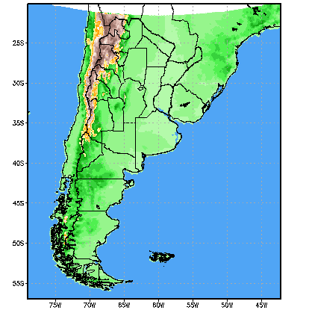 | 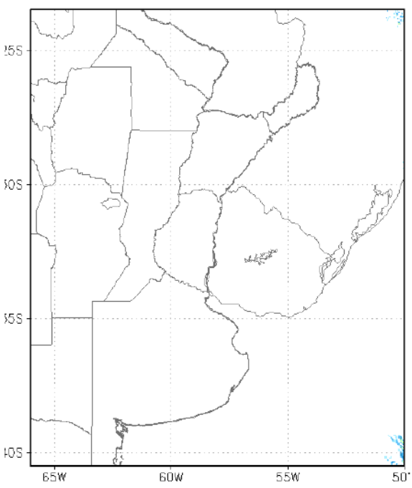

Figure 3:120hs accumulated precipitation (mm) forecasted by WRF-CTRL model (left) and its difference respecto WRF-CPTEC model (right). The squares show the studied subregions.

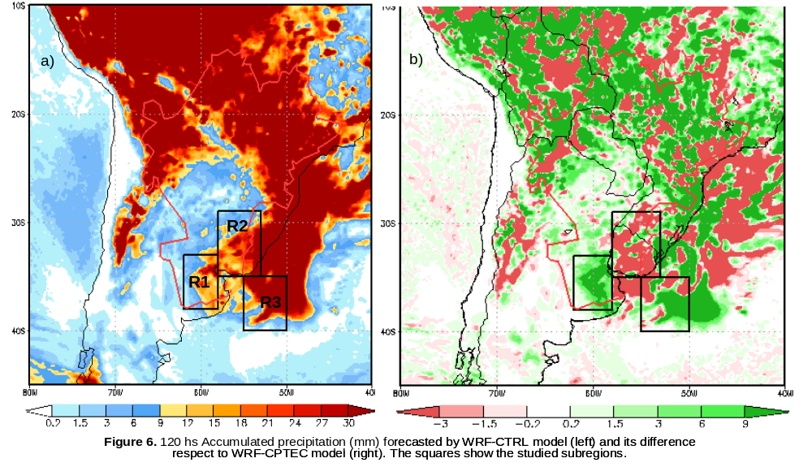

Figure 4: South American domain of the WRF-ARW model daily runs in support of the Uruguay River Monitoring Program.
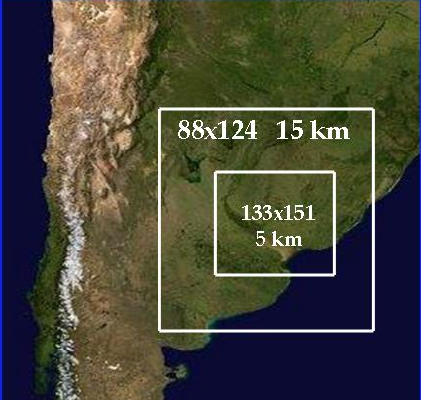

Figure 5: Example of HIRHYLTAD/MBLM 12-hour accumulated plume forecast of the Uruguay River Monitoring Program, in the vicinity of the city of Gualeguaychú | Figure 6: Example of a 36 hr forecast of 4 smoke plumes released from imaginary sources in the vicinity of the city of Buenos Aires. The graph shows the disposition of the instantaneous plumes at 0500 local time of 2 June 2014
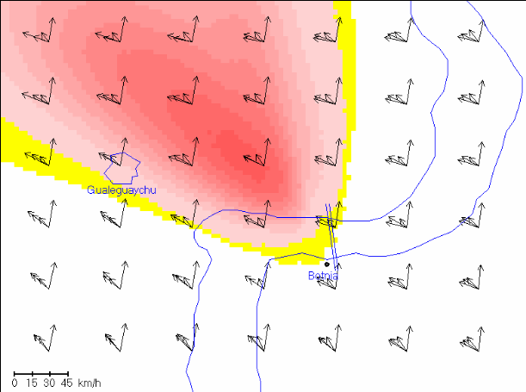 | 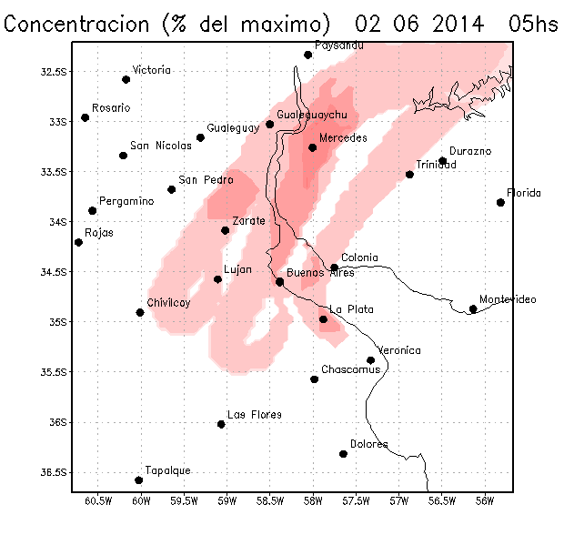

Figure 7: Ash concentration forecasts at 300FT every 3hrs obtained from Fall3d initialized with WRF-ARW and employing Buoyant Plume scheme.



