JOINT WMO TECHNICAL PROGRESS REPORT ON THE GLOBAL DATA PROCESSING AND FORECASTING SYSTEM AND NUMERICAL WEATHER PREDICTION RESEARCH ACTIVITIES FOR 2011

Italy - USAM CNMCA

1. Summary of highlights.
- Consolidation of a very high resolution local area model integrated over the Italian domain (COSMO-IT, 2.8 Km grid spacing)
- An ensemble Kalman filter based data assimilation algorithm (LETKF) is operational since 2011.

2. Equipment in use.

- GTS management:
Message Switching System (MSS)
Computer type: cluster of 2 HP Proliant ML350
OS: Linux RH 4.0
RDBMS: MySQL in High Availability.

- Data collecting and processing system:
The data collecting and processing system relies upon three RDBMS. In the very first one the data received from the GTS-connected systems are inserted for later use. A second one is being used for filtering, collecting and processing data for daily operational activity. A third RDBMS is being used for collecting weather data when they become aged and are made available for climatological studies. An High Availability HP Tru64 cluster (in active/active failover configuration) is being used for this task. It is composed of
  - 2 Compaq AlphaServer GS60E each with 4 processors EV6 and EV67 onboard;
  - 2 HP ES 45 each with 4 processors EV68C onboard.
The operating system in use is UNIX in the HP Tru64 version, while IBM Informix RDBMS are being used. The mentioned cluster has dedicated storage shaped in a 5+1 RAID configuration.

Since October 2009 a non-conventional observations collecting system is in pre-operational mode. The focus is to extend the number of observations provided to the data assimilation system. The equipment in use is composed of
  - 1 HP Server with 2 Intel Xeon 5310 4 cores processors;
The operating system in use is Suse SLE 10.3 and the database is mysql.

A G.I.S. project is in advanced development form and it is hosted on
  - 1 HP Server with 2 Intel Xeon 5310 4 cores processors;
The operating system in use is Suse SLE 10.3 and the database is mysql.

- GRIDDED data collecting system:
The task is accomplished by a software application named DISTRI.C.O. (an acronym in Italian language referring to the concept of GRIB files Distributing System). It works as a FRONT-END for GRIB format data file reception and as BACK-END for GRIB format data file re-distribution to final users. The application runs on an ALPHA Tru64 cluster composed of 2 HP DS20E machines. The application architecture relies upon a RDBMS Informix configured in High Availability arrangement - structured in an active/active failover configuration.

- High Performance Computing Resources:
Since September 2009 a new High Performance Computing Facility has been set up at the National Center for Aeronautical Meteorology and Climatology. In December 2009 such a computing facility has become fully operational. The computing facility is a 194 nodes Hewlett Packard Linux Cluster arranged in three different groups; the first group consists of 128 nodes each of them with two quad-core Intel Harpertown 3.16 GHz onboard. The amount of volatile memory for a single node in this case is 8 GB. The second group consists of 64 dual-processor nodes with the 2.6 GHz AMD Opteron and in this case the amount of volatile memory is 4 GB, The third group is made up by two control nodes in High Availability configuration assisting the whole set of 192 computing nodes. The overall peak performance of the Computing Facility is 12,6 Teraflops.

3. Data and Products from GTS in use (daily)

Data received from GTS:

AIREP | AMDAR | BUOY | PILOT | SHIP | SYNOP | TEMP-TEMPSHIP | PROFILER | AMV  MSG/MODIS | ACAR
4450 | 38400 | 800 | 50 | 14600 | 100500 | 2300 | 3300 | 275000 | 20000

GRIB from UK Met Office: 8000
BUFR from UK Met Office. 100

RAOB | ASCAT METOP | IASI L2
88900 | 125.700 | 15.800

GRIB from ECMWF (Global model, EPS model, Wave model): 6000
GRIB from ECMWF (Boundary Condition): 23000

4. Forecasting system.
The operational short-range numerical forecasting system is composed of :
- Ensemble Kalman Filter (EnKF) Data Assimilation System based on the CNMCA LETKF algorithm and the hydrostatic regional model HRM integrated over the Mediterranean-European region (10km, 40 vertical levels);
- High-resolution non-hydrostatic model COSMO-ME integrated over the Mediterranean-European region (7km);
- Very high-resolution non-hydrostatic model COSMO-IT integrated over the Italian region (2.8km resolution).
COSMO-ME is initialised by the CNMCA EnKF data assimilation system and driven by IFS boundary conditions. COSMO-IT is nested into COSMO-ME. Along with the standard LETKF analysis, a control state LETKF analysis is computed using the standard Kalman gain and a control run, instead of the background ensemble mean. COSMO-ME is initialised by the control state of the CNMCA data assimilation cycle and driven by IFS boundary conditions. COSMO-IT is nested into COSMO-ME.

4.1 System run schedule and forecast ranges

The schedule of the short range forecasting system, based on LETKF Analysis, is the following:

 | 0000 UTC | 0600 UTC | 1200 UTC | 1800 UTC
Cut-off | 2h 50m | 2h 50m | 2h 50m | 2h 50m
LETKF analysis end | 03.40 UTC | 09.40 UTC | 15.40 UTC | 21.40 UTC

The high resolution forecasting system has the following schedule
:
 | 0000 UTC | 1200 UTC
COSMO-ME range | 72h | 72h
COSMO-ME time step | 60” | 60”
COSMO-ME end | 04.30 UTC | 16.30 UTC

 | 0000 UTC | 1200 UTC
Nudging | 05.20 UTC | 17.50 UTC
COSMO-IT range | 24h | 24h
COSMO-IT time step | 25” | 25”
COSMO-IT end | 05.00 UTC | 17.00 UTC

4.2 Medium range forecasting system (4-10 days)

4.2.1 Data assimilation, objective analysis and initialization
4.2.1.1
None

      - Research performed in this field

No research performed in this field

4.2.2 Model
4.2.2.1 In operation.

The ECMWF T71279L91 operational deterministic model is being used at CNMCA. Surface and upper air fields of the 00Z and 12Z runs are routinely downloaded via RMDCN on 0.25° horizontally spaced mesh for surface fields and on a 1.0° horizontally spaced mesh for upper air fields. An increase of the horizontal resolution is being considered and made operational before the end of 2010. The effective horizontal resolution will be determined considering all the data traffic made possible by the current available bandwidth. A bi-dimensional pictorial representation of such fields is being used for operational meteorological support worldwide within 80° N and 60°S. The same data are being used for text and pictorial representation for single site forecasts within the same area. All the upper air fields refer to pressure levels from 925 HPa up to 50 HPa. The time step between two following meteorological fields products issued is 6 hours from T+0h until T+168h and 12 hours between T+168h and T+240h. The possibility to reduce the time step to 3 hours is being considered and applied if allowed by the available bandwidth.

4.2.2.2 Research performed in this field
None

4.2.3 Operationally available Numerical Weather Prediction Products.
The following field parameters are operationally available. Most of them are pictorially represented in the form of bidimensional lat-lon maps.

ECMWF T1279L91 deterministic atmospheric model from 00Z and 12Z runs:

Analysis products.

Surface parameters:
- Mean sea level pressure;
- 10 meters wind;
- 2 meters temperature;
- 2 meters dew point.

Upper Air parameters:
- Geopotential Height at 1000 HPa, 925 HPa, 850 HPa, 700 HPa, 500 HPa,300 HPa;
- Temperature at 1000 HPa, 925 HPa, 850 HPa, 700 HPa, 500 HPa,300 HPa;
- Vertical Velocity at 700 HPa;
- Vorticity at 500 HPa;
- Potential Vorticity at 300 HPa.

Forecast products.
Surface parameters:
- 6 hours integrated total and convective precipitation;
- 12 hours integrated total and convective precipitation;
- 2 meters air temperature;
- 2 meters max air temperature in the last 6 hour period;
- 2 meters min temperature in the last 6 hours period;
- 2 meters dew point temperature;
- Mean sea level pressure;
- Surface Pressure;
- Weather impacts on specific activities determined by threshold values set on meteorological impact parameters;
- Vertical Velocity at 700 HPa;
- 10 meters wind;
- Total cloud cover, Low cloud cover, High cloud cover, Medium cloud cover;
- 10 meters wind max gust;

Upper air parameters:
- Geopotential height at 1000 HPa, 925 HPa, 850 HPa, 700 HPa, 500 HPa, 300 HPa;
- Temperature at 1000 HPa, 925 HPa, 850 HPa, 700 HPa, 500 HPa, 300 HPa;
- Wind at 1000 HPa, 925 HPa, 850 HPa, 700 HPa, 500 HPa, 300 HPa;
- Relative Humidity at 1000 HPa, 925 HPa, 850 HPa, 700 HPa, 500 HPa, 300 HPa;
- Wet bulb potential temperature at 850 HPa and 700 HPa;
- Vorticity at 500 HPa;
- Isoentropic potential vorticity IPV = 2 at 300 HPa;

ECMWF WAM wave model from 00Z and 12Z runs:

Forecast Products:

- Significant wave height;
- Mean direction of significant wave height;
- Mean period of significant wave height.

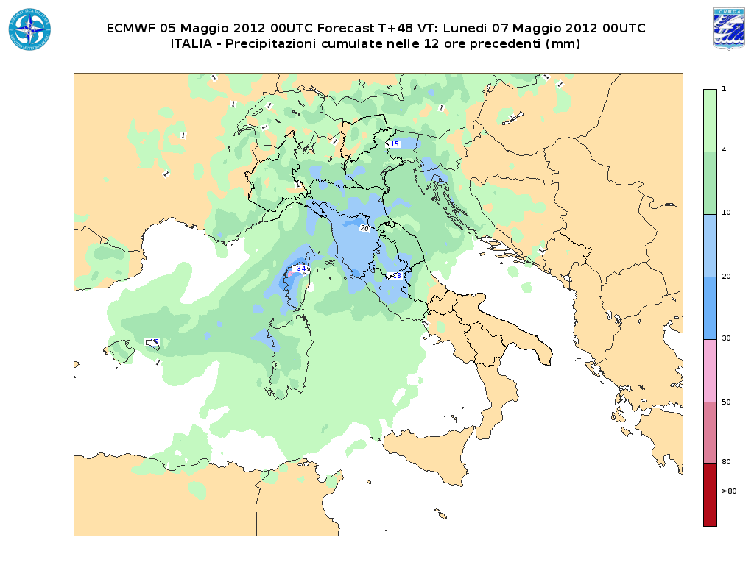
Fig.1 Example of pictorial representation of 12 hours time interval integrated precipitation from ECMWF T1279L91 operational model.

4.2.4 Operational techniques for application of NWP products (MOS, PPM, KF, Expert Systems, etc..)
4.2.4.1 In operation

ARGO
Statistical (perfect-prog) post-processing local forecasts from ECMWF model outputs are still regularly produced for 150 Italian stations, at 6 hours intervals and up to 144 hours.

4.2.4.2 Research performed in this field

New evaluation of ARGO coefficients.

4.2.5 Ensemble Prediction System (EPS)
4.2.5.1 In operation
None

4.2.5.2 Research performed in this field
Use of ECMWF EPS system

4.2.5.3 Operationally available EPS Products
Products and maps from ECMWF EPS, like EPSgrams, probability maps and plumes.

4.3 Short-range forecasting system (0-72 hrs)

4.3.1 Data assimilation, objective analysis and initialization
4.3.1.1 In operation.

The operational data assimilation cycle (Bonavita, Torrisi and Marcucci, Q.J.R.M.S. 2008, 2010) is based on the Ensemble Kalman Filter (EnKF) approach, in particular the LETKF version (Hunt et al.2007) has been chosen. The CNMCA-LETKF data assimilation is running on the Mediterranean-European domain with 40 ensemble members plus a control run, having a 0.09° grid spacing (∼10 km) and 40 vertical levels. The control state LETKF analysis is computed using the standard Kalman gain and a control run, instead of the background ensemble mean. The COSMO-ME deterministic run is initialized from the LETKF control state analysis.
Temperature, wind and specific humidity on model levels and surface pressure are provided

The main characteristics of the operational atmospheric data assimilation system are reported in the following table:

Assimilated obs. | SYNOP, SHIP, BUOY, TEMP, SHIP, PILOT, WIND-PROFILER/RADAR, AIREP, AMDAR, ACAR, AMV from MSG2, , scatterometers winds from METOP and AMSU-A radiances (since june 2012)
Assimilation cycle | 6 hours
Analysis method | LETKF
First guess | 6 hours HRM forecasts
Coverage | Mediterranean European region
Horizontal resolution | 0.09 ° x 0.09 °
Vertical resolution | 40 model levels
Initialization | DFI
Model and sampling error | “Relaxation-to-prior spread”multiplicative inflation method according to Whitaker et al. 2010  Climatological additive noise
Lateral and surface BCs perturbation | Lateral Boundary Perturbation with ECMWF EPS  Climatological perturbed SST

A 3 hourly intermittent data assimilation cycle using a multivariate three dimensional variational scheme (3D-VAR) – physical space analysis system (PSAS) with first guess at right time (FGAT) (Bonavita and Torrisi, Meteorol. Atmos. Phys. 8, 2005) is running only to produce Euro Atlantic synoptics maps. Temperature, wind and specific humidity on 40 model levels and surface pressure are provided on the Euro-Atlantic domain (14 km, Fig.1).
The main characteristics of the 3DVAR atmospheric data assimilation system are reported in the following table:

Assimilated obs. | SYNOP, SHIP, BUOY, TEMP, SHIP, PILOT, WIND-PROFILER/RADAR, AIREP, AMDAR, ACAR, AMV from MODIS and MSG2, scatterometers winds from METOP and AMSU-A radiances.
Assimilation cycle | 3 hours
Analysis method | 3D Multivariate FGAT PSAS analysis
First guess | 3 hours EuroHRM forecasts
Coverage | Euro-Atlantic area
Horizontal resolution | 0.125° x 0.125°
Vertical resolution | 40 model levels
Initialization | Incremental DFI

The DWD variational soil moisture analysis using SYNOP observations is run at 00 UTC. The IFS snow analysis masked with the snow LAND-SAF product along with the IFS sea surface temperature are used once a day.
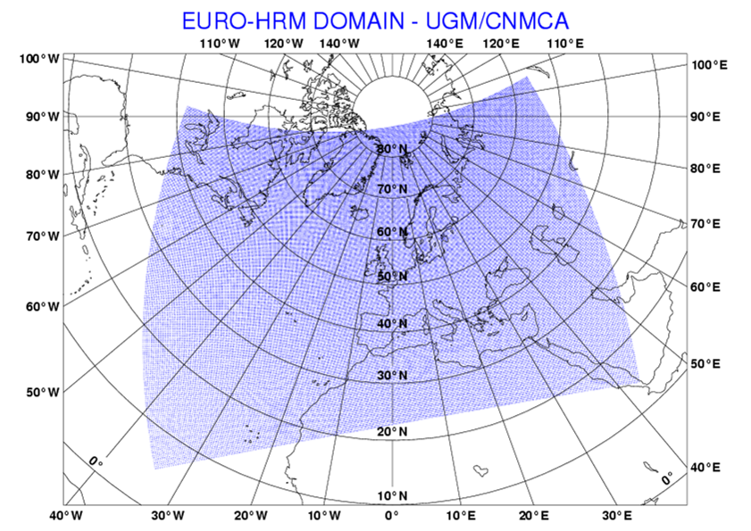

Fig.1 Integration domain for the EURO-HRM hydrostatic model

4.3.1.2 Research performed in this field

Recent developments are:
- Consolidation of the LETKF algorithm and migration from 3DVAR to LETKF as operational assimilation scheme;
- Improvement of lateral boundary treatment (perturbation with EPS);
- Monitoring of IASI temperature profiles and evaluation of their error characteristics as possible candidates at new assimilated data;
- Monitoring of non-GTS local surface observations;
- Assimilation tests of AMSU-A radiances in LETKF according to methods proposed in Fertig et al. 2007;
- Monitoring of radiosounding observations reporting latitude-longitude displacements.

Current development activities comprise:
- Further tuning of the operational LETKF setup ;
- Tests of LETKF assimilation using COSMO model;
- Monitoring of new satellite data (AMSU-B, MHS radiances, HIRS, etc)
- Optimization of observation selection in the local patch in order to reduce the computation time without loss of information;
- Continue investigation of model error representation (covariance localization, stochastic physics, bias correction, etc);
- Handling non-linearities and balancing issues;
- Short-range ensemble prediction system based on the LETKF data assimilation system.

4.3.2 Model
4.3.2.1 In operation
[Model in operational use, (domain, resolution, number levels, range, hydrostatic?, physics used)]

Non-Hydrostatic Modeling

The non-hydrostatic modelling area is based on a COSMO model. COSMO-ME is integrated over the European area with a 7km grid spacing (fig. 2) using interpolated CNMCA LETKF control analysis as initial state and IFS forecast fields as lateral boundary conditions. Vertical resolution is 40 vertical levels.
The main features of the operational implementations of the COSMO-ME are summarized in the following table:

COSMO-ME
Domain size | 779x 401
Grid spacing | 0.0625° (7km)
Number of layers / top | 60 / ∼22 Km
Time step and integration scheme | 40 sec Runge-kutta HE-VI time-splitting
Forecast range | 72 hrs
Initial time of model run | 00/12 UTC
Lateral boundary conditions | IFS
L.B.C. update frequency | 3 hrs
Initial state | Interpolated LETKF CNMCA control state analysis
Initialization | None
External analysis | snow cover,SST
Special features | Filtered topography
Status | Operational
Hardware | HP Cluster Linux (CNMCA)/IBM P690 (ECMWF)

COSMO-IT is the very high resolution configuration of COSMO Model integrated over the Italian domain (Fig.3) using COSMO-ME fields as boundary conditions.

COSMO-IT
Domain size | 542x 604
Grid spacing | 0.025° (2.8 km)
Number of layers / top | 65 / ∼22 Km
Time step and integration scheme | 25 sec Runge-Kutta HE-VI time-splitting
Forecast range | 24 hrs
Initial time of model run | 00/12 UTC
Lateral boundary conditions | COSMO-ME
L.B.C. update frequency | 1 h
Initial state | Nudging
Initialization | None
External analysis | None
Special features | Filtered topography
Status | Operational
Hardware | HP Cluster Linux (CNMCA)/IBM P690 (ECMWF)

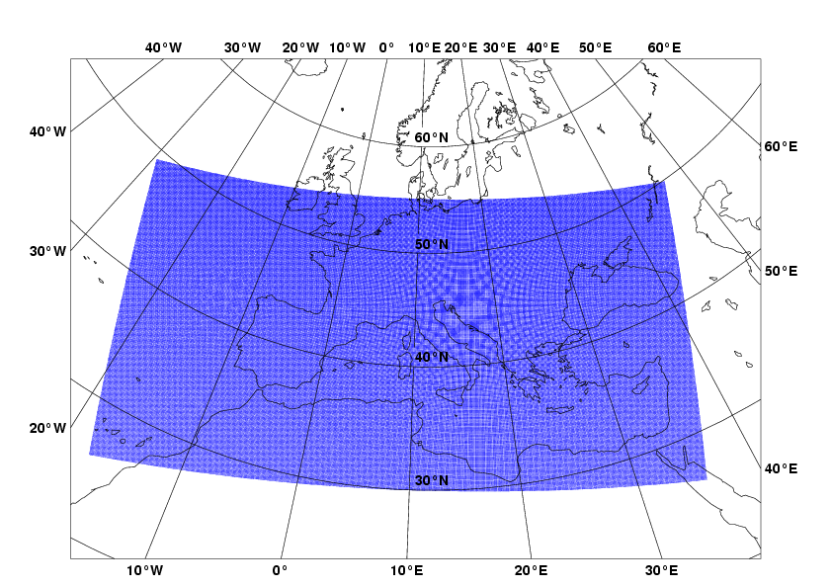
COSMO-ME
- CNMCA

Fig. 2: Integration domain for the COSMO-ME non-hydrostatic model implementation.
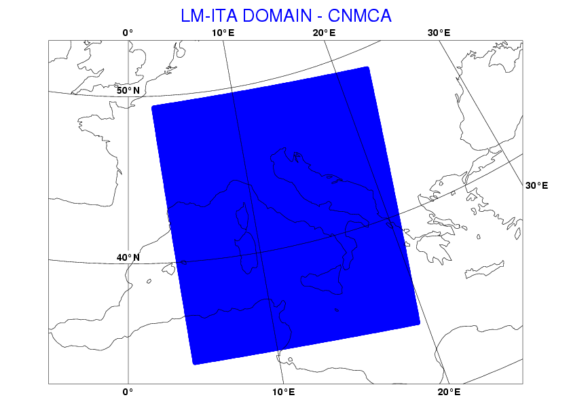
COSMO-IT

Fig. 3: Integration domain for the COSMO-IT non-hydrostatic model implementation.

4.3.2.2 Research performed in this field

- test of new physical parameterizations (e.g. marine surface layer) in COSMO models;
- test of COSMO-IT rapid update cycle;
- deterministic post-processing of COSMO-IT fields;
- reduction of COSMO-ME grid spacing to 5km and of COSMO-IT grid spacing to 1.6km.

4.3.3 Operationally available NWP products.

Prognostic variables on model levels:
Temperature, specific humidity, zonal and meridional wind component, vertical wind component (COSMO), cloud water content, cloud ice content, water content of rain and snow (COSMO), surface pressure (HRM), pressure perturbation (COSMO), turbulent kinetic energy (COSMO).

Prognostic surface fields:
Temperature, water content and ice content of soil layers, temperature of snow surface, snow density, water content of snow and interception store.

Diagnostic fields:
2m temperature, 2m dew point, 10m wind components, mean sea level pressure, total precipitation, synthetic satellite radiances (COSMO), and so on.

A detailed list of numerical weather products available is given below:

COSMO-ME not-hydrostatic deterministic atmospheric model from 00Z and 12Z runs:

Analysis Products:

Surface parameters:
- Mean sea level pressure;
- 2 meters temperature;
- 2 meters dew point temperature;
- 10 meters wind;

Upper air parameters:
- Geopotential height at 1000 HPa, 925 HPa, 850 HPa, 700 HPa, 500 HPa, 300 HPa, 200 HPa, 100 HPa;
- Air temperature at 1000 HPa, 925 HPa, 850 HPa, 700 HPa, 500 HPa, 300 HPa, 200 HPa, 100 HPa;
- Horizontal wind at 1000 HPa, 925 HPa, 850 HPa, 700 HPa, 500 HPa, 300 HPa, 200 HPa, 100 HPa;
- Rel Humidity at 1000 HPa, 925 HPa, 850 HPa, 700 HPa, 500 HPa, 300 HPa, 200 HPa, 100 HPa.

Forecast Products:

Surface parameters:
- Mean sea level pressure;
- 2 meters air temperature;
- 2 meters max and min air temperature;
- 2 meters dew point temperature;
- 10 meters wind;
- 10 meters max gust;
- Total cloud cover, low cloud cover, medium cloud cover, high cloud cover;
- Base height and top height of convective clouds;
- 6-hours integrated precipitation;
- 6-hours convective precipitation;
- 2 meters relative humidity.

Upper air parameters:
- Geopotential height at 1000 HPa, 925 HPa, 850 HPa, 700 HPa, 500 HPa, 300 HPa, 200 HPa, 100 HPa.
- Air temperature at 1000 HPa, 925 HPa, 850 HPa, 700 HPa, 500 HPa, 300 HPa, 200 HPa, 100 HPa.
- Wind at 1000 HPa, 925 HPa, 850 HPa, 700 HPa, 500 HPa, 300 HPa, 200 HPa, 100 HPa.
- Relative Humidity at 1000 HPa, 925 HPa, 850 HPa, 700 HPa, 500 HPa, 300 HPa, 200 HPa, 100 HPa.

COSMO-IT not-hydrostatic deterministic atmospheric model from 00Z and 12Z runs:

Analysis Products:

Surface parameters:
- Mean sea level pressure;
- 2 meters temperature;
- 2 meters dew point temperature;
- 10 meters wind;

Upper air parameters:
- Geopotential height at 1000 HPa, 925 HPa, 850 HPa, 700 HPa, 500 HPa, 300 HPa, 200 HPa, 100 HPa;
- Air temperature at 1000 HPa, 925 HPa, 850 HPa, 700 HPa, 500 HPa, 300 HPa, 200 HPa, 100 HPa;
- Horizontal wind at 1000 HPa, 925 HPa, 850 HPa, 700 HPa, 500 HPa, 300 HPa, 200 HPa, 100 HPa;
- Rel Humidity at 1000 HPa, 925 HPa, 850 HPa, 700 HPa, 500 HPa, 300 HPa, 200 HPa, 100 HPa.

Forecast Products:

Surface parameters:
- Mean sea level pressure;
- 2 meters air temperature;
- 2 meters max and min air temperature;
- 2 meters dew point temperature;
- 10 meters wind;
- 10 meters max gust;
- Total cloud cover, low cloud cover, medium cloud cover, high cloud cover;
- Base height and top height of convective clouds;
- 6-hours integrated precipitation;
- 6-hours convective precipitation;
- 2 meters relative humidity.

Upper air parameters:
- Geopotential height at 1000 HPa, 925 HPa, 850 HPa, 700 HPa, 500 HPa, 300 HPa, 200 HPa, 100 HPa.
- Air temperature at 1000 HPa, 925 HPa, 850 HPa, 700 HPa, 500 HPa, 300 HPa, 200 HPa, 100 HPa.
- Wind at 1000 HPa, 925 HPa, 850 HPa, 700 HPa, 500 HPa, 300 HPa, 200 HPa, 100 HPa.
Relative Humidity at 1000 HPa, 925 HPa, 850 HPa, 700 HPa, 500 HPa, 300 HPa, 200 HPa, 100 HPa.

VERTICAL PROFILES

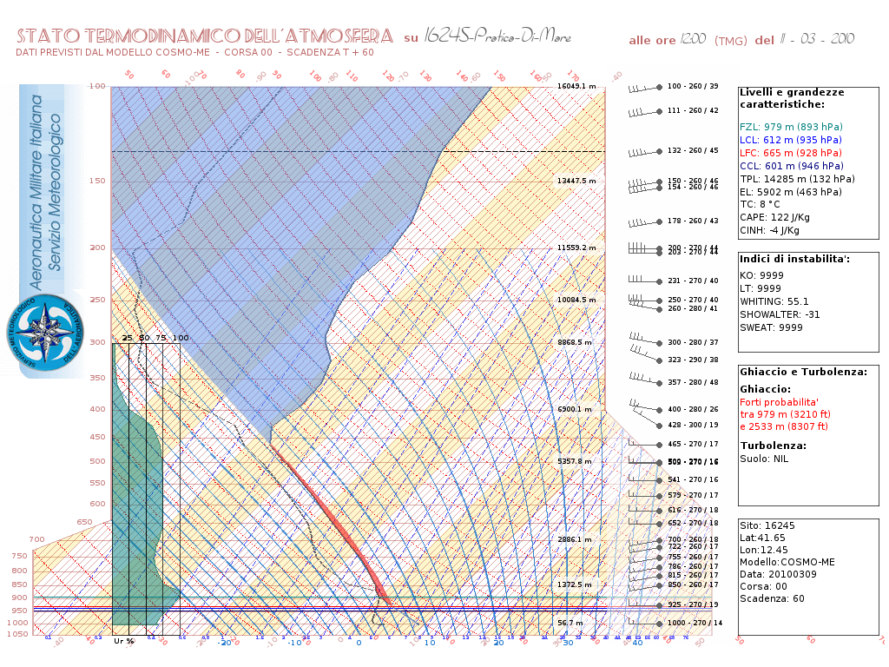

Fig. 4: Example of Vertical profile product from COSMO-ME model fields

A new pictorial representation of vertical profiles has been developed, validated and made operational since summer 2009. In this context an Herloffson diagram is being operationally used. It is an exact digital replica of the paper version used in the past by the Italian Met Service personnel to plot upper air observations. It is used both for observations and forecasts plotting.

METGRAMS
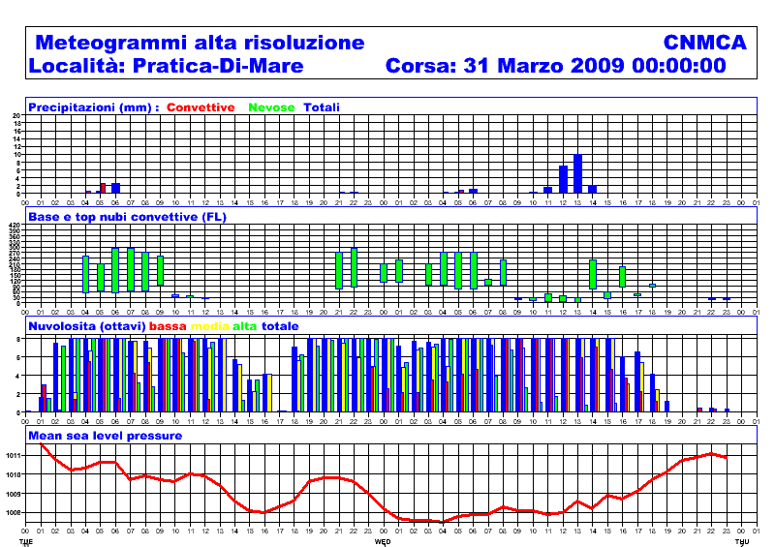

Fig. 5: Example of a meteogram product from COSMO-ME model fields

A massive production of metgrams is being operational at the Italian Met Service. Every day more than 3000 metgrams are being produced and delivered to final users on the Italian Air Force web site via “http” and “ftp” protocols. A thematic criteria is used to produce different kind of metgrams. Aeronautical metgrams are conceived for example in terms of a set of meteorological parameters specific for aeronautical use like ceiling and top of convective clouds, convective and large scale precipitation discriminating rain from snow, low, medium and high cloud coverage, mean sea level pressure and QNH. General purpose metgrams are instead conceived in terms of more general meteorological parameters such as mean sea level pressure, 2m temperature, 2m relative humidity, 10 m horizontal wind. Besides new thematic metgrams are being developed. Among them it is important to point out the “transport theme” which will include all the meteorological parameters related to surface transports (railways, highways, and maritime routing).

WEGO

The new CNMCA Project Weather Environment GIS Oriented (WEGO) it is under development phase and some of its functionalities are already fully operational and available on the Air Force Met Service Intranet. The basic idea is to provide Meteorological information, forecasts as well as observation, on a GIS environment to exploit the possibility to connect the very high resolution models available at CNMCA to the real orography and/or specific sites like airports, highways, hydrological basins and so on. The application is web-based and the production of Metgrams on the fly from all the operational models is already operational. Below a metgram on a grid point around Rome is shown. The metgram is created in real time on any of the available grid points of the model chosen by the user taking into account the orography, the position, the land/sea fraction and in the general the similarity with the real site you need to have the forecasts. Through the use of IFS model, on the fly Metgrams are available all over the world.
Next implementations are: Vertical Profiles on demand all over European area with non-hydrostatic models, Meteorological maps with a special transparent background in order to make the orography and other layers visible below and the overlap functionalities in order to create your own composition of fields.
In the overall plan WEGO is the core of the new Meteorological Workstation for forecasters.
The GIS engine has been chosen to be Google map, but other GIS layers can be used.
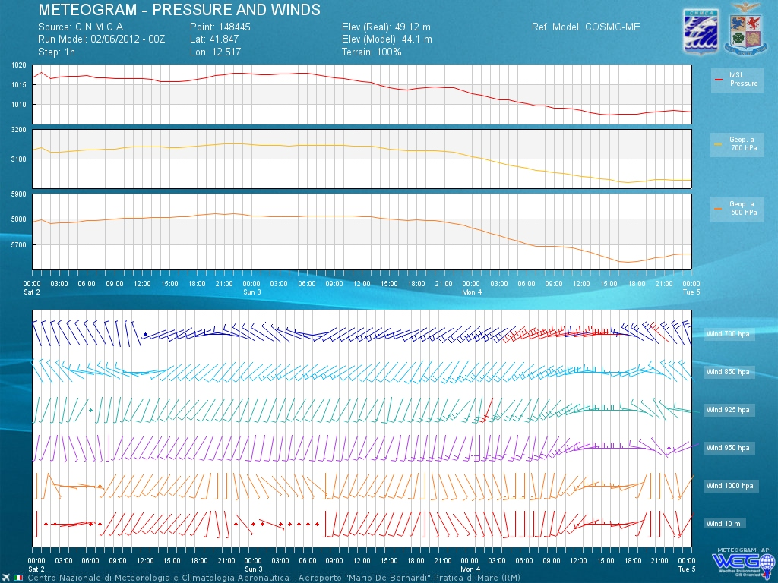

SYNTHETIC SATELLITE IMAGES

A process-based modelling approach is used to generate synthetic satellite images from COSMO-ME outputs. The method is based on the radiative transfer model code RTTOV (currently parallelized code of version 7.1 is used).

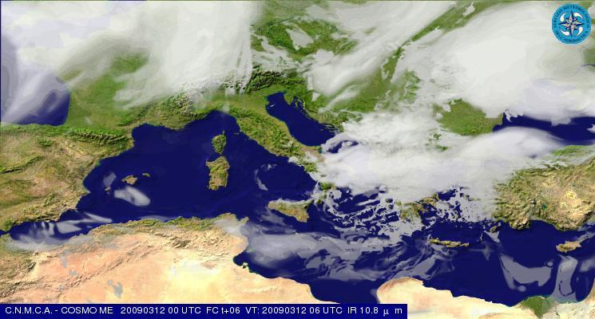

Fig. 6: Example of a synthetic satellite simulated image using COSMO-ME model outputs

AWI

A deterministic post-processing package of the COSMO-ME model fields known as Automatic Weather Interpretation (AWI) is in use at CNMCA. A series of multi-parameter decisional tree allows the determination of weather phenomena (drizzle, rain, snow, thunderstorms, fog, etc.) as well as of the cloud type, the risk of icing, strong wind or heat waves. Details are given in Ciciulla (Workshop on Statistical and Dynamical Adaptation, 5–6 May 2003, Wien, http://srnwp.met.hu/). An example of AWI product (referring to significant weather phenomena) is given in Fig. 7. An improvement of the algorithms used in AWI is currently being developed. Current work is focused on the improvement of the algorithms used in AWI.

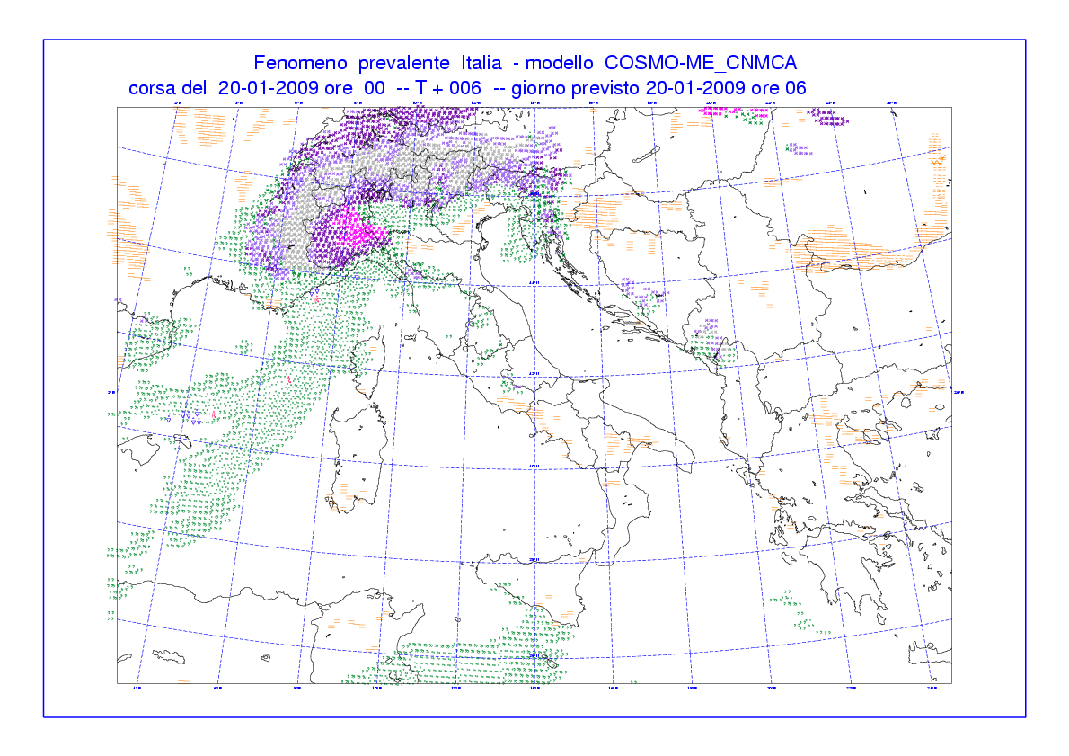
Fig. 7: Example of AWI product from post-processed COSMO-ME model fields.

LOCAL FORECASTS.

The full set of weather parameters from COSMO-ME model and derived variables from Automated Weather Interpreter is daily being retrieved for a collection of about 1200 sites and then encoded both in extended SYNOP-like message and XML format for further applications.
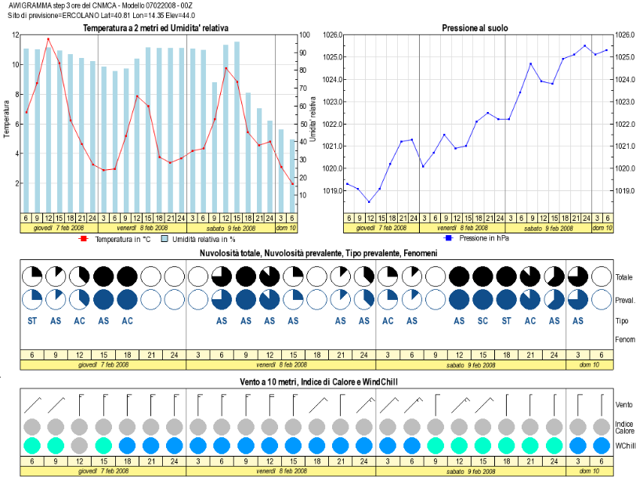

Fig. 8: Example of the pictorial representation of AWI post-processing for local forecast being used at CNMCA.

The main difference between metgrams and the AWI-based local forecasts is in the full exploitation of the the most significant weather phenomena. The forecasters and the final users are being provided with pictorial and text AWI local forecasts via Intranet/Internet sites or via the official FTP public site.

REGIONAL FORECASTS.

As the reader may be aware, the Italian territory is divided into 20 regional bodies called “Regioni” from the administrative point of view. For these bodies a specific weather forecast at CNMCA is daily being prepared and issued 24/7 twice a day. To prepare these product the forecaster is presented a synthetic icon representation inferred from the single point forecasts related to all the grid points pertaining each region up to 78 hours. At each point a set of weather parameters is taken from COSMO-ME model and the weather phenomena insisting on that point is inferred through the set of AWI post-processing algorithms. The synthetic icon representation and its spatial range representativeness is performed by an algorithm set up in cooperation with operational forecasters.

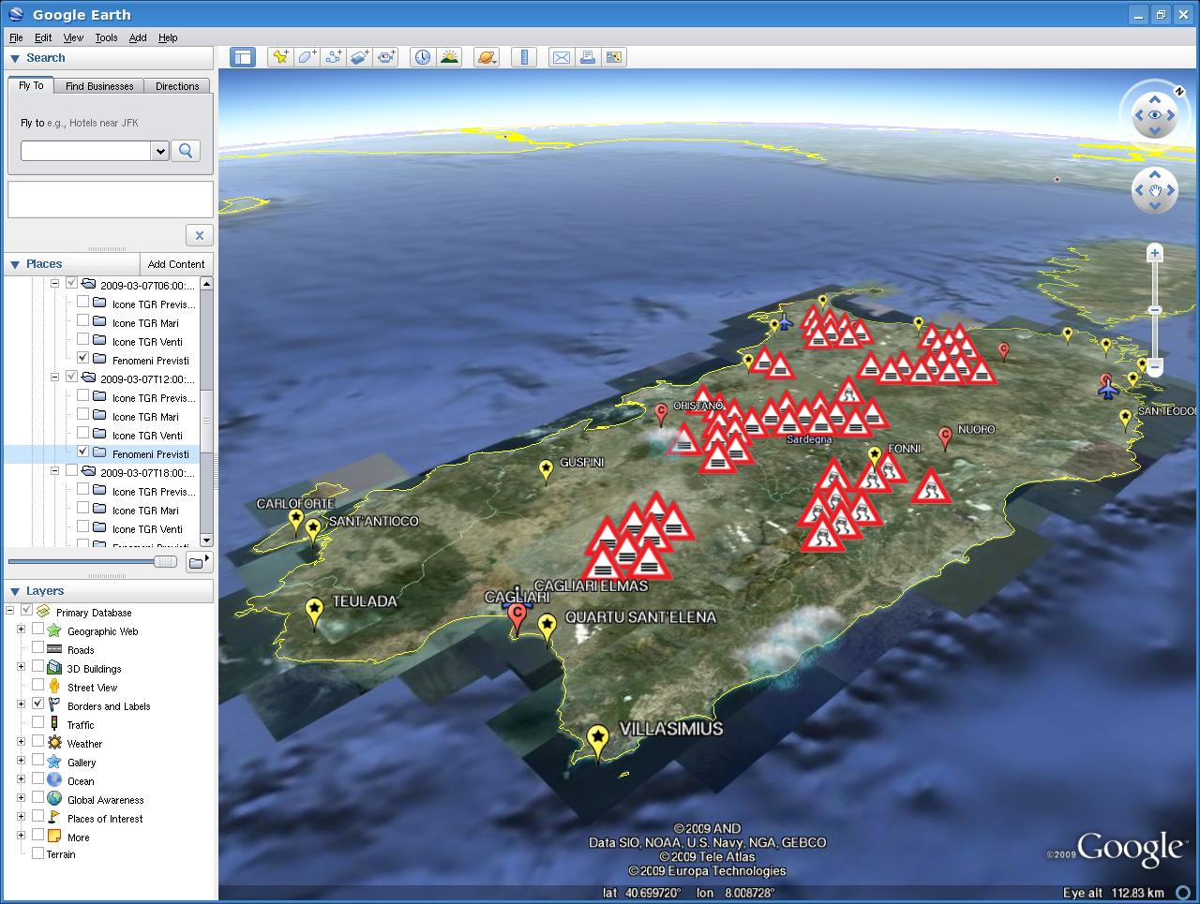

Fig. 9: Example of the pictorial AWI post-processing for the Regional Forecast production being used at CNMCA.

The synthetic icon representation is moreover being furtherly developed with the aim of producing an automated behaviour in Google Earth software where significant icons are displayed while the geographical detail associated to zooming increases.

4.3.4 Operational techniques for application of NWP products
4.3.4.1 In operation
None

4.3.4.2 Research performed in this field

Further progress is expected by the foreseen upgrade with MOS / Kalman Filter based algorithms.
Currently a dependent regression algorithm is operational for about 50 sites, using last 15 days of observations and deterministic forecasts as training dataset. The performance of the statistical algorithm with respect to the deterministic forecast is being investigated.

4.3.5 Ensemble Prediction System
4.3.5.1 In operation
None

4.3.5.2 Research performed in this field

None

4.3.5.3 Operationally available EPS Products

4.4 Nowcasting and Very Short-range Forecasting Systems (0-6 hrs)

4.4.1 Nowcasting system
The Nowcasting activities is based on the management of special observation retrieved from RADAR and
LIGHTINING network and satellite data.

4.4.1.1 In operation

RADAR system:
- SRI composite of radar data collected from the Italian Air force stations (Brindisi, Pisa, Grazzanise, Istrana, Decimomannu), regional meteorological services, National Agency for Civil Aviation, National Department for Civil Protection and few foreign country sites (France, Switzerland, Slovenia) is produced every 15 minutes, as in figure.

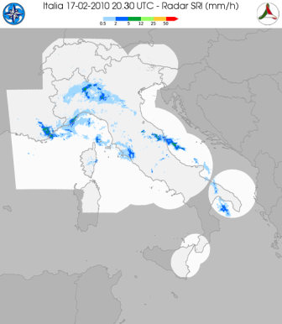

SATELLITE Systems:
The satellite area receives data via EUMETCAST system and from polar satellites (METOP, POESS, FY, TERRA and AQUA). The satellite branch elaborates data in the visible and infrared bands to produce image in b/w and rgb composite. Products of 2nd level are designed for an easy use of satellite information. In 2009 the integration of different sources has been implemented to supply an overview to decision makers about the critical parameters.

The service runs on European and Asiatic areas, but on demand, the service can be exported on area of interest.
The physical parameters managed from Italian Met Service are summarized in the following table:

Parameters | sensor | Area
Cloud Type | SEVIRI | Europe
CTH | SEVIRI | Europe
CTT | SEVIRI | Europe
CTP | SEVIRI | Europe
Convective Clouds | SEVIRI | Europe
LST | SEVIRI | Europe
SST | SEVIRI | Mediterranean
Rain Rate | AMSU/DMSP | Europe/
Accumulated Rain | AMSU/DMSP/SEVIRI | Europe
Total Ozone | SEVIRI | Full Disk
Total Humidity | SEVIRI | Full Disk
AMV | SEVIRI | Italy
Sea Wind | ASCAT/QuickScat | Itally
Volcanic Asch | SEVIRI/AVHRR | Europe/Italy
Fire- probability of detection | SEVIRI | Italy

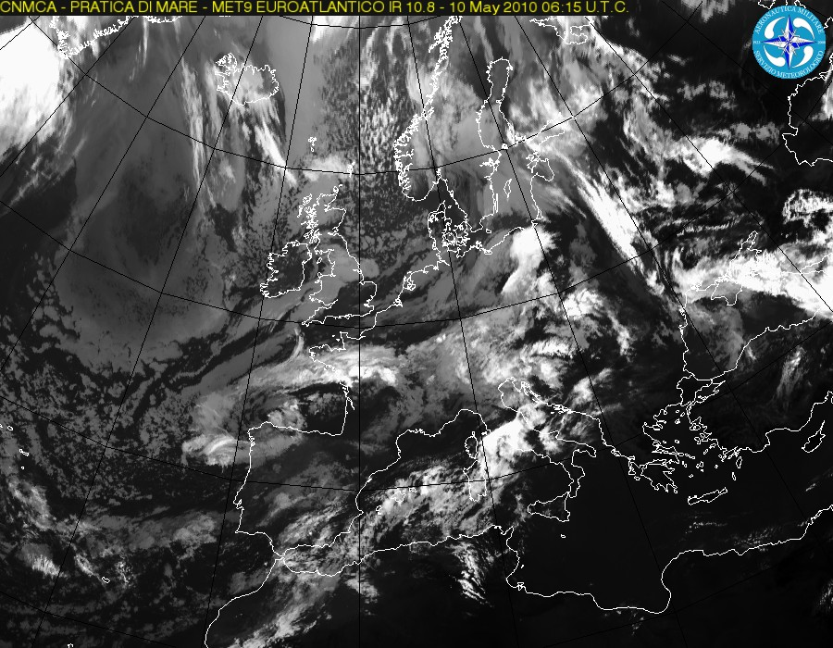

Example of infrared picture on European area.
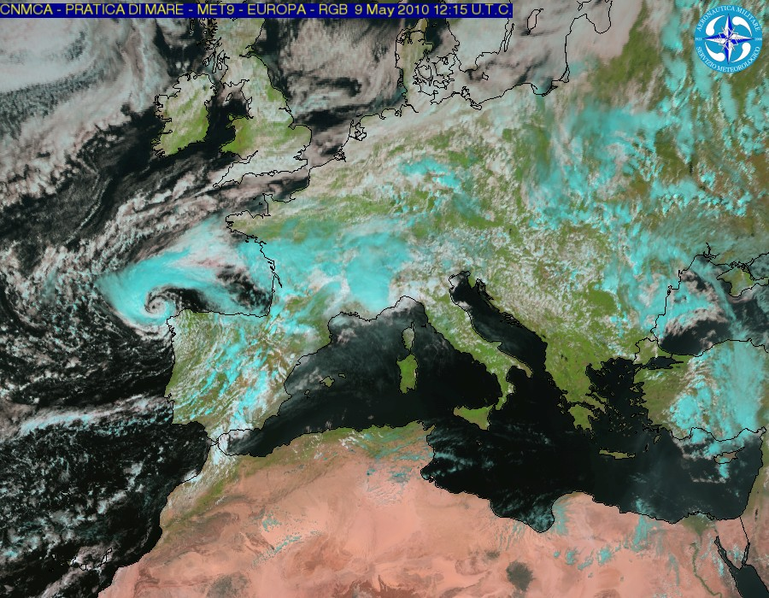
- Example of RGB picture on European area.

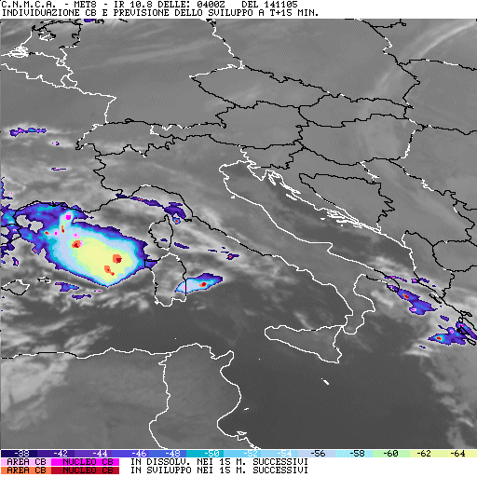

- Example of 2nd level product to recognize and very short range forecasts of stormy cells.

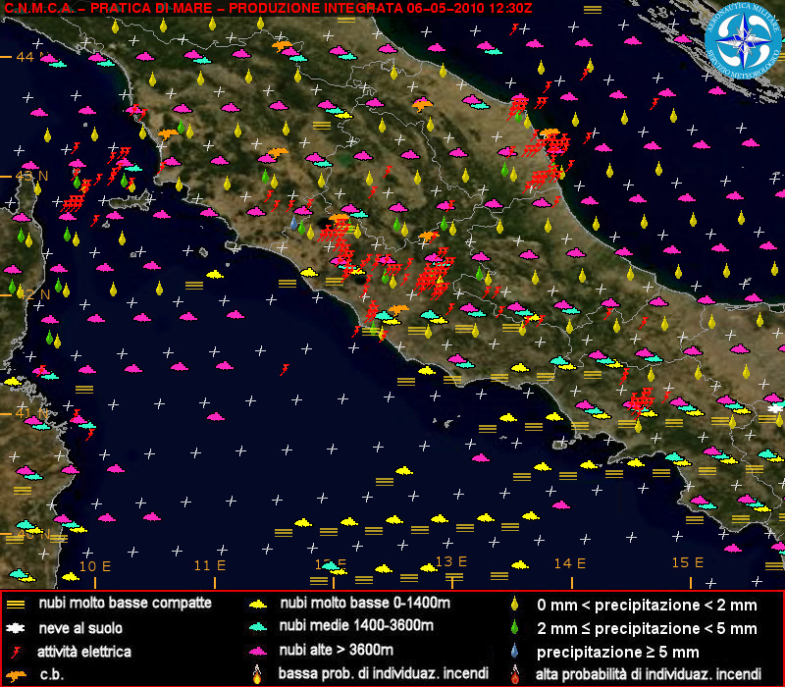

- Example of INTEGRATED INFORMATION TO SUPPORT DECISION MAKERS. The pictures visualizes only the presence of parameters showed and the bottom of the figure. The image summarize a lot of parameters retrieved from different sources.

LIGHTNING DETECTION system:
USAM-CNMCA has realized a national network for the location of electrical discharge, available every 5 minutes

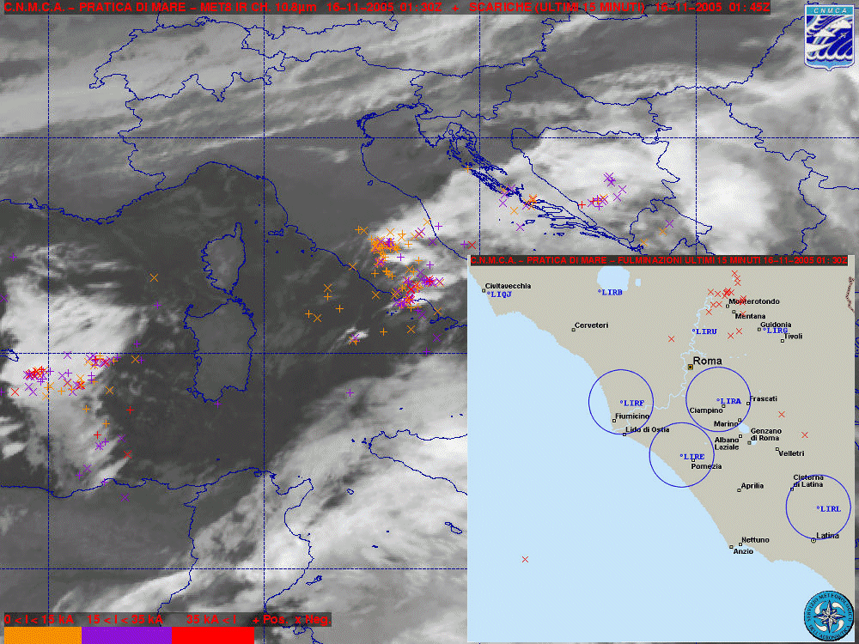

4.4.1.2 Research performed in this field

In 2011 a study sponsored by EUMETSAT was conducted, in the context of Lightning Imager Science Team, with the aim of building a data flow simulator of Meteosat Third generation – Lightning Imager.

4.4.2 Models for Very Short-range Forecasting Systems

4.4.2.1 In operation

None

4.4.2.2 Research performed in this field
None

4.5 Specialized numerical predictions
- The ECMWF T1279L91 fields referring to wind, relative humidity and temperature are being used for NBC protection program. In the same program particle trajectories inferred from ECMWF EPS are used as well.
- The ECMWF T1279L91 wind speed, temperature and relative humidity fields are also used to infer heat index and wind-chill factor.
- From DWD Global Model, UV forecasts are routinely downloaded in text format and pictorially represented within the framework of a population protection program.

In cooperation with CNR-ISMAR institute a sea state forecast system, named NETTUNO, has been implemented in 2008.
In cooperation with INGV-Bologna a high-resolution oceanic model driven by COSMO-ME model is under development.

4.5.1 Assimilation of specific data, analysis and initialization (where applicable)
4.5.1.1 In operation

None

4.5.1.2 Research performed in this field

None

4.5.2 Specific Models
4.5.2.1 In operation

NETTUNO system is based on the ECMWF version of WAM model integrated over the whole Mediterranean basin which is driven by COSMO-ME forecast winds. It was developed in cooperation with the ISMAR-CNR institute of Venice.
Forecast fields (mean wave period and direction, significant wave height) are given every 3 hrs up to 72 hrs.
A brief summary of NETTUNO features is given in the following table:

NETTUNO
Domain size | 846X321
Grid spacing | 0.05°
Time step | 120 s
Forecast range | 72 hrs
Initial time of model run | 00/12 UTC
N° frequencies/directions | 30/36
Atmospheric model wind | COSMO-ME
Wind update frequency | 1 hr
Initial state | Previous run
Status | Operational
Hardware | IBM P690 (ECMWF)

A high resolution (1’) WAM model driven by COSMO-IT wind forecast and nested in the 3’ Nettuno is operational over the Italian domain.

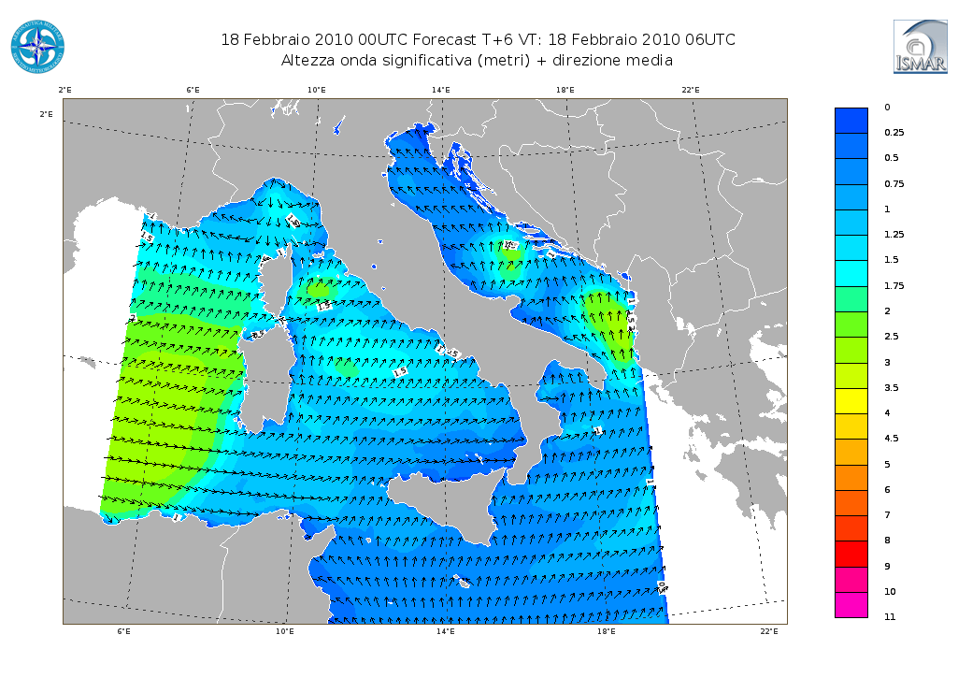
High resolution WAM (1’) driven by COSMO-IT forecast winds

4.5.2.2 Research performed in this field

The use of SWAN model for the sea state forecast near coastal area is also under development in cooperation with CUGRI of Salerno. A two-way coupling between the WAM and COSMO-ME model is under development in collaboration with ISMAR-CNR. The development of a high-resolution oceanic model over Mediterranean Sea forced by COSMO-ME forecasts is ongoing in cooperation with INGV of Bologna.

4.5.3 Specific products operationally available

A variety of products are available twice per day as maps and grib files as well, like mean wave period and direction, significant wave height every 3 hours.

4.6 Extended range forecasts (ERF) (10 days to 30 days)

4.6.1 Models
4.6.1.1 In operation
None

4.6.1.2 Research performed in this field

None

4.6.2 Operationally available NWP model and EPS ERF products

None

4.7 Long range forecasts (LRF) (30 days up to two years)
4.7.1 In operation
None

4.7.2 Research performed in this field

None

4.7.3 Operationally available EPS LRF products
None

5. Verification of prognostic products
5.1
Quality Control of forecast products through the new unified system named VERSUS (VERification System Unified Survey) based on RDBMS system and a web-based GUI are carried out routinely at CNMCA. The development of a complete Conditional and Standard Verification Tool has been the first priority and outcome of the VERSUS project in the COSMO consortium framework (developed in the period 2006-2008).
From a more general point of view the main purpose of VERSUS is the systematic evaluation of model performances in order to reveal, in a way different from the usual classical verification tools, model weaknesses. It is able to provide information providing hints which could be the causes of model deficiencies that can usually be seen in the operational verification.
The typical approach to Conditional Verification consist of the selection of one or several forecast products and one or several mask variables or conditions, which would be used to define for example thresholds for the product verification (e.g. verification of T_{2M} only for grid points with zero cloud cover in model and observations). Through the development of VERSUS software a unified tool able to perform operational standard verifications, operational conditional verifications along with experimental standard and conditional verifications, in batch and interactive mode, has been achieved.

Statistical scores and scores plots are produced for the following NWP models, in operation at CNMCA: COSMO-ME, COSMO-I7, for both surface and upper air parameters; COSMO-IT and ECMWF, only surface parameters.

The following are the basic verified weather parameters for all the models:

- 2m Temperature;
- 10m wind-Speed and direction;
- 6h,12h,24h Cumulated Precipitations;
- MSLP;
- 2m Dew Point Temperature;
- Total cloud cover

along with forecasted upper air parameters:

- Temperature;
- Geopotential;
- Wind speed and direction;
- Relative Humidity and/or Dew point.

These are regularly available every 3 hours (6 or 12 hours for upper-air) for all the Italian Meteorological stations. A set of stratifications in time are routinely performed as follows:

- Monthly mean
- Quarterly mean
- Yearly mean (mainly for the calculation of a Global quality index)

The scores can be also morphologically (or geographically) stratified in coastal, valley and mountain stations or Northern, Central and Southern Italy, all over Italy and so on.

Scores produced for continuous variable are: Mean Error, Mean Absolute Error, Root Mean Squared Error and their respective Skill Scores for accuracy. As reference scores both persistence, random chance and climatology can be used.
Scores produced for categorical events (e.g. precipitation) are computed from a 2*2 contingency table showing the frequency of “yes” and “no” forecasts and corresponding observation. These contingency tables can be computed for different thresholds values. There are a quite large number of measure that can come out from such a table and all of them can be computed through the use of VERSUS software. Among these: frequency bias, probability of detection, false alarm ratio, equitable threat score, odds ratio.
In the following some verification plots are shown as an example for COSMO-ME model 00UTC run, for 2m temperature (ME, MAE and RMSE) and 12h cumulated precipitation (FBI) for 2011:

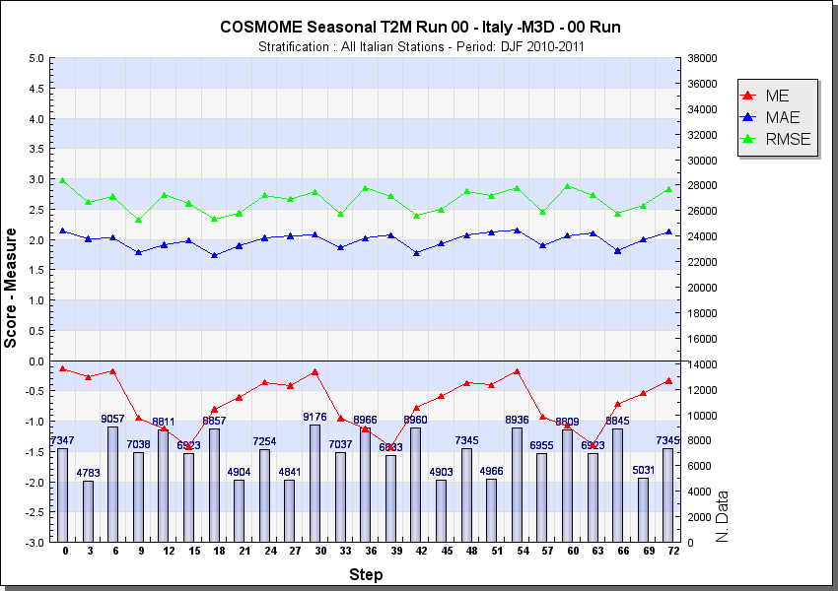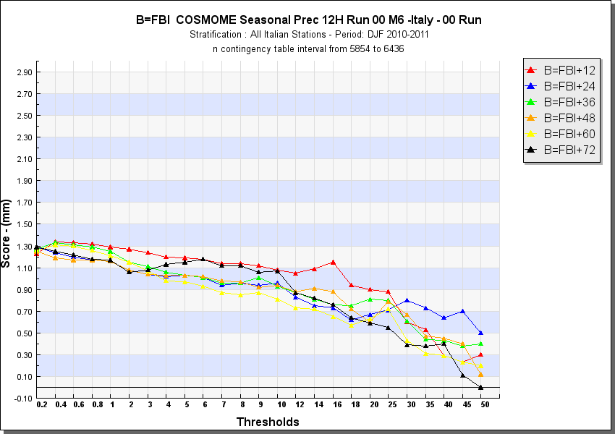

2mT (ME, MAE, RMSE) and 12h precipitation (FBI) on all Italian Stations DJF 2010-2011

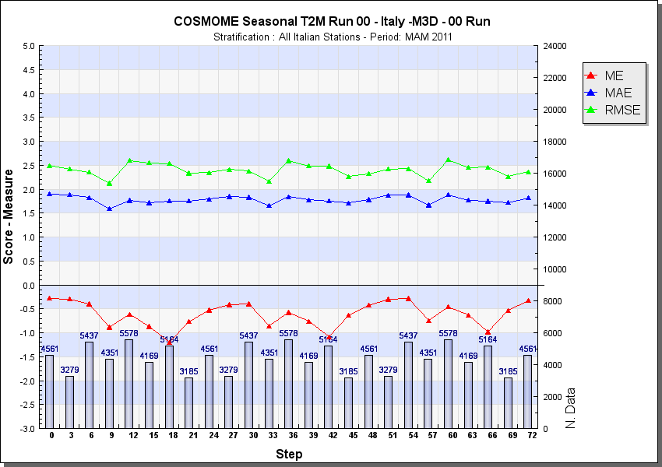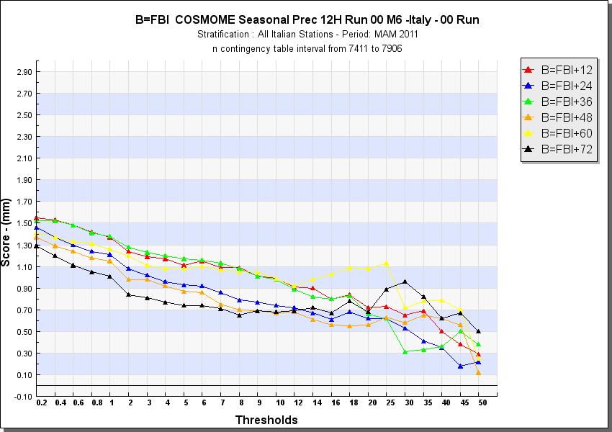

2mT (ME, MAE, RMSE) and 12h precipitation (FBI) on all Italian Stations MAM 2011

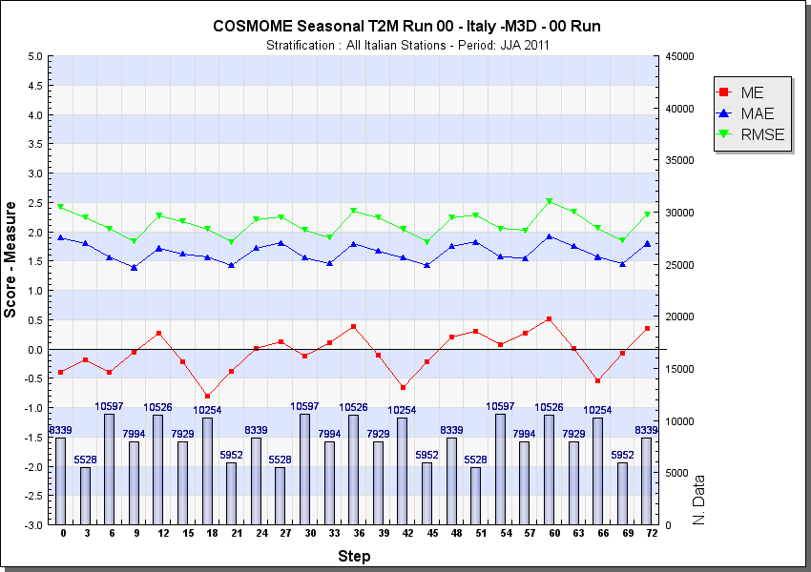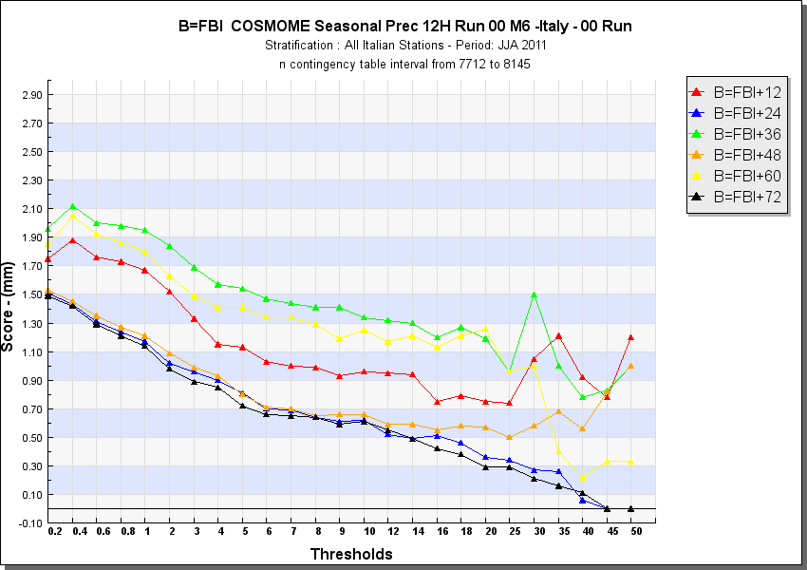
2mT (ME, MAE, RMSE) and 12h precipitation (FBI) on all Italian Stations JJA 2011

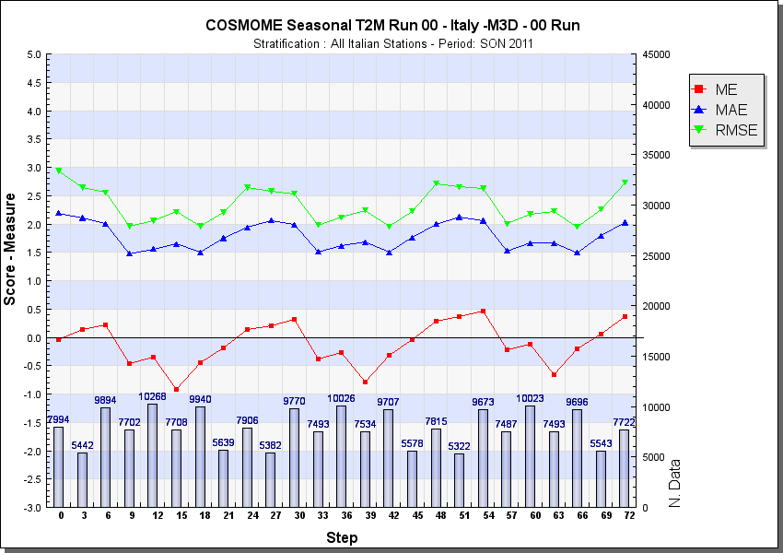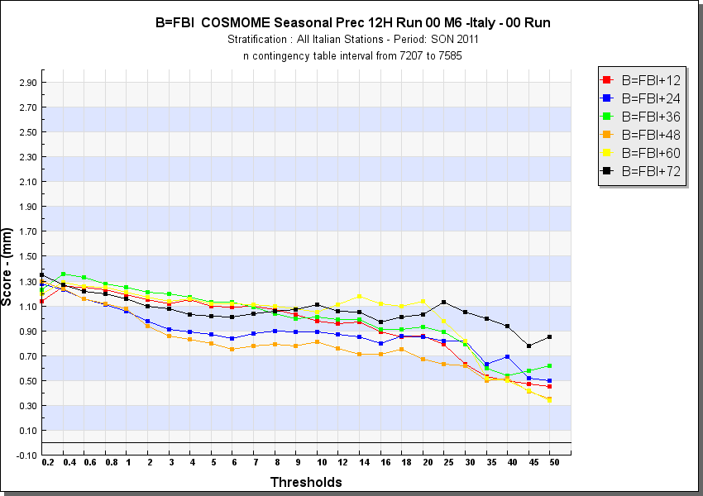

2mT (ME, MAE, RMSE) and 12h precipitation (FBI) on all Italian Stations SON 2011
And an example for upper air verification, always for COSMO-ME model 00UTC run - SON 2011 quarterly:

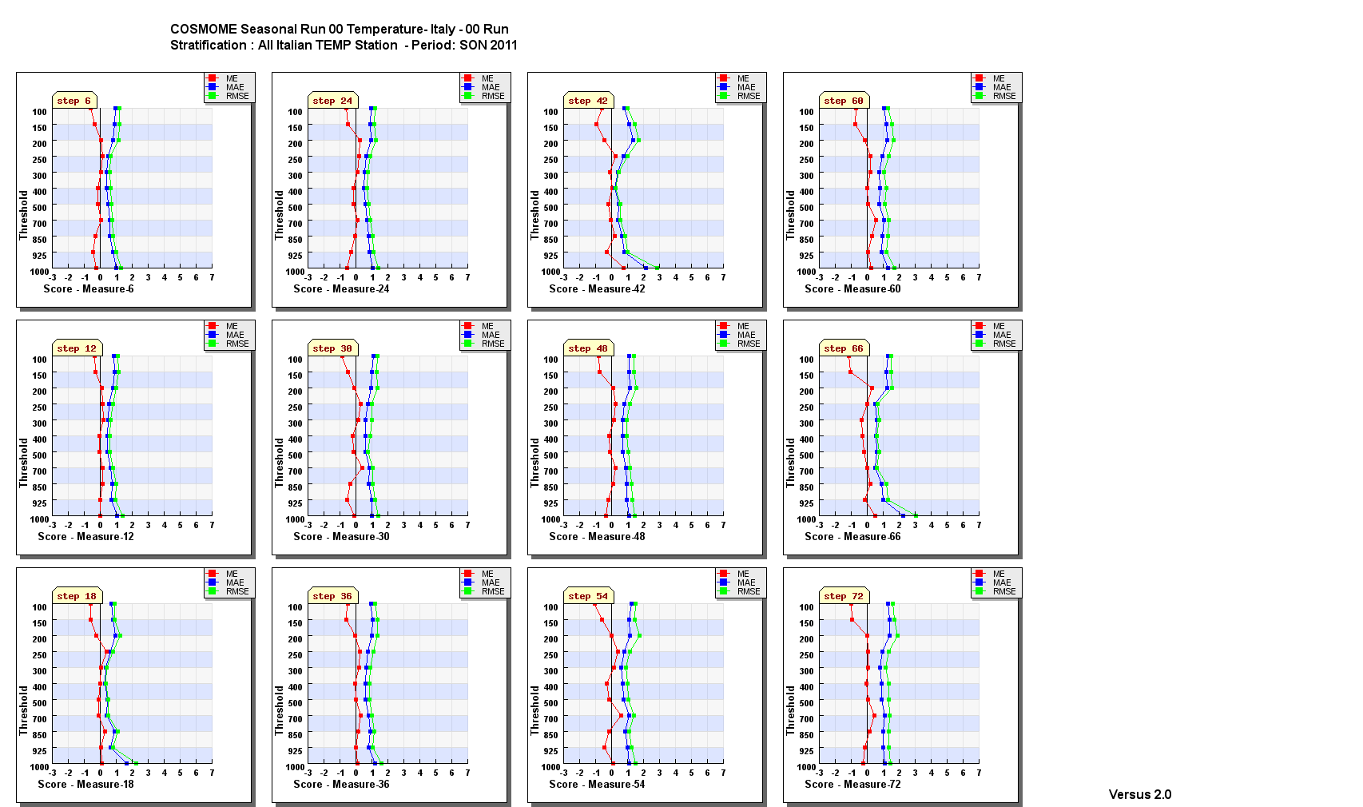

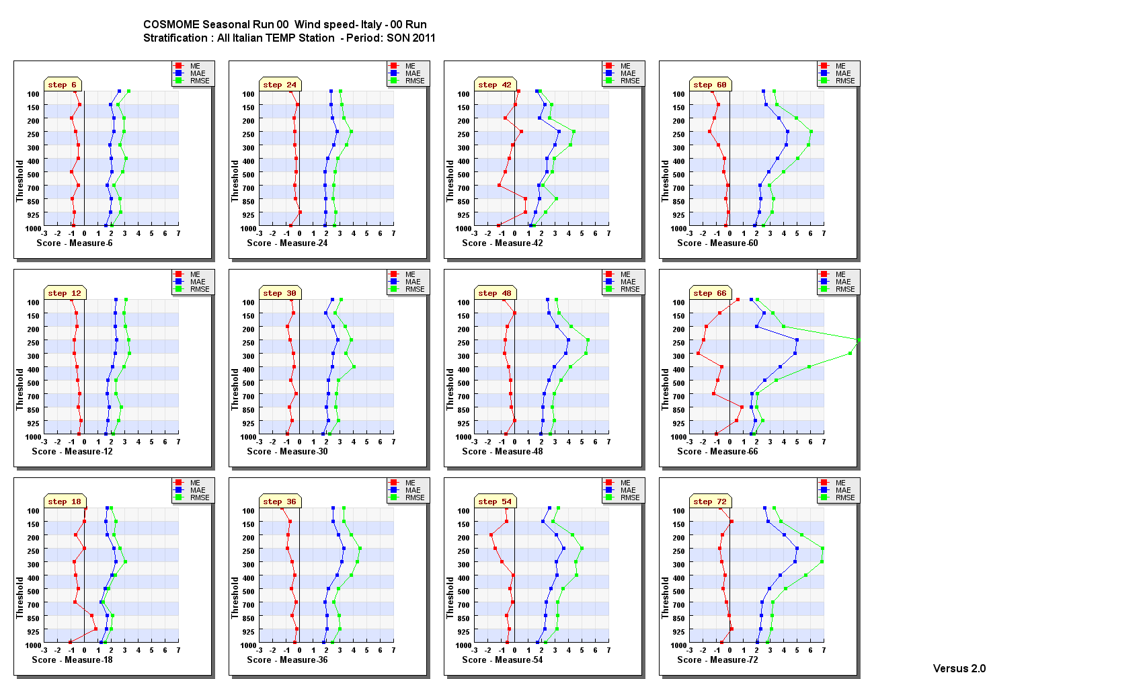

5.2 Research performed in this field

VERSUS had not been planned to cover all the existing verification methods, as well as all the possible production from a NWP, since the project started in 2006 and NWP improved since that in resolution and complexity. Also, not all types of observations can be used at present in VERSUS software, for example observation from satellite and radar.
In more detailed main open points and fields of research to be included in the next future (until 2011) in VERSUS software developments are:

  - probabilistic and ensemble forecasts verification;
  - obj-based (SAL methods) and fuzzy verification methods applied to precipitation;
  - New scores for extreme events (e.g. extreme dependency score);
  - ad hoc tailored User-oriented verification;
  - inclusion of statistical features like confidence intervals and bootstrap method;
  - Use of non conventional obs (e.g. radar, satellite, raingauges) and gridded observations (precipitation analysis).

To face and solve these open points an extension of VERSUS project has been proposed: VERSUS 2 in COSMO consortium framework. The project is planned to be completed in 2013.

6. Plans for the future (next 4 years)

6.1 Development of the GDPFS

6.1.1 At the moment a programme to upgrade supercomputer system at CNMCA is under development. Following some internal collaboration with University and the participation of Italy in the Priority project POMPA of COSMO consortium (see section 7.1.2), the probably adopted solution will be an hybrid CPU-GPU, exploiting the new hardware architecture named CUDA. This new architecture seems to be promising in terms of performances and expenses, being cheaper than the traditional CPU asking for the same performances.

6.1.2 Within 2013 the very core of the current Data Processing System and consequently part of the Forecasting System will be completely revised. The Data processing System will be renewed in the light of the Service Oriented Architecture and in order to make it compliant with the European Community INSPIRE Directive and future migration plan to WMO WIS.

6.2 Planned research Activities in NWP, Nowcasting and Long-range Forecasting

6.2.1 Planned Research Activities in NWP

Further tuning of LETKF algorithm and operational implementation of the CNMCA LETKF data assimilation system with COSMO model.
Implementation and test of a short range ensemble prediction system.
Improvement of convection resolving model forecast up to 1km grid spacing.

6.2.2 Planned Research Activities in Nowcasting

6.2.3 Planned Research Activities in Long-range Forecasting

Consortium

7.1 System and/or Model

The COSMO Model (http://cosmo-model.org/content/model/general/default.htm) is a non-hydrostatic limited-area atmospheric prediction model. It has been designed for both operational numerical weather prediction (NWP) and various scientific applications on the meso-β and meso-γ scale. The COSMO Model is based on the primitive thermo-hydrodynamical equations describing compressible flow in a moist atmosphere. The model equations are formulated in rotated geographical coordinates and a generalized terrain following height coordinate. A variety of physical processes are taken into account by parameterization schemes.
Besides the forecast model itself, a number of additional components such as data assimilation, interpolation of boundary conditions from a driving model, and postprocessing utilities are required to run the model in NWP-mode, climate mode or for case studies.

7.1.1 In operation

Regional numerical weather prediction at CNMCA is entirely based on the COSMO Model, COSMOE-ME and COSMO-IT (See mainly sections 4.3.1 and 4.3.2).

On behalf of COSMO, ARPA-SIMC operates the regional ensemble prediction system COSMO-LEPS (http://www.cosmo-model.org/content/tasks/operational/leps/default.htm) at the European Centre for Medium Range Weather Forecasts (ECMWF) in the “Framework for Member-State time-critical applications”. COSMO-LEPS is the Limited Area Ensemble Prediction System developed within the COSMO consortium in order to improve the short-to-medium range forecast of extreme and localized weather events. It is made up of 16 integrations of the COSMO model, which is nested on selected members of ECMWF EPS.
COSMO-LEPS covers Central and Southern Europe with 511x415 grid points/layer at a grid spacing of 7 km and 40 layers. The system runs twice a day, starting at 00 and 12UTC with a forecast range of 132 hours.

7.1.2 Research performed in this field

The joint research and development is mainly undertaken in the eight working groups (http://cosmo-model.org/content/consortium/structure.htm) and a number of priority projects and priority tasks. The current priority projects are: “Kilometre-Scale Ensemble-Based Data Assimilation” (KENDA), see section 7.4.1, “Conservative Dynamical Core” (CDC) which aim is to get a dynamical core with explicit conservative properties for very-high model resolutions, “Towards Unified Turbulence-Shallow Convection Scheme” (UTCS) which aims at development of unified turbulence/subscale convection parameterization for very high resolution convection-resolving model, “Verification System Unified Survey 2” (VERSUS2) developing an operational verification package for deterministic and ensemble forecasting, “Performance On Massively Parallel Architectures” (POMPA) for preparation of the COSMO model code for running on future high performance computing systems and architectures, and “Consolidation of Operation and Research Results for the Sochi Olympic Games” (CORSO) for enhancing and demonstrating COSMO-based NWP systems in winter conditions and for mountainous terrain. The priority task “Mire Parameterization’ focuses on parameterization of mire effects for heat and water balances for land surface scheme. Environmental prediction aspects of the model involving chemistry, aerosol effects and transport (COSMO ART) are developed in close cooperation with University of Karlsruhe in Germany.

7.2 System run schedule and forecast ranges

See section 4.3.2 and 4.4.3

7.3 List of countries participating in the Consortium
COSMO stands for COnsortium for Small-scale MOdelling. The general goal of COSMO is to develop, improve and maintain a non-hydrostatic limited-area atmospheric model, the COSMO model, which is used both for operational and for research applications by the members of the consortium.
The consortium was formed in October 1998 at the regular annual DWD (Germany) and MeteoSwiss (Switzerland) meeting.
A Memorandum of Understanding (MoU) on the scientific collaboration in the field of non-hydrostatic modeling was signed by the Directors of DWD (Germany), MeteoSwiss (Switzerland), USAM (Italy, then named UGM) and HNMS (Greece) in March/April 1999. The MoU has been replaced by an official COSMO Agreement, which was signed by the Directors of these four national meteorological services on 3 October 2001.
In 2002, the national weather service of Poland (IMGW) joined the Consortium in effect from 4 July. The National Institute of Meteorology and Hydrology (NMA) of Romania and the Federal Service for Hydrometeorology and Environmental Monitoring of the Russian Federation joined the Consortium in effect from 21 September 2009.
Currently, the following national meteorological services are COSMO members:
Germany | DWD | Deutscher Wetterdienst
Switzerland | MCH | MeteoSchweiz
Italy | USAM | Ufficio Generale Spazio Aereo e Meteorologia
Greece | HNMS | Hellenic National Meteorological Service
Poland | IMGW | Institute of Meteorology and Water Management
Romania | NMA | National Meteorological Administration
Russia | RHM | Federal Service for Hydrometeorology and Environmental  Monitoring

These regional and military services within the member states are also participating:
Germany | AGeoBw | Amt für GeoInformationswesen der Bundeswehr
Italy | CIRA | Centro Italiano Ricerche Aerospaziali
Italy | ARPA-SIMC | ARPA Emilia Romagna Servizio Idro Meteo Clima
Italy | ARPA Piemonte | Agenzia Regionale per la Protezione Ambientale  Piemonte

Four national meteorological services, namely INMET (Brazil), DHN (Brazil), DGMAN (Oman) and NCMS (United Arab Emirates) as well as the regional meteorological service of Catalunya (Spain) use the COSMO model in the framework of an operational licence agreement including a license fee. National meteorological services of developing countries (e.g. Egypt, Kenya, Rwanda) can use the COSMO model free of charge. Lateral boundary conditions based on the global model GME of Deutscher Wetterdienst are provided free of charge to all COSMO users.

7.4 Data assimilation, objective analysis and initialization

7.4.1 In operation
The data assimilation system for the COSMO model is based on the observation nudging technique. The variables nudged are the horizontal wind, temperature, and humidity at all model layers, and pressure at the lowest model level. The other model variables are adapted indirectly through the inclusion of the model dynamics and physics in the assimilation process during the relaxation. At present, radiosonde, aircraft, wind profiler, surface synoptic, ship, and buoy data are used operationally. For model configurations at the convection-permitting scale, radar-derived precipitation rates are included additionally via the latent heat nudging method. If nudging is used for data assimilation, an extra initialization is not required. Separate two-dimensional analysis schemes based on the successive correction technique are deployed for the depth of the snow cover and the sea surface temperature, and a variational scheme for the soil moisture.
As for COSMO-LEPS, the following initialization is performed: the upper-level initial conditions of the individual members are interpolated from the ECMWF EPS elements providing the boundaries. On the other hand, the initialization at the lower boundary is performed by taking the surface fields of COSMO-EU, including soil temperature and humidity, and blending them with those provided by ECMWF.
7.4.2 Research performed in this field
The focus of research efforts lies on the development of a novel data assimilation scheme based on the Local Ensemble Transform Kalman Filter technique in the frame of the KENDA priority project. Its main purpose will be to deliver perturbed initial conditions for convection-permitting ensemble prediction systems. For more information, see
http://www.cosmo-model.org/content/tasks/priorityProjects/kenda/default.htm.
In the framework of the nudging scheme, work is in progress to assimilate also the following observations:
- radial velocity from Doppler radars, by nudging only the radial wind component
- integrated water vapour derived from ground-based GNSS (GPS) data
- 10-m horizontal wind vector data derived from scatterometers (ASCAT, OSCAT)
- 2-m temperature data, by adjusting both the atmospheric and soil temperatures.
Furthermore, the assimilation of radar-derived precipitation rates by a 1DVAR plus nudging approach is being developed and tested in comparison to the latent heat nudging scheme.

7.5 Operationally available Numerical Weather Prediction (NWP) Products

See section 4.3.3.

As for COSMO-LEPS, the available operational products include the following:
- “deterministic products”: different weather scenarios (one per member) for the model variables, at several forecast ranges;
- “probabilistic products”: probability of exceedance of user-defined thresholds for the different model variables, at several forecast ranges;
- “pointwise products”: meteograms over station points in terms of the main model variables.

7.6 Verification of prognostic products

See section 5 in reports of COSMO members.

7.7 Plans for the future (next 4 years)

7.7.1 Major changes in operations

See section 6.1 in reports of COSMO members

7.7.2 Research performed in this field

A 5-year science plan

(http://cosmo-model.org/content/consortium/reports/sciencePlan_2010-2014.pdf) summarizes the strategy and defines the main goal of the joint development work with COSMO. The main goal is to develop a model system for short to very short range forecasts with a convective-scale resolution to be used for operational forecasting of mesoscale weather, especially high impact weather. The research-oriented strategic elements to achieve the goal are: an ensemble prediction system, an ensemble-based data assimilation system and a verification and validation tool for the convective scale, extension of the environmental prediction capabilities of the model, use of massively parallel computer platforms. The actions for achieving the goal are undertaken within the current priority projects and task (see section 7.1.3) which will be complemented by the future projects, e. g. on convective-scale ensembles.

In the near future, the planned research activity relative to COSMO-LEPS will include the following:
- revision of the methodology used to select the ECMWF EPS members providing initial and boundary conditions to COSMO-LEPS;
- investigation of the added value obtained by adding new members (driven by a set of global deterministic runs) to the present configuration of COSMO-LEPS.

8. References

